MODULE TITLE: FRONT OFFICE OPERATIONS

M4X01920

ASSESSMENT TITLE: ANALYSING IMPORTANCE OF FRONT OFFICE AND 5 STAR FRONT OFFICE STAFF IN HOTEL

STUDENT NAME: IOSIF DANIEL STAN

STUDENT ID NUMBER: 1815337

LECTURER NAME: DR.JAHANZEEB QURASHI

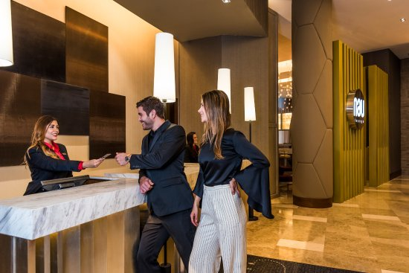

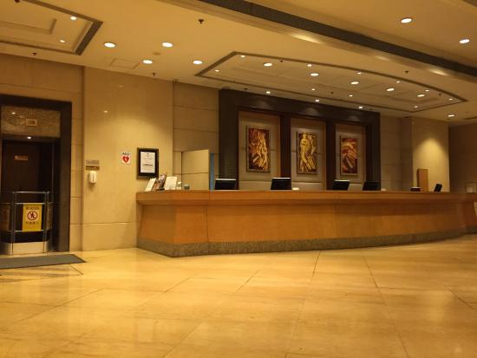

Table of Content

1.Introduction.....................................................................pag.3
2.The importance of the Front-Office in the Hotel………...pag.3
2.1.Organisation of the Front-Office service…………..…pag.3-4
2.2.The tasks of the Front-Office staff………………………pag.4
2.3.Night Audit Manager……………………………………..pag.5
3.Conclusion…………………………………………………..pag.6
4.Reference……………………………………………………pag.7

The purpose in this assignment is to study, research and analyse the importance of the Front-Office Department, its efficiency hospitality industry.
Introduction:

As in the case of a hotel, and in the case of the front-office service, the organizational structure can be shown through an organizational chart. Even if there are hotels of different sizes, the structure of the staff is about the same, the differences that appear refer to the number of personnel that operate within this service. to hold a number of functions (for example: freight forwarder, freight forwarder, courier, so on).

The importance of the Front-Office in the Hotel

1.Organization of the FRONT - OFFICE service

This service is organized into several functional compartments or sections, each with its own responsibilities. During the stay in the hotel tourists ask for a number of services from the hotel, which inevitably puts them in contact with its staff. Most of these contacts are made with the employees of the front-office service, each sector of this department having a specific task.

The main sectors of activity within the front-office service are: reservations, reception, concierge, cashier, telephone exchange. The role of this department (service) is materialized in the promotion and sale of hotel services, accommodation and additional services. The main activities are:

Promotion and sale of hotel services
Reservation planning and registration
• Evidence of customer movement and room situation
•Welcoming customers
• Allocation of accommodation space
• Recording customer data
• Performing additional services
• Solving requests and complaints
• Recording customer consumption
• Receiving the value of the services consumed by the client
• Issuance of payment notes and invoices
• Key management
• Carrying out communications inside and outside the hotel: by telephone, fax, fax
• Preparation of daily reports and reports
• Preparation of specific statistics
• Collaboration with the two departments

The organization of the front office depends on several factors, namely:
• The size of the hotel. Large hotels have more staff and tend towards greater specialization of sectors and their staff, whereas in small hotels, a wide range of tasks are performed by a single staff member.
• Standard of services. The upper-class hotels provide their clients with personalized services, which is why they require a greater specialization.
• The type of customers. Businessmen need efficient check-in and check-out services, but they are willing to carry their own luggage. As a result, a commercial hotel needs more staff in the front desk than in the concierge. Tourists usually ask for information about local attractions, in a tourist hotel it is necessary to place greater emphasis on information and assistance providers and less on administrative and financial-accounting activities. In the holiday hotels the clients can come and go from the hotel at any of the 24 hours of the day, which requires the complete and continuous presence of the front-office staff.
During the stay at a hotel the clients can request certain services and can participate in certain transactions with the hotel, which are mostly carried out by the front-office service.

2.The tasks of the Front-Office staff

Booking office
The booking office staff includes:
• Reservation manager (or reservation supervisor)
• Reserve agents

Reception (front desk)
The main duty of the reception of a hotel is to ensure the reception and accommodation of the guests, but also the services that they request, the good performance of the activities of this service, depending to a large extent on the type and the number of the operations that take place in different stages of the stay in the hotel.

The office of greeting the guests
This office comprises a large number of personnel (the head of the office, the porters, porters and baggage’s, so on).

Baggage holders (concierge / lobby services)
The baggage department includes a large group of personnel in uniform, including: the chief lobbyist; porters; Porter. The chief luggage manager subordinates all the front-office uniform personnel and works at the office in the main lobby of the hotel.

The correspondence and information office (messaging)
The person in charge of the office leads the team of employees who manage the keys of the rooms and sends to the tourists the messages that came on their behalf. A desk for information and correspondence is normally only available in very large hotels. The information and correspondence sector include:
• The correspondence and information supervisor
• Correspondence and information workers

The telephone office
The personnel in this sector includes the telephone supervisor and telephone operators, both for day and night operations. The telephone supervisor and telephone operators handle all incoming and outgoing calls from the hotel's telephone exchange. The personnel of this sector must have communication and linguistic skills.

Customer relations workers
In large hotels, there is often very little contact between customers and other staff, apart from receptionists and baggage handlers. In such hotels, customer service workers have the role of trying to create an atmosphere of increased hotel concern for customers.

Front-office cashier
The staff that is part of the front-office cashier includes the cashier's supervisor (cashier) and cashiers. The cashier supervisor bears the full responsibility for the cash receipts and the methods for their accomplishment, as well as for the supervision of the cashiers of the front-office.
In some hotels, the front-office cashiers are subordinated to the account manager rather than the front-office manager, and the chief cashier is directly subordinated to the chief accountant and not the head of reception, even if cash operations are performed within this service. .

3.Night Auditor Manager

The personal of the reception compartment can be made up of two teams, one specialized for day work and one for night work or can be divided into shifts that work during different times of the day.

Front-desk deserve can be served by a separate team of workers during the night or, less commonly, its service can be done by night shifts.

The activity of the front desk during the night is relatively reduced, at night being usually the period when various documents are processed, and the results of the different operations performed are verified, these activities are known as

audit.

Among the tasks of the audit are checking and completing the clients' account sheets, the balance of the hotel's revenues and the preparation of statistics and reports for hotel revenue managers. In the past, most of the systems used to perform account and leasing operations were either manual or electronic or mechanical.

With the introduction of hotel management information systems, most of the activities are performed automatically by computers throughout the day. Thus, the need for employees for the account operations and the audit activities is reduced and the tasks of the night audit staff, which will only have to prepare the hotel reports and statistics obtained from the computer, are greatly simplified.

Occasionally, staff can manually complete various reports and perform some special checks. One of the most important tasks that night audit workers must take care of is the 'back-up' of the computer system. This involves making copies of all files from computers, so that the consequences of a possible computer system crash can be prevented.

Conclusion:
In conclusion, it can be said that the front-desk service is the most visible in a hotel, the focus of the activity being the front desk (front desk or counter).
It is understood that this is usually the place where customers make their first significant impressions about the hotel, the communication center for all the operations carried out in the hotel.
It can also be understood that the activities specific to the front-office service are carried out at the level of the reception hall - the central point to which all the services in a hotel converge.

Reference:

1.

Virgil Balaure, Iacob Catoiu, Catalin Veghes - Marketing Turistic, Ed Uranus,
Bucuresti 2005

2. Philip Kotler 'Principiile marketingului', Editura Teora, Bucuresti, 2004
1.

Virgil Balaure, Iacob Catoiu, Catalin Veghes - Marketing Turistic, Ed Uranus,
Bucuresti 2005

2. Philip Kotler 'Principiile marketingului', Editura Teora, Bucuresti, 2004
1.

Virgil Balaure, Iacob Catoiu, Catalin Veghes - Marketing Turistic, Ed Uranus,
Bucuresti 2005

2. Philip Kotler 'Principiile marketingului', Editura Teora, Bucuresti, 2004
Kotler, P., Marketing Principles, Teora Publishing House, Bucharest 2004

Kotler, P., Marketing Management, Teora Publishing House, Bucharest, 2007

Lupu, N., Hotel-Economics and management, All Publishing House, Bucharest, 1999

Stancioiu, Aurelia Felicia, Marketing Strategies in tourism, Economic Publishing House, Bucharest, 2006

Stanciulescu, Gabriela, tourism Operations technique, Economic Publishing house, Bucharest, 1998
Sue Baker, Pam Bradley, Jeremy Huyton - Principles of Hotel Reception Operations, Ed. ALL BECK Bucharest, 2002, page 57
"What does front office staff do?" wise GEEK. Retrieved 14 October 2014. accessible @ https://www.wikipedia.org.Front_office (accessed 5/11/2019)

