Effect of Noise in SSB-SC, DSB-SC and AM
Radio Frequency Systems (ACDA5019)
Henry Rennison 2218326

Contents
Table of Figures 2
Introduction 3
Background Research 3
Amplitude Modulation (AM) 3
Single Sideband Suppressed Carrier (SSB-SC) 3
Double Sideband Suppressed Carrier (DSB-SC) 3
Task 1 4
Task 2 10
Task 3 – SSB-SC 13
Task 4 Comparison of Modulation Techniques 16
Spectrum analysis 17
Power Efficiency 17
Noise Tolerance 18
Bandwidth Efficiency 18
Overall Assessment 18
Conclusion 19
Amplitude Modulation 19
Single Sideband Suppressed Carrier 19
Double Sideband Suppressed Carrier 19
Future Work 19
Bibliography 20

Table of Figures
Figure 1 0.6 AM 3
Figure 2 0.6 Spc An 4
Figure 3 AM Crit 5
Figure 4 AM Under 6
Figure 5 AM Over 7
Figure 6 AM Simulink 8
Figure 7 DSb-SC Simulink 9
Figure 8 DSb-SC 0.5 9
Figure 9 DSB-SC SNR-15 10
Figure 10 SSB-SC Simulink 11
Figure 11 SSB-SC 0.5 11
Figure 12 SSB-SC SNR-15 12
Figure 13 SSB-SC Spec 13
Figure 14DVB- SC Spec 13
Figure 15 AM SPEC AN 14

Introduction
This report is structured to provide an understanding of the principals of AM (Amplitude Modulation), SSB-SC (Single Sideband Suppressed Carrier) and DSB-SC (Double Sideband Suppressed Carrier). This report will investigate these modulation schemes through tasks that are aimed at understanding their characteristics, performance and noise resilience. The simulations and modulation techniques were all done on Simulink. The report aims to provide a comprehensive understanding of the key modulation techniques.

Background Research
This part of the report will give definitions and examples of three modulation schemes:
- AM (Amplitude Modulation)
- SSB-SC (Single Sideband Suppressed Carrier)
- DSB-SC (Double Sideband Suppressed Carrier)

Amplitude Modulation (AM)
Amplitude modulation is a technique used in communication systems where the amplitude of a higher frequency carrier wave is changed in proportion to the information signal being transmitted, the frequency of the carrier will remain the same. [1]

Single Sideband Suppressed Carrier (SSB-SC)
Single sideband suppressed carrier is a type of amplitude modulation where only one of the sidebands is transmitted, while the carrier and the other sideband are removed. This is to save bandwidth and improve the power efficiency. [2}

Double Sideband Suppressed Carrier (DSB-SC)
Double sideband supressed carrier is a type of amplitude modulation where both sidebands are transmitted, but the carrier is removed. This saves power since the carrier doesn’t carry any useful information. [3] A common use case for DSB-SC is in FM radio and analogue television transmitters as they require more efficient power usage.

Task 1
This task will look into the fundamentals of AM, it will look at the time and frequency domains whilst changing the modulation index. It will be tested at 0.6 and then it will be run three more times at under-modulation, over modulation and critical conditions. This task will also compare the difference between modulated signals with the demodulated signals.
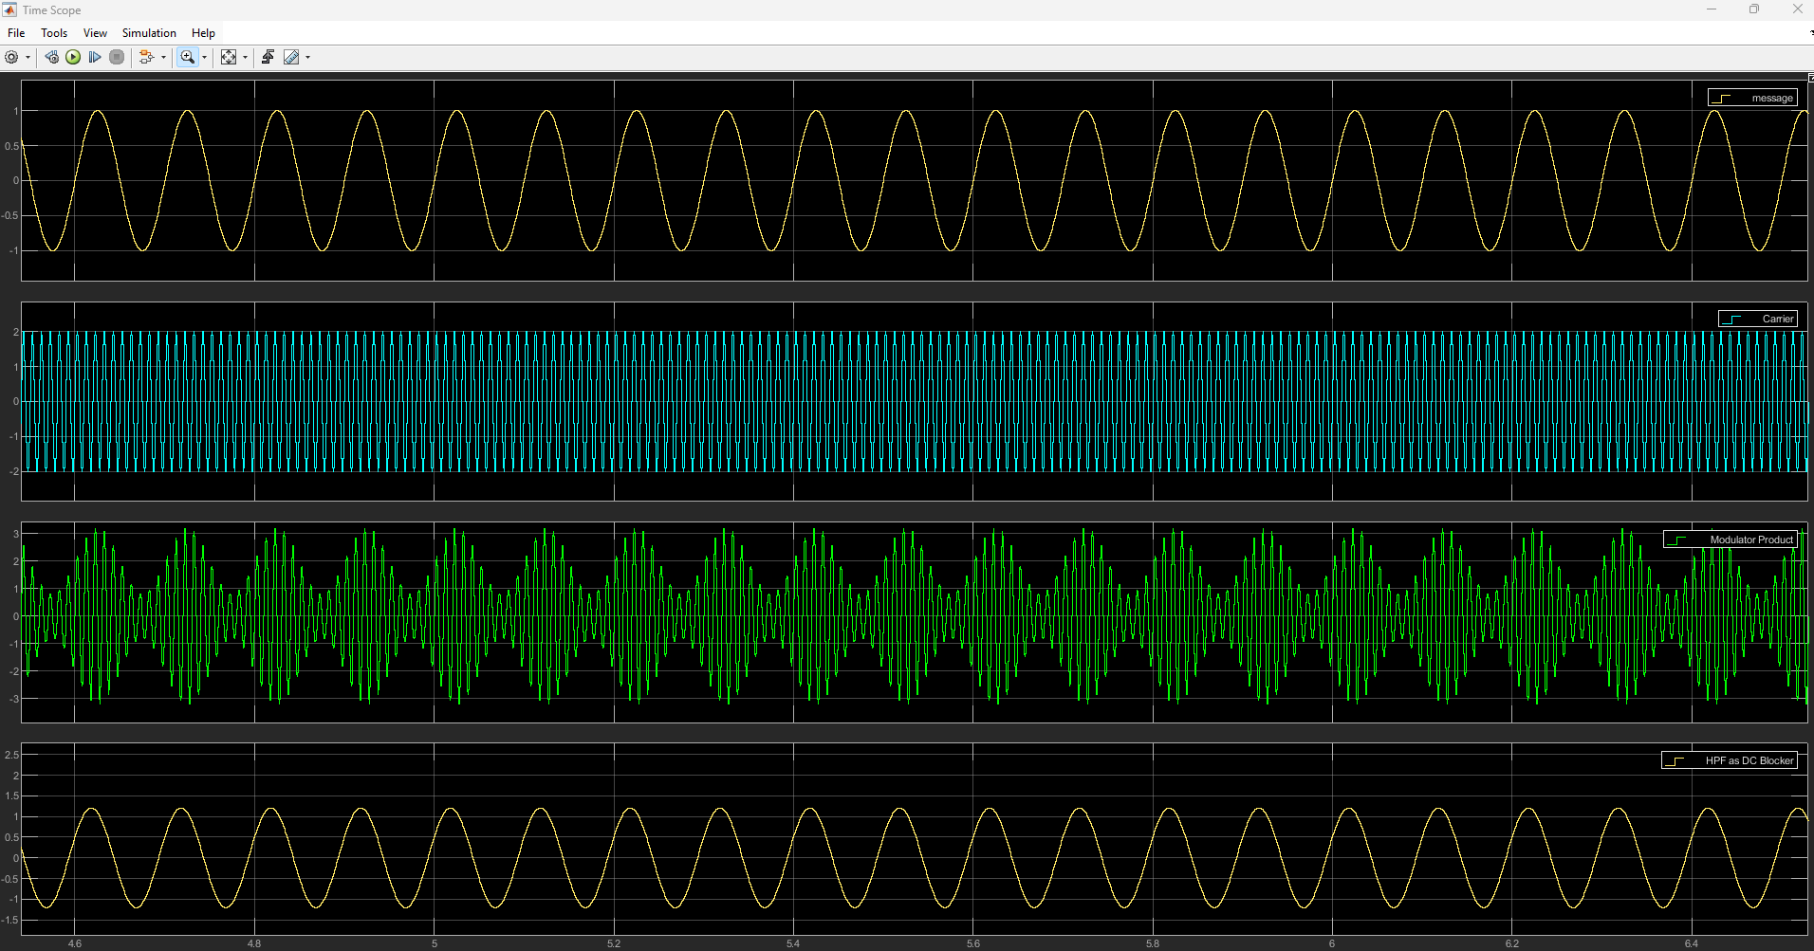
Figure 1 0.6 AM
In the above image you can see the top waveform represents the message signal which is the modulating signal. Its frequency is lower than the carrier signal which is what you would expect to see on a typical AM design. The second waveform (blue) is the carrier signal, which is a higher frequency than the message signal. This is unmodulated signal and serves as the base for modulation. The third waveform (green) is the AM Modulated signal, the amplitude of the carrier varies according to the message signal, which then creates the AM signal. This waveform should mirror the message signal. The final plot shows the demodulated signal. In the above case this waveform resembles the message signal. This suggests a successful demodulation process.

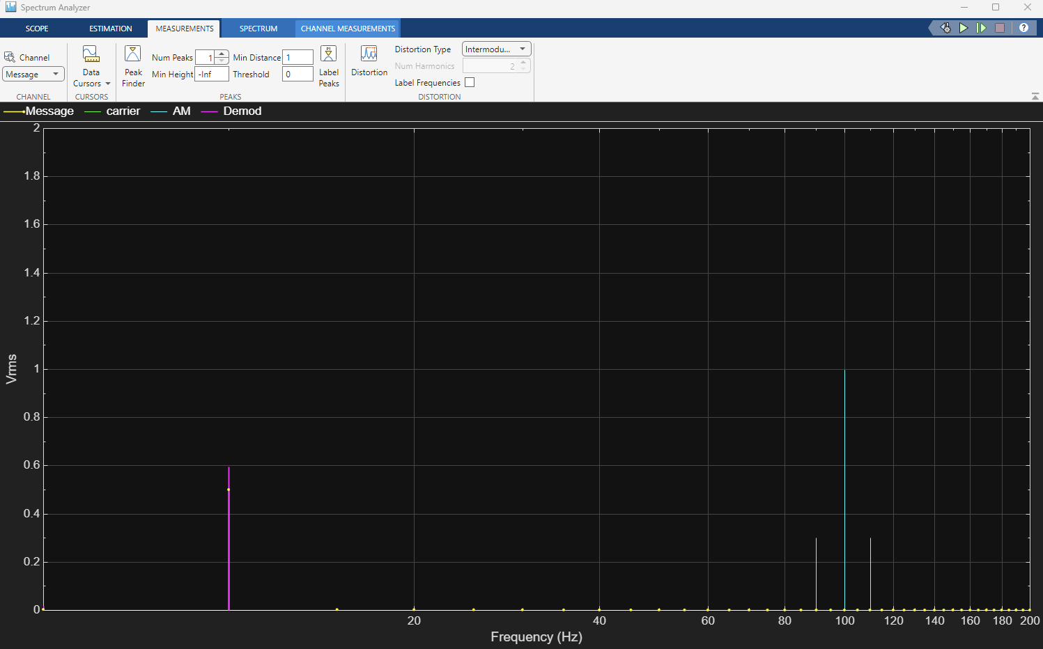
Figure 2 0.6 Spc An
Above is the screen shot of the spectrum analyser when the modulation index is set to 0.6. The spectrum shows a single peak at the message signal’s frequency (10Hz) This is the low frequency component of the system. It also shows a sharp peak at the carrier signal frequency (100Hz) this is expected as it represents the unmodulated carrier used in AM. The AM spectrum (sidebands) are visible either side of the carrier signal at (90Hz and 110Hz) These two bands contain the modulated message signal.

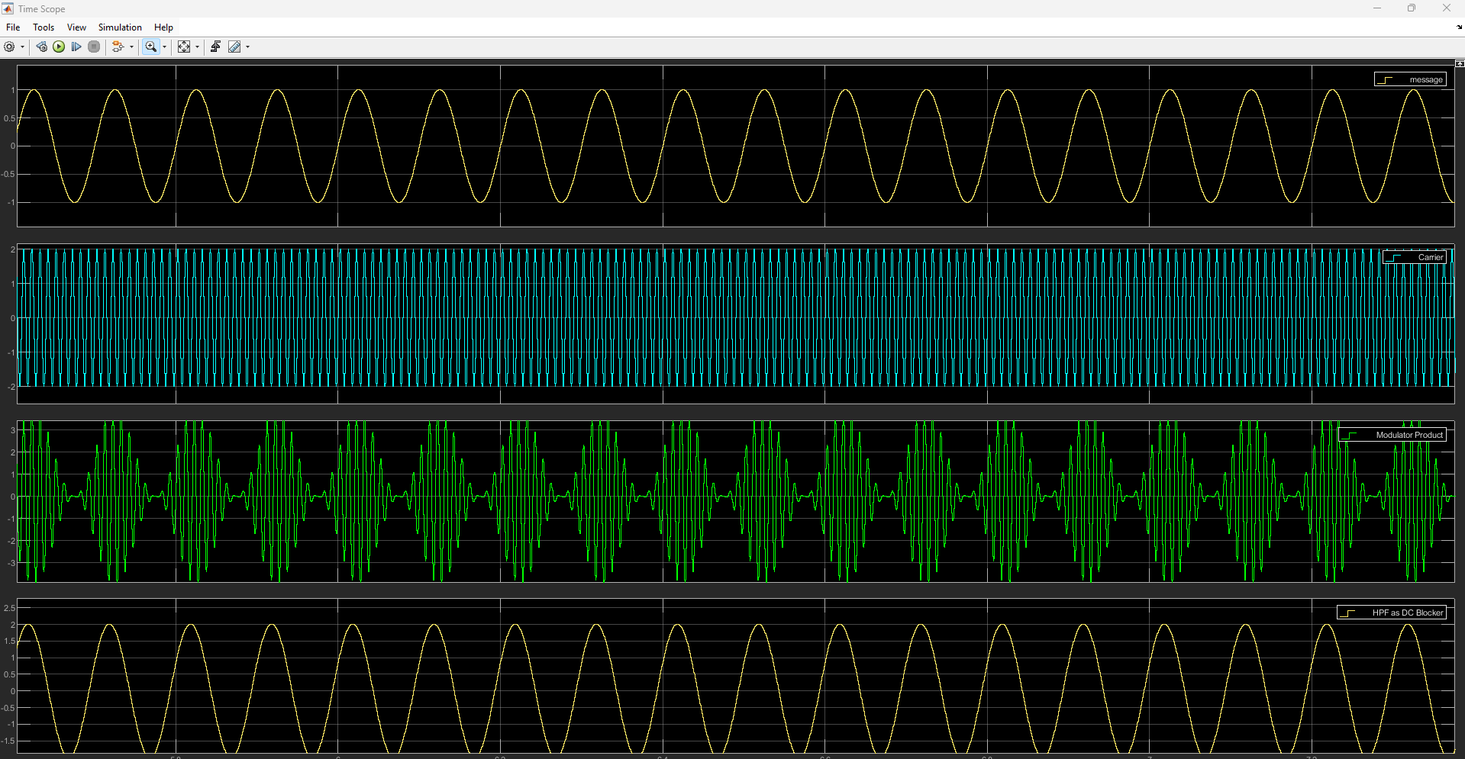
Figure 3 AM Crit
Above is the scope when running the modulation index at critical modulation, Critical modulation occurs when the modulation is exactly 1. When using critical modulation, the amplitude of the modulating signal is equal to the amplitude of the carrier signal. This is shown above as the modulated signal matches the shape of the message signal. The demodulated signal matches the original message signal very closely. [4]

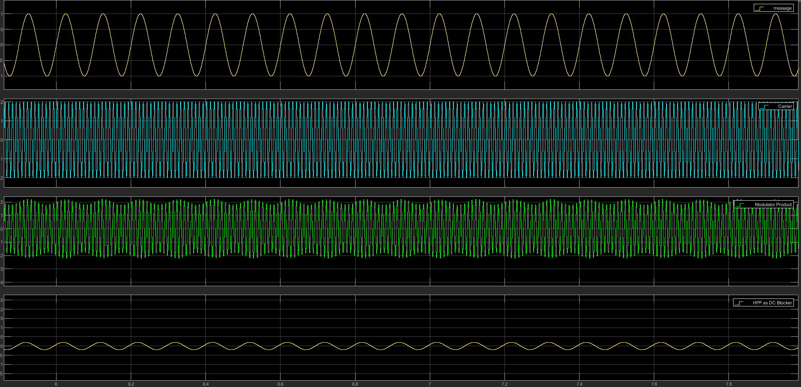
Figure 4 AM Under
The above image shows under modulation, under modulation occurs when the modulation index is less than 1. This means the amplitude of the modulating signal is smaller than the amplitude of the carrier signal as above. Since the carrier signal is stronger than needed it results in wasted power and reduced efficiency. [5]

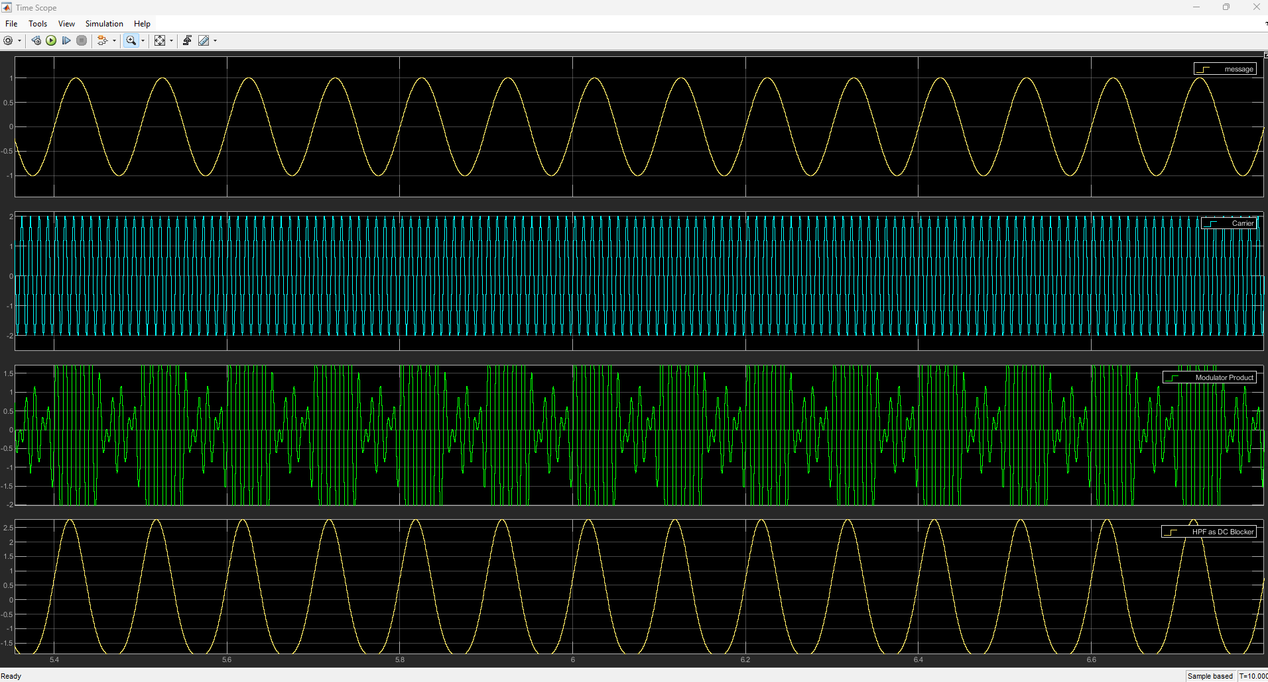
Figure 5 AM Over
The above image shows an example of over modulation, this occurs when the modulation index is set to greater than 1. This happens when the amplitude of the modulating signal is larger than the amplitude of the carrier. This can cause the introduction of additional frequency components into the spectrum, which can in turn make interference with adjacent signals. It also can lead to the original message be very difficult to recover accurately during demodulation. [6]

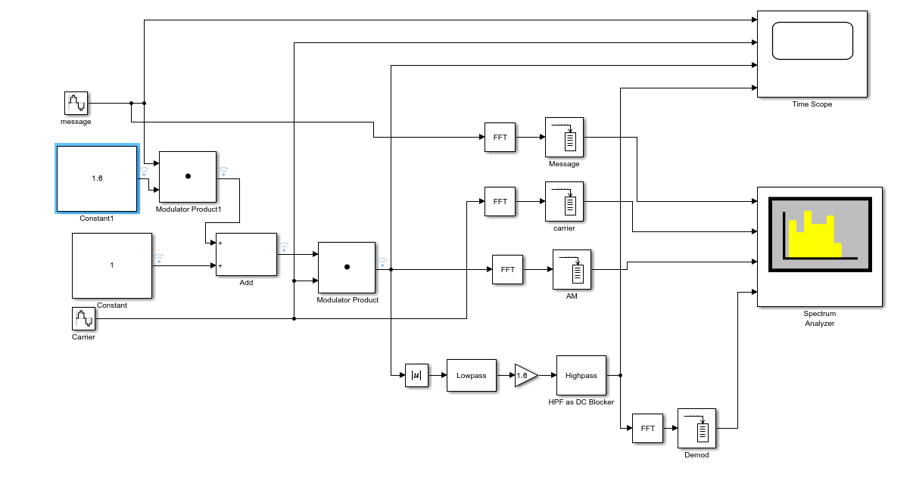
Figure 6 AM Simulink

Task 2

This task focuses on the use of DSB-SC modulator. For the first tests the, modulation index was set to 0.5 to maintain a consistent level of modulation and to ensure optimal signal transmission. The demodulation process recovers the original signal and checks it in both the time and frequency views to ensure it matches accurately. The next part of this task was to add some random noise into the modulator. Then compare both sets of results to see the effects that adding noise to the transmitted signal has had.
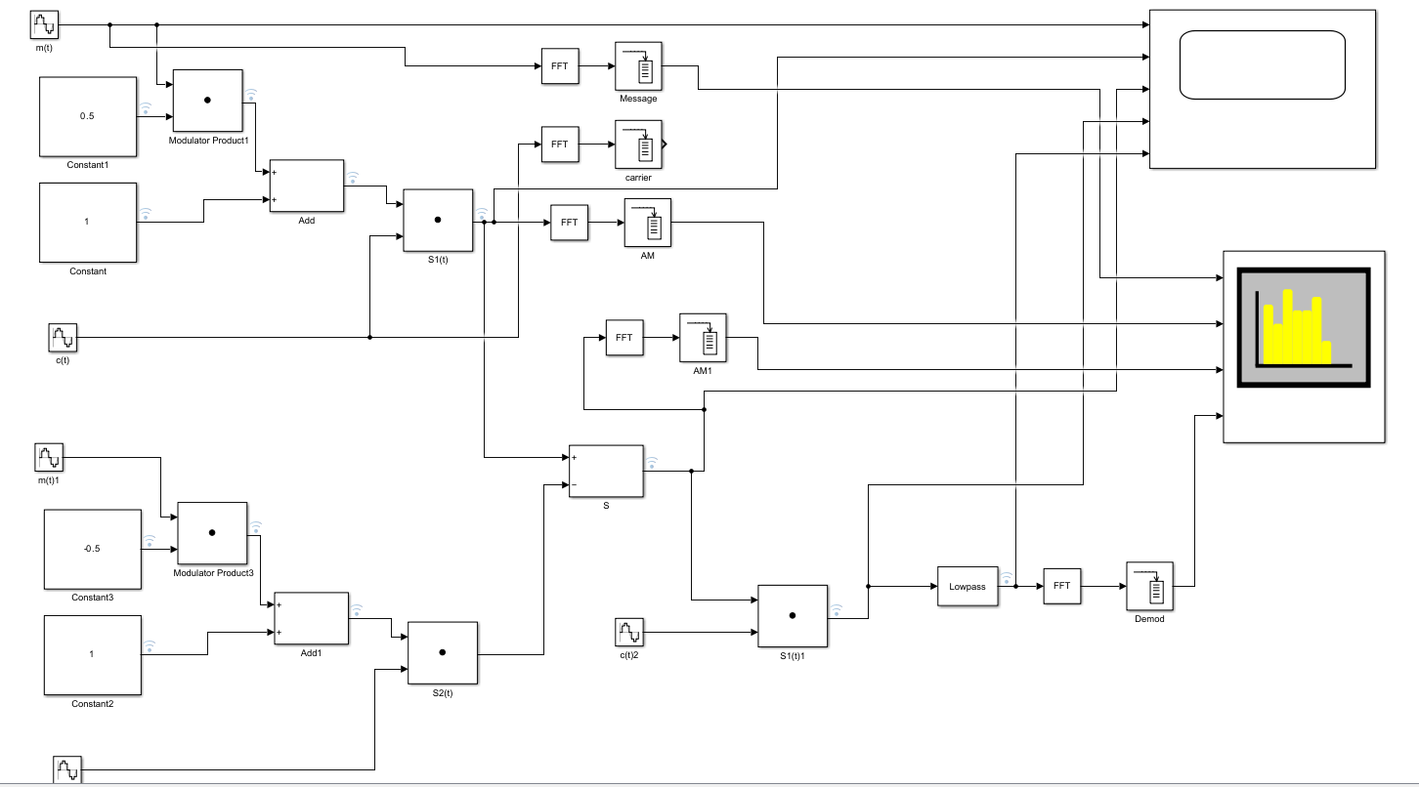
Figure 7 DSb-SC Simulink
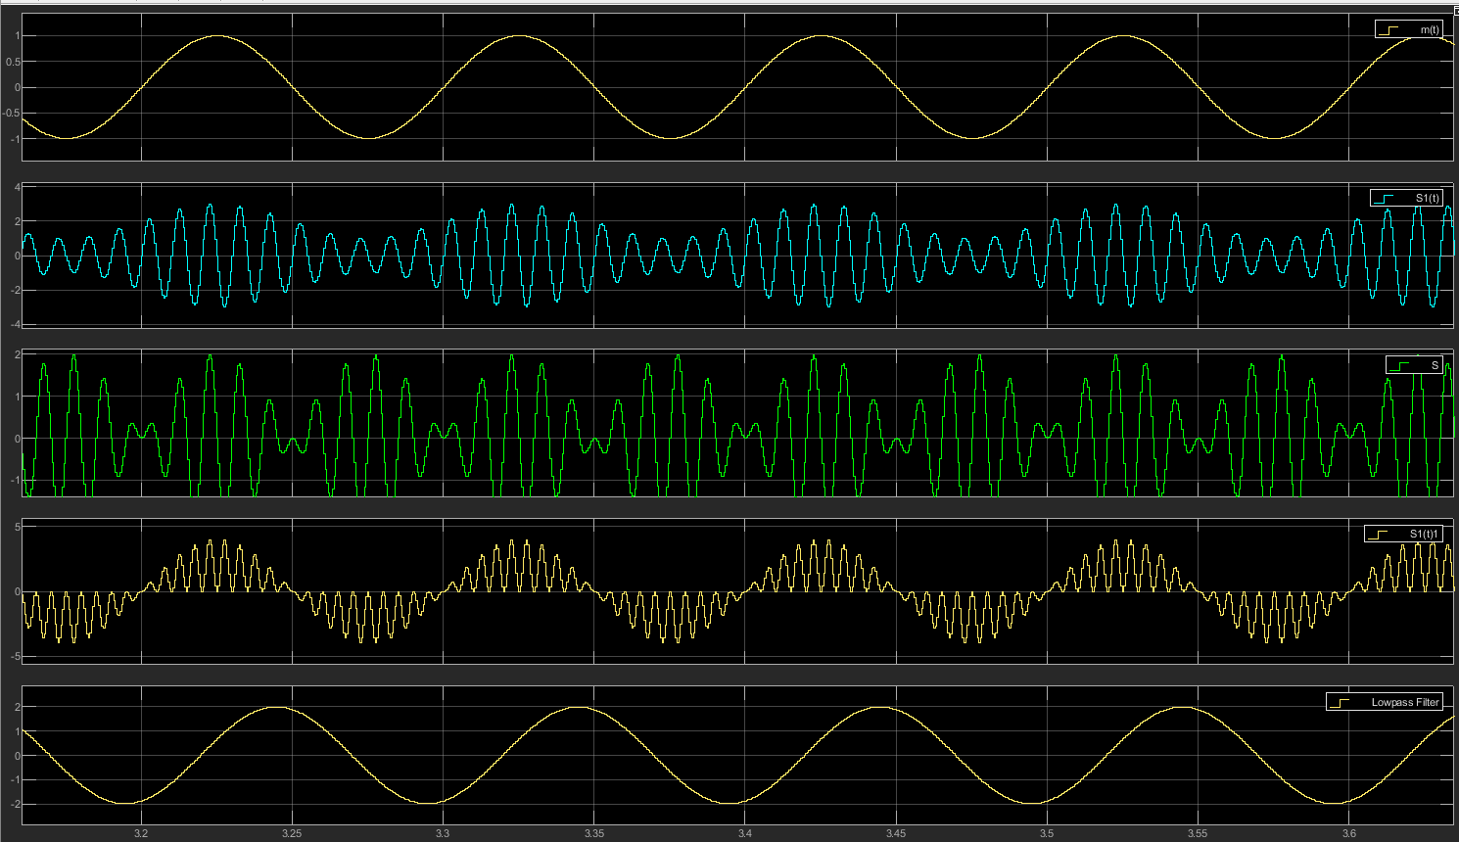
Figure 8 DSb-SC 0.5
The above image is of a DSB-SC modulator using a balanced modulator and then demodulating it. Its modulated signal has a high frequency sine wave where the amplitude varies according to the message signal. However, after demodulation the recovered signal does resemble the original message. Where the modulation index is set to 0.5 you would expect to the amplitude of the modulating signal to be half of the carrier signal.

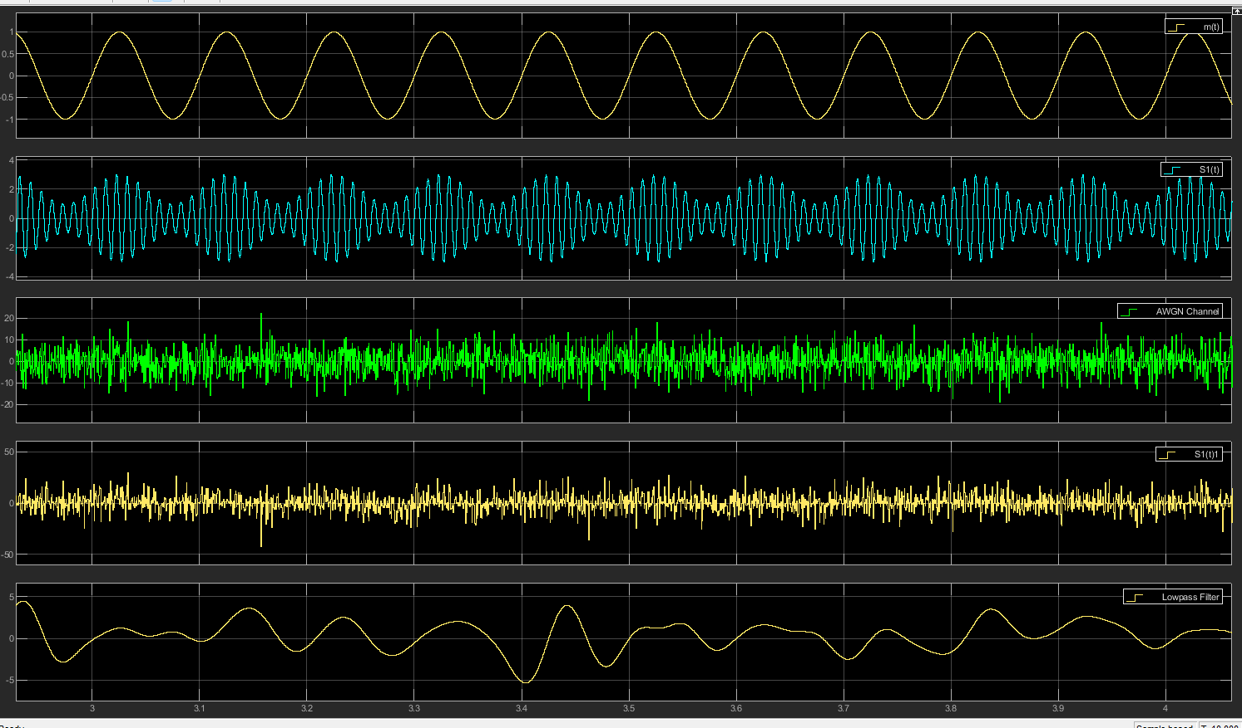
Figure 9 DSB-SC SNR-15
The above image is the DVB-SC run with a modulation index of 0.5 and -15 SNR as can be seen the modulated signal now has random fluctuations on it its waveform due to the noise. The demodulated signal is very difficult to distinguish due to the noise. Overall there is greatly reduced clarity on both the modulated and demodulated signals, in this case the noise appears to be to strong for the signal as it has a great impact.

Task 3 – SSB-SC
This task focuses on the use of SSB-SC modulator. For the first tests the, modulation index was set to 0.5 to maintain a consistent level of modulation and to ensure optimal signal transmission. The demodulation process recovers the original signal and checks it in both the time and frequency views to ensure it matches accurately. The next part of this task was to add some random noise into the modulator. Then compare both sets of results to see the effects that adding noise to the transmitted signal has had.

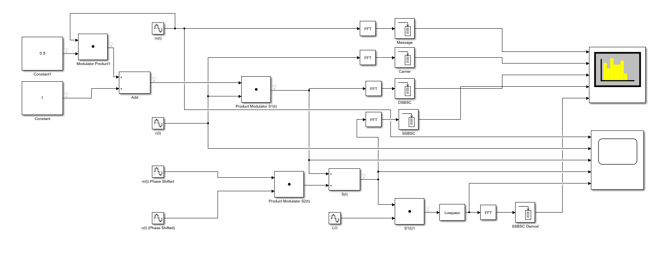
Figure 10 SSB-SC Simulink
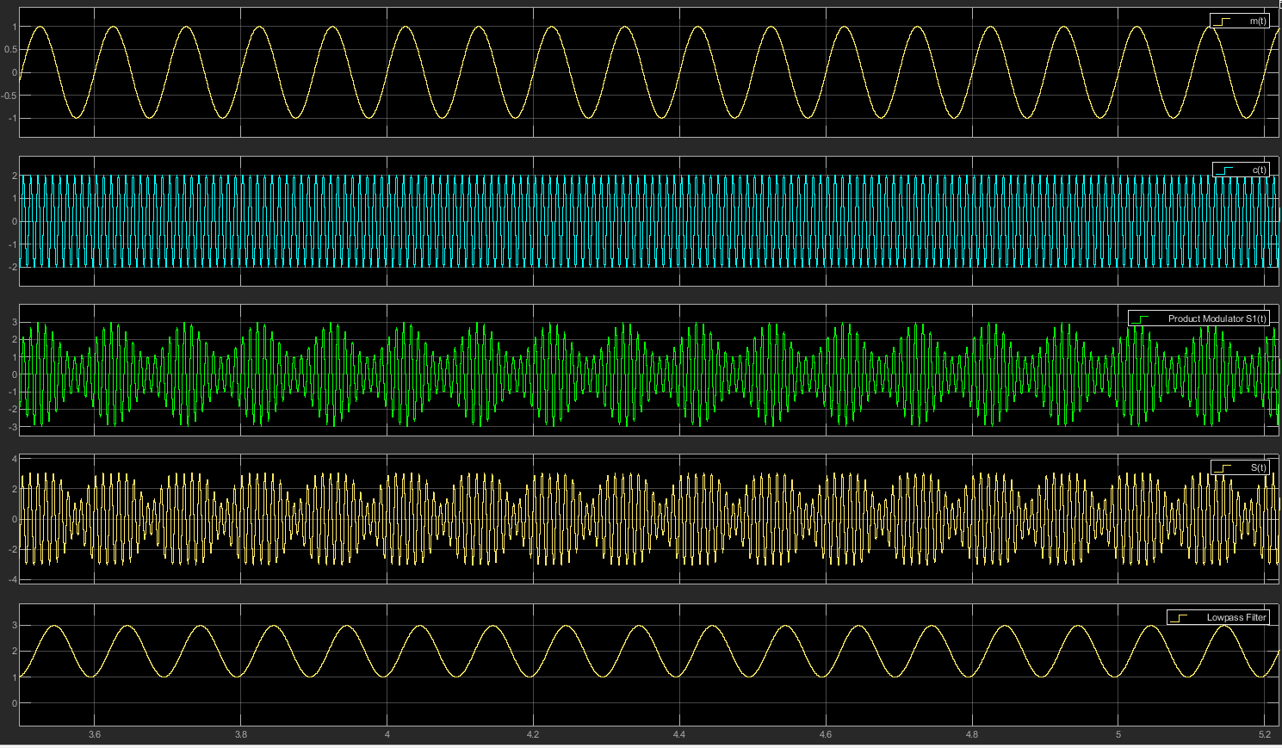
Figure 11 SSB-SC 0.5
The above image is of an SSB-SC modulator with a modulation index of 0.5. The waveform does resemble a high-frequency sine wave but its amplitude does vary according to the message signal. The recovered signal does look like the message signal and the demodulated signal has minimal distortion and does resemble the input. Bandwidth efficiency is visible as only half the bandwidth required. This image demonstrates the high bandwidth efficiency of SSB-SC and its ability to recover the original message with minimal distortion.
With noise -15
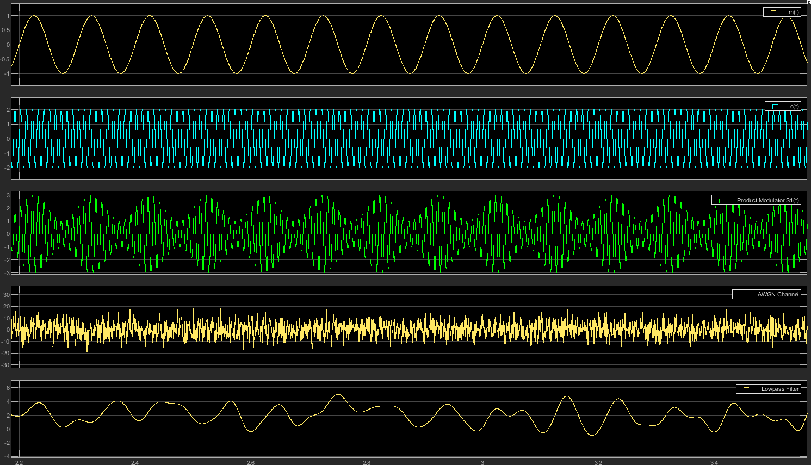
Figure 12 SSB-SC SNR-15
The above image is of a SSB-SC with a modulation index of 0.5 and a SNR of -15. The modulated signal does represent a modulated message however it is affected by the noise. The demodulated recovered signal does resemble the original message signal however it is not as clear. There are many distortions in the peaks and zero crossings making it look much less smooth.

Task 4 Comparison of Modulation Techniques
This part of the report will cover the performance evaluation of modulation techniques which is a critical part of analogue communication system design. It will compare and look into their efficiency and robustness under varying conditions. All three of the systems (AM, DSB-SC, SSB-SC) will be analysed to identify their strengths and limitations. .
SSB-SC with noise
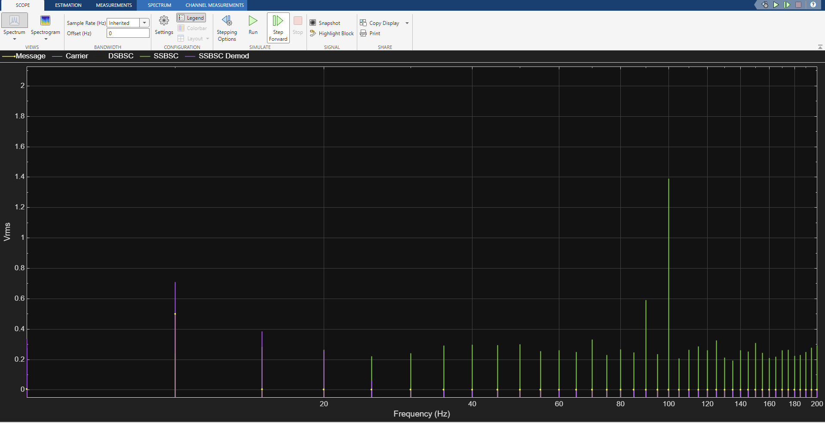
Figure 13 SSB-SC Spec
DVB-SC with noise
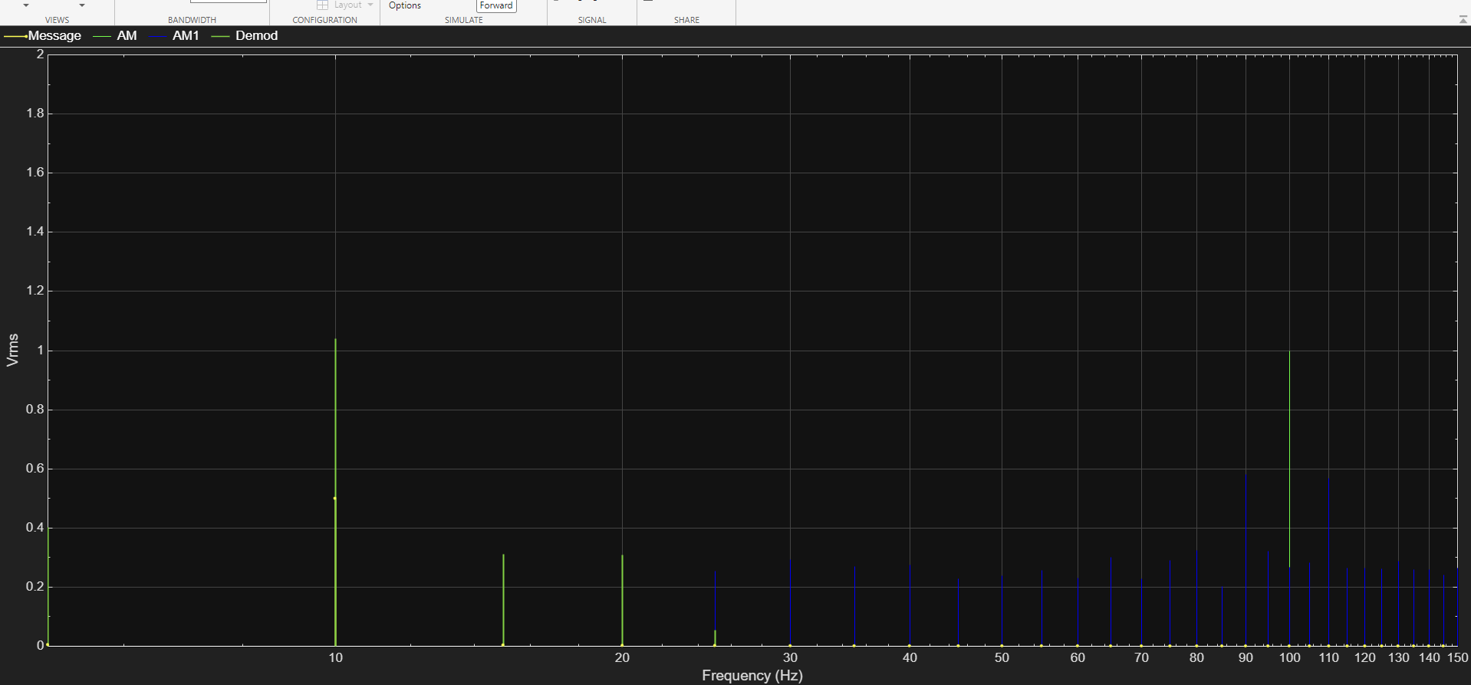
Figure 14DVB- SC Spec
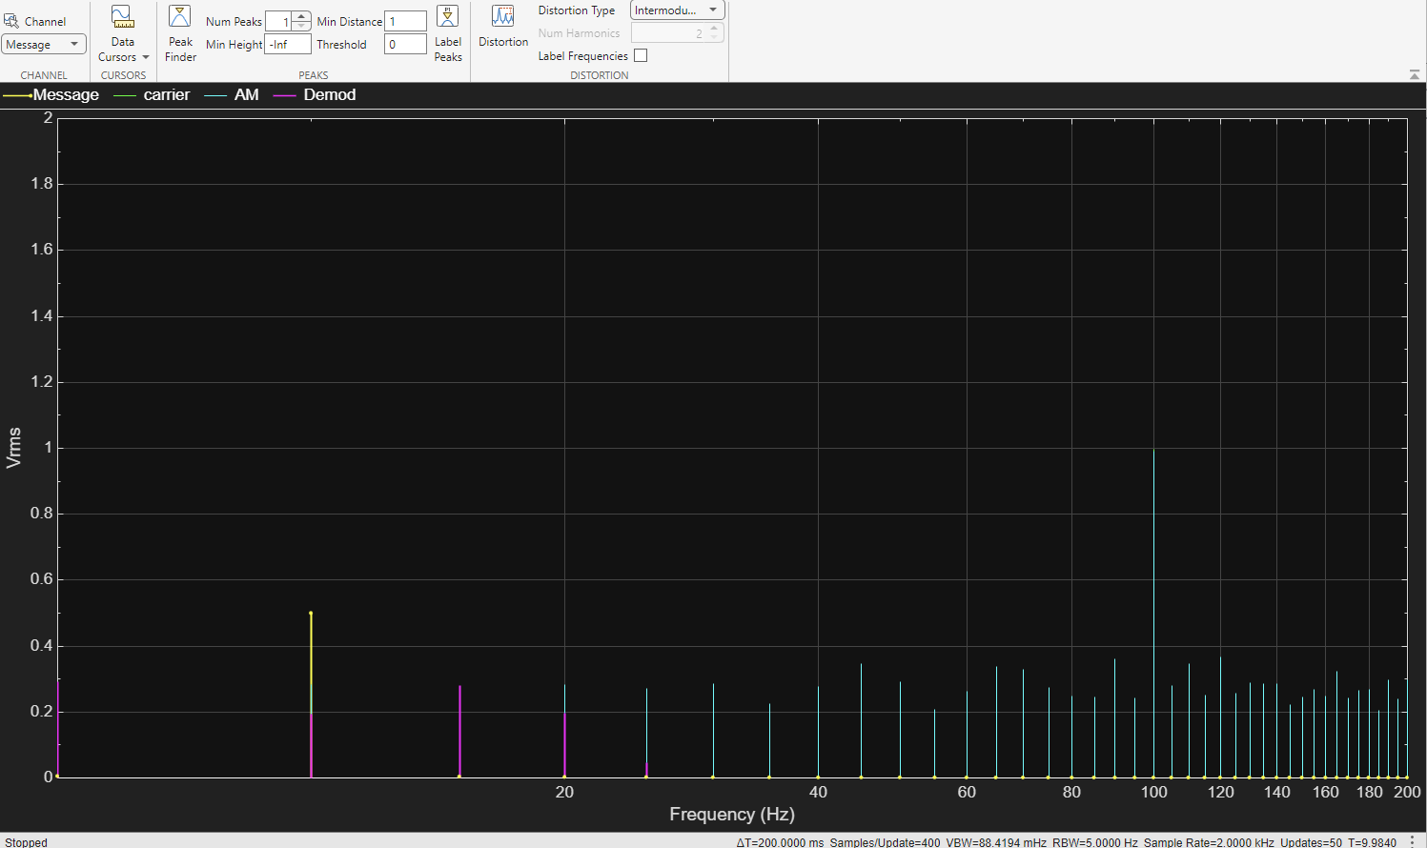
Figure 15 AM SPEC AN

Spectrum analysis
AM: the spectrum shows the carrier frequency and two sidebands which increases the bandwidth usage.
SSB-SC: only one sideband is present which in turn saves bandwidth.
DSB-SC: Both sidebands are present without the carrier, this does reduce power consumption but in turn requires more bandwidth.

Power Efficiency
AM: probably the least power efficient of all the modulators in question. This is partly down to a large portion is used on the carrier.
SSB-SC: Easily the most power efficient due to the suppression of the carrier and one sideband.
DSB-SC: Somewhere between SSB-SC and AM in terms power efficiency as it does use carrier suppression but it does transmit both sidebands.

Noise Tolerance
AM: Very susceptible to noise especially in the carrier and both the sidebands.
SSB-SC: Much better noise tolerance than AM mostly due to the reduced bandwidth but will still be affected under strong noise conditions.
DSB-SC: Again, very much in between the other two modulation techniques, fairly good noise tolerance as the noise affects both sidebands but the absence of a carrier improves the overall resistance.

Bandwidth Efficiency
AM: Requires twice the bandwidth of the modulating signal.
SSB-SC: Requires the same bandwidth as the modulating signal, which makes SSB-SC the most bandwidth efficient.
DSB-SC: Requires twice the bandwidth of the modulating signal, similar to the AM but without the carrier.

Overall Assessment
AM: Is best suited for applications where simplicity is more critical than efficiency.
SSB-SC: The most efficient method for scenarios requiring higher bandwidth and greater power efficiency.
DSB-SC: Very much a middle ground between SSB-SC and AM. But still has many use cases.
After going through all the modulation schemes and looking at multiple factors, it would appear that SSB-SC comes out as the most overall efficient technique in terms of bandwidth and power. However, can be quite complex so DSB-SC is a perfectly viable alternative for less strict applications. That being said AM still remains a practical choice for older systems and ones with a simple implementation.

Conclusion
This report as covered three key modulation techniques AM, SSB-SC and DSB-SC. This was done through simulations on Simulink and theoretical analysis. The findings were as follows:

Amplitude Modulation
While being the simplest of the three to implement and create on Simulink it has large inefficiencies in power and bandwidth utilisation. It is also very susceptible to noise making it more useful for legacy systems such as radio broadcasting.

Single Sideband Suppressed Carrier
SSB-SC appears to be the most efficient of the three when it comes to bandwidth and power, this makes it the best choice for applications which require minimal resource usage. It is however one of the more complex to implement.

Double Sideband Suppressed Carrier
DSB-SC offers a balance between the other two techniques and 0ffers a viable alternative when the SSB-SC complexity can be restricting. It can also be useful if the AM inefficiencies aren’t suitable for the specific use case.

Future Work
Ideas for future work could be to test all the modulation techniques under varying SNRs or different noise types. This could help provide a deeper understanding of how all the techniques respond and help make more informed decision. Another possible line of testing could be to test the modulation schemes against digital alternatives such as QAM and PSK, this could be helpful to understand the trade offs between digital and analogue. Another good test could be to perform the test on hardware using an SDR as this would help to validate the findings in a real-world scenario. Finally, a good test would be to compare the modulation schemes against a specific modern application (satellite communication or 5G).

Bibliography
[1]
“Amplitude Modulation,” BYJUS, Oct. 07, 2019. https://byjus.com/jee/amplitude-modulation/
[2]
“What is Single sideband (SSB) modulation? definition, generation, advanatages, disadvantages and applications of Single sideband modulation,” Electronics Coach, Jul. 26, 2018. https://electronicscoach.com/single-sideband-modulation.html
[3]
Roshni Y, “What is Double Sideband Suppressed Carrier Modulation (DSB-SC)? Definition, generation, applications of DSB-SC - Electronics Coach,” Electronics Coach, Jul. 24, 2018. https://electronicscoach.com/double-sideband-suppressed-carrier-modulation.html#google_vignette
[4]
A. Sek and Brian, “The critical modulation frequency and its relationship to auditory filtering at low frequencies,” The Journal of the Acoustical Society of America, vol. 95, no. 5, pp. 2606–2615, May 1994, doi: https://doi.org/10.1121/1.409831.
[5]
A. Shaik, “Amplitude Modulation – Physics and Radio-Electronics,” www.physics-and-radio-electronics.com. https://www.physics-and-radio-electronics.com/blog/amplitude-modulation/
[6]
“About: Overmodulation,” dbpedia.org. https://dbpedia.org/page/Overmodulation

