BSc Civil Engineering – Cris Davies/1705493
UWTSD
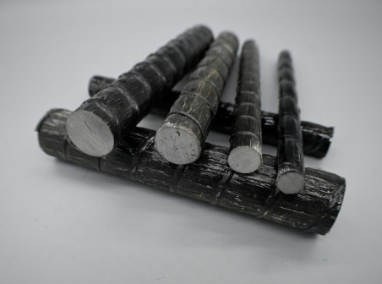
Is Basalt Fibre Reinforced Polymer (BFRP) a viable replacement for steel in reinforced concrete applications?
Independent Project – L6 BSc
06/05/2026

Author’s declaration
I declare that the work in this dissertation was carried out in accordance with the regulations of the University of Wales, Trinity Saint David. The work is original except where indicated by special references in the text and no part of the dissertation has been submitted for any other degree.

Any views expressed in the dissertation are those of the author and in no way represent those of the University of Wales, Trinity Saint David.

The dissertation has not been presented to any other University for examination either in the United Kingdom or overseas.

I hereby give permission for my work, if accepted, to be available for photocopying and inter-library loan, and for the title and summary to be made available to outside organisations.

Signed ……………………………C. Davies…………………………………………………
Date ……………………………06/05/2026……………………………………………….

Acknowledgements
I would like to thank my supervisor Allan Nantel who has been instrumental in motivating my work and for providing invaluable knowledge and experience in the field of material science and Civil Engineering. Also, a thank you to the other supervisors who have provided their thoughts and support with this project, and to all staff past and present at UWTSD for a fantastic experience that I will not forget. I started this course in 2017, and I will miss it greatly.

A special thank you to Sergio Garate for the use of ‘his’ lab, for his knowledge and his humour that kept me going during my lab work.

Finally, a huge thank you to Mam, Glyn, Steph and the girls for putting up with me during this period and giving me the support and motivation to continue with my education through an extremely difficult period over the last few years.

Abstract
This dissertation investigates the mechanical performance of Basalt Fibre Reinforced Polymer (BFRP) reinforcement in comparison with conventional steel reinforcement in concrete beams. The study aims to evaluate differences in load–deflection behaviour, ultimate load capacity, and failure mechanisms, while also considering implications for durability and potential structural applications. The primary objective was to determine whether BFRP could provide a viable alternative to steel reinforcement in structural concrete, particularly in environments where corrosion resistance is critical.

To achieve this, an experimental laboratory programme was undertaken using small-scale reinforced concrete beams (500 mm × 100 mm × 100 mm). A total of fifteen beams were cast, comprising plain concrete control specimens, steel-reinforced beams (10 mm and 12 mm), and BFRP-reinforced beams (8 mm, 10 mm, and 12 mm). All specimens were produced using a C35 concrete mix designed in accordance with the BRE method. Following a 28-day curing period, beams were tested under three-point bending to assess structural performance. Load and time data were recorded and used to generate comparative load–response behaviour.

The results indicate clear behavioural differences between reinforcement types. Steel-reinforced beams demonstrated ductile behaviour, characterised by yielding prior to failure and gradual load reduction. In contrast, BFRP-reinforced beams exhibited a predominantly linear elastic response up to failure, followed by a sudden and brittle rupture. Despite this, BFRP beams achieved comparable, and in some cases higher, ultimate load capacities than steel-reinforced specimens. Plain concrete beams showed significantly lower load capacity and brittle failure, confirming the structural contribution of reinforcement.

These findings align with existing literature, which highlights the high tensile strength but limited ductility of fibre-reinforced polymer materials. The study confirms that while BFRP offers advantages in corrosion resistance and strength-to-weight ratio, its brittle failure mode presents design challenges that must be carefully considered.

Limitations of the research include the small specimen size, absence of direct deflection measurements, and controlled laboratory conditions that may not fully represent real-world behaviour. Further research is recommended to investigate long-term durability, full-scale structural performance, and hybrid reinforcement strategies combining steel and BFRP.

Overall, the study concludes that BFRP has strong potential for use in specific structural applications, particularly in aggressive environments, but should not be considered a direct replacement for steel without appropriate design adaptation.

Table of Contents
Author’s declaration 1
Acknowledgements 1
Abstract 2
Figures & Tables 6
1. Introduction & Background 7
1.1 Context and Overview 7
1.2 Problem Statement 7
1.3 Research rationale 8
1.4 Scope and Limitations 8
1.5 Aim and Objectives 8
1.6 Background 9
1.6.1 Reinforced concrete Fundamentals 9
1.6.2 Limitations of steel reinforcement 9
1.6.3 Fibre reinforced polymer (BFRP) 9
1.6.4 Basalt Fibre Reinforced Polymer (BFRP) 10
1.6.5 Comparison between Steel and BFRP 10
2 Literature Review 11
2.1 Reinforced concrete durability and corrosion challenges 11
2.2 Fibre reinforced polymers in concrete structures 11
2.3 Basalt fibre reinforced Polymer (BFRP): Material, properties, and applications 12
2.4 Mechanical Performance: Tensile, Bond and flexural comparisons 13
2.4.1 Tensile behaviours of reinforcing bars 13
2.4.2 Bond behaviour between bar and concrete 13
2.4.3 Flexural and structural behaviour of beams 13
2.4.4 Durability and environmental performance 14
2.4.5 Methodological approaches and best practices 14
2.4.6 Summary and research gap 15
3 Methodology 16
3.1 Experimental Philosophy and Design Framework 16
3.2 BFRP procurement 16
3.3 Laboratory Health and Safety 17
3.4 Materials Characterisation 17
3.4.1 Cement 17
3.4.2 Aggregates and Sieve Analysis 17
3.5 Reinforcement Materials 18
3.5.1 BFRP Material Properties 18
3.5.2 Steel material Properties 19
3.5.3 Material comparison 20
3.6 Concrete Mix Design and Batching 20
3.6.1 Mix Proportions (per mix) 20
3.6.2 Selection of Concrete Strength and specimen geometry 21
3.7 Mixing Procedure 21
3.7.1 Weighing and batching of raw materials 21
3.7.2 Mixing of concrete 22
3.7.3 Batch verification & error 23
3.7.4 Slump Testing 23
3.7.5 Beam Casting and Reinforcement Placement 24
3.7.6 Demoulding and Curing Regime 25
3.7.8 Cube Compression Testing 26
3.7.9 Three-Point Bending Test Procedure 26
3.8 Data Interpretation Framework 27
4. Results 28
4.1 Introduction 28
4.2 Concrete Compressive strength results 28
4.3 Beam flexural test results 28
4.3.1 Plain concrete beams (No reinforcement) 28
4.3.2 Steel reinforced concrete beams (SR-RC) 29
SR-RC 10mm 29
SR-RC 12mm 29
4.3.3 BFRP Reinforced concrete beams (BFRP-RC) 29
BFRP reinforcement 8mm 29
BFRP reinforcement 10mm 29
BFRP reinforcement 12mm 29
5. Analysis & Discussion 30
5.1 Introduction 30
5.2 Compressive strength of concrete 30
5.3 Flexural behaviour of concrete beams 30
5.3.1 Plain concrete beams 30
5.3.2 Steel Reinforced Concrete beams 31
5.3.3 BFRP Reinforced Concrete Beams 33
5.3.4 Failure Modes and Structural Behaviour 35
5.4 Comparative Performance of Steel and BFRP Reinforcement 38
5.5 Results conclusion 40
5.6 Sustainability and service life implications 40
6. Conclusion & Further work 41
6.1 Overview of Research & Objectives 41
6.2 Summary of Experimental Findings 41
6.3 Interpretation in the context of literature 42
6.4 Final Evaluation: Viability of BFRP as a Reinforcement Material 42
6.5 Practical Implications for Engineering practice 43
6.6 Limitations of the study 44
6.7 Recommendations for further Research 44
6.8 Concluding Statement 44
6.9 Achievement of Aims and Objectives 45
7. References 46
8. Appendices 49
Bastech UK – BBA Certificate 49
Sieve Log Graph 59

Figures & Tables
All figures & tables by author:

Table 1 - Mechanical properties of Steel and BFRP 10
Table 2 - Specimen casting & testing dates 16
Table 3 - Sieve analysis data 18
Table 4 - Specimen list 18
Table 5 - Manufacturers mechanical properties of BFRP & Steel reinforcement 20
Table 6 - Cube compressive strength results 28
Table 7 - Plain concrete beam results 28
Table 8 - Steel reinforced (10mm) beam results 29
Table 9 - Steel reinforced (12mm) Beam results 29
Table 10 - BFRP (8mm) Beam results 29
Table 11 - BFRP (10mm) Beam results 29
Table 12 - BFRP (12mm) Beam results 29

Figure 1- Sieve analysis equipment 17
Figure 2 - Cross section of BFRP reinforcement 19
Figure 3 - Cross section of Steel reinforcement 19
Figure 4 - Portland cement batching on calibrated scales (Author, 2026) 22
Figure 5 – Aggregates (Author, 2026) 22
Figure 6 - Water being added to mix 22
Figure 7 - Aggregates being added to mix 22
Figure 8 - Slump testing 23
Figure 9 - Former for bar depth 24
Figure 10 - Beam casting 24
Figure 11 - Bar depth being measured 25
Figure 12 - Beams and cubes in curing tank 25
Figure 13 - Matest compression and three-point bending equipment 26
Figure 14 - Plain concrete average 31
Figure 15 - SR-RC 10mm 32
Figure 16 - SR-RC 12mm 32
Figure 17 - BFRP 8mm 33
Figure 18 - BFRP 10mm 34
Figure 19 - BFRP 12mm 34
Figure 20 - Thermal imaging of 12mm SR-RC beam 35
Figure 21 - Failure mode of SR-RC beam 35
Figure 22 - Failure mode of BFRP beam 36
Figure 23 – Delamination on failure of BFRP 12mm beam 37
Figure 24 – Comparison of average ultimate loads 39

Introduction & Background

1.1 Context and Overview
Reinforced concrete (RC) underpins much of the world’s infrastructure because it combines concrete’s compressive capacity with the tensile strength of reinforcement embedded within it (Neville, 2011; Mehta and Monteiro, 2014). Yet the long-term performance of RC is increasingly governed by durability rather than initial strength. Corrosion of steel reinforcement triggered by carbonation or chloride ingress remains the dominant deterioration mechanism in many UK and European environments, impacting serviceability, safety, and maintenance budgets (Alexander and Beushausen, 2019). Against the backdrop of national Net Zero objectives, the UK’s professional bodies have emphasised lower-carbon, longer-life materials and systems to reduce whole-life impacts of infrastructure (ICE, 2020; UKGBC, 2023).

One route is to replace conventional steel with fibre-reinforced polymer (FRP) reinforcement. FRPs are non-corrosive, light, strong, and recent research and standards development have moved them closer to mainstream structural use. Within this family, Basalt FRP (BFRP) has gained attention due to its natural availability, favourable strength-to-weight ratio and promising durability (Mohamed et al., 2021; Shamass and Cashell, 2020). However, questions remain about mechanical performance relative to steel, particularly stiffness, cracking behaviour and bond under standard RC configurations. This study addresses that need with a controlled, short-term mechanical comparison of steel- and BFRP-reinforced concrete beams.

1.2 Problem Statement
The corrosion of steel reinforcement leads to significant loss of serviceability and load-carrying capacity in RC structures. When steel corrodes, expansive rust products cause cracking and spalling of the concrete cover, reducing bond and stiffness and compromising material safety. Global maintenance costs arising from such deterioration is estimated at hundreds of billions of pounds annually (Alexander and Beushausen, 2019). Although protective coatings, increased cover thicknesses, and the use of stainless or galvanised steels can slow corrosion, these measures increase initial costs and rarely provide a permanent solution (Ožbolt et al., 2020).
FRPs provide an opportunity to eliminate corrosion altogether. However, substituting steel with FRP introduces new design considerations. FRP bars, including BFRP, exhibit linear-elastic behaviour up to brittle rupture, with no yielding or plastic redistribution. Their lower elastic modulus (typically 40–50 GPa compared with 200 GPa for steel) can lead to increased deflection and crack widths under service loads (Wydra et al., 2024). Moreover, bond strength depends heavily on surface treatment and resin adhesion rather than on mechanical ribbing. These factors have created uncertainty among engineers and policymakers regarding FRP’s suitability for mainstream structural applications. A rigorous experimental comparison between BFRP and steel-reinforced concrete, using identical mix designs and testing protocols, is therefore required to establish realistic mechanical performance expectations.

1.3 Research rationale
The UK Government’s 2050 Net Zero target and similar global commitments highlight the need for low-maintenance, long-life infrastructure materials (ICE, 2020). Steel corrosion not only affects safety but also drives repeated repair cycles, adding to embodied carbon and operational costs. BFRP’s corrosion immunity and favourable strength-to weight ratio could therefore contribute to more durable and sustainable structures.
While several studies have investigated FRP performance, many have focused on glass or carbon fibre systems. Comparative studies directly assessing BFRP against steel remain limited, particularly under identical experimental conditions. Additionally, much of the available research originates outside Europe, where material grades, environmental exposure, and testing protocols differ. This dissertation addresses these gaps by conducting a controlled, side-by-side experimental investigation suitable for UK practice. The study’s outcomes will provide engineers and policymakers with reliable data on BFRP’s structural viability and inform potential updates to national design standards.

1.4 Scope and Limitations
The study focuses on the short-term mechanical properties of BFRP- and steel-reinforced concrete beams tested under laboratory conditions. It does not address long-term environmental ageing, fatigue loading, or full-scale field performance. The experimental programme will use a single concrete mix design (C35, w/c ≈ 0.5) and reinforcement diameters typical of small structural elements (12 mm). Results will therefore reflect comparative behaviour rather than absolute design capacities. Nonetheless, the findings will provide a valuable basis for future research into durability modelling and life-cycle assessment of FRP-reinforced systems. Standards followed include BS EN 12390 for concrete properties and ISO 10406-1:2025 guidance for FRP testing, alongside laboratory standard operating procedures (SOPs) for three-point bending.

1.5 Aim and Objectives
Aim:
To evaluate and compare the mechanical performance of Basalt Fibre Reinforced Polymer (BFRP) and conventional steel reinforcement in concrete through laboratory testing.
The following objectives support this aim:
- To review existing literature on the mechanical and durability properties of both Steel and BFRP-reinforced concrete.
- To critically analyse, through laboratory testing, the load deflection behaviour, resistance, failure characteristics, and ultimate capacities of both Steel and BFRP, to recognised standards (BS EN 12390, BS EN ISO 15630-1).
- To scrutinise and interpret test results in relation to sustainability and service-life performance of the reinforcing materials, identifying implications and possible applications for structural design inclusion in end product.

1.6 Background

1.6.1 Reinforced concrete Fundamentals
Reinforced concrete (RC) is a composite material in which concrete provides compressive strength while embedded steel reinforcement carries tensile forces. The bond between the two materials enables strain compatibility and composite action under load (Neville, 2011; Mehta and Monteiro, 2014). Since its widespread adoption in the late nineteenth century, RC has become the principal construction material for buildings, bridges, tunnels and retaining structures because of its versatility and cost efficiency.

However, the material’s long-term performance is governed by durability rather than ultimate strength. Factors such as carbonation, chloride ingress, freeze–thaw cycles and alkali–silica reaction contribute to deterioration (Alexander and Beushausen, 2019). Among these, corrosion of steel reinforcement remains the most critical. Once corrosion begins, the resulting volume expansion of rust exerts internal pressure on the surrounding concrete, causing cracking, delamination, and loss of bond. This progressive degradation shortens service life and increases maintenance costs.

1.6.2 Limitations of steel reinforcement
Steel’s key advantages, ductility, yield plateau, and predictable design rules are offset by its susceptibility to corrosion in aggressive environments. Even with quality concrete and cover, carbonation fronts or chloride ingress can initiate corrosion, producing expansive oxides that crack and spall the cover, reduce bond and stiffness, leading to needing repair. Service-life modelling highlights the sensitivity of corrosion initiation and propagation to exposure and material parameters, reinforcing the case for non-corroding reinforcement in severe environments (Alexander and Beushausen, 2019). Policy drivers in the UK further encourage solutions that extend service life and cut whole-life carbon (ICE, 2020; UKGBC, 2023).

1.6.3 Fibre reinforced polymer (BFRP)
Fibre-reinforced polymers are composites consisting of high-strength fibres (glass, carbon, aramid, or basalt) embedded within a polymeric matrix such as epoxy or vinyl ester. FRPs are lightweight, non-magnetic and corrosion-resistant, with tensile strengths often exceeding 1000 MPa (Bertolini, 2008; Mohamed et al., 2021). Their use in civil engineering began in the 1980s for externally bonded strengthening and has expanded to internal reinforcement in new construction. Despite their corrosion immunity, FRPs differ markedly from steel. They are linearly elastic up to brittle rupture and possess lower moduli typically 30–60 GPa compared with about 200 GPa for steel resulting in greater deflection under service loads (ACI 440, 2015). Compressive and shear capacities are also lower because polymer matrices deform or buckle under compression (Zhang et al., 2025). Bond behaviour depends on surface treatment and resin adhesion rather than mechanical ribs. Consequently, FRP design relies on strain limits rather than stress redistribution, demanding a shift in design philosophy from ductility to strength and serviceability control.

1.6.4 Basalt Fibre Reinforced Polymer (BFRP)
Basalt fibre reinforced polymer is a more recent addition to the FRP family. Basalt fibres are produced by melting naturally occurring volcanic rock at approximately 1450 °C and drawing the melt into continuous filaments. These are coated with resin to form bars or sheets. Because basalt is abundant and requires no additives, BFRP offers favourable economics and low embodied carbon (Inman et al., 2017). Mechanically, BFRP bars exhibit tensile strengths of 800-1200 MPa and moduli of 40-50 GPa, with density around 2600 kg/m³ (Mohamed et al., 2021). It possess excellent corrosion resistance, high thermal stability up to 200 °C, and good compatibility with cementitious materials. However, like other FRPs, it lacks ductility and has relatively low compressive strength (20–25 % of tensile capacity). Bond performance depends on surface textures and coated or ribbed bars provide higher adhesion and improved load transfer (Al-Hamrani et al., 2023). Research has also shown that BFRP retains most of its strength after exposure to alkaline or saline environments, demonstrating its suitability for marine and water-retaining structures (Zhang et al., 2025). Environmental assessments further highlight BFRP’s advantages. Life-cycle analyses indicate that substituting steel with BFRP can reduce embodied carbon by 20-30 % when maintenance and corrosion repair are considered (Inman et al., 2017). These attributes align with sustainable-construction priorities under the UK Government’s Net Zero 2050 strategy (ICE, 2020).

1.6.5 Comparison between Steel and BFRP
Property | Steel | BFRP
Density | ~7,850kg/m3 | ~2,600kg/m3
Tensile Strength | 500-600 MPa | 800-1,200 MPa
Elastic Modulus | ~200 GPa | ~45 GPa
Corrosion Resistance | Poor | Excellent
Table 1 - Mechanical properties of Steel and BFRP
The key contrasts between steel and BFRP reinforcement can be summarised across mechanical, durability and sustainability dimensions.
• Mechanical properties: Steel exhibits yielding and ductility, allowing redistribution of stresses; BFRP behaves linearly up to brittle failure. Although BFRP’s tensile strength is higher, its modulus is approximately one-quarter that of steel, necessitating larger reinforcement ratios for similar stiffness (Wydra et al., 2024).
• Durability: Steel corrodes in aggressive environments, while BFRP is immune to electrochemical attack. Bond degradation in BFRP occurs mainly through resin softening or surface damage rather than chemical corrosion (Al-Hamrani et al., 2023).
• Thermal and fire behaviour: Steel retains strength at high temperatures, whereas BFRP loses stiffness beyond 250 °C because of resin softening (Wydra et al., 2024).
• Sustainability: BFRP production emits less CO₂ and consumes less energy than steel manufacture (Inman et al., 2017).
These comparisons reveal clear trade-offs: BFRP eliminates corrosion and reduces environmental impact but sacrifices stiffness and ductility. The challenge lies in quantifying these differences under controlled conditions to inform appropriate design factors.

Literature Review

2.1 Reinforced concrete durability and corrosion challenges
Reinforced concrete (RC) remains the world’s most widely used construction material because it couples the compressive strength of concrete with the tensile capacity of embedded steel reinforcement (Neville, 2011; Mehta and Monteiro, 2014). Despite its effectiveness, the principal durability limitation of RC is the corrosion of steel bars, which progressively undermines both serviceability and structural safety. Two mechanisms dominate: carbonation and chloride ingress. Carbonation occurs when atmospheric carbon dioxide diffuses through the pore network of concrete and reacts with calcium hydroxide to form calcium carbonate, lowering the pH from around 13 to below 9. Once alkalinity falls, the passive ferric-oxide layer protecting the steel becomes unstable, permitting corrosion initiation (BRE, 2001). Chloride attack, common in marine and de-icing environments, depassivates steel locally even when the pore solution remains alkaline (Shi et al., 2012). The increase in volume of corrosion by-products generates tensile stresses in the surrounding concrete, leading to cracking, delamination, and spalling. Loss of bond further accelerates deterioration and shortens design life. The global cost of corrosion repair runs into tens of billions annually, accounting for a large proportion of infrastructure maintenance budgets (Alexander and Beushausen, 2019). Traditional protection strategies such as increased cover depth, surface coatings, or cathodic protection extend service life but do not eradicate the electrochemical process. Consequently, researchers have investigated alternative non-metallic reinforcement systems capable of providing equivalent tensile performance without susceptibility to corrosion. This pursuit has led to extensive research into fibre-reinforced polymers (FRPs).

2.2 Fibre reinforced polymers in concrete structures
Fibre-reinforced polymers are composite materials formed from high-strength fibres, glass, carbon, aramid, or basalt embedded in a polymeric matrix, typically epoxy or vinyl ester. They exhibit very high tensile strength-to-weight ratios, electromagnetic neutrality, and total immunity to electrochemical corrosion (Bertolini, 2008; Mohamed et al., 2021). However, compared with conventional steel, FRPs possess lower elastic moduli (30–60 GPa versus steel ~200 GPa), limited compressive strength, and fail in a linear-elastic manner without ductility. The relatively brittle nature of FRPs demands careful consideration of serviceability limits such as crack width and deflection.

Nassif et al. (2024) conducted a global review of FRP durability, identifying environmental degradation of the fibre matrix interface as a key challenge. Moisture ingress, ultraviolet exposure, and thermal cycling can weaken interfacial bonding, ultimately reducing tensile capacity. Nevertheless, FRPs have gained increasing adoption in bridge decks, retaining walls, and coastal defences where corrosion resistance outweighs their stiffness limitations. Design guidance is now formalised through documents such as ACI 440 (2015) encouraging use under defined service environments but recognising the need for long-term field data.

2.3 Basalt fibre reinforced Polymer (BFRP): Material, properties, and applications
Basalt fibre is manufactured by melting naturally occurring volcanic rock at about 1450 °C and drawing the melt into continuous filaments. These fibres are impregnated with resin to form bars, sheets, or tendons. Basalt is abundant, inert, and non-toxic, giving BFRP a strong sustainability profile. Its production consumes less energy than carbon or aramid fibre, and no additives are required during melting (Inman et al. 2017). Mechanically, BFRP exhibits tensile strengths between 800 and 1200 MPa and an elastic modulus of 40-50 GPa, with a density of approximately 2600 kg/m³ (Mohamed et al., 2021). Although its tensile strength exceeds that of mild steel, the modulus is roughly one quarter, producing higher deflections for equivalent loads. FRP materials also have relatively poor compressive capacity, typically 15–25 % of their tensile strength because the resin matrix buckles under compression. This limitation requires higher reinforcement ratios or hybrid designs in flexural members.

The chemical composition of basalt fibres governs their mechanical, thermal, and durability properties. Basalt fibres are primarily a silicate glass system rich in silicon dioxide (SiO₂), generally comprising 51-59 wt % of the total mass. This high silica content provides chemical inertness and contributes to fibre rigidity. Aluminium oxide (Al₂O₃) typically accounts for 14-18 wt %, improving viscosity control and thermal stability, while iron oxides (Fe₂O₃ + FeO) range from 9-14 wt %, influencing both colour and heat resistance (Jia et al., 2023; Don et al., 2024). Minor constituents include magnesium oxide (MgO) ≈ 4 – 6 wt %, calcium oxide (CaO) ≈ 5-9 wt %, and small amounts of sodium (Na₂O), potassium (K₂O), and titanium dioxide (TiO₂). These alkali and alkaline-earth oxides act as network modifiers, slightly opening the silicate structure and influencing moisture uptake and chemical durability (Jia et al., 2023).

Because basalt deposits vary regionally, oxide ratios differ between fibre producers. Experimental work by Don et al. (2024) and Li et al. (2023) demonstrated that fibres drawn from basalts with higher SiO₂ + Al₂O₃ contents (> 70 wt %) exhibited superior tensile strength and reduced degradation in alkaline pore solution. In contrast, elevated alkali oxides or CaO levels correlated with marginally higher mass loss after prolonged immersion. Such variability highlights the importance of compositional certification when specifying BFRP for structural use.

The predominance of silica and alumina makes basalt fibres chemically compatible with cementitious materials, limiting interfacial reactions and contributing to long-term durability of BFRP bars embedded in concrete (Zhang et al., 2025). In addition, iron-bearing oxides improve resistance to softening at elevated temperature, an advantage over E-glass FRP (Mohamed et al., 2021). Overall, the chemical composition underpins BFRP’s combination of high tensile strength (800-1200 MPa), moderate modulus (40-50 GPa), and excellent corrosion resistance, positioning it as a sustainable alternative reinforcement material.

Inman et al., (2017) compared concrete beams reinforced with BFRP and with steel, reporting similar ultimate strengths when BFRP reinforcement ratios were increased, though deflections were greater and post-cracking stiffness lower. A subsequent study by Hassan et al. (2021) confirmed that hybrid BFRP–steel reinforcement improved crack control and delayed yielding while providing corrosion protection. The potential of BFRP in coastal and water-retaining structures is therefore considerable, particularly where maintenance access is limited. However, researchers continue to investigate its long-term performance and variability between manufacturers, which remain barriers to full-scale structural adoption.

2.4 Mechanical Performance: Tensile, Bond and flexural comparisons

2.4.1 Tensile behaviours of reinforcing bars
Steel reinforcement demonstrates a clear yield plateau and ductile strain hardening that allows redistribution of internal stresses after cracking. BFRP bars, by contrast, exhibit a linear-elastic stress–strain relationship until sudden rupture, with no plastic deformation. Typical ultimate strains range between 1.8 % and 2.2 %, compared with ~0.25 % for steel (Wydra et al., 2024). This characteristic provides high tensile capacity but eliminates warning before failure, making design control of deflection and cracking essential. Temperature sensitivity is another factor. Wydra et al. (2024) observed that BFRP strength declines markedly beyond 250 °C as resin softens, whereas steel retains most of its strength until ~500 °C. Consequently, FRP-reinforced structures require explicit fire protection measures. El Refai et al. (2014) outlined the correct testing methodology per ASTM D7205, emphasising the need for end-tabbing and precise strain measurement to avoid premature grip failures.

2.4.2 Bond behaviour between bar and concrete
Effective stress transfer between reinforcement and concrete is critical for composite action. Steel achieves this through mechanical interlock of deformations and chemical adhesion, whereas FRPs depend primarily on surface treatment and resin–cement paste friction. Bao et al. (2025) demonstrated that sand-coated BFRP bars can match or exceed the bond strength of deformed steel under monotonic loading but show slightly higher slip under cyclic loads. Al-Hamrani et al. (2023) found that ribbed BFRP bars maintained over 80 % of their initial bond strength after immersion in saline and alkaline environments, outperforming smooth bars. Bond strength is therefore greatly dependent on surface geometry, resin type, and bar length. Kazemi et al. (2023) noted that environmental conditioning primarily affects the outer resin layer rather than the internal fibre structure, implying that proper surface design can offset durability concerns.

2.4.3 Flexural and structural behaviour of beams
Flexural testing provides the most direct means of comparing industry wide structural performance. Belay et al. (2024) tested beams reinforced with steel, glass, and basalt-FRP and observed that BFRP beams displayed greater mid-span deflection and wider cracks but similar ultimate loads when reinforcement ratios were adjusted. Hassan et al. (2021) reported comparable ultimate capacities between steel and BFRP beams yet noted that failure in BFRP beams was brittle once the bar reached rupture strain. Elbawab et al. (2025) identified a linear relationship between reinforcement modulus and service deflection, reinforcing the need for stiffness correction factors in BFRP design. Overall, BFRP-reinforced concrete can achieve adequate ultimate strength and crack control provided design accommodates its lower modulus and brittle nature.

2.4.4 Durability and environmental performance
Durability is the defining advantage of FRP reinforcement. Unlike steel, FRPs are electrochemically inert and therefore immune to corrosion caused by carbonation or chloride ingress. Nevertheless, long-term exposure to moisture, alkalinity and elevated temperature can weaken the fibre-matrix interface, leading to gradual reductions in strength and stiffness. Zhang et al. (2025) exposed FRP bars to saline and alkaline solutions for one year and recorded a modest decrease in tensile capacity of less than 10 %, confirming good resistance when high-quality resins are used. Heshmat et al. (2025) similarly reported minor bond deterioration of BFRP bars after immersion in aggressive solutions, while the internal fibres remained unaffected. These findings suggest that the durability of BFRP is governed more by resin stability and surface treatment than by the fibres themselves.
Basalt fibres are formed from a single natural mineral source and contain no additives that could leach into the environment. Consequently, BFRP has a smaller ecological footprint than either glass or carbon-based FRPs (Inman et al., 2017). Life-cycle assessments demonstrate that replacing steel reinforcement with BFRP can reduce embodied carbon by approximately 20-30 % when full maintenance cycles are considered. A comparative assessment by ResearchGate (2023) of FRP versus steel reinforced beams found that FRP alternatives achieved lower global-warming potential and energy demand indices, despite higher material costs per kilogram. When combined with reduced corrosion-related maintenance, BFRP therefore represents a credible option for sustainable construction, particularly in marine or water retaining environments where durability demands are high.

2.4.5 Methodological approaches and best practices
Laboratory evaluation of BFRP and steel reinforcement follows international and European testing standards. Tensile strength of FRP bars is measured in accordance with ASTM D7205/D7205M and BS EN ISO 10406-1 (2025), which specify gauge length, strain measurement and tabbed end anchorage. Steel bars are tested to BS EN ISO 15630-1. Concrete compressive and splitting-tensile strengths are determined following BS EN 12390-3 and -6. Bond behaviour is typically assessed using pull-out tests based on ASTM D7913, where embedment length ranges from 5 to 10 times the bar diameter.

Flexural beam testing remains the most common method for comparing global industry structural performance. Most researchers, including Belay et al. (2024) and Hassan et al. (2021), adopt four-point bending with spans of 1.6–1.8 m, measuring load, mid-span deflection and surface strain through linear variable displacement transducers (LVDTs) and foil strain gauges. Recorded data include cracking load, service deflection, and ultimate capacity. Common shortcomings in previous work include inconsistent specimen geometry, variable concrete mixes, and differing reinforcement ratios between steel and BFRP samples. These inconsistencies complicate direct comparison of results. The methodology proposed in the present study addresses these gaps by employing a single mix design (C35 concrete, w/c ≈ 0.5), identical beam geometry (100×100×500mm) and equal reinforcement ratios for both steel and BFRP. This approach isolates reinforcement type as the single variable, providing a fair and transparent comparison of mechanical performance.

2.4.6 Summary and research gap
Existing literature demonstrates growing interest in replacing steel with non-corrosive FRPs for enhanced durability and sustainability. Yet despite promising mechanical and environmental performance, BFRP remains under-represented in design codes and structural applications. Few studies directly compare BFRP and steel reinforcement within identical concrete mixes and geometries. The absence of consistent experimental data limits engineers’ ability to calibrate design guidelines and predict service life performance.

This research therefore aims to fill that gap through a controlled laboratory testing programme comparing the mechanical behaviour of steel and BFRP reinforced concrete beams. The results will contribute to an improved understanding of stiffness, cracking, and strength differences between the two reinforcement types, supporting the potential inclusion of BFRP in future UK design standards.

This dissertation directly addresses these shortcomings by conducting controlled mechanical tests on concrete beams reinforced with steel and with BFRP under identical conditions. The results will clarify stiffness, strength, and serviceability trade-offs, contributing to the wider understanding of BFRP’s structural potential within the framework of modern sustainable design.

Methodology

3.1 Experimental Philosophy and Design Framework
The experimental programme was developed to investigate the short-term flexural behaviour of reinforced concrete beams containing conventional steel reinforcement and basalt fibre reinforced polymer (BFRP) reinforcement. The primary objective was to isolate the influence of reinforcement material and bar diameter on structural response while maintaining control over all other variables. Concrete strength class, aggregate grading, water–cement ratio, specimen geometry, curing conditions and loading configuration were therefore kept constant throughout the investigation.

A laboratory based batching and casting approach was adopted in preference to ready mix supply. This ensured accurate proportioning of materials, reduced variability between batches and enabled consistent replication of specimens. This approach aligns with established experimental methodologies used in FRP-reinforced concrete beam research (Shamass and Cashell, 2020). The experimental design therefore allows meaningful comparison between steel-reinforced concrete (SR-RC) beams and BFRP-reinforced concrete (BFRP-RC) beams under identical structural conditions.

The laboratory work was carried out at the University of Wales Trinity St David’s (UWTSD), SA1 campus, Swansea, at the school of Engineering. Careful consideration was taken to ensure that there were no conflicts with the (28day) cure and demoulding dates. Below is a table outlining the dates of batching, casting and testing for the beams:

Specimen Casting Dates | Demoulding & Testing
BFRP beams & Plain Concrete (PC) beams – 12/11/25 | 10/12/25 (28 day)
Steel beams & sample cubes – 21/01/26 | 18/02/26 (28 day)
Table 2 - Specimen casting & testing dates

3.2 BFRP procurement
The BFRP reinforcement used in the study was procured from Bastech, a UK based supplier of basalt fibre reinforced polymer products. The bars were supplied in nominal diameters of 8mm, 10mm and 12mm and were accompanied by manufacturers documentation, including BBA certification and material test data. A site visit was undertaken, during which the production process was observed and discussed with technical staff. This provided insight into the manufacturing process and the quality control measures associated with the material.

The use of a commercially available, certified product ensures that the material properties adopted are representative of those used in practical construction applications.

3.3 Laboratory Health and Safety
All laboratory activities were undertaken in accordance with institutional safety procedures and relevant UK health and safety regulations. Personal protective equipment including safety boots, gloves, eye protection and dust masks was worn during batching and mixing operations.

Care was exercised when handling and cutting BFRP reinforcement. Unlike steel, BFRP bars consist of fibre bundles embedded within a polymer matrix and may release fine fibres during cutting. Cutting was therefore carried out using an abrasive disc under controlled conditions with appropriate respiratory protection.

During flexural testing, safety barriers were positioned around the loading frame. BFRP reinforcement exhibits linear elastic behaviour until brittle rupture and does not provide the ductile warning associated with steel yielding (Ortiz et al., 2023). Appropriate exclusion zones were therefore maintained during loading.

No ethical approval was required as the study involved materials testing only.

3.4 Materials Characterisation

3.4.1 Cement
Ordinary Portland cement conforming to BS EN 197-1 was used throughout.

3.4.2 Aggregates and Sieve Analysis
Fine and coarse aggregates complied with BS EN 12620. Prior to batching, sieve analysis was conducted in accordance with BS EN 933-1 to determine particle size distribution. The grading curve confirmed suitability for structural concrete and compatibility with the selected beam geometry.

A maximum aggregate size of 20 mm was selected. Given the relatively small beam cross-section (100 mm depth), this reduced the risk of compaction difficulties and ensured adequate bond interaction between reinforcement and surrounding concrete.
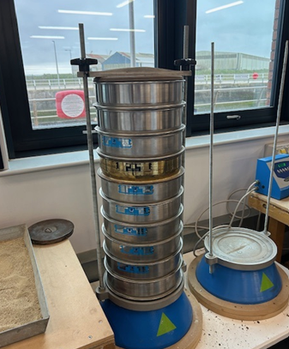
Figure 1- Sieve analysis equipment (Author, 2026)

Sieve Size (mm & µm) | Mass (g) | % On sieve | % Passing
3.35 | 3.71 | 0.00371 | 99.629
2.00 | 7.20 | 0.0072 | 98.909
1.18 | 15.05 | 0.01505 | 97.404
600µm | 103.80 | 0.1038 | 87.024
425µm | 445.72 | 0.44572 | 42.452
300µm | 239.85 | 0.23985 | 18.467
<300µm (Pan) | 184.47 | 0.18447 | 0.02
Table 3 - Sieve analysis data

3.5 Reinforcement Materials
Steel reinforcement (SR) bars of nominal diameters 10 mm and 12 mm were used as the control reinforcement. These bars exhibit elastic plastic behaviour with a yielding plateau prior to strain hardening.

Basalt fibre reinforced polymer (BFRP) reinforcement bars of nominal diameters 8 mm, 10 mm and 12 mm were selected as the alternative reinforcement material. BFRP reinforcement is characterised by linear elastic behaviour until tensile rupture, without yielding (Mohamed et al., 2021). This fundamental difference influences crack development, stiffness degradation, and failure mechanism, as discussed in chapter 2.

Testing procedures for FRP reinforcement generally align with ISO 10406-1, which defines methods for determining tensile properties of FRP bars.
Specimen ID | Reinforcement type | Bar diameter (mm) | Number of beams
Plain concrete | N/A | N/A | 3
BFRP 8 | Basalt FRP | 8 | 3
BFRP 10 | Basalt FRP | 10 | 3
BFRP 12 | Basalt FRP | 12 | 3
STEEL 10 | Steel | 10 | 3
STEEL 12 | Steel | 12 | 3
Table 4 - Specimen list

3.5.1 BFRP Material Properties
The mechanical properties of the BFRP reinforcement used in this study were obtained from the manufacturer’s BBA certified documentation. The bars exhibit characteristic tensile strengths in the range of approximately 1390–1430 MPa, with a modulus of elasticity between 53–56 GPa depending on bar diameter. While the tensile capacity is significantly higher than conventional steel, the lower modulus of elasticity results in reduced stiffness under loading.

Bond strength values of approximately 18-19 MPa were reported, along with flexural tensile strengths exceeding 1300 MPa. The material demonstrates linear elastic behaviour up to failure, with no yielding phase, and failure occurs in a brittle manner once the ultimate tensile strength is reached. These properties are consistent with typical fibre reinforced polymer behaviour and form a key basis for comparison within this study.

Figure 2 - Cross section of BFRP reinforcement (Bastech, 2024)

3.5.2 Steel material Properties
The steel reinforcement used in this study is assumed to conform to Grade B500B in accordance with BS 4449:2005+A3:2016. This grade is widely used in reinforced concrete construction within the UK and provides a characteristic yield strength of 500 MPa, with an ultimate tensile strength typically ranging between 550-650 MPa.

In contrast to BFRP, steel exhibits a significantly higher modulus of elasticity of approximately 200 GPa, resulting in greater stiffness and improved resistance to deflection under loading. Steel reinforcement also demonstrates ductile behaviour, characterised by a distinct yielding plateau prior to strain hardening. Due to limitations in available laboratory equipment, direct tensile testing of the steel reinforcement was not undertaken, and standardised material properties were adopted.
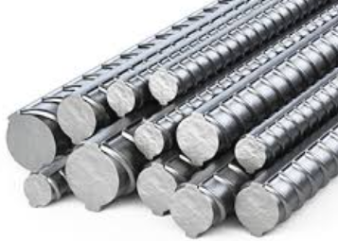
Figure 3 - Cross section of Steel reinforcement (Bastech, 2024)

3.5.3 Material comparison
A comparison of the material properties highlights the fundamental differences between BFRP and steel reinforcement. While BFRP provides significantly higher tensile strength and improved corrosion resistance, its lower stiffness and brittle failure behaviour contrast with the ductility and higher modulus of steel. These differences are expected to influence crack development, load deflection response, and overall structural performance, forming the basis for the comparative analysis undertaken in this study.

Property | BFRP – (8-12MM) | Steel (B500B)
Tensile Strength (MPa) | 1390-1430 | 500-650
Modulus of Elasticity (GPa) | 53-56 | 200
Bond Strength (MPa) | 18-19 | ~12-20*
Behaviour | Linear Elastic | Elastic-Plastic
Yielding | No | Yes
Failure Mode | Brittle | Ductile
Corrosion Resistance | High | Low
*Typical range depending on concrete and rib profile
Table 5 - Manufacturers mechanical properties of BFRP & Steel reinforcement

3.6 Concrete Mix Design and Batching
A target strength class of C35 was selected in accordance with BS EN 206. This grade reflects typical structural concrete used in UK beams and slabs and aligns with compressive strength ranges adopted in FRP beam research (Mohamed et al., 2021).

Concrete mix design was carried out using the BRE method (Building research establishment, 1997), which provides a structured approach for determining appropriate mix proportions based on target strength, workability, and material characteristics. The BRE method is widely adopted within UK practice and builds upon earlier DOE guidance, offering improved accuracy and workability for normal weight concrete.

3.6.1 Mix Proportions (per mix)

15dm³ x 2.5g/cm³ (density of concrete) = 37.5kg
=37.5 Rounded to 40 due to the slump (workability) test
∴ per mix 40kg of concrete is needed
Using the ratio, 1+1.5+3.0=5.5

40kg/5.5 = 7.27kg of cement per mix
7.27 x 1.5 = 10.9kg of sand per mix
7.27 x 3.0 = 21.81kg of course aggregate per mix
Which means per mix, 39.98kg of aggregates will be used per mix

∴ Using a w/c ratio of 0.5=7.27x0.5=3.635 litres of water per mix

3.6.2 Selection of Concrete Strength and specimen geometry
The selection of a target compressive strength of C35 was considered appropriate for this study as it represents a commonly used structural concrete grade in reinforced concrete construction. This strength class provides a realistic balance between workability and mechanical performance, ensuring that the behaviour observed during testing is representative of practical engineering applications. Furthermore, the use of a consistent and moderately high strength concrete reduces variability in material performance, allowing the influence of reinforcement type to be more clearly isolated.

The beam dimensions of 500 mm × 100 mm × 100 mm were selected to enable controlled laboratory testing while maintaining structural relevance. This size allows for effective handling, uniform casting, and compatibility with available testing equipment, whilst still providing sufficient span and depth to observe flexural behaviour and crack development under three-point bending. The chosen geometry therefore offers a suitable balance between experimental control and structural realism.

3.7 Mixing Procedure

3.7.1 Weighing and batching of raw materials
All constituent materials were weighed individually using calibrated digital laboratory scales prior to mixing. The scales were checked for zero error before each batching operation to ensure measurement accuracy. Cement, fine aggregate, and coarse aggregate were weighed separately in clean containers to avoid cross-contamination.

Aggregates were brought to a surface-dry condition prior to weighing. Where necessary, moisture content was visually assessed and adjustments to effective water content were made to maintain the target water cement ratio. Water was measured using a graduated container.

The batching process for each mix followed a strict sequence:

• Coarse aggregate weighed and recorded
• Fine aggregate weighed and recorded
• Cement weighed and recorded
• Mixing water measured and recorded

All measured quantities were documented in a laboratory batching sheet to ensure traceability and repeatability.

The decision to weigh materials individually, rather than rely on volumetric batching, was made to minimise variability and ensure consistency between specimens. Precise control of material proportions is particularly important in comparative experimental studies where small differences in mechanical behaviour are being evaluated (Shamass and Cashell, 2020).

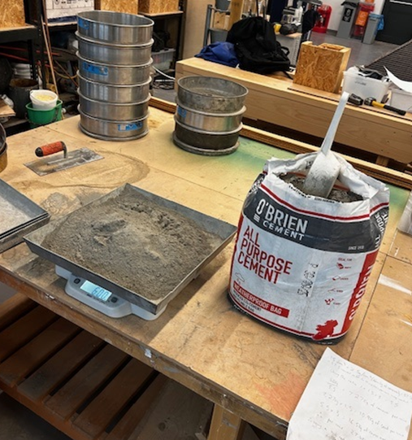  Figure 4 - Portland cement batching on calibrated scales (Author, 2026) | 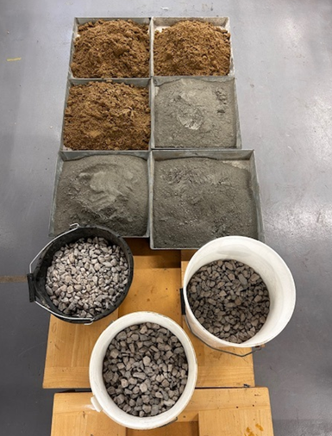  Figure 5 – Aggregates (Author, 2026)

3.7.2 Mixing of concrete
The Concrete was mixed using a laboratory drum mixer following a consistent sequence.
Coarse and fine aggregates were introduced first and dry-mixed for approximately one minute. Cement was then added and mixed dry with the aggregates for a further minute to ensure even distribution. Water was gradually introduced while mixing continued for an additional two to three minutes until a homogeneous consistency was achieved.
Maintaining a consistent mixing sequence and duration was essential to reduce variability between batches and ensure uniform mechanical properties across specimens.

  Figure 6 - Water being added to mix (Author, 2026) | 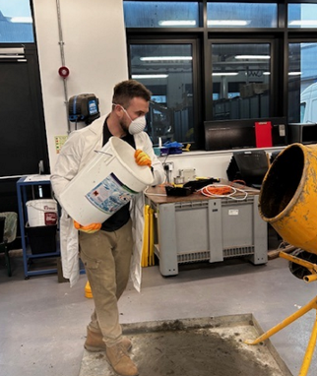  Figure 7 - Aggregates being added to mix (Author, 2026)

3.7.3 Batch verification & error
During initial batching a discrepancy was identified whereby a double batch was prepared without the full quantity of aggregate being added. This was detected during the casting stage through routine checks of the labelled containers and expected batch weights. In accordance with the laboratory quality control procedure, the batch was immediately discarded and not used for beam preparation. Subsequent batches were verified prior to mixing to ensure all constituent materials were correctly proportioned.

3.7.4 Slump Testing
The workability of fresh concrete was assessed using the slump test in accordance with BS EN 12350-2:2009. This test provides an indication of the consistency and flowability of the mix, which is critical for ensuring adequate compaction and effective encapsulation of reinforcement within the beam moulds.
The slump cone was placed on a level, non-absorbent surface and filled in three approximately equal layers. Each layer was compacted with 25 strokes of a standard tamping rod to ensure uniform consolidation. After filling, the cone was lifted vertically and the resulting reduction in height of the concrete was measured to the nearest 5 mm.
The recorded slump for each batch was:
- BFRP Mix 1 - 75mm
- BFRP Mix 2 – 70mm
- Steel Mix 1 – 75mm
- Steel Mix 2 – 75mm

The slump test confirmed that the concrete possessed adequate workability to flow around reinforcement without segregation, which is particularly important in small-scale reinforced specimens.
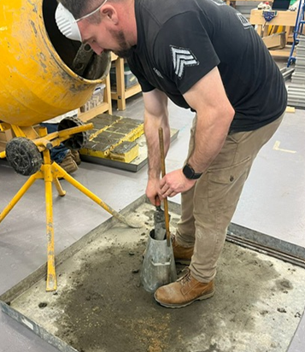

Figure 8 - Slump testing (Author, 2026)

3.7.5 Beam Casting and Reinforcement Placement
Beam moulds measuring 500 mm × 100 mm × 100 mm were prepared and coated with release agent (Sika Release Oil) prior to casting.
The Concrete was placed in two approximately equal lifts. Each lift was compacted using a tamping bar to remove entrapped air and ensure complete coverage within the moulds. 25 tamps per layer was completed per mould.
Reinforcement was positioned at one third of the total beam depth from the soffit, corresponding to an effective depth of ~33mm. A wooden former was created and utilised to ensure that the reinforcement position was regulated to the correct depth. Under three-point bending, tensile stresses develop at the bottom third of the beam. Positioning reinforcement at this depth ensures that tensile forces are resisted following first cracking, thereby governing post-cracking stiffness and ultimate flexural capacity (Shamass and Cashell, 2020).

Each beam contained two longitudinal bars. Bar positioning was maintained without the use of any equipment as the concrete mix was stiff enough to maintain the reinforcement depth.
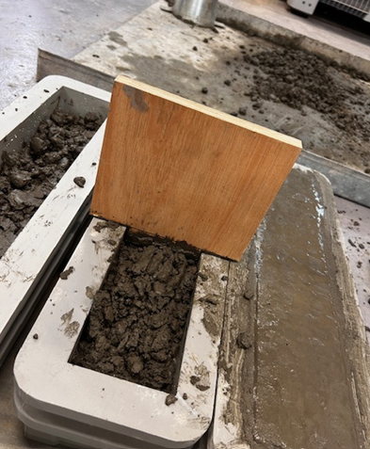  Figure 9 - Former for bar depth (Author, 2026) | 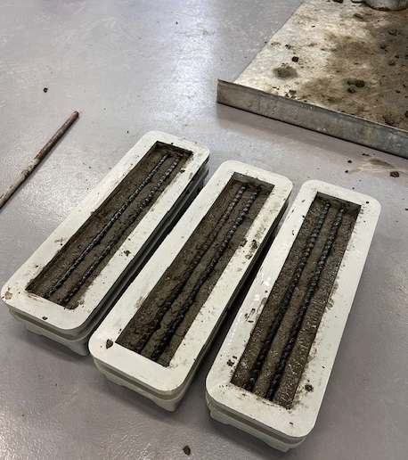  Figure 10 - Beam casting (Author, 2026)
Concrete was placed in two lifts and compacted using light internal vibration to minimise entrapped air without disturbing reinforcement alignment. The surface of each beam was struck off and lightly finished using a steel trowel.
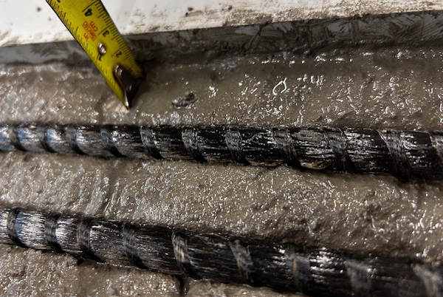
Figure 11 - Bar depth being measured (Author, 2026)

3.7.6 Demoulding and Curing Regime
Specimens were demoulded after approximately 24 hours and transferred to a water-curing tank. Curing was conducted for 28 days in accordance with BS EN 12390-2. The 28-day curing period represents the standard benchmark for assessing structural concrete strength in UK practice. The temperature in the curing tank was maintained at 18°c by a thermostat.

Figure 12 - Beams and cubes in curing tank (Author, 2026)

3.7.8 Cube Compression Testing
Companion 100 mm cube specimens were cast from each batch. Compressive strength testing was conducted at 28 days in accordance with BS EN 12390-3 using a Matest calibrated compression testing machine.

The average compressive strength recorded was 43.31 MPa, confirming that the target C35 strength class had been achieved.

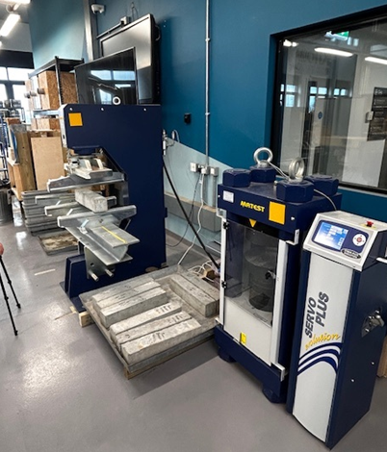

Figure 13 - Matest compression and three-point bending equipment (Author, 2026)

3.7.9 Three-Point Bending Test Procedure
Flexural testing was performed using a three-point bending configuration with a simply supported span of 400 mm. The machine used was the Matest three point bending machine.

Three categories of beams were tested:

- Steel-reinforced concrete beams (SR-RC)
- Basalt fibre reinforced polymer reinforced concrete beams (BFRP-RC)
- Plain concrete control beams

Load and mid-span deflection were recorded continuously to produce load–deflection response curves.

The following parameters were identified:

- First cracking load (The load at which the first visible crack forms, indicating that the tensile strength of the concrete has been exceeded).
- Post-cracking stiffness (The stiffness of the beam after cracking, reflecting the ability of the reinforcement to carry tensile forces and limit deflection)
- Ultimate flexural capacity (The maximum load sustained by the beam before failure, representing its overall bending strength)
- Observed failure mechanism (The mode of failure, such as reinforcement yielding, rupture, or concrete crushing, indicating the structural behaviour at collapse).

Steel-reinforced beams were expected to exhibit ductile flexural behaviour due to yielding of reinforcement prior to concrete crushing. In contrast, BFRP-reinforced beams were anticipated to demonstrate linear elastic behaviour until brittle tensile rupture or concrete crushing (Ortiz et al, 2023; Shamass and Cashell, 2020).

3.8 Data Interpretation Framework
Results were analysed by comparing average ultimate flexural capacity, stiffness characteristics and failure mechanisms across reinforcement types and diameters. Behaviour was interpreted in the context of the mechanical differences between elastic–plastic steel reinforcement and linear elastic BFRP reinforcement discussed in Chapter 2.

The flexural testing programme provides direct insight into the structural performance of reinforced concrete beams and allows comparison between reinforcement types under controlled conditions.

By evaluating differences in cracking behaviour, stiffness, and ultimate flexural capacity, the results contribute to assessing whether BFRP reinforcement can be considered a viable alternative to steel in specific structural applications.

Results

4.1 Introduction
This chapter presents the experimental results obtained from the concrete cubes compressive strength testing and flexural testing of the BFRP and steel reinforced concrete beam specimens. Results are presented in tabulated and graphical form for each specimen group, including plain concrete, steel – reinforced concrete (SR-RC), and basalt fibre reinforced polymer reinforced concrete (BFRP – RC) beams.

4.2 Concrete Compressive strength results
Concrete compressive strength was determined using 100mm x 100mm x 100mm cube specimens tested at 28 days in accordance with BS EN 12390-3.

Cube ID | Failure load (KN) | Compressive strength (MPa)
CUBE-1 | 443.013 | 44.301
CUBE-2 | 441.659 | 44.166
CUBE-3 | 435.744 | 43.574
CUBE-4 | 441.018 | 44.102
CUBE-5 | 429.402 | 42.940
CUBE-6 | 468.167 | 46.817
CUBE-7 | 431.256 | 43.126
CUBE-8 | 454.415 | 45.441
Table 6 - Cube compressive strength results
The average compressive strength achieved was 43.31 MPa.

4.3 Beam flexural test results
Flexural testing was conducted using a three-point bending configuration. The following sections present results for each specimen group

4.3.1 Plain concrete beams (No reinforcement)

Table 7 - Plain concrete beam results

Beam ID | First crack load (kN) | Ultimate Load (kN)
PC1 | 10.326 | 6.196
PC2 | 12.186 | 7.312
PC3 | 9.132 | 5.479
Average | 10.548 | 6.329

4.3.2 Steel reinforced concrete beams (SR-RC)

SR-RC 10mm
Beam ID | First crack load (kN) | Ultimate Load (kN)
SR-RC 10mm 1 | 30.664 | 13.398
SR-RC 10mm 2 | 35.420 | 21.252
SR-RC 10mm 3 | 36.260 | 21.756
SR-RC 10mm Average | 34.114 | 18.802
Table 8 - Steel reinforced (10mm) beam results

SR-RC 12mm
Beam ID | First crack load (kN) | Ultimate Load (kN)
SR-RC 12mm 1 | 34.520 | 20.712
SR-RC 12mm 2 | 46.074 | 27.645
SR-RC 12mm 3 | 35.423 | 21.254
SR-RC 12mm Average | 38.672 | 23.203
Table 9 - Steel reinforced (12mm) Beam results

4.3.3 BFRP Reinforced concrete beams (BFRP-RC)

BFRP reinforcement 8mm
Beam ID | First crack load (kN) | Ultimate Load (kN)
BFRP8mm 1 | 17.671 | 10.602
BFRP8mm 2 | 33.981 | 20.389
BFRP8mm 3 | 24.994 | 14.996
BFRP 8mm Average | 25.548 | 15.329
Table 10 - BFRP (8mm) Beam results

BFRP reinforcement 10mm
Beam ID | First crack load (kN) | Ultimate Load (kN)
BFRP10mm 1 | 33.773 | 20.264
BFRP10mm 2 | 26.559 | 15.936
BFRP10mm 3 | 21.781 | 13.069
BFRP 10mm Average | 27.371 | 16.423
Table 11 - BFRP (10mm) Beam results

BFRP reinforcement 12mm
Beam ID | First crack load (kN) | Ultimate Load (kN)
BFRP12mm 1 | 25.018 | 15.011
BFRP12mm 2 | 23.328 | 13.997
BFRP12mm 3 | 23.432 | 14.059
BFRP 12mm Average | 23.926 | 14.355
Table 12 - BFRP (12mm) Beam results

Analysis & Discussion

5.1 Introduction
This chapter presents a detailed analysis of the experimental results obtained from compressive strength testing of concrete cubes and flexural testing of reinforced concrete beams. The primary aim is to evaluate the structural performance of basalt fibre reinforced polymer (BFRP) reinforcement in comparison to conventional steel reinforcement.

The discussion focuses on compressive strength consistency, flexural capacity, cracking behaviour, and failure mechanisms, with results interpreted in the context of the theoretical framework established in Chapter 2. Emphasis is placed on assessing whether BFRP can provide a viable alternative to steel reinforcement, not only in terms of strength but also regarding ductility, reliability and structural behaviour.
Where appropriate, the findings are compared with both classical reinforced concrete theory and more recent research (post-2018), enabling a critical evaluation of how emerging materials such as BFRP perform under controlled experimental conditions.

5.2 Compressive strength of concrete
The average compressive strength achieved across the cube specimens was 43.31 MPa, with individual values ranging from 42.94 MPa to 46.82 MPa. This represents a variation of less than 10%, indicating a high degree of consistency in batching, mixing and curing. The achieved strength significantly exceeds that expected for a standard C35 mix, suggesting that the concrete provided a robust and reliable basis for structural testing.
Maintaining this level of consistency was important in isolating the effects of reinforcement type on flexural behaviour. As discussed in Chapter 2, Neville (2011) identified curing conditions, compaction, and water cement ratio as the dominant factors influencing compressive strength. The low variability observed in this study confirms that these factors were well controlled, ensuring that differences in beam performance can be attributed primarily to reinforcement behaviour.

Recent studies, including those by Alexander & Beushausen (2016), further emphasise that consistent compressive strength is critical when evaluating alternative reinforcement materials, as variability in concrete properties can obscure the true structural contribution of reinforcement. The results obtained here therefore provide a reliable foundation for comparative analysis.

5.3 Flexural behaviour of concrete beams

5.3.1 Plain concrete beams
The plain concrete beams exhibited an average first crack load of 10.55 kN, with an ultimate load of 6.33 kN, representing a reduction of approximately 40% following crack initiation. This immediate loss of load-carrying capacity highlights the brittle nature of unreinforced concrete, which lacks the ability to redistribute tensile stresses once cracking occurs.
This behaviour aligns with classical reinforced concrete theory, as outlined by Mosley et al. (2012), where concrete is considered ineffective in tension and reliant on reinforcement to provide structural integrity. These results provide a clear baseline for comparison, demonstrating the necessity of reinforcement in flexural members.

Figure 14 - Plain concrete average

5.3.2 Steel Reinforced Concrete beams
The steel reinforced beams demonstrated a substantial improvement in performance compared to plain concrete. The 10 mm steel reinforcement increased the first crack load to 34.11 kN, representing an increase of approximately 223%, while the 12 mm reinforcement further increased this value to 38.67 kN (~266% increase). Similarly, ultimate load capacity increased from 6.33 kN in plain concrete to 18.80 kN and 23.20 kN, representing increases of approximately 197% and 266% respectively.

This clear relationship between reinforcement diameter and load capacity is consistent with Eurocode 2 design principles (BS EN 1992-1-1), where flexural strength is directly proportional to the area of tensile reinforcement. As discussed in Chapter 2, Mosley et al. (2012) highlight that increasing reinforcement area enhances both moment capacity and crack control.

Furthermore, the steel reinforced beams exhibited ductile behaviour, with the ability to sustain load beyond initial cracking due to stress redistribution and yielding of the reinforcement. This behaviour aligns with the findings of more recent studies, such as Belay et al. (2024), which confirm that steel reinforcement provides predictable and stable structural performance under flexural loading.

Figure 15 - SR-RC 10mm

Figure 16 - SR-RC 12mm

5.3.3 BFRP Reinforced Concrete Beams
The BFRP reinforced beams demonstrated improved performance relative to plain concrete, with first crack loads ranging from 23.93 kN to 27.37 kN, representing increases of approximately 127% to 160%. Ultimate load capacities ranged from 14.36 kN to 16.42 kN, corresponding to increases of approximately 127% to 159%.

However, unlike steel reinforcement, the BFRP specimens did not exhibit a consistent increase in strength with increasing bar diameter. The 12 mm BFRP bars produced lower ultimate loads than the 10 mm bars, indicating that reinforcement area alone does not govern structural performance in these systems.

This behaviour reflects the material characteristics discussed in Chapter 2, where BFRP reinforcement was identified as having a lower modulus of elasticity and bond-dependent behaviour. Recent studies, including Elgabbas et al. (2018) and Zhang et al. (2021), have similarly reported that FRP-reinforced members do not always demonstrate proportional increases in strength with increased reinforcement area, due to limitations in bond performance and stress transfer mechanisms. Figure 17 shows delamination of a 12mm BFRP specimen occurring.

The results suggest that, while reinforcement area influences performance, it is not the sole factor in BFRP reinforced systems. Instead, structural behaviour appears to be strongly influenced by bond characteristics and the lower modulus of elasticity of the material.

Figure 17 - BFRP 8mm

Figure 18 - BFRP 10mm

Figure 19 - BFRP 12mm

5.3.4 Failure Modes and Structural Behaviour
The failure modes observed in this study highlight a fundamental difference between steel and BFRP reinforcement. Steel reinforced beams exhibited ductile failure behaviour, characterised by gradual crack propagation and increasing deformation prior to failure. This behaviour provides structural warning and is a key consideration in design, as discussed in Chapter 2.

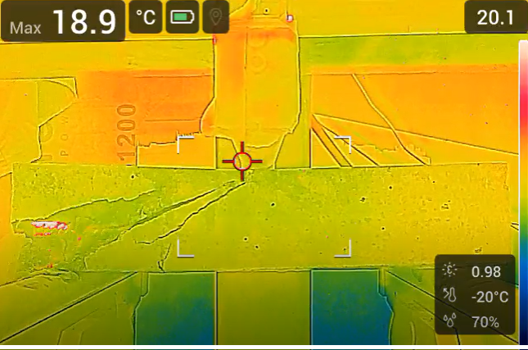
Figure 20 - Thermal imaging of 12mm SR-RC beam
Thermal imaging of the 12 mm steel-reinforced beam shows a clear localised temperature increase adjacent to a visible crack zone on the left-hand side of the span. The thermal “hot spot” coincides with an area where the concrete cover has fractured and partially spalled, exposing a zone of concentrated strain. This indicates that, as loading progressed, cracking localised and the internal forces were increasingly carried by the reinforcement, with energy dissipation occurring through plastic deformation and frictional processes within the cracked region. This behaviour is consistent with the expected ductile response of steel-reinforced concrete, where cracking develops progressively and is accompanied by localised energy absorption prior to ultimate failure.

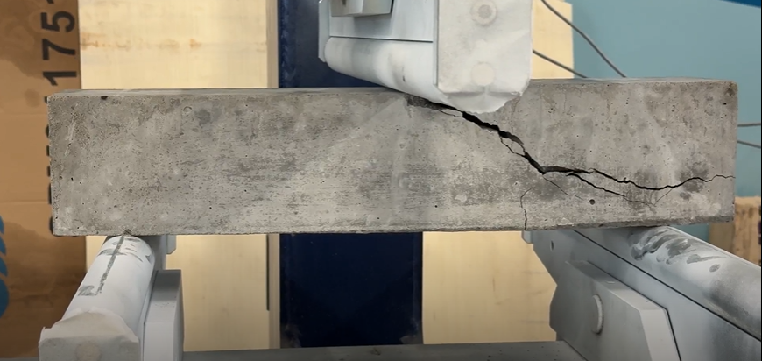
Figure 21 - Failure mode of SR-RC beam
Visual inspection of the 12 mm steel-reinforced beam following testing shows the formation of a dominant crack initiating at the underside and propagating diagonally towards the loading point. The crack pattern is indicative of combined flexural and shear behaviour, with tensile stresses causing cracking at the bottom fibre and subsequent propagation as loading increased. Localised spalling of the concrete cover is evident along the crack path, suggesting concentrated strain and loss of concrete contribution in this region. Despite this damage, the beam remains intact, indicating that the steel reinforcement continued to sustain tensile forces after cracking. This behaviour is consistent with the ductile response of steel-reinforced concrete, where cracking develops progressively and is accompanied by redistribution of stresses prior to ultimate failure.

In contrast, the BFRP reinforced beams demonstrated brittle failure behaviour, with limited deformation prior to failure. Once the tensile capacity of the reinforcement was reached, failure occurred suddenly. This observation is consistent with recent research by Guo et al. (2020), which identifies the absence of a yielding phase as a defining characteristic of FRP materials.

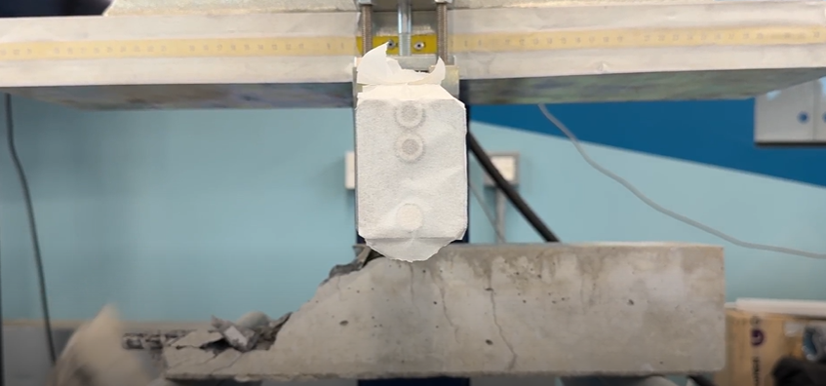
Figure 22 - Failure mode of BFRP beam
The BFRP-reinforced beam exhibited in figure 22 a predominantly brittle failure mechanism, characterised by sudden cracking and rapid loss of load-carrying capacity. As shown in Figure 22, a major flexural crack has formed at the soffit directly beneath the applied load, propagating vertically towards the compression zone. Unlike steel-reinforced specimens, there is no evidence of significant crack distribution or progressive widening, indicating limited stress redistribution prior to failure. The failure appears localised, with a pronounced fracture zone and visible concrete spalling near the tensile face, suggesting that once the tensile capacity of the BFRP reinforcement was exceeded, the beam failed abruptly. This behaviour is consistent with the linear elastic response of fibre-reinforced polymer materials, which do not exhibit yielding. Consequently, the absence of ductility results in minimal warning prior to failure, reinforcing the inherently brittle nature of BFRP-reinforced concrete systems observed in experimental studies.

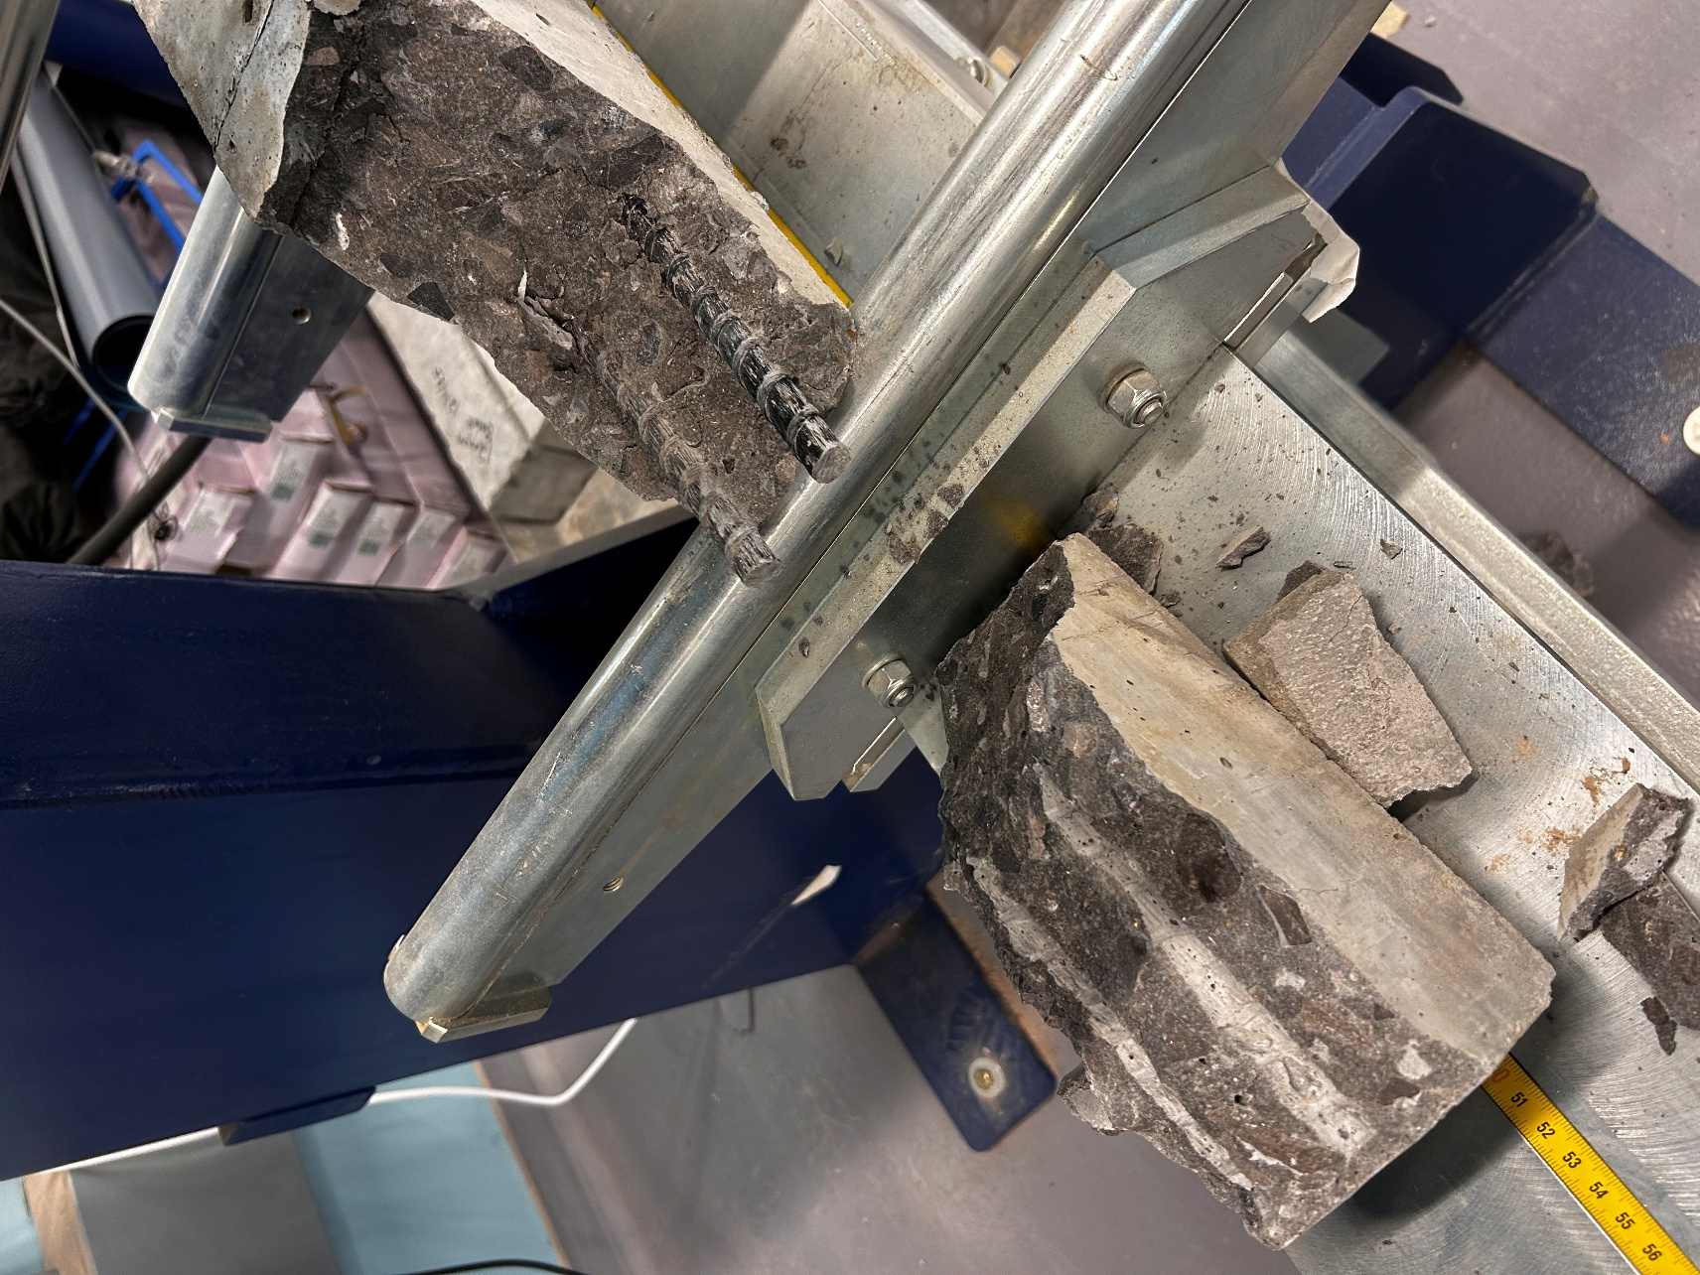
Figure 23 – Delamination on failure of BFRP 12mm beam

The post-failure condition of the BFRP-reinforced beam, shown in Figure 23, provides further insight into the failure mechanism. The exposed reinforcement and surrounding fracture surface indicate signs consistent with bond deterioration between the BFRP bar and the concrete matrix. Unlike ribbed steel reinforcement, which promotes strong mechanical interlock, BFRP bars rely on surface treatment and adhesion, which can result in comparatively weaker bond performance. The relatively clean separation and limited concrete adherence observed along the reinforcement interface suggest that partial debonding may have occurred prior to ultimate failure. This would have reduced the efficiency of stress transfer between the concrete and reinforcement, contributing to the sudden and localised brittle failure observed. However, it is important to note that this behaviour is likely coupled with the inherently linear elastic response of BFRP, and therefore the failure mechanism should be interpreted as a combination of bond limitations and the absence of a yielding phase, rather than bond failure alone.

The implications of this behaviour are significant. While steel allows for redistribution of stresses and increased structural resilience, BFRP requires more conservative design approaches to ensure safety. This reinforces the conclusions drawn in the literature review that FRP-reinforced structures must be designed with a greater emphasis on serviceability and failure control.

From a structural design perspective, the brittle failure observed in BFRP-reinforced beams presents a significant limitation. Unlike steel reinforcement, which provides a degree of plastic deformation and energy absorption prior to failure, BFRP exhibits minimal warning. This has important implications for structural safety, particularly in applications where progressive collapse must be avoided. As a result, design approaches incorporating BFRP must adopt more conservative assumptions, with increased emphasis on serviceability limits and redundancy within the structural system

5.4 Comparative Performance of Steel and BFRP Reinforcement
A direct comparison of the experimental results highlights clear differences in the structural behaviour of steel and basalt fibre reinforced polymer (BFRP) reinforcement under flexural loading. While both materials significantly improved the performance of concrete compared to unreinforced specimens, their effectiveness varied in terms of load capacity, stiffness and consistency.

Steel reinforced beams consistently achieved higher cracking and ultimate loads, with the 12 mm steel specimens reaching 23.20 kN, compared to a maximum of 16.42 kN for BFRP, representing a difference of approximately 40%. This reflects the higher modulus of elasticity of steel and its ability to effectively transfer tensile stresses within the composite section. The results also demonstrated a clear and predictable relationship between reinforcement diameter and structural performance for steel, with increased bar size resulting in increased load capacity. This behaviour aligns with the principles outlined in BS EN 1992-1-1 and discussed in Chapter 2, where flexural resistance is related to the area of tensile reinforcement.

In contrast, the BFRP reinforced beams did not exhibit a consistent relationship between bar diameter and performance. While an increase from 8 mm to 10 mm resulted in a modest improvement, the 12 mm specimens showed a reduction in both cracking and ultimate loads. This suggests that reinforcement area alone does not govern the structural behaviour of BFRP systems. As discussed in the literature review, BFRP reinforcement is more dependent on bond performance and material stiffness, which can limit the effective utilisation of larger diameter bars.

The difference in stiffness between the two materials also plays a significant role in their structural response. Steel reinforcement contributes to a stiffer composite section, resulting in improved crack control and more stable post-cracking behaviour. In contrast, the lower modulus of elasticity of BFRP leads to reduced stiffness and a greater reliance on the surrounding concrete to resist deformation. This behaviour supports the findings presented in Chapter 2, where FRP-reinforced members were identified as being governed more by serviceability considerations than ultimate strength. Ductility represents a further key distinction. The steel reinforced beams exhibited a progressive response following crack initiation, allowing for redistribution of stresses within the section. In contrast, the BFRP reinforced beams demonstrated a more brittle response, with limited capacity for stress redistribution. This difference reflects the fundamental material properties outlined in the literature review, where steel is characterised by a yielding phase, while BFRP behaves in a linear elastic manner up to failure.

Overall, the results indicate that while BFRP reinforcement can enhance the flexural performance of concrete relative to unreinforced specimens, its behaviour is less predictable and more dependent on material-specific characteristics than steel. The absence of a consistent relationship between reinforcement size and performance, combined with reduced stiffness and ductility, highlights the need for alternative design considerations when using BFRP reinforcement.

Figure 24 – Comparison of average ultimate loads

5.5 Results conclusion
The lack of a proportional increase in flexural capacity with increasing BFRP bar diameter suggests that structural performance is governed by more complex mechanisms than reinforcement area alone. Unlike steel, which benefits from mechanical interlock and yielding behaviour, BFRP relies heavily on bond characteristics between the bar surface and surrounding concrete. As bar diameter increases, the force carried by the reinforcement increases proportionally, resulting in higher bond stress demand between the reinforcement and the concrete. If this demand exceeds the bond capacity, localised slip or partial debonding may occur, reducing the effective mobilisation of tensile capacity.

5.6 Sustainability and service life implications
While the experimental programme focused primarily on short-term mechanical behaviour, the findings have important implications for long-term durability and sustainability. Steel reinforcement is highly susceptible to corrosion in aggressive environments, leading to increased maintenance requirements and reduced service life. In contrast, BFRP reinforcement is inherently resistant to electrochemical corrosion, offering the potential for significantly extended structural lifespan.

The improved durability of BFRP has implications beyond structural performance, particularly in terms of whole-life carbon. Reduced maintenance and repair interventions can lead to lower embodied carbon over the life of a structure, aligning with current sustainability objectives within the UK construction sector. However, this benefit must be balanced against the mechanical limitations identified in this study, particularly reduced stiffness, and brittle failure behaviour.

These findings suggest that BFRP may be most suitable in applications where durability governs design, such as marine structures or infrastructure exposed to de-icing salts. In such environments, the long-term benefits of corrosion resistance may outweigh the limitations in mechanical behaviour, provided appropriate design measures are adopted.

Conclusion & Further work

6.1 Overview of Research & Objectives
This dissertation set out to investigate whether basalt fibre reinforced polymer (BFRP) can be considered a viable alternative to conventional steel reinforcement in reinforced concrete applications. The study was motivated by the well-established durability limitations associated with steel reinforcement, particularly corrosion in aggressive environments, and the increasing interest in fibre reinforced polymer materials as a potential long-term solution.

To address this, a controlled experimental programme was developed, combining compressive strength testing of concrete cube specimens with flexural testing of reinforced concrete beams under three-point bending. The primary objective was to compare the structural performance of steel-reinforced concrete (SR-RC) and BFRP-reinforced concrete (BFRP-RC) specimens, focusing on cracking behaviour, load deflection response, ultimate flexural capacity, and failure mechanisms. A secondary objective was to assess the influence of reinforcement diameter on performance within each material group.

These objectives were achieved through a consistent and repeatable methodology, with careful control of mix design, specimen preparation and curing conditions. As a result, variations in structural behaviour can be attributed primarily to the reinforcement type rather than inconsistencies in the concrete itself.

6.2 Summary of Experimental Findings
The compressive strength results confirmed that the concrete achieved an average strength of approximately 43 MPa, exceeding the target C35 classification. This provided a reliable baseline for evaluating the structural performance of the beam specimens.

Flexural testing revealed clear and consistent differences between steel and BFRP reinforcement. Steel-reinforced beams achieved higher first cracking loads and greater ultimate flexural capacity across all tested configurations. The 12 mm steel specimens produced the highest average performance, demonstrating the expected relationship between increasing reinforcement area and load capacity.

BFRP-reinforced beams also demonstrated a significant improvement in performance compared to plain concrete; however, they did not match the capacity achieved by steel. A particularly notable observation was the non-linear relationship between BFRP bar diameter and structural performance. While steel exhibited a predictable increase in strength with increasing bar diameter, this trend was not replicated in the BFRP specimens. The 10 mm BFRP beams achieved the highest performance within that group, while the 12 mm specimens did not provide a corresponding improvement. This suggests that bond behaviour and stiffness play a more dominant role in BFRP systems than cross-sectional area alone.

The load–deflection behaviour further highlighted the fundamental differences between the two materials. Steel-reinforced beams exhibited a nonlinear response characterised by gradual stiffness reduction and ductile behaviour, providing visible warning prior to failure. In contrast, BFRP-reinforced beams demonstrated a predominantly linear response up to failure, followed by sudden brittle collapse.

6.3 Interpretation in the context of literature
The experimental findings of this study are consistent with the literature reviewed in Chapter 2. Previous research has established that BFRP reinforcement provides high tensile strength and strong resistance to corrosion but is limited by reduced stiffness and brittle failure behaviour compared to steel. The results obtained in this study reinforce these observations.

The linear elastic response observed in the BFRP-reinforced beams aligns with established material behaviour reported by Mohamed et al. (2021), who highlighted the absence of yielding in fibre reinforced polymer systems. In contrast, the nonlinear response exhibited by steel-reinforced beams reflects the ductile behaviour associated with yielding, which remains a fundamental advantage in structural design.

The reduced stiffness and increased sensitivity to cracking observed in the BFRP specimens are also consistent with findings reported by Shamass and Cashell (2020), who identified serviceability performance as a key limitation in FRP-reinforced members. Similarly, the inconsistent relationship between bar diameter and structural performance observed in this study supports more recent work by Belay et al. (2024), which suggests that bond behaviour and reinforcement interaction play a critical role in determining flexural capacity.

Overall, the findings of this study confirm that while BFRP can enhance the structural performance of concrete compared to unreinforced specimens, its behaviour differs significantly from steel and requires alternative design considerations.

6.4 Final Evaluation: Viability of BFRP as a Reinforcement Material
The central aim of this dissertation was to determine whether BFRP can be considered a viable alternative to steel reinforcement. Based on the results obtained, BFRP cannot currently be regarded as a direct replacement for steel in conventional reinforced concrete design.

Steel continues to offer a combination of strength, stiffness, and ductility that is essential for structural reliability. The ability of steel to yield prior to failure provides an important safety mechanism, allowing for stress redistribution and reducing the likelihood of sudden collapse.

In contrast, BFRP reinforcement exhibits fundamentally different behaviour. While it provides high tensile strength and excellent resistance to corrosion, its lack of ductility and lower stiffness introduce limitations that must be carefully considered in design. The brittle nature of failure observed in this study highlights the potential risks associated with relying solely on BFRP in structural applications where warning prior to failure is critical.

However, this does not diminish the value of BFRP as a material. Rather, it suggests that its use should be selective and tailored to specific applications. In environments where durability is the governing factor such as marine structures, bridge decks exposed to de-icing salts, and chemically aggressive conditions. The corrosion resistance of BFRP may provide significant long-term benefits.

6.5 Practical Implications for Engineering practice
The findings of this study have important implications for engineering practice, particularly in the selection and application of reinforcement materials in concrete structures. While BFRP reinforcement demonstrates clear advantages in terms of corrosion resistance, its mechanical behaviour differs fundamentally from conventional steel, requiring a shift in design approach.

In structural applications, the lower modulus of elasticity of BFRP leads to increased deflections and earlier crack development under service loads. As a result, designs incorporating BFRP are likely to be governed by serviceability limit states rather than ultimate strength. To address this, engineers may need to adopt higher reinforcement ratios, reduced bar spacing, or alternative detailing strategies to control deflection and cracking. In addition, the absence of yielding in BFRP introduces a brittle failure mode, meaning that structures must be designed with greater conservatism and, where possible, redundancy to mitigate the risk of sudden collapse.

Despite these limitations, BFRP reinforcement offers significant advantages in durability-critical applications. One of the most relevant uses is in marine and coastal infrastructure, where conventional steel reinforcement is highly susceptible to chloride-induced corrosion. In such environments, BFRP can provide a longer service life and reduce the need for costly maintenance and repair. Similarly, BFRP is well suited to bridge decks and highway structures exposed to de-icing salts, where corrosion of steel reinforcement is a primary cause of deterioration.

BFRP reinforcement is also increasingly considered for use in water-retaining structures, such as reservoirs and treatment facilities, where resistance to chemical attack is beneficial. In addition, its non-corrosive and non-magnetic properties make it suitable for specialised applications, including tunnel linings, precast elements, and structures requiring electromagnetic neutrality, such as those near sensitive equipment or railway signalling systems (Bastech UK, 2023).

Further practical applications include thin concrete elements and architectural panels, where the high tensile strength of BFRP can be utilised to reduce section thickness and overall weight. There is also potential for use in modular construction and precast systems, where durability and handling advantages are beneficial.

Overall, the results of this study indicate that BFRP should not be considered a direct replacement for steel reinforcement in all applications. Instead, it should be applied selectively, particularly in environments where durability governs design. When used appropriately, BFRP has the potential to extend service life, reduce maintenance requirements and contribute to more sustainable construction practices.

6.6 Limitations of the study
While the findings provide valuable insight into the behaviour of BFRP-reinforced concrete, several limitations must be acknowledged. The study was based on small-scale beam specimens, which may not fully represent the behaviour of full-scale structural elements.

The experimental programme also focused on short-term mechanical behaviour and did not consider long-term effects such as fatigue, or environmental degradation. These factors are particularly relevant for BFRP reinforcement and may influence long-term performance.

In addition, the number of specimens tested for each configuration was limited, which may introduce variability in the results. A larger sample size would improve the statistical reliability of the findings.

6.7 Recommendations for further Research
Further research is required to fully understand the potential of BFRP reinforcement in structural applications. Future studies should focus on full-scale testing to better replicate real-world conditions and loading scenarios.

Long-term durability testing is also essential, particularly in aggressive environments where BFRP is expected to provide the greatest benefit. Investigation into bond behaviour and surface treatment of BFRP bars would help to address the inconsistencies observed in this study.

The development of hybrid reinforcement systems represents another promising area of research, as does the refinement of design guidance and standards for BFRP-reinforced structures.

6.8 Concluding Statement
In conclusion, this study demonstrates that while BFRP reinforcement offers clear advantages in terms of durability and resistance to corrosion, it does not currently provide the structural performance required to replace steel in general reinforced concrete applications. Its use should therefore be considered carefully and applied selectively, with a clear understanding of its limitations and appropriate design considerations.

6.9 Achievement of Aims and Objectives
The aim of this study, to evaluate and compare the mechanical performance of BFRP and conventional steel reinforcement in concrete through laboratory testing, has been achieved. The experimental programme provided a direct comparison of load–deflection behaviour, failure characteristics and ultimate capacities, allowing the structural performance of both materials to be critically assessed.

The first objective, relating to the review of existing literature, was addressed through a comprehensive analysis of current research on the mechanical and durability properties of both steel and BFRP-reinforced concrete. The second objective was met through controlled laboratory testing, which enabled the identification of key behavioural differences, particularly in terms of stiffness, cracking behaviour and failure mechanisms.

The third objective, concerning sustainability and service-life implications, was achieved through interpretation of the experimental results in the context of durability and practical application. The findings highlight that while BFRP is not a direct replacement for steel in all applications, it offers clear advantages in durability-critical environments and has potential for targeted use within structural design.

References
ACI Committee 440 (2015) Guide for the Design and Construction of Structural Concrete Reinforced with FRP Bars (ACI 440.1R-15). Farmington Hills, MI: American Concrete Institute.

Alexander, M. and Beushausen, H. (2019) ‘Durability, service life prediction, and modelling for reinforced concrete structures – review and critique’, Cement and Concrete Research, 122, pp. 17–29. Available at: https://doi.org/10.1016/j.cemconres.2019.04.018.

Al-Hamrani, A. et al. (2023) ‘Bond durability of sand-coated and ribbed basalt FRP bars’, Construction and Building Materials, 413, 133741. Available at: https://www.sciencedirect.com/science/article/pii/S0950061823031021.
Bastech UK (2023) Basalt Fibre Reinforced Polymer (BFRP) Reinforcement Products. Available at: https://bastech.co.uk
Belay, A.A., Krassowska, J. and Kosior-Kazberuk, M. (2024) ‘Comparative performance analysis of small concrete beams reinforced with steel bars and non-metallic reinforcements’, Applied Sciences, 14(10), 3957. Available at: https://www.mdpi.com/2076-3417/14/10/3957.

Bertolini, L. (2008) Steel Corrosion in Concrete: Fundamentals and Civil Engineering Applications. Boca Raton: CRC Press.

BRE (2001) Carbonation Depths in Structural Concrete. Watford: Building Research Establishment.
BRE (1997) Design of normal concrete mixes. Watford: BRE
British Standards Institution (2002) BS EN 197-1:2000 Cement – Part 1: Composition, specifications and conformity criteria for common cements. London: BSI.

British Standards Institution (2009a) BS EN 12350-2:2009 Testing fresh concrete – Part 2: Slump test. London: BSI.

British Standards Institution (2009b) BS EN 12390-2:2009 Testing hardened concrete – Part 2: Making and curing specimens for strength tests. London: BSI.

British Standards Institution (2009c) BS EN 12390-3:2009 Testing hardened concrete – Part 3: Compressive strength of test specimens. London: BSI.

British Standards Institution (2009d) BS EN 12390-6:2009 Testing hardened concrete – Part 6: Tensile splitting strength of test specimens. London: BSI.

British Standards Institution (2012) BS EN 933-1:2012 Tests for geometrical properties of aggregates – Part 1: Determination of particle size distribution – Sieving method. London: BSI.

British Standards Institution (2021) BS EN 206:2013+A2:2021 Concrete – Specification, performance, production and conformity. London: BSI.
British Standards Institution (2016) BS 4449:2005 + A3:2016 Steel for the reinforcement of concrete – Weldable reinforcing steel – Bar, coil and decoiled product – Specification. London: BSI.
El Refai, A. et al. (2015) ‘Bond performance of basalt fiber-reinforced polymer bars to concrete’, Journal of Composites for Construction, 19(3), 04014050.
(Use this only if you actually cite El Refai in the text; your current literature review cites El Refai in the tensile/bond section but the source is missing from the bibliography.)

Hassan, A. et al. (2021) ‘Behaviour of concrete beams reinforced using basalt and steel reinforcement’, Engineering Structures, 242, 112564. Available at: https://www.sciencedirect.com/science/article/abs/pii/S0141029621004016.
(Your current file includes this in the literature review list and it is consistent with the journal record.)

Inman, M., Thorhallsson, E.R. and Azrague, K. (2017) ‘Mechanical and environmental assessment and comparison of basalt fibre reinforced polymer (BFRP) rebar and steel rebar in concrete beams’, Energy Procedia, 111, pp. 31–40.

Institution of Civil Engineers (2020) State of the Nation 2020: Infrastructure and the 2050 Net-Zero Target. London: ICE. Available at: https://www.ice.org.uk/news-views-insights/policy-and-advocacy/policy-insights/state-of-the-nation-2020-infrastructure-and-the-2050-net-zero-target.

International Organization for Standardization (2025) ISO 10406-1:2025 Fibre-reinforced polymer (FRP) reinforcement of concrete — Test methods — Part 1: FRP bars and grids. Geneva: ISO. Available at: https://www.iso.org/standard/84321.html.
Use one year only throughout the dissertation; your current file alternates between 2023 and 2025 for the same standard.

Kazemi, S. et al. (2023) ‘Bond durability of GFRP bars in seawater concrete’, Materials and Structures, 56(3), 67. Available at: https://link.springer.com/article/10.1617/s11527-023-02153-5.

Mehta, P.K. and Monteiro, P.J.M. (2014) Concrete: Microstructure, Properties and Materials. 4th edn. New York: McGraw-Hill Education.

Mohamed, O.A., Benmokrane, B., Ahmed, E.A. et al. (2021) ‘Durability and mechanical properties of concrete reinforced with FRP bars’, Polymers, 13(9), 1402. Available at: https://www.mdpi.com/2073-4360/13/9/1402.

Mosley, W.H., Bungey, J.H. and Hulse, R. (2012) Reinforced Concrete Design to Eurocode 2. 7th edn. Basingstoke: Palgrave Macmillan.

Nassif, A. et al. (2024) ‘Durability of FRP bars and reinforced concrete – a comprehensive review’, Civil Engineering Journal, 10(SP01), pp. [check exact pages from journal record]. Available at: https://civilejournal.org/index.php/cej/article/view/5174.

Neville, A.M. (2011) Properties of Concrete. 5th edn. Harlow: Pearson Education.

Ortiz, J.D. et al. (2023) ‘FRP-reinforced/strengthened concrete: State-of-the-art review on durability and mechanical effects’, Materials, 16(5), 1990. Available at: https://doi.org/10.3390/ma16051990.

Ožbolt, J. et al. (2020) ‘Modelling of corrosion-induced damage in reinforced concrete: A review’, Cement and Concrete Research, 132, 106040. Available at: https://doi.org/10.1016/j.cemconres.2020.106040.

Shamass, R. and Cashell, K.A. (2020) ‘Experimental investigation into the flexural behaviour of basalt FRP reinforced concrete members’, Engineering Structures, 220, 110950. Available at: https://doi.org/10.1016/j.engstruct.2020.110950.

Shi, X. et al. (2012) ‘Corrosion of steel bars in concrete: Prevention and rehabilitation’, Journal of Materials in Civil Engineering, 24(3), pp. 355–368. Available at: https://doi.org/10.1061/(ASCE)MT.1943-5533.0000371.

Thomas, P. and Gupta, R. (2021) ‘Corrosion management of concrete bridges in coastal environments’, Proceedings of the Institution of Civil Engineers – Bridge Engineering, 174(4), pp. 273–284. Available at: https://doi.org/10.1680/jbren.20.00029.

UK Green Building Council (2023) Net Zero Whole Life Carbon Roadmap: Progress Report. London: UKGBC. Available at: https://ukgbc.org/resources/whole-life-carbon-roadmap-progress-report/.

Wydra, M., Turkowski, P. and Fangrat, J. (2024) ‘Comparative analysis of the BFRP and steel reinforcement bars under fire conditions’, Archives of Civil Engineering, 70(2), pp. 85–98. Available at: https://doi.org/10.24425/ace.2024.148314.

Appendices

Bastech UK – BBA Certificate





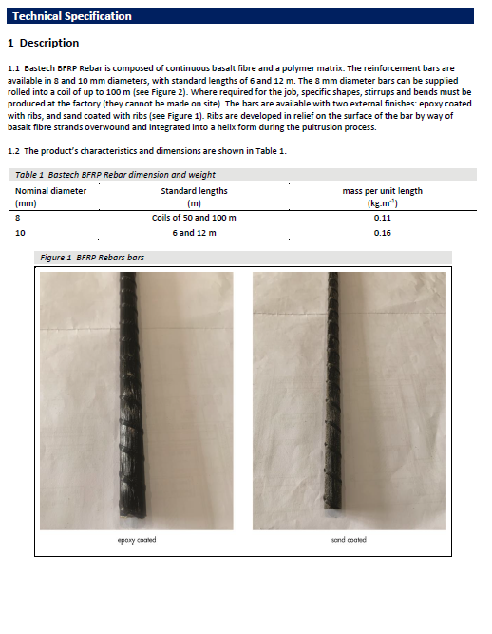

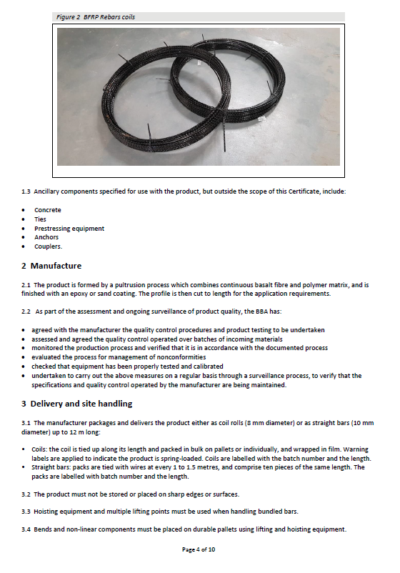


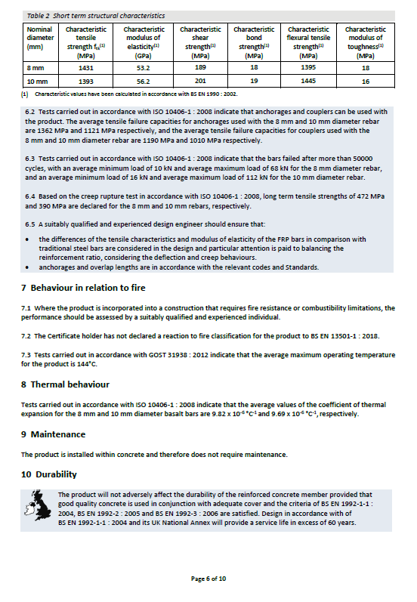
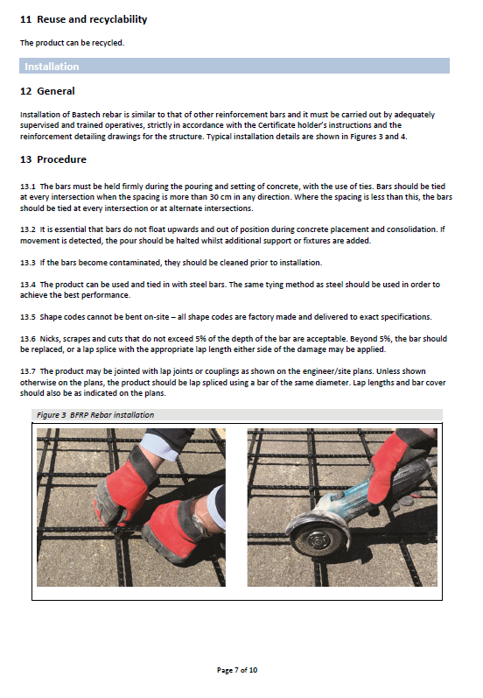
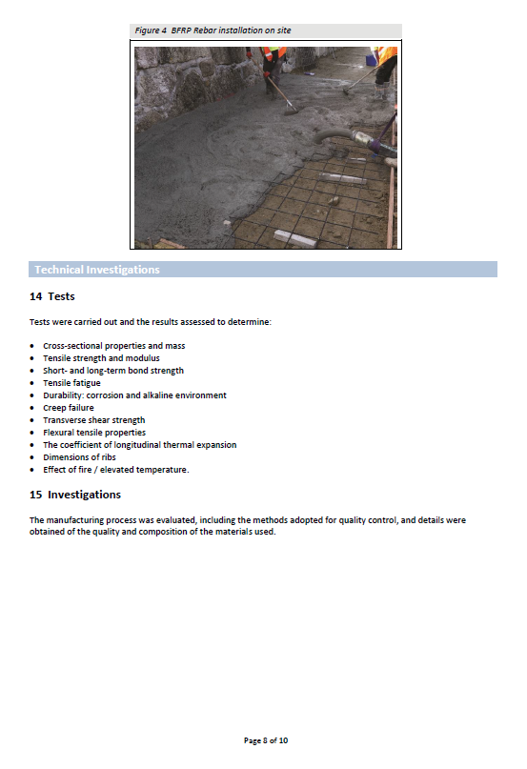




Sieve Log Graph


