
BMSW4002 Report
Effective Team-Working and Communication

April 1, 2020
Shajna bagom student number 1709594

Executive Summary

The purpose of this report is to investigate teamwork theories to improve the teamworking skills in the organisation detailed in the case study. Also, to look into and the importance and aspects of different methods of communication and how they can be implemented to help in improving and continuing the success of the organisation.

Contents
Executive Summary 1
Introduction 3
Importance of Teamwork 4
Meredith Belbin’s Theory 4
Dr Bruce Tuckman Theory 5
Importance of Two-Way Communication 6
Bibliography 10

Introduction
Teamwork is a vital skill that is require and essential in maintain and running a successful organisation. Good teamwork involves groups working together to achieve shared targets or goals. Being able to get along with different types of people in very important. There are many aspects to good teamwork skills. This will report will identify different teamwork theories and how they are useful to the organisation in the case study to and how these models are useful for the organisation in implementing good communication.

Importance of Teamwork

Teamwork involves groups working together to achieve shared targets or goals. Excellent teamwork is what differentiates good companies from exceptional ones. Teamwork skills consist of constant abilities that allow employers to work effectively in an organised group.
It is visible that the organisation is struggling with teamworking structures. With one assistant off on long term sickness, not replacing that member with another can impact on the customer service performance and workload pressure on other members of staff. Having no formal teams in the workplace allows staff members to work how they choose, impacting on the success and reputation of the organisation. Only calling in staff when needed and having no regular shift plan is a high-risk factor for the organisation as this will lead to low performing staff, poor customer service, unorganised stock availability, poor display leading to poor quality and more. Poor communication within the team, which is having an impact on the communication within the organisation, which is affecting important information being shared.
There are many models that can help improve the teamwork structure in the organisation, such as Belbin and Tuckman theories. These models identify the stages and roles needed to be in place and carried out by the team members or an organisation.

Meredith Belbin’s Theory

Meredith Belbin’s theory identifies nine roles that make a successful team. His study shows that the most effective teams have individuals who can take on each or some of the following nine roles;
Resource Investigator
Uses their inquisitive nature to find ideas to bring back to the team.
Strengths: Outgoing, enthusiastic. Explores opportunities and develops contacts.
Allowable weaknesses: Might be over-optimistic and can lose interest once the initial enthusiasm has passed.
They may: forget to follow up on a lead.
Team worker - Helps the team to gel, using their versatility to identify the work required and complete it on behalf of the team.
Strengths: Co-operative, perceptive and diplomatic. Listens and averts friction.
Allowable weaknesses: Can be indecisive in crunch situations and tends to avoid confrontation.
They may: be hesitant to make unpopular decisions.
Co-ordinator - Needed to focus on the team's objectives, draw out team members and delegate work appropriately.
Strengths: Mature, confident, identifies talent. Clarifies goals.
Allowable weaknesses: Can be seen as manipulative and might offload their own share of the work.
They may: over-delegate, leaving themselves little work to do.
Plant -Tends to be highly creative and good at solving problems in unconventional ways.
Strengths: Creative, imaginative, free-thinking, generates ideas and solves difficult problems.
Allowable weaknesses: Might ignore incidentals and may be too preoccupied to communicate effectively.
They may: be absent-minded or forgetful.
Monitor Evaluator - Provides a logical eye, making impartial judgements where required and weighs up the team's options in a dispassionate way.
Strengths: Sober, strategic and discerning. Sees all options and judges accurately.
Allowable weaknesses: Sometimes lacks the drive and ability to inspire others and can be overly critical.
They may: be slow to come to decisions.
Specialist - Brings in-depth knowledge of a key area to the team.
Strengths: Single-minded, self-starting and dedicated. They provide specialist knowledge and skills.
Allowable weaknesses: Tends to contribute on a narrow front and can dwell on the technicalities.
They may: overload you with information.

Shaper - Provides the necessary drive to ensure that the team keeps moving and does not lose focus or momentum.
Strengths: Challenging, dynamic, thrives on pressure. Has the drive and courage to overcome obstacles.
Allowable weaknesses: Can be prone to provocation and may sometimes offend people's feelings.
They may: risk becoming aggressive and bad humoured in their attempts to get things done.
Implementer - Needed to plan a workable strategy and carry it out as efficiently as possible.
Strengths: Practical, reliable, efficient. Turns ideas into actions and organizes work that needs to be done.
Allowable weaknesses: Can be a bit inflexible and slow to respond to new possibilities.
They may: be slow to relinquish their plans in favour of positive changes.
Completer Finisher - Most effectively used at the end of tasks to polish and scrutinize the work for errors, subjecting it to the highest standards of quality control.
Strengths: Painstaking, conscientious, anxious. Searches out errors. Polishes and perfects.
Allowable weaknesses: Can be inclined to worry unduly, and reluctant to delegate.
They may: be accused of taking their perfectionism to extremes (Anon., 2020)
All the roles of Belbin’s theory are highly recommended and need to run a successful organisation. If each role is carried out properly then the team’s performance will improve. The team can be kept small if all the nine team roles are carried out through individuals. This does not mean that the organisation has to hire nine individuals to carry out each of the roles, the managers in charge of selecting the team must ensure all roles of Belbin’s theory are being met, this could mean one member of the team have the skills to take on two or even three of roles. A team on three or four positive skilled members can implement Belbin’s theory effectively.

Dr Bruce Tuckman Theory

Dr Bruce Tuckman published his Forming Storming Norming Performing model in 1965. He added a fifth stage, Adjourning, in the 1970s (Chapman, 2019). Tuckman believed that a successful workplace is achieved by taking steps to achieve their goals. Tuckman’s believed the following stages are highly important and required to achieve good teamwork.
Forming - the team is put together, and tasks are given. They spend time planning, gathering information and bonding. Trust is not fully developed at this stage.
Storming - ideas on how to complete the task are being made by the team. Different ideas may create friction within the team, with members competing for their ideas to be put in use. This stage can break relations within the team. The team must get past these problems and choose the ideas to complete the task effectively. Strong leadership is required at this phase.
Norming - teams work towards the common goal effectively with each member knowing what is required. Trust is built between team members and leaders can take a step back as team members take on greater responsibility.
Performing - teams are executing the task at a high level. Team members are independent, motivated and have the knowledge of performing the task. Respect is gained between team members.
Adjourning - groups are parted after the task is finished. Individuals may feel locate this troublesome as they may have fabricated cosy associations with different individuals, not recognizing what lies ahead.

The organisation is lacking in teamwork skills. If Tuckman’s model is applied in the workplace, they are likely to overcome the issues they are having. If the stages are followed properly and effectively all the members of the team. Following Tuckman’s theory is a good way to help overcoming the poor communications issue they are facing. Following Belbin’s and Tuckman’s models can assist on resolving and improving communication skills within the organisation.

Importance of Two-Way Communication

Communication is a vital skill that is required in all workplaces. if communication skills lack in an organisation many problems are likely to crop up. ‘Workplace communication is vital to an organization's ability to be productive and operate smoothly’ (Lombardo, 2020). This organisation lacking communication with the team and structure. It is the managers job have good communication to train and maintain their staff’s communication skills. There are many forms of communication which assist the organisation, such as verbal and non-verbal. Both are important and can say different things. It is important to be aware of owe own and others verbal and non-verbal communication.
Verbal communication – are the things we say, ‘verbal communication in a work setting takes place between many different individuals and groups such as co-workers, bosses and subordinates, employees, customers.
The best supervisors don’t merely tell their subordinates what to do and expect them to listen. Instead, they employ active listening skills to understand employee needs and perspectives, engage in verbal negotiation to address and defuse issues, and capitalize upon opportunities to praise individual and team achievement
- Advising others regarding an appropriate course of action
- Assertiveness
- Conveying feedback in a constructive manner emphasizing specific, changeable behaviours
- Disciplining employees in a direct and respectful manner
- Giving credit to others
- Recognizing and countering objections
- Showing an interest in others, asking about and recognizing their feelings
- Speaking calmly even when you’re stressed
- Terminating staff
- Training others to carry out a task or role
- Using affirmative sounds and words like “uh-huh,” “got you,” “I understand,” “for sure,” “I see,” and “yes” to demonstrate understanding
- Using self-disclosure to encourage sharing (DOYLE, 2020)
Non-Verbal communication - is the things we don’t say using words, it relies on various non-verbal cues like physical movements, tasks, colors, signs, symbols, signals charts, etc. to express feelings, attitudes or information. Although no word is used in non-verbal communication, it can effectively communicate many human feelings more accurately than verbal methods of communication.

- Eye contact.
- Facial expressions.
- Gestures.
- Posture and body orientation.
- Body Language.
- Space and Distance.
- Proximity.
- Para-linguistic.
- Humor.
- Touch.
- Silence.
- Personal Appearance.
- Symbol.
- Visual Communication (Anon., 2017)
Both methods of communication are affective if the message is clear and is received by the receiver. There are many communication models that can help organisations to improve and maintain good communication skills. Models such as the Communication cycle, Shannon and Weaver and Berlo’s models.
Communication cycle –
(Anon., 2016)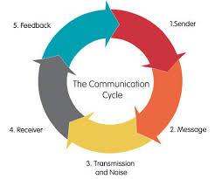

Shannon and Weaver –
 (Anon., 2018)

Berlo’s model -
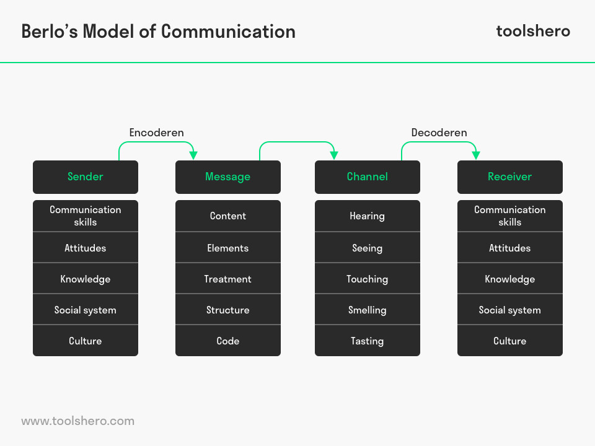
(Jense, n.d.)
All the models have a very common relationship as they all revolve around a sender, a message, a channel and a receiver. Although each of the model are a little different as they have a few different additions to each other. These models can be implemented verbally and non-verbally. Implementing any on the model’s structure can assist the organisation to improve their communication within the workplace. Having communication outside of the workplace is a lot of the time important too. Maintaining a good relationship with members of the organisation can help in getting tasks done smoothly and being organised.
Alongside communication skills, it is important for all individuals in the organisation have a good sense of listening skill. Listening will help build relationships, solve the problems by listening to each other’s ideas and thoughts, ensures everyone is understanding each other, resolve any conflict within the team and improve accuracy. There are many aspects to listening skills:
- Face the speaker and maintain eye contact
- Be attentive, give and pay attention,
- Keep an open mind, listen without judging and criticizing
- Listen to the words and try to picture what is being said
- Do not interrupt and don’t impose your solutions or opinions
- Wait for the speaker to pause to ask clarifying questions
- Ask questions on to ensure understanding
- Try to feel and sense what the speaker is feeling
- Give the speaker regular feedback
- Pay attention to non-verbal speech
The organisation needs structure, this can be attained by improving teamwork structure by implementing Tuckman’s four stages and taking on board Belbin’s nine team roles. This will resolve many of the organisation’s problems. Also, implementing one of the communication models will help in sharing ideas and though to maintain the success of the organisation.

Bibliography
Anon., 2016. Potential Unearthed Personal Development. [Online]
Available at: https://www.potentialunearthed.co.uk/wp-content/uploads/2017/09/Comms-Cycle-Handout.pdf
[Accessed 2nd April 2020].
Anon., 2017. IEDU Notes. [Online]
Available at: https://www.iedunote.com/nonverbal-communication
[Accessed 2nd April 2020].
Anon., 2018. Shannon and Weaver Model Of Communication. [Online]
Available at: https://www.businesstopia.net/communication/shannon-and-weaver-model-communication
[Accessed 2nd April 2020].
Anon., 2019. Recreation Results. [Online]
Available at: https://www.recreationresults.com/blog/tag/teams
[Accessed 30th March 2020].
Anon., 2020. Belbin. [Online]
Available at: https://www.belbin.com/about/belbin-team-roles/
[Accessed 30th March 2020].
Chapman, A., 2019. Business Balls. [Online]
Available at: https://www.businessballs.com/team-management/tuckman-forming-storming-norming-performing-model/
[Accessed 30th March 2020].
DOYLE, A., 2020. the Balance Careers. [Online]
Available at: https://www.thebalancecareers.com/verbal-communication-skills-list-2059698
[Accessed 2nd April 2020].
Ingram, D., n.d. why is teamwork important in retail?. [Online]
Available at: http://smallbusiness.chron.com/teamwork-important-retail-10945.html
Jense, B., n.d. [Online]
Available at: https://www.toolshero.com/communication-skills/berlos-smcr-model-of-communication/
[Accessed 2nd April 2020].
Lombardo, J., 2020. Study.com. [Online]
Available at: https://study.com/academy/lesson/workplace-communication-importance-strategies-examples.html
[Accessed 2nd April 2020].
Morgan, P., 2017. The Business Student's Guide To Study and Employability Skills. In: London : Sage, p. 208 .

