
Student Name | Jahanviben Sodha
Student ID | 2530085
Programme | MSc Public Health and Social Care in Practice
Module | Social Epidemiology and Public Health Development
Module code | LCHS7000
Lecturer | Itse Olaoye
Assignment Title | Component 2 Analytical Report
Topic Name | Ethnicity And Health Inequality
Word Count | 2749

Table of Contents
Task 1: Social Epidemiological Analysis 3
Title: Ethnicity and health inequality in healthcare inequalities of South Asian elderly people 3
Introduction 3
Contextual factor and underlying factor 3
Barrier to health care access 6
National Response to reduce health inequalities in South Asian elderly people: 6
The role of NHS in supporting South Asian elderly people 6
Conclusion 6
Task 2: Epidemiological Analysis 7
Introduction 7
Main Body 9
Conclusion 12
References 13

Task 1: Social Epidemiological Analysis

Title: Ethnicity and health inequality in healthcare deliveries among South Asian elderly people

Introduction
Ethnicity refers to the shared identity of a social group based on language, culture and ancestry (Smith and William, 2024). Health inequalities refer to the unfair and systematic differences in health status due to unequal distribution of health care (Lee et al., 2020). Here, the health inequalities often lead to mental health disorders among elderly people in the UK (WHO, 2025). From this perspective, this report aims to explore the ethnicity and health inequality issues in the South Asian elderly people of the UK by underpinning the epidemiological information of their life course, as health inequality can lead to major diseases and even death. The structure of this report is composed of asserting the contextual factors and providing justified evidence for them. Additionally, an epidemiological analysis is pointed out at the end to highlight the understanding of the processes as an epidemiologist.

Contextual factor and underlying factor
3 diseases
Cardiovascular Disease
Cardiovascular disease has a fatal impact on the lives of South Asian elderly people in the UK. The South Asian elderly people are more likely to have coronary heart disease compared to white populations in the UK. Here, it is found that South Asians are 50% more likely to have cardiovascular events and death compared to White Europeans. As they are unequally served in health care access, it leads to an increased probability of CVD in South Asians (Patel et al., 2022). It can be improved by providing equal health care to South-Asians, as they are more susceptible to the disease; focusing on their health condition will be helpful for improving the probability of the disease in individuals. Therefore, it can be summarised that ethnic diversification is a major cause of Cardiovascular diseases among South Asian elderly individuals in the UK.
Diabetes (Type 2)
The south Asian populations more frequently experience Type 2 disease than white populations. It happens due to socioeconomic deprivation, such as limited access to healthy food and low income, which reduces opportunities for physical activities (Porhcisaliyan et al., 2021). Additionally, in 2010, the South Asian Health Foundation (SAHF) stated that there are approximately 388,000 South Asian people with T2D in the UK, representing 15% of the UK population with T2D (Hanif and Susarla, 2018). The diabetes significantly influenced Atherosclerotic Cardiovascular Disease (ASCVD) risk 23% in the South Asian population compared to 8% of the Europeans (Muniyappa and Narayanappa, 2024). It indicates that the influence of T2DM is harmful in south Asian populations and can reduce the healthcare quality of the individuals. It can be mitigated through culturally sensitive education and community-based programs about Type 2 diabetes in south Asian populations (Goff et al., 2025).
Mental Health
South Asians are more likely to experience mental health disparities compared to white people due to cultural stigma and lack of care (Birtel and Mitchell, 2023). It hampers their daily life operations and negatively impacts their mental health, leading to stress and anxiety.
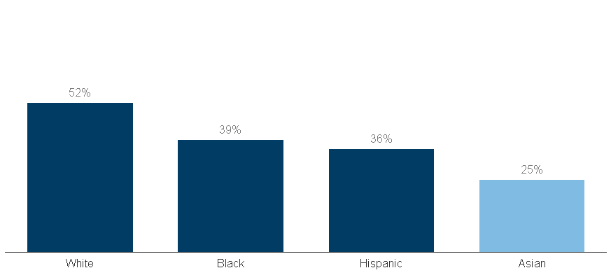
Figure 1: Different adults who received mental health services in 2021
(Source: Artiga and Panchal, 2023)
Here, the disparity in mental health care of the individuals often leads to anxiety and depression in south Asian elderly individuals due to social isolation (Islam et al., 2023). It can be addressed through tailored mental health services and educational awareness campaigns, for reducing the probabilities of mental health issues in the south Asian elderly individuals (Ahad et al., 2023). Therefore, it can be summarised that mental health disparities can be crucial sometimes, and it must be recognised to achieve better mental health outcomes for elderly people.

3 Social issues
Racism
The racism of South Asian elderly individuals hugely impacts their lifestyle, social image, and also leads to health inequalities among people in the UK. Here, racism also harms their personal life and diminishes their employment chances. Furthermore, 51% participants in the UK have reported some kind of discrimination in health services due to disparity in racism or ethnicity (NHSRHO, 2025). Additionally, Ajayi (2021), stated that the lack of language and cultural competencies often creates barriers in the healthcare access of old south Asian individuals. Conversely, Danso and Danso (2021), argued that racism also has a devastating impact on the health care of the South Asian communities. Therefore, it can be summarised that racism has a negative impact on the health of South Asian elderly individuals.
Socioeconomic inequality
The socioeconomic deprivation is a major factor for south Asian individuals, as this hugely impacts their health and personal life due to racism in their ethnicity. Here, low income leads to malnutrition in south Asian ethnicity and increases the chances of health issues. Here, Evandrou et al. (2016), stated that above 35% of Pakistani, Indian and Bangladeshi elderly people are the poorest fifth in income distribution in comparison with British and other mixed and Asian peoples.
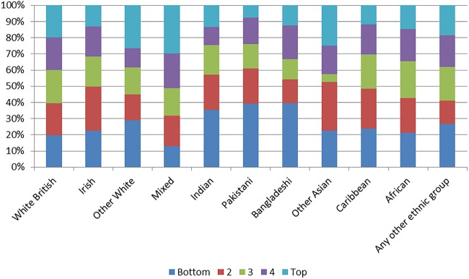
Figure 2: the income distribution of UK by ethnicity
(Source: Evandrou et al., 2016)
Therefore, it can be identified that the socioeconomic inequalities of South Asian elderly individuals are key barriers for them in healthcare and may impose significant threats in future.

Barrier to health care access
The barrier to healthcare services of south Asian individuals is a major burden on their health. The barriers like cultural stigma and language barriers augment disparities among the elderly individuals, and lead to social isolation in individuals and reduce their productivity (Lai et al., 2020). Additionally, lack of health care can reduce their health, which may even lead to death. Therefore, it can be summarised that the lack of health care access can lead to negative circumstances.

National Response to reduce health inequalities in South Asian elderly people:
The national government of the UK has established The National Healthcare Inequalities Improvement Programme (HiQiP) for addressing the health disparities of south Asian elder people (NHS England, 2026). Additionally, it enables individuals to address their health problems easily and improve their mental health condition simultaneously. Additionally, the NHS has implemented the Core20PLUS5 approach for reducing healthcare inequalities in the UK (NHS England, 2026b). Therefore, it can be acknowledged that the implementation of these programmes is done for the betterment of the South Asian elderly people. Hence, it will be helpful in the future to improve their mental health conditions.

The role of NHS in supporting South Asian elderly people
Charities like South Asian Health Foundation (SAHF) established in 1999, are helpful for reducing health inequalities in the UK, specifically for the UK’s South Asian population. It addresses specific diseases like cardiovascular diseases and type 2 diabetes in the UK (SAHF, 2026). Additionally, SAHF also helps to raise awareness among South Asian individuals about the health inequalities through community education and partnerships (SAHF, 2026).

Conclusion
From the overall findings, it can be summarised that the South Asian ethnicity has a great disparity due to the racial distinction and minority groups. Additionally, various factors like racism, socioeconomic inequality and unequal health access, crucially impact the health access of the South Asian elderly people. However, as the government of the UK has established charities like SAHF and programmes like the National Healthcare Inequalities Improvement Programme and Core20PLUS5, these are helpful in improving awareness among South Asian individuals and upholding equal distribution of health services in the ethnic minority groups.

Task 2: Epidemiological Analysis

Introduction
Definition:
Type 2 diabetes (T2D) is a health problem which arises from the insufficient insulin production or inefficiency of the body in using insulin correctly, which develops sugar in the body and leads to T2D (Mayo Clinic, 2026).
Social, cultural, and health consequences
From a health perspective, it damages the heart, kidneys, eyes and nerves of the affected individuals. Socially, it may induce loneliness due to blurred vision, darkened skin and weight loss (Mayo Clinic, 2026). Culturally, it reconstructs food culture by changing the food habits of the affected individuals, impacting their food habits (Iqbal, 2023). It also carries a negative stigma, due to which individuals hide the situation, which negatively impacts their social relationships (CDC, 2024).
Prevalence of Type 2 Diabetes:
Type 2 diabetes has significantly influenced the health of millions of elderly people in both the UK and the worldwide context. Globally, Type 2 diabetes has shown major growth between previous years, which has been assumed to grow rapidly over the next few years (Ong et al., 2023).
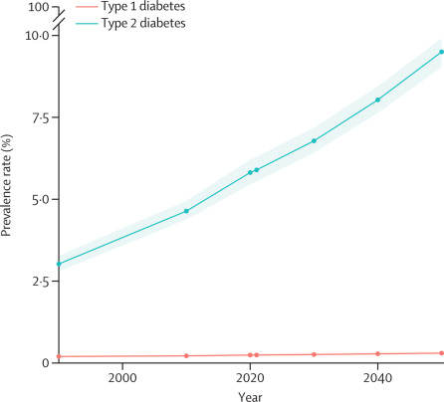
Figure 3: Global prevalence of the T2D
(Source: Ong et al., 2023)
Additionally, the growth of the disease is highly prevalent in elderly people, as it is found that in the global context, it has affected millions of elderly south Asian people (Yang et al., 2024). However, as the chart is illustrated in the global context, separation of the specific ethnicity may be complex.
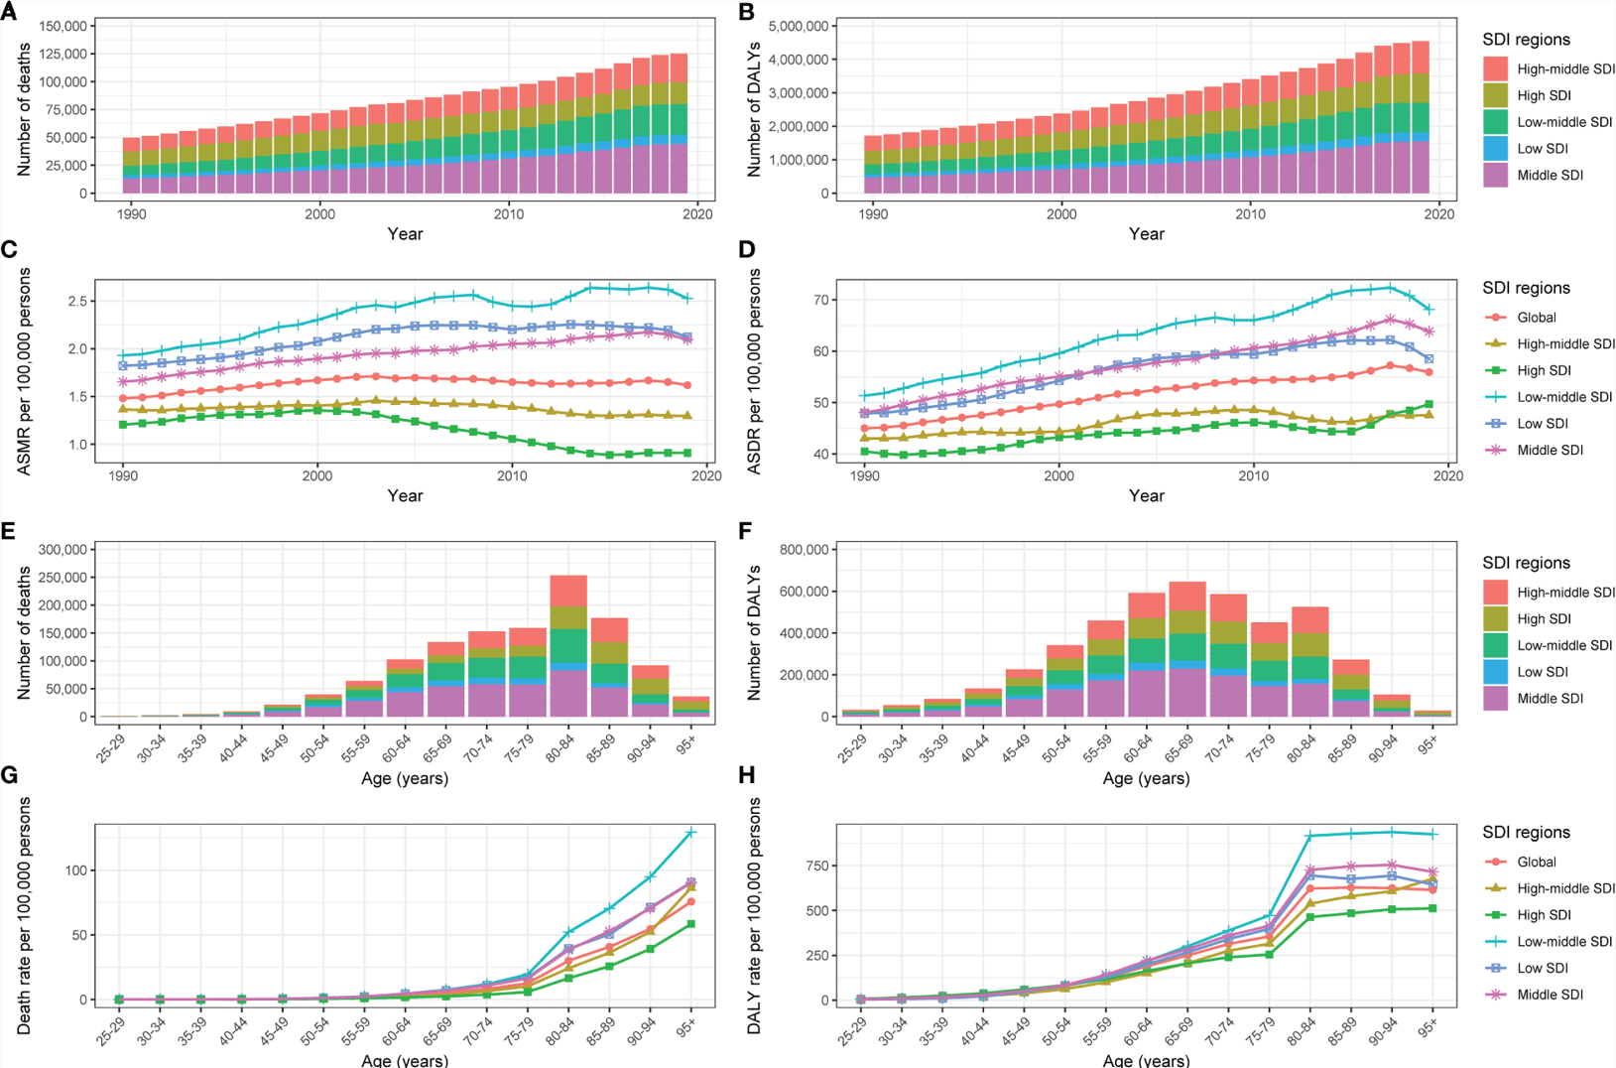
Figure 4: Type 2 diabetes attributed to physical inactivity by Sociodemographic index.
(Source: Yang et al., 2024)
Conversely, England has seen huge growth in the prevalence of T2D among South Asian elderly people (Stewart, 2026).
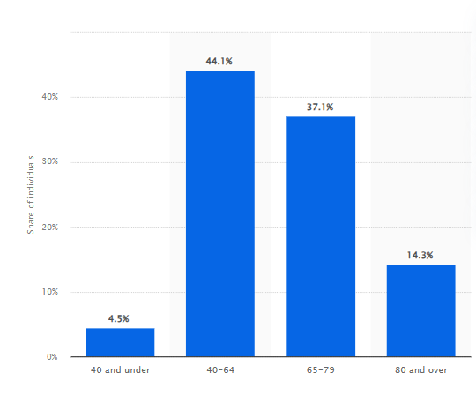
Figure 5: People by age registered in 2023-24 with T2D in England
(Source: Stewart, 2026)
The prevalence of T2D indicates a major growth of the disease among the South Asian elderly people especially in the age group of 40-64. Therefore, T2D has a major prevalence among South Asian people in the UK and also in the Global context, hence acknowledging these factors is crucial for the understanding of the epidemiological insights about this disease.

Main Body
Public health measure
Prevention:
The prevention of the disease is harnessed by the UK government through a specialised programme for offering low-calorie meal replacement for 12 weeks, to support south Asian elderly individuals to adopt healthy eating and prevent T2D (Dhir et al., 2023). It prevents the susceptibility of T2D in elderly individuals and upholds a healthy lifestyle for South Asian elderly individuals.
Protection:
To protect the elderly individuals of the south Asian people, the UK government has established local NHS bodies for vascular checks to identify pre–diabetes and CVD (Tanner et al., 2022). It helps in the early diagnosis of T2D in South Asian individuals to reduce the risk of T2D. Additionally, the NHS has established DESMOND (Diabetes Education and Self-Management for Ongoing and Newly Diagnosed) to protect south Asian elderly individuals from T2D through culturally adopted content like guidance upon religious rituals and dietary habits in localised languages for protecting the possibilities of T2D in the South Asian elderly individuals of the UK (Diabetes.CO.UK, 2019).
Promotion:
It is important to reduce the possibilities of T2D in the UK through health awareness among south asian elderly individuals. Here, the UK government has introduced 'Healthier You' NHS Diabetes Prevention Programme (NDPP) for advising elderly south Asian individuals about what to eat, specific physical exercises relatable to the south Asian dilemma (NHS England, 2026a). This promotes specific health practices for reducing the chances of T2D in South Asian elderly individuals.
Determinants/Risk Factors:
The key risk factors and determinants of T2D in South Asian communities are that their biological composition is often characterised by lower BMI but deep subcutaneous fat and higher visceral fat compared to other ethnic groups. This excess fat in their body often leads to insulin resistance and augments the probability for T2D in south Asian elderly individuals (Wolf et al., 2021). Conversely, poverty is a determinant in inducing T2D, as the lack of healthy food due to poverty can augment the possibilities of T2D in South Asian elderly individuals.
Epidemiological studies and needs assessment
From an epidemiological perspective, T2D is obvious in south Asian due to their ethnic factors. Here, Narayan and Kanaya (2020), opined that due to the lack of lower beta cell reserve, South Asians may face diminished insulin secretion, limiting their ability to resist insulin in comparison to other ethnic groups. Here, the Mediators of Atherosclerosis in South Asians Living in America (MASALA) study has indicated that the south Asians have the lowest insulin secretion among distinct ethnic groups (Gujral and Kanaya, 2021).
Monitoring/Surveillance system used for monitoring T2D in South Asian elderly individuals
The UK government has implemented distinct strategic approaches for monitoring the incidence of T2D in south Asian elderly individuals. Here, the NHS has adopted the National Service Framework for Diabetes for monitoring and reducing the risk of developing T2D in South Asian Elderly individuals. The NHS has implemented surveys for assessing the experience of the patients in the care process for improving their specific areas of care in local areas and understanding their faults in providing care to the individuals (Department of Health, 2026).
The public health impact/ short-and long term consequences of T2D on the South Asian elderly people
The T2D has a fatal short and long-term impact on the south Asian elderly individuals.
Long-term health impact
From an epidemiological perspective, T2D has a long-term impact on individuals, often leading to premature mortality in South Asian elderly individuals due to its prevalence in coronary artery disease (CAD) and a 3-fold higher risk of myocardial infarction (MI) (Muniyappa and Narayanappa, 2024). Additionally, it may also lead to Diabetic Kidney Disease (DKD) and higher rates of diabetic nephropathy, often leading to end-stage renal disease (Rout and Jialal, 2025).
Short-term health impact
In its short-term impact, it stimulates morbidity in individuals due to its increased risks in cognitive impairment, vascular dementia and physical frailty of South Asian elderly individuals, impacting the public health of the South Asian community, posing a high economic burden on the individuals (Kalra et al., 2022).
Intervention:
The intervention will be given for T2D in a community-based, culturally tailored diabetes prevention and management programme for the NHS. It will be focused on the dietary modification of the South Asian elderly individuals in the UK. The screening will be done by collecting data through the local hospitals about the T2D patients in the UK. Local language will be used for better understanding in the culturally adapted lifestyle modification education of the T2D processes. To identify individuals at risk at an early stage, addressing the issue of late diagnosis will be mitigated from the approach. Additionally, in the communities, mental health support will be given for the betterment of the condition and group activities will be organised for improving physical activities and reducing isolation (Chutiyami et al., 2025). Moreover, the community workers from similar ethnic backgrounds would facilitate trust, improve communication, and increase the participation rates through addressing barriers related to cultural and language mistrust of healthcare systems (Carson et al., 2022). Lastly, a workforce will be adopted to gather data about the intervention and make improvements upon the findings. It will be helpful to make patient aware and change their lifestyle.
Strengths and Weaknesses
The UK government has played a crucial role through the footsteps of the NHS to make changes in the T2D disease of the minor ethnic group of south Asian elderly individuals. The strengths include a large–scale UK dataset, the ability to identify high-risk groups. The strategies implemented by the NHS, like DESMOND, are fundamental for acknowledging the concerns about T2D through culturally adaptive factors (Diabetes.CO.UK, 2019). However, the reliance on the standard (BMI) of the NHS augments the risks of developing severe conditions in South Asian elderly people, as they have the probability of developing T2D at a lower BMI (Hanif and Susarla, 2018). It indicates a weakness of the epidemiological approach due to relying on the standard BMI measures. The weaknesses include over-reliance on quantitative data and difficulty in capturing structural factors. Additionally, the structural factors like poverty, housing and employment conditions are not fully addressed by this investigation, which may limit its long-term impact. Hence, acknowledging these dynamics is crucial for the fundamental improvement of the health care practices of the NHS and for reducing health care inequality across the UK.

Conclusion
From the above findings, it can be summarised that T2D is a major disease in South Asian elderly individuals, as they are more susceptible to the disease. Additionally, various social factors like poverty and cultural stigma affect elderly individuals and raise significant concerns about the health inequalities in the UK. Moreover, T2D has a major prevalence worldwide and in the UK, and it has major effects on public health. Due to that, the NHS have adopted various strategies for the betterment of the disease in the landscape of the UK. Lastly, the intervention has been suggested for the betterment of the health care practices in the UK, and the strengths and the weaknesses are highlighted for understanding the role of the NHS in the improvement of the T2D disease care of south Asian elderly individuals.

References
Ahad, A.A., Sanchez-Gonzalez, M. and Junquera, P. (2023) ‘Understanding and addressing mental health stigma across cultures for improving psychiatric care: A narrative review’, Cureus, 15(5), p.e39549. https://doi.org/10.7759/cureus.39549
Ajayi, O., 2021. A perspective on health inequalities in BAME communities and how to improve access to primary care. Future healthcare journal, 8(1), pp.36-39. https://doi.org/10.7861/fhj.2020-0217
Artiga, S. and Panchal, N. (2023) ‘Gaps in mental health care for Asian and Pacific Islander people and other people of color. Kaiser family foundation’, Available from: Gaps in Mental Health Care for Asian and Pacific Islander People and Other People of Color| KFF. Available at: https://www.kff.org/mental-health/gaps-in-mental-health-care-for-asian-and-pacific-islander-people-and-other-people-of-color/
Birtel, M.D. and Mitchell, B.L. (2023) ‘Cross‐cultural differences in depression between White British and South Asians: Causal attributions, stigma by association, discriminatory potential’, Psychology and Psychotherapy: Theory, Research and Practice, 96(1), pp.101-116. Available at: https://doi.org/10.1111/papt.12428
Carson, S.L., Hong, C., Behforouz, H., Chang, E., Dixon, L.Z., Factor, D., George, S.M., Lewis, J., Majeno, A., Morales, M. and Porter, C. (2022) ‘Mechanisms for community health worker action on patient-, institutional-, and community-level barriers to primary care in a safety-net setting’, The Journal of ambulatory care management, 45(1), pp.22-35. Available at: https://doi.org/10.1097/JAC.0000000000000405
CDC (2024) Diabetes Stigma. Available at: https://www.cdc.gov/diabetes/articles/diabetes-stigma.html (Accessed: 21 April 2026).
Chutiyami, M., Cutler, N., Sangon, S., Thaweekoon, T., Nintachan, P., Napa, W., Kraithaworn, P. and River, J. (2025) ‘Community-engaged mental health and wellbeing initiatives in under-resourced settings: A scoping review of primary studies’, Journal of primary care & community health, 16, p.21501319251332723. Available at: https://doi.org/10.1177/21501319251332723
Danso, A. and Danso, Y., 2021. The complexities of race and health. Future Healthcare Journal, 8(1), pp.22-27. https://doi.org/10.7861/fhj.2020-0225
Department of Health (2026) National Service Framework for Diabetes: Standards. Available at: https://assets.publishing.service.gov.uk/media/5a7ad8cb40f0b66a2fc03365/National_Service_Framework_for_Diabetes.pdf (Accessed: 21 April 2026).
Dhir, P., Maynard, M., Drew, K.J., Homer, C.V., Bakhai, C. and Ells, L.J. (2023) ‘South Asian individuals’ experiences on the NHS low-calorie diet programme: a qualitative study in community settings in England’, BMJ open, 13(12), p.e079939. Available at: https://doi.org/10.1136/bmjopen-2023-079939
Diabetes.CO.UK (2019) DESMOND – Diabetes Education and Self Management for Ongoing and Newly Diagnosed. Available at: https://www.diabetes.co.uk/education/desmond.html#google_vignette (Accessed: 21 April 2026).
Evandrou, M., Falkingham, J., Feng, Z. and Vlachantoni, A. (2016) ‘Ethnic inequalities in limiting health and self-reported health in later life revisited’, J Epidemiol Community Health, 70(7), pp.653-662. https://doi.org/10.1136/jech-2015-206074
Goff, L.M., Johnson, D.A., Bell, V., Blyden, S., Bower, P., Dale, J., Harris, T., Healey, A., Hoverd, E., Jin, H. and Kelly, T. (2025) ‘Culturally Tailored Diabetes Self-Management Education and Support Programs in Black African and Caribbean Adults With Type 2 Diabetes (HEAL-D): Protocol for a Multicenter, Pragmatic Randomized Controlled Trial’, JMIR Research Protocols, 14(1), p.e71861. Available at: https://doi.org/10.2196/71861
Gujral, U.P. and Kanaya, A.M. (2021) ‘Epidemiology of diabetes among South Asians in the United States: lessons from the MASALA study’, Annals of the New York Academy of Sciences, 1495(1), pp.24-39. Available at: https://doi.org/10.1111/nyas.14530
Hanif, W. and Susarla, R. (2018) ‘Diabetes and cardiovascular risk in UK South Asians: an overview’, Br. J. Cardiol, 25(Suppl 2), pp.S8-S13. Available at: http://dx.doi.org/10.5837/bjc.2018.s08
Iqbal, S. (2023) ‘Cultural factors influencing the eating behaviours of type 2 diabetes in the British South-Asian population: a scoping review of the literature’, Journal of Global Health Reports, 7. Available at: https://doi.org/10.29392/001c.84191
Islam, F., Qasim, S., Ali, M., Hynie, M., Shakya, Y. and McKenzie, K. (2023) ‘South Asian youth mental health in Peel Region, Canada: Service provider perspectives’, Transcultural psychiatry, 60(2), pp.368-382. https://doi.org/10.1177/13634615221119384
Kalra, S., Dhar, M., Afsana, F., Aggarwal, P., Aye, T.T., Bantwal, G., Barua, M., Bhattacharya, S., Das, A.K., Das, S. and Dasgupta, A. (2022) ‘Asian best practices for care of diabetes in elderly (ABCDE)’, The Review of Diabetic Studies: RDS, 18(2), p.100. Available at: https://doi.org/10.1900/RDS.2022.18.100
Lai, D.W., Li, J., Ou, X. and Li, C.Y. (2020) ‘Effectiveness of a peer-based intervention on loneliness and social isolation of older Chinese immigrants in Canada: a randomized controlled trial’, BMC geriatrics, 20(1), p.356. https://doi.org/10.1186/s12877-020-01756-9
Lee, H., Kim, D., Lee, S. and Fawcett, J. (2020) ‘The concepts of health inequality, disparities and equity in the era of population health’, Applied Nursing Research, 56, p.151367. Available at: https://doi.org/10.1016/j.apnr.2020.151367
Mayo Clinic (2026) Type 2 diabetes. Available at: https://www.mayoclinic.org/diseases-conditions/type-2-diabetes/symptoms-causes/syc-20351193 (Accessed: 21 April 2026).
Muniyappa, R. and Narayanappa, S.B.K. (2024) ‘Disentangling dual threats: premature coronary artery disease and early-onset type 2 diabetes mellitus in South Asians’, Journal of the Endocrine Society, 8(1), p.bvad167. Available at: https://doi.org/10.1210/jendso/bvad167
Narayan, K.V. and Kanaya, A.M. (2020) ‘Why are South Asians prone to type 2 diabetes? A hypothesis based on underexplored pathways’, Diabetologia, 63(6), pp.1103-1109. Available at: https://doi.org/10.1007/s00125-020-05132-5
NHS England (2026) National Healthcare Inequalities Improvement Programme. Available at: https://www.england.nhs.uk/about/equality/equality-hub/national-healthcare-inequalities-improvement-programme/ (Accessed: 20 April 2026).
NHS England (2026a) NHS Diabetes Prevention Programme (NHS DPP). Available at: https://www.england.nhs.uk/diabetes/diabetes-prevention/ (Accessed: 21 April 2026).
NHS England (2026b) Core20PLUS5 (adults) – an approach to reducing healthcare inequalities. Available at: https://www.england.nhs.uk/about/equality/equality-hub/national-healthcare-inequalities-improvement-programme/core20plus5/ (Accessed: 21 April 2026).
NHSRHO (2025) Patients report alarming lack of trust in NHS primary care providers. Available at: https://nhsrho.org/news/patients-report-alarming-lack-of-trust-in-nhs-primary-care-providers/ (Accessed: 20 April 2026).
Ong, K.L., Stafford, L.K., McLaughlin, S.A., Boyko, E.J., Vollset, S.E., Smith, A.E., Dalton, B.E., Duprey, J., Cruz, J.A., Hagins, H. and Lindstedt, P.A. (2023) ‘Global, regional, and national burden of diabetes from 1990 to 2021, with projections of prevalence to 2050: a systematic analysis for the Global Burden of Disease Study 2021’, The Lancet, 402(10397), pp.203-234. Available at: https://doi.org/10.1016/S0140-6736(23)01301-6
Patel, M., Abatcha, S. and Uthman, O. (2022) ‘Ethnic differences between South Asians and White Caucasians in cardiovascular disease-related mortality in developed countries: a systematic literature review’, Systematic Reviews, 11(1), p.207. Available at: https://doi.org/10.1186/s13643-022-02079-z
Porhcisaliyan, V.D.O., Wang, Y., Tan, N.C. and Jafar, T.H. (2021) ‘Socioeconomic status and ethnic variation associated with type 2 diabetes mellitus in patients with uncontrolled hypertension in Singapore’, BMJ open diabetes research & care, 9(1), p.e002064. Available at: https://doi.org/10.1136/bmjdrc-2020-002064
Rout, P. and Jialal, I. (2025) ‘Diabetic nephropathy’, StatPearls [Internet]. Available at: https://www.ncbi.nlm.nih.gov/books/NBK534200/
SAHF (2026) PROMOTING IMPROVEMENTS IN THE QUALITY OF HEALTHCARE TO SOUTH ASIANS ACROSS THE UK. Available at: https://www.sahf.org.uk/ (Accessed: 20 April 2026).
Smith and L, William. (2024) Ethnicity and ethnic groups. Available at: https://www.ebsco.com/research-starters/ethnic-and-cultural-studies/ethnicity-and-ethnic-groups (Accessed: 20 April 2026).
Stewart, C. (2026) England: distribution of individuals with type 2 diabetes 2023/24, by age. Available at: https://www.statista.com/statistics/387343/individuals-with-type-2-diabetes-by-age-in-england/?srsltid=AfmBOoodLNqyUKgLkhjHuxVYEtlHeG1MukLo00dPAulbzQd7HDqtgSiD (Accessed: 21 April 2026).
Tanner, L., Kenny, R.P.W., Still, M., Ling, J., Pearson, F., Thompson, K. and Bhardwaj-Gosling, R., 2022. NHS Health Check programme: a rapid review update. BMJ open, 12(2), p.e052832. Available at: https://doi.org/10.1136/bmjopen-2021-052832
WHO (2025) Mental health of older adults. Available at: https://www.who.int/news-room/fact-sheets/detail/mental-health-of-older-adults#:~:text=Some%20older%20adults%20are%20at,with%20a%20chronic%20health%20condition. (Accessed: 20 April 2026).
Wolf, R.M., Nagpal, M. and Magge, S.N. (2021) ‘Diabetes and cardiometabolic risk in South Asian youth: A review’, Pediatric diabetes, 22(1), pp.52-66. Available at: https://doi.org/10.1111/pedi.13078
Yang, X., Sun, J. and Zhang, W. (2024) ‘Global trends in burden of type 2 diabetes attributable to physical inactivity across 204 countries and territories, 1990-2019’, Frontiers in Endocrinology, 15, p.1343002. Available at: https://doi.org/10.3389/fendo.2024.1343002

