The Blitz
“…there was only rubble. I couldn’t find anyone. The town was all flat”. This was the reaction of one Swansea fireman’s wife following the Three Nights’ Blitz, 19th-21st February 1941.
Although Swansea had sustained casualties as a result of Luftwaffe attacks prior to this, the sustained bombardment over 72 hours was unique outside London. Surprisingly, some of Swansea’s oldest buildings, the Castle, Swansea Museum, the Glynn Vivian Art Gallery survived but the town’s commercial heart was razed, with the Ben Evans store, which seemed to have supplied everyone with everything for upward of fifty years, was flattened.
The Luftwaffe unleashed 1273 high explosive bombs and 56,000 incendiary devices to devastate an area of 41 acres using target maps based on aerial reconnaissance photographs. 857 properties were destroyed, 11,000 properties were damaged. 230 people were killed, 409 were injured.
The belief that Wales was too far west to be of interest to German bombers was unfounded, “…when the war came to an end Dylan Thomas’s ‘ugly lovely town was a disembowelled wreck”. (John Davies, historian)

Civil Defence
Living in such close proximity to a major port, perceived as a target, the inhabitants of Swansea developed civil defence measures even before war was declared.
The Air Raid Precautions (ARP) Department, established by the Corporation, co-ordinated the work of the other emergency services, enforced black-outs, set up sirens around the town, sequestrated buildings for ARP use and publicised ARP measures widely. During the pre-war years the Swansea Fire Brigade was manned from the Police Force but in 1938 five hundred reinforcements were drafted in as the Auxiliary Fire Service.
Anti-gas training was given to the police, the fire service and ARP wardens, and gas masks were issued free of charge to the entire population. There was even a special ‘helmet’ for babies, and people were required to carry their masks with them at all times. Swansea also had three battalions of Local Defence Volunteers, later renamed the Home Guard. Their role was to defend the coastline and other strategic points, such as the railway, from imminent attack and invasion.

Swansea museam website

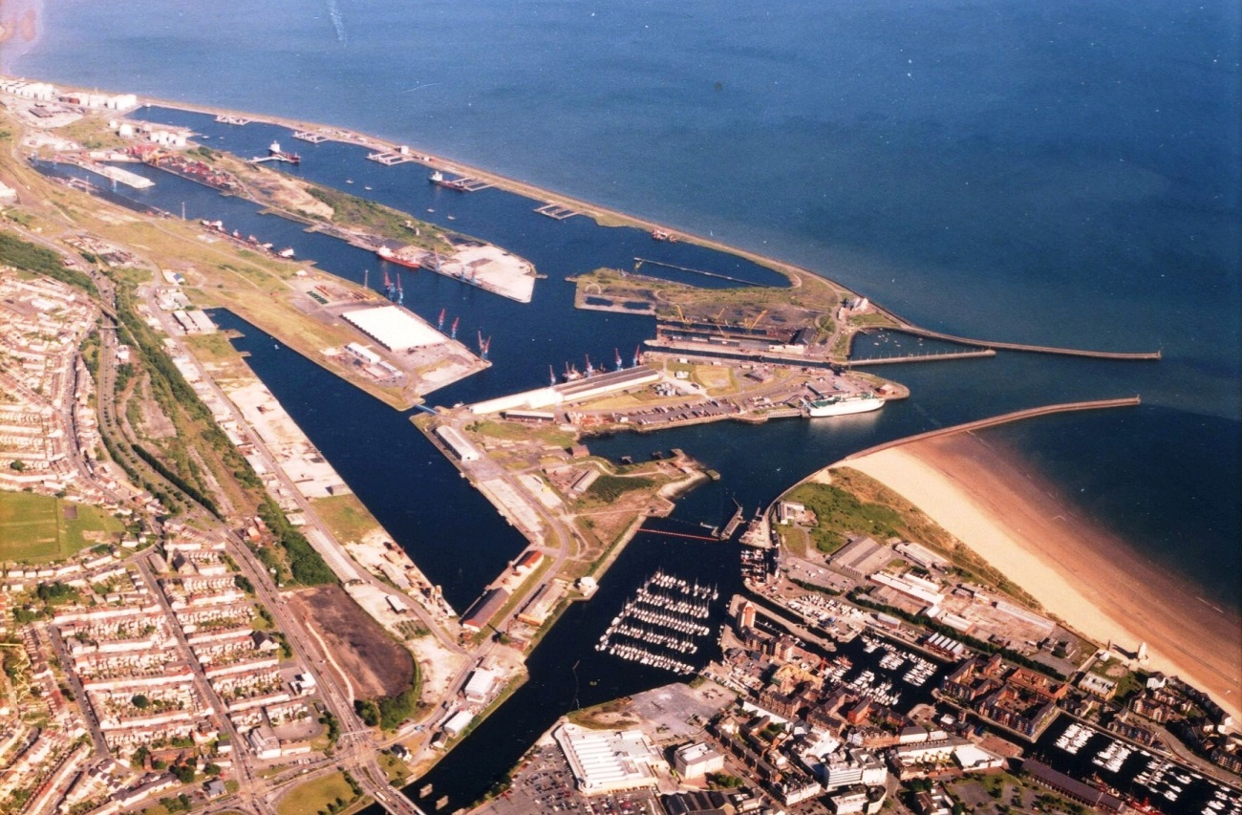

Swansea’s development as a major port began during the early part of the eighteenth century when a rapid expansion in local coal mining and iron production, together with the introduction of copper smelting and tinplate manufacture, resulted in the establishment of many new wharves along the banks of the River Tawe.
Increasing levels of trade throughout the eighteenth century demonstrated a pressing need for more permanent harbour facilities, and so in 1791 the Swansea Harbour Trust was established to undertake this responsibility. The duty of the Trust was to “repair, enlarge and preserve the Harbour of Swansea”, and its initial task was to widen and deepen the harbour entrance to accommodate the larger trading vessels of the day. In 1794 the Trust erected the familiar stone light-house still seen today on Mumbles Head, and in 1809 completed the building of two stone breakwaters to protect the entrance channel and form a small tidal harbour within the area known as Fabian’s Bay.
The continuing growth of traffic between the port and the collieries and metallurgical industries of the Swansea Valley highlighted the need for an improved system of transportation, leading to the completion of the Swansea Canal between Ystradgynlais and Swansea in 1798. This eighteen mile long waterway contributed greatly to the development of Swansea’s maritime trade, as did the later construction of the Neath & Swansea Junction (Tennant) Canal which opened in 1824 to provide a link between the Neath Canal at Aberdulais Basin and ‘Port Tennant’ in Fabian’s Bay, Swansea.
By this time the local copper industry – which had begun with the commissioning of the Landore Copperworks in 1717 – was flourishing due to the ready availability of the high-grade anthracite coal that was essential to the copper-smelting process. During its peak in the middle of the nineteenth century, seventeen of the eighteen copperworks in Great Britain were located within the Swansea area. Before too long the technical skill and knowledge developed within this industry was adapted to the processing of other non-ferrous metals such as lead, spelter, zinc, tin, nickel, silver, and even gold, resulting in Swansea becoming an acknowledged world leader in metallurgical processing and manufacture.
To accommodate such a rapidly escalating level of trade, the Swansea Harbour Trust found it necessary to provide larger, more efficient port facilities and so the Town Float – later to be known as the North Dock – was constructed by diverting the lower reach of the River Tawe into a new channel or ‘cut’, and forming an enclosed dock on the original course of the river bed. This work was completed in 1852 and, in that same year, a private concern known as the Swansea Dock Company began the construction of a second enclosed dock – the South Dock – on the foreshore west of the River Tawe. Financial difficulties set in, however, and the Swansea Dock Company was eventually bought out by the Swansea Harbour Trust who completed the project in 1859.
By 1870 the port was handling over 1.5 million tons per annum, and in 1877 it was recorded that “there is no other harbour in the Kingdom where such an amount of work is done on a given space as at Swansea”. Such growth made imperative the need for further port facilities and so, in 1879, the Swansea Harbour Trust began the construction of a new enclosed dock on the east side of the River Tawe, taking in the whole area of Fabian’s Bay. Known as the Prince of Wales Dock, it was completed in 1881 and extended to its present size in 1898.
Despite a sharp decline in the local copper trade towards the end of the nineteenth century Swansea continued to prosper as a port, with coal exports alone running at over 2 million tonnes per annum. Tinplate exports had also increased – from just 6,000 tons in 1875 to more that 250,000 tons in 1895 – to become one of Swansea’s major traffics. Further port expansion was again required and, in 1905, work commenced on Kings Dock - a larger dock on the seaward side of the Prince of Wales Dock. This work was completed in 1909, together with the long sea wall enclosing an additional area of water later to be named Queens Dock when it officially opened in 1920.
With the Kings Dock in operation the exportation of coal, coke and patent fuel quickly grew, reaching a record level of 5.5 million tons in 1913. Tinplate exports reached their peak in 1924, when 621,000 tons were shipped through the port. However, the early twentieth century saw the beginning of a change in industrial energy resources from coal to oil, and the first oil refinery to be built in the UK - the Llandarcy Refinery – was completed in 1918. To cater for the port's new oil tanker traffic, five large oil jetties, together with associated pipelines and storage tanks, were constructed within the Queens Dock. During the height of this trade in the early 1950’s, oil imports and exports through the Port of Swansea totalled around 8 million tons per annum.
The development of the new docks system on the east side of the River Tawe, together with the progressive reduction of coal exports due to the increasing use of oil, resulted in the docks on the west side of the river becoming largely obsolete. The North Dock closed in 1930 – although the North Dock Basin remained open until 1969 – and the South Dock closed in 1971, only to be thoroughly revitalised in later years as Swansea’s prestigious Maritime Quarter. Today, of course, the Prince of Wales Dock is the centrepiece of the new SA1 redevelopment scheme, whilst the Queens Dock has been rendered virtually redundant by the closure of both the Llandarcy Oil Refinery and the BP Chemicals plant at Baglan Bay. Principally, therefore, it is the Kings Dock that continues to handle the remaining commercial traffic passing through the Port of Swansea.
Note:- Control of the port was retained by the Swansea Harbour Trust until 1923, when the ownership of Swansea and other South Wales ports was transferred to the Great Western Railway Company. Nationalisation under the Transport Act of 1947 brought Swansea Docks into public ownership under the Docks & Inland Waterways Executive of the British Transport Commission, and later, from 1963, under the British Transport Docks Board. The present administrative authority, Associated British Ports, succeeded the British Transport Docks Board in 1982 as part of the government’s drive for privatisation.
Ian Rogerson Swansea and portable docks website

A Brief History Of The Railway
Here is an outline of the key moments in the history of The Swansea & Mumbles Railway.
Origins
During the Industrial Revolution, Swansea developed into an important centre and a seaport town. The Swansea & Mumbles Railway was formed so that lime produced from the Gower kilns and coal from the Clyne Valley could be transported to the wharfs at Swansea.
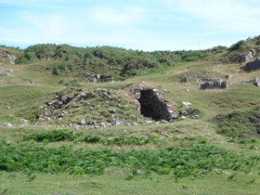
Early Days
There was a growth of industry along the river Tawe during the 18th century and Swansea became famous for its Copper Industry. The Swansea & Mumbles Railway (or the Oystermouth Railroad as it was then known) was originally constructed as a mineral line and not as a passenger service.
Becoming the World’s First Passenger Service
In the year 1807, the Swansea & Mumbles Railway began to carry passengers. It was the first railway in the world to do so. The first passenger carriages were made from the mineral wagons used on the tramroad. The man responsible for this was Benjamin French, an initial shareholder in the railway.
‘Horse Power’
Horse drawn trains remained on the Swansea & Mumbles Railway until 1896 (albeit intermittently with steam powered locomotives). The change from horse-drawn to steam trains did cause anxiety. It was thought that the idea of a noisy, speeding steam locomotive through the streets would frighten people and horses.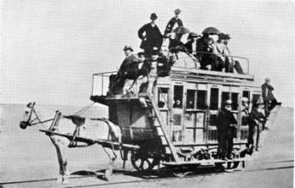
Full Steam Ahead
Steam trials took place on the Swansea & Mumbles Railway between 1878 and 1885 and also between 1892 and 1896. Three of the Swansea & Mumbles Railway steam trains were given names. They were called ‘Crumlyn’, ‘Swansea’ and ‘Hampshire’.
REPORT THIS AD
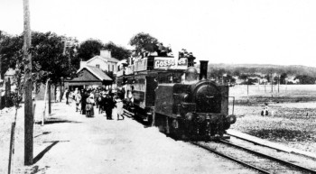
Glory Years
In 1893, The Swansea & Mumbles Railway was extended to Southend. Previously the terminus was at Oystermouth. The extension to the Mumbles was completed in 1898. This made the Swansea & Mumbles Railway very popular with day trippers and tourists who visited the Mumbles Pier.
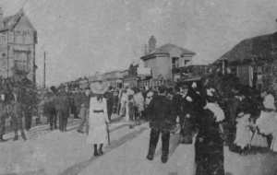
Electrification
The 1920’s was the last decade when the Mumbles Train was hauled by steam locomotives. Steam locomotives ran on the railway until March 1st 1929. Electric trains took over the following day.
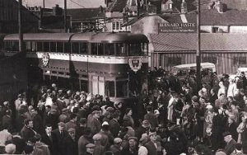
“During the War”
The Second World War (1939-1945) affected Swansea very badly. Heavy bombing raids known as ‘The Blitz’ caused chaos and severe damage to many buildings in the centre and suburbs. The Swansea & Mumbles Railway became an important form of transport during the war years. The electric powered trains were unaffected by petrol rationing.
REPORT THIS AD
Goodbye to the Mumbles Railway
In October 1958, 90% of the shares of the Mumbles Railway Ltd. passed into the hands of the South Wales Transport Company (SWTC). The Swansea and Mumbles Railway finally closed on the 5th January 1960. The last train entered the Rutland Street terminus at 12:20 am.

Mumbles railway.com

A detailed site investigation report will cover a multitude of different aspects relating to the development. This aspect of the development will be undertaken by a specialist Geotechnical company, incorporating the following:-
- Introduction
  - General – (name of the client, what’s proposed for the development)
  - Objective – (investigate, examine, assess and identify)
  - Scope of Work – (desk study and physical testing)
- The Site
  - Site Location and Description
  - Land Use and Site Operations
  - Surrounding Land Use
- Site History
- Site Environmental Setting
  - Physical Setting
  - Geology and Mining
  - Hydrology and Hydrogeology
  - Landfill Site
  - Potential Contamination
- Site Investigation
  - Fieldworks
  - Laboratory Physical Testing
  - Laboratory Chemical Testing
- Ground Conditions
- Geotechnical Recommendations
  - Site Preparation
  - Foundations/Piling and Floor Slabs
  - Risk to Building and Materials Durability
  - Excavations and Formations
  - Access Road and Car Parking Areas
Appendices
A Radon Report
B Trial Pit Logs
1 Site Location
2 Site Plan
Integral Geotechnique – from a work document
The site has had a number of different working aspects undertaken upon it over the past 250 years, the areas which are of main interest/concern to this report are: -
Historically: -
- The site has been used as a railway/tram line in the past and the concern here is that there may be historical railway tracks and sleepers still running or laying under the surface or below the man-made ground.
- During World War Two Swansea received some heavy bombing from the German Luftwaffe, therefore there is a possibility of unexploded ordnance laying below the surface of the said development site. This area must therefore be inspected and treated with the utmost respect due to this high risk.
- A large build-up of man-made ground, as shown on the borehole samples, reference SS69SE/ 345/ 1-3. This would indicate the possibilities of high levels of land contamination.
Present day
At present the site is being used as a car parking area, beach access point and viewing platform for the general public. Care must be taken due to the possibility of service lines and pipes below the ground, along with the general public occupying the shoreline.
Approved document C, Site preparation and resistance to contaminants and moisture, suggests that the extent and level of site investigations needs to be tailored to the type of development and the previous use of land.
The approved document suggests that site investigations should consist of four well-defined stages:
- Planning stage: Setting clear objectives for the site investigation, including scope and requirements, which enable it to be planned and carried out efficiently and provide the required information.
- Desk study: Reviewing historical, geological and environmental information about the site.
- Site reconnaissance (a walkover survey): Identifying actual and potential hazards and the design of the main investigation.
- Main investigation and reporting: Including intrusive and non-intrusive sampling and testing to provide soil parameters for design and construction.
Site investigations should include:
- Susceptibility to groundwater levels and flow.
- Underlying geology, and ground and hydro-geological properties.
- Identification of physical hazards.
- Identification of methane and other gases.
- Determining an appropriate design.
- Providing soil parameters for design and construction.
Where a site may be affected by contaminants, a combined geotechnical and geo-environmental investigation should be considered and remediation maybe necessary.
It may also be necessary to notify findings to regulatory authorities, for example:
- Where contaminants are found that had not been previously known about.
- In planning applications.
- In relation to waste management and the protection of water quality and resources.
Designing Buildings wiki.
The building regulations relating to the ground investigation and substructure construction on this site So are.
- Approved document A structure. https://gov.wales/building-regulations-guidance-part-structural-safety
- Approve document C contamination and moisture. https://gov.wales/building-regulations-guidance-part-c-resistance-contaminants-and-moisture
- Contaminated Land Statutory Guidance – 2012. https://gov.wales/sites/default/files/publications/2019-08/contaminated-land-statutory-guidance-2012.pdf
Code of construction practice
A code of construction practice (CoCP) sets out the standards and procedures to which a developer or contractor must adhere in order to manage the potential environmental impacts of construction works.
Many local authorities (and some other public bodies and large clients) have codes of practice that apply to new developments, setting out requirements in relation to matters such as:
- Permitted working hours.
- Liaison with neighbours.
- Noise and dust monitoring.
- Air quality.
- Agriculture, forestry and soil.
- Cultural heritage.
- Ecology.
- Settlement.
- Land and landscape protection.
- Traffic and transport.
- Waste management.
CoCP’s may be attached to a planning permission, or they may form part of the contract documentation for a project. Suppliers, or developers may be required to develop a site environmental management plan (SEMP) setting out how they will comply with the CoCP.

Due to the geological makeup of the site, as well as the planning Department for full planning consent prior to the start of the development, other departments that may require notification are: - Environmental Health Department, Health and Safety Executive, Building Control to undertake the required phase inspections of the development, along with the Local Authority Structural Engineers.
Each of the above departments will undertake their own separate inspection of reports and/or on-site investigations. Environmental Health will inspect the issued reports as well as undertaking multiple on-site inspections, during the site clearance, excavation and reinstatement of any imported land fill.
Health and Safety will undertake a full inspection of the written reports and may visit site initially, otherwise their involvement is limited.
Building Control will have the most involvement, structured around their stage inspections, incorporating, ground and foundation inspection, supper structure inspection, pre-plaster inspection and final inspection, incorporating all certification.
Structural Engineering department will undertake a full and in-depth assessment of all structural calculation, making sure all details are correct and suitable for the superstructure being implemented.

Driven Pile foundations.

I have decided to implement driven concrete piles, this is due to the structural makeup of the site ground conditions.
As per the boar-hole data, the ground consists of up to 4.95m deep of bricks, ash, sand and clay, with a further 3m of dense brown sand and with some gravel. A further 3.05m of grey-brown gravel and boulder clay runs before hitting very stiff boulder clay for 7.60m, at which point grey mudstone is discovered. (drillers description)
I would structure my piles to a depth of 5.50M. Driven piles displace the material around the pile shaft outwards and downwards instead of removing it, this in turn will densify loose soil upon implementation.
My pile cap or foundation will be a 900mm wide x 450mm steal meshed reinforced concrete foundation, structured with an RC 35 S2 concrete mix.
The above decision is bases upon the borehole test results shown at the end of this report.

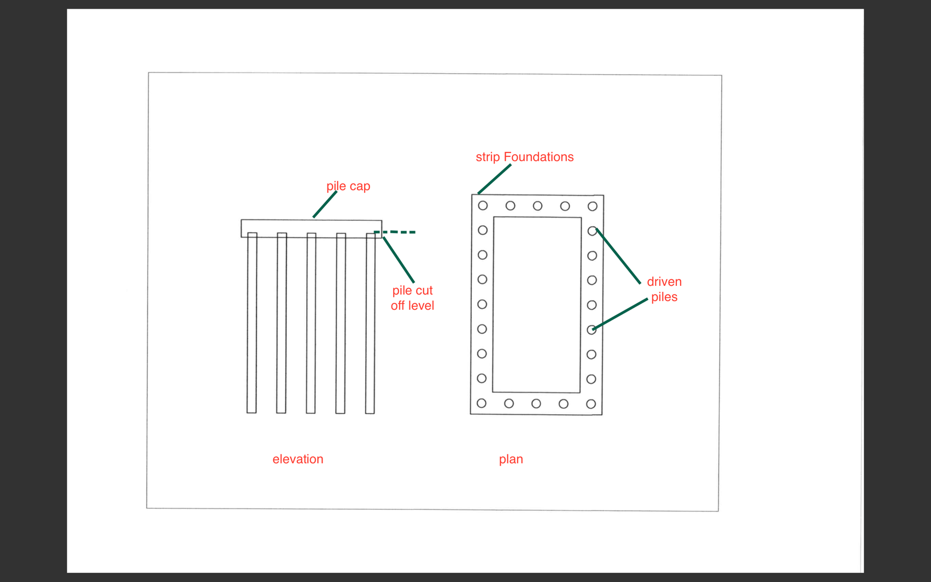
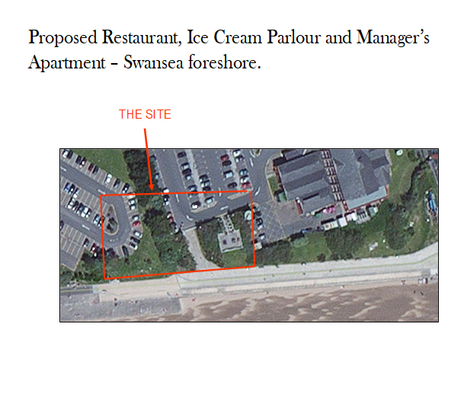
Paxton Street Borehole Results


