

Lewis wells
Student number: 1503245
Module: Research Methods & Data analysis
Lecturer: Dr Mabrouka Abuhmida

Table of Contents
Abstract 3
Introduction 3
Case study 4
Tests 4
Frequency distribution 5
Measures of central tendency 8
Mean 8
Median 8
Mode 9
Standard deviation 9
Variance 11
T-test 12
Conclusion 14
Bibliography 15

Figure 1 – Sample dataset.. 4
Figure 2 - Ranges 5
Figure 3 – Mature Students frequency distribution. 6
Figure 4 – Young Student frequency distribution. 6
Figure 5 – Mature Students Tally. 7
Figure 6 – Young Students Tally. 7
Figure 7 – Formula and mean for datasets. 8
Figure 8 - Calculating the Median Values. 9
Figure 9 - Standard Deviation with and without Outliers. 10
Figure 10 - Standard deviation Mature students. 10
Figure 11 - Standard deviation Young students. 11
Figure 12 - Alpha ranges. 11
Figure 13 - Variances with and without outliers. 12
Figure 14 - F-test results. 12
Figure 15 - T-test with alpha 0.10. 13
Figure 16 - T-test with alpha 0.02. 13
Figure 17 - T-test with alpha 0.01. 14

Abstract

The following document will outline important techniques associated with data analysis and apply them to a sample dataset to achieve a decision to accept or reject a hypothesis. The techniques will be imperative in the decision making and provide useful information regarding the significance of the differences between the datasets.

Introduction

Data analysis is the process of reviewing, purifying, transforming and developing the data with the purpose of uncovering valuable information to help support any decisions or assumptions made [1]. There are a multitude of techniques which can be applied by businesses or organisations to analyse the data sets they have, they use these techniques to help the organisation attain a more effective operation.

Case study

A study was performed to test the satisfaction of university students, the study included younger and mature students and concluded with the students providing a satisfaction feedback score between 0 - 60. The purpose of the case study is to identify any differences between the young students (aged 17 -20) and the mature students (aged 45 -62).
The results of the feedback are below:

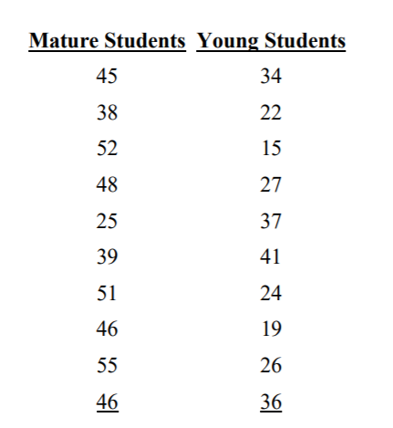
Figure 1 – Sample dataset..
The higher the score indicates a higher degree of satisfaction.
For the purpose of the investigation into the differences in the data a hypothesis must be specified to test against. The null hypothesis or $H_{0}$ will be $H_{0}:μ_{Mature}=μ_{Young.}$ The $H_{0}$ is the opposite of what the investigation intends on examining [2]. For this investigation the case study aimed to “examine differences” so the $H_{0}$ is that the sets are equal and there are no differences and the $H_{1}$ or alternate hypothesis is that there are differences between the sets so a $H_{0}$ would be rejected.
A relevant set of tests will now be conducted to determine any differences or similarities within the data and provide a decision on the possibility of accepting or rejecting the hypothesis stated.

Tests

Frequency distribution
The current data set is unorganised to the first step would be to order the data so the data can be understood simpler, a frequency distribution can give a better representation of the sample sets of data. The frequency distribution provides a summary of how the frequencies are distributed over values, these scores can be grouped together for large data sets or data sets with a large range.
The first step is to find the range of the sample sets; this can be seen below:
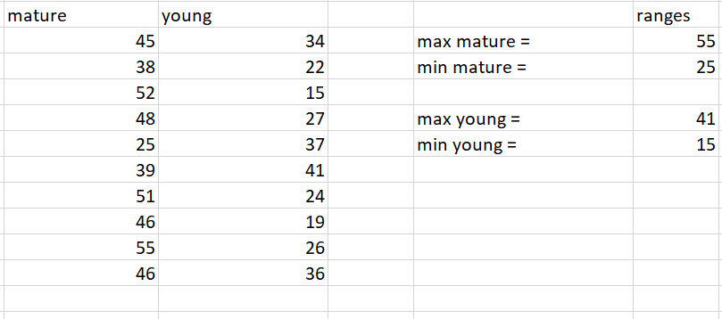
Figure 2 - Ranges
By analysing the two sample sets these assumptions can be made:
- The amount of data gathered is limited, each set only has 10 values.
- They have large ranges considering they are small data sets, mature has a 30 difference and young has a 26.

Due to the high ranges in the data sets it would be suggested that tallying the data in groups would be beneficial, with such a small amount of values to attain information from incrementing the tally score by one would be detrimental to the retrieval of data. To calculate how the interval’s increment, the minimum range is subtracted from the maximum and divided by the amount of values in the data [2].
- Maximum mature = 55, Minimum mature 25, (55 – 25 = 30), (30/10 =3).
- Maximum young = 41, Minimum young = 15, (41 – 15 = 26), (26/10=2.6).
Based on the results of the range analysis an interval increment of 3 would be appropriate to represent the data in the frequency distribution. The histogram and polygon below illustrate the results from the frequency distribution.

Figure 3 – Mature Students frequency distribution.

Figure 4 – Young Student frequency distribution.

Figure 5 – Mature Students Tally.

Figure 6 – Young Students Tally.
The univariate data shows the intervals and frequency of the data set in a polygon and pivot chart. When analysing the graph’s, it noticeable that the distribution is skewed and there is no normal curve. The graphs illustrate different scales of variability and do not appear to signify any resemblance of a normal curve, this would possibly be because of the ranges and the dataset containing outliers [3].
The normal is curved is typically represented by a bell shape curve when producing a type of frequency distribution, if a graphical representation indicates a bell curve then it can be believed that this would suggest that there is some correlation within the data which is not apparent in the illustrations above [4]. It can be noted that the mature student’s illustration provides a more positive skew than the young students; however, at this stage of the investigation a decision cannot be made regarding the acceptance of the hypothesis.

Measures of central tendency

The measures of central tendency are techniques used when analysing statistics to identify centre points or common value within a dataset [5]. The methods will give an indication where the preponderance of values fall within the distribution and the results can be used to compare against any other results obtained, or nay results from future tests.

Mean

The mean is calculated by adding the values in a dataset and dividing by the amount of values in it. Formula $\overline{X}=\frac{\sum{X}}{N}=$ Result [6]. Figure 7 shows the results when the mean is applied to the dataset.
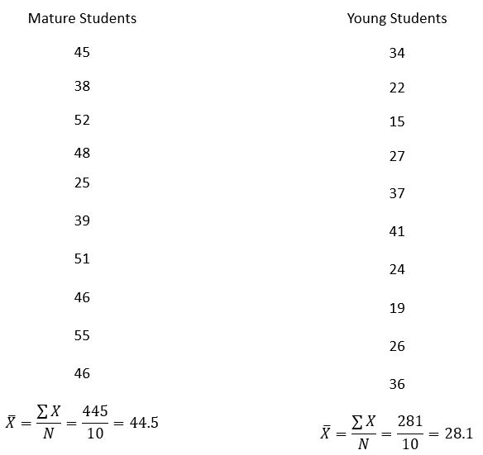
Figure 7 – Formula and mean for datasets.
It can be observed from figure 7 that the two samples of data have a significantly different averages, the next step is to find the median.

Median

The median is essentially a central point value which divides the distribution in half [7], the dataset is organised from the minimum value and ascends to the maximum value.
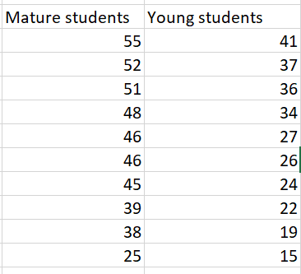
Positions 5 and 6.
Figure 8 - Calculating the Median Values.

Figure 8 shows the satisfaction levels when organised, each category has 10 values each so the median will be calculated by taking the difference from position 5 and 6 and dividing it by 2 then adding it to the value contained within position five [7].
Mature median = 46.
Young median = 26.5.

Mode

The mode consists of the most reoccurring values within a dataset [8], when applied to the sample set the results are:
Mature student’s mode = 46 (represented twice in Figure 8).
Young student’s mode = Not available, there is no reoccurring values in the sample data of the young students. If the experiment was conducted with more test subjects, then this would increase the probability of a reoccurring score.
The tests have presented meaningful inconsistencies between the mature and young students, more tests will commence to strengthen the decision to accept or reject the null hypothesis stated previously. It is important to consider the representations from the frequency distribution already conducted, the distribution was skewed conceivably due to the scale of ranges and occurrence of outliers so further tests to test the difference should be undertaken [9]. Testing the variance and standard deviation will give an improved approval to accept or reject the null hypothesis.

Standard deviation

The standard deviation is a method used to calculate the proportion of variation of a set of values, it provides a numeric value which can give an indication of how close the values are to the mean of the dataset. A low value would signal that the values are close to the mean and high return value the opposite [10].
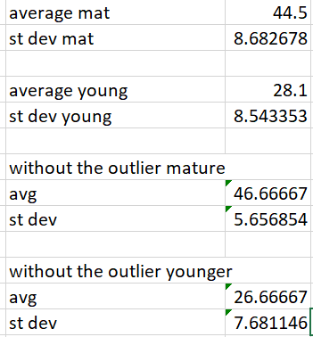
Figure 9 - Standard Deviation with and without Outliers.
Figure 9 shows the results of applying the standard deviation to the dataset. The initial standard deviation is relatively similar between the sample sets but when the outlier is removed from each set the is some variation between the sets.
An outlier is a value which has no correlation or relation to the rest of the points in a dataset, outliers can be a result of human error or just a random result. They can have huge significance in statistical analyses because they can cause abnormally large ranges and affect the tests which they are contained in [11].

Figure 10 - Standard deviation Mature students.
It can be seen from figure 10 that the majority of the values reside above the mean of the mature sample, the data had been sorted from minimum to maximum to demonstrate where the mean exists.
Below shows the standard deviation of the Young student’s sample, the majority of the values reside below the mean of the dataset.

Figure 11 - Standard deviation Young students.

When plotting the standard deviation, it would be expected that 68% of the values fall into the range of what the standard deviation deviates from the mean (figure 11).
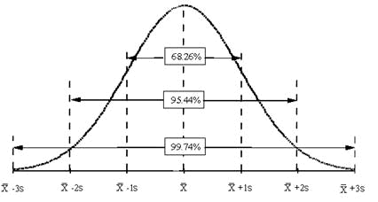
Figure 12 - Alpha ranges.
The illustration above shows where the data would be expected to reside based on a normal distribution, any values outside the 95% can be considered outliers or incorrect samples. Depending on the results of the T-test which will follow, will give an indication on the significance of the mean values and will provide clear judgement regarding the hypothesis.

Variance

The variance in statistical is effectively an alternate way to represent the standard deviation, the variance is calculated by squaring the standard deviation. The standard deviation can provide the user with a better interpretation of the result in comparison to the data; whereas the variance is commonly thought of as a better way to develop the theory [12].
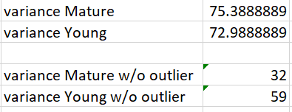
Figure 13 - Variances with and without outliers.
Figure 9 illustrates the variances of the sample data, there is some difference between the data sets with the outliers included; but without the outliers there is significantly more variance. The extent of the variance may not appear to be substantial (without outliers) but the mean of the two sample sets has a great difference, the variance only tests how far away the values are from the mean but is still an important method to add evidence to the decision to accept or reject the null hypothesis.
A further F-test was completed to check if the variances in the two samples sets were equal the results are contained below in figure 14.
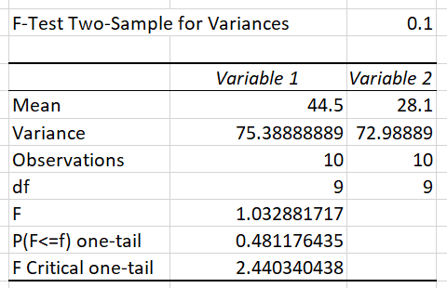
Figure 14 - F-test results.
F is inferior to F critical one-tail which would imply that the null hypothesis would be accepted in this test; however, a t–test will give a greater indication to accept the null hypothesis as a whole.

T-test

A T-test is used to compare the means of the two samples of data [7], as the case study only has two samples (mature and young), the T-test will result in values which can be tested against a p-value which invariably will indicate the measure of difference between the two sample sets of data. This test if useful for the experiment to provide justification to accept or reject the null hypothesis by examining the significance between the means of the datasets. This test will be the final test conducted and if any differences are identified then it would be correct to reject the null hypothesis.
The first step when conducting a T-test is to declare the hypothesis, the null hypothesis or $H_{0}$ will be $H_{0}:μ_{Mature}=μ_{Young.}$ and the $H_{1}$ or alternate hypothesis is that there are differences between the sets.
The dataset will be tested against specific significance levels:
- 0.10.
- 0.02.
- 0.01.
A two-tailed t-test will be exercised because the hypothesis is to discover if the sets are equal rather than greater or less than each-other.
The results of the T-test ($t_{stat}$ and $t_{crit}$) will be used to compare against the alpha values which will show the volume of significance regarding the mean from each set.
As the null hypothesis is testing for equal data between the sets a two-tailed T-test will be conducted, a two-tailed t-test should be undertaken when testing if the datasets represent equal information and accept the null hypothesis if this is true.
The results of the t-test are show below:
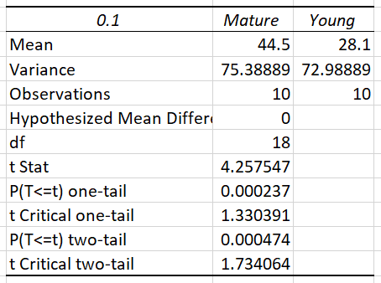
Figure 15 - T-test with alpha 0.10.
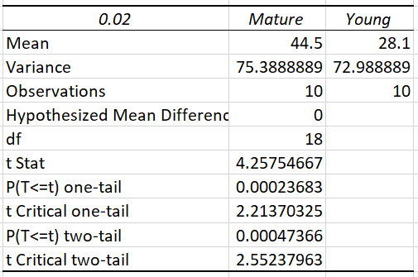
Figure 16 - T-test with alpha 0.02.
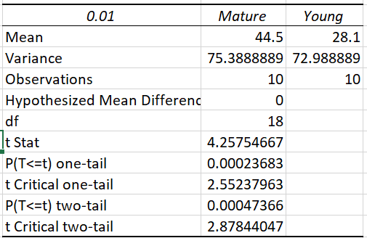
Figure 17 - T-test with alpha 0.01.
The t-test was completed with alphas 0.10, 0.02 and 0.01, the purpose was to acquire the values of the ($t_{stat}$ and $t_{crit}$) to contrast together. It can be acknowledged from the illustrations that the $t_{stat}$ is greater than the $t_{crit}$ which would suggest that there significant grounds to reject the null hypothesis. Using the alpha 0.01 (1%) and receiving a greater $t_{crit}$ value demonstrates that there is less than a 1% chance (at each end of the distribution) that the level of significance ensued by chance.

Conclusion

After examining the datasets and proceeding to commence various tests, it can be concluded that the $H_{0}:μ_{Mature}=μ_{Young}$ can be rejected. The f-test which compared the variances between the sample sets was the only test where the $H_{0}$ was accepted, this result was not unexpected as the f-test only tests for the extent of the variance from the mean of the samples.
The measures of central tendency provided useful information to help reject the $H_{0}$, testing the mean of the datasets resulted in a substantial difference. The difference in the mean of the two sets presented an early assumption or indication that the $H_{0}$ would be rejected but further tests needed to be conducted to further strengthen that decision.
The datasets were ordered to calculate the mode and median and indicated more levels of disparity regarding the samples.
The standard deviation and variance results showed insignificant levels of differentiation which was enough to accept the $H_{0}$ for that test alone.
Finally, a t-test was conducted to finally enhance the decision to reject the $H_{0}$, it was undertaken and the results were utilised to compare against the alpha. The t-test provided the most important evidence in the conclusion to reject the null hypothesis. All 3 $t_{stat}$ values showed a greater denomination than the and $t_{crit}$ which identifies the degree of significance levels when comparing the means.
The test would have more efficient had the dataset been larger, when trying to test the impact the outliers it can be assumed that they are significant due to the minimal size of the dataset. The value 25 was a clear outlier in the Mature sample as it had a substantial difference to the mean than the rest of the data.
The choice to reject the null hypothesis is definitely the right decision as the majority of the tests resulted in producing significant differences when comparing the datasets.

Bibliography

[1] | W. M. j. W. M. MohammedJ. Zaki, Data mining and Analysis, Cambridge university press, 2014.
[2] | J. H. Kranzler, statistics for the terrified, Rowman & Littlefield, 2017.
[3] | D. W. T. H. R. T. Gareth James, An introduction to statistical learning, Springer Science & Business Media, 2013.
[4] | H. W. Garrett Grolemund, R for Data Science, O'Reilly Media Inc, 2016.
[5] | P. Bazeley, Qualitative Data Analysis, SAGE, 2013.
[6] | S. Few, Show me the numbers, Analytics Press, 2012.
[7] | P. C. B. Andrew Bruce, Practical statistics for data scientists: 50 Esssential concepts, O'Reilly media Inc, 2017.
[8] | A. Downey, Think Stats, O'Reilly Media Inc, 2011.
[9] | J. M. S. Jeffrey S. Saltz, An Introduction to Data Science, SAGE Publications, 2017.
[10] | R. T. J. H. F. Trevor Hastie, The Elements of Statistical Learning, Springer Science & Business Media, 2001.
[11] | C. Taylor, “How are outlies Determined in Statistics,” ThoughCo, 05 June 2017. [Online]. Available: https://www.thoughtco.com/what-is-an-outlier-3126227. [Accessed 02 January 2019].
[12] | W. Winston, Microsoft Excel Data Analysis and Business Modelling, Microsoft Press, 2016.

