Module 2 – BMPF 7323
Research Methodology and Ethics
Angelina Van Dyke
Student No. 2316809
Word Count: 4117

Introduction

This examination of research design commences with an exploration of ontology and epistemology to clarify my personal ontological standpoint, considering both subjective perspectives and broader philosophical implications of the concepts of worldview and spirituality and their impact on singing career motivation and artistic expression. Since people make decisions based on their worldview or framework of understanding (Steiner, 1983), it is reasonable to link worldview and career motivation on the one hand and spirituality and artistic choices on the other. Career decisions often reflect intellectual priorities, while artistic output tends to mirror the spiritual values of the artist.

Various research paradigms will be reviewed, with a critical assessment of their relevance to the proposed research. Methodological considerations include ontological and epistemological assumptions, types of research paradigms, and approaches to data collection and analysis. Deliberating on a suitable theoretical perspective to undergird my methodology, I will explore various frameworks, realizing that different theoretical perspectives reassemble the elements of the world under investigation into novel configurations, each theory offering unique insights (Gilbert, 1999). For example, the construct of motivation in my study can be viewed from several psychological perspectives, each involving different notions about the individual within society and professional life. An overview and evaluation of quantitative and qualitative research methodologies, research designs, and methods will be provided.

Issues surrounding my future research proposals will be examined concerning the potential impact of insider researcher status on my research involving colleagues and mentors. While insider research offers a unique perspective on the topic, there are challenges such as subjectivity and potential bias. Triangulating insights from historical sources and employing a mixed methods approach help mitigate these issues. Foregrounded ethical considerations are informed consent, confidentiality, maintaining integrity, and refraining from altering findings.

Critical Evaluation
Ontology is the study of being or what is considered reality. My ontology assumes a rational universe in which reality is composed of interacting, yet separate, physical and metaphysical mechanisms, which individuals apprehend and respond to from within their perspectival means (Frame, 2012; Poythress, 2014). While it is not possible to reduce metaphysical experience to mathematical equations or empirical evidence, repeatable patterns of subjective spiritual experience can be rationally described and discussed, moving the topic beyond conjecture toward a measurable scale of qualities such as awe, peace, or compassion (Underwood, 2011). One can postpone questions of ontology with a rational, realistic phenomenology that contrasts with the rational, materialistic ontology of positivism and the subjective, non-materialistic phenomenology of most spirituality (Hartmann, 2017). The ‘being’ of the subject is included in the reality being examined, separate from, yet interactive within it, providing a rich hermeneutic (Heidegger et al., 2008). For example, in a performance a soloist exists as an individual entity within the reality of a performance space, separate from the audience and other performers (Levinson, 2011). However, the soloist's 'being' interacts with the music, lyrics, and emotional expression of the song, intentionally shaping the atmosphere and energy of the performance space for both soloist and audience (Foulds-Elliott, 2004). This interactive involvement illustrates how the 'being' of the soloist, is included in the reality of the performance while remaining distinct from it.
Epistemology studies truth claims and what can be accepted as knowledge. It explores whether knowledge is limited to verified facts or includes presuppositions, intuitions, and non-empirical logic (Ravitch and Riggan, 2012). Dudovskiy (2022) categorized knowledge as intuitive, authoritarian, logical, or empirical, emphasizing objectivity. Heron and Reason (1997) and Heron (1996) prioritized experiential, presentational, propositional, and practical knowledge, advocating for social change. The epistemological spectrum ranges from objective positivism, based on quantitative data, to subjective interpretivism, based on researchers' and participants' experiences (Scott, 2022). Pragmatism integrates multiple methods for practical outcomes, alongside positivism and interpretivism, requiring high standards for justifying knowledge claims and research design (Sol & Heng, 2022). These constructs should form a coherent whole, unifying understanding with both data and theory-driven approaches.
My epistemological stance acknowledges objective truth, subjectively perceived through individual engagement with realities, allowing for knowledge construction through mental representations (Piaget, 1970). For example, a study examining audience perceptions of vocal performances may require both quantitative and qualitative methods to capture the full experience (Scott, 2022). Quantitative analysis tests hypotheses and theories, objectively reporting statistical analysis of large sample data numerically, whereas qualitative analysis subjectively explores ideas for forming theories or hypotheses, categorising, summarising, or interpreting smaller sample data in words (Creswell and Creswell, 2022). Merrill (2023) used a mixed-methods approach to study untrained listeners' perceptions of singing, combining a quantitative questionnaire and qualitative interviews to link vocal characteristics with listener reactions. Qualitative analysis managed the psychosocial nature of vocal research within a pragmatist-realist paradigm, allowing for a thoughtful mix of quantitative and qualitative data collection and analyses (Scott, 2022). In short, the positivist, interpretivist, and pragmatist lenses offer different ways to investigate audience perceptions: positivist methods quantify experimental or survey data such as tracking eye movements (Kawase and Obata, 2016), interpretivism values understanding meaning from individual viewpoints through interviews or observation (Heim, 2022), and pragmatism employs mixed methodologies to consider both objective and subjective indicators of performance quality and audience engagement for practical insights (Merrill and Ackerman, 2020).
Axiology is what you believe about something, namely the study of values or axioms. Determining beliefs depends on the relative value placed on knowledge based on intuition, faith, books, research, experts, logical reasoning, established facts, or practical experience (Scott, 2022). Hatfield’s (2024) case study on motivation in elite musicians and sports athletes employed semi-structured interviews within a post-positivistic framework of critical realism. This approach recognizes an objective reality while acknowledging the limitations and biases in human knowledge, affirming that social phenomena occur both in the mind and the external world (Bhaskar, 2015; Miles and Huberman, 1994). Specifically, social interaction relates to Theory of Mind (Leslie, 1987), the ability to attribute mental states such as beliefs, desires, intentions, and emotions to oneself and others, a critical skill for understanding and predicting the behaviour of others and navigating social interactions effectively. Since Hatfield’s study (2024) is embedded in Self-Determination Theory (SDT) (Deci and Ryan, 1985, 2000; Ryan and Deci, 2020), the inquiry and subsequent data analyses abductively expanded the theory by triangulating inductive extra-theoretical explorations with deductive, theory-confirming strategies. Furthermore, in SDT, Deci and Ryan posit that intrinsic motivation is driven by the fulfillment of autonomy, competence, and relatedness needs, which complements self-discrepancy theory (Higgins, 1987), suggesting that discrepancies between actual and ideal selves motivate change and enhance well-being, as measured in terms of autonomy, competence, and relatedness. Where self-discrepancy theory may fall short is in its negative focus on the gap between real and ideal and the neglect of other factors influencing career motivation, such as evolving opportunities, calling, or intrinsic passion for music (Dobrow, 2013).
Hatfield’s (2024) model of inquiry is a good candidate for my study of late 20th century classical singers, since the semi-structured interviews are both exploratory and provide evidence for hypothesising that worldview and spirituality significantly impact professional career motivation. Not only is the topic of motivation highlighted within a similar participant category in Hatfield’s study, but also the theoretical impact of the singer’s worldview and spirituality can be analysed within this epistemological framework.
Paradigms
Schwandt (2007) defines a paradigm as a shared worldview guiding how problems are investigated and solved. Kuhn (1962) describes it as a set of beliefs, values, methods, and assumptions in a scientific community. Outlining the paradigm wars since the 1970s, Denzin (2010) describes the movement from positivism to post-positivism, which recognizes the existence of objective reality but acknowledges that our understanding of it is inherently imperfect and influenced by human perspectives and biases. Debates between quantitative (post-positivist) and qualitative (constructivist and interpretivist) camps advocating for the superiority of their approach in generating valid knowledge have reconfigured the relationship between paradigms, methodology, epistemology, and ethics (Denzin, 2010). Consequently, incommensurability theories have given way to complementarity, encouraging a combination of methods and perspectives (Dalwadi et al., 2021). My future study will use a mixed-methods approach to comprehensively address the research questions (Creswell and Creswell, 2022). It will integrate post-positivist and interpretivist frameworks within a complimentary pragmatist paradigm (Fetters, 2016), prioritizing flexible design over a strict epistemological stance to produce socially useful knowledge (Felizer, 2010).
Understanding the experience of professional singers and their capacity to tap into their spiritual and intellectual resources during singing requires open research methods (Flick, 2018). A constructivist paradigm, which values multiple perspectives and suggests reality is shaped by human interactions (Creswell and Plano Clark, 2018), is a candidate for analyzing semi-structured and narrative interviews, allowing for the interpretation of participants' experiences and realities (Pringle-Nelson, 2023). This interpretivist approach would contextualize these experiences, acknowledging multiple realities and perspectives (Willis, 2007) within a constructivist pragmatist framework to emphasize the practical consequences of beliefs and actions (McChesney and Aldridge, 2019). Constructivism emphasizes the process of knowledge formation and the existence of multiple realities based on individual experiences, while interpretivism prioritises understanding and interpreting the subjective meanings and experiences of individuals within their specific contexts (Denzin and Lincoln, 2018). Employing hermeneutical phenomenology to interpret complex meanings and assumptions about worldview and spirituality from participant contributions (Gadamer, 1998), researchers avoid self-focused interpretations by "bracketing out" their own experiences, focusing on the phenomena revealed (Finlay, 2012).
The mixed-method approach in this study is modeled after philosophical pragmatism, avoiding a specific problem-focused approach which can lead to an "everything-is-okay-as-long-as-the-work-gets-done" mindset (Gibson, 2016). Bolstered by critical realism, a layered ontology which differentiates between the empirical, actual, and real levels of reality causing observable phenomena (Maxwell and Mittapalli, 2010), the practical insights of pragmatism applied to the field of vocal pedagogy are complimented by a nuanced understanding of the hidden influences of spirituality and worldview. Triangulating various methods helps mitigate researcher bias, ensuring epistemological and ontological integrity and sensitivity (Burke, 2016). However, combining qualitative understanding and quantitative measurement through triangulation is challenging (Mertens and Hesse-Biber, 2012). Triangulation in qualitative sociological research considers agential causation (A-causation) capturing human behaviour intentions and quantitative mechanical causation (M-causation) for ordered behaviour processes (Howe, 2012). Both methods address these causations, showing compatibility at the technique and procedures level (Howe, 2012). For example, a quantitative survey identifying why professional singers teach later in life can find A-causal relationships, compared with qualitative data from interviews. Mixed methods interpretivism reverses the role of quantitative methods to descriptions and qualitative methods to explanations of causation (Howe, 2012). Integration of quantitative and qualitative data should provide a coherent explanatory framework, not just agreement between data sets.
In my own study design, a qualitative analysis of text for keywords, meanings, and themes from participant interview data would be an essential component of flagging a causal relationship between worldview and career motivation, and spirituality and artistic expression. The biographical content analysis provides a larger sampling, allowing for numbered occurrences of references to spirituality, religion, worldview, emotion, motivation, expression, artistic vision and singing. Following Howe’s explanation (2012), the quantified biographical data would describe agential causation, while the qualitative interview data would explain it.

Research Design and Methodology
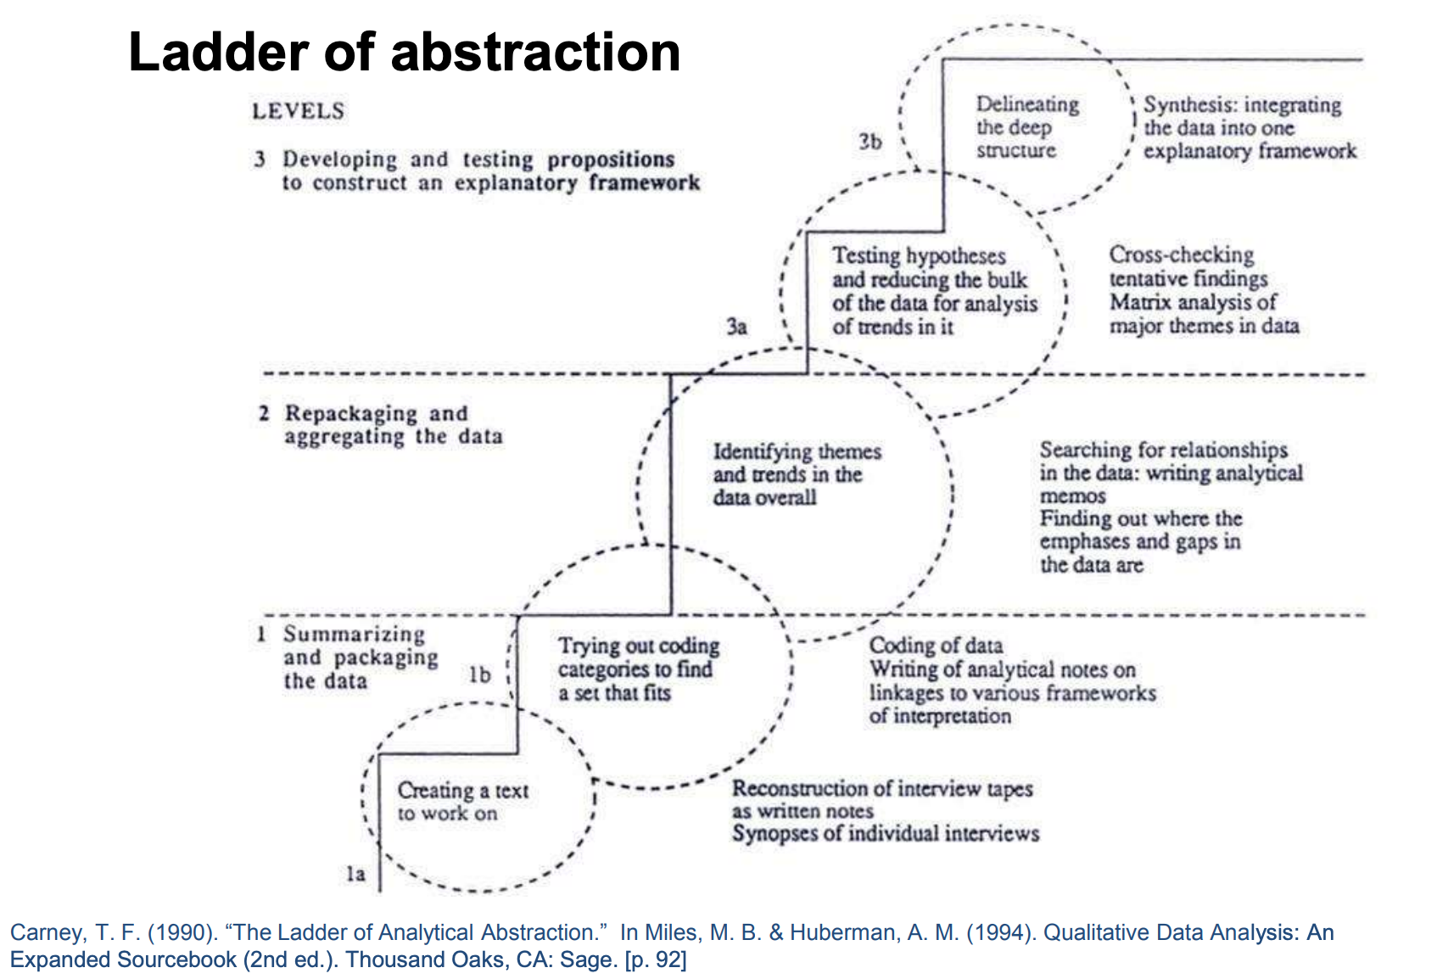
Research design provides the overarching structure for a study, outlining its purpose, scope, approach, and intended outcomes (Creswell and Creswell, 2022). Quantitative and qualitative methods within a complementary post-positivist and interpretivist paradigm of pragmatism and critical realism are kept separate to realize the strength of each paradigmatic position (Teddlie and Tashakkori, 2010). This study utilizes a mixed methods approach, including biographical surveys, case studies, and interviews, to explore the impact of worldview and spirituality on 20th-century North American classical singers’ careers and artistic expressions. Data will be collected from 75-100 biographies, select case studies, and 3-5 participant interviews, all analysed using Carney’s (1990) ladder of abstraction (in Miles and Huberman, 1994, p. 92).

These levels of abstraction are analogous to cycles of coding text, first descriptive, then interpretive, and finally explanatory, delineating patterns, themes, and causal links (Miles and Huberman, 1994; Saldaña, 2016). Some codes will be pre-defined in relation to key research variables, such as setting and context, worldview, spirituality, ways of thinking, motivations, and relationships to societal structures. This initial etic perspective would be processed into a more inductive post-defined coding approach, taking cue from grounded theory and the emic stance of participant data instead of prioritizing the researcher's perspective and the opportunistic application of theories (Glaser and Strauss, 2017).
A basic qualitative research study applied to the participant interviews aims to understand how subjects make meaning of their experiences. Added dimensions will include phenomenological and narrative analysis to focus on both the essence or underlying structure of a phenomenon and the use of people’s stories to understand experience (Miriam and Tisdell, 2015).
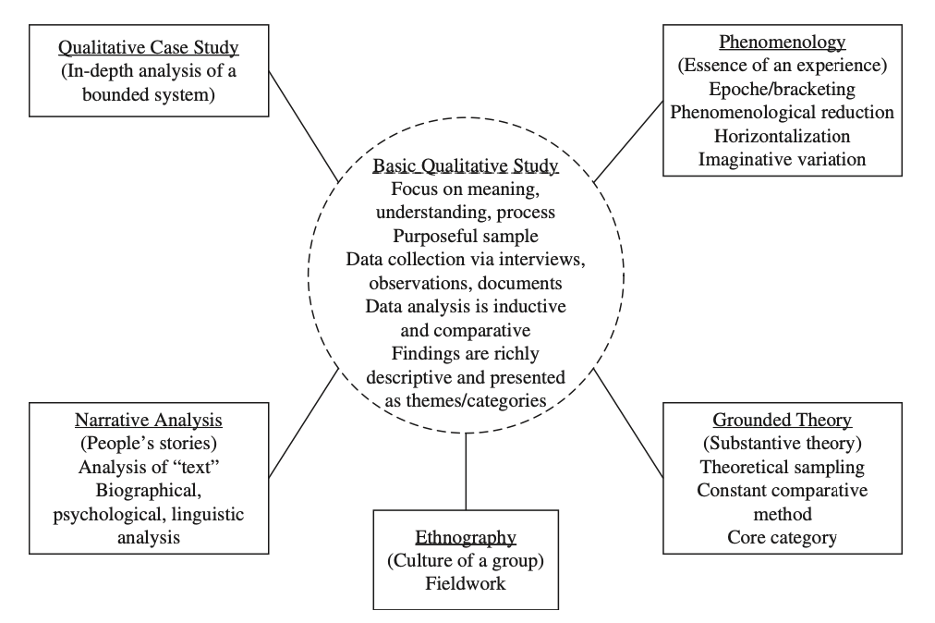 Figure from Miriam and Tisdell, 2015, p. 42. Types of Qualitative Research
Thus, participants can construct how the phenomenon of worldview and spirituality influences career and singing expression and what this means for singers, audiences, and pedagogues. A narrative analysis would interpret the stories of participants to construct the meaning of their experiences, much like Tisdell’s (2003) study of 31 adult educators in understanding how spirituality informed their own development and efforts as cultural workers (in Merriam and Tisdell, 2015, p. 25).
Both Husserl's phenomenology and Heidegger's hermeneutic circle offer philosophical frameworks for comprehending human experience. Husserl's (1988) phenomenological philosophy focuses on qualitative phenomenology, exploring how lived experiences are transformed into consciousness. It challenges positivism in psychology by emphasizing the inherent connection between subject and object, suggesting a strong embodiment perspective that implies limitations to transcending one’s physical environment. This perspective is taken by Dallas Willard (2021) who states, “The body lies right at the center of spiritual life – a strange combination of words to most people. One can immediately see all around us that the human body is a (perhaps in some cases even the) primary barrier to conformity to Christ” (p. 159). While a perceived obstacle to conformity to Christ, the body is not necessarily the centre of spiritual life, just as tension in one’s psoas muscles inhibits breathing and singing but is not the centre of breathing and singing (Koch, 2017; Bartoskova, 2021). On point, it is more certainly the soul which lies at the centre of spiritual life (Bolman and Terrence, 2001).
While any attempt to transform self that ignores the physical body is doomed to failure, embodiment as a central spiritual principle implies that all mental life is evaluated solely in relation to physicality. In contrast, Heidegger's hermeneutic circle (Being in Time, 1927) involves deriving new insights by continually moving between the whole of an experience and its individual parts, reflecting a shift towards subjectivism and introspective analysis (Gadamer, 1998). In "The Origin of the Work of Art" (1935–1936) Heidegger contends that artists and artworks are interdependent, asserting that the concept of 'art' itself is inseparable from both artists and artworks. An example of the hermeneutic circle in arts research is Paterson and Higgs (2005), who use open-ended interviews, focus groups, extensive literature review, and hermeneutic circle throughout their spiraling interpretive process, underlining the harmonious relationship between the research topic and approach.
Evaluating these two frameworks for my proposed research shows that both are compatible with post-positivist and interpretivist paradigms. A phenomenological approach requires bracketing out researcher bias to protect research integrity, while hermeneutics emphasizes reflecting on the researcher's role in interpreting results (Winter, 2024). For analyzing participant interviews on worldview's influence on career motivation and spirituality's impact on artistic expression, a social constructivist hermeneutic approach may be more suitable. Hermeneutics enables deep exploration of subjective perspectives and interpretations, drawing on the researcher's expertise for self-reflection and understanding (Kvale, 1996). This approach allows for a nuanced analysis of worldview, spirituality, career motivation, and artistic expression, considering their interconnectedness and broader context.

Research Methods
Research methods are the specific techniques, practical tools, or procedures used to collect, analyze, and interpret data in a study. Content analysis will investigate textual data from singers’ biographies, identifying trends connecting worldview and career trajectory (Hsieh and Shannon, 2005; Krippendorf, 2019). It allows for the identification of qualitative keywords and themes, as well as the quantitative counting of references to spirituality and singing in printed material. This approach enables the researcher to identify trends connecting worldview and career trajectory, as well as spirituality and artistic expression.
Relevant case studies of classical singers with substantial biographical data will be analyzed hermeneutically to understand the culture of singing and address research questions creatively, prioritizing investigation content and purpose over method (Kvale, 1996). Case studies contribute to understanding the dynamics present within a single setting (Eisenhardt, 1989), but their inherent subjectivity tends to lack reliability and generalisability. Therefore, care must be taken not to overstate claims or the validity of findings, clearly distinguishing between petite generalisations, grand generalisations, and theory-building generalisations (Stake, 1995).
To ensure better reliability the method includes case studies in comparison with semi-structured interviews in conversational style (Flick, 2018). Semi-structured interviews will combine structure with exploration, eliciting depth and detail (Rubin and Rubin, 2012). Buys et al. (2022) used semi-structured interviews with colleagues in an academic setting, finding them humbling and rewarding due to rigorous research processes supported by theoretical constructs and open, honest discussions with participants. In keeping with this approach, the theoretical constructs of spirituality, worldview, and motivation scaffolding the investigation of my study will be made explicit to interviewees, so that the horizons of the study will not be an exploration of these constructs per se, but of their interactions and resulting phenomenon when combined with singing and career motivation.
Focus groups, as noted by Berg (2009), can be stimulating and dynamic, allowing opinions to flow and views to build. Paterson and Higgs (2005) utilized focus groups before conducting semi-structured interviews on professional artistry in occupational therapy, highlighting their ability to triangulate research and provide a forum for experts to review findings and complete the hermeneutic circle (Paterson and Higgs, 2005). Participants who made interesting or insightful comments during the focus groups were invited for interviews. While focus groups may be appealing for initiating discussions among singers about spirituality and career motivation, conducting them over Zoom calls may be impractical due to difficulties in establishing rapport and the invisibility of non-verbal communication within the group (St. John, 1999).
Instead of a focus group, my study utilizes a preliminary pilot study interview to examine question structure, answerability, and typical responses offered by singers, steering the horizons of my investigation (Castillo-Montoya, 2016). What became apparent in pilot interviews was how the chronological order of the questions changed depending on the topics each participant spontaneously brought up, emphasizing the need to be flexible in semi-structured interviews (Kvale et al., 2015). In addition, the phenomenon of worldview and spirituality were not always clear in how singers narrated their experience, even after I had defined them. A post hoc definition may not serve the study best, but coming from the perspective of grounded theory, it would allow themes to emerge from the analyses that give shape to the notions of spirituality and worldview. In grounded theory, concepts and theories are generated from the data itself, not by proving or disproving a priori hypotheses (Glaser and Strauss, 2017).
Insider Research
The immersed quality of insider research for singing teachers (Easterby-Smith et al., 2008) has both advantages and disadvantages. Advantageously, my investigation indirectly examines my own practice, distancing my teaching and performing from some of the ambiguities of my role as both researcher and practitioner (Hanson, 2013). Therefore, insider research as action research (Costley, 2009, 2013) is not applicable to my study, but subsequent practice in teaching and performing can be enriched by my findings, thereby affirming them.
Having a passion for the topic under investigation, the interface between spirituality and worldview as it impacts singing expression and career motivation interests me intensely as I sing for my church and teach others. Learning how other professional classical singers navigate this interface is an exciting opportunity for me to grow professionally, pedagogically, and to take the lead in a new field of inquiry (Costley and Gibbs, 2006). The inherent subjectivity of insider research and the tendency towards biased results (Mercer, 2007) are mitigated by triangulating insights from 20th century singers and their biographies. With this historical distance and mixed methods approach, my insider position should not negatively impact attention to pertinent issues and findings (Greene, 2014).
However, the challenges of insider research remain with the case study interviews of select colleagues and mentors, and the problem of over-familiarity or lack of self-awareness of my own assumptions and biases could impact the validity of the research (Curtis, Murphy, and Shields, 2013). Additionally, the accuracy of conclusions drawn from the research may be limited by the exploratory interpretive nature of the research and its internal and external construct validity. Issues of generalizability aside, insider pitfalls can be avoided by practicing reflexivity to explore the space between both insider and outsider research positions (Dwyer and Buckle, 2009) and through member checking for data verification (Guba, 1981).
Ethics

When executing hermeneutical research with interview data, ethical considerations include ensuring informed consent, privacy, anonymity, and managing sensitive information with care and confidentiality throughout the process (Paterson and Higgs, 2005). Some participants may be too well-known to maintain anonymity. If participants consent to be named initially, they will be anonymised in the body of the work. This will enable me as the researcher to maintain distance from the subject and data to portray content with integrity and confidence, refraining from altering the text and interview findings. Miles and Huberman (1994, pp. 290-297) provide a synopsis of key ethical questions:
- Worthiness of the project: Will the research contribute in some significant way?
- Competence boundaries: Do I have the expertise to carry out the study and am I prepared to study and consult with others?
- Informed consent: Do the participants have full information about the study?
- Benefits, costs, and reciprocity: Do participants gain equitably from their investment of time, energy, and expertise?
- Harm and risk: What might this study do to hurt people?
- Honesty and trust: Am I telling the truth, and do we trust each other?
- Privacy, confidentiality, and anonymity: How identifiable are the individuals?
- Integrity and quality: Was the study conducted carefully, thoughtfully, and correctly in terms of some reasonable set of standards?
Informed consent with a participation information sheet will be processed and secured before the interviews take place. The integrity and quality of the study depends on satisfying ethical standards (Guillemin and Gillam, 2004) and ensuring meaningful academic conversation by preparing background research and reading widely on related topics (Bryman, 2012). In terms of potential harms and risks to participants, due care must be taken to preserve anonymity, psychological well-being, and access to participant interview data (Costley and Gibbs, 2006; Heggen and Guillemin, 2012). During the interview trust is developed and maintained by a comfortable level of self-disclosure without over-sharing (Buys et al., 2022). The credibility or quality of the study can be assessed by the accuracy with which the interpretations of the data reflect the constructed realities of the participants (Burke, 2016).
Conclusion

Having considered several elements of research design the proposed methodology and design provide a comprehensive framework for exploring the influence of worldview and spirituality on 20th century North American classical singers' career motivations and artistic expressions. By employing a mixed methods approach that integrates content analysis of biographical data and hermeneutic interpretation of historical case studies and conversational interviews, this study aims to uncover nuanced insights into how subjective beliefs and feelings impact professional trajectories in the arts. The use of Carney’s (1990) ladder of abstraction for data analysis ensures a systematic progression from data summarization to the construction of an explanatory framework, enhancing the study's rigor and depth. Triangulating data sources and types enhances reliability and validity by cross-checking information from multiple sources and methods (Miles and Huberman, 1994).

The theoretical and philosophical underpinnings of the research, supported by the psychological self-determination and self-discrepancy theories, provide a robust foundation for interpreting the multifaceted dimensions of singers' experiences. Together with clear definitions of worldview and spirituality bounding the inquiry, this framework allows for a holistic exploration of physical, psychological, emotional, intellectual, and spiritual levels of awareness, contributing to a deeper understanding of the interplay between personal beliefs and professional practices.

Furthermore, the utilization of content analysis and hermeneutical interpretation enriches the study by capturing the cultural nuances and lived experiences of the singers. These methods not only ensure a rigorous analysis of case studies and interview data but also facilitate a creative and reflexive approach to constructing narratives that resonate with the complexities of artistic expression and career development. Ultimately, this research seeks to contribute to both theoretical advancements in the fields of arts and humanities and practical insights that can inform the pedagogy and mentoring of future generations of classical singers.
References
Bartoskova, M. (2021) The role of the psoas major muscle in speaking and singing. Voice & Speech Review ,15(2), pp. 200–210.
Berg, B.L. (2009) Qualitative Research Methods for the Social Sciences, 7th ed. Allyn & Bacon.
Bhaskar, R. (2015) The possibility of naturalism: A philosophical critique of the contemporary human sciences (4th ed.). Routledge.
Bolman, L. G. and Deal, T. E. (2001) Leading with Soul: An Uncommon Journey of Spirit. United States: John Wiley & Sons, Incorporated.
Buys, T., Casteleijn, D., Heyns, T., et al. (2022) A reflexive lens on preparing and conducting semi-structured interviews with academic colleagues. Qualitative Health Research, 32(13), pp. 2030–2039.
Burke, S. (2016) Rethinking ‘validity’ and ‘trustworthiness’ in qualitative inquiry: How might we judge the quality of qualitative research in sport and exercise sciences? In Brett Smith and Andrew C. Sparkes (Eds.), Routledge Handbook of Qualitative Research in Sport and Exercise. (pp. 330-339). Routledge.
Bryman, A. (2012) Social research methods (4th ed.). Oxford University Press. https://books.google.co.za/books?id= vCq5m2hPkOMC
Carney, T. F. (1990). Collaborative Inquiry Methodology. Windsor, Ontario, Canada: University of Windsor, Division for Instructional Development.
Castillo-Montoya, M. (2016) ‘Preparing for interview research: The Interview Protocol Refinement Framework’, The Qualitative Report, 21(5), pp. 811-831.
Costley, C. and Gibbs, P. (2006) Researching others: Care as an ethic for practitioner researchers. Studies in Higher Education (Dorchester-on-Thames) 31(1), pp. 89–98.
Creswell, J. W. and Creswell, J. D. (2022) Research design: Qualitative, quantitative, and mixed methods approaches (6th ed.). Sage Publications
Creswell, J. W., & Plano Clark, V. L. (2018). Designing and conducting mixed methods research (3rd ed.). Sage Publications.
Curtis, W., Murphy, M. and Shields, S. (2014) The position of the researcher. In: Research and Education. Routledge, pp. 187–194.
Dawadi, S., Shrestha, S. and Giri, R. A. (2021) Mixed-methods research: A discussion on its types, challenges, and criticisms. Journal of Practical Studies in Education, 2(2), pp. 25- 36. https://doi.org/10.46809/jpse.v2i2.20
Deci, E. L., and Ryan, R. M. (1985) Intrinsic motivation and self-determination in human behavior. Plenum.
Deci, E. L., and Ryan, R. M. (2000) The “what” and “why” of goal pursuits: Human needs and the self- determination of behavior. Psychological Inquiry, 11(4), pp. 227–268
Denzin, N. K. (2010) Moments, mixed methods, and paradigm dialogs. Qualitative Inquiry, 16(6), pp. 419-427. Los Angeles, CA: SAGE Publications.
Denzin, N. K. (2012) Triangulation 2.0. Journal of Mixed Methods Research, 6(2), pp. 80–88.
Denzin, N. K., and Lincoln, Y. S. (Eds.). (2018) The Sage Handbook of Qualitative Research (5th ed.). Sage Publications
Dobrow, S.R. (2013) Dynamics of calling: A longitudinal study of musicians. Journal of Organizational Behavior, 34(4), pp. 431–452.
Dudovskiy, J. (2022). The Ultimate Guide to Writing a Dissertation in Business Studies: A Step- by-Step Assistance (6th ed.).
Dwyer, S. C. and Buckle, J. L. (2009) The space between: On being an insider-outsider in qualitative research. International Journal of Qualitative Methods, 8, pp. 54–63.
Eisenhardt, K.M. (1989) Building theories from case study research. The Academy of Management Review, 14(4), pp. 532–550
Fetters, M. D. (2016) Haven’t we always been doing mixed methods research? Lessons learned from the development of the horseless carriage. Journal of Mixed Methods Research, 10(1), pp. 3–11. https://doi.org/10.1177/1558689815620883
Finlay, L. (2012) Debating phenomenological research methods. In N. Friesen, C. Henriksson, and T. Saevi (Eds.), Hermeneutic Phenomenology in Education (pp. 17–39). Sense Publishers.
Flick, U. (2018) An introduction to qualitative research (6th ed.). Sage Publications. https://us.sagepub.com/en-us/nam/an-introduction-to-qualitative-research/book261109
Frame, J. (2012) A primer on perspectivalism. The works of John Frame & Vern Poythress. https://frame-poythress.org/a-primer-on-perspectivalism/
Foulds-Elliott, S. D. (2004). Respiration in operatic singing: Intention to communicate. PhD Thesis, School of Communication Science and Disorders, University of Sydney.
Gadamer, H. (1998). Truth and method (2nd ed.). Continuum.
Gibson, K. (2016) Mixed methods research in sport and exercise: integrating qualitative research. In Brett Smith and Andrew C. Sparkes (Eds.), Routledge Handbook of Qualitative Research in Sport and Exercise. (pp. 382-396). Routledge.
Gilbert, N. (1999) Researching social life, Sage Publications, London
Glaser, B. G. and Strauss, A. L. (2017) The discovery of grounded theory: Strategies for qualitative research, First edition. Routledge.
Gray, D. E. (2004). Doing research in the real world. Sage Publications. https://us.sagepub.com/en-us/nam/doing-research-in-the-real- world/book224992
Greene, M.J. (2014) On the inside looking in: Methodological insights and challenges in conducting qualitative insider research. Qualitative Report 19(29), pp.1–13.
Guba, E. G. (1981) Criteria for assessing the trustworthiness of naturalistic inquiries. Educational Communication and Technology Journal, 29, pp. 75-92.
Guillemin, M., ane Gillam, L. (2004) Ethics, reflexivity, and “ethically important moments” in research. Qualitative Inquiry, 10(2), pp. 261–280. https://doi.org/10.1177/ 1077800403262360
Hanson, J. (2013) Educational developers as researchers: The contribution of insider research to enhancing understanding of role, identity and practice. Innovations in Education and Teaching International 50(4), pp. 388–398.
Hartmann, N. (2017) New ways of ontology. First edition. Taylor and Francis.
Hatfield, J. L. (2024) Determinants of motivation in world-class musicians and Olympic athletes: Exploring the front and the back side of the medallion. Psychology of Music, 52(2), pp. 119-140.
Haug, S. (2020) The artworks in Heidegger’s “Origin of the Work of Art” International Philosophical Quarterly 60(1). Bronx: Foundation for International Philosophical Exchange: pp. 57–74.
Heggen, K., & Guillemin, M. (2012) Protecting participant’ confidentiality using a situated research ethics approach. In J. Gubrium, J. Holstein, & A. Marvasti (Eds.), The SAGE handbook of interview research: The complexity of the craft (2nd ed., pp. 465–476). SAGE
Heidegger, M. (2008). The Origin of the Work of Art (1935-1936). Indiana University Press.
Heidegger, M., Macquarrie, J., Robinson, E. S. et al. (2008) Being and time / Martin Heidegger; Translated from the 7th German Ed. by John Macquarrie & Edward Robinson; New York: Harper Perennial / Modern Thought.
Heim, C. (2022). Participant observation in practice and techniques for overcoming researcher insecurity: A case study at the Deutsches Theater. In D. Snyder-Young and M. Omasta (eds.) Impacting Theatre Audiences: Methods for Studying Change, pp. 26-38. Routledge.
Heron, J. (1996) Co-operative inquiry. London: Sage.
Heron, J. & Reason, P. (1997). A participatory inquiry paradigm. Qualitative Inquiry, 3(3), pp. 274-294.
Higgins, E.T., 1987. Self-discrepancy: a theory relating self and affect. Psychological Review, 94(3), pp. 319-340.
Howe, K. R. (1988) Against the quantitative-qualitative incompatibility thesis or dogmas die hard. Educational Researcher ,17(8), pp. 10–16. https://doi.org/10.3102/0013189X017008010.
Howe, K. R. (2003) Closing methodological divides: Toward democratic educational research. Dordrecht, the Netherlands: Kluwer.
Howe, K. R. (2004). A critique of experimentalism. Qualitative Inquiry, 10(1), pp. 42-61. Thousand Oaks, CA: SAGE Publications.
Howe K. R. (2012) Mixed methods, triangulation, and causal explanation. Journal of Mixed Methods Research, 6(2), pp. 89-96 Los Angeles, CA: SAGE Publications.
Hsieh, H., & Shannon, S. (2005) Three approaches to qualitative content analysis. Qualitative Health Research, 15(9), pp. 1277–1288. https://doi.org/10.1177/1049732305276687
Husserl, E. (1998) Ideas pertaining to a pure phenomenology and to a phenomenological philosophy. First book: General introduction to a pure phenomenology (trans. F. Kersten). Kluwer.
Koch, L. (2017) “The Psoas Is.” Accessed May 20. https://www.yogajournal.com/practice- section /the-psoas-is
Krippendorf, K. (2019) Content analysis: An introduction to its methodology (4th ed.). Sage Publications.
Kuhn, T. (1962). The structure of scientific revolutions. Chicago: University of Chicago Press.
Kvale, S. (1996) The 1,000-page question. Qualitative Inquiry 2(3), pp. 275-284.
Kvale, S., Brinkmann, S., Anderssen, T. M., & Rygge, J. (2015). Det kvalitative forskningsintervju (The qualitative research interview) (3. utg.). Gyldendal Akademisk.
Kvale, S. (2007) Doing interviews. London, Sage Publications
Leslie, A. M. (1987) Pretense and representation: The origins of “Theory of Mind”. Psychological Review, 94(4), pp. 412-426.
Levinson, J. (2011) Music, art, and metaphysics: Essays in philosophical aesthetics (New. ed.) Oxford: Oxford University Press.
Maxwell, J. A., & Mittapalli, K. (2010) Realism as a stance for mixed method research. In A.Tashakkori & C.Teddlie (Eds.), SAGE handbook of mixed methods in social & behavioral research (2nd ed.). Thousand Oaks, CA: Sage
McChesney, K. and Aldridge, J. (2019) Weaving an interpretivist stance throughout mixed methods research. International Journal of Research & Method in Education, 42(3), pp. 225–238. Routledge.
Mercer, J. (2007) The challenges of insider research in educational institutions: wielding a double‐edged sword and resolving delicate dilemmas. Oxford Review of Education, 33(1), pp. 1-17, DOI: 10.1080/03054980601094651
Merriam, S.B. and Tisdell, E.J. (2015) Qualitative research: A guide to design and implementation. United States: John Wiley & Sons, Incorporated.
Merrill, J. and Ackermann, T.-I. (2020) “Like static noise in a beautiful landscape”: A mixed- methods approach to rationales and features of disliked voices in popular music. Psychology of Aesthetics, Creativity, and the Arts, 17(5), pp. 562-580.
Merrill, J. (2023) Auditory perceptual assessment of voices: Examining perceptual ratings as a function of voice experience. Current Psychology, 42(17), pp. 14334–14349.
Mertens, D. and Hesse-Biber, S. (2012) Triangulation and mixed methods research: Provocative positions. Journal of Mixed Methods Research, 6(2), pp. 75–79.
Miles, M. B., & Huberman, A. M. (1994). Qualitative data analysis: An expanded sourcebook. Thousand Oaks, CA: Sage.
Paterson, M., and Higgs, J. (2005) Using hermeneutics as a qualitative research approach in professional practice. Qualitative Report, 10(2), pp. 339–357.

Paterson M, Higgs J and Wilcox S (2005) The Artistry of Judgement: A Model for Occupational Therapy Practice. The British Journal of Occupational Therapy 68(9), pp. 409–417.

Piaget, J. (1970) Genetic epistemology. New York Chichester, West Sussex: Columbia University Press. https://doi.org/10.7312/piag91272
Pringle-Nelson, C. (2023) Interpretive description. In J. M. Okoko et al. (eds.), Varieties of Qualitative Research Methods, pp. 257-261. Springer Texts in Education, https://doi.org/10.1007/978-3-031-04394-9_41
Poythress, V. S. (2014) Redeeming philosophy: A God-centered approach to the big questions. Crossway.
Ravitch, S.M. and Riggan, M. (2012) Reason & Rigor: How Conceptual Frameworks Guide Research. Sage Publications.

Riemann, G. (2006) An Introduction to "Doing Biographical Research". Historical Social Research (Köln), 31(3 (117)), pp. 6–28.

Rubin, H.J. and Rubin, I. (2012) Qualitative interviewing: The art of hearing data, 3rd ed. SAGE.
Ryan, R. M., and Deci, E. L. (2020) Intrinsic and extrinsic motivation from a self-determination theory perspective: Definitions, theory, practices, and future directions. Contemporary Educational Psychology, 61, Article 101860. https://doi.org/10.1016/j.cedpsych.2020.101860
Saldaña, J. (2016) The coding manual for qualitative researchers (3rd ed.). Sage Publications.

Schwandt, T. A. (2007). Sage dictionary of qualitative inquiry (3rd ed.). Thousand Oaks, CA: Sage.

Scott, S. (2022) Insights, considerations, and suggestions for the practitioner-research in voice studies, Voice and Speech Review, pp. 1-20. doi:10.1080/23268263.2022.2137972
Sol, K. and Heng, K. (2022) Understanding epistemology and its key approaches in research. Cambodian Journal of Educational Research, 2(2) pp. 80-99.
Stake, R.E. (1995) The art of case study research. Sage Publications.
Steiner, M. (1983) The search for order in a disorderly world: Worldviews and prescriptive decision paradigms. International Organization, 37(3), pp. 373-413. https://www.doi:10.1017/S0020818300032720
St. John, W. (1999) Focus group interviews. In V. Minichiello, G. Sullivan, K. Greenwood, & R. Axford (eds.), Handbook for Research Methods in Health Sciences (pp. 419-430). Sydney, Australia: Addison-Wesley.
Teddlie, C., and Tashakkori, A. (2010) Overview of contemporary issues in mixed methods research. In SAGE Handbook of Mixed Methods in Social & Behavioral Research (2 ed., pp. 1-42). SAGE Publications, Inc., https://doi.org/10.4135/9781506335193

Tisdell, E.J. (2003) Exploring spirituality and culture in adult and higher education. John Wiley & Sons.

Underwood, L.G. (2011) The Daily Spiritual Experience Scale: Overview and Results. Religions, 2(1), pp. 29–50.

Willard, D. (2021) Renovation of the heart: Putting on the character of Christ, 20th Anniversary Ed. NavPress.
Willis, J. W. 2007. Foundations of qualitative research. Thousand Oaks: Sage.
Winter, D. (2024) Research Methodologies – Overview. Voice Study Centre. https://voicestudycentre.instructure.com/courses/235/pages/research-methodologies- overview?module_item_id=925

