Deconstructing Art and Design Histories: Research Practices and Methodologies
Introduction
Art and design histories have traditionally told a narrow version of history that highlights European, and often male, artists and designers exclusively. This telling of art and design histories has silenced many underrepresented voices, including women, the global majority, Indigenous Peoples and diverse and other marginalized activists. Today’s researchers draw upon various practices and theories to deconstruct art and design histories. Deconstruction involves taking apart traditional narratives, tracing how they were created, and creating alternative accounts that are more inclusive and honest.
In this essay, three major research practices that facilitate deconstruction are explored: archival research, oral history, and critical visual analysis. The three principal theories that offer a basis for deconstruction: feminist theory, postcolonial theory, queer theory are also explored. Examples and real-life projects will be used and discussed to show how these practices and theories are actively reshaping and rethinking art and design histories today.
Research Strategies for Deconstruction

Archival Research
Archives contain documents, photographs, art, and materials - all, of course, artifacts, and stories about the past. On the flip side, many of these archives were produced by institutions that were powerful in their own right, like colonial governments, wealthy collectors, and arts institutions. The identity of the archive producer matters because it infused those archives with values and biases embedded within those institutions. Archives rarely capture works by women, artists of colour, and Indigenous creators.
Nowadays, researchers have begun to map out new ways of archival intervention that questions the archive itself. Now researchers are as likely to ask who originally produced the archive, who was excluded, and why some stories are preserved while others are lost. As an example, The Black Archives in Amsterdam is an archive that focuses on histories of Black people in the Netherlands. By creating new archives and bridging missing voices, researchers are actively creating disruption to the normative historical record.
As an alternative example, art historian Tamar Garb mentions how colonial attitudes about what was collected from Africa, and how it was displayed in Europe, are ingrained in collections. Researchers now conduct critical readings of those collections, pointing out the ways in which those collections embedded colonial imaginaries regarding race and power. Such a counter-reading is of course an act of deconstruction because it changes our understandings about the objects, as well as about the people who produced those objects.
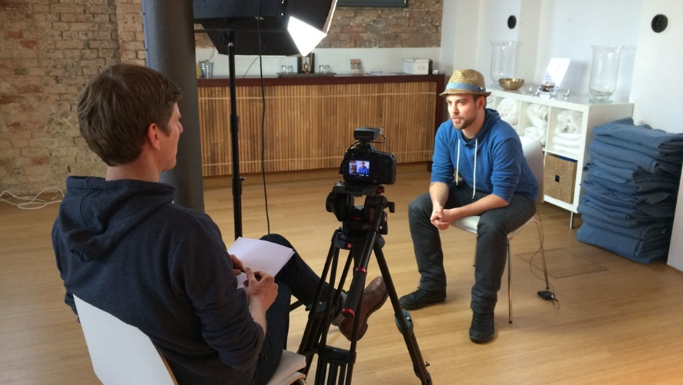
Oral Histories
Historically, articles written for, and records produced by, historians, generally ignored or eliminated the experiences of people who did not hold power over their own narratives. Oral histories offer a stopgap for this by excavating personal memories and testimonies articulated in speech. Oral histories are valuable by offering situated first-person accounts and lived experiences - that were never documented in official narratives.
In design, there are projects like the British Library's 'Recording Lives.' This project investigates oral histories of craftspeople, designers, and artists whose work may not be acknowledged by an official account. The way in which oral histories illuminate ways of working, problems, and achievements that would otherwise be lost. Reported oral histories are particularly valuable for communities that have robust oral storytelling traditions but less written accounts.
Through oral histories, researchers can navigate counter narratives to establish that there were distinct histories because many people shaped the formation of art and design. Researchers can create histories mediated by feelings, personal histories, and disparate narratives.

Critical Visual Analysis
Analyzing works of art and design is another area of research where researchers look at specific artworks or designs themselves to make visible their meanings. Critical visual analysis is looking closely at a work of art and unpacking what it shows us about the time and society in which it was made. Researchers are not concerned only with the 'style' or 'beauty' of an artwork; they are concerned with political, cultural, and social meaning.
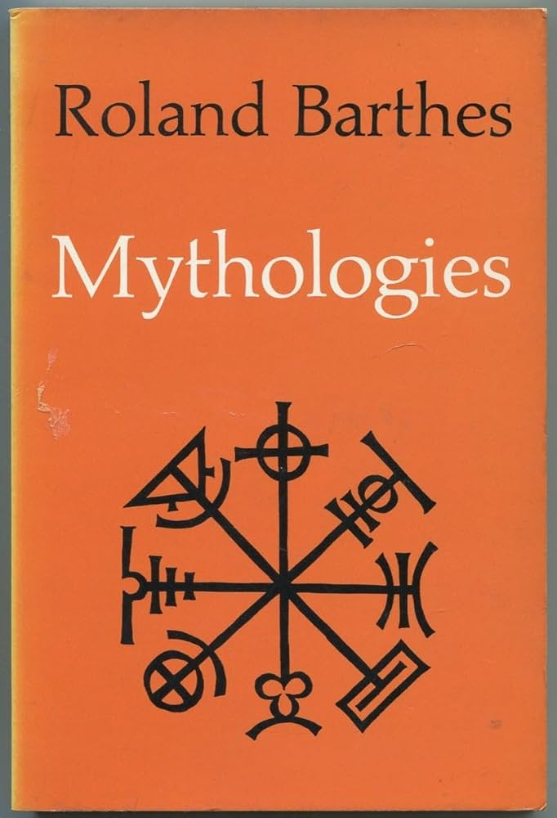
The theorist, Roland Barthes, named two ways that there could be meanings in an image: a surface meaning (denotation) and a hidden, or suggested meaning (connotation). Barthes was able to show that an image might just look simple; however, an advertisement from the 1950s, for example, might imply meanings that were about gender roles, or race, consumption culture, and much more, all of which can also be around power and social behaviour. By unpacking these meanings, researchers were able to explain how art and design were implicated in establishing meanings around social ideas and behaviours in their context.
Critical visual analysis challenges viewers to think beyond appearances and to question what do images really say about power, identity, and society.
Current Theories for Deconstructing Histories
Feminist Theory
Feminist theory has been significant in furthering the challenge to who has made important art and design histories. In 1971 art historian Linda Nochlin published an essay entitled Why Have There Been No Great Women Artists? In her essay, Nochlin argued that women had been excluded from the art world not for the lack of talent, but for the lack of opportunity, education, and professional networks.
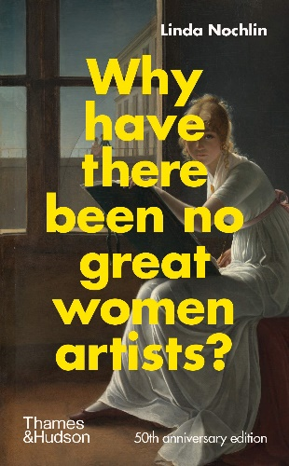
Another feminist art historian, Griselda Pollock, foregrounded ideas about how spaces — the home, the studio and, importantly in feminist art making, the privileges of feminine domesticity — shaped women's experiences of making art. Pollock also argued that women artists who had successfully made a place for themselves as artists seldom operate comfortably within their own culture; instead they were grasped or trapped by social situation to do, what was acceptable, and this shaped how they made art, and how their art was valued.
Feminist researchers also look to challenge what constituted important art. They focus on the art of craft, textiles, and other media often categorized as 'women's work'. In this way they extended the parameters of what was considered art and developed an understanding of art and visual culture produced by women.

Postcolonial Theory
Postcolonial theory examines how colonial histories impact our understanding of art, design and identity. The colonizers imposed their own culture on the colonized and also shaped how they understood art and culture. Non-European art is typically viewed as ‘primitive’ and ‘exotic’ which brings with it problematic associations with racism.

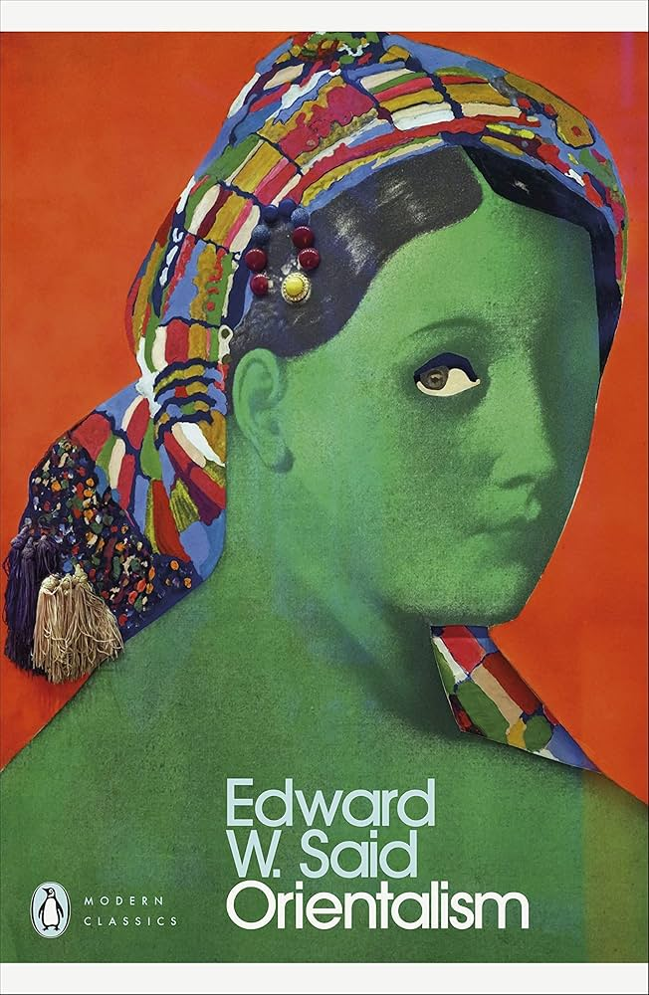
In Orientalism, Edward Said discussed how European writers and artists created distorted images of Eastern cultures to serve as justification for colonial imposition. Said also pointed out that this way of thinking also framed the way that non-Western artifacts were contextualized, displayed and interpreted.
A prominent example of postcolonial thinking is Rasheed Araeen’s 1989 exhibition The Other Story which provided an acknowledgment of the work developing by African, Caribbean and Asian artists in Britain, and the fact that their work was missing from the canon of historical art practice in the UK. It is instructive to consider for postcolonial theorists, that the writing of art history is not possible without some referential context of global practices.
Postcolonial theory also spills into contemporary design practice in its critique of cultural appropriation, where designers reference symbols from other culture and then proceed to use these symbols without any reference to the significance of those symbols, or their real meaning.
Queer Theory

The practice of queer theory provides another means to contest and necessarily interrogate art and design histories. Queer theory contests that histories can only represent heterosexual and normative gender identities. Many LGBTQ+ artists operated either within a secrecy that constrained their work, or were misrepresented by critics and historians from a rectangular perspective.
Amelia Jones, is firstly, one of the few scholars that represents queer theory and queer identity formation through, in part, performance art, body art and visual culture, and illustrates how those that produce forms of art and design provide a potential for contestation of gender and sexuality.
Artists like Keith Haring took action into public spheres, with the public, by foregrounding queer life, AIDS activism and sexual identity, in their public work. Queer theory presents opportunities to discover and explore hidden or covert references within artworks, as well as undermine any conditioning of historical consciousness that exists in art, that come from histories that have purposely been obscured and denied, in scholarship and interpretation.
Queer theory also importantly reminds us that art and design is never neutral - it is located and rationalized through identity and experience.

Case Studies
Guerilla Girls and Institutional Critique
The Guerilla Girls formed as a activist art group in the 1980s. They dress in gorilla masks, disguising their identity, and produce posters, billboards and exhibitions that illuminate sexism and racism in the art world. The poster “Do Women Have to be Naked to Get into the Met Museum?” (1989) highlighted, that in contrast to other artwork from predominantly male artists, naked women are displayed in museums but hardly in the case of the women artists.
The Guerilla Girls combine considered research — counting the rate of exhibition of women and minority artists — with graphics bold and strong enough to get their point across. Their successful work employs and orchestrates research and activism to challenge powerful institutions from which the art world is derived.
The Guerilla Girls also remind us that deconstruction is not only an academic activity but can entail doing and making in public to reach wider audiences.
Decolonising the Design Curriculum
Within education, a number of universities are working on decolonising the design curriculum. For years, design education has focused on European movements, including the Bauhaus or Swiss Style, while ignoring design traditions from Africa, Asia, Latin America, and Indigenous cultures.
The UAL Decolonising the Arts Curriculum Zine is an example of how students and staff are calling for change. It brings together essays, artworks, and interviews that asked the question "what are we teaching?" and then encourages alternatives. When we talk about decolonising the design curriculum, we need to think about what it means to simply add more diverse examples, while actually rethinking the values and notions that construct design education.
This work is important in enabling educators to rethink their knowledge and understand that design history is not a story exclusively constructed by western notions, but a complex web of influences, traditions, and ideas created by many places and histories of all around the world.
Conclusion
Deconstructing art and design histories is necessary to create a fuller, fairer understanding of the past. Traditional histories relied on the exclusion of many voices to shape the power. Using research practices including archival interventions, oral histories, and critical visual analysis, researchers are finding ways to better share and draw from parts of the histories. Theories, including feminist theory, postcolonial theory, and queer theory provide critical tools to counter established assumptions and refocus on the experience of the excluded.
To be clear, deconstruction should not mean one destroys history; rather, it is to build better histories—more rich, complex and honest histories. As researchers deconstruct and reconstruct art histories and design histories, they can also help better inform future generations of a richer understanding of creativity and culture.

Reference list
Rasheed Araeen, The Other Story, 1989.
Roland Barthes, Mythologies, 1972.
Tamar Garb, Bodies of Modernity, 1996.
Amelia Jones, Body Art: Performing the Subject, 1996.
Linda Nochlin, Why Have There Been No Great Women Artists?, 1971.
Griselda Pollock, Vision and Difference, 1988.
Edward Said, Orientalism, 1978.
UAL, Decolonising the Arts Curriculum Zine, 2018. (Available online).

