Abigail Davies (2114472)

University of Wales Trinity St. David
Artificial Intelligence and Machine Learning (ACCA6011)
Assignment – ML Model

Table of Contents
1. Abstract 3
2. Introduction 4
3. Problem Statement with Literature Support 5
4. Methodology 7
4.1. Data Preparation 7
4.2. Initialise, Compile and Train Model 8
4.3. Evaluate the Model 8
4.4. Fine-tune for Best Performance 9
5. Experiments 10
5.1. Analyse Solver Algorithms and Kernel Functions 10
5.2. Analyse Impact of Balanced Class Weight 10
5.3. Analyse Impact of Size of Testing / Training Split 10
5.4. Identifying the Best Parameter for LR Model 11
5.5. Identifying the Best Parameter for SVM Model 12
6. Results 13
6.1. Final Parameters for Models 13
6.2. LR – Confusion Matrix 13
6.3. SVM – Confusion Matrix 14
6.4. AUC-ROC Graph 14
7. Discussion Of Results 15
8. Conclusion 16
9. Recommendations 17
10. References 18
11. Appendix (Link to video) 19

Abstract
This study documents the investigation into how machine learning (ML) algorithms can be utilised to forecast customer churn for a Telecom company. Customer churn is a frequent issue within the industry, that can make a significant difference on the success of the company. These statistics are vital in reporting as it indicates whether methods to retain customers more efficiently are needed. Two methods are analysed through various experiments, obtaining similar results, thus allows recommendations for future work.

Introduction
Customer churn is the quantity of existing customers that have stopped purchasing products or services from a business over a specific time period [1]. Generally, businesses use this statistic to gain an understanding of the satisfaction and loyalty their customers have towards their business [1]. Methods that predict this figure can be extremely useful in organisations, as it can affect the growth and revenue of a business [2]. For this reason, it is a vital indicator that should be monitored closely to identify patterns and factors that could be negatively impacting the business. ML algorithms that have been proven to predict accurate reports of these levels, allowing businesses to make changes in advance, thus potentially making significant improvements to the overall performance. This study aims to investigate the performance of two algorithms, using an existing dataset that is available online, called Telco Customer Churn [3]. The two algorithms that will be focused on are Support Vector Machine (SVM) and Logistic Regression (LR). Both are supervised learning methods that are generally used for classification tasks, making them key algorithms for the task at hand [4].

Problem Statement with Literature Support
Customer churn within all businesses is vital to the overall success of the company. In fact, Sundaramahadevan states that most businesses that operate in the telecom industry, consider retaining existing customers as more important than gaining new customers because the cost involved in introducing new customers [5]. The researcher further states that the average customer churn rate in such highly competitive markets are around 15-25% annually [5].
Another researcher that analysed customer churn rates in the telecom industry is Bhale [6]. In 2023, the architect stated that an organisation called Databel, were left with no choice but to complete a thorough analysis of the different factors that could be contributing to the concerning customer churn levels [6]. Taking their findings into account, they were able to make recommendations on how to progress with changes that positively impact the retention of customers within the organisation [6].
Similarly, Dr. Agarwal et al investigated how customer churn could be predicted using ML to gain control on retaining their customers [7]. The two algorithms that were analysed by the researchers were LR and Naïve Bayes (NB) [7]. In contrast to the studies previously discussed, this research focused on the financial industry, examining how banks can surpass those who do not predict customer churn levels by putting preventative measures in place [7]. Supporting this, a manager from a customer service platform quoted that even minor levels of churn can accumulate over time and therefore, should not go unrecognised [7].
Refocusing on the telecom industry, Lalwani et al argues that customer churn is one of the biggest challenge that this industry experiences [8]. Additionally, expresses their interest in the advancements of ML and artificial intelligence (AI) being utilised to predict customer churn metrics [8]. The study consists of a six-stage methodology where a number of algorithms are analysed including SVM and LR and the data was divided into an 80/20 split for training and testing [8]. The figures for LR and SVM have been extracted into table 1.

Table 1: Lalwani et al comparison of ML models, focusing on SVM and LR only [8].
Rounded to the nearest whole number.
Model | Accuracy | Recall | Precision | F1-Score | AUC Score
LR | .80 | .80 | .79 | .79 | .82
SVM (Linear) | .79 | .80 | .79 | .79 | .79
SVM (Poly) | .80 | .81 | .80 | .78 | .80

As shown in the results in table 1, the performance of the model can be measured in many ways. Each have a mathematical equation on how they are calculated.
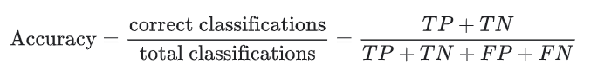
Accuracy is the calculation of how many classifiers were correct, compared to the total number of classifiers [9]. The calculation is shown in figure 1, where TP = true positive, TN = true negative, FP = false positive and FN = false negative.
Figure 1 [9]

Recall is also known as the true positive rate as it a calculation to identify how many positives were correctly classified as positives [9]. The calculation is shown in figure 2.

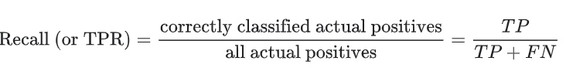
Figure 2 [9]
The next evaluation method to be discussed is precision which is similar to recall as it also evaluates the positive values. The definition is the volume of predicted positive classifiers that are positive [9]. Figure 3 is a visualisation of the calculation.
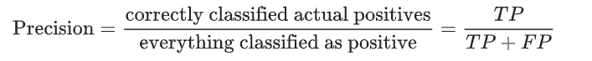
Figure 3 [9]

F1-score uses the calculations from both recall and precision, where the harmonic mean of the two is detected [10]. Figure 4 is the mathematical formula.
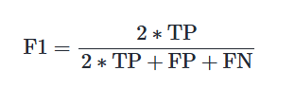
Figure 4 [10]

The final evaluation method to be discussed is the AUC score, which stands for area under the curve. It is generally represented in a graph, illustrating the likelihood of the model placing the positive higher than the negative, when given a random sample [11].

Methodology

Data Preparation
The first stage of the methodology will be to prepare the data. As the data set is pre-generated from Kangle, this stage will involve importing the required libraries, cleansing of the data, and setting the features and the labels for the models to focus on. Figure 5 is a screenshot of the imports used in this project. All have been inserted to the top cell of the notebook as best practice [12].
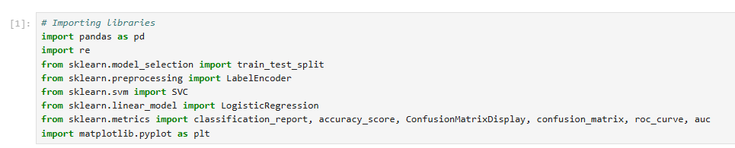
Figure 5

Moving onto importing the data set, the pandas library allows the csv file to be read into the project before using the train_test_split feature to divide the data set into a training and testing set. Initially, the focus will be on a 70% training set and 30% testing set but this can be adjusted as required when evaluating the performance of the models. The code for this can be viewed in figure 6.

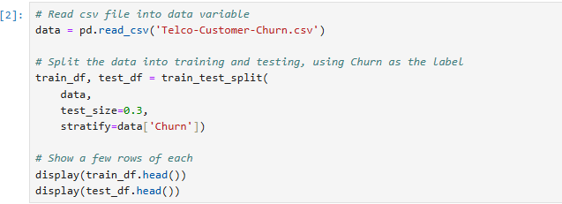
Figure 6

The next step of data preparation is to clean the data. The partition of data is performed prior to cleaning data due to the consequences of possibly leaking data into the testing set from the training set [13]. Initially, any missing values will be handles by replaced with ‘0’, followed by encoding categorical variables. The aim of encoding categorial variables is to allows non-numerical variables to be converted appropriately so that they can be handled by the model at hand [14]. This is vital with linear regression and SVM [14].
The final phase of the data preparation is to set the features and label for the model to focus on. In other words, this assigns the x and y axis data. Some columns in the data set are also dropped at this stage to focus on the columns that are all the same data type and that would assist in the performance of the model. A screenshot of this code is in figure 7.

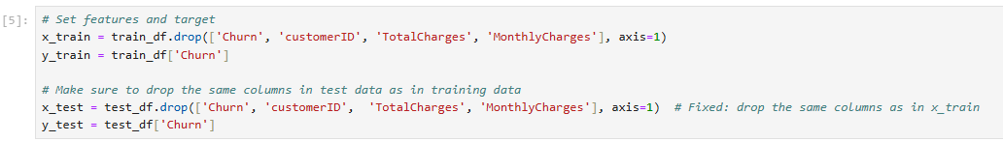
Figure 7

Initialise, Compile and Train Model
The next stage of the project is it initialise, compile and train both models. This includes setting parameters for the model like max_iter and kernel. The screenshot in figure 8 is the initial parameters that were set for this program, however hyperparameter grid will be integrated at a later stage to identify the best parameters to achieve the greater performance results.

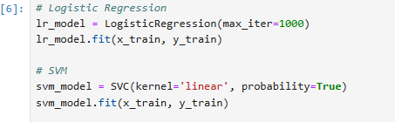
Figure 8

Evaluate the Model
Evaluating the performance of each of the models is vital to understanding how well they can predict the probability of customer churn based on the dataset at hand. The screenshot below (figure 9) shows how various libraries imported are being utilised to display the accuracy results, as well as the classification report which contains the recall, precision and F1-score.
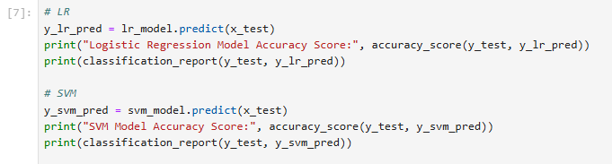
Figure 9

Another way to evaluate the performance of the models is using a confusion matrix. This is a visual representation of the comparison of the predicted and actual results, e.g. the number of cases that were correctly predicted, compared to those which were incorrectly predicted [15]. The snippet of code that generates this is in figure 10.
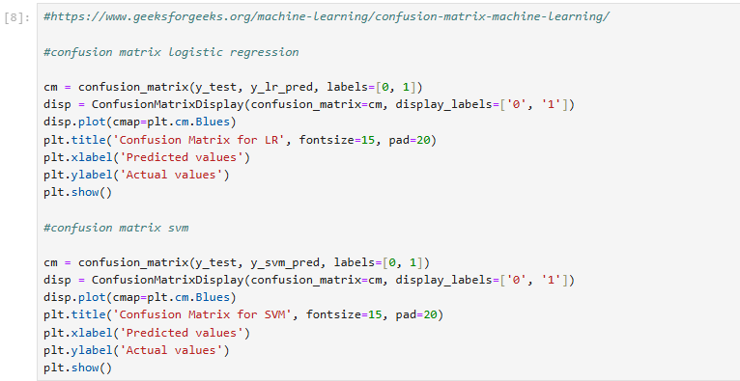
Figure 10

Finally, the last evaluation method used will be an AUC-ROC curve as referenced in the literature review. This will be another visual presentation of the comparison of two models by them being plotted onto the same graph.

Fine-tune for Best Performance
Once the evaluation results for both models have been displayed, it’s important to analyse and perform fine-tuning procedures to achieve the most effective performance [16]. The class weight, cost of misclassification and testing and training split sets will be revisited and tested for both models. Additionally, the kernel type will be evaluated for SVM model, and the solver type and penalty will be evaluated for the LR. The individual tests will be discussed in more detail in the experiments of the report.

Experiments

Analyse Solver Algorithms and Kernel Functions
The first experiment to take place was to identify which kernel and which solver returned the higher accuracy rates where the training and testing split was 70/30. Table 1 and table 2 have been generated based on the results of each test.
Table 1: Comparison of Results of different LR Solver Algorithms
Solver Type | Accuracy Score
Liblinear | 79.89%
LBFGS | 79.13%
Saga | 79.51%

Table 2: Comparison of Results of different SVM Kernel Functions
Kernel Type | Accuracy Score
Linear | 79.13%
RBF | 78.09%
Poly | 73.45%
Sigmoid | 63.27%

Analyse Impact of Balanced Class Weight
The second experiment was to identify the impact on introducing a balanced class weight to both models, where the Solver and Kernel are the highest performing from test one, e.g. solver = liblinear and kernel = linear. Table
Table 3: Comparison of Results of class weight being balanced or none.
Model | Algorithm / Function | Class Weight | Accuracy Score
LR | Liblinear | Balanced | 72.14%
LR | Liblinear | None | 79.89%
SVM | Linear | Balanced | 64.32%
SVM | Linear | None | 79.13%

Analyse Impact of Size of Testing / Training Split
The third test actioned, examined the impact on changing the training and testing split from 70/30 to 80/20. A study suggests that focusing on these volumes will allow for greater results [17]. Table 4 is the comparison of the two data split portions where the algorithm / function and class weight that achieve the better results from the previous tests were taken forward for assessment.
Table 4: Comparison of Results of class weight being balanced or none.
Model | Algorithm / Function | Training/Testing Split | Accuracy Score
LR | Liblinear | 70/20 | 79.89%
LR | Liblinear | 80/20 | 77.64%
SVM | Linear | 70/30 | 79.13%
SVM | Linear | 80/20 | 78.07%

Identifying the Best Parameter for LR Model
The initial experiments analysed the manual amendments, although, this test investigates how the GridSearchCV can be used to identify the best parameters for both models. This is called hyperparameter tuning. Upon the first execution, the error message shown in figure 11 shows how some combinations failed due to incompatibility.
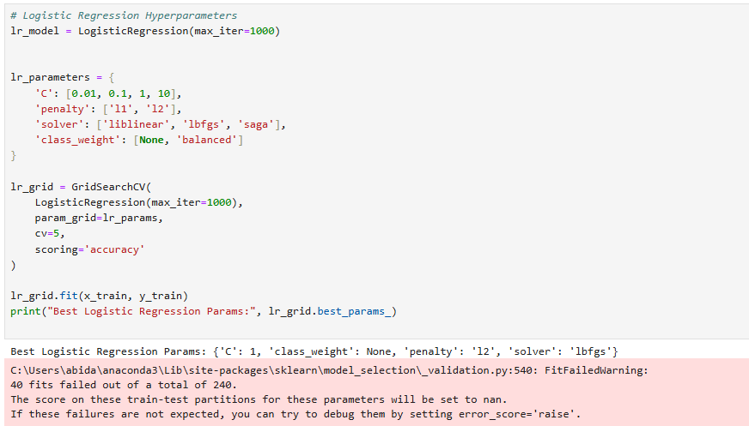
Figure 11

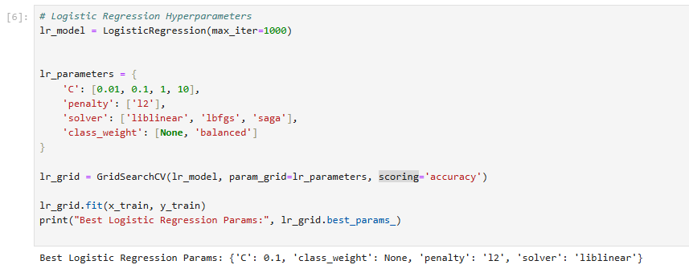
Following investigation, using the anaconda assistant, it became apparent that some penalties were not compatible with some solvers. Once the problematic penalty was removed, the results returned as expected (figure 12).
Figure 12

Identifying the Best Parameter for SVM Model
This experiment was not as successful as when tested on LR Model. Hyperparameters using the same function used in test four appeared to take over an hour to execute. Whilst investigating the code and utilising AI tools such as ChatGPT to recognise if there were any obvious issues causing the excessive runtime issues, it was suggested that it was because the volume of data and number of parameters that the SVM was attempting to run through. For this reason, a manual alternative method was taken where the better resulting kernel and class weight identified from earlier tests were chosen, so that only the C value was adjusted. Amending the C value controls the balance of achieving a greater distance for the decision boundary and the data points, whilst limiting the classification errors [18]. Table 5 is the evaluation information extracted from each run.
Table 5: Comparison of Results of C Parameter in SVM where the class weight is none and testing/ training split is 30/70.
Function | C Parameter | Accuracy Score
Linear | 0.01 | 79.18%
Linear | 0.1 | 78.84%
Linear | 1 | 79.56%
Linear | 10 | 79.65%

Results

Final Parameters for Models
For the LR model, the final parameter settings whilst using the hyperparameter function appear to be:
- max_iter=1000
- c=0.1
- class_weight=none
- penalty:l2
- solver:liblinear
For the SVM model, the final parameter settings are:
- probability=true
- kernel=linear
- c=1

Table 5: Classification report for final models
Model | Accuracy | Precision | Recall | F1-Score
LR | 80% | 0 (No) – 83% | 0 (No) – 91% | 0 (No) – 87%
LR | 80% | 1 (Yes) – 67% | 1 (Yes) – 50% | 1 (Yes) – 57%
SVM | 80% | 0 (No) – 83% | 0 (No) – 92% | 0 (No) – 87%
 |  | 1 (Yes) – 67% | 1 (Yes) – 47% | 1 (Yes) – 55%

LR – Confusion Matrix
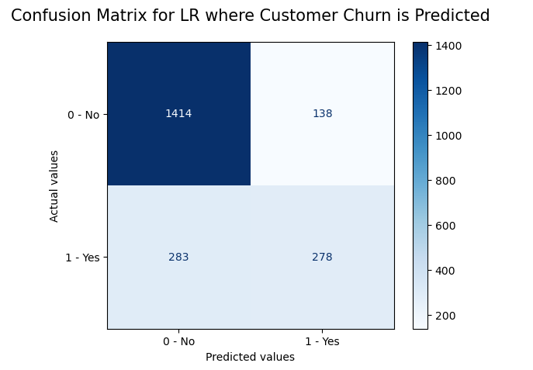
Figure 13 is the confusion matrix produced for the LR model.
Figure 13

SVM – Confusion Matrix
Figure 14 is the confusion matrix produced for the SVM model.
Figure 14
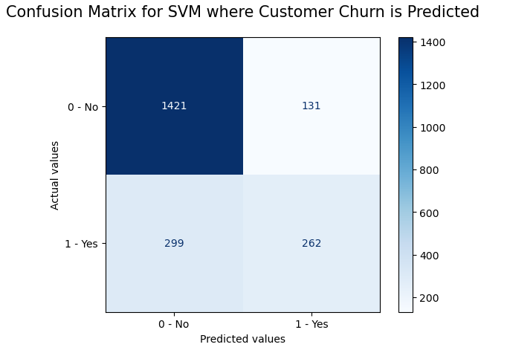

AUC-ROC Graph
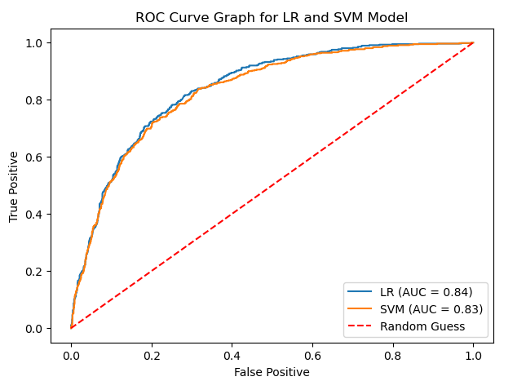
The AUC-ROC graph (figure 15) has been generated to plot both models for ease of comparison due to the similarity in results.
Figure 15

Discussion Of Results
Firstly, when comparing the results from the classification report of both models in table 5, there is not much between the results of each evaluation calculation. Generally, the models did not appear to predict churn values equal to 1 (Yes), as well as predicting churn values equal to 0 (No). The confusion matrix shown in figure 13 and 14, also reflects this. However, out of a total of 2113 records that were tested by both trained models, approximately 73% had an actual value of 0 (churn = no). This signifies the impact of the class weight being set to none, instead of balanced and likely the cause for values set to 1 (Yes), not performing as well. That being said, experiment two does show that introducing a balanced class weight reduces the overall accuracy of the models.
Matching the assessment of the classification report and confusion matrix, the AUC-ROC graph also illustrates the similarity between the LR and SVM performance levels. Whilst both achieved good scores, if both were given a random sample, LR would have a slight advantage of correctly predicting a positive value over the negative value.

Conclusion
To conclude, the LR model with solver set to liblinear and SVM model with kernel set to linear had great overall performance results. There were only marginal discrepancies when comparing the results the model achieved for the more dominant class. However, the minority class did not perform as well for either models. Further studies are recommended to analyse the significance of this, utilising alternative methods to attempt to resolve the contrast in classes seen.

Recommendations
Based on the findings of this study, further recommendations would be to develop and evaluate other models like Lalwani et al [8]. This would give a clearer indication of how well the LR and SVM model performed. Additionally, investigating methods to address the imbalanced results could also be explored, considering the models returned greater scores on the class that had higher volumes in the test data.

References
[1] K. O'Brien and A. Downie. (Sep. 9, 2024). What is customer churn?. Available: https://www.ibm.com/think/topics/customer-churn.
[2] M. S. Azeem. (2023). Customer Churn Dataset. Available: https://www.kaggle.com/datasets/muhammadshahidazeem/customer-churn-dataset.
[3] Blastchar. Telco Customer Churn. (2018). Available: https://www.kaggle.com/datasets/blastchar/telco-customer-churn?resource=download.
[4] Geeksforgeeks. (May. 7, 2023). Differentiate between Support Vector Machine and Logistic Regression. Available: https://www.geeksforgeeks.org/machine-learning/differentiate-between-support-vector-machine-and-logistic-regression/.
[5] V. Sundaramahadevan. (2022). Telecom Churn Case Study. Available: https://www.kaggle.com/datasets/venkatasubramanian/telecom-churn-case-study.
[6] R. Bhale. (Nov. 22, 2023). Case Study - Telecom Customer Churn Analysis. Available: https://www.linkedin.com/pulse/case-study-telecom-customer-churn-analysis-rutuja-bhale-sbdmc/.
[7] V. Agarwal, S. Taware, S. A. Yadav, D. Gangodkar, A. Rao and V. K. Srivastav. V. Agarwal, S. Taware, S. A. Yadav, D. Gangodkar, A. Rao and V. K. Srivastav. Customer - churn prediction using machine learning. Customer - churn prediction using machine learning. 2022 2nd International Conference on Technological Advancements in Computational Sciences (ICTACS) 2022 2nd International Conference on Technological Advancements in Computational Sciences (ICTACS) pp. 893. pp. 893. 2022. DOI: 10.1109/ictacs56270.2022.9988187.
[8] P. Lalwani, M. K. Mishra, J. S. Chadha and P. Sethi. P. Lalwani, M. K. Mishra, J. S. Chadha and P. Sethi. Customer churn prediction system: A machine learning approach. Customer churn prediction system: A machine learning approach. Computing Computing 104104(2), pp. 271. pp. 271. 2021. DOI: 10.1007/s00607-021-00908-y.
[9] Google Developers. Classification: Accuracy, recall, precision, and related metrics. Available: https://developers.google.com/machine-learning/crash-course/classification/accuracy-precision-recall#false_positive_rate.
[10] Scikit-learn Developers. f1_score. Available: https://scikit-learn.org/stable/modules/generated/sklearn.metrics.f1_score.html.
[11] Google Developers. Classification: ROC and AUC. Available: https://developers.google.com/machine-learning/crash-course/classification/roc-and-auc.
[12] G. v. Rossum, B. Warsaw and A. Coghlan. (Aug. 1, 2013). PEP 8 – Style Guide for Python Code. Available: https://peps.python.org/pep-0008/.
[13] Geeksforgeeks. (Feb. 19, 2024). Encoding Before vs After Train_Test_Split?. Available: https://www.geeksforgeeks.org/machine-learning/encoding-before-vs-after-train_test_split/.
[14] Geeksforgeeks. (Nov. 25, 2024). Encoding Categorical Data in Sklearn. Available: https://www.geeksforgeeks.org/machine-learning/encoding-categorical-data-in-sklearn/.
[15] w3schools. Machine Learning - Confusion Matrix. Available: https://www.w3schools.com/python/python_ml_confusion_matrix.asp.
[16] A. Bonnet. A. Bonnet. Fine-tuning models: Hyperparameter optimization. Fine-tuning models: Hyperparameter optimization. (Aug. 22, 2023). Available: https://encord.com/blog/fine-tuning-models-hyperparameter-optimization/.

[17] A. Gholamy, V. Kreinovich and O. Kosheleva. A. Gholamy, V. Kreinovich and O. Kosheleva. Why 70/30 or 80/20 relation between training and testing sets: A pedagogical explanation. Why 70/30 or 80/20 relation between training and testing sets: A pedagogical explanation. 2018Available: https://scholarworks.utep.edu/cs_techrep/1209/.
[18] EUROPEAN INFORMATION TECHNOLOGIES CERTIFICATION ACADEMY. EUROPEAN INFORMATION TECHNOLOGIES CERTIFICATION ACADEMY. What is the purpose of the C parameter in SVM? how does a smaller value of C affect the margin and misclassifications? What is the purpose of the C parameter in SVM? how does a smaller value of C affect the margin and misclassifications? Artificial Intelligence, EITC/AI/MLP Machine Learning with Python, Support Vector Machine, SVM Parameters, Examination Review Artificial Intelligence, EITC/AI/MLP Machine Learning with Python, Support Vector Machine, SVM Parameters, Examination Review 2023. Available: https://eitca.org/artificial-intelligence/eitc-ai-mlp-machine-learning-with-python/support-vector-machine/svm-parameters/examination-review-svm-parameters/what-is-the-purpose-of-the-c-parameter-in-svm-how-does-a-smaller-value-of-c-affect-the-margin-and-misclassifications/.

Appendix (Link to video)
https://youtu.be/ueCyEpa0fTo

