

Student Name: Diana Macovei

Student ID number: 2026629

Module: Problem Solving and Decision Making

Module Code: BMSW 4004

Assignment Title:
Understanding and addressing the problem of work-related stress among by UK employees

Module Lecturer: Chijioke Uba

Contents
Introduction: 2
The nature and impact of the complex problem on employees and their organisations 2
A research-informed cause-and-effect and PESTEL analysis of work stress among UK workers 4
• PESTEL analysis 4
• Analysis the cause and effect. Fishbone Diagram 5
Propose alternative solutions to address work stress among UK workers 6
Evaluation of alternative solution 7
• PMI analysis 7
Plan for implementing solution, Monitoring and Review to chosen solution 8
Conclusion 9
References 9

Introduction

Work-related stress and the influence on health that cause stress are current topics for many people. Stressful events and circumstances at work have become the main cause of stress. Due0to several0stressors, performance0at work is0directly0affected also0this factor can0result0different0levels0of stress. People in everyday life worry about all sorts of things, the extra pressure that appears at work causes the stress that everyone manages individually. Stress in turn has several negative effects that affect the employee.
In this paper I will identify nature and impact of the problem, the main causes of stress using relevant methods of analysis. I will identify possible solutions that can help reduce stress at work and I will create a plan to implement the solution chosen.

The nature and impact of the complex problem on employees and their organisations
In the 21st century, it is the century of technology development and globalization where stress is an increasingly typical part of everyday life, more and more often it gets out of control and affects a person in the long run, this often leads to serious health conditions. According to a 2020 survey, the most common types of stress in the UK are work-related, confirmed by almost four-fifths of respondents. The importance of understanding work stress has become more important for companies than for employees (Calnan, 2001).
According to Williams, N., Robinson, A.N., Robinson, B. J., Bevan, M. (2004-06) the three most common causes of workplace stress are poor communication, low participation in decision making, and role ambiguity or conflict.
According to the Health and Safety Executive, workplace stress is now the fastest growing cause of absence from work. Work-related stress and resulting sickness absence cost the UK economy about £3.7 billion every year (HSE research). According to Health and Safety Executive (HSE) in 2019 – 2020 1.6 million working people suffering from a work-related illness and 38.8 million working days lost due to work-related illness and workplace injury.
According to HSE data, of all workers, women were the most affected by work-related stress and men were significantly less affected. Comparing the data in the figure below, men in the 16-24 and 55-plus age groups have significantly lower work-related stress rates. While women in the 25 to 34 and 35 to 44 age groups had significantly higher work-related stress rates.
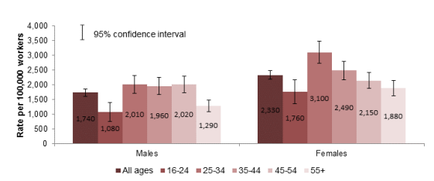
Source: LFS, estimated annual average 2017/19-2019/20
95% confidence intervals are shown on the chart.
The figure below shows which sectors are most affected by stress. Stress is more prevalent in public service industries, such as education; health and social care; and public administration and defence. By occupation, professional occupations that are common across public service industries such as healthcare workers; teaching professionals and public service professionals, show higher levels of stress as compared to all jobs.
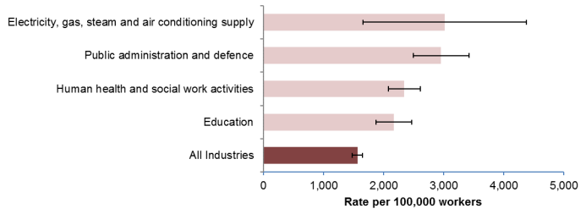
Source: LFS, estimated annual average 2017/19-2019/20
95% confidence intervals are shown on the chart.

A research-informed cause-and-effect and PESTEL analysis of work stress among UK workers

PESTEL analysis
Stress affects people at work in many ways and the causes of stress are diverse. The factors that can affect can be internal or external. To identify the external factors of the problem work stress among UK workers, I applied the PESTEL method (political, economic, social, technological, environmental, and legal framework). PESTEL analysis is a useful tool, more detailed and effective approach and less subjectively (Zorpas, 2020). The PESTEL method developed by Fahey and Narayanan that analyses the external factors that can affect a business. PESTEL is used to analyse how the external environment influences a business. The tool provides a structured picture of the macro-environmental factors that a company must consider when making decisions. (Jinbo Song, Yan Sun, Lulu Jin, 2017).
Pestel analysis of the problem work stress among UK workers. For this case, I identified only political, economic, and social factors. The political factors mainly concern social institutions, policies, and laws. Economic factors include macro- and microeconomic aspects that jointly influence industry development. Social factors refer to residents, the culture, and values. Below I have listed the PESTEL factors that in my opinion are linked to the problem.
Political: Increasing local taxes such as Council Tax, Tax Road; Tax for drive in a clean air zone/ low emission zone; new travel rules for non-British citizens related to BREXIT.
Economical: Interest bank rates; Cost of living/ rent; Price increase for gas/ electricity.
Social: social media-virtual communication. the development of technologies has caused the development of the virtual world. People no longer meet face to face to socialize, this happens online, without leaving home. Lack of social interaction and verbal communication is a cause of stress, especially for the younger generation, who are addicted to the telephone.

Analysis the cause and effect. Fishbone Diagram

Also known as cause-and-effect diagrams or Ishikawa diagrams, fishbone diagrams are named due to the appearance of a fish skeleton when completed. This model was developed by Kauro Ishikawa (Cox and Sandberg, 2018). This tool is mainly used to classify the potential causes of a problem and, finally, to identify the root causes. The Fishbone model is understood as a method of finding different types of solutions to organizational problems that reduce the versatility of organizational requirements. In fact, the mode is an intellectual tool in which the key elements are concentrated. (Korać and Simić, 2019).
Stress related work, and the potential for health caused by stress, has become a common and current topic for many people. Most people employed in companies can cite more stressful events and circumstances at work. Strans J. W. (2005) listed some of them in his work: inefficient management, lack of decision-making by management, excessive working hours, uncertainty about future employment prospects and job pressure are some of the causes of stress described by employees. Studies show that most respondents listed that the cause of work-related stress was workload pressures, including tight deadlines and too much responsibility and lack of managerial support. (HSE, 2009/10-2011/12).
The diagram below, the Fishbone diagram, shows the major factors that I think can cause stress. Stress related to work, money, family, health, technologies are the main categories. Each of the main categories was analysed and through the brainstorming method we found other possible factors that contribute to the problem.
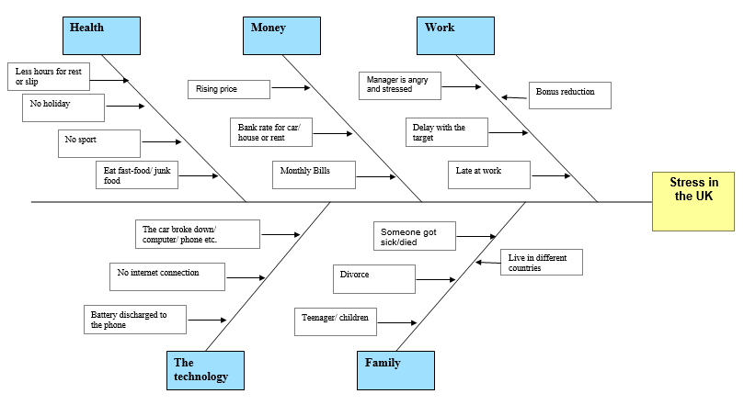

Propose alternative solutions to address work stress among UK workers

I used two tools: PESTEL analysis and Fishbone diagram, to identify the root causes of the problem work related stress in the UK. So, following the PESTEL analysis, the main cause of the stress that I identified is money, which is directly related to work. That is, if we were satisfied with the work we had and earned enough money, we would no longer be worried about rising prices or other taxes. It follows that one of the possible solutions would be to increase the salary or work overtime, to earn more money. Another identified cause of stress is workplace performance. Increased workload, including tight deadlines and too much responsibility and lack of managerial support. Organizing courses or training by companies to develop and improve employee skills would be a possible solution to avoid stress and achieve good performance. From the Fishbone analysis we see that the family factor is another cause of stress, which in turn I also consider to be related to work stress. Or these two causes influence each other. The possible solution to this problem would be creating flexible timetable for staff. I believe that this solution allows the organization of time both to spend with the family and to work.
Doing the analysis, I concluded that I have three possible solutions to solve the problem of work-related stress. Below I will do the PMI analysis to see which solution can be implemented.

Evaluation of alternative solution

PMI analysis

PMI analysis represent a strategy that requires to look at three outlooks: the positive, minuses or the negative (Sharma, 2017). “Plus” is related to the positive elements of the topic: the benefits or advantages, pros. “Minus” is related to negative element: disadvantages, cons “Interesting” is related to those points that neither good nor bad, but are regarded as neutral observation, implications (Sharma, 2017).
PMI: increasing pay
Each idea in the plus-minus-interesting category will be given scoring which will range from (for example +5 to -5). After scoring each possible solution, the numbers are counted to decide whether an action should be taken or not.
Plus | Minus | Interesting
You can make some savings +3 | Increasing cost for the company -3 | Increase of performance +2
You can go on vacation +5 | More money – more taxes -2
 | Other employees may request a salary increase -5
Total: +8 | -10 | +2
Total score: 0

PMI: staff training
Plus | Minus | Interesting
Increase of performance +4 | Increasing cost for the company -4 | New information +3
Better teamwork +3 | Takes time -3 | Development of new knowledge +4
Employees will be more confident +4
Total: +11 | -7 | +7
Total score: +11

PMI: creating flexible timetable for staff
Plus | Minus | Interesting
Allows family time planning +5 | Additional costs for organization -5 | With a flexible schedule you can apply to the university +3
In case of an emergency, you can change shifts with someone +2 | The shift can also coincide with the holidays/weekends -4
Total: +7 | -9 | +3
Total score: +1

Based on the above PMI analyses, the staff training solution accumulated the +11 score. This strong positive score indicates that the solution can be implemented to solve the problem of work-related stress among by UK employees.

Plan for implementing solution, Monitoring and Review to chosen solution
Once the main solution is established, the implementation stage follows to apply the solution. Implementation means acting on the chosen solution.
Problem: ‘Work-related stress’ faced by UK employees
Chosen solution: staff training
Actions | Description | Timeline | Staff responsible
Identify what training is necessary | Speak with the department manager to identify the materials necessary for training | 10 Jan. 2022 –  10 Feb. 2022 | HR, Manager support
Identify people who will present this training | Speak to the HR/Marketing department to identify companies that provide such services | 11 Feb. 2022 –  18 Feb. 2022 | HR, Manager support
Identify workers who will participate in the training | Online quiz; Speak with line manager; Reviews of customers; Complains; | 19 Feb. 2022 –  28 Feb. 2022 | IT, HR, Manager support
Establishing training hours and forming groups |  | 01 Mar. 2022 –  05 Mar. 2022 | HR, Manager support

Monitoring plan
 | Description | Time frame | Staff responsible
Participation | The training was attended by a number of x employees | Daily/weekly | Internal auditor
Engagement | Out of X number of active employees were Y employees. | Daily/weekly | Internal auditor
Understanding | Out of the total number of participants in the training, only X number assimilated and understood the purpose. | Daily/weekly | Internal auditor

Evaluation plan
Success indicator | Data source | Time frame | Staff responsible
Feedback from workers | Survey before and after training | Every 6 month | HR, IT
Resignation requests | HR department | Every month | HR

Conclusion

Work is the place where we spend more than half of our time from 8 hours a day to 12 hours, so it is very important to combine the useful with the pleasant. Stress as a word is understood and used in a negative sense that human perceives because of pressure. Pressure at work can be caused by several factors but which has negative effects on the performance and health of employees. Each individual employee therefore perceives the level of pressure differently, it affects people differently, and is difficult to measure. The latter have helped0companies to meet0certain0management standards that contribute to the poor health0and well-being of0employees to be0managed0correctly and0actively to0support individual0and organizational0productivity and to avoid0rising0illness0rates and0absences.

References
- Antonopoulou, P., Killian, M., Forrester, D., Levels of stress and anxiety in child and family social work: Workers' perceptions of organizational structure, professional support, and workplace opportunities in Children's Services in the UK, Elsevier Ltd, Children and youth services review, 2017-05, Vol.76, p.42-50
- Calnan, M., Wainwright, D., Forsythe, M., Wall, B., Almond, S., Mental health, and stress in the workplace: the case of general practice in the UK, Oxford: Elsevier Ltd, Social science & medicine (1982), 2001, Vol.52 (4), p.499-507
- Cox, M., Sandberg, K., Modelling Causal Relationships in Quality Improvement, Current Problems in Pediatric and Adolescent Health Care, July 2018, Volume 48, Issue 7, Pages 182-185
- Health and Safety Executive, Work-related stress, anxiety, or depression statistics in Great Britain, 2020, Annual Statistics
- https://www.hse.gov.uk/statistics/
- Korać, D., Simić, D., Fishbone model and universal authentication framework for evaluation of multifactor authentication in mobile environment, Computers & Security 20 May 2019, Volume 85 (Cover date: August 2019), Pages 313-332
- Jinbo Song, Yan Sun, Lulu Jin, PESTEL analysis of the development of the waste-to-energy incineration industry in China, Renewable and Sustainable Energy Reviews, Volume 80, December 2017, Pages 276-289
- Sharma, H.L., PMI (Plus-Minus-Interesting): A creative thinking strategy to foster critical thinking, International Journal of Academic Research and Development, Volume 2; Issue 6; November 2017; Page No. 974-977
- Stranks J. W. (2005) Stress at work: management and prevention, Elsevier Butterworth-Heinemann, Linacre House, Jordan Hill, Oxford OX2 8DP30 Corporate Drive, Burlington, MA 01803
- Williams, N., Robinson, A.N., Robinson, B. J., Bevan, M., UK worker representatives’ views on the causes of stress in the workplace, England: Oxford University Press, Occupational medicine (Oxford), 2004-06, Vol.54 (4), p.273-274
- Zorpas A.A., Strategy development in the framework of waste management, Science of The Total Environment Volume 716, 10 May 2020

