Assignment ECDE7013

In what ways do Autonomy and Choice Impact upon Student Engagement in Secondary Science?

Miss Lucy Allison Paradice BSc MPhil PGCE

University of Wales Trinity Saint David
July 2023

Table of Contents

Abstract ....................................................................................................................................5

Chapter 1: Introduction ..........................................................................................................6
1.1 Rationale and Purpose of this Study ...................................................................................6
1.2 Local School and Participants .............................................................................................7

Chapter 2: Literature Review ................................................................................................9
2.1 Introduction to the Literature ..............................................................................................9
2.2 Defining ‘Engagement’ .....................................................................................................11
2.3 Links to Motivation ...........................................................................................................15
2.4 Autonomy and Choice .......................................................................................................16
2.5 The Research Question and its Importance .......................................................................19

Chapter 3: Research Design .................................................................................................21
3.1 Epistemology and Ontology Perspectives .........................................................................21
3.2 Interpretivism: Explanation and Justification to the Research ..........................................22
3.3 Pragmatism as the Theoretical Framework: Its Benefits and Limitations ........................24
3.4 Reflexivity and Researcher Positionality ..........................................................................27

Chapter 4: Methodology .......................................................................................................28
4.1 Introduction to Methodology ............................................................................................28
4.2 Sampling ............................................................................................................................29
4.3 Data Collection Methods ...................................................................................................30
4.3 (i) Quantitative Method – Self-reported Questionnaires ...................................................31
4.3 (ii) Qualitative Method – Semi-structured Interviews ......................................................32

Chapter 5 – Data Analysis …………………………………………………………………34
5.1 Data Analysis – Self-reported Questionnaires………………………..…………….…....34
5.2 Data Analysis – Thematic Analysis ……………………………………………………..41
5.3 Ethical Considerations …………………………………………………………………...44

Chapter 6 – Findings and Data Analysis ………………………………………………….47
6.1 Quantitative Results ……………………………………………………………………..47
6.2 Qualitative Results ………………………………………………………………………48

Chapter 7 – Discussion and Conclusion …………………………………………………..50
7.1 Limitations and Recommendations - Purposive Sample ………………………………...50
7.1(i) Limitations and Recommendations – Methodology …….....………………………….51
7.3 Contributions to the Field of Study and Conclusion …………………………………….53

Reference List ……………………………………………………..………………………..55

List of Appendices .................................................................................................................64
Appendix A: ...........................................................................................................................64
A1 Student Consent Form .......................................................................................................64
A2 Parental Consent Form ......................................................................................................67
Appendix B: ...........................................................................................................................71
B1 Student Survey Engagement Statements ...........................................................................71
B2 Emotional Engagement Pre and Post Study Survey Responses ........................................73
B3 Social Engagement Pre and Post Study Survey Responses ...............................................74
B4 Cognitive Engagement Pre and Post Study Survey Responses .........................................74
B5 Behavioural Engagement Pre and Post Study Survey Responses .....................................76
Appendix C: ...........................................................................................................................77
C1 Student Survey Responses (Pulse Rate Activity) – Social Engagement (Working in a Group) .....................................................................................................................................77
C2 Student Survey Responses (Pulse Rate Activity) – Social Engagement (Working Alone).......................................................................................................................................77
Appendix D: ...........................................................................................................................78
D1 Student Survey Responses (Density Column) – Emotional Engagement..........................78
D2 Student Survey Responses (Density Column) – Cognitive Engagement...........................78
D3 Student Survey Responses (Density Column Prac. 1) – Emotional Engagement..............79
D4 Student Survey Responses (Density Column Prac. 2) – Emotional Engagement..............79

List of Figures ……………………………………………………..………………..................
Figure 1 Convergent Parallel Design ......................................................................................28
Figure 2 Hierarchical Coding Frame .......................................................................................42

In what ways do Autonomy and Choice Impact upon Student Engagement in Secondary Science?

Abstract
This study seeks to explore the impact of student engagement and motivation in practical secondary science when autonomy and choice are the primary focus in teaching and learning disciplines. Literature widely documents positive student engagement links (Flowerday and Schraw, 2003) and intrinsic and extrinsic motivation connections (Deci and Ryan, 1995) to autonomy and choice elements in the classroom. However, practical science studies that explore effective teaching strategies are noticeably scarce.
A mixed methods research framework is adopted that examines engagement and motivation behaviours to support the validation and reliability of the research. Consideration is given to the challenges met in measuring unquantifiable variables by the use of qualitative and quantitative methods. Further to this, this study aims to accommodate the definitions of all engagement subtypes i.e. cognitive, behavioural, emotional and affective by moulding the research to fit a multi-dimensional construct. As such, the theoretical framework is interpretivist and pragmatic and utilises self-reported questionnaires, semi-structured interviews and classroom observations. Thematic data analysis aims to explore questionnaire and interview responses to define engagement subtypes to which those who respond to autonomy and choice in science subject areas belong.

Chapter 1 - Introduction
1.1 Rationale and Purpose of this Study
School education has dramatically changed as a result of the COVID-19 pandemic and 98% of the world’s student population have been affected by school closures and the change to online learning (UNSECO, 2021). The urgent transition in education has posed many challenges to teachers and students who have needed to adapt to new technological teaching methods in alternative learning environments.
As a teacher of science, I joined in the pursuit to develop effective teaching strategies that could accommodate the new learning environment, making appropriate use of technological tools to motivate and engage students. I embraced the challenge of creating an online science laboratory that would encourage students to explore science at home and expand independent learning skills. Having created online lessons with audio and video instruction, I guided students to create practical demonstrations of scientific principles in their own home. For example, having instructed and demonstrated the making of a density column using household supplies and illustrating the various densities of liquids, I suggested that students source their own supplies and recreate the column. The willingness to participate in most all students was encouraging and their positive feedback was a good indication that autonomy and choice factored highly as motivation and engagement markers. Furthermore, I observed how student interest was enhanced as alternative household materials were sourced which self-propelled independent investigations.
My observations of enhanced student engagement through this experimental online teaching and learning strategy inspired me to expand and refine my research to exploring the impact to learning through encouraging autonomic behaviours.
The Self Determination Theory (Deci and Ryan, 1985) is a firmly established and accepted premise that recognises that students will be motivated and engaged if relatedness, competence and autonomy are the intrinsic and extrinsic motivational factors. These findings have provided the solid foundation for motivational and engagement studies and given scope for broader research, although minimal studies have explored teaching strategies that encourage autonomic behaviours in the classroom, especially within secondary science practical lessons. Further to this, some studies have suggested that some teachers use ‘controlling’ strategies that foster autonomic behaviours which are linked to intrinsic motivational factors towards learning (Niemic and Ryan, 2009; Stroet, Opdenakker, and Minnaert, 2013) some teachers rely upon controlling strategies that use extrinsically based rewards and reprimands (Pelletier, Séguin-Lévesque and Legault,2002). The latter suggests that motivational strategies used are selectively adapted by individual teachers according to their personal pedagogical preferences and underlying beliefs.
Despite the existence of widely documented literature that upholds the significance of motivation and engagement studies, there is insufficient research to support the specific teaching methods used to enhance motivation. Hence, the rationale and focus of this study aims to address this gap in the literature by exploring effective teaching strategies that deliver autonomy and choice assignments in practical science. Also, the study will conclude by exploring the varying results of introducing autonomy and choice in the classroom through several different methods.

1.2Local School and Participants
The research for this study is conducted at a local, modern-built, English-medium comprehensive school which accommodates 1,283 students. I am currently a science practitioner at the same school where my role is also that of the researcher.
The twelve participants for the study have been purposively selected and are a small mixed ability year nine class. Their varying skill sets make them suitable candidates that accommodate the multi-dimensional construct model for all engagement sub-types that will provide reliability and validity to the data collected.
All students have been entered for the WJEC entry level examinations in science where ongoing assessments are made as per WJEC guidelines in subject areas of chemistry, biology and physics. The broad ranging curriculum offers flexibility in teaching methods used and a greater scope to trial strategies that present elements of choice in science practical lessons and assignments which promote student autonomy wherever possible.

Chapter 2 – Literature Review
2.1 Introduction to the Literature
Engagement and motivation are commonly linked in studies related to student learning outcomes and academic success (Woolfolk and Margetts, 2007).
Considerable discussions within the literature continue to explore the factors that affect student motivation and engagement. Their existence suggests an interchangeable quantity where motivation and engagement go hand in hand. However some research (Blumenfeld, Kempler and Krajcik, 2006), has suggested that motivation is necessary, but insufficient alone without engagement for students to achieve academic success. Alternative studies, (Hufton, Elliott and lllushin, 2002), have proposed that high levels of engagement exhibit high levels of motivation. Hence, a general consensus suggests that researchers should accept the importance of motivational factors but must also examine engagement in and as part of learning. Motivation of science students has been described as, ‘students active engagement in science related tasks for performing a higher knowledge of science(Lee and Brophy, 1996).
Measuring motivation in education as a standalone quantity is complex due to the difficulty in describing it operationally. As such, motivation studies have focussed upon observing student behaviours and learning traits. Although the Self Determination Theory (Deci and Ryan, 1985) established the basic needs for a motivated student (autonomy, competence and relatedness), criticism has arisen around the measurement in motivation studies whereby the participant’s responses may mirror their own opinions of themselves which may not reflect reality (Danili and Reid, 2004). Nonetheless, motivation has been asserted as a vital educational variable which is highly multi-faceted in that it controls behaviour and learning and is affected by personality traits. In addition, there is an implication that motivation can be ‘controlled’ by the teacher and the teaching environment although it must be considered that other factors exist that are not influenced by teacher such as the school establishment and the student themself (Barlia, 1999).
Researchers continue to search for credible and reliable methods for quantifying motivation, although there is a clear indication that supporting research can be acquired from studies in engagement. These studies suggest more successful quantifiable methods for data collection as engagement is an observable behaviour that is the evidence for motivation.
This literature review considers the challenges met through motivation studies where the researcher’s definition of motivation weighs considerably on the focus of the study and its use of the term ‘motivation’ which infers some inconsistency if recognised as the only variable. However, it is important to acknowledge the presence and impact of motivation, regardless of its interpretation as it remains important criteria for data reliability and validation. Similarly, engagement studies demand clear definition and clarity of purpose as the default understanding of engagement remains broad and open ended in most fields of research. Nevertheless, the definition of engagement recognises a universal classification of its sub-types as cognitive (Sinatra, Heddy and Lombardi, 2015), affective (Sinatra et al., 2015) and behavioural (Birch and Ladd, 1997). This loose categorisation suggests that engagement research is favourable as it may be refined with the possibility of collating quantifiable data.
Both approaches will be explored in studies that reflect on the strengths and weaknesses of motivation and engagement research whilst considering the benefits and limitations of adapting a multi-dimensional perspective.

2.2 Defining ‘Engagement’
Engagement has been defined as,
‘A multi-dimensional construct that consists of behavioural, cognitive and affective subtypes’ (Christenson, Reschly and Wylie, 2012). Whilst this may be an accepted broad lending definition, the reference to ‘a multi-dimensional construct’ suggests that multiple aspects of engagement lie within specified contexts in an educational setting.
A further definition,
‘Engagement is difficult to define operationally, but we know it when we see it, and we know it when it is missing’ (Newman, 1986), suggests its ambiguous definition leading to potential complexities in research when measuring an unquantifiable variable.
Whilst educators promote motivation and engagement with their students, both terms are often used interchangeably without clear purpose and definition. Similarly, engagement studies need to make comprehensible explanations for their use and appropriation of ‘engagement’ in order for consistent data collection to remain credible.
Although the broad and varied definitions of engagement reside within grounded theoretical frameworks (Azevedo,2015), formal theories of engagement within academic domains, particularly science, have not been refined. This highlights the importance for researchers to provide clarity in their adaptation of engagement within the frame work of their studies. One such study (Schlechty, 2002, p. 64) has expanded the typology of engagement by stating that ‘the engaged student not only completes the task at hand but does so with enthusiasm and diligence’. One may argue that further clarity may be needed to define yet another unquantifiable measurement in using terminology such as ‘enthusiasm’ and ‘diligence’. Additionally, other scholars (Bomia,Beluzo, Demeester, Elander, Johnson and Sheldon, 1997) present similar descriptions to defining engagement as a ‘student's willingness, need, desire and compulsion to participate in, and be successful in, the learning process promoting higher level thinking for enduring understanding’. The reference made to ‘higher level thinking’ infers connections of engagement to problem solving and critical thinking skills. However, a deeper analysis of this paper (Bomia et al., 1997) reveals its focus as the impact of teaching strategies on intrinsic motivation lending much support to the well established Self Determination Theory (Deci and Ryan, 1985).
There appears a common theme in that researchers struggle to avoid cross linking engagement with motivation as they loosely refer to them as one in the same, and yet they exist as markedly different variables. Furthermore, the meaning of engagement alone appears to vary in accordance with the theoretical perspective of the researcher and the context of the study environment and its participants. There are some educators and theorists however, (Sinatra et al., 2015) who have recognised this conceptualisation and labelled the contextual field of the engagement event as its ‘grain size’. The grain size may vary from a micro level (a student’s engagement as an individual in a singular task of the moment) to a macro level (a larger scale of engagement of a group of learners or school establishment). In both cases, the identification of a grain size, allows engagement to be observed and measured, thus presenting some transparency to engagement research. For example, measurements made at a micro level of engagement may include the recording of student’s physiological and psychological responses such as response time to lesson tasks. At a macro level of engagement, measurements may include long term observations and discourse analyses. In summary, multiple methods of measurement can be utilised which are appropriate to the grain size. Further research (Fredricks, Blumenfeld and Paris, 2004) has expanded upon the engagement spectrum and proposed the existence of engagement subtypes. These subtypes allow the characterisation of behavioural, emotional and cognitive dimensions which, in turn, recognise the multi-faceted properties of engagement whilst also highlighting the challenges to research in this field.
Fredericks’s model (2004) recognised the three independent dimensions as behavioural, emotional and cognitive and specified them to be interlinked although not isolated. Supporting theories (Appleton, Christenson, Kim, and Reschly, 2006) proposed behavioural engagement to be directly observable phenomena which may be recorded by school disciplinary actions and teacher reprimands. Cognitive engagement was associated with students displaying problem solving, logic and critical thinking skills. Similar cognitive observations can also be accredited to other researchers previously noted (Bomia et al., 1997) who recorded student engagements of this subtype whilst addressing the impact of teaching strategies to intrinsic motivation. The third subtype, emotional engagement, is often confusingly referred to as motivational engagement as it relates to the positive and negative emotions that students feel towards their school environment, their teachers and their peers. As motivation studies raise their own complexities in terms of making valid measurements, theorists have criticised the misguided reference to motivation in an otherwise robust and accepted engagement model (Linnenbrink and Pintrich, 2003). Nonetheless, whilst misconceptions within all fields of social studies have been acknowledged (VanSledright, 2008), ambiguities within science studies are prevalent due to scientific conceptions conflicting with human experiences and perceptions. For example, a child’s perception of a flat Earth derives from their personal experience although this conflicts with the scientific notion of a spherical Earth (Vosniadou and Brewer, 1992).
However, through recognising the diversity and broad coverage in the definitions of engagement, there appears to be an accepted and general consensus that engagement fits a multi dimensional construct model that encompasses different aspects of behaviours – cognitive, behavioural and emotional. Nevertheless, much research has omitted to explore the unique contributions of each subtype of engagement in favour of a general construct of engagement. This infers some uncertainty in the interpretation of the findings as individual dimensions of engagement are not recognised.
Further research in the form of the Math and Science Engagement Scale (Wang, Fredricks, Ye, Hofkens and Linn, 2016), have addressed the limitations of Frederick’s engagement model (Fredericks et al., 2004) in a sequential mixed methods design that considers the possibility of multiple distinct factors of specific engagement dimensions. Most importantly, the Math and Science Engagement Scale (Wang et al., 2016), has been accepted as a pivotal contribution to engagement studies as it demonstrates a bi-factor model fit in addition to a multi-dimensional construct. The model has been accredited for its reliability and validity due to its inclusion of characterising a global engagement dimension in addition to behavioural, cognitive, emotional and social engagement subtypes. This study will therefore refer to the bi-factor model (Wang et al., 2016) for appropriate student survey questions that consider all engagement subtypes (see Appendix B1).
However, despite the universal acceptance of the engagement model (Fredericks et al., 2004) and the bi-factor model (Wang et al., 2016), there continues to be much debate concerning the number and levels of engagement subtypes. For example, a three dimensional model was presented (Schaufeli and Bakker, 2004) that categorised student activities of engagement under subheadings of vigour, absorption and dedication. Additional models (Appleton et al., 2006) suggested a fourth categorisation that included ‘academic achievement’ as a behavioural subtype which reflected upon a student’s ability to complete a task on time.
Although many theorists have considered two, three and four dimensional models of engagement, research has established a firm acceptance in the reliability and validity of the models and engagement scales of Fredericks and Wang et al., (2016) to provide the fundamental explanations of the multidimensional factors of engagement.

2.3 Links to Motivation
Motivation and engagement links have provided a constant source of research interest. Authentic engagement has been associated with high academic achievement in later student life whilst motivation is firmly recognised as a vital component to student engagement in learning (Ryan and Deci, 2009). Diminished levels in student motivation studying science, especially during adolescent years (Beymer, Rosenberg, and Schmidt, 2020) have raised concern within the education sectors. This was highlighted further when PISA (2012) recorded a lack of student motivation in STEM subjects (Science, Technology, Engineering and Mathematics) in the UK despite an above average attainment score in comparison to 34 countries. Further research was prompted to explain this phenomenon.
Motivation and engagement are terms that are frequently mentioned together but they have varied definitions and offer different perspectives to research.
Measuring motivation however poses its challenges and consequently data collection is often obtained through a process of observing student behaviours and identifying learning and personality traits.
The Self Determination Theory (SDT) (Deci and Ryan, 1985) was pivotal in recognising that students required three basic needs to be a motivated learner. According to the SDT, autonomy, competence and relatedness are the required attributes of an intrinsically and extrinsically motivated student.
One may even remark upon similarities between Deci and Ryan’s (1985) SDT and Fredericks et al.’s (2004) engagement model as both identify student personalities and learning behaviours as their research indicators although they refer to motivation and engagement as separate dimensions. To expand further, Deci and Ryan (2000) made comparisons with the SDT framework and that of the engagement model (Fredericks et al., 2004) in order to explore the relationship between motivation and engagement to a student’s learning. They concluded that both frameworks existed as separate entities but were largely parallel to one another. As an example, a motivated student may display rebellious learning behaviours whereas an intrinsically motivated student may also be authentically engaged. In summary, whether an engagement or motivation study is conducted, an essential requirement is to explain fully the terminology used and explain the theoretical framework within which the research resides. However, above all, the existence of both motivation and engagement contributions should be accredited to the research findings.

2.4 Autonomy and Choice
The SDT (Deci and Ryan, 1985) recognised that there are three basic human needs required to create the ideal learning experience. These are relatedness, competence and autonomy. Relatedness refers to the human desire to make interactions and connections with others and to harness a sense of belonging. Competence relates to the confidence a student may feel in their own abilities to complete a new task. Autonomy can explain the freedom of acting in harmony with oneself whilst in the classroom. This may manifest itself as a student making independent choices within tasks and assignments.
Research has documented the impact of autonomic teaching strategies and perceived students who were offered choice in lesson tasks to have displayed more enjoyment, improved performance and a greater persistence in a variety of new activities (Black and Deci, 2000).
It is important to note that there are two recognised forms for teaching autonomy. Teachers may use instructional strategies and practices that promote autonomy (Hänze and Berger, 2007) or alternatively they may adapt the classroom environment to be autonomy supportive versus controlling (Reeve, 2018). Research findings (Barch,Carrell, Jang, Jeon and Reeve,2004) have inferred that students who have been taught by autonomy-supportive teachers learn more, retain more knowledge and have a greater resilience to learning. Further research (Guay, Boggiano and Vallerand, 2001) has also indicated that students acquire a deeper understanding when compared to students that are taught in a controlling environment.
Conversely, teachers who exhibit controlling behaviours withhold students control over their own actions and propose solutions to problems rather than allowing students to independently explore their own ideas. As such, a controlling environment offers students little to no choice and their motivation is extrinsically based (i.e. rewards and praise are dependent on attaining long term goals, advancement in further studies and future career development) (Assor, Kaplan and Roth,2002).
Research widely documents the positive impacts of an autonomy-supportive teaching environment which has highlighted the short term enhancements to student motivation and engagement. However, one may argue that further research is required to establish the long term impact to student advancement in learning such as university admissions (particularly science subjects) and career choices made. One such study (Foreback, 2010) explored the effects of student choice and understanding in a junior science class (key stage two). The findings noted that although student choice proved to be an effective motivational strategy, the overall academic performance did not improve. In fact, the academic performance of the students within the controlling teaching environment who were not given choice was marginally greater. These results certainly suggest a need for longitudinal studies to explore the long-term impact of autonomy and choice implemented teaching.
The consensus from extensive research (Barch,Carrell, Jang, Jeon and Reeve,2004) suggests positive influences in the classroom when autonomy and choice are promoted. However, consideration should be given to the learning behaviours and personality traits of every student. In other words, autonomy and choice will not provide every student with the same learning experience. This area of social science has been explored considerably where student personalities have been linked to learning behaviours. As a result, ‘The Big Five Personality Traits’ (Goldberg, 1981) was developed as an acceptable model which had a purpose of understanding the relationship between academic achievement and student behaviours. The five personality traits represented a continuum that attempted to categorise individuals according to which trait they displayed. The five traits were listed as extraversion, agreeableness, openness, conscientiousness and neuroticism (Cherry, 2019). (The Big Five Personality Traits, Goldberg, 1981) is a particularly useful model when considering the teaching strategies that support autonomy. For example, findings (Connell and Wellborn, 1994) have revealed that the dimensions of the social environment within a classroom can have an undermining effect on adaptive motivation. This may introduce learning limitations for some students and nullify the good intentions from autonomy teaching. Similarly, autonomy strategies such as collaborative teaching that encourage group work, role play and classroom discussion may cause some students with sensitive learning behaviours to feel anxious and unwilling to participate in autonomy based activities.
In conclusion, student differentiation must be considered to be a main variable that will inevitably affect the way that autonomy and choice driven lessons are received by the student participants.

2.5 The Research Question and its Importance
This study aims to address the research question,
‘In what ways do autonomy and choice impact upon student engagement in secondary science?’
Literature studies have acknowledged a continued decline in student attitudes, interest and motivation levels towards science learning from 11 years onwards. Although motivation studies have documented teaching strategies that enhance intrinsic behaviours associated with student personality traits and learning behaviours (Deci and Ryan, 1985), minimal research has explored ways to enhance student engagement, particularly in science related subjects. The definition of ‘engagement’ differs from ‘motivation’ and infers a long term interest in science rather than an initial drive to learn science. Therefore, engagement studies may deliver a more relevant perspective of understanding how to procure a consistent student interest in engaging with science lessons in school and furthering career aspirations in STEM (science, technology, engineering and mathematics) related professions. This study is significantly important to social science research as it attempts to consider possible reasons for a diminishing interest in adolescent learning in science. A further area for research may recommend a longitudinal study so that continued science progressions of the student participantsmay be monitored. However, for the purpose of this study, the active research will take place and data will be collected during the course of two school terms.
Autonomy and choice have been considered as influential factors that impact positively upon student motivation (Barch,Carrell, Jang, Jeon and Reeve,2004) although few references have linked this to the engagement model (Fredericks et al., 2004) and its associated subtypes. This study proposes that students who display traits that align with emotional engagement more so than cognitive and behavioural engagement types are more likely to respond constructively to autonomy and choice structured lessons. This may infer that some student personalities are more inclined to respond favourably to autonomy and choice than others do. Conversely, some or all students may exhibit negative engagement behaviours in response to an autonomy-supported lesson. This is an important hypothesis to consider as it can allow teachers to differentiate their strategies to optimise student engagement by considering autonomy and choice in relation to the learner type.
In conclusion, the comprehensive study considers student engagement as a multi-dimensional construct and explores all engagement subtypes using a mixed methods research design. The methodology acknowledges the importance of valid and reliable data and is adapted to accommodate the research question.

Chapter 3 – Research Design
3.1 Epistemology and Ontology Perspectives
Several researchers (Myers,and Avison, 1997 and Neuman, 2011) have acknowledged that all scientific studies should be based on some fundamental philosophical assumptions that acknowledge the nature of the research, consider the evidence available to address the study and use the appropriate methods to provide the data. These assumptions have been loosely categorised within three sections. The first assumption relates to belief of the object of the study whilst the second assumption hinges on the knowledge associated with the study. The final assumption bases itself upon linking the empirical world and the knowledge together (Orlikowski and Baroudi, 1991).
It is important to discuss the ontological and epistemological perspectives considered for the study as it will provide clarity to the methodology adopted in the research design. In addition, a succinct explanation of assumptions will enable future researcher to improve upon the quality of work, upgrade methodologies and implement recommendations (Raddon, 2010).
Whilst a paradigm is recognised as a broad overview of ontology, epistemology and the methodology of the study, it must be noted that different paradigms will have different assumptions in terms of its ontological and epistemological perspective.
A general definition of ontology makes reference to the nature of reality which seeks to answer a research question based on existing knowledge (Hudson and Ozanne, 1988). Conversely, epistemology refers to the perception of the researcher in how they interpret reality (Carson, Gilmore, Perry and Gronhaug, 2001).
It is therefore necessary to deeply consider the nature of the inquiry as it shapes the philosophical perspective of the researcher and defines the methodology of the research. As such, this study is concerned with variables and factors such as human behaviours which cannot be explored in the same manner as physical phenomena. Also, measuring engagement poses complexities for researchers as it exists as an unquantifiable variable which is not directly observable. These factors contribute to an interpretivist paradigm which explores indices such as behavioural patterns of participants in relation to their experiences. In addition, this will allow the interpretivist researcher to review the context of the research and the participants involved as a unique event, unlike a positivist approach which adopts a more generalised perspective (Moustakas, 1994).
The ontology of interpretivism perceives reality through the meaning and understanding of social and practical elements in research (Saunders, Lewis, and Thornhill, 2009). This approach points towards a subjective epistemology that distinguishes between the research context and its subjects by assuming that human behaviours cannot be separated from their knowledge (Saunders et al., 2009).

3.2 Interpretivism: Explanation and Justification to the Research
Adopting an interpretivist paradigm to this study is beneficial to the researcher in many ways. For example, it can allow the researcher to review the behavioural aspects of the participants based upon their personal experiences. This would support the assumptions and beliefs of the interpretivist researcher, which, in turn, describe the reality of their perception. Furthermore, as the research presents opportunities to consider multiple variables, one may argue that data procured from personal contributions may enhance the validity and reliability of the results (Myers, 2002). Conversely, a positivist approach would seem unsuitable to this study because the epistemology would depend upon the discovery of facts, regularities, and data which is quantifiable and measurable.
Further supporting arguments for adopting an interpretivist perspective include the varied methodologies that are available that can provide depth and meaning from individual experiences with interviews and discussions. In summary, an interpretivist paradigm offers qualitative methods that can be tailored to the research question and offer a deep insight into the context of the study.
In contrast, a positivist paradigm would not enable the same level of depth and insight and would potentiality limit the methodologies which will be primarily quantitative in nature. Results would therefore be numerical and statistical instead of in depth and meaningful words (Thanh and Thanh, 2015) which may diminish the validity and reliability of the study. However, the validity of interpretive research may also be questioned as it rejects the foundational base to knowledge and hence cannot be analysed under the same criteria as a scientific paradigm. For example, in assuming that reality is subjective which differs from person to person, the interpretations of the participants and the researchers cannot be presumed to be the same (Rolfe, 2006). Consequently, validity and reliability which rely upon criteria such as triangulation and peer review would be supplementary to an interpretive study whose foundation is based upon a subjective reality (Angen, 2000). As such, the researcher’s own interpretations in terms of belief systems, ways of thinking and cultural preferences may impact upon the research outcomes and be perceived as bias (Mack, 2010).
Whilst acknowledging the possible drawbacks of interpretivist research, it is worth considering that an interpretivist paradigm offers advantageous qualities that fit the research inquiry. As an example, the literature (Taylor, 2008) explains that the interpretivist paradigm has helped raise the awareness of the role of the teacher within the classroom in terms of their core values and beliefs. Hence an interpretivist paradigm has allowed research to explore the teacher’s impact on student learning for the advancement of pedagogical strategies.
In summary, the nature and the context of the research can be seen to significantly influence the selection of the relevant paradigm. It can also be recognised that whilst an interpretivist approach is unique in its role to provide a holistic framework for the study, it is necessary to consider interrelated applications of alternative but yet supporting paradigms to ensure a comprehensive study that provides validity, reliability and relevancy. Above all, interpretivism accepts the definition of engagement as a multi-dimensional construct that builds on the supportive strengths of qualitative and quantitative methods, more of which will be discussed in the methodology chapter.

3.3 Pragmatism as the Theoretical Framework: Its Benefits and Limitations
As discussed earlier, the epistemological perspective of the research affects the choice of research design and methodology. Additionally, it is accepted that interpretivism and positivism exist as the predominant paradigms in social science research. In fact, Orlikowski and Baroudi (1991), considered both paradigms as extreme opposites of each other in regard to their philosophical theories and scientific assumptions. Whilst appreciating the inclination to adopt an interpretivist approach to the study, validity and reliability prompt the research to be open to consider alternative paradigms.
Pragmatism presents an alternative yet plausible paradigm that offers itself as an acceptable theoretical framework that appears fitting to the study. A critical evaluation of both the merits and shortcomings of a pragmatic viewpoint however should be considered to justify its credence.
Pragmatism adopts the theory (Dewey, 1931) that things and events exist independently of observers. It perceives the researcher as paramount to creating theories and scientific predictions and acknowledges that experimentation in the world is pivotal.
Some theorists (Goles and Hirschheim, 2000) have noted pragmatism as a philosophical framework that resides half way between interpretivism and positivism. In other words, a qualitative researcher may be seen to adopt an interpretive approach aiming for comprehension and understanding, whilst also adopting a pragmatic approach which strives to attain constructive knowledge as a result of action. Hence, it can be recognised that the two paradigms share a common link towards gaining understanding. On the other hand, there are notable differences that describe interpretivism as an understanding in its own right whereas pragmatism is described as being instrumental to a change in existence (Dewey, 1931). Furthermore, the methodology from a pragmatic view point views the research question as the fundamental inquiry of the study, whereas interpretivism considers the main inquiry to be the field or context of the study (Klein and Myers, 1999). Moreover, pragmatic research does not adopt a rigid framework towards research methods. It rather adheres to a flexible design that uses varied methods to satisfy the research purpose and its empirical position (Goles and Hirschheim, 2000). This supports the defined parameters of ‘engagement’ in the study, in line with fitting the multi-dimensional construct model as previously discussed (Christenson, Reschly and Wylie, 2012).
The combined paradigms of pragmatism and interpretivism appear relevant and suited to the inquiry as they both lean towards utilising qualitative methods which best describe student behaviours and attitudes towards engagement. However, one might argue that a comprehensive study should also include quantitative analysis on an equal footing in order to optimise validity and reliability. Consequently, there is consideration given to using a mixed methods design, which will be discussed in the methodology chapter.
Finally, it must be recognised that a divide continues to exist between the positivist and constructivist school of thought which has caused much debate amongst educational researchers. This has been considered to be the cause of a major crisis in educational research and has been defined as ‘false dualism’, ‘false primacy’, ‘false certainty’ and ‘false expectancy’ (Badley, 2003). As a brief outline of each facet, false dualism recognises the divide between positivists who believe in objective reality and constructivists who argue for reality being a social construction. False primacy considers that the positivist paradigm has dominated over critically reflective approaches such as interpretivism. False certainty recognises researchers who have withdrawn from considering alternative theoretical frameworks’ paradigms in favour of residing with the dominant paradigm. Finally, false expectations refer to governmental demands for more evidence-based and conclusive research results that may address educational problems.
In conclusion, whilst accepting the opposing opinions of positivists and constructivists who adhere to a rigid research structure, pragmatism offers an alternative perspective. It does not suggest a specific set of methodology tools and strategies. Instead, it proposes that the researcher adopts a working perspective or specifically, ‘a specific way to understand the possibilities and limitations of research in, on and for education’ (Badley, 2003).
Hence the theoretical framework adopted for the study aims to combine interpretivism with a pragmatic approach. This approach would appreciate that the inquiry offers a working point of view on educational research as opposed to a formula for teaching methods.

3.4 Reflexivity and Researcher Positionality
Reflexivity refers to the relationship of the researcher with the study and its participants (Brannick and Coglan, 2006). It recognises that the researcher is not simply an unbiased, neutral observer but is involved in the progression of knowledge whose opinions and assumptions may impact upon the interpretation of data.
This study recognises the dual role of the researcher and teacher and accepts that ethical limitations may occur as a result. However, in recognising the existence of reflexivity, the study aims to concentrate on producing valid and reliable data using an interpretivist and pragmatic approach. As stated earlier, the epistemology of the research impacts upon the research design and methodology, hence in this case, a convergent parallel design is used which appreciates the impact of reflexivity and optimises data validity and reliability.

Chapter 4 – Methodology
4.1 Introduction to Methodology
Mixed methods research is a process that describes collecting and analysing qualitative and quantitative data in relation to a single study (Onwuegbuzie and Teddlie,2003). These methods are generally used for the purpose of expanding the breadth and scope of a study and to support and counterbalance weakness of either approach (Creswell, Clark, Gutmann and Hanson, 2003).
In recognising the complexities of measurement from the unquantifiable variables in this study, a mixed method approach will present more validity and reliability to its findings. Furthermore, a convergent parallel design (see figure 1) will allow qualitative and quantitative data to be collected simultaneously whilst functioning autonomously and operating side by side (Flick, 2009). This is recognised as triangulation which combines both quantitative and qualitative methods in a single study. Its relevancy to this study acknowledges that the participants who complete the questionnaires are also interviewed. Both data sets will be combined and compared (Creswell et al., 2003).
Figure 1.
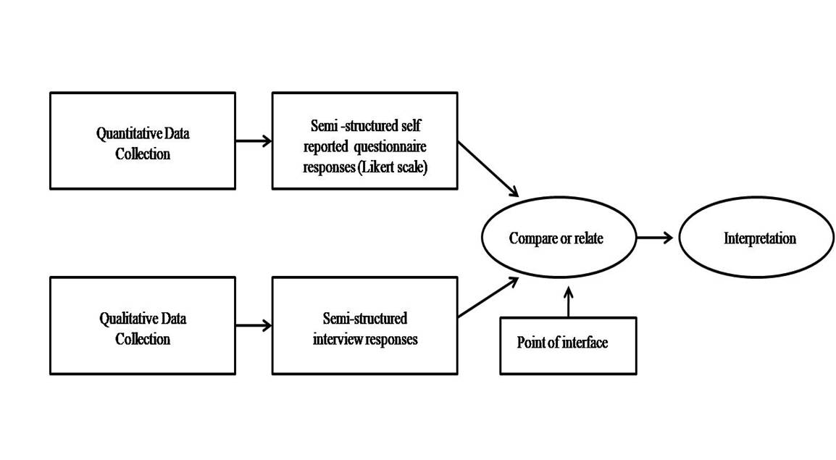
Convergent parallel design (Creswell, Clark, Gutmann, and Hanson, 2003)
4.2 Sampling
Researchers have identified a distinguishable difference in sampling that is determined by the nature of the inquiry (Patton, 1990). For example, quantitative research generally involves larger sample groups, whereas qualitative research uses smaller samples which are purposively selected on the basis that the participants satisfy the conditions and criteria of the study. A purposive sample can provide valuable information that cannot be obtained through other sampling designs and gives the researcher an advantage in inviting participants who will deliver the optimal perspective in answer to the research inquiry.
In this case, the purposively chosen sample group consists of twelve year nine students of varying abilities. Due to their enrolment to the WJEC Entry Level Examination for science, the broad curriculum offers prospects to the teacher to deliver autonomy supported lessons that support the research question. In addition, the students satisfy the study criteria as their varied skill sets and abilities present opportunities for the researcher to explore multiple learning behaviours and responses to autonomy based learning in science which may not have generated more varied data if the sample group were of a similar academic skill set.
All participants and their parents/carers were given written correspondence outlining the nature and the purpose of the study and requesting their written consent (see appendix A1 and A2). Although all students and parents/carers consented to take part, only four students engaged in the semi-structured interviews and some students were absent during the autonomy and choice structured lessons. The reduced sample size will be acknowledged in the data analysis and limitations sections of the study and recommendations considered in light of future study in this area.
Furthermore, purposive sampling presents a distinct disadvantage in that the researcher may be subconsciously biased in selecting the sample group and inadvertently omits an important characteristic needed from the sample group. The study also presents additional potential limitations in that the researcher is also the teacher delivering the research lessons and is already familiar with class. Hence the pre-existing teacher-student rapport may influence the study findings due to feelings of coercion and obligation.
Despite the liabilities noted in purposive sampling, the study perceives its usefulness and relevance as it allows a broader exploration of varied engagement subtypes as they respond to autonomy and choice in the classroom. Furthermore, the research criteria demand a clear and concise explanation of engagement in context with the study. Thus a purposive sample aligns appropriately with the multi-dimensional construct of engagement (Christenson, Reschly and Wylie, 2012).

4.3 Data Collection Methods
A convergent parallel design is proposed for data collection in the mixed methods study. This approach appreciates the benefits to research integrity by utilising combined qualitative and quantitative approaches.
All student participants engaged in four practical lessons over the period of two school academic terms. Standard curriculum lessons were delivered in between the research program. Two of the lessons gave students explicit instructions and guidance throughout. One of these lessons directed students to prepare a density column. The other lesson directed students to measure their own pulse rate after completing specified timed activities.
Several weeks later, the same student participants were presented with the same lesson content for the density column experiment and the pulse rate measurement activity. However, students were encouraged to source their own reagents to make a density column. They were given a choice of available reagents from the school laboratory and suggestions were made to bring in suitable items from home. Similarly, with the pulse rate experiment, students were allowed to choose their own activities to test their pulse rate and choose their own variables for data collection. Autonomy and choice were encouraged in these lessons and student responses were recorded in structured self-reported questionnaires (quantitative) and semi-structured interviews (qualitative) following the completion of each practical activity.

4.3 (i) Quantitative Method – Self-reported Questionnaires
Self-reported questionnaires are advantageous for collecting a large amount of quantitative data and can be administered quickly and effectively through online delivery. Student familiarity from prior online lesson tasks serves as an additional benefit that aims to bring prompt and accurate responses. In addition, self-reported questionnaires offer additional insight into cognitive and emotional behaviours which are not directly observable. With this method, student subject data (thoughts and attitudes) can be recorded which is preferable to student object data (centre target grades, attendance). Above all, the questionnaire questions can be adapted to fit the multi-dimensional construct of the engagement model (Christenson, Reschly and Wylie, 2012).
However, whilst accepting the usefulness of self-reported questionnaires for providing a generalisation of the findings, its limitations must also be considered. One of the main disadvantages is the possibility that respondents may not answer truthfully, especially if the questions may be considered sensitive or if they feel that they need to respond in a socially acceptable way. This phenomenon, known as ‘social desirability bias’, may impact the reliability and validity of the questionnaires. Furthermore, some respondents may be more likely to respond ‘yes’ regardless of the content of the question (an acquiescent response bias) or conversely, more likely to respond ‘no’ (a non-acquiescent bias).
In light of the possibility of biased responses, the four point Likert scale (Likert, 1932) will be used for the questionnaire responses (strongly agree, agree, strongly disagree, and disagree). The omission of a five-point scale aims to reduce neutral responses. Six surveys in total will be delivered online (anonymously) to the participants prior and post each autonomy supported lesson. The format of the questions support the math/science engagement scale model (Wang et al., 2016) as they specifically address emotional, social, behavioural and cognitive engagement sub types (see Appendix B). The same twelve questions will be asked in two pre and post study surveys and will include questions from each engagement subtype (Wang, Fredricks, Ye, Hofkens and Linn, 2016). Whilst the survey questions within the study period will vary in wording and context, they will continue to adhere to the math/science engagement scale (Wang et al., 2016). Data analysis will review any evidence of possible patterns in increased engagement types from autonomy-supported and choice-promoted teachings. All questionnaires are created with Microsoft Forms which collates all responses. The data is converted to percentage values and presented in pie chart and bar graph form created with Microsoft Excel.

4.3 (ii) Qualitative Method – Semi-structured Interviews
As discussed previously in this chapter, this research has adopted a convergent parallel mixed methods design(Creswell et al., 2003), where the qualitative and quantitative strands of the research are conducted independently and their findings brought together as one overall interpretation.
In this study, four of the participants consented to take part in semi-structured interviews after their participation in autonomy-supported lessons. The impact on data collection from a reduced sample size recognises the interviews as the weaker research method and naturally places more emphasis on the survey responses. The general consensus, however, acknowledges that qualitative research samples are often small in order to support the depth of the quantitative analysis. Also, even though small samples may undermine the internal and external validity of the data, smaller participant groups incite positive rapport with the researcher and natural conversations can develop. This minimises bias and leads to the generation of more truthful data.
The ten minute interviews were conducted after each set of standard and autonomy structured practical lessons and the participants were asked to compare their experiences with both lesson structures. Some question examples include,
‘How would you describe the lessons that you took part in, in your own words?’
‘How did the lesson tasks make you feel?’
‘Did you prefer one lesson more than the other? Why is that?’
The audio recordings were then transcribed using Microsoft Word and transcribing software ‘Flixier’ (Flixier Tools, 2023) with a deductive approach to thematic analysis (Braun and Clarke, 2006). This supports the interpretivist theoretical framework of the study as the pragmatic researcher accepts that existence of pre-determined themes from quantitative data. In addition, a pragmatic researcher with a holistic perspective will embrace the exploration of individual experiences and behavioural patterns that will be beneficial to the findings.

Chapter 5 – Data Analysis
5.1 Data Analysis – Self-reported Questionnaires
It is important to return to the inquiry of the study to ensure that the data analysis addresses the research question;
‘In what ways do Autonomy and Choice Impact upon Student Engagement in Secondary Science?’
In essence, the research requires the data to record engagement responses of students when lesson structures have included elements of autonomy and choice. The convergent parallel design of the research used student self-reported questionnaires as the fundamental data source (quantitative) and an inductive approach to thematic analysis on semi-structured interviews as the qualitative data. In this way, the methodology considered various ways that autonomy and choice could impact student engagement.
With reference to the literature already discussed, (Barch,Carrell, Jang, Jeon and Reeve,2004) a study was conducted to explore the impact of autonomy and choice on emotional, social, cognitive and behavioural engagement subtypes. Their findings from survey responses inferred enhanced emotional engagement when autonomy and choice were promoted in classroom teachings. Interestingly, cognitive and behavioural responses did not show increased engagement. In contrast, the data collated from this study has probed this phenomenon further in search of possible correlations with autonomy and all engagement subtypes. This was attempted by incorporating the bi-factor science/math engagement model (Wang et al., 2016) and using categorized engagement type survey questions (see Appendix B1).
The participants completed six questionnaires in total during the course of the study; the initial questionnaire was completed at the beginning of the study prior to the introduction of autonomy and choice with a purpose of providing a base line calibrant. It comprised of four closed statements from each engagement subtype; emotional, social, cognitive and behavioural engagement. Responses were made on a four point Likert scale (Likert, 1932) ranging from ‘strongly agree’, ‘agree’ to ‘strongly disagree’ and ‘disagree’. A five point Likert scale was purposively omitted to prevent respondents making neutral selections. In hindsight and from an ethical standpoint, this may be viewed as a coercive act by the researcher. However, having already established an existing rapport with the participants through previous teachings, I believed that answers would be more credible and honest by imposing a rigid response structure.
The final questionnaire was presented to the participants at the end of the study and was identical in content to the initial questionnaire. The purpose here was to simply compare responses after the students had experienced autonomy and choice and to create a generalised idea of the findings. These could then be compared with qualitative results (obtained from the semi-structured interviews) before interpretation in accordance with the convergent parallel design of the research.
The statements used in the first and last questionnaire were as follows (see Appendix B1),
‘I enjoy learning new things in science lessons’
‘I don’t like working with class mates and prefer to work alone in science lessons’
‘I do other things when I am supposed to be paying attention in science lessons’
‘I think about different ways to solve a problem’
The data collected from the survey responses is presented graphically in a pie chart format for each engagement type (see Appendices B2, B3, B4 and B5).
The initial findings indicated that emotional engagement responses (see appendix B2) of ‘strongly agree’ to ‘I enjoy learning new things in science ‘increased from 27% to 50% following the autonomy and choice intervention lessons. Conversely, the ‘agree’ statements decreased from 73% to 36% following the intervention. One may argue that the increased ‘strongly agree’ responses were markedly more noticeable in comparison to the fewer ‘agree’ responses, which may have inferred a heightened emotional engagement from autonomy. The interpretation of this result may be supported or rebuked by exploring the thematic information retrieved from interview analysis, however initial findings suggest that emotional engagement is positively impacted through autonomy and choice. The possibility also exists that students who initially selected ‘agree’ may have later chosen strongly agree, accounting for the increase in ‘strongly agree’ answers and decrease in ‘agree’ responses.
Conversely, student responses to the social engagement statement (see Appendix B3) were varied and less consistent. Neither positive nor negative links could be made from social engagement responses because of autonomy and choice teachings. For example, the statement, ‘I don’t like working with class mates and prefer to work alone’, generated no ‘strongly agree’ responses although the ‘agree’ statements dropped from 18% to 13% following the intervention. These figures almost suggest that the introduction of autonomy and choice may make students less inclined to embrace the opportunity to explore independent learning skills and think outside the box. Additionally, whilst this may be seen as a positive result for emotional engagement, the percentage is not wholly indicative of a significant change when compared to other emotional subtypes.
In contrast, a larger decrease was recorded with ‘strongly disagree’ responses that dropped from 55% to 38%. Therefore, social engagement data presented a conflicting theory suggesting that autonomy and choice have, in fact, encouraged students to feel more comfortable working as a group rather than alone. It appears that the social engagement construct has generated varied responses. The inconsistencies recorded here suggest a need to compare keenly with qualitative data to establish reliability and credibility towards reviewing the social engagement construct.
Cognitive engagement (see Appendix B4) indicated a 50% increase in ‘agree’ responses to, ‘I think about different ways to solve a problem ‘after the autonomy and choice lessons. This suggests a strong positive impact to student involvement in autonomy lessons with students demonstrating initiative and a keen interest to pursue scientific inquiry.
Lastly, behavioural engagement responses to the statement, ‘I do other things when I am supposed to be paying attention in science’ highlighted an interesting phenomenon that suggested a negative consequence to student behaviour through autonomy and choice strategies. Students appeared to be more prone to distractions and were less focussed on completing lesson tasks. It appeared that with an absence of rigid pedagogy and teacher instruction, some pupils did not achieve their learning potential. In this case, ‘strongly agree’ responses increased from 0% to 13% following the study intervention and the ‘disagree’ responses increased from 36% to 50%. It may be considered that these results reaffirm the importance of recognising the individuality of student learning behaviours and personality traits. In summary, autonomy and choice do not impact all students in the same way.
At this point in the study, it is important to realise that the data discussed above relates to the overall experiences of the participants before and after their engagement in all autonomy and choice structured lessons. As the research question seeks to explore ‘In what ways do Autonomy and Choice Impact upon Student Engagement in Secondary Science?’ it is worth investigating other factors which may or may not influence individual student engagement subtypes.
This viewpoint can be illustrated by analysing student survey responses from a pulse rate activity. Students were initially directed to complete a series of physical activities including running on the spot, performing star jumps and making circular movements with their arms. Participants were directed to measure their own pulse rates following the completion of timed activities and to record their data in bar graph format with explicit instructions for drawing axes, using appropriate scales etc. All participants were allocated to work in small groups as directed by the teacher (and researcher). The same lesson content was then delivered to the same participants a week later with minimal instruction. Participants were invited to measure their pulse rates by choosing their own activities, timings, classmates to work with and methods for presenting their results. Participant experiences were recorded in one self-reported questionnaire after both lessons. This questionnaire, however, contained two additional questions that required respondents to rate their opinions based on social engagement behaviours. The amended questionnaire was implemented to satisfy the research purpose that recognises its flexible framework and pragmatic approach (Goles and Hirschheim, 2000) and supports the multi-dimensional construct model of engagement.
The two statements created and used were,
1). ‘In lessons where I can choose my equipment and resources, I much prefer working in a group’
2). ‘In lessons where I can choose my equipment and resources, I much prefer working alone’
Responses were made via a rating scale (five heart icons equating to a strong agreement and one heart icon to mean not in disagreement). The results (see Appendix C) interestingly indicated that the student response rate for preferring to work in a group acquired the highest average rating over all other questionnaire responses (4.0). Similarly, responses to preferring to work alone were the lowest average rating of all other responses (2.73). The inferred findings from the social engagement pulse rate activity appear to suggest that the type of activity may be an influencing factor towards enhancing social engagement. Furthermore, a visual observation of participant behaviours noted a general increased enjoyment level, which was later echoed in some interview responses. Some students embraced the opportunity to move around the classroom as they completed their tasks. This may be considered an additional engagement influencer and will be discussed in a thematic analysis of the qualitative data in the next section.
A further two lessons were introduced into the study that involved the investigation of various liquid densities. As with the pulse rate activity, the participants were presented witha non-autonomy supported lesson that delivered scientific content, a clear method and instructions to create a density column. Participants were limited to using three liquids in their investigation – namely cooking oil, water, and household detergent. The participants were then informed that they would repeat the lesson a week later using their own choice of liquids (to be brought in from home or selected from a wider range of liquids that were made available). My observations at this point acknowledged a keen student interest in the substances that they could bring into school. Their questions and curiosities were encouraging; I observed one participant who endeavoured to explore the density of nail polish and another participant who requested the use of the school laboratory detergent and hand sanitizer as alternative substances.
As a result of the observations, I exercised the pragmatic and interpretivist approach to the research design by amending the questionnaire format to address primarily emotional engagement responses. I introduced the word ‘choice’ frequently within the questions in addition to ‘exciting’, ‘enjoy’ and ‘boring’. My intention was to draw the participants’ attention to the liquid choices presented to them in the density column activity so that they may compare their experiences when choice was not available. In addition, I attempted to use relatable vocabulary to make the participants feel at ease to generate truthful responses. Examples of the questions used were;
1). ‘It was exciting to choose different liquids and objects to create my own density column’

2). ‘I found it difficult to choose my own liquids’

3). ‘I enjoyed the first density practical (Practical 1) - (Oil and water only and some objects)’

4). ‘I enjoyed the second density practical (Practical 2) - (My choice of liquids and objects)’

The questionnaire responses to statement number 1 (see above and Appendix D1) revealed 60% in agreement and 40% who strongly agreed. This is surprising in that it reflects some reservations in student opinions but is also encouraging to recognise the majority responded positively.
Statement number 2 relates to cognitive engagement and considers student responses to their perceived difficulty in making their own choices. Whilst 80% of students disagreed, 20% agreed that introducing choice posed some challenges (see Appendix D2).
Statement number 3 and 4 invite participants to make a direct comparison between teacher led and autonomy supported lessons (see Appendices D3 and D4). Comparably, the autonomy-supported lessons generated no strongly agree responses but 100% of the responses were agreed answers. This unexpected result mirrors the responses from statement 1 concerning feelings of excitement when choice options are available. In summary, although the consensus perceives positive enhancements to some engagement subtypes (mainly emotional and cognitive), the data recognises a small percentage of uncertainty. This may be due to the influence of other contextual factors at play or student learning behaviours and personality traits.

5.2 Data Analysis – Thematic Analysis
Supporting qualitative data for the study was retrieved through a deductive approach to thematic analysis (Braun and Clarke, 2006) using manual coding from four semi-structured interviews. The concept of driven-coding was appropriate to the research as the quantitative data collected from self-reported questionnaires suggested pre-determined themes within student learning behaviours and their engagement subtypes. For example, some inference indicated enhanced emotional and cognitive engagement from autonomy and choice supported lessons. This presents itself as a form of pre-existing coding which is an advantage to the deductive approach of thematic analysis. It means that the research inquiry could be addressed directly by structuring open-ended interview questions appropriately. However, care was given to acknowledge the involvement of bias in presuming and unconsciously inciting interview responses, which may detract from noting themes that developed naturally.
Four participants each consented to one five to ten minute audio-recorded interview following engagement in both autonomy and choice-supported lessons. The interview questions were semi-structured but open ended to allow respondents to offer honest opinions. Examples of the questions used were,
‘How would you describe the lessons that you took part in completely your own words?’
‘Did you prefer one type of lesson more than the other?’
‘What would you have liked to have done differently?’
The data collected was minimal due to the small participant engagement, but it created an opportunity for a thorough analysis using a hierarchal coding frame. This coding was selected as it could capture participant responses based on their feelings on autonomy and choice-supported lessons. The hierarchical framing was able to support a larger code frame, which allowed opportunities to capture data from different levels within the multi-dimensional construct of engagement (see Figure 2).
Figure 2.
Hierarchical coding frame (Braun and Clarke, 2006)
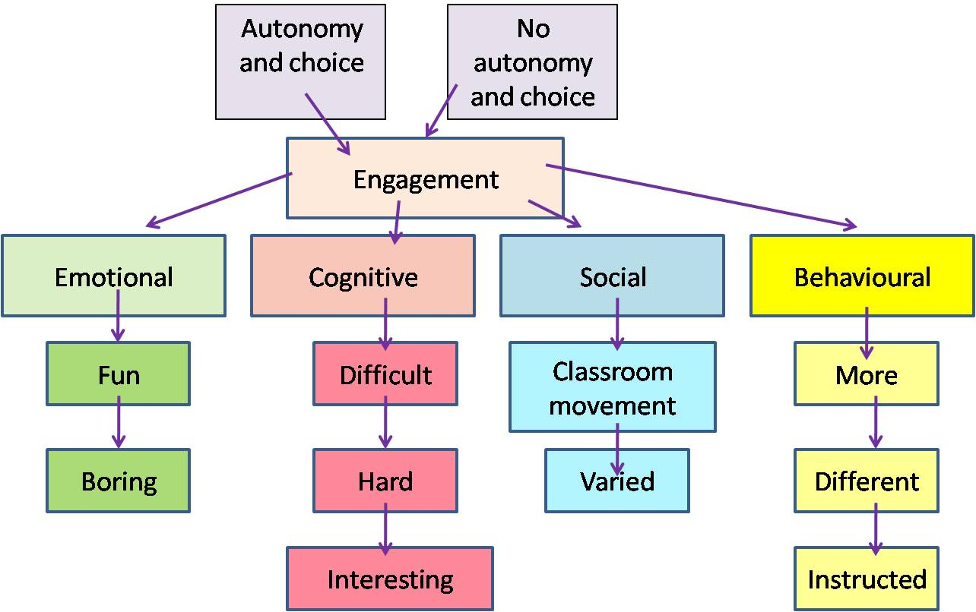

The frame was adapted to accommodate the research inquiry and identify themes. The top level relates to the research question and the second level relates to the topic of the study. The third level associates with the categories of the data (or predetermined themes) but the fourth level details the attributes or specific theme of the study topic.
Consistency in coding is paramount for data reliability for deductive and inductive approaches. As an illustration of this, it has been shown that the mental frame and experiences of the coder can affect the selection and interpretation of codes. In fact, if the same survey is analysed by the same coder on a different day, different results may be produced. In an attempt to mitigate this, the transcripts were reviewed twice without referring to the results using the ‘test-retest method’ (Braun and Clarke, 2006) to ensure consistency and accuracy.
Predetermined themes in all four interview responses were detected from common references made to ‘fun’ and ‘boring’ when comparing autonomy and choice-supported lessons to non-autonomy and non-choice lessons. However, new themes were identified that connected social and behavioural engagement types together. For example, one participant expressed enjoyment in the pulse rate lesson as it presented itself as a carousel activity with an opportunity to move around the classroom. As an observer, I too noted an enhanced engagement in this pulse rate activity from most participants, although a consequential effect of movement in the classroom was a general loss of focus by most participants and an unwillingness to return to each task and complete the activity. This phenomenon was also apparent from the social engagement survey responses. These were varied and inconsistent but pointed towards other influential factors at play such as the type of lesson activity involved. That is to say, the autonomy and choice supported pulse rate activity invoked more positive social engagement responses possibly due to the novelty of its carousel features. A further hint of cross-linked themes with behavioural and social engagement was recognised with an interviewee’s response to the offer of choice in pulse rate activities. The respondent expressed a clear preference for teacher guidance and to be instructed on which activity to do rather than to be given the choice to make an independent decision. This suggests the need to acknowledge that different learner types will respond more or less favourably to autonomy and choice and perhaps simply need less options to choose from or stricter, more precise parameters for exploration.
Conversely, when participants were asked about their experiences about the density column activity in both lessons, themes were identified with ‘difficult’, ‘hard’, and ‘interesting’ which supported the math/science engagement scale (Wang et al., 2016) and fitted the cognitive engagement subtypes. Therefore, in this case, pre-determined themes were correctly aligned for cognitive responses and all participants appeared focussed and interested in the idea of using substitute liquids.
To conclude this section of the study, it can be implied from the thematic analysis and supporting quantitative data that autonomy and choice lesson strategies are significant influential factors that may positively or negatively impact upon student engagement. Additionally, there is much evidence for considering the importance of other prominent variables such as student personality traits and learning behaviours, lesson activities, the learning environment, social interactions and relations with peers and teachers.

5.3 Ethical Considerations
The purposive sample for this study comprised of twelve year nine students with ranging academic abilities. Ethical considerations were given to the participants in alignment with BERA and BPS guidelines (2008).
Participants (and their respective parents/carers) were sent a typed letter requesting informed consent. The letter outlined the purpose of the study and the required involvement of the respondents (see Appendices A1 and A2). This was specified as voluntary involvement which may be withdrawn at any time without any reason being specified. Furthermore, full student anonymity and confidentiality was assured and protected throughout the research period with no personal identification of any participant to be disclosed should there be any publication of the study data. Supplementary information was provided concerning the data’s involvement in the university assignment, the temporary storage of data on the university server (until study completion when it will be destroyed) and the offer to disclose study results to the participants should they wish to review.
Further acknowledgement and consideration was given to the participants to minimise the risk of harm and feelings of coercion from peers and the researcher by continual reminders that they may opt out at any point.
It must be noted in this section that my approved ethics form discussed all possible strategies that would have been desirable and useful in a mixed methods design approach to addressing the research inquiry. However, during the study period, methodology adjustments were required as a result of limitations imposed upon the research by the educational establishment and the study location. Although reassurance from the university and reference to BERA and BPS (2018) research guidelines were provided, the educational gatekeepers were reluctant to grant permissions to allow visual classroom observations and recordings. Consequently, the research has omitted data that would have been collected through visual recordings (using Microsoft Stream) of autonomy and choice supported lessons. In addition, visual observations recorded with the Leuven scale for engagement (Laevers,2003) have not been included in the data collection, although consideration has been given to incidental observations made by the researcher in support of quantitative (self-reported questionnaires) and qualitative (semi-structured interview) data. Nonetheless, it is perceived that data reliability and validity was established and maintained with afore mentioned methods to provide an insightful perspective towards addressing the research inquiry.

Chapter 6 – Findings and Data Analysis
6.1 Quantitative Results
It is important to review the specifics of the research and recognise that it calls for an analysis of ways in which (if any), autonomy and choice impact upon student engagement. The study has built its purpose from the established engagement model (Fredericks et al., 2004) and bi-factor model (Wang et al., 2016) and accepts the multi-dimensional construct for the definition of engagement. Furthermore, the research appreciates the validity and usefulness of the math/science engagement scale (Wang et al., 2016) and expands existing engagement statements to further probe emotional, social, behavioural and cognitive responses in self-reported questionnaires.
Quantitative data collected from questionnaire responses indicated a positive influence on emotional engagement when practical lessons promoted autonomy and choice. In contrast, social engagement responses indicated a less distinct pattern and inferred a higher student interest towards working alone in autonomy supported lessons due to a reduced number of ‘agree’ statements. Conversely, a larger decrease in ‘disagree’ statements suggested students’ favoured working as a group following their autonomy classroom experiences. This variability in positive and negative responses points to a social imbalance where other influential factors may be at play. On reflection, the ranging responses may be attributable to the use of a four point Likert scale (Likert, 1932) which omitted the option to select a neutral response. Although, if this were to be a contributing factor, variant responses would also be noted within the other engagement subtypes statements and yet this was not the case. In summary, the inconsistencies of the social engagement responses may be explained by reviewing interview responses. Through thematic analysis, these indicated that some students preferred carousel type lessons (such as the pulse activity) as they were able to move around the classroom. This generated a positive impact to social engagement. Conversely, the density column activity generated a less positive impact on social engagement but produced enhanced cognitive engagement responses. This was evident by a 50% increase in ‘agree’ statements to ‘I think about different ways to solve a problem’ after both autonomy and choice lessons.
As a further example, behaviour engagement responses appeared to decline with autonomy based lessons and students frequently were observed to be off task and easily distracted. This phenomenon may be attributed to the availability of too much choice and consequent lack of lesson structure. These results have suggested that the effects autonomy and choice are subject to the learning style of the individual student.

6.2 Qualitative Results
Qualitative methods were employed with four consenting participants who engaged in short (five to ten minute) semi-structured interviews at the end of the study. A hierarchical coding frame (Braun and Clarke, 2006) was adopted to identify and code themes from the audio transcripts. Although the sample group was small which inferred less validity and reliability to the results, some participant feedback during the interviews was insightful and useful to explaining anomalous questionnaire responses. The deductive approach recognised the existence of predetermined themes such as ‘choice’ and ‘fun’ by reviewing questionnaire responses and loosely categorising their engagement subtypes. However, new themes such as ‘movement’ were linked to an increased social engagement from the pulse activity although the same respondent disfavoured choosing the activity and consequently generated a negative behavioural engagement response. This suggests that too much choice and autonomy does not create the optimum learning environment for all pupils. The findings emphasize the importance of differentiation and accommodating individual student learning needs and personality traits.

Chapter 7 – Discussion and Conclusion
7.1 Limitations and Recommendations
7.1 (i) Purposive Sample
Sample sizes are ascertained differently in qualitative and quantitative studies. However, there is an underlying acceptance in research that small sample sizes in qualitative research provide ‘saturation’ and quality to the data (Malterud, Siersma and Guassora, 2016). Nonetheless, this study recognises that the sample size for the semi-structured interviews (four transcripts) was insufficient to support a valid and reliable thematic analysis of the data. Despite this, its contribution in support of the quantitative evidence was noted as useful as supplementary evidence and provided more insight to explain the anomalous social engagement responses (chapter 6.2). Possible suggestions for future research would be to invite a larger sample group to participate to ensure higher engagement in supplementary mixed methods such as interviews where most students appeared reluctant to have their audio opinions recorded.
With additional reference to the purposive sample chosen for the study, general findings suggested that further research would be more beneficial if the student group was a larger mainstream class with standardised skill sets and abilities. The current study sample comprised of twelve students who displayed varied learning behaviours and personality traits. This introduced an element of inconsistency when trying to establishing a base line from initial survey responses. Moreover, student absences were a frequent occurrence throughout the study which impacted negatively on data collection from an already small sample group. Continued research in this area needs to be extensive but with significant focus upon reliability and validity. Effort must be made to ensure that external influences such as school absences are limited and participant criterion is generalised as much as possible so that data patterns can be directly identified and anomalies ruled out.

7.1(ii) Methodology
In situ problems with educational research are frequently referenced in the literature (Sinatra, Heddy and Lombardi, 2015) with particular acknowledgment made to the complexities involved in measuring engagement without interrupting the flow of natural learning. Science lesson tasks and activities can often be very detailed and challenging. Teaching strategies may require group work, practical investigations, equipment use, safety awareness, experimental observations and data collection. Similarly, challenges were faced in this study to record reliable and credible data without disruption to the natural progression of learning. On reflection, this could be mitigated by using a process known as experienced sampling (Hektner, Schmidt and Csikszentmihalyi, 2007) where engagement events could be observed and recorded in context. The employment of experience sampling would involve contacting students on numerous occasions within a school day (via a pager or email correspondence) to ask them to write down if they are engaging with the lesson at that moment. In this way, the researcher would be able to capture emotional, social, cognitive and behavioural engagement as it occurs. This method may be considered beneficial as it is unobtrusive and does not interfere with the flow of student engagement during science learning.
Prospective ideas towards methodology improvements would be advantageous from refinements to semi-structured interview questions. The open-ended questions used were considered too vague and required more structure. This may be attributed to the personality traits of the purposive sample chosen (as mentioned above) which may be mitigated through selecting a larger sample group with fewer individual learning challenges and requirements. As the researcher, I became aware of introducing coercive language by verbalising choice answers. This, of course, negated the intention of encouraging truthful responses. Hence, potential recommendations for future interviews would be to carefully review the format of structured interviews and consider the disposition of the intended respondents to ensure that they are comfortable and at ease with the recording process.
A final reflection of a research method chosen considers the use and effectiveness of the four point Likert scale (1932) for self-reported student questionnaire responses. The purpose of eliminating a neutral choice option was impactful and generated definitive responses which fitted the questionnaire’s purpose. Initially, the data that produced a wide variance in social engagement responses may have been considered to be a consequence of the refined response options available. However, a closer review of the data concluded that all other engagement types did not display the same wide ranging responses. In this situation, the four point scale was effective in highlighting a prominent impact to autonomy that suggested other influential factors to autonomy were evident such as student personality traits and lesson activities (chapter 5.1).
The overall purpose for selecting a mixed methods approach to the study has been to optimise the production of reliable and credible results through utilising varied research methods and tools. Hence, it must be recognised that the intended research design had initially considered the use of four methods. In addition to student self-reported questionnaires and semi-structured interviews, the study planned to utilise classroom lesson recordings (audio and visual) and observations logged with the Leuven scale of engagement (Laevers, 2003).Unfortunately, the gatekeepers of the educational establishment expressed reluctance to permit classroom lesson recordings. They voiced concerns for the involvement of student data to the study although full documentation was provided (BER, BPS, 2018) and reassurances made by the university. The study would have most definitely benefited from data collected and interpreted from all four methods which would have also have satisfied the parameters of the chosen convergent parallel design (Creswell et al., 2003). Time restrictions however may have impeded upon the depth of analysis required from all four research methods. Therefore, further engagement research will endeavour to use the additional methods mentioned to justify comprehensive findings that offer more credibility and reliability to the study. Moreover, a longitudinal study would yield more meaningful data and subsequently indicate relevant data that demonstrates future science career choices.

7.2 Contributions to the Field of Study and Conclusion
Concerns exist for the future of the STEM workforce as there continues to be a decline in graduate entries in scientific fields and careers (Tytler, Osborne, Williams, Tytler and Cripps Clark,2008). Increased efforts in engagement research have been conducted in fervent attempts to explain the phenomenon. For example, a study that focussed upon facilitating student interest in science subjects and related careers generated a student value from their findings. The identification of a coefficient value led to more students enrolling in science courses (Harackiewicz, Rozek, Hulleman and Hyde, 2012). Similarly, Deci and Ryan, (1985) defined student criteria for successful intrinsic and extrinsic motivation which highlighted the impact of autonomy, relatedness and competency. However, whilst applauding existing contributions made to engagement studies and appreciating its defining complexities, it appears that the pursuit to isolate a secret ingredient to student academic success continues to challenge the empirical mind.
This study has reviewed the impact of autonomy and choice on student engagement and has identified engagement subtypes that are more influential than others. Furthermore, it has accentuated the importance of differentiation and recognition of how each student adopts individual personality traits and learning behaviours which impact on the learning experience. Each characteristic may or may not alter a student’s perception towards the learning environment. In other words, autonomy and choice may be influential with a student who displays high levels of emotional engagement, but less impactful with a student who demonstrates social engagement traits.
In summary, autonomy and choice cannot be considered as separate factors that may influence any engagement subtype. Consideration must be given to the student’s personality, abilities and attributes so that differentiation is relative to the student for an optimal learning experience.

[Word count 12,179]
Reference List

Angen, M.J., 2000. Evaluating interpretive inquiry: Reviewing the validity debate and opening the dialogue. Qualitative health research, 10(3), pp.378-395.

Appleton, J.J., Christenson, S.L., Kim, D. and Reschly, A.L., 2006. Measuring cognitive and psychological engagement: Validation of the Student Engagement Instrument. Journal of school psychology, 44(5), pp.427-445.

Assor, A., Kaplan, H. and Roth, G., 2002. Choice is good, but relevance is excellent: Autonomy‐enhancing and suppressing teacher behaviours predicting students' engagement in schoolwork. British journal of educational psychology, 72(2), pp.261-278.

Barch, J., Carrell, D., Jang, H., Jeon, S. and Reeve, J., 2004. Enhancing high school students’ engagement by increasing their teachers’ autonomy support. Motivation and Emotion, 28(2), pp.147-169.

Barlia, L., 1999. High school student's motivation to engage in conceptual change-learning in science. The Ohio State University.

British Educational Research Association (2018) Ethical guidelines for educational research. 4th edn. Available at: https://www.bera.ac.uk/researchers-resources/publications/ethical-guidelines-for-educational-research-2018 (Accessed: 5th July 2022).

Beymer, P.N., Rosenberg, J.M. and Schmidt, J.A., 2020. Does choice matter or is it all about interest? An investigation using an experience sampling approach in high school science classrooms. Learning and Individual Differences, 78, p.101812.
Birch, S., and GW Ladd, 1997, Interpersonal relationships in the school environment and children’s early school adjustment. Journal of School Psychology, 35(1), pp.61-79.

Black, A.E. and Deci, E.L., 2000. The effects of student self-regulation and instructor autonomy support on learning in a college-level natural science course: A self-determination theory perspective.

Bomia, L., Beluzo, L., Demeester, D., Elander, K., Johnson, M. and Sheldon, B., 1997. The Impact of Teaching Strategies on Intrinsic Motivation. p.294

Badley, G., 2003. The crisis in educational research: a pragmatic approach. European educational research journal, 2(2), pp.296-308.

Brannick, T. and Coghlan, D., 2006. Reflexivity in management and business research: what do we mean?. Irish Journal of Management, 27(2).

Braun, V. and Clarke, V., 2006. Using thematic analysis in psychology. Qualitative research in psychology, 3(2), pp.77-101.

Carson, D., Gilmore, A., Perry, C. and Gronhaug, K., 2001. Qualitative marketing research. Sage.

Cherry, K., 2019. What are the big 5 personality traits. Very well Mind.

Christenson, S., Reschly, A.L. and Wylie, C., 2012. Handbook of research on student engagement (Vol. 840). New York: Springer.

Connell, J.P. and Wellborn, J.G., 1994. Engagement versus disaffection: Motivated patterns of action in the academic domain. Rochester, NY: University of Rochester.

Creswell, J.W., Plano Clark, V.L., Gutmann, M.L. and Hanson, W.E., 2003. Advanced mixed methods research designs. Handbook of mixed methods in social and behavioral research, 209(240), pp.209-240.

Danili, E. and Reid*, N., 2004. Some strategies to improve performance in school chemistry, based on two cognitive factors. Research in Science & Technological Education, 22(2), pp.203-226.

Deci, E.L. and Ryan, R.M., 1985. Self-determination and intrinsic motivation in human behavior. EL Deci, RM Ryan.–1985.

Dewey, J., 1931. The Development of American Pragmatism.” Philosophy and Civilization. GP Putnam’s Sons, New York.

Flick, U., 2009. An Introduction to Qualitative Research, 4th Edn. London: Sage.
Flowerday, T. and Schraw, G., 2003. Effect of choice on cognitive and affective engagement. The Journal of Educational Research, 96(4), pp.207-215.
Flixier. Available at: https://editor.flixier.com/tools/all-tools (Accessed: 02 July 2023).

Foreback, L.E., 2010. Effects of student choice on engagement and understanding in a junior high science class. Michigan State University.

Fredricks, J.A., Blumenfeld, P.C. and Paris, A.H., 2004. School engagement: Potential of the concept, state of the evidence. Review of educational research, 74(1), pp.59-109.

Goles, T. and Hirschheim, R., 2000. The paradigm is dead, the paradigm is dead… long live the paradigm: the legacy of Burrell and Morgan. Omega, 28(3), pp.249-268.

Goldberg, L.R., 1981. Language and individual differences: The search for universals in personality lexicons. Review of personality and social psychology, 2(1), pp.141-165.

Guay, F., Boggiano, A.K. and Vallerand, R.J., 2001. Autonomy support, intrinsic motivation, and perceived competence: Conceptual and empirical linkages. Personality and Social Psychology Bulletin, 27(6), pp.643-650.

Hänze, M. and Berger, R., 2007. Cooperative learning, motivational effects, and student characteristics: An experimental study comparing cooperative learning and direct instruction in 12th grade physics classes. Learning and instruction, 17(1), pp.29-41.

Harackiewicz, J.M., Rozek, C.S., Hulleman, C.S. and Hyde, J.S., 2012. Helping parents to motivate adolescents in mathematics and science: An experimental test of a utility-value intervention. Psychological science, 23(8), pp.899-906.

Hektner, J.M., Schmidt, J.A. and Csikszentmihalyi, M., 2007. Experience sampling method: Measuring the quality of everyday life. Sage.

Hudson, L.A. and Ozanne, J.L., 1988. Alternative ways of seeking knowledge in consumer research. Journal of consumer research, 14(4), pp.508-521.

Hufton, N., Elliott, J. and Illushin, L., 2002. Motivation to learn: The elusive role of culture: Qualitative accounts from three countries. British Educational Research Journal, 28, pp.267-291.

Klein, H.K. and Myers, M.D., 1999. A set of principles for conducting and evaluating interpretive field studies in information systems. MIS quarterly, pp.67-93.

Laevers, F., 2003. Experiential education: Making care and education more effective through well-being and involvement. Involvement of children and teacher style. Insights from an international study on experiental education, pp.13-24.

Lee, O. and Brophy, J., 1996. Motivational patterns observed in sixth‐grade science classrooms. Journal of Research in Science Teaching: The Official Journal of the National Association for Research in Science Teaching, 33(3), pp.303-318.

Likert, R., 1932. A technique for the measurement of attitudes. Archives of psychology.

Linnenbrink, E.A. and Pintrich, P.R., 2003. The role of self-efficacy beliefs instudent engagement and learning intheclassroom. Reading &Writing Quarterly, 19(2), pp.119-137.

Mack, L., 2010. The philosophical underpinnings of educational research.

Malterud, K., Siersma, V.D. and Guassora, A.D., 2016. Sample size in qualitative interview studies: guided by information power. Qualitative health research, 26(13), pp.1753-1760.

Moustakas, C., 1994. Phenomenological research methods. Sage publications.

Newmann, F.M., 1986. Priorities for the future: Toward a common agenda. Social Education, 50(4), pp.240-50.

Neuman, L.W., 2011. Social Research Methods: Qualitative and Quantitative Approaches (Edition. No. 7) Pearson Education. Inc. Boston, MA, USA.

Myers, M.D. and Avison, D. eds., 2002. Qualitative research in information systems: a reader. Sage.

Niemiec, C.P. and Ryan, R.M., 2009. Autonomy, competence, and relatedness in the classroom: Applying self-determination theory to educational practice. Theory and research in Education, 7(2), pp.133-144.

Organisation for Economic Co-operation and Development (OECD), 2013. PISA 2012 Results: Ready to Learn: Students’ Engagement, Drive and Self-Beliefs (Volume III): Preliminary Version. Paris, France: OECD.

Onwuegbuzie, A.J. and Teddlie, C., 2003. A framework for analyzing data in mixed methods research. Handbook of mixed methods in social and behavioral research, 2(1), pp.397-430.

Orlikowski, W.J. and Baroudi, J.J., 1991. Studying information technology in organizations: Research approaches and assumptions. Information systems research, 2(1), pp.1-28.

Osborne, J., Simon, S. and Collins, S., 2003. Attitudes towards science: A review of the literature and its implications. International journal of science education, 25(9), pp.1049-1079.

Patton, M.Q., 1990. Qualitative evaluation and research methods. SAGE Publications, inc.

Pelletier, L.G., Séguin-Lévesque, C. and Legault, L., 2002. Pressure from above and pressure from below as determinants of teachers' motivation and teaching behaviors. Journal of educational psychology, 94(1), p.186.

Raddon, A., 2010. Early stage research training: Epistemology & ontology in social science research. Generic Skills Training for Research Students, pp.1-14.

Rolfe, G., 2006. Validity, trustworthiness and rigour: quality and the idea of qualitative research. Journal of advanced nursing, 53(3), pp.304-310.

Reeve, J., 2018. Understanding motivation and emotion. John Wiley & Sons.
Ryan, R.M. and Deci, E.L., 2009. Promoting self-determined school engagement: Motivation, learning, and well-being.

Saunders, M., Lewis, P. and Thornhill, A., 2009. Research methods for business students. Pearson education.

Schaufeli, W.B. and Bakker, A.B., 2004. Job demands, job resources, and their relationship with burnout and engagement: A multi‐sample study. Journal of Organizational Behavior: The International Journal of Industrial, Occupational and Organizational Psychology and Behavior, 25(3), pp.293-315.

Sinatra, G.M., Heddy, B.C. and Lombardi, D., 2015. The challenges of defining and measuring student engagement in science. Educational psychologist, 50(1), pp.1-13.

Stroet, K., Opdenakker, M.C. and Minnaert, A., 2013. Effects of need supportive teaching on early adolescents’ motivation and engagement: A review of the literature. Educational research review, 9, pp.65-87.

Schlechty, P.C., 2002. Working on the Work: An Action Plan for Teachers, Principals, and Superintendents. The Jossey-Bass Education Series. Jossey-Bass, 989 Market Street, San Francisco, CA 94103-1741. p.64

Taylor, P.C., 2008. Multi-paradigmatic research design spaces for cultural studies researchers embodying postcolonial theorising. Cultural Studies of Science Education, 3, pp.881-890.

Tytler, R., Osborne, J., Williams, G., Tytler, K. and Cripps Clark, J., 2008. Opening up pathways: Engagement in STEM across the primary-secondary school transition. Canberra: Australian Department of Education, Employment and Workplace Relations.

Thanh, N.C. and Thanh, T.T., 2015. The interconnection between interpretivist paradigm and qualitative methods in education. American journal of educational science, 1(2), pp.24-27.

Unicef, 2021. What's Next? Lessons on Education Recovery.

VanSledright, B., 2008. Narratives of nation-state, historical knowledge, and school history education. Review of research in education, 32(1), pp.109-146.

Vosniadou, S. and Brewer, W.F., 1992. Mental models of the earth: A study of conceptual change in childhood. Cognitive psychology, 24(4), pp.535-585.

Wang, M.T., Fredricks, J.A., Ye, F., Hofkens, T.L. and Linn, J.S., 2016. The math and science engagement scales: Scale development, validation, and psychometric properties. Learning and Instruction, 43, pp.16-26.

Woolfolk, A. and Margetts, K., 2007. Educational psychology. NSW, Australia.

Appendices
Appendix A
A1 – Student Consent Form

STUDENT CONSENT FORM

PROJECT TITLE: IMPACT OF STUDENT LED PRACTICAL WORK IN SCIENCE

Name of Researcher: Miss Lucy Paradice BSc MPhil PGCE
Please initial boxes.

1. I confirm that I have read and understand the information sheet dated 14.3.2023for the above study.

2. I understand that my participation is voluntary and that I am free to withdraw from the study at any time, without giving any reason.
3. I understand that I can choose to withdraw at any time, without giving a reason.

4. I understand that the information given will be used in a university assignment.

5. I understand that my name will not appear at any time.
6. I agree to take part in the above study.

__________________________________________________ __________
Student’s name

Student’s signature Date
When completed, please return this form to Miss L. Paradice, Science Teacher at Cwmtawe School by Friday 17th March 2023 or at your earliest convenience.

Thank you.

INFORMATION sheet

PROJECT TITLE: IMPACT OF STUDENT LED PRACTICAL WORK IN SCIENCE

14th March 2023
Dear Student,
My name is Lucy Paradice and I am studying for a PhD qualification at Yr Athrofa, University of Wales Trinity Saint David. I am your science teacher at Cwmtawe Community School.

I would like to invite youto participate in my research project. The title of the project is:

In what ways do Autonomy and Choice Impact upon Student Engagement in Secondary Science?

I aim to explore engagement levels in practical science lessons where you will be presented with opportunities for independent learning. Through your participation, I hope to produce results that demonstrate the positive impacts to learning and enjoyment in science when all students are given opportunities to make individual choices of assignment types and resources selected to practically demonstrate scientific principles.

I shall be asking students to complete questionnaires, short interviews and engage in lesson recordings (where individual student identity will be omitted). The research project will span over 4 lessons during the latter part of this term and beginning of the Easter term.

All names will be kept strictly confidential and the identity of participants will only be known to me. Your participation in this study is completely voluntary so you can withdraw from the study at any stage. You will also be asked to give your assent before, during and at the end of the study.

After careful and precise analysis of the data obtained from the questionnaire, interview and video recordings, I would be happy to provide you with a copy of the findings at your request. The results of the research will be discussed in a university assignment that will contribute to my PhD course. The results of this study will be stored temporarily on the University’s secure storage server and all raw data will be destroyed once the assessment has been marked.

If any questions do arise, feel free to contact me at your convenience.
Yours sincerely,

Miss Lucy A Paradice BSc MPhil PGCE

A2 – Parental Consent Form

parental CONSENT FORM

PROJECT TITLE: IMPACT OF STUDENT LED PRACTICAL WORK IN SCIENCE
Name of Researcher: Miss Lucy Paradice BSc MPhil PGCE

Please initial boxes.
1. I confirm that I have read and understand the information sheet dated 6.3.2023for the above study.

2. I understand that my child’s participation is voluntary and that I am free to withdraw my child from the study at any time, without giving any reason.

3. I understand that my child can choose to withdraw at any time, without giving a reason.

4. I understand that the information given by my child will be used in a university assignment.

5. I understand that my child’s name will not appear at any time.

6. I agree for my child to take part in the above study.

__________________________________________________ __________
Child’s name

Parent signature Date
When completed, please return this form to Miss L. Paradice, Science Teacher at Cwmtawe School by Monday 13th March 2023 or at your earliest convenience.

Thank you.

INFORMATION sheet

PROJECT TITLE: IMPACT OF STUDENT LED PRACTICAL WORK IN SCIENCE
6th March 2023
Dear Parent / Guardian,
My name is Lucy Paradice and I am studying for a PhD qualification at Yr Athrofa, University of Wales Trinity Saint David. I am a science teacher at Cwmtawe Community School.

I would like to invite your child to participate in my research project. The title of the project is:

In what ways do Autonomy and Choice Impact upon Student Engagement in Secondary Science?

I aim to explore engagement levels in practical science lessons when students are presented with opportunities for independent learning. Through your child’s participation, I hope to produce results that demonstrate the positive impacts to learning and enjoyment in science when students are given opportunities to make individual choices of assignment types and resources selected to practically demonstrate scientific principles.

I shall be asking students to complete questionnaires, short interviews and engage in lesson recordings (where individual student identity will be omitted). The research project will span over 4 lessons during the latter part of this term and beginning of the Easter term.

All names will be kept strictly confidential and the identity of participants will only be known to me. Your child’s participation in thisstudy is completely voluntary so you or your child can withdraw from the study at any stage. Your child will also be asked to give their assent before, during and at the end of the study.

After careful and precise analysis of the data obtained from the questionnaire, interview and video recordings, I would be happy to provide you with a copy of the findings at your request. The results of the research will be discussed in a university assignment that will contribute to my PhD course. The results of this study will be stored temporarily on the University’s secure storage server and all raw data will be destroyed once the assessment has been marked.

I thank you in advance for your time. If any questions do arise, feel free to contact me at your convenience.
Yours sincerely,
Miss Lucy A Paradice BSc MPhil PGCE

Appendix B
B1 – Student Survey Engagement Statements (Wang et al., 2016)
Cognitive Engagement
1. I go through the work for science/math class and make sure that it's right.
2. I think about different ways to solve a problem.
3. I try to connect what I am learning to things I have learned before.
4. I try to understand my mistakes when I get something wrong.
5. I would rather be told the answer than have to do the work.
6. I don't think that hard when I am doing work for class.
7. When work is hard, I only study the easy parts.
8. I do just enough to get by/ I do more than required in class.

Behavioural Engagement
9. I stay focused.
10. I put effort into learning science/math.
11. I keep trying even if something is hard.
12. I complete my homework on time.
13. I talk about science/math outside of class.
14. I don't participate in class/I do participate in class.
15. I do other things when I am supposed to be paying attention.
16. If I don't understand, I give up right away.

Emotional Engagement
17. I look forward to science/math class.
18. I enjoy learning new things about science/math.
19. I want to understand what is learned in science/math class.
20. I feel good when I am in science/math class.
21. I often feel frustrated in science/math class.
22. I think that science/math class is boring.
23. I don't want to be in science/math class.
24. I don't care about learning science/math.
25. I often feel down when I am in science/math class.
26. I get worried when I learn new things about science/math.

Social Engagement
27. I build on others' ideas.
28. I try to understand other people's ideas in science/math class.
29. I try to work with others who can help me in science/math.
30. I try to help others who are struggling in science/math.
31. I don't care about other people's ideas.
32. When working with others, I don't share ideas.
33. I don't like working with classmates.

B2– Emotional Engagement Pre and Post Study Student Survey Responses

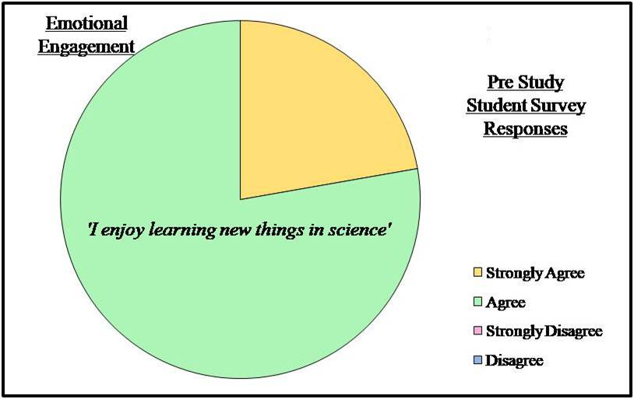

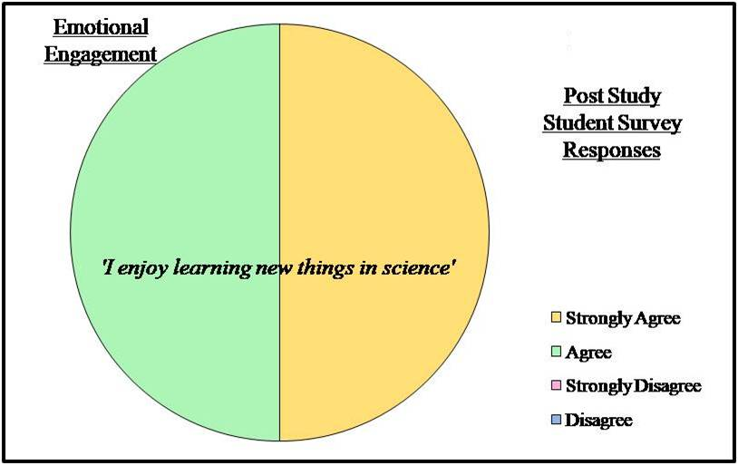

B3– Social Engagement Pre and Post Study Student Survey Responses

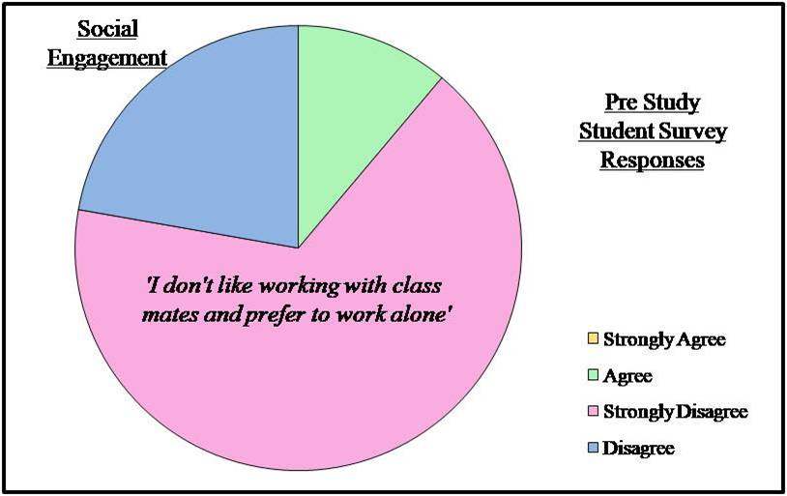

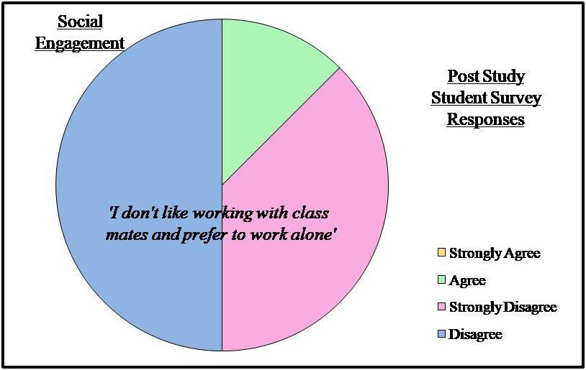

B4– Cognitive Engagement Pre and Post Study Student Survey Responses

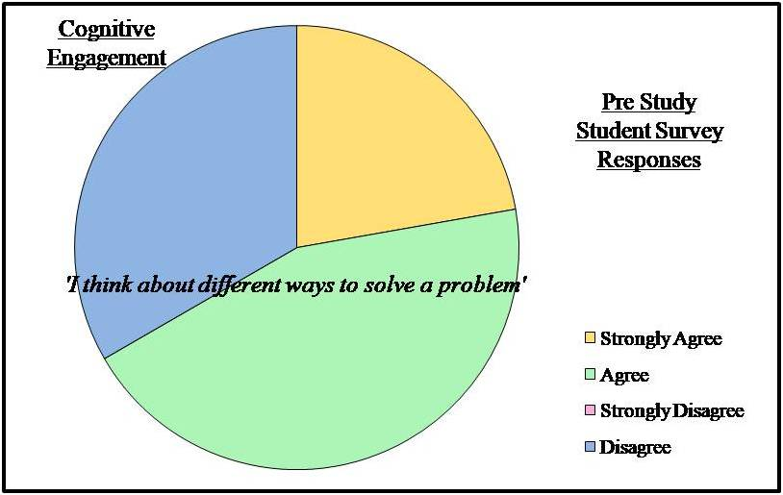

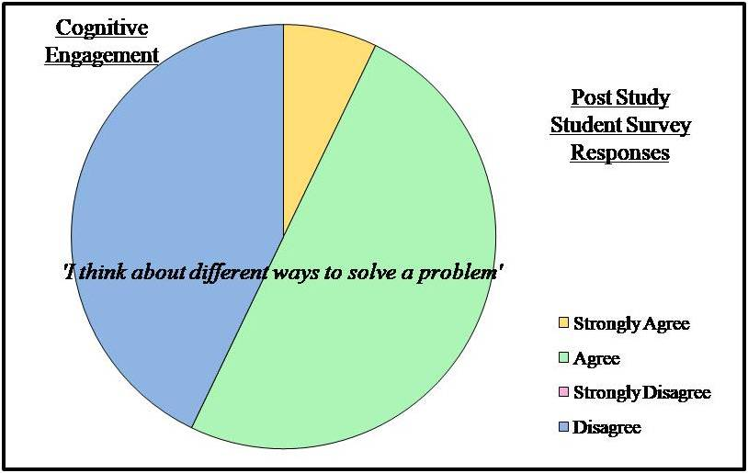

B5 – Behavioural Pre and Post Study Student Survey Responses

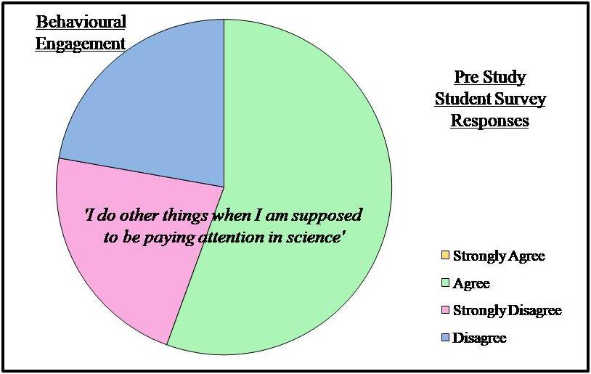

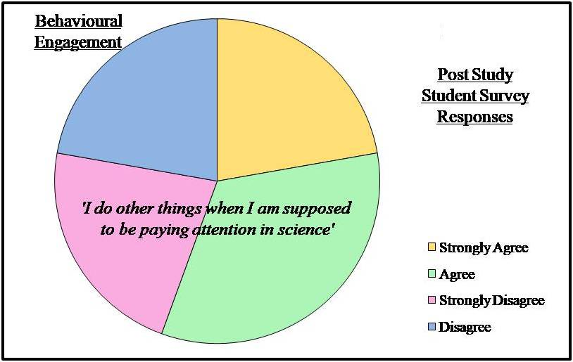

Appendix C
C1 – Student Survey Responses (Pulse Rate Activity)
Social Engagement - (Preference of Working in a Group)
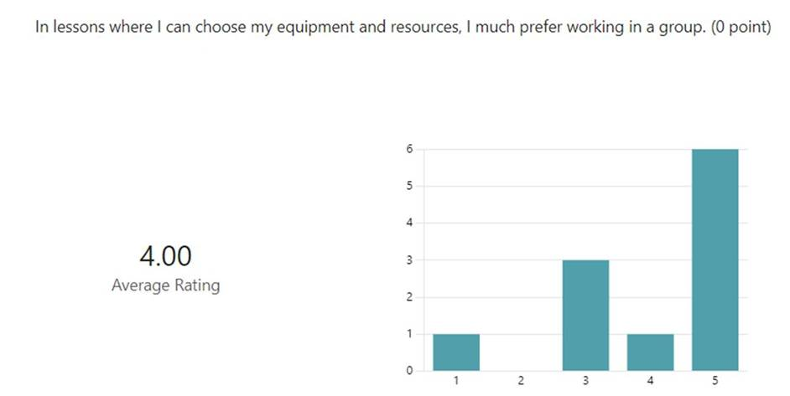

C2 – Student Survey Responses (Pulse Rate Activity)
Social Engagement - (Preference of Working Alone)
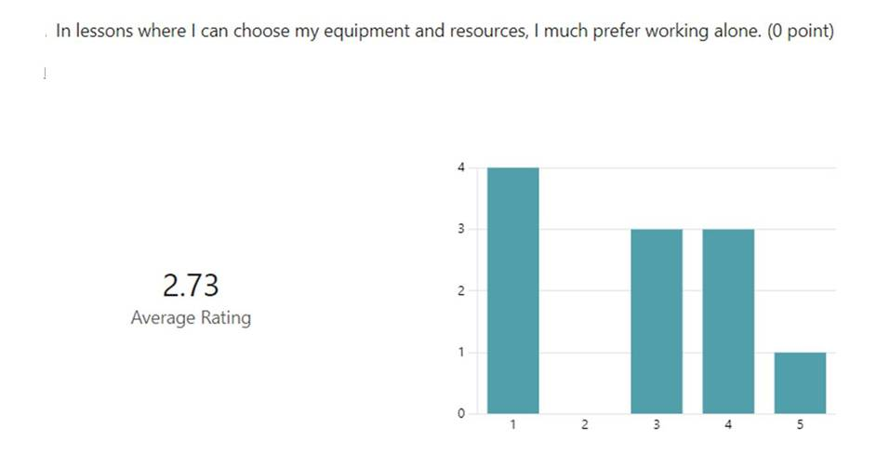

Appendix D
D1 – Student Survey Responses (Density Column Activity)
Emotional Engagement
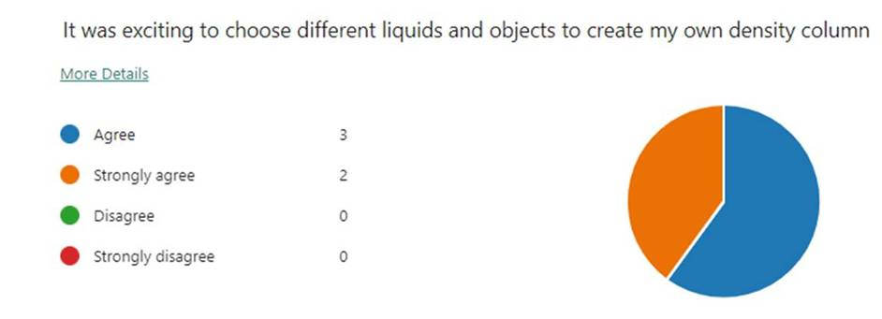

D2 – Student Survey Responses (Density Column Activity)
Cognitive Engagement
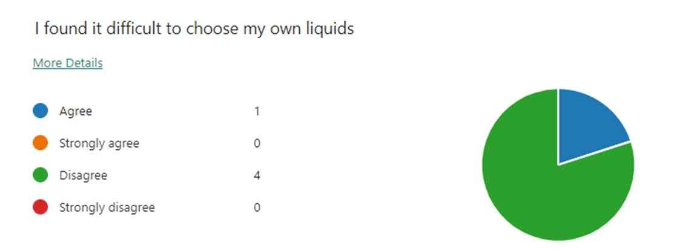

D3 - Student Survey Responses (Density Column Activity)
Emotional Engagement – Lesson Comparison (Practical 1)
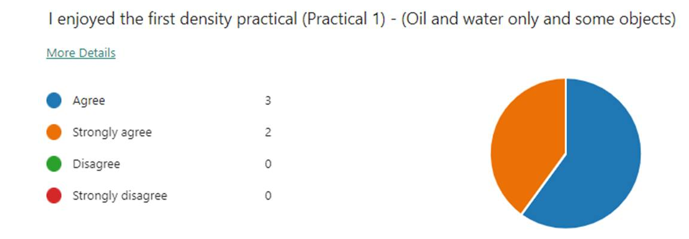
D4 – Student Survey Responses (Density Column Activity)
Emotional Engagement – Lesson Comparison (Practical 2)



