

NAME: NICOLA PLUMMER
STUDENT ID: 2320431
COURSE NAME: BSC APPLIED COMPUTING
MODULE NAME: INDEPENDENT PROJECT PROPOSAL
PROJECT TITLE: SMART WEB-BASED ACCESSIBILITY AND LEARNING SUPPORT SYSTEM FOR DEAF BRITISH STUDENTS

MODULE CODE: ACCA 6020
SUPERVISOR: DR. MOBOLANLE BELLO
SUBMISSION DATE: JULY 31, 2026
TIME: 2:00 PM

Table of Contents
1.0 INTRODUCTION 2
1.1 BACKGROUND 2
1.2 PROBLEM STATEMENT 2
1.3 AIM AND OBJECTIVES 3
RESEARCH AIM 3
OBJECTIVES 3
1.4 SCOPE AND LIMITATIONS 3
2.0 LITERATURE REVIEW 4
2.1 RESEARCH GAP 6
3.0 METHODOLOGY 6
3.1 SYSTEM DEVELOPMENT APPROACH 6
3.2 TOOLS AND TECHNOLOGIES 6
3.3 REQUIREMENTS ANALYSIS 6
3.4 SYSTEM ARCHITECTURE 7
3.5 DATA COLLECTION METHOD 8
4.0 EXPECTED OUTCOMES AND IMPACT 8
5.0 PROJECT TIMELINE 9
6.0 CONCLUSION 10
REFERENCES 11
APPENDICES 13

1.0 INTRODUCTION

1.1 BACKGROUND
Artificial Intelligence (AI) is increasingly shaping and improving educational accessibility for students and support diverse learning needs. For Deaf British students, tools such as speech recognition, natural language processing and automated captioning can make digital learning more approachable. This proposal introduces a smart web-based accessibility and learning support system designed specifically for Deaf British learners. The aim is to bring AI-powered communication tools and British Sign Language (BSL) learning resources together in one supportive, easy-to-use platform.
Although educational technology, has improved, many Deaf students still struggle to access learning materials that genuinely meet their needs. Platforms like Microsoft Teams and Zoom offer automatic captions, but these captions are built for general audiences rather than Deaf users who depend on accuracy, clarity and cultural relevance. When captions fall short, students can miss key information, feel less confident participating in discussions and experience barriers to independent study. For many BSL users, written English is a second language and can make academic content harder to interpret.
Research highlights the value of AI in improving communication and learning for Deaf students. Bhuiyan et al. show that AI can strengthen accessibility and support classroom communication [1]. Samaradivakara et al. also demonstrate that AI-supported captioning can enhance learning experiences for Deaf and hard-of-hearing students [2]. Fox, Woll and Cormier emphasise that sign-language technologies must be shaped around Deaf communities and their lived experiences [3]. Together, these studies show that while current tools offer helpful features, they rarely provide a unified, user-centred learning environment.
A smart web-based accessibility and learning support system will improve accessibility and support independent learning for Deaf British students.

1.2 PROBLEM STATEMENT
Current accessibility tools often address often focus on a single feature such as automatic captions or British Sign Language (BSL) resources, rather than supporting the broader learning experiences of Deaf students. While captions help students follow spoken content, they do not always make complex academic language easier to understand or support different communication preferences. Samaradivakara et al. show that tailored captioning can strengthen accessibility for Deaf and hard-of-hearing learners [2]. However, Fox, Woll and Cormier argue that accessibility tools should be shaped around the lived experiences and needs of Deaf users [3], and Loaiza-Ramírez and González-Beltrán highlight the importance of flexible, user-centred digital accessibility [4]. Together, these studies show that current tools lack an integrated learning environment. However, this project proposes an AI-powered platform that combines communication, learning and accessibility support for Deaf British students.

1.3 AIM AND OBJECTIVES

RESEARCH AIM
The aim is to design and develop a smart web-based accessibility and learning support system using AI to improve communication, accessibility and independent learning for Deaf British students. The project reflects research on AI opportunities in Deaf education [1] and the importance of designing technology around Deaf users.

OBJECTIVES
- Investigate the accessibility barriers experienced by Deaf learners and evaluate existing AI‑based educational tools to identify gaps in current provision.

- Inform the design of a user‑centred web application built with HTML, CSS, JavaScript and external AI APIs, using insights gained from the initial analysis.

- Develop a functional prototype that integrates AI captioning, editable transcripts, simplified English, personalised accessibility settings and BSL learning resources.

- Assess the system’s usability and accessibility through structured testing with Deaf learners, emphasising user involvement and flexible accessibility features.

1.4 SCOPE AND LIMITATIONS
A functional web-based prototype will be developed for Deaf British students using HTML, CSS and JavaScript because they support accessible and responsive web design. External AI APIs will provide speech-to-text captioning, text summarisation and keyword extraction, allowing the project to focus on improving accessibility rather than developing new AI models. New AI or BSL recognition models will not be created as this would require specialist knowledge and resources beyond the scope of an undergraduate project. Taborri et al. describe sign language recognition as a specialised area of AI research [6], while Desai et al. highlight the challenges of developing reliable sign language AI systems [5]. Together, these studies support the decision to integrate existing AI services into an accessible web application. Evaluation will assess functionality, usability, accessibility and overall user experience.

2.0 LITERATURE REVIEW

Artificial Intelligence (AI) is progressively being used to improve accessibility and create more inclusive learning for Deaf students. Technologies such as automatic captioning, natural language processing and sign language recognition can reduce communication barriers [2], [6]. However, many existing tools still focus on individual accessibility features, meaning Deaf students often need to use different technologies to support communication, understanding and learning.
Bhuiyan et al. [1] suggest that AI can improve communication and learning in Deaf education, while Samaradivakara et al. [2] show that tailored captioning improves access to spoken information. However, Pavani and Leonetti [7] argue that captions alone are not enough and should be used alongside sign language. Together, these studies suggest that communication support is valuable but does not fully meet Deaf students' wider learning needs.
Research also highlights the importance of involving Deaf people in technology design. Fox, Woll and Cormier [3] argue that accessibility technologies should be developed with Deaf users, while Desai et al. [5] show that limited Deaf involvement can introduce bias into sign language AI if Deaf perspectives are unrepresented. Similarly, Loaiza-Ramírez and González-Beltrán [4] support flexible, user-centred accessibility that can adapt to individual needs.
Studies into sign language technology also highlights both opportunities and challenges. Taborri et al. [6], Violet and Leena Sri [9], and Najib [10] discuss AI applications for sign language recognition and interpretation. Although literature shows AI improvement in sign language recognition, concerns remain around recognition accuracy, language variation and BSL complexities.
Berrezueta-Guzman, Daya and Wagner [8] explore virtual reality for sign language education, while Hernández-Martínez et al. [11] show AI can improve accessibility and tailored learning. However, existing technologies are unreliable to provide total educational support. There is little evidence of a single web-based platform combining AI communication support, personalised accessibility, BSL resources and intelligent study tools for Deaf British students.

COMPARISON TABLE
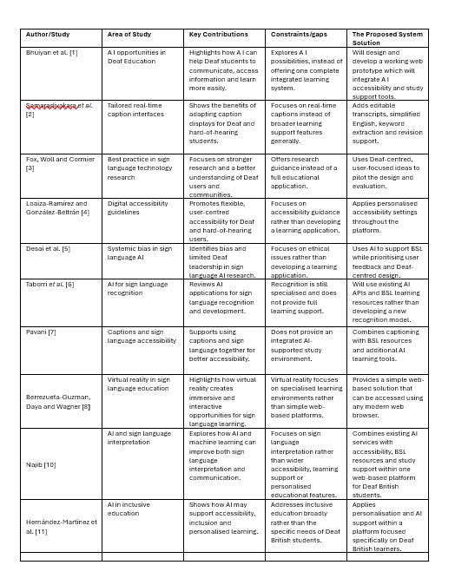
Figure 1: The comparison table highlights the work, study area, contributions and gaps on the use of AI within the British Deaf Community. The proposed System Solution aims to correct these limitations and gaps.

2.1 RESEARCH GAP
Current accessibility tools often work in isolation, offering captions, sign-language recognition or separate learning resources, which forces Deaf students to rely on multiple tools. This fragmented approach can limit accessibility and overlook individual learning needs. This research also stresses the importance of flexible, user-centred technologies created with meaningful Deaf involvement [5]. A single AI-powered web platform will ultimately address this gap to combine these resources to support Deaf British students.

3.0 METHODOLOGY
This project will use Design Science Research (DSR) to design and evaluate a practical solution to a real-world problem. The outcome will be a smart web-based accessibility and learning support system for Deaf British students, bringing problem identification, design, implementation and evaluation into one structured process.

3.1 SYSTEM DEVELOPMENT APPROACH
An Agile approach will support development by building and improving the system through small, repetitive stages. Regular user feedback will help identify accessibility issues early, allowing features to be refined throughout development rather than only during final testing. This is particularly important for an accessibility-focused project. Development will follow requirements analysis, design, implementation, testing and evaluation, guided by ongoing user feedback.

3.2 TOOLS AND TECHNOLOGIES
The system will be developed using HTML, CSS and JavaScript because they provide a simple and reliable way to create accessible, responsive websites. HTML, CSS and JavaScript will create an accessible and interactive website connected to external AI APIs. These services will provide speech-to-text captioning, text summarisation, simplified English and keyword extraction, keeping the project within the scope of an undergraduate study without developing new AI models [5]. The interface will follow WCAG by prioritising clear navigation, readable content and customisable accessibility features, reflecting the flexible, user-centred approach recommended by Loaiza-Ramírez and González-Beltrán [4].

3.3 REQUIREMENTS ANALYSIS
System requirements are based on findings from the literature and the learning needs of Deaf students. Functional requirements include AI captioning, editable and downloadable transcripts, simplified English, keyword extraction, personalised settings, BSL resources and user registration. Non-functional requirements focus on usability, accessibility, reliability and performance. Their recommendations will help shape system requirements throughout development, ensuring accessibility is considered from the beginning.

3.4 SYSTEM ARCHITECTURE
The proposed system will use a simple web-based architecture that connects the user interface with external AI services. Students will access the website through a web browser, to access accessibility features, learning tools and BSL resources. JavaScript will manage communication between the website and external AI APIs. Results, including captions, summaries and keywords, will be displayed through the interface. Figure 1 illustrates how the main system components interact to provide accessibility and learning support for Deaf British students.

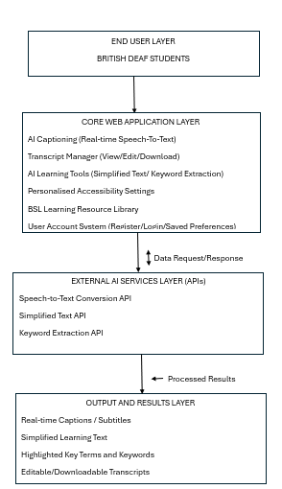
Figure 2: A complete system architecture for the proposed web-based platform, designed to address gaps in AI accessibility and learning support for Deaf British students.

3.5 DATA COLLECTION METHOD
The prototype will be evaluated using qualitative usability testing because it explores participants' experiences and identify accessibility issues. Deaf participants will complete tasks such as generating captions, downloading transcripts and using AI learning tools to assess the system's core features. A short questionnaire using Likert-scale and open-ended questions will collect feedback on navigation, caption readability, accessibility, usefulness and overall user experience. Participants’ feedback will be used to identify improvements and refine the prototype. Ethical approval and informed consent will be maintained throughout the evaluation.

4.0 EXPECTED OUTCOMES AND IMPACT
The expected outcome is a functional prototype of a smart web-based accessibility and learning support system for Deaf British students. By combining communication support, personalised accessibility, BSL resources and AI-assisted learning tools within a single platform, the project aims to address the fragmented approaches identified in current accessibility technologies. The prototype could support more inclusive learning and demonstrate how existing AI services can be used to create practical user-centred accessibility solutions.

5.0 PROJECT TIMELINE

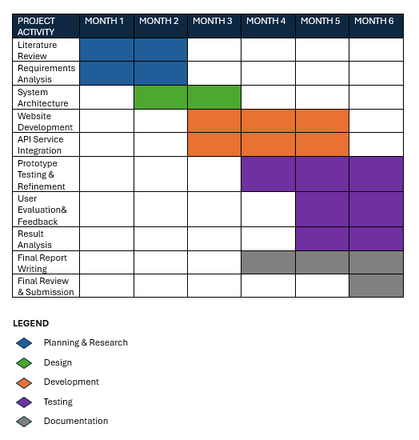
Figure 3: Independent Project Proposal Six- Month Timeline Gantt Chart.

6.0 CONCLUSION
This proposal presents a smart web-based accessibility and learning support system for Deaf British students. Research suggests AI can improve communication, accessibility and learning, although current solutions often remain fragmented or focus on individual technologies. The proposed system addresses this gap by combining AI captioning, personalised settings, intelligent study tools and BSL resources. Guided by Deaf-centred design and accessibility principles.

REFERENCES

[1] M.A.R. Bhuiyan et al., Exploring AI Opportunities in Deaf Education: Understanding Design Needs Through Teacher and Parent Perspectives in Bangladesh. Proceedings of the 2026 CHI Conference on Human Factors in Computing Systems /, 1–18. https://doi.org/10.1145/3772318.3791810 [Accessed: Jun. 20, 2026].

[2] Y. Samaradivakara et al., CHI Conference on Human Factors in Computing Systems Honolulu HI USA 2024. (n.d.). SeEar: Tailoring Real-time AR Caption Interfaces for Deaf and Hard-of-Hearing (DHH) Students in Specialized Educational Settings. Extended Abstracts of the CHI Conference on Human Factors in Computing Systems /, 1–8. https://doi.org/10.1145/3613905.3650974 [Accessed: Jun. 21, 2026].
[3] N. Fox, B. Woll, and K. Cormier, “Best practices for sign language technology research,” Universal Access in the Information Society, vol. 24, no. 1, pp. 69–77, Sept. 2023. https://doi.org/10.1007/s10209-023-01039-1 [Accessed: Jun. 21, 2026].

[4] I. Loaiza-Ramírez and B. A. González-Beltrán, “Digital accessibility guidelines for deaf and hard of hearing persons: a state-of-the-art review article,” Universal Access in the Information Society, vol. 25, no. 1, Dec. 2025. https://doi.org/10.1007/s10209-025-01270-y [Accessed: Jun. 24, 2026].

[5] A. Desai, M. De Meulder, J. A. Hochgesang, A. Kocab, and A. X. Lu, “Systemic biases in sign language AI research: A Deaf-led call to reevaluate research agendas,” in Proc. LREC-COLING 2024 11th Workshop on the Representation and Processing of Sign Languages, 2024, pp. 54–65. [Accessed: Jul. 1, 2026].

[6] J. Taborri et al., "The Use of Artificial Intelligence for Sign Language Recognition in Education: From a Literature Overview to the ISENSE Project," 2023 IEEE International Conference on Metrology for eXtended Reality, Artificial Intelligence and Neural Engineering (MetroXRAINE), Milano, Italy, 2023, pp. 122-126 https://doi.org/10.1109/MetroXRAINE58569.2023.10405716 [Accessed: Jul. 1, 2026].

[7] F. Pavani and V. Leonetti, “On the Coexistence of Captions and Sign Language as Accessibility Solutions in Educational Settings,” Audiology Research, vol. 16, no. 1, p. 20, Jan. 2026. https://doi.org/10.3390/audiolres16010020 [Accessed: Jul. 6, 2026].

[8] Berrezueta-Guzman S, Daya R and Wagner S (2025) Virtual reality in sign language education: opportunities, challenges, and the road ahead. Front. Virtual Real. 6:1625910. https://doi.org/10.3389/frvir.2025.1625910 [Accessed: Jul. 6, 2026].

[9] A comprehensive survey on recent advances and challenges in sign language recognition systems Discover Artificial Intelligence Violet, I. M. Melanshia; Leena Sri, R.
Vol. 5 Issue 1, p. 419, 2025. [Accessed: Jul.6, 2026].

[10] Najib, Fatma M. "Sign language interpretation using machine learning and artificial intelligence." Neural Computing and Applications 37, no. 2 (2025): 841-857. [Accessed: Jul. 7, 2026].

[11] Hernández-Martínez et al., 2025. "The Impact of Artificial Intelligence on Inclusive Education: A Systematic Review" Education Sciences 15, no. 5: 539. https://doi.org/10.3390/educsci15050539 [Accessed: Jul. 7, 2026].

APPENDICES
TABLE 1. APPENDIX A
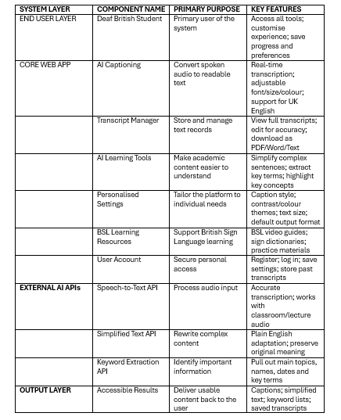

TABLE 2. APPENDIX B
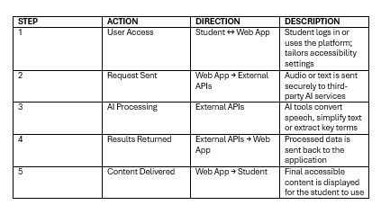
Breakdown and explanation of how the System Architecture should work.

Table 1 breaks down the proposed system architecture into clear, easy-to-follow sections. It outlines each component, explains what it is designed to do and shows how it supports the accessibility and learning needs of Deaf British students. This helps to create a clearer picture of how the overall system will be structured.

Table 2 then builds on this by describing how the system is expected to function in practice, including how users move through the website, how the web application connects with external AI services and how results are delivered back to users. While the architecture diagram offers a broad overview, these tables provide a more detailed explanation of how the system will work and how it aims to enhance learning and accessibility.
There was a limited word count, therefore tables were used to further explain how the proposed system should work.

