

ACDA4010 OME Study Skills End of Module Report

Scott d C Dashwood
HNC lvl4 OME Apprenticeship
August 2021

Table of Contents
Section 1: Introduction & Presentation 3
Section 1.1: Introduction 3
Section 1.2: Personal Presentation 3
Section 2: Skills Evaluation 5
Section 2.1: Success at University 5
Section 2.2: Success in employment 5
Section 2.3: Self Evaluation 6
Section 2.4: Goals 6
Section 3: Application of Study Skills 7
Section 3.1: Looking After Data 7
Section 3.2: Time Management & Self-organisation 8
Section 4: Conclusion 9
References 10
Section 5: Appendices 11
Section 5.1: Personality/trait test results 11
Section 5.2: Cryptowall Report 15

Section 1: Introduction & Presentation

Section 1.1: Introduction
University is a distinct path available to many early on in their life. A means to develop one’s education, to broaden horizons, and to specialise in an area of study in order to undertake a career within a specialised field. University demands a certain skill-set and approach to best succeed, and modules such as Study Skills seek to bring all entrants to higher education up to a minimum level of understanding to best place them to proceed with their studies. There are many approaches to study skills, some even suggesting that ‘Study-Skills Modules’ are not even the best way of building that initial preparation for study, rather merging course content into wider modules directly teaching the specific ‘skills’ required for a given topic [1]. Regardless of the how and why; learning how to make best use of library resources, referencing to the required format, understanding one’s own strengths and weaknesses, and learning how to be a ‘good-student’ are valuable skills however they may be taught. This report seeks to cover some of the key areas covered in the Study Skills Module.

Section 1.2: Personal Presentation
One of the first key ‘soft-skills’ introduced was presenting an article of work. Communication is one of the most valuable skills an individual can call upon. It is an expression of thought and idea [2] without which no development could occur. Therefore, learning to prepare and present a PowerPoint-presentation on ourselves was a logical first step in building experience in communication.
As per the presentation, the Author introduced a brief overview; citing birthplace, hobbies and interests and plans for the future. These are shown in figures 1 through 4.

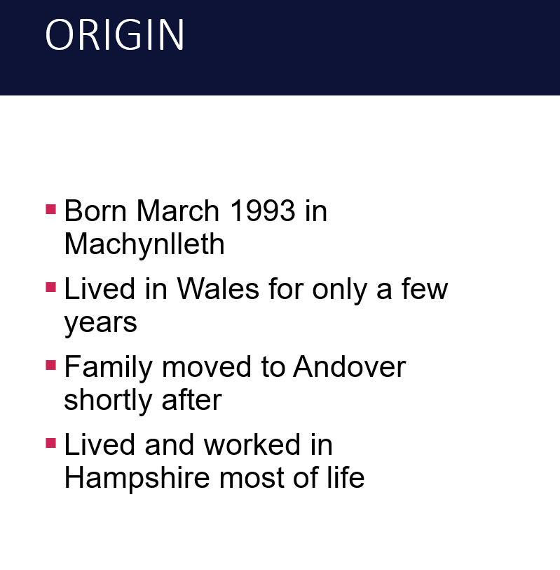
Figure 1: Slide 2, Origin
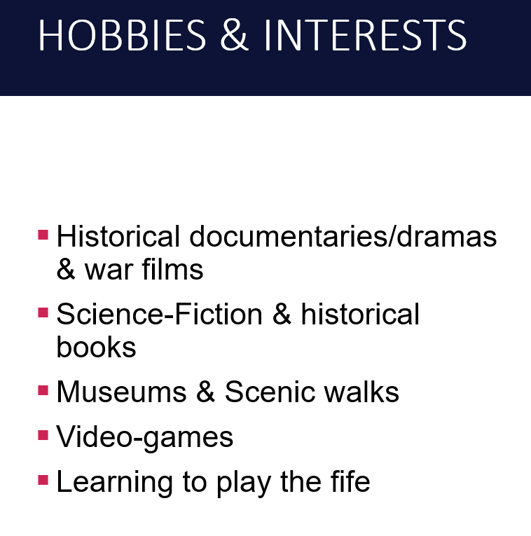
Figure 2: Slide 3, Hobbies & interests
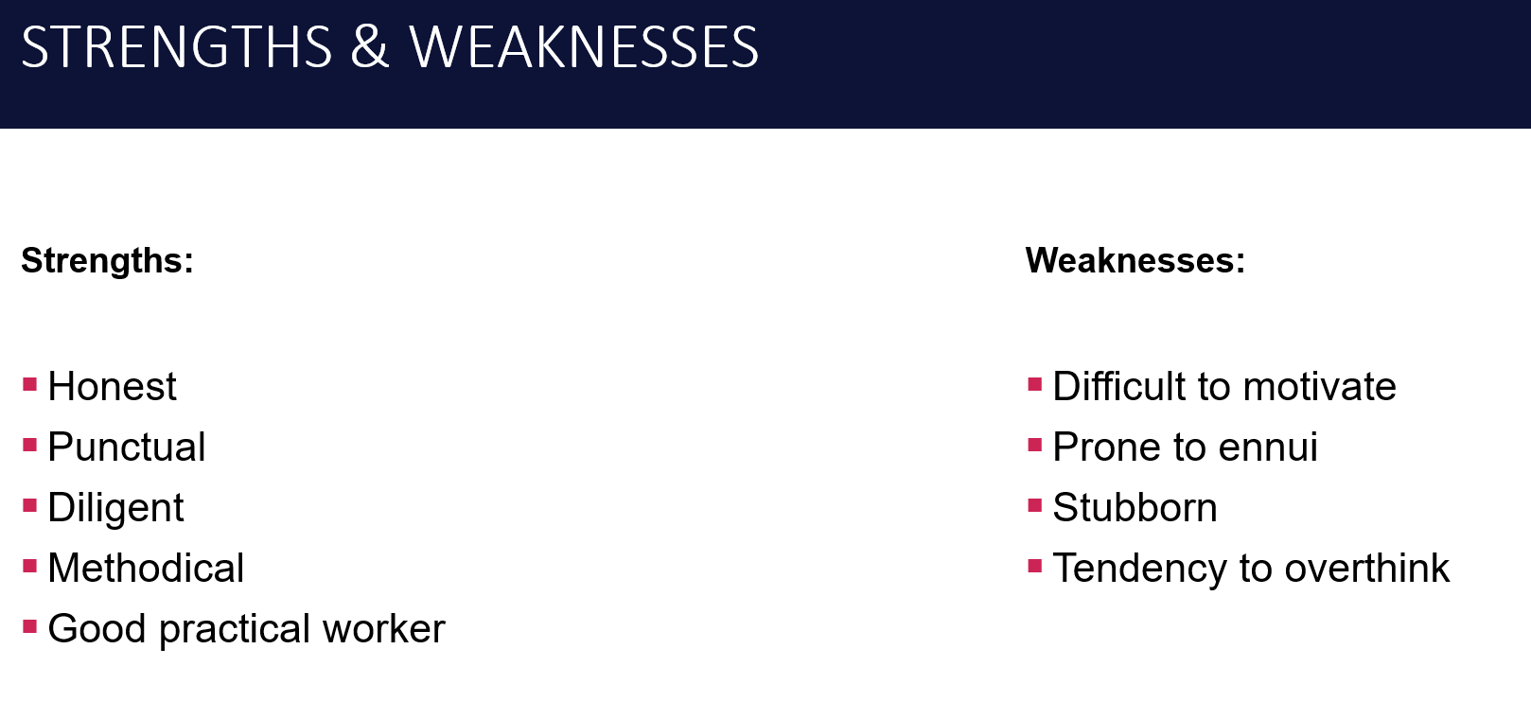
Figure 3: slide 8, Strengths & weaknesses
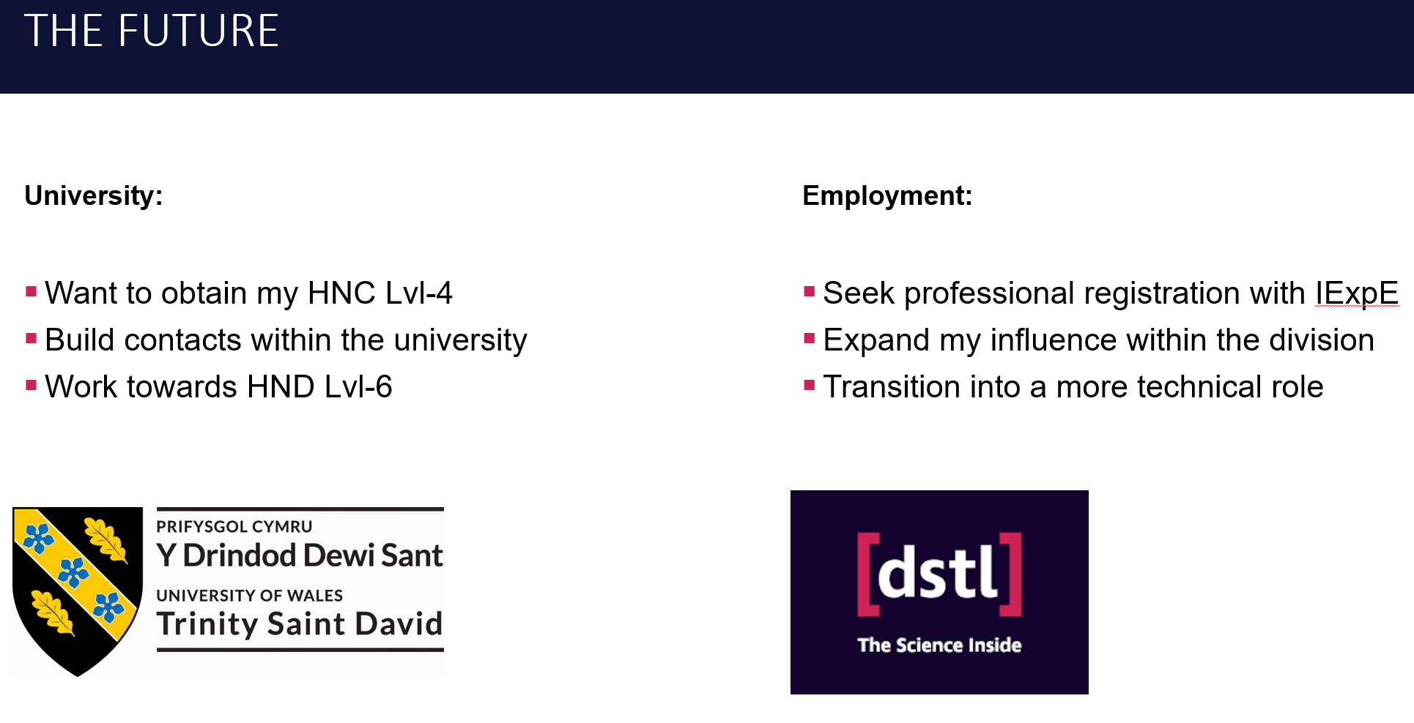
Figure 4: Slide 9, the future
One issue with beginning the presentation was in determining which style would best keep the reader’s attention. While the information contained would be presented by the Author, the details shown still had to captivate the audience to a degree. An original plan was to use a corporate template, but this was rejected due to concerns of infringing crown copyright. Eventually the matter was settled by using a simple format inspired by the template but removing all branding and copyrighted material.
One great benefit of initially drafting off a corporate template was that it allowed familiarity with a tool that would be expected to be used in the workplace, this helped in re-learning PowerPoint. A software that the Author had not had cause to use for many years.
Future areas for improvement would lie in the quality of the content itself. While the topic in question was broad, more detail could have added greater context on what was being presented. Feedback given at the time indicated less time spent looking down at the computer Which would suggest a lack of familiarity with the presented work. To remedy this, proper revision of the work and more practice on delivery would allow for more time spent looking at the audience rather than the prompt.

Section 2: Skills Evaluation

Section 2.1: Success at University
Success is defined as having achieved a previously stated goal or target. By this definition, one can reasonably assume success at university would involve achieving a grade in-line with one’s expectations. The path to reaching these expectations is as varied as the people treading it. Each individual must call upon skills and experiences to best help them tackle what often is one of the hardest hurdles in their young life. Some universities will set out ‘skill-sets’ that they suggest students work towards, things such as; time management, interpersonal skills critical thinking, assertiveness, and creativity [3] [4] [5].
Additionally, it is expected that students exercise a great deal of independence for their work as well as motivating themselves to succeed [6]. It is in this motivation that the author feels most success is made. If a student has a strong desire to study, then they will likely push themselves beyond their peers. This can be seen in students who attend university more because they want to rather than due to external pressure, this ‘intrinsic motivation’ [7] could be seen as a powerful edge over those who may just see university as a party opportunity. Further study links intrinsic-motivation with motivation provided from other sources to produce a positive correlation with performance [8].
By combining a broad range of key academic skills alongside a strong motivating force, the student is best placed to tackle their studies and make the most of their abilities. As with everything, it is always easier said, than done. Aside from external factors, such as health & wellbeing, one of the biggest threats to a student’s success is procrastination. While procrastination can be seen as a symptom of low-confidence or an inability to cope with negative emotions [9], it’s affect is profound.
Regardless of outcome or issue, time spent preparing for study, as well as time in study itself, generates skills and experiences that provide a unique benefit to the student that are, by design, carried into the workplace. Success in education has the potential to translate into success in the workplace.

Section 2.2: Success in employment
Many parallels can be drawn between skills earned in academia and the soft-skills developed in employment. This is likely due to university being a tool to develop and prepare young adults for certain specialised areas of employment. Time management, interpersonal skills and assertiveness tend to translate into project management, teamworking and leadership relatively easily. That being said, the workplace is not the classroom and with there being such variety in jobs on offer, a varied skill-set can be very useful.
According to the two top employment websites, Reed & Indeed; the ability to communicate, work well within a team (As well as independence where needed), a good work ethic, and adaptability as well as a host of other skills form a core toolbox employers look for in prospective applicants [2] [10]. This is on top of basic skills such as numeracy, literacy and IT competency that should already be well drilled into former students.

Section 2.3: Self Evaluation
As part of the process of introspection, reflection and evaluation, the author was tasked with outlining strengths and weaknesses and assessing suitable careers for comparison. Self-reflection is certainly a nuanced task with many subjective areas of study. It is, however, valuable to see what one’s expectations are and how they line up with reality.
The author has always felt their strengths lie in academic fields, avoiding areas that require high degrees of socialising and person-to-person-interaction. The Author’s perceived strengths are in; integrity, flexibility, honesty, a desire to learn, and a meticulous nature. Conversely, perceived weaknesses; very-low motivation, self-criticism, introversion, and organisation.
Part of the journey of evaluation was to test whether the self-created-image was a true reflection of the self or if there were hidden details that had been missed. Rather than a full psychiatric assessment, which would have been informative, but impractical. It was decided to make use of online resources for personality tests and career path testers. Several online personality tests were conducted and the results seem to indicate a strong similarity with initial assessments. Of the four tests done, covering traits, career-choices, and personality, all of them compared favourably to the initial perception of introverted, yet intelligence-based traits. The tests themselves are attached to this report’s appendix.

Section 2.4: Goals
With evaluation completed, the logical next step is to set a series of goals that best compliment the previously outlined character profile. Knowing that there is an aspect of introversion, there must be at least one goal that serves to introduce elements of socialising and connecting with new contacts. Additionally, it is possible to build upon intellectual traits to forge new academic skills or qualifications. The following table outlines goals set to the S.M.A.R.T guidelines, following these guidelines the goals should be Specific, Measurable, Attainable, Relevant, Time-based:

Strengths, skills and qualities
- Methodical/Meticulous
- Willingness to learn & develop
- Honesty
- Practical mindedness

What I need to work on, develop or improve
- Motivation and perseverance
- Organisation & timekeeping
- Reflective statements
- Note taking

My Priorities: What I am going to do, When and How
What? | When? | How?
- Transition into a more technical role | Within the next six months | Secondments, work experience, similar jobs within the company
- Develop at least one new method of organisation | Within the next three months | Seek advice from colleagues, google organisation methods, follow advice from module
- Improve reflective writing | Within the next month | Utilise feedback, grading from current study skills report
- Build contacts/influence within workplace | Within the next six months | Attend conferences, seminars, ask questions of colleagues, request secondment/opportunities

How will I measure if I have improved?
- Attendance at new and interesting technical events
- Less stress due to better organisation (Happier disposition)
- Better outcomes at bi-yearly reviews and catch-up meetings
- Knowing more people, having more contacts in workplace phonebook

Section 3: Application of Study Skills

Section 3.1: Looking After Data
In 2016, 91% of households in the UK were reported to own a personal computer [11]. With the ever-increasing usage of personal electronic devices, there is increased reliance on these mediums to hold personal information from banking details and work-documents through to images and music. Each file has varying degrees of importance, and each file has varying degrees of impact if lost.
According to the National Cyber Security Centre, having multiple backups in a 3-2-1 configuration with at least three copies on at least two devices with one offsite backup being an optimum strategy for the most resilient data security measures [12].
The following table lists several options for data backup:
Medium | Positives | Negatives
Thumb-drive (USB-stick) | - Very cheap  - Highly portable  - Easily replaceable  - Encryptable | - Easily lost  - Limited storage  - Can be damaged  - Can be stolen  - Can’t be set to auto-backup
External Hard Drive | - Cheap  - Portable  - Replaceable  - Encryptable  - Varied storage size options | - Can be lost  - Can be damaged  - Can be stolen  - Can’t be set to auto-backup (Unless always plugged in)
Separate PC/Laptop | - Redundancy | - Can reduce storage size on device  - Expensive  - Can be lost to damage if not offsite
Cloud based storage | - Always available  - Can be cheap  - Offsite backup  - Can be accessed by multiple devices  - Can be set to auto-backup | - Can be expensive  - Limited storage at base-price  - Privacy concerns  - Possible risk of loss if company fails  - Vulnerable to malware
Network Attached Storage | - Always available  - Can be offsite  - Can be accessed by multiple devices  - Redundancy  - Can be set to auto-backup | - Expensive  - Vulnerable to malware  - Not beginner friendly

There are many options available that can be chosen based on the requirement of the task and the value of the data. For the purposes of this report, the data that needs to be secured is simply word .doc files. Therefore, all of the previously stated methods are viable, but the Author has chosen to limit the costs involved and has opted for an external hard-drive, the OneDrive (Cloud storage) and a USB-stick. There is future possibility of purchasing a NAS but further research is required to make an informed decision.
There is always an element of risk in life, and as ever the risk must be assessed. The following situations have been identified as the most likely threats to the safety of the data intended to be protected and how that risk is mitigated by the chosen methods:
- Device failure: The most likely threat and the main purpose of backing up. Should the PC fail, all three backup solutions would be viable in order to retrieve the lost data.
- Fire: The second most likely threat, this would destroy all solid media such as the external drive, but the data would be kept safe on the OneDrive
- Theft: Much the same as with a fire, physical media would be lost but the OneDrive would be secure. Given the nature of the data, having it in the hands of others would not be considered an issue otherwise encryption would be sought.
- Malware attack: This would compromise the OneDrive data and perhaps one of the physical media devices, but as the physical devices are not networked there would be no risk of cross-infection.
- Ransomware: Much the same as malware, this could have the potential to take out all three backups if not properly managed. However, the chances of having both a USB-stick and external hard-drive installed at the same time for backing up are almost remote. Therefore, the risk is managed.
Touching upon the last point raised in the above list, ransomware is arguably the most damaging and difficult to fix software-based threat to data. If a PC breaks, most of the time it can be fixed, even with a damaged storage device, data can be recovered. However, if ransomware encrypts the data, the only way that data can be retrieved is by paying-off the people with the encryption key. This matter is discussed in a brief report appended to this essay entitled “Cryptowall Report”.

Section 3.2: Time Management & Self-organisation
As discussed in section 2 it has already been determined that time management and organisation are key factors in success. This section intends to outline what steps can be taken to capitalise on these valuable skills. Initially, establishing the framework for an e-portfolio provides the groundwork for more advanced planning. Figure 5 shows a basic layout currently in use for the e-portfolio and PDP. This will be the storage location for all data related to the aforementioned. It will provide structure and guidance on filling out the rest of the necessary parts.
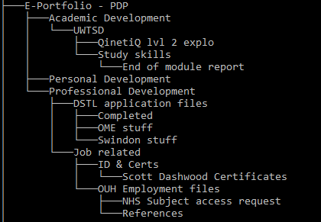
Figure 5: Screencap of file-tree for development folders
Next comes the use of planning tools. Presently, a work-based outlook calendar is being used. This has limitations as it is based solely on a work-network and contains classified data which cannot be moved off network. Therefore, it is intended for a new calendar to be established on a Google account. This allows for the most flexibility, sustainability, and easiest system to learn and become familiar. Additionally, a work diary is being maintained on Excel, this is a day-by-day account of what the Author is doing, which is intended to form a major part of the evidence required for future reviews. Once these are established, further efforts can be made on what will be the hardest part. Implementing it.
Personal development comes from motivation and a desire to improve. This has been a topic of some great consternation to this Author and is why there is great intent, but little proof of work-done. The next ‘big-step’ in the burgeoning development plan is to seek input from health professionals into tackling serious mental health shortcomings. While lying beyond the scope of this report, it is the Authors belief that a healthy mind creates a healthy body, and at this point the mind is far from healthy. Much the same as a car-engine may need servicing, so too can the body. It is believed that development in this area may allow for much greater implementation of the desired strategies outlined in this module, especially in terms of planning for success.

Section 4: Conclusion
There is an old saying; “Proper planning prevents poor performance”. While the origin of the phrase may be dubious, its meaning is not. Being prepared for something is almost always better than being unprepared. This reflects well on the module for Study Skills as it seeks, by its very definition, to teach the skills necessary to prepare someone for not only their time in higher education, but in life. There is an enormous amount of data and research into studying and how it can be made more effective, much of it lies beyond the scope for this report, much of it revolves around deeper investigation into psychology and the inner-workings of the mind. At its core, there must be a desire to learn and develop the skills, to build upon one’s strengths and work hard to diminish one’s weaknesses or at the very least find workarounds.
While working on this report, the Author has laid the groundwork for a great deal of further development. What has been researched here is just the beginning of a very long and very profound journey of development that it is hoped will culminate in not only the completion of the University course, but also of furthering professional development in the workplace, perhaps even leading to professional accreditation with a related institute. At any rate, the Author has reaffirmed prior held-notions on character, noting that one’s strengths lie in academia and pursuits of knowledge, while areas of creativity and imagination could be worked on, though do not form integral parts to success in their chosen field.
Areas of future study would revolve around further broadening methods for organisation and time-keeping skills. While plans have been laid to improve these areas, they are still very much in their infancy, and provided help is sought addressing the issue of motivation, much more can be done to build upon what has been learned such; as diary-keeping, calendar organisation, and stress-management. It is also necessary to further develop working knowledge of NAS-based data backup as this will be a preferred long-term method of data security.

References

[1] | U. Wingate, “Doing away with 'study skills'.,” Teaching in Higher Education, vol. 11, no. 4, pp. 457-469, 2006.
[2] | Indeed Editorial Team, “10 Valuable Soft Skills That You Need to Succeed in Your Career,” Indeed, 12 Februaury 2021. [Online]. Available: https://uk.indeed.com/career-advice/career-development/soft-skills. [Accessed 17 07 2021].
[3] | “Essential Skills for College Students,” Clarke University, 2021. [Online]. Available: https://www.clarke.edu/campus-life/health-wellness/counseling/articles-advice/essential-skills-for-college-students/. [Accessed 17 07 2021].
[4] | J. Morris, “What skills do students need to succeed,” Cambridge Assessment, 01 04 2016. [Online]. Available: https://blog.cambridgeinternational.org/what-skills-do-students-need-to-succeed/. [Accessed 17 07 2021].
[5] | “15 skills for college success,” Arizona State University, [Online]. Available: https://admission.asu.edu/parent-blog/college-life/15-skills-college-success. [Accessed 17 07 2021].
[6] | S. Cottrell, The Study Skills Handbook, 5th ed., London: Red Globe Press, 2019, p. 13.
[7] | R. A. Augustyniak, A. Z. Ables, P. Guildford, H. L. Lujan, R. N. Cortright and S. E. Dicarlo, “Intrinsic motivation: an overlooked component for student success,” American Physiological Society, 2016.
[8] | R. A. Kusurkar, T. J. Ten Cate, C. M. P. Voss, P. Westers and G. Croiset, “How motivation affects academic performance: a structural equation modelling analysis,” Advances in Health Sciences Education, vol. 18, pp. 57-69, 2013.
[9] | T. Hailikari, N. Katajavouri and H. Asikainen, “Understanding procrastination: A case of a study skills course,” Social Psychology of Education, vol. 24, pp. 589-606, 2021.
[10] | A. Rolfe, “Graduate skills - what are employers looking for?,” Reed, 2021. [Online]. Available: https://www.reed.co.uk/career-advice/graduate-skills-what-are-employers-looking-for/. [Accessed 17 07 2021].
[11] | “Access to computers from home (indicator),” OECD, 2021. [Online]. Available: https://data.oecd.org/ict/access-to-computers-from-home.htm. [Accessed 2021].
[12] | “10 Steps to Cyber Security,” National Cyber Security Centre, 11 May 2021. [Online]. Available: https://www.ncsc.gov.uk/collection/10-steps/data-security. [Accessed 17 07 2021].

Section 5: Appendices

Section 5.1: Personality/trait test results
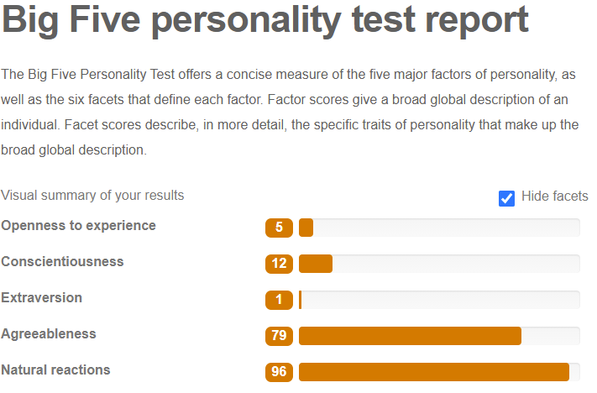
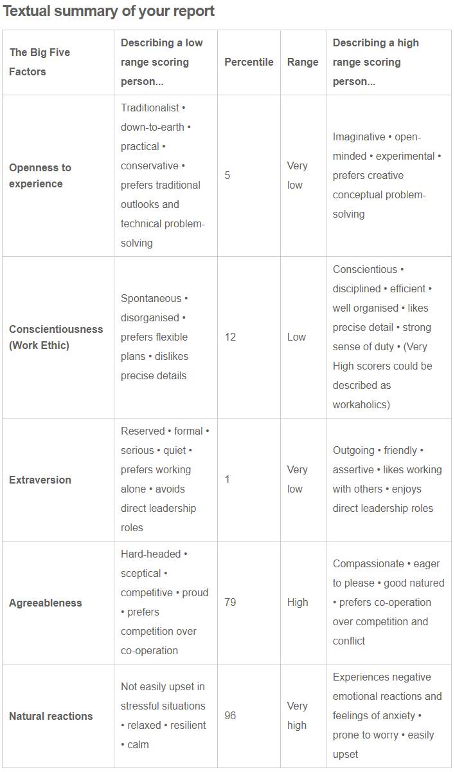
Figure 6: 123test.com big five test results
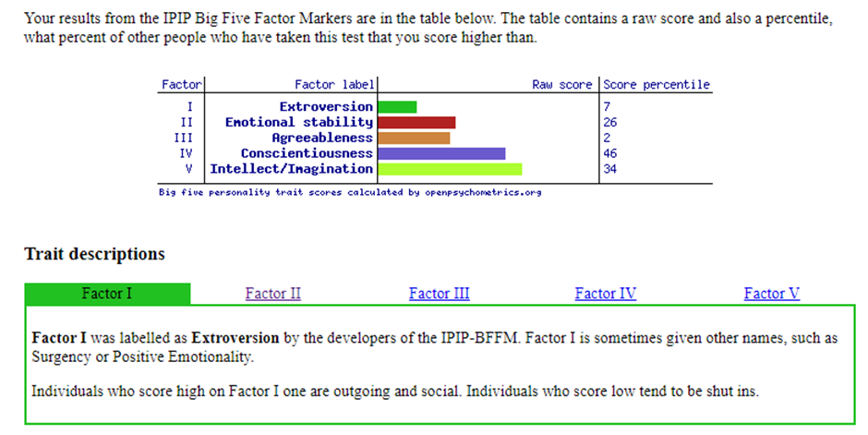
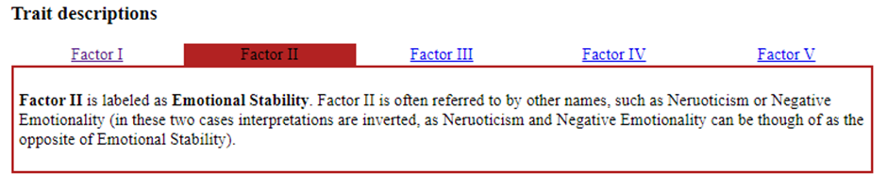
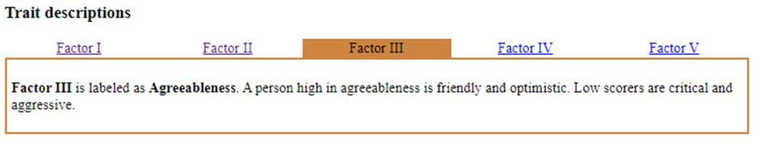
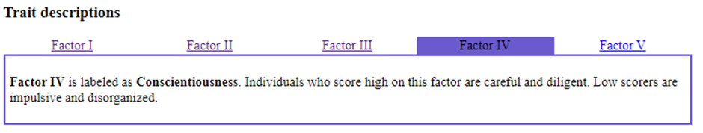
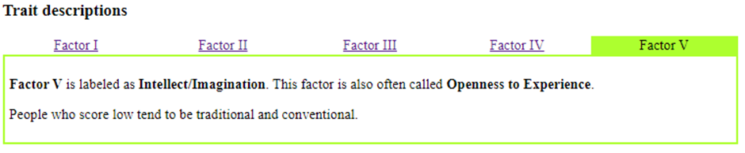
Figure 7: Big five test results from openpsychometrics.org

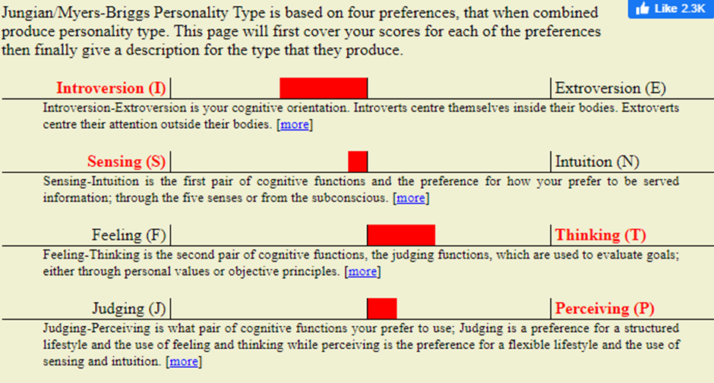
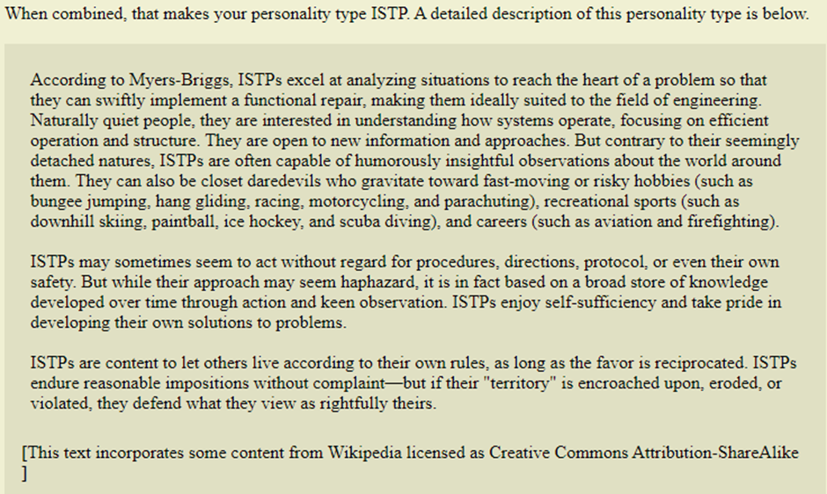
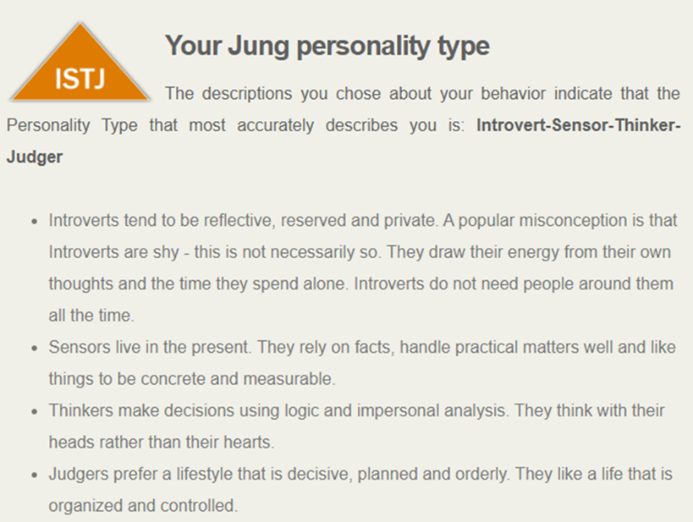
Figure 8: Open extended jungian test results from openpsychometrics.org

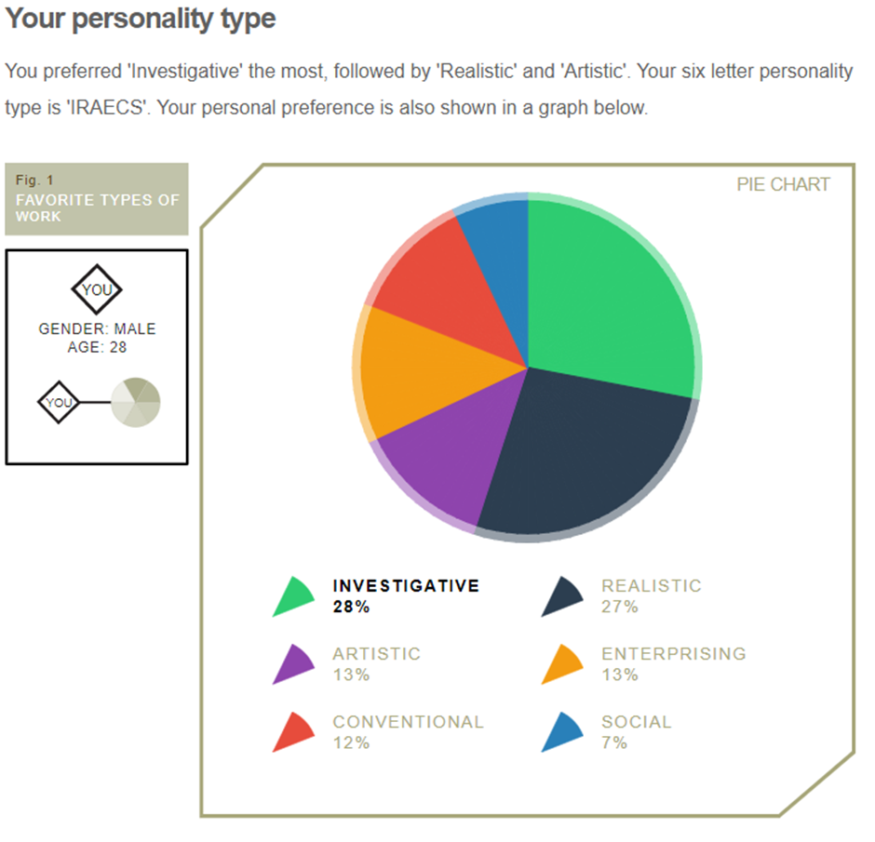
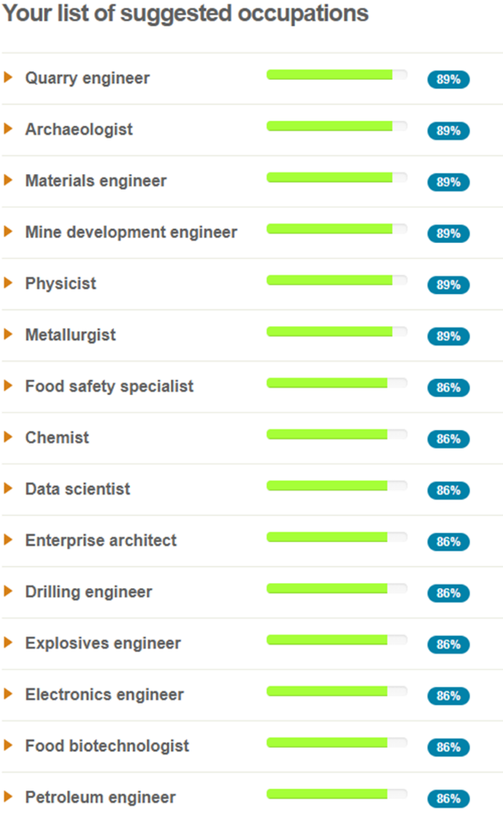
Figure 9: holland model career aptitude test from 123test.com

Section 5.2: Cryptowall Report

Study Skills: Cryptowall report

Table of contents:
1. Introduction
2. What is at risk?
2.1. Cryptowall
2.2. Risk mitigation, backing up properly
3. Conclusions
4. References
1. Introduction:
Every month there are hundreds of recorded attacks performed on IT infrastructure governing everything from industry and the public sector through to personal home networks. This report shall elaborate on the risks posed by online based viruses attacks, and how the risks can be mitigated.
The main scope of this article is to focus specifically on the Cryptowall ransomware attacks but it is important to understand the key differences between the various types of computer virus. Norton defines a computer virus as any kind of malicious program that, once activated, will seek to alter a program or key-system on the infected computer [1].
Computer viruses are usually broken down into a few key threats:
• Malware, another name for ‘computer virus’. This is any software that could harm your computer’s data or system function [2]
• Trojan Horse, much like it’s historical namesake, this is malicious code that once installed onto the system, creates a backdoor through which data can be lost or stolen via an external source. [2]
• Ransomware, once on a system, targets user-generated files such as pictures or documents and encrypts them. Once encrypted, the user is usually held at ransom for the code to decrypt the files. [3]
2. What is at risk?
As an organisation hosting countless documents on a network accessed by numerous individuals both internally and externally, there is significant risk. Possible threats to It infrastructure were identified very early on, a journal for public accountants back in 1989 stated [4]:
“ Computer viruses pose real risks for certified public accountants. Viruses can damage firm equipment, data, and programs, and can also damage the data, programs, and equipment of clients”
Ransomware propagates through various means, although is primarily spread through emails with malicious attachments or is unknowingly downloaded when a user visits infected website [5]. This means that any user can be a potential source of infection, and any networked system can be a target

2.1. Cryptowall
Cryptowall was a major ransomware program that initially began back in 2014. Based off older software, it evolved to utilise its own version of TOR gateways as a means of accessing their payment servers. Additionally Cryptowall also utilises secure methods of file deletion so that deleted files cannot be recovered [6]. This software is constantly evolving and has at least 4 versions. The software itself hides deep within the OS, adding itself to the systems start-up folder, not only can it delete original directories post-encryption, but it steals passwords and bitcoin wallets [7].
At present, there is no way to break the encryption, no way to restore deleted files. Once files have been hit by the malware, the only way to potentially recover is to pay the ransom, although there is supposedly only a 19% chance that the ransomer returns the files [7].

3. Conclusion
Given the threat posed by malware and the fact that there isn’t much that can be done once it takes hold of a system, the only solution is prevention. The best method of de-risking potential data-loss is to back-up the software, either having separate secure networks or offsite backups. Additional hard-copies or separate physical drives could also prove valuable if loss should occur.

References

[1] “What Is A Computer Virus,” NortonLifeLock, 2021. [Online]. Available: https://uk.norton.com/internetsecurity-malware-what-is-a-computer-virus.html. [Accessed 01 07 2021].
[2] DELL Technologies, “What are the different types of Viruses, Spyware and Malware that can infect my computer?,” Dell Technologies , 21 02 2021. [Online]. Available: https://www.dell.com/support/kbdoc/en-uk/000132699/what-are-the-different-types-of-viruses-spyware-and-malware-that-can-infect-my-computer. [Accessed 01 07 2021].
[3] McAfee, “What Is Ransomware?,” McAfee, 2021. [Online]. Available: https://www.mcafee.com/enterprise/en-gb/security-awareness/ransomware.html. [Accessed 01 07 2021].
[4] J. B. Waggoner, “Computer viruses: the risks posed to CPAs and how to deal with them. (certified public accountants),” CPAJournal, 08 1989. [Online]. Available: http://archives.cpajournal.com/old/07688648.htm. [Accessed 01 07 2021].
[5] UC Berkeley, “How does a computer become infected with Ransomware?,” UC Berkeley, 2021. [Online]. Available: https://security.berkeley.edu/faq/ransomware/how-does-computer-become-infected-ransomware. [Accessed 01 07 2021].
[6] “CryptoWall and HELP_DECRYPT Ransomware Information Guide and FAQ,” BLEEPINGCOMPUTER, 10 07 2014. [Online]. Available: https://www.bleepingcomputer.com/virus-removal/cryptowall-ransomware-information. [Accessed 01 07 2021].
[7] J. Petters, “The State of CryptoWall in 2018,” VARONIS, 17 6 2020. [Online]. Available: https://www.varonis.com/blog/cryptowall/. [Accessed 1 07 2021].

