SICKLE CELL DISEASE
Student Name: Ashok Bharat Patel
Student ID Number: 2532746
Programme: MSc Public Health and Social Care in Practice
Module: Community Care and Management of Longer-term Conditions
Module Code: LCHS7003
Lecturer: AISHAT BAKRE
Submission Date: 26/6/2026
Word Count: 3000

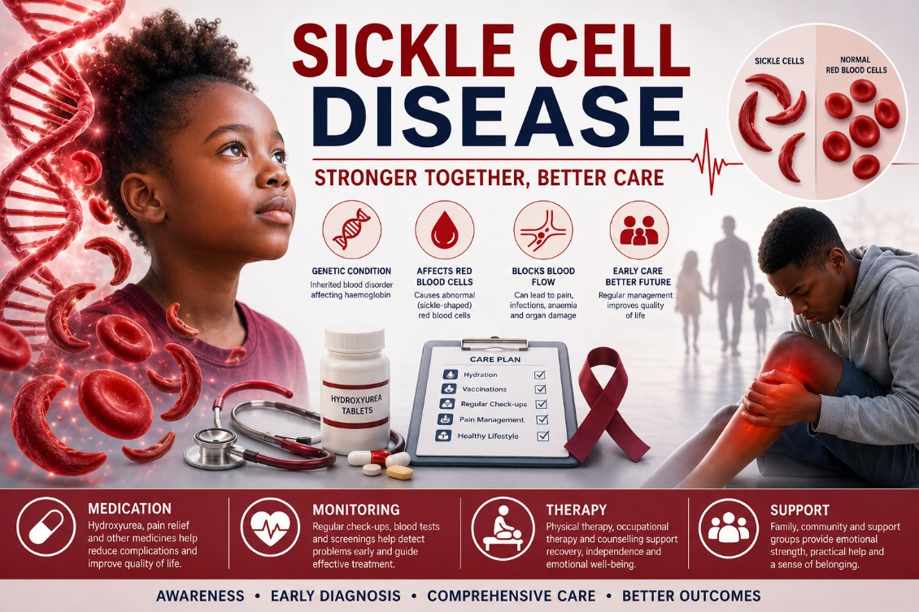
Table of Contents
Definition 3
Aetiology & Pathophysiology 4
Epidemiology & Burden 5
Risk Factors 7
Physical, Psychological & Social Impact Physical Impact 8
Physical Impact 8
Psychological Impact 10
Social Impact 11
Evidence-Based Management in the UK 13
Theoretical Models 15
Policy & Political Context 16
Recommendations 17
Summary 18
References 20

Definition
Sickle cell disease refers to a set of inherited disorders related to red blood cells caused by the formation of hemoglobin S and resulting in vaso-occlusion, hemolysis and progressive organ damage. This is the most common hereditary blood disease in the UK and one of the leading causes of pain, disability, poor quality of life of the affected people. This condition is heterogeneous and lifelong. Without adequate care, the progression of complications causes pain, organ damage and shortened life expectancy (Kato et al., 2018; Piel et al., 2023; Kunz and Tagliaferri, 2024).
Sickle cell disease is widespread globally. Based on the estimates for 2021, about 7.74 million people suffer from this disease. Projections show that in the future, the prevalence of the disease is likely to continue to grow due to the increase in population in the areas with high prevalence rates (Thomson et al., 2023; WHO, 2025). In the UK, sickle cell disease is one of the primary causes of admission to hospitals because of genetic diseases and places significant strain on both general practice and specialized hematological services (Sickle Cell Society, 2025; NHS England, 2025).
Besides, this disease affects the patients physically, psychologically and socially. They experience frequent severe pain crises, fatigue, organ complications, anxiety, depression, social isolation and disruption in education and work. All these issues negatively affect not only patients themselves but also their relatives and caregivers experiencing extra stress (Druye et al., 2024; Jacob et al., 2025; NHS England, 2025).
Thus, proper management of this disease requires a complex approach targeting both physical, psychological and social challenges of having a chronic illness. This information booklet provides a critical analysis of the disease in terms of its definition, causation and burden, as well as its effects on the patients and their families. Besides, the document discusses existing evidence-based treatments of sickle cell disease through the NHS, as well as related theories, frameworks and policies. Recommendations for improving the situation are offered.

Aetiology & Pathophysiology
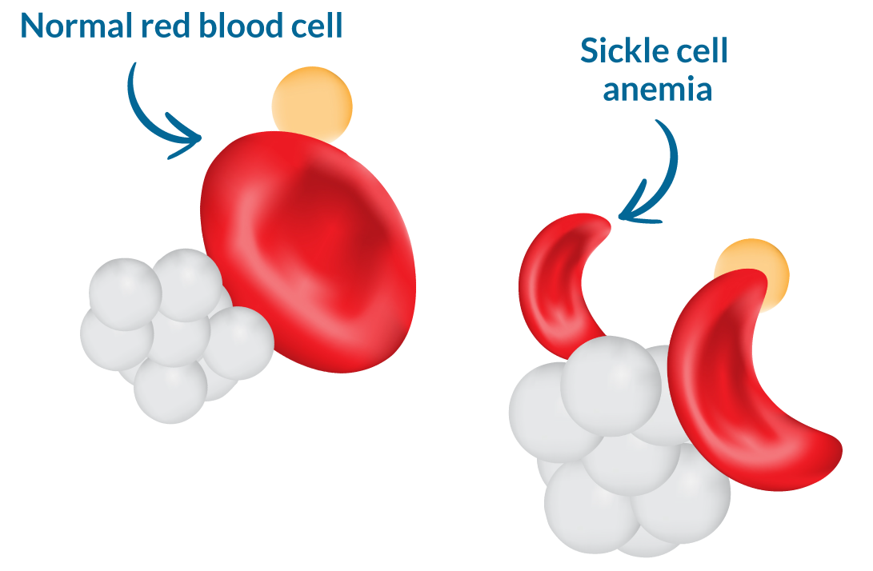
Figure 1: Sickle Cell Disease
A sickle cell disease represents a spectrum of genetically based hemoglobin diseases defined as an alteration in hemoglobin structure resulting in sickling of red blood cells, vaso-occlusion, chronic hemolysis, and organ damage (Kato et al., 2018; Kunz and Tagliaferri, 2024). The term “blood disease” fails to describe a heterogeneous and complicated nature of this pathogenetic entity that involves hematologic, vascular, inflammatory, and systemic components and leads to the violation of physiological processes in several organ systems (Piel et al., 2023; Miller and Gladwin, 2012).
As sickle cell disease is caused by genetic abnormalities, it results from the complex interactions of non-modifiable, such as genetic background, genotype (HbSS is the most severe), ethnic origin, and family history, and modifiable factors, including dehydration, infections, hypothermia, and stress (Kato et al., 2018; Patel et al., 2024). Depression in oxygen levels induces formation of abnormal polymers of hemoglobin S which cause deformity of erythrocytes, vaso-occlusive events, ischaemia/reperfusion injuries, and development of organ damage that manifests in strokes, acute chest syndrome, and nephropathies (Sharma et al., 2025; Kunz and Tagliaferri, 2024). At the same time, chronic hemolysis and endothelial dysfunction lead to extensive vascular inflammation and hypercoagulability which contribute to the vicious cycle of complications (Miller and Gladwin, 2012; Kato et al., 2018).
Today, there is a considerable amount of scientific data that indicates the necessity of viewing sickle cell disease as a systemic vascular disorder with increased risks of cardiorenal and cerebrovascular pathologies (Kunz and Tagliaferri, 2024; Sharma et al., 2025). Moreover, sickle cell disease is highly heterogeneous and includes several genotypes that need individualized therapeutic approach (Piel et al., 2023; Jacob et al., 2025).

Epidemiology & Burden
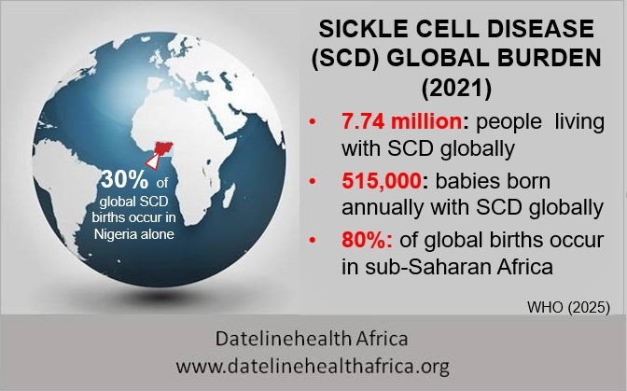
Figure 2: The prevalence of Sickle Cell Disease
Sickle cell disease is the most prevalent genetic blood disorder across many regions globally, responsible for causing chronic disability and reduced life expectancy among patients. According to the Global Burden of Disease Study 2021, 7.74 million people across the world suffered from sickle cell disease. It accounted for a substantial burden which has shown a 41.4% increase since 2000 (Thomson et al., 2023). The global burden of this condition is expected to rise further in the future, with continued high numbers of births in sub-Saharan Africa and increasing survival in high-income countries (Thomson et al., 2023; WHO, 2025).
Sickle cell disease contributes significantly to healthcare utilization, with vaso-occlusive crises being the leading cause of emergency admissions. Women and individuals from certain ethnic groups often experience higher rates of complications (Sickle Cell Society, 2025; NHS England, 2025). In the United Kingdom, sickle cell disease contributes significantly towards the burden of genetic conditions. The disease causes considerable contribution to emergency department attendances, hospital admissions, and poor quality of life, especially among working-age adults (Sickle Cell Society, 2025; NHS England, 2025).
Recently available data in the United Kingdom show that individuals suffering from sickle cell disease have higher healthcare utilization in terms of emergency admissions and hospital stays than the general population, with significant disparities in outcomes (NHS England, 2025). Sickle cell disease has caused a considerable economic burden on the United Kingdom in terms of direct and indirect costs, including costs incurred on specialist care, transfusions, gene therapies, loss of productivity, and disability (Sickle Cell Society, 2025; NHS England, 2025). Disability and inability to work or attend education are important aspects because many individuals suffer from frequent absences or have to leave employment prematurely, thereby causing wider social and economic inequality (Druye et al., 2024; Jacob et al., 2025).
It is evident that there exist health inequalities among patients who suffer from sickle cell disease as people coming from areas of higher deprivation and Black ethnic groups experience later diagnosis, poorer pain management, and worse functional outcomes (NHS England, 2025; Sickle Cell Society, 2025). Notwithstanding its high prevalence and impact, sickle cell disease still remains relatively under-recognised in some primary care settings as a consequence of limited awareness and historical perceptions about the condition (NHS England, 2025; Jacob et al., 2025).

Risk Factors
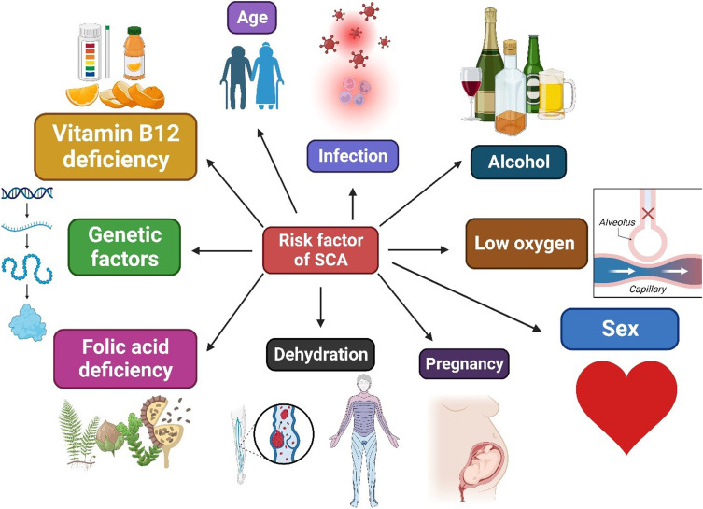
Figure 3: Risk Factors Sickle Cell Disease
Non-Modifiable Risk Factors
- The pathogenesis of SCD complications is multifactorial and involves complex interaction of genetic, biological, and environmental factors, but not only a single cause (Kato et al., 2018; Piel et al., 2023).
- Specific genotype remains one of the strongest non-modifiable risk factors, with HbSS generally causing more severe disease than HbSC due to higher rates of polymerisation and haemolysis (Kato et al., 2018; Kunz and Tagliaferri, 2024).
- Ethnicity is a major risk factor, with highest prevalence and often more severe phenotypes in people of African and Caribbean descent, though data on exact biological mechanisms continue to evolve (Sickle Cell Society, 2025; Patel et al., 2024).
- History of previous complications, such as stroke or acute chest syndrome, increases the risk of recurrent events and long-term organ damage (Miller and Gladwin, 2012; Sharma et al., 2025).
- Genetics plays an important role beyond the primary mutation, as modifiers such as fetal haemoglobin levels and alpha-thalassemia co-inheritance significantly influence disease severity (Kato et al., 2018; Piel et al., 2023).
Modifiable Risk Factors
- The most studied and most powerful modifiable risk factor is dehydration and infection, which act via promoting polymerisation and triggering vaso-occlusive crises (Patel et al., 2024; Jacob et al., 2025).
- There is an increased risk of complications in individuals with poor access to specialist care, delayed treatment of crises, and lack of adherence to hydroxyurea or vaccination schedules, though the strength of evidence varies (NHS England, 2025; Sickle Cell Society, 2025).
- Psychosocial and lifestyle factors, including stress, smoking, and poor nutrition, were recently described to play a role in triggering crises and worsening overall outcomes, supporting the need for holistic management (Druye et al., 2024; Jacob et al., 2025).
- It is possible to consider several modifiable risk factors, but the complexity of interaction between genetic, biological, and social determinants complicates implementation of effective prevention programmes (Patel et al., 2024; NHS England, 2025).

Physical, Psychological & Social Impact Physical Impact

Physical Impact
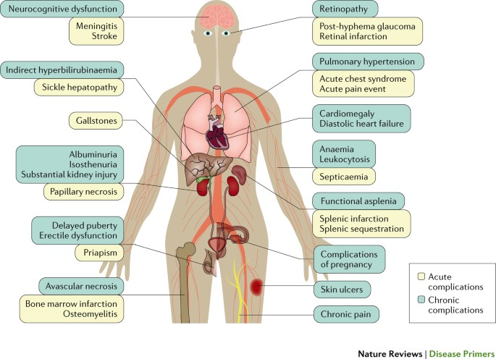
Figure 4: Physical Impact of SCD
The symptoms associated with SCD include severe pain crises, hemolytic anaemia, and susceptibility to infection resulting in decreased mobility and reduced performance of daily activities (Kato et al., 2018; Kunz and Tagliaferri, 2024). Severe pain may not always be predictable, but it can become regular and debilitating, affecting patients’ mobility and making it hard to perform their job or study and also reducing sleep (Miller and Gladwin, 2012; Jacob et al., 2025).
Organ damage such as stroke, acute chest syndrome, pulmonary hypertension, nephropathy, and avascular necrosis impacts the ability to perform tasks, increasing the risk of long-term complications, particularly in adult patients (Sharma et al., 2025; Kunz and Tagliaferri, 2024). Some additional diseases accompany SCD, like heart problems, kidney disease, and pain conditions, making functioning even harder (Miller and Gladwin, 2012; Jacob et al., 2025). Fatigue, despite being often underestimated, is one of the most prevalent symptoms, which affects patients' physical function and is highly correlated with anaemia, pain, and sleep disorders (Druye et al., 2024; Sharma et al., 2025).

Psychological Impact
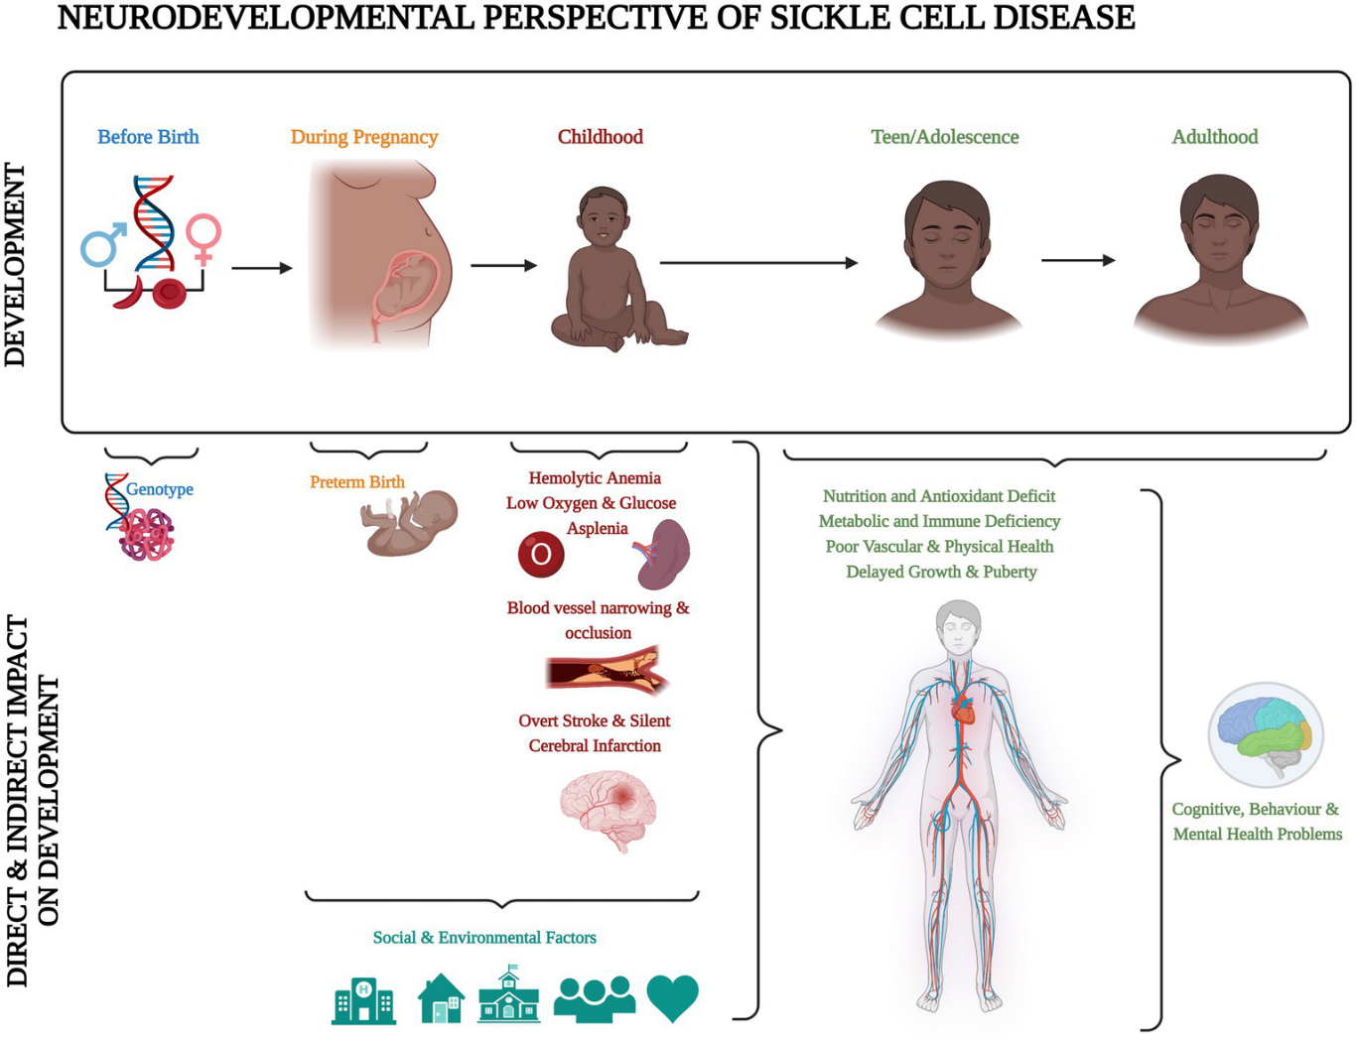
Figure 5: Psychological Impact of SCD
The prevalence of anxiety and depression disorders in people with SCD is very high when compared to the general population (Druye et al., 2024; Jacob et al., 2025). It has been proven that there is an interaction between psychological distress and SCD in which pain and disability increase the likelihood of developing anxiety and depression, while these diseases exacerbate pain sensitivity and coping skills (Druye et al., 2024; Jacob et al., 2025). Fear of crises and development of disease is a common phenomenon, resulting in sedentary behavior, kinesiophobia, and low quality of life (Jacob et al., 2025; NHS England, 2025).
Negative influence of psychological distress on treatment adherence, engagement in self-care activities, and patients' satisfaction with healthcare was also found (Druye et al., 2024; Jacob et al., 2025). Despite proven negative influence of the condition on the mental well-being of patients, psychological interventions are not included in care pathways for SCD patients in the UK (Jacob et al., 2025; NHS England, 2025).

Social Impact

Figure 6: Social Impact of SCD
SCD constitutes an important factor behind failure to maintain educational and work activity, as many individuals struggle with regular attendance at schools or workplaces due to pain and hospitalisation (Druye et al., 2024; Sickle Cell Society, 2025). Social withdrawal, loss of interest in leisure activities and feeling isolated may arise among some people owing to the chronic pain and fatigue, as well as frequent crises (Jacob et al., 2025; NHS England, 2025).
The economic burden of SCD involves not only affected individuals but also includes financial losses, expenses of travel to specialist treatment facilities and the necessity to have additional assistance provided (Sickle Cell Society, 2025; NHS England, 2025). The burden for families and informal caregivers may include stressful situation, disruption of the routine, financial burden, and additional care responsibilities which could potentially harm the wellbeing of the person (Druye et al., 2024; Jacob et al., 2025). In addition, socioeconomic and ethnic disparities impact the social burden of SCD, since disadvantaged individuals have difficulties with receiving proper social and medical assistance (NHS England, 2025; Sickle Cell Society, 2025).

Evidence-Based Management in the UK
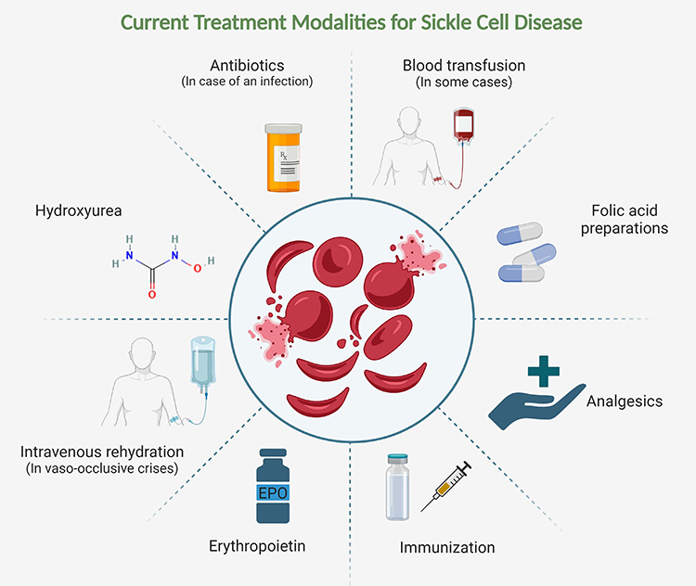
Figure 7: Evidence-Based Management in the UK
Management of SCD within the UK depends upon national guidelines and specialist commissioning, under which holistic person-centred approach is crucial and involves patient education, hydroxyurea, and overall support (NHS, 2026a; NICE, 2023). Non-pharmacological and preventative treatment methods represent the basis for management of SCD. Vaccinations, penicillin prophylaxis, and trigger avoidance education represent the key interventions in order to decrease infection and crises (NHS, 2026b; Sickle Cell Society, 2025). Patient education and self-management are critical components that will allow the patient to get more information on their condition, recognize early warning signs, and set realistic goals for everyday functioning (NHS, 2026c; Jacob et al., 2025).
High-risk individuals require disease-modifying therapy using hydroxyurea in order to decrease the number of crises and necessity for transfusions (Patel et al., 2024; Frangoul et al., 2024). Pharmacological treatment for acute crises requires immediate application according to an individualized plan. Strong analgesia including opioids should be provided promptly when indicated and chronic treatment is oriented at prevention (NICE, 2012 updated 2023; Jacob et al., 2025). Innovative treatment approaches including gene therapy with exagamglogene autotemcel can be offered to eligible individuals with severe form of the disease when optimization of conventional treatment approaches has been achieved (Frangoul et al., 2024; Leonard and Kanter, 2025).
Specialist hemoglobinopathy services referral and consideration of curative procedures like stem cell transplant must be considered when disease severity impacts significantly on the quality of life of the individual and conservative treatment options have been optimized (NHS England, 2025; Sickle Cell Society, 2025). Multidisciplinary approach including hematologists, specialists in nursing, psychology, and pain management is considered the best way but not every area has access to such comprehensive team (Jacob et al., 2025; NHS England, 2025). Primary and emergency services are integral parts of SCD management although time constraints, lack of specialist knowledge, and delay in providing analgesia represent the barriers to delivering quality acute care (NHS England, 2025; Jacob et al., 2025). Despite detailed national guidance and specialist commissioning there is still considerable variance in availability of evidence-based treatment including pain management and gene therapy (NHS England, 2025; Sickle Cell Society, 2025).

Theoretical Models
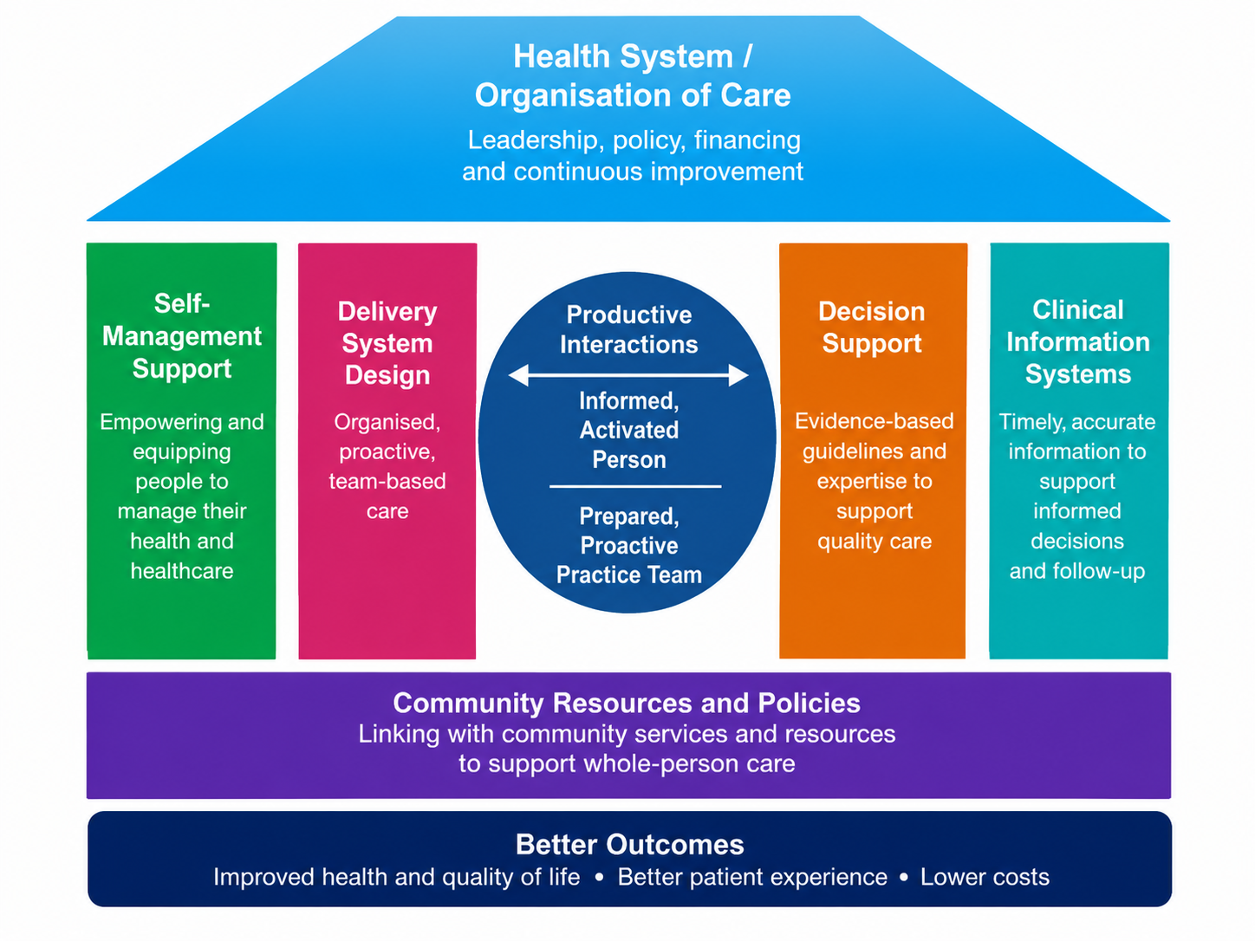
Figure 8: Chronic Care Model
Management of long-term illnesses such as sickle cell disease requires well-structured theoretical frameworks that can ensure a more proactive and coordinated care approach. Among the models that can be used for management of patients with SCD, two particular approaches are particularly relevant (Hunter et al., 2023; Jacob et al., 2025). One of the well-known frameworks for the improvement of care outcomes in case of chronic illness is the Chronic Care Model created by Wagner and colleagues, which has been widely applied internationally (Wagner et al., 2001). The main components of the Chronic Care Model are self-management support, delivery system design, decision support, and clinical information systems. They fit very well into the framework of management of patients with lifelong and variable conditions such as sickle cell disease (Patel et al., 2024; Jacob et al., 2025).
The NHS Personalised Care Model in the UK that works via the framework of the House of Care model is a modification of the Chronic Care Model adapted for the British health system (Year of Care Partnerships, 2025).
The House of Care approach includes a productive dialogue between the patient and the healthcare practitioner supported by organisational systems and community resources, and therefore it fits very well for sickle cell disease and similar lifelong conditions where self-management and partnership working are essential (Year of Care Partnerships, 2025; NHS England, 2025). Both approaches mentioned above imply the transformation of reactive, crisis-driven care into a holistic person-centred approach to the illness (Hunter et al., 2023; Jacob et al., 2025). However, the implementation of these models in practice in the NHS is inconsistent because of different barriers, including lack of resources, time constraints in primary and emergency care, and uneven access to multidisciplinary support and self-management programmes (NHS England, 2025; Sickle Cell Society, 2025).

Policy & Political Context
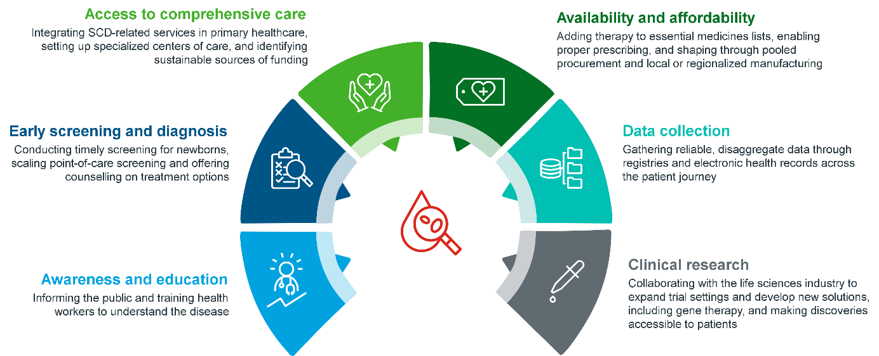
Figure 9: Integrated Care and Specialized Commissioning for Sickle Cell Disease
In the UK, the significance of sickle cell disease as a vital lifelong condition requiring an integrated and person-centred approach has been recognised. Thus, the NHS Long Term Plan and other strategic documents emphasize early intervention, personalized approach and tackling of health inequalities for those who have genetic and chronic illnesses (NHS England, 2025; Sickle Cell Society, 2025). There are national standards and special commissioning for hemoglobinopathy services providing a management model for sickle cell disease trying to tackle variation in practice and promoting evidence-based approach to the management of sickle cell disease (NHS England, 2025; Jacob et al., 2025).
The establishment of Integrated Care Systems may help with improving the management of sickle cell disease because of better coordination of care between primary, community and secondary care sectors (NHS England, 2025; Jacob et al., 2025). However, there are still plenty of issues to be tackled. For instance, shortage of specialists including hematologists, specialist nurses and psychologists makes it complicated to gain access to assessment and treatment services (NHS England, 2025; Sickle Cell Society, 2025). Also, the issue of inequality of access to evidence-based treatment such as rapid pain relief, psychological intervention, hydroxyurea optimization, and gene therapy referral in sickle cell disease should be solved (Jacob et al., 2025; NHS England, 2025).
Principles of personalized care and shared decision-making are promoted by policy frameworks in the UK; nevertheless, their implementation is hard due to the lack of time during acute visits and the absence of possibilities for the provision of the structured self-management support (NHS England, 2025; Jacob et al., 2025). Despite the existence of the policy frameworks aimed at prevention and high-quality management of sickle cell disease, the gap between policies and practices is obvious as far as addressing biopsychosocial aspects of the disease and ethnic and socioeconomic inequalities are concerned (NHS England, 2025; Sickle Cell Society, 2025).

Recommendations
The pathways for timely early diagnosis and annual comprehensive review in both general practice and specialist care must be improved via enhanced clinician training, use of appropriate assessment tools, and well-defined referral guidelines since late presentation of patients to specialists adversely affects their long-term outcomes (NHS England, 2025; Jacob et al., 2025). There is a need for the screening process for the psychological wellbeing of people affected by sickle cell disease due to the high proportion of mental disorders that have a direct impact on their pain and adherence (Druye et al., 2024; Jacob et al., 2025).
Evidence-based programs for patient self-management should involve education about avoiding trigger factors, recognition of pain, and use of hydroxyurea (Patel et al., 2024; Sickle Cell Society, 2025). Patients' access to disease-modifying treatments such as hydroxyurea optimisation and gene therapy should be more equal since there are significant inequalities among patients from poor socioeconomic backgrounds and ethnic minorities (Frangoul et al., 2024; Leonard and Kanter, 2025; NHS England, 2025).
Family members and carers of patients with sickle cell disease need more attention and assistance since they are under huge stress, both emotional and physical, due to helping the patient (Druye et al., 2024; Jacob et al., 2025). Inequality in access to specialized care and new treatments in different regions should be overcome by implementing better commissioning processes, decreasing variability in referral, and strengthening Hemoglobinopathy Coordinating Centers (NHS England, 2025; Sickle Cell Society, 2025). The principles of palliative and supportive care should be introduced earlier in treatment of people with advanced organ dysfunction and multiple complications (Jacob et al., 2025; NHS England, 2025).

Summary
Sickle cell disease is a major and lifelong public health problem both in the United Kingdom and around the world because of its high incidence rate and the burden on those who suffer from it and their families. This is because sickle cell disease is an incredibly diverse and complicated genetic condition, which leads to repeated pain, organ damage, psychological suffering, and discrimination.
There are proven and evidence-based treatment options, such as hydroxyurea, specialized multidisciplinary care, and the recently developed gene therapy techniques. However, there is still a great number of problems in terms of implementation, delayed access to pain relief treatment, mental health integration, and health inequalities. The theoretical approaches like Chronic Care Model and House of Care Model can be used to solve these problems in case they are properly applied. The main problems that should be addressed include the lack of healthcare professionals, disparities between regions, stigmatization in acute settings, and underdeveloped psychosocial and family support.

References
Acharya, B., Mishra, D.P., Barik, B., Mohapatra, R.K. and Sarangi, A.K., 2023. Recent progress in the treatment of sickle cell disease: an up-to-date review. Beni-Suef University Journal of Basic and Applied Sciences, 12(1), p.38. Available at: https://link.springer.com/content/pdf/10.1186/s43088-023-00373-w.pdf (Accessed: 21 June 2026).
Butt, H., Mandava, M. and Jacobsohn, D., 2025. Advances in gene therapy for sickle cell disease: from preclinical innovations to clinical implementation and access challenges. The CRISPR journal, 8(3), pp.174-188. Available at: https://journals.sagepub.com/doi/abs/10.1089/crispr.2024.0101 (Accessed: 21 June 2026).
Christy, M. and Fisher, B., 2025. Gene therapy: A new hope in sickle cell disease treatment. Journal of Pediatric Health Care, 39(1), pp.122-129. Available at: https://www.jpedhc.org/article/S0891-5245(24)00181-0/pdf (Accessed: 21 June 2026).
Druye, A. A., Amoadu, M., Boso, C. M., Nabe, B., Kagbo, J. E., Alhassan, A., Odonkor, F. O., Lanyo, G. S., Davies, A. E., Doe, P. F., Okantey, C., Ofori, G. O., Agyare, D. F., and Abraham, S. A., 2024. Self-management needs, strategies and support for individuals with sickle cell disease in developing countries: a scoping review. BMJ open, 14(9), e087723. Available at: http://pubmed.ncbi.nlm.nih.gov/39260843/ (Accessed: 21 June 2026).
Elendu, C., Amaechi, D.C., Alakwe-Ojimba, C.E., Elendu, T.C., Elendu, R.C., Ayabazu, C.P., Aina, T.O., Aborisade, O. and Adenikinju, J.S., 2023. Understanding sickle cell disease: causes, symptoms, and treatment options. Medicine, 102(38), p.e35237. Available at: https://journals.lww.com/md-journal/_layouts/15/oaks.journals/downloadpdf.aspx?an=00005792-202309220-00030 (Accessed: 21 June 2026).
Frangoul, H., Locatelli, F., Sharma, A., Bhatia, M., Mapara, M., Molinari, L., Wall, D., Liem, R.I., Telfer, P., Shah, A.J. and Cavazzana, M., 2023. Exagamglogene autotemcel for severe sickle cell disease. Blood, 142, p.1052. Available at: https://www.sciencedirect.com/science/article/pii/S0006497123076553 (Accessed: 21 June 2026).
Frangoul, H., Locatelli, F., Sharma, A., Bhatia, M., Mapara, M., Molinari, L., Wall, D., Liem, R.I., Telfer, P., Shah, A.J. and Cavazzana, M., 2024. Exagamglogene autotemcel for severe sickle cell disease. New England Journal of Medicine, 390(18), pp.1649-1662. Available at: https://cancer-networks.com/wp-content/uploads/2024/04/exagamglogene-autotemcel-for-severe-sickle-cell-disease.pdf (Accessed: 21 June 2026).
Gargano, L.P., Fachi, M.M., Oliveira, L.A., Lobo, C., Melnikoff, K.N.T., Soriano, S., Maior, M.D.C.L.S., Kron-Rodrigues, M.R., Gomes, D.F., Junior, H.A.O. and Lucchetta, R.C., 2025. Updating the Brazilian clinical practice guidelines for sickle cell disease: Recommendations and development process. Hematology, Transfusion and Cell Therapy, 47(4), p.103964. Available at: https://pubmed.ncbi.nlm.nih.gov/40850219/ (Accessed: 21 June 2026).
Jacob, S.A., Frei-Jones, M., Saif-Ur-Rehman, S., Hulbert, M.L., O’Brien, A.R., Strunk, C., Villella, A., Talati, R., Owusu-Ansah, A., Coyne, F. and McGann, P.T., 2025. National Alliance of Sickle Cell Centers Consensus Recommendations on Sickle Cell Disease Health Maintenance: A Consensus Statement. JAMA network open, 8(11), p.e2543421. Available at: https://jamanetwork.com/journals/jamanetworkopen/articlepdf/2841331/jacob_2025_cs_250005_1762459856.75958.pdf (Accessed: 21 June 2026).
Kato, G.J., Piel, F.B., Reid, C.D., Gaston, M.H., Ohene-Frempong, K. and Krishnamurti, L., 2018. Costa FF. Sickle cell disease nature reviews disease. Primers., 4, pp.1-22. Available at: https://pubmed.ncbi.nlm.nih.gov/29542687/ (Accessed: 21 June 2026).
Kunz, J.B. and Tagliaferri, L., 2024. Sickle cell disease. Transfusion Medicine and Hemotherapy, 51(5), pp.332-344. Available at: https://karger.com/tmh/article-pdf/51/5/332/4285899/000540149.pdf (Accessed: 21 June 2026).
Leonard, A. and Kanter, J., 2025. Clinical data comparison for FDA-approved gene therapies in sickle cell disease. Experimental Biology and Medicine, 250, p.10806. Available at: https://pmc.ncbi.nlm.nih.gov/articles/PMC12719290/ (Accessed: 21 June 2026).
Li, L. and Mandal, P.K., 2024. Recent advancements in gene therapy for sickle cell disease and β-thalassemia. Frontiers in Hematology, 3, p.1468952. Available at: https://www.frontiersin.org/journals/hematology/articles/10.3389/frhem.2024.1468952/pdf (Accessed: 21 June 2026).
Locatelli, F., Lang, P., Corbacioglu, S., Wall, D., Meisel, R., Li, A.M., de La Fuente, J., Shah, A.J., Carpenter, B., Kwiatkowski, J.L. and Mapara, M., 2023. Exagamglogene autotemcel for transfusion-dependent β-thalassemia. Blood, 142, p.1053. Available at: https://www.sciencedirect.com/science/article/pii/S0006497123076565 (Accessed: 21 June 2026).
Makani, J., Ofori-Acquah, S.F., Nnodu, O., Wonkam, A. and Ohene-Frempong, K., 2013. Sickle cell disease: new opportunities and challenges in Africa. The scientific world journal, 2013(1), p.193252. Available at: https://onlinelibrary.wiley.com/doi/pdf/10.1155/2013/193252 (Accessed: 21 June 2026).
Miller, A. C., and Gladwin, M. T., 2012. Pulmonary complications of sickle cell disease. American journal of respiratory and critical care medicine, 185(11), 1154–1165. Available at: https://pmc.ncbi.nlm.nih.gov/articles/PMC3373067/ (Accessed: 21 June 2026).
National Institute for Health and Care Excellence (NICE), 2023. Sickle cell disease: managing acute painful episodes in hospital [CG143]. Available at: https://www.nice.org.uk/guidance/cg143 (Accessed: 21 June 2026).
NHS England, 2025. Sickle cell disease: what every clinician needs to think about. Available at: https://www.england.nhs.uk/blog/sickle-cell-disease-what-every-clinician-needs-to-think-about/ (Accessed: 21 June 2026).
NHS, 2026a. Sickle cell disease. Available at: https://www.nhs.uk/conditions/sickle-cell-disease/ (Accessed: 21 June 2026).
NHS, 2026b. Sickle cell disease – Treatment and support. Available at: https://www.nhs.uk/conditions/sickle-cell-disease/treatment/ (Accessed: 21 June 2026).
NHS, 2026c. Sickle cell disease – Living with. Available at: https://www.nhs.uk/conditions/sickle-cell-disease/living-with/ (Accessed: 21 June 2026).
Patel, Z.V., Prajjwal, P., Bethineedi, L.D., Patel, D.J., Khullar, K., Patel, H., Khatri, K., Marsool, M.D.M., Gadam, S., Aleti, S. and Amir, O., 2024. Newer modalities and updates in the management of sickle cell disease: a systematic review. Journal of Blood Medicine, pp.435-447. Available at: https://www.tandfonline.com/doi/pdf/10.2147/jbm.s477507 (Accessed: 21 June 2026).
Sharma, A., Hankins, J.S., Boelens, J.J., Cancio, M., Peddinti, R., Rispoli, L., Sloan, S., Costa, S.D., Peled, S., Wiethoff, A. and Sitaram, R., 2025. Normalization of cerebral hemodynamics after gene therapy in adults with sickle cell disease. American journal of hematology, 100(10), pp.1882-1885. Available at: https://onlinelibrary.wiley.com/doi/pdf/10.1002/ajh.27757 (Accessed: 21 June 2026).
Sickle Cell Society, 2025. About Sickle Cell. Available at: https://www.sicklecellsociety.org/about-sickle-cell/ (Accessed: 21 June 2026).
Tebbi, C.K., 2022. Sickle cell disease, a review. Hemato, 3(2), pp.341-366. Available at: https://www.mdpi.com/2673-6357/3/2/24 (Accessed: 21 June 2026).
Thomson, A.M., Culbreth, G.T., Haile, L.M., Rafferty, Q., Lo, J., Fukutaki, K.G., Cruz, J.A., Smith, A.E., Vollset, S.E., Brooks, P.M. and Cross, M., 2023. Global, regional, and national prevalence and mortality burden of sickle cell disease, 2000–2021: a systematic analysis from the Global Burden of Disease Study 2021. The Lancet Haematology, 10(8), pp.e585-e599. Available at: https://www.thelancet.com/journals/lanhae/article/PIIS2352-3026(23)00118-7/fulltext?linkId=100000205683156 (Accessed: 21 June 2026).
Wagner, E.H., Austin, B.T., Davis, C., Hindmarsh, M., Schaefer, J. and Bonomi, A., 2001. Improving chronic illness care: translating evidence into action. Health affairs, 20(6), pp.64-78. Available at: https://www.researchgate.net/profile/Connie-Davis-2/publication/11542684_Improving_Chronic_Illness_Care_Translating_Evidence_Into_Action/links/5440fcfc0cf2e6f0c0f42b6f/Improving-Chronic-Illness-Care-Translating-Evidence-Into-Action.pdf (Accessed: 21 June 2026).
World Health Organization (WHO), 2025. Sickle-cell disease. Available at: https://www.who.int/news-room/fact-sheets/detail/sickle-cell-disease (Accessed: 21 June 2026).
Year of Care Partnerships, 2025. The House of Care model. Available at: https://www.yearofcare.co.uk/house-of-care (Accessed: 21 June 2026).

