University of Wales Trinity Saint David


Assignment Title: Report
Student Name: Saira Usman
Student ID: 2
Module: International Business Concepts
Module Code: LCMB70034
Name of Lecturer: Akshay Narayanan
Internal verifier: Vasilios Tavlaridis
Hoang Nguyen
Date: 17 March 2026
Word count: 5149

Contents
1. Introduction 1
2. Industry and Country Overview-see Appendix-I- Mexico Automotive Industry overview 1
a. Industry Context 1
b. Size, scope, and economic importance –See Appendix-II 2
c. Major Companies-See Appendix-III 2
Established Leaders 2
3. Applying Porter’s Diamond Model to Mexico Automotive Industry Report- See Appendix-IV 3
4. Critical Evaluation of Ford Motor Company‘s Operations in Mexico 6
4.1 Introduction to the Chosen MNC and Industry Context 6
5. Conclusion 11
Section 2: Reflective Account of the Research and Analysis Process 12
References 15
Appendixes 18
Appendix-I- Mexico Automotive Industry Overview 18
Appendix-II 23
Appendix-III Popular firms in the Industry 25
Appendix-IV 31

Singapore Fintech Industry Report
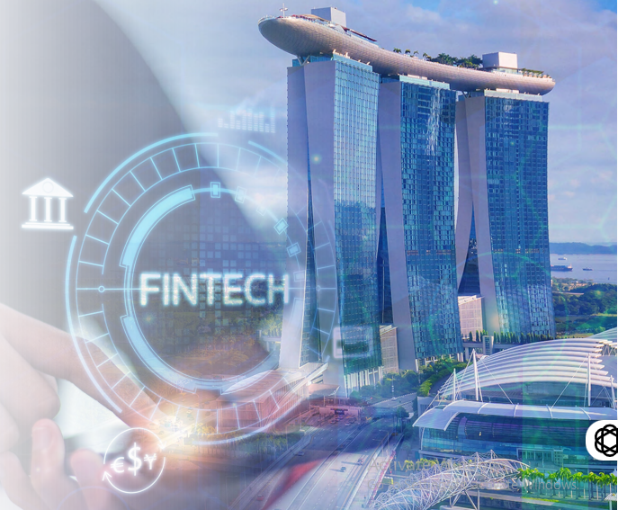

1. Introduction
The report provides a detailed overview of the Singapore Fintech market, which is a jurisdiction that has so far established itself as a global and regional leader. The document examines the existing situation in the Singapore Fintech ecosystem by relying on numerous 2025 industry reports, regulatory releases, and market studies. The report starts by giving a summary of the size, scope, and economic significance of the industry, as a key pillar of digital economy of the country. Later parts name and analyze the key domestic and multinational companies that have their businesses in the sector and compare them in terms of strategies, market positioning and performance. Integrating insights based on over twenty different sources, including the Monetary Authority of Singapore (MAS), industry associations and top consultancies, this report provides a data-driven view of the major trends, regulatory changes, and competitive forces currently determining one of the most dynamic and active Fintech centres in the world.

2. Industry and Country Overview-Refer to Appendix-I

a. Industry Context
The Fintech industry is a developed and central part of the Singaporean economy that serves as an international hub of innovation and a strategic point of entry to the rest of the ASEAN market (SFA, 2023). The sustainable regulatory framework by the Monetary Authority of Singapore (MAS), which has matured into a global regulator with several laws like the Payments Services Act, and detailed licensing infrastructures of the digital payment token service providers form the foundation of the ecosystem (MAS, n.d.). The position of Singapore as a financial hub is strengthened by the fact that it is a supply-chain hub, a transaction hub, and a talent hub and, therefore, attracts international business ventures to gain entry into the growth markets of ASEAN (SFA, 2023). National Quantum-Safe Network Plus forms part of the national digital infrastructure and has been tested by the major banks; DBS, OCBC, HSBC, and UOB to provide quantum-safe banking; thus, showing a desire to quantum-proof their financial technology (Fintech News Singapore, 2025). Singapore has over 133 foreign banks operating with six local banks and thus providing a complex financial services environment enabling Fintech innovation (Fintech News Singapore, 2025). This fact is evidenced by the fact that Singapore leads the Southeast Asian Fintech, given that there are over 147 Fintech companies by September 2022, the highest in the region (SFA, 2023).

b. Size, scope, and economic importance – Refer to Appendix-II
The financial importance of Singapore Fintech sector is supported by the fact that it has a huge contribution to the financial sector as well as facilitating foreign investment. In 2024, the gross domestic product of Singapore was SGD 731.4 Bn, which is supported by a highly advanced financial services industry that allows Fintech to develop (Fintech News Singapore, 2025). In 2022, Singapore did not follow the global trend, and Fintech funding increased in a three-year record of US$4.1billion, which was an increase of 22% compared to the previous year (SFA, 2023). Although the world is facing Fintech investment headwinds, Singapore had witnessed an inflow of capital, which strengthens its position as a safe haven of capital amid trade fragmentation (KPMG, 2025). The volume of transactions of instant payments in the world was US$60 trillion in 2025, which demonstrates the enormous size of the market of digital payments that Singapore is a part of (Fintech Magazine, 2025).
Singapore's Fintech ecosystem comprises hundreds of firms, with the largest concentration in payments (20.4%), followed by wealthtech (12.7%) and regtech (12.3%) (Fintech News Singapore, 2025). The increase in the industry is indicated by the patterns of consumer adoption, as the percentage of cryptocurrency ownership among the Singaporean population is at 49 (Fintech News Singapore, 2025). The number of e-money transactions made by consumers per year amounts to SGD2.52billion, and its value is SGD2.04billion, and its card payments amount to SGD148.9Billion (Fintech News Singapore, 2025). New trends influence the future direction of the sphere, such as embedded finance, where the revenue of APAC is expected to grow by US$108.6 billion in 2022 to US357.9 billion in 2029 (SFA, 2023). It is estimated that tokenised asset markets will be valuing up to US$24 trillion as a trend which Singapore is also pursuing by undertaking projects like Project Guardian (SFA, 2023). More than US$8.9 trillion has been processed on the first half of 2025, and the transfer volumes are almost higher than Visa and Mastercard, which shows the increasing mainstreaming use of digital assets (Fintech Magazine, 2025).

c. Major Companies- Refer to Appendix-III
The competitive environment includes multinationals in the world, local banks, and online banks. Big players like Grab and Sea Group have used super-app family to integrate financial services (Fintech News Singapore, 2025). Efforts Visa and HSBC are global payment giants working on technologies such as stablecoin prefunding and tokenised deposits (Fintech News Singapore, 2025). The three major traditional local banks (DBS, OCBC, and UOB) partner with MAS in quantum-safe banking experiments and tokenised bonds (Fintech News Singapore, 2025). Specialized international companies Airwallex and Thunes have raised large funding round in 2025 (Fintech News Singapore, 2025).
Financial reports differ significantly among digital banks. Retail-based Trust Bank turned into the fourth largest retail bank with 1 million users and reduced its losses by 27 per cent to SGD93.3million (Fintech News Singapore, 2025). GXS Bank, which is supported by Grab and Singtel, also deals with financing of retail and SMEs but has a high net loss of SGD 145.4 million but increased incomes more than twice (Fintech News Singapore, 2025). MariBank is also seeking a combined approach that provides remittances and investment services, where the losses have reduced to SGD5.06million (Fintech News Singapore, 2025). ANEXT Bank and Green Link Digital Bank are both focused on SMEs on the wholesale level, with GLDB recording 447 per cent income growth and 83 per cent decrease in losses (Fintech News Singapore, 2025).
Airwallex and Thunes raised roomy US300 and US150 million respectively as cross-border solutions and payments infrastructure respectively in payments and wealthtech (Fintech News Singapore, 2025). The Syfe and Endowus wealth manager are two funds that have raised US$80million and US52.5million respectively, and their target groups are different (Fintech News Singapore, 2025). Dtcpay is active in regulated stablecoin payments in the digital asset sector, and it earned the Fintech Frontiers 50 list, whereas Sygnum became a unicorn (Fintech News Singapore, 2025). The market structure created by tough Digital Payment Token licensing policy of MAS is biased in favour of well-capitalised companies like StraitsX (XSGD issuer) within an evident system of compliance (Fintech News Singapore, 2025; Allen and Gledhill, 2025). Together with other efforts that include the Global Fintech Hackcelerator and FSTI grants, this regulatory framework solidifies Singapore as the most robust Fintech center in Asia (MAS, n.d.; SFA, 2023).

3. Applying Porter’s Diamond Model to Singapore Fintech Iindustry Report
Using the Diamond Model by Porter to Singapore Fintech Industry Report – See Appendix -IV. The Diamond Model of National Advantage by Michael Porter provides a theoretical framework that can be used to explain the circumstances in which a particular country will achieve prominence in a specific industry in the world. The model, when targeted at the financial technology (Fintech) industry in Singapore, explains a self-reinforcing group of benefits based on the sound policy, the well-developed infrastructure, and the active competition.
Factor Conditions
Singapore possesses sophisticated and specific factor conditions that cannot be lost to Fintech innovation. The country has a well-educated and qualified human resources, developed through partnerships, e.g., the one between GLDB and Republic Polytechnic, that target to develop Fintech talent (Fintech News Singapore, 2025). Monetary Authority of Singapore actively builds this talent pool by organizing such events as the Global Fintech Hackcelerator and large Financial Services Transformation Initiative (FSTI) grants (SFA, 2023; MAS, n.d). It is supported by world-leading digital facilities, such as the National Quantum-Safe Network Plus, which already has been tested on by major banks to quantum-safe banking (Fintech News Singapore, 2025). Moreover, Singapore is a supply-chain and transaction hub, which provides it with sophisticated physical and technological infrastructure required to support global finance (SFA, 2023). Having over 133 foreign banks in operation among six local banks gives it an abundance of financial services knowledge (Fintech News Singapore, 2025).
Demand Conditions
The Singapore domestic market is challenging and advanced, hence creating a powerful force of unending innovation. The digital literacy level of Singaporean consumers is high (49 percent of the population owns cryptocurrency and the younger age groups, Gen Z (40 percent) and Millennials (39 percent) are at the top of the adoption) (Fintech News Singapore, 2025). This need of high-order digital services is attributed to the 2.04billion e-money transactions of S$2.52billion and 2.29Billion card payments in 2024 (Fintech News Singapore, 2025). Merchant services, which accept cryptocurrency, are also in demand in businesses to the tune of almost US 1billion by 2022 (Q2 2024) (Fintech News Singapore, 2025). This advanced domestic market forces domestic companies to be innovative resulting in the production of competitive products and services in the global market (MAS, n.d.).
Related and Supporting Industries
The extensive infrastructure of supporting industries that are of world standard also contributes to the success of Fintech in Singapore. There is a significant number of technology companies that work with artificial intelligence, data analytics, and blockchain in the innovation hub (SFA, 2023). This ecosystem is actively cultivated by the government using its agencies like the Economic Development Board (EDB) that makes Fintech innovation one of its primary growth areas (EDB, 2025). Strong related industries, an established venture-capital and private-equity environment that funded US$4.1 billion in 2022--a post-pandemic peak—are strong related industries (SFA, 2023). Larger 2025 funding rounds in companies like Airwallex (US$300 M), Thunes (US 150 M) and bolttech (US 147 M) also confirm this investment ecosystem (Fintech News Singapore, 2025).
Firm Strategy, Structure, and Rivalry
The strength of competition within the Singaporean Fintech industry is one of the main driving forces of the international competitiveness. The market is a saturated player field of players, consisting of global multinationals like Grab and Sea, traditional banks like DBS and OCBC, and a new breed of digital banks (Trust, GXS, MariBank, ANEXT, GLDB), all competing to share the market (Fintech News Singapore, 2025). Competition forces companies to establish their unique strategies, which is demonstrated by a different financial performance and market orientation of digital banks, with Trust Bank focusing on retail segment and GLDB focusing on high-growth SME (Fintech News Singapore, 2025). In the payments environment, there is intense competition between international platforms like Airwallex and Visa and local innovators like dtcpay, which drives the constant enhancement of cross-border and stablecoin payment services (Fintech News Singapore, 2025).
Government and Chance
The model created by Porter recognizes the impact of the government and random occurrences. Government, more importantly MAS is not an inactive spectator but a key architect behind the competitiveness of Singapore. Its proactive measures have developed a transparent, consistent, and progressive regulatory environment, such as the Payments Services Act, regulatory sandboxes, and the Financial Services Industry Transformation Map 2025 (SFA, 2023; MAS, n.d.; MAS, n.d.–a). In 2025, the market was intentionally manipulated to remove losers by introducing a tougher licensing regime to Digital Payment Token Service providers that had only foreign clients, which forced the companies to leave the market (Fintech News Singapore, 2025; MAS, n.d.). Global uncertainties in the economy and fragmentation in trade have been some of the chance events that have ironically played to the advantage of Singapore, with the country witnessing increased investments as a sanctuary destination that appears to be safe and stable (KPMG, 2025). Its strategic position and its position as a gateway to the fast-growing ASEAN market, which is projected to grow to as high as US$1 trillion GMV as of 2030, is a geographical advantage that has become more and more valuable (SFA, 2023). COVID -19 also increased digital transformation, and Singapore was very prepared to take advantage of it (SFA, 2023).

4. Critical Evaluation of Grab Holdings Company‘s Operations in Singapore
To conduct the current analysis, the example of a multinational technology company based in Singapore, Grab Holdings, has been chosen as the model multinational company that works in the Fintech industry of Singapore. This part critically analyses the factors that determine the success of Grab in Singapore by applying the PESTLE (Political, Economic, Social, Technological, Legal, and Environmental) framework, which will determine the market appeal and its feasibility to operate.
Company Overview and Market Position
Grab Holdings has established itself as one of the largest Fintech companies in Singapore, working both under its financial services branch, GrabFin, and its digital bank, GXS Bank (Fintech News Singapore, 2025). In fiscal year 2025, the financial services division brought in US 347 million of revenue, which is a large segment of the company in terms of diversified business model besides Deliveries (US 1.8 billion) and Mobility (US 1.22 billion) (Grab Holdings Annual Report, 2025). In 2025, Grab made a historic breakthrough when the company recorded a net profit of US $200million in its annual report, a significant improvement compared to the annual loss of US $158million of 2024 (Grab Holdings Annual Report, 2025). Monthly Transacting Users of the Company Topped 50 million in Q4 2025, which is an increment of 15 per cent/year/year, and monthly user conversion, has been 37 per cent (Grab Holdings Annual Report, 2025). Grab has increased its financial services portfolio by acquiring 50.1 per cent of the stakes in the U.S.-based digital investing platform, Stash Financial, to pay US 425 million and investing in the Validus Capital to expand its SME financing services (Fintech News Singapore, 2025). Singapore has a Fintech market of US$12.05billion in 2025, which is projected to grow at a compound annual growth rate of 16.12 per cent and is expected to have US25.45billion by 2030 hence offering generous headroom to the growth of Grab (Mordor Intelligence, 2025).
Political Factors
The political environment in Singapore provides incredible political stability and active governmental encouragement of Fintech innovation to the direct benefit of the operations at Grab. The Monetary Authority of Singapore (MAS) has managed to position itself as a global regulator and enacted the Payments Services Act, which introduces a detailed licensing framework of electronic payment token services (MAS, n.d.). Under this Act there are more than 480 applications to crypto-services licences of MAS since January 2020, with an estimated 170 (35%) of the applications requesting Digital Payment Token (DPT) service licences (MAS, n.d.). The regulator has been very strict on the oversight and 30 DPT applications have been revoked after they interacted with MAS and 2 applications were denied due to not satisfying anti-money laundering and technology-risk requirements (MAS, n.d.). The political leadership of Singapore has always focused on the development of Fintech, and this is confirmed by the declaration of Deputy Prime Minister Gan, who stated that Singapore had always been a partner you can rely on and that trust was going to be a valuable thing in the modern world (SGPC, 2025). The Financial Services Industry Transformation Map 2025 (FSITM 2025) by the government is a strategic plan of the development of the sector that will form a predictable policy environment that will favour long-term corporate planning (MAS, n.d.). The S$1.0billion (US$770.0million) FSTI.3.0 programme by MAS co-funds up to 50% of projects in quantum-safe online protection and AI-based risk models, which directly subsidizes innovation by other companies including Grab (SFA, 2023). The political determination to keep Singapore as a trusted partner to the trading as well as economic partners even in the times of crisis like COVID-19 when ports stayed open and deliveries of goods were made to reinforce the jurisdiction appeal to multinational operations (SGPC, 2025).
Economic Factors
The strong macroeconomic environment of Singapore offers a strong base on which the Grabs financial services will grow. The Singapore economy has been showing good results in 2025 and is likely to witness another year of robust though slower GDP growth in 2026 and anchored by the presence of tech-related activities in line with the global AI boom (CBRE, 2025). The MAS Core Inflation has stabilized to a projected 1.0-2.0% in 2026 compared to 0.7% in 2025, which means that the price levels are stable and will support consumer spending as well as borrowing (CBRE, 2025). The current AI-driven IT upcycle has been contributing to high-tech industrial manufacturing and export operation in the economies participating in the electronic supply chain, which has a positive impact on the Singapore digital economy (CBRE, 2025). The GDP of Singapore was S$731.4billion in the year 2024 and this is the basis of the advanced financial services infrastructure that Grab uses (Fintech News Singapore, 2025). In 2025, the entire volume of instant payment transactions at the global level amounted to US$60 trillion, which indicates the huge size of the digital payments market that Grab can serve (Fintech Magazine, 2025). Project Nexus is a multilateral project that will connect payment systems in Singapore, Malaysia, Thailand, India, and the Philippines and will make it possible to change the T +2 settlement to real time, which will open up about US 120 billion of liquidity and save on the costs of cross-border transactions (Fintech News Singapore, 2025; BIS cited in Fintech News Singapore, 2025). The financial services business of Grab is expanding at a high pace, but forecasted to break even in terms of EBITDA in the second half of 2026, with the company projecting the revenue of 2026 as $4.04-$4.10 billion and Adjusted EBITDA as $700-$720 million (Grab Holdings Annual Report, 2025).
Social Factors
Singapore is a very digitalised society which offers both opportunities and threats to the Fintech business of Grab. Cryptocurrency adoption reached 49 % ownership among Singaporeans, with younger generations leading at 40 % for Gen Z and 39 % for Millennials (Fintech News Singapore, 2025). The annual e-money transactions made by consumers amounting to $2.04 billion and card payments amounting to $2.29 billion with values amounting to S$2.52 and S148.9 billion respectively (Fintech News Singapore, 2025). The 6.11millions and a median age of 43.2 is a mature and financially literate consumer base (Fintech News Singapore, 2025). The adoption of digital banking has been increasing with GXS Bank (Grab and Singtel joint venture) registering total income of S$29.6m in FY2024, which is 107% more than in 2023 although it still incurs a net loss of S145.4m (Fintech News Singapore, 2025). Competitor Trust Bank has grown to be the fourth largest retail bank and boasts of one million users which shows a high rate of consumer acceptance of digital only banking (Fintech News Singapore, 2025). Super-app consumers are keen on super-apps, and the number of Monthly Transacting User of Grab is expected to reach over $50 million consumers in Q4 2025, an increase of 15% over the year (Grab Holdings Annual Report, 2025).

Technological Factors
The high-tech nature of the Singaporean system, by offering an avenue on which the Fintech innovations of Grab will thrive, lies representative of the city-state of Singapore in its future-proofing of financial technology. An example of such an endeavor is the National Quantum -Safe Network Plus, recently trialled by DBS, OCBC, HSBC, and UOB (Fintech News Singapore, 2025). It is estimated that the agentic AI market in the financial services will grow by about US 2.1billion to US 80.9billion by 2034, thus facilitating autonomous decision-making in KYC triage, transaction reconciliation, and loan approvals, among others (SunTec Group, 2026). Consistent with this pattern, the acquisition of Stash Financial by Grab puts the company in a position to capitalize on AI-based wealth-management solutions, with the AI in Fintech market having potential to grow until 2030 (Fintech Magazine, 2025). It is estimated that the embedded finance market in the world will amount to US 148.4 billion in 2025 and will amount to US 197.1 billion in 2026 and will finally reach $1.73 trillion by 2034 at a 31.5% CAGR (SunTec Group, 2026). The super-app model that Grab plans to launch exploits this trend by integrating lending, insurance, and investment products into the day-to-day digital experiences of its users. Due to the On-demand GMV, the company grew by 21 percent year-over-year in Q4 and FY 2025 to US 22.1 billion, facilitated by the integration of technology that allows it to grow on the basis of product-led affordability and high levels of user engagement (Grab Holdings Annual Report, 2025). In that regard, MAS has released detailed regulatory sandbox guidelines that add clarity, flexibility, and transparency to the field of Fintech experimentation, which has allowed companies like Grab to test new products within a set of parameters (MAS, n.d.).
Legal Factors
The strong legal system in Singapore provides regulatory predictability and enforces compliance costs and burdens on strategic flexibility of Grab. The Digital Payment Token service providers have been provided with strict rules by MAS, which include detailed notices on AML/CFT-related requirements (FSM-N27), suspicious activity reporting (FSM-N28), regulatory returns (FSM-N29), technology risk management (FSM-N30), cyber hygiene (FSM-N31), conduct standards (FSM-N32), disclosure and communications (FSM-N33), and prescribed matters and forms (FSM-N34) (Fintech News Singapore, 2 Protection from Scams Bill came into effect in January 2025, granting the authorities the authority to direct banks to block further transactions and take all possible measures to prevent losses further, which adds extra compliance measures to digital banks like GXS ( Fintech News Singapore, 2025). The licensing of digital banks by MAS requires that the holder should cater to underserved segments; an example of this is that GXS Bank provide gig-economy workers with an interest-saving account on a daily basis (Fintech News Singapore, 2025). The regulator has already been found to be keen on imposing standards after declining 2 DPT applications as well as monitoring 30 withdrawals due to supervisory engagement (Fintech News Singapore, 2025). New laws limiting BNPL late-fee rates and banning crypto cash-back incentives may impact the product-design flexibility and revenue models at Grab (Allen and Gledhill, 2025). The Payment Services Act offers exemptions of DPT service providers, including payment businesses of Grab, but in the context of applications pending applications, exemptions are available until the time of approval, rejection, or withdrawal of applications (MAS, n.d.).
Environmental Factors
The environmental factors are becoming more relevant to the Fintech environment of Singapore, thus, providing both opportunities and compliance needs to Grab. In Q2 2025, ESG-oriented financial products were in demand with global sustainable open-ended and exchange capacity funds recording net inflows of US 4.9 billion, exceeding ETF asset levels of 65.2 billion (Fintech Magazine, 2025). In 2024, the United Kingdom spent £632 million on green Fintech s, which is an indication that the world is adopting the trend and Singapore is following suit through projects like 2020-launched Project Greenprint that leverages technology to be environmentally friendly (Fintech Magazine, 2025; SFA, 2023). Sustainability has been identified as one of the central topics of MAS, and the tokenisation of asset markets is expected to reach up to US $24‛trillion, which opens the prospects of tokenising green bonds and carbon-credit trading (SFA, 2023). There is growing demand among consumers to have confirmed methods of sustainability, and it has been predicted that, in the future, carbon-footprint monitoring on banking apps will be a normal feature and that real-time emissions information will be added to purchases (Fintech Magazine, 2025). Green lending products or carbon -tracking integrations may be able to make the financial services of Grab stand out as sustainable, thus meeting the need of the sustainable finance trend that S&P Global has highlighted as a key driver of decision-making by 2023 (SFA, 2023). Nevertheless, the greenwashing issues may lead to the rise in the demand of the checked sustainability indicators, which will necessitate that Grab should be associated with the strong ESG standards instead of shallow allegations (Fintech Magazine, 2025).

Conclusion
This report shows that the Singapore Fintech sector has become a highly developed, globally competitive ecosystem that is operating as a domestic-level innovation hub and a strategic gateway to ASEAN markets. The industry is also based on a strong economy where GDP stood at $731.4 billion in 2024 and Fintech investments totalled US 4.1 billion in 2022, making it the opposite of the global trends (Fintech News Singapore, 2025; SFA, 2023). Hundreds of firms are part of the ecosystem in the areas of payments (20.4%), wealthtech (12.7%), and regtech (12.3%), with infrastructure on a scale, such as the National Quantum-Safe Network Plus, and projects like Project Nexus (Fintech News Singapore, 2025). The use of Porters Diamond Model has shown that the competitive advantage is based on the high level of domestic demand (49 measurements of cryptocurrency ownership, 2.04 billion e-money transactions per year), advanced factor conditions including the huge FSTI grants, the high level of rivalry among the players (Grab and traditional banks), and active governance with the help of MAS, which provides the clarity in regulation but promotes innovation (Fintech News Singapore, 2025; SFA, 2023).
In the future, the Fintech sector in Singapore can be expected to continue its expansion due to the operationalisation of Project Nexus by 2026, the integration of stablecoins in the context of transparent MAS, and the integration of AI, embedded finance, and tokenisation (Fintech News Singapore, 2025, BDO, 2026). Having more than 147 Fintech companies and the highest regional concentration, Singapore can balance its innovation and practical regulation, which is why the country is the leading Fintech hub in Asia and has become the global standard of financial technology excellence (SFA, 2023).

Section 2: Reflective Account of the Research and Analysis Process
This reflective account has critically used the Gibbs Reflective Cycle (1988) in the analysis of the methodology applied in the research and evaluation of the Singapore Fintech industry to compose a business report on a foreign business.
Description
The research and preparation of the above sections of this report, namely the industry overview, the Porters Diamond Model analysis of the Singapore Fintech ecosystem, and the PESTLE analysis of the Grab Holdings, entailed the synthesis of information obtained out of 33 separate sources searched via google, google scholars, articles and journals. These were industry reports on Fintech News Singapore (2025), regulatory reports on the Monetary Authority of Singapore (MAS, n.d.), global Fintech investment reports, published by KPMG (2025) and Innovate Finance (2025), and strategic frameworks published by consultancies like Allen and Gledhill (2025) and Drew Napier (2025). The assignment required pulling certain statistics, including Singapore GDP that is projected to reach S$731.4 billion in 2024 (Fintech News Singapore, 2025), the ratio of cryptocurrency ownership being 49% (Fintech News Singapore, 2025) and the initial profit that Grab is expected to make of US 200 million per year in 2025 (Grab Holdings Annual Report, 2025), and fitting them into a logical analytical story.
Feelings
First, the researcher was distressed with the amount of materials and the need to reference each sentence. The inconvenience was experienced where source documents had no clear author or date of publication forcing the researcher to have a more detail research. The completion of the Grab PESTL analysis, which incorporated both financial information of Grab Holdings Annual Report (2025) and competitor information of Sea Group Annual Report (2025) and GoTo Group Annual Report (2025), created a feeling of achievement in creating a multifaceted corporate analysis.
Evaluation
The research practice brought both successful results and difficulties. On the positive side, the variety of sources that included not only the state materials like the Bermuda Fintech Strategy (Bermuda Government, 2026) but also the analyses of the industry prepared by the SunTec Group (2026) made the perception of the industry quite multi-layered. The need of using each of the 33 sources provided full coverage as opposed to cherry-picking. The PESTLE model was useful in the organization of the Grab analysis, with the political factors based on MAS licensing data (MAS, n.d.), economic factors based on CBRE forecasts (CBRE, 2025), and technological factors based on projections of agentic AI (SunTec Group, 2026).
Analysis
The process showed significant trends regarding the Fintech ecosystem in Singapore, as well as regarding successful research methodology. The merge of articles continued to point at three trends: regulatory transparency as a competitive edge (MAS got more than 480 licence applications; MAS, n.d.); technological infrastructure as a basis (the trials of the National Quantum-Safe Net Plus proved its workability; Fintech News Singapore, 2025); and maturity of the ecosystem (147 Fintech companies are present in the area; SFA, 2023). These trends confirmed the use of the Diamond Model created by Porter, proving the interaction of factor conditions with demand conditions and the government to develop the national advantage. In the case of the Grab analysis, the PESTLE framework provided an insight into the relationship between macro-environmental factors. The S$1billion of political stability and SFA S9-153-3.0 programme of MAS (SFA, 2023) provides favourable conditions, and the social factor of 49% cryptocurrency adoption (Fintech News Singapore, 2025) drives demand.
Conclusion
The source organisation was strengthened methodologically, as the experience made it clear that it was essential. It would have been more efficient to make a matrix in which every source would have been connected to particular statistics and analytical themes. The figures showed in a consistent way that regulatory clarity encourages inflows of investments, with the global cryptocurrency market capitalisation of PS2 trillion (US$2.6 trillion) and the process of stablecoins of over US$8.9 trillion processed in early 2025 (Fintech Magazine, 2025; Fintech News Singapore, 2025). In the case of Grab, the discussion showed that despite the competitive advantage that the super-app concept and strategic acquisitions bring to the company, growing competition of Sea Monee division (57.6% growth) and GoTo financial services (revenue almost doubles) requires constant adjustment ( Sea Group Annual Report, 2025; GoTo Group Annual Report, 2025).

Action Plan
In case one of the research projects, similar, was to be conducted in the future, I would make a few methodological improvements. First, I would build an organized database before writing and each source would be sorted by topic (regulatory, economic, competitive) and the most important statistics would be noted with all referencing information. This would avoid the distraction of the writing process by verifying sources and the issue of misattribution. Second, I would establish a citation-grouping plan, which would enable the repetition of similar facts obtained in the same source to be referenced simultaneously, which would enhance the storytelling and academic integrity. Third, I would devote more time to the first phase of synthesis, tracing how the sources relate to one another to identify confirmation or contradiction which would enhance analytical information. Lastly, I would explicitly use several types of analytical frameworks at the same time, including PESTLE as an environmental scanning tool and Porters Diamond as a national competitiveness tool, to be able to be comprehensive and find areas of overlap of the frameworks, e.g., how legal factors (regulatory clarity) improve the state of factors (attracting skilled talent and capital). Such methodological advances would raise the efficiency and the level of analysis in the prospective industrial studies.

References
- Above A Tech (2025) Singapore Fintech statistics 2025. Available at: https://abovea.tech/singapore-Fintech -statistics-2025/ (Accessed: 1 March 2026).
- Allen & Gledhill (2025) Three key Fintech trends in 2025. Available at: https://www.allenandgledhill.com/sg/perspectives/articles/32355/sgkh-three-key-Fintech -trends-in-2025 (Accessed: 10 March 2026).
- BDO (2026) 2026 Fintech industry predictions. Available at: https://www.bdo.com/insights/industries/Fintech /2026-Fintech -industry-predictions (Accessed: 10 March 2026).
- Bermuda Government (2026) Bermuda Fintech strategy 2026–2028. Available at: https://www.gov.bm/sites/default/files/2026-03/BERMUDA%20FINTECH %20STRATEGY%202026-2028.pdf (Accessed: 16 March 2026).
- CBRE (2025) Singapore market outlook 2025. Available at: https://www.cbre.com.sg/about-us/singapore-market-outlook-2025 (Accessed: 17 March 2026).
- Chambers and Partners (2025) Fintech 2025: Singapore trends and developments. Available at: https://practiceguides.chambers.com/practice-guides/Fintech -2025/singapore/trends-and-developments (Accessed: 17 March 2026).
- Drew & Napier (2025) Legal 500 comparative guides: Fintech 2025 Singapore chapter. Available at: https://www.drewnapier.com/DrewNapier/media/DrewNapier/Legal-500-Comparative-Guides-Fintech -2025-Singapore-chapter.pdf (Accessed: 09 March 2026).
- Economic Development Board Singapore (n.d.) Fintech innovation in Singapore: Sustaining growth in uncertain times. Available at: https://www.edb.gov.sg/en/business-insights/market-and-industry-reports/Fintech -innovation-in-singapore-sustaining-growth-in-uncertain-times.html (Accessed: 3 March 2026).
- Fintech Festival (n.d.) Singapore Fintech Festival. Available at: https://www.Fintech festival.sg/ (Accessed: 12 March 2026).
- Fintech Festival (2025) SFF festival guide. Available at: https://www.Fintech festival.sg/hubfs/SFF%20-%202025/SFF%20Festival%20Guide/SFF%20Festival%20Guide.pdf (Accessed: 17 March 2026).
- Fintech Magazine (2026) Top 10 Fintech predictions for 2026. Available at: https://Fintech magazine.com/news/top-10-Fintech -predictions-for-2026 (Accessed: 11 March 2026).
- GFTN (2025a) Fintech investments flash report Q3 2025. Available at: https://gftn.co/hubfs/Fintech %20Investments%20Flash%20Report%20-%20Q3%202025/Fintech %20Investments%20Flash%20Report%20-%20Q3%202025.pdf (Accessed: 15 March 2026).
- GFTN (2025b) Singapore Fintech Festival 2025 wraps up 10th edition. Available at: https://gftn.co/press/singapore-Fintech -festival-2025-wraps-up-10th-edition-framing-the-technology-blueprint-for-the-future-of-finance (Accessed: 10 March 2026).
- GFTN (2025c) Fintech investments first half 2025. Available at: https://gftn.co/insights/Fintech -investments-first-half-2025 (Accessed: 17 March 2026).
- Innovate Finance (2025) H1 2025 Fintech investment landscape. Available at: https://www.innovatefinance.com/announcements/press-release-h1-2025-Fintech -investment-landscape-global-Fintech -investment-stabilises-competition-increases-the-uk-loses-its-second-position-to-the-uae/ (Accessed: 14 March 2026).
- International Journal of Islamic Business (2025) Fintech research article. Available at: https://repo.uum.edu.my/id/eprint/32686/1/IJIB%2010%2001%202025%201-13.pdf (Accessed: 17 March 2026).
- KPMG (2025) Singapore Fintech sees surge in investments. Available at: https://kpmg.com/sg/en/media/press-releases/2025/09/singapore-Fintech -sees-surge-in-investments-despite-global-trade-fragmentation-and-tariff-escalation-kpmg-pulse-of-Fintech -h1-25.html (Accessed: 17 March 2026).
- KPMG (2026) Pulse of Fintech FY26. Available at: https://assets.kpmg.com/content/dam/kpmg/kz/pdf/2026/02/Pulse-of-Fintech -FS-TL-FY26.pdf (Accessed: 13 March 2026).
- Legal 500 (2025) Singapore Fintech guide. Available at: https://www.legal500.com/guides/chapter/singapore-Fintech / (Accessed: 13 March 2026).
- Monetary Authority of Singapore (2025) Global Fintech Hackcelerator 2025. Available at: https://www.mas.gov.sg/-/media/mas-media-library/news/media-releases/annex-a---about-global-Fintech -hackcelerator-2025.pdf (Accessed: 12 March 2026).
- Monetary Authority of Singapore (2025) Fintech development. Available at: https://www.mas.gov.sg/development/Fintech (Accessed: 17 March 2026).
- Monetary Authority of Singapore (2025) Financial services industry transformation map 2025. Available at: https://www.mas.gov.sg/development/financial-services-industry-transformation-map-2025 (Accessed: 12 March 2026).
- Mordor Intelligence (n.d.) Singapore Fintech market. Available at: https://www.mordorintelligence.com/industry-reports/singapore-Fintech -market (Accessed: 17 March 2026).
- Research and Markets (2025) Singapore Fintech market share analysis. Available at: https://www.researchandmarkets.com/reports/5458889/singapore-Fintech -market-share-analysis (Accessed: 11 March 2026).
- Singapore Fintech Association (2025) Fintech talent report 2025. Available at: https://singaporeFintech .org/wp-content/uploads/2025/11/SFA-Fintech -Talent-Report-2025-3.pdf (Accessed: 15 March 2026).
- Singapore Government (2025) Joint media release: Singapore Fintech Festival 2025. Available at: https://www.sgpc.gov.sg/api/file/getfile/Joint%20media%20release_Singapore%20Fintech %20Festival%202025%20Explores%20the%20Technology%20Blueprint%20for%20the%20Next%20Decade%20of%20Finance_9%20Nov%202025.pdf (Accessed: 17 March 2026).
- SME Finance Forum (n.d.) Singapore Fintech Association study visit. Available at: https://www.smefinanceforum.org/sites/default/files/Singapore_Fintech _Association%20Study%20Visit.pdf (Accessed: 17 March 2026).
- Statista (2026) Methodology: Top Fintech companies Singapore 2026. Available at: https://cdn.statista-rankings.com/services-financiers/classements/Fintech s-sg-2026/methodologie-tech-en-asie-top-entreprises-Fintech -singapour-2026.pdf (Accessed: 9 March 2026).
- Suntec Group (2026) Fintech in 2026: Balancing growth, intelligence and trust. Available at: https://www.suntecgroup.com/articles/Fintech -in-2026-balancing-growth-intelligence-and-trust/ (Accessed: 17 March 2026).
- The Access Group (2025) Singapore Fintech trends 2025. Available at: https://www.theaccessgroup.com/en-sg/blog/act-singapore-Fintech -trends-2025/ (Accessed: 17 March 2026).
- Victoria Government (2025) Singapore Fintech Festival 2025. Available at: https://global.vic.gov.au/meet-our-global-team/naila-mazzucco/singapore-Fintech -festival-2025 (Accessed: 16 March 2026).
- World Economic Forum (2025) Future of global Fintech (second edition). Available at: https://reports.weforum.org/docs/WEF_Future_of_Global_Fintech _Second_Edition_2025.pdf (Accessed: 17 March 2026).

Appendixes

Appendix-I- Mexico Automotive Industry Overview
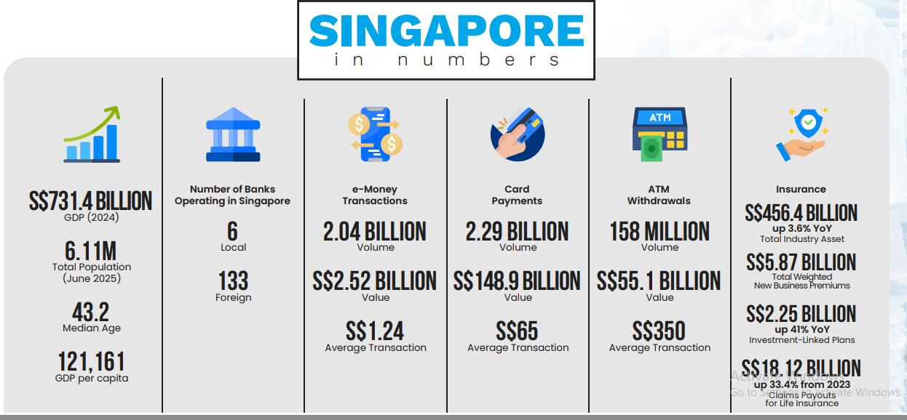

Source: https://static1.squarespace.com/static/5530dddfe4b0679504639dc1/t/69310cbe40530578244c53ef/1764822206105/Singapore-Fintech-Report-2025.pdf
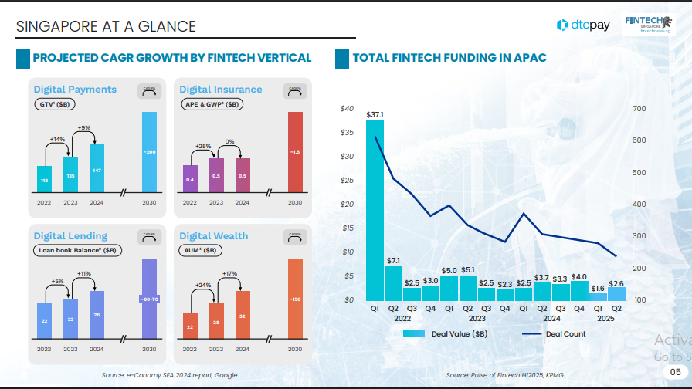

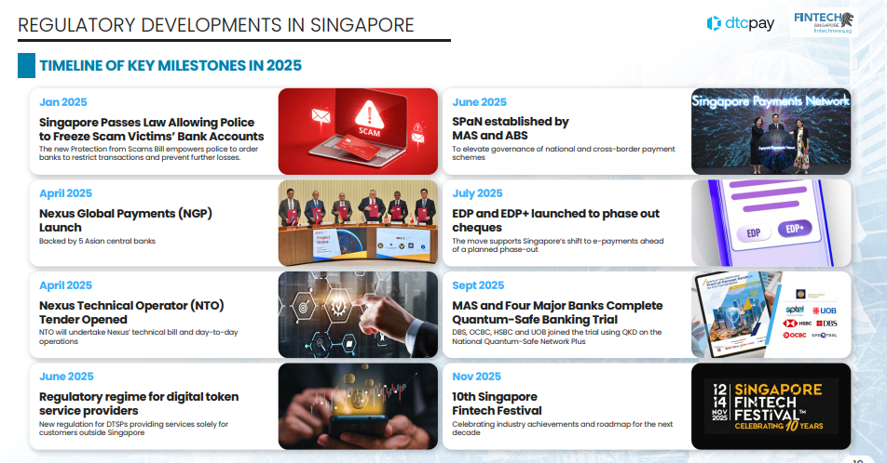
Source: https://static1.squarespace.com/static/5530dddfe4b0679504639dc1/t/69310cbe40530578244c53ef/1764822206105/Singapore-Fintech-Report-2025.pdf

Appendix-II

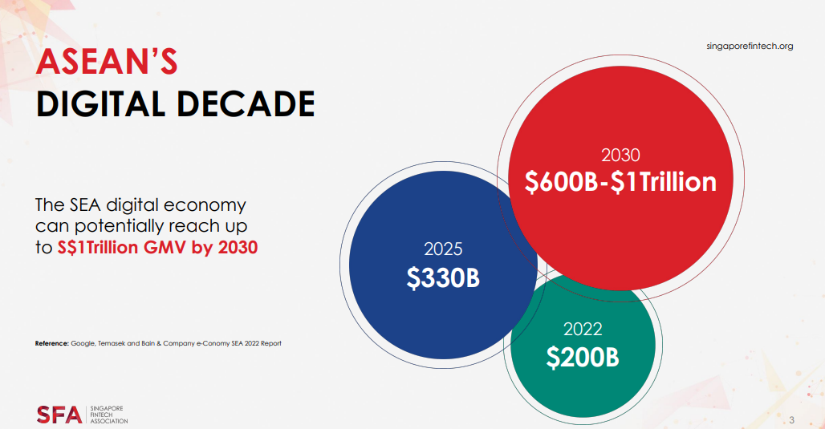
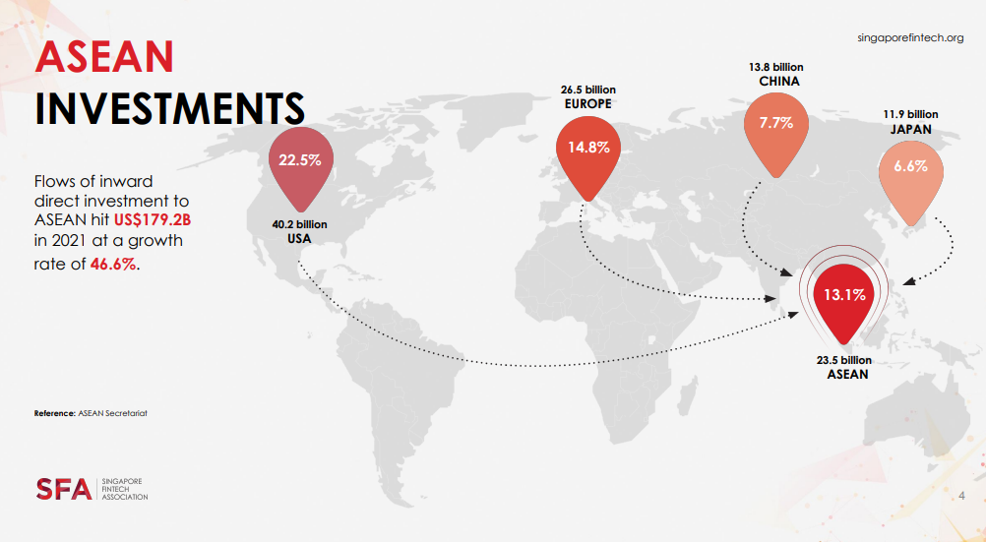
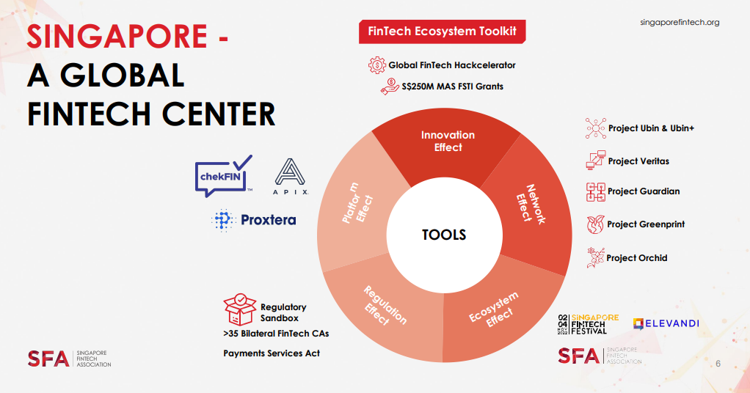
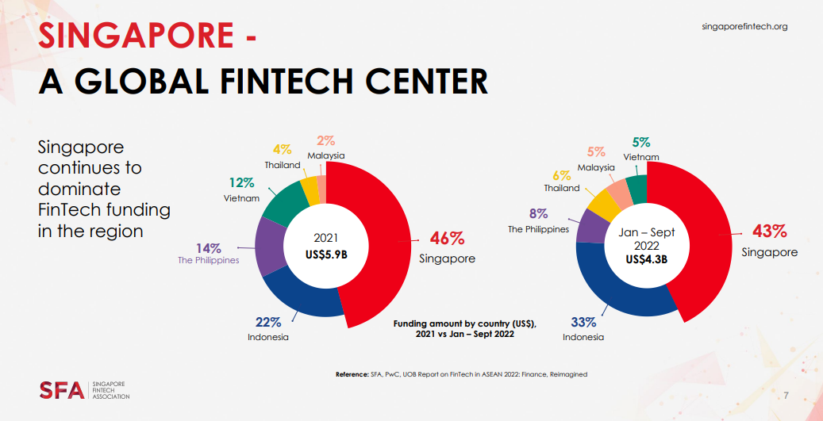
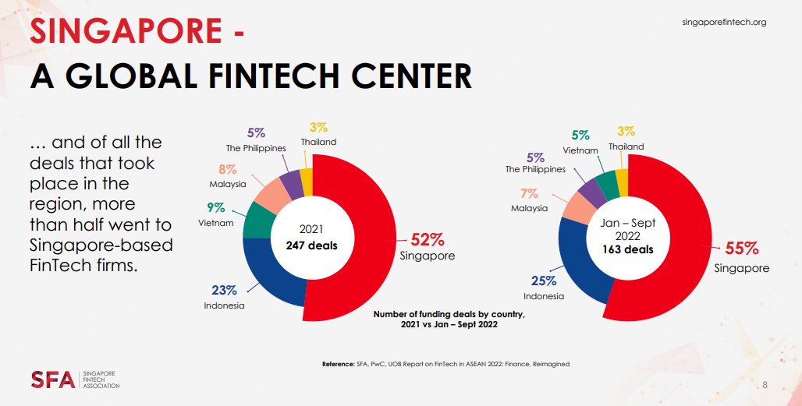
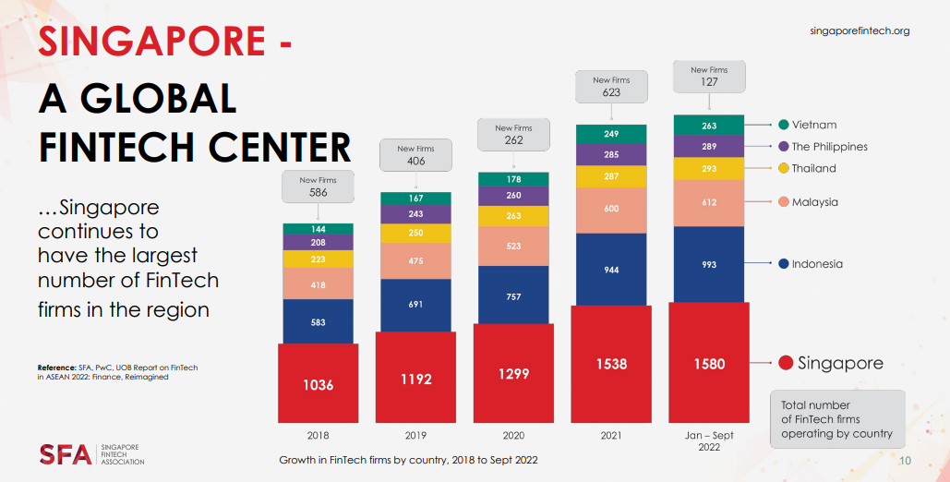

Appendix-III Popular firms in the Industry
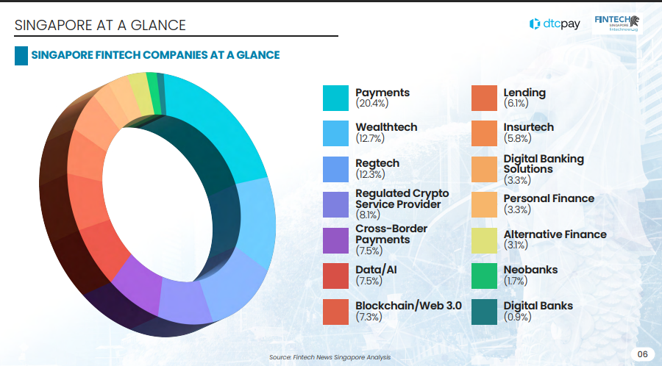

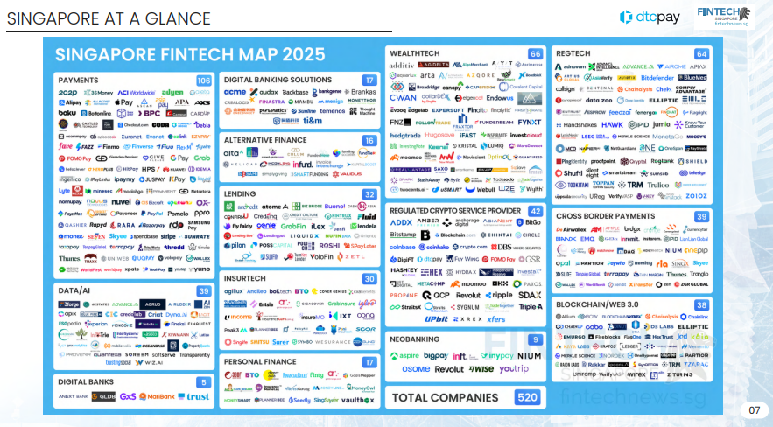Source: https://static1.squarespace.com/static/5530dddfe4b0679504639dc1/t/69310cbe40530578244c53ef/1764822206105/Singapore-Fintech-Report-2025.pdf

