

Data Analysis & Visualisation

Module Name: Data Handling & Business Intelligence
Module Code: LCBB5000
Student Name: Alina Mutoi
Student Number: 2028702

Lecturer: Dr. Anupam Mazumdar
Submitted date: 1st of September 2022

Executive Summary
The use of the IF function helps to identify that Superstore can generate profit by the sale of 38 products, while there will be a decline in sales of 8361 products. The advantages and disadvantages of both Excel and SPSS have been presented, in which it is observed that both are the most significant tools for calculating a large amount of data. The applications are cost and time-consuming. Moreover, the proper use of excel function mainly interoperate the product range and sales through evaluating the shipping cost and unit price. Therefore, the company needs to boost its supply chain to identify more profit benefits.

Table of Contents
Part 1: 4
Introduction 4
Main Body 4
Product sales based on Category 5
Product sales based on units 6
Product sales as pre-profit 9
Pre-processing data 11
Performance-based on products 12
Conclusion 13
Part 2 14
1. Introduction 14
2. Discussion on SPSS and its evaluation 14
2.1 Preference of students 15
2.2 Gender of students 16
2.3 Descriptive statistics of preferences 17
2.4 Specific example of K-Means 18
2.5 Data mining and text mining method 19
2.6 Advantages and disadvantages of SPSS and Excel 19
2.7 Conclusion 21
References 22

Part 1:

Introduction
Data visualization or Business Intelligence allows the businesses and service users to make the right decisions in order to improve the activity, by handling and dealing with huge amount of data. It is beneficial in terms of identifying the development patterns, as well as making errors based on the business by indicating the flag or progressive signals. However, this process generates a huge amount of business data and skills important for the data handlers to boost productivity.
In the context of data handling, it is an authentic source and way to ensure business integrity through research and address the related issues.

Main Body
The integral part of the report focuses on the various factors and elements that affect the business revenue and level of production. There are various types of selling and product units that can be identified through product sales. A novel and crucial direction to find information in a data base is the use of histogram data models and histogram regression models, which are based on symbolic analysis (Dobronets and Popova, 2018, p.2). Thus, it can be based on several product categories which also determine the declination of profit growth and margins. However, the company interpreted its products through different categories and data interpretations. In such cases, their proper use of Excel functions generates a huge impact on the product estimation and its evaluations.
The use of excel functions through the innovative techniques of data handling and intelligence give better observation regarding the products. One of the most often used tools for data visualisation in both business and academic applications is the PIVOT Table (Boschetti et al. 2020, p.2).

Product sales based on Category
It can be observed that the company identifies various products and estimated data, as the category of the product has mainly enriched with the demands and supply technology. However, it reflects that the firm almost sold more than 14920 products in previous years. The overall estimation of sales amount consists of multiple types as Furniture, office suppliers and many more. The furniture incurs its huge sales amount as compared by the official suppliers.
Row Labels | Sum of Sales
Furniture | 5178590.542
Office Supplies | 3752762.1
Technology | 5984248.182
Grand Total | 14915600.82
Table 1: Overall sales based on product category
(Source: created by the learner)
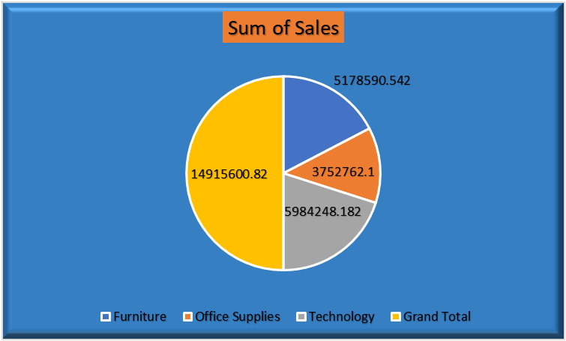
Figure 1: Product categories
(Source: Created by the learner)
The value of sales has been more affected based on various factors and requirements of the product. With the quick development and modernization of high-throughput sequencing (HTS) techniques, biological data is growing exponentially (Chen et al. 2018, p.2). It is noticeable that the Technology is the most common factor, compared to the different levels and individual product margins or value-added cost operations.

Product sales based on units
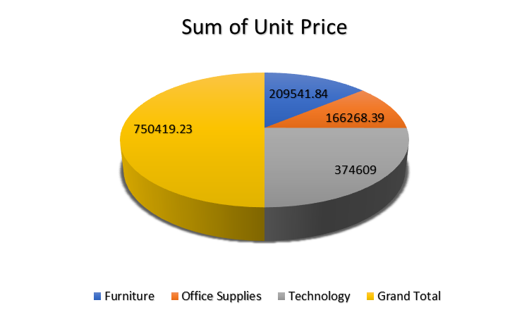
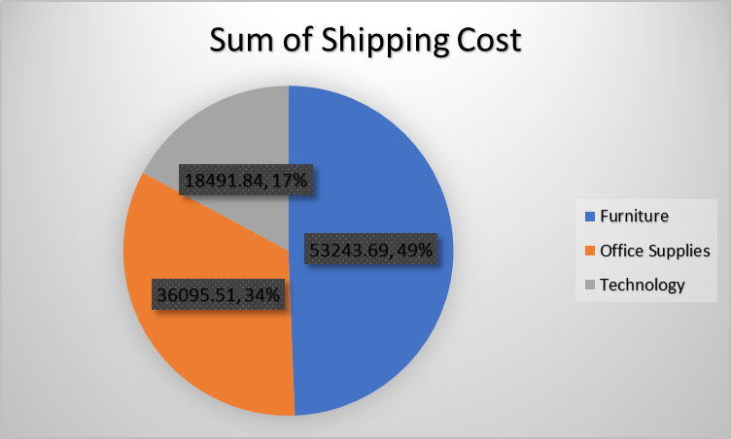
Figure 2: Product unit price evaluations
(Source: Created by the learner)
The above figure evaluates the overall data and product unit price and techniques by using the excel functions. The “Superstore” company evaluates its innovative products with effective price and techniques, as the highest price and product range have been estimated as 750419. By layering many dimensions on the x- or y-axis and showing data on numerous pages, a Pivot Table is a two-dimensional spreadsheet (based on product price and their range) that aids in the analyses of multidimensional data (Bimonte et al. 2021, p.1).
The unit price of the product has been estimated by executing various factors and elements to ensure Data Intelligence. As the amount of publicly accessible data increases and from outside sources, many organisations obtain information relevant to their decision-making processes, enterprise databases to their internal databases in order to combine such data sources (Nobari and Rafiei 2022, p.1). The Data Intelligence techniques and purpose affect the product price and shipping cost. However, the cost of the product has mainly affected the huge sales within the markets.

PIVOT TABLE
Row Labels | Sum of Shipping Cost | Sum of Sales | Sum of Profit
Furniture | 53243.69 | 5178590.542 | 117433.03
Office Supplies | 36095.51 | 3752762.1 | 518021.43
Technology | 18491.84 | 5984248.182 | 886313.52
Grand Total | 107831.04 | 14915600.82 | 1521767.98

PIVOT TABLE
Row Labels | Sum of Order Quantity | Sum of Unit Price
Furniture | 44324 | 209541.84
Office Supplies | 118281 | 166268.39
Technology | 52175 | 374609
Grand Total | 214780 | 750419.23

Table 2: PIVOT Table
(Source: Self-created)
PIVOT Table identifies that the company estimates its product and shipping cost based on the entire product category. Apart from this, other factors here are office supplies and production costs. Companies must identify and eliminate production costs that are unnecessary in order to maintain product quality and a competitive selling price while also increasing profits (Palulun et al. 2021, p.6385). Moreover, office supplies are huge among all categories as compared to the overall products.

Product sales as pre-profit
It can be observed that profit is the key indicator of every industry, as it helps the business to take the necessary decisions by manipulating the data. This is because the company promotes the product within the market. Using financial performance as a gauge to understand how the organisation is using its financial resources (Ichsan et al. 2021, p.298). Similarly, the profit based on various products has been evaluated through the appropriate use of IF Functions and big data intelligence techniques.
Row Labels | Sum of Profit
Furniture | 117433.03
Office Supplies | 518021.43
Technology | 886313.52
Grand Total | 1521767.98
Table 3: Profit wise product sales
(Source: Self-created)
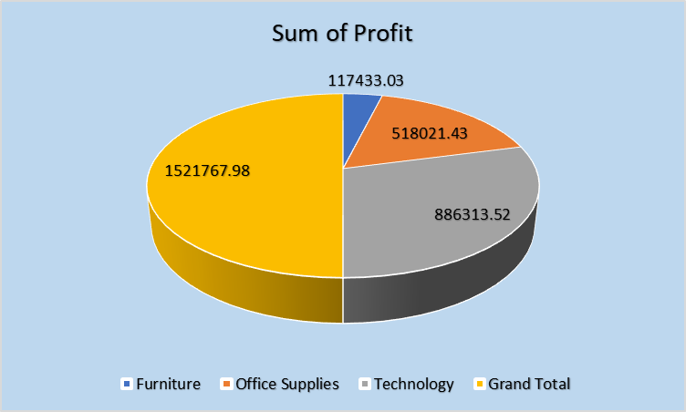
Figure 3: Profit-wise product sales
(Source: Self-created)
Apart from the evaluation of overall profit based on product and its quality items of the company, it can be identified that the product data generates the business profits. The overall profit has been estimated as £ 1521767. The sales data and techniques suggest the company needs to maintain its focus to perform in an authentic way and source through enhancing the development strategy. The most effective way to visualise, communicate, and summarise data is through tables and figures (Panos, 2020, p.127).
Technology plays a huge role in evaluating the profit benefits based on every product category, intended to make a profit within the market of the UK. More than 60% of the overall sales have been determined by low-income growth and prosperity. Thus, the suppliers of the company contribute their best efforts to evaluate product profit.
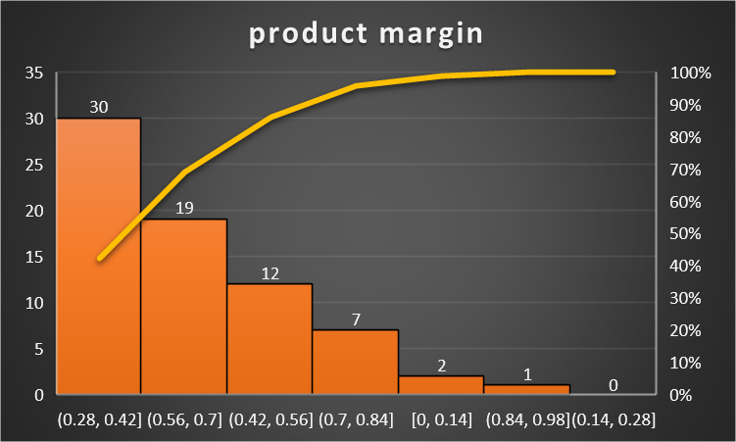
Figure 6: Product base margin
(Source: Created by the learner)
The above graphs and data representation identify the margin and the range of the products. The product has been declined through the overall maximization of company sales within the specific period of time. As per the graphical representation, it can be observed that the company is more focused on its price range of profit maximization through selling and categorization of products. This is because enhancing the product category and its importance has been able to highlight the basic necessity of the products. Existing model designs and training methods are hampered by the input of multidimensional data (Zhou et al. 2020, p.320). Through the use of IF functions through excl, the suppliers have been able to easily determine the data handling and generate the chance to evaluate profit maximization as per the product benefits or demand.

Pre-processing data
Pre-processing data helps the business to boost production efficiency and techniques, by reaching the next level through processing data appropriately. The entire business and product data stored within the supermarket generally boosts the business cycle and profit for the further buying or selling operations. Macroeconomics' central issues revolve around the cyclical nature of wages and its implications for the spread of business cycle shocks (Cacciatore and Ravenna, 2021, p.1).
Moreover, the pre-processing data is an innovative or quality tool that helps to determine the business and its specific ways to get the stock performance within the markets.

Performance-based on products
As per the supermarket products, the pre-processing data maintains the overall business evaluation as compared to the market performance. PIVOT Table is mainly used to evaluate the overall product category and its performance through the analysis of If functions. It is crucial for an enterprise's operations to record all of their transactions and activities. Its storage location is referred to as a database (Qarkaxhija, 2018, p.28). The product performance reflects as profit as 38 and declination of profits as 8361.
The graphical representations determined that the product needs to generate more productive outcomes and reduces the chance of declinations.
The use of the IF function can be helpful for the company as it allows comparisons between the value and the expectation of the business in a logical way. This analysis helps to identify the difference between the actual value and its expectations.
In the context of “Superstore”, it is observed that this company has sold different types of products such as “office supplies”, “technology” and many others. Through the use of the IF function, it can be identified whether this company has a decline in sales or generate profit. This research has evaluated that “Superstore” sales of office supplies with Order ID 36 can be helpful in making a profit. In addition to this, Order ID 236 has included the sale of office supplies which also represents profitability. On the other hand, it is observed that the sale of Order ID 515 can decline. On the basis of this analysis, there are a few products by the sale of which the company can generate increased profitability, while a few products have included a decrease in sales.
From the sale of 38 products, “Superstore” will generate profit, while there will be a decline in sales of 8361 products.

Conclusion
The current research is based on identifying the overall product range and price in the UK. It mainly identifies the various cost-based products and shipping to evaluate the sum of price and units of each product. Apart from this, the products have been categorized through properly estimating the excel functions as PIVOT Table and If functions. It consists of various products such as office supplies and furniture. Therefore, through the systematic use of count IF functions, the product has been able to categories its price and demand the products. This can be identified through proper planning and retention of disposable data.

Part 2

1. Introduction
Data analysis is one of the important techniques which measures the performance and evaluation of the data set. The main importance of the study is to use the SPSS software in the estimation and measurement of the preferences of high school students by conducting the survey. The study also focuses on the preparation of charts and tables by using the SPSS software for ensuring high quality in the data analysis.

2. Discussion on SPSS and its evaluation
SPSS is one of the data analysis software by which a company can evaluate and manage their data of business. In this study, SPSS has been used for measuring the results of a survey conducted by the company, questioning 200 high school students on their favourite ice cream and games. The SPSS software has also been used for determining the number of male and female students to show the preference of students in the survey. It is highly helpful to completely grasp one's data and become familiar with some of its inherent qualities by using graphical methods to investigate model assumptions (Astivia and Zumbo, 2019, p.5).
The results and outcomes of the survey associating the responses of 200 high school students have been depicted below in form of a graph and tables, along with their explanations:

2.1 Preference of students
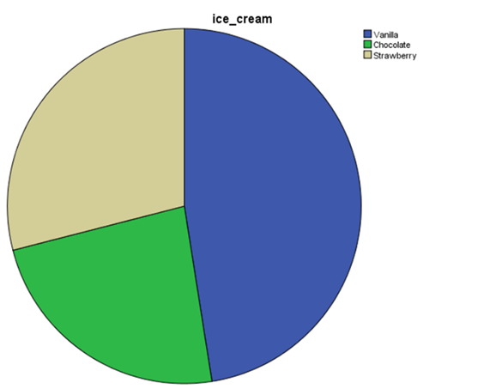
Figure 7: Vanilla flavour preference
(Source: Self-made)
The survey provides the preference of three ice creams: Vanilla, Chocolate, and Strawberry. Investigating the validity and dependability of the questionnaire design was the study's goal (Anaam et al. 2020, p.3). From the above figure, it has been understood that most students have responded to vanilla ice cream in comparison to the other two ice creams. It means that the craze for chocolate and strawberry flavour ice cream is quite low among students.

2.2 Gender of students
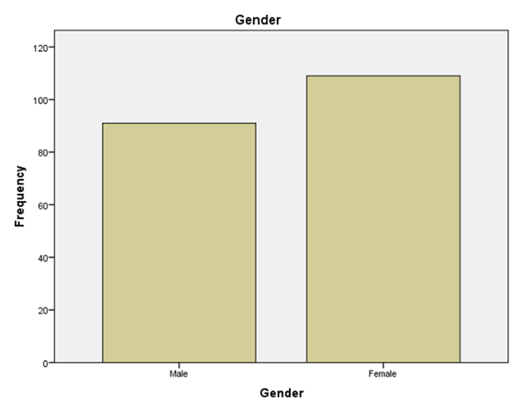
Figure 8: Gender
(Source: Self-made)
The use of SPSS software has made the work easy for the company to segregate the male and female students out of the total population. Data analysis activities are crucial to the research process since they will affect how accurately conclusions are drawn through the usage of analytical tools (Purwanto et al. 2021, p. 60). The above graph identifies that the population of females is significantly high in comparison to males. This means most responses have been provided by female students and it would help estimate their responses.

2.3 Descriptive statistics of preferences
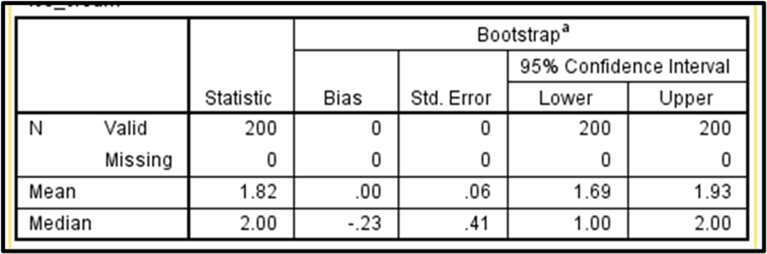Figure 9: Mean and median
(Source: Self-made)
Descriptive statistics of the preferences for ice cream in male and female students have been derived in the above figure. It also depicts the means and median of the participants who like the ice-creams of different flavours. The main result is 1.82 and the median is 2, which means the preference of chocolate flavoured ice cream is very low in students rather than the preference of strawberry flavoured ice cream. Hence, most students have responded to the strawberry flavour ice cream.

2.4 Specific example of K-Means
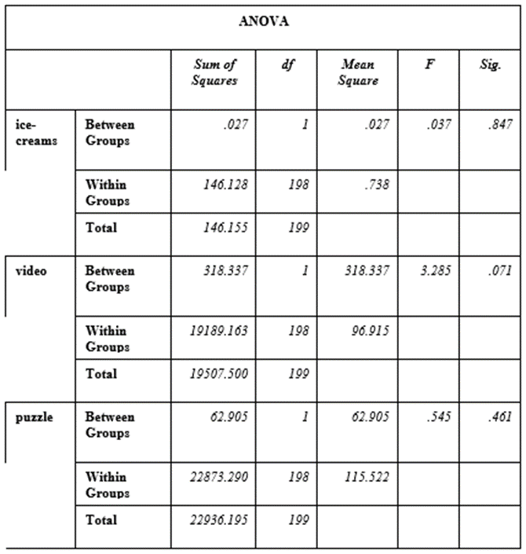
Figure 10: K-Means
(Source: Self-made)
K-Means is one of the useful clustered tables that shows the outcomes of puzzles, ice cream, and video games. The above figure has been derived by using the SPSS software and shows the relationship of results between the three variables. The significant value of ice cream, video, and puzzle is "0.847, 0.461, and 0.71"respectively. The results show that the value of puzzle and ice cream is quite higher than 0.50 and it shows a positive relationship between them. However, the significance of the video is lower than 0.50, which is a symbol of weak relationships.

2.5 Data mining and text mining method
Data mining is the crucial process by which companies and their management are doing the sorting of a large data set. The main importance of sorting the data is to identify the relationship between different variables of the data set. The process of data mining is now used everywhere for eliminating the burden of a large data set by reducing the complexity as well. On the other hand, Text mining is the process of structuring the data and information in text form. By structuring the business information, one can be able to gather reliable and accurate data, which will be highly important in the business's success. Moreover, the text mining process is helpful in creating new insights and business information for improving business services.
Apart from that, it has been found that the most common methods of text and data mining are “Regression analysis, Clustering analysis, and Classification analysis”. Amazon is one of the multinational companies that use the text mining process in business for structuring their data and creating new insights as well. A classification scheme for the crucial elements that businesses must take into account when putting their company logistics model into practise has been considered (Marchet et al. 2018, p. 23). On the other hand, data mining is used by Netflix in their business for sorting the large data set so that the management of the company would easily understand.

2.6 Advantages and disadvantages of SPSS and Excel
Software | Advantages | Disadvantages
Excel | - Excel is the best way for storing data significantly  - The primary advantage of Excel is the organisation of data with large amounts into logical and orderly spreadsheets and charts. A company or an individual has become able to provide a visual representation of data in an effective way.  - Excel has consisted of formulas and features related to the calculation which make the process easier and reduce time as well. Through this way, a company can evaluate both complex and simple equations in a quicker way. | - Entering the data manually can consume excess time in case there are lots of data. Therefore, it is stated that Excel is one of the time-consuming software.  - This software has included a few tools that are required to be purchased.
SPSS | - Several complex tests of statistics are resented in SPSS.  - A company or an individual can interpret results in an easier way.  - SPSS is one of the comprehensive software regarding statistics. | - SPSS is an expensive software in the context for students.  - It is a complex software that requires effective training.  - The development of graphs in SPSS is not simple.
Table 4: Advantages and Disadvantages of Excel and SPSS
(Source: Self-created)

2.7 Conclusion
SPSS evaluation has been done in the above discussions for gathering the results and outcomes of the survey contained by associated 200 high school students. It has been concluded that most of the students who provided their responses are female and they have shown interest in vanilla flavours of ice cream.

References
- Anaam, E.A., Abu Bakar, K.A., Mohd Satar, N.S. and Ma’arif, M.Y., 2020. Investigating the Electronic Customer Relationship Management Success Key Factors in the Telecommunication Companies: A Pilot Study. Journal of Computational and Theoretical Nanoscience, 17(2-3), pp.1460-1463.
- Astivia, O.L.O. and Zumbo, B.D., 2019. Heteroskedasticity in Multiple Regression Analysis: What it is, How to Detect it and How to Solve it with Applications in R and SPSS. Practical Assessment, Research, and Evaluation, 24(1), p.1.
- Bimonte, S., Antonelli, L. and Rizzi, S., 2021. Requirements-driven data warehouse design based on enhanced pivot tables. Requirements Engineering, 26(1), pp.43-65.
- Boschetti, M.A., Golfarelli, M. and Graziani, S., 2020. An exact method for shrinking pivot tables. Omega, 93, p.102044.
- Cacciatore, M. and Ravenna, F., 2021. Uncertainty, wages and the business cycle. The Economic Journal, 131(639), pp.4-37.
- Chen, C., Chen, H., He, Y. and Xia, R., 2018. TBtools, a toolkit for biologists integrating various biological data handling tools with a user-friendly interface. BioRxiv, 289660(10.1101), p.289660.
- Dobronets, B.S. and Popova, O.A., 2018, May. Piecewise polynomial aggregation as preprocessing for data numerical modeling. In Journal of Physics: Conference Series (Vol. 1015, No. 3, p. 032028). IOP Publishing.
- Ichsan, R., Suparmin, S., Yusuf, M., Ismal, R. and Sitompul, S., 2021. Determinant of Sharia Bank's Financial Performance during the Covid-19 Pandemic. Budapest International Research and Critics Institute-Journal (BIRCI-Journal), pp.298-309.
- Nobari, A.D. and Rafiei, D., 2022, May. Efficiently transforming tables for joinability. In 2022 IEEE 38th International Conference on Data Engineering (ICDE) (pp. 1649-1661). IEEE..
- Palulun, Y., Luhsasi, D.I. and Sitorus, D.S., 2021. Analysis of Readiness to Use Target Costing Method in Production Cost Efficiency Efforts at Risha Bakery. Budapest International Research and Critics Institute-Journal (BIRCI-Journal), pp.6385-6395.
- 1Panos, A. and Mavridis, D., 2020. TableOne: an online web application and R package for summarising and visualising data. Evidence-Based Mental Health, 23(3), pp.127-130.
- 1Purwanto, A., Asbari, M., Santoso, T.I., Sunarsi, D. and Ilham, D., 2021. Education Research Quantitative Analysis for Little Respondents: Comparing of Lisrel, Tetrad, GSCA, Amos, SmartPLS, WarpPLS, and SPSS. Jurnal Studi Guru Dan Pembelajaran, 4(2).
- Qarkaxhija, J., 2018. Database creation through if, vlookup, sum and sumif functions of Microsoft Excel. Prizren Social Science Journal, 2(2), pp.27-34.
- Zhou, M., Tao, W., Pengxin, J., Shi, H. and Dongmei, Z., 2020, April. Table2analysis: Modeling and recommendation of common analysis patterns for multi-dimensional data. In Proceedings of the AAAI Conference on Artificial Intelligence (Vol. 34, No. 01, pp. 320-328).

