Module Name: Network Operating Systems and Services Module code: ACCA5023 Student: Eric Fernandes Student ID: 2414945 Lecture: MD. Sadeque Imam Shaikh Group: BSC Applied Computing UWTSD (London Campus)
Eric Fabricio Ferro Fernandes

Assessment 1 Network Operating Systems and Services
28/11/2025

Table of Content

TASK 1 - Research Report 1
Introduction 1
1- Hypervisor Research 2
2. IP Addressing Research 3
3. Routing Research 4
4. Network Services Research 5
Conclusion 5
TASK 2 - Network Operating Systems and Services Implementation 6
Introduction 6
1 - Hypervisor Oracle Virtualbox Manager 6
2 - Linux operating system 7
3 - Windows Server 2019 and Windows Client operating systems 8
4 – Virtual Machine Linux and Windows 8
5 - Internal Network for Windows and Linux 10
6- IP Addressing Configuration and Implementation 13
7- Internal Network Architecture 16
8- Connectivity Testing Framework and Validation Procedures 18
Outcome 1: Successful Connectivity Within Network Segments 18
Outcome 2: Unsuccessful Connectivity Between Different Network Segments 21
Conclusion 22
REFERENCES 22

TASK 1 - Research Report

Introduction
Network Operating Systems and Services form the backbone of modern IT infrastructure, enabling communication, resource sharing, and service delivery across distributed computing environments. This research report examines four critical components essential to understanding contemporary network infrastructure: hypervisors, IP addressing schemes, routing protocols, and network services. The analysis is grounded in practical application using VirtualBox virtualization technology, combined with Linux and Windows Server operating systems. Understanding these technologies is fundamental for IT professionals designing, implementing, and managing network infrastructures that support organizational objectives. This report explores each component sequentially, providing theoretical foundations and practical relevance to real-world network deployment scenarios.

1- Hypervisor Research

A hypervisor, also referred to as a virtual machine monitor (VMM), represents a critical software layer that enables the abstraction and sharing of physical hardware resources among multiple virtual machines (VMs) [1]. Hypervisors operate at the lowest software level, intercepting hardware access requests from guest operating systems and managing resource allocation dynamically. VirtualBox, an open-source hypervisor developed by Oracle, exemplifies Type 2 hypervisor architecture, wherein the hypervisor runs as an application atop a host operating system [2]. This architectural approach contrasts with Type 1 hypervisors such as VMware ESXi or Microsoft Hyper-V, which execute directly on bare metal hardware.
VirtualBox provides substantial advantages for educational and development environments: cost-free licensing removes financial barriers to entry; extensive cross-platform compatibility supports Windows, Linux, and macOS host systems; and comprehensive documentation facilitates adoption among novice users [3]. The hypervisor enables creation of isolated virtual machines executing diverse guest operating systems—including Windows Server 2019 and various Linux distributions—on a single physical host without interference or resource contention. This capability proves invaluable for network simulation and testing scenarios.
Technical capabilities include snapshot functionality for rapid system state preservation and restoration; flexible networking configurations supporting bridged, NAT, and host-only modes; and robust storage management through virtual disk formats such as VDI and VMDK. Performance considerations remain relevant; Type 2 hypervisors introduce computational overhead compared to bare-metal alternatives, though virtualization efficiency has improved substantially through hardware-assisted virtualization extensions (Intel VT-x, AMD-V). VirtualBox's resource consumption profiles, typically utilizing 512MB-2GB RAM per virtual machine depending on workload intensity, require careful capacity planning on host systems with limited resources. Understanding hypervisor functionality proves essential for implementing practical network infrastructure simulations and comprehending modern cloud computing architectures.

2. IP Addressing Research

Internet Protocol (IP) addressing constitutes the fundamental mechanism enabling host identification and routing within network environments. IP addresses function as logical identifiers, permitting devices to locate and communicate across interconnected networks regardless of physical topology [4]. IPv4 remains the predominant addressing scheme in contemporary deployments, utilizing 32-bit address space divided into four octets, yielding approximately 4.3 billion unique addresses. However, IPv6, employing 128-bit addressing, addresses IPv4 exhaustion and provides enhanced routing efficiency and security capabilities [5].
Subnet masking represents a critical IP addressing concept facilitating logical network segmentation. Classless Inter-Domain Routing (CIDR) notation (e.g., 192.168.1.0/24) denotes both network address and subnet mask concisely, enabling precise delineation of network boundaries. A /24 subnet mask permits 254 usable host addresses, while /25 subnets reduce this to 126 addresses, facilitating granular network design aligned with organizational requirements. Private address ranges—10.0.0.0/8, 172.16.0.0/12, and 192.168.0.0/16—enable internal network operations without requiring globally unique addresses, permitting organizations substantial flexibility in network architecture.
Dynamic Host Configuration Protocol (DHCP) automates IP address assignment, eliminating tedious manual configuration. DHCP servers maintain address pools and lease configurations to clients, managing renewal cycles and address reclamation. Conversely, static IP assignment, wherein administrators manually configure each device's address, provides predictable infrastructure suitable for server deployments. In VirtualBox network configurations, careful IP planning ensures no address space conflicts between host systems, virtual machines, and external networks. Understanding CIDR notation, subnet calculation, and address allocation strategies proves essential for designing scalable, efficient network infrastructures that accommodate organizational growth and connectivity requirements.

3. Routing Research

Routing encompasses the processes through which network packets traverse interconnected networks to reach destination hosts. Routers, specialized network devices operating at Layer 3 of the OSI model, examine packet destination addresses and forward traffic along optimal paths toward targets [6]. Two fundamental routing paradigms exist: static routing, wherein administrators manually configure forwarding rules, and dynamic routing, where algorithms automatically discover network topologies and adapt paths responding to network changes.
Static routing proves suitable for simple network topologies with limited paths. Administrators configure routing tables specifying next-hop addresses for particular destination networks. VirtualBox implementations frequently employ static routing for inter-network communication between virtual machines configured with different network segments. However, static routing scales poorly in complex environments with numerous network segments or redundant paths.
Dynamic routing protocols autonomously exchange topology information between routers, enabling adaptive path selection. Routing Information Protocol (RIP), employing hop-count metrics, suits smaller networks, while Open Shortest Path First (OSPF), utilizing sophisticated cost calculations, scales effectively across enterprise infrastructures [7]. Border Gateway Protocol (BGP) enables routing across autonomous systems, forming the Internet's foundational routing mechanism. BGP complexity renders it inappropriate for internal network deployments.
The OSI model's layered architecture separates routing concerns from link-layer addressing, enabling flexible routing implementations. Layer 3 (Network Layer) addresses handle inter-network routing, while Layer 2 (Data Link Layer) addresses manage intra-network communication. Understanding this separation proves critical for diagnosing connectivity issues and designing multi-segment networks. In VirtualBox environments, host-only networks employing internal virtual switches require explicit routing configuration when VMs require inter-segment communication. Mastering routing fundamentals enables network professionals to design resilient, efficient infrastructures accommodating organizational scalability requirements.

4. Network Services Research
Network services encompass applications and protocols enabling resource sharing, communication, and information exchange across networked environments. Several core services prove fundamental to modern network infrastructure and deserve detailed examination. Dynamic Host Configuration Protocol (DHCP) servers automate IP address assignment, eliminating manual configuration burden and enabling devices to obtain network parameters automatically upon connection [4]. DHCP simplifies network administration, particularly in environments with frequent device connectivity changes.
Domain Name System (DNS) provides human-readable hostname-to-IP address translation, abstracting underlying addressing complexity from end users. Instead of memorizing IP addresses, users reference hostnames such as "www.example.com," with DNS servers providing corresponding IP addresses transparently [8]. DNS employs hierarchical architecture with authoritative servers maintaining zone records, recursive resolvers serving client queries, and caching mechanisms reducing query latency. Understanding DNS configuration proves essential for network professionals implementing internal DNS infrastructure supporting organizational services.
Hypertext Transfer Protocol (HTTP) and its secure variant (HTTPS) facilitate web communication, enabling browsers to retrieve content from web servers across networks. HTTPS implements encryption through Transport Layer Security (TLS), protecting transmitted data from unauthorized interception. Web services increasingly dominate modern application architectures, making HTTP/HTTPS competency essential.
File Transfer Protocol (FTP) and Secure Copy Protocol (SCP) enable file transfer across networks. While FTP remains legacy, SCP offers encrypted alternatives for sensitive data movement. Simple Mail Transfer Protocol (SMTP), Post Office Protocol (POP3), and Internet Message Access Protocol (IMAP) collectively comprise email infrastructure. These services demonstrate the layered nature of network services, with lower-layer protocols (DNS, DHCP) enabling higher-layer applications (web services, email).

Conclusion
Hypervisors, IP addressing, routing, and network services represent interconnected components essential to contemporary network infrastructure. VirtualBox exemplifies accessible virtualization technology enabling practical exploration of these concepts. Mastering these foundational technologies equips IT professionals with knowledge necessary for designing, implementing, and maintaining robust network infrastructures supporting organizational objectives. Continued study of these domains remains essential as network complexity evolves and emerging technologies reshape infrastructure landscapes.

TASK 2 - Network Operating Systems and Services Implementation

Introduction
Task 2 implements practical network infrastructure design utilizing virtualization technologies, operating system deployment, and IP addressing configuration. This assignment demonstrates applied understanding of network operating systems concepts through hands-on infrastructure implementation and systematic connectivity validation.

1 - Hypervisor Oracle Virtualbox Manager
VirtualBox selection as primary hypervisor balances accessibility, cost-effectiveness, and technical capability requirements. VirtualBox's Type 2 hypervisor architecture enables deployment across diverse host systems while maintaining performance adequate for educational network infrastructure [1]. Continued topology expansion in Coursework 2 supporting DNS, DHCP, and routing services requires hypervisor supporting multiple network adapters and internal network segmentation—capabilities inherent to VirtualBox architecture. Open-source licensing eliminates licensing constraints supporting flexible network expansion and experimentation [2].
VirtualBox hypervisor downloaded directly from Oracle official distribution channels, ensuring software authenticity and security compliance [1]. Windows Server 2019 and Debian Linux distributions obtained from respective official sources—Microsoft Download Center and Debian Project repositories—validating source credibility and software integrity. Strategic sourcing from authoritative repositories demonstrates professional infrastructure practices prioritizing security and reliability [3].

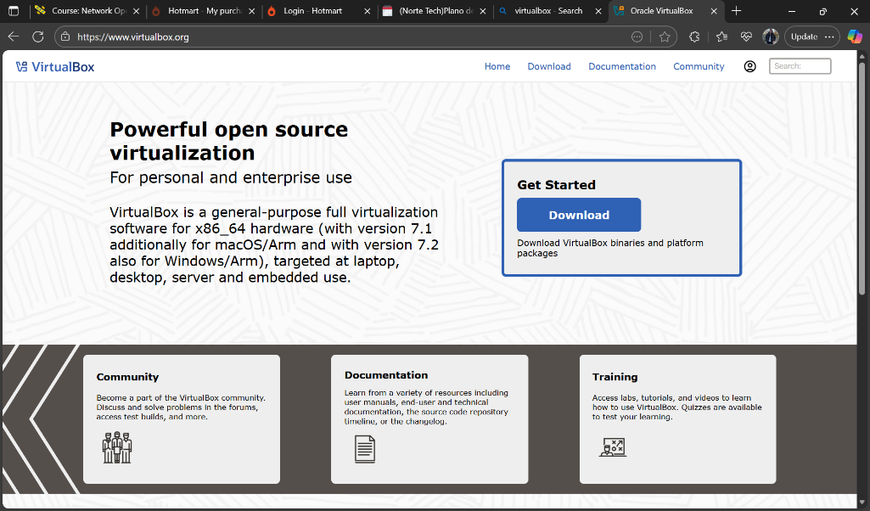

2 - Linux operating system
The Linux operating system chosen for both server and client roles was a Debian-based distribution. This method guarantees the authenticity of the operating system files.
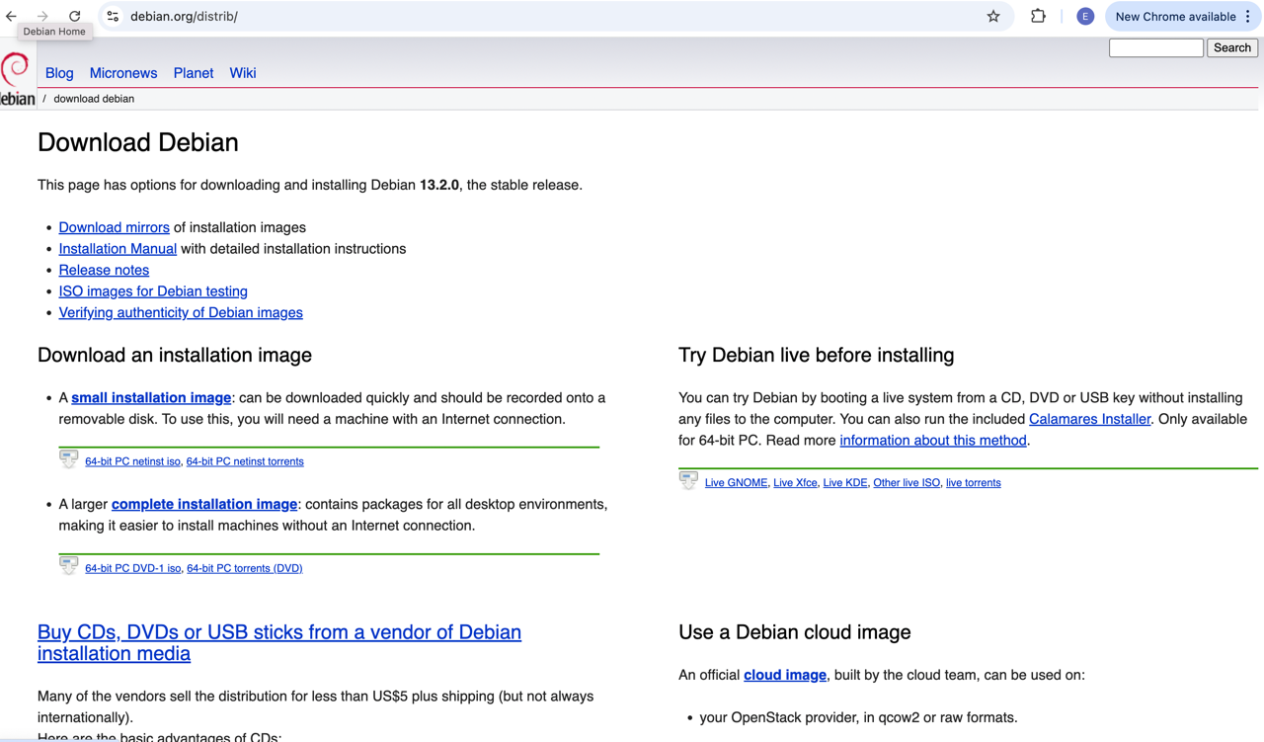

3 - Windows Server 2019 and Windows Client operating systems
For the Windows Server 2019 and Windows Client operating systems, evaluation editions were sourced from the Microsoft Evaluation Center.
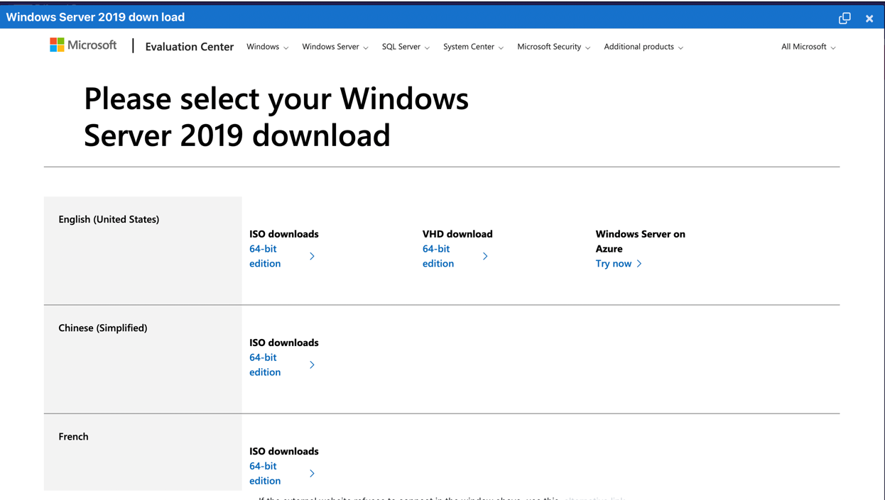

Each download was verified, where applicable, using checksums to confirm file integrity, a critical step in preventing the deployment of compromised software.

4 – Virtual Machine Linux and Windows
The deployment phase involved the systematic creation and configuration of four virtual machines within VirtualBox, meticulously adhering to the specified network topology. This process ensures that each VM is appropriately resourced and connected to the correct network segments, laying the groundwork for IP addressing and service configuration.
Four virtual machines deployed within VirtualBox environment: Windows Server (Server_1), Windows Client (Client4), Linux Server (Linux_Server), Linux Client (Client_Linux1). Internal Network 1 connects Windows systems; Internal Network 2 connects Linux systems, establishing network segmentation aligning with infrastructure specialization [3].

VM Windows
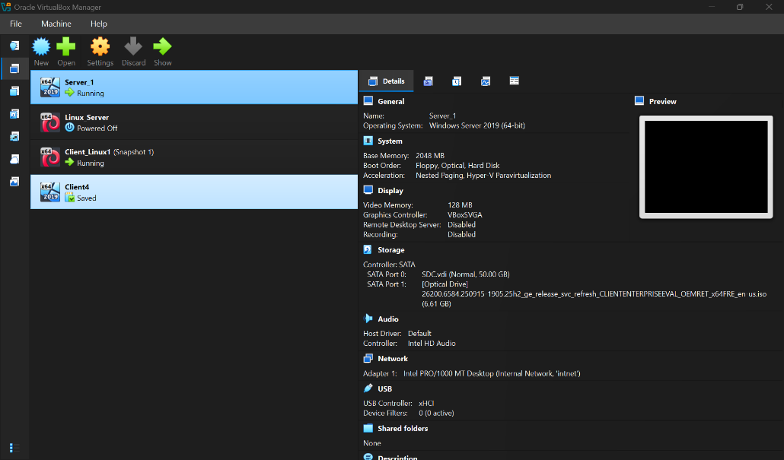

Installation of Windows Server and Client
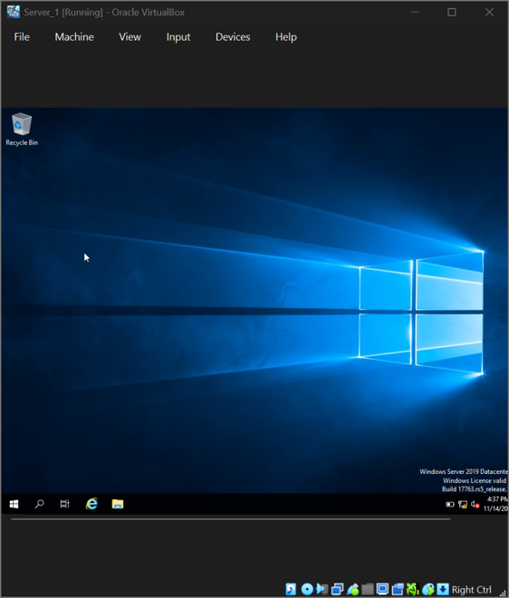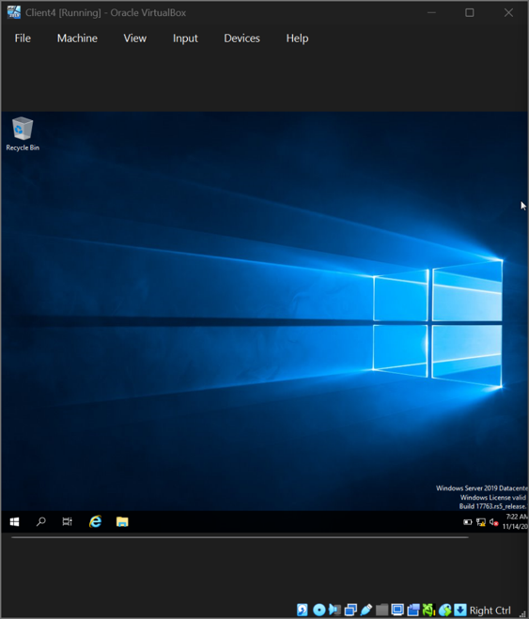

VM Linux
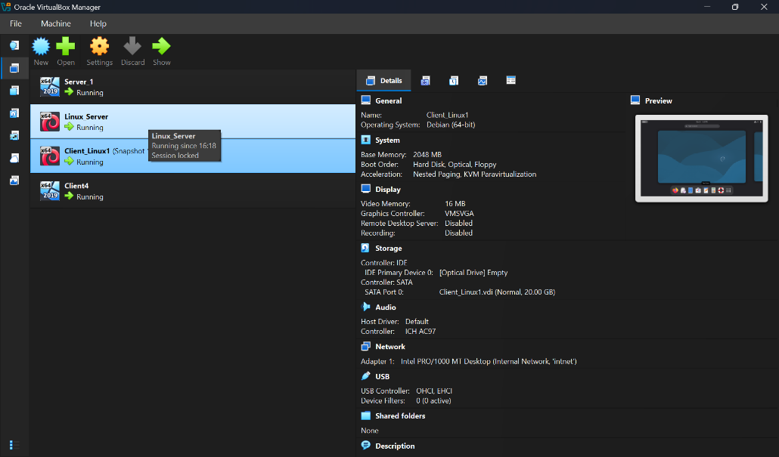

Installation of Linux Server and Client
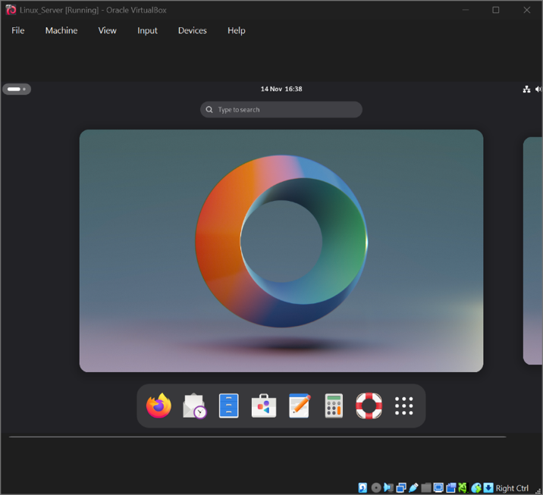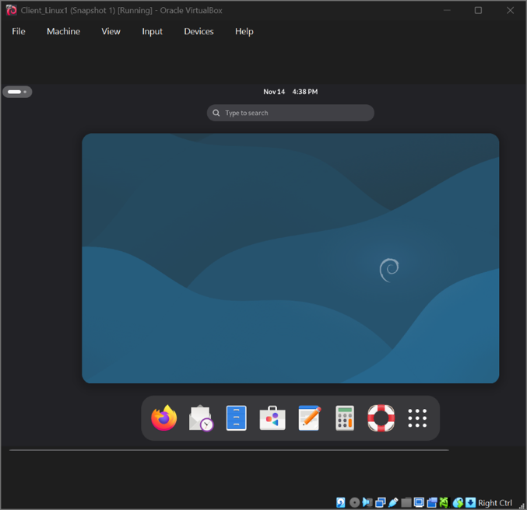

5 - Internal Network for Windows and Linux
The overall network topology, as visible within the VirtualBox Manager, clearly illustrates the four VMs and their respective network connections. This visual representation confirms the successful deployment of the virtual infrastructure according to the design specifications, providing a clear overview of the environment before IP addressing.

Creation of Network with Internal Network for Windows
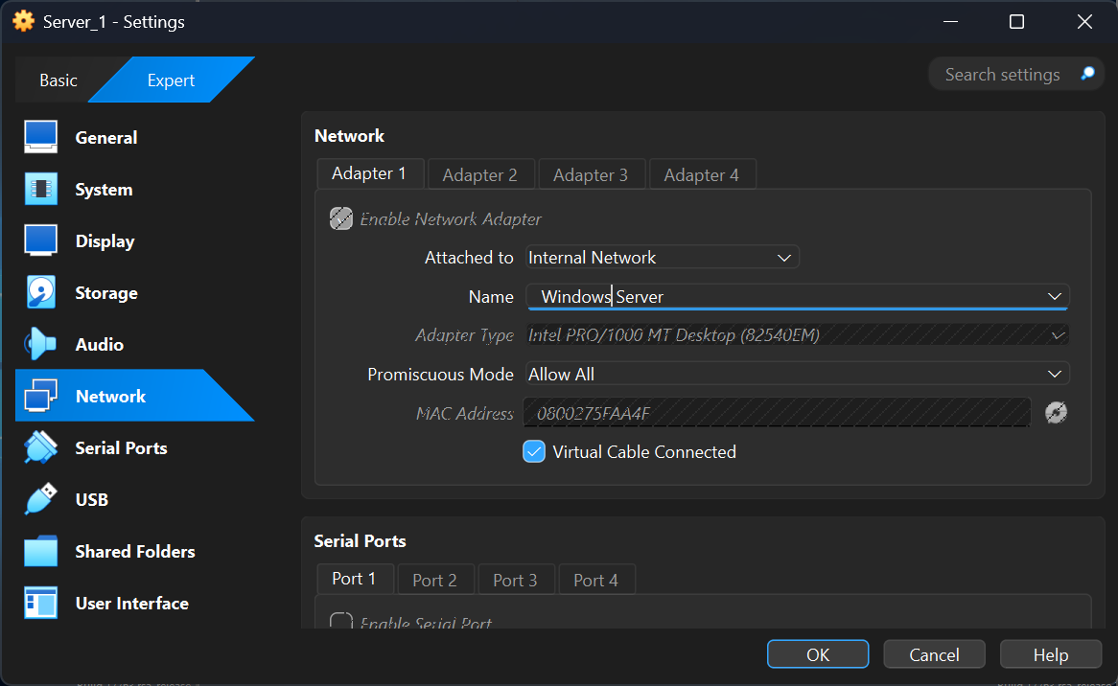

Creation of Network with Internal Network 2 for Linux
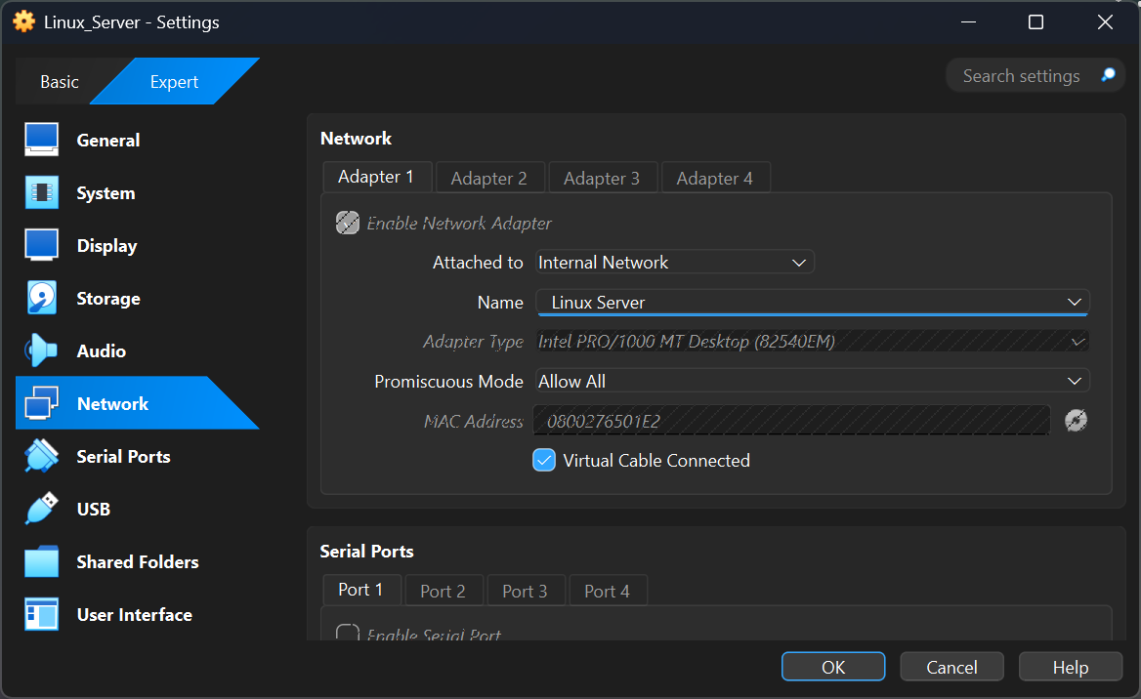

Evidence of 2 Windows PCs are connected with Internal Network
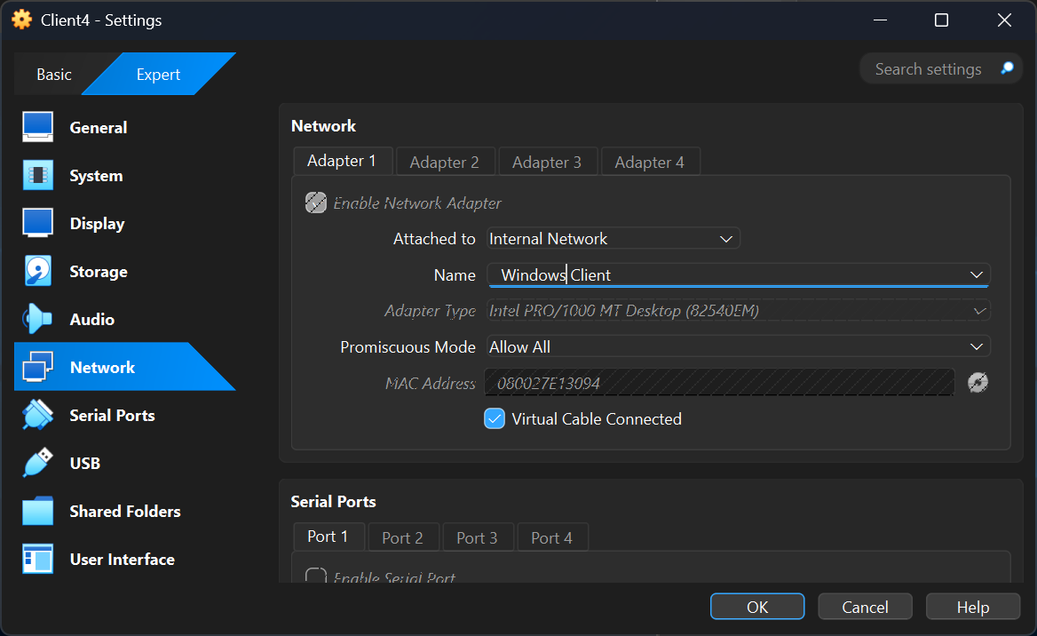

Evidence of 2 Linux PCs are connected with Internal Network 2
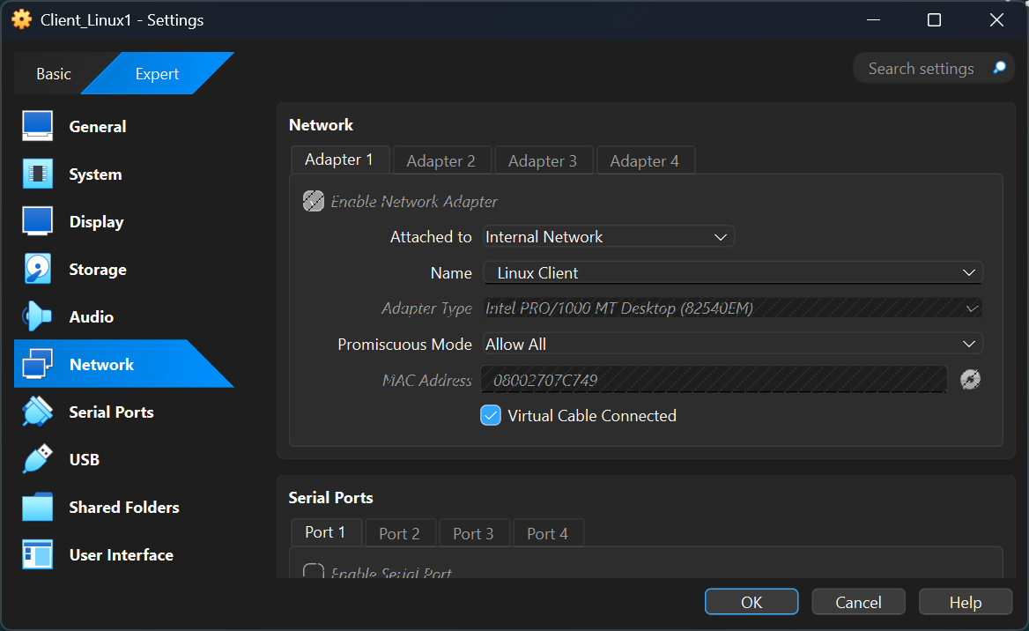

6- IP Addressing Configuration and Implementation
Systematic IP address configuration establishes foundational network connectivity enabling inter-machine communication and service accessibility [9]. The network design implements two distinct subnet segments utilizing private address space, ensuring logical network segmentation and controlled communication patterns. Configuration methodology prioritizes clarity, consistency, and alignment with established addressing conventions supporting network scalability and administrative simplicity.
Systematic IP addressing implements two distinct subnets: Windows infrastructure occupies 192.168.1.0/24 (Server_1: 192.168.1.1; Client4: 192.168.1.10); Linux infrastructure occupies 192.168.2.0/24 (Linux_Server: 192.168.2.1; Client_Linux1: 192.168.2.10). Static address assignment ensures consistent addressing supporting reliable infrastructure operations. Subnet segmentation demonstrates network design principles emphasizing infrastructure specialization and controlled communication patterns [9]
Windows Client IP configuration (ipconfig - 192.168.1.10) with timestamp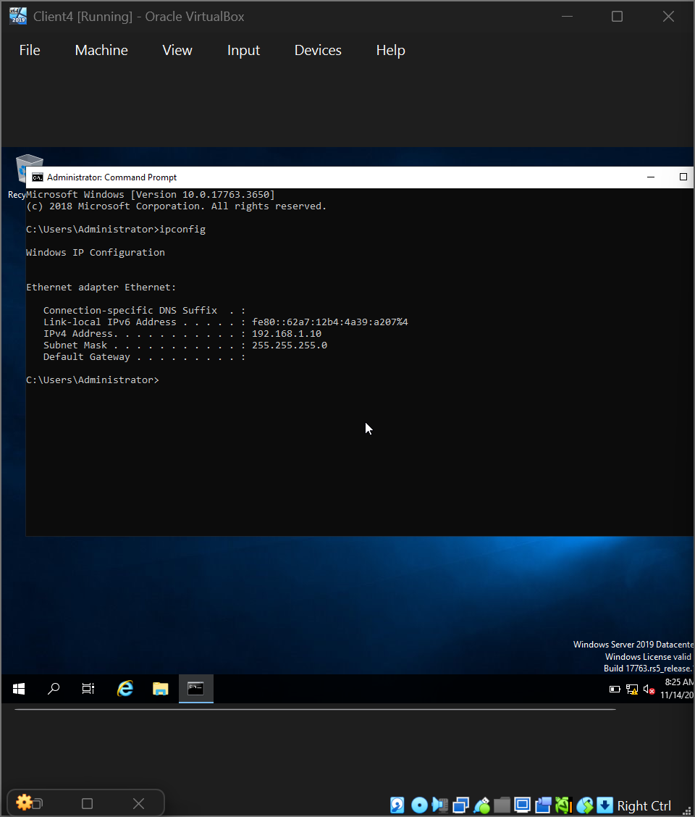

Windows Server IP configuration (ipconfig - 192.168.1.1) with timestamp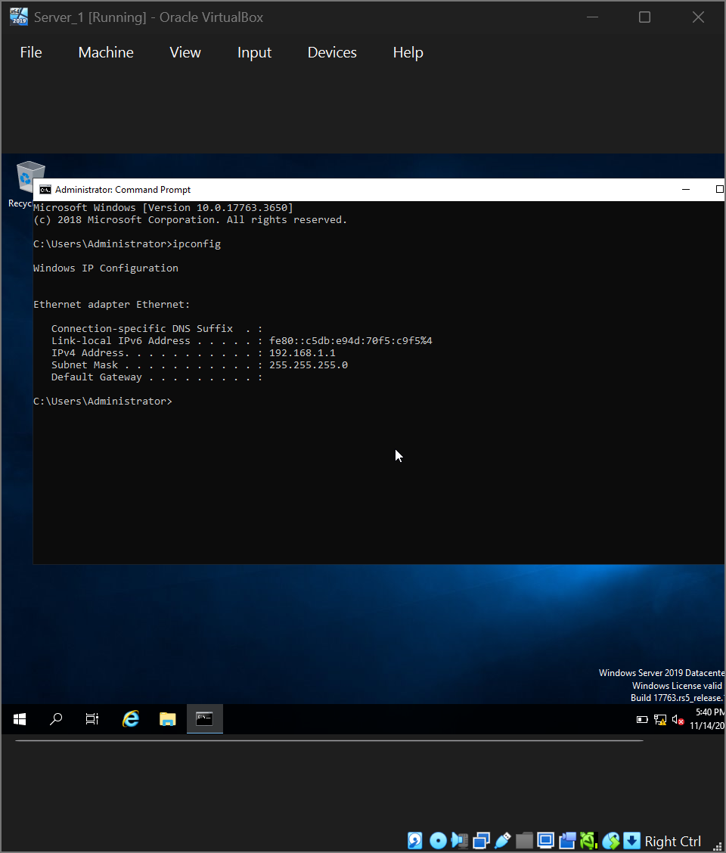

Linux Server IP configuration (ip add show - 192.168.2.1/24) with timestamp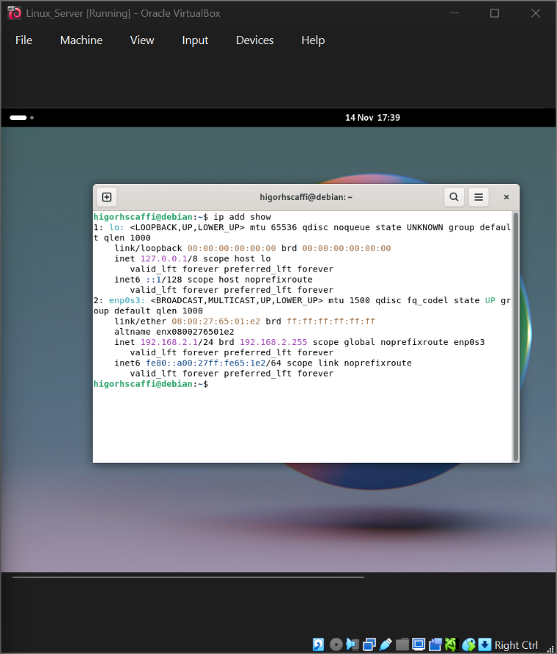

Linux Client IP configuration (ip add show - 192.168.2.10/24) with timestamp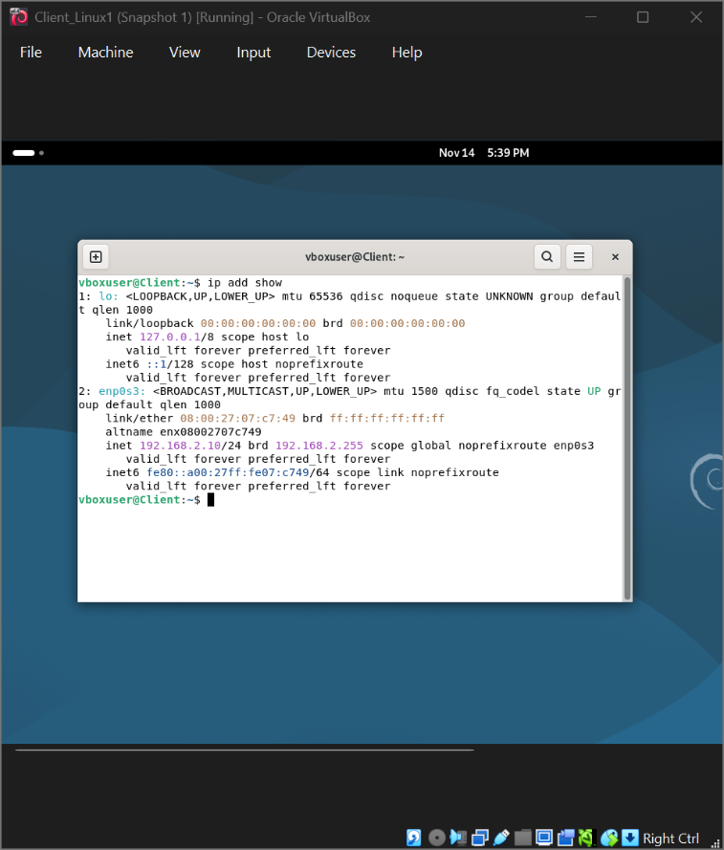

7- Internal Network Architecture
The network topology implements two distinct internal network segments utilizing VirtualBox's Internal Network functionality, providing complete isolation from host systems and external networks whilst enabling controlled inter-virtual machine communication. Internal Network 1 accommodates Windows infrastructure (Server_1, Client4); Internal Network 2 accommodates Linux infrastructure (Linux_Server, Client_Linux1) [10]. Network isolation supports heterogeneous infrastructure management and distinct operational procedures optimized for respective operating system environments.

VirtualBox Network Configuration showing Internal Network 1 with Server_1 and Client4
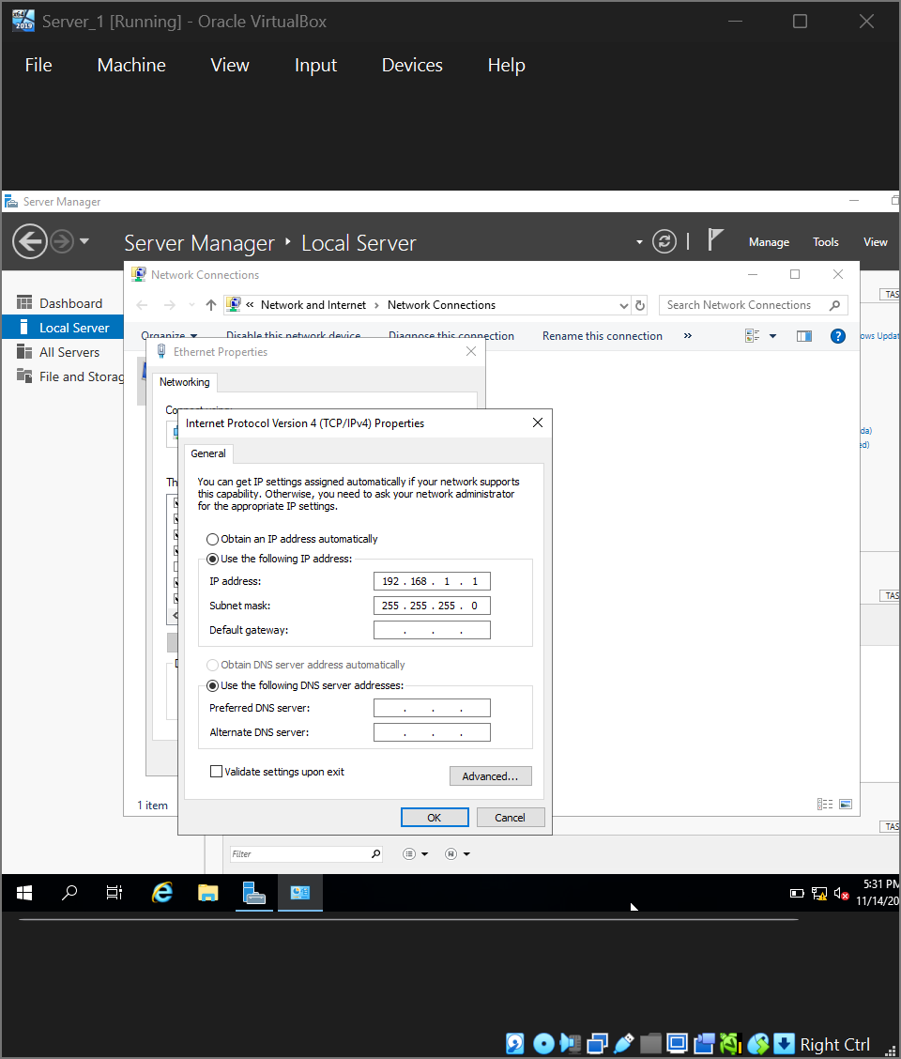

VirtualBox Network Configuration showing Internal Network 2 with Linux_Server and Client_Linux1
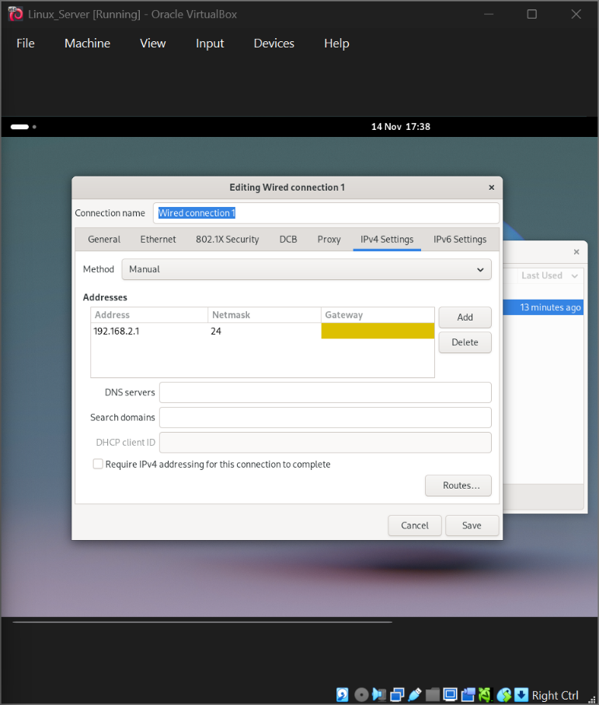

8- Connectivity Testing Framework and Validation Procedures
Systematic connectivity testing validates network design implementation, confirms proper IP address configuration, and demonstrates Layer 3 (Network Layer) routing dependencies essential for understanding network operating system principles.

Outcome 1: Successful Connectivity Within Network Segments
Connectivity testing within isolated network segments establishes Layer 2 and Layer 3 functionality validation. Windows network segment (192.168.1.0/24) demonstrates complete intra-network connectivity through successful ping exchange between Server_1 (192.168.1.1) and Client4 (192.168.1.10).
Windows Network - Ping from Client4 to Server_1 (192.168.1.1) showing successful replies with 0% packet loss
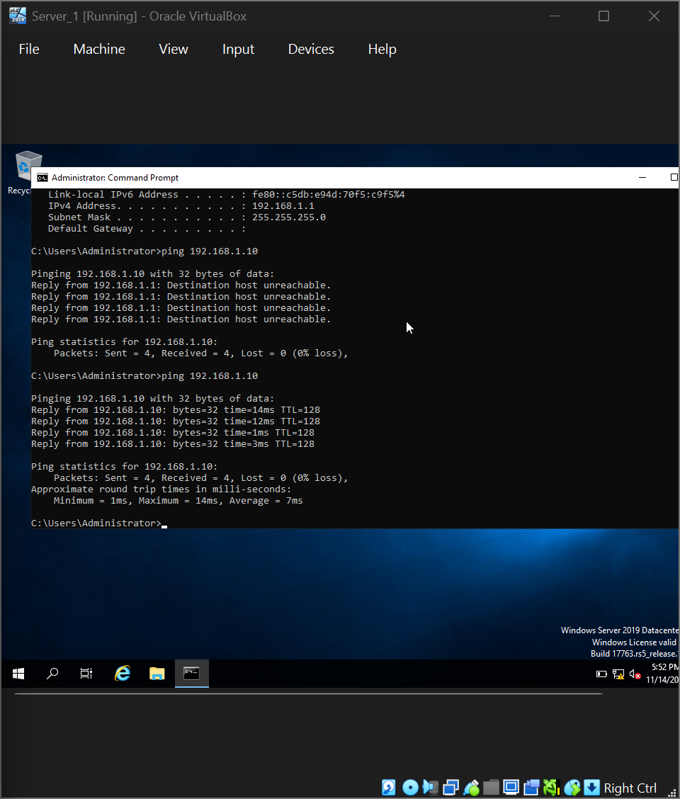

Windows Network - Ping from Server_1 to Client4 (192.168.1.10) showing successful replies with 0% packet loss
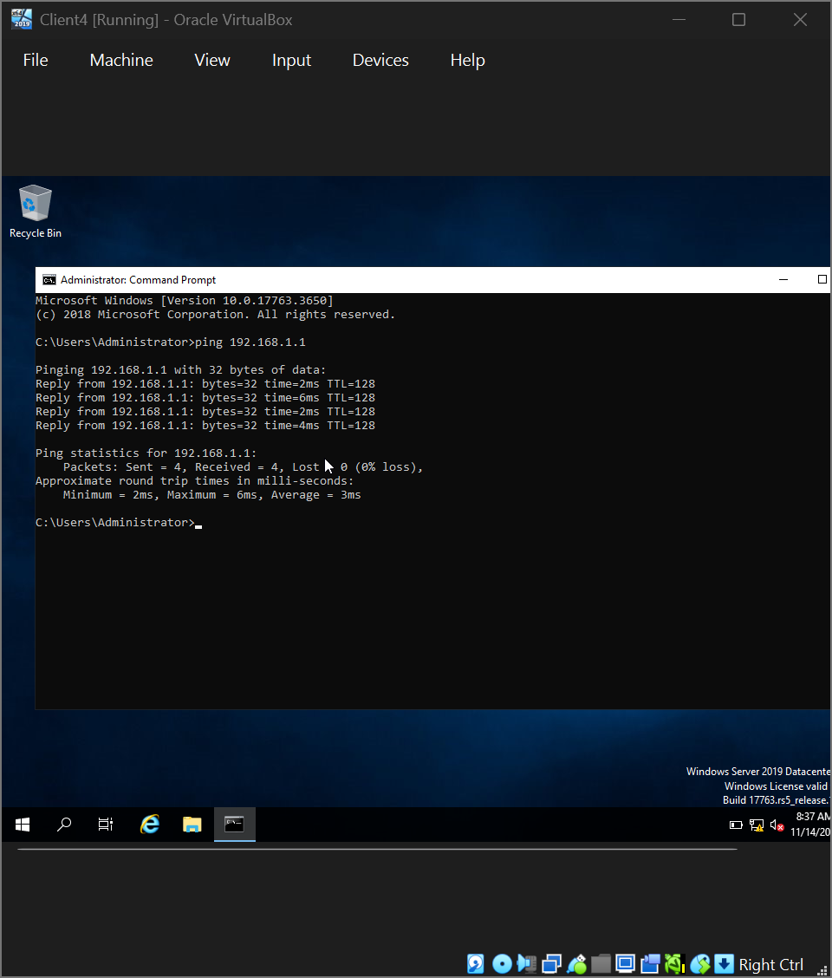
Bidirectional ping exchange validates symmetric communication pathways within Windows infrastructure segment, confirming proper network interface configuration and inter-machine connectivity.
Linux network segment (192.168.2.0/24) demonstrates equivalent successful intra-network connectivity. Linux_Server (192.168.2.24) and Client_Linux1 (192.168.2.10) exchange ICMP echo requests/replies successfully, confirming proper IP address assignment and network interface functionality.

Linux Network - Ping from Client_Linux1 to Linux_Server (192.168.2.24) showing successful responses
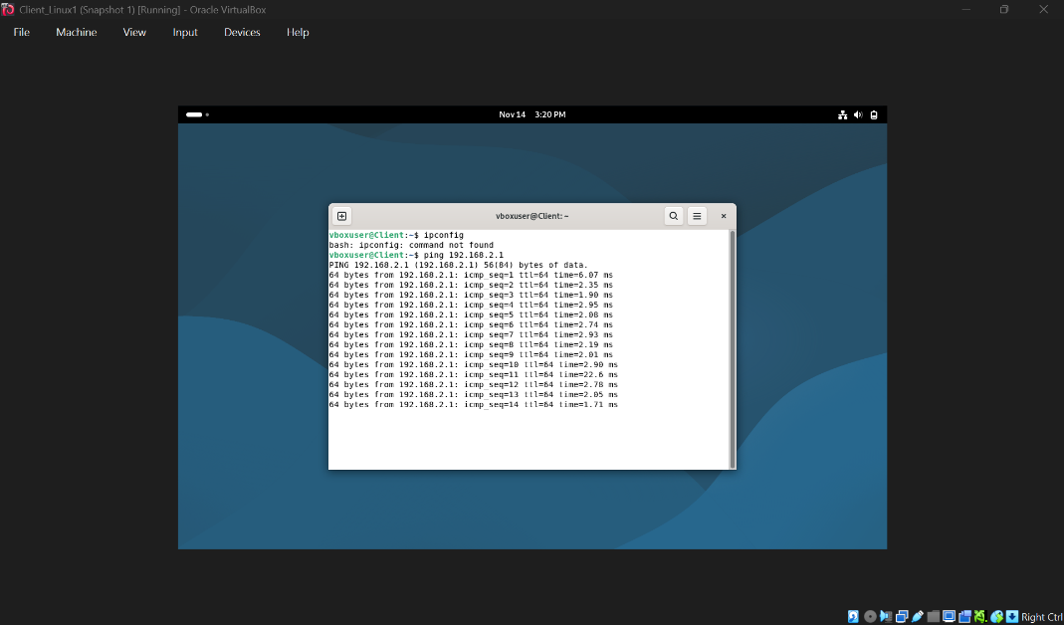
Linux ping responses display TTL (Time To Live) values characteristic of Linux systems, confirming Linux operating system network stack functionality.

Linux Network - Ping from Linux_Server to Client_Linux1 (192.168.2.10) showing successful responses
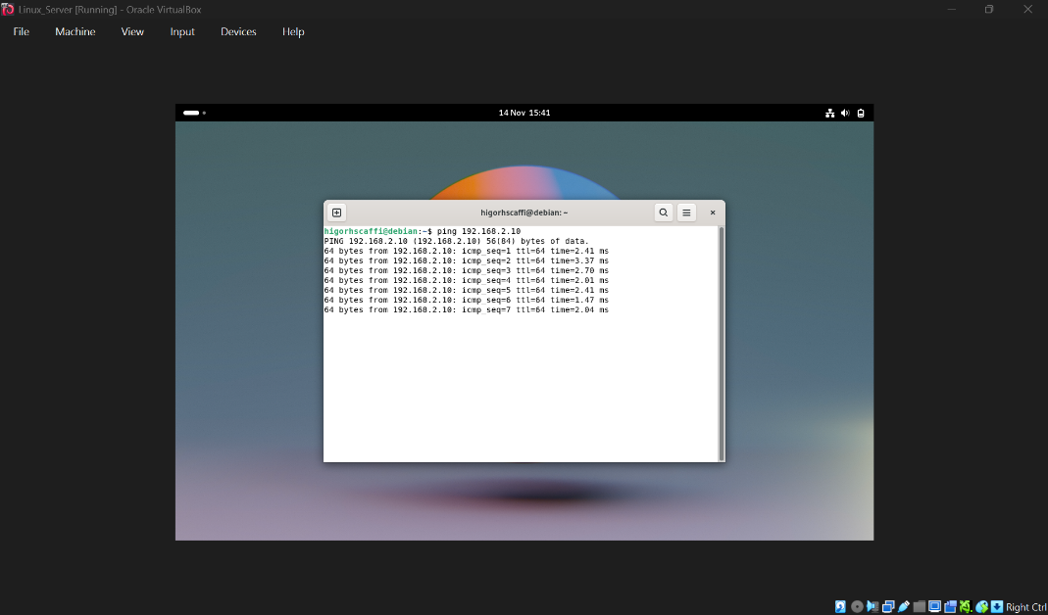
Successful intra-network connectivity within both Windows and Linux segments validates proper IP addressing scheme implementation, network interface configuration accuracy, and Layer 2 switching functionality supporting frame delivery between machines within identical subnets.

Outcome 2: Unsuccessful Connectivity Between Different Network Segments
Cross-segment connectivity testing demonstrates Layer 3 routing dependency. Windows Client attempting to communicate with Linux Server (192.168.1.10 → 192.168.2.24) results in timeout conditions and failed connectivity.
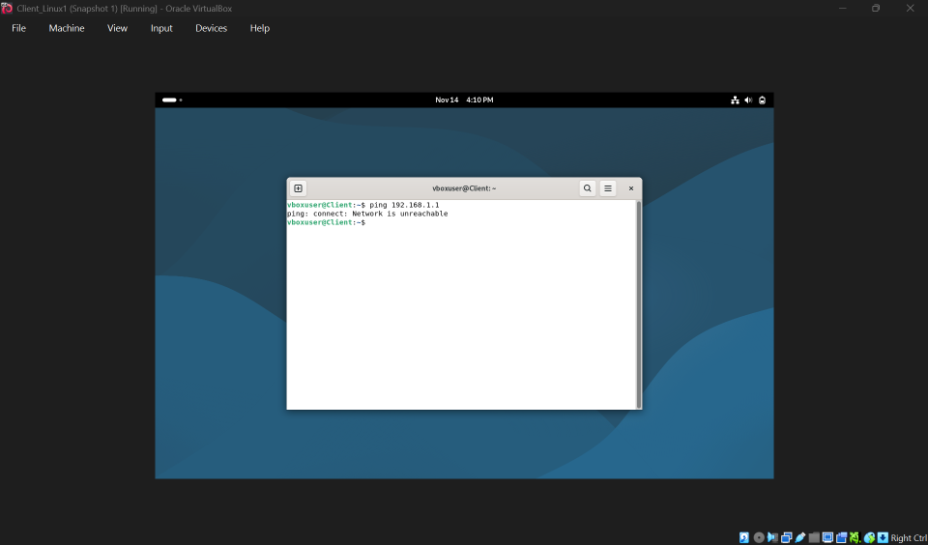
Timeout responses indicate packet transmission but absence of response reception, characteristic of unreachable destination addresses when routing paths remain undefined. The requesting machine transmits ICMP echo requests; however, absence of configured routing entries prevents packets from reaching target network segments.
Linux Client attempting communication with Windows Server (192.168.2.10 → 192.168.1.1) similarly demonstrates connectivity failure.
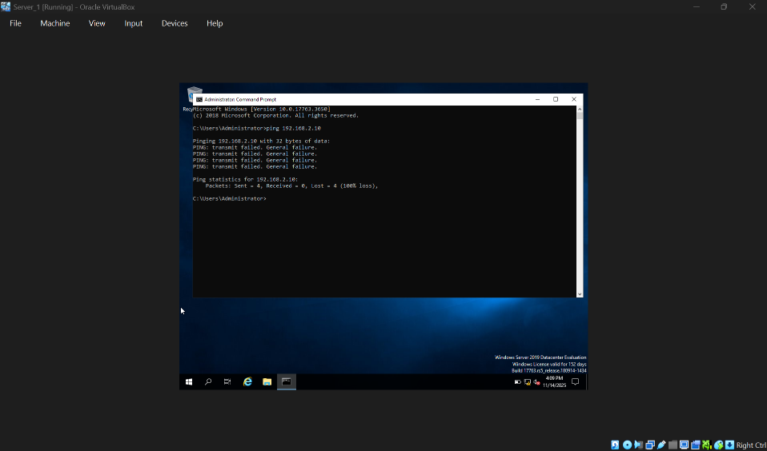
"Destination unreachable" responses indicate explicit routing failure recognition by network stack, confirming absence of routing paths supporting cross-subnet communication. This expected failure outcome demonstrates fundamental network layer principles: Layer 2 switching enables intra-network communication; Layer 3 routing enables inter-network communication.

Conclusion
Task 2 implementation successfully demonstrates systematic network infrastructure design, operating system deployment, and connectivity validation. Strategic hypervisor selection, proper IP addressing configuration across segregated network domains, and systematic connectivity testing validate practical understanding of network operating system principles. Outcome 1 confirming successful intra-network communication and Outcome 2 demonstrating expected cross-network routing absence establish foundation supporting Coursework 2 advanced network services implementation [12].

TASK 3: REFLECTION REPORT

3.1 Technical Reflection: Network Deployment and Testing
Task 2 implementation proceeded smoothly with minimal deployment challenges. Infrastructure setup utilizing VirtualBox, operating system installation, and network configuration executed systematically without significant obstacles. Static IP addressing across segregated subnets (192.168.1.0/24 Windows; 192.168.2.0/24 Linux) completed without address conflicts.
Classroom instruction addressing firewall configuration proved essential. Initial Windows Firewall settings potentially restricted internal network communication; instructor guidance to disable firewall facilitated unrestricted connectivity testing within isolated internal network environment. This configuration decision illuminated firewall operational principles and their impact on network communication.
Connectivity testing validated network design through systematic ping procedures. Outcome 1 demonstrated successful intra-network communication across Windows and Linux segments, confirming proper IP configuration and Layer 2 switching functionality. Outcome 2 demonstrated expected cross-network connectivity failure, highlighting routing dependency—absence of configured routing prevented inter-subnet communication, validating fundamental network layer principles [1].
No DNS resolution complications or IP address conflicts emerged. Testing procedures executed systematically with expected outcomes aligning with network design expectations.

3.2 Personal Reflection
Task 2 reinforced theoretical concepts from Task 1 through practical hands-on experience. Understanding virtualization evolved from theoretical description to operational implementation. Network design principles emphasizing segmentation transformed from abstract concepts to tangible infrastructure reality. Successful intra-network connectivity and intentional cross-network failure demonstrated Layer 2/Layer 3 interaction principles empirically, solidifying comprehension beyond theoretical study [2].
Classroom collaboration with instructor guidance illustrated professional network administration practices emphasizing systematic troubleshooting. Task 2 completion establishes practical foundation supporting Coursework 2 advanced network services implementation with confidence in infrastructure management and testing procedures.

REFERENCES
[1] Oracle Corporation, "VirtualBox User Manual," 2024. [Online]. Available: https://www.virtualbox.org/manual/
[2] P. Barham et al., "Xen and the art of virtualization," in Proceedings of the 19th ACM Symposium on Operating Systems Principles, 2003, pp. 164-177.
[3] D. Windt, "Virtualization technologies: A comprehensive review," Journal of Network and Systems Management, vol. 28, no. 3, pp. 1-25, 2020.
[4] Cisco Networking Academy, "CCNA Routing and Switching: IPv4 Addressing," 2023. [Online]. Available: https://www.cisco.com/
[5] S. Deering and R. Hinden, "Internet Protocol, Version 6 (IPv6) Specification," RFC 2460, 1998. [Online]. Available: https://tools.ietf.org/html/rfc2460
[6] W. Richard Stevens and K. R. Fall, TCP/IP Illustrated, Volume 1: The Protocols, 2nd ed. Boston: Addison-Wesley, 2011.
[7] J. Moy, "OSPF Version 2," RFC 2328, 1998. [Online]. Available: https://tools.ietf.org/html/rfc2328
[8] P. V. Mockapetris, "Domain Names—Concepts and Facilities," RFC 1035, 1987. [Online]. Available: https://tools.ietf.org/html/rfc1035
[9] J. C. Cisco, "VLSM and Route Summarization," Cisco Press, 2011. [Online]. Available: https://www.ciscopress.com/
[10] "Linux Network Configuration," Linux Foundation, 2023. [Online]. Available: https://www.linux.com/
[11] Microsoft Corporation, "Windows Server 2019 Documentation," 2023. [Online]. Available: https://docs.microsoft.com/en-us/windows-server/
[12] "Internet Control Message Protocol," RFC 792, 1981. [Online]. Available: https://tools.ietf.org/html/rfc792

