
Marketing Management

Name | Satishchandra Sonera
Student ID | 1705988
Module Code | SBMA7138
Tutor Name | Richard Small
Submission Date | 15th Jan 2018

Contents:
Introduction 3
Company Background 4
Marketing Challenges for the company 5
Swot Analysis 5
PESTLE Analysis 7
Customer End to End Journey 9
Analysis of Close Competitors’ 9
Marketing Mix 10
Conclusion 12
References List 13

Introduction
According to Philip Kotler “Marketing is the science and art of exploring, creating, and delivering value to satisfy the needs of a target market at a profit. Marketing identifies unfulfilled needs and desires. It defines, measures and quantifies the size of the identified market and the profit potential. (Kotler, P. 2009).
Marketing management is defined as a whole process of evaluating and planning the development of the new product, its showcasing i.e. advertisement, promotion of the product and selling. In short, the making the advertisement plans and strategies and its implementation of that plan is short understanding of the marketing.
In the current market scenario situation and the picture of marketing getting change very fast, as an increasing level of international competition, new technologies level and degree of digitalization inviting various new challenges in the organizations.
Marketing activities includes all the actions that of individual and organization which is designed to identify and to evaluate and fairly satisfied the needs of the all of the gathering which is engaged in this whole process.
In the recent market situations management of the marketing is being most important and most crucial factor for the organizations in terms of achieving the command and getting the desired goal in the different markets and also to gain and to maintain strong and long-term connection with stakeholders as well as loyal customers. Here the marketing manager who is responsible for the whole process of marketing, his role including planning, implementing and evaluating the marketing strategies which is made to achieve particular results in the organization. For this plan of strategies making he has to use the available information of the market, product, demands, taste of customers and also the level of competitors. the whole plan is base on his capability of analysing and forecasting the business scenarios and by which company can get the idea where to focus to achieve the goal of the organization. (Leonidou et al. 2017)).
The simple understanding of the marketing management is satisfaction of their costumers in such a way that can make them different and level up from the other competitors. marketing management and strategies is not any stable process it is continuing process of planning, implementing and keep updating that strategies and ideas.
Marketing strategies and its management includes the process of planning of retaining and engaging their customer while keeping company profitability in mind. So marking activities contain marketing analysis, various strategies and management of marketing. ( Dibb, S.2012)
In this Business Report study of marketing strategies and various different aspect of the “Burger King” business been discussing.

- Background of the Company:

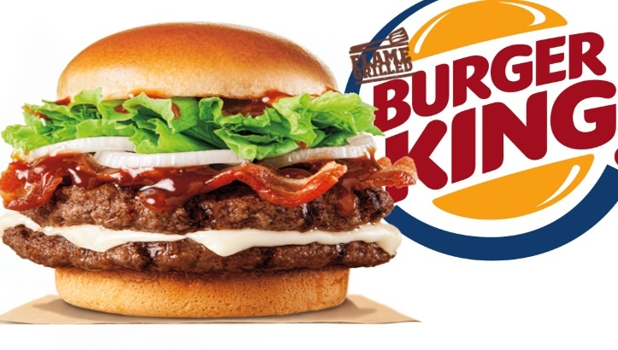
Burger King also known as “BK” is the global American fast food restaurant chain. its headquarter in Florida. BK founded in 1953 named “InstaBurger King”. While facing financial crisis in the term of InstaBurger King in 1954, two franchisee David Edgerton and James McLamore Miami – based purchased this company and give the new name as “Burger King”. After it over the next half century company ownership has changed many hands, and later on in 2010 3G Capital of Brazil hold the higher number of shares of the company. And this new owner has changed the fortune of the business with the partnerships with Berkshire Hathaway and merged with Canadian based doughnut chain.
For the Burger King the year of 1970 was in its golden age of advertising. But then in the starting of the year 1980 BK losing its focus from the advertising. A progression of less effective publicizing efforts made by a parade of promoting organizations proceeded for the following two decades. In 2003, Burger King procured the Miami-based publicizing organization Crispin Porter + Bogusky (CP+B), who totally rearranged its promoting with a progression of new battles focused on an updated Burger King character nicknamed "The King", joined by another online nearness. While very effective, some of CP+B's ads were ridiculed for seen sexism or social harshness. Burger King's new proprietor, 3G Capital, later ended the association with CP+B in 2011 and moved its promoting to McGarryBowen, to start another item situated battle with extended statistic focusing on.
Burger King's menu has extended from a fundamental offering of burgers, French fries, soft drinks, and milkshakes to a bigger and more assorted arrangement of items. In 1957, the "Whopper" turned into the principal real expansion to the menu, and it has moved toward becoming Burger King's mark item since.
Then again, BK has presented numerous items, which neglected to get hold in the commercial center. Some of these disappointments in the United States have seen accomplishment in remote markets, where BK has likewise custom-made its menu for local tastes. From 2002 to 2010, Burger King forcefully focused on the 18– 34 male statistic with bigger items that frequently conveyed correspondingly a lot of unfortunate fats and trans-fats.
As of December 31, 2016, Burger King revealed it had 15,738 outlets in 100 nations. Of these, 47.5% are in the United States and 99.5% are exclusive and worked, with its new proprietors moving to a completely diversified model in 2013.
Burger King's association with its establishments has not generally been amicable. Infrequent spats between the two have caused various issues, and in a few examples, the organization's and its licensees' relations have worsened into point of reference setting court cases. (BURGER KING®, 2018).
- Marketing challenges for the Company:
The Direction of marketing has changed all through time. Globalization and digitalization have changed the meaning of promoting methodology, adjusting the business condition all the while. Because of the change, the business organizations or associations encounter shifted business scopes, openings however alongside such advantages, the level of competition aslo increase in certain level. The globalization has permitted diverse organizations of the comparable division to lead business in a specific market. ((Leeflang et al. 2014).
Now Digitalization has enabled the organizations to build up and fortify association with different organizations and customers. Thinking about the other viewpoint, the customers or clients have the extension to examine differed choices concerning item buy, in this way it has turned out to be troublesome for an organization to secure and hold client intrigue and dedication.
Burger king has already reach at high level of the recognition and success in the fast food business. It’s been successful in in the country as well as many other various foreign markets.
Alongside numerous Food sectors, Burger King itself ended up to battle and difficulties in the incising level of macro trends, which gives more emphasis to hygienist and healthy food.
Apart from this all berries Burger king constantly fight for the better market hold and higher market proportion. As the competitors of Burger king are also giants such a MC’D, KFC, Subway, Pizza hut etc who are already leading the market, and it also need to focus on the other food chains who are providing packet food or ready to eat food or who are new entering into the market with creative ideas. So though being a power full rival Burger King has also experiencing many law falls in their business due to high level of cut throat competition and raising the level and digitalization in the advertisement. To being capable enough for long time in this competitive market by considering the strategies of competitors “Burger King” also have to perform extraordinarily. Burger king always come up with the out-menu option the risky experiments always, which contain high level of risk, if they avoid the strategies of competitors than it will become more and more difficult to survive in this market, as fast food business overall holding boost in the business. (Coelho et al. 2016).
- SWOT Analysis:
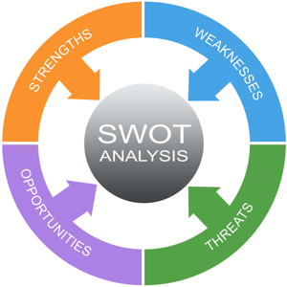
Burger King's capacity to keep its position as one of the greatest players in the Quick administration/fast food eatery industry is somewhat in view of the business vital adjust appeared in this SWOT Analysis.
The SWOT analysis analyses the Strengths, Weaknesses, Opportunities and Threats. As in the food services business Burger Kings must use its strengths to compete with giants like MC’D, even they must consider and focus into the risk and threats coming in their path in the fast food business.
It is proven that the burger king keeping its position as a one of the leading player in the market this below SWOT analysis explain the effect of internal factors in the business of Burger King.
Strengths:
The Strengths of the business depends on the capacity of the organization. This below portion of the SWOT analysis decides the internal important aspect which draw business limit with respect to proceeded with Developement. Burger King's few main Strengths are as following.
Very strong Brand image, High penetration Market, Moderate differentiation of products.
Burger king is itself biggest brand in the food industry. And at this level of reorganization and condition it is being easy to open the new branch of new outlets or introduce the new products. Higher market penetration is the one of the strengths as it is having huge number of burger king restaurant in the market. Its moderate differentiation is allowing to come up with uniqueness of few products.
Weaknesses:
Burger king’s weaknesses are directly associated by its business model and strategic approaches. The following listed few weaknesses of burger king.
Easy imitable business, Very limited product mix, low control on franchise concept.
Opportunities
The new opportunities of burger king offer many chances and option of business growth and business success, this part of SWOT analysis indicates external factors by which firm can improves its performance. Its opportunities are Product Innovation, Development of whole market, Improvement in service quality.
Threats Facing by Burger King
The external factors that pushing back of limiting the performance of the business of the Burger King. Its Threats are very high level of competition, Imitation, raising demand of healthy food.
(Jackson, S. E., Joshi, A., & Erhardt, N. L. (2003)

PESTLE Analysis of Burger King

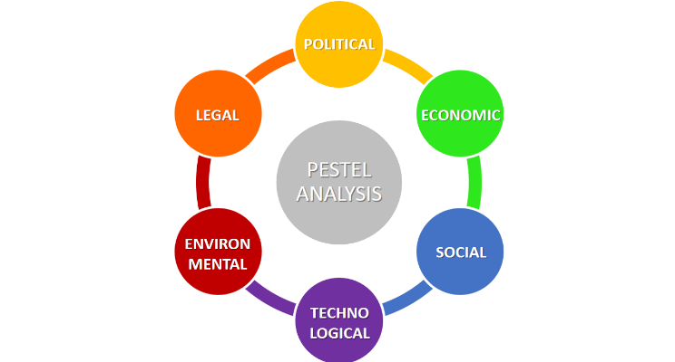
The PESTEL/PESTLE Analysis system distinguishes the hugest factors in the association's remote or full-scale condition. In Burger King's case, these outer variables incorporate the impacts of legislative and nongovernmental associations, and also patterns or changes in innovations, among others. This PESTLE analysis helping indicate Burger King’s performance during long term.
Political Factor
This Factor determine the performance of business. This part indicates and gives idea about the Governmental influence on the business. For the burger king these few political external factors included
- Support of Government for new opportunities and globalization (Opportunity)
- Political stabilities in large market i.e. opportunities (Opportunity)
- Support of Government for E-commerce (Opportunity)
Government always supporting globalization. So, by this burger king can take advantage of this support. And also, the stability can also help to minimize the market risk. Burger King can also improve its capacity of e-commerce.
Economical Factor:
This factor directly effecting to the business of burger king. This par of analysis indicates the outlines the economic variation and also its effect on the business performance. Following are main economical factors affecting the burger king.
- Enhancing the agreements of international trades (Opportunity)
- Economic stability of the U.S (Opportunity)
- High growth of economic in the develop market (Opportunity)

Social Factor
Burger king must always have taken an account for social factor in its remote – Macro environment. Social trends always change the market trend and business should also drawn accordingly. This part of analysis indicated effect of that only.
- Rise of diversification of costumer (Opportunity)
- Higher consciousness of health (Threat and Opportunity)
- Increasing the support of animal rights (Threat and Opportunity)

Technological Factor
Burger King more depends and focusing on technological factor, this part of analysis indicates the level of influence into macro and remote environment of the business. Below are few main technological factors affecting BK.
- Wide range of availability of automation technologies (Opportunity)
- Popularity of mobile technology (Opportunity)
- Low rate of R n D activity in the business of quick service industry (Opportunity)

Environmental factor
Environment also can make great impact on the burger business. This part shows the impact of the ecological factors into the business. This factor includes.
- Change in climate/ weather (Threat)
- Give more importance to business sustainability (opportunity)
- High popularity of low carbon lifestyle (Opportunity)

Legal Factor
Burger king must consider legal requirements. Few factors are as below
Law of Import and export (opportunity)
Law of protection of environment (opportunity)
Law of GMO (Threat), (Gillespie, A. 2007)

Customer’s End to End Journey:
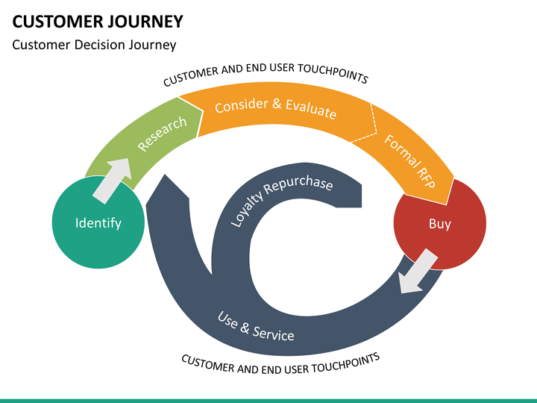
In this competitive world each organization mainly focus on the services and the customer satisfaction. For following this process company gives attention to whole buying journey of customer not only at the point of buy. For example, since the customer entering in the store to leave him happy with the services this whole process is customer journey. Customer satisfaction ratio gives the clear impact of the company image in the market.
Burger king already at the very good level of the customer satisfaction where in now to perfume extraordinary and to raise the brand awareness Burger king also have to help and have to focus the whole buying journey of the customer and to help them throughout their end to end journey. Apart from the development of the quality product company should also give the emphasis on customer satisfaction ratio while purchasing and experiencing the burger king brand. To shine differently in the market of fast food burger king needs to think out of the box, apart from the common practices for customer satisfaction they need to implement the ideas and creativity that compel customer to visit again and again and which can make them feel special. And as they serving variety of customers they should also bring diversity in the service according to the taste and preferences of the costumers. (Cartwright, R. 2003)
Analysis of Close Competitors:
As Burger king is in the business of Fast food and quick serving restaurants the industry which is already at the boom level with very high level of international competition, at this current market scenario burger king has to take their competitor very seriously and has to evaluate and focus every small step of their competitors.
Below are few close competitors of Burger King:
McDonald’s
McDonald's in an American possessed chain of eateries that has some expertise in serving various fast food including fries, refreshments, Fried chicken, soft drinks and breakfast menu among others. It is viewed as the biggest chain of fast food eateries in the whole world.
MC’D Is number one competitor of the Burger King due to its massive presence it is number one competitor among all the peers.
KFC
KFC is also very known and big named brand in the international market, whose main product is fried chicken. KFC is US based fast food chain which along with the fried chicken who serving sandwiches, beverages, fries many other snakes. KFC gathered huge liking from the various parts of the worlds from its service and products.
KFC has widely enhancing its business and open many new branches specially in last decade.
It is often got number 2 rank after MC’D. KFC also direct rival of Burger king among all competitors.
Subway
In the list of competitor’s Subway is leading chain in fast food business, and giving noticeable competition to burger king. It has started its business with sandwiches, which they continue overs years and still in that path. Subway come up with very unique design of sandwiches which is more admirable by the people.
Pizza hut
It is again an American based fast food chain which running huge numbers of outlets In USA as well as in the foreign market. As Pizza is one of the most appreciable and liking part in the fast food that people enjoyed a lot. Pizza hut is very well known in offering best quality pizza with delivery and take away concept.

- Marketing Mix 4Ps Strategies of Burger King:

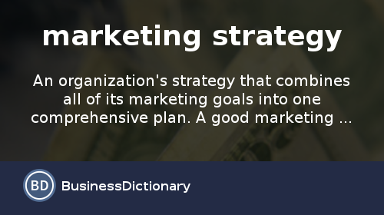

Burger King following its marketing mix (4PS), As a reaction of the dynamic and to the market which is already tasted in global quick service restaurant. The four P of marketing mix is very good combination of techniques and strategies to effectively implement the marketing plan.
The advertising blend is a mix of methodologies and strategies to viably execute a marketing plan. The advertising blend is a. mix of procedures and strategies to adequately actualize a marketing plan. In this scenario Marketing mix intended to maximize its level of competition in against different competitors. hence major competitors such as a Mc’ D and KFC are in the eye of Burger king’s efforts of Marketing mix. And these efforts help to achieve the desired goal and getting top position in the business of fast food.
The marketing mix strategies of burger king 4Ps facilitates the business competition.
Product Mix - Products of Burger king
Burger kings running as a quick serving restaurant and its focusing on its main product Burger.
This segment of the promoting blend presents authoritative yields offered to target clients.
The main products of Burger King are Burgers, Sides, Chicken and fish, Salad and veggies, Beverages, desserts etc.
Beside the principle product offering of burgers, Burger King additionally offers chicken and fish as options. Likewise, the organization packages its items as esteem dinners and children suppers. In this segment of the advertising Mix, Burger King has a restricted approach, as showed in its constrained Product mix.
In any case, Product mix Push Burger King's generic methodology through economies of scale from extensive scale generation of a predetermined number of product offerings.
Place: Place Distribution
Now The product of Burger King available in its restaurants worldwide. The tool of marketing mix refers to the location that outlet use to do transaction with targeted customers.
Following are few medium of product distribution of burger king
Restaurants, mobile app, online web sides.
Apart from physically going in the outlets, customers can also use the mobile app of “Burger King” and can avail the extra benefits such as a coupons and freebies and also they can go to online and place the order from its web sides for home deliveries. Out of these all option available Burger king mainly relies in the physical presence of its restaurants.
Promotional Mix – Burger King’s Promotion
Burger king adopting various promotional techniques for its products and business. This tool of the marketing mix includes the sources of communication with targeted audience about the offers available in the firm. few promotional efforts which are used by burger kings for the product promotion are Advertising, sales promotion, personal selling, public relationship.
Burger king mainly gives emphasis to advertisement to promote its product. Burger king gives advertisement online, through the TV and by the media. Moreover, its promoting business by the mobile apps and websites notification as well. Personal selling includes on the floor selling by convincing to buy more product according to their taste to whom who has already ordered something. In terms of raising the level of public relationship Burger king contribute in many foundation and provides financial assistance for educational programme.

Pricing strategies or burger king
Burger king’s pricing strategies mainly depends on its generic factors of cost leadership, which will diminish cost and prices. In this tool of marketing mix fair and appropriate price of the product is considered. Its pricing strategies are Market oriented and bundle pricing strategies.
Burger King utilizes Marketing situated valuing procedure as its essential way to deal with estimating. This estimating methodology includes setting costs in view of winning economic situations, including free market activity conditions and also the evaluating of contending firms. Its second strategy is bundle pricing strategy. It includes food pack such as a Value meal and kid meal which is more affordable then the buying things separately. Its gives prove that Burger king mainly consider the condition of the market for deciding its prices. (Dominici, G. (2009).

Conclusion:
In the current market scenarios, one can conclude that each company needs to put the heavy efforts to make and to implement the different and unique advertisements. And by taken into account the all factors including inner of outsider factors organization has to behave accordingly. Apart from the only promoting their products company needs to focus on the behaviour and satisfaction of the customers. Globalization and technology of digitalization open many fresh and prospective opportunity for the business so each company needs to develop capacity to see these kinds of opportunities coming in their ways.
Where even Burger King also needs to evaluating and considering new challenges in term of enhancement of the business and also to grab the new opportunities. The different analysis helps company to evaluate and educate themselves to know their stands and level of service they are offering by which they can fill the dent and move further.
Along with all other aspect of the company such as production planning, customer satisfaction, promotional activities the Marketing strategies is also equally important aspect for the business.

Reference List:
- Kotler, P. (2009). Marketing Management. UK: Pearson Limited.
- Dibb, S. (2012). Marketing Concepts & Strategies. UK: Cengage Learning EMEA.
- BURGER KING®. (2018). BURGER KING®. [online] Available at: http://www.burgerking.co.uk/ [Accessed 11 Jan. 2018].
- Burger King Corporation (2015). About us.
- Jackson, S. E., Joshi, A., & Erhardt, N. L. (2003). Recent research on team and organizational diversity: SWOT analysis and implications. Journal of management.

- Jacobs, T., Shepherd, J., & Johnson, G. (1998). Strengths, weaknesses, opportunities and threats (SWOT) analysis. Exploring Techniques of Analysis and Evaluation in Strategic Management.

- Dominici, G. (2009). From marketing mix to e-marketing mix: a literature overview and classification. International Journal of Business and Management, 4(9), 17-24

- Goi, C. L. (2009). A review of marketing mix: 4Ps or more? International Journal of Marketing Studies.

- Van Waterschoot, W., & Van den Bulte, C. (1992). The 4P classification of the marketing mix revisited. The Journal of Marketing, 83-93

- Gillespie, A. (2007). PESTEL analysis of the macro-environment. Foundations of Economics, Oxford University Press, USA

- Housing Industry Association (2011). An Introduction to PESTLE Analysis. HIA Ltd

