Dissertation Intro

Narrative is the result of our surrounding world. Capturing stories that can be timelessly shared, from generation to generation, like a time capsule, or a museum of thought. Memories of our favourite movies, to our current collection of books and graphic novels, that give us the opportunity to escape into a world of fantasy that has the potential to teach and enlighten us, or to just provide us with comfort and entertainment. It is these narratives that stay with us, that are apart of who we are, and a representation of our culture, and ourselves. Narrative can be used as a form of self-expression, like a style of clothing, or taste in music. The characters that we meet along the way become our friends, their adventures become our adventure, and so on. And with the ever retelling of old stories, or the introduction to new stories, it can sometimes feel like a stimulation overload; an over saturated market flooded with soulless remakes, or another attempt to be original. An outlook that can sometimes make the audience cynical to ‘new’. Is this cynicism justified? Or is it a common trait among human beings to believe that what they grew up with, was ‘better’? It is possible to be bias to what we grew up with, due to ‘nostalgia goggles’, a perfectly well justified reason to why things were “better in our day”, but if we were to dig deeper into what makes a story, then we may find out that all stories tend to come from the same place. On the surface, maybe not so much. But the underlying structure or the ‘skeleton’ of a piece of narrative can be argued to be the same story retold over and over. Narrative can be seen as the art of repetition, and how the repetition is necessary for change, or to progress. Maybe things were better in our day due to the nostalgia, but it could also be that our subconscious recognises this structure in narrative, but seeing something new on the surface, can make us feel uncomfortable. So, what exactly is the cause of this phenomena? Is repetition truly necessary? Even a film based on a true story will take liberties to provide the audience with some basic rules of narrative like the ‘beginning, middle and end’, and everything that comes in between.

“Classics like The Shining (inspired by Stephen King’s solitary stay at an apparently haunted hotel) and Peter Benchley’s Jaws (sparked in part by a 1964 news story of a Great White shark being captured off the coast of Montauk) are just two famous examples of novels based on true stories that became tantalizing narratives.”.

Sometimes a story based on true events is done so because the events play out like a piece of narrative in itself (‘Catch Me if You Can’, ‘Walk the Line’), like the saying ‘life imitates art’.

This essay will go into detail on repetition in narrative, comparing contemporary pop culture, and looking into some mythological and religious text examples, in order to see where some of our more beloved stories of today, come from. We will also look into some reoccurring trends, such has opposing characters within a story. The conclusion will be based on a more in depth understanding on why this tends to happen, and may result in more than one answer. Maybe not necessarily the ‘correct’ answer, as much of this essay will rely on the notion that art is subjective, and depending on the viewer, will sometimes change the intended meaning of a piece of work.

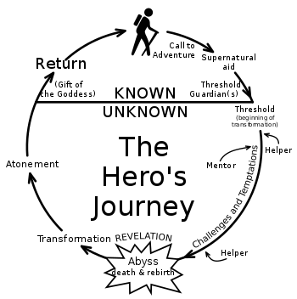
Part One: Structure, Repetition and Symbolism

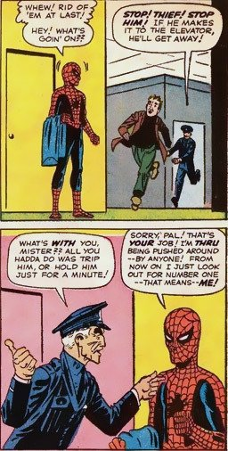
Joseph Campbell theorised that all stories follow the same structure. This can be visualised in the form of a circle, which works as a literal visual metaphor for a story becoming ‘full-circle’. This will begin with the hero (main character/s) having the call to adventure, which they sometimes may decline, at first, for example, in ‘The Matrix’ Neo literally receives a phone call to escape whilst he is in work, however he changes his mind, and is then captured by the agents who are perusing him. Sometimes the hero will refuse the call in a much straighter forward fashion. Spider-man originally turned down the opportunity to be a hero, but this lead to a personal tragedy (his uncle’s death).
Amazing Fantasy #14 – Stan Lee & Steve Ditko

It is usually due to a tragedy, or some other life altering event, that the hero will decide to set out on their journey into the ‘other world’ (another realm, somewhere that may be out of their comfort zone). The ‘other world’ is where they gain enlightenment (or something of metaphorical equivalence, like power, an object etc.), they will then travel back to their world, having changed. ‘The Wizard of Oz’ is a perfectly literal example of the hero’s return home;
[Dorothy] learned self-reliance from her experiences, and newfound appreciation for her family, who can be stern but clearly care a great deal about her. She knows there are people out there who care about her, and if she ever meets them again, she'll be all the stronger for their shared experiences.

Although, at first, this may be seen as a strict guideline, and can be easily argued against, this structure is merely an outline of how a narrative is constructed, and isn’t to be taken literally. The ‘call to adventure’ doesn’t have to be a physical journey, it can be a spiritual, philosophical or even a psychological journey. Just like the ‘other world’, doesn’t necessarily always have to be a physical destination.

‘All things are in process, rising and returning. Plants come to blossom, but only to return to the root. Returning to the root is like seeking tranquillity. Seeking tranquillity is like moving toward destiny. To move toward destiny is like eternity. To know eternity is enlightenment, and not to recognize eternity brings disorder and evil.’ – p 163

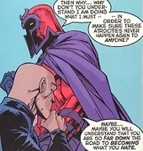
Campbell’s idea of the entire process of a narrative can be described, simply, by using the metaphor of a flower. The eternal process of the life of a flower, for example, and recognising this process is enlightenment, and the return of the hero is based upon this enlightenment. Failure to achieve this will result in the hero being forced to stay in the ‘other world’, in which they will eventually be consumed by its evil (‘evil’ in the sense of the opposing intent of the journey, which may sometimes result in the moral meaning of the word).
X-Men #1 – Stan Lee & Jack Kirby
We are able to apply this idea to many contemporary and pop culture story lines: In Star Wars, Anakin fails to recognise enlightenment through bringing eternal balance to the force, and is then consumed by the lurking evil of the ‘dark side’. In Xmen, we have Charles Xavier and Erik Lehnsherr (Magneto) fighting for the same thing, which is equality for mutants, yet Xavier is able to recognise the bigger picture (co-existence) whilst Lehnsherr fails and therefore becomes the thing he swore to fight against, which is the mistreatment of others who are different.

‘The hero adventures out of the land we know into darkness; there accomplishes his adventure, or again is simply lost to us, imprisoned, or in danger; and his return is described as a coming back out of that yonder zone.’ – p188
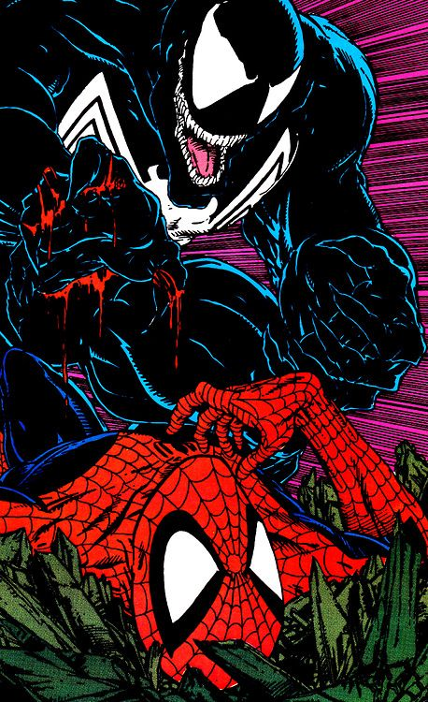
Amazing Spider-man #316 – Todd Mcfarlane

The hero will sometimes encounter their opposite. This could be the balance that we, as human beings, crave. Or it’s a way of fulfilling our morbid curiosity of what would happen if the hero were to be consumed by evil. In pop culture, we have the hero Spider-man, who has to occasionally face off with his opposite; Venom. Both come from the same world, similar occupation, both end up with similar powers, yet they are at the opposite end of the moral spectrum. In other stories, the hero’s opposite may be an internal battle with themselves. In ‘Fight Club’, for example, we are introduced to our main character (unnamed) who meets (creates) their opposite (Tyler Durden), in a subconscious act of desperation to escape the societal norm “And I wasn't the only slave to my nesting instinct. The people I know who used to sit in the bathroom with pornography, now they sit in the bathroom with their IKEA furniture catalogue.” (28) The whole point of Tyler’s character is that he is the epitome of what our main character wishes to be; the opposite of who they are. “Tyler is funny and charming and forceful and independent, and men look up to him and expect him to change their world. Tyler is capable and free, and I am not.” (130). This is an example of how the hero’s opposite is a repetition of itself, but different, and becomes so as a result of the other. Deleuze states ‘Lightening, for example, distinguishes itself from the black sky but must also trail it behind, as though it were distinguishing itself from which does not distinguish itself from it.’ – p36 One cannot exist without the other, the light exists because of the dark, this continuous connection, and change.
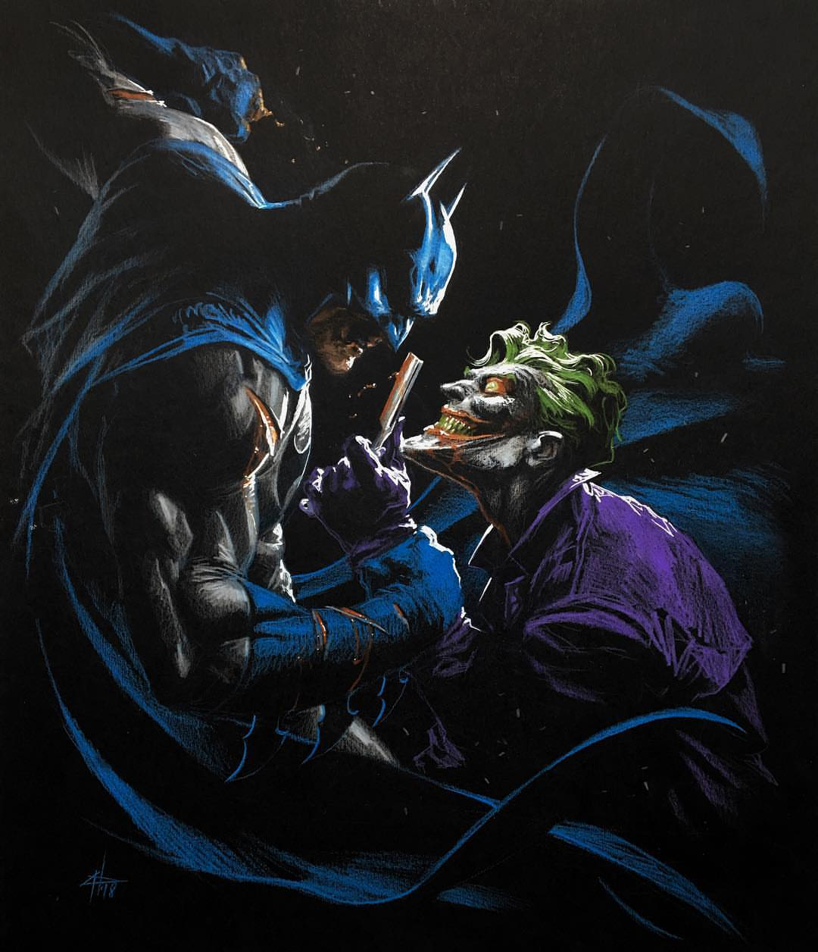
‘Batman & The Joker’ - Gabriele Dell'Otto

Another example of this, in pop culture, is Batman and the Joker. Both character’s, existing in the same world. Both products of their surrounding society, yet polar opposites. Batman stands for justice, and stays true to his ‘no kill’ rule, yet the Joker has a very potent existential view on life “It’s all a joke! Everything anybody ever valued or struggled for…It’s all a monstrous, demented gag!” - (88) that will allow him to go on a mass killing spree without blinking an eye. Even their physical appearance is opposite in every way, Batman with his dark colours, hiding his identity in the shadows, and the Joker’s bright colours and distinguishable face, with no identity. The opposing character, such as the Joker, will exist in order to highlight the main character’s faults and imperfections. In the animated movie ‘Under the Red Hood’, Batman’s moral code is brought into question, as a result of the Joker’s presence;

Batman: No! God Almighty, no! It'd be too damned easy. All I've ever wanted to do is kill him. A day doesn't go by when I don't think about subjecting him to every horrendous torture he's dealt out to others and then... end him.
Joker: Awwww! So you do think about me.
Batman: But if I do that, if I allow myself to go down into that place, I'll never come back.

This brings into question the meaning of ‘opposite’. Opposite, in this case, would be the same character, but different (just as the Joker is a reflection of Batman, but separated by a moral code, making them opposite forces) Just as repetition, may not be simply defined as a continuous copy. The opposite is a mere reflection of our hero, to show, the aforementioned alternate path they could have taken. Or, to enter the ‘other world’ and not return. The hero’s opposite, is just as important, as they provide the audience with a deeper understanding of our hero’s psychological state. This may be a reason as to why we never get a clear identity of the Joker, or the main protagonist in Fight Club. As they aren’t simply defined by their identity, they are a personification of the hero’s psychology (Fight Club would be defined as the reverse of this statement, making Tyler Durden the main character, and the ‘hero’ a plot device to understand Tyler’s mental state, whom, ironically, is a figment of the Hero’s imagination, created to portray the Hero’s psychology).

‘The returning hero, to complete his adventure, must survive the impact of the world.’ – p194

Campbell may argue that each story, although shares the same structure, only differentiates from each other through symbolic narrative. However, whether or not ‘repetition is a necessity in story telling’ can be contradicted, depending on how we, as a collective, view repetition. An example of this contradiction is mentioned on ‘Narrative First’, who goes into detail, criticising Campbell’s theory, “The Hero loses himself and is reborn. This is exactly what happens to Clarice Starling in The Silence of the Lambs and Jake Gittes in Chinatown. Wait. No, it isn't.” It’s true, that not every great story takes the exact route that Campbell suggests, however, it is difficult to argue against the use of symbolism, that already exists within our subconscious. For example, Campbell writes about multiple cases where people talk about their dreams:
“’I had to climb a mountain. There were all kinds of obstacles in the way. I had now to jump over a ditch, now to get over a hedge, and finally to stand still because I had lost my breath.’ This was the dream of a stutterer” (85)
Campbell goes on to write about many other dream examples that use subconscious symbolism, and this can also be applied to narrative, as these symbols, whether or not they’re witnessed in a dream state, still come from our (the dreamer’s/author’s) mind. For example, I decided to take a paragraph from Campbell’s book, and look up certain keywords in ‘Dictionary of Symbols’, to see if the description of each symbol, matched up with what was being said in the paragraph:
“For those who have not refused the call, the first encounter of the hero-journey is with a protective figure (often a little old crone or old man) who provides the adventurer with amulets against the dragon forces he is about to pass.” – (58)

- Dragon – “Strict guardians or as symbols of evil and of diabolical tendencies. They guard buried treasure [to be won]” (307)
- Amulet – “…Egyptian mummies were covered in gold, bronze, stone or faience amulets to preserve the immortality of the dead as they had guarded his or her health, happiness and life on Earth” (20)
- Old man (old age) – “…old age has always been respected, this is because it is the image of longevity, of experience and wisdom acquired over the years, itself no more than a flawed image of immortality” (715)

Campbell’s theory of the hero’s journey can be contradicted, if taken at face value (as seen above), and there certainly could be a long list of narratives that may not play out exactly how Campbell suggests. However, it is based on mythology, and the symbolism of mythology comes from our inner conscious (as mentioned above about symbolism and dreams). Just as Freud states;

“I recognised the presence of symbolism in dreams from the very beginning. But it was only by degrees and as my experience increased that I arrived as a full appreciation of its extent and significance [...] This symbolism isn’t peculiar to dreams, but characteristic of unconscious ideations, in particular among the people, and it is to be found in folklore, and in popular myths, legends, linguistic idioms, proverbial wisdom and current jokes, to a more complete extent than in dreams.” (350)

‘Reflections, echoes, doubles and souls do not belong to the domain of resemblance or equivalence; and it is no more possible to exchange one’s soul than it is to substitute real twins for one another’ – p1

If we take on board Deleuze philosophy, we can admit that Campbell’s structure will be forever changing. Some narrators/author’s may purposely go out of their way to contradict Campbell, or perhaps the more natural progression would be that over the ages, this repetition of structure will eventually be unrecognisable from Campbell’s original philosophy, which, in itself, is a contradiction. Perhaps the necessity for repetition is necessity for change in the way that we structure narrative.

On the contrary, what if this need for repetition is subjective in itself? Do we only notice these patterns because we choose to?

“…either a narrative is merely a rambling collection of events, in which case nothing can be said about it other than by referring back to the storyteller’s (the author’s) art, talent or genius – all mythical forms of chance – or else it shares with other narratives a common structure which is open to analysis, no matter how much patients its formulation requires.”–p80

It appears this statement can both support and go against whether or not repetition is a core element in narrative. Barthes seems to take more of an open-minded approach to repetition, and leaves it up to the individual to decide whether or not it’s worth exploring the similarities between stories – almost as if to say that anything can be relative to something else, if we look hard enough for the similarities, as mentioned earlier, this essay takes a subjective approach to art, and the meaning of a piece of work depends on the individual that views it.

There are two ways in which we can approach this outlook. The spiritual/philosophical outlook would be to say that perhaps narrative is the result of the human condition. One of the things that connects us. The oneness (AUM).

The three letters of AUM represent these three vibrations inherent in creation. (Even though the variant spelling in English is “Om,” AUM is more accurate.) “A (Akaar)” represents the vibration that brings into manifestation the created universe; “U (Ukaar)” represents the vibration that preserves the creation; and “M (Makaar)” represents the destructive vibration that dissolves the manifested universe back into the Infinite Spirit.

Or, there’s the more scientific/natural outlook, that maybe it’s human nature to notice patterns and structure, in order to help us seek familiarity as part of a survival instinct, or even a natural need to belong, or to be at home (the comforting sense of nostalgia, for example).

Quite simply, humans are amazing pattern-recognition machines. They have the ability to recognize many different types of patterns - and then transform these "recursive probabilistic fractals" into concrete, actionable steps.

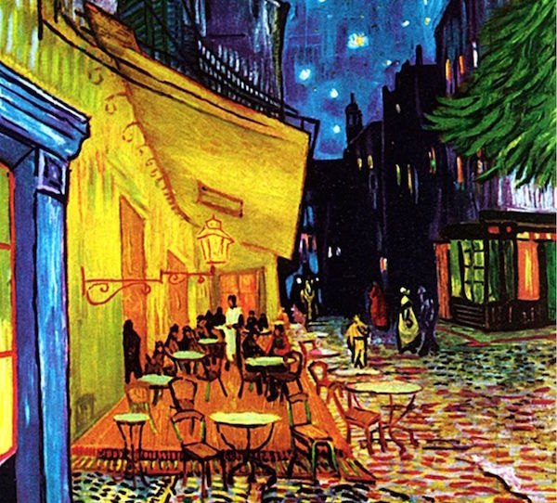
It could however, be a combination of both, or neither. It isn’t necessarily about finding concrete evidence on how we explain narrative patterns, but to rather gain perspective and learn to appreciate different narrative with more depth. Like how a painter may use visual symbols in a work of art, that may be an insight to their world. For example, it’s theorised that Vincent Van Gogh paid homage to the Last supper of Christ, in his painting ‘Café terrace at night’.
Café Terrace at Night (1988) – Vincent Van Gogh

Part Two: Parallels & Adaptions

As we may already know, there are many metaphors within narrative, some more obvious than others. Many of these metaphors are a reference to mythology and religious text. A more popular example of this is comparing a character, or several characters in a story, to Jesus Christ. Lord of the Rings is a great example of this, as it not only has one, but several main characters that carry aspects of the story of Jesus. Gandalf the Grey is the most prominent example:

When we first meet Gandalf in The Fellowship of the Ring, we encounter a wizened old man with a long grey beard, bushy eyebrows, a flowing cloak, and a wooden staff worn from travel. Like Jesus, everywhere Gandalf goes he seeks to help others, restore hope, and fight evil.

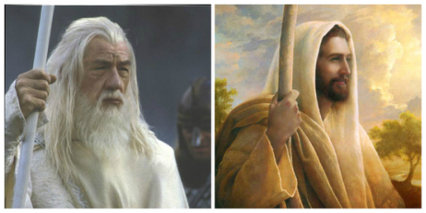
He then sacrifices himself to fight the Balrog, to which he is eventually ‘reborn’ as Gandalf the White “Beyond all hope you return to us in our need! What veil was over my sight? Gandalf!” (495).
Gandalf & Jesus Christ - chipweir.weebly.com

We are also introduced to Strider, who is later revealed to be King Aragorn:

The Christ symbolism in Aragorn largely draws from the Jesus of Revelation. In Christian theology, Jesus Christ is going to return to the world and rescue all those who have faithfully served God. When Jesus returns, the book of Revelation describes Jesus as a warrior much like Aragorn…

It is stated that although Tolkien was Roman Catholic, he made no effort to incorporate his beliefs in his writings, as it is said “Tolkien detested allegory and stated himself that his novels were never written with the intent of preaching religion”. The religious metaphors in his writings can therefore be an example of the aforementioned subconscious mind, which is one of the main reasons for repetition occurs in writing.
Again, we can draw these parallels of ancient religious texts to pop culture comic books. The basic principle between good and evil, which is prominent throughout religious texts, is the core message of most super hero story lines. Spider-man, for example, sacrifices his happiness in order to use his gift to save others (Christ’s sacrifice, for others’ sin).
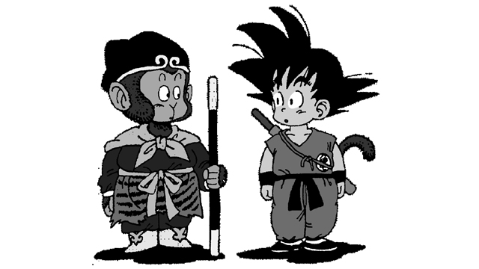
‘Sun Wukong & Son Goku’ – Akira Toriyama

Even without drawing parallels from religious texts, old stories are sometimes retold for a modern audience, such as the popular Manga ‘Dragonball’ is a retelling of the 16th century Chinese novel ‘A Journey to the West’, which Akira Toriyama admitted to doing this purposely; “Journey to the West became Toriyama’s guide as he put together the foundations of Dragon Ball, and he modernized the story by adding more martial arts into the mix.” Adapting an old story is something that tends to happen more and more (‘Marvel Cinematic Universe’, for example). It’s a way of sharing a great story, that will be relatable to a modern audience.

Conclusion of Chaos
The philosophy of repetition is one of many dimensions. It’s not necessarily as simple as stating that something “is a copy of a copy of a copy” (11). It’s important that we take into consideration the surrounding environment of the ‘copy’, and how that replica is differentiated. For example, the placement of that copy won’t be the same as the original copy, nor the timing of its existence.

‘Hume takes as an example the repetition of cases of the type AB, AB, AB, AB, A …. Each case or objective sequence AB is independent of the others. The repetition … changes nothing in the object or the state of affairs AB. On the other hand, a change is produced in the mind which contemplates: a difference, something new in the mind. Whenever A appears, I expect the appearance of B. Is this the for-itself of repetition, an originary subjectivity which necessarily enters into its constitution? Does not the paradox of repetition lie in the fact that one can speak of repetition only by virtue of the change of difference that it introduces into the mind which contemplates it? (90)

Just like ‘the butterfly effect’, these minor differences, will eventually go on to become something entirely different. Therefore, it’s safe to say that repetition is evolution, and the stories that we share are an example of this. And although change is inevitable in our world, we will always continue with the pattern in which our conscious and subconscious dictates. This is why, not only is repetition absolutely necessary in narrative (like a scientific law), it’s also a way of ironically showing us that stories still have the potential to be original and unpredictable, because of this repetition, just like the butterfly effect, can be the cause of chaos.

