Assignment 1
University of Wales Trinity Saint David
School of Engineering
Gear Box Housing Report
Aimee Gore
1302416
Date: 17/06/2019
CAE M5X02064
Andy Harrison

Contents
Table of Figures 3
Abstract 4
1 Introduction 5
1.1 Finite Element Analysis 5
1.2 Motion Simulation 5
1.3 Use within Industry 6
1.4 Use in product development 6
2 History of Simulation 7
3 Benefits and Limitations 7
4 Gearbox Assembly 8
4.1 Design of Gearbox Housing 8
4.2 Simulation Analysis 12
5 Conclusion 15
6 References 17

Table of Figures
Figure 2 – Gearbox Housing (Gore, 2019) 8
Figure 3 – Gearbox Housing (Gore, 2019) 9
Figure 4 – Gearbox Housing (Gore, 2019) 9
Figure 5 – Design Tree for Housing (Gore, 2019) 10
Figure 6 – Mates used (Gore, 2019) 10
Figure 7 – Rigid Groups and Redundancies (Gore, 2019) 11
Figure 8 – Solid Bodies (Gore, 2019) 11
Figure 9 – Solid Bodies (Gore, 2019) 12
Figure 10 – Solid Bodies (Gore, 2019) 12
Figure 11 – Solid Bodies (Gore, 2019) 12
Figure 12 – Force applied to combined gear (Gore, 2019) 13
Figure 13 – Force applied to combined gear in opposite direction (Gore, 2019) 13
Figure 14 – RPM of Motor (Gore, 2019) 13
Figure 15 – Force applied on gear box (Gore, 2019) 14
Figure 16 – Velocity/Time graph (Gore, 2019) 14
Figure 17 – Initial velocity/time graph (Gore, 2019) 15
Figure 18 – 200 RPM velocity/time graph (Gore, 2019) 15

Abstract

The purpose of this report is to outline the uses of Finite Element Analysis and motion simulation, it will explain the history and development as well as the limitations and benefits. The second half of the report goes into detail regarding the design and application of FEA and motion simulation to a gear box housing that the author has created. The analysis will include decision choices and how this affects the motion simulation. Results have been generated via a velocity/time graph and analysis of this has also been undertaken and how this can alter depending on stresses applied to the design.
The Gear Box Housing can be found in the following link:
https://uowtsd-my.sharepoint.com/:f:/g/personal/1302416_student_uwtsd_ac_uk/EjoXsQdNNVJOpqEF-DrdhQEBFl9hVqpV-SY79KgzgY0orA?e=qmvWmd

Introduction

Finite Element Analysis and Motion Simulation are widely used in industry and engineering applications. They can be used as an efficient and effective tool to help develop ideas and solutions. Companies use these tools to reduce costs and time spent manufacturing prototypes, and the use of these methods in product design are common place throughout the engineering and manufacturing industry, as they are considered a reliable method of design and material analysis.

Finite Element Analysis
“Finite element analysis (FEA) or finite element modelling (FEM) are generally synonymous terms for computer-based methods of stress analysis which are used when the shapes, numbers or types of materials, or the loading history are too complicated to yield to analytical methods.” (Dar et al, 2002)
The use of FEA or FEM can help in engineering applications to help design and develop ideas and prototypes. It is an effective tool as it can highlight potential issues during the development stage instead of after production and manufacture. By using a FEA programme, the design of a product can be scrutinised and assessed for the application in a variety of scenarios. This will raise any faults and potential issues during the design process, therefore allowing the designer/engineer to correct before manufacturing has begun. This is saving both time and money for the business as well as making the design process easier for the engineers involved.
Finite Element Analysis is the use of points or nodes which are in the shape of the design. Each point has finite elements which form the element mesh, this mesh contains all the structural and material properties of the design. Once simulated, this will demonstrate how the part will react to defined conditions and applications through the relationships defined by the designer, i.e. material, distance and shape via the predetermined statistical analysis. (Koutromanos, 2018)

Motion Simulation
Due to the increasing pressure felt by many companies and businesses to keep up with an ever changing and adapting industry, engineers need ways to produce and test ideas in a short amount of time. FEA and motion simulation help to produce these ideas and simulate any stresses that the design might face, without the financial and time associated with making a prototype and manually testing. FEA will show any limitations of a product, for example any weaknesses in the design like joints or corners, or any issues connecting various different parts together. Motion simulation demonstrates how a part interacts with another or as a complete working part in various situations, including motors, springs, wheels etc. This is supported below by SolidWorks, the motion simulation programme used by many businesses to help facilitate product design.
“Motion simulation provides complete, quantitative information about the kinematics-including position, velocity, and acceleration, and the dynamics- including joint reactions, inertial forces, and power requirements, of all the components of a moving mechanism.” (SolidWorks, 2019)

Use within Industry
FEA and motion simulation is used widely in a variety of industries including, but not limited too; automotive, aerospace, biomedicine and heavy industry. The reason for using FEA and motion simulation are all for the same purpose if not for very different applications and designs. The capability of the program is vast and proves that it is invaluable in industries that are forever adapting. By using FEA and motion simulation, engineers and designers can analyse the effectiveness of designs and potential ideas, as well as coming up with solutions to existing problems, without investing in the manufacture of prototypes. It also allows engineers to look at problems on a more practical scale. For example, real problems and situations that happen ‘on site’ but involve components that are meters high of the ground or involve a lot of preliminary work to investigate. The dimensions, materials and issues can be scaled down and solutions can be engineered on a desktop from the engineer’s office. Although this might not find a final solution, it can help to visualise potential solutions and test theories with very little expenditure on behalf of the company.

Use in product development
FEA and motion simulation is an invaluable tool in product development. Like its use within industry it can help create solutions and develop ideas. However, its use in product development has allowed businesses to create multiple prototypes and sample their effectiveness within hours of creating the idea as supported below.
“The rapid increase in both computing power and sophistication of computational methods and models of physical phenomena and the growing ability to transport results between various models are improving the scope of applications, robustness, accuracy, realism and cost effectiveness of VP [Virtual prototyping] technology at an incredibly fast pace.”(Zorriassatine et al, 2003).
Prototyping can be a lengthy and costly procedure, as there can be several parts that a product needs to fit with. There can be multiple material choices and potential design ideas that are suitable for the application, by using FEA and motion simulation, engineers can assess how suitable and practical a design is in a relatively quick time.
By using FEA and motion simulation of products, engineers and designers only need to manufacture very few physical prototypes before the product is potentially fit for manufacture. The product can be put through a variety of scenarios, experiencing stresses on different parts, and analysis is done on how the product and material choice reacts. If the part is damaged or breaks, no money is lost during this process as it can simply be taken back to the original part (Fucci, 2011).

History of Simulation
The finite element method was first established in the 1940’s as a need to further structural analysis in engineering and can be accredited to A. Hrennikoff (1941); who outlined how stress produced by various factors can affect objects and the calculations that are used for the analysis of this, and R. Courant (1943); “who developed finite element method and he used piecewise polynomial interpolation over triangular sub regions to model torsion problem” (Koura et al, 2015).
“Although these pioneers used different perspectives in their finite element approaches, they each identified the one common and essential characteristic: mesh discretization of a continuous domain into a set of discrete sub-domains, usually called elements.” (SimScale, 2015)
In 1973 Gilbert Strang and George Fix published ‘An Analysis of the Finite Element Method’ which paved the way for FEM to be generally used to help model physical systems in engineering applications including biomechanics, automation and aviation (Strang, 2008). Since then FEA, FEM and motion simulation have continued to grow and develop becoming an invaluable tool for industry and designers.

Benefits and Limitations
There are many benefits of using FEA and motion simulation throughout industry and product development. By using these tools, product performance and reliability improves and different scenarios can be tested before a product is exposed to a situation. Product and material reliability are tested before manufacture and so the designer is aware of any faults that may arise. The obvious benefits include the reduction in the need for a physical prototype for testing and therefore less material wastage. By designing the prototype on a FEA programme it highlights any issues before the manufacturing process, therefore saving money as well as time for all parties. It also gives the opportunity for various designs and materials to be tested without the expense of physically making different prototypes. (Siemens, 2019)
Limitations when it comes to FEA are related to the equations used in stress analysis. There can be a large amount of stress concentrated on small areas, normally around certain design features. Due to linear FEA, which is the normal analytical method used, it can produce results that are not as accurate in predicting the effects of the applied stresses. As a result the areas are normally strengthened as a precaution but this adds weight and cost to the part (Sparta Engineering, 2015). Because the analysis is carried out on a model and not the part all calculations are approximate and estimations. The part may react differently when manufactured and this always should be considered. (Design World Online, 2007)

Gearbox Assembly

Design of Gearbox Housing
The design of the gearbox housing is below:
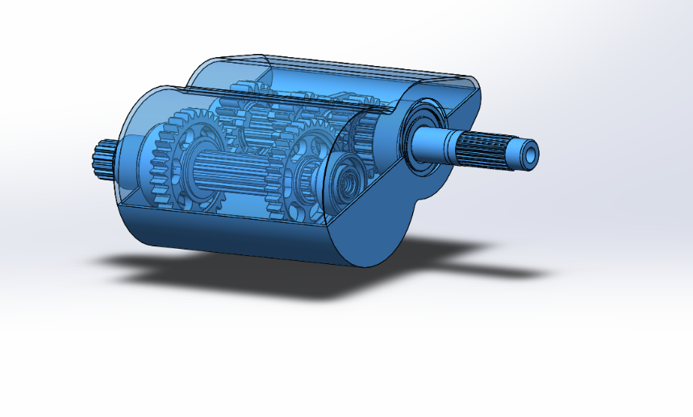
Figure 2 – Gearbox Housing (Gore, 2019)
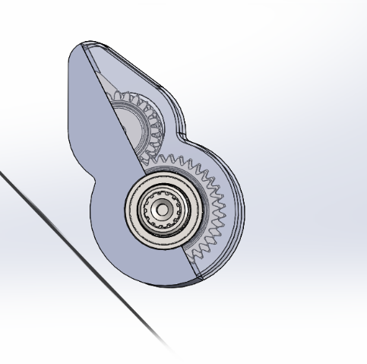
Figure 3 – Gearbox Housing (Gore, 2019)
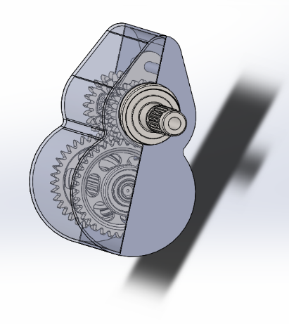
Figure 4 – Gearbox Housing (Gore, 2019)
The choice of design is simplistic and effective. The design was created by sketching the desired shape, using the shapes available on SolidWorks toolbar, and extruding the sketch. This included the required holes for the input and output bearing. The design was then shelled out, with the casing measuring 2mm thick. The author decided against using design features that would complicate the design including chamfer and ribs. It was later realised it would make the motion simulation an easier task to complete as the more support that the gearbox housing contained would reduce the need for mates and solid bodies as the parts could only interact in one way. Further consideration could be given to how the casing connects together, including further design developments for how the part is made. Whether the part is to be cast, moulded or milled, will have to be considered when designing. The author did not take this into consideration and so the design was a solid body with the gearbox housed inside.
Difficulty was faced trying to make the gearbox interact together correctly. There were many issues faced with required mates, and, during the simulation redundant mates. However, this was more difficult due to the simplicity of the design as explained previously. This meant that many elements had to be mated to each other as there was very little casing design to be mated to.
It was decided to keep the design simple, only using the features, sketch and extrude then mirror the design. As shown in the design tree below:
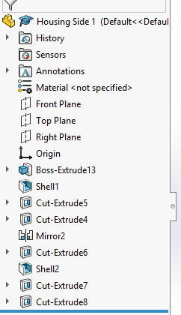
Figure 5 – Design Tree for Housing (Gore, 2019)
This was decided as the author wanted to keep the design as simple as possible in order to concentrate on motion analysis. The design was mirrored with all the bearings fixed to the casing for the motion simulation part.
The design tree below shows the mates used during the simulation:
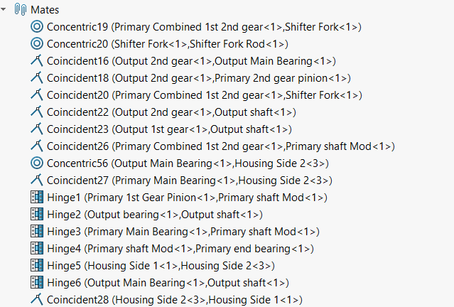
Figure 6 – Mates used (Gore, 2019)
Original design of the gearbox and housing resulted in over 25 redundant mates. In order to reduce these redundancies to 12, which is the final figure, involved working through the designed gearbox and housing, changing the current mate to one more suitable or creating rigid bodies.
By using rigid bodies the author reduced the amount of mates needed. Rigid bodies show a relationship between parts, for example, the rigid groups used in this simulation include the gears and the output shaft as one, and the other being the housing and bearings.
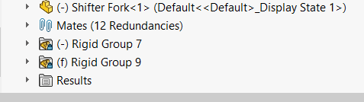
Figure 7 – Rigid Groups and Redundancies (Gore, 2019)

The number of mates used is also reduced by using solid bodies. This is where relationships are defined by parts that interact together, for example, gears as shown in the figures below.
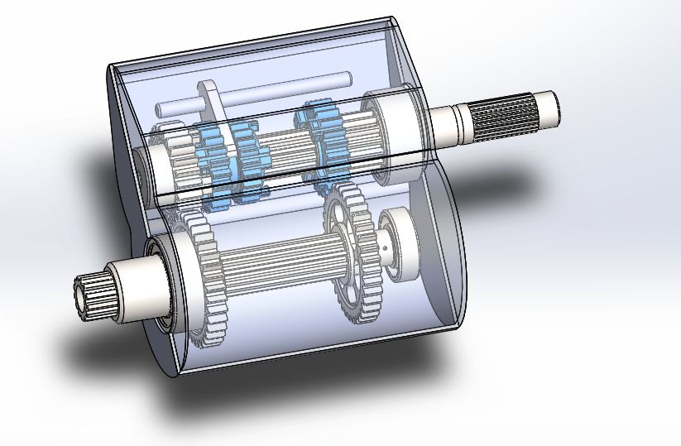
Figure 8 – Solid Bodies (Gore, 2019)
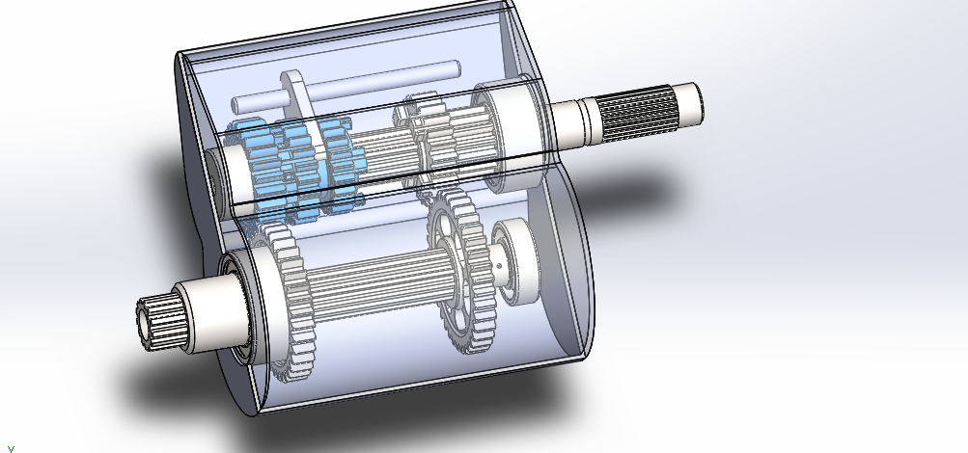
Figure 9 – Solid Bodies (Gore, 2019)
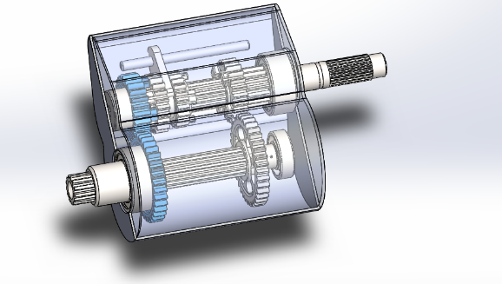
Figure 10 – Solid Bodies (Gore, 2019)
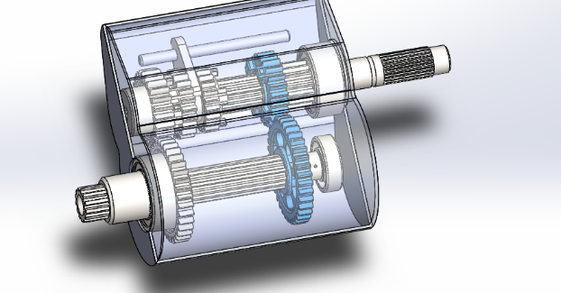
Figure 11 – Solid Bodies (Gore, 2019)
By using solid bodies instead of mates it defines the relationship that the gears should interact with each other therefore, reducing the need to mate the gears. Figures 8 and 9 represent the combined gear and how it fits into both the input gears. Figures 10 and 11 show how the input gears interact with the output gears and therefore how the gearbox operates.
The author decided against relationship equations due to the successful operation of the gearbox. It was found that when equations were used the gearbox wouldn’t operate successfully within the housing parameters.

Simulation Analysis
For the simulation analysis there were certain parameters that needed to be outlined to help simulate the operation of the gearbox. These included the forces used to operate the gears and any friction and dampening that needed to be included. The SolidWorks motion simulation function allows the author to set up relationships with the interacting components. This includes the ability to set what material is being used and how this affects part interaction. For the purpose of this assignment the author has chosen steel (greasy) as the material. Therefore, the motion simulation will recreate these conditions during simulation. For this the parameters are already established. However, there were parameters that needed to be set by the author. This included the torque and forces used on the gears. The author chose to use a force of 1N on the shifter to enable it to interact with the gear as shown in Figure 12 below,
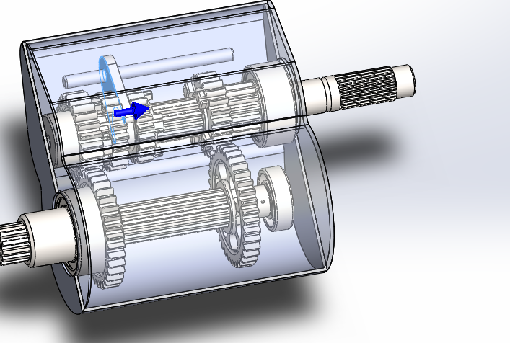
Figure 12 – Force applied to combined gear (Gore, 2019)
In order for the shifter to switch gears a force of 5N was applied in the opposite direction after 2 seconds, shown below.
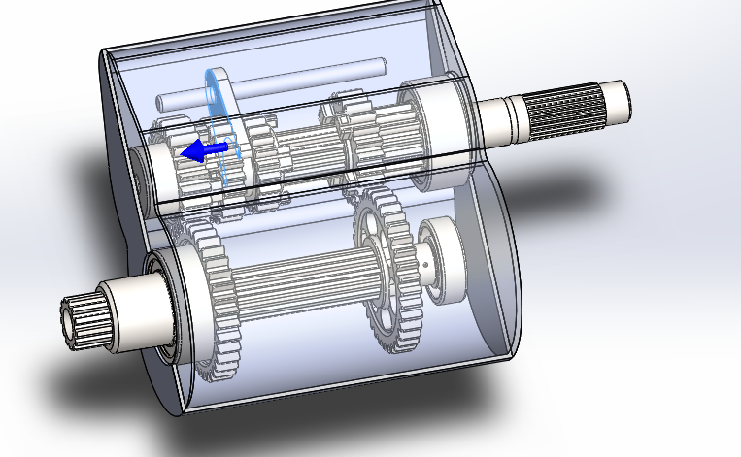
Figure 13 – Force applied to combined gear in opposite direction (Gore, 2019)
The author set the motor torque to 100RPM as shown below in Figure 14,
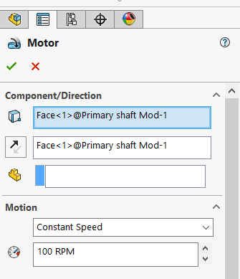
Figure 14 – RPM of Motor (Gore, 2019)
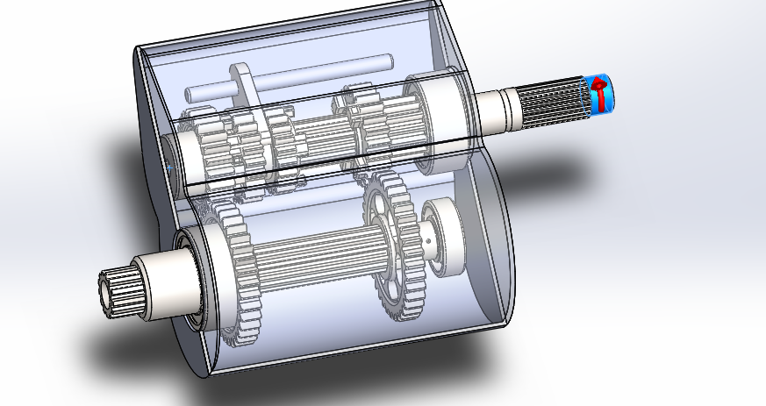
Figure 15 – Force applied on gear box (Gore, 2019)
A dampening force was applied to the bearings of 0.05Nm/deg in order to provide friction to the part.
After setting the parameters the author was then able to simulate the gearbox and housing. This then allowed the author to produce a velocity/time graph shown below in Figure 16.
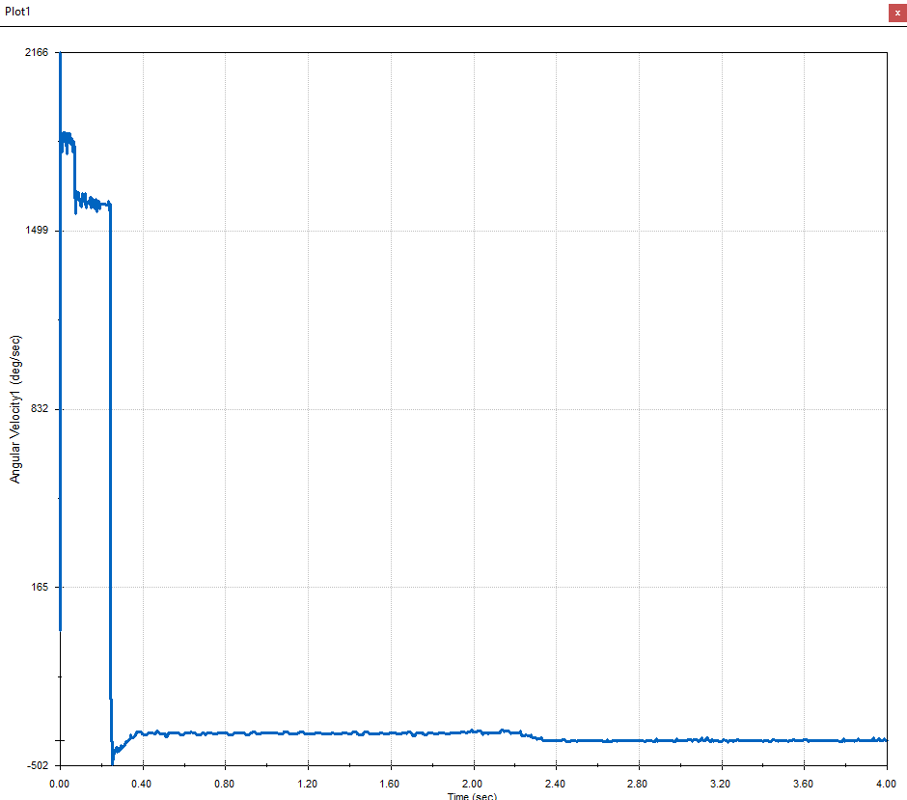
Figure 16 – Velocity/Time graph (Gore, 2019)
The velocity/time graph shows that initially there is a lot of erratic movement; this is due to the gears trying to fit together. However, once the gears have connected, at approximately 0.25seconds the graph is relatively smooth until the step change when the gear switches.
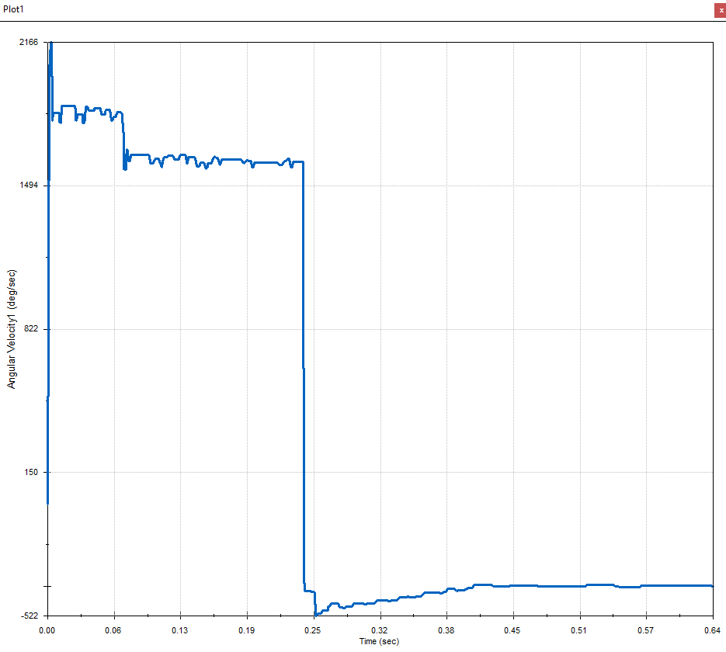
Figure 17 – Initial velocity/time graph (Gore, 2019)
Comparatively, when the RPM was increased to 200 the new graph is shown below in Figure 16,
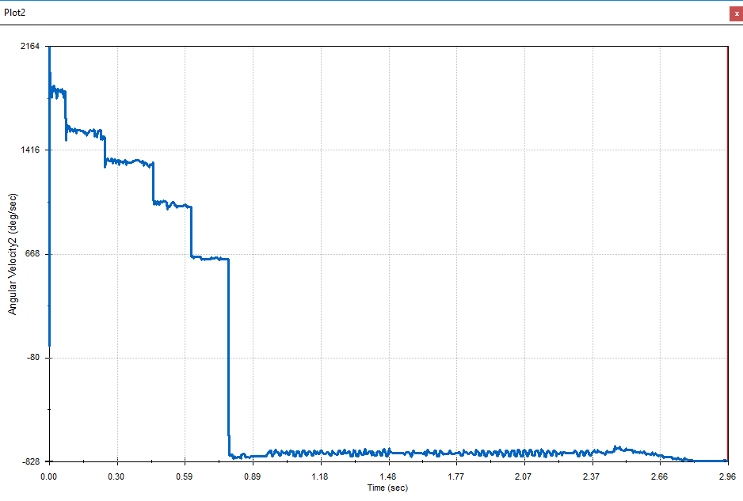
Figure 18 – 200 RPM velocity/time graph (Gore, 2019)
By increasing the RPM of the motor the graph became a lot more erratic and it was decided to keep the RPM lower at 100RPM. Explanations for this erratic movement could be a result of the mates and the simplicity of the casing providing little to no support for the bearings and gears.

Conclusion
Throughout the design process consideration was taken to the purpose of the casing and how the gears would interact to create the most efficient casing. It was a difficult process that required a lot of time and thought taken to create a viable casing that would do the required job. The motion simulation shows that the design of the casing is fit for purpose and creates the required output. Recommendations given to go forward would include the author needing more experience and knowledge of CAD programmes to enable detailed gearbox housing. The more detail included would have created results that would be able to provide more information for the author. Unfortunately due to the lack of detail included in the casing design, the results of the graph highlight issues and the casing would require a lot more detail to reduce these highlighted problems.

References

Courant, R. 1943. Variational Methods for the Solution of Problems of Equilibrium and Vibrations. Bulletin of American Mathematical Society 48, pp. 1-23.
Designworldonline.com 2007. Design World. [Online]. [05 June 2019]. Available from: https://www.designworldonline.com/using-fea-to-study-a-mechanical-part/
Dar, F., Meakin, J. and Aspden, R. 2002. Statistical Methods in Finite Element Analysis. Journal of Biomechanics. 35(1), pp. 1155-1161.
Fucci, M. 2011. Innovation in Product Design: From CAD to Virtual Prototyping. 1st ed. New York: Springer.
Gore, A. 2019, Gearbox Assembly 1. SolidWorks CAD
Hrennikoff, A. 1941. Solution of Problems of Elasticity by the Framework Method. Journal of Applied Mechanics 8(4), pp. 169–175
Koura, M. M, Muhammad, L. Z, and Amr A. S. S. 2015. Virtual System to Simulate the Performance of Various Categories of Machine Tools during the Design Stage. American Journal of Mechanical Engineering 3(1), pp. 7-15.
Koutromanos, I., 2018. Fundamentals of Finite Element Analysis: Linear Finite Element Analysis. Wiley.
Miller, D. E. 1998. Modeling and Simulation Technology - A New Vector for Flight-Tests. Master’s thesis, School of Advanced Airpower Studies, Air University, Maxwell Air Force Base, Alabama.

Siemens.com 2019. Siemens PLM Software. [Online]. [10 June 2019]. Available from: https://www.plm.automation.siemens.com/global/en/our-story/glossary/finite-element-analysis-fea/13173
Simscale.com 2019. SimScale. [Online]. [10 June 2019]. Available from: https://www.simscale.com/docs/content/simwiki/fea/whatisfea.html
SolidWorks. 2019, Understanding Motion Simulation. White Paper
Spartaengineering.com 2015. Sparta Engineering. [Online]. [05 June 2019]. Available from: http://www.spartaengineering.com/the-limitations-of-finite-element-analysis/
Strang, G., 2008. An Analysis of The Finite Element Method. Wellesley-Cambridge Press.
Zorriassatine, F., Wykes, C., Parkin, R. and Gindy, N. 2003. A Survey of Virtual Prototyping Techniques for Mechanical Product Development. Journal of Engineering Manufacture. 217(1), pp. 513-530.

