

Internet of Things (IoT) using LoRaWAN

by
Nabil Ouzahra

Supervisor: Dr Mabrouka Abuhmida
Second Marker: Dr Tim Bashford

Project submitted as part of the requirements for the award of BSc (Hons) Computer Networks & Cybersecurity

May 2019

Declaration of Originality

I, NABIL OUZAHRA declare that I am the sole author of this Project; that all references cited have been consulted; that I have conducted all work of which this is a record, and that the finished work lies within the prescribed word limits.

This work has not previously been accepted as part of any other degree submission.

Signed: Nabil Ouzahra

Date: 01/05/2019

FORM OF CONSENT

I NABIL OUZAHRA hereby consent that my Project, submitted in candidature for the B.Sc.(Hons) Computer Networks degree, if successful, may be made available for inter-library loan or photocopying (subject to the law of copyright), and that the title and abstract may be made available to outside organisations.

Signed: Nabil Ouzahra

Date: 01/05/2019

Copyright Acknowledgement

I acknowledge that the copyright of this project report, and any product developed as part of the project, belong to University of Wales Trinity Saint David, Swansea.

ABSTRACT
In recent years the rise of Internet of Things (IoT) trend has paved the way to the development of new low power network technologies to support this huge growth. All statistics seem to confirm that in the current market SigFox, NB-IoT and LoRa are the main contenders. However, LoRa starts to be more adopted and deployed by many cities and countries on a large scale thanks to its long range, low power consumption and easy implementation. The author has engaged in this research in order to demonstrate that LoRa technology can support the growth of IoT as well as the technological development of Swansea city in becoming a “Smart City”. In order to evidence that long range data transmission using LoRa is efficient, a real-life scenario experiment has been developed founded on academic research and a critical literature review aiming at developing an environmental system to monitor the water and air quality in Swansea using LoRaWAN. In this prototype we have developed a multichannel gateway using RAK831 LoRa modulator and Raspberry-Pi to forward the sensor nodes data to The Things Network (TTN) platform. In terms of nodes, we developed two EcoSensors to monitor the air and water quality to measure CO2, turbidity, pH and temperature.
This paper provides an overview of IoT implementation using LoRa and an in-depth analysis of real-life scenario experiment in Swansea to attain the aim and objectives of this project. The overall aim of this thesis is to demonstrate that LoRaWAN network implementation would be the ideal network to support the growth of IoT and the development of similar environmental applications.

ACKNOWLEDGEMENTS
I would like to express my sincere gratitude and thanks to all the individuals inside and outside the University of Wales Trinity Saint David for their kind support and guidance throughout this project.
I would like to take this opportunity to express my gratitude to all my lecturers, among them Dr Kapilan Radhakrishnan and Dr Carlene Campbell, and I would also like to express my special gratitude to the Project Supervisor Dr Mabrouka Abuhmida for her guidance and support throughout this work.
My thanks and appreciation also go to my parents and family for their encouragement and help to accomplish this work.

Table of Content

CHAPTER 1 - INTRODUCTION 6
1.1 Introduction 6
1.2 Motivation 9
1.3 Aim 9
1.4 Objectives 10
1.5 Structure of the project 10
CHAPTER 2 - BACKGROUND RESEARCH 12
Overview 12
2.1 Wireless technologies 12
2.1.1 Overview 12
2.1.2 Current wireless technologies 13
2.1.3 Wireless communication characteristics 13
2.1.4 Technical challenges of wireless communications 15
2.1.5 Advantages 16
2.2 Wireless Sensor Networks (WSNs) 16
2.2.1 Overview 16
2.2.2 WSNs Topologies 17
2.2.3 WSNs Characteristics 18
2.3 Water quality sensors 18
2.3.1 Overview 18
2.3.2 Water quality sensors research 19
2.4 Air quality sensors 20
2.4.1 Overview 20
2.4.2 Air quality sensors research 20
2.5 Low Power Wide Area Networks (LPWANs) 22
2.5.1 LPWANs Overview 22
2.5.2 SigFox 23
2.5.3 LTE-M 23
2.5.4 NB-IoT 23
2.6 LoRa Technology 24
2.6.1 LoRa overview 24
2.6.2 LoRa Protocol 25
2.6.3 LoRa network architecture 25
2.6.4 LoRa Parameters 26
Summary 27
CHAPTER 3 – RELATED WORK 28
Overview 28
Literature review 28
1st Paper 28
2nd Paper 29
3rd Paper 30
4th Paper 32
Summary 33
CHAPTER 4 - RESEARCH AND DEVELOPMENT METHODOLOGY 34
Research Overview 34
4.1 Research Process 34
4.2 Research Philosophy 34
4.3 Research Approach 35
4.4 Research Design 35
4.5 Data collection method 36
4.6 Time Horizons 37
Summary 38
CHAPTER 5 – DESIGN & IMPLEMENTATION 39
Overview 39
5.1 Problem formulation 39
5.2 Design 40
Overview 40
Project design 41
Implementation design 41
5.3 Implementation 42
5.3.1 Hardware 42
5.3.2 Software 47
5.3.3 Building The LoRa gateway using the RAK 831 and Raspberry-Pi 3+ 49
5.3.4 Building the Water Quality Transmitter using the RAK 811 and Arduino-Uno 55
5.3.5 Building the Air Quality Transmitter using the RAK 811 and Arduino-Uno 58
5.3.6 Sensors calibration 59
5.3.7 Arduino codes developed 61
5.3.8 Integration of the All the things talks web platform 65
5.3.9 Integration of the TTN mapping 68
5.4 Testing 70
5.5 Analysis 74
Summary 76
Chapter 6 - CONCLUSIONS AND RECOMMENDATIONS 77
6.1 Summary 77
6.2 Conclusion 77
6.3 RecomMendations FOR FURTHER Research 78
Chapter 7 – REFLECTIONS 79
Chapter 8 – REFERENCES 82
Chapter 9 – BIBLIOGRAPHY 85
9.1 Bibliography 85
9.2 Appendices 86
RAK831 specifications: 86
RAK811 specifications: 88
Arduino-Uno specifications: 89
pH sensor specifications: 90
CO2 Sensor specifications: 91
Temperature sensor (DS18B20) specifications: 91
9.3 Project management 92
9.3.1 Physical and human resources 92
9.3.2 Planning of the project 92
9.3.3 Risk assessment 94
9.4 Ethics form 95
9.5 Logbook 97
9.6 Other material 98
Codes developed by the author 98
9.7 Glossary 107
9.8 List of figures 108
9.9 List of tables 110

CHAPTER 1 - INTRODUCTION

Introduction

The Internet of Things (IoT) has become one of the leading trends that have shaped our world. This interconnectivity has changed the way we leave our life. IoT has become a novel paradigm driven by the technological development of computing capabilities, the evolution of semiconductors and the progression of wireless technologies [1]. Today’s world has become smarter, more and more intelligent and interconnected to the point of no return thanks to this profound technology. There would be no better way to describe it than the central statement of Mark Weiser [2] in the scientific American seminal paper in 1991: “The most profound technologies are those that disappear. They weave themselves into the fabric of everyday life until they are indistinguishable from it”.
Kevin Ashton one of the pioneers of IoT couldn’t be more accurate when he titled his renowned presentation in 1991 “The Internet of Things”, the word “things” has left the door wide open to our imagination; this could be substances, plants, animals, objects etc.
The growth of internet has played a major role also in having more and more devices connected, expert anticipating that a staggering 75 billion devices and 212 billion sensors will be connected to the internet by 2025 [3] as illustrated in figure - 1, with this growth the world of internet traffic has entered its Zettabyte era (ZB) and created great opportunity for the IoT market worldwide, one of the leading market analysist ”Forbes” has forecast that this growth could reach $520 billion in 2021, doubling the Compound Annual Growth Rate (CAGR) between 2017 and 2021 [4] and expected to excide $1.7 trillion by 2020 from wearable devices only as per figure – 2 [5].
Communication is the main key behind any IoT network, with the improvement and diversity of Wireless Communication (WC) [6] more and more IoT applications start to benefit from the simplicity of connections and mobility. Furthermore, Wireless Sensor Networks (WSN) has proven to be one of the most successful models used in the IoT field, never less this model has come with many challenges and weaknesses such as energy consumption, limited processing powers, the security of data, the amount of data and bandwidth governing rules.
In recent years many protocols such as IEEE 802.15.4, ZigBee and Bluetooth/LE have been designed to provide viable solution to some IoT applications offering short range communication with low power consumption and moderate bitrate, to overcome this limitation of coverage when wide urban coverage was needed, cellular network back then wasn’t able to provide a comprehensive solution to this issue, simply because of its designing standards, Cellular network was not design to cope with a large number of machine-types requests [7]. Therefore, field experts and business has developed a variety of Low Power Wide Area Networks (LPWANs) solutions such as LoRa (Long Range), SigFox, Weightless, DASH7 to suit different IoT models and needs [8].
LoRa technology has emerged as the perfect contender for “Smart Sensing Technology” and start to be widely used in different applications such as environment monitoring, agriculture applications, industrial solutions etc. due to the nature of communication required, less data to be transmitted at a time (250 bps - 50 kbps) , some of these sensors are powered using batteries, being an open source protocol operating in free unlicensed bandwidth and finally the long distance of coverage (up to 15 Km in rural & 5 Km in urban environment) [9].
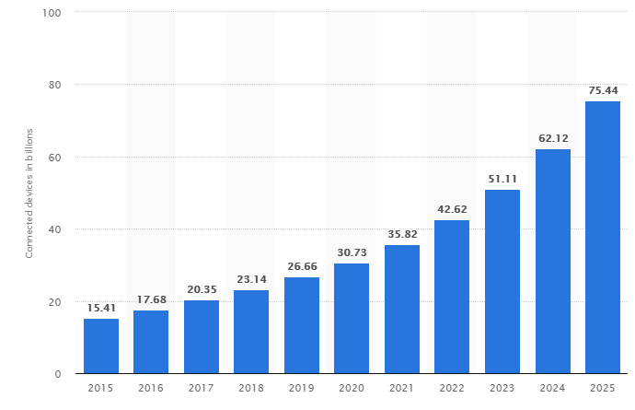
This report will focus more on building and deploying LoRaWAN (LoRa Wide Area Network) network using multichannel gateway and an IoT EcoSensor prototype model, analysing its characteristics, range, security, data loss and the benefits of building such low cost LPWAN.
Figure 1 - Internet of Things (IoT) connected devices installed base worldwide from 2015 to 2025 (in billions)
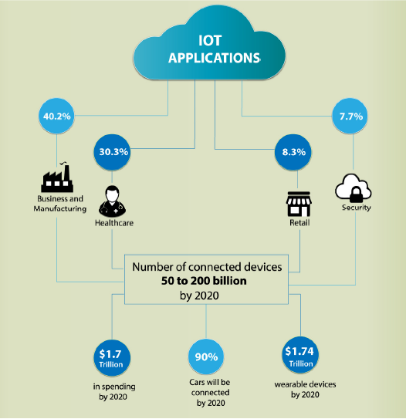
Figure 2 - IoT Market growth by 2020 [10]

Motivation

This section discusses the four major factors that have motivated the author to undertake this project. The first factor is to highlight the technology gap existing between what is available in Swansea and what is accessible elsewhere. Indeed, project IoT-Scotland and “ARWAIN” in Cardiff city are among the inspiring LoRaWAN models that have been built to support and drive more IoT applications. Second, there is a need to develop more environmental solutions to help monitor and protect the region of Swansea-Port Talbot. Third, this project takes part in the development of a novel solution to help monitor the Swansea lagoon marine life using an efficient long-range data transmission in the absence of WiFi access. Fourth, this topic is used as a career path foundation for the future.

Aim

The aim of this project is to analyse the use of LoRaWAN network in suitable IoT prototype model and study its capabilities. This project should highlight the benefits of building such a low-cost network and the potentials of creating more smart systems in our cities and rural areas.
In this project, we will be developing an EcoSensor monitoring system using LoRaWAN network to provide a real time useful data on web interface about water quality (pH, turbidity and temperature) and air quality (CO2 Carbon Dioxide) of Swansea marina or the river Tawe.

Objectives

This project is set to have five objectives:
- Conducting a literature review regarding the use of LoRa technology in an IoT application.
- Creating a water sensor node to transmit water quality data such as pH, turbidity and temperature to the “the things network” platform from long distance (2.4 Km).
- Creating an air sensor node to transmit CO2 carbon dioxide level in the air to the “the things network” platform.
- Creating an actual coverage map of Swansea city centre using the Received Signal Strength Indication (RSSI) and Signal-to-Noise Ratio (SNR) information.
- Highlighting the benefits of building a LoRaWAN network for the use of environmental IoT models (low data & long range) and the impact that could have in our life.

This Project will help to appraise the use of LoRa technology in IoT, its long range, security, effectiveness and sustainability.
Many cities around the world have started to adopt LoRa technology and have built an entire LoRaWAN network coverage, thanks to many EcoSensors solutions and applications have been implemented such as smart street lighting, smart flood systems, smart waste management etc. Therefore, this project is testbed to highlight the huge benefits of building an entire LoRaWAN network that could make Swansea city one of the smart cities in Wales.

Structure of the project

This project was structured and divided into nine chapters to provide the reader with all the elements necessary to have a better understanding and to provide a sense of flow throughout the reading of this report. The project can be segmented into three major parts. The first part deals with the background research and literature review related to the topic of wireless communication in general and the use of LoRa technology to develop IoT solutions. The second part details the process of designing and testing a prototype EcoSensor application developed to monitor the air and water quality in Swansea. Finally, the third part focuses on the analysis of the results as well as the conclusions and reflections which can be drawn from the entire project.
Chapter 1: illustrates the report overview, the details of the aim and objectives set and provides the reader with the structure of the entire project report.
Chapter 2: concentrates on the background research linked to all the topics related to this project: wireless communication, WSN, LPWAN technologies and an in-depth research of LoRa communication.
Chapter 3: focuses on the literature review of previous works to help the author build a good foundation of knowledge in LoRa implementation, open the questions left by other researchers and explore existing information in this field of research.
Chapter 4: concentrates on the research process, research philosophy, research approach and research design used in this study to achieve the established aim and objectives.
Chapter 5: details the process of developing and designing a prototype EcoSensor to monitor the air and water quality in Swansea and highlights all the steps followed to implement and test this prototype.
Chapter 6: provides the reader with a summary of the entire work done throughout the project, the deduction made from the analysis of the results, the work achieved, and the recommendations made for further research in the topic of IoT using LoRa technology.
Chapter 7: details the reflections drawn by the author throughout the course of this project, discusses whether the objectives have been met and what the author could have done to address any limitations.
Chapter 8: provides a list of references in the IEEE format used throughout the report writing.
Chapter 9: provides a list of background reading sources used but not quoted and a list of appendices.

CHAPTER 2 - BACKGROUND RESEARCH

Overview

The rise of LoRa technology deployment in the world of IoT combined with the increase of environmental concerns in general and in South Wales in particular has led the author to contemplate the development of a live environmental monitoring system using LoRa. A thorough research was conducted on wireless technologies, WSN, LPWANs and some of the main contenders to LoRa, in order to attain a better understanding of this technology.

Wireless technologies

2.1.1 Overview

Wireless communication appeared well before the pre-industrial age; however, the world had to wait until Italian engineer Guglielmo Marconi, the pioneer of radio technology, had his breakthrough in 1897, demonstrating the first successful radio transmission from the Isle of Wight to a towboat station 18 miles-away.
Since the birth of radio communication, wireless communication has continued to grow rapidly especially in the last few decades where it has managed to attract the media attention and the public imagination [10].
Wireless technologies enable devices to communicate without the use of physical connections. Instead, they rely mostly on the use of radio frequency to transmit data across the air. With radio waves, the range distance can vary from a few meters to thousands of kilometres in application such as Global Positioning System (GPS) and satellites. It is far from being a perfect technology as it has its technical problems and security concerns. However, the keys of its growth and success in some major fields such as cell phones and IoT support are within the characteristics themselves: mobility, simplicity, reachability, maintainability and roaming services, not to mention the massive advantages that can be gained [11].

Current wireless technologies

Throughout the evolution of wireless communication, many technologies and standards have been developed to suit different needs and to improve prior ones, thanks to the efforts and collaboration between the industry players and the official standards organisation such as IETF (Internet Engineering Task Force), IEEE (Institute of Electrical and Electronics Engineers), ANSI (American National Standards Institute), 3GPP (3rd Generation Partnership Project), LTE etc. [12]. Each technology was designed to provide certain area coverage, certain data bitrate and using a specific frequency spectrum and modulation technique to transmit the data.
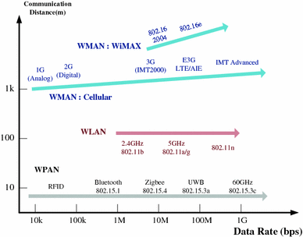
Some of the major Wireless communication that have been developed to this date and widely used (as seen in figure - 3) are: satellite communication, radio broadcast, WiFi (IEEE 802.11), WiMAX (IEEE 802.16), Bluetooth (IEEE 802.15.1), ZigBee (IEEE 802.15.4), Cellular 3G/4G, LoRa, NB-IoT (Narrowband IoT) etc. [11] [13].
Figure 3 - Evolution of wireless communication

Wireless communication characteristics

Wireless communication can be divided into two major types: the first one uses radio wave transmission and the second type utilises lightwave. This paper will focus on the most important part, the microwave transmission, the one used by LoRa and most major wireless technologies existing nowadays. Every wireless data transmission is governed by the laws of physics [10]. It is very important to highlight some of these important elements to have a better understanding when starting the implementation phase.
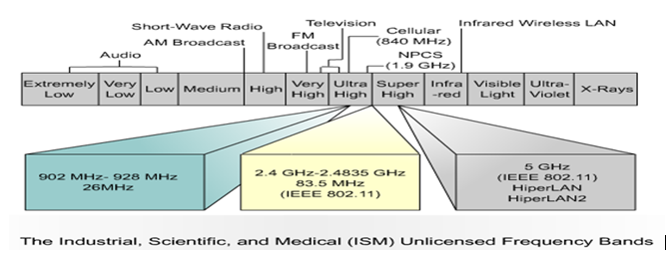
Radio frequency or radio wave is a form of electromagnetic transmission that can be generated and sent through the air, using a portion of the electromagnetic spectrum ranging from 3 kHz to 300 GHz [14]. However, in this project we will focus more on the low band unlicensed band also called ISM spectrum (please see figure - 4).
Figure 4 - ISM UNLICENSED FREQUENCY BANDS [13]
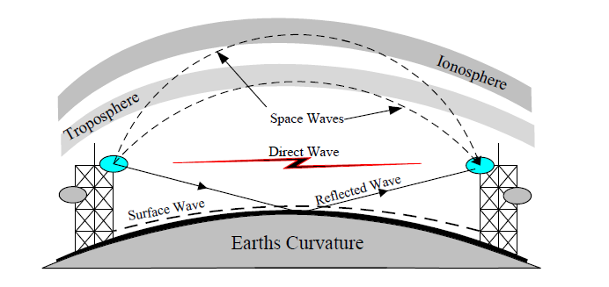
Every RF wave will have its unique characteristics based on the frequency, the type of antenna used (Yagi, Dipole, Parabolic etc.), the antenna gain and the type of waves as illustrated in figure - 5 (direct wave, ground, troposphere, and ionosphere, etc.), the propagation and signal modulation technics such as Quadrature Amplitude Modulation (QAM), Quadrature Phase Shift Keying (QPSK), Binary Phase Shift Keying (BPSK) and Frequency Shift Keying (FSK) [11]. In this paper we will focus on the Industrial, Scientific, and Medical (ISM) band portion (unlicensed band) of the electromagnetic spectrum simply because it is used by LoRa and most LPWAN technologies. We will also explain briefly the Chirp Spread Spectrum (CSS) modulation technique used by LoRa.
Figure 5 - Types of Radio waves

Technical challenges of wireless communications

Wireless communications are still facing a great level of technical challenges and limitations when it comes to accomplishing the perfect data transmission or at least a high level of successful data rate. Many elements contribute to the problems that wireless communication are still facing.
One of the most common issues is related to the nature of the environment where data get transmitted. Radio waves carrying the data could face different types of challenges before reaching the receiver such as reflection, refraction, diffraction, scattering, interference, signal absorption, path loss, multipath fading and shadowing as illustrated in figure - 6.
Other issues are more related to spectrum limitation, energy consumption, mobility of users and Signal Noise Interference (SNR). However, security is still considered as one of the biggest threats that wireless communication is still facing simply because data can be intercepted at any time. For these reasons’ organisation standards, players in the communication business and manufactures always pay a great level of attention when it comes to security.
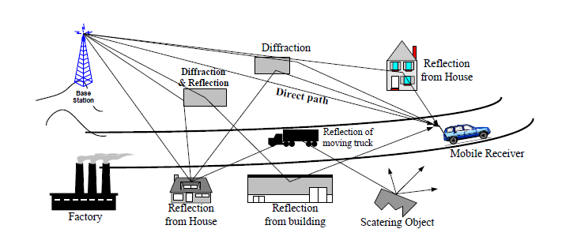
Figure 6 - Waves reflection, diffraction, scattering, and absorption

Advantages

Regardless of the security issues that have always surrounded the wireless technology, it is still considered as one of the greatest novel solutions ever created that has changed and impacted our 21th century [15].
At the core of its success come great advantages [11][15][14]:
- Mobility: this is one of the key features that wireless communication can offer: the fact that the data can be transmitted anywhere through the air using radio waves within the range of the signal. For example, this will allow individuals to communicate effectively regardless of their location.
- Cost effectiveness: wireless communication comes with huge savings on costs in terms of physical infrastructure and maintenance in comparison with all wired communication technologies.
- Accessibility: with these types of technologies Accessibility is one of the top features that have been improved. Many rural regions and remote areas have benefited from accessing information, online education, entertainment, etc.
- Increase efficiency: better communication means faster and safer transfer of data and information between users, business associates and machines.

In the next section we will be conducting a research on Wireless Sensor Network (WSN), to understand the role of these type of networks in environmental IoT applications.

Wireless Sensor Networks (WSNs)

Overview

It is very important to conduct a good research on this substantial topic of WSN, for a simple reason, because it lies at the heart of this project. WSN attracted tremendous attention in the past from academic and field experts to help develop solutions and designs to tackle all the issues and problems they were facing. With all these efforts and the advancement of both wireless communication and microchips, WSN have become one of the significant technologies of the 21st century [16]. One of the key characteristics of these types of network solutions comes from the flexibility and the ability to adapt to any aimed solution. With its popularity, many civil and military WSN applications continue to be developed in different fields: in healthcare monitoring, industrial process, environmental and pollution monitoring, home intelligence, early warning natural disasters systems, etc. [17] [18].

WSNs Topologies

With very little infrastructure needed to implement in these types of WSNs, it is considered as highly flexible and used in different designs to suit different solutions. Among the most popular network designs:
- STAR network (one point to multipoint): with this type of simple network (at illustrated in figure - 7), all the remote nodes can send data to a single base station without the need to go through other nodes. The simplicity of transmitting the data helps to reduce the latency and keeps the nodes power consumption at its minimum. However, the major drawback of this design topology would be the range of coverage [16] [17].
- MESH network: it is a multi-hop communication technology, where nodes can transmit data via other nodes. Each node can act as a network router forwarding packets from node to node. This helps to overcome the radio-wave range limitation and allows more redundancy against node failures and more scalability. However, with this approach there is the cost of higher power consumption [16] [17].
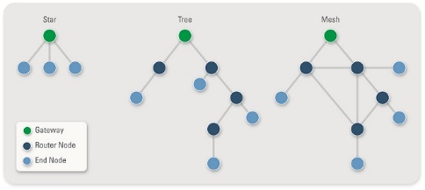
- TREE network (hybrid star-mesh network): The Tree network provides a strong and versatile way of communication, while maintaining the power consumption very low. The network is designed in a way to only enable certain nodes with a healthy battery level or powered from the main to forward the data, while keeping the low battery nodes in standby mode [16] [17].
Figure 7 - WSNs Topologies

WSNs Characteristics

Some of the key characteristics of most WSNs can be summarised as follows:
- Highly redundant network capable of overcoming nodes failures.
- Power and energy efficient, capable of reducing energy consumption throughout the entire network.
- Allowing mobility and flexibility as per its nature.
- Scalable and adaptable to different solutions.
- Very simple to use.
- Robust when it comes to harsh environment deployment, where infrastructure is impossible to have.
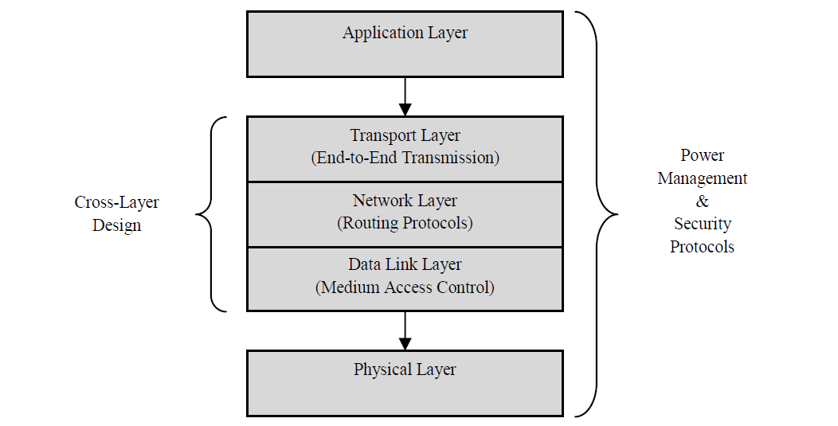
- Unique in terms of layer design and architecture (please see figure - 8) [19] [17].
Figure 8 - WSN network architecture [18]

Water quality sensors

Overview
Throughout the history of human existence on earth, the element of water has always been vital for our existence. The efforts deployed to establish protection and monitoring systems to ensure the quality of this vital element are not inimitable to the 21st century alone; this go back 28 centuries ago, where the Romans were obliged to build a system to tackle the problem of the Tiber river water pollution. Back then they designed an elaborated system of pipes with filters, ventilation and sample checks points to ensure the quality of their water. To this day this Roman system still stands as evidence of their ingenuity [20].

Water quality sensors research

Water quality can be evaluated through the chemical, biological and physical conditions. Any changes to these physiognomies can have a big effect on its vitality. To ensure its quality many organisations, institutes and bodies have set certain standards to regulate this sector (example: EU Commission) [21]. With the help of some of the advanced sensors developed nowadays by some of the high-tech manufacturers such as SIEMENS, MICRO, ICENTA, GEONICA, etc., monitoring some of the crucial parameters such as pH, salinity, conductivity, dissolved oxygen, chlorine level and turbidity has become an easy task [22].
In terms of employment approaches, water quality sensors could be divided into two categories: the 1st approach is to deploy the sensor to directly measure a certain components of interest (concentration, chemical, biological, etc.) and the 2nd approach would be to conduct surrogates measurements [23].
When it comes to the specific nature of these water quality sensors, we could organise them into different types [24] [23] [21]:
TOC sensors (Total Organic Carbon): this is a very sophisticated piece of equipment capable of analysing and measuring the organic carbon level with high accuracy, mainly used in water treatment facilities.
Chlorine Residual sensors: these types of sensors are also widely used in water treatment centres to ensure the monitoring of the level of chlorine residual in our drinking water. Due to the efficiency and cost of chlorine in water treatment it is still widely used and not been replaced.
Turbidity sensors: these types of sensors are used to measure the amount of light transmitted in water to ensure its clarity and are widely used in rivers and lakes to monitor the changes. It is measured by Nephelometric Turbidity Unit (NTU) [13] .
Conductivity sensors: they have been developed to measure the water electrical conductivity or total ionic concentration level. The amount of solid minerals and salt dissolved in the water (Total Dissolved Solids - TDS) is measured by the unit of Siemens per centimetre (S/cm).
Other well-known types of sensors are pH sensors, Ambient Light sensors, Dissolved Oxygen sensors, Oxidation Reduction Potential (ORP) sensors etc.

Air quality sensors

Overview

In our modern days air pollution has become a hot topic, the atmospheric air quality in our urbans and big cities has reached an alarming level especially among developing countries such as India, Pakistan, China, and Brazil, not to forget our developed countries where the air pollution in some cities and capital has reached a high level. The long term exposure to this high levels of pollution could have direct impact on the population health, the World Health Organisation (WHO) has reported that in 2010 only that 223 thousands death a direct cause of lung cancers caused by a high toxic level of polluted air [25].
Information about the air pollution emission is very important for the public health especially for our urbans and industrial cities, this is mainly done through base stations operated by government officials capable of gathering a very accurate measurement to substances such as Carbon dioxide (CO2), Sulphur oxides (SO_{x}), Nitrogen oxides (NOx) etc. [26]. However, the measurement methodology approach of these base stations appears to be complex, costly and limited. The mathematical modelling approach to provide an overall measurement level throughout a large surface does not reflect the true reading from one part of city to another. Therefore it would be very beneficial to utilise the rise of low-cost sensors technologies [27] to create a network of sensors across cities capable of polishing live data through a web platform and also able to replicate these base stations regardless the high accuracy.

Air quality sensors research

Low cost air pollution sensors technologies have attracted more and more attention in last few years, thanks to their accuracy and simplicity of deployments. In this research we will focus more on low-cost sensors simply because they are able to replicate the functions of the high-tech expensive ones. If only the quality of measurements of these low-cost sensors can improve, this could become a game changer [28].
Air pollution sensors can be categorised to their type of usage and the built-in technologies applied, in term of usage; some are suitable for indoors, otters for outdoors. When it comes to the built-in technologies, there is several types of sensors available on the market:
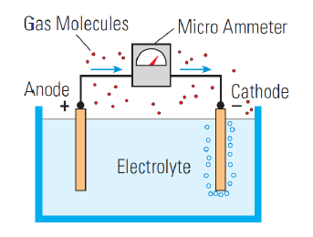
- Electrochemical sensors: This type of sensors uses a chemical approach to measure the reaction between the different gases in the air and the electrode submerged in the sensor liquid (please see figure - 9). Capable of producing a good measurement and considered as highly sensitive (from mg/m³ to µg/m³), it is mainly used to measure NO2, SO2, O3 and nitric oxide NO [29].
Figure 9 - Electrochemical sensor approach

- Metal oxide sensors: In this type of sensors, the resistive semiconductor sensor reacts to the level of gases in the air and changes the value of its resistance. The change of resistance is measured through voltage output. Widely used and cost effective, it is also considered as sensitive. These metal oxide sensors can also provide precise readings (from mg/m³ to µg/m³). However, they are highly affected by humidity and temperature [29] [30].
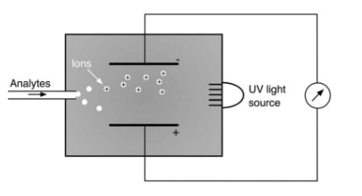
- Photo-Ionization detectors: Photo-Ionization Detector (PID) is a highly sensitive sensor, widely used by experts in the field of air monitoring and expensive to some extent [29]. The concept of this type of sensors is based on using ultraviolet light to irradiate and ionize the air sample inside the chamber to produce ionized molecules. The intensity of the direct current between the two plates inside the chamber gives a clear indication of the level of molecule detection (mg/m³ to µg/m³) (please see figure - 10) [31].
Figure 10 - The concept of Photo-Ionization Detector (PID) [35]
- Optical sensors: This type of sensors is mainly used to measure CO and CO2, with moderate cost that can vary between £100 and £300. In terms of efficiency, these sensors are rated as highly sensitive and able to detect particles between 300 and 2000 ppm. However, the main issue with these sensors is the drift over time of their calibration [29]. Most optical sensors use a variety of spectroscopic measurements such as Raman Scattering, Surface Plasmon Resonance (SPR) and fluorescence [32].

Low Power Wide Area Networks (LPWANs)

LPWANs Overview

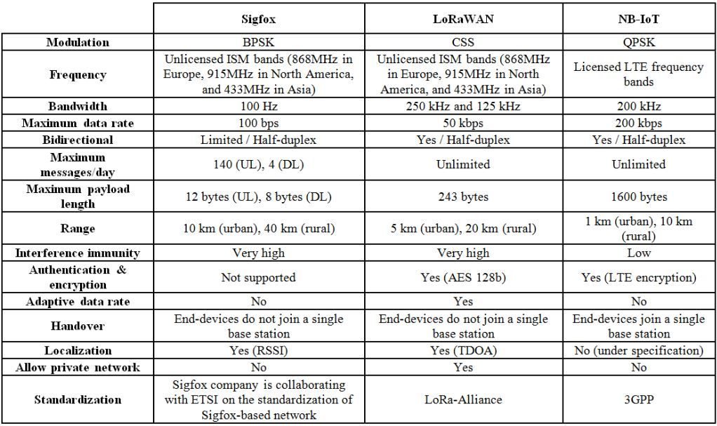
Unlike the Wi-Fi or ZigBee the Low Power Wide Area Networks (LPWANs) such as SigFox, Weightless or LoRa technologies have been designed to fulfil the new requirement of long range, low rate and low power consumption to the novel IoT application within the free unlicensed sub-Gigahertz frequency [33]. The convergence efforts of different alliances and groups such as LoRa Alliance and the 3rd Generation Partnership Project (3GPP) have created different technologies. They can be categorised into two groups: the non 3GPP standards (operate in ISM unlicensed spectrum) such as LoRa, SigFox, Telensa, Weightless, etc. and the 3GPP standards (operate in licensed spectrum) such as LTE-M, NB-IoT, EC-GSM (please see table -1) [34].
Table 1 - COMPARISON BETWEEN LORA - SIGFOX - NB-IOT [18]

SigFox

SigFox technology has been developed by a French start-up company in Toulouse in 2010. Unlike LoRa open source, SigFox is private property owned. It uses the Ultra Narrow Band (UNB) modulation technique and offers unique IoT solutions in 58 countries and is still expanding. It operates in the unlicensed Industrial, Scientific and Medical (ISM) radio band. The use of BPSK modulation in the Ultra-narrow band of 100Hz at maximum rate of 100bps makes it very efficient and more power efficient. It is a bidirectional communication system, allowing the transmission of small amount of data per day (140 uplink messages - 12 bytes max payload / 4 downlink messages - 8 bytes max payload) [34]. However, the SigFox network coverage can reach up to 13 Km [35].

LTE-M

The Long-Term Evolution for Machines communication (LTE-M) has been designed and developed by 3GPP and its Task Force members to provide a good service and address the issues of Low Power Wide Area (LPWA) IoT market. It was developed in 2013 under Release 12/13 as part of a continuous upgrade [36].
This technology provides coverage of up to 11 Km with maximum of 1Mbits/s, operating in (700-900 MHz) licensed spectrum with expected standby lifetime of 10 years for each node. It is the ideal solution for many smart applications such as automated meter reading, assets tracking and low-density sensors for businesses. However, this type of services comes with a cost [35].

NB-IoT

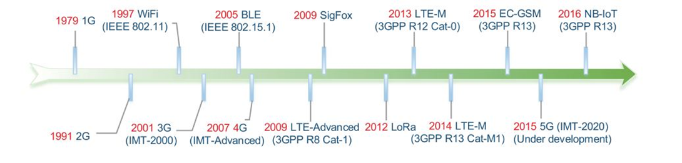
Narrow-Band for IoT was released in 2015 by 3GPP as an improvement of LTE-M (as illustrated in figure - 11). As per its name it uses the ultra-narrow band technology to improve its coverage, is energy efficient and still capable of moderate 150Kbps throughput [35].
Figure 11 - Evolution for the LTE IoT [28]

LoRa Technology

LoRa overview

LoRa (Long Range) technology is a wireless data communication system initially developed by French company Cycleo of Grenoble before becoming the property of Semtech in 2012. It has become very popular in the last few years, thanks to the huge efforts of LoRa Alliance [37].
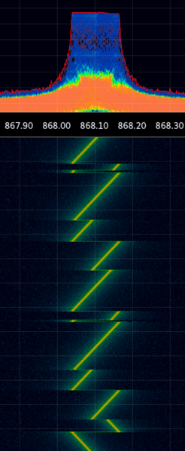
It uses a unique modulation technique called Chirp Spread Spectrum (CSS) (please see figure – 12) to achieve long-range coverage (5 Km in urban / 15 Km in rural areas) and long life of battery-powered nodes [38], thanks to its light designed protocol. It also operates in the unlicensed ISM bands (433, 868 or 915 MHz), depending on the region with a maximum payload transmission of 255 octets and a top bitrate of 50 Kbps. In terms of security, it is considered highly secure thanks to its Advanced Encryption Standard (AES) 128 encryption method [39].
Figure 12 - LoRa signal (CSS)

LoRa Protocol

It is a Long-Range wireless communication protocol that was developed and approved by LoRa Alliance, with the primary aim of achieving better battery life and energy consumption. Within this protocol we can refer to two different layers (as illustrated in figure - 13) [8]:
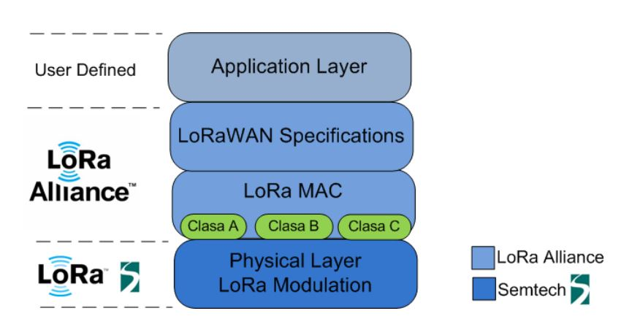
The physical layer was developed by Semtech using CSS modulation technique and a MAC layer (LoRaWAN) protocol. This medium access control mechanism allows communication between many nodes and gateways in an efficient and secure way. This protocol is an open standard developed by LoRa Alliance [39].
Figure 13 - LoRaWAN Protocol stacks

LoRa network architecture

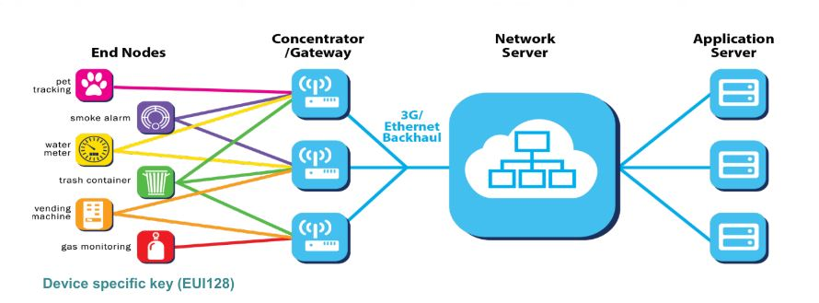
Most of LoRa networks use a “star-of-star topology” which includes end devices/nodes, LoRa gateways, network servers and application servers (as shown in figure - 14) [40].
Figure 14 - LoRaWAN Network Architecture
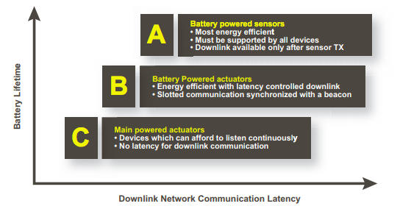
All data transmissions between nodes and gateways are secured using an AES 128 encryption [39]. The role of the gateway is to forward these frames to the LoRa server over a higher throughput interface such as Ethernet or 4G. The role of these gateways is simple bidirectional relays without any packet analysis. However, the network server is responsible for decoding the packets received and generating the packets to be sent to the nodes. One of the key features that can impact heavily on the battery-life in these networks is the end-devices classes (A-B-C) [8][41] [42], as illustrated in figure - 15.
Figure 15 - LoRaWAN Devices Classes and their impact on battery lifetime

LoRa Parameters

LoRa modulation technique consists of several parameters that can be customised to ensure the efficiency of data transmission and the solution as a whole: Spreading Factor (SF), Code Rate (CR) and Bandwidth (BW). In terms of SF LoRa uses different levels that specify the transmitting power, sub-frequency and the air time. LoRaWAN spreading factors are 7 to 12; low spreading factor results in low range coverage, low air-time, low power consumption and higher throughput (data-rate) and vice-versa [43] (please see figure -16). In terms of BW, the higher it is the higher data-rate and the lower sensitivity. Different continents and regions use different frequencies band, which is set by LoRa regulators. In Europe LoRaWAN uses the frequency band 863-870 MHz [8]. Within this band most channels are subject to 1% duty cycle set by the regulators to ensure operation of all deployed solutions and stop any abuse of these unlicensed frequencies [44]. In terms of coding rate (CR), code rate is a mechanism used by LoRa to protect its signal from interference bursts. CR varies between 4/5 and 4/8; the higher the CR the better protection [37].
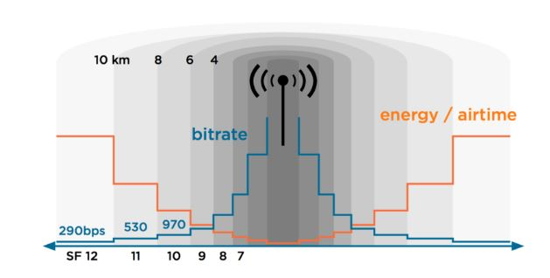
Figure 16 - LoRa (SF) air-time, energy & range relations

Summary

The purpose of this chapter is to outline all the intersected features related to the technology of LoRa and the development of this project. The research draws the attention to the evolution of wireless communication, its benefits as well as the issues still present regardless of the technological progress. All through the WSNs and LPWANs research, the author has outlined the characteristics of these types of networks, the differences between LoRaWAN and its contenders so as to highlight the reasons why LoRa should be used to support the growth of IoT. Further research revealed that the LoRa network structure, its protocol and its unique characteristics can only benefit any IoT solutions.
In the next chapter, the author will conduct a literature review of four previous works related to the use of LoRa and other similar technologies to develop smart EcoSensors.

CHAPTER 3 – RELATED WORK

Overview

The aim of this chapter is to conduct a literature review on the use of LoRa technology or similar LPWAN protocols, which should help the author to develop an EcoSensor system based on a variety of sensors to monitor and capture data from our environment. This research will try to analyse and reflect upon the methods, designs, hardware and approaches used to develop similar projects. The process of this literature review will assist the author in obtaining more knowledge and a better understanding of the use of LoRa technology. Through critical analysis of these carefully selected studies, the author will use these findings to accomplish the objectives of this project.

Literature review

1st Paper

Kumar and Jasuja [45] (2017, p.1341) explain that little attention has been paid to measuring a particulate matter of parameters such as temperature, carbon monoxide, and sulphur dioxide and attempts to address the issues. The authors design a system consisting of DSM501A, which is a PM sensor to monitor the particulate matter together with the sensors for observing environmental parameters using Raspberry-Pia minicomputer that is low powered, relatively cheap, and very flexible. The system is designed in that Raspberry-Pi is the central node dominating the system. The sensors are used to direct the environmental variables that are linked to the Arduino board [36, pp. 1342]. On the other hand, the Raspberry-Pi is joined to the Arduino Uno using a USB cable. Information observed by the sensors is channelled using Raspberry-Pi to the cloud due to its good network connection.
Raspberry-Pi is a computer with a single board, which assists the sensors to operate effectively. The sensing unit used has five sensors used to monitor air pollution. The sensors are DSM501A, which can detect even fine particles: MQ9, which senses carbon dioxide, MQ15, which can detect CO2, DHT22, which senses temperature and relative humidity, and BMP 180, which senses barometric air pressure and altimeter [36, pp. 1343]. The different types of software used are Node-RED, integrated development environment and MQTT protocol. The methodology requires booting up the Pi, which enables the Node-RED to begin running automatically. For the system to use the cloud services of the IBM, an account is designed at the IBM Bluemix where the gadget is also registered [36, pp. 1343]. As the sensors and Raspberry-Pi are already connected, data received is sent from Watson IoT to the cloud and can be seen anywhere in the globe as long as the device is connected to the Internet. The results of the environmental parameters are presented in a tabular form and are shown in IBM Bluemix Cloud [36, pp. 1345]. The results have been taken from the different sensors and show similar figures of environmental parameters which indicate high accuracy.
The system proposed by the authors is a low-cost way to monitor environmental parameters from any part of the world. The system is low cost as the whole system is connected to one computer and information can be read from different parts of the world. With a perfect connection, the primary requirement to obtain accurate data is having a good Internet connection that is not expensive. The system consumes little power as the whole system is interconnected. The system increases accuracy by using five different sensors, which concentrate on the parameter each measure best.

2nd Paper

Alvear, Zamora, Calafate, Cano and Manzoni [46] acknowledge that monitoring air pollution is an essential need for all cities. The authors noted the weakness in the field in that most ways used to measure air pollution involve using fixed monitoring stations, which are not only costly but also hard to install. The authors developed an EcoSensor that can measure pollution through mobile sensors. The EcoSensor depended on mobile sensing, which can be small relatively cheap gadgets that can be installed in cars to check on the contamination of different parts of a town. The low-cost sensor gathers pollution information and transmits the data to a cloud system through a smartphone. The cloud server using the system analyses the pollution distribution via spatial interpolation methods to come up with comprehensive pollution maps of a town. From the literature review on the authors’ work, mobile sensing has been recognised to be the best design to measure pollution distribution especially in crowded areas such as cities [37, pp. 2].
The EcoSensor proposed integrates both hardware and software elements. The first element is the waspmote sensor, which is utilised in computing pollution information, next is raspberry pi, which works as the gateway connecting the sensor and the Android-based gadget. The third element is the android gadget, which stores the information collected, indicates real-time pollution status, and transfers the received data to the cloud server in the presence of network connection [37, pp.2]. The waspmote sensor operates on the Arduino platform and ensures it shows the specific location of each data collected, which it transfers to the Raspberry-Pi. The Raspberry-Pi communicates through two interfaces, which are the Arduino platform and Bluetooth that is utilised in transmitting data to the android gadget. The Android device uses Bluetooth and a source of Internet connection to communicate information to the cloud server. The cloud server has a web system that stores the data in a database and enables drafting a report to be made available to the web server’s administrator. The authors analyse the impact caused by sensor orientation as well as the influence caused by time and spatial sampling to ensure the measurements taken are accurate [37, pp. 5]. The results indicated that sensor orientation in certain limits have very little influence on information gathered while the actual path of collecting data has a positive correlation to the results, particularly when estimating pollution distribution.
The system proposed by the authors is useful in determining pollution of air especially with the aim of analysing pollution distributions of areas. The method allows the collection of accurate data utilising the low-cost way. The approach uses a combination of low-end sensors, smartphones, and cloud services that are all available and makes it cheaper for cities and organisations to determine pollution distribution. The major strength of the method is that it is highly flexible, as data can be collected in the presence of movement, which reduces rigidity. However, the approach is not perfect in spatial interpolation procedure, which needs to be addressed to increase the efficiency of the method.

3rd Paper

Manoharan and Rathinasabapathy [47] monitors water quality, distribution and amount used using M2M-LoRa, which is a kind of wireless connectivity utilised in transmitting water in long ranges of up to 15kms. Lora is a physical layer modulation that employs chirp spread spectrum. The receiver can record information with 19.5db below the floor and over the air at a rate of 10.9kbps. LoRa network uses LoRa parameter, which can be set to tune the receiver by differentiating the following parameters: RF transmission power, carrier frequency, the spreading factor, coding rate, and the bandwidth [38, pp. 58. The LoRa mote can be linked to other LoRa mote in different points and security has to be highly considered, as it is highly susceptible to insecurity. The authors also discuss smart meters, which are utility meters used to measure amounts of electricity, gas, water, and heat used that assists in estimating bills and giving meter readings to both customers and suppliers. The primary goal of smart metering is saving water by measuring the water quality, distribution, and amount used through LoRa application. LoRa application requires enormous amounts of information, high-quality service and reliability, and use of adequate procedures to ensure it is efficient in smart metering [38, pp. 59].
Smart water involves checking on water quality, distribution as well as how it is used. pH, turbidity, dissolved oxygen, nitrate, fluoride, and electrical conductance are the parameters used to measure water quality. The process also involves analysing properties of water in its natural sources. Smart metering involves using the level and flow sensors that assist in quantifying incoming and outgoing water amounts. LoRaWAN Technology can be used in intelligent metring although it does not use traditional communication methods such as ZigBee, Wi-Fi, and Bluetooth cannot be used for remote locations, and edge nodes have to be utilised [38, pp. 60]. LoRa is efficient for monitoring water sources for up to 15kms where many taps, pipelines, and tanks can be connected to eliminate water misuse. The technology needs separate infrastructure and mainly requires a gateway to communicate with other nodes. Non-contact ultrasonic sensors are utilised when determining water level in tanks and are connected to LoRa mote via GPIOs.
The proposed system is adequate for monitoring water that is being transmitted for long ranges and can be less useful for household use. A system that can be used for individual houses should be developed as the LoRaWAN Technology is not applicable for small scale use. It is highly effective where there is no availability of the cellular network, which makes it useful for water catchment areas such as forests. The technology is susceptible to insecurity and therefore, security must be counter-checked in points where LoRa motes connect to other LoRa motes. Although the system has a few limitations, it is highly useful for large scale use like in towns and villages and would help reduce water wastage, ensure people take quality water, and measure water levels that would notify users in case of potential threats in levels of water.

4th Paper

Loriot and Shahrour [40] focus on discussing the use of LoRaWAN technology and how it is used for communicating data in large-scale. LoRaWAN is an open protocol that allows data communication for long ranges of 15 to 20 kilometres in rural areas and 2 to 8 kilometres in cities. The technology utilises spectrum-spreading modulation, which allows consumption of low energy and secure communication between ends using little data. LoRaWAN technology link devices in both ends, which communicate using a star network topology. AES128 encryption is done to ensure security, which is generated from a unique security key and a unique gadget identifier. In LoRaWAN technology, the network server maintains network intelligence by managing security, ensuring authenticity identification, message reception, and storage of data.
In LoRaWAN technology, an application platform manages the system by adding applications and gadgets. Also, LoRaWAN ensures there is an application programming interface, which assists in retrieving information. The technology is suitable for fixed devices as well as mobile gadgets that do not need high transmission and reception capacity [32, pp. 2]. LoRaWAN is an open source and allows the connection of some equipment. The authors conducted indoor and outdoor tests on how technology can operate using one gateway. The findings indicated that LoRaWAN technology performs well in outdoor environments and that buildings result in weak signals as the quality of data is disturbed during transmission [32, pp. 4]. Indoor tests showed that efficient performance using one gateway.
The authors put much emphasis on explaining how LoRaWAN technology works and conducted a test to show its strengths and weaknesses. While the technology can operate indoors using one gateway; in an outdoor setting, more than one gateway is required to improve its efficiency. The presence of buildings could lead to weak signals as structures act as hindrances of quality data. Therefore, the technology would need to be modified to reduce the occurrence of hindrances to its performance. Additionally, the technology is efficient for large-scale projects leaving out the small-scale ones.

Summary

All four papers have illustrated different significant deductions that the author has used to develop the overall design of this project. Firstly, the author has concluded from this process that the issue of power consumption should be addressed when developing any IoT application system because that could affect the overall efficiency. Secondly, the author has realised that a low-cost approach to design any environmental monitoring system may cut cost, allow flexibility and simplify the implementation. However, this type of system efficiency could degrade in spatial interpolation procedure where only estimated data get computed based on the nearby point of data collection. Finally, the author has determined that LoRaWAN technology is more efficient when deployed on a large scale rather than a small one; that the studies also show that LoRa technology is not perfect when deployed in urban environment which can impact the quality of the data transmitted.

CHAPTER 4 - RESEARCH AND DEVELOPMENT METHODOLOGY

Research Overview

The objective of this methodology chapter is to discuss the research methods and approaches that were used to explore and investigate the formulated research aim and objectives. The aim of the study was to develop an Eco-Sensor monitoring system using LoRaWAN technology to provide real-time data on a web interface about the water quality (pH, turbidity and temperature) and the air quality (CO2 Carbon dioxide) of the Swansea marina and possibly the Swansea lagoon in the future. The research methodology chapter discusses the research process, research philosophy, research approach and research design used in this study.

Research Process

An empirical research process was used in the current study to develop an Eco-Sensor monitoring system. The research process was used to create a systematic model aimed at constructing an Eco-Sensor monitoring system and help understand the validity and reliability of the information research in addressing the identified research problem. In formulating the model, the researcher used an inductive process which according to Creswell [48] is reasoning where premises are perceived as supplying evidence based on an empirical truth in concluded observations. Clont [49] agrees that the conclusions of an inductive process provide probable evidence based on practical research findings. The method is essential in making it possible to verify the validity of the research process to ensure each step of the research has been covered and addressed [50].

Research Philosophy

The research philosophy used in this study was based on positivism and realism to identify how data was collected and analysed in this study. Positivists argue that scientific knowledge can only be explored through established empirical and statistical evidence [51]. As such, positivism is a way of examining and investigating data validity based on scientific evidence. In this study, the researcher used empirical research to identify and collect practical evidence to assess the formulated research aim [52]. In contrast, realism argues that information needs to be represented as it is, or in terms of being practical and facing the established facts. The researcher used realism considering its central role in assisting to implement the study findings and also the need to use his own ideas to ensure improvement in completing the Eco-Sensor monitoring system using LoRaWAN technology.
Ghauri and Grønhaug [53] noted that realism is used to explore data from previous publications and also to help to compare past ideas to the latest establishments so as to provide an avenue for future improvement. As such, both realism and positivism philosophies were used in this research, where positivism was used to investigate the differences and logic of the Eco-Sensor monitoring system simulations and comparing the output [54]. In contrast, realism was used to analyse existing synthetic models through network motifs of relaying real-time valuable information on web interface about air quality and water quality in the Swansea Marina and possibly the Swansea Lagoon. The philosophical approaches were used to analyse the findings of the experiment to achieve the research aim and objectives.

Research Approach

The deductive method was a research approach used to analyse and complete the research that focus in achieving the set standards. Deductive reasoning was used to explore the previous research findings, implying that the research postulations and statistical evaluation of the findings to check the anticipated probability level. Prior research on the same topic was undertaken by exploring past literature studies to comprehend the techniques used to undertake the experiment in meeting the set needs. Therefore, the researcher used the approach to ascertain whether the experimental results would have similar findings [48], or different results, from the previous studies. The approach ensures that the new experiment is able to address and identify new extortions by using various approaches.

Research Design

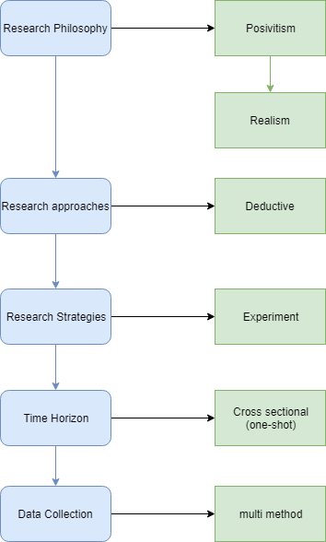
A research design ensures that important ideas are collected to give a systematic view of the project and how to achieve the set objective. The research design follows a multi-method approach to make it possible to investigate and analyse the research findings to create a successful Eco-Sensor monitoring system. The design includes principles that are generated using the literature review process on the LoRa technology so as to undertake the research experiment. A systematic process design (please see Figure 17) has been developed to accomplish our aims of conducting the experiment of deploying LoRaWAN technology in Swansea to serve an IoT EcoSensor application. Every section will be responsible for maintaining the requirement requested by the entire system.
Figure 17 - Systematic process design

Data collection method

As explained earlier the author has used a multimethod data collection throughout this project. This includes the data gathered from the literature review, similar experiments and our main experiment. Each source has helped the author to attend the aims of this project and better understand the LoRa technology.
Table 2 - Data collection method
Component | Research approach
Chapter 2  Literature review | Qualitative – Based on Literature review  Action research – Reflection upon previous studies and establishing better understanding of LoRa communication systems.
Chapter 3  Research Methodology | Qualitative – Methodologies research  Action research – Reflection upon previous studies and findings
Chapter 4  Design & Implementation | Qualitative – Developing a unique project design with the support of action research  Action research – Reflection upon previous studies and findings
Chapter 5  Testing and Evaluation | Qualitative – Experiment and literature review  Action research – Establishing the findings from the experiment
Chapter 6  Conclusion and Recommendation | Action research – Reflection upon previous study and outcomes
Chapter 7  Reflection | Action research – Reflection upon previous study and outcomes

Time Horizons

In this project experiment, the data will be collected just once, over a short period of time due to the safety of the hardware. Therefore, this study is cross-sectional or what is known as a one-shot data collection.
Figure 18 presents an estimate of the time horizons used in undertaking this study. The goals and milestones of the project are reflected in the Gantt chart shown below.
Figure 18 - Gantt chart showing an estimation of the research duration and research objectives

Summary

Throughout the examination of critical reviews and research methodologies of prior studies, the author has established an extensive knowledge in order to design a unique experiment to test the efficiency of LoRaWAN in environmental applications. The outcome of this study has helped the author to form a systematic view of the project and how to attain the objectives.
The next chapter will focus on the design and implementation aspects of developing a prototype of two EcoSensors using LoRa to monitor air and water in Swansea.

CHAPTER 5 – DESIGN & IMPLEMENTATION

Overview

In this thriving IoT and smart solutions era, thanks to the technological advancement of microchips and Internet, it has become necessary to build an appropriate and efficient infrastructure across our cities and rural areas to support this expanding growth. This chapter focuses on the design approach of an EcoSensor system to monitor the water and air quality of Swansea based on the research and Literature review. This ystem was initially developed to display a live data on the “All things Talk” integration platform and to plot a LoRa map coverage of Swansea city centre using the RSSI and SNR signal information with the help of the TTN mapper.

5.1 Problem formulation

Every IoT application has its own characteristics: power consumption, range, cost, level of security and infrastructure vary from one solution to another. However, they all have one common goal: sending valuable data to the internet platform.
In recent years, concerns about our environment have increased among individuals, organisations and governments. However, this research shows that very little has been done to monitor and provide valuable live data to the population of the Swansea and Port Talbot region, particularly regarding the concerns about the air and water quality caused by the local heavy industry (Tata Steel) regardless of their green policy. The major issue here is not having the right network infrastructure that could boost the quantity, quality and simplicity of deploying more and more environmental applications throughout the region. A similar project to the one launched in Cardiff in 2017 (Project ARWAIN) [55] that has made LoRa communication available throughout the entire city should be replicated in our region. Different comparison studies between LoRa and its main rivals demonstrate that LoRaWAN is still the ideal solution in terms of cost, coverage, simplicity of deployment and power consumption (please see figure - 19).
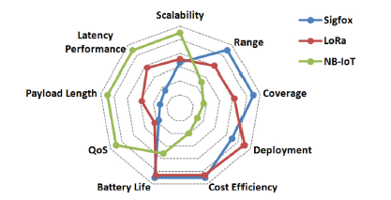
Figure 19 - Comparison analysis between LoRa, SigFox and NB-IoT (main technologies contenders of LPWAN) [12]

5.2 Design

Overview

The overall system broadly consists of three modules: first, a multichannel LoRa gateway operating at 868 MHz, built using Raspberry-Pi 3 and RAK831 modulator, capable of supporting 800 nodes if the 1% policy usage is met [56] and configured to check and route all the packet to the TTN server. Second, an air sensor node designed using an Arduino Uno and RAK811 LoRa transmitter mounted as hat, configured to transmit the data captured by the MG811 CO2 sensor to the gateway. Third, a water sensor node designed using Arduino and RAK811 LoRa module to send the data captured by the three connected sensors (pH, turbidity and temperature).
In this prototype design, the author has configured the gateway Wi-Fi connection to use a 4G mobile hotspot to provide a backhaul internet to the TTN server, which would be an advantage for all the testing and experiments.

Project design
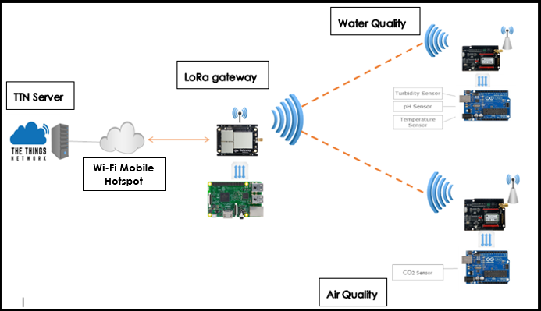
Figure 20 – Block diagram for the complete project [69]

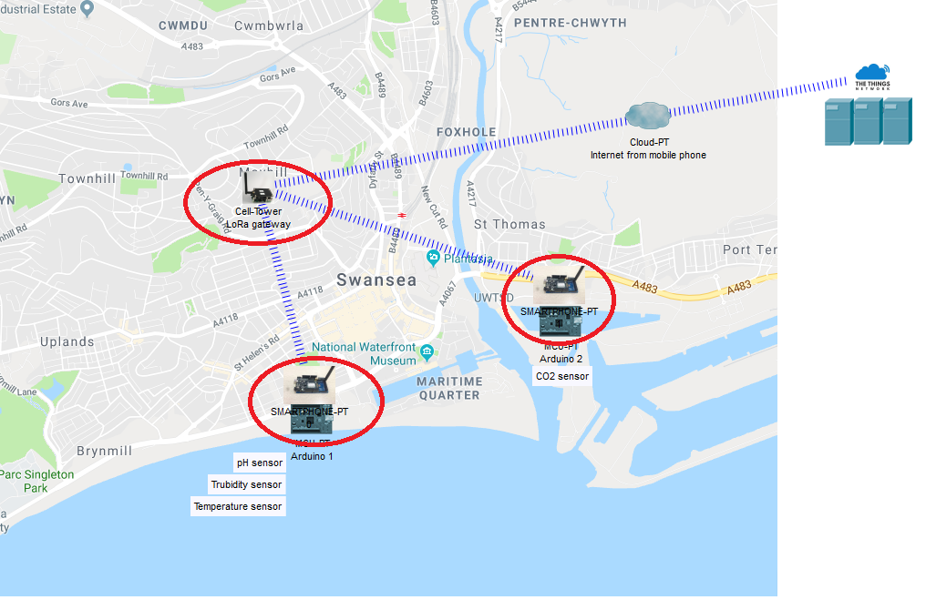
Implementation design
Figure 21 - Implementation prototype design [69]

5.3 Implementation

5.3.1 Hardware

- RAK 831
RAK 831 is the LoRaWAN gateway module based on the SX1301 chip developed by Semtech, operating in three different frequency bands (433MHz/868MHz/915MHz), capable of simultaneous multichannel communication (8 uplinks and 1 downlink) with -138 dBm signal sensitivity and up to 20 dBm power output. This modulator can handle the LoRa signal (chirp spread spectrum) without any knowledge of the SF used by the transmitting nodes.
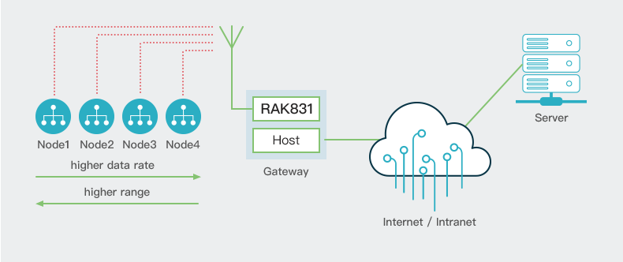
In this project we will be using the 868MHz version suitable for the Europe region to build our LoRa gateway using a Raspberry-Pi3 (MCU). This host processor will be configured to handle all the data traffic between the modulator itself and the TTN server (as illustrated in figure - 22) [57].
Figure 22 - RAK 831 application diagram

- RAK 811
RAK 811 is the LoRa wireless transmitter module based on the Semtech LoRa chip SX1276, designed to act as a node or an end device in the LoRaWAN network. This module is designed to use a sub-gigahertz spread spectrum modulation to achieve a long-range transmission (+10 miles). This module was designed to fully support all conformity standards of LoRaWAN class A&C.
RAK 811 is a bidirectional communication system (2 ways), highly sensitive (up to -148 dBm) designed to reach extreme distances. It uses AES 128 encryption for security and supports 2 modes of activation OTAA/ABP (Over the Air Activation/Activation by Personalisation). All the technical characteristics and data sheet can be found in the appendices.
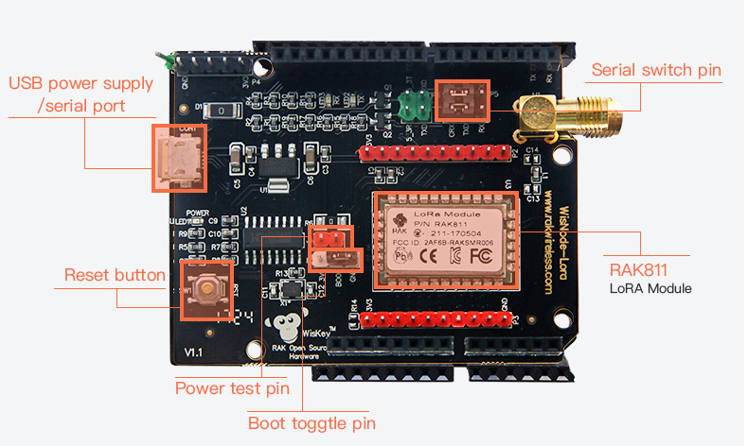
In this project, we will be building two Eco-Sensors using RAK811 (please see figure - 23) and an Arduino-Uno MCU board to transmit water and air data captured by our sensors to the gateway. All the data will be transmitted in HEX for compatibility reasons and later on converted to decimal values.
Figure 23 - RAK811 WisNode

- Raspberry-Pi 3+
Raspberry-Pi is a small computer designed within a single board by the Raspberry-Pi Foundation, capable of emulating all the functions of an everyday use computer. It is a very useful kit of technology, used in teaching and research projects similar to ours. Each model has its own operating system, CPU power, memory RAM, graphics card and single Micro-SD slot. Most Raspberry-Pi support WiFi, Bluetooth and Ethernet connections, which is making it an ideal solution for wireless applications.
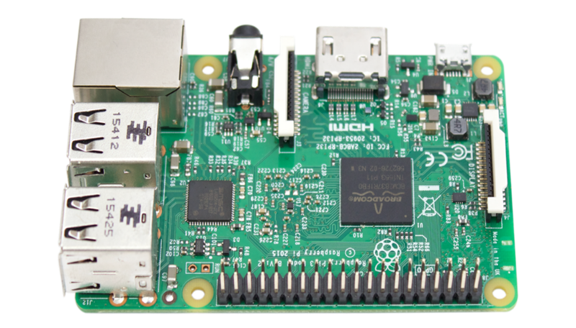
The main reason for using the Raspberry-Pi 3+ (please see figures - 24) as the host to our RAK 831 LoRa modulator to build our gateway is the high processing power thanks to the quad-core ARMv8 processor of 1.4GHz and its satisfactory 1 GB of RAM. It is also worth pointing out the Pins compatibility with the RAK831 (please see the Appendices for the specifications of the Raspberry-Pi3+).
Figure 24 - Raspberry-Pi 3+

- Arduino Uno
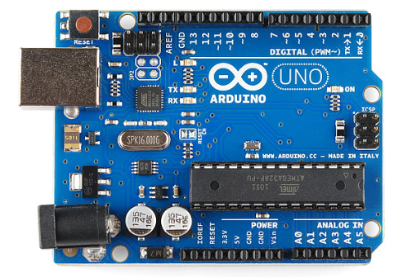
Arduino was first developed in 2005 by Massimo Banzi and others in Italy as part of their research work. It is an open source platform developed using microcontrollers and software to build electronic projects able to control both analogue and digital sensors. The Arduino Integrated Development Environment (IDE) was developed using C and C++ to enable the user to interact with the hardware and to design their project using a simplified C programming language. It is widely used for teaching and research projects mainly because of its simplicity and cost factor. Many types of Arduinos have been developed to suit different needs: Arduino Uno (please see figure - 25), Duo, Mega, Leonardo etc., all uses different chips that vary in terms of processing powers, memory and speed. They may appear as less powerful when benchmarked against other rivals such as Raspberry-Pi, Jetson and i.MX8, but when it comes to the ranking among users Arduino still stands at the top of the best developed MCU boards [58] [59].
Figure 25 - Arduino Uno [58]
- pH sensor (PH0-14 with BNC interface)
pH is the measurement of the acidity and alkalinity of liquids. The level of this element can be a very significant indicator of the harm and danger threatening our rivers and marine life. Many environmental projects rely on this type of basic readings to monitor the water quality of rivers and lakes.
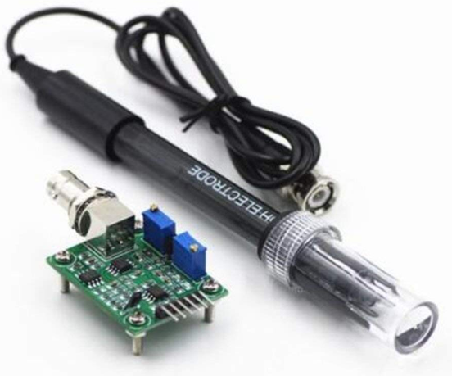
For this project, we have selected a PH0-14 sensor (please see Figure 26) based on compatibility, cost, working conditions and power consumption. Many types of pH sensors exist on the market and some are very expensive, sensitive and more industry designed. In this project, the pH sensor has to be Arduino compatible, with less power consumption (between 5/10 mA) and a wide coverage range (0 to 14 pH).
Figure 26 - pH Sensor (PH0-14)

- Turbidity sensor (0-1000 NTU)
For this project, we have selected a standard analogue turbidity sensor (please see Figure 27), capable of measuring the water turbidity between 0 and 3000 Nephelometric Turbidity Unit (NTU). This sensor was built for research project, is compatible with Arduino boards, effective and low-cost.
Figure 27 - Turbidity sensor probe
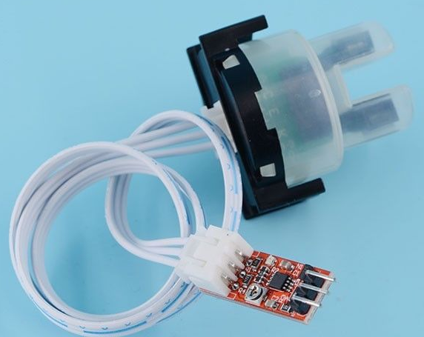
This probe can measure the degree of the light scattered by the different particles in the liquid and is easy to calibrate to zero NTU using the circuit board potentiometer.

- Temperature sensor (DS18B20)
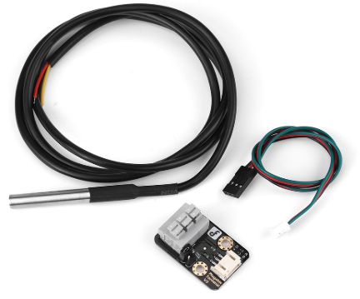
DS18B20 temperature sensor is a waterproof digital module sensor compatible with Arduino. This sensor can provide measurements between 10°C and +85°C and has a good accuracy of (±0.5°C). It is simple to use and cost effective. The key element in selecting this sensor is the low current draw of 1mA for each measurement, which would give a high life cycle to the battery powering the project [60].
Figure 28 - Temperature sensor (DS18B20)

- MG811 Carbone Dioxide sensor (CO2)
The MG811 CO2 is an analogue sensor designed for project research. It can be used for indoor or outdoor measurements, is highly sensitive and capable of providing readings between 0 and 10000 ppm when well calibrated. This sensor is considered as being compatible with both Arduino and Raspberry-Pi, but the reality is that the performance and the accuracy suffer when it is not powered externally using full 6V. However, this sensor is still considered by researchers as being highly effective when well calibrated. It uses less power (200 mA) but is still considered as a low-cost sensor (please see the appendices for the MG811 specifications).
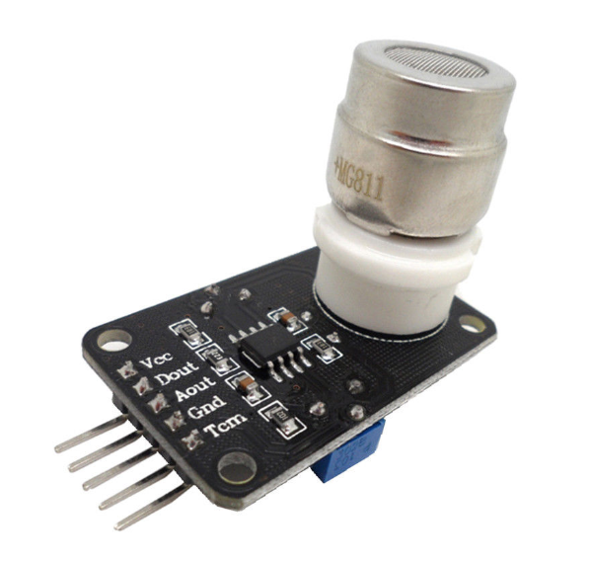

Figure 29 - MG811 CO2 sensor

5.3.2 Software

- Arduino IDE (v1.8.9)
Arduino IDE software is an open source platform based on Java and other open sources software. It runs on multiple platforms such as Windows, Linux or Mac. This software enables the users to write simple codes before uploading them to the Arduino board to be executed. For this project we will be using the Windows Arduino IDE 1.8.9 (latest version) to develop the codes for all four sensors to transmit the data to the LoRa gateway [60].

- Raspbian Stretch lite (v4.14)
Raspbian stretch lite is a small image based on Debian Stretch. This software will allow the Raspberry-Pi to fully function when booted from the 4.14 flash image [61]. This software will be flashed to a bootable SD card and mounted to our Raspberry-Pi.
- Etcher (v1.5.5)
Etcher is an open source software developed by Balena Etcher [61] and is a great tool when it comes to flashing IOS image to a bootable drive. This software will be used to flash the SD card with Raspbian Stretch lite image so that the Raspberry-Pi functions properly when hosting the RAK831 modulator.
- STM32 Flash loader demonstrator (v2.8.0)
STM32 Flash loader demonstrator is a free software developed by the giant ST Microelectronics [62]. This PC utility tool runs on Microsoft.
STM32 Flash loader will be used to execute the RAK811 bootloader and to perform firmware upgrade with appropriate image version for the EU region ISM band (868 MHz). In addition, we will be able to configure the LoRa chip “eui” number and other characteristics such as signal power, mode of transmission, type of authentication, etc.
- Hercules SETUP utility (v3.2.8)
This is a freeware software developed by HW group and a very useful tool for different types of port terminal controls such as RS-485, RS-232, UDP/IP and TCP/IP [63]. This software will allow us to configure and test the LoRa chip in the RAK811 transmitter module to suit the project needs.

5.3.3 Building The LoRa gateway using the RAK 831 and Raspberry-Pi 3+

The following steps and stages have been followed to build the LoRa gateway using RPi3 and RAK831 modulator:
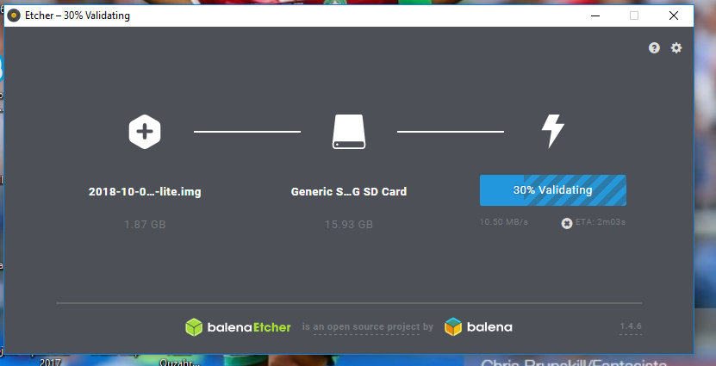
- Flashing the RPi booting SD card with Raspbian Stretch lite image to start the device for the first time. As explained in the software section this was done using Etcher (v1.5.5).
Figure 30 - Flashing SD card with Etcher
- To enable SSH for the first time, we had to create a blank ssh file without any extension as part of the Raspbian stretch lite image files.
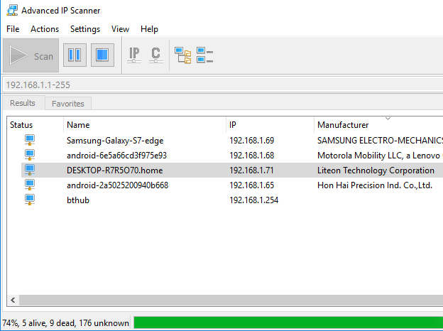
- Connecting the RPi3 to the local home network through the Ethernet cable and scanning for the IP address using Advanced IP Scanner software.
Figure 31 - Advance IP scanner

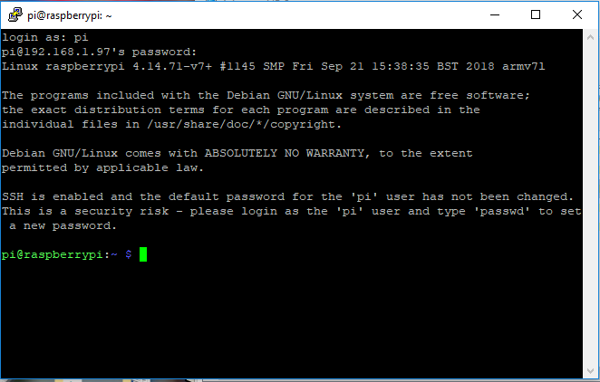
- Logging to the RPi using Putty with default username and password (pi/raspberry).
Figure 32 - logging to RPi for first time
- Changing the username and password.
Figure 33 - Changing the username and password
- Enabling SPI and changing the time zone and region.
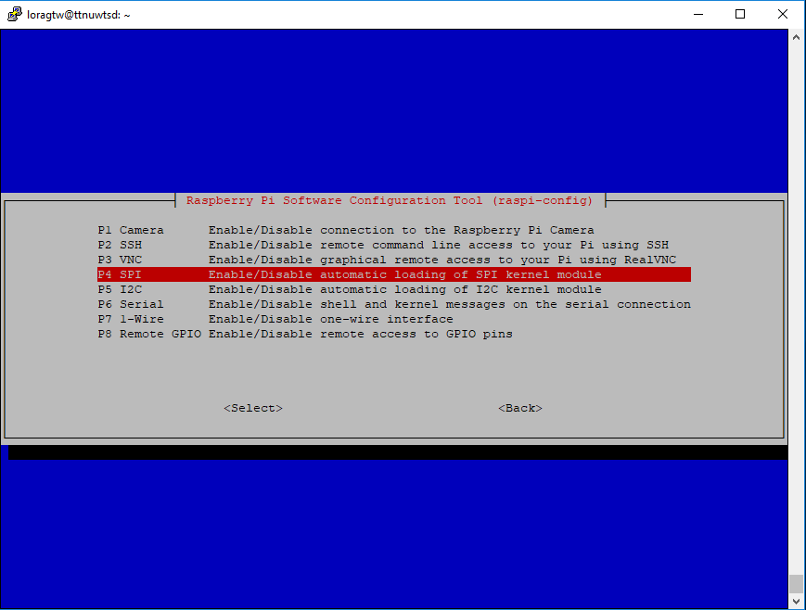
Command: “sudo raspi-config”
Figure 34 - Enable SPI

- Enabling the wireless connection and configuring SSIDs and keys to allow the RPi to connect to the home network and phone hotspot when testing outdoor using the command:
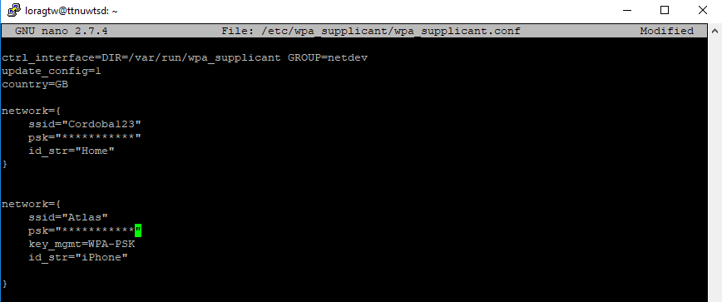
“sudo nano /etc/wpa_supplicant/wpa_supplicant.conf”
Figure 35 - Configuration of Wireless connections

- Rebooting the RPi and running update & upgrade using the home Wi-Fi connection.
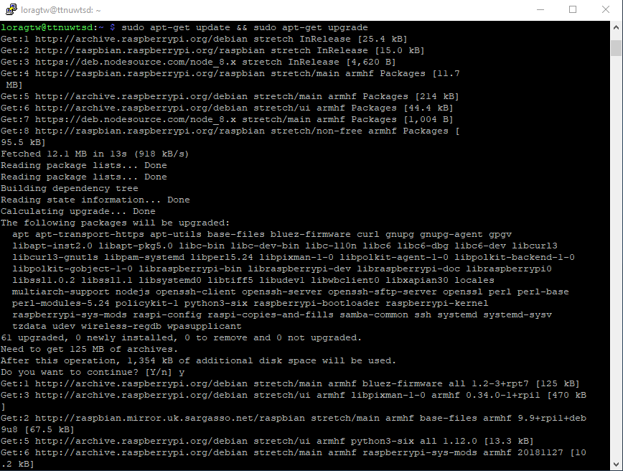
Command: “sudo apt-get update && sudo apt-get upgrade”
Figure 36 - RPi update & upgrade

- Installing “git” to be able to clone repositories.
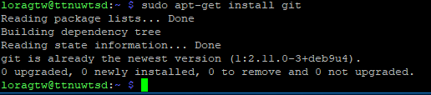
Command: “sudo apt-get install git”
Figure 37 - Installing "git"

- Installing the “ic880a-gateway” repository to enable the RAK831 modulator.
Command: “git clone -b spi https://github.com/ttn-zh/ic880a-gateway.git”
Figure 38 - Installing ic880a repository
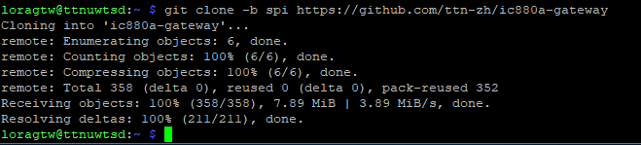
- Making the necessary changes to the ic880a repository for the gateway to function properly using RAK831 instead of “IMST” concentrator; changing the reset pin in the start.sh file to 17 instead of 25 so that our gateway can communicate with the TTN server.
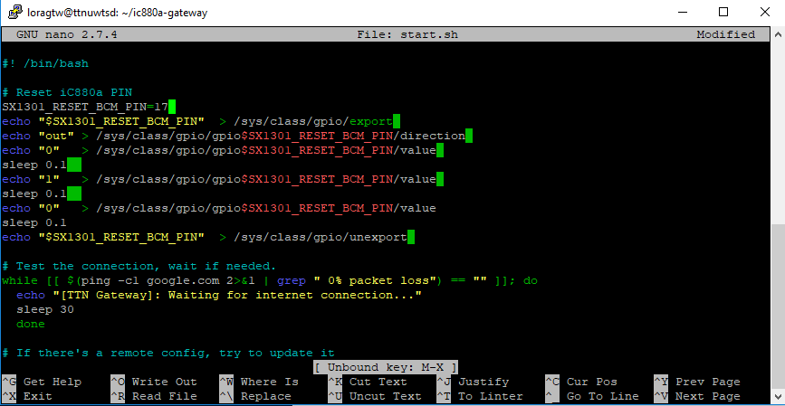
Command: “sudo nano start.sh”
Figure 39 - changing the reset pin to 17
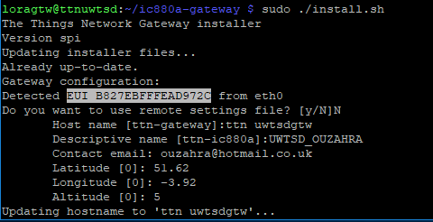
- Completing the installation of all the files using the command “sudo ./install.sh”. In this process it was important to make a note of the “eui” number to be able to register the gateway in the TTN console.

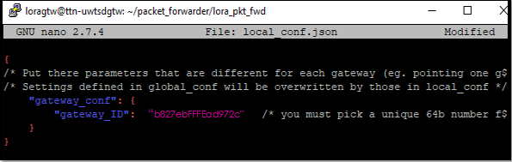
- Making changes to the “local-jaso.config” file so that the gateway ID matches the gateway eui number generated previously.
Figure 40 - Configuration of gateway ID in json.config file

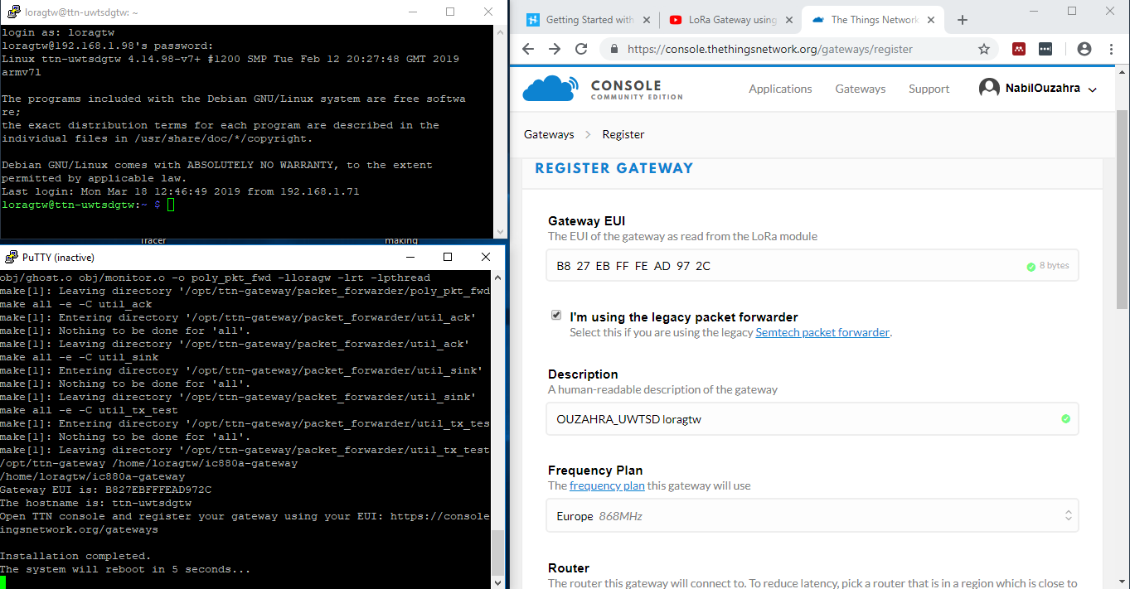
- Registering the gateway on the TTN console for the first time using the same “eui” number after reboot.
Figure 41 - registering the gateway to the TTN server
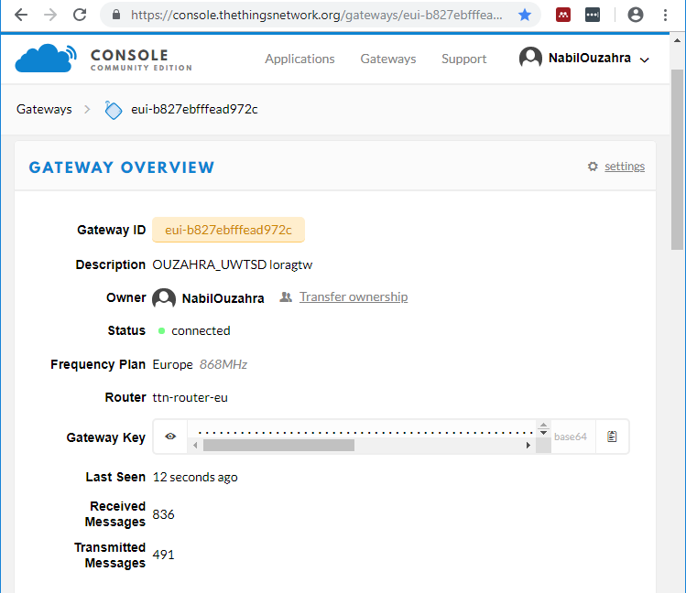
- The gateway was successfully connected to the TTN server and ready to handle any LoRa traffic.
Figure 42 - LoRa gateway successfully connect to the TTN server
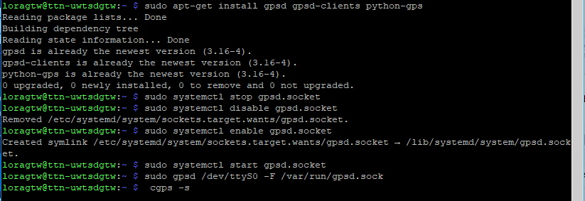
- GPS module integrated with RAK831 modulator was also configured and tested using the following codes:
Figure 43 - GPS configuration
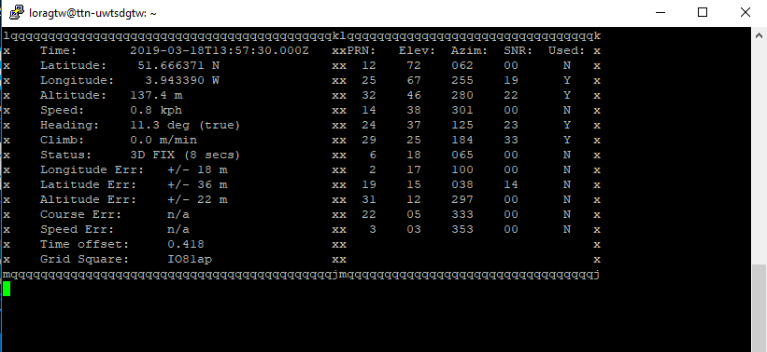
Figure 44 - GPS module operational
Figure 45 - Installing the gateway

5.3.4 Building the Water Quality Transmitter using the RAK 811 and Arduino-Uno

The following steps have been followed to configure the water quality node using RAK811 and Arduino-Uno:
- Before assembling the RAK811 LoRa transmitter with the Arduino Uno, some settings, update and configuration had to be executed so that the water quality node sensor could communicate with the LoRa gateway.
- Setting the RAK pins to a booting mode before connecting the USB serial port to the computer.
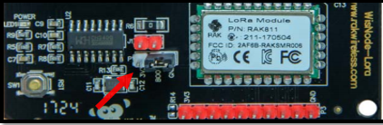
(Connecting the boot pin to 3V pin)
Figure 46 - RAK811 booting mode

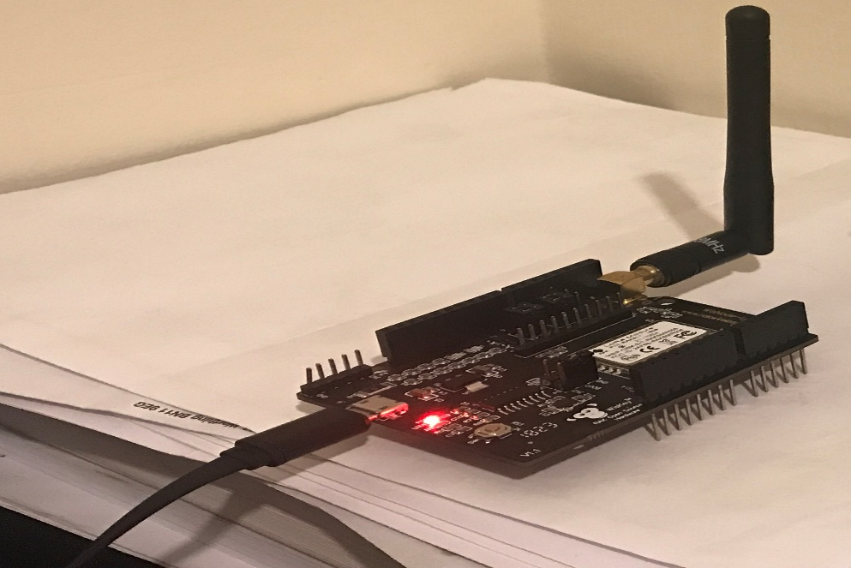
- Connecting the USB serial port to the computer to start firmware upgrade and installing new image to the RAK811.
Figure 47 - Connecting the RAK811 via USB cable

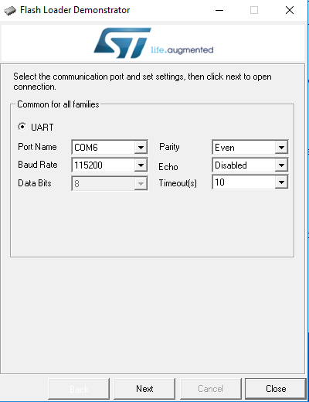
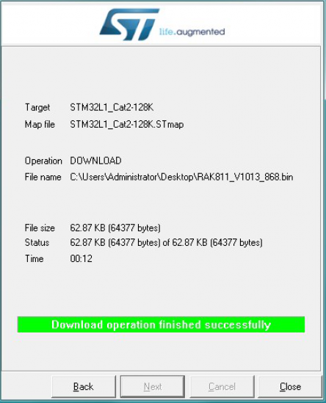
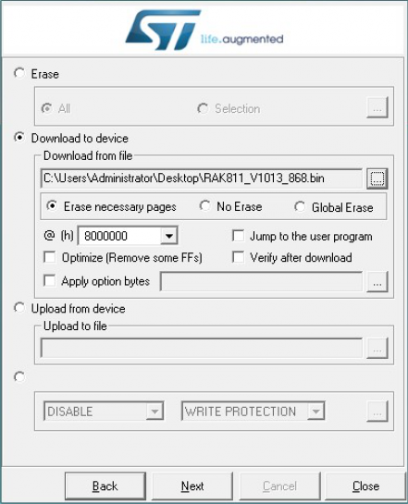
- Launching STM32 bootloader “Demonstrator GUI” software to start upgrading the image to “RAK811_V2022_EU868.bin”
Figure 48 - Upgrading the firmware of the RAK811

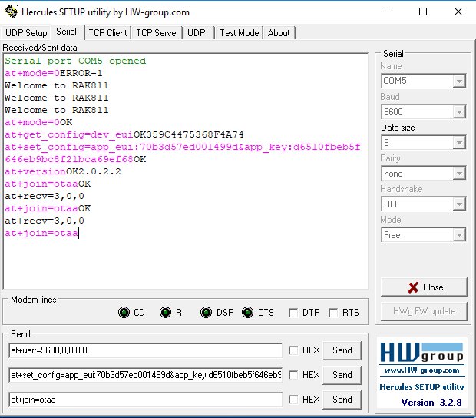
- Configuring the LoRa chip in the RAK811 using “Hercules v3.2.8” software to use LoRaWAN mode (as illustrated in Figure 46), configuring OTAA, adjusting the baud rate to 9600, setting the band to 868MHz and TX power signal to 14dBm to achieve a long-range transmission. All the codes executed in the configuration stage can be found in Figure 49.
Figure 49 - Configuring RAK811 using Hercules software

- The following codes in yellow have been executed using Hercules software:

Welcome to RAK811 // booting of the RAK811
at+mode=0OK // setting the transmission to LoRa mode
at+get_config=dev_euiOK359C4475368F4A74 // gathering the EUI number of the RAK811
at+set_config=app_eui:70b3d57ed001499d&app_key:d6510fbeb5f646eb9bc8f21bca69ef68O // OTAA configuration to match the LoRa gateway keys
at+versionOK2.0.2.2 // checking the version
at+join=otaaOK // launching the OTAA
at+recv=3,0,0 //OTAA successful
Welcome to RAK811 // reset
at+join=otaaOK
at+recv=3,0,0
at+uart=9600,8,0,0,0OK // adjusting baud rate to 9600 for compatibility with Arduino
at+bandOKEU868 // setting the band to EU868 MHz
at+send=0,2,010203040506OK //sending data to test the transmitter
at+recv=2,0,0 // data received
Welcome to RAK811 //resetting the RAK811
at+join=otaaOK
at+recv=3,0,0
at+send=0,2,000000000000007F0000000000000000OK // sending 16 HEX code
at+recv=2,0,0 //message received
at+rf_config=867700000,10,0,1,8,14OK // setting the TX power to 14dBm on the 867.7 MHz frequency

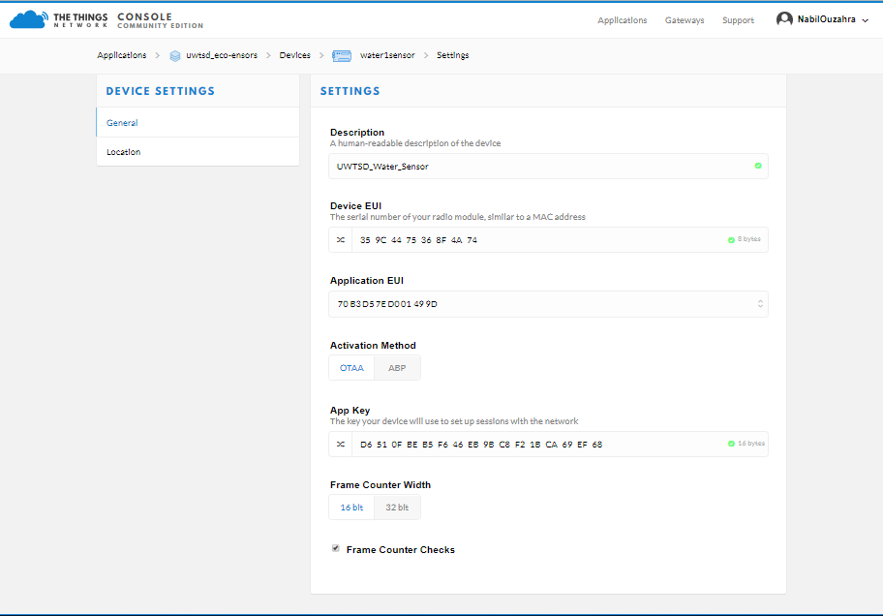
- Registering the water quality sensor in the TTN server using the eui number generated in the configuration process.
Figure 50 - Water quality node registered to the TTN server
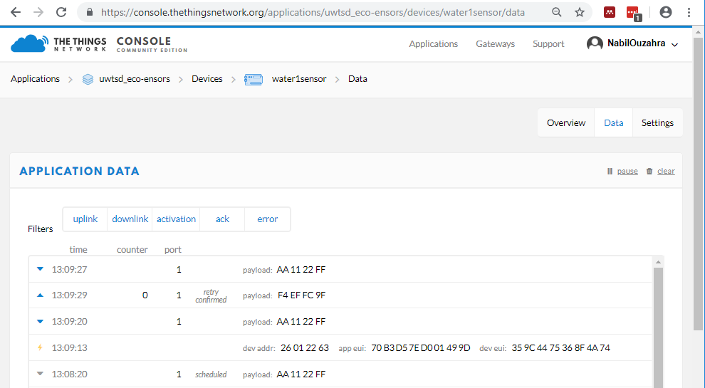
- The water quality node and the LoRa gateway have been successfully tested to check uplink data transmission.
Figure 51 - Uplink data transmission between the RAK and LoRa gateway

- Assembling the water quality sensor node:
The RAK811 and the Arduino will be mounted as a hat to interconnect the TX and RX pins (Transmitting and Receiving pins) with all the sensors powered using the +5V and GND pins. Each analogue sensor will have a dedicated analogue input in the Arduino to measure each element, while the temperature sensor will be connected to the digital pin (D5), pH to the analogue pin (A4) and turbidity to the analogue pin (A5).

- To complete this phase, an Arduino code has been developed to be able to transmit this data in a single payload of 6 HEX bytes. The process of developing this code was very challenging and complex. However, great knowledge and skills have been learned to resolve all the issues.

5.3.5 Building the Air Quality Transmitter using the RAK 811 and Arduino-Uno

In terms of developing the air quality node, the same procedure was followed as explained in the previous steps for the water sensor node. The only difference is the payload as only 2 HEX bytes get sent to the gateway.

5.3.6 Sensors calibration

Except for the temperature sensor, each sensor was calibrated in small labs using an Arduino code to convert the analogue signal (voltage) to an equivalent true decimal value and the adjustment of the output voltage using the PCB potentiometers.
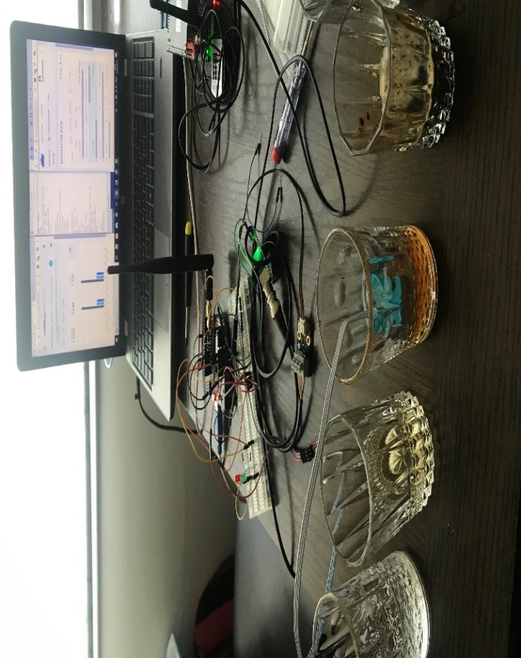
- Regarding the turbidity, the sensor was calibrated using three different solutions to represent 0 NTU, 1000 NTU and 3000 NTU (please see figure 52).
Figure 52 - Turbidity sensor calibration

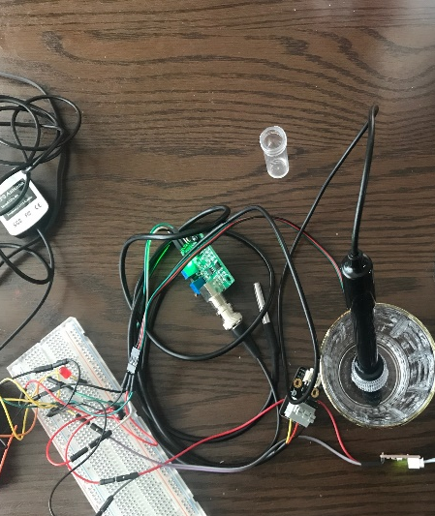
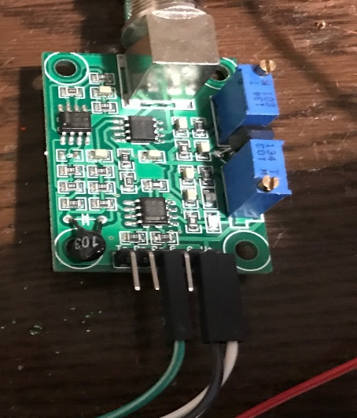
- In terms of pH, the sensor was adjusted to a reading of seven pH on normal drinking water using its capacity potentiometer (please see figure 53).
Figure 53 - pH sensor calibration
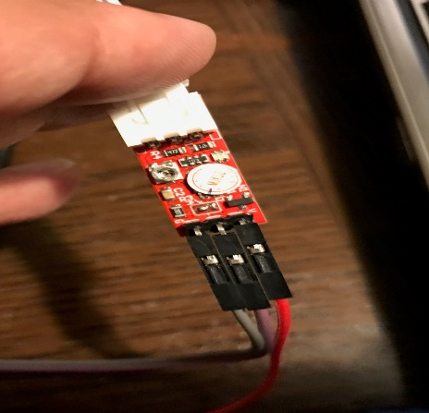
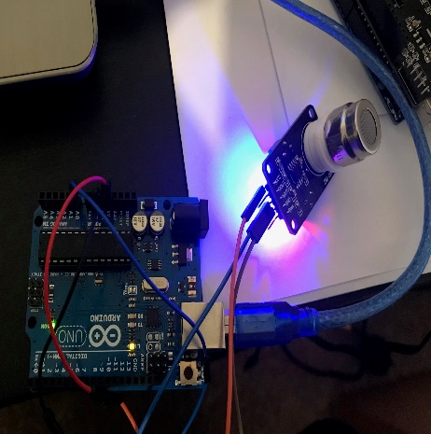
- In terms of the MG811 CO2 sensor, the sensor was adjusted to 400 ppm reading of fresh air using its PCB potentiometer (please see figure 54).
Figure 54 - MG811 CO2 sensor calibration

5.3.7 Arduino codes developed

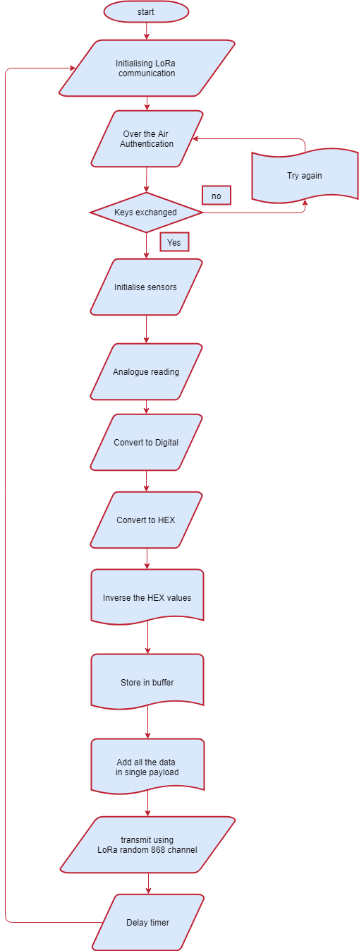
In this section we will explain the process of the Arduino code developed using a flow chart diagram (the actual code will be attached to the appendices).
Figure 55 - Arduino code flow chart [69]
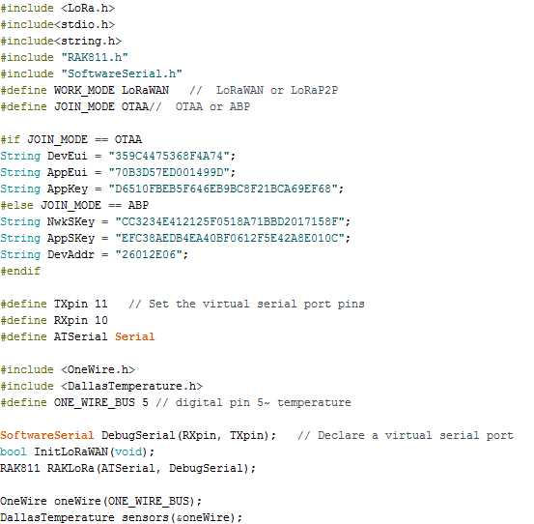
1st Step: including all the libraries needed for the code to work and defining all the variables.

2nd Step: Initialising LoRa communication and OTAA key exchange between the node and the gateway.
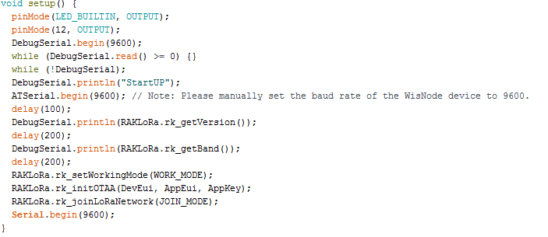

3rd Step: Converting each analogue reading to digital (pH, CO2, Turbidity).

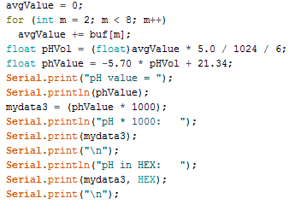
pH code
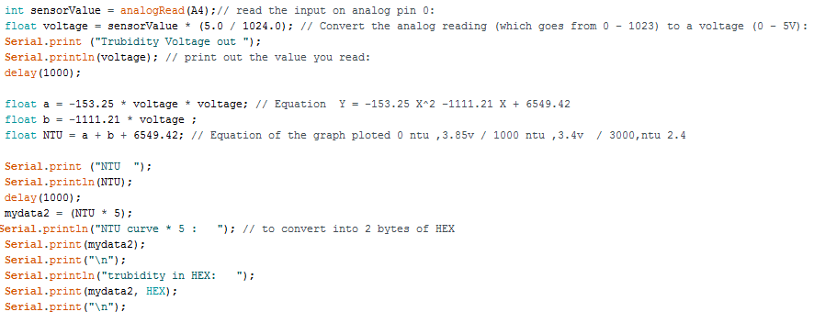
Turbidity Code
CO2 Code
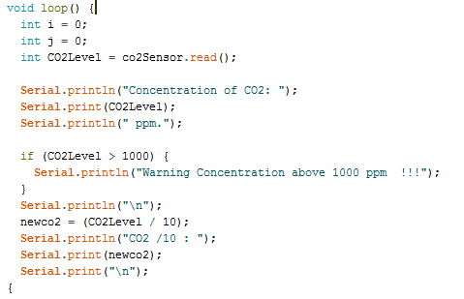

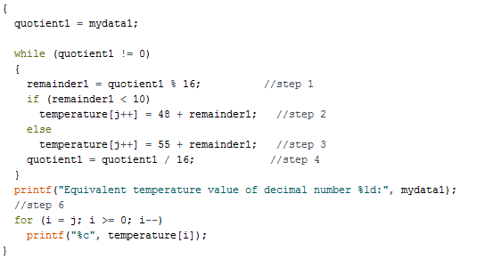
4th Step: Converting the temperature decimal value to HEX (same code was used for pH, turbidity and CO2).
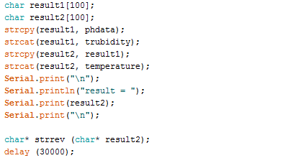
5th Step: Reversing all the Hex data and storing it as char before sending it.
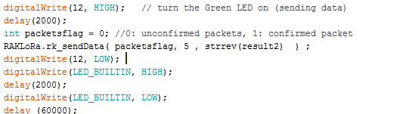
Last Step: Sending the data to the gateway before repeating the same loop after 60 seconds

5.3.8 Integration of the All the things talks web platform

To be able to view a live data stream of the applications, the TTN platform provides a variety of useful APIs integration among them the “All things Talk Maker”. This integration can be easily added and configured using the ID name of the application running, the “eui” number and access key provided. To complete the process of integration each device has to be registered on the “All things Talk Maker” platform with the same credentials and settings, including the payload decoder (JSON code).
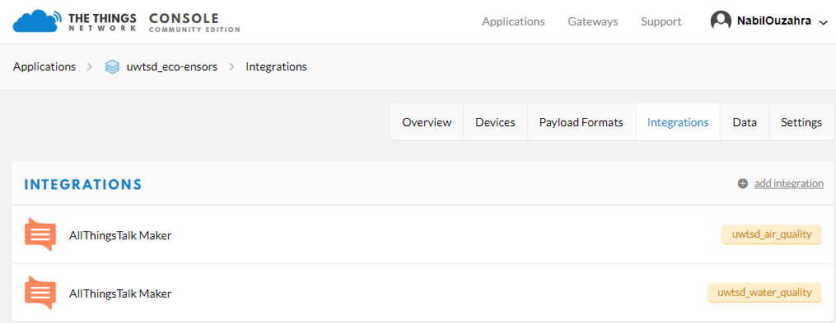
1st step: adding the integration for each application running on the TTN server.
Figure 56 - All things Talk integration added to the TTN platform

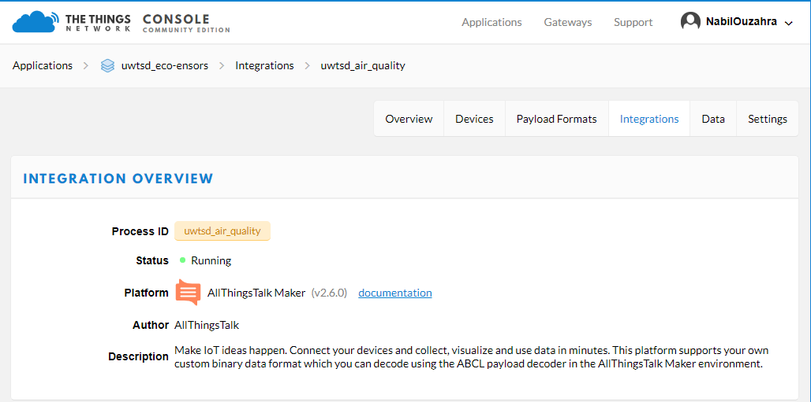
2nd step: configuring the “All things Talk Maker” integration.
Figure 57 - All things Talk integration configured and running
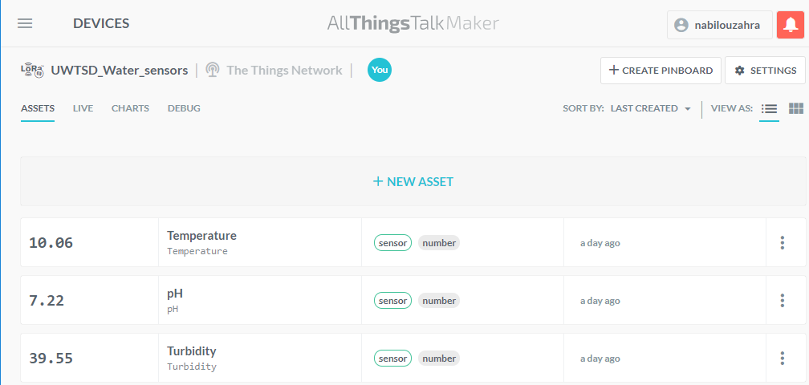
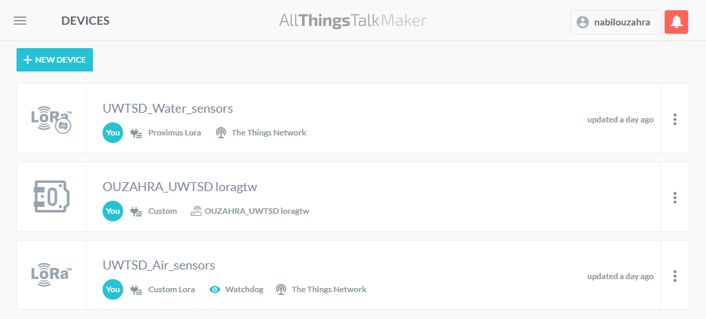
3rd step: registering all the devices and sensors on the “All things Talk Maker” platform.
Figure 58 - All the sensors added to each application
Figure 59 - All the devices registered on the All things Talk platform

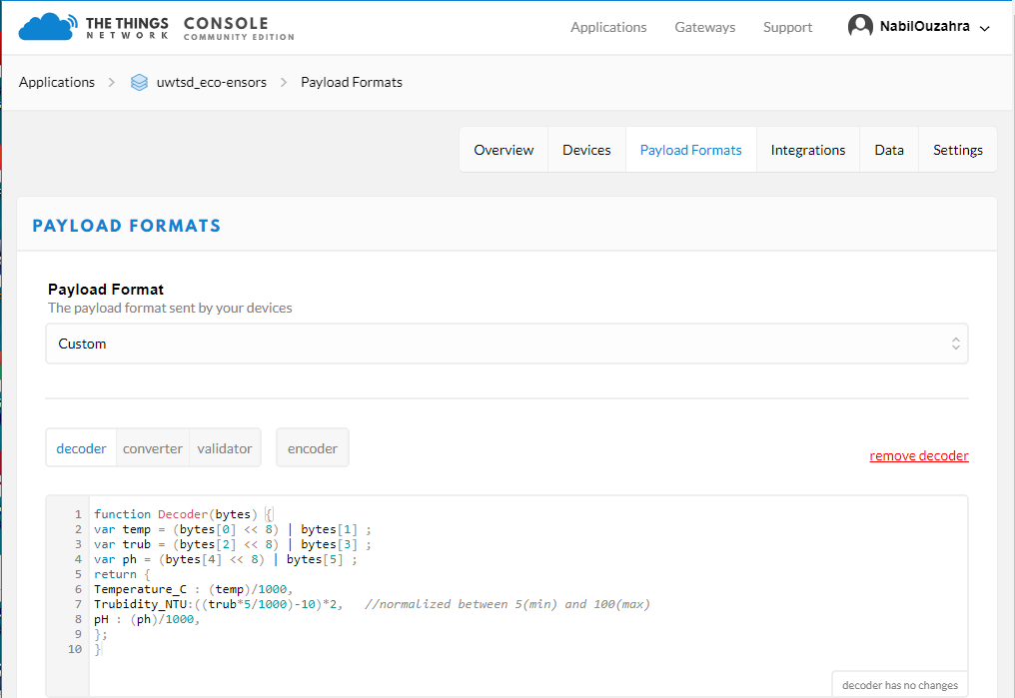
4th step: configuring all the sensors with the appropriate payload decoder (JSON code).
Figure 60 - Payload decoder code in the TTN platform (developed by the author)
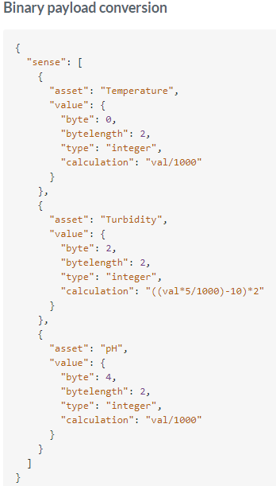
Figure 61 - Payload decoder code in the All things Talk platform (developed by the author)

5th step: testing each application to check if the data matches in TTN and “All things Talk Maker” platforms.

5.3.9 Integration of the TTN mapping

This integration has been added to create a map coverage of Swansea city centre during the tests. The air sensor will be deployed for this purpose to send 2 HEX payload packets from different point locations. To achieve this, a TTN mapper application [64] (please see figure 59) has to be installed on a mobile device to provide the TTN server with geolocation coordinates to help map each packet received to a single point on the map. This very innovative application developed by the TTN team has helped many projects throughout the world to produce a detailed map which includes significant information such as RSSI, SNR and the SF.
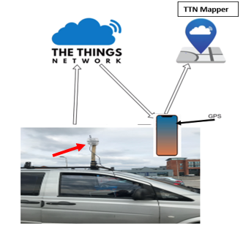
1st step is adding the integration of TTN mapper on the air sensor application.
Figure 62 - TTN mapper concept [7]

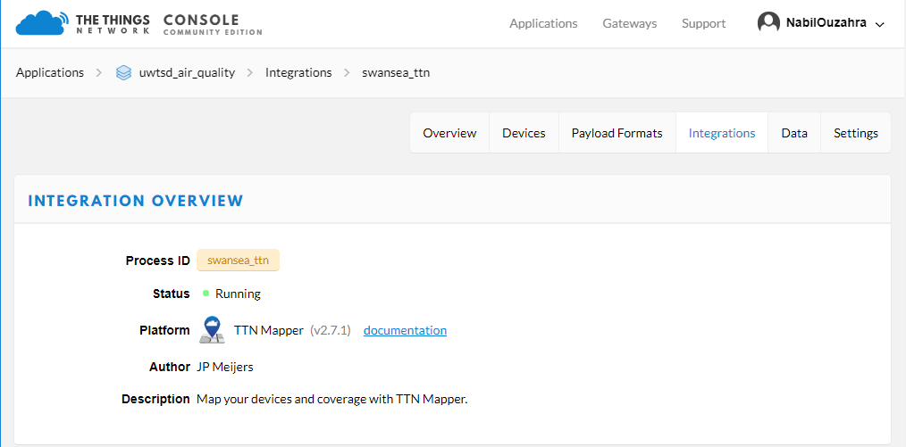
2nd step is installing and configuring the TTN mapper App on a mobile phone.
Figure 63 - adding the TTN mapper to the air sensor application
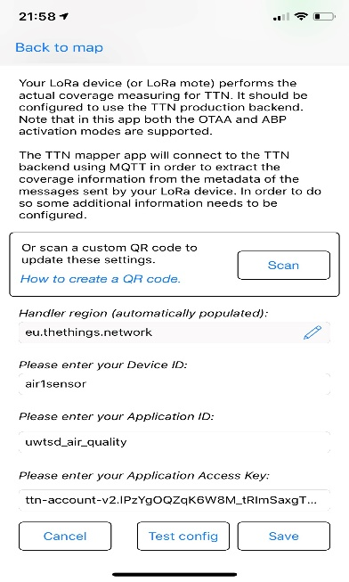
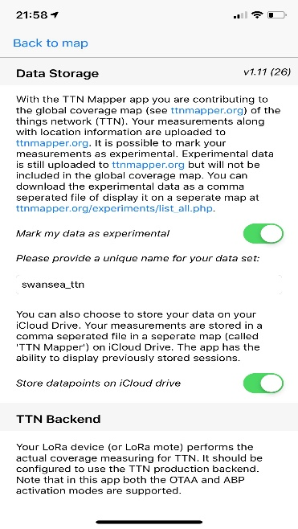
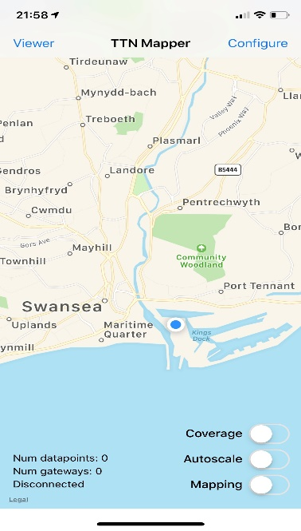
Figure 64 TTN mapper installed and configured on mobile phone

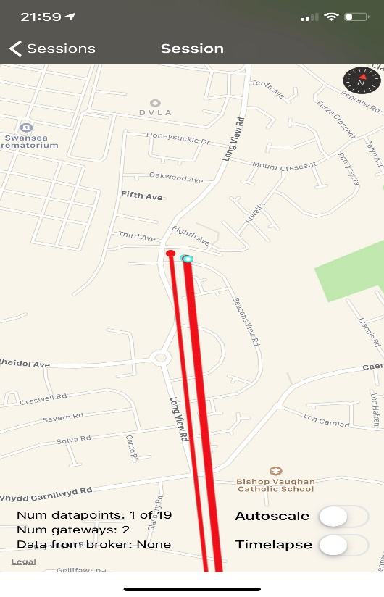
3rd step is running a test to check if the TTN mapper is working.
Figure 65 - TTN mapper testing

5.4 Testing

This section covers the details of the project testing as demonstrated in figure 21. This experiment is divided into two sections:
1st Section:
Testing the water sensor and the air sensor from the river Tawe close to the UWTSD university, live data was sent to the LoRa gateway located on Mount Pleasant hill, covering a distance of 2.4 km. For this purpose, the author had designed a floating platform with all three sensors submerged in water (please see the figures below). After setting all the necessary elements of this experiment such as checking the gateway connection to the internet, checking all the power connections to the power banks, the author ran a live simulation for 30 minutes during which the data was successfully received on both platforms (TTN and “All things Talk”).
In this experiment the author had chosen the leave the transmission protocol set to default mode; this way the gateway would use its default algorithm using RSSI (Receiver Signal Strength Indicator) to assign the appropriate SF to the nodes. All the data was sent with a bandwidth of 125 kHz and a code rate of 4/5 using a 5 dBi omnidirectional antenna on each node and 2 dBi on the gateway.
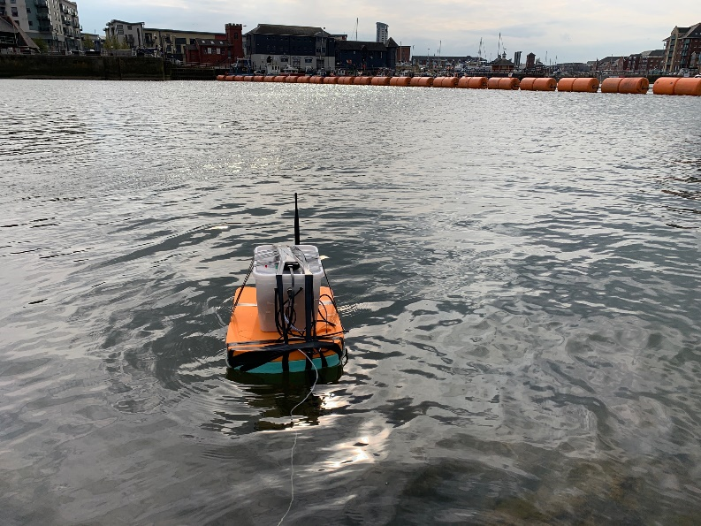
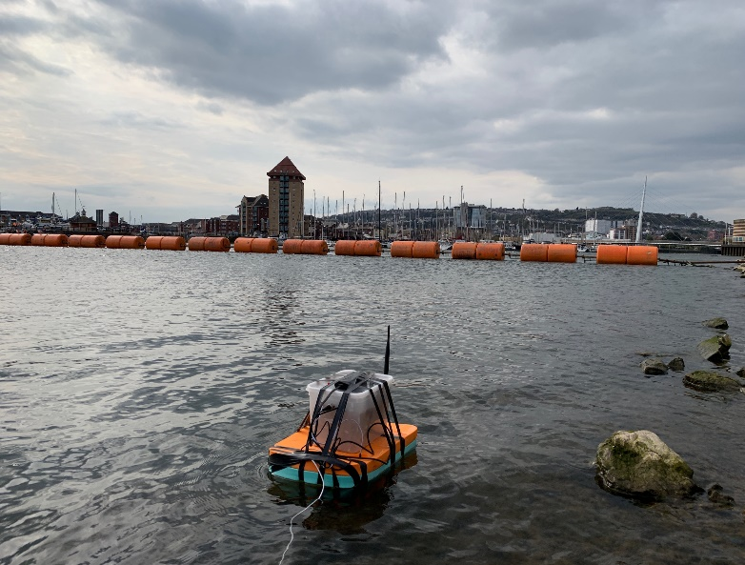
Figure 66 - Water sensor set to transmit
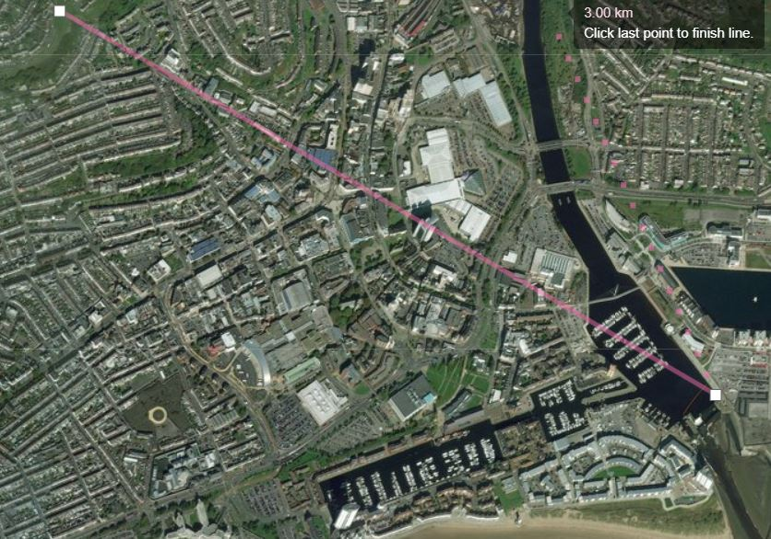
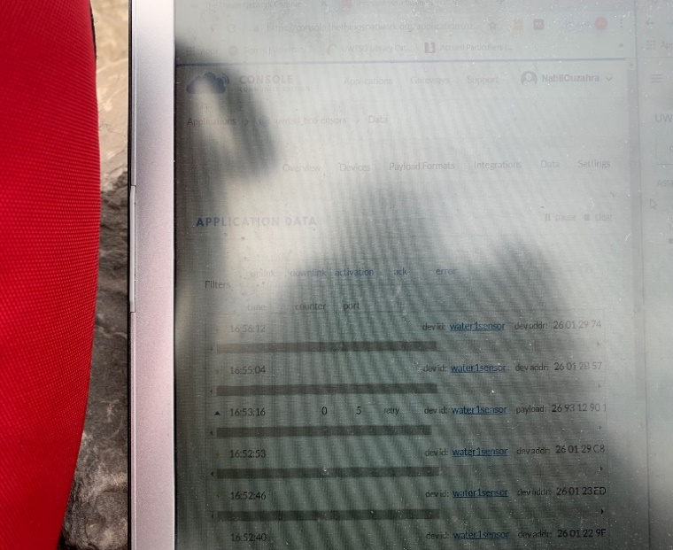
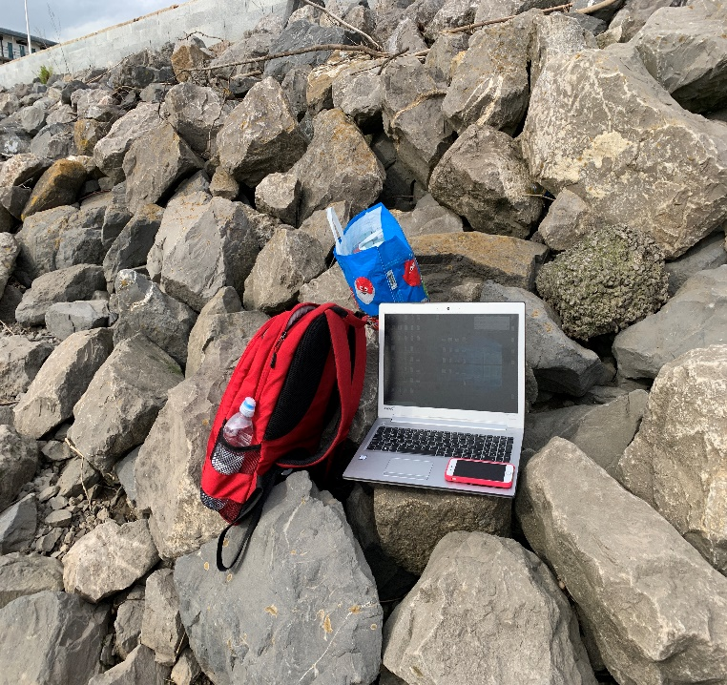
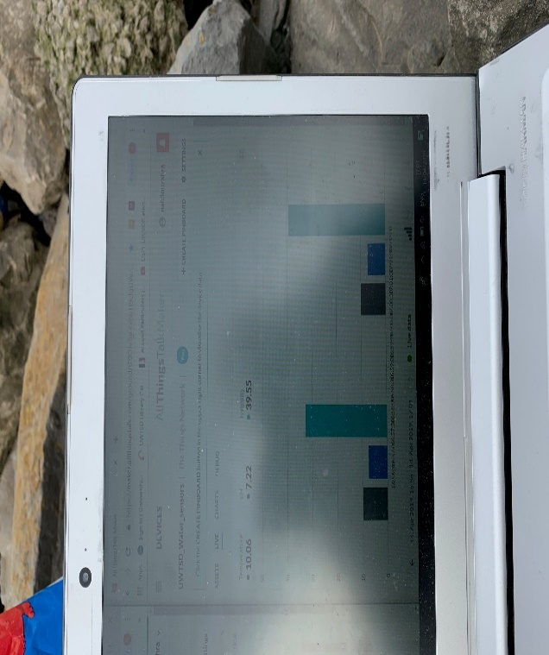
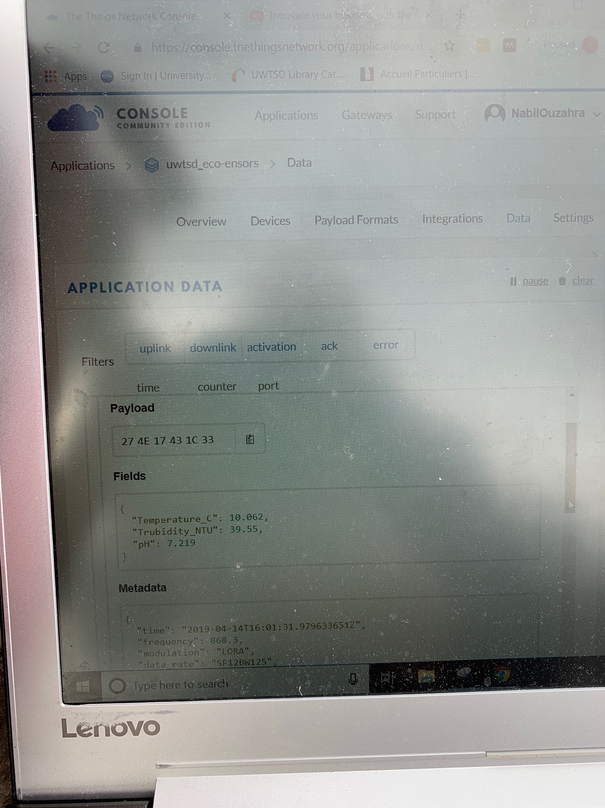
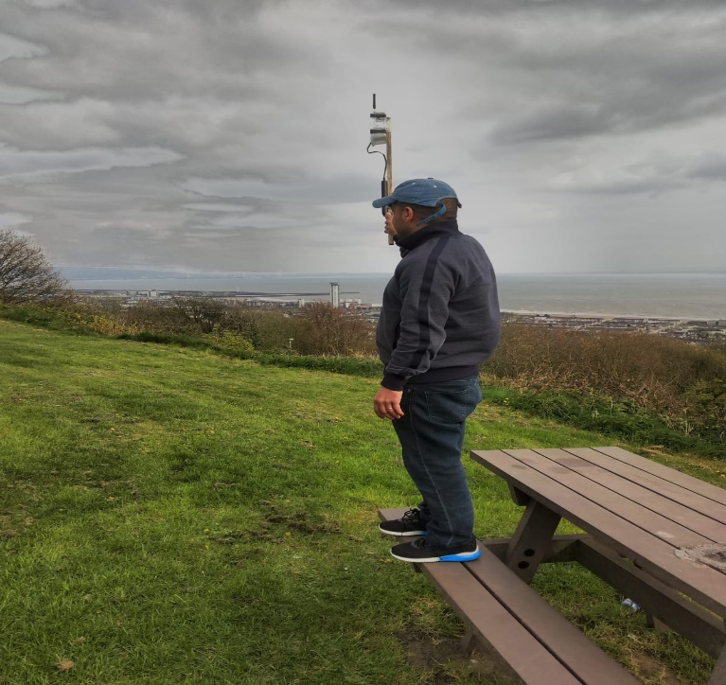
Figure 67 – Distance between the nodes and the gateway (2.4 Km)
Figure 68 - Setup to monitor the data transition
Figure 69 - Data received on the All things Talk platform
Figure 70 - Live data received on the TTN
Figure 71 - Evidence of data transmitted using SF12
Figure 72 - The gateway set to receive data on Mount Pleasant hill
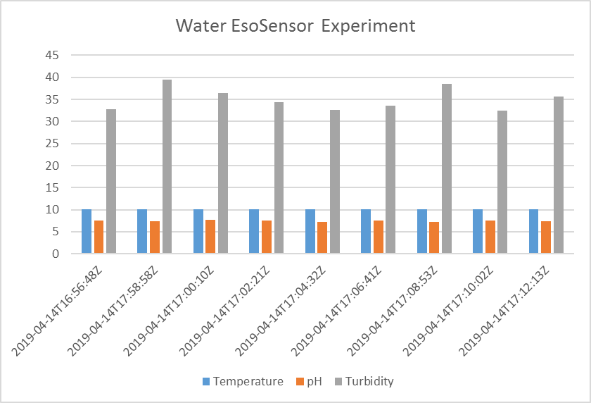
Figure 73 - Graph plotted for the data received on the “All things Talk” platform.

2nd Section:
This part of the testing was set to produce a coverage map of the mobile transmitter (air sensor) driven across the city centre to check if the data could be sent successfully, and also to check the RSSI and SNR of the signal.
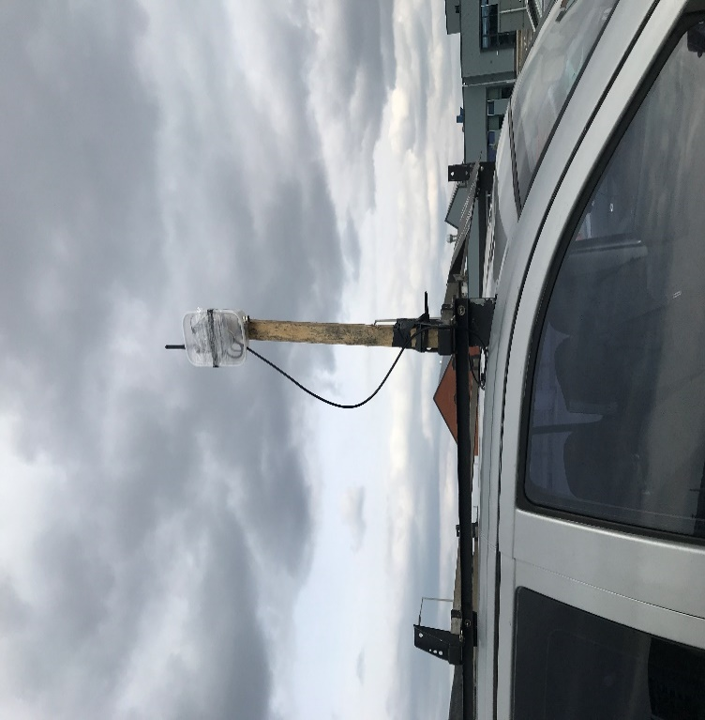
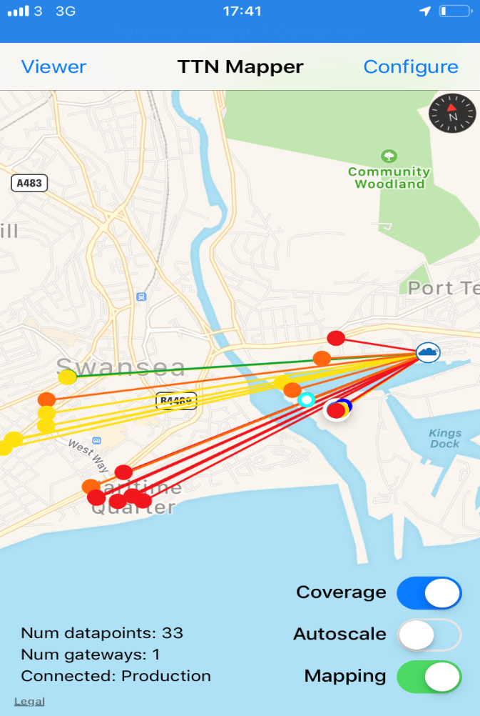
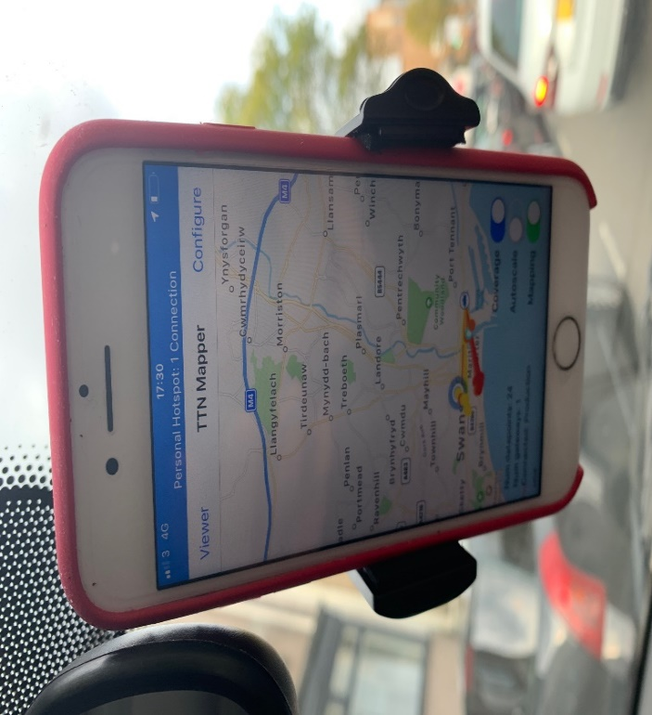
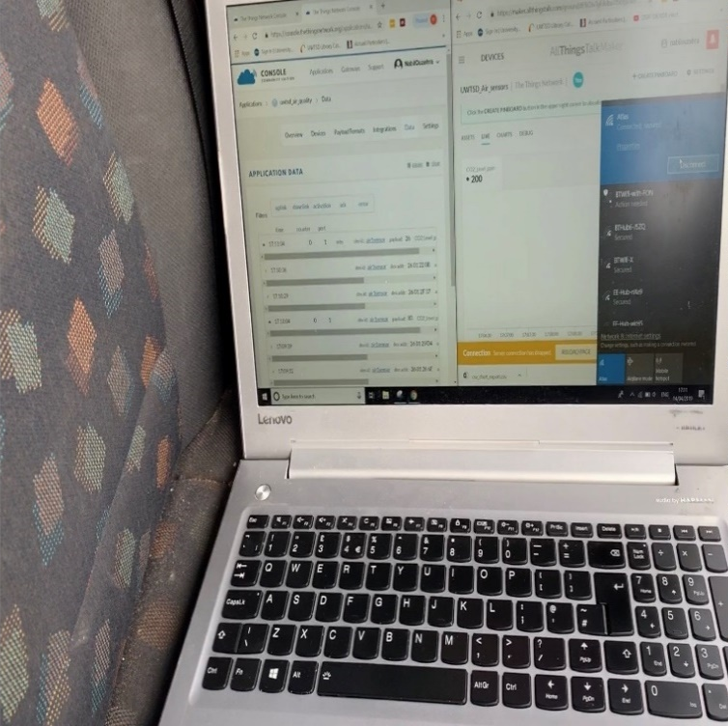
To achieve this the air sensor was mounted on top of a car while the TTN mapping was active on the mobile phone. The results showed and proved that the height of the gateway had helped to transmit the data from different points where there was no line of sight (please see the figures below).
Figure 77 - Air sensor mounted to start the TTN mapping
Figure 74 - Signals pointing to the old location of the gateway
Figure 76 - Laptop set to check the data transmitted
Figure 75 - TTN mapping in progress
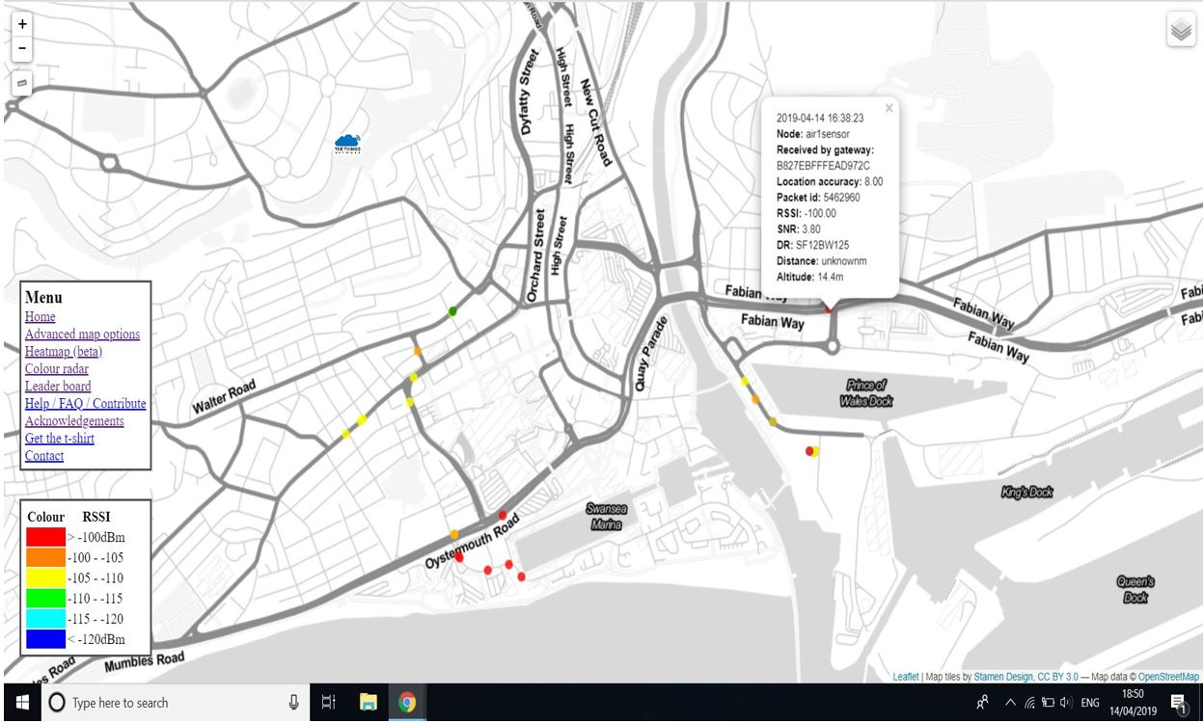
Figure 78 - TTN map of Swansea experiment stored on the TTN Mapper
- The experiments data and videos can be accessed using these links: https://ttnmapper.org/experiments/map.php?name=TTNswanses [65]
https://www.youtube.com/watch?v=1h6Nm2tIjGE
https://youtu.be/uDTdIQxqTkc

5.5 Analysis

This section analyses and discusses the overall performance of the experiments conducted and whether the aim and objectives of this project have been accomplished.
The goal of the first experiment was to send live data (temperature, pH and turbidity) captured by the sensors from the river Tawe (Marina end) to a LoRa gateway based on Mount Pleasant hill, covering the long-range distance of 2.4 km. This was a way to put to test whether the height was an advantage regarding packet loss and also a way to crosscheck whether the low SF 7 and SF 8 could transmit successfully.
Based on the results of this experiment, the prototype of this project has proven to be successful. The initial connection between the gateway and the nodes was established using SF 7 and as predicted LoRa packets started to stream through in both platforms (TTN and “All things Talk”). Due to the weather conditions we were unable to keep this experiment running for more than 30 minutes. However, the overall results were satisfying.
The goal of the second experiment was to produce a coverage information of the LoRa signal using GPS location points, RSSI and SNR with the help of the TTN mapper integration. This was a way to check the quality of the coverage area of Swansea city centre using a single gateway at high altitude. The results showed that the line of sight has a major effect on data transition when using SF 7 and SF 8. However, with SF 9 and above all the data was sent successfully in the absence of line of sight within the perimeter of 2.4 km.
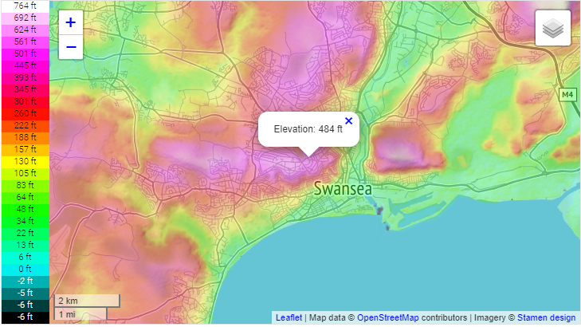
The author has recognised that the gateway would be more efficient if configured to use only SF 9, SF 10, SF 11 and SF 12 to overcome the issue of signal degradation. This experiment has confirmed that the topographical nature of Swansea city could have a major impact on the signal quality and the range of LoRaWAN (please see figure - 79) [66]. The author believes that building an entire LoRaWAN network using a few gateways scattered across the hills of the city and high buildings would benefit the local community and help to protect the environment in the future.
LoRa gateway location during the Experiments
Figure 79 - Swansea topographic map

Summary

The author considers this chapter as the pinnacle of this project. The process of designing and implementing has been challenging. Every section in the development of this project was recorded and documented to ease the day to day running of this project, from the making of the gateway to the result analysis of our two experiments. From the analysis of these experiments, all the positive results confirm that LoRa technology has proven to be a suitable communication protocol to support IoT smart applications designed for small data. To better use this technology in Swansea city, the author recommends that LoRaWAN potentials should be tested and exploited further.

Chapter 6 - CONCLUSIONS AND RECOMMENDATIONS

6.1 Summary

This report delivers an analysis and evaluation of IoT using LoRa technology. We engaged in this project in order to develop an EcoSensor system to monitor the air and water quality in Swansea, to prove that long-range data transmission is possible using LoRa and to highlight the benefits of the topographical nature of Swansea when it comes to testing LoRaWAN. The background research and Literature review sections have helped the author to acquire further knowledge about LoRa communication and its implementation in real life scenarios. This knowledge was used to develop a project implementation design to help accomplish the aim and objectives of this project. The results of this experiment show that our monitoring system is operational and that LoRa data was exchanged between the nodes and the gateway covering 2.4 km. In terms of signal quality, the mapping experiment shows that the communication between the gateway and the nodes in the absence of line of sight could only be achieved using SF 9 and higher.

6.2 Conclusion

This project has given the author a better understanding of how LoRa communication operates. Throughout the background research and Literature review many important aspects associated to IoT applications using LoRa have been discovered. It became clear that LoRaWAN technology was one of the ideal networks to support the growth of IoT for the time being, for several reasons: easy to implement; a single multichannel gateway can support up to 800 devices; it operates in the free ISM band and is considered as the best LPWAN technology when it comes to coverage range. In terms of the results gathered from the two experiments, we can say that the line of sight and SF have a direct impact on the range of coverage and the quality of communication. We concluded that only the use of SF 9 and above would reach the gateway in an urban environment. As more and more cities start to build LoRaWAN networks to support the use of IoT, the author believes that Swansea city should follow in the steps of Cardiff city, Amsterdam and the Scotland national IoT project which has developed a national coverage LoRaWAN network to develop different fields such as “smart cities”, utilities, precision farming and lighting [67].

6.3 RecomMendations FOR FURTHER Research

Further development of this project would require the use of three or four gateways scattered around the city, which would give the researcher more accurate data to build a more realistic map of the coverage and signal information. Developing further the node EcoSensors would require more advanced sensors in order to have a proper analysis of the water and air quality, such as the ones manufactured by “Libelium” [68].
One point that was discussed during the TTN mapping but was not possible to achieve due to a lack of time and human resources was the possibility to produce a wider LoRa signal map for each Spreading Factor, which would be very beneficial. The analysis of this data could help with the planning of gateways positions in the future.
Finally, we would like to see similar projects focusing on analysing the Swansea Bay sea front in order to have a better understanding of the quality of its water.

Chapter 7 – REFLECTIONS

Reflection statement
The overall objectives set for this project were successfully achieved as shown in this report. The research was conducted in a methodological way. The author engaged with each section as planned to overcome all the issues faced and to attain all the milestones set. The author managed to overcome the lack of information on “RAK” modulators by diving into private forums debating the RAK technology implementations. The project experiment design was structured in an academic and professional way to prove our thesis.
Throughout this project the author has enriched his academic knowledge in the subject of IoT and wireless communication in general and LoRa in particular, not to mention the amount of skills and attributes that he has learned and developed:
- Project management: developing the project plan with the help of a Gantt chart and setting well-structured milestones to break down the work load.
- Meeting planning: preparing all the points to be addressed when planning the meetings with the project supervisor to maximise efficiency and benefits.
- Time management: the author has set well-structured tasks and milestones to be attained within a tight deadline to be able to accomplish the aim and objectives of this project on time.
- Delivering under pressure: balancing a busy family life with other modules and the management of this project was a very difficult task. However, the author succeeded in balancing all three after a few weeks.
- Improvising: due to budget limitations, the author had to be more creative to overcome some issues in conducting the experiments and making them successful.

Lessons learnt
- Breaking down tasks into sections to ease up the work.
- Only through hard work and good planning objectives can be met.
- Well-structured planning makes a huge difference when running any project.
- How to achieve all the objectives set for this project.
- How important good documentation and data backup are to ease the work and avoid unnecessary delays.

Aspects that could be tackled differently
The project started later than expected due a change of subject itself. However, the author managed to get back on course a few weeks later.
Regarding seeking help from other lecturers to resolve programming problems when unable to solve them, the author instead insisted to resolve all the issues through a self-learning approach to produce some JSON codes and to get both Arduino codes working appropriately.
More time should be allocated to the design and implementation section, simply because of its complexity.
The author should have consulted the engineers behind the “ARWAIN” project in Cardiff as many questions could have been answered regarding the LoRa implementation.

Barriers experienced throughout this project
- Time management was a big issue due to family commitments.
- Lack of programming skills especially with the JSON language.
- Budget limitations as the author was unable to acquire advanced sensors that could have boosted the quality of the end product.
- Lack of human resources to conduct the experiments.

Positives
- Good planning and time management were key to the success of this project.
- The motivation and adequate guidance from the project supervisor have helped the author to produce quality work.
- The quality of the learning facilities available on the new IQ campus was very important in this project success.

Guidance to future students
- Identify the project subject as early as possible.
- Never change the objectives agreed to cut down work load.
- Have a good planning for your project and stay motivated throughout.
- Breakdown big tasks into small units and milestones.
- Stay focused and positive throughout the project to achieve the aim and objectives set.
- Seek help when needed and consult widely because knowledge is all around.
- Prepare for the planned meetings with the supervisor and always attend them regardless of the amount of work completed.
- Take the supervisor guidance on board and work on it.
- Adhere to the laws and regulation of the university.

Summary
This project has opened new doors and opportunities to acquire more knowledge and skills. By engaging in this project, the author has learned a great amount of information from different fields outside the Networking and project management was one of them. It was also very important to breakdown the workload into small sections and to seek knowledge from everyone around.
The author believes that the key to a successful project is good planning, hard work and motivation.

Chapter 8 – REFERENCES

[1] L. Atzori, A. Iera, and G. Morabito, “The Internet of Things: A survey,” Comput. Networks, vol. 54, no. 15, pp. 2787–2805, 2010.
[2] S. Madakam, R. Ramaswamy, and S. Tripathi, “Internet of Things (IoT): A Literature Review,” J. Comput. Commun., vol. 3, no. 3, pp. 164–173, 2015.
[3] Statista.com, “Internet of Things (IoT) connected devices installed base worldwide from 2015 to 2025 (in billions),” 2018. [Online]. Available: https://www.statista.com/statistics/471264/iot-number-of-connected-devices-worldwide/. [Accessed: 19-Apr-2018].
[4] Louis columbus, “IoT Market Predicted To Double By 2021, Reaching $520B,” Forbes, 2018.
[5] Statista.com, “• IoT: number of connected devices worldwide 2012-2025 | Statista,” 2019.
[6] O. C. Khutsoane, A. M. Abu-mahfouz, S. Africa, and B. Isong, “IoT Devices and Applications based on LoRa / LoRaWAN,” no. November, 2017.
[7] F. Yu, Z. Zhu, and Z. Fan, “Study on the feasibility of LoRaWAN for smart city applications,” Int. Conf. Wirel. Mob. Comput. Netw. Commun., vol. 2017–Octob, pp. 334–340, 2017.
[8] A. Lavric and A. I. Petrariu, “LoRaWAN communication protocol: The new era of IoT,” 2018 14th Int. Conf. Dev. Appl. Syst. DAS 2018 - Proc., pp. 74–77, 2018.
[9] T. M. Workgroup, “What is it ? A technical overview of,” LoRa Alliance, no. November, 2015.
[10] A. Goldsmith, “by Andrea Goldsmith,” Wirel. Commun., p. 250, 2005.
[11] L. Ahlin and J. Zander, “Principles of Wireless Communications,” no. April, 1998.
[12] Dr Carlene Campbell, “M5X01045: Module Contents,” UWTSD Wireless technology, 2017. [Online]. Available: http://moodle.uwtsd.ac.uk/mod/folder/view.php?id=21320. [Accessed: 30-Oct-2017].
[13] X. Chen, S. Xu, H. Yin, W. Wang, and G. Wei, “Potentials of IR-UWB technology for ubiquitous computing,” Pers. Ubiquitous Comput., vol. 15, no. 1, pp. 75–84, 2011.
[14] O. C. Ugweje, Radio Frequency and Wireless Communications, no. April 2004. 2008.
[15] S. Atanasov, “An overview of wireless communication technologies used in wireless sensor networks,” Int. Sci. Conf. eRA-8, no. ISSN-1791-1133, pp. 11–18, 2013.
[16] M. A. M. and M. M. Islam, “Overview of Wireless Sensor Network Chapter,” RFID Technol. Secur. Vulnerabilities, Countermeas., pp. 75–100, 2013.
[17] Z.-E.-H. Kamal and M. A. Salahuddin, “Introduction to Wireless Sensor Networks,” Wirel. Sens. Mob. Ad-Hoc Networks, no. July 2014, pp. 3–32, 2015.
[18] A. J.Albarakati, “An Overview of Wireless Sensor Networks (WSN&apos;s),” Int. J. Comput. Appl., vol. 118, no. 5, pp. 30–33, 2015.
[19] P. Tiwari, V. P. Saxena, and R. G. Mishra, “Wireless Sensor Networks : Introduction , Advantages ,” no. March 2016, 2015.
[20] Chiara Umekubo, “Water in Ancient Rome - WATER POLLUTION,” 2018. [Online]. Available: http://quest2016-07.weebly.com/water-in-ancient-rome.html. [Accessed: 26-Feb-2019].
[21] J. Raich, Review of sensors to monitor water quality, no. December. 2013.
[22] White Paper, “Overview of Water Quality Sensors as Pertinent to Water Distribution Systems (EPA 817-R-07-002).,” 2012.
[23] S. Winkler, L. Rieger, E. Saracevic, A. Pressl, and G. Gruber, “Application of ion-sensitive sensors in water quality monitoring,” Water Sci. Technol., vol. 50, no. 11, pp. 105–114, 2004.
[24] A. Gunatilaka, P. Moscetta, and L. Sanfilippo, “Recent Advancements in Water Quality Monitoring-the use of miniaturized sensors and novel analytical measuring techniques for in-situ and on-line real time measurements,” Proc. Int. Work. Monit. Sens. Water Pollut. Control. Beijing, no. November, pp. 33–43, 2007.
[25] E. F. K. Aguiar et al., “Low-Cost Sensors Calibration for Monitoring Air Quality in the Federal District—Brazil Low-Cost Sensors, Monitoring Air Quality, Calibration of Micro-Sensors MiCS-5521 (CO/VOC), WebGIS,” J. Environ. Prot. (Irvine,. Calif)., vol. 6, no. 6, pp. 173–189, 2015.
[26] O. A. M. Popoola et al., “Use of networks of low cost air quality sensors to quantify air quality in urban settings,” Atmos. Environ., vol. 194, no. February, pp. 58–70, 2018.
[27] G. Biskos et al., “The rise of low-cost sensing for managing air pollution in cities,” Environ. Int., vol. 75, pp. 199–205, 2014.
[28] S. J. Johnston et al., “IoT deployment for city scale air quality monitoring with Low Power Wide Area Networks,” 2018.
[29] European_Commission, “Measuring air pollution with low-cost sensors,” 2018.
[30] A. Dey, “Semiconductor metal oxide gas sensors: A review,” Mater. Sci. Eng. B Solid-State Mater. Adv. Technol., vol. 229, no. December 2017, pp. 206–217, 2018.
[31] S. O. Agbroko and J. Covington, “A novel, low-cost, portable PID sensor for the detection of volatile organic compounds,” Sensors Actuators, B Chem., vol. 275, no. August, pp. 10–15, 2018.
[32] J. Pan, J. H. Choi, C. Nanotubes, and P. Applications, “Optical Sensor,” 2017.
[33] M. Centenaro, L. Vangelista, A. Zanella, and M. Zorzi, “Long-range communications in unlicensed bands: The rising stars in the IoT and smart city scenarios,” IEEE Wirel. Commun., vol. 23, no. 5, pp. 60–67, 2016.
[34] K. Mekki, E. Bajic, F. Chaxel, and F. Meyer, “Overview of Cellular LPWAN Technologies for IoT Deployment: Sigfox, LoRaWAN, and NB-IoT,” PerIoT’18 - Second IEEE Int. Work. Mob. Pervasive Internet Things, pp. 413–418, 2018.
[35] M. Chen, Y. Miao, X. Jian, X. Wang, and I. Humar, “Cognitive-LPWAN: Towards Intelligent Wireless Services in Hybrid Low Power Wide Area Networks,” No. Yy, Mon., vol. XX, no. c, p. 1, 2018.
[36] GSMA, “Long Term Evolution for Machines: LTE-M,” GSMA, 2018. .
[37] M. Bor, J. Vidler, and U. Roedig, “LoRa for the Internet of Things,” Ewsn ’16, pp. 361–366, 2016.
[38] J. Haxhibeqiri, E. De Poorter, I. Moerman, and J. Hoebeke, “A Survey of LoRaWAN for IoT: From Technology to Application,” Sensors (Basel)., vol. 18, no. 11, 2018.
[39] A. Augustin, J. Yi, T. Clausen, and W. M. Townsley, “A study of Lora: Long range & low power networks for the internet of things,” Sensors (Switzerland), vol. 16, no. 9, pp. 1–18, 2016.
[40] M. Loriot, A. Aljer, and I. Shahrour, “Analysis of the use of lorawan technology in a large-scale smart city demonstrator,” 2017 Sensors Networks Smart Emerg. Technol. SENSET 2017, vol. 2017–Janua, pp. 1–4, 2017.
[41] B. Hellstr, “LoRa ® LoRaWAN, What is the real value?”
[42] P. S. Cheong, J. Bergs, C. Hawinkel, and J. Famaey, “Comparison of LoRaWAN classes and their power consumption,” 2017 IEEE Symp. Commun. Veh. Technol. SCVT 2017, vol. 2017–Decem, pp. 1–6, 2017.
[43] J. E. Shuda and A. J. Rix, “Module-Level Monitoring of Solar PV Plants using Wireless Sensor Networks,” no. March, 2018.
[44] Semtech, “LoRa Technology: Ecosystem, Applications and Benefits,” p. 10, 2017.
[45] A. M. Kirthima, “Air Quality Monitoring System using Raspberry Pi and Web Socket,” vol. 169, no. 11, pp. 28–30, 2017.
[46] O. Alvear, W. Zamora, C. T. Calafate, J. C. Cano, and P. Manzoni, “EcoSensor: Monitoring environmental pollution using mobile sensors,” WoWMoM 2016 - 17th Int. Symp. a World Wireless, Mob. Multimed. Networks, no. x, 2016.
[47] A. M. Manoharan and V. Rathinasabapathy, “Smart Water Quality Monitoring and Metering Using Lora for Smart Villages,” 2nd Int. Conf. Smart Grid Smart Cities, ICSGSC 2018, pp. 57–61, 2018.
[48] J. W. Creswell, Research design : qualitative, quantitative, and mixed methods approaches. SAGE Publications, 2013.
[49] J. Clonts, “The concept of reliability as it pertains to data from qualitative studies.,” Annu. Meet. South West Educ. Res. Assoc. Houston, TX. , 1992.
[50] L. R. Frey, C. H. Botan, G. L. Kreps, and B. London Toronto Sydney TblEo Singapore, INVESTIGATING COMMUNICATION AN INTRODUCTION TO RESEARCH METHODS SECOND EDITION ALLYN AND BACON, 2nd ed. Memphis, 2000.
[51] J. Creswell, Research Design Qualitative, Quantitative, and Mixed Methods Approaches. Nebraska-Lincoln, 1994.
[52] J. Creswell, Educational research: Planning, conducting, and evaluating quantitative and qualitative research, Fourth Edi. Nebraska-Lincoln: Pearson, 2002.
[53] P. N. Ghauri and K. Grønhaug, Research methods in business studies, 4th ed. Harlow: Financial Times Prentice Hall, 2010.
[54] by R. Burke Johnson and A. Onwuegbuzie, “Mixed methods research: A research paradigm whose time has come,” Educ. Res., vol. 33, no. 7, pp. 14–26, 2004.
[55] W. Richard, “https://www.thethingsnetwork.org/community/cardiff/,” 2017. [Online]. Available: https://www.thethingsnetwork.org/community/cardiff/. [Accessed: 03-Mar-2019].
[56] A. Lavric and V. Popa, “Internet of things and LoRaTM low-power wide- area networks challenges,” Proc. 9th Int. Conf. Electron. Comput. Artif. Intell. ECAI 2017, vol. 2017–Janua, pp. 1–4, 2017.
[57] RAK Wireless, “RAK831 - RAK | The Middleware from RAK Enable IoT,” 2019. [Online]. Available: https://www.rakwireless.com/en/WisKeyOSH/RAK831. [Accessed: 05-Mar-2019].
[58] L. Louis, “WORKING PRINCIPLE OF ARDUINO AND USING IT AS A TOOL FOR STUDY AND RESEARCH,” Int. J. Control, vol. 1, no. 2, 2016.
[59] Arduino LLC, “Arduino,” 2019. [Online]. Available: https://store.arduino.cc/. [Accessed: 09-Mar-2019].
[60] M. I. Products, “DS18S20 High-Precision 1-Wire Digital Thermometer DS18S20 High-Precision 1-Wire Digital Thermometer Absolute Maximum Ratings,” vol. 92, pp. 1–21.
[61] Raspberrypi.org, “Download Raspbian for Raspberry Pi,” 2019. [Online]. Available: https://www.raspberrypi.org/downloads/raspbian/. [Accessed: 17-Mar-2019].
[62] ST-Microelectronics, “FLASHER-STM32,” no. April 2016, pp. 1–3.
[63] HW group, “Hercules SETUP utility | HW-group.com,” 209AD. [Online]. Available: https://www.hw-group.com/software/hercules-setup-utility. [Accessed: 17-Mar-2019].
[64] Thomas Sealy, “TTN Mapper | The Things Network,” 2019. [Online]. Available: https://www.thethingsnetwork.org/docs/applications/ttnmapper/. [Accessed: 15-Apr-2019].
[65] TTN Team, “TTN_Swnasea Mapper,” 2019. [Online]. Available: https://ttnmapper.org/experiments/map.php?name=TTNswanses. [Accessed: 24-Apr-2019].
[66] Topographic maps, “Topographic map Swansea.” [Online]. Available: http://en-gb.topographic-map.com/places/Swansea-662795/. [Accessed: 17-Apr-2019].
[67] IoT Scotland, “Network | IoT Scotland,” 2019. [Online]. Available: https://www.iot-scotland.net/network/. [Accessed: 15-Apr-2019].
[68] Libelium, “Libelium - Connecting Sensors to the Cloud.” [Online]. Available: http://www.libelium.com/. [Accessed: 17-Apr-2019].

[69] |  | N. Ouzahra, Designed by the author, 2019.

Chapter 9 – BIBLIOGRAPHY

Bibliography
[70] G. Mulligan, “LoRaWAN Delivers Affordable IoT Connectivity: Low-power wireless architecture enables cost-effective global M2M communications.,” Prod. Des. Dev., vol. 72, no. 8, pp. 13–18, Dec. 2017.
[71] J. Navarro-Ortiz, M. Eldefrawy, F. Adelantado, and G. Mulligan, “Understanding the Limits of LoRaWAN.,” IEEE Commun. Mag., vol. 55, no. 9, pp. 60–68, Dec. 2017.
[72] “SENET LAUNCHES GLOBAL LORAWAN CONNECTIVITY.,” Comput. Protoc., vol. 31, no. 12, pp. 3–6, Dec. 2017.
[73] F. Adelantado, “Understanding the Limits of LoRaWAN.,” IEEE Commun. Mag., vol. 55, no. 9, pp. 34–41, Sep. 2017.
[74] M. Eldefrawy, “Formal security analysis of LoRaWAN.,” Comput. Networks, vol. 148, pp. 328–340, Jan. 2019.
[75] Semtech, “LoRa Technology REAL WORLD SOLUTIONS SMART CITIES.”

Appendices

RAK831 specifications:
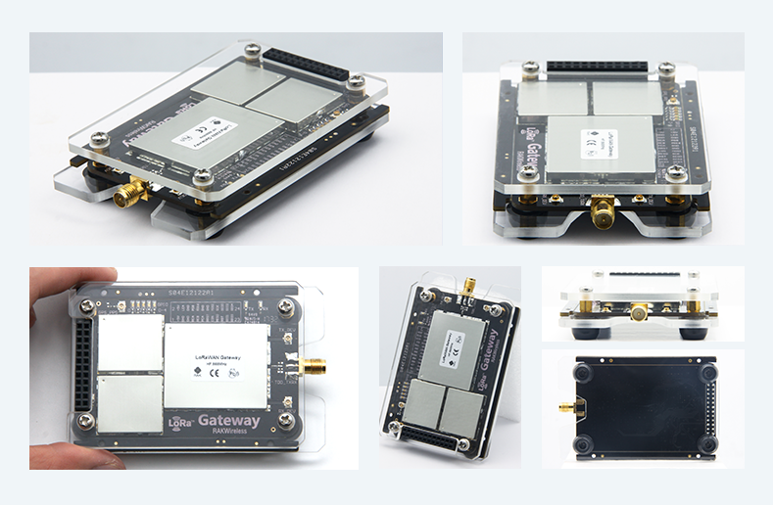
RAK 831 Hardware
Figure 80 - RAK 831 Hardware

RAK 831 Parameters
Table 3 - RAK 831 parameters
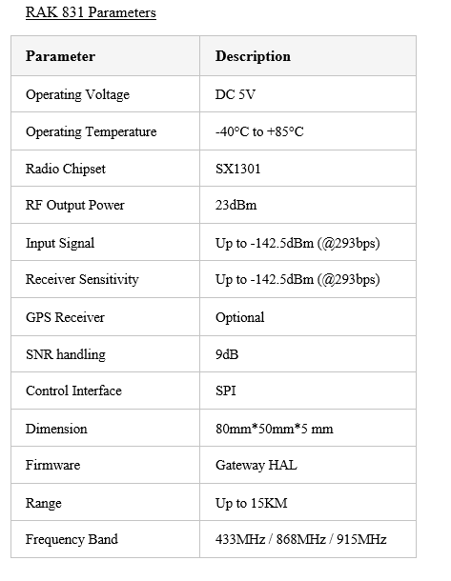
SX1301 Chip Diagram
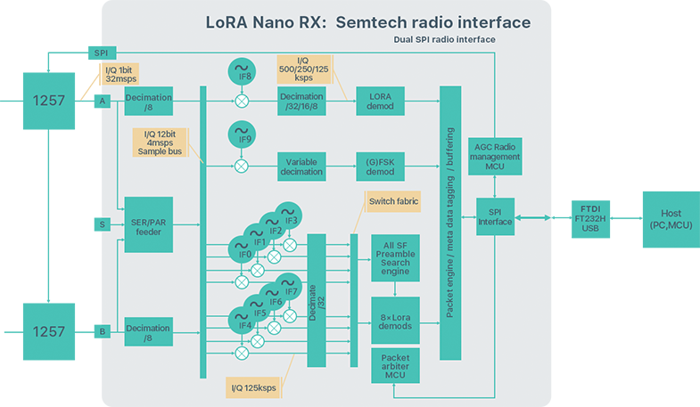
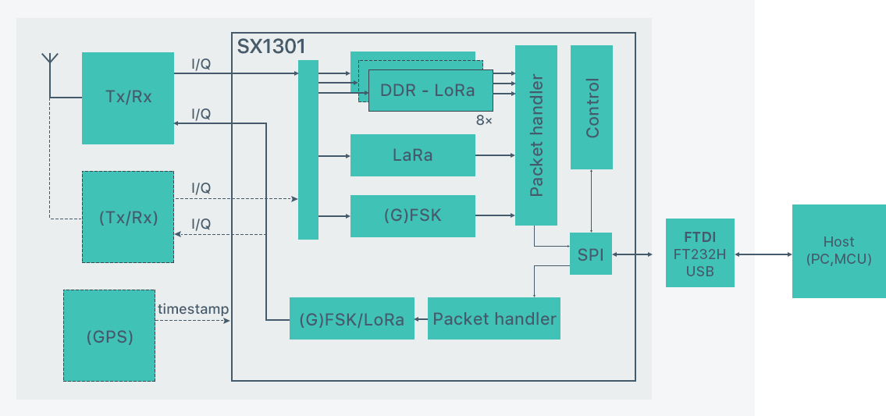
RAK 831 Block Diagram
Figure 81 - RAK 831 Block Diagram
Figure 82 - SX1301 Chip diagram

RAK811 specifications:
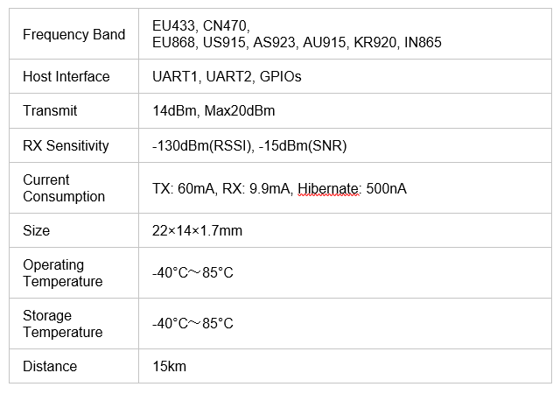
RAK 811 Parameters
Table 4 - RAK 811 parameters

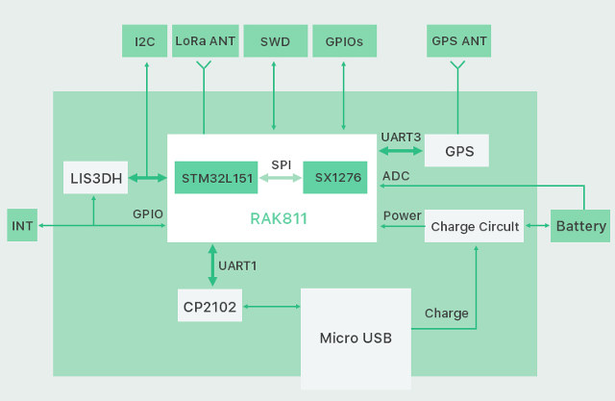
RAK 811 Block Diagram
Figure 83 - RAK811 Block diagram

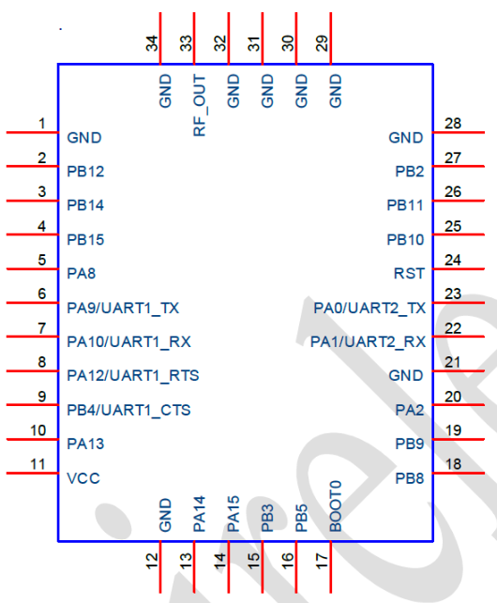
RAK 811 Pins
Figure 84 - RAK811 Pins out

Arduino-Uno specifications:
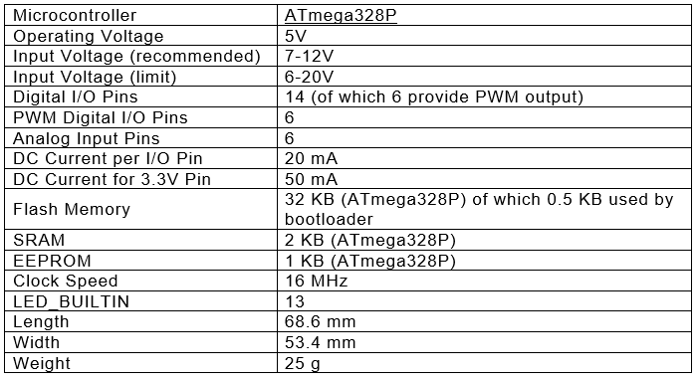
Arduino Uno Data sheet
Table 5 - Arduino Uno data sheet

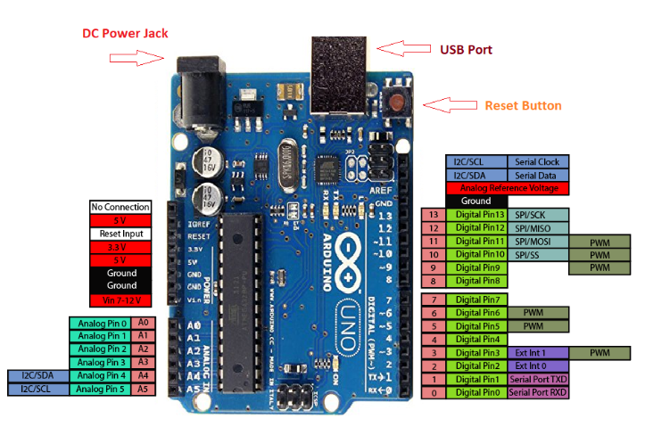
Arduino Pin-Out
Figure 85 - Arduino Uno Pin-Out

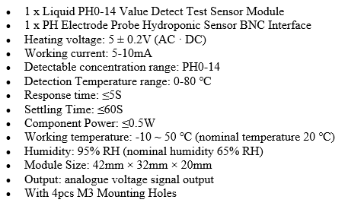
pH sensor specifications:

CO2 Sensor specifications:
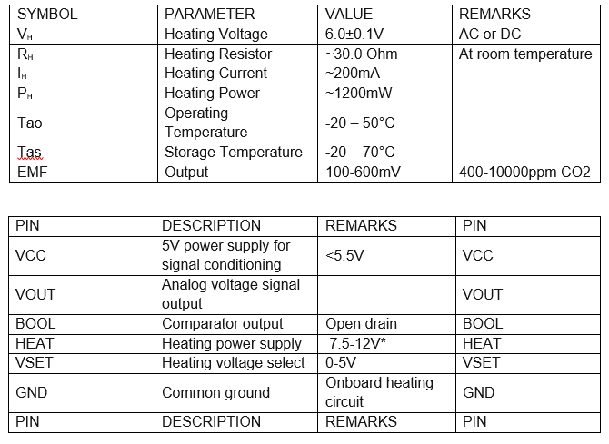
Table 6 - MG811 CO2 sensor specifications

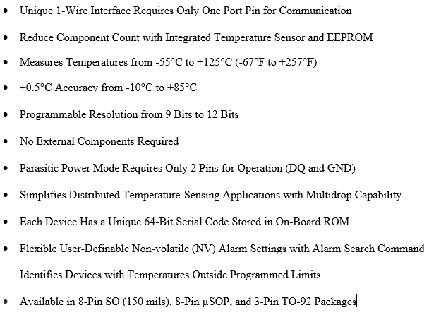
Temperature sensor (DS18B20) specifications:

Project management

Physical and human resources

Every successful project would require different tools and resources, which could vary from the hardware and software to the individuals involved in this project. It is important to identify all the resources needed at an early stage to avoid any unnecessary delays and interruptions.
The list of resources required for this project is as follows:
Software resources:
Microsoft suit, Arduino IDE, Raspbian Stretch lite, Etcher, STM32 Flash loader, Hercules SETUP utility.
Hardware resources:
Arduino Uno, Raspberry-Pi 3, RAK831, RAK811, four sensors (temperature, CO2, turbidity, pH), three antennas (5dBi and 2dBi), laptop, mobile phone and two power banks.
Library materials:
Access to e-books, journals and books from the main library.
Human resources:
Project Leader Mr Nabil ouzahra, Project Supervisor Dr Mabrouka Abuhmida and a fellow student to assist with the testing experiment.

Planning of the project

At the heart of any successful project there is good planning. It is inevitable that problems and hurdles will be faced throughout the project. However, the key here is to set goals and objectives deadlines for each phase of this project to help complete each section within the timeframe that had been set.
The Project Planning and Gantt chart (as illustrated in Figures 18/19) show that this project has been divided into three major parts: Literature review, Design and implementation and Report writing. Each section has then been divided into subsections and allocated the appropriate time to be completed. The last and most important section of this project, the project report, is the only section that should be started as early as possible in order to be more efficient, gain time and be able to break down the writing of a 12,000-word report.
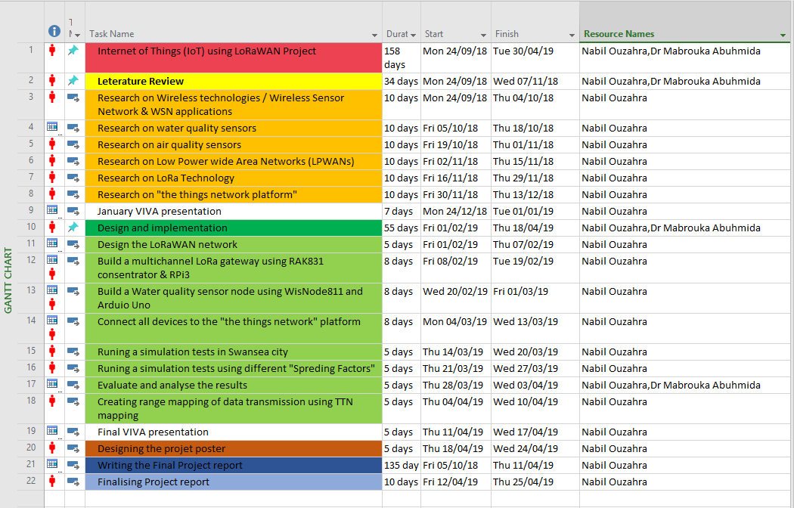
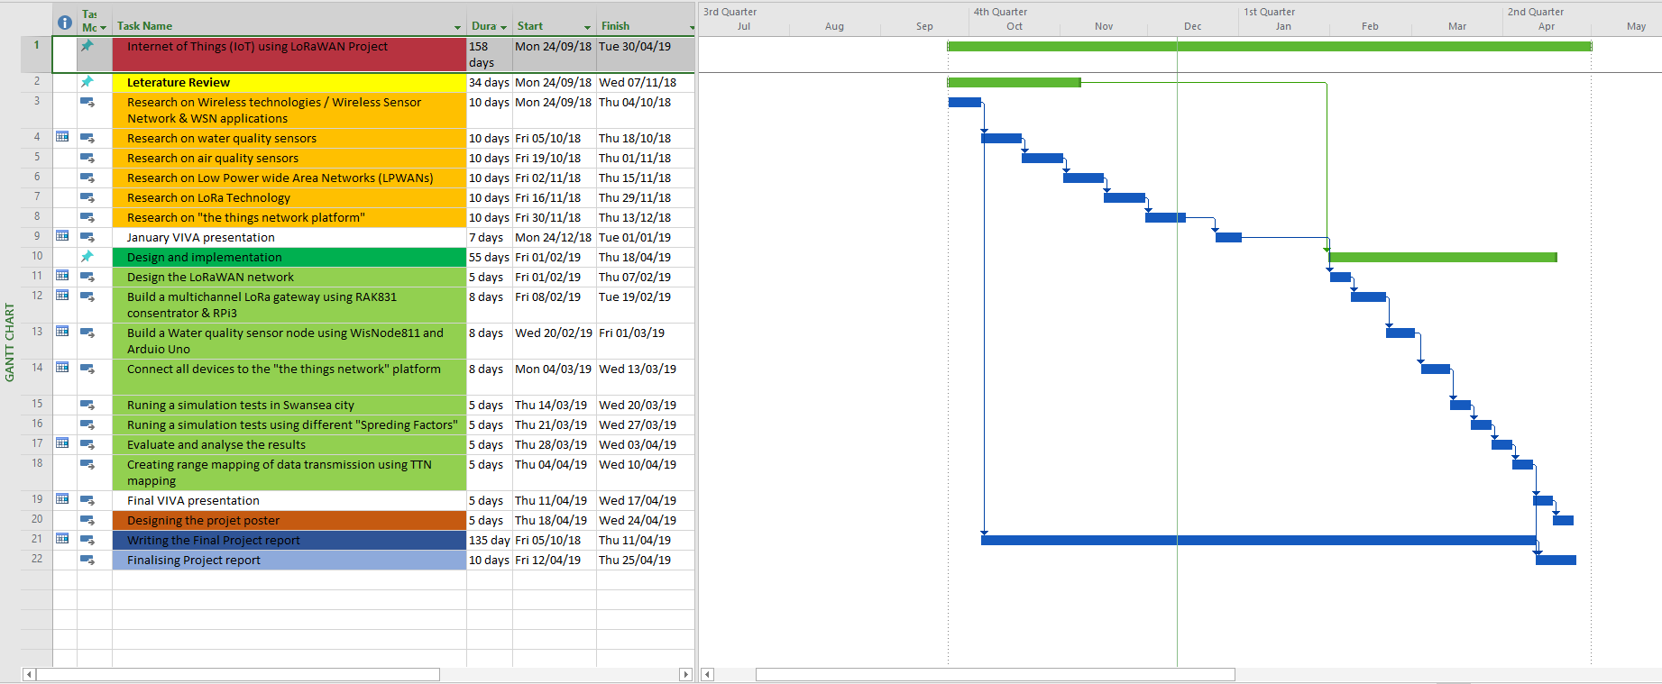
Figure 86 - PROJECT PLANNING WITH RESOURCE [69]
Figure 87 - PROJECT PLANNING WITH GANTT CHART [69]

Risk assessment

It is very important to have an extensive risk analysis to help identify all the possible threats that this project could face:
- Budget limitations could become an issue when purchasing reliable sensors and the LoRa gateway.
- Licence software limitations: some software are only for university use.
- Access restrictions to the lab out of hours could become an issue.
- Back-up data failure: any loss of data related to the making of this project or during the experiments could have negative impacts.
- IT maintenance schedules or power failures within the campus could delay the progress of this project.
- The need for assistance when running tests.

Ethics form
PROJECT RESEARCH Approval Form (Ethics)
Have you considered whether there are any problematic ‘ethical issues’ in your proposed research project? If not, you really should talk to your Course Tutor or Supervisor to discuss if there are any issues you need to address.
If you have already completed an ‘Ethics Approval Form’ within your Faculty/School, you do not need to complete this form. However, you haven’t considered the ethics issues in your proposal, you need to complete this form.
Not all details necessarily apply to your area of study, so you may leave some boxes blank, but do try and complete it as fully as you can. All sections deal with potential ethical issues which need careful consideration before you commence your research, to ensure you deal with them properly (in accordance with the law, for example). You may find it easier to complete the form with assistance from your tutor/supervisor.
Name: | Nabil Ouzahra
Project/Research Title: | IoT using LoRaWAN
Name of Supervisor: | Mabrouka Abuhmida
School/Dept. | SOAC
Faculty: | UWTSD
Proposed Start Date: | 01/10/2018 | End Date: | 01/05/2019

1. Summary of planned research please indicate briefly below the purpose of your planned project/research, together with your aims, main research questions and research design – you can continue onto a separate sheet if necessary
This report delivers an analysis and evaluation of IoT using LoRa technology. We engaged in this project to develop an EcoSensor system to monitor the air and water in Swansea, to prove that long range data transmission is possible using LoRa and to highlight the benefits of Swansea topographical nature when it comes to testing LoRaWAN.
This project is set to have five objectives:
- Conducting a literature review regarding the use of LoRa technology in an IoT application.
- Creating a water sensor node able to transmit water quality data such as pH, turbidity and temperature to the “the things network” platform from long distance.
- Creating an air sensor node able to transmit CO2 carbon dioxide level in the air to the “the things network” platform.
- Creating an actual coverage map of Swansea city centre using the Received Signal Strength Indication (RSSI) and Signal-to-Noise Ratio (SNR) information.
- Highlighting the benefits of building a LoRaWAN network for the use of environmental IoT models (low data & long range) and the impact that could have in our life.

2. Methodology you need to be clear about the methodology you intend to use in your study; this could include any number of methods, so either tick those shown below (where appropriate) or put the details in the box marked *
 | Interviews |  | Participant Observation |  | Use of personal data
 | Focus groups |  | Questionnaire | X | Literature Review
 | Performance |  | Presentation | X | Other (state below)*

Experiment

3. Participants - Does your proposed project/research involve human participants?

 | 1. Yes, as a primary source* |  | 2. Yes, as a secondary source* | X | No- go to section 4

*If you have ticked yes, you are likely to need an Advanced CRB check before undertaking your study

If yes, indicate who your participants are:

 | Early years/Pre-School children |  | Adults - give details below
 | School age children |  | Vulnerable people - give details below
 | Young People aged 17-18
 | Unknown at this stage

4. Other Ethical issues (tick all that may apply to your research)

 | Administration of drugs incl. alcohol |  | Deprivation
 | Unpleasant stimuli in any manner or form |  | Active deception or withholding information
 | Collection of highly personal information |  | Payment

5. Are there any ethical concerns other than those listed above?

NO

6. If there are any ethical concerns, please state how you intend to minimise any risk of harm or distress that could be caused

No Risks involved

You should enclose the research proposal form, together with any materials (e.g. questionnaire, interview schedule) when submitting this form to your tutor/supervisor.

Student Signature Nabil Ouzahra__________________________Date___30/04/2019____________

**********************************************************************************
Supervisor’s Signature ____M.A.________________________Date___30/04/2019____________

Ethics clearance given at Faculty Level
Clearance not given at Faculty level – forwarded for discussion at the next meeting of the University Ethics Committee. Details below:
Comments:

Chair’s Initials |  | Date

Details on this form will be always be dealt with in accordance with the terms of the Data Protection Act 1998. The completed form will be retained on the student’s file after approval (for audit purposes) and may be forwarded firstly to the Faculty Board and thereafter to the University Ethics Committee for a discussion of the issues highlighted.

Logbook

Date | Activity | Comments
03/10/2018 | Meeting with the project Supervisor Mabrouka Abuhmida | The aim and objectives agreed with the Project Supervisor.
17/10/2018 | Meeting with the project Supervisor Mabrouka Abuhmida | Highlighting all the elements that should be covered on the background research.
24/10/2018 | Purchasing the necessary Hardware | The author has ordered all the hardware needed for this project.
31/10/2018 | Meeting with the project Supervisor Mabrouka Abuhmida | Discussion about the appropriate previous works should be used on the literature review chapter with the Supervisor.
14/11/2018 | Meeting with the project Supervisor Mabrouka Abuhmida | Advice has given to the author on how to critically analyses the journals to produce a quality work.
28/11/2018 | Meeting with the project Supervisor Mabrouka Abuhmida | Analysing the work has been accomplished on chapter 1 and 2.
12/12/2018 | Meeting with the project Supervisor Mabrouka Abuhmida | Discussion about the research methodology chapter and what should be done in this section.
16/01/2019 | Meeting with the project Supervisor Mabrouka Abuhmida | Analysing the work done on chapter 3 and getting some feedback regarding the interim Viva presentation.
30/01/2019 | Meeting with the project Supervisor Mabrouka Abuhmida | Discussion about the initial testing of sensors and the calibration process.
01/02/2019 | Developing the gateway | The author has developed and tested the gateway on the TTN platform.
13/02/2019 | Meeting with the project Supervisor Mabrouka Abuhmida | Discussion about the appropriate web platform to be used for the graphical presentation of the data captured.
15/02/2019 | Developing the air and water node sensors | The author has developed the two EcoSensor nodes, the air and water EcoSensors have been successfully connected to the gateway.
27/02/2019 | Meeting with the project Supervisor Mabrouka Abuhmida | Discussion about some coding issues when real data get send to the gateway.
13/03/2019 | Meeting with the project Supervisor Mabrouka Abuhmida | Live demonstration of the entire prototype testing designed.
27/03/2019 | Meeting with the project Supervisor Mabrouka Abuhmida | The Project Supervisor has given some valuable advices on how to document the Experiments.
03/04/2019 | Preparing all the element for the experiments | The author preparing all the element needed for the testing such as configuring the backhaul internet for the gateway using hotspot mobile WiFi etc.
14/04/2019 | Live experiments testing | With the help of a fellow student the author has conducted a live experiment test successfully.
20/04/2019 | Preparing the Final Viva presentation | The final Viva presentation drafted following the university guidelines.
24/04/2019 | Meeting with the project Supervisor Mabrouka Abuhmida | Discussion about the Final report and the positive results accomplished.
25/04/2019 | Designing the project poster | The project poster has been designed using the final report for this project.
01/05/2019 | Submitting the project report | The final project submitted on time.

Other material

Codes developed by the author
Water EcoSensor code:
#include <LoRa.h>
#include<stdio.h>
#include<string.h>
#include "RAK811.h"
#include "SoftwareSerial.h"
#define WORK_MODE LoRaWAN // LoRaWAN or LoRaP2P
#define JOIN_MODE OTAA// OTAA or ABP
#if JOIN_MODE == OTAA
String DevEui = "359C4475368F4A74";
String AppEui = "70B3D57ED001499D";
String AppKey = "D6510FBEB5F646EB9BC8F21BCA69EF68";
#else JOIN_MODE == ABP
String NwkSKey = "CC3234E412125F0518A71BBD2017158F";
String AppSKey = "EFC38AEDB4EA40BF0612F5E42A8E010C";
String DevAddr = "26012E06";
#endif
#define TXpin 11 // Set the virtual serial port pins
#define RXpin 10
#define ATSerial Serial
#include <OneWire.h>
#include <DallasTemperature.h>
#define ONE_WIRE_BUS 5 // digital pin 5~ temperature
SoftwareSerial DebugSerial(RXpin, TXpin); // Declare a virtual serial port
bool InitLoRaWAN(void);
RAK811 RAKLoRa(ATSerial, DebugSerial);
OneWire oneWire(ONE_WIRE_BUS);
DallasTemperature sensors(&oneWire);
float Celcius = 0;
float NTU = 0;
const int analoginPin = A5;
int sensorValue = 0;
unsigned long int avgValue;
float b;
int buf[10], temp;
void setup() {
pinMode(LED_BUILTIN, OUTPUT);
pinMode(12, OUTPUT);
DebugSerial.begin(9600);
while (DebugSerial.read() >= 0) {}
while (!DebugSerial);
DebugSerial.println("StartUP");
ATSerial.begin(9600); // Note: Please manually set the baud rate of the WisNode device to 9600.
delay(100);
DebugSerial.println(RAKLoRa.rk_getVersion());
delay(200);
DebugSerial.println(RAKLoRa.rk_getBand());
delay(200);
RAKLoRa.rk_setWorkingMode(WORK_MODE);
RAKLoRa.rk_initOTAA(DevEui, AppEui, AppKey);
RAKLoRa.rk_joinLoRaNetwork(JOIN_MODE);
Serial.begin(9600);
}
int mydata1, mydata2, mydata3, quotient1, quotient2, quotient3, remainder1, remainder2, remainder3;
char temperature[100];
char trubidity[100];
char phdata[100];
void loop() {
int i, j, k , l, h, g = 0;
for (int m = 0; m < 10; m++)
{
buf[m] = analogRead(analoginPin);
delay(100);
}
for (int m = 0; m < 9; m++)
{
for (int n = m + 1; n < 10; n++)
{
if (buf[m] > buf[n])
{
temp = buf[m];
buf[m] = buf[n];
buf[n] = temp;
}
}
}
avgValue = 0;
for (int m = 2; m < 8; m++)
avgValue += buf[m];
float pHVol = (float)avgValue * 5.0 / 1024 / 6;
float phValue = -5.70 * pHVol + 21.34;
Serial.print("pH value = ");
Serial.println(phValue);
mydata3 = (phValue * 1000);
Serial.println("pH * 1000: ");
Serial.print(mydata3);
Serial.print("\n");
Serial.println("pH in HEX: ");
Serial.print(mydata3, HEX);
Serial.print("\n");
DebugSerial.println("Send data error!");
sensors.requestTemperatures();
delay(1000);
Celcius = sensors.getTempCByIndex(0);
mydata1 = (Celcius * 1000);
Serial.println("Celcius: ");
Serial.print(Celcius);
Serial.print("\n");
Serial.println("temp * 1000: ");
Serial.print(mydata1);
Serial.print("\n");
Serial.println("temp in HEX: ");
Serial.print(mydata1, HEX);
Serial.print("\n");
int sensorValue = analogRead(A4); // read the input on analog pin 0:
float voltage = sensorValue * (5.0 / 1024.0); // Convert the analog reading (which goes from 0 - 1023) to a voltage (0 - 5V):
Serial.print ("Trubidity Voltage out ");
Serial.println(voltage); // print out the value you read:
delay(1000);
float a = -153.25 * voltage * voltage; // Equation Y = -153.25 X^2 -1111.21 X + 6549.42
float b = -1111.21 * voltage;
float NTU = a + b + 6549.42; // Equation of the graph ploted 0 ntu ,3.85v, 1000 ntu ,3.4v, 3000,ntu 2.4
Serial.print ("NTU ");
Serial.println(NTU);
delay(1000);
mydata2 = (NTU * 5);
Serial.println("NTU curve * 5 : "); // to convert into 2 bytes of HEX
Serial.print(mydata2);
Serial.print("\n");
Serial.println("trubidity in HEX: ");
Serial.print(mydata2, HEX);
Serial.print("\n");
{
quotient1 = mydata1;
while (quotient1 != 0)
{
remainder1 = quotient1 % 16; //step 1
if (remainder1 < 10)
temperature[j++] = 48 + remainder1; //step 2
else
temperature[j++] = 55 + remainder1; //step 3
quotient1 = quotient1 / 16; //step 4
}
printf("Equivalent temperature value of decimal number %ld:", mydata1);
//step 6
for (i = j; i >= 0; i--)
printf("%c", temperature[i]);
}
{
quotient2 = mydata2;

while (quotient2 != 0)
{
remainder2 = quotient2 % 16; //step 1
if (remainder2 < 10)
trubidity[l++] = 48 + remainder2; //step 2
else
trubidity[l++] = 55 + remainder2;//step 3
quotient2 = quotient2 / 16; //step 4
}
printf("Equivalent trubidity value of decimal number %ld:", mydata2);
//step 6
for (k = l; k >= 0; k--)
printf("%c", trubidity[k]);
}
{
quotient3 = mydata3;
while (quotient3 != 0)
{
remainder3 = quotient3 % 16; //step 1
if (remainder3 < 10)
phdata[g++] = 48 + remainder3; //step 2
else
phdata[g++] = 55 + remainder3; //step 3
quotient3 = quotient3 / 16; //step 4
}
printf("Equivalent pH value of decimal number %ld:", mydata3);
//step 6
for (g = h; g >= 0; g--)
printf("%c", phdata[g]);
}
char result1[100];
char result2[100];
strcpy(result1, phdata);
strcat(result1, trubidity);
strcpy(result2, result1);
strcat(result2, temperature);
Serial.print("\n");
Serial.println("result = ");
Serial.print(result2);
Serial.print("\n");

char* strrev (char* result2);
delay (30000);

digitalWrite(12, HIGH); // turn the Green LED on (sending data)
delay(2000);
int packetsflag = 0; //0: unconfirmed packets, 1: confirmed packet
RAKLoRa.rk_sendData( packetsflag, 5 , strrev(result2) ) ;
digitalWrite(12, LOW);
digitalWrite(LED_BUILTIN, HIGH);
delay(2000);
digitalWrite(LED_BUILTIN, LOW);
delay (60000);
DebugSerial.begin(9600);
while (DebugSerial.read() >= 0) {}
while (!DebugSerial);
DebugSerial.println("StartUP");
ATSerial.begin(9600); // Note: Please manually set the baud rate of the WisNode device to 9600.
delay(100);
DebugSerial.println(RAKLoRa.rk_getVersion());
delay(200);
DebugSerial.println(RAKLoRa.rk_getBand());
delay(200);
RAKLoRa.rk_setWorkingMode(WORK_MODE);
RAKLoRa.rk_initOTAA(DevEui, AppEui, AppKey);
RAKLoRa.rk_joinLoRaNetwork(JOIN_MODE);

return;
}

Air quality sensor code:
#include "CO2Sensor.h"
#include <LoRa.h>
#include<stdio.h>
#include<string.h>
#include "RAK811.h"
#include "SoftwareSerial.h"
#define WORK_MODE LoRaWAN // LoRaWAN or LoRaP2P
#define JOIN_MODE OTAA // OTAA or ABP
#if JOIN_MODE == OTAA
String DevEui = "85F54A858E6566F5";
String AppEui = "70B3D57ED00155DC";
String AppKey = "03011C631334A42A64B160CB94FAC821";
#else JOIN_MODE == ABP
String NwkSKey = "D16336A66D734B4AED09F0E41105FE7D";
String AppSKey = "1AD871C0A1F18DD864DAB83E45466C54";
String DevAddr = "2601177D";
#endif
#define TXpin 11 // Set the virtual serial port pins
#define RXpin 10
#define ATSerial Serial
SoftwareSerial DebugSerial(RXpin, TXpin); // Declare a virtual serial port
bool InitLoRaWAN(void);
RAK811 RAKLoRa(ATSerial, DebugSerial);
CO2Sensor CO2Sensor(A0, 0.99, 100);
void setup() {
DebugSerial.begin(9600);
while (DebugSerial.read() >= 0) {}
while (!DebugSerial);
DebugSerial.println("StartUP");
ATSerial.begin(9600); // Note: Please manually set the baud rate of the WisNode device to 9600.
delay(100);
DebugSerial.println(RAKLoRa.rk_getVersion());
delay(200);
DebugSerial.println(RAKLoRa.rk_getBand());
delay(200);
RAKLoRa.rk_setWorkingMode(WORK_MODE);
RAKLoRa.rk_initOTAA(DevEui, AppEui, AppKey);
RAKLoRa.rk_joinLoRaNetwork(JOIN_MODE);
Serial.begin(9600);
CO2Sensor.calibrate();
}
int quotient, remainder, newCO2;
char CO2data[100];
int i, j;
void loop() {
int i = 0;
int j = 0;
int CO2Level = CO2Sensor.read();
Serial.println("Concentration of CO2: ");
Serial.print(CO2Level);
Serial.println(" ppm.");
if (CO2Level > 1000) {
Serial.println("Warning Concentration above 1000 ppm !!!");
}
Serial.println("\n");
newCO2 = (CO2Level / 10);
Serial.println("CO2 /10 : ");
Serial.print(newCO2);
Serial.print("\n");
{
quotient = newCO2;
while (quotient != 0)
{
remainder = quotient % 16; //step 1
if (remainder < 10)
CO2data[j++] = 48 + remainder; //step 2
else
CO2data[j++] = 55 + remainder; //step 3
quotient = quotient / 16; //step 4
}
printf("Equivalent CO2data value of decimal number %ld:", CO2data);
//step 6
for (i = j; i >= 0; i--)
printf("%c", CO2data[i]);
}
Serial.print("\n");
Serial.print(CO2data);
Serial.print("\n");
char* strrev (char* CO2data);
Serial.print("\n");
Serial.println("CO2 HEX reverse = ");
Serial.print (strrev(CO2data));
Serial.print("\n");
delay (30000);
int packetsflag = 0; // 0: unconfirmed packets, 1: confirmed packets
RAKLoRa.rk_sendData( packetsflag, 1,(CO2data) );
return;
}

Payload decoder codes used in TTN:
- Water sensor
function Decoder(bytes) {
var temp = (bytes[0] << 8) | bytes[1] ;
var trub = (bytes[2] << 8) | bytes[3] ;
var ph = (bytes[4] << 8) | bytes[5] ;
return {
Temperature_C : (temp)/1000,
Trubidity_NTU:((trub*5/1000)-40)*2, //normalized between 5(min) and 100(max)
pH : (ph)/1000,
};
}

- Air sensor
function Decoder(bytes) {
var CO2 = bytes [0] ;
return {
CO2_Level_ppm : (CO2)*10,
};
}

Payload decoder codes used in “ All things Talk” platform:
- Water sensor
{
"sense": [{"asset": "Temperature",
"value": {
"byte": 0,
"bytelength": 2,
"type": "integer",
"calculation": "val/1000"}},
{"asset": "Turbidity",
"value": {
"byte": 2,
"bytelength": 2,
"type": "integer",
"calculation": "((val*5/1000)-40)*2"}},
{"asset": "pH",
"value": {
"byte": 4,
"bytelength": 2,
"type": "integer",
"calculation": "val/1000"}}]}

- Air sensor
{
"sense": [{"asset": "CO2_Level_ppm",
"value": {
"byte": 0,
"type": "integer",
"calculation": "val*10" } } ] }

Glossary

LoRa: Long Range
LoRaWAN: LoRa Wide Area Network
IoT: Internet of Things
WSN: Wireless Sensor Network
LPWAN: Low Power Wide Area Network
WC: Wireless Communication
RSSI: Received Signal Strength Indication
SNR: Signal-to-Noise Ratio
IEEE: Institute of Electrical and Electronics Engineers
WiMAX: Worldwide Interoperability for Microwave Access
NB-IoT: Narrowband IoT
ISM: Industrial, Scientific and Medical radio
QAM: Quadrature Amplitude Modulation
BPSK: Binary Phase Shift Keying
FSK: Frequency Shift Keying
QPSK: Quadrature Phase Shift Keying
CCS: Chirp Spread Spectrum
AES: Advanced Encryption Standard
LTE-M: The Long-Term Evolution for Machines communication
3GPP: 3rd Generation Partnership Project
NTU: Nephelometric Turbidity Unit
SF: Spreading Factor
CR: Coding Rate
BW: Bandwidth
TTN: The Things Network
RAK831: LoRa multi-channel Modulator
RAK811: LoRa Transmitter
Raspberry-Pi: Small single-board computers
Arduino Uno: Open-source microcontroller board
CPU: Central Processing Unit
SSH: Secure Shell cryptographic network protocol
GPS: Global Positioning System
dBi: Antenna Gain

List of figures
Figure 1 - Internet of Things (IoT) connected devices installed base worldwide from 2015 to 2025 (in billions) 8
Figure 2 - IoT Market growth by 2020 [10] 9
Figure 3 - Evolution of wireless communication 13
Figure 4 - ISM UNLICENSED FREQUENCY BANDS [13] 14
Figure 5 - Types of Radio waves 14
Figure 6 - Waves reflection, diffraction, scattering, and absorption 15
Figure 7 - WSNs Topologies 17
Figure 8 - WSN network architecture [18] 18
Figure 9 - Electrochemical sensor approach 21
Figure 10 - The concept of Photo-Ionization Detector (PID) [35] 21
Figure 11 - Evolution for the LTE IoT [28] 23
Figure 12 - LoRa signal (CSS) 24
Figure 13 - LoRaWAN Protocol stacks 25
Figure 14 - LoRaWAN Network Architecture 25
Figure 15 - LoRaWAN Devices Classes and their impact on battery lifetime 26
Figure 16 - LoRa (SF) air-time, energy & range relations 27
Figure 17 - Systematic process design 36
Figure 18 - Gantt chart showing an estimation of the research duration and research objectives 37
Figure 19 - Comparison analysis between LoRa, SigFox and NB-IoT (main technologies contenders of LPWAN) [12] 40
Figure 20 – Block diagram for the complete project [69] 41
Figure 21 - Implementation prototype design [69] 41
Figure 22 - RAK 831 application diagram 42
Figure 23 - RAK811 WisNode 43
Figure 24 - Raspberry-Pi 3+ 44
Figure 25 - Arduino Uno [58] 45
Figure 26 - pH Sensor (PH0-14) 45
Figure 27 - Turbidity sensor probe 46
Figure 28 - Temperature sensor (DS18B20) 46
Figure 29 - MG811 CO2 sensor 47
Figure 30 - Flashing SD card with Etcher 49
Figure 31 - Advance IP scanner 49
Figure 32 - logging to RPi for first time 50
Figure 33 - Changing the username and password 50
Figure 34 - Enable SPI 50
Figure 35 - Configuration of Wireless connections 51
Figure 36 - RPi update & upgrade 51
Figure 37 - Installing "git" 51
Figure 38 - Installing ic880a repository 52
Figure 39 - changing the reset pin to 17 52
Figure 40 - Configuration of gateway ID in json.config file 53
Figure 41 - registering the gateway to the TTN server 53
Figure 42 - LoRa gateway successfully connect to the TTN server 53
Figure 43 - GPS configuration 54
Figure 44 - GPS module operational 54
Figure 45 - Installing the gateway 54
Figure 46 - RAK811 booting mode 55
Figure 47 - Connecting the RAK811 via USB cable 55
Figure 48 - Upgrading the firmware of the RAK811 56
Figure 49 - Configuring RAK811 using Hercules software 56
Figure 50 - Water quality node registered to the TTN server 57
Figure 51 - Uplink data transmission between the RAK and LoRa gateway 58
Figure 52 - Turbidity sensor calibration 59
Figure 53 - pH sensor calibration 59
Figure 54 - MG811 CO2 sensor calibration 60
Figure 55 - Arduino code flow chart [69] 61
Figure 56 - All things Talk integration added to the TTN platform 62
Figure 57 - All things Talk integration configured and running 62
Figure 58 - All the sensors added to each application 63
Figure 59 - All the devices registered on the All things Talk platform 63
Figure 60 - Payload decoder code in the TTN platform (developed by the author) 64
Figure 61 - Payload decoder code in the All things Talk platform (developed by the author) 64
Figure 62 - TTN mapper concept [7] 65
Figure 63 - adding the TTN mapper to the air sensor application 65
Figure 64 TTN mapper installed and configured on mobile phone 66
Figure 65 - TTN mapper testing 66
Figure 66 - Water sensor set to transmit 67
Figure 67 – Distance between the nodes and the gateway (2.4 Km) 68
Figure 68 - Setup to monitor the data transition 68
Figure 69 - Data received on the All things Talk platform 68
Figure 70 - Live data received on the TTN 68
Figure 71 - Evidence of data transmitted using SF12 68
Figure 72 - The gateway set to receive data on Mount Pleasant hill 68
Figure 73 - Graph plotted for the data received on the “All things Talk” platform. 69
Figure 77 - Air sensor mounted to start the TTN mapping 70
Figure 74 - Signals pointing to the old location of the gateway 70
Figure 76 - Laptop set to check the data transmitted 70
Figure 75 - TTN mapping in progress 70
Figure 78 - TTN map of Swansea experiment stored on the TTN Mapper 71
Figure 79 - Swansea topographic map 72
Figure 80 - RAK 831 Hardware 83
Figure 81 - RAK 831 Block Diagram 84
Figure 82 - SX1301 Chip diagram 84
Figure 83 - RAK811 Block diagram 85
Figure 84 - RAK811 Pins out 86
Figure 85 - Arduino Uno Pin-Out 87
Figure 86 - PROJECT PLANNING WITH RESOURCE [69] 90
Figure 87 - PROJECT PLANNING WITH GANTT CHART [69] 90

List of tables
Table 1 - COMPARISON BETWEEN LORA - SIGFOX - NB-IOT [18] 22
Table 2 - Data collection method 36
Table 3 - RAK 831 parameters 83
Table 4 - RAK 811 parameters 85
Table 5 - Arduino Uno data sheet 86
Table 6 - MG811 CO2 sensor specifications 88

