
CertHE Computing Skills for Workplace

Module Name: Introduction to Web and Database Concepts

Student Name: Vithursha Parameswaran
Student ID: 2442072
Group: 4

Lecturer’s Name: Abida Perveen

Contents
Medi Link Pharmacy Database System 5
Introduction 5
Scenario Analysis 5
ER Diagram 6
Data Structure Design 7
Normalisation (Up to 3NF) 8
Sample Data 9
Queries 11
Low Stock Query 11
11
Sales by Customer Query 12
12
Customer perception Query 13
Total Sales Query 14
Medicine and Supplier Query 15
Forms and Reports 16
Customer Form 16
Medicine Form 16
Sales Form 17
Sales Report 17
Medicine Report 18
Validation and Testing 18
Reflection 19
Conclusion 19
References 20

Medi Link Pharmacy Database System

Introduction

This report describes the design and development of a database system for Medi Link Pharmacy. The pharmacy is A growing local business that at present manages stock, prescriptions, and customer information manually. This traditional approach can create to mistakes, inefficiencies, and difficulties in handling data as the business continues to grow.
To address these issues, a database has been developed using Microsoft Access. The system is intended to store and organise information related to medicines, suppliers, customers, prescriptions, and sales transactions. By automating these processes, the database helps improve accuracy, reduce manual workload, and produce useful reports to support management decisions and regulatory compliance.

Scenario Analysis

The database system is organised form around five key entities: Customers, Suppliers, Medicines, Sales, and Prescriptions. These entities represent the essential data required to support the daily operations of the pharmacy.
Customers are responsible for buying medicines, while suppliers provide the medicines to the pharmacy. The Sales entity records transaction details for each purchase, and the Prescriptions entity stores information about medicines prescribed by doctors to specific customers.
The Customers table includes fields such as Customer, Customer Name, Phone, and Address. The Suppliers table contains Supplied, Supplier Name, and Phone. The Medicines table stores Medicined, Medicine Name, Price, Stock Quantity, and Supplied, which links each medicine to its supplier. The Sales table includes Sale, Medicined, Customer, Quantity, and Total Price to record transaction details. The Prescriptions table contains Prescription, Customer, Doctor Name, and Date Issued.
The relationships between these entities are as follows: one supplier can supply many medicines, one customer can have many prescriptions, one customer can be linked to many sales transactions, and each medicine can be included in many sales records.

ER Diagram
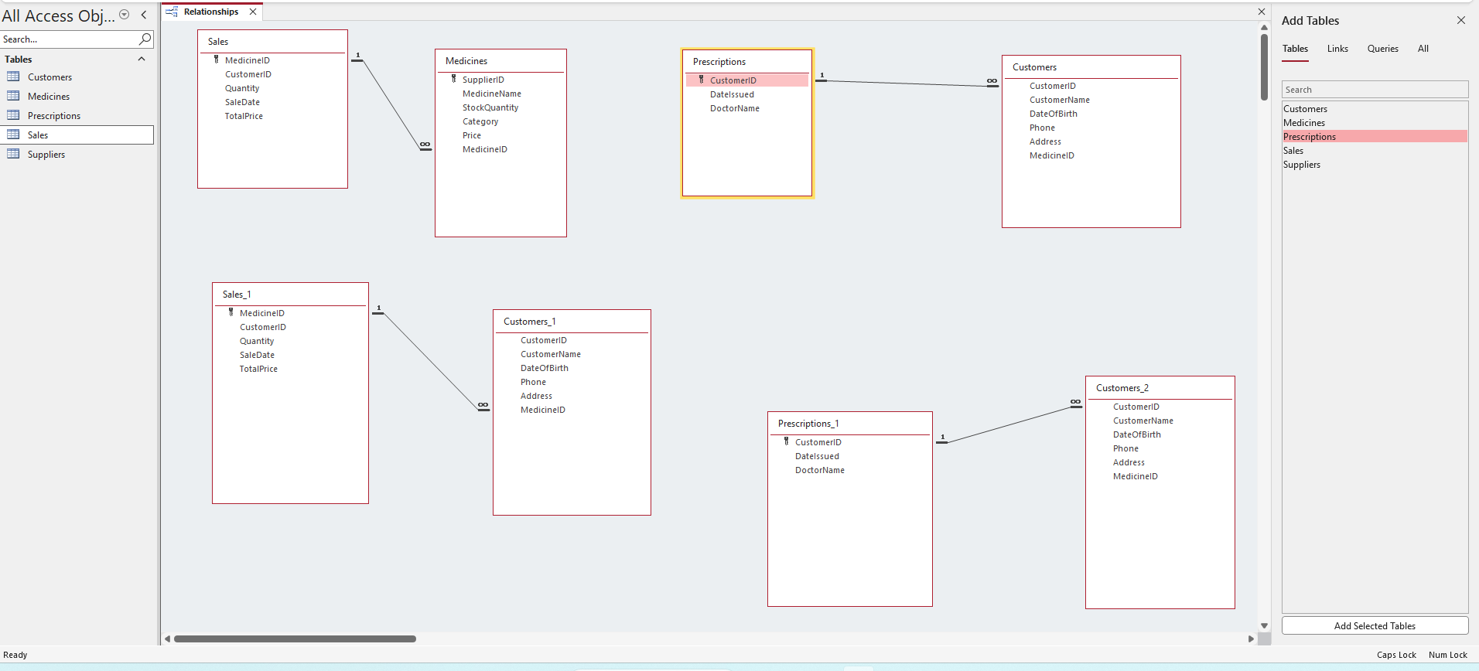
The Entity Relationship Diagram (ERD) shows how the database tables are connected. Each table has a primary key, and foreign keys are used to link tables together. The ERD illustrates the relationships between customers, suppliers, medicines, prescriptions, and sales, ensuring that data is stored in a consistent and organised way. These relationships include one-to-many connections between Suppliers and Medicines, Customers and Sales, and Customers and Prescriptions

Data Structure Design

The Medi Link Pharmacy database was developed using Microsoft Access and is organised into five main tables: Customers, Suppliers, Medicines, Sales, and Prescriptions. Each table is structured to store essential information required for the pharmacy’s daily operations.
The Customers table contains details such as Customer, Customer Name, Phone, and Address. The Suppliers table holds information including Supplier ID, Supplier Name, and Phone to manage supplier records. The Medicines table includes fields like Medicine ID, Medicine Name, Price, Stock Quantity, and Supplier ID, allowing each medicine to be associated with a specific supplier.
The Sales table is used to record transactions, with fields such as Sale ID, Medicine ID, Customer ID, Quantity, and Total Price. The Prescriptions table stores prescription-related data, including Prescription ID, Customer ID, Doctor Name, and Date Issued.
Each table is assigned a primary key to uniquely identify its records—for example, Customer ID in the Customers table and Medicine ID in the Medicines table. Relationships between tables are established using foreign keys. For instance, Supplier ID in the Medicines table links to the Suppliers table, while Customer ID in the Sales table connects to the Customers table. These relationships enforce referential integrity and ensure data accuracy.
Overall, the database structure is designed to organise data effectively, reduce redundancy, and support dependable data storage and retrieval.

Normalisation (Up to 3NF)

Normalisation is the method of structuring data within a database to reduce duplication and improve accuracy. In this system, the database has been organised up to the Third Normal Form (3NF).
First Normal Form (1NF):
At this stage, all data is stored in atomic form, meaning each field contains only a single value. There are no repeating groups or multiple entries within one column, and every record is uniquely identified by a primary key.
Second Normal Form (2NF):
Here, all non-key attributes are fully dependent on the entire primary key. This removes partial dependencies, ensuring that each field is related to the whole primary key rather than just a part of it.
Third Normal Form (3NF):
At this level, all attributes depend only on the primary key and not on other non-key attributes. This eliminates transitive dependencies and further reduces data redundancy.
By following these stages of normalisation, the database is made more efficient, reduces unnecessary duplication, and ensures greater consistency and reliability of the data.

Sample Data

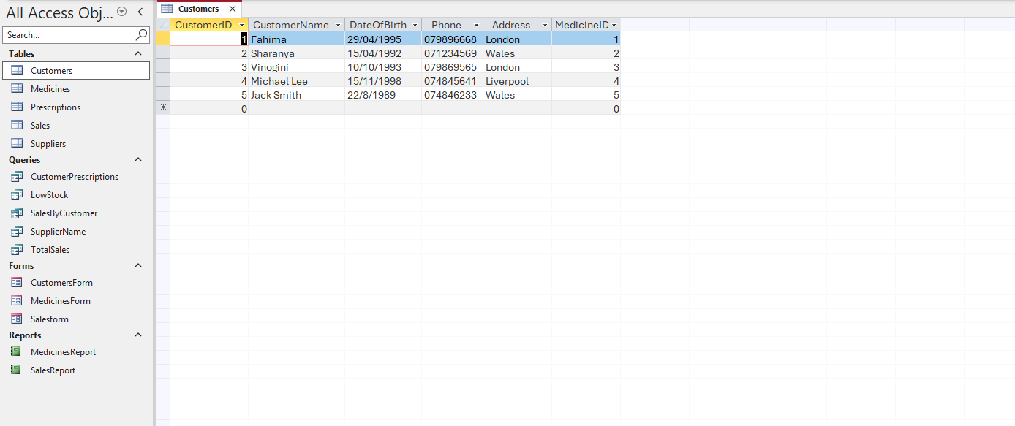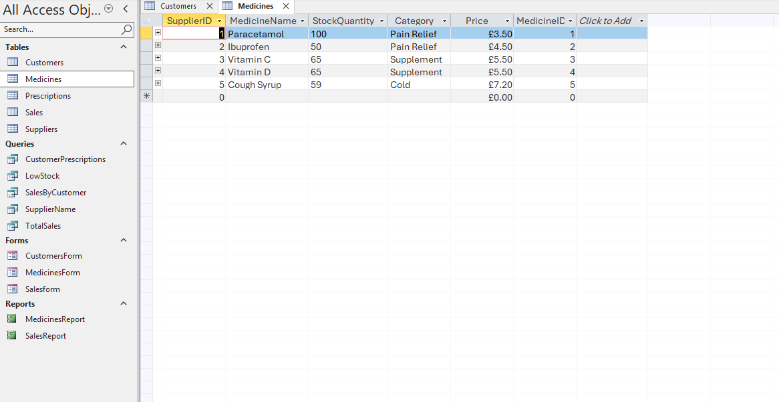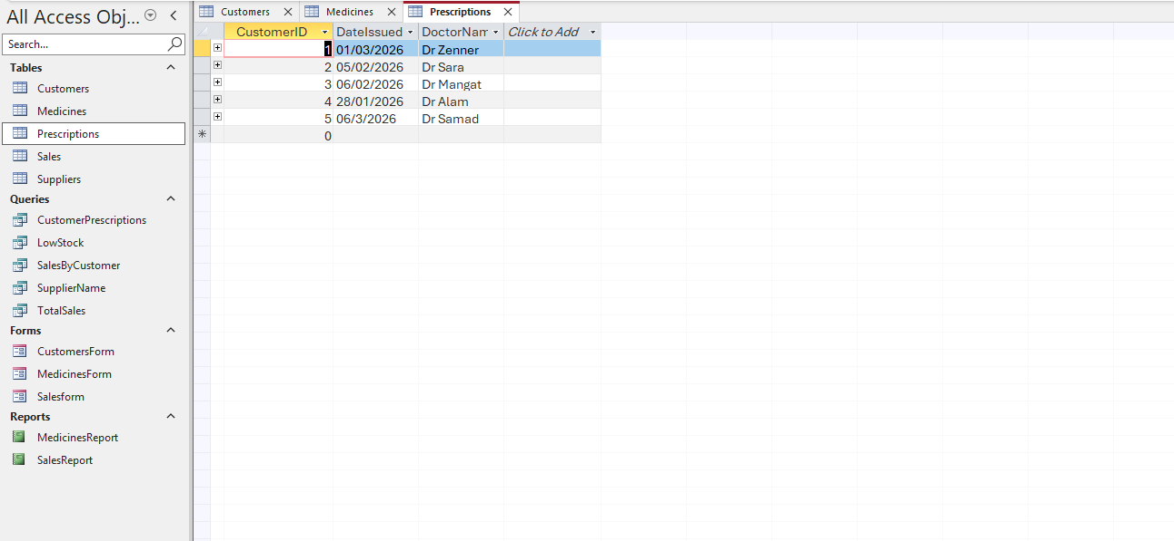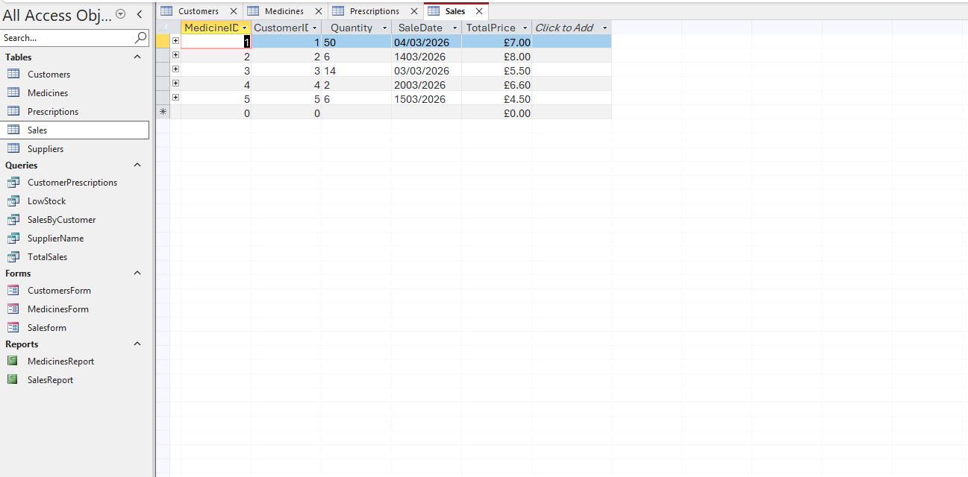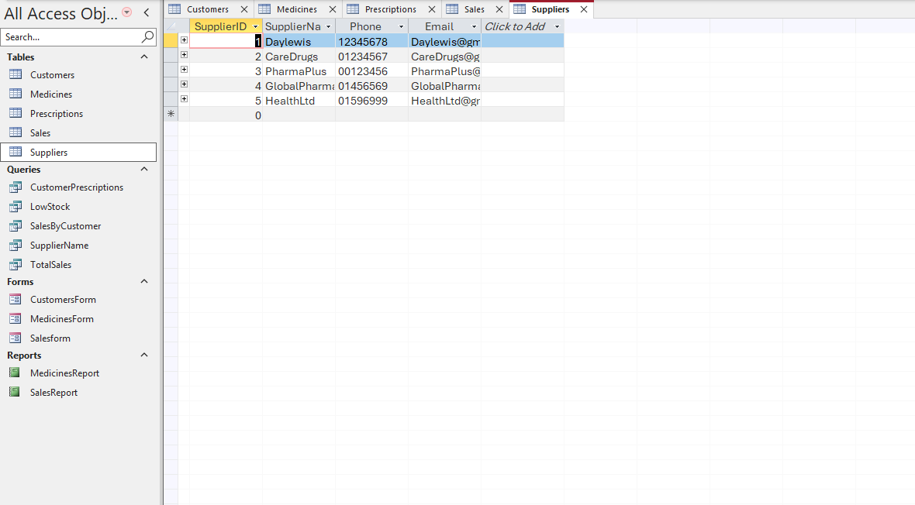

Example data was entered into each table to represent realistic pharmacy activities, with at least five records inserted into every table. The Customers table holds customer information, the Suppliers table stores supplier details, and the Medicines table includes data such as prices and stock quantities.
The Sales table records transactions that link customers to the medicines they buy, while the Prescriptions table keeps track of prescriptions issued by doctors. This sample data was then used to test the database and verify that all relationships and connections between tables work as expected.

Queries

Low Stock Query

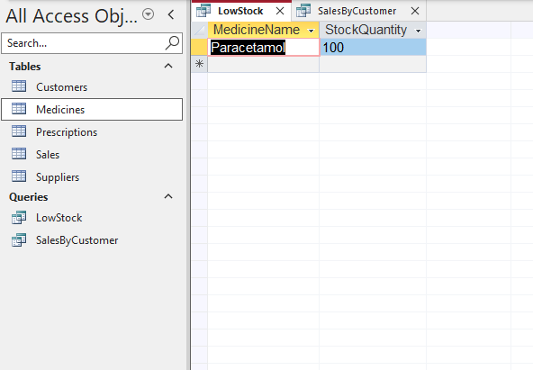
This query is used to identify medicines that have low stock levels. It helps the pharmacy know when certain medicines need to be reordered, making it easier to avoid running out of important items.

Sales by Customer Query

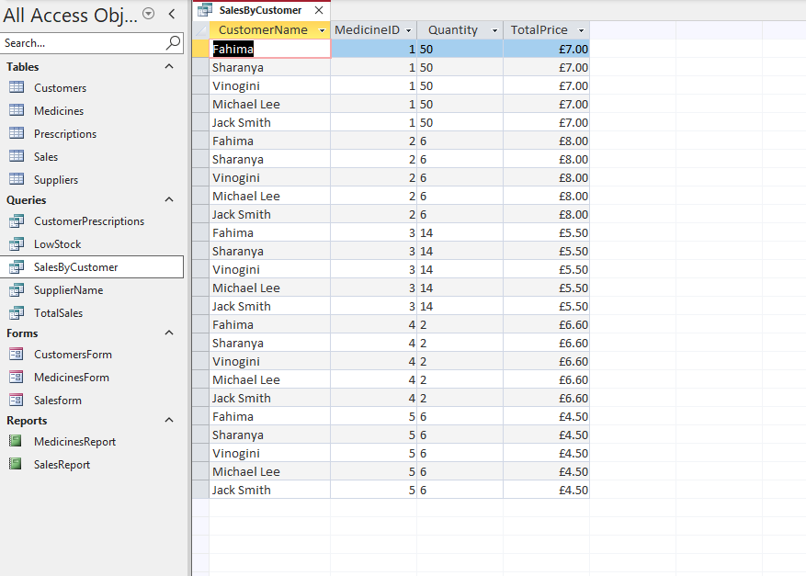
This query displays the sales made by each customer, showing the medicines they purchased and the total price for each transaction.

Customer perception Query
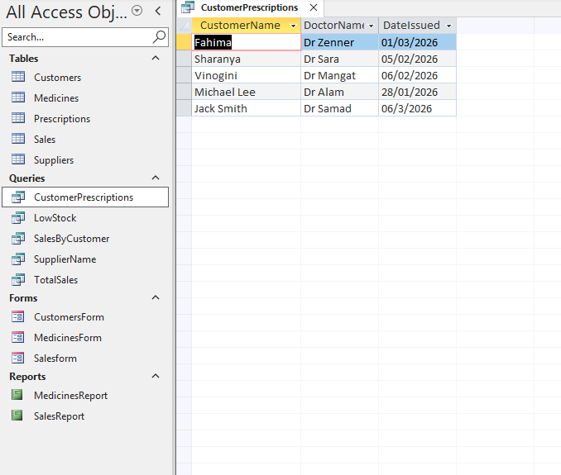
This query displays the prescription details for each customer, including the name of the doctor who issued the prescription.

Total Sales Query

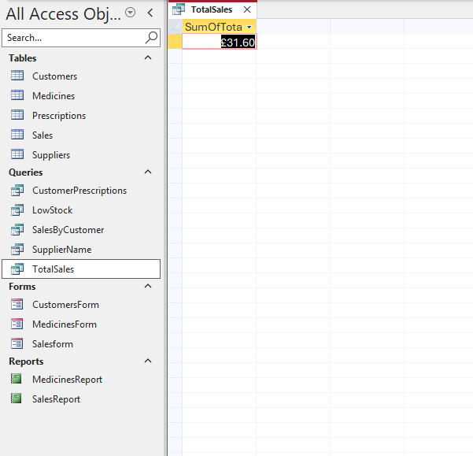

Medicine and Supplier Query
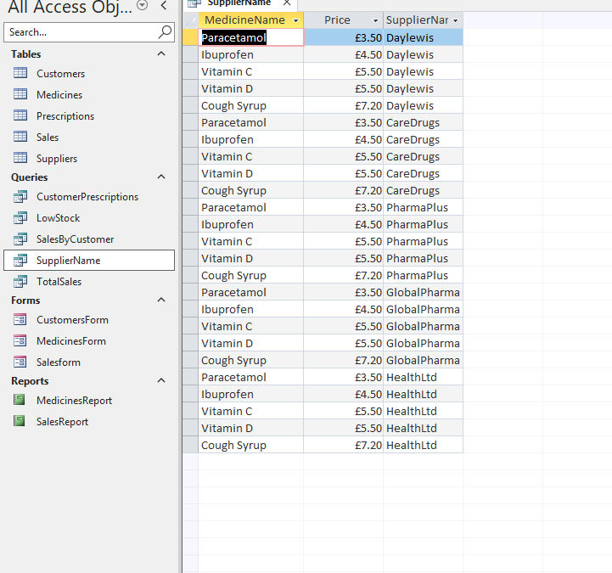

Forms and Reports

Customer Form
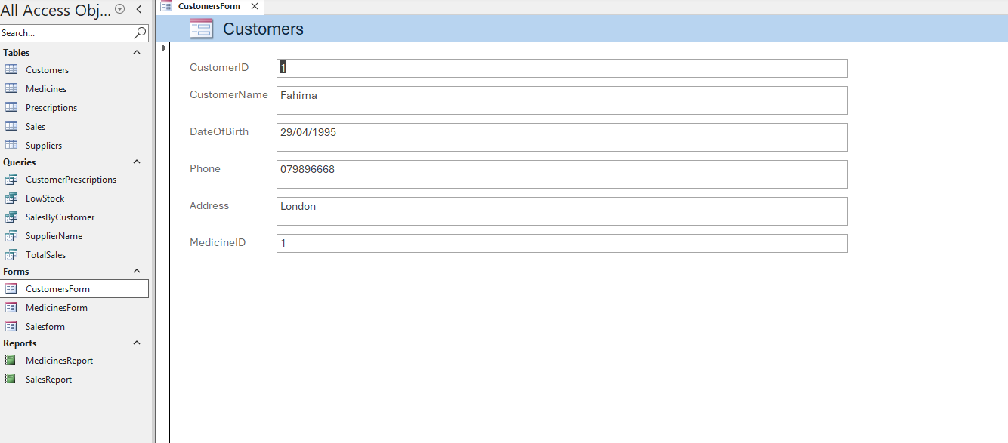

Medicine Form

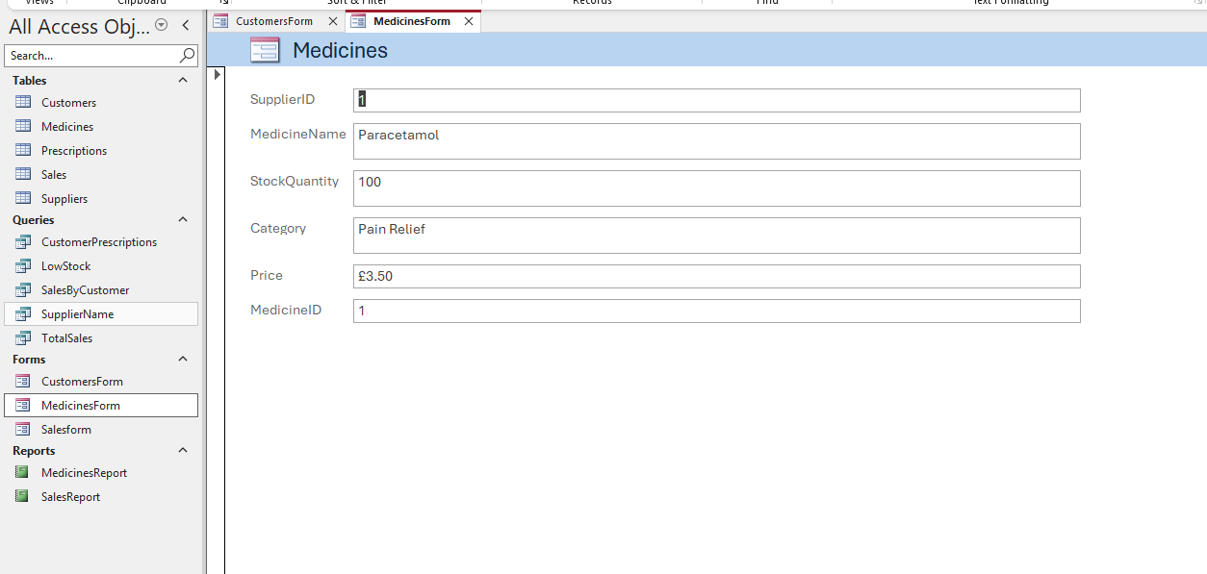

Sales Form
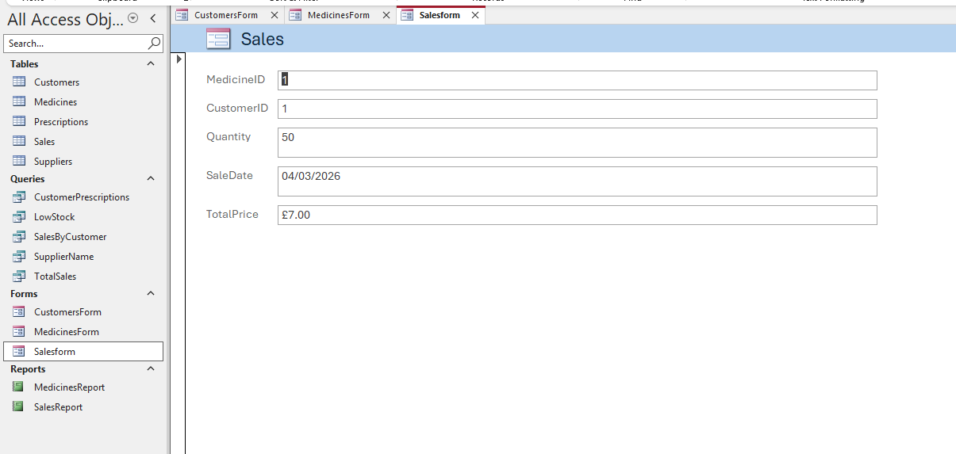

Sales Report
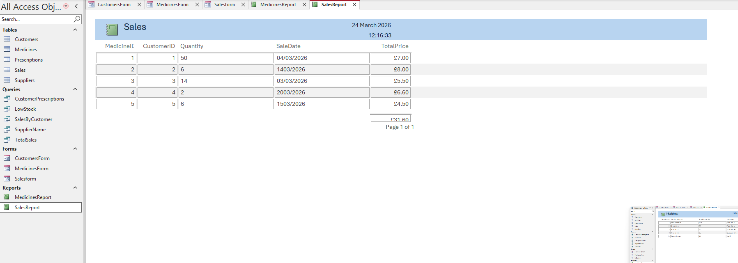

Medicine Report
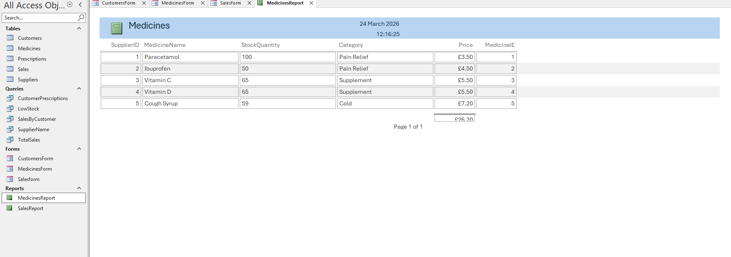
Forms were created to make it simple to enter and view data in the database. The Customer Form, Medicine Form, and Sales Form offer a clear and user-friendly interface for adding and checking records.
Reports were also created to display data in a neat and organised way. The Sales Report shows details of transactions, and the Medicine Report lists information about medicines. These reports help with decision-making and make it easier to analyse the pharmacy’s data.

Validation and Testing

The database system was tested to make sure that all tables, relationships, and queries worked correctly. Data was entered into each table to confirm that it was stored and displayed accurately.
Relationships between tables were validated by enforcing referential integrity, which prevents invalid data entry. For example, a sale cannot be created unless it is associated with an existing customer and a valid medicine.
Queries were also tested to confirm they produced accurate results. For example, the low-stock query successfully identified medicines with limited quantities, while the total-sales query correctly calculated overall sales values. Overall, the testing showed that the database meets its requirements and operates as intended.

Reflection
During this assignment, I learned how to design and build a database system using Microsoft Access. I have more understanding of creating tables, setting up relationships, and writing queries to extract useful information.
At first, I found relationships and queries difficult to understand, but with practice I was able to complete them successfully. This experience helped develop my problem‑solving skills and increased my confidence in using database tools.
In the future, I would enhance the system by adding more advanced features such as automated calculations, improved user interfaces, and more detailed reports. Overall, this assignment helped me build important skills in database design and management.

Conclusion
In conclusion, the database system for MediLink Pharmacy was successfully created and implemented using Microsoft Access. It organises and manages key information, including customers, suppliers, medicines, prescriptions, and sales, in a clear and structured way.
By using relationships, queries, forms, and reports, the system improves data accuracy and works more efficiently than manual methods. Overall, the database meets the pharmacy’s requirements and provides a reliable solution for managing data and supporting

References

[1] T. Connolly and C. Begg, Database Systems, Pearson, 2015.

[2] Microsoft, "Microsoft Access Documentation." [Online]. Available: https://support.microsoft.com

[3] A. Silberschatz, H. Korth and S. Sudarshan, Database System Concepts, McGraw-Hill, 2019.

[4] T. Connolly and C. Begg, Database Systems: A Practical Approach to Design, Implementation, and Management, 6th ed., Pearson, 2015.

[5] A. Silberschatz, H. Korth and S. Sudarshan, Database System Concepts, 7th ed., McGraw-Hill, 2019.

[6] Microsoft, "Microsoft Access Support." [Online]. Available: https://support.microsoft.com

[7] Oracle, "Introduction to Databases." [Online]. Available: https://www.oracle.com/database

[8] (Microsoft, n.d.)

[9 (Begg, 2015)] IBM, "What is a Database?" [Online]. Available: https://www.ibm.com/topics/database

