Knowledge and information management skills for the workplace
Module Code: BMSK5006
Lecturer Name: Dr Md Nazmul Hasan
Learner Name: Erum Naz
Learner ID:1711121

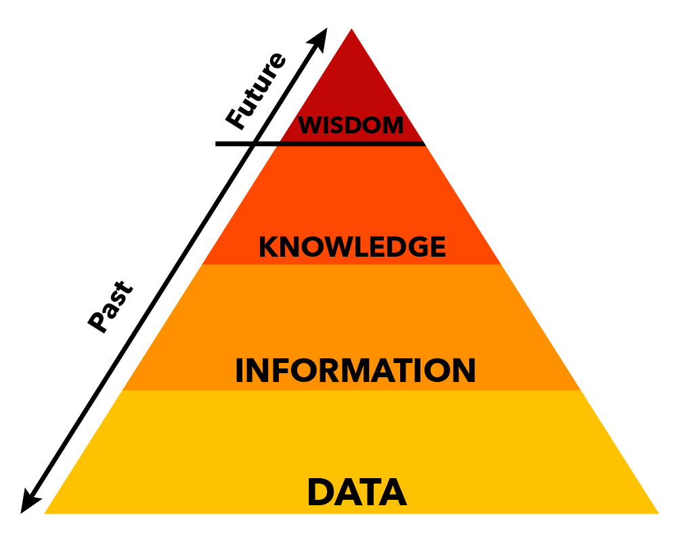

Part 1
Explain why the same set of data can be considered as useful information by some and useless data by others. Further, could this useful information be termed as “knowledge”? Why?
19.1 million people are living in the United Kingdom and every house has a TV in their house. This data will be useful for TV Licencing company because every household who have a TV in their house will buy a TV licence and there will be a profit for the TV Licence company. That data will useless for the Local council because local council will only be interested that how many people are living in a local state and they will collect council tax from that state only and provide other services such as education, health and social care, bins and library funds etc.
HM Revenue and Custom will keep the record of every individual who is employed in the United Kingdom because it will be beneficial for them because the employee will pay the tax on their earning.This information will useless for employers because employer will only keep the record of the employee who is employed by them.
According to GOV.UK “We are the UK’s tax, payments and customs authority, and we have a vital purpose: we collect the money that pays for the UK’s public services and helps families and individuals with targeted financial support. We do this by being impartial and increasingly effective and efficient in our administration. We help the honest majority to get their tax right and make it hard for the dishonest minority to cheat the system.”
All the above information is knowledge because when employers register the employee to HM Revenue and Custom that comes under their knowledge that how many hours is that individual is working then HM Revenue calculate the income of an individual and get the tax from their wages and employer deduct that tax from their salary and pay to HM Revenue before they pay to an employee.
Same is with the TV licence company the data is the figures that how many people are living in UK that gives them the information to check how many houses should be registered for the TV licence and rest they will contact them to purchase their TV licence which will convert into information.
Describe the ways in which “knowledge” differs from “data” and “information.” Justify your answer with a relevant diagram.
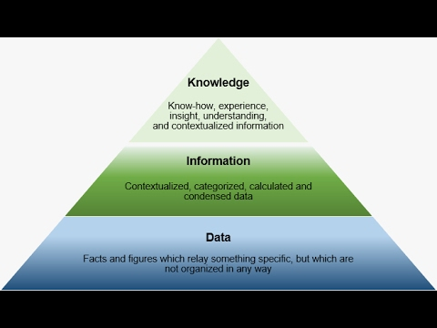
Data is row facts and figures and they will be unmeaningful till they have specific meaning. According to Jack Vaughan(2019) “In computing, data is information that has been translated into a form that is efficient for movement or processing. Relative to today's computers and transmission media, data is information converted into binary digital form. It is acceptable for data to be used as a singular subject or a plural subject. Raw data is a term used to describe data in its most basic digital format.”

Information is a structure and it will have calculated data which have been learnt through personal experience or through education. Information is reversible and it came from data and became information and it will reverse back into data as figures.
According to Margaret Ross (2019) “Information is stimuli that have meaning in some context for its receiver. When information is entered into and stored in a computer, it is generally referred to as data. After processing (such as formatting and printing), output data can again be perceived as information.”
Knowledge
Knowledge is awareness of something or someone. It could be fact, information, skills or description. knowledge will be gathered from different sources such as books, online and article etc.
According to Ronak Singh Bais (5th September 2019) “Knowledge is gathering information from all around the world. Like reading books, talking, daily life experience and much more. and implement that in our daily life. And without implementation, it's just mere information that we gather. Many people confuse knowledge with information and for the information is knowledge forex- Reading great quotes daily is not knowing it's just information that we gather and if don't use it then it's not knowledge.”
The difference between data and information and knowledge is, data is raw fact and Figueres and they don’t have any meaning till it’s become information. Information comes from data and with the exact figures, it becomes information and that information becomes a knowledge which is understandable and gathered from information and it is a full set of peace to be used in any industry.
3. Does a player in a card game use tacit or explicit knowledge? Explain why. Define and explain the difference between the two.
Tacit knowledge:
Tacit Knowledge is the feelings you know inside but cannot express in words.
Explicit Knowledge:
Explicit knowledge is what can be put in words and its measurable and it can be easily transferable to others.
A player who plays cards uses the tacit knowledge because they cannot tell what is going on in other players mind and what cards they have in their hand, or which card will make them win. They do have an idea in their head, but they are not sure whether they are right or wrong. They cannot be 100% if the next player who has a turn will make them win if they threw a card so tacit knowledge is been there for them to know but they can not prove it with the words and its not measure able.
The difference between the two is the cards they individual is playing will have an idea in his/her head but that will not be measurable and that individual will not be able to explain to others. Although the individual has knowledge in their heads and if they won the game with their guess but they will still not measure it in words that it was in their head and they have won because of that but in reality they have won or lost because of the luck.
4. Consider five decisions you have made today (they could be simple such as taking a turn while driving or even choosing a soda at a convenience store). In each case determine the data, information, or knowledge that were involved in the decision.
4a. Working with Mencap
I decided to work for Mencap. The data is Mencap is a charity who have homes all over the United Kingdom. The information is they have clients with disability such as learning disability, down syndrome, autism disorder and intellectual disabilities. This information has been gathered from their website. The knowledge is an individual will go and work in one place rather than delivering a service door to door and make a difference in people life and deliver the service to their lives an make them feel to live an independent life as every other individual does. The individual is trained in a sector to deliver excellent service to their clients and make the clients independent to live their life and do the daily task as every individual does with their support because they have same right to live as every individual does.
4b. Complete a Degree
I decided to complete my degree. The data is to complete my degree from University of the ales Trinity Saint David. The information is the BA Hons Leadership and Management Skills only been taught by this University. Knowledge will be that the individual will learn all the skills in 2 years to complete their degree and will be qualified in the relevant department to start the new Career.
4c.Travel by West midlands
I choose to travel by Westmidlnads. The data is west midlands buses is a company who does the services for the buses all over the west midlands. The information is they easy to access all the over the west midlands and the knowledge is that these buses are cheaper than Diamond bus company and they are available to travel every 6-7 minutes at day time and every 20 mints in evenings and they are really reliable services. The benefits of using this service are you can get group tickets, adult and child tickets so it will save financially.
4d. Shopping from Tesco
I chose to shop from Teso. The data is, it’s a big supermarket. The information is it is based locally and you get all the groceries, meat poultry, toiletries etc under one floor. Knowledge is what you are getting all the shopping under one floor rather than going to into different places and shop and that will be able to save the money and time to travel into different supermarkets.Also,shopping with one supermarket will give you the vouchers locality point and you will save the money with these offers. You will be used to with the supermarket and you knew where to get the product because sometimes you only need one or two things and you are short with time so you will be able to save your time by knowing that where you will be able to get the stuff from.
4e. Using Navigation
The data is Google map is a popular app to use the navigation. The information is it is very easy to use and you can use it to get access to the route by a car,buses,train,walk and even taxi route such as Uber.The knowledge is you use the internet to download the route and you can use it and when we going out and you don’t have internet still you will be able to get into your chosen destination accurately.
5. Now consider how those decisions would have been influenced by the lack of pre-existing data, information, or knowledge.
The above decisions have influenced me by choosing the right path for a career because while you are working and delivering service door to door does not pay you the money for the hours you are the road, while with Mencap you go and work in one place and get paid for the hours you worked for.
To complete the degree and become and teacher is the best decision for the career because as a teaching assistant you do the same job as a teacher but you get paid less than a teacher. Eventhough they prepare their lesson in advance but that is one-off and they will be free for the rest of the year.By choosing to complete the degree will open the doors to success and will be able to work 9-5 rather than working weekends and late nights.
Travel by West Midlands was the best choice because they are direct buses which go to Birmingham and surrounding areas while diamond buses are not providing the same service from Walsall to Birmingham. That open more door for the career, and you can go the extra mile to do the work and have better satisfactory job.
Shopping with Tesco is beneficial because you can go under one shop and buy each and everything a household need while you are short of time when you are working full time you have set targets and specific times to do the things so shopping under one floor save the time.
6. You have recently invented a new product. Collect demographic data from a sample population, determine how you would use this data, and convert it into information and possibly knowledge for promoting the product.
A foldable electronic bicycle has been recently invented and it is very useful for travelling because while you are travelling in bused the bus driver does not allow the bicycle in the bus because of the health of the safety requirements.This bike is foldable and this bike has a smart case where it gets folded and closed and stored into a suite case. It is lightweight and has wheels underneath it so it can be pulled very easily like a suitcase and it will not get more space.
Demographic data: Demographic data is a statical data which has been used to collect the characteristics of the population, age,income etc.
Demographic data for the bicycle have been collected around the world to determine the targets of the bike’s success. The bike has been ridden by 300 people,where it was 100 children and 200 men and women.Most people were working-class people and they absolutely loved the product and age range was 10 – 40 years.
10% of people didn’t like the bicycle. 88% people loved the product and said they will buy it and used it and 2% wasn’t sure in the survey.The bicycle was more popular in working-class women and men and they said they will definitely buy this because it is lightweight and foldable so it will be easy to take it to work and store it underneath their desk at work.That will cut their journey to travel by buses and save time for work.
The information has been gathered from the survey which shows that people have used the product and it shows not only people will buy the bicycle but they will recommend to others to buy it so the overall result has positive feedback for the bicycle.

References:
- GOV.UK (2019) HM Revenue and Custom: What HM Revenue and Custom does Access on 09th October 2019 [Online] Via: https://www.gov.uk/government/organisations/hm-revenue-customs
- TechTarget (2019) Data Accessed on 09th October 2019 [Online] Via: https://searchdatamanagement.techtarget.com/definition/data
- TechTarget (2019) Definition:Information Accessed on 09th October 2019 [Online] Via: https://searchsqlserver.techtarget.com/definition/information

Quora (2019) What is Knowledge Accessed on 09th October 2019 [Online] Via: https://www.quora.com/What-is-knowledge

Part 2
Describe how the overall approach adopted by American Airlines incorporated the basic competitive strategies of cost leadership and product differentiation.
Porter Competitive strategies:
“Michael Porter described the theory in his 1985 book ‘Competitive Advantage: Creating and Sustaining Superior Performance’. The basis was formed by three strategies, namely cost leadership, differentiation and focus. He divided the latter into cost focus and differentiation focus.”(Kuijk,2013).
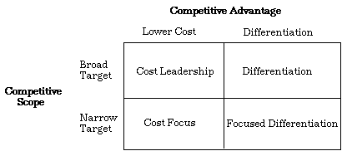
Porter competitive strategies will be used to discuss the cost leadership and differentiation.

Cost leadership:
Cost leadership is a term that has been used in a business to explains the ways of the cheapest manufactures or provide a particular product or commodity in a competition. In the organisation cost leadership focus on the internal process. The strategy is for the business to use the low-cost procedure to maintain the high demand for the profit.
Differentiation:
Differentiation is a process of making the products different in a way that no one will have that product before and they will use that strategy to compete in the market. That will have positive impact on a business to lead the market and have more profit than others.
How that system implements the airline?
In 1953 the airline industry struggles to manage the business because they were struggling to get the customers and it was hard at that time for them to manage the flight’s bookings & reservations and cancellation without any information.That has resulted into overbooking or underbooking, passengers service issues and utilisations.C.R. Smith,president of American Airlines and R. Blair Smith, a senior sales representative for IBM introduce the system called the data processing which will electronically make the seat reservations for the agents.That way they will have the record of the customers and cancellations and reservation so they do not have the loss for their business,while they used to have handwritten system which was not beneficial for their business.Sabre is still introducing new technology to work around for the better picture for the business such as Sabre Red Workspace,a marketing leading workspace where people can make booking from mobile.
According to Revfine(2003) “Sabre is regarded as one of the ‘big three’ GDS systems, with a history that can be traced back to the 1960s. The company and network are based out of Southlake, Texas, in the United States, and it is estimated that around 60,000 travel agencies around the world currently utilise the system in order to sell travel products. Although Sabre technically has a smaller market share than one of its rivals, Amadeus, a larger percentage of bookings made using the Sabre system are hotel-related, as opposed to airline-based.”
American airline and IBM replaced a handwritten system into the Semi-Automatic Business Research Environment of the 1950s. That system differentiate the business and it helped them to grow and their cost leadership saved 30% for the airline.Their business had a growth financially by increasing demand for the travel agents selling their airline’s tickets online
. The scope is high because they used the low prices for the customers to get better savings and most of the customers will be attracted because of the prices.They replace the handwritten system so people can use their own computers/laptops to book their tickets on the cheapest prices.That will have a high demand for the business in the industry for them.On the other hand differentiation is high because of the demand of the nature of the product which each individual will want to go for and that will help them to grow their business and that will be a big benefit for them financially.That makes them different from other airlines in the lower cost and high demand for the reservation the seats online.
In what ways did SABRE provide American Airlines with a competitive advantage? Your analysis should refer to concepts related to the strategic use of information systems, for example, entry barriers.
In this part, porter’s 5 forces will be used to analyse the competitive advantages of Sabre to American airline.
Porters Five Forces Model:
According to J Chapplow (2019) “Porter's Five Forces is a model that identifies and analyzes five competitive forces that shape every industry and helps determine an industry's weaknesses and strengths. Five Forces analysis is frequently used to identify an industry's structure to determine corporate strategy. Porter's model can be applied to any segment of the economy to understand the level of competition within the industry and enhance a company's long-term profitability. The Five Forces model is named after Harvard Business School professor, Michael E. Porter.”
Sabre Competitive advantage and analysis
Bargaining power:
Bargaining power is an equal opportunity in an organisation and which one organisation is influenced by the other organisation.such as if an organisation is selling something by 12% the other organisation will try to sell 10% to attract more customers to extend their business.
Sabre automatically used the system for customers to compare the prices and that bargaining power of the customer will be high and they will have more benefits such as they will save the money to get the same flight. That will save money for customers and its good opportunity to save the money for them and they can enjoy the same flight at a lower cost than others.The buyer's income within the industry is low.That means the pressure to purchase at low prices making the buyers more price-sensitive,so buying power is a weaker force in the industry.
Threats of substitute
The substitute is something which is the availability of the product consumer can buy from another company/firm. Threats of substitute mean if an organisation is providing the same product as you and you will have a loss because if their strategy works to sell the same product in the same price that will have a loss to the company.
Barriers are high in American airline and Substitute will be more expensive for the customers and they may pay more because of the cost of the plane and because of the fewer amount of substitute. There is very few substitutes available the way Amerian airline work so it will be costly for the customers to get a substitute. Comperitively ,the substitute will be more expensive if the customer has to get the substitute so the switching power would be low.
Threats of new entrance:
The definition of the new entrance means as anything in an organisation which could cause damage to the organisation.Such as if there is another organisation open in the same area and provide the same facilities as your business on a lower cost,that will have long term financial loss.To fix that the organisation will come with an alternative solution to get more profit rather than having a loss on business.
Even though threats for the new entrance are high but the overall growth of the Sabre has not been affected because of their prices. By the end of 1989 Sabre was running more than 130,000 agencies around the world,so it decreases the barrier to entry to market sector. The capital requirement of the business is high so it will be a decrease in the industry and it will be very difficult for the new entrance.
The access to the distribution business is high that’s mean anyone can come into the same industry and can set up the same business. when there is few selling the service in the industry, it is very easy to set up the same business and start with the lower margin.All of these factors make the threat to the new entrants in the industry.
The extent of rivalry between existing competitors:
The rivalry among competitors is an intensity, which refers to the extent in the industry and the extent which up the pressure in the industry and put the pressure on each other in firms and limits the profit potential. In some cases the competitors try to steal the profit and market share from each other.
Sabre system could be replaced in the market and on the basis of the new technologies have been introduced every single day Sabre will be replaced and American airline can have a loss but with the lower cost and fast service of the online system, the airline can make more profit in industry and they could keep their customers who have already used their service without any disruption so there would be fewer chances for the customer to switch to the other providers.The American airline’s product is highly differentiated so it is difficult for competing firm to win the customers if each other because their products are unique.This makes rivalry among existing firms a weaker force within the industry.
Power of Suppliers:
Power of supplier in porters five forces refers to the firm which has more profit on a lower cost,they have more customers and their quality is good and people have been attracted by them because of the service they can get from them not anywhere.
Power of supplier for the airline is agents, food providers,services for the airline such as technician, maintenance service and customer services.Sabre has an online system where people can pick their food online because people have different dietary requirement .it could be because of health problems such as nut & dairy allergies & gluten-free, religion such as vegetarian & vegans and halal food.If they do not have that service people can easily change request in advance.SO,that will increase the bargaining power and if their providers cant provide the food what airline needed they can easily switch to another supplier.Barganig power of supplier is weeker because suppliers do not provide a threat to the airline.
The overall above approach of the proter’s 5 Forces concludes that Sabre gave more benefit to American airline by giving them more customers which lead them to the high profit. With the sabre system it reduced the risk of being exposed to the higher fares and suppliers will seek the people will recommend them to others and that will increase their business.Sabre system has increased the profit for airline throughout the world by having more than 130,000 travel agencies,1 billion fare options for the people on the comfort of their homes.
Although SABRE was undoubtedly successful, American Airlines was not able to maintain its competitive advantage beyond the late 1980s. What factors played a part in the erosion of the company’s lead over its competitors and how did the company react?
Sabre had an excellent start and because of that system there. American airline had a big advantage of the people using their service and they had a good profit in the business,but they left their idea open and easy for competitors to get into the industry easily.Such as if they would have maintained the Sabre regularly and did not sat calmly and left it for the competitor's open-door they would have been more successful.Also, they should have bought a system where no other online company could easily have an acces to their system and would have copied their system,with the lock on their system it would still have been successful.
The American Airline should have a strategic management control system where they should have ensured the achievement of the business with the regular record system.Key success factor should either suggest the strategic objectives or measures for strategic objectives for the business unit or for both of them.
They should have in advance introduced the system where all the customers can get the hotels,car and meals in one deal. People would have not been going to the other website to book the tickets and had travelled with them.
They should make their business more attractive with some discount vouchers so people will come back to them to book again such as: if a person is booking a ticket they should give them voucher straight away for them to book next time.That will open more door for them to reopen the system.
Information System
1. Define an information system:
An information system is a set of components which can be used to collect, store, process and distribute information. It usually includes hardware and software. The information systems could be used to solve business issues/problems. They are composed of people, roles, technology and tasks.
An example in schools could be when teachers are taking the class attendance on a program called SIMS ( School Information Management System ). This is good because all staff such as teachers, head of the year, headteacher and parents can see their child's attendance and can access the system to see pupils attendance. This is a fantastic live system which keeps track of pupil attendance throughout the day and parents can access this to check if pupils have attended all lessons.
Another example could be search engines that search for specific information that is required by the user. An example of the compares the market. This company uses processes to find specific insurance quotes required by the user. This saves the user time searching individual quotes from each individual insurance provider. This is very popular as clients only have to type their details once as opposed to numerous times in separate the websites. You search what you want to search and the information system provides relevant information regarding what you have inputted into the search criteria.
2.Describe the categories of computer-based information systems, providing relevant business examples for each category identified:
There are four types of information system such as
Transaction Processing system
Management information system
Decision support system
Office automation system
Transaction support system:
The transaction support system is one the category of the computer-based information system which stores,captures,classifies,update and retrieve data from record keeping.Transaction system is anything which can affect the whole business.Such as employee record,payroll,order processing and reservations. An employee record system, In the headoffice the admin assistant will keep all the records of the employees in the system such as Name, Date of Birth, Contact details, Home Adress,Bank details etc. An employee can log in to the website as well and they can see all the details about them as well. That way the employee will stay engaged with all the relevant people in the firm.
Manager will update the system that how many hours a month an employee worked so the payroll assistant will have the record of the employee and they will be able to deal with their payroll and accountant will make their wage slips and send the tax to the tax department and will pay National Insurance for the employee.
Management Information system:
A management information system is the computer-based information system which kept all the record for the management which is relevant, timely, accurate, complete and concise. Examples of a management information system are performance of management, leadership, human resources, sales and marketing system, innovation system, office automation system, enterprise resource planning system, accounting and finance systems and management reporting system. For Example, In schools, the manager will have all the record of the tutors and the strength and weaknesses of the tutors therefore if a staff member called sick so the manager in advance will have all the schedule of the tutors of the day plus strength and weakness so the manager will try to cover the shift with their staff first before they will be able to get an agency staff.
Decision support system:
The decision support system is the system where the business needs that information once and it is not predictable. Decision support system has been designed to respond to a high volume of request. Decision making system allows the manager to make the decision which is not highly structured often they called unstructured or semi-structured decision. For example banks use the decision-making system on a daily basis. When a person applies for a loan online the system will accept or decline the request. If it is gone through, they will pay you into your bank account. These are useful decision-making system which saves the times for both customers and people who are working in the bank.
Office automation system:
The office automation system is a computer-based information system which collects, process, store and transmit electronic messages, documentations and other forms of communication among the individuals in an office-based environment, workgroup and organisation. Examples of office automation systems are employee analytic, hiring process, meetings, deadlines, form autofill, facility management, office design, customer support, digital signature etc. For example in an office a person will regularly in touch with other employees regarding the meetings such as when, where and how to arrange that and most importantly what needs to be added and what are areas needs to be covered in meetings and they will be able to have a backup plan such as if there is an emergency a manager would not be able to attend the meeting who will be able to cover that and how that will be structured and meet the requirements of the meeting.
3. Explain how computer-based information systems can support managers at each level of an organisation.
SIMS is a School Information Management System which has been used in Great Britain to keep the record of all the students in schools,colleges,universities.This system has been named after a gynaecologist J. Sims who used to keep the record of the patients of the examination, treatments and enemas. All the schools throughout the UK used this system to keep the record where a teacher get the attendance of one class and that will be stored in the information system so, the manager,admin team, student services and parents at home can have a track of the attendance of the student. According to Capita SIMS (2019) “SIMS provides school teams with the tools they always knew they needed but never had. Once implemented, SIMS surprises them with how easy and quick it is to efficiently manage school life and drive improvement. Whether you want to shake up your school MIS or just get more from SIMS, we can help, and we’ll be here for you every step of the way”.
The benefits of using SIMS in schools are.
Raise the Bar
Lift the lid on learning
Be ready for anything
Bring people together
That gives the teacher freedom and time to teach and it allows them to show the record of the students anytime and more beneficial anywhere and that system will communicate with the whole school system so head of each subject,managers,principles can access anytime to get the access of that. That will have up to date access of the student's attendance and the record of the progress of the school which will allow the principle to kept he record of their finances and the funding they will claim for each student. So the teacher(lower level),Head of year(lower to medium),Manager(middle level) and principle(Upper level) will have the access of the system and SIMS will support on all level of management.

References:

Toolshero (2019) Porter’s Generic Strategies: What are Porter’s Generic Strategies? Accessed on 06th November 2019 [Online] Via: https://www.toolshero.com/strategy/porters-generic-strategies/
- Investophedia (2019) Porter’s 5 Forces:What is Porter’s Five Forces? Accessed on 10th November 2019 [Online] Via: https://www.investopedia.com/terms/p/porter.asp

Revfine Optimising Revenue (2019) What is the Sabre Global Distribution System?; What is Sabre GDS? Accessed on 10th November 2019 [Online] Via: https://www.revfine.com/sabre-gds/
- Capita Sims (2019) How sim helps schools everyday Accessed on 25th November 2019 [Online] Via:https://www.capita-sims.co.uk/why-sims

