ACBA4001: Construction Portfolio
  - By Ben Kneeshaw – 1902457

Table of contents

1. Introduction
2. Construction detailing
2.1. Foundations
2.2. External walls
2.3. Flooring
2.4. Partition walls
2.5. Roofing
2.6. Openings
3. Conclusions

1. Introduction

This report shall outline a number of construction methods that can be used to construct the proposed dwelling. These will be in compliance with current building regulations for new-builds. Special care will be taken to avoid the issues of: humidity, thermal bridging and condensation.

2. Construction detailing

2.1 Foundations

The proposed structure will be built upon a level Greenfield site with 450mm of topsoil above firm subsoil with low clay content that is above the water table. As such a suitable and cost-effective solution will be a strip foundation with a mass concrete footing, as shown in appendix A. All load bearing walls will then be built up from said strip foundation.
As the subsoil is firm with low clay content the footing of the foundation should be at least 650mm in width and 150mm in height, this will allow it to support maximum loads of 70kN/m, thus giving extra stability when faced with adverse weather conditions. This is in compliance with current building regulations as shown in figure 1. The depth will be at least one metre to the underside so as to avoid any issues with ground movement and keep the load-bearing walls stable (Chudley & Greeno (2020, p.208)).
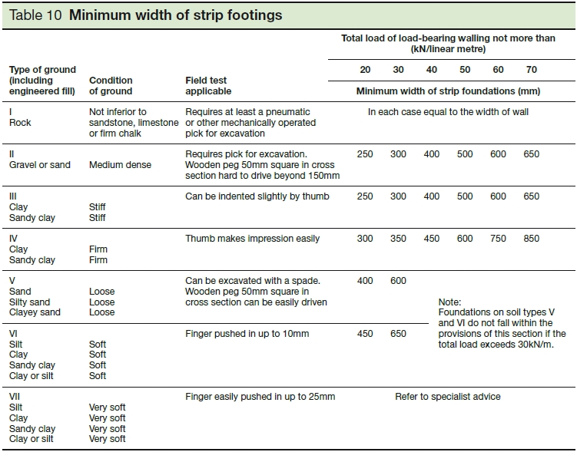

Figure 1:
Minimum width of strip foundations

2.2 External walls

The external walls will be the only load-bearing walls for this project, with an external wall running between the utility room and kitchen/diner, supporting the roof and providing insulation to upstairs areas. These will be of standard brick on block construction with a partial fill cavity, as shown in appendix A.
In order to comply with building regulations, shown in figure 2, the leaves of the wall will need to be at least 300mm thick. As such an external wall of 102.5mm coupled with an internal wall of 200mm would be suitable and allow standard size bricks and blocks to be used. A cavity of 100mm will be suitable for the insulation and internal trimmings. Plaster will be applied to any part of said wall that is internal.
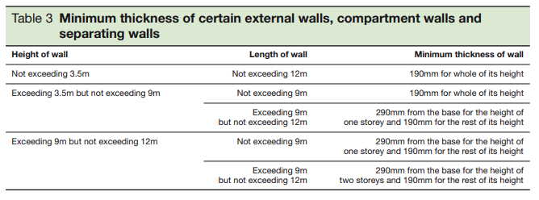
Figure 2:
Minimum thickness of load-bearing walls in small properties.

The walls will be built up from the strip foundations using suitable quality bricks for the underground section. The outer leaf shall be brick lain in a stretcher bond whilst the inner leaf will be two concrete blocks thick. As the walls are built up above ground, weak concrete will be used to fill the underground cavity, this will prevent the walls shifting underground due to pressure. Special care must be taken to assure the concrete fill does not exceed 225mm below the first DPC (Chudley & Greeno (2020, p.213)). The DPC’s will be at least 150mm above ground, placed on the first applicable point, most likely to be 3 bricks above ground or similar. The DPM will extend from underneath the floor slab to lap with the DPC in order to protect against ground moisture, in compliance with building regulation C2 of approved document A (Chudley & Greeno (2020, p.314)).
The 100mm cavity will include 50mm of insulation, restrained to the inner leaf, and 50mm of airspace. Flashing shall be applied to the insulation where it meets the cavity to direct any internal moisture downwards and out of the wall whilst protecting the insulation. Weep-holes will be put in place at 450mm intervals just above the base of the flashing, with at least two above each opening, in compliance with building regulations. Wall ties will be used to ensure the stability of the walls, stainless steel ties at a minimum spacing of 450mm vertically and 750mm horizontally, with at least 2.5 per metre squared, will be best for this due to the width of the cavity (Chudley & Greeno (2020)). Additionally a vapour control membrane will be installed between the inner leaf and insulation in order to protect against damp.

2.3 Flooring

The ground floor shall be comprised of two suspended timber floors with honeycombed sleeper walls, with one running throughout the main part of the building and a separate one for the utility room/bathroom. The upper floors are to be traditional timber with softwood tongue and groove flooring.
Chudley & Greeno (2020, p. 270) state that in order to comply with approved document C of the building regulations each suspended floor must: have a subfloor covered with oversite concrete, have a minimum of 150mm ventilated space between the subfloor and timber joists and have a DPC between the sleeper wall and wall plate. As such all these issues will be dealt with by the suggested floors, shown in appendix B.
For the main part of the building there will be 4 sleeper walls, running east to west. With one 30mm from the rear external wall, another 30mm from the front external wall and a third halfway between the first two at a distance 3370mm form either external wall. The fourth sleeper wall will be in the living room alcove, at a distance of 30mm from the external wall at the front of the project. The east and west ends of each sleeper wall will be 15mm from the external walls with special care taken to ensure the sleeper walls never touch the external walls. 26 joists will be needed at 400mm spacing. These will be attached to the wall plates atop the sleeper walls. Insulation will be applied between and on top of the joists so as to eliminate the issue of thermal bridging, with nylon netting supporting said insulation. A vapour control membrane will then be introduced above the insulation to help deal with moisture. The flooring will need to be fitted with 15mm gaps either side to allow room for expansion. As such a good solution would be ‘click’ timber flooring as it can be fitted as floating above the insulation and held in place by skirting boards once plaster has been applied to the inner leaf of the external walls. Ventilation will be along the external walls at 2m spacing, it will also be along the bottom of the internal external wall at the same spacing.
The same solution will be adopted for the utility room/bathroom. However different spacing will be required. The sleeper walls will run at the same distance from the front and rear external walls and the same gap will be needed at the east and west ends, a third sleeper wall will be directly between the first two at a distance of 2925mm. In this case though, 5 joists will be required with 500mm spacing.
The upper flooring will consist of joists running north to south, fitted to the external walls using joist hangers to reduce thermal bridging and allow for easy refitting in the future. These will be of timber class C24 so as to cover a large span and support partition walls. They will need to be 75x170 for the area covering the dining room to the edge of the staircase and 75x220 for the area covering the living room. They should all be spaced at 400mm apart. This complies with the regulations shown in figure 3. Herringbone strutting will be required at 1 third of the span of each joist. The insulation will be placed between and above the joists, held in place using purlins. The flooring will be softwood tongue & groove as it can be fitted as floating. A cross section of the upper floors joists and flooring is shown in Appendix C.
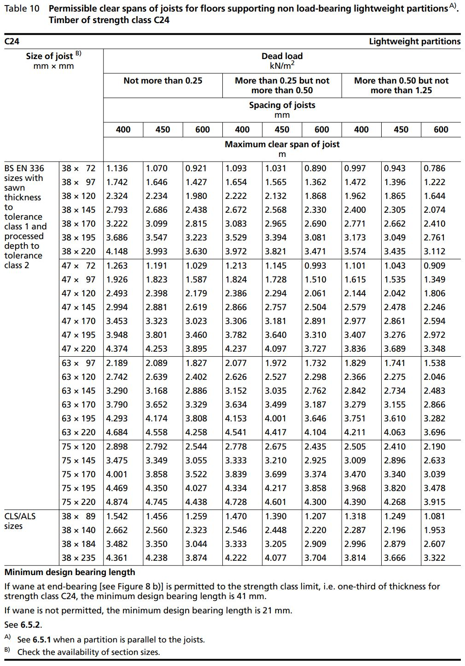
Figure 3:
Permissible clear spans of joists

2.4 Partition walls

The partition walls will be of standard plaster slab construction, fixed together using adhesive. These will be 100mm thick with a thin layer of plaster on either side so as to provide suitable insulation against: noise, fire heat and dampness. They will also be strong enough to hold any fittings required.
As the upper floors are made of timber strong enough to support partition walls, no remedies will need to be put in place there. However for the suspended timber floors on the ground floor there are a number of remedies that can be applied so as to support the additional load. These are detailed in Appendix D and should be used at the constructors discretion as joist spacing may change based on unforeseen circumstances. Solution A is for when the joist coincides with a partition and solutions B and C are for when the partition is between the joists.

2.5 Roofing

The roof over the main span of the property will be a slanted roof at a 40 degree pitch with gable ends at the east and west edges. There will be 600mm of space between each rafter. The alcove will be covered with a pitched roof with a gable end at the south face of the property. The utility area will be covered with a pitched roof with a gable end at the west edge. All roofs will be of warm pitched roof construction so as to mitigate any thermal bridging whilst providing insulation to living areas within the property, shown in appendix E. This will require insulation between each rafter with insulation board and a vapour control membrane fixed to the underside before plastering. All eaves will be closed flush eaves, shown in appendix F. The tiling will be slate lain using the double-lap method. All roofs will be attached to the external walls using wall plates and nail plates with heavy restraints for vertical loads and light restraints for the lateral loads.
As the main span of the roof is over 10m two trusses will be required for support, trusses are shown in appendix G. These will be queens post trusses placed either side of the proposed hallway area within the loft, so as to provide suitable access to the loft spaces. They will be supported by the external walls and attached to the wall plate using nail plates. The pitched roof covering the alcoves has a small span so a couple roof will be ideal. For the roof covering the utility area a purlin roof will be required so as to cover the span comfortably.

2.6 Openings

All openings in the external walls will be supported through the use of lintels. As the proprietor has specified sandstone above all openings, galvanised steel lintels will be ideal as it means the lintel will be internal allowing for any suitable exterior façade, shown in appendix H. Where the wall cavity meets the opening on either side a concrete block will be used to bridge the gap, as such vertical DPC’s will be needed to ensure the wall is protected against the elements, this is shown in appendix I.

