

Academic Discipline of Tourism and Hospitality Management

BA(Hons) International Hotel Management

Winter Term 2025

BMIH6005

Organisational Consultancy- LEVEL 6

Name of the Report: Sayeman Beach Resort, Branding Department
Name: Zakaria Chowdhury
ID: 2222623
Consultancy Company Name: Green Horizons Consultancy
Date: 2/17/2025

Use of Generative AI in Assessment

Category | Description | Yes | No
RESEARCH | For this assessment, you can use Generative AI to support you in research, including searching for bibliography, using tools to summarise, compare and interrogate materials. | ☐ | ☑
STRUCTURE | For this assessment, you can use Generative AI to support you in structuring your submission, including creating a draft argument structure, identifying parts and headings, etc. | ☐ | ☑
PROOFREADING | For this assessment, you can use Generative AI to check your own text/creation for grammatical and syntactical mistakes, including rephrasing of your own work within specific standards. | ☐ | ☑
WRITING | For this assessment, you can use Generative AI to create text for submission. | ☐ | ☑
CREATIVE | For this assessment, you can use Generative AI to create creative materials, such as images. | ☐ | ☑
PROGRAMMING | For this assessment, you can use Generative AI to create and check code. | ☐ | ☑
NONE | For this assessment, you are not allowed to use any type of Generative AI support. This includes research support, structure support, writing/proofreading support and creative support. | ☐ | ☑

Executive Summary
For the consultancy report for Sayeman Hotel in Bangladesh, a detailed analysis of the sustainability issues of the company was done with respect to the environmental, social, and economic sides of the company. As identified with this, the hotel has suffered from an integration of sustainable practices in terms of operating efficiency, expenditure control, brand image, and sustainability. The report makes a systematic analysis of these challenges and has assessed the root causes of the same in order to provide strategic recommendations to change the hotel’s sustainability profile without compromising on profitability and customer satisfaction.

Problem Identification
The findings of the study are based on several problems the Sayeman Hotel experiences such as high usage of energy, high volume of wastewater, little effort made to manage waste, and few participations of employees to involve themselves in working on sustainability measures. These factors not only increases hotel’s operation expenses but they also weigh negatively on the hotel’s environmental footprint that, if the problem continues, will negatively to the hotel’s reputation, and the capability of attracting eco-friendly guests. Furthermore, the difficulties in the implementation of sustainable reforms are aggravated by the lack of structural change management strategies. If these challenges are not addressed, the financial strain, loss of competitive advantage and non-compliance with regulatory requirements may stop the hotel from having long-term success.

Findings and Analysis
The analysis of Sayeman Hotel’s operational framework showed several inefficiencies in its operations. Because Bangladesh’s energy prices remain important, the hotel greatly depends on conventional energy sources, and its reliance on those contributes to growing utility bills. Inefficient plumbing systems and excessive laundry cycles also waste consumer water. It does not have a structured recycling and waste management plan in place, and this means a large number of recyclable materials are thrown in the trash where it wreaks havoc on the environment. In addition, employee awareness and participation in sustainable practices are low, as training and incentives for doing so are not well put in place.
A comparative study was done to analyze the financial and environmental impact of all the inefficiencies to measure the performance of the hotel using such sustainability benchmarks of similar hotels in the region. The results indicate that hotels that have invested in green technologies and sustainable operational models have significantly reduced costs and increased guest satisfaction. This means that Sayeman Hotel is risking losing market share to its competitors that meet the preferences of budding environmentally conscious travellers. Furthermore, the industry trends suggest an increase in eco-friendly accommodations and therefore call for immediate intervention.

Recommendations
To counter these challenges, the consultancy has suggested some recommendations; including the use of energy-efficient technologies like solar panels and LED, example, and the proper implementation of a comprehensive waste segregation and recycling program, as well as the proper implementation of water consumption optimization measures via the use of smart water saving devices. Moreover, it is suggested that there be a staff training program aimed at developing the work culture for environmental responsibilities. We see these strategies as compatible with globally recognised sustainability frameworks and can bring substantial savings in terms of operational expense and help to project a positive image in terms of the hotel’s corporate social responsibility (CSR).
The structured change management strategies are incorporated into the recommendations to provide a smooth adoption and minimal resistance from stakeholders. All the aspects of Lewin’s Change Management Model have been applied fully to lead the transition from existing unsustainable practices to a sustainable future by unfreezing them and implementing new sustainable solutions and then reinforcing such changes through continuous monitoring and training. Other elements of Kotter’s 8-Step Model have been integrated, including building on a sense of urgency, forming a guiding coalition, and gaining short-term wins to maintain momentum and stakeholder buy-in.
The sustainability transition also includes engaging key stakeholders such as employees, suppliers and guests as a major component. Structured training programs will be provided to the employees to increase awareness about eco-friendly practices. It will encourage suppliers to provide sustainable products and materials and it will compel hiring to align with the hotel’s sustainability objectives. Reusing linen and cutting waste will be some of the green initiatives that guests are invited to partake in. It will bring about a twofold approach to sustainability, which views the internal and external stakeholders.

Conclusion
The report details an effective way of measuring the impact and achievement of these sustainability initiatives. They have identified key performance indicators (KPIs), or reductions in energy and water consumption as well as improvements to waste management efficiency, and staff engagement levels with sustainability practices. Assessments will be made by regular audits, customer feedback, and financial performance reviews. While the expected benefits are, cost savings, improved brand image, higher customer loyalty and compliance with international sustainability standards that may permit green certification and international partnership.
They also provided a detailed cost analysis so that the changes proposed would be viable, having regard for the hotel’s financial status and the market dynamics. The initial investment in sustainable infrastructure does seem expensive, but long-term financial gains in terms of utility savings as well as retention of customers outweigh the costs. The proposed budget mirrors the revenue-generating capability of the hotel and is realistic given its scale. In addition, the consultancy has looked into potential sources of funding, for example through government sustainability grants or by forging partnerships with environmental groups to make up for the lack of funding.
The implementation phase of the action plan will be over 12 months and will be divided into phases for ease of execution. The first phase includes an internal sustainability audit, setting of measurable goals and involvement of stakeholders. The second phase is on the infrastructural changes, including installation of energy efficient installations and enhancement of waste management. The last phase is an ongoing monitoring, further development and scaling up of strategies according to the initial results.

Contents
Executive Summary 2
Problem Identification 2
Findings and Analysis 2
Recommendations 3
Conclusion 4
Introduction 7
The Problem 8
Consultancy Firm 9
Theoretical Frameworks 9
Analysis 10
STEEPLED Analysis 11
1. Socio-cultural Factors 11
2. Technological Factors 12
3. Economic Factors 12
4. Environmental Factors 13
5. Political Factors 13
6. Legal Factors 13
7. Ethical Factors 13
8. Demographic Factors 14
SOAR Analysis of Sayeman Beach Resort 14
Key Problems Identified at Sayeman Beach Resort from STEEPLED and SOAR Analysis 17
1. Environmental Pollution & Regulatory Non-Compliance (Core Issue) 17
2. Reputation & Brand Perception Crisis 18
3. Market Competitiveness & Financial Risk 19
Recommendations 22
Sustainable Waste Management: From Compliance to Competitive Advantage 22
Eco-Friendly Operations: Embedding Sustainability into the Guest Experience 23
Cultural Transformation: Overcoming Resistance and Embedding Sustainability 23
Managing Resistance: Addressing Psychological and Structural Barriers 24
Evaluating Success, Measuring Impact, and Assessing Costs 25
Action Plan 28
Conclusion 31
References 33

Introduction
Sayeman Beach Resort is known as the first private hotel of Cox's Bazar in Bangladesh since it was established in 1964 (Sayeman, 2025). The hotel was originally located in Baharchora, and it was a favourite amongst celebrities, heads of state and dignitaries. Reimagined and relocated to Marine Drive, at Kolatoli Beach the resort came up as a modern, oceanfront resort in 2015. Sayeman Beach Resort today has 228 guest rooms, including 16 Panorama Ocean Suites commanding 180 degrees of view of the Bay of Bengal (Sayeman, 2025). In addition to the infinity pool, dining options at the resort include multiple options, as well as a convention hall that makes the resort a premium destination in Cox's Bazar (Sayeman, 2025). Nevertheless, sustainability challenges, especially with its environmental practices, have questioned this reputation over the last few years.
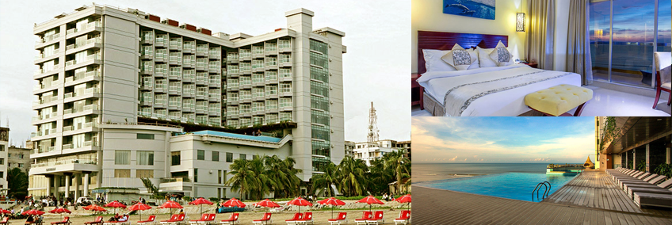
Figure 1: Sayeman Resort
(Sayeman, 2025)
Department of Environment (DOE) gave the resort a fine (BDT 50,000) for releasing hazardous liquid waste into the pristine waters of Cox’s Bazar beach harming the local ecosystem to a great extent (Daily Star, 2025). In 2019, DoE officials found the STP (Sewerage Treatment Plant) at the resort inactive (Daily Star, 2025). Since its business suffered so badly, its earnings per share (EPS) dived a whopping 94 per cent to Tk0.05 in fiscal 2019-20 from the earlier fiscal (TBS, 2025). As with that serious hit, of course, the pandemic played a huge role, but it is combined with the concern for sustainability as well. It is precisely such environmental mismanagement incidents that paint a negative brand picture that brands themselves sell as the luxury eco-friendly retreat. This is a problem that the resort has to deal with owing to the growing global awareness about sustainability and the ever-increasing traveller preference for environmentally conscious accommodations. This doesn’t only have environmental consequences; it also has financial and reputational consequences which deter eco-aware tourists and do damage to the hotel’s yield.

The Problem
The problem is that the resort is located in Sayeman Beach Resort and fails to practice sustainable waste management, and this has resulted in environmental pollution. In particular, the majority of the waste generated from the resort has been directly discharged into nearby water bodies resulting in water pollution of the beach and harm to marine ecosystems. Not only does it violate the environmental regulations, but it also risks degrading Cox’s Bazar’s status as a UNESCO World Heritage pending and a key source of tourism revenue for Bangladesh (The Financial Express, 2025). Additionally, these are actions that create a negative image of Sayeman’s corporate social responsibility (CSR) commitments, as the corporate jargon within their claims conflicts with the corporate action.
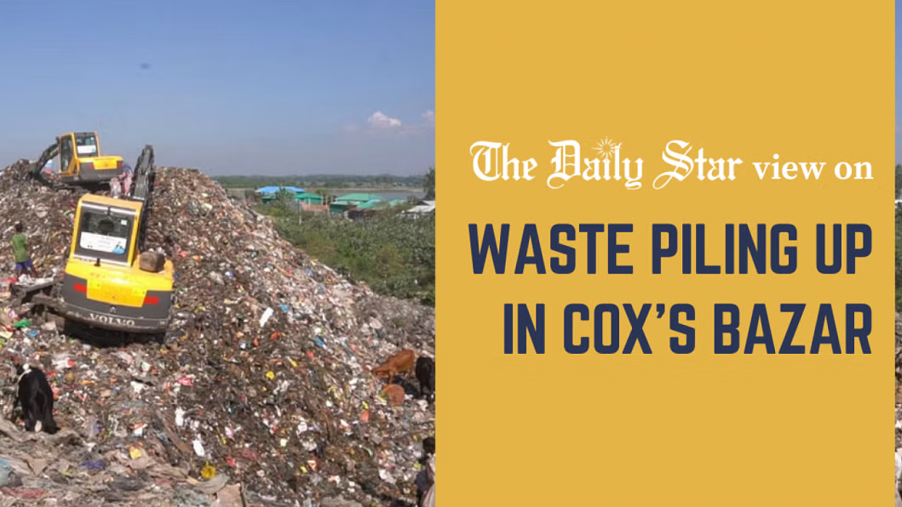
Figure 02: Pollution of Cox Bazar
(The Financial Express, 2025)
Due to the growing demands from the consumer for sustainability, and the increase in public and government scrutiny alike, Sayeman Beach Resort has to start addressing this issue urgently. If such failure occurred, it could lead to additional regulatory penalties, long-term reputational damage and loss of competitiveness in the market, as travellers are opting for eco-friendly accommodations.

Consultancy Firm
Fictitious consultancy firm, Green Horizons Consultancy, has addressed this challenge as it deals with sustainable business practice and environmental compliance. Green Horizons Consultancy was set up in 2012 as an end-to-end solutions provider to hospitality businesses to help integrate sustainable frameworks in their operations. It takes a data-driven approach out of a genuine commitment to environmental responsibility and the bottom line of business profitability (Mavridopoulou and O'Mahoney, 2020). From industry knowledge and innovative strategies, our team of experts provides the expertise to make clients achieve the best in both operational excellence and environmental compliance (O'Mahoney, 2021).
Green Horizons Consultancy has assisted a few high-profile hotels in Asia in addressing such environmental challenges and putting in place measures that have resulted in sustainability. We have a knowledge base in frameworks such as STEEPLED (Social, Technological, Environmental, Political, Legal, Ethical, and Demographic), SOAR (Strengths, Opportunities, Aspirations and Results), TOWS (Threats, Opportunities, Weaknesses and Strengths) and developing forward-thinking actionable strategies.

Theoretical Frameworks
To analyze and resolve the sustainability challenges of Sayeman Beach Resort, I intend to apply the following frameworks.
STEEPLED analysis: This tool will enable a full understanding of the external factors impacting Sayeman Beach Resort’s environmental policies. Through analysis of the social, environmental and political pressures, the analysis will identify areas in which the resort can improve its compliance with sustainability standards.
SOAR Analysis: By utilizing this framework, Sayeman’s internal strengths will be matched with external opportunities to produce aspirational goals and measurable outcomes. For instance, using its brand image and beachfront position to bring in eco-friendly ideas.
The TOWS Matrix: This strategy formulation tool will be used to generate particular answers that are a mixture of chances and threats and weaknesses and strengths in the resort. For example, strategies for change in regulatory penalties as an opportunity to construct a sustainability-focused brand identity.
The purpose of this report is to identify external and internal solutions that Sayeman Beach Resort can take actions to address its environmental challenges, restore its losses in reputation and be a pioneer of green luxury hospitality in Bangladesh. This is not simply a regulatory issue; it is about aligning the process with how the rest of the world is operating under tried and tested structures of sustainability for sustainable, long-term growth and customer trust.

Analysis
The STEEPLED analysis provides a systematic encompassing approach for evaluating the various outside factors in the hotel and tourism sector of Bangladesh with a specific emphasis on Cox’s Bazar. Through this analysis, we understand the challenge and the consequences that come from the direct discharge of liquid waste to nearby water bodies, as in the case of Sayeman Beach Resort.

STEEPLED Analysis

1. Socio-cultural Factors
Cox’s Bazar is famous for its nature that attracts a large number of tourists annually Last month of last year alone, the beach town saw an influx of roughly 1.6 million where turnover was around Tk 1,600 crore (TBS, 2025b). However, this influx has caused environmental degradation which threatens the lives of the local communities of fishermen and those who are especially dependent on access to marine resources. The pollution of beaches and water bodies spoils the area and threatens the livelihoods of people (Daily Star, 2025b).
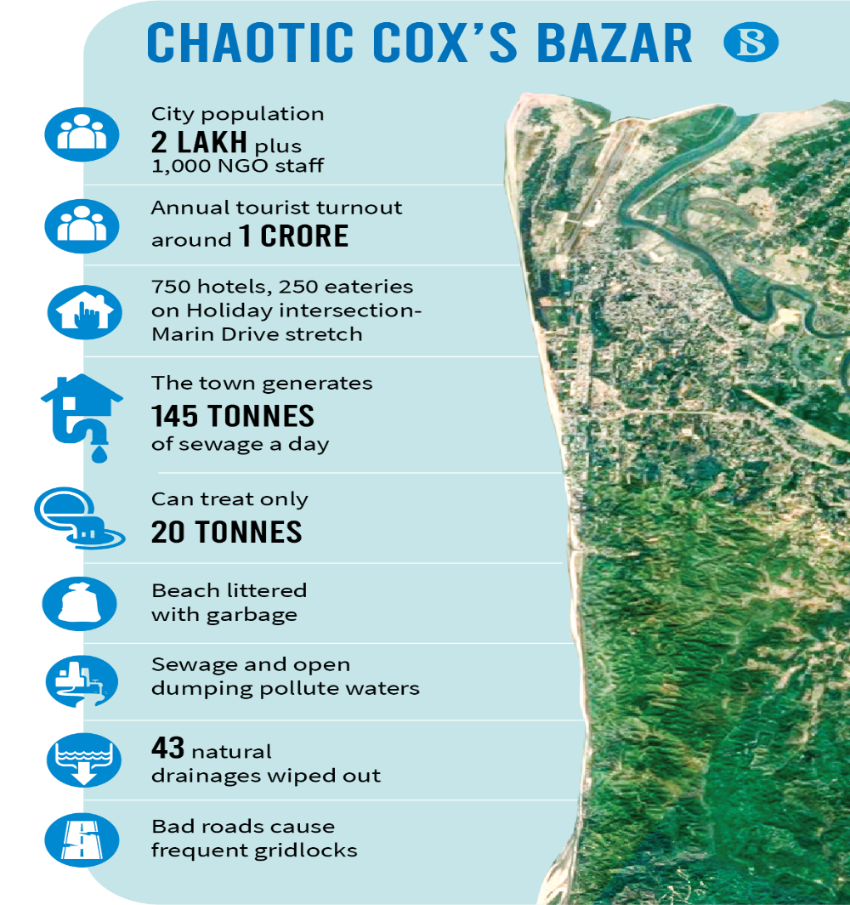
Figure 03: Socio-Cultural Factors Related to Cox Bazar and Hotel Tourism Around It
https://www.tbsnews.net/bangladesh/coxs-bazar-idyll-losing-itself-unplanned-urbanisation-305260

2. Technological Factors
Some of the challenges faced by the tourism industry in Cox's Bazar involve an inadequate waste management system (UNDP, 2025). There is no modern infrastructure for treating waste so entering untreated waste directly into the sea is practised. It hampers marine ecosystems simultaneously, leading to risks to health for both parties, locals and visitors (New Age, 2025). To address such issues, advanced waste management technologies need to be implemented to save the environment.

3. Economic Factors
The economy of Cox Bazar depends on tourism as multiple businesses state that tourism is a major money spinner for them especially during peak seasons. For instance, In the last 15 days of 2024, the Tk. 1,600 crore was generated by the tourism sector. But lack of environmental care with the resulting pollution by resorts can dissuade the tourists who will end up losing potential revenue. Additionally, the monetary expense of clean-up of the environment together with potential fines may exhaust the economic sources of a company engaged in such malpractices (TBS, 2025a).
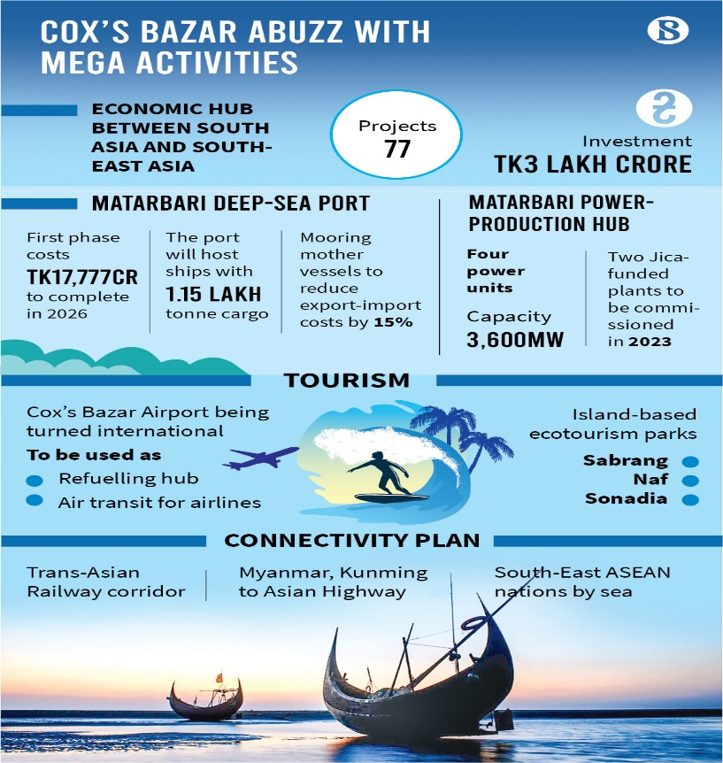
Figure 04: Economic Aspects of Hotel Tourism Around Cox Bazar
(TBS, 2025a)

4. Environmental Factors
To a large extent, it is unchecked tourism and poor waste management that has had an extremely big impact on the environment. A fact that the beaches are filled with common pollutants that are plastic bottles, food packets etc which in turn spoils the natural beauty of the beach and harms marine life (The Financial Express, 2025). Such long-term ecological consequences may lead to an impact on the biodiversity and general health of the marine ecosystem (UNDP, 2025).

5. Political Factors
As a result of laws which protect coastal areas, many of the regions of Bangladesh have been declared preserved regions. For example, it was declared a protected zone of about 15 square kilometres of Cox’s Bazar in 1999 (Mahamud and Takewaka, 2018). In the case of Sayeman Beach Resort, failure to adhere to these regulations can lead to legal actions such as fines, and a demolishing order.

6. Legal Factors
The environmental regulations in Bangladesh are made to safeguard natural resources as well as public health. This law empowers the Department of Environment to impose fines on the establishments where these laws are violated. In 2019, Sayeman Beach Resort was fined for allegedly tossing polluted water into the sea (Daily Star, 2025). These types of legal actions are simply a deterrent to verify that companies choose to adopt sustainable practices or else, they can find themselves involved in legal proceedings.

7. Ethical Factors
Corporate Social Responsibility (CSR) is a great focal point for businesses across the world. Resorts and hotels in Cox's Bazar are to come up in an environmentally viable manner. Any gap between a company's CSR claims and its real practice may cause reputational damage and damage a firm's credibility in terms of its products and services marketed. For example, if a resort mismanages the environment, its image can get tarnished and therefore people will stop patronizing the resort and incur financial losses.

8. Demographic Factors
The demographic profile of the tourists is changing and the number of tourists who prefer eco-friendly and sustainable travel options is increasing. A whopping 98 per cent of Bangladeshi tourists feel that Cox’s Bazar’s tourism programs should have eco-tourism integrated into them (Lupa and Hossain, 2019). Given this, the shift in consumer preference necessitates those resorts and hotels to adopt sustainable practices to be able to satisfy the expectations of modern travellers, and remain in the market.

SOAR Analysis of Sayeman Beach Resort
Category | Details
Strengths | Award-Winning Services: Recognized as the Leading Beach Resort at the South Asian Travel Awards (SATA) in 2019 and 2024 (Sayeman Resort, 2025).  Prime Location: Located in Cox’s Bazar which is the world’s longest natural sea beach for local and international tourists (Smits, 2025).  A Beachfront Beyond the Bounds of Luxury: Provides luxury beachfront accommodations and hotels with lofty premium beachfront hotels and luxury amenities (Sayeman Resort, 2025).  Much experienced Leadership: Led by Pubudu Fernando, who received South Asia’s Best General Manager at SATA 2024 (Sayeman Resort, 2025).  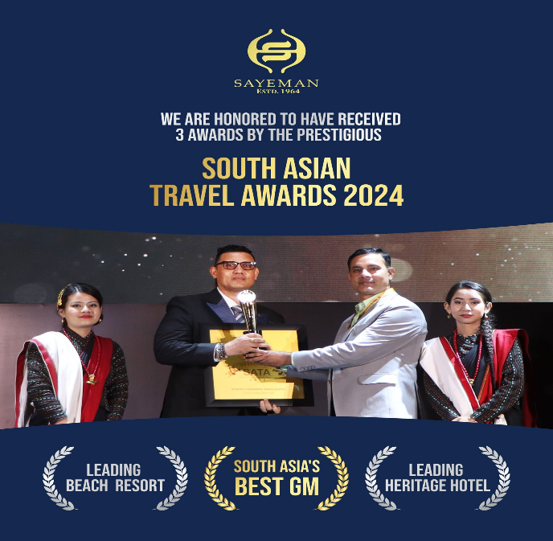  Figure 05: South Asian Travel Awards 2024  (Sayeman Official Facebook Page)  Heritage & Reputation: First private hotel in Cox’s Bazar since 1964, and a well-known brand in Bangladesh  Customer Satisfaction: High ratings on platforms like TripAdvisor and Booking.com for excellent service (TripAdvisor, 2025).  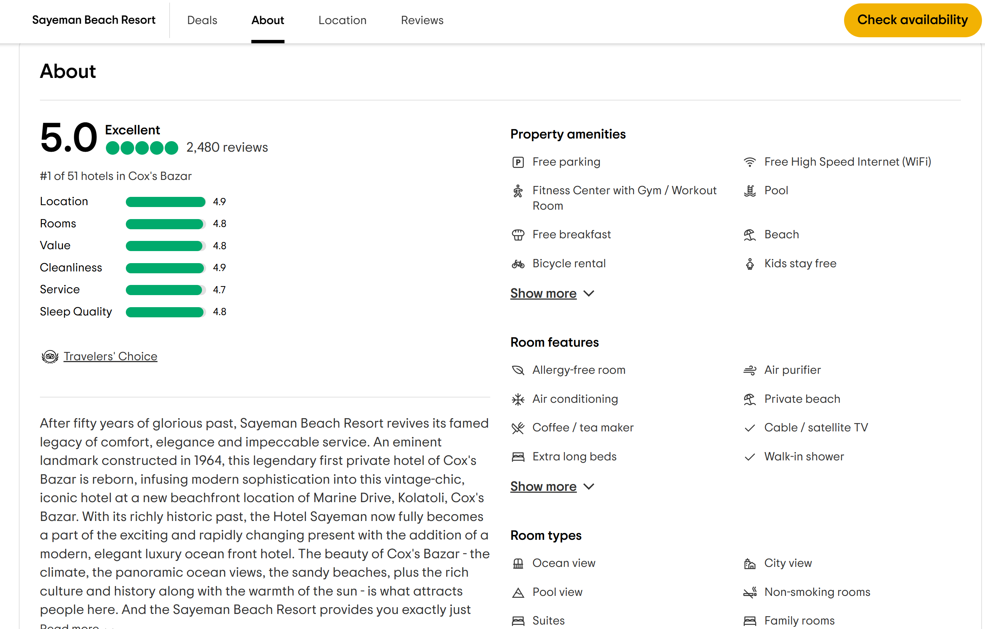  Figure 06: TripAdvisor 5/5 Rating  (TripAdvisor, 2025)
Opportunities | Sustainable Tourism Practices: Assisting in solving to focus on only environmental concerns such as sustainable waste management.  Expanding International Marketing: Targeting foreign travellers through global promotions.  Green Certifications: The green certifications are implemented to attract eco-conscious tourists.  MICE Tourism: Take business tourism to another level by combining Event Hosting and Corporate Event Hosting. A part of collaborating with travel agencies and airlines to create bookings (Kim et al., 2018).  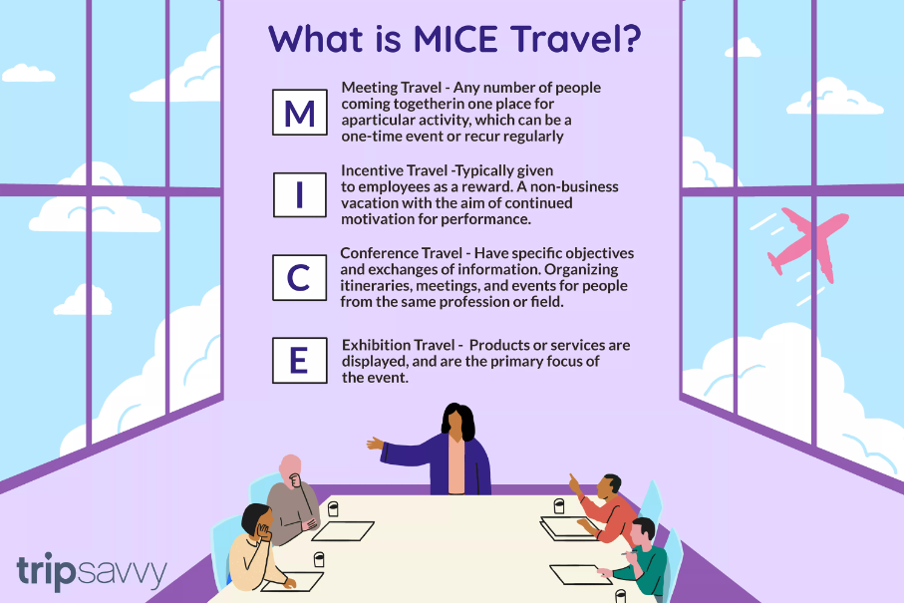  Figure 07: MICE Tourism  (Kim et al., 2018)
Aspirations | Being a Regional Leader: Building itself as the top sustainable luxury resort in South Asia.  Improving CSR: Using the eco-tourism initiative to improve corporate social responsibility (CSR) efforts.  Personalized Services and Exclusive Guest Experiences: This involves providing guests of the guest house with some personalized services and exclusive experiences.  Technological Integration: Implementing smart hospitality solutions, such as AI-driven concierge services.
Results | Increased Tourist Footfall: Attracting more domestic and international visitors post-pandemic.  Positive Brand Recognition: Recognition from global tourism boards and increased media exposure.  Increased Revenue Streams: Attracting more revenue from luxury services, events and partnerships.  Increased Customer Loyalty: Returning customers to repeat their experience, which they get from better service and a good brand image.

Key Problems Identified at Sayeman Beach Resort from STEEPLED and SOAR Analysis

1. Environmental Pollution & Regulatory Non-Compliance (Core Issue)
The serious environmental pollution brought about by the direct discharge of liquid waste in the surrounding water bodies is the most critical issue of Sayeman Beach Resort. It is a degrading practice that they are also using this irresponsible waste management practice which is degrading Cox's Bazar a most vital tourism destination of Bangladesh. The addition of such a sector further compounds the problem with its nonexistence of proper waste treatment infrastructure, and the case of ineffective enforcement of environmental regulations around the hospitality operations (Daily Messenger, 2025).
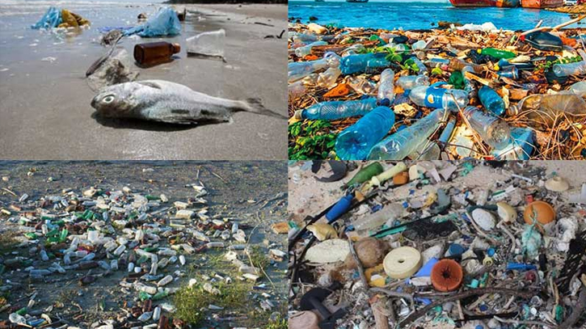
Figure 08: Environmental Pollution at Cox Bazar
https://www.dailymessenger.net/editorial/news/16367
This environmental negligence will have its repercussions. As a UNESCO World Heritage candidate, Cox’s Bazar’s status is threatened by pollution that if the aim succeeds can bring the county much international tourism and investment. Secondly, a penalty is at stake for Sayeman as the Bangladeshi government is tightening its environmental regulations and failure to comply is becoming ever more expensive. Next, the resort’s actions have contributed to a public image that is not good at all, especially for environmentally conscious traveller who choose resorts based on their sustainability. If this issue is not addressed by Sayeman, it will not only bear regulatory penalties but also lose customer trust and bookings.

2. Reputation & Brand Perception Crisis
Having established itself as a luxury environmentally responsible brand, Sayeman Beach Resort fails to live up to its own word by not implementing sustainable waste management techniques. That inconsistency has given the hotel a terrible reputation crisis as consumers and stations are starting to doubt the hotel’s credibility. Damage to standing with the eco-conscious traveller, and potential investors, is being done by the resort’s corporate social responsibility (CSR) commitments.
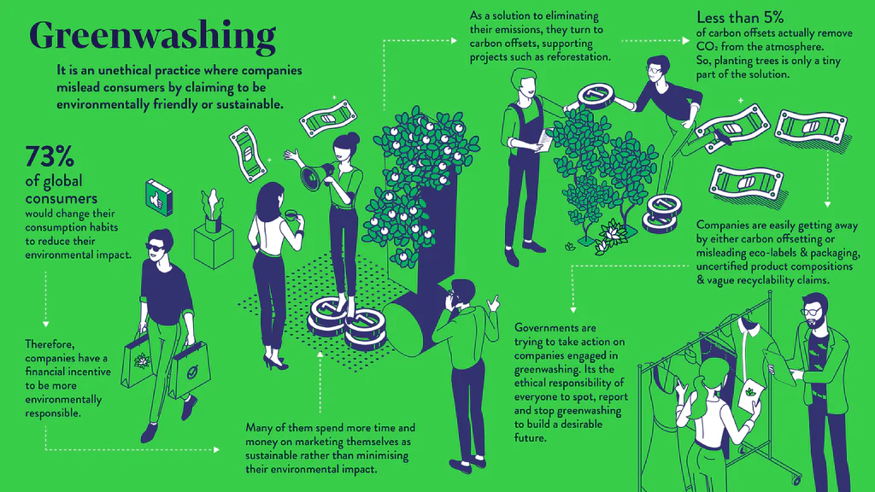
Figure 09: Greenwashing Marketing Tactic by Organisations
https://sabai.design/blogs/the-green-house/a-useful-guide-to-understanding-greenwashing-how-to-avoid-it
The greenwashing of Sayeman has led it to market itself as a responsible and sustainable resort, but without living up to its words in operations is the primary cause of this issue. For example, on the official website of Sayeman, there is no mention of CSR related to their effort to minimize environmental pollution. No specific campaigns or activities are presented yet they claim to be environmentally friendly. At the same time, the complaints of customers related to environmental issues have not been transparently addressed and more fuelled distrust. What has made it all the tougher for Sayeman to regain its name is the lack of crisis communication and damage control strategy. Over time, this negative perception will leave the hotel at risk of losing high-value guests, partnerships and its ability to be seen as a premium destination (Ko, Chan and Wong, 2019).

3. Market Competitiveness & Financial Risk
The extension of the hospitality industry is being influenced by the shifting in the demand for sustainable tourism in Bangladesh and worldwide. In this process, many international and local hotels in Cox’s Bazar have also incorporated eco-friendly infrastructure, green energy solutions, and responsible waste management into their business models. However, Sayeman’s age-old practices are positioning the organization as an increasingly uncompetitive player in the evolving tourism market.
The financial risk of this lack of competitiveness was a translation of such competitiveness. In the face of growing government watchfulness on environmental violations, Sayeman will find herself subject to regulatory fines or having her operations compelled to twisted expenses. Also, tourists are becoming more specific when choosing a resort to visit and they choose to favour resorts that best suit their sustainable attributes (Shamsub and Lebel, 2012). Sayeman’s future may be to experience a decline in occupancy rates and loss of premium clientele, straight hitting its revenue along the way. In addition, the confidence of investors in the brand may be destroyed, thereby limiting opportunities to expand and innovate.
Each of these problems links to the others, forming a vicious cycle of degradation of the environment, damage to reputation and damage to finances. Sayeman Beach Resort will become long-term irrelevant in that industry if it does not take immediate corrective action, as sustainability is becoming an increasingly mandatory business principle.
TOWS Analysis of Sayeman Beach Resort
TOWS Factor | Strategic Response
Strengths + Opportunities (SO) Strategies  Using strengths to maximize opportunities (PIRNAR, Kurtural and Eriş, 2019) | Award Recognition in Leveraging: Use its SATA awards and leadership accolades for international marketing to attract high-end travellers.  Integrate the hotel’s reputation and location to promote Eco-Tourism: Promote Eco Tour by creating Sustainability Initiatives like the beach during Eco Beach Clean Ups, and Green Certificate (Shamsuddoha, 2019).  Enhance Event Hosting Capabilities: Leverage such luxury facilities to offer MICE services (Meetings, Incentives, Conferences, Exhibitions) to lobby corporate clients.
Strengths + Threats (ST) Strategies  Using strengths to mitigate threats (PIRNAR, Kurtural and Eriş, 2019) | Enhance Environmental Compliance: Take advantage of their capability of financial puissance and prestige to try to set up sustainable waste managing practices, and answer to pollution issues.  Improve the Crisis Management & the PR Strategy: It is better to proactively take part in CSR initiatives that mitigate negative publicity against the company and its products.  Strengthening Market Position: Positioning as a heritage with an emphasis on premium service quality to differentiate itself against new technology competing options.
Weaknesses + Opportunities (WO) Strategies  Overcoming weaknesses by taking advantage of opportunities (PIRNAR, Kurtural and Eriş, 2019) | Design and Implement a Comprehensive Sustainability Plan: To address regulatory concerns, get eco certificates and be able to dispose of liquid waste systems accordingly.  Provide training to Operational Staff on Environmental Awareness: Arrange programs that would make operational practices in sync with sustainability commitments.  Green Organizations: Engage with environmental NGOs who can increase credibility and lend an eco-tourism potential (Merli et al., 2019).
Weaknesses + Threats (WT) Strategies  Minimizing weaknesses and avoiding threats (PIRNAR, Kurtural and Eriş, 2019) | The company needs to make immediate investments in waste treatment systems to prevent government fines and protect its reputation.  The company needs to release transparency reports and sustainability updates to accomplish trust reconstruction with consumers.  The company should develop revenue streams beyond beach tourism through wellness retreats as well as adventure tourism to decrease its financial dependence on beach visitors.

Recommendations
The hospitality industry has no option but to become sustainable, especially for luxury resorts which massively depend on pristine natural environments to attract tourists. Urgent strategic intervention is needed into Sayeman Beach Resort's failure to use effective waste management in light of misalignment between branding and operational practices (Burnes, 2014). The following are recommendations for sustainable waste management and the incorporation of eco-friendly operations into cultural transformation. Nevertheless, change cannot be forced but needs to be systematically integrated based on structured change management principles to sustain it against resistance.

Sustainable Waste Management: From Compliance to Competitive Advantage
Sayeman Beach Resort should change from reactive compliance to paying fines for pollution, to proactive environmental stewardship. The first immediate recommendation is the installation of an advanced sewage treatment Plant (STP), which is to prevent any untreated wastewater from spilling into Cox’s Bazar’s marine ecosystem. Yet, that is not enough to simply install infrastructure. Thus, to achieve these sustainability parameters, a closed-loop waste management system must be embedded in operations wherein treated water is to be reused for irrigation and organic waste composted onsite for onsite landscaping.
This can be useful with Lewin’s Change Model (1947). The “Unfreeze” stage demands waking up from denial and resentful acceptance of environmental responsibility as a requirement without a significant return on investment. With consideration of benefits for long-term expenditure reduction, an improvement in compliance, and a positive contribution to brand equity (Doppelt, 2017), the financial analysis must highlight how sustainable waste management can contribute to these issues. Training employees in the “Change” phase on waste segregation and recycling of water is crucial. In the final ‘Refreeze’ phase, policies must include metrics of sustainability in performance reviews and it must be expected, and not an afterthought (Hayes, 2022); (Whittington et al., 2020); (Kotter, 2012).
The institutional theory further supports this approach because it claims that organizations enhance sustainable practices beyond regulatory pressures by achieving legitimacy (Scott, 2008). For Sayeman to get to a higher level, it shouldn’t stop from pushing for green globe or earth check certification – which indicates that sustainability is a crucial core business thesis and not a brush rule.

Eco-Friendly Operations: Embedding Sustainability into the Guest Experience
A hospital can be sustainable only if it is tangible to the guests. At Sayeman Beach Resort, the usage of single-use plastics should be replaced by biodegradable ones, the sensor-based water and energy controls should be installed, as well as carbon offset programs by which guests contribute to local conservation programmes. Nevertheless, eco-friendly operations are not the cup of tea due to challenges like, cost, limitations in the supply chain and guest expectations (Baron and Armstrong, 2007).
Partially, this transition can be guided by Kotter’s Eight-Step Model (1996). The process of establishing urgency is easy: Sayeman’s regulatory violations and his reputational damage are very good reasons. The problem is to create a guiding coalition. If employees are meant to be sustainability ambassadors at all, they cannot be passive recipients of top-down directives (Ali, Elias and Touni, 2013). This follows participative change management which states that the more employees own the change the less they resist it (Burnes, 2020).
Additionally, marketing sustainability cannot be a sacrifice, but rather, it must be marketed as an experience. It has been established that luxury travellers are willing to pay a premium for eco-friendly hospitality provided they are marketed effectively (Bohdanowicz & Zientara, 2008). With a “Sustainable Luxury” package, Sayeman can choose organic food underground, locally sourced treatments at the spa, as well as eco-friendly room decorating. Sayeman embeds sustainability in the guest experience as a means to move from compliance-driven change to value-driven transformation.

Cultural Transformation: Overcoming Resistance and Embedding Sustainability
The main reason why organizational change initiatives fail is not due to weak strategies but it is due to cultural resistance (Schein 2010). Staff members at Sayeman oppose sustainability as a business focus at the same time that managers are hesitant to alter their established operational sequences. Sayeman needs to establish sustainability across the organization by going deeper than basic training programs.
According to Schein’s Cultural Model (2010) organizations need to modify fundamental organizational beliefs for transformative change to take effect. The resort must understand sustainability as its core identity instead of treating it as an add-on CSR effort. This can be achieved by:
- The HR department should modify evaluation criteria by adding sustainability performance indicators for staff who participate in environmental sustainability projects (Hoffman, 2018).
- Organizational sustainability leaders should be identified as Green Champions to act as influential examples who drive progressive behavioral changes according to (Armenakis & Harris, 2009); (Subramaniam et al., 2011).
- The company produces transparent sustainability reports every quarter which document its success indicators together with details about shortcomings for stakeholders (Lozano, 2015).
- The director inspires transformational changes through inspiration rather than imposition because this leadership theory matches these methods (Bass & Riggio, 2006). Sustainability within Sayeman should transcend the status of initiative to become the fundamental foundation of the company.

Managing Resistance: Addressing Psychological and Structural Barriers
- Organizations in cost-efficient industries must expect resistance to change due to their adherence to standardized procedures. According to research by Kotter and Schlesinger (2008), employees oppose change primarily because they worry about losing their jobs while they cannot understand new procedures and doubt company leaders’ dedication to change implementation. Sayeman needs to establish various strategies for detecting as well as countering potential issues which could arise in order to prevent their development.
- The organization must present financial evidence which reveals that sustainable practices produce extended benefit savings to guarantee understanding by workers and supervisory staff (Doppelt 2017).
- Staff tend to be concerned that new sustainability projects and automated systems might lead to a loss of their job positions (Presbitero, 2016). Change should not be seen as threatening by Sayeman since they should introduce sustainability certifications which will establish their workforce as leaders in green hospitality (Dent & Goldberg, 1999).
- Scientific research demonstrates that sustainability programs gain better acceptance when organizations implement them through small steps instead of making sudden changes (Oreg et al., 2011). Sayeman should initiate visible and low-resistant sustainability measures like cutting plastic usage before implementing major organizational shifts in waste management systems.

Evaluating Success, Measuring Impact, and Assessing Costs
The recommended changes listed above require successful implementation and sustaining by Sayeman Beach Resort and it is important to set clear success metrics, impact evaluation frameworks, and financial considerations for such to occur. To achieve sustainable transformation in the hospitality sector, the proposed approach is to use data to measure the environmental, profitability, and reputation benefits present (Jones, Hillier & Comfort, 2017). This section examines how Sayeman Beach Resort can monitor and assess progress, effectiveness and cost efficiency for sustainable waste management, eco-friendly business and cultural transformation.
Measuring the success of sustainable waste management
For the environmental strategy of Sayeman Beach Resort, the Sewerage Treatment Plant (STP) is the cornerstone. Though the presence of success cannot be described through decision, it should be able to be quantitatively measured in terms of a reduction in released pollution levels and compliance with regulations. According to Chan & Hsu (2016), to have successful management of waste in the hospitality segment, water contamination rates are lower which has been proven by third-party environmental audits.
For measuring impact, Sayeman can arrange quarterly checks on the water quality with the Department of Environment (DOE) and measure the levels of biological oxygen demand (BOD) and chemical oxygen demand (COD) in the discharged water. Furthermore, waste diversion rates documented and compared with pre-implementation baselines need to be informed as well (Testa & Iraldo, 2016).
It becomes important from a financial point of view to analyze the Return on Investment (or ROI) of STP installation to determine if there is a profitable investment. However, according to studies, advanced treatment plants in mid-sized hotels recover the costs in less than five to seven years because of low fines to regulatory and operational efficiencies (Mensah, 2019). The long-term financial saving can also be considered to be the difference between Sayeman’s estimated installation cost of $250,000–$300,000 (same for same-sized resort with Southeast Asia) and water procurement costs and improved marketability to the eco-conscious traveller.
Evaluating the Impact of Eco-Friendly Operational Practices
KPIs (Key Performance Indicators) should be considered for the transition to sustainable operational practices including single-use plastics, water conservation, and use of renewable energy. According to Jones & Wynn (2020), to verify their initiatives as green, hospitality businesses should be monitoring metrics like kilowatt hour (kWh) reductions per occupied room and litres per guest per night on consumption of water.
Sayeman Beach Resort should implement the following to measure the success of eco-friendly practices.
- Monitored monthly energy audits to measure reductions in energy usage in the presence of solar panel installation and energy-efficient lighting (Gössling, 2018).
- Eco-friendly amenity and service perceptions in guest engagement surveys (Han, Yu & Kim, 2018).
- Supplier audits to ensure all or at least some of the procurement lines fulfil sustainable standards such as biodegradable packaging, and fair trade product sourcing (Nicholls and Kang 2012); (Buttrick, 2009).
It is estimated that transitioning Sayeman’s size resort to energy-efficient LED lighting and solar water heating systems (Tang, 2019) would cost about $120,000 – $150,000, with a break-even period of four years. Further, single-use plastic phase-out and its move to biodegradable replacements may lead to a 20–30 per cent increase in procurement costs, although this can be offset by enhanced customer loyalty and premium pricing strategies (Font, Elgammal & Lamond, 2017); (Whittington and Molloy, 2005)

Assessing Cultural Transformation and Employee Engagement
Boosting employee beliefs and actions represents an essential requirement for deep-seated organizational transformation according to Schein’s (2010) Organizational Culture Model. Success indicators for Sayeman's operational value transformation based on sustainability can be measured through employee commitment levels together with retention numbers and completion outcomes for sustainability training sessions.
Key measurement tools include:
- The company conducts yearly surveys of its employees who rate their opinions regarding green corporate practices (Benn, Edwards & Williams, 2018).
- The HR systems track completion rates of sustainability training following the methodology presented by Teng, Horng and Hu (2012).
- Reduction in staff turnover is an indicator of increased organizational commitment (Holliday, Schmidheiny & Watts, 2018).
Sustainability training programs with both external certifications and internal workshops have an annual budget range between $30,000 and $50,000. Organizations that implement training effectively achieve operational efficiency along with decreased waste which leads to long-term financial improvement (Boiral, 2016).
The financial benefits need to be evaluated with corresponding Cost-Benefit Analysis assessments.
In the hospitality sector sustainability investments which usually need expensive initial expenditures demonstrate proven long-term financial advantages. The investor benefits of Sayeman Beach Resort include:
- The investment in improved waste management prevents regulatory penalties by eliminating their associated fines.
- Research shows eco-conscious visitors have demonstrated their willingness to pay between 10–15% additional fees when staying in sustainable hotels as noted by Choi, Jang and Kandampully (2015).
- Energy-efficient hotel infrastructure enables businesses to reduce their annual utility expenses by 20% according to Warren & Becken (2017).
An extended cost-benefit assessment at the hotel will simulate ROI trends throughout ten years while consolidating investments in capital expansion with operational savings from improved sustainability marketing.
The assessment framework of Sayeman Beach Resort's sustainability transformation requires a measurement system which unites ecological impact indicators with operational performance variables cultural development metrics and financial efficiency outcomes. The resort needs to perform periodic evaluations of its STP systems alongside eco-friendly methods and staff involvement initiatives with data coming from KPIs audit findings and survey participant feedback. The resort needs an initial investment ranging from $400,000 to $500,000 to launch but compliance savings alongside operational improvements and positive brand impact generate continuous financial benefits. Sustainable transformation serves two fundamental roles for Sayeman Beach Resort: it represents a moral necessity and provides the resort with an essential strategic business tool to succeed in the global hospitality markets.

Action Plan
Number | Problem | Solution | Desired Outcome | Time Scale | Completion Date | Planned Budget (BDT)
1 | High energy consumption and carbon footprint | Install energy-efficient LED lighting, smart thermostats, and motion sensors across the hotel. Transition to renewable energy sources where feasible. | Reduced electricity consumption and operational costs, improved environmental sustainability, and enhanced brand reputation. | 6 months | 15/09/2024 | BDT 7,000,000
2 | Excessive water usage and waste | Implement water-saving fixtures such as low-flow toilets and showerheads. Introduce a linen and towel reuse program for guests. | Lower water bills, conservation of resources, and positive guest engagement in sustainability efforts. | 4 months | 01/07/2024 | BDT 2,100,000
3 | Waste management inefficiencies | Set up a comprehensive recycling program and food waste composting. Partner with local charities for excess food donations. | Reduction in landfill waste, increased recycling rates, and positive CSR impact. | 5 months | 10/08/2024 | BDT 1,400,000
4 | Lack of staff training on sustainability | Develop and conduct sustainability workshops for all employees, focusing on energy conservation, waste management, and eco-friendly customer service. | Improved employee awareness, proactive sustainability practices, and seamless adoption of green initiatives. | 2 months | 30/05/2024 | BDT 700,000
5 | Inefficient procurement of supplies | Partner with local and sustainable suppliers for food, cleaning products, and amenities. Prioritize biodegradable and recyclable packaging. | Lower carbon footprint, improved supplier relationships, and marketing opportunities highlight sustainability. | 3 months | 20/06/2024 | BDT 1,120,000
6 | Guest engagement in sustainability is low | Develop an interactive sustainability campaign, including digital signage, in-room QR codes, and incentives for eco-conscious behaviour. | Increased guest participation, improved brand image, and strengthened commitment to sustainability. | 4 months | 01/08/2024 | BDT 1,680,000

Total estimated budget: BDT 14,000,000

Conclusion
The consultancy report demonstrates that Sayeman Hotel demands sustainability integration because it will boost operational efficiency while minimizing costs and building market dominance. The main operational problems which need resolution at Sayeman Hotel involve excessive energy usage combined with hefty water utilization alongside ineffective waste disposal practices insufficient sustainability training for personnel problematic procurement procedures and limited guest involvement with eco-friendly programs. The hotel faces multiple sustainability challenges which might both raise operational expenses and affect its reputation while decreasing its capability to compete on sustainability.
The report presents strategic suggestions which serve to improve Sayeman Hotel's prolonged sustainability together with maintaining its financial stability. The proposed energy-efficient systems together with water-saving technologies and a waste management program will minimize resource usage at operational costs. Employee training programs will enable staff members to implement sustainable practices as they gain the necessary knowledge to promote sustainability across the organization. The implementation of interactive sustainability programs alongside benefits for guests will enable Sayeman Hotel to establish itself as both eco-conscious and forward-thinking in providing hospitality services.
The planned action plan includes effective implementation protocols that define expenditure limits as well as duration targets and quantifiable results metrics. The use of Kotter’s eight-step model in combination with the stages of change management framework proposed by Lewin through a structured change management process will aid in smooth transitions and make staff adapt to changes. The chosen frameworks also assist in the development of such measures as urgent measures and sustained monitoring involving the stakeholders and feedback systems to reinforce the implementation of the change.
Three key advantages will be achieved in the adoption of the strategy towards sustainability adoption at Sayeman Hotel whereby, better reputation, financial advantage and regulatory alignment and superior guest satisfaction. These programs should be corporate social responsibility programs that will bind the hotel and the local community closer and will ensure the prosperity of both prosperity and environmental sustainability.
We are thankful to Sayeman Hotel for allowing our company to work on this project. Such opportunities allowed for the hotel’s collaboration on the delivery of solutions compliant with the hotel’s sustainability targets as well as economic reality. This to the organization suggests that these proposed recommendations will help the organization be successful in the long term concerning operational excellence for the success of Sayeman Hotel. We will spare our or additional clients' consultancy services supplying a ready team for monitoring sustainability progress and strategy optimization with suggestions for such constant improvements. Sayeman Hotel has strong support from the organization as it seeks to realize its quest to reach sustainable development through possible future partners.

References
Ali, M., Elias, A. and Touni, R. (2013). Impact of changing Management on Hotels’ Employees. Journal of Association of Arab Universities for Tourism and Hospitality, 10(1), pp.1–19. doi:https://doi.org/10.21608/jaauth.2013.210522.
Armenakis, A. A. & Harris, S. G. (2009) ‘Reflections: Our journey in organizational change research and practice’, Journal of Change Management, 9(2), pp. 127-142.
Baron, A. and Armstrong, M. (2007) Human Capital Management. London: Kogan Page.
Bass, B. M. & Riggio, R. E. (2006) Transformational leadership. 2nd edn. New York: Routledge.
Benn, S., Edwards, M. & Williams, T. (2018) Organizational change for corporate sustainability. 4th edn. London: Routledge.
Bohdanowicz, P. & Zientara, P. (2008) ‘Corporate social responsibility in hospitality: Issues and implications. A case study of Scandic’, Scandinavian Journal of Hospitality and Tourism, 8(4), pp. 271-293.
Boiral, O. (2016) ‘Greening the corporate culture: A case study’, Business Strategy and the Environment, 25(3), pp. 207-222.
Burnes, B. (2014) Managing Change. 4th edn. Great Britain: Prentice Hall.
Burnes, B. (2020) Managing change. 7th edn. Harlow: Pearson.
Buttrick, R. (2009) The Project Workout. London: Prentice Hall.
Cameron, E. & Green, M. (2019) Making sense of change management: A complete guide to the models, tools and techniques of organizational change. 5th edn. London: Kogan Page.
Chan, E. S. & Hsu, C. H. (2016) ‘Environmental management research in hospitality’, International Journal of Contemporary Hospitality Management, 28(5), pp. 823-842.
Choi, H. C., Jang, J. & Kandampully, J. (2015) ‘Sustainable practices in luxury hotels’, Journal of Hospitality and Tourism Management, 25(2), pp. 37-48.
Daily Messenger, N. (2025). Urgent steps needed for environmental protection. [online] The Daily Messenger. Available at: https://www.dailymessenger.net/editorial/news/16367 [Accessed 16 Feb. 2025].
Daily Star, N. (2025a). The Daily Star. [online] The Daily Star. Available at: https://www.thedailystar.net/country/doe-fines-sayeman-beach-resort-polluting-environment-1813663 [Accessed 17 Feb. 2025].
Daily Star, N. (2025b). The Daily Star. [online] The Daily Star. Available at: https://www.thedailystar.net/opinion/editorial/news/coxs-bazars-sewage-problem-3311966 [Accessed 16 Feb. 2025].
Deci, E. L. & Ryan, R. M. (2017) Intrinsic motivation and self-determination in human behavior. Berlin: Springer.
Dent, E. B. & Goldberg, S. G. (1999) ‘Challenging resistance to change’, The Journal of Applied Behavioral Science, 35(1), pp. 25-41.
Doppelt, B. (2017) Leading change toward sustainability: A change-management guide for business, government and civil society. 2nd edn. Sheffield: Greenleaf Publishing.
Font, X., Elgammal, I. & Lamond, I. (2017) ‘Green marketing strategies in hospitality’, Tourism Management, 62(1), pp. 72-82.
Gill, R. (2012) ‘Why the PR strategy of storytelling improves employee engagement and adds value to CSR: An integrated literature review’, Public Relations Review, 37(5), pp. 91-101.
Goh, C. & Jie, F. (2019) ‘Sustainability strategies in the hospitality industry: Drivers, enablers, and barriers’, Sustainable Development, 27(4), pp. 885-899.
Gössling, S. (2018) Tourism and sustainability: Development, globalisation and new tourism in the third world. 4th edn. London: Routledge.
Han, H., Yu, J. & Kim, W. (2018) ‘Impact of green initiatives on customer loyalty’, International Journal of Hospitality Management, 76(3), pp. 186-195.
Hayes, J. (2022) The theory and practice of change management. 6th edn. London: Palgrave Macmillan.
Henderson, J. C. (2019) ‘Sustainable tourism and CSR: Hotel sector engagement’, Tourism Review, 74(2), pp. 215-226.
Hoffman, A. J. (2018) How culture shapes the climate change debate. Stanford: Stanford University Press.
Holliday, C., Schmidheiny, S. & Watts, P. (2018) Walking the talk: The business case for sustainable development. London: Routledge.
Jones, P. & Wynn, M. (2020) The changing business environment and sustainability. London: Palgrave Macmillan.
Jones, P., Hillier, D. & Comfort, D. (2017) ‘Sustainability in the hospitality industry’, Sustainable Development, 25(6), pp. 482-491.
Kim, S., Yoon, Y., Kim, M. and Kim, Y. (2018). The Study of the MICE Brand Equity and Brand Loyalty by Creating Shared Value in MICE Industry. Journal of Tourism Management Research, 22(5), pp.69–88. doi:https://doi.org/10.18604/tmro.2018.22.5.4.
Ko, A., Chan, A. and Wong, S.C.K. (2019). A scale development study of CSR: hotel employees’ perceptions. International Journal of Contemporary Hospitality Management, 31(4), pp.1857–1884. doi:https://doi.org/10.1108/ijchm-09-2017-0560.
Kotler, P., Keller, K. L., Goodman, M., Brady, M. & Hansen, T. (2021) Marketing management. 16th edn. Harlow: Pearson.
Kotter, J. (2012) Leading Change. Harvard Business Review Press.
Kotter, J. P. & Schlesinger, L. A. (2008) ‘Choosing strategies for change’, Harvard Business Review, 86(7-8), pp. 130-139.
Kotter, J. P. (1996) Leading change. Boston: Harvard Business School Press.
Lewin, K. (1947) ‘Frontiers in group dynamics: Concept, method and reality in social science; social equilibria and social change’, Human Relations, 1(1), pp. 5-41.
Lozano, R. (2015) ‘A holistic perspective on corporate sustainability drivers’, Corporate Social Responsibility and Environmental Management, 22(1), pp. 32-44.
Lupa, Z.S., and Hossain, M.F (2019). Potentials of Establishing Eco-tourism in Cox’s Bazar: Understanding Tourist Perspectives and Preferences for a Right Marketing Mix. AIUB Journal of Business and Economics, 16 (1), 183-204.
Mahamud, U. and Takewaka, S. (2018). Shoreline Change around a River Delta on the Cox’s Bazar Coast of Bangladesh. Journal of Marine Science and Engineering, 6(3), p.80. doi:https://doi.org/10.3390/jmse6030080.
Mavridopoulou, A. and O'Mahoney, J. (2020) 'Elitism in Strategy Consulting: How Institutional Prestige Influences Recruitment', Management Consulting Journal, 3(1), pp. 12-22.
Mensah, I. (2019) ‘Sustainability practices in hotels: A review’, Journal of Hospitality and Tourism Management, 39(1), pp. 110-119.
Merli, R., Preziosi, M., Acampora, A. and Ali, F. (2019). Why should hotels go green? Insights from guests experience in green hotels. International Journal of Hospitality Management, 81(0278-4319), pp.169–179. doi:https://doi.org/10.1016/j.ijhm.2019.04.022.
New Age, N. (2025). Pollution threatens world’s longest sea beach. [online] Newagebd.net. Available at: https://www.newagebd.net/article/86662/pollution-threatens-worlds-longest-sea-beach [Accessed 16 Feb. 2025].
Nicholls, S. & Kang, S. (2012) ‘Green initiatives in the lodging industry’, Journal of Sustainable Tourism, 20(1), pp. 121-140.
Noordzife, G. (2014) Project Management of Hotel Opening Processes: Exploring Better Ways to Manage New Hotel Openings. CreateSpace.
O'Mahoney, J. (2021) 'How Small Consultancies Grow: Challenging Problem-Based Theorising', Management Consulting Journal, 4(1), pp. 5-20.
Oreg, S., Vakola, M. & Armenakis, A. (2011) ‘Change recipients’ reactions to organizational change: A 60-year review of quantitative studies’, Journal of Applied Behavioral Science, 47(4), pp. 461-524.
PIRNAR, İ., Kurtural, S. and Eriş, E.D. (2019). SWOT-TOWS Analysis of Urla Destination’s Alternative Tourism Development. International Journal of Contemporary Tourism Research, 27(17), pp.235–244. doi:https://doi.org/10.30625/ijctr.650380.
Presbitero, A. (2016). How do changes in human resource management practices influence employee engagement? A longitudinal study in a hotel chain in the Philippines. Journal of Human Resources in Hospitality & Tourism, 16(1), pp.56–70. doi:https://doi.org/10.1080/15332845.2016.1202061.
Sayeman Resort, N. (2025). Sayeman Beach Resorts Wins ‘LEADING BEACH RESORT’. [online] Best Hotel in Cox’s Bazar | Bangladesh-2025. Available at: https://sayemanresort.com/sayeman-beach-resorts-wins-leading-beach-resort-award-from-sata/ [Accessed 16 Feb. 2025].
Sayeman, N. (2025). Best 5 Star Hotel in Cox’s Bazar with Infinity Sea View-Bangladesh. [online] Best Hotel in Cox’s Bazar | Bangladesh-2024. Available at: https://sayemanresort.com/ [Accessed 17 Feb. 2025].
Schein, E. H. (2010) Organizational culture and leadership. 4th edn. San Francisco: Jossey-Bass.
Schein, E. H. (2010) Organizational culture and leadership. San Francisco: Jossey-Bass.
Scott, W. R. (2008) Institutions and organizations: Ideas and interests. 3rd edn. Thousand Oaks: Sage Publications.
Senge, P. M. (2006) The fifth discipline: The art and practice of the learning organization. New York: Doubleday.
Shamsub, H. and Lebel, L. (2012). Identifying tourists with sustainable behavior: a study of international tourists to Thailand. Journal of Environmental Management and Tourism, 3(1). doi:https://doi.org/10.2478/v10260-012-0003-z.
Shamsuddoha, M. (2019). Eco Tourism: An Establishment of Sitakunda Eco Park in Bangladesh. SSRN Electronic Journal, 27(17). doi:https://doi.org/10.2139/ssrn.1445265.
Smits, J. (2025). The Longest Beach in the World: Cox’s Bazar - Travel Begins at 40. [online] Travel Begins at 40. Available at: https://www.travelbeginsat40.com/2020/02/the-longest-beach-in-the-world-coxs-bazar/ [Accessed 16 Feb. 2025].
Subramaniam, N., Collier, P., Phang, M. and Burke, G. (2011) 'The effects of perceived business uncertainty, external consultants and risk management on organisational outcomes', Journal of Accounting & Organizational Change, 7(2), pp. 132-157.
Tang, C. (2019) Sustainable tourism planning and development. New York: Springer.
TBS, N. (2025a). Cox’s Bazar: An economic game-changer in the making. [online] The Business Standard. Available at: https://www.tbsnews.net/economy/coxs-bazar-economic-game-changer-making-269590 [Accessed 16 Feb. 2025].
TBS, N. (2025b). Sayeman Beach Resort to buy 25 lakh Peninsula shares. [online] The Business Standard. Available at: https://www.tbsnews.net/economy/stocks/sayeman-beach-resort-buy-25-lakh-peninsula-shares-358345 [Accessed 16 Feb. 2025].
TBS, N. (2025c). Tk1,600cr worth of turnover in 15 days as Cox’s Bazar sees year-end rush. [online] The Business Standard. Available at: https://www.tbsnews.net/economy/tk1600cr-worth-turnover-15-days-coxs-bazar-sees-year-end-rush-1029276 [Accessed 16 Feb. 2025].
Testa, F. & Iraldo, F. (2016) ‘Indicators for measuring environmental sustainability in hotels’, Tourism Management, 56(1), pp. 138-149.
The Financial Express, N. (2025). The Financial Express. [online] The Financial Express. Available at: https://thefinancialexpress.com.bd/national/two-hotels-fined-for-polluting-environment-in-coxs-bazar-1656475275 [Accessed 16 Feb. 2025].
TripAdvisor, N. (2025). Tripadvisor. [online] Tripadvisor. Available at: https://www.tripadvisor.com/Hotel_Review-g667467-d7736740-Reviews-Sayeman_Beach_Resort-Cox_s_Bazar_Chittagong_Division.html [Accessed 16 Feb. 2025].
UNDP, N. (2025). The waste keeps piling up. [online] UNDP. Available at: https://www.undp.org/bangladesh/stories/waste-keeps-piling [Accessed 17 Feb. 2025].
Whittington, R. and Molloy, E. (2005) HR's Role in Organisation: Shaping Change. Research Report. London: Chartered Institute of Personnel and Development.
Whittington, R., et al. (2020) Exploring Strategy. Harlow: Pearson Education Limited.

