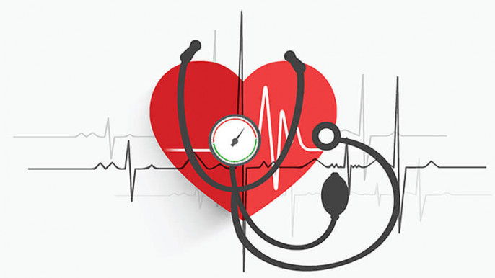

Student name: Muhammad Javed
Student ID number: 2437694
Social Epidemiology and Public Health Development LCHS7000
Component 2 analytical Report Age and health inequalities
Dr Hamdi Hussain

Task 1 – Social Epidemiological Analysis: Age and Health Inequalities in Birmingham, UK

Introduction
Health inequalities are preventable, avoidable, and unjust disparities in the health status of social groups. They are caused by disparate allocation of social, economic, and environmental resources as opposed to biological variation (Marmot et al., 2013; GOV.UK, 2022). The age, income and geographical disparities in the United Kingdom show drastic health outcomes. The ageing process is one of the primary inequality axes: individuals get older, which results in the emergence of various long-term conditions and increased care needs, but the deprived are situated worse (GOV.UK, 2022).
Hypertension is a dominant non-communicable condition that disproportionately impacts older adults and is the cause of cardiovascular morbidity and mortality (Murray et al., 2020). Approximately 32 per cent of the adults in England suffer from hypertension, and almost 30 per cent of hypertension cases are not diagnosed (ONS, 2023). The older adults in the city of Birmingham are at high risk, and access to preventive measures is unequal due to deprivation and ethnic diversity. This discussion examines the relationship between ageing and social determinants and how they interact to influence hypertension prevalence and outcomes, and to determine how national policy and organisations respond to these disparities.
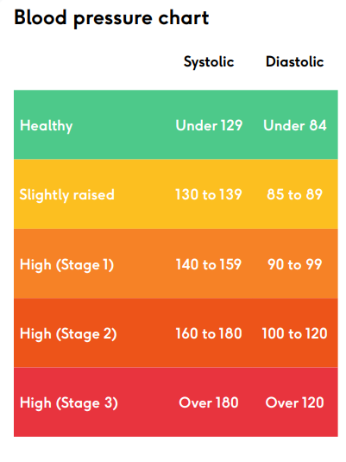
Figure 1: Blood Pressure Chart (BHF, 2023)

Contextual Background and Underlying Factors
Disease/Illness 1: Hypertension with High Prevalence.
According to NHS Digital (2023), hypertension is observed in one out of three adults in England, with nearly 60 per cent of adults aged 65 and above having it. Surveillance data on Baltimore indicate that the rates of surveillance in deprived wards are higher than the national rates (Office for Health Improvement and Disparities [OHID], 2022). Hypertension: this is usually non-symptomatic; the condition causes high chances of stroke, heart disease, and renal failure (WHO, 2021). The prevalence is high, both because of biological ageing and also due to poor diet, lack of exercise, and stress throughout life.
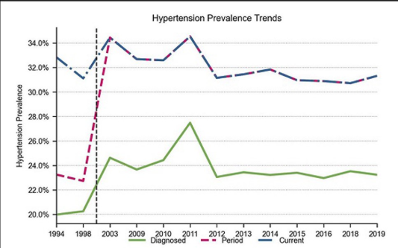
Figure 2: Hypertension prevalence trends in England (1994–2019) (Source: Graham et al., 2024)
Figure 2 shows national hypertension prevalence trends from 1994 to 2019 by diagnosed (green), era (pink), and current (blue). The graph shows a strong increase in period and present prevalence during the late 1990s and early 2000s, then stabilising at 31-34% from 2003. Diagnostic prevalence grows more slowly over the same era, indicating detection and primary-care recording improvements. The persistent discrepancy between diagnosed and total prevalence suggests that many persons have undetected hypertension, underscoring population screening and early detection issues. The data confirms that hypertension has been a major public health issue for two decades, especially among elderly and poorer people (Graham et al., 2024).
Disease/Illness 2: Heart Diseases Morbidity and Mortality.
Hypertension is the primary cause of cardiovascular disease (CVD), which is the number 1 cause of death in older adults (British Heart Foundation [BHF], 2023). Stroke and CVD hospitalisations in the West Midlands are higher than the national averages for individuals aged 65 and above. In the world, uncontrolled blood pressure is the cause of approximately half of all heart disease and stroke (WHO, 2021). The campaign F.A.S.T. has made hypertension an initial modifiable stroke risk, where over 100,000 strokes occur annually in the UK (GOV UK, 2021).
Disease/Illness 3: Poorly Controlled and Unidentified Hypertension.
Although the NHS Health Check, 5.5 million people are undiagnosed with hypertension in England (Public Health England [PHE], 2019). Poor health literacy, contact with GPs less often than once, and insufficient access to digital means are seen to prevent detection among older adults. The databases of Baltimore indicate lower control rates (under 140/90 mmHg) in the poor regions (Birmingham City Council, 2022). Poor management poses a risk that leads to stroke, disability and premature deaths (NICE, 2023).
Social Problems 1: Socioeconomic Deprivation.
More than 40 per cent of the neighbourhoods in Birmingham are among the most deprived in England (Birmingham City Council, 2022). The quality of the diet, lack of activity, and smoking habits of older adults in these regions are the most common causes of hypertension (Marmot et al., 2020). Economic struggle is also a limiting factor to medication adherence and GP visits. Reading between the least and the most affluent income groups, the older adults in the most impoverished regions are twice as likely to experience uncontrolled hypertension (BHF, 2023).
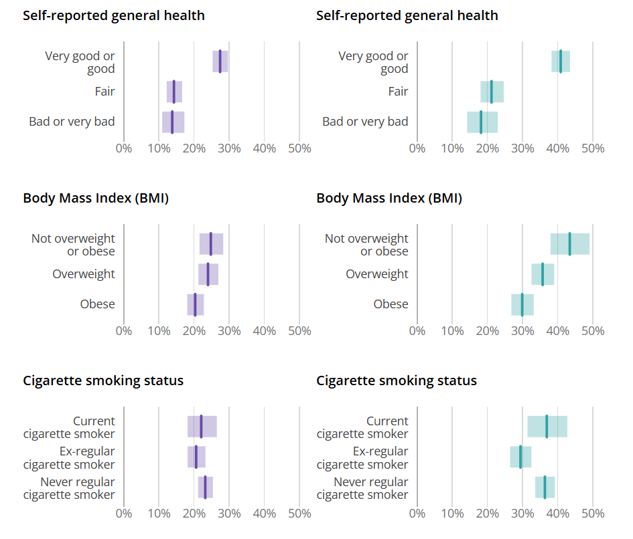
Figure 3: The proportion of adults with hypertension that were undiagnosed, by sex and self-reported general health status, England 2015-2019. (Source: ONS, 2023).
The figure 3 illustrates that persons with poor self-reported health, higher BMI, and current smoking status had undetected hypertension more likely. The trends show how behavioural and health-status determinants cause missed hypertension detection, perpetuating inequality.
Social Problem 2: Social Loneliness and Isolation.
Chronic loneliness is experienced by one out of twelve older adults in Birmingham (ONS, 2021). Loneliness increases stress hormones and blood pressure (Hawkley and Cacioppo, 2010) and decreases the desire to exercise or take medicine. In the context of the COVID-19 pandemic, the impact of isolation on monitoring and worsening of chronic conditions occurred (Department of Health and Social Care, 2022).
Social problem 3: Unfair Access to Healthcare.
Underprivileges in access also continue to affect the older population in Birmingham, especially the Black Africans, Caribbean and South Asian groups. Diagnosis and treatment are hindered by cultural, linguistic and financial barriers (Becares et al., 2022). The lack of digital access among older adults also restricts online consultation and remote monitoring (ONS, 2022). It is vital to fight these systemic obstacles in order to achieve equal cardiovascular results (GOV.UK, 2022).

National Response to Minimise Inequalities.
The NHS Long Term Plan (2019) has cardiovascular prevention at its heart, ensuring that 150,000 heart attacks, strokes, and cases of dementia are prevented within a decade due to improved hypertension identification and digital monitoring. OHID-led Public Health Outcomes Framework (2021) monitors the life-expectancy and hypertension metrics in order to inform the local policies, including the free NHS Health Check offered to 40- to 74-year-olds (OHID, 2022).
The Marmot Review - Build Back Fairer (Marmot et al., 2020), recommends introducing social determinants: housing, education, and employment, into the policy on ageing and chronic disease. NICE NG136 (2023) is evidence-based in its standards and diagnosis and management, and it gives equal access to antihypertensive therapies. Integrated Care Systems connecting NHS providers, local councils and community groups are the approach supported by the Department of Health and Social Care (2022) as a response to the health inequalities of older people. These strategies are combined as a whole, representing a multifaceted strategy that consists of prevention, equal service provision, and social-policy reform.

Organisations that help the Target Group.
BHF finances cardiovascular research and local community programmes called Healthy Hearts that provide blood-pressure measurements and lifestyle environmental guidance to vulnerable elderly people. Blood Pressure UK operates the national Know Your Numbers! Week, encourage free community testing and awareness (BHF, 2023). The social aspects of hypertension, which Age UK undertakes, include befriending, physical-activity programmes, and digital-inclusion support of older residents (Age UK, 2022).
OHID and NHS England cooperate at the system level to prevent cardiovascular diseases with the Cardiovascular Disease Prevention Programme, which incorporates community pharmacy cheques and equal access to drugs (NHS England, 2019; OHID, 2022). These alliances show a multi-sector-based integration of medical management and social support.

Conclusion
There is a disproportionate burden of hypertension among older adults in Birmingham, which is a result of both biological ageing and social disadvantage. The interplay between high prevalence, poor control and higher CVD mortality and deprivation, loneliness and access barriers. Systems on a national level, including the NHS Long Term Plan, Marmot Review, and the Public Health Outcomes Framework, offer mechanisms for targeted screening and managing diseases on a community level. Organisations such as Age UK, BHF and Blood Pressure UK go further with these initiatives with social support and education.
The long-term success will be based on the combination of health promotion and socioeconomic transformation: older adults in deprived urban areas should have equal access to opportunities to prevent and manage hypertension and lead longer and healthier lives.

Task 2 – Epidemiological Analysis: Hypertension among Adults in Birmingham, UK

Introduction
Epidemiology is the scientific study of health-related events in populations and their predictors, and the use of the same to manage the disease (Schneider, 2020). Hypertension is a prevalent and probably one of the most prevalent non-communicable diseases (NCD) in the world, and a significant modifiable risk factor of cardiovascular morbidity and mortality (World Health Organisation [WHO], 2021). It has been estimated that there are 1.28 billion adults with hypertension across the globe, in the majority of whom diagnosis and management are scarce (Murray et al., 2020).
Hypertension is a leading cause of yearly deaths due to heart disease and stroke in the United Kingdom (BHF, 2023). All national surveys indicate that about 32% of adult individuals in England have high blood pressure, and only a third of them are not diagnosed (NHS Digital, 2023). The prevalence rates increase drastically with age and deprivation, which creates sharp regional inequalities.
In the context of one of the most culturally diverse and socio-economically disadvantaged urban centres in the UK, hypertension poses a public health issue in the city of Birmingham. According to local data published by the OHID (2022), the rates were higher than the national ones, especially among older and minority populations. The analysis examines the epidemiological patterns, determinants of hypertension, surveillance, and interventions in Birmingham, providing a hint at evidence-based and equity-based prevention.

Public Health Measures
The principle of preventing disease, prolonging life, and promoting health through organised social effort is also relevant in the efforts by the public health to respond to hypertension, as suggested by Winslow (1920). Such attempts work under the protection, promotion, and prevention (Schneider, 2020).
Health Protection entails country-wide programmes, which alter structural environments. The voluntary salt-reduction policy introduced in the UK in 2001 forced manufacturers to repackage their foodstuffs and implement front-of-pack labelling. Assessment revealed a 15 per cent decrease in the average salt consumption and subsequent decline in death rates due to stroke (He, Brinsden and MacGregor, 2014). There is also the complementary tobacco-control legislation and alcohol-pricing policies to reduce the risk of hypertension.
Health Promotion focuses on empowerment and change of behaviour. Campaigns on a national scale, like Better Health and Know Your Numbers! Week (Blood Pressure UK) provide adults with the benefits of monitoring their blood pressure and maintaining balanced diets. On the local level, the Healthy Hearts Initiative of Birmingham collaborates with local leaders and religious organisations to provide culturally relevant education and screening in impoverished wards (Birmingham City Council, 2022).
Disease Prevention is concerned with the early identification and control. The NHS Health Check programme is aimed at cardiovascular risk screening of adults aged 40-74 years old, and walk-in BP monitoring is now available in pharmacies and GP practices. These programmes are the principles of the Ottawa Charter (WHO, 1986) that include creating conducive environments, empowering communities and transforming services to a preventive orientation.

Determinants and Risk Factors.
Both social and biological determinants have been established as having a significant role in the development and management of hypertension based on the epidemiological evidence. A recent national cohort study by Tapela et al. (2021) on nearly 100,000 hypertension patients in the UK showed that poor control was strongly linked with older age, obesity and excessive scores on the deprivation index. Despite the treatment, women and the population in socioeconomically deprived areas had lower blood pressure control rates, which highlights the ongoing inequalities in health.
Another determinant is the neighbourhood context. Buys et al. (2015) revealed in the University of Alabama at Birmingham Study of Ageing that hypertension prevalence and treatment outcomes in older adults, as well as the disadvantaged neighbourhoods, were significantly worse, despite the attitude to individual-level income and education. These findings, even though they are grounded in the United States, support the social gradient effects that are found in British cities like Birmingham.
The patterns of risk in the long-term are also demonstrated in the CARDIA study (Levine et al., 2011), a 20-year longitudinal study of more than 5,000 adults. It said that the younger adults of higher BMI, reduced physical activity and African ancestry acquired hypertension earlier and more persistently during adulthood. All these strong epidemiological studies indicate that hypertension is a product of age, adiposity, socioeconomic disadvantage, and lifestyle exposures, all of which are of strong relevance among ageing and ethnically diverse populations in Birmingham.

Populations Affected
Epidemiological research in the UK reveals that urban older adults have a disproportionate burden of hypertension, and ethnic minorities have a disproportionate burden. A more recent massive study with more than 200,000 primary care records in London in the year 2014-2021 found that hypertension prevalence and poor control were the greatest in adults aged 65 years old and in black Africans and South Asians (Basta et al., 2024). It was also the foundations of the study that noted the underdiagnosis and inconsistent coding in those boroughs that were deprived, and these frailties resembled those that had been recorded in Birmingham.
Previous results of the Health Survey for England presented by Zaninotto, Mindell and Hirani (2007) also indicated ethnic differences whereby the Black Caribbean males and females had the highest prevalence of raised blood pressure, followed by South Asians. These epidemiological studies, combined with each other, could identify older adults in poorly socioeconomically endowed, ethnically varied urban regions such as Birmingham as the most vulnerable group in this study.

Surveillance Systems
Effective hypertension control is based on accurate data. The Quality and Outcomes Framework (QOF) gives GP practices a reason to keep current registers and meet blood-pressure targets in order to produce granular practice-level data. On a regional scale, the OHID Cardiovascular Intelligence Network combines primary-care, hospital and mortality data to track the trends and resource distribution.
The Health Survey for England cross-sectional prevalence data is available nationally, whereas electronic records in Integrated Care Systems allow near real-time tracking. These surveillance systems are aligned with the WHO Global Monitoring Framework on NCDs (2021), since local indicators are to be fed into the world goals to reduce raised blood pressure 33 by 2030. Triangulation of data enables the health authorities to identify the inequalities promptly and assess the policy impact.

Public Health Impact
There are very severe medical and economic costs associated with hypertension. It is the leading cause of strokes and 40% of coronary mortality across the globe (WHO, 2021) and has an estimated cost of PS2.1 billion to the NHS per annum in its treatment and loss of productivity (BHF, 2023). In the city of Birmingham, hypertensive heart disease hospitalisation is 18 per cent higher than the England average (OHID, 2022).
Uncontrolled hypertension in the clinical context increases the rates of renal disease, dementia, and heart failure, decreasing the quality of life and independence of older people. In psychosocial terms, chronic illness is a source of anxiety, depression, and caregiver strain. The condition increases welfare dependency, social-care expenditure, economically, a problem that is exacerbated by the ageing population in Birmingham. England is expected to increase its adult hypertension population by 59 per cent without long-term prevention (Public Health England, 2019).
The societal health effect of hypertension is spread in morbidity, mortality and healthcare use. The EPIC-Norfolk research (Khaw et al., 2004) proved that blood pressure, systolic and diastolic, increased in a direct proportion to urinary excretion of sodium, which is good population-level evidence that dietary intake of salt directly elevates the risk of hypertension. The UK salt-reduction policy has been informed by this association.
The issues of ethnic differences in clinical outcomes were described in Eastwood et al. (2015), who compared South Asian men and European men who belonged to the Southall and Brent Revisited (SABRE) cohort. They discovered that South Asian men were found to increase the risk of stroke by a unit change in blood pressure, which highlighted the joint cardiovascular and equity effects of untreated hypertension.
Delgado et al. (2017) examined 79,376 people ≥ 80 years old in England and found that even treated hypertension was a risk factor in increasing the likelihood of heart failure and all-cause death. Such results emphasise the long-term consequences of hypertension in old age, with multimorbidity, frailties, and health dependency implications. Taken together, these pieces of epidemiological evidence stress the fact that hypertension continues to be a significant factor in untimely death, morbidity, and resource burden in the ageing population of the UK.

Intervention and Evaluation.
Integrated intervention combines community intervention, clinical intervention, and policy intervention. At the local level, the Birmingham Healthy Hearts is a collaboration between NHS trusts, the City Council, and voluntary organisations to provide screenings in mosques, churches, and leisure centres. The initial assessment demonstrates a higher detection in high-risk populations and adherence to medications (Birmingham City Council, 2022).
The Blood Pressure UK "Know Your Numbers!" campaign nationally -since 2001--has made BP testing routine. According to independent reviews, the level of public awareness did increase in 2012-2021, and CBP cheques of the community reached more than 1.5 million each year (BHF, 2023).
Other interventions are GP recall systems, workplace-wellbeing programmes and digital self-monitoring, which is assisted and sustained through the NHS Digital Weight Management Programme.
Assessment frameworks are equivalent to general public-health practice:
Process evaluation: determines the levels of participation and coverage of campaigns.
Impact evaluation: analyses behavioural changes -e.g. reduction of salt or increased cheque-ups.
Outcome evaluation: assesses the long-term impact (e.g. reduced mean blood pressure or decreased stroke admissions, etc.) (NICE, 2023).
QOF and OHID feedback loops make constant improvement possible, and qualitative research can be conducted with the service users to modify interventions to the local requirements.

Strengths and weaknesses of the Epidemiological Approach.
The best opportunity for epidemiology is the ability to produce objective evidence about population-level outcomes that can inform health policy and allocation of resources. It measures the disease burden, establishes a causal pathway, and measures interventions through surveillance and statistical analysis (Schneider, 2020). The UK Biobank cohort studies offer a plentiful amount of data related to lifestyle, genetic variables, and the outcomes of hypertension.
However, limitations exist. Regular data can omit short-lived or marginalised groups, which reduces inequality (Green and Thorogood, 2018). Cross-sectional designs are not causal, and quantitative indicators could miss the psychosocial factors such as loneliness or discrimination. In addition, epidemiology also tends to favour biomedical risk factors at the expense of structural factors, including housing or employment. The qualitative and participatory approach involving community interviews or co-production can provide a greater understanding of lived experiences and can improve the acceptability of the intervention.

Conclusion
Hypertension has been one of the main causes of preventable morbidity and mortality in Birmingham. With intertwined biological and social determinants, the prevalence and poor control are higher in the older, ethnically diverse and deprived population of the city compared to the national levels. Early detection and treatment have been reinforced by national policies and surveillance systems, including the NHS Long Term Plan, QOF and OHID Intelligence Network, but inequalities continue in spite of biomedical solutions.
The perceived reaction to the burden needs to be upstream and structural: addressing poverty, enhancing healthy food settings, and easing access to green and active spaces. By combining these with community screening focused on targeted areas and culturally competent health education, it will be guaranteed that the prevention will reach the people who are at the greatest risk. The future prosperity of sustainable development requires continuous data-based partnership among the NHS, local government, and civil society groups to deliver cardiovascular equity to the ageing population of Birmingham.

References
Age UK (2022) Annual report and impact summary 2022–23. London: Age UK. (No date). Available at: https://www.ageuk.org.uk/siteassets/documents/annual-reports-and-reviews/age-uk-annual-report-22-23-final.pdf (Accessed: 12 November 2025).
Basta, K., Ledwaba-Chapman, L., Dodhia, H., Ashworth, M., Whitney, D., Dalrymple, K. and Wang, Y., (2024). Hypertension prevalence, coding and control in an urban primary care setting in the UK between 2014 and 2021. Journal of hypertension, 42(2), pp.350-359.
Becares, L., Stopforth, S., Nazroo, J. and Kapadia, D., (2024). Ethnic inequalities in later life: Final report for the Nuffield Foundation.
Birmingham City Council (2022) Public Health intelligence, Public Health intelligence | Birmingham City Council. Available at: https://www.birmingham.gov.uk/downloads/download/1664/public_health_intelligence (Accessed: 12 November 2025).
Blood Pressure UK (2021) Know your numbers! Week evaluation report. London: Blood Pressure UK. (No date). Available at: https://www.bloodpressureuk.org/know-your-numbers/know-your-numbers-week/ (Accessed: 12 November 2025).
British Heart Foundation (2023) Cardiovascular disease statistics – UK factsheet 2023. London: BHF. Available at: https://www.ageinternational.org.uk/siteassets/documents/reports/2022/age-international-annual-report-2021-22-final.pdf (Accessed: 12 November 2025).
Buys, D.R., Howard, V.J., McClure, L.A., Buys, K.C., Sawyer, P., Allman, R.M. and Levitan, E.B., (2015). Association between neighborhood disadvantage and hypertension prevalence, awareness, treatment, and control in older adults: results from the University of Alabama at Birmingham Study of Aging. American Journal of Public Health, 105(6), pp.1181-1188.
Delgado, J., Masoli, J.A., Bowman, K., Strain, W.D., Kuchel, G.A., Walters, K., Lafortune, L., Brayne, C., Melzer, D., Ble, A. and As part of the Ageing Well Programme of the NIHR School for Public Health Research, England, 2017. Outcomes of treated hypertension at age 80 and older: cohort analysis of 79,376 individuals. Journal of the American Geriatrics Society, 65(5), pp.995-1003.
Department of Health and Social Care (2022) Direct and indirect health impacts of COVID-19 in England: emerging Omicron impacts (no date) GOV.UK. Available at: https://www.gov.uk/government/publications/direct-and-indirect-health-impacts-of-covid-19-in-england-emerging-omicron-impacts/direct-and-indirect-health-impacts-of-covid-19-in-england-emerging-omicron-impacts (Accessed: 12 November 2025).
Eastwood, S.V., Tillin, T., Chaturvedi, N. and Hughes, A.D., (2015). Ethnic differences in associations between blood pressure and stroke in South Asian and European men. Hypertension, 66(3), pp.481-488.
GOV.UK (2021) Relaunch of the Act FAST campaign to improve stroke outcomes, GOV.UK. Available at: https://www.gov.uk/government/news/relaunch-of-the-act-fast-campaign-to-improve-stroke-outcomes (Accessed: 12 November 2025).
GOV.UK (2022) Health inequalities in health protection report 2025 (no date) GOV.UK. Available at: https://www.gov.uk/government/publications/health-inequalities-in-health-protection-report/health-inequalities-in-health-protection-report-2025 (Accessed: 12 November 2025).
Graham, C., Steckelmacher, J., Prasher, J., Capel, M., Ahmed, A., Poulter, N., Sever, P. and Gupta, A., (2024). Trends in hypertension prevalence and control in England over the last 3 decades: Health Survey of England 1994-2019. European Heart Journal, 45(Supplement_1), pp.ehae666-2562.
Green, J. and Thorogood, N., (2018). Qualitative methods for health research.
Hawkley, L.C. and Cacioppo, J.T. (2010) ‘Loneliness matters: a theoretical and empirical review of consequences and mechanisms’, Annals of Behavioral Medicine, 40(2), pp. 218–227.
He, F.J., Brinsden, H.C. and MacGregor, G.A., (2014). Salt reduction in the United Kingdom: a successful experiment in public health. Journal of human hypertension, 28(6), pp.345-352.
Khaw, K.T., Bingham, S., Welch, A., Luben, R., O'Brien, E., Wareham, N. and Day, N., (2004). Blood pressure and urinary sodium in men and women: the Norfolk Cohort of the European Prospective Investigation into Cancer (EPIC-Norfolk). The American journal of clinical nutrition, 80(5), pp.1397-1403.
Levine, D.A., Lewis, C.E., Williams, O.D., Safford, M.M., Liu, K., Calhoun, D.A., Kim, Y., Jacobs Jr, D.R. and Kiefe, C.I., (2011). Geographic and demographic variability in 20-year hypertension incidence: the CARDIA study. Hypertension, 57(1), pp.39-47.
Marmot, M. et al. (2013) Fair society, healthy lives – The Marmot Review. London: The Strategic Review of Health Inequalities in England.
Marmot, M., Allen, J., Goldblatt, P., Herd, E. and Morrison, J., (2020). Build Back Fairer: The COVID-19 Marmot Review, London: Institute of Health Equity [online]
Murray, C.J., Aravkin, A.Y., Zheng, P., Abbafati, C., Abbas, K.M., Abbasi-Kangevari, M., Abd-Allah, F., Abdelalim, A., Abdollahi, M., Abdollahpour, I. and Abegaz, K.H., (2020). Global burden of 87 risk factors in 204 countries and territories, 1990–2019: a systematic analysis for the Global Burden of Disease Study 2019. The lancet, 396(10258), pp.1223-1249.
National Institute for Health and Care Excellence (NICE) (2023) Hypertension in adults: diagnosis and management (NG136). London: NICE. Available at: https://www.nice.org.uk/guidance/ng136 (Accessed: 12 November 2025).
NHS Digital (2023) Health Survey for England 2022: Hypertension and cardiovascular disease. Leeds: NHS Digital. Available at: https://digital.nhs.uk/data-and-information/publications/statistical/health-survey-for-england/2022-part-2/adult-health (Accessed: 12 November 2025).
NHS England (2019) The NHS long term plan. London: NHS England. (No date) NHS Choices. NHS. Available at: https://www.longtermplan.nhs.uk/ (Accessed: 12 November 2025).
Office for Health Improvement and Disparities (OHID) (2022) Office for Health Improvement and Disparities GOV.UK. Available at: https://www.gov.uk/government/organisations/office-for-health-improvement-and-disparities (Accessed: 12 November 2025).
Office for National Statistics (2023) Risk factors for undiagnosed high blood pressure in England: 2015 to 2019, Risk factors for undiagnosed high blood pressure in England - Office for National Statistics. Office for National Statistics. Available at: https://www.ons.gov.uk/peoplepopulationandcommunity/healthandsocialcare/healthandwellbeing/articles/riskfactorsforundiagnosedhighbloodpressureinengland/2015to2019?utm_source=chatgpt.com (Accessed: 14 November 2025).
Office for National Statistics (ONS) (2021). Wellbeing and Loneliness - Community Life Survey 2020/21 (no date) GOV.UK. Available at: https://www.gov.uk/government/statistics/community-life-survey-202021-wellbeing-and-loneliness/wellbeing-and-loneliness-community-life-survey-202021 (Accessed: 12 November 2025).
Office for National Statistics (ONS) (2023). Dataset Health state life expectancies by Index of Multiple Deprivation (IMD 2015 and IMD 2019), England, at birth and age 65 years (2021) Health state life expectancies by Index of Multiple Deprivation (IMD 2015 and IMD 2019), England, at birth and age 65 years - Office for National Statistics. Office for National Statistics. Available at: https://www.ons.gov.uk/peoplepopulationandcommunity/healthandsocialcare/healthinequalities/datasets/healthstatelifeexpectanciesbyindexofmultipledeprivationengland (Accessed: 12 November 2025).
Public Health England (2019) NHS Health Check programme: Best practice guidance. London: PHE. Available at: https://www.england.nhs.uk/london/wp-content/uploads/sites/8/2019/08/2.1.7-NHS-Health-Check-Best-Practice-Guidance-2017.pdf (Accessed: 12 November 2025).
Schneider, M.-J. (2020) Introduction to public health. 6th edn. Burlington, MA: Jones & Bartlett Learning.
Tapela, N., Collister, J., Clifton, L., Turnbull, I., Rahimi, K. and Hunter, D.J., (2021). Prevalence and determinants of hypertension control among almost 100 000 treated adults in the UK. Open heart, 8(1), p.e001461.
The Kings fund (2024). Tackling health inequalities: seven priorities for the NHS Available at: https://www.kingsfund.org.uk/insight-and-analysis/long-reads/tackling-health-inequalities-seven-priorities-nhs (Accessed: 12 November 2025).
Winslow, C.E.A. (1920) ‘The untilled fields of public health’, Science, 51(1306), pp. 23–33.
World Health Organization (1986) Ottawa charter for health promotion. Geneva: World Health Organization. First International Conference on Health Promotion, Ottawa, 21 November 1986 (no date) World Health Organization. World Health Organization. Available at: https://www.who.int/teams/health-promotion/enhanced-wellbeing/first-global-conference (Accessed: 12 November 2025).
World Health Organization (2021) Hypertension report. World Health Organization. World Health Organization. Available at: https://www.who.int/teams/noncommunicable-diseases/hypertension-report (Accessed: 12 November 2025).
Zaninotto, P., Mindell, J. and Hirani, V., (2007). Prevalence of cardiovascular risk factors among ethnic groups: results from the Health Surveys for England. Atherosclerosis, 195(1), pp.e48-e57.

