
contemporary CHALLENGES: MAKING a difference
BMSW4007


Nela Frunza Haham 2210514
27 November 2023
UNIVERSITY OF WALES TRINITY SAINT DAVID

How Climate Change affects the weather
Ideas and Solutions

INTRODUCTION
Climate change is a critical issue of our modern day that calls for creative, comprehensive solutions that go across humankind. An important technique for tackling the multidimensional problems related to climate change is design thinking, a human-centric approach to problem-solving. Design thinking provides a novel viewpoint to investigate reliable, adaptive, and inclusive solutions as the globe struggles with the effects of rising temperatures, harsh weather, increased sea levels, intensified extreme weather events, and disturbances to ecosystems and biodiversity are some of these effects (Liedtka,2014).
One of the biggest and most common problems affecting our planet right now is climate change how affects the weather. It speaks about long-term changes in regional and global climate patterns that are mostly caused by human activity, such as the release of gases, like carbon dioxide and methane into the atmosphere.
For the environment, economies, communities, and the welfare of future generations, these modifications to the Earth's climate system have far-reaching effects. With its emphasis on empathy, creativity, and teamwork, design thinking transcends conventional approaches to problem-solving. To provide solutions that speak to people personally, it promotes a thorough understanding of the needs, experiences, and worries of those impacted by climate change (IPCC,2021).

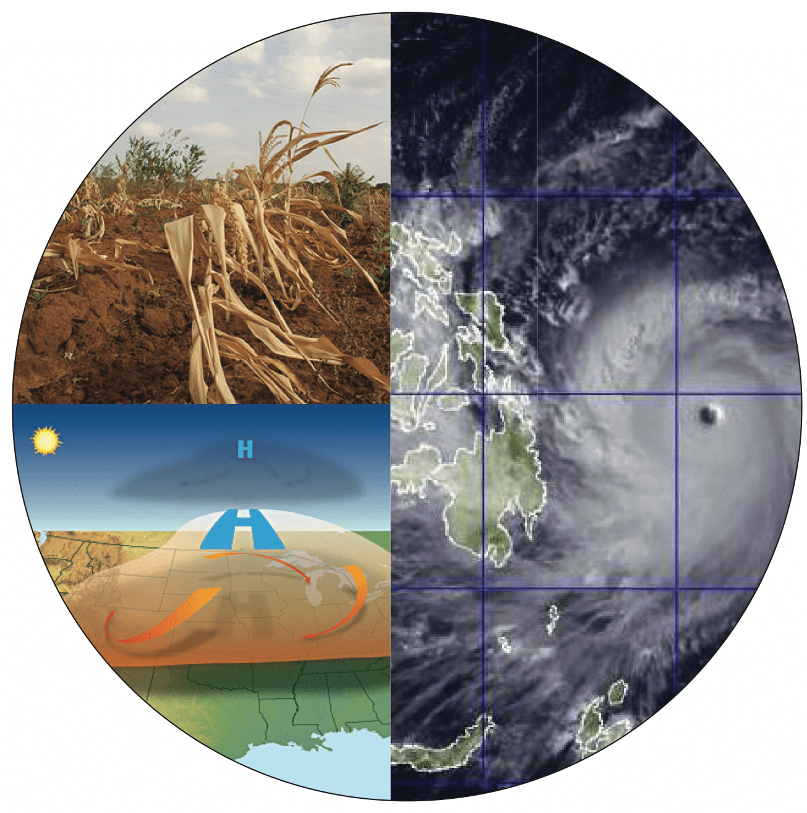

Findings

According to (Brown,2008) Ideate stage as it is known in the context of Design Thinking, is a crucial phase in which innovative solutions to difficulties are developed. Participants examine a variety of potential solutions during this phase by participating in brainstorming and idea production exercises. A process called ideation fosters original ideas, critical thinking, and the ability to suspend judgement. Design thinking promotes ideas and cross-disciplinary collaboration. Earth's average surface temperature has risen abnormally quickly during the past century, mostly because of gases created by human combustion of fossil fuels. This phenomenon is known as global warming. The gases that are classified as greenhouse gases include water vapour, carbon dioxide, nitrous oxide, ozone, and methane. Every year that goes by, it gets harder to anticipate the weather since there are fewer distinct seasons and higher average temperatures. Ever since the 21st century began, there has been a steady increase in the frequency of hurricanes, cyclones, droughts, floods, etc. The villainous force responsible for these alterations is global warming. The meaning of the word, which indicates the Earth's rising warmth, is rather obvious.
According to recent studies, many scientists believe the following are the primary four causes of global warming: deforestation, greenhouse emissions, pollution, and carbon emissions (Lineman,2015)
Severe heat waves can be extremely dangerous to one's health, increasing the risk of heat-related illnesses and even death. The hazards are amplified due to global warming (Kim, Kabir, and Ara Jahan,2014).
Ideas and solutions:
Weather is a natural phenomenon, and we can’t control directly. Finding the appropriate solution is crucial, even though it is almost too late to decrease the rate of climate change of weather. To discover a solution to climate change everyone—individuals as well as governments—must cooperate. The management of pollution, population increase, and the utilisation of natural resources are a few things to think about. Cutting back on the amount of plastic we consume is a crucial contribution we can make. One of the contributors to global warming is plastic which takes years to recycle. Our generation will try to reduce carbon emissions by cutting down on burning fossil fuels. Deforestation is another element to consider, as it will help reduce global warming. To make the environment greener, more tree planting needs to be promoted and action to be taken towards it (Bastin,2019).

How to help our planet:

-Adopt and encourage energy-efficient practice, investment in renewable energy sources including solar, wind and hydropower, promote agroforestry, climate -resilient crops, and sustainable agricultural methods.
-Investing in technology that collect and store carbon dioxide emissions from power plants and industrial processes.
--Public transportation and sustainable mobility, to lessen dependency on individual car usage, invest in and give priority to public transportation, walking, and bicycling. Prevent using cars or vehicles that damage the air (Emissions Gap Report,2020).
-Reuse, reduce, and recycle campaigns have the effect of using less energy and producing less pollution (Apte, & Mishra, 2023 and Sandu et.al.,2022).
-Infrastructure that is climate-resilient is design and constructed to resist the effects of climate change, including rising sea levels and extreme weather.
-Public transportation and sustainable mobility, to lessen dependency on individual car usage, invest in and give priority to public transportation, walking, and bicycling.
-Policy and regulation, adopt and implement laws and rules that control greenhouse gas emissions.
- Through education and outreach, raise public knowledge of climate change and encourage environmentally beneficial behaviour.

CONCLUSION

Weather patterns over the long term are changing due to climate change, which is caused by human activities like deforestation and the combustion of fossil fuels. Rising sea levels, altered rainfall patterns, altered temperature extremes, and an increase in the frequency and severity of extreme weather events are some of the effects. The effects of these modifications on agriculture, ecosystems, and human cultures are extensive.
Global warming will continue to pick up speed if humans continue to emit greenhouse gases. The effects are being felt on a much smaller scale, but they will soon intensify and become severe. Humans could save the day; all that is needed is to take it. Every person should cut back on their energy use. To cut down on energy waste, incentives should be provided for fuel-efficient vehicles and other electronics. In addition, this will lessen the amount of greenhouse gases in the environment and enhance air quality. Fighting together is the only way to overcome the effects of global warming.

REFERENCES:

1. Apte, S., & Mishra, P. (2023). Geo-Environmental and Human Health Impact of Spent Lithium-Ion Battery Waste and Its Recycling: A Critical Review. International Journal of Environment and Waste Management, 1(1), 1. Https://Doi.Org/10.1504/Ijewm.2023.10037666
2. Bastin, J. F., et al. (2019). "The global tree restoration potential." Science, 365(6448), 76-79.
3. Brown, T. (2008). "Design thinking." Harvard Business Review, 86(6), 84-92.
4. Intergovernmental Panel on Climate Change (IPCC). (2021). "Climate Change 2021: The Physical Science Basis - Summary for Policymakers."
5. Kim, K.H., Kabir, E. and Ara Jahan, S., 2014. A review of the consequences of global climate change on human health. Journal of Environmental Science and Health, Part C, 32(3), pp.299-318.
6.Liedtka, J. (2014). Innovative ways companies are using design thinking. Strategy&Leadership,42(2),28-33.
7.Lineman, M. (2015). Talking about climate change and global warming. PloS one, 10(9), p.e0138996.
8.United Nations Environment Programme (UNEP).” Emissions Gap Report 2020.

