Reflective Journal

Unit 1 Topic 3 – Addressing Sustainability
Description
Where was I?
I am in my living room currently going through the slide show presentation
Who else was there?
Only myself
Why was I there?
I was here preparing to go through the Unit 1 Topic 3 presentation.
What was I doing?
I was going through the Unit 1 Topic 3 presentation and taking notes as I went through the slides
What happened?
I learned about climate change, how it occurred, what it caused and the effects of climate change. Such as Urbanisation causing premature death.
Feelings
How was I feeling at the beginning?
I was feeling eager and wanted to learn more about climate change and what climate change causes. As I always heard about climate change and its dangers but never really researched more into it.
What was I thinking about?
I was thinking about the current climate changes I knew roughly about such as the fuel from vehicles in the road damaging the air we breathe
What did other people’s actions make me think?
The action of Olafur Eliasson made me realise how global warming is a big issue which is directly linked with climate change.
How did I feel about the outcome?
I feel good about the outcome with this presentation as it has shown me more ways we can help with changing the climate and how little things have a big impact on the world. Such as using recyclable bottles, separating our trash etc. This may seem small to us but it makes a big impact.
What do I think about it now?
It re enforced the idea I previously had that we humans are the changemakers. After watching a video in the slide a changemaker who inspired me is Olafur Eliasson he hauled 30 Icebergs to London to show the public the effects of climate change. He explained this was caused by global warming. That really is eye opening.
Evaluation
What was good about the experience?
I felt good with learning about how to improve the climate. The difference we make is small but is big in the long run. Such as using recyclable items.
What was bad about the experience?
I wouldn’t say the experience was bad, but it made me realise how we all negatively add to climate change. For example, with fuel consumption with driving a car, we may use the car to get to work but we also leisure drive such as to go shopping. We can easily use public transport or a bicycle and save the fuel from polluting our air.
Analysis
‘Breaking it down’
What did I do well? / Not so well?
I took rough notes when going through each slide this made it easier for me to compile a paragraph.
I should’ve taken a break whilst going through the slides the so the ideas would’ve come more freely instead of trying to do the work in one sitting.
Did it go as expected? Why / why not?
Yes, the unit did go as expected as I entered the presentation with the a clear cut intention of what climate change is and its impact to the world we live in. I was also ready to learn about the other effects of climate change.
What theory / research helps me understand the experience?
The videos at the end of the slide helped me understand climate change more for example the video ‘How to save our planet’ A small thing I learned from the video such as separating our trash, e.g. glass, garden waste, general waste. This re-enforces the quote I learned on the slide show small changes have big effects and doing something as small and simple as that will help improve the climate.
Conclusion
Could I have done anything differently?
Managed my time a little better so I could have had multiple sittings through the slideshow instead of trying to complete all the notes in one sitting.
What are the key things I have learned from this incident – about me, my performance?
The most important thing that I learned from this assignment is that we as humans need to raise awareness to climate change and only we can make a difference no matter how small the action is it will have a big impact on the world we live in today.
I also noted whilst going through the presentation I prefer watching the Youtube videos included in the slideshow instead of reading through the slides.
Can this be evidence of achievement of placement outcomes / competencies?
Yes, I believe this is an achievement as it shows I am competent in reading information off the slideshow and providing my own input, thoughts and ideas.
What would I do in a similar situation in the future?
Familiarise myself with the topic before going through the slideshow so I have a better understanding.
Also manage my time better so I don’t have to do the work in one sitting.
What aspects of my knowledge / skills could I develop?
I believe I need to improve on my computer skills as I am not very computer literate. Also engage in the lectures.
How will I do this?
Take extra courses, and make sure to attend every university lecture & ask questions, go through study materials
What goals can I set myself for the future?
- Improve my time management skills.
- Take extra time.
- Take extra courses on electronics.
- Be more active in the class and ask more questions
- Pay more attention during the slideshow and read all the information clearly
What outcomes / competencies do I need to focus on now?
What I learned from the slideshow I need to apply. For example, I commit to driving less where possible and taking public transport or walking if possible to prevent negative effects to the climate. I also commit to reuse and recycle items I can. Also avoid plastic items such as single use water bottles and instead opt to drink tap water.
Screenshots:
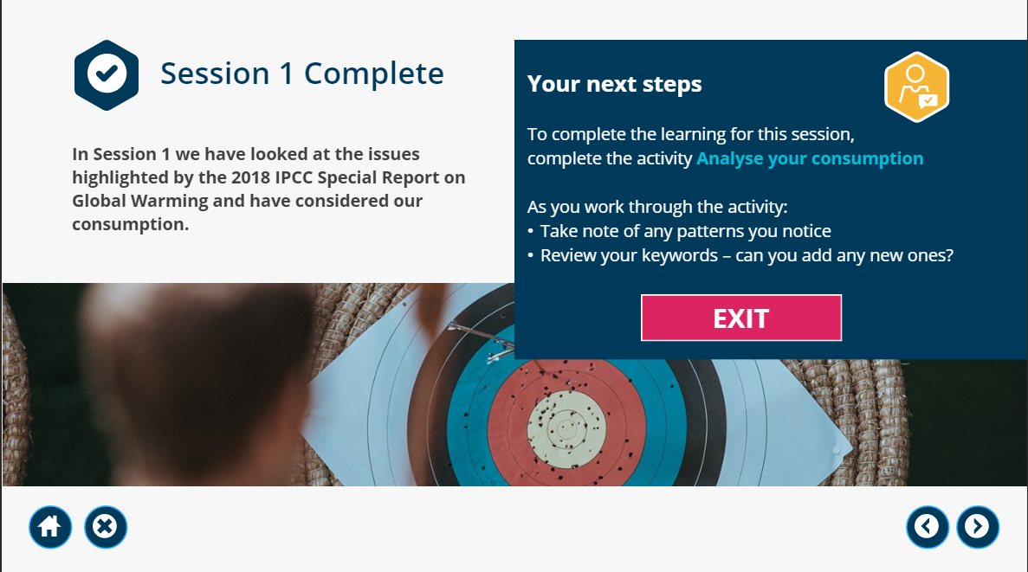

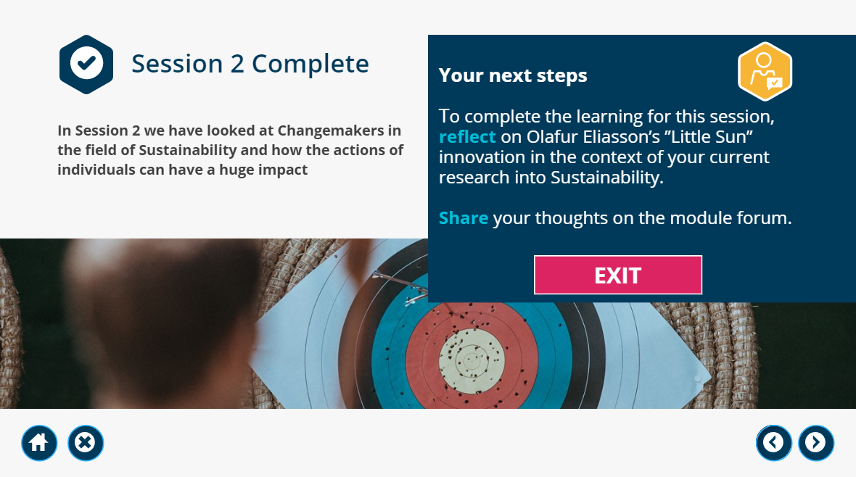

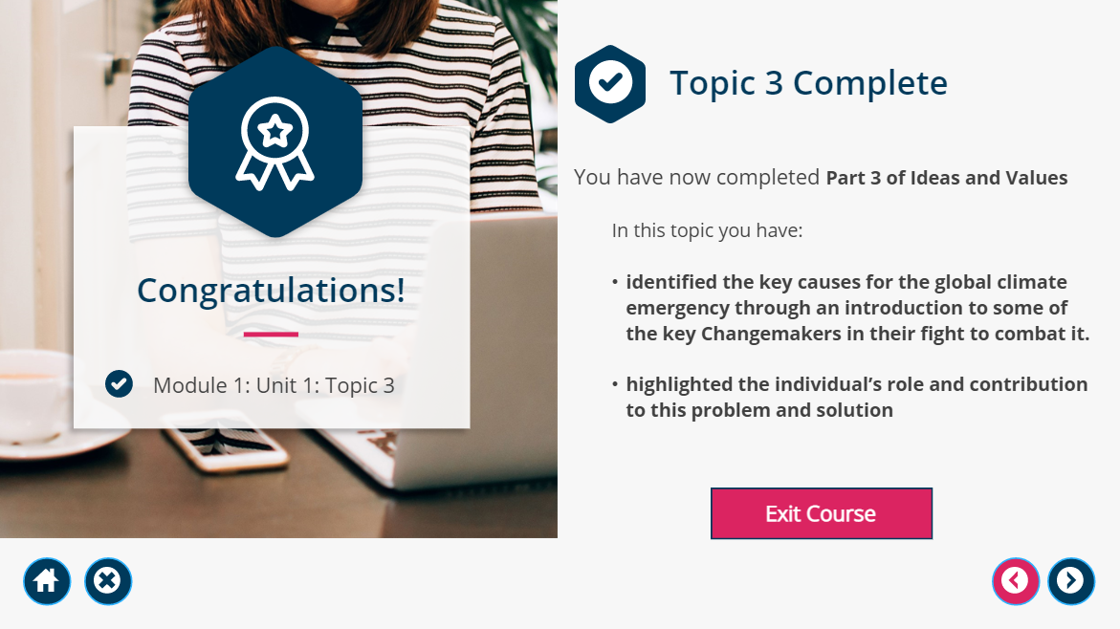

Unit 1 – How Innovation changes the world
Description:
Where was I?
I am in my living room currently
Who else was there?
Only myself
Why was I there?
I was here preparing to go through the Unit 1 Innovation presentation
What was I doing?
I was going through the Unit 1 Innovation presentation and taking notes as I went through the slides
What happened?
I gained a better understanding of how Innovation changed the world.
Feelings
How was I feeling at the beginning?
I was eager to learn about different innovations and how they have impacted the world we currently live in.
What was I thinking about?
I was thinking about the innovations we currently use such as the light bulb created by Thomas Edison and how if we didn’t have that creation, we would still be using candles.
What did other people’s actions make me think?
The innovations of other people made me think if they can create such great innovations and they are only human I also have the ability to create an innovation too if I apply myself and work hard.
How did I feel about the outcome?
I feel good about the outcome this presentation has also made me feel a lot better about myself as it established that we have the opportunity to create the future if we apply ourselves. And how the University provides me a platform to achieve my dreams of being an electrician and making a difference.
What do I think about it now?
I think of Innovation as a great thing as said before if we did not have certain innovations such as a lightbulb, we will be living in a very different world compared to now.
Evaluation
What was good about the experience?
I learned many things and came across new theories such as the Kondratiev wave cycle which I did not even know existed.
And also Society 5.0 which showed me how we have so far to come and how so many innovations are yet to be created to better our lives.
Going through the slides also made me realise that if an innovation like a computer did not exist and was not invented it would be very difficult to complete this course and we probably would have still be using typewriters.
What was bad about the experience?
I did not agree with the statement ‘progress is problem solving and we should look at things like climate change, nuclear war, health and wellbeing as problems to be solved not apocalypse in waiting.
As if certain innovations were not created or thought of we would not have these problems. For example, if a vehicle was not innovated we would not have problems with the climate from the fuel combustions.
Analysis
‘Breaking it down’
What did I do well? / not so well?
I believed I did well with Unit 1 I took notes of what I understood through each slide and made a paragraph. But believe I should’ve taken a break instead of trying to finish the work all in one sitting. If I took a break and thought about the work my ideas would be fresh and come easily.
Did it go as expected? Why / why not?
Yes the unit did go as expected as I entered the presentation with the a clear cut intention of what an Innovation is and also I was ready to learn new innovations and how they impact the world today.
What theory / research helps me understand the experience?
Society 5.0 helped me understand the concept of innovation. We have come a long way in terms of innovation but with the concepts described it still shows we have a long way to go.
For example, an innovation that was explained with the refrigerator monitoring the condition of stored food to cut down waste. Sounds like a great innovation but is yet to be produced and how it will change the world drastically, improving in food quality and cutting down in food waste.
Conclusion
Could I have done anything differently?
I should’ve taken a break instead of trying to finish the work all in one sitting. If I took a break and thought about the work my ideas would be fresh and come easily. I need to work on time management.
What are the key things I have learned from this incident – about me, my performance?
I have learned that I have the opportunity to create the future if I apply myself. And how the University provides me a platform to achieve my dreams of being an electrician and making a difference.
I also noted whilst going through the presentation I prefer watching the Youtube videos included in the slideshow instead of reading through the slides.
Action Plan
What would I do in a similar situation in the future?
Familiarise myself with the topic before going through the slideshow so I have a better understanding.
Also manage my time better so I don’t have to do the work in one sitting.
What aspects of my knowledge / skills could I develop?
I believe I need to improve on my computer skills as I am not very computer literate. Also engage in the lectures.
How will I do this?
Take extra courses, and make sure to attend every university lecture & ask questions, go through study materials
What goals can I set myself for the future?
- Improve my time management skills.
- Take extra time
- Take extra courses on electronics
- Be more active in the class and ask more questions
- Pay more attention during the slideshow and read all the information clearly
Screenshots:
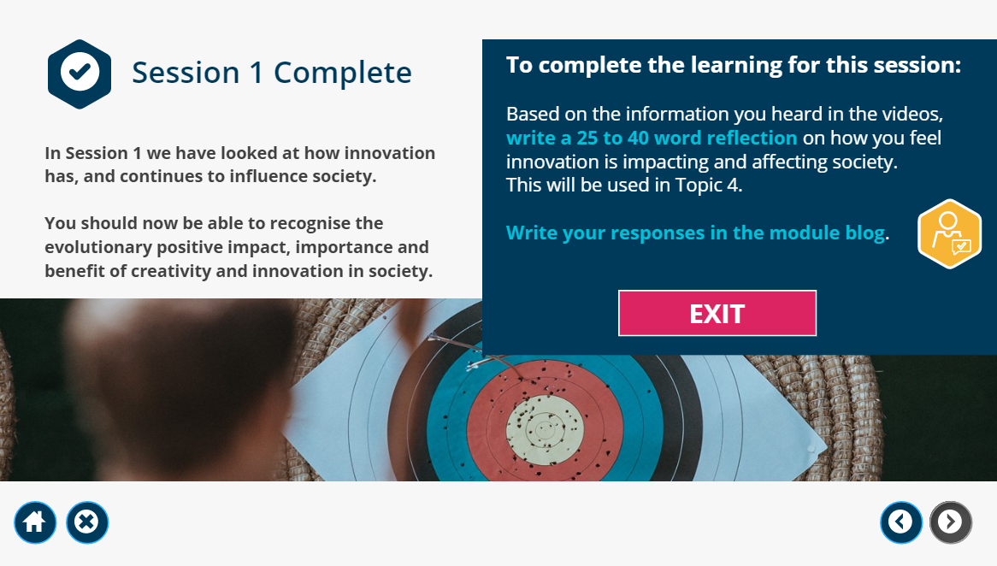

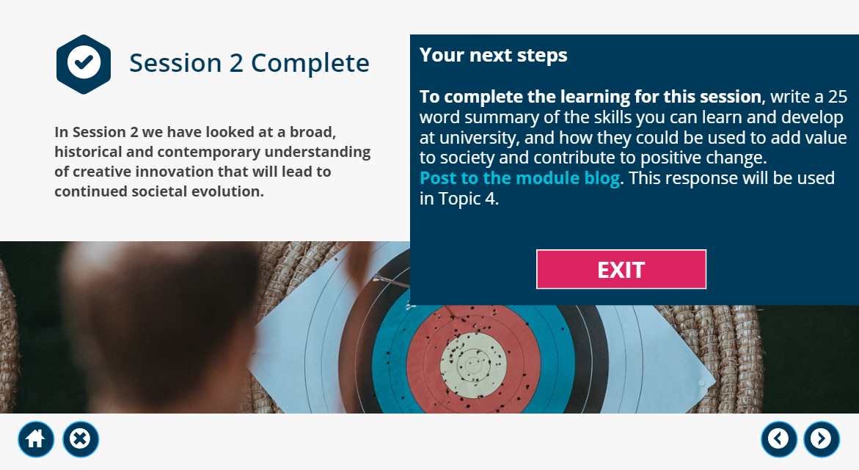

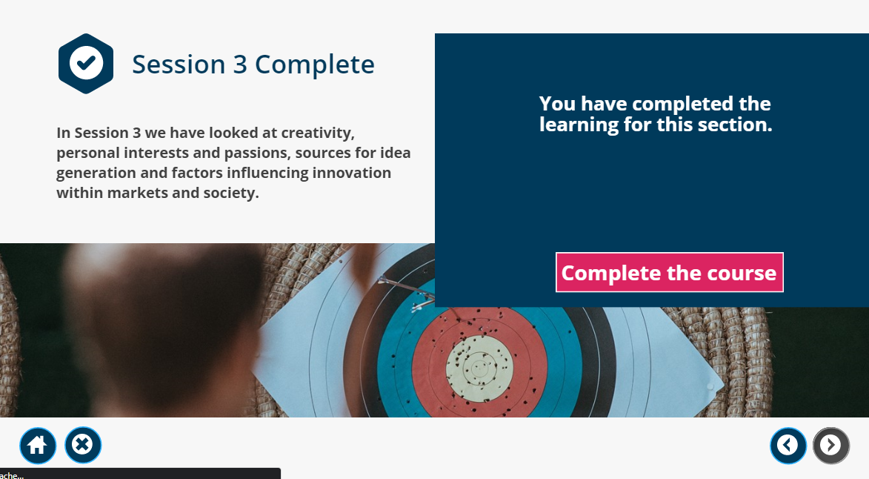

Unit 2 – Topic 1
Description
Where was I?
I am in my living room currently going through the slide show presentation
Who else was there?
Only myself
Why was I there?
I was here preparing to go through the Unit 2 presentation the art of creating value.
What was I doing?
I was going through the Unit 2 Changemaking and taking notes as I went through the slides
What happened?
I learned about what a change maker is and the relationship between change and creating value.
Feelings
How was I feeling at the beginning?
I was ready and eager to learn about what a changemaker is and how different change makers create different values.
What was I thinking about?
Before I started the presentation I was thinking to myself what does the word changemaker mean and how does a person become a changemaker.
What did other people’s actions make me think?
The change of banning cups by the Scottish government is a great change I think. As mentioned on the article in the presentation 99.75% of single use cups do not get recycled. This is a great change which creates value as it helps the climate.
How did I feel about the outcome?
I felt good with the outcome of this presentation as it has explained to me that we are all changemakers in our very own way.
What do I think about it now?
It re enforced the idea I previously had that we humans are the changemakers. After watching a video in the slide a changemaker who inspired me is Olafur Eliasson he hauled 30 Icebergs to London to show the public the effects of climate change. He explained this was caused by global warming. That really is eye opening.
Evaluation
What was good about the experience?
I felt good with learning about how to improve the climate. The difference we make is small but is big in the long run. Such as using recyclable items.
What was bad about the experience?
Nothing was bad about the experience with this presentation
Analysis
‘Breaking it down’
What did I do well? / Not so well?
I took rough notes when going through each slide this made it easier for me to compile a paragraph.
I should’ve taken a break whilst going through the slides the so the ideas would’ve come more freely instead of trying to do the work in one sitting.
Did it go as expected? Why / why not?
Yes, the unit did go as expected as I entered the presentation with the a clear cut intention of what a change maker is and the meaning of it and its impact to the world we live in.
What theory / research helps me understand the experience?
I roughly understood the Mackaguchi’s BBG tool as a tool for evaluating change.
Conclusion
Could I have done anything differently?
Managed my time a little better so I could have had multiple sittings through the slideshow instead of trying to complete all the notes in one sitting.
What are the key things I have learned from this incident – about me, my performance?
The most important thing I’ve learned from this presentation is that ---
I also noted whilst going through the presentation I prefer watching the lecture videos included in the slideshow instead of reading through the slides.
Can this be evidence of achievement of placement outcomes / competencies?
Yes, I believe this is an achievement as it shows I am competent in reading information off the slideshow and providing my own input, thoughts and ideas.
What would I do in a similar situation in the future?
Familiarise myself with the topic before going through the slideshow so I have a better understanding.
Also manage my time better so I don’t have to do the work in one sitting.
What aspects of my knowledge / skills could I develop?
I need to improve on my active listening skills as when things are being said to me I am hearing but not actively listening thus not understanding what is being said
How will I do this?
Make sure I listen and pay attention to what is being said.
What goals can I set myself for the future?
- Improve my time management skills.
- Take extra time.
- Take extra courses on electronics.
- Be more active in the class and ask more questions
- Pay more attention during the slideshow and read all the information clearly
What outcomes / competencies do I need to focus on now?
I need to improve on my active listening skills as I find myself hearing things but not listening to them carefully therefore not understanding what is actually being said.
Screenshot:


