MARKETING MANAGEMENT
Executive Summary
The report provides a brief analysis of different kinds of internal and external market models regarding its impact on the marketing of Tesco under different consumer markets. It has helped in knowing about the performance of the organisation by being compliant under changing market trends to maintain its long run sustainable development. The conclusive section of report provides appropriate recommendations that can make quality improvement in business operations of the organisation for long run business growth.
Table of Contents
1. Introduction 4
2. PESTLE 4
3. Porter's 5 Forces 6
4. SWOT 7
5. Advantages and disadvantages of SWOT 8
6. Segmentation, Targeting and Positioning 9
7. Marketing Mix 12
8. Conclusion 13
9. Recommendations 13
References 14

1. Introduction
Marketing management helps an organization effectively promote its products and services for gaining quality growth in business opportunities. The report has provided a brief analysis of internal and external market scenario analysis for Tesco and its influence on its daily performance. It has helped in knowing about different kinds of business elements that affect the profitability of the organization based on its market operations.

2. PESTLE
Political: UK has a stable government system that helps in development of effective policies for making improvement in the corporate sector. It has maintained positive relationships with countries like the US that can provide it with required assistance for exchange and development of cultural values.
Economical: It has maintained a positive growth in its GDP trend of $2.74 trillion for the year 2019 making it the 6th strongest economy globally. There are a diverse range of resources in its economy that provide suitable opportunities for business organizations for maintaining a positive flow of services.
Social: The population of the UK has observed consistent growth in birth rates that can help in improving demand for products and services across business sectors. It can help organizations in increasing their flow of services and maintaining quality development of business activities across various consumer markets of the UK.
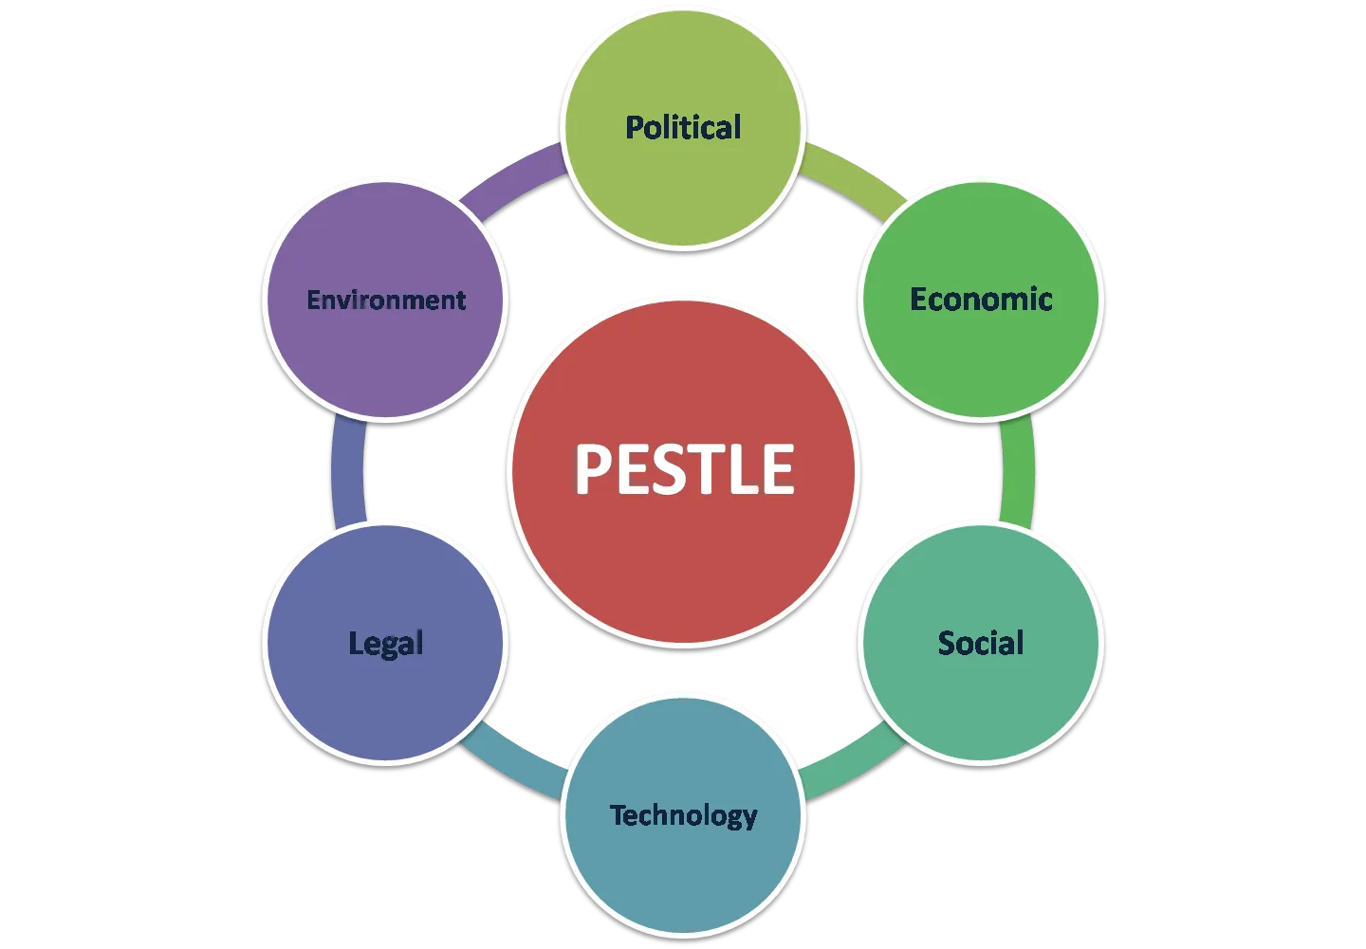
Figure 1: PESTLE Model
(Source: Created by Researcher)
Technological: Regular research and development initiatives are undertaken by UK that has helped it in making quality improvement in its usage of technological resources. UK has started focusing on making development of start-ups that can create new business opportunities for budding entrepreneurs (Olson et al. 2018).
Legal: UK is compliant under “Employment Act 1996” that helps in safeguarding the rights of employees and generates positive efficiency at the workplace. It also focuses on maintaining cultural diversity by being compliant under “Equality Act 2010” to prevent any unnecessary discrimination of employees at the workplace.
Environmental: The growth of globalization has resulted in an increase to pollution levels of the UK that affects its societal developments. It is made sure by the organizations that socially responsible behaviour is maintained by recycling and usage of biodegradable resources for business operations.

3. Porter's 5 Forces
The following observations have been made for Tesco based on usage of Porter's Five Forces model to devise new strategic approaches for maintaining its sustainable market operations:
Competitive rivalry: There is a high level of competition in the retail industry due to the increase in demands for consumer goods and providing basic services to consumers (Katsikeas et al. 2019). Tesco faces competition from brands like Morrison, Aldi and Sainsbury that creates major competition for the organization in meeting with its market objectives.
Supplier power: The bargaining power of suppliers is less due to the availability of different supply chain channels creating minimal effect on the firm's performance. Tesco has made sure to maintain different supply chain systems in its business that can help in procurement of required resources for meeting its business objectives.
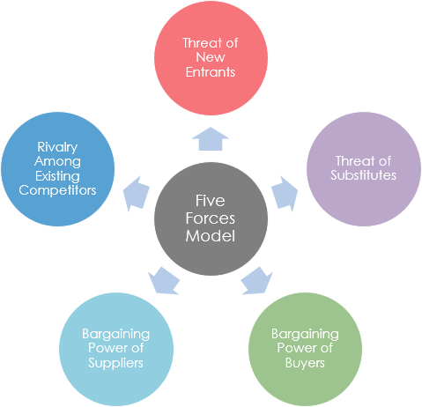
Figure 2: Porter’s Five Forces Model
(Source: Created by Researcher)
Buyer power: Buyers have the power to influence the performance of Tesco as there are many other retail organizations available in the market for supplying desired services to customers. It is observed that bargaining power of buyers is high and needs to be controlled effectively for maintaining consistent growth in business revenues.
Threat of substitution: Substitution of products and services is usually low in retail industry as household products are usually demanded from retail stores like Tesco for daily activities of consumers. It prevents customers from directly shifting to other service providers due to consistency maintained by the organization in the quality of its products and services (Rana et al. 2020).
Threat of new entrants: New organizations can easily gain access in the retail industry using both traditional and digital business platforms that affects the profitability of Tesco. It increases the competition for the organization as the same kind of products and services can be provided under minimal costs influencing the buying behaviour of the customers.

4. SWOT
Strengths: The major strength of Tesco is its brand value in the retail industry that has maintained positive loyalty among customers. Supply of products and services is made by the organization in over 14 countries to diversified consumer segments. It has helped the organization in making consistent development of new store outlets under new markets for maintaining positive satisfaction among its customers using a diversified range of products and services.
Weaknesses: Tesco has not been able to maintain positive performance in retail markets of US and Japan that has affected its business expansion. It focuses on reduced cost approaches for supplying products and services to customers that might lead to loss during vulnerable market scenarios. Exploitation of labour and application of unethical work practices are other contributing factors to Tesco’s weakness affecting its market sustainability and development.
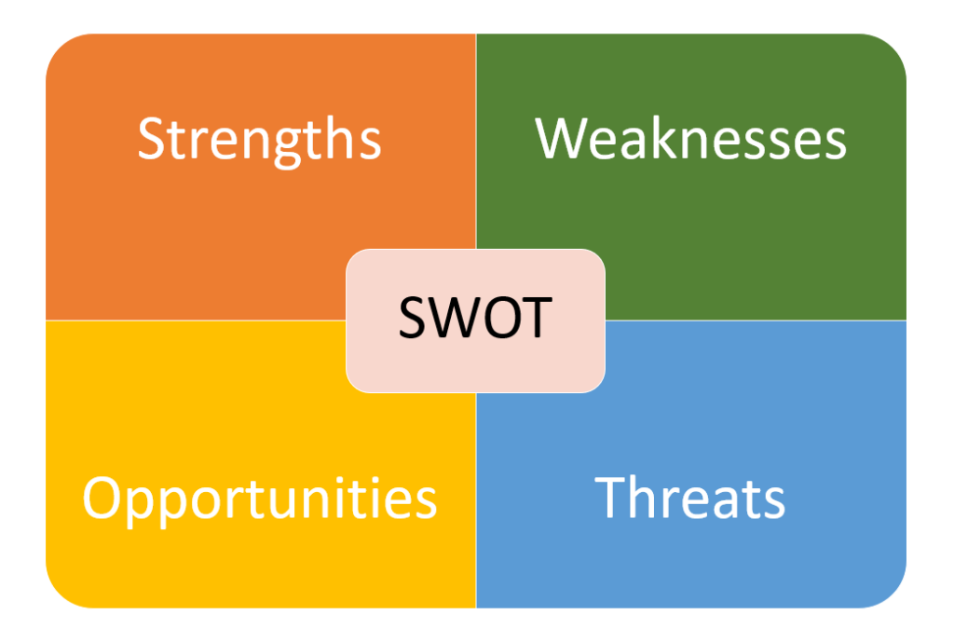
Figure 3: SWOT Model
(Source: Created by Researcher)
Opportunities: The launch of discount store “Jacks” can be an effective strategic approach that can help Tesco in maintaining quality growth in its consumer base by sculpting affordable range of services to customers. It has maintained consistent development in its online business model for increasing its flow of services across new geographic regions (Paul, 2018). Development of joint ventures with organizations of new retail markets can provide Tesco with better access to consumer markets and improve its profitability.
Threats: Due to the consistent growth in Covid pandemic, Tesco has faced major loss of revenue from its daily operations in consumer markets due to lack of suitable distribution channels. The exit of the UK from the European Union has affected the business expenses of Tesco and hampered its profits acting as a major threat for its market operations. Increasing competition from retail chains like Lidl and Aldi has also made vulnerable market scenarios for the organization in meeting its daily targets.

5. Advantages and disadvantages of SWOT
Based on the SWOT analysis of Tesco, the following advantages have been observed that can be helpful for its business growth in future:
- Maintainence of positive brand image can help the organization in retaining its customers for long run business.
- Increase in its number of retail stores can help in generation of better revenue by reaching out to new customers for supplying products and services.
- Diversified range of services that are supplied by the organization apart from daily groceries and household goods can provide it with better exposure to new consumer markets (Deepak and Jeyakumar, 2019).
- The organization has also maintained improvement in its technological resources by using “RFID-enabled barcode systems” for keeping a track on the quantity of stocks available at its workplace.
- It has also helped in improvement of its mobile app services for delivering quick services to consumers as per their convenience maintaining positive satisfaction.
On the other hand, the following disadvantages can be harmful for the organization and create challenges for its market operations:
- Failure of market operations in developed nations like the US and Japan can prevent the organization from making any quality growth in its new market ventures.
- It has faced fines and charges due to lack of transparency in its financial profits and its representation to shareholders.
- Usage of increasing debts from external sources can create increase in business liabilities affecting its business profits (Tanasiichuk et al. 2019).
- Lack of market research prior to launching a new retail outlet can lead to decline in its flow of services in new markets.
- It can create a negative impact on its market goodwill and lead to poor business operations affecting its long run sustainable business development.

6. Segmentation, Targeting and Positioning

Geographic | Region | UK along with 13 other countries
Geographic | Density | Both rural and urban
Demographic | Age | All age customers
Demographic | Gender | Both males and females
Demographic | Income | Low and middle income
Demographic | Occupation | Students, employees and professionals
Demographic | Education | High school, technical, Bachelors or higher
Demographic | Social status | Working class, skilled working class, lower middle class and middle class
Demographic | Family size | Single individuals, nuclear or extended families
Psychographic | Lifestyle | Traditionalists and contended conformers
Psychographic | Personality | Easy-going and determined
Behavioural | Occasions | Regular
Behavioural | Benefits sought | Cost advantage and variety
Behavioural | User status | Active
Behavioural | Attitude | Sceptical, positive
Table 1: Segmentation and targeting of Tesco
(Source: Created by Researcher)
Based on the above table it can be analyzed that being a retail organization, Tesco focuses on supplying its products and services to consumer segments of mainly middle and lower income category. It has helped the organization in maintaining positive growth in its profits by supplying quality household services to consumers of all age categories (Lindgreen et al. 2021).
The following positioning methods are applied by Tesco to its customers:
- Functional positioning: Tesco supplies high quality products and services using a functional positioning approach to its selected customers. It helps the organization in maintaining quality flow of services to higher income category customers and make quality improvement in its business revenues.
- Symbolic positioning: Supply of clothing products is done by the organization under this approach to maintaining emotional engagement with its customers. It provides the organization with an opportunity to portray its fair business tactics used for supplying quality services to customers for gaining quality business growth (Chernev, 2019).
- Price positioning: Sale of products and services of own brand products are done by Tesco using price positioning technique. It provides an affordable range of services to customers and maintains their long term loyalty for developing profits for the organization.
- Experimental positioning: Sale of beauty and wellness products is done by Tesco using this method based on the quality of response given by consumers to its range of products and services. It helps in knowing about changes taking place in consumer taste and preference to make quality improvement in product benefits to suit consumer’s needs (Rutz and Watson, 2019).
- Multi-segment position: It helps the organization in using different kinds of products and services of both high and low variants to supply to customers. Tesco is able to maintain optimum balance in its flow of services to different consumer segments and make quality improvement in their satisfaction level using its products range.

7. Marketing Mix
The following 4 P’s marketing principle is used by Tesco for supplying its range of products and services to customers:
Product: Different kinds of products related to food, clothing, electronics and financial assistance are provided by Tesco in its retail outlets. It helps the organization in paying attention to basic needs of its customers and makes quality development in its market operations. Both national and international variants of products are supplied by the organization to its customers that has helped it in maintaining quality growth in its business unit.
Price: Tesco has maintained a lower price range of its products for the consumers that have helped it in retaining them for long run business purposes. It has helped the organization in maintaining positive dissatisfaction among its customers by providing them with quality services under minimal prices. As a result, it has helped the organization in maintaining a positive brand image in the retail market and making consistent growth in its business ventures (Gryshchenko et al. 2020).
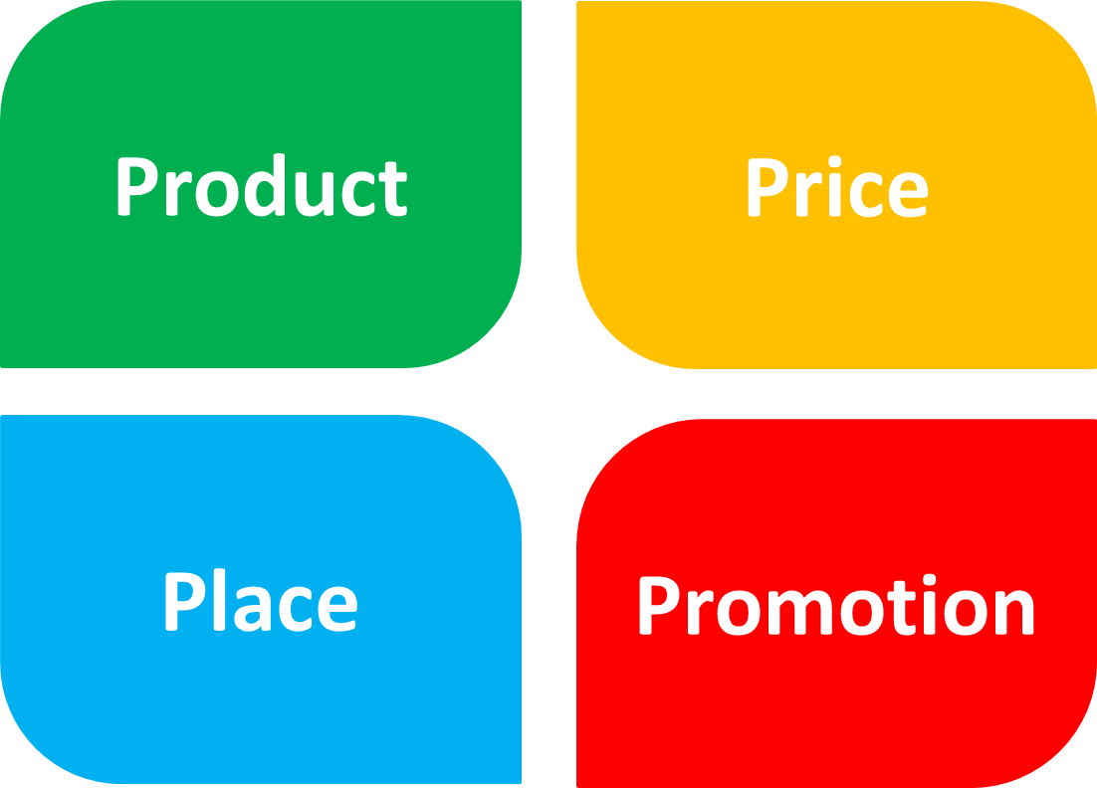
Figure 4: 4P’s Marketing Mix
(Source: Created by Researcher)
Place: The organization operates in 14 countries under different consumer sectors using both online and offline mode of business. It has helped the organization in maintaining effective distribution of its range of products across consumer markets and gain quality growth in its business operations. Usage of both physical and online stores is done by the customers for gaining quality products from Tesco and maintains positive satisfaction towards its market efficiency.
Promotion: Tesco uses innovative advertising campaigns for promoting its products and services across consumer markets. It focuses on informing the customers about the cost effective strategy and socially responsible business practices to gain quality growth in its sales volume. As a result, there is a development of savings among customers by purchasing increasing products from Tesco due to its lower prices (Yasa et al. 2020).

8. Conclusion
Hence it can be concluded from the report that Tesco has the potential in maintaining consistent development in its business development for long run sustainable development. It needs to focus on changing market trends and develop a quality range of products to provide better satisfaction to customers.

9. Recommendations
It can be recommended to Tesco that it pays attention to the quality of its goods rather than just relying on a low cost strategy. There needs to be improvements required to be made in its resource utilization techniques to develop innovative product lines to fulfil consumer expectations (Varadarajan, 2019). Tesco can maintain positive competition in the retail industry based on positive supply of its services to customers and also make improvement in its revenue from daily market operations.

References
Chernev, A., 2019. Strategic marketing management: Theory and practice. Cerebellum Press.
Deepak, R.K.A. and Jeyakumar, S., 2019. Marketing management. Educreation Publishing.
Gryshchenko, I., Chubukova, O., Bilovodska, O., Gryshchenko, O. and Melnyk, Y., 2020. Marketing-oriented approach to evaluating the strategy of distribution management for innovative products in logistics. WSEAS Transactions on Environment and Development.
Katsikeas, C., Leonidou, L. and Zeriti, A., 2019. Revisiting international marketing strategy in a digital era: Opportunities, challenges, and research directions. International Marketing Review.
Lindgreen, A., Di Benedetto, C.A. and Kock, F., 2021. How to develop original, courageous ideas in business marketing research. Industrial Marketing Management, 95, pp.A1-A4.
Olson, E.M., Slater, S.F., Hult, G.T.M. and Olson, K.M., 2018. The application of human resource management policies within the marketing organization: The impact on business and marketing strategy implementation. Industrial Marketing Management, 69, pp.62-73.
Paul, J., 2018. Toward a'masstige'theory and strategy for marketing. European Journal of International Management, 12(5-6), pp.722-745.
Rana, S., Prashar, S., Barai, M.K. and Hamid, A.B.A., 2020. Determinants of international marketing strategy for emerging market multinationals. International Journal of Emerging Markets.
Rutz, O.J. and Watson, G.F., 2019. Endogeneity and marketing strategy research: An overview. Journal of the Academy of Marketing Science, 47(3), pp.479-498.
Tanasiichuk, A., Hromova, O., Abdullaieva, A., Holovchuk, Y. and Sokoliuk, K., 2019. Influence of transformational economic processes on marketing management by an international diversified conglomerate enterprise. European journal of sustainable development, 8(3), pp.448-448.
Varadarajan, R., 2019. Theoretical underpinnings of research in strategic marketing: a commentary. Journal of the academy of marketing science, 47(1), pp.30-36.
Yasa, N., Giantari, I.G.A.K., Setini, M. and Rahmayanti, P.J.M.S.L., 2020. The role of competitive advantage in mediating the effect of promotional strategy on marketing performance. Management Science Letters, 10(12), pp.2845-2848.

