

Student Name ;Rex Amu.
Student id .2028603.
Model ;BWSW6103_Lon.
Lecturer; Nadeem Mirza.

Task 1
Report.
Change Management for IKEA Furniture Home and Kitchen.

Executive Summary
The concept of this report was to showcase how Ikea overcome the last pandemic crisis with their change management process and the leadership style .The report show what went well and bad and how the organisation was able to implement the change process and the sustainability the change during past covid 19 and the exit of the Brexit and the current economic inflation. Ikea has expanded their stores globally . Ikea structure and organisation culture which focus on cost cutting and also welcome open innovation . The organisation has a unique services and quality products on low cost for their customers, e-commence payment ,online ordering and also assemble of the furniture for their customers and attractive store layout system and car park. Ikea delivery their product for customers with 24hours service

Table of Contents.
Page No

- Executive Summary…………………………………………………………………………………………………….2
- Introduction……………………………………………………………………………………………………………….4
- Main body……………………………………………………………………………………………………………………5
- Business Environment………………………………………………………………………………………………….6
- Ikea Internal environment SWOT………………………………………………………………………………7
- Ikea External environment PESTLE ………………………………………………………………………………8
- Change Management Model……………………………………………………………………………………….10.
- Kurt Lewins Model………………………………………………………………………………………………………11
- John Kotter’s Model……………………………………………………………………………………………………12
- Pettigrew change Model………………………………………………………………………………………………15
- Proposed and Implementation of Change process for Ikea………………………………………….18.
- Recommendation &Conclusion…………………………………………………………………………………...20
- References…………………………………………………………………………………………………………………...21

Introduction.
Ikea is one the leading furniture retailer in the global business today. Ikea furniture came into live in 1950 with catalogue marketing combined with a showroom where customers could see and touch IKEA products. The founder Ingvar Kamprad, due to the research he was 17 yrs. Where he started using a local county milk delivery van to transport his good to the nearest station. But today Ikea group has growth over 70.000 co-workers and their margin is closing to 11million euro. However, we understand that the company has three distinct feature which are the function, the quality, and the low price. cite by(Kling k and Goteman 2003). The origin of Ikea was from Sweden, but in 1963 Ikea group continue to expand his business globally to the neighbouring countries like Norway, were he started using nontraditional material for furniture like plastic , which shape the design of Ikea well know worldwide today with the strategy of targeting young families. Today Ikea has over 150 stores round the world over twenty countries. One of IKEA's revolutionary innovations was the concept of flat-pack furniture. In the 1950s, IKEA introduced furniture that could be disassembled and packed into flat boxes for easy transportation and self-assembly by customers. This not only reduced shipping costs but also made it convenient for customers to transport furniture home.

Main Body.
Ikea offers solutions, services, and goods for home furnishings through its subsidiaries. The corporation operates in three business areas: industrial, range and supply, and franchising. In addition to textiles, it offers products in the following categories: kitchen and dining, lighting, and smart home, setting room and workspace, bedchamber and washroom, cooking, eating and decoration, and food.
Despite the fact that IKEA's net income increased by double digits in 2011 and it achieved record revenue levels, the company had challenges in certain regions, most notably Ireland and the UK, where sales were affected by inflation and consumer confidence. In reaction to the crisis of sovereign debt and its excessive dependence on the European market, IKEA is tripling the number of stores it opens in China and allocating €3 billion towards its expansion plans. IKEA is unlikely to join the Indian retail market anytime soon, despite the government of India opening up the sector. This is because there are limits on international corporations entering the Indian retail sector.

Business Environment.
IKEA vision is to improve day by day life for as many people as possible. The business concept is to supply a broad selection of well-designed, practical home furnishings at costs that are as cheap as possible so that the greatest number of people may afford them. However, the recent post covid Play a significant impact on the revenue of fiscal year in 2021.However, using the swot analysis to identify the company future and how they overcome their competitors. Sustainability has been highlighted by the organisation as a key value. Some of the main competitors are Argos, Ashley furniture home store. john Lewis and DSF furniture.
IKEA SWOT.
Strength.
- Innovations to drive costs.
The organisation system of innovations includes new materials that are inexpensive and
More environmentally friendly, as well as the use of the most current techniques for handing,
Packing ,and transporting items. Low prices are the key to Ikea organisation strategy.

- Strong culture on Sustainability.
IKEA is the world's biggest consumer of wood, therefore if it doesn't have a sustainable method of sourcing its raw materials, consumers, environmental groups, and the government will be chasing after it. By transforming the entire value chain, the company hopes to reduce its reliance on raw materials, choose products that are supplied sustainably to lessen its impact on the environment, and increase production and logistical efficiency. This method was a strategy to make their customers happy and to understand the inflation and covid nineteen impact on customer, by cutting their price low and also plan impact on competitive advantage for their competitors. buy and implements the best practices to induce that decision.

- Customer understanding.
IKEA's in-depth customer understanding is their main key of competitive advantages. The company employed top practises to encourage customers to make purchases by understanding the purchasing criteria that drive those decisions. IKEA provides a vast array of products at affordable costs. Designers are always producing new things that seem fashionable to consumers. Every product is made to be simple to construct and transport. Additionally, the organisation provides the best shopping experience and the largest selection of products. These elements are all in line with what consumers need and want, which boosts sales. IKEA would be unable to outperform its present rivals without such broad customer understanding and best practises to capitalise on that knowledge.

- Product life cycle.
Ikea sustainable strategies to introduce product life cycle, make sure the products should be flat-packed so that more items can be shipped at once; products should also be easier to dismantle and recycle. The company works with environmentally friendly woods and cotton, avoiding the excessive use of chemicals and water, as these are two of the most essential raw resources used in the creation of IKEA's products. Life's ultimate conclusion is the last phase of the cycle. The company is also looking into recycling sofas and other home furnishings. The majority of IKEA stores recycle light bulbs and exhausted batteries.
- Cost conscious culture.
IKEA has an organisational culture that is entirely focused on cost-cutting. This affects every facet of the company, motivating staff members to look for methods to reduce expenses without sacrificing quality. The leadership style is about looking after people which great more value for the business. We view leadership as a behaviour rather than a title. We prioritise people's values over their skill and background. those who set an example for others by "walking the talk" Being our best selves and bringing out the best in one another are the main goals. We think that people should be empowered. Individual development can be achieved through accepting and giving responsibility. Everyone is motivated to contribute to development when they are optimistic, trusting of one another, and forward-thinking. Unlike other companies, we are not and never wish to be like them. We prefer to challenge accepted wisdom, think creatively, try new things, and take risks—always with a good reason.
One of the external factors of changes in Ikea was to used pestle analysis to identify .

PESTLE Analysis
Pestle analysis highlight how Organisations can detect and comprehend external elements that may impact their performance and decision-making through the comprehensive framework that analysis offers. It is a useful tool for risk management, strategic planning, and seeing possibilities and dangers in the outside world cited (2012). Organisations can improve their competitive edge by using this analysis to assist them make educated decisions and adjust to changing situations. Its strategic tools management helps organizations assess and understand the external macro-environmental factors that can impact their operations. Ikea has able to sustain their technology approach during covid 19 to make their customers and employees safe during the last pandemic.

- Technology.
IKEA most likely increased their emphasis on internet services and e-commerce throughout the pandemic. To accommodate the growing demand for online shopping, they will be extending their online product offerings, upgrading their online platforms, and optimising the user experience. physical distancing measures in place, e-commerce has experienced a surge in popularity. Online shopping and contactless payment options have become essential for businesses, providing a safe and convenient way for consumers to purchase goods and services. Another management changing was remote working solution for its employees. This includes collaboration tools, virtual meetings, and other technologies to support remote work and communication. Ikea normal practice a Democratic leadership style which focus on empathy, motivation, inspiration, and collaboration. Based on my research a leadership style is based on the current situation of the organisation to adapt to a circumstance

- Legal.
IKEA, a global furniture retailer, has indeed demonstrated a strong commitment to sustainability and environmental responsibility. The company's approach to environmental regulations encompasses various aspects, including waste disposal, emissions, use of hazardous substances, and sourcing of raw materials. IKEA has a comprehensive chemical management policy, restricting the use of hazardous substances in its products. The company works towards compliance with global regulations such as REACH (Registration, Evaluation, Authorization, and Restriction of Chemicals).
In the case of Brexit, the United Kingdom's departure from the European Union introduced changes to trade relations and customs procedures. IKEA, like many other companies, had to adapt to new regulatory frameworks, potential delays at borders, and changes in supply chain planning. the dynamic nature of international trade regulations requires IKEA to stay vigilant, adapt to changes, and proactively manage its global supply chain. This adaptability is crucial for minimizing disruptions and ensuring the continued efficiency of its operations, especially in the face of geopolitical shifts or changes in trade policies.
Meanwhile, IKEA is known for its flat organizational structure, promoting open communication and accessibility. This structure is designed to encourage collaboration and the sharing of ideas across all levels of the organization. Teamwork is a fundamental aspect of IKEA's culture. Employees are encouraged to work collaboratively, and decisions are often made through consensus-building processes.
IKEA's organizational culture is a critical factor in the company's ability to innovate, maintain a competitive edge, and fulfil its mission of providing well-designed, functional, and affordable home furnishings to a global customer base. The cultural elements mentioned above contribute to IKEA's unique identity and success in the retail industry.
IKEA's leadership style is characterized by a balance between democratic decision-making, transformational leadership principles, and an enterprising spirit. Leaders at IKEA focus on inspiring and empowering their teams, fostering innovation, and contributing to the company's long-term vision and mission.

Change Management Models.
Definition. Change management models provide structured approaches to guide organizations through the process of implementing change. Different models offer various frameworks, steps, and principles to facilitate successful change initiatives. Cited(original on 2015-12-08). Here are several well-known change management models: Lewin's Change Management Model, Kotter's 8-Step Change Model and Pettigrew Model.
- Kurt Lewin’s change Management Model.
Theories of change explain how well organisations can adjust their structures, procedures, and strategies. Lewin’s change model, the positive model, and the action research model show the stages of organisational transformation. Cited (Burke, 2008). The three phases of Lewin's model—unfreezing, change, and refreezing—were investigated in this work. While this model lays out general procedures, more details need to be considered in order to customise these phases for certain scenarios. Kurt Lewin, a psychologist, and social scientist developed this three-stage model in the 1940s. The model is simple yet powerful and is often used as a foundation for more contemporary change management theories.
.
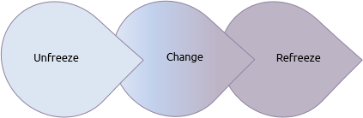
This Photo by Unknown Author is licensed under CC BY-SA
Online resource google image.
  - Unfreeze; This stage involves preparing the organization for change by creating awareness about the need for change and overcoming any resistance to it. Communicate the need for change. Create a sense of urgency. Establish a guiding coalition or team to lead the change effort. Identify and address concerns and resistance from employees. Lewins model of change basically identify three stage that need to be addressed. Change in organisation play a significant impact on the employee and management. The leader needs to communicate why for change because both parties are important for change. Meanwhile, this situation depends on the leadership style being practice in the organisation . Theories and models have been put out to help managers and other leaders drive organisational changes. These tools enable them to keep an eye on, assess, and schedule changes utilising structure in order to respond quickly to changes in the internal or external environment and predict how people, markets, products, and t technology will change over time. Cite(Van Ossten, 2006) .
  - Change: This stage focuses on implementing the actual changes identified in the previous
Stage. It is a period of transition where the organization moves from its current state to a desired future state. Introduce new processes, structures, or systems. Provide support and resources for employees undergoing change. The leader also encourages and facilitate open communication to address any emerging issues promptly. The kind of leadership that an organisation has is crucial to its change process. In order to improve organisational performance, transactional executives use rewards and penalties with their workforce. Cited(Bass 1985).This leadership focus on maintaining order and getting tasks done within the existing structure of an organization. This approach is rooted in the concept of a "transaction," where leaders provide rewards or punishments to motivate followers to achieve specific goals. Transactional leaders emphasize clarity in roles and responsibilities, as well as the use of contingent rewards and punishments. Transactional leaders are typically more task-oriented than relationship-oriented. They focus on achieving specific objectives and meeting performance standards.
  - Refreeze. In this stage, the changes are embedded into the organizational culture, and stability is restored. The new ways of operating become the norm, and employees adapt to the changes. Reinforce the new behaviours and practices. Recognise and celebrate. Integrate how the changes into policies and procedures how to monitor and provide ongoing support. The structure for managing the change process is identified by the change management structure, which also provides direction. which covers the present leadership structure, change consultants, tools for promoting change, and the political and inter-personal skills needed to start the change process. Cited (Beck hard and Harris, 1987)
However, Kurt Lewins changes management model didn’t really highlight all the step process for change management. There may be a fear of the unknown or concerns about whether the proposed changes will be beneficial., Meanwhile Kotter’s 8 step change model emphasis on more detail for organisation need to consider during management process.

  - John Kotter’s 8 step change Model. John Kotter, a renowned leadership and change management expert, developed an 8-step change model to guide organizations through the process of implementing successful change. The Kotter 8-step change model is widely used in the field of organizational development. Based on the research the process of implementing changing in organisation is so critical, because based on the readiness of the employee. {Kreitner, Kinicki, 2007).This model focus on the top-level management are responsible for the change for process in an organisation. Here are the eight steps:

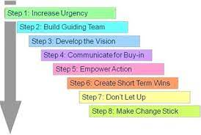
Online resource googles image picture.

  - Create a sense of urgency. Kotter(1996)Creating a sense of urgency is the first step in John Kotter's 8-Step Model for leading change. It involves communicating the need for change and motivating stakeholders to act promptly. However, explained why the change needs to be done, because people are difficult to move from their comfort zone. Meanwhile let the stakeholder understand the risk for the change and opportunity that associate with the change. These is where the leader plan vital role in the early stage able to convince the key people in the organisation why it necessary to make a change. All those during the covid 19 Ikea leadership style(situation leadership style), need to highlight why the change are important for employee and also for customers by introducing the system of remote working . e-commerce payment system and 2-meter distance gap for the safety for the employee.
  - Build Guiding Team. Form a cross-functional group of influential individuals who support the change. John Kotter’s also highlighted for any changing to be successful the leader need have coalition who has more power to lead the change, who understands the improvement of the change. Based on the Kurt Lewins describe this process of implementation of the changing from previous to the desired future stage. He also identifies as task orientation leadership style.
  - Developed The Vision. This is where you have to conduct a thorough assessment of the current state of the organization. By conducting using the strength and weakness of the organization (swot analysis).During changing the organisations value , culture and history are to consider. Ensure that the vision aligns with the core values of the organization.
The vision should resonate with employees and stakeholders on a personal and emotional level. Any changing process ,the culture of the organisation play impact, which Kurt Lewin’s fail to mention on his change model .Organisation culture has huge impact in a change process.
  - Communicate For Buy-in. This is where the leader has to address questions and concerns.
That employee may have. Also, the leader has to use all possible means of communicating the vision and the strategies. For example, any changing in workplace without communication always cause problems within the workplace.

  - Empower Action. Well, this stage the leader need Change structures, systems, and policies.
That undermine the change future. Encourage risk-taking and non-traditional ideas. The leader will also need to remove any obstacles for change.
  - Create A Short-Term Wins. Here the leader will celebrate and recognize employees for
their contributions and success of he changes. Plan for and create short-term achievements that demonstrate. Because “whenever you let up before the job is done, critical momentum can be lost and regression may follow,” leaders must control short-term victories in order to prevent complacency from building cited (Kotter, 1996, p. 133). Kotter's transformation model was employed to ensure that the vision's end goal was sustained through the jubilation of short-term milestones.

  - Don’t Let Up .Kotter explained that this were the leader reinforce the change by
Continuously building on the success of achieved. However, the use of feedback and lessons learned can be apply for adjustment and improvement for the change management .
  - Make Change Stick. Now the leaders need to ensure that the new behaviours and practices, procedures, and performance expectations. Also embed the changes into the organizational culture and make them a part of everyday activities.

Pettigrew Change management model.
Pettigrew's model emphasizes the importance of considering both the internal and external contexts of change. He argues that effective change management requires an understanding of the organizational culture, power dynamics, and external environmental factors.

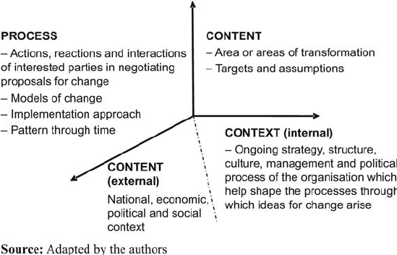

It's important to note that Kotter's model emphasizes the need for leadership and communication throughout the change process.
In essence, the combination of strong leadership and effective communication creates a foundation for guiding the organization through the complexities of change. Leaders need to inspire, guide, and communicate with their teams throughout the entire process, from creating awareness and urgency to embedding the changes into the organizational culture.
Meanwhile based on my research for change management ,no model is better than other .We notice every organisation with different situations and circumstances. Lewin's model is straightforward and easy to understand. The three steps—unfreeze, change, refreeze—provide a clear framework for initiating and managing change. Lewins model is too simplistic and linear, not fully capturing the complexity of modern organizational change, which often involves multiple, simultaneous initiatives.
All those Both models recognize the importance of considering the human side of change, addressing resistance, and involving employees in the process.
Inline with my argument, John Kotter’s model provides a more comprehensive and detailed approach to organizational change, addressing various aspects such as urgency, communication, and short-term wins. The model recognizes the critical role of leadership and effective communication throughout the change process. One of the disadvantages of Kotter’s model the eight steps may seem overwhelming to some organizations, particularly smaller ones, or those with limited resources. Implementation can be challenging if not approached with careful planning.

Proposed and Implementation of Change strategy for Ikea Furniture company.
Organizational culture plays a critical role in the success or failure of change management initiatives. The alignment (or misalignment) of the existing culture with the desired changes can significantly impact the development and implementation of change strategies. Ikea furniture culture align with the transformational leadership style for his employee and customers.

- Open Communication Plan
A culture that values open communication and transparency can facilitate the flow of information related to the change. Ikea communicate with their staff by email, teams, and information board. Craft clear and consistent messages explaining the reasons for the change and its benefits. Identify key stakeholders and their concerns. Effective communication is a critical factor in the success of any change management process. Communication plays a pivotal role in guiding employees through the transformation, managing resistance, and ensuring that the organization moves cohesively toward the desired future state. Communication outlines how roles and responsibilities will evolve during and after the change. By email ,team meeting ,and information board required for implementation as communication strategy for me choose organisation Ikea for change process.

- Process Implementation.
After the implementation of a change strategy, it's essential to focus on sustaining the changes and continuously improving the organization. Continue to offer support and resources to employees as they adapt to the changes. Regularly assess the progress and adjust as needed. Address any unforeseen challenges that may arise. However, With the help of ensuring Foster a culture of continuous improvement within the organization. Meanwhile make sure the change process aligns with the organization culture.

- Staff Training Programs.
Implement internal training programs for Ikea staff to equip employees with the necessary skills to adapt to the new processes or technologies.
Lack of insufficient training for team can play negative impact in any management change process. Change management and leadership skill are all important for the effectiveness for any initial. Based on the research all leadership style can used for any change process, depend on the situation and the financial input of the organisation. However, the transformational leadership style will be ideal for Ikea furniture based on the size of the organisation . The transformational leadership explained about the employee ,motivation ,inspiration and the empathy. Also, John Kotter’s change model refers to the stakeholder are important in change process because the first stage need to convince the employee and communicate the risk and the benefit of the change . The last pandemic 2019 most of the organisations was unable to adapt to crisis based on lack of training with the modern technology like the remote working , teams meeting , and the e-commerce payment. The used of new technology, change many organisations how reactive and initiative-taking when it to management change process.

- Evaluation plan.
This is where the leader welcome feedback from the stakeholder and employee for any adjustment measure for change management plan for any continuation of improvement. By introducing a system for documentation all the entire evaluation
process by collecting method and data monthly. Create a level of awareness and perception of customers regarding IKEA's sustainability practices. The suggestions box was another key for Ikea to improvement for change management. By considering organisation benchmarks and best practices for comparison .However, another strategy for the evaluation plan is the use of key performance indicators,(KPI).
The key performance indicators should be regular review and update to align with evolving business goal and market dynamics. Seeking feedback from stakeholders for improvement effectiveness of the KPI for the choose organisation.

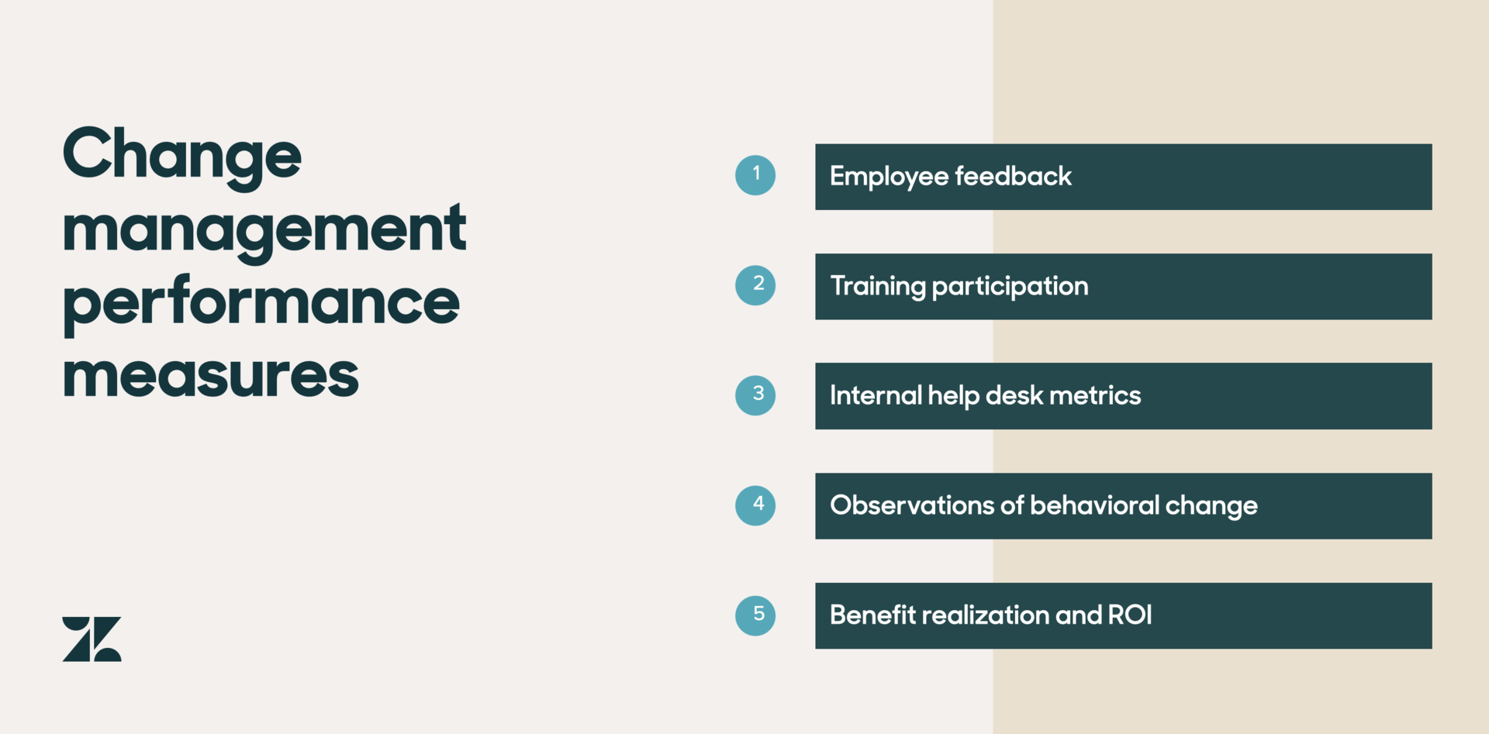

Google image online resource. KPI Matrix diagram.

Recommendation.
Throughout the change process my recommendation for me choose organisation Ikea is Kotter’s 8 step of change model. The model consists of eight steps that are designed to help organisations successfully navigate through change initiatives. Throughout the entire change process, effective communication is crucial. Leaders should be transparent, open to feedback, and responsive to concerns. Additionally, involving employees in the change process and creating a culture that embraces change as a constant can contribute to long-term success. Making a change permanent is a part of the organisation structure and process. Ikea always update their policies, procedures, and the system to support the new change process .

Conclusion.
Through this module, the implementation of change processes in an organisation depends on context of the crisis. Based on report many researchers argue that organizations may choose to integrate elements from both models based on their specific needs and contexts. Effective change management often involves a tailored approach that considers the unique challenges and dynamics of the organisation undergoing change. Kotter’s and Lewins models are the two most influential for understanding and managing changing in organisation because they share a similarity and distinct approach. Meanwhile, Kotter’s model provides a more detailed and sequential approach, focusing on leadership and vision. Kotter's model is often considered more suitable for large-scale organizational transformations. While Lewins model is about unfreeze-change-refreeze sequence, emphasizes the psychological and systemic aspects of change. The model also acknowledges that change can be ongoing and that the refreezing stage is not always permanent. All those Pettigrew model emphasizes on the internal and external factors for Implementing change process in any organisation. Meanwhile Pettigrew model have positive impact for Ikea change process. The Brexit crisis and inflation was an external context for Ikea .This were leadership style need to come in for any situation.

References.

Kling, K. and Goteman, I., 2003. IKEA CEO Anders Dahlvig on international growth and IKEA's unique corporate culture and brand identity. Academy of Management Perspectives, 17(1), pp.31-37.
Wikipedia (2013). IKEA. Available at: http://en.wikipedia.org/wiki/IKEA
"IKEA Group Sustainability Strategy 2016
https://thestrategystory.com/blog/ikea-pestel-analysis
Srdjevic, Z., Bajcetic, R. and Srdjevic, B., 2012. Identifying the criteria set for multicriteria decision making based on SWOT/PESTLE analysis: a case study of reconstructing a water intake structure. Water resources management, 26, pp.3379-3393.
Bastiaanssen WGM, Allen RG, Droogers P, D’Urso G, Steduto P (2007) Twenty-five years modeling irrigated and drained soils: state of the art. Agric Water Manag 92:111–125
Hussain, S.T., Lei, S., Akram, T., Haider, M.J., Hussain, S.H. and Ali, M., 2018. Kurt Lewin's change model: A critical review of the role of leadership and employee involvement in organizational change. Journal of Innovation & Knowledge, 3(3), pp.123-127.
Calder, A.M., 2013. Organizational change: Models for successfully implementing change.
"Home". International Organizational Change Management Institute. Archived from the original on 2015-12-08. Retrieved
Stetler, C.B., Ritchie, J.A., Rycroft-Malone, J., Schultz, A.A. and Charns, M.P., 2009. Institutionalizing evidence-based practice: an organizational case study using a model of strategic change. Implementation Science, 4(1), pp.1-19.

