University of Wales Trinity St David, Cardiff
Student Name: Chahir ben trad
ID: 2223851
Module Name: Managing enterprise (BMSW4011-card)
Lecturer: Mel squire
Table of Contents
Part 1 3
Reflection 3
Part 2 5
Company concept and justification of the idea 5
Mission statement 5
Business Aims 5
Business Objectives 5
Legal Identity of Chahd's Residence 6
Marketing and PR Plan 6
Pricing Strategy 6
7 P’s analysis of Chahd’s Residence 7
Physical Location 8
Human Resource Strategy 8
Organisational structure 9
Sources of Finance 9
Cash flow forecast 10
SWOT Analysis 10
References 11

Part 1

Reflection
The development of a business plan and business plan-based presentation on Chahd’s Residence was a comprehensive process that has provided me with a significant level of understanding about how business ideas should be developed. I have selected the tourism and hospitality industry where the business will operate in future. In this business plan, I have shown the aim, objectives and goal of the business along with the information on legal identity. I have discussed the target market marketing process and 7P’s marketing mix analysis for the business. To further attract the investors, I have also designed a PowerPoint Presentation based on the same business idea. All those detailed business plans have provided me with a significant level of knowledge on the factors that have a significant impact on business activities.
There were both positive and negative sides to this business plan development assignment. The positive aspects of a comprehensive experience in developing business ideas by using the information on market trends, customer expectations and competitive strategies. Moreover, I have also gained knowledge about the marketing strategy and human resource strategy development of an organisation and finally, I have also learned the experience of doing a SWOT analysis of a particular business. One of the challenges was the development of a business PowerPoint presentation. Moreover, in terms of setting the pricing strategy and fulfilling their finance sources requirement was tough for me. I learned a lot about strategic advertising, making financial choices, and company planning from this experience. What I've learnt is that in the hotel sector, knowing what the customers want is essential for setting prices, providing the right services, and achieving overall success. In addition, I learned the hard way how crucial investors are when it comes to raising funds.
In every aspect, I learned a lot about myself and how to think critically and solve challenges through the process of composing and delivering a business plan. I also realized how important it is to do studies on the market, make a budget, and determine risks when building a company. If I could do it all over again, I would make sure to adhere to my backers' pitch more to boost my faith and execution. In the future, if I get a chance to make a business plan again, I will do more primary research on the business idea and its preferred location along with the target market. Moreover, I will also try to use some environmental analysis tools and some industry analysis tools for the business idea, so that it becomes more clear for the investor on which basis they could invest in the business.

Part 2

Company concept and justification of the idea
The report is going to describe a business idea named Chahd's Residence. It will be a holiday accommodation service and will operate its activities in the tourism and hospitality industry of Tunisia. It will be established in Port El Kantaoui, Hammam Sousse, Tunisia. It will be an 8-appartement-based holiday accommodation facility which will provide a complete package of accommodation and food packages for the visitors. Establishing a hotel in this location will be a great business idea because it is a very famous tourist spot in Tunisia (Coslett, 2020). The beautiful Marina at Port el Kantaoui was constructed in 1979. With almost 300 boats docked, it is lovely. The architecture is white-washed and has an Arab-Moorish flair (Tripadvisor.com, 2024). One can sit down and enjoy the picturesque scenery at any one of the many eateries or cafés in the area (Manai, 2018). So Chahd's Residence will get a lot of guests here if it can provide quality services to them because of its exciting physical location.

Mission statement
The mission of Chahd's Residence is to provide the highest level of service to the customers and to fulfil the expectations of the visitors by surpassing their perceptions of what constitutes greatness.

Business Aims
This hotel aspires to be the premier establishment that reimagines its legacy by providing guests with first-rate products and services, while also contributing to long-term economic growth through strategic investments, providing a secure work environment for the employees, and upholding the highest standards of quality.

Business Objectives
The key objective of Chahd's Residence can be described as SMART objective criteria,
Specific: Chahd's Residence want to be one of the key accommodation service providers for visitors in Port El Kantaoui, Tunisia.
Measurable: By achieving at least a 70% average occupancy rate within its first two years of business operations, Chahd's Residence can measure its success.
Achievable: This goal can be achieved by the Chahd's Residence by being involved in digital, social media and target marketing initiatives and by providing the best quality services to the visitors.
Relevant: This objective is set based on the aim of this business so it is highly relevant to the business.
Time-bound: The primary time frame will be 2 years to achieve a 70% average occupancy rate and within the next 5 years it should be around 85%.

Legal Identity of Chahd's Residence
The legal structure of Chahd's Residence will be a private limited company. The initial owners will bring some portion of the start-up capital with a significant amount of loan (Robb and Robinson, 2014). Then the owner will sell its ownership stake to other investors under the condition of limited liability. The main advantage of establishing the business as a private limited company is it can create a legal entity of business and the owners can enjoy the opportunity of limited liability. However, this type of business requires high compliance costs and can face restricted capital structure and more legal barriers as the disadvantages.

Marketing and PR Plan
The main customers of Chahd's Residence will be those who visit Port El Kantaoui, Tunisia on holidays, company, or to do business. Due to this area's high volume of visitors, both domestic and foreign visitors seeking fast and pleasant lodgings will make up the bulk of its target market (Kris, 2024). Furthermore, it will aim for a mix of leisure and exploration, appealing to families, couples, and lone visitors alike. These fully furnished apartments are also a great option for business visitors who are in the region for meetings or corporate functions.
A multi-channel marketing plan will be put into place to entice and engage those who are potential clients (Beritelli and Schegg, 2016). The role of online travel agencies like Booking.com, and Airbnb in attracting tourists from other countries is taking a huge part of Chahd's Residence (Garcia, Dos Anjos and Doğan, 2022). To increase exposure and consumer involvement, this organisation will have a prominent social media footprint on sites like Facebook, Instagram, and TikTok (Hensel and Deis, 2017). The best way for this hotel to spread the word about its brand is to team up with influential people, travel companies and travel providers.

Pricing Strategy
For pricing strategy, Chahd’s Residence will use a combination of cost leadership and differentiation. This hotel will provide high-quality services and products to the guests and it will mostly attract budget-friendly travellers and people who will visit this place for their recreation or the purpose of business (Fiet, 2025). So, this hotel will usually charge a lower price than the other competitors, and it will also provide different types of services, such as food packages and other entertainment services, which will be all-inclusive in their prices. Moreover, this hotel will provide different types of seasonal offers so that they can be attracted to this business, which will help Chahd’s Residence to get cost leadership over other competitors. Moreover, it will also provide luxurious services with two of its apartments and will charge a higher price for those services under the differentiation strategy.

7 P’s analysis of Chahd’s Residence
Product: Chahd's Residence will provide vacation flats that are completely equipped with all the necessary amenities, including food and lodging. Travelers, whether for vacation or work, will appreciate the residence's eight fully furnished apartments. In addition, it serves clients by delivering high-quality cuisine according to their preferences.
Price: A mix of cost leadership and product differentiation will make up the pricing strategy. Using a price differentiation approach, we will provide competitive prices to budget-conscious travellers while providing a range of quality services.
Place: Port El Kantaoui, Hammam Sousse, Tunisia, is a popular destination for tourists, and it will be the perfect spot for Chahd's Residence. The hotel is perfect for vacationers because of its closeness to the water, marina, dining options, and retail centres.
Promotion: For promotional purposes, Chahd's Residence will use multi-channel promotional media with a mix of digital and traditional marketing strategies. Chahd's Residence will mainly focus on a marketing strategy by which it will provide promotional advertisement on its website, the websites of different travel groups and through different social media platforms (Garcia, Dos Anjos and Doğan, 2022).
People: The staff at Chahd's Residence will be highly skilled and dedicated to providing exceptional service to every one of its guests. Workers in the service industry, including wait staff, housekeepers, and cooks, fall under this category.
Process: The service delivery process of Chahd's Residence will be easy and hassle-free, which will provide the customers with a premium-level experience. The guests of this organisation can book their preferred service from the online booking system, and the checking and check-out process will be flexible. The guests will get 24/7 customer support along with regular cleaning and maintenance Services.
Physical evidence: The key physical evidence of Chahd's Residence will be its well-designed apartments, online presence and positive customer reviews.

Physical Location
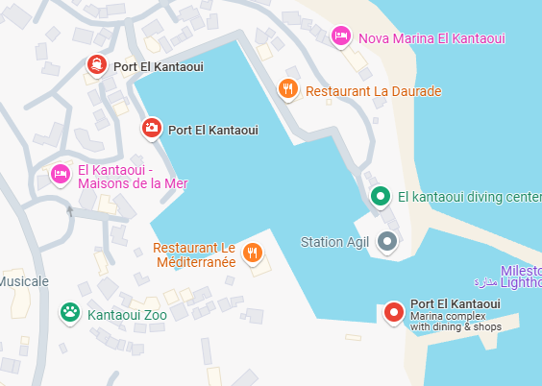
The physical location of Chahd's Residence; Source: (Google Map, 2025)

Human Resource Strategy
Primarily this business will be run by a small team of human resources which will be led by the general manager who will oversee all the operational and managerial activities including marketing, branding and guest satisfaction. There will be two front desk receptionists who will work for the check-in and check-out purposes of the guest. Then there will be a team who will work for the housekeeping services and will maintain the hygiene and comfort standard of all the rooms. There will be some kitchen staff who will prepare and serve meals for the guests and there will be some maintenance technicians who will ensure all the appliances and facilities are working well. This organisation will also have a marketing and social media manager who will promote the business to potential customers. The recruitment process of this organisation will be done by putting advertisements on different job portals and it will directly recruit employees from the local hospitality schools and institutions. All the employees will get competitive salaries and some other benefits such as medical facilities, convenience for house rent and transportation services.

Organisational structure

Sources of Finance
The main sources of finance for this business will be collected from a bank in the form of a bank loan. The owners of this business will primarily get a loan of £200,000 for establishing this business. The land of this hotel will be provided by the owner himself. The owners will also contribute some start-up costs. In the upcoming years, it is expected that this company will be able to get some more investment from other sources.

Cash flow forecast
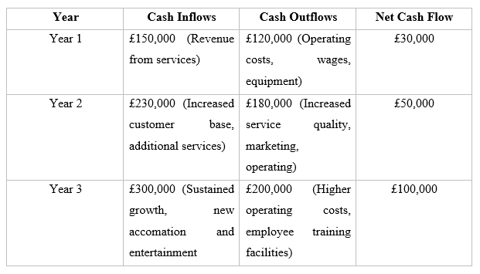

SWOT Analysis
Strengths  Prime location  Fully equipped apartments  Reasonable price of the rooms  Multi-channel marketing strategy | Weaknesses  Limited brand recognition  High operational cost  Seasonal demand  Shortage of skilled labour
Opportunities  Strong demand for tourism in Tunisia  Social media & influencer marketing  Partnerships with travel agencies & tour operators | Threats  High competition (Biggest threat)  Rising operational costs  Changing customer preferences

References
Beritelli, P., and Schegg, R. (2016) Maximizing online bookings through a multi-channel-strategy: Effects of interdependencies and networks. International Journal of Contemporary Hospitality Management, 28(1), 68-88.
Coslett, D. E. (2020) Preservation and tourism in Tunisia: on the colonial past in the neocolonial present. The Journal of North African Studies, 25(5), 727-752.
Fiet, J.O. (2025) ‘Cost leadership strategy’, The Theoretical Logic of Strategy, pp. 173–178. doi:10.1007/978-3-031-79014-0_36.
Garcia, G., Dos Anjos, S. And Doğan, S. (2022) ‘Online travel agencies and their role in the tourism industry’, Advances in Hospitality and Tourism Research (AHTR), 10(3), pp. 361–386. doi:10.30519/ahtr.865546.
Google Map (2025) Google search. Available at: https://g.co/kgs/qzb5wbT (Accessed: 04 March 2025).
Hensel, K., and Deis, M. H. (2017) Using social media to increase advertising and improve marketing. The Entrepreneurial Executive, 15, 87.
Kris (2024) Port El Kantaoui, Tunisia.com. Available at: https://www.tunisia.com/port-el-kantaoui/ (Accessed: 04 March 2025).
Manai, A. (2018) The origins of Tunisian tourism. Journal of Mediterranean Studies, 27(1), 49-61.
Robb, A.M. and Robinson, D.T. (2014) The capital structure decisions of new firms. The Review of Financial Studies, 27(1), pp.153-179.
Tripadvisor.com (2024) Port El Kantaoui - all you need to know before you go ..., Tripadvisor.com. Available at: https://www.tripadvisor.com/Attraction_Review-g1189197-d4954635-Reviews-Port_El_Kantaoui-Hammam_Sousse_Sousse_Governorate.html (Accessed: 04 March 2025).

