

Assignment 2: Project Management & Innovation.
Module Name: Changemakers: Creativity and Value Creation
Module Code: ACCA 5023
Student Name: Kumarage Senevirathne
Student ID: 2435087
Lecturer Name: Dr Osman Elgawi

Contents
Introduction 3
Task 1 – Project Management 3
Q1. Project Scope and Planning 3
Project Scope 3
Proposed Solution 4
Technologies and Resources 4
Project Timeline and Schedule 5
Project Constraints 5
Gantt Chart 6
Development Methodology 6
Q2. Project Design 7
Design 1 – System Flowchart 7
Design 2 – Entity Relationship Diagram (ERD) 9
Design Evaluation 10
Task 2 – Enterprise & Innovation (Enterprise) 11
Q1. PEST and SWOT Analysis of Microsoft 11
PEST Analysis 11
SWOT Analysis 12
Ethical Considerations 12
Q2. Gardeners Hub Technology Start-up 13
Business Type (Legal Classification) 13
Business Strategy 13
Funding Opportunities 14
Conclusion 14
References 15

Introduction
Effective project management, innovation, and strategic planning are fundamental to the successful development of modern digital solutions. The high project failure rate has led scholars and researchers to investigate the factors that influence project success [1].
As environmental sustainability becomes an increasingly important global priority, technology can play a significant role in encouraging environmentally responsible behaviour while strengthening local communities. The importance of environmental sustainability initiatives (ESI) for supply chain management, engineering practice, and research cannot be disputed [2]. This report presents the planning, design, enterprise considerations, and personal reflection for the proposed Gardeners Hub project, a digital platform designed to connect gardening enthusiasts while promoting sustainable waste management through a compost subscription service.
The Gardeners Hub platform combines a web and mobile application that enables users to share gardening experiences, access educational resources, subscribe to compost collection services, and participate in community gardening activities. By encouraging households to recycle organic waste into compost, the project aims to reduce landfill waste, improve environmental awareness, and promote healthier lifestyles. The project also supports community engagement by allowing users to exchange gardening knowledge and participate in local events.
The report applies project management principles to define scope, technology choices, methodology, scheduling, and system design. It also evaluates enterprise planning through PEST, SWOT, legal and ethical analysis, and start-up development. A reflective section discusses skills gained, societal impact, and risks of implementing the proposed solution.
The report illustrates how effective planning, innovation, and sustainable technology can be combined to develop a practical computing solution that addresses both environmental and community needs while supporting long-term business growth.

Task 1 – Project Management

Q1. Project Scope and Planning

Project Scope
The proposed project is Gardeners Hub, a web and mobile application designed to promote sustainable gardening and reduce household organic waste through a community-based compost subscription service. The development of web applications is at its height because of the ongoing reliance on the Internet and the advancement of technological trends [8]. The platform enables users to connect with other gardening enthusiasts, exchange gardening knowledge, participate in local events, and subscribe to scheduled compost collection services. By integrating social networking with environmental sustainability, the system aims to encourage responsible waste management while supporting healthier lifestyles and stronger community engagement.
The primary problem addressed by the project is the increasing amount of organic household waste being sent to landfill due to limited recycling opportunities and a lack of public awareness. Many individuals are interested in gardening but lack access to practical advice, community support, or environmentally friendly composting solutions. Gardeners Hub addresses these challenges by providing a single digital platform that combines educational resources, community interaction, and subscription-based compost services.

Proposed Solution
The proposed solution consists of two integrated components:
- A responsive web and mobile application for users to create accounts, join gardening communities, share posts, and access educational content.
- A subscription management system allowing users to schedule compost collection services, earn rewards for participation, and monitor their compost contributions.
The platform encourages sustainable behaviour through a reward system that provides discounts or gardening products to active members, promoting long-term user engagement.

Technologies and Resources
The development of Gardeners Hub requires several modern software technologies.

Technology | Purpose
React.js | Front-end web development
Flutter | Mobile application development
Node.js | Backend server
MySQL | Relational database
Firebase Authentication | Secure user login
AWS Cloud | Hosting and storage
GitHub | Version control
Visual Studio Code | Software development

Additional project resources include a project manager, software developer, UI/UX designer, testing participants, internet connectivity, laptops, and cloud computing services.

Project Timeline and Schedule
The concept of project management has grown in significance throughout time. It is true that how you work on and finish the project is crucial, but how you organise and oversee its scope is even more crucial [3]. The project is expected to be completed over 10 weeks, with each phase building on the previous stage.
Week | Activity
1 | Project planning
2 | Requirements gathering
3 | System design
4–6 | Software development
7 | Database integration
8 | System testing
9 | User evaluation
10 | Documentation and project submission

Project Constraints
Several constraints may affect the successful completion of the project.
Time Constraints: A novel idea in project management is the Theory of Constraints (TOC). It has been successfully applied in the manufacturing sector [4]. The project must be completed within the allocated academic schedule.
Budget Constraints: Limited financial resources require the use of open-source software and free development tools wherever possible.
Technical Constraints: Developers must possess knowledge of web development, databases, cloud technologies, and mobile application development.
Legal Constraints: When gathering and keeping user data, the system must abide by the UK General Data Protection Regulation (GDPR) [5].
Resource Constraints: Limited testing participants and hardware availability may reduce the number of usability tests conducted before deployment.

Gantt Chart
The widespread use of microcomputer-based project management software has led to a rise in the popularity of Gantt charts [6].
The project schedule can be represented using the following Gantt chart.

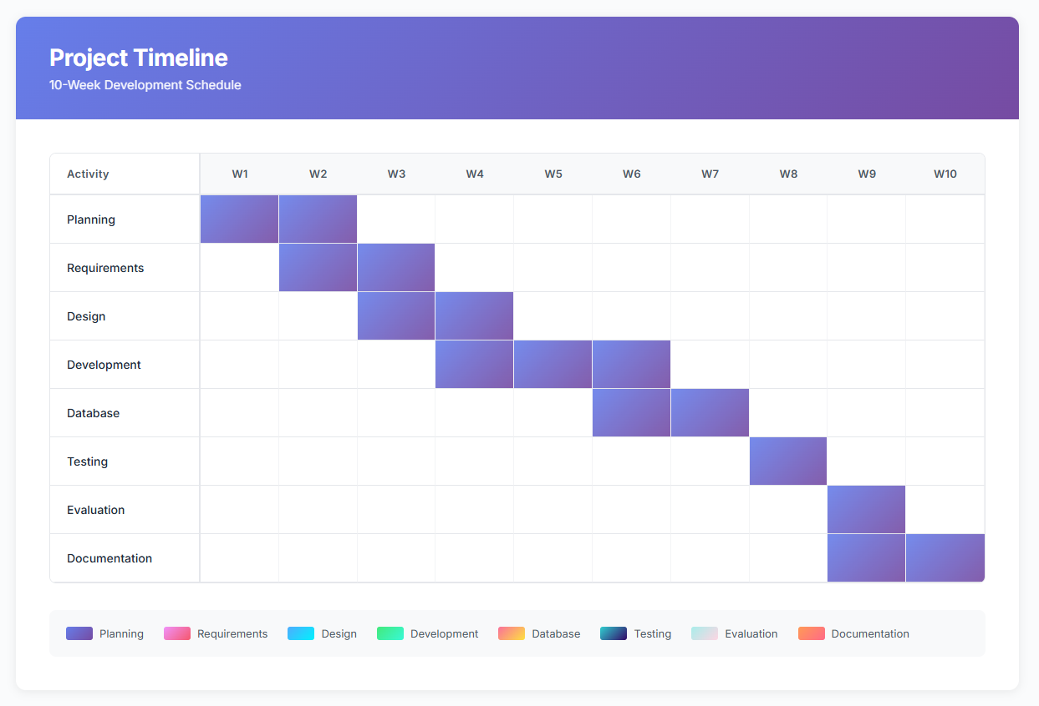
Figure 1 Gannt chart: Created with monday.com

Development Methodology
The project will follow the Agile Scrum development methodology. Agile is commonly used in software engineering because it supports iterative development, continuous testing, and regular stakeholder feedback [7]. The project will be divided into short development sprints, each delivering a functional component of the system. Sprint reviews and retrospective meetings will enable continuous improvement throughout the project development lifecycle. This approach reduces project risks, improves the quality of the software, and allows new requirements to be incorporated without significantly disrupting the project schedule.

Q2. Project Design
A well-defined system design provides a clear blueprint for software development and ensures that stakeholder requirements are translated into a practical solution [8]. During the planning phase of the Gardeners Hub project, two design artefacts were produced: a Flowchart and an ERD Entity Relationship Diagram. These designs help developers understand the system's functionality, user interactions, and interface layout before implementation begins.

Design 1 – System Flowchart
The system flowchart illustrates the sequence of activities performed by users when interacting with the Gardeners Hub platform. It demonstrates the logical flow of information from user registration through to compost subscription and community participation. In the context of teaching beginners to programming, programming environments built around a recognisable, flowchart-based notation have been utilized extensively [9].
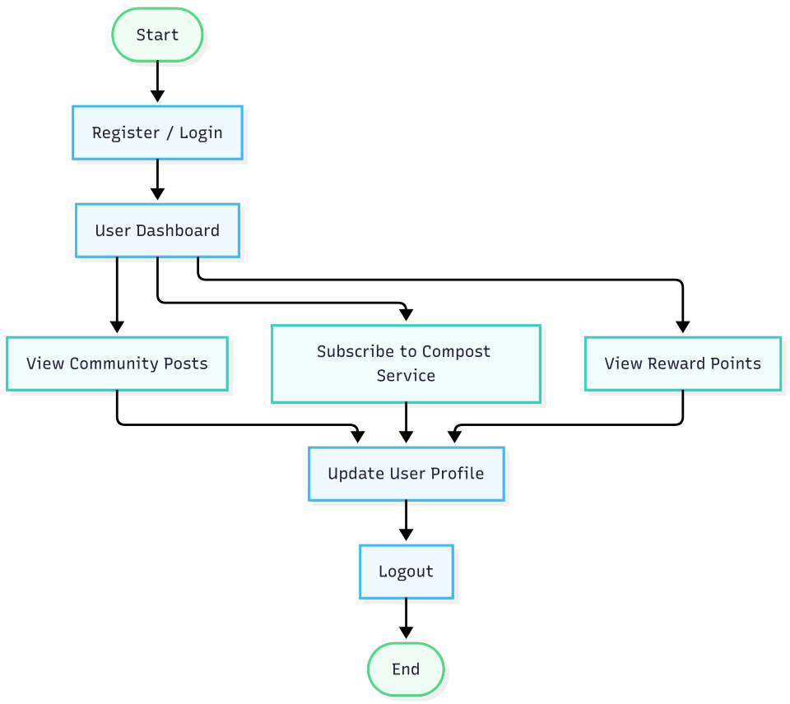
Figure 2 Flow Chart: Created with mermaid.ai
Flowchart Description
The flowchart begins with user registration, followed by secure authentication through the login process. Once authenticated, users are directed to the main dashboard where they can browse community gardening posts, subscribe to compost collection services, monitor reward points, and update their profiles. After completing their activities, users log out of the system. This logical representation assists developers in understanding user interactions and supports efficient implementation of application functionality.

Design 2 – Entity Relationship Diagram (ERD)
An entity relationship diagram, sometimes referred to as an ERD or E-R diagram, is a method that provides a detailed description of how a system's data is kept [10]. It will illustrate how data is organised within the Gardeners Hub database. It identifies the main entities, their attributes, and the relationships between them. A well-designed ERD ensures data consistency, minimises redundancy, and supports efficient database management.
Main Entities
User
- UserID (PK)
- FullName
- Email
- Password
- PhoneNumber
Subscription
- SubscriptionID (PK)
- UserID (FK)
- PlanType
- CollectionDate
- Status
CommunityPost
- PostID (PK)
- UserID (FK)
- Title
- Content
- DatePosted

Reward
- RewardID (PK)
- UserID (FK)
- Points
- RewardLevel

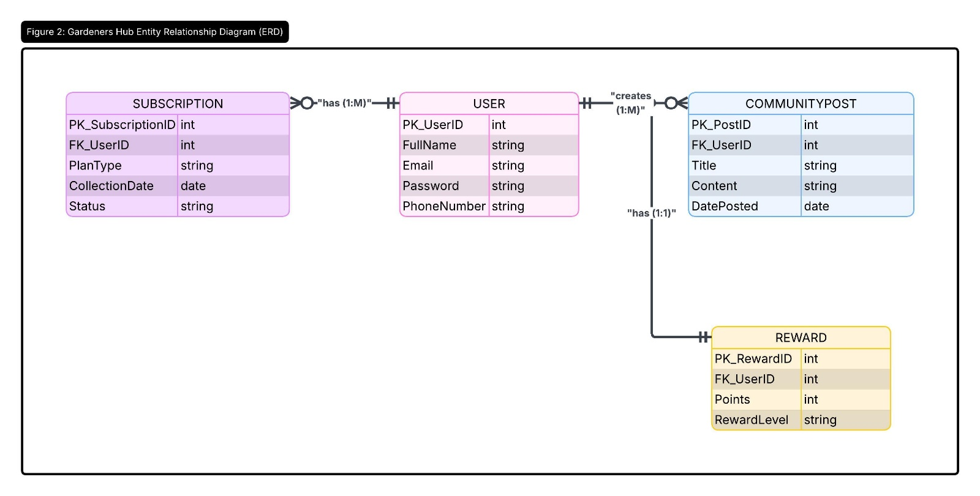
Figure 3 ERD Diagram. Created with lucid

ERD Description
The User entity is the central component of the database. Each registered user may create multiple community posts and maintain one or more compost subscriptions. Every user also has an associated reward record that stores accumulated points and membership level. Primary keys can uniquely recognise each record, while foreign keys maintain relationships between tables and ensure referential integrity. This structure enables efficient storage, retrieval, and management of user information while supporting future expansion of the platform.

Design Evaluation
Effective design is essential for maintaining user engagement in websites and mobile applications [11]. Producing Flowchart during the planning stage helps identify usability issues, reduces development costs, and minimises changes during implementation.
Similarly, the Entity Relation Diagram clearly identifies the responsibilities of different users within the system. It defines the functional requirements and establishes how users and administrators interact with the application. This improves communication between developers, designers, and stakeholders while supporting accurate software development.
Together, these two design artefacts provide a solid foundation for implementing Gardeners Hub. They improve project planning, reduce ambiguity, and ensure that the final system aligns with user requirements. By documenting both the interface design and the system functionality before development begins, the project team can minimise errors, improve software quality, and deliver a user-friendly application that supports sustainable gardening and community engagement.

Task 2 – Enterprise & Innovation (Enterprise)

Q1. PEST and SWOT Analysis of Microsoft
To evaluate the external and internal business environment that influences technology organisations, a PEST analysis and SWOT analysis have been conducted using Microsoft as an example. A PEST analysis evaluates political, economic, social, and technological factors, while a SWOT analysis considers internal strengths and weaknesses alongside external opportunities and threats [12].

PEST Analysis
Factor | Key Considerations
Political | Microsoft operates globally and must comply with different government regulations, including GDPR in Europe, digital privacy laws, cybersecurity legislation, taxation policies, and international trade regulations [5]. Government investment in digital transformation and artificial intelligence also creates new business opportunities.
Economic | Inflation, exchange rate fluctuations, rising cloud infrastructure costs, and global economic uncertainty can affect Microsoft's profitability. However, increasing demand for cloud computing, AI services, and remote working solutions continues to drive business growth.
Social | Society increasingly relies on digital technology for communication, education, healthcare, and business. Growing awareness of environmental sustainability, accessibility, and digital inclusion encourages Microsoft to develop socially responsible technologies that benefit a wider range of users.
Technological | Rapid advances in artificial intelligence, cloud computing, cybersecurity, automation, and Internet of Things (IoT) technologies require Microsoft to invest continuously in research and innovation. Maintaining technological leadership is essential in a highly competitive market.

SWOT Analysis
Strengths Weaknesses
Global brand recognition High operational costs
Market leader in cloud computing (Azure) Dependence on enterprise customers
Strong financial resources Some products require frequent updates
Continuous investment in AI and research Complex software ecosystem

Opportunities Threats
Expansion of AI technologies Increasing cybersecurity threats
Growth of cloud computing Strong competition from Google and Amazon
Government digital transformation programmes Rapid technological change
Sustainable technology initiatives Data privacy regulations

The analysis demonstrates that successful technology companies continuously adapt to changing political, economic, social, and technological environments while investing in innovation and customer-focused solutions.

Legal and Ethical Considerations
Gardeners Hub must comply with several legal and ethical responsibilities throughout its development and operation.

Legal Considerations
- Compliance with the UK General Data Protection Regulation (GDPR) when collecting user information [5].
- Secure storage of personal data through encryption and secure authentication.
- Compliance with copyright laws when users upload images, videos, and educational content.
- Clear terms and conditions explaining how user data will be processed.
- Protection of intellectual property, including software code, branding, and digital content.

Ethical Considerations
The project should operate transparently and responsibly by ensuring user privacy and fairness. Personal information should only be collected where necessary and never shared with third parties without consent. The platform should also provide equal access to all users by following accessibility standards such as the Web Content Accessibility Guidelines (WCAG) [12]. Moderation policies should prevent harmful or misleading content from being shared within the gardening community, creating a safe and inclusive environment.

Q2. Gardeners Hub Technology Start-up
Proposed Business Name: Gardeners Hub Ltd
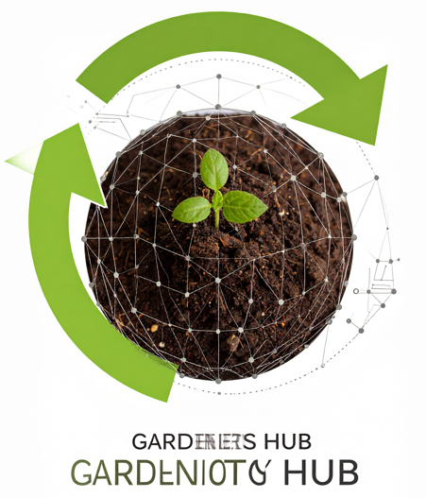
Proposed Logo
A green leaf growing from a compost bin, surrounded by a circular arrow representing recycling and sustainability. The logo symbolises environmental responsibility, community collaboration, and continuous growth.

Business Type (Legal Classification)
Gardeners Hub would operate as a Private Limited Company (Ltd). This structure limits the financial liability of shareholders, provides greater credibility with investors and customers, and allows the company to raise investment more easily as it expands [13].

Business Strategy
The company's vision is to become a leading digital platform that connects gardening communities while promoting sustainable waste management.
Key strategic objectives include:
- Develop an intuitive web and mobile application.
- Build partnerships with local councils and gardening organisations.
- Offer flexible monthly and annual compost subscription packages.
- Encourage customer loyalty through reward points and referral programmes.
- Expand services nationally before entering international markets.
Revenue will be generated through subscription fees, premium memberships, advertising opportunities, partnerships with gardening retailers, and future marketplace services for gardening products.

Funding Opportunities
Several funding initiatives could support the development and growth of Gardeners Hub:
- Innovate UK innovation grants.
- UK Government green technology and sustainability funding programmes.
- University enterprise competitions.
- Angel investors interested in environmental technology.
- Crowdfunding platforms such as Kickstarter.
- Small business loans and accelerator programmes.
Securing multiple funding sources would reduce financial risk while supporting product development, marketing, and future expansion.

Conclusion
This report has presented the planning, design, enterprise considerations, and reflection for the proposed Gardeners Hub project. The project aims to promote sustainable gardening and responsible organic waste management through a digital platform that combines community engagement with a compost subscription service. By integrating modern computing technologies with environmental sustainability, the project offers practical benefits for both individuals and local communities.
The report demonstrated effective project management through a clearly defined scope, project schedule, Agile Scrum methodology, and supporting design artefacts, including a system flowchart and Entity Relationship Diagram (ERD). Enterprise concepts were explored using PEST and SWOT analyses, together with legal and ethical considerations, highlighting the importance of data protection, accessibility, and sustainable business practices. A start-up proposal also illustrated the commercial potential of Gardeners Hub.
Overall, the project has strengthened my knowledge of software development, database design, project planning, and entrepreneurship while enhancing my problem-solving and research skills. If implemented, Gardeners Hub could contribute to reducing household waste, encouraging sustainable behaviour, and strengthening community collaboration. With continued development and stakeholder support, the platform has the potential to become a valuable digital solution that delivers environmental, social, and commercial benefits.

References
[1] Munther Al-Nimer, M. Anwar, I. B. Hani, and O. Hujran, “Project management team and project success: an overview,” Management Review Quarterly, Dec. 2024, doi: 10.1007/s11301-024-00484-3.
[2] T. Schoenherr and S. Talluri, “Environmental Sustainability Initiatives: A Comparative Analysis of Plant Efficiencies in Europe and the U.S.,” IEEE Transactions on Engineering Management, vol. 60, no. 2, pp. 353–365, May 2013, doi: 10.1109/tem.2012.2198653.
[3] A. Khan, “Business Management,” 2006. Accessed: July 23, 2026. [Online]. Available: https://brainmass.com/business/human-resources-management/business-management-271591
[4] A. K. Mishra, “Implication of theory of constraints in project management,” International Journal of Advanced Trends in Engineering and Technology, vol. 5, no. 1, Jan. 2020, doi: 10.5281/zenodo.3605056.
[5] UK Government, “Data Protection Act,” www.gov.uk, 2025. Accessed: July 23, 2026. [Online]. Available: https://www.gov.uk/data-protection
[6] J. M. Wilson, “Gantt charts: a Centenary Appreciation,” European Journal of Operational Research, vol. 149, no. 2, pp. 430–437, Sept. 2003, doi: https://doi.org/10.1016/S0377-2217(02)00769-5.
[7] S. Sharma and N. Hasteer, “A comprehensive study on state of Scrum development,” 2016 International Conference on Computing, Communication and Automation (ICCCA), pp. 867–872, Apr. 2016, doi: 10.1109/ccaa.2016.7813837.
[8] J. Molina-Ríos and N. Pedreira-Souto, “Comparison of development methodologies in web applications,” Information and Software Technology, vol. 119, p. 106238, Mar. 2020, doi: 10.1016/j.infsof.2019.106238.
[9] S. Xinogalos, “Using flowchart-based programming environments for simplifying programming and software engineering processes,” 2013 IEEE Global Engineering Education Conference (EDUCON), pp. 1313–1322, Mar. 2013, doi: 10.1109/educon.2013.6530276.
[10] J. Frantiska, “Entity-Relationship Diagrams,” Visualization Tools for Learning Environment Development, pp. 21–30, Oct. 2017, doi: 10.1007/978-3-319-67440-7_4.
[11] R. Garett, J. Chiu, L. Zhang, and S. D Young, “A Literature Review: Website Design and User Engagement,” Online journal of communication and media technologies, vol. 6, no. 3, p. 1, July 2016, Accessed: July 23, 2026. [Online]. Available: https://pmc.ncbi.nlm.nih.gov/articles/PMC4974011/
[12] A. Alsaeedi, “Comparing Web Accessibility Evaluation Tools and Evaluating the Accessibility of Webpages: Proposed Frameworks,” Information, vol. 11, no. 1, p. 40, Jan. 2020, doi: 10.3390/info11010040.
[13] Companies House, “Companies House,” Mar. 2023. Accessed: July 23, 2026. [Online]. Available: https://www.gov.uk/government/organisations/companies-house

