
The impact of obesity and possible solutions
Psychology in Health and Social Care

July 23, 2021
Michelle Garcia dos Santos 1921108
Lecturer: Rebecca Kavanagh

Contents
Introduction 2
Social Learning Theory and Social Identity Theory 3
Attitudes 4
Theory of Planned Behaviour 6
Conclusion 8
Recommendation 9
References 9

Introduction

The aim of this report is to find alternatives and understand the rise in obesity levels observed by Clinical Commissioning Group (CCG) specially in younger patients. Therefore, we will go through research to understand and measure the problem that now is increasing pressure on services and finances. With the understanding of Social Learning Theory and Social Identity Theory, Attitudes and Theory of Planned Behaviour we will suggest an effective strategy plan to reduce the levels of obesity and encourage healthy eating behaviours.
The literature review will analyse data regarding to obesity rates across the UK in between men and women to better understand what the possible social and biological main causes of unhealthy eating behaviours and its impacts over the population and care sector are. Once an understanding of the problem is reached a recommendation will be proposed to either reduce or eliminate the issue. We will go through related psychological theories relevant and useful for Health and Social Care Practice discussing the use of perspectives when and if they should be applied in the obesity issue and what would be the benefits.
Finally, a conclusion will be made taking in consideration the literature review and all the important points observed in this report to support recommended actions.

Social Learning Theory and Social Identity Theory

Social Learning Theory is one of the newest studies in Psychology to understand and direct peoples approaches in the society and its use started in the 50’s. Due to the high influence in human learning and development it is shaped around conventional learning.
According to Bandura individual’s behaviour is learnt via observing, repetition, and modelling. (Kurt, 2020)
The theory approach emphasises learning that takes place in a societal setting stating that individuals acquire knowledge with each other. (Chavis, 2011)
By drawing into the concept of Social Learning Behaviour we may assume based in several evidence and quantifiable data that theories of behaviour are extensively used to promote change broad as well as defective conducts and behaviours related to depression, anorexia, chronic pain, drug abuse, anxiety, obesity, phobias, passive and compulsive behaviours. harm, anger disorder, mental retardation, and alcoholism. (Chavis, 2011, p. 2)
According to research there are several ways to identify the behaviours above through Social Learning Theory which includes description given by the patient through a questionnaire or even the individual’s description of his/her family in context allowing relevant comparison with the individual used as a model. In some cases, measurement come by comparison of the individuals taking part in the experiment, they are commonly analysed by one or more specialists with deep knowledge about participants.
In Social Learning Theory we find a relation to identify in people’s behaviour where in general an individual through observation tries to match its decisions and behaviours with a model individual, and it may lead to the same or similar results accordingly but even though that’s the goal, in theory the role model’s behaviour would just be repeated as it is actually shaped around the observer’s wishes or needs creating distortion. These achievements are better analysed watching the stimulus of everyone that changes from one to another considering environment, cultural aspects, financial situation and more. (Goslin, 1969)
The research shows that these issues mentioned previously are also related to social identities which influences in how the individual is perceived within the group or outside it. These perceptions may vary accordingly throughout different judgemental processes involving physical appearance, old fashion pre-conceived ideas of how someone should look like and the importance of food abundancy on the way people from that group sees the individual. Although its relevance not enough research was done in social identity when it comes into the relation with food palate perception or palate impressions. Anyhow according to the source, the study demonstrates a connection in between societal aspects related to individual’s cultural environment and eating excessively. In this context, is also the fact that people create associations to the group that leads to categorise themselves within and therefore the situation will shape how they identify and self-score their eating behaviour to score their importance to the group. That said, the way the individual sees oneself and how their evaluate their role in society have a strong influence in finding the motivation to change those behaviours suggesting that the more the individual is immersed in a social context the more it may impact this person decisions in relation to food intake, varying according to social and financially related contexts given it appears to be that the outcome is not predictable as life context changes constantly. (Hackel, et al., 2018)

Attitudes

Attitude is a state of mental and neurological preparation, through empirical organization, which exerts an indicative or effective impact on the individual's feedback to all objects and circumstances connected to him and this is just one of the at least 16 definitions Allport given to attitude. (Murchison, 1935)
  - Thurstone Theory
Thurstone's method of constructing an attitude scale includes two main steps.
The first step collects attitude declarations to cover all possible thinking’s, and results are measured according to their disadvantages or benefits for the given attitude object. (Roberts, et al., (1999)
  - Allport’s Theory

Allport's theory emphasizes the uniqueness of the person and the inside cognitive and motivational forms that impact conduct, such as personality, propensities, abilities, attitudes, and characteristics.
Allport (1937) accepts that identity is naturally decided at birth and formed by a person's natural encounter. (Ajmal, (2020) (Murchison, 1935)
Attitudes play a huge role in obesity and according to Walther and Langer it may be formed by conditioning situations and certain types of stimulus where it will form through either suggested or unintentional situations. (Prislin & Crano, 2011)
Three dominant kinds of poor diet attitudes were used as regressors in the original paper approach: restrained, compulsive, and compulsive eating (external and emotional eating).
Restrained eating, on the other hand, is defined as an extreme restriction (both qualitative or quantitative) of food consumption in someone's eating routine that is insufficient to meet health needs.
External stimuli are often very appealing to make a person try very hard to eat even though they are not experiencing the actual state of appetite. (Izydorczyk, et al., 2019)
Annually from 2015 through 2035, the increase of severe obesity in Scotland, Wales, and England was calculated.
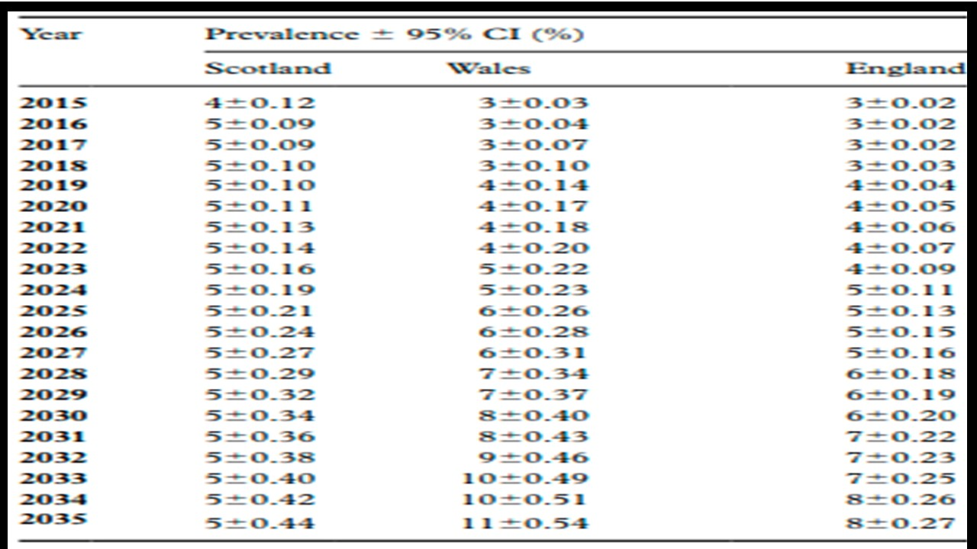
(Keaver, et al., 2020)
Forecasts based on gender
In all 3 nations, morbid obesity is expected to rise among males and females. Between 2015 to 2035, the incidence for men is expected to rise in Scotland from 4% to 6%, in Wales from 2% to 13%, and in England from 2% to 7%. From 2015 to 2035, the reported incidence for women in Scotland is expected to rise from 3% to 5%, from 3% to 9% in Wales, and from 4% to 8% in England. (Keaver, et al., 2020)
Overall positive heath eating attitudes are linked to good acceptance and adherence to good eating habits such as fruit and vegetables and are strongly connected to the desire to look good compared to others and be healthy. (Kowalkowska, et al., 2018)
Morbid obesity is becoming more common over the globe, according to prior studies. While there was an effort in England to stimulate the nutritional contexts via the implementation of the sugar-sweetened drinks levy and an extra support for restructuring, this support was hampered by the food sector's ethical considerations, that has prevented major change. (Keaver, et al., 2020)

Theory of Planned Behaviour

The theory of planned behaviour is known as social cognition models, these models assume that social behaviour is decided by an individual’s convictions towards behaviour in given social contexts and by their social discernments and desires and not essentially by their cognitions and attitudes.
That said, we may affirm that TPB is one of the most popular conceptual substructures to explore how cognitive factors of attitude, personalised norms, recognised behavioural standard, and behaviour desire affect people’s eating behaviours.
The TPB, has been criticized in two areas: hypotheses as well as interpretation of certain aspects. The TPB has indeed been critiqued for its emphasis on logical decision-making, despite the fact that not all behavioural choices are founded on a reasonable assessment of the behaviour's pros and cons.
Eating patterns, are not always made using critical thought patterns; alternatively, individuals often will eat anything they want before giving it much thought.
The thoughts an individual has with the average individual which performs in a specific behaviour is referred to it as the model impression, and this is one of the factors of behavioural willingness.
For instance, individuals who had favourable impressions of smoking were more inclined to be motivated to smoke themselves, according to Spijkerman et al. (2004); this association can be understood by the reactive decision-making method. According to researches, the TPB aspects, particularly attitudes and subjective standards, are not well understood. (Jun & Arendt, 2016)
The research reveals that behavioural inclination had a larger effect on poor eating habits, stressing the importance of the unconscious or impulsive decision-making approach in eating habits. (Jun & Arendt, 2016)
According to the Theory of Planned behaviour in an initial stage the personal attitude will corroborate for the result addressing to the case study, it means that the personal inclination to eat unhealthy foods meaning the attitude of the individual, combined with outcome beliefs that it is more tasty, or its harmless because of the outcome evaluation that he knows several people that eat the same and is not fat or unhealthy, therefore the type of food is not a problem in the invidual’s opinion which will then lead to a pattern of unhealthy habits because the intention poorly directed, is to feel satisfied and probably follow other models of the the group he/her forms part. In the same context the subjectve norms of the invidual will impact in the normative beliefs and motivation to comply which impacts in the formation of an opinion in regard to heathy or unhealthy eating, measuring how determined the individual is in relation to healthy eating as some will encourage using the taste or the fact that is just chicken even when is coated and fried and others will come back with the argument that eating vegetables, fruit and a low fat consumption is beneficial in many heath aspects including independancy from others considering that and obese people may have reduced mobility. In the last part of the theory application we have personal control beliefs and those are composed by self-efficacy beliefs, which is about how strong the inviduals mindset is to make changes in their life or body. The second part of this stage is perceived external barriers, meaning those external situations that we notice and may stop us to reach a goal. (Psychology, 2016)

Conclusion

This paper has identified that according to Bandura in the Social Learning Theory, that behavioural knowledge is learnt in the social context via observation (Kurt, 2020), repetition and modelling and is associated with how individuals get to know others and is extensively applied to treat behaviours such as depression, anorexia, chronic pain, drug abuse, anxiety, obesity, phobias, passive and compulsive behaviours. harm, anger disorder, mental retardation, and alcoholism (Chavis, 2011) being and effective applied via stimuli as well as identifying when individuals try to match behaviours with their chosen model. (Goslin, 1969)
The Social identity theory is important to understand how people is perceived in and out their groups and although is not enough research in this field the research demonstrates the influence of the environment with excessive eating what reinforce that social context change is beneficial for a positive outcome. (Hackel, et al., 2018)
In Attitudes we’ve seen it’s definitions according to Thurstone and Allport and the role it plays in obesity being via suggestion or unintentional situations (Prislin & Crano, 2011) that leads the individual to react towards situations eating excessively conducting the individual to restrained, compulsive and compulsive eating (Izydorczyk, et al., 2019), providing forecast of the rise of morbid obesity between 2015 and 2035 in UK, in both men and women through qualitative and quantitative data. (Keaver, et al., 2020)
The Theory of Planned Behaviour state that choices are made through influence of attitude towards a determined behaviour, social influence and perceived behaviour control and is also known as cognition model where behaviour is decided through the individual’s convictions towards behaviour in social contexts. According to the TPB people with liking towards unhealthy habits tends to do it themselves eventually. (Jun & Arendt, 2016)

Recommendation

The use of Social Learning Theory is recommended to identify and treat eating disorders and the Social Identity Theory to understand how individuals react according to their group as well as the impact of Attitudes in eating behaviours and how the mindset defined in TPB works to implement actions such as medical and psychological support, a balanced nutritional diet and campaigns from the government and NHS to alert the population about the risks of obesity and how to obtain support on this matter.
Once the right team, including nutritionists, doctors, and psychological support is in place using its combined knowledge in patients the financial pressure should be overcome by positive results and reduced expending with food and medicines once weight lost and heathy diet reaches adherence from patients.

References
Ajmal, I., (2020). Psychology Lectures. [Online]
Available at: https://www.youtube.com/watch?v=Nm4QxCBSemo
[Accessed 15 07 2021].
Allport, G. W., (1935). Atitudes. [Online]
Available at: http://aurora.upsi.edu.my/wp-content/uploads/2021/02/ALLPORT-ATTITUDES-ARTICLE.pdf
[Accessed 08 07 2021].
Chavis, A. M., (2011). Social Learning Theory and Behavioral Therapy: Considering Human Behaviors within the Social and Cultural Context of Individuals and Families. Routeledge Taylor & Francis Group, 1(10.1080/19371918.2011.591629), pp. 1 - 2.
Goslin, D. A., (1969). Social Learning Theory of Identificatory Processes. Handbook of Socialization Theory and Research, Volume 1, p. 2.
Hackel, L. M., G. C., Wohl, M. J. & Bavel, J. J. V., (2018). From groups to grits: Social identity shapes evaluations of food pleasantness. Journal of Experimental Social Psychology, 1(https://doi.org/10.1016/j.jesp.2017.09.007), p. 2.
Izydorczyk, B., Sitnik-Warchulska, K., ́nczyk, S. L. & Lipiarz, A., (2019). Psychological Predictors of Unhealthy eating attitudes in young adults. Frontiers in Psychology, 1(doi: 10.3389/fpsyg.2019.00590), p. 4.
Jun, J. & Arendt, S. W., (2016). Understanding healthy eating behaviors at casual dining restaurants using the extended theory of planned behavior. International Journal of Hospitality Management, 1(53), p. 2.
Keaver, L., Xu, B., Jaccard, A. & Webber, L., (2020). Morbid obesity in the UK: A modelling projection study to 2035. Journal of Public Health, 48(422–427), p. 3.
Kowalkowska, J. et al., (2018). Health- and Taste-Related Attitudes Associated with Dietary Patterns in a Representative Sample of Polish Girls and Young Women: A Cross-Sectional Study (GEBaHealth Project). Nutrients, 10(doi:10.3390/nu10020254), pp. 11, 12.
Kurt, D. S., (2020). Educational Technology. [Online]
Available at: https://educationaltechnology.net/social-learning-theory-albert-bandura/
[Accessed 22 07 2021].
Murchison, C., (1935). Attitudes - Handbook of Social Psychology. Clark University, p. 1.
Prislin, R. & Crano, W. D., (2011). Attitudes and Attitude Change. 1 ed. New York; London: Psychology Press.
Psychology, S., (2016). Successful Psychology. [Online]
Available at: https://www.youtube.com/watch?v=77QiDn8lsUA&t=340s
[Accessed 22 07 2021].
Roberts, J. S., Wedell, D. H. & Laughlin, J. E., (1999). Validity Issues in the Likert and Thurstone approaches to attitude measurement. Educational and Psychological Measurement, 59(2), pp. 2, 3.

