Normans and their ‘myth’ – Portfolio
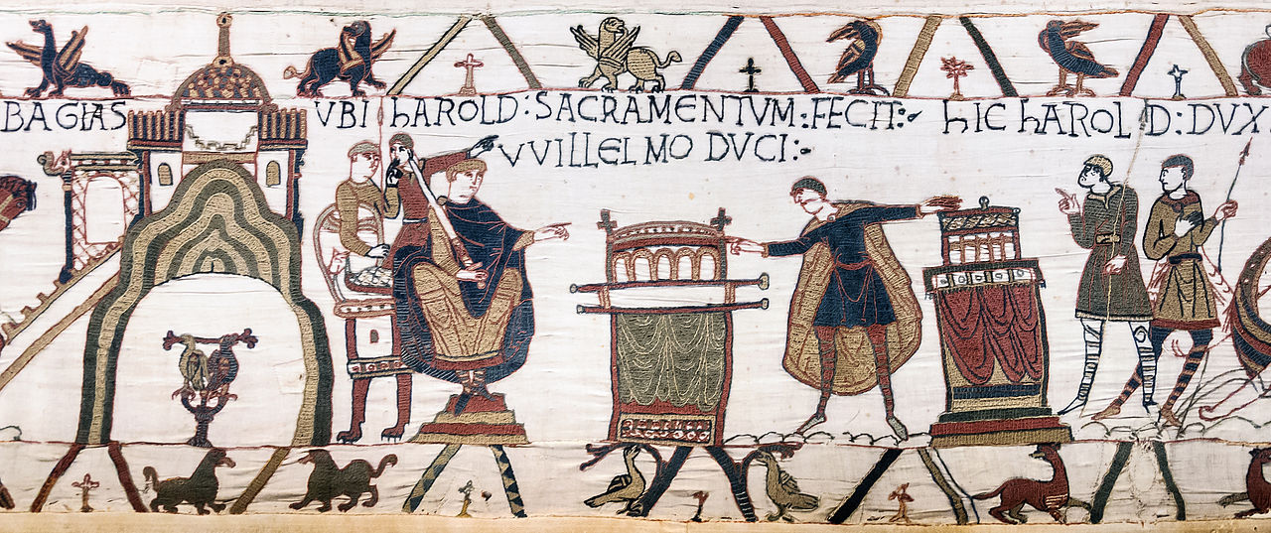
The Bayeux Tapestry is one of the most significant source materials available to any historian. Whether being analysed as a remarkable piece of art or a historical account of one of the most famous events in English history, it endures as a much-debated artefact. This essay will examine the above scene, Harold’s oath of support for Duke William as King of England, which is seen as ‘the key to the entire narrative’. To do this we must analyse the source in relation to what we can infer from it regarding the Normans and the wider scholarship that surrounds this centuries old debate, and for these purposes the other details in the scene, such as the drawings in the borders, are not relevant.
While it is difficult to trace the history of the Tapestry, historians are largely unanimous in crediting Williams half-brother, the Bishop of Odo, with commissioning the work in a bid to affirm William’s claim to the throne. Despite being the crux of a piece of propaganda the scene is not without much debate and interpretation. Musset describes the scene as ‘one of the most enigmatic moments on the Tapestry’. He raises key questions regarding the piece, one of which concerns the two relics Harold swears on. He cites Wace who claimed that Harold didn’t understand what he was swearing on, but dismisses this, claiming it is not believable to suggest he did not realise what was taking place. Whilst this may be true, it does not eliminate the possibility that while he understood what was happening, he was doing so under duress. This is a vital element of the story, as if Harold has indeed sworn on sacred relics and broken his promise, this gives William and his men a just cause for their conquest; not only has Harold lied to him, he has lied to God. Looking at other Norman invasions a religious cause is usually the justification used. This scene aids our understanding of what they were trying to achieve with this scene, and the rest of the Tapestry in preserving their motivation and reasoning for why William laid claim to the throne of England.
Musset’s crucial question concerns what Harold is swearing in the scene. He acknowledges that most historians view it as relating to the throne and who would be succeeding Edward, but throughout makes repeated reference to the vagueness of the image. This is interesting to consider, that despite being a piece commissioned by the Normans that it still invites interpretation and debate. Douglas alludes to the lack of an Anglo-Saxon point of view concerning the oath and succession debate, claiming this makes the Norman sources even more crucial evidence. This point is perhaps crucial as the Normans were able to create a visually stunning, clear narrative of the story, with the Tapestry having an advantage of speaking to illiterate people amongst a community. The Anglo-Saxon Chronicle contains no direct reference to any ‘oath’, but in discussing Edward’s death; with the ailing king committing his kingdom ‘to a distinguished man, Harold himself’. The reference to the conflict beginning with William is simply of someone who ‘wanted to come here and win this land’, which plays into the idea of the Normans as simply ruthless invaders. This is also rather vague and unsubstantial but here we can see the Anglo-Saxon attempt to record their own history, although one similarity between the sources is the anonymous nature of the entries. Higham’s analysis of the scene seeks to downplay its narrative as largely unimportant, claiming that various writers near to this time made no mention of this oath and went as far as praising his time as king. He views the focus on this oath as an ‘exercise in the construction of memory for political and dynastic advantage in the aftermath of victory’. This leads us back to the conclusion that this is the Normans as the victors, getting to write their version of history. When analysing the Normans as a collective as it allows to see another instance of them seeking to take control of how they are seen in history.
Many historians place Harold as the central character of the Tapestry, with the oath being the beginning of his downfall. Cowdrey is surprised by the attention given to Harold throughout; with him being referred to more than anyone else. Given that it exists as a justification for the Norman invasion of England this is surprising but upon greater examination is appears that there are sympathetic references to Harold. Walker views this debate over the rightful heir to the throne as consigning Harold to history as a ‘minor interruption’, having had his reputation damaged by the Normans in the subsequent years. That this overriding image of Harold has endured and has been told through centuries is significant, giving us an example of the Normans taking control of their narrative and sensing the importance of telling this story for generations to come. However, Walker may not be completely correct as the popularity of the work along with the focus Harold receives, arguably has preserved himself and his story in a way very few other kings have had, especially kings that reigned for such a short time. What this also tells us is that William’s half-brother wished to affirm William’s right to invade England and that the conflict was a just one. This is line with other Norman conquests, such as the invasion of Sicily. It is intriguing to consider the vagueness that the image possesses, along with other scenes in the Tapestry lend a more sympathetic tone to Harold’s story, which gives us as insight that while the Normans wished to affirm William’s claim, they were trying not to destroy Harold for their English audience. There is subtle support for Harold, with debate as to whether the scene shows the oath being extorted from Harold, and the rest of the Tapestry portraying him ‘with dignity, even heroism’. This subtext, much like the subtle critique of the Normans in works such as Historia Normannorum , lends itself to speculation that perhaps those working on the Tapestry imposed their own message onto the work.
This source is a hugely valuable insight in our understanding of the Normans, and specifically the ‘myth’ that surrounds them. What we can learn from this scene is how as always, the Normans were aware of the need to record their history and justify their conquest of England. As usual with Norman sources, the scene and the Tapestry works on multiple levels, with the surface level being that of the powerful William and Harold swearing his oath, therefore being in deference to the Duke. We also see however the significance Harold and his story are given and therefore cannot view the work as aiming to completely disregard him. We know that the Normans were not only interested in celebrating their accomplishments but also the motivations behind them, and what this says about them. In this instance we can see the significance of Harold’s broken oath as breaking a promise to God, granting William his justification for the conquest. It has endured for centuries and has managed to affect the reputation of the fallen Harold and preserve the legitimacy of William’s claim to the throne. This has the effect of reinforcing that the Normans were very aware of their image and place in history, as well as how to preserve this.

Bibliography
Primary Sources
Bayeux Tapestry. (ca. 1070. Tapestry. Bayeux, France).
Dudo of St Quentin. Historia Normannorum: History, Tradition and Memory (ca. 996-1015).
The Anglo-Saxon Chronicles (Ed.) Swanton, Michael (London, Phoenix Press, 2000).
Secondary Sources
Anonymous. ‘Embroidering the Conquest’ The Week. Issue 1160, 2018.
Douglas, David. ‘Edward the Confessor, Duke William of Normandy, and the English Succession’ The English Historical Review. Vol. 68, No. 269, 1953.
(Ed.) Owen-Crocker, Gale R. King Harold II and the Bayeux Tapestry (Woodbridge, The Boydell Press, 2005).
Musset, Lucien. The Bayeux Tapestry (Woodbridge, The Boydell Press, 2005).
Walker, Ian W. Harold, The last Anglo-Saxon King (The History Press, 2010).

Lucien Musset, The Bayeux Tapestry (Woodbridge, The Boydell Press, 2005). p. 146.
Ibid,.
Musset, p. 152.
Musset, p. 150.
David Douglas, ‘Edward the Confessor, Duke William of Normandy, and the English Succession’ The English Historical Review, Vol. 68, No. 269, 1953.
The Anglo-Saxon Chronicles (Ed.) Michael Swanton (London, Phoenix Press, 2000). p. 196.
N. J. Higham, King Harold II and the Bayeux Tapestry (Ed.) Gale R. Owen-Crocker (Woodbridge, The Boydell Press, 2005). p. 20.
H. E. J. Cowdrey, King Harold II and the Bayeux Tapestry (Ed.) Owen-Crocker, Gale R. (Woodbridge, The Boydell Press, 2005).
Ian W Walker, Harold, The last Anglo-Saxon King (The History Press, 2010). p. XV.
Anonymous, ‘Embroidering the Conquest’ The Week. Issue 1160, 2018.
Dudo of St Quentin, Historia Normannorum: History, Tradition and Memory (ca. 996-1015).

