University of Wales Trinity Saint David
Engineering Skills (ACHA4022A)
Engineering Skills Technical Report
Evan Williams
2500733
Submission Date: 6/12/25
Word Count: 2006

Contents Page
Introduction 3
Health & Safety 4
Security Risk Matrix 6
Engineers Role in Society 7
Problem Solving 8
Team Structure 9
Conclusion 10
Reference List 11

Figure 1. Problem-driven product manufacturing process innovation strategy model (Qian Zhao et al 2025) 9
Figure 2 - Team Structure (Shuo Yu et al 2022) 10

Table 1 - Risk Assessment 4
Table 2 - Risk Matrix 6

Introduction
In this technical report there will be five main topics covered, the Health and Safety requirements to complete tasks in the machine workshop using a Lathe, identifying Security Risks to the automotive industry with the rise of autonomous vehicles and producing risk matrixes, identifying Engineers Roles in Society and the codes of conducts that may apply to them, identifying what Problem Solving methods that engineers may use while developing a new product if and when a problem occurs and reviewing the Team Structure that was used when I was a part of a team in college.

Health & Safety
As part of the course there is a module that requires students to perform various tasks in the machine workshop, including producing a component using different techniques on a Lathe. To complete those tasks, there are various pieces of legislation that are required to be followed with the first being the Provision and Use of Work Equipment Regulations. The Health and Safety Executive (1998) notes that all equipment that is provided should be safe and inspected for safety, used only by anyone with training and alongside health and safety measures like guards. Another applicable piece of legislation being the Personal protective equipment at work regulation. The Health and Safety Executive (2022) have included in the regulation that if PPE is required for a task, then employers must provide the PPE and the information and training that is required to use it safely. The next piece of legislation that is applicable to this task is the Health and Safety at Work etc Act. This is an act set in place by the government and then enforced by the Health and Safety Executive (1974) noting that all employers should be carrying out jobs in order to keep themselves, employees and the public safe at work. As the University is a business these regulations apply to the tasks carried out and the machinery like the lathes that they are being carried out on.
Table 1 - Risk Assessment
Reference | Task | Hazard | Existing Controls | Who does it effect? | Likelihood | Severity
1 | Machining | Entanglement | Guards, not interfering with the chuck when rotating, loose clothing tucked in, long hair tied up and use of emergency stop button, steel toe cap boots, dust jacket, safety glasses. | The operator | 2 | 5
2 | Machining | Workpiece Ejecting | Guards, ensuring workpiece is secure before machining, carefully controlling tools and not bringing into contact with workpiece at speed, steel toe cap boots, dust jacket, safety glasses. | The operator, others in the workshop. | 2 | 4
3 | Machining | Sharp tools | Use of gloves and dust jackets and only holding tools by the handle, steel toe cap boots, safety glasses. | The operator. | 4 | 2
4 | Machining | Swarf | Wearing gloves and dust jackets, wipe away any swarf in between operations with machine off, steel toe cap boots, safety glasses. | The operator. | 5 | 2
5 | Machining | Hot components | Wearing gloves when handling the workpiece (with machine off), steel toe cap boots, dust jacket, safety glasses. | The operator. | 3 | 2

Security Risk Matrix
During recent years vehicles have become more connected and autonomous than ever before, this does however come with new digital and physical security threats. First, digital threats like compromised backend servers can have different effects depending on the type of malware that has gotten into the system. Described by Dr Ahmed Nasser (2023), it could be there to steal sensitive information on certain vehicles and owners or to take over the systems inside of the vehicles which could mean that it doesn’t function properly, potentially leading to crashes. (Risk 1)
Next, in autonomous vehicles Light Detection and Ranging systems are used for navigation and can be targeted with attacks that can “intentionally introduce changes to the input data to induce detection/classification errors, potentially leading to erroneous warnings or accidents, with consequences ranging from property damage to loss of life” (Guesmi & Shafique, 2024, Page 2, Paragraph 6). (Risk 2)
As the vehicles become more connected, they are also becoming connected to the road traffic systems (traffic lights for example). According to Zhiyi Li et al (2016, Paragraph 2), the “Intelligent transportation systems (ITS), an essential component of the ongoing evolution of smart cities, aim at perfecting decision making in traffic planning and traffic management.”. Meaning that if these systems were to be targeted with a malicious attack, then there could physical risks to the occupants of the vehicles that are relying on those for autonomous travel. (Risk 3)
Attacks can also be deployed unknowingly by the owner of the vehicle through methods like accessories being plugged into USB slots, for example buying and plugging in an adapter for the vehicles Apple CarPlay to turn it from wired to wireless that has software stored on the device that deploys viruses into the vehicles systems allowing hackers control over different aspects of the car. (Risk 4)
Table 2 - Risk Matrix
 | Consequence
Likelihood
Likelihood |  | Risk 4 | Risk 3
Likelihood |  |  | Risk 1 | Risk 2
Key:
- Low Risk = Green Highlight.
- Medium Risk = Yellow Highlight.
- High Risk = Red Highlight.
As you can see from table 2, Risk 2 was deemed the highest risk, in order to mitigate the risk, there is a holistic and proportionate approach that can be made. For the holistic approach, the level of cybersecurity behind the Light Detection and Radar systems and ECU could be increased in order to protect them more as well as installing a fail-safe that alerts the occupents of the vehicle to take over the control of the vehicle in the case that the systems do fail then there is a chance to safely stop the vehicle before an accident occurs. For the proportionate response because the risk is deemed to be medium to high then it should mean that more money can be put towards these systems and the cybersecurity behind them through means of engineering teams installing better systems in the vehicles meaning that there is a higher standard cybersecurity to protect against any malicious attacks.

Engineers Role in Society
Engineers in society have responsibilities placed upon them by the area of their expertise and the organisations they are connected to. One way this is done is by creating codes of conduct that the members must follow to have guidelines and rules on the activities they carry out, whether it is from a financial or an environmental point of view.
One example of these organisations would be Motorsport UK. The organisation hosts many types of races with examples being rallying, karting and circuit racing which means they need a code of conduct in order to keep all members, including engineers, to the same basis with policies that revolve around environmental issues to try to keep the environmental impact from the activities to a minimum. This therefore requires that engineers designing the vehicles to be making the correct considerations in an effort to reduce the impact. Evidence of this is in their code of conduct Motorsport UK states that “Motorsport UK recognises that for motor sport activities to be sustainable they must be managed such as to minimise the depletion of natural resources and pollution of the environment.” (Motorsport UK, https://www.motorsportuk.org/wp-content/uploads/2020/12/2021-03-08-motorsport-uk-yearbook-2021-p047-051-national-sporting-code-a.pdf, page 4, para 8).
Formula 1 are another organisation who have published a code of conduct outlining expectations from their members with environmental considerations made. In the code of conduct Formula 1 (2023) incorporated complying with the goals that the United Nations have set out in regards to sustainability as well as targeting to achieve a net zero carbon footprint of their operations by 2030. With this code of conduct engineers have the responsibility to make better decisions with different aspects like materials, for example, instead of just going with what is easiest they should be thinking if there are other options that could be better for the impact it has on the environment even if it is a higher price.

Problem Solving
When developing new products there may be issues in the development process. If these issues arise then there are different methods that may be used which starts with identifying the problem and conducting research into how it has occurred for a solution to be identified. After the problem has been identified then, Figure 1 shows that there can be four main types of problems and the methods to fix them.
According to Qian Zhao et al (2025) these are: Improvement-type problems, Substitution-type problems, Integration-type problems and Thinking-type problems and based off of these problems there tends to be different methods to solve the problems depending on the type. For improvement type problems the methods used focus on addressing the problems and improving upon the original design to give a better product. With substitution type problems, methods are used when improvements are not being made with the current way the processes are occurring, so substitutions are made to keep the improvements coming whether it be method of machining the product or the personnel on the team creating the product.
When integration type problems arise then methods are used to combine different types of technology to provide a solution to the problem, an example of this would be a problem with the volume of emissions a vehicle was producing and the solution that was thought of was to convert the engine into a hybrid, combining electric and the original petrol/diesel engine to lower the emissions produced. For thinking type problems there are heuristic methods of problem solving used, these being simply thinking out all of the details of the product, the manufacturing process for example, and brainstorming a solution for the problem. If the problem requires it then these methods may be used together however using just one should be enough to find a solution.
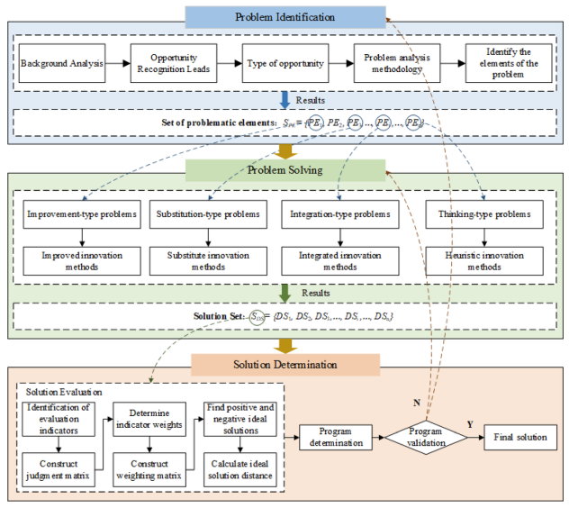
Figure 1. Problem-driven product manufacturing process innovation strategy model (Qian Zhao et al 2025)

Team Structure
In college there was a module that required me and 4 others to research and present information on a specific topic in a set time of 5 lectures. For this we used the Scrum Framework as our team structure. Azemi and Ma (2023) describe the scrum framework to be composed of the products owner who presents the information, scrum master who keeps the team on track and development team who conduct research and development. Overall, the team worked well with only one main negative aspect being one of the team members showing up to only one lecture. This meant that we were one person down in the development team, however the scrum master stepped in to help pick up the slack from that team member allowing us to get the project done on time. I thought that the communication and time management of the project was good as we were in the same classroom together with timed slots meaning that we had clear deadlines of when different aspects of the project needed to be completed. We also each had our responsibilities and expectations set by the products owner which helped me to know exactly what was required of myself and the others so that I could focus on my roles without worrying about other aspects of the project.
Figure 2 - Team Structure (Shuo Yu et al 2022)
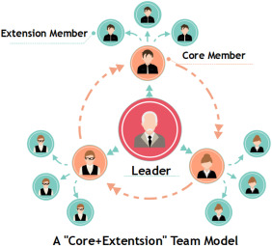
Figure 2 above shows another team structure we may have used if we had more members in the team. The team structure consists of a Leader, Core member and Extension members. The extension members serve as research and development of products with core members overseeing their extension members ensuring that they stay on track and to share the information that has been gathered by the extension members so that they can feed it off to other core members and then the leader.

Conclusion
To conclude, the chapters above have described different aspects of being an engineer that must be addressed including health and safety and the legislation behind tasks, security risks involving autonomous vehicles, their role in society and codes of conduct to be followed, problem solving methods in the case of an issue in product development and team structures used when in a project.

Reference List
Health and Safety Executive (1998). Provision and Use of Work Equipment Regulations 1998 (PUWER). https://www.hse.gov.uk/work-equipment-machinery/puwer.htm [Accessed 22/11/2025]
Health and Safety Executive (2022). Personal Protective Equipment at Work Regulations 2022. https://www.hse.gov.uk/pubns/books/l25.htm [Accessed 30/11/25]
Health and Safety Executive (1974). Health and Safety at Work etc Act 1974. https://www.hse.gov.uk/legislation/hswa.htm [Accessed 30/11/25]
Dr. Ahmed MK Nasser (2023). Automotive Cybersecurity Engineering Handbook: The automotive engineer's roadmap to cyber-resilient vehicles. https://r3-vlebooks-com.ezproxy.uwtsd.ac.uk/EpubReader?ean=1781801072632# [Accessed 2/12/25]
Amira Guesmi, Muhammad Shafique (2024). Navigating Threats: A Survey of Physical Adversarial Attacks on LiDAR Perception Systems in Autonomous Vehicles. https://arxiv.org/pdf/2409.20426 [Accessed 2/12/25]
Zhiyi Li et al (2016). Assessing and mitigating cybersecurity risks of traffic light systems in smart cities. https://ietresearch-onlinelibrary-wiley-com.ezproxy.uwtsd.ac.uk/doi/full/10.1049/iet-cps.2016.0017 [Accessed 5/12/25]
Motorsport UK (2025), About Us, https://www.motorsportuk.org/about-us/ [Accessed 23/11/25]
Motorsport UK (2021), National Sporting Code, https://www.motorsportuk.org/wp-content/uploads/2020/12/2021-03-08-motorsport-uk-yearbook-2021-p047-051-national-sporting-code-a.pdf [Accessed 23/11/25]
Formula 1 (2023), Code of Conduct, https://media.formula1.com/image/upload/v1701969109/content/dam/fom-website/manual/Misc/f1_code_of_conduct/F1_Code_of_Conduct_7_December_2023.pdf [Accessed 24/11/25]
Qian Zhao et al (2025). Problem driven innovation design strategies research for product manufacturing process. https://www.nature.com/articles/s41598-025-99097-3.pdf [Accessed 4/12/25]
Asad Azemi and Xiaoguang Ma (2023). Student Tam Formation Using SCRU12M. https://ieeexplore.ieee.org/document/10343197/authors#authors [Accessed 6/12/25]
Shuo Yu et al (2022). Collaborative Team Recognition: A Core Plus Extension Structure https://www-sciencedirect-com.ezproxy.uwtsd.ac.uk/science/article/pii/S1751157722000980#fig0002 [Accessed 6/12/25]

