
Skills for the Workplace
Module Assignment Submission
Student Name: | Victoria Ryall
Student Number: | 1811434
Module No: | BMSK4006
Module Title: | Managing Enterprise in the 21st Century

Statement of Confirmation of Authenticity
By the act of making this submission, the student declares that this is the work of the student named above. The work has not, in whole or in part, been knowingly presented elsewhere for assessment, or where assessment has been built on a previous assessment, this has been identified. Where materials have been used from other sources it has been properly acknowledged. If this statement is untrue, the student acknowledges that an assessment offence has been committed.
Attention is drawn to the plagiarism and unfair practice policies of both the University and of ILM.
Permission for ILM to use this script
ILM uses learners’ submissions – on an anonymous basis – for assessment standardisation. By submitting, both the centre and the learner agree that ILM may use this script on condition that identifying information is removed. However, if you are unwilling to allow ILM use this script, please refuse by ticking the box: □

Table of Contents
Introduction 3
Section 1 Reflection 3
Conclusion 9
References 10

Introduction

Within this assignment we will look at the process of producing a business plan, being part of a team, research and working together communication and may more skills. This assignment has allowed us to use what we have learnt over the last 12 months and below will offer a reflection of my experience throughout.

.

Section 1

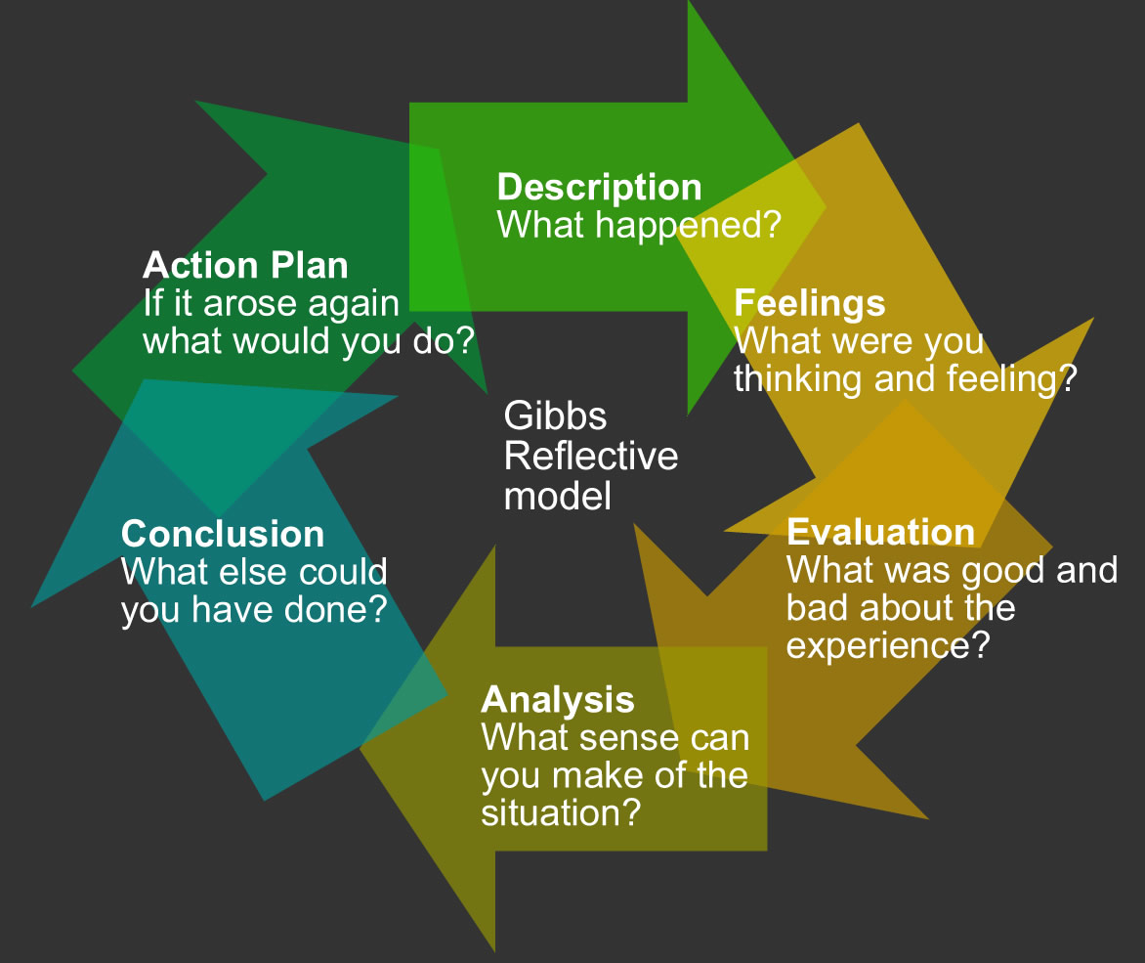
Within this module we have been asked to produce a business plan and then reflect on the whole experience we have undertaken. I am going to use Gibbs reflection model GIBBS, G. (1988). as I find this model works well with as I have used it on previous assignments. As you can see, above is an example of how the model works.
.

Description
Within this assignment I was matched up to 2 of my class mates Fahim and Numan, the task we had to present was a business plan for a small enterprise. I was part of the team and my duties were to cover the marketing, competitors, sales and Marketing Strategy. Within my reflection I will explain what my thoughts of the business was, how I found the process how we worked as a team and what I could have done different or we as a team. Within this module we have been asked to produce a business plan , and present it as if this was a real opportunity.
.
Feelings
On the residential weekend we had already been put into our teams, one of the members were unable to attend due to his child being unwell so we were already a man down, needless to say myself and Fahim the Team Leader continued to take notes and allocate whom was doing what within the plan , Fahim had already come up with a business model and was adamant this is what he wanted to do. His suggestion was A massage Parlour. I felt that this was an unappropriated thing to do as most people would refer it to a brothel or sex parlour. I was pleased he took my advice and we started Brainstorming which felt I was more involved with the idea he wanted to use, After a few ideas were thrown back and forth we came up with a massage business that only targets the commercial industry offering stress and mental health relief, I was then happy with the decisions that we had made and our task going forward. We both decided whom would do what and I was allocated with the marketing side of things as I deal with this in my daily job. Once we left the weekend I did feel that life took over and the business plan became second nature or even a distant memory for a few weeks , we had holidays and lots of double work shifts which left the team leader with no time this was very difficult but we still managed to meet a few times and discuss the business , then family bereavement happened and I felt I could not even think of the plan but both Fahim and Numan were a great support and they helped me with some of my sections , I feel that the timing of the business plan took us off guard and that we did not realise the effort and time we had to put in , with day to day life getting on top , I feel maybe in the real world that this could have been delayed a little, but obviously we had a timescale to stick to .
Evaluation
The whole experience has made me realise that setting up a business is not just about an idea and there you go, you need to really look into it find your markets understand your competitors, there are loads of factors and laws that you have to adhere by some of them you would not even realise if you don’t do your research , a market is really hard to get into and to be honest after this experience I really don’t think that setting up on my own in business is something I would like to do at the moment especially if I needed to rely on other people for my business to succeed . It seems a very lonely place to be. I will be honest again to the circumstances that has gone on with myself I took myself away from this maybe if this hadn’t had happened, I would have had a completely different experience and would have wanted to run my own business I will say never say never. Circumstances and life experience predict a lot as to what we can achieve. I do believe this has made me doubt my abilities and I haven’t given this assignment my all.

Analyse

After looking at the results and the Dragons den experience although I felt that the results achieved were minimal I do believe that if we had talked and communicated a lot more we could of offered a much more in depth business plan , If I was to try to do this again I would do things a lot different give myself more time instead of leaving it until late resulting in a personal predicament which was unavoidable, I would have had a more varied and wiser understanding of the whole plan , I would also maybe pressure the other members to meet earlier so everyone knew each other’s area and not just the basics .However the team leader was working two shifts and found it ery difficult to commit .
Conclusion
Overall I did not enjoy this assignment but only because of personal matters , but what I did experience was the knowledge and understanding of what it takes to come up with a business plan and felt this was a very vital reality to experience and understand what it take to produce a professional business plan , although I do feel that we failed and were minimal it has still given us an understanding and a vital knowledge of what is needed and how this works , taken this into consideration I certainly know where I fell down and how I need to improve .

Action Plan
Within this process there are things I can take away from it and improve on. I have completed a gap analysis to show what I think I need to tackle
.
Objective | Current Position | Deficiency | Action
What do I want to do? | What can I already do? | What am I lacking? | How do I fix this?
Stop Procrastinating | Plan my day | Self-motivation | Do a time table
Stop speaking to much give others a turn | Talk | Stop button | Think before I speak
Share a problem | Speak to friends a colleague | Reaching out | Let people in more to help

Once completing the gap analysis, it has shown me that areas I need to improve on, there are probably many more but I found in this assignment this is what has maybe held me back. Looking at this I am going to produce a personal development plan to overcome my down falls.

Objectives | Tasks | Success Criteria | Time Frame | Resources
List your Goals | What do you need to do to achieve these goals? | How will you identify your success? | When do they need to be done by? | Who or what do you need to help you?
Let others have the Lime light | Think before I speak, when asked a question to a team member don’t answer for them | When I next experience a team assignment | Next 12 months | Help from fellow students to let me know when I do this
Prepare earlier | Stop procrastinating | By time management and maybe instead of staying at home going to the library on my days off so no distractions | Ongoing | Library, dairy help from friends and family

Although my personal development plan has only two points, I do believe that these are going to be vital to my success going forward , I have come to realise that I do speak for people a lot , this isn’t an intentional thing and from my point of view I could argue that it’s because I want to help hem , but its not a good trait and I need to work on it .The other point is procrastination , leaving everything to last minute is not a good thing I have learnt within this assignment by leaving things to last minute it has not gone in my favour , if something happens which delays you from completing work the only one that suffers is your self , going forward in the BA honour I will allocate every Thursday and Friday at the library in school hours , this will enable me to keep on top and complete a good 12 hours a week to my work, by doing this on a weekly basis I believe it will keep me ahead of my game and give me a good supporting structure.

Conclusion

My overall conclusion to this assignment shows me that teamwork is important, research and working together immensely helps a new idea and starting up in business is not as easy as it looks. You need to constantly be in touch and actually know what the others are doing. It’s not for me at this time but good luck to those whom succeed.

References

GIBBS, G. (1988) Learning by Doing: A Guide to Teaching and Learning Methods. Oxford: Further Educational Unit, Oxford Polytechnic.

