
Can fea replace physical testing?
  - Joseph Julian Blackmore
  - Student Number: 1702858
Date: 25/03/20
Module Code: M6X00420
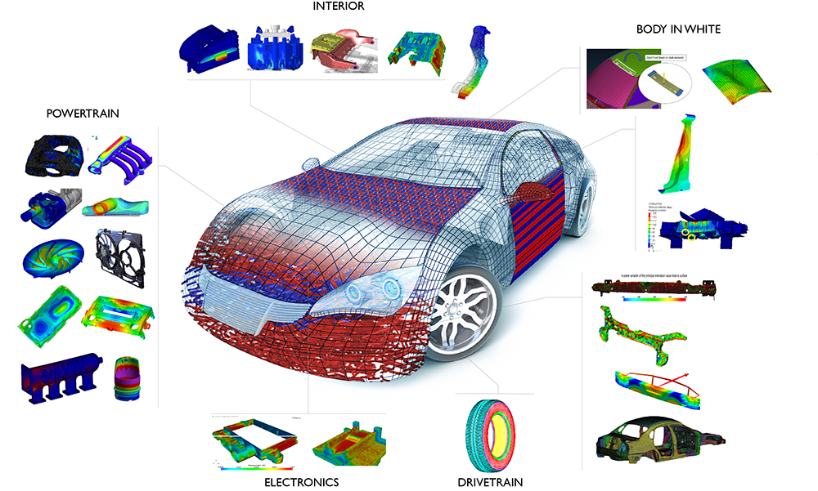

(Altem Technologies , n.d.) Figure 1

Contents

Introduction

Why is finite element analysis used alongside physical testing?

2.1 How utilising FEA reduces the overall time and financial cost of product design

2.2 Why FEA is used in conjunction with physical testing in order to improve vehicle safety

3. How physical testing can be correlated to a finite element analysis model in vehicle crash testing

3.1 How sensors are used to record data from physical crash tests to inform crash simulations

3.2 Case study comparing a physical test and FEA simulation

4. Should finite element analysis ever replace physical crash testing?

4.1 Conclusion

Introduction

Finite element analysis (FEA) is a method of predicting how a component or entire system reacts to real world forces such as heat, vibration, fluid flows, and mechanical loadings utilising computational resources. FEA is used in a wide variety of engineering disciplines in order to allow design engineers to more efficiently complete their component and overall system designs. As technology continues to advance at a rapid rate, the accuracy and usability of computational resources continues to develop. Today engineers have access to far more powerful and easy to use computational resources than they did even as little as a decade ago. As the power and understanding of computational methods such as FEA continues to grow, this raises questions about how far should FEA be taken in regards to the engineering design process, such as can FEA have the potential to completely replace physical testing altogether?. In this report the FEA method is evaluated in terms of understanding why companies use this method in the automotive industry, how computational tests using FEA can be correlated to physical tests, in addition to discussing if FEA can ever replace physical testing. In the automotive industry FEA can be applied to aid the design and development of vehicles in a variety of aspects. FEA can be used to inform design decisions so that individual components and the overall vehicle can meet the requirements needed in order to satisfy the vehicle specification. Extensive testing and product development is required when developing a new product in the automotive industry. This is necessary so that the manufacturer is confident that a vehicle will achieve the desired performance in regards to occupant safety, noise vibration and harshness damping, aerodynamic efficiency and being able to meet the set criteria for performance in extreme conditions and durability. FEA has been, and will continue to be, a fundamental part of the vehicle design process.

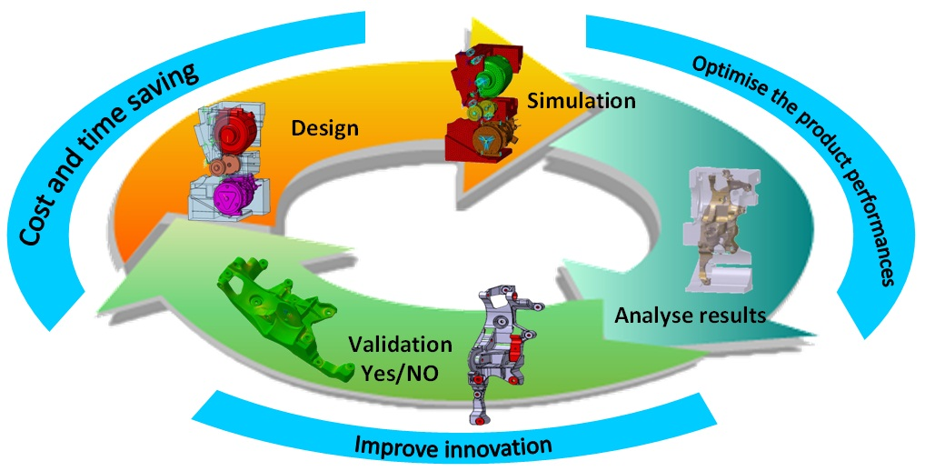
Figure 2 (S. Roth, 2011)

Why is finite element analysis used alongside physical testing?

The automotive industry is extremely competitive, manufacturers are under constant pressure from competitors and increasingly stringent regulatory requirements. This forces the continual development of new technology and improved designs to be implemented as quickly and effectively as possible in order for manufacturers to stay ahead of the curve. The development of new models has historically been a time consuming and expensive process, therefore any computational resources that can reduce the cost and timescale of the development process will give a great advantage within the automotive sector. Computer aided design began to make its way into the automotive industry in the late 1960s to early 1970s as two dimensional wire frame and mesh renderings began replacing drafting boards. Between 1970 and 1980 surface and solid modelling was introduced, whilst 3D cad wire frames were introduced in the early 1980s. (Keenan, 1995). Car manufacturers realised that utilising this ever evolving and improving technology to design their vehicles could give them an advantage over the competition as time to market is exceptionally important in this sector. This has led to computer aided design and the FEA method becoming an intrinsic part of the automotive engineering design process. Moving predictive simulation to as early in the design process as possible is a major objective within the automotive industry, as this can allow the manufacturer to reduce development time and costs by reducing the number of design cycles and eliminating as much physical testing as possible (Abbey, 2014). By utilising FEA, alternative designs and materials can be compared more quickly and without the need for physical testing comparisons.
Figure 3 (Belhe, 2014)
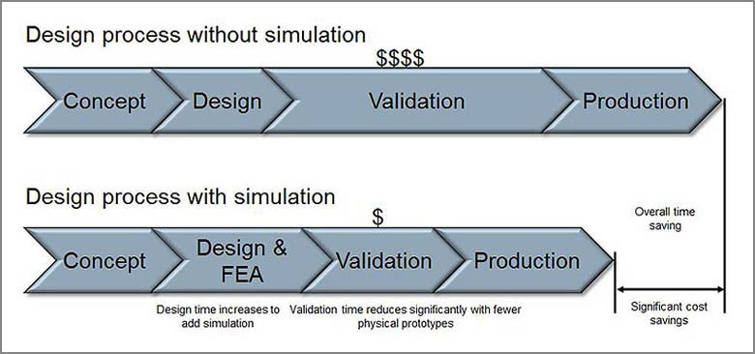

2.1 How utilising FEA reduces the overall time and financial cost of product design
The FEA process increases the amount of time that is spend in the design phase of the product development when compared to only relying on physical testing to inform design decisions. However, by investing resources in the design phase greater financial and time savings can be made by greatly reducing the money and time spent in the validation phase of the design process. This validation phase is reduced when the FEA process is used in conjunction with physical testing as less physical testing is required in order to validate different design prototypes. By analysing design prototypes using the finite element method, prototype designs that are found to be unfeasible with limited doubt by the simulations can be discarded earlier in the validation stage. By using FEA, design engineers can discard designs that are unsuitable before needing to physically test them in order to prove whether they should be taken further along the design process or not. Reducing the amount of physical testing not only has the benefits of reducing the time and money spent validating designs, but also reduces material waste and energy consumption in the development of a product. This is of particular significance in the automotive industry as vehicles are complex systems made up of thousands of components with differing material properties and varying requirements for yield strength, durability, impact absorption etc. Due to the nature of vehicle design the FEA process and physical testing can be carried out on a component basis, on a sub-system basis or on the entire vehicle.

2.2 Why FEA is used in conjunction with physical testing in order to improve vehicle safety
FEA is of particular use when used in conjunction with physical testing by automakers in order to improve the safety of their vehicles. Physical testing of vehicle safety and structural integrity in the case of an impact in particular is an expensive and time consuming process. This is a necessary expenditure however as any engineering oversights regarding the structural performance of their vehicles can result in costly recalls and even lawsuits in the case of failures that affect the safety of the vehicle. By utilising the FEA method to optimise and validate vehicle design in order to improve occupant protection, this gives automakers the ability to improve their designs based on prior knowledge whilst reducing the amount of physical tests that are required in order make continual design improvements. FEA is of particular use in its ability to offer design optimisation, many CAD software packages offer the ability to use FEA in order to produce optimised component designs that meet the durability and impact absorption properties required as efficiently as possible. Design optimisation software can allow design engineers to make more informed design decisions by offering data informed guidance so that the engineers can find the most suitable compromise in component geometry in terms of meeting the physical properties required, minimum component mass and manufacturability. By using FEA to optimise component designs as effectively as possible, automotive engineers have been able to achieve continually improving designs in regards to safety, whilst minimising the weight gain of their vehicles in order to maintain sufficient fuel consumption and performance. In order to validate the performance of a vehicle in regards to occupant safety a variety of impact scenarios are carried out by an independent body, such as by Euro NCAP in Europe and by the IIHS in North America. It is vitally important that new models brought to the market achieve commendable results in such tests as poor ratings can result in potential customers choosing a competitors offering instead. It is crucial that the design development of vehicles in regards to improving occupant safety is a collaborative process between the data collected from the physical tests carried out, and the computational simulations that are developed using FEA. This is required so that the physical properties of the components meet the expected mechanical resistance suggested by the initial numerical computer simulations. As with all simulations, the results achieved are always a prediction, the accuracy of which is entirely dependent on the quality of the information inputted into the computer by the user. (Cecchel, et al., 2019).

How physical testing can be correlated to a finite element analysis model in vehicle crash testing

A vehicle can be considered as a complex compound structure made up of thousands of mechanical and electrical components that undergo complex cyclic loadings along with dealing with weathering and extreme temperatures through regular usage. This presents a significant challenge in being able to predict the behaviour of a vehicle in a range of impact scenarios. A car manufacturer needs to thoroughly test their design in order to ensure that they have a deep understanding and confidence in their design before any vehicle can be sold to the general public. In the past structural performance was largely based on failure predictions based on material strength or the yield strength, this was used to predict how fluctuating loads could cause failure through fatigue or how applying loads that surpass the yield stress of the component would cause it to fail in the result of an impact. In practice, material failure is influenced by a wide variety of factors such as surface quality, surface treatments, harmonics, stress or strain range and cycle sequence effects. If a loading is fluctuating with time, as would be the case in the real-life application of a component such as in a front wishbone as a part of a suspension system for example, further uncertainties are brought into the equation that are not considered simply by using the material properties to estimate the potential for component failure. By using a properly developed FEA technique, this allows the design engineers to consider the variety of aspects that influence the durability and structural integrity of a component in a real-life usage scenario. (Abdullah, et al., 2008 )
In order for vehicle impact simulations to accurately convey how a vehicle will perform in a crash, data that has been collected from physical tests needs to be used to inform the information inputted into the simulation programme. By using data collected from physical tests to correlate with an FEA model, the accuracy of the simulations can be continually improved. Poor correlation between FEA simulations and physical tests can lead engineers to make poor design choices, wasting time and money in the process. The method of correlating physical tests to the FEA simulation will vary depending on the type of testing that is being carried out. In order to collect useful data from vehicle crash tests, very detailed observation is carried out by engineers and a variety of sophisticated sensors are used to record data from the tests.

3.1 How sensors are used to record data from physical crash tests to inform crash simulations
As the entire purpose of completing vehicle crash tests is to improve the protection of the occupants inside the vehicle, the biomechanical stresses exerted on the passengers needs to be established. In order to protect vehicle occupants as effectively as possible, the transfer of energy resulting from an impact needs to be diverted as much as possible away from the occupants whilst maintaining the structural integrity of the vehicle. Maintaining a strong ‘survival cell’ is necessary so that the passenger compartment of the vehicle is not compromised, thus resulting in serious injury. By using sophisticated crash test dummies, strategically placed accelerometers and high speed cameras, the forces exerted on the passengers can be recorded, allowing for the ability to test the impact absorbing abilities of improved vehicle designs.
The acceleration severity index (ASI) was developed to classify the severity of inertia force on an occupant theoretically placed at the vehicles centre of gravity. According to the European standard EN 1317-2:2010, (NSAI Standards, 2010) three impact severity levels are classified as A, B and C classes for full frontal impacts, the respective recommended values of ASI for each class are:
• Class A: ASI≤1
• Class B: 1.0≤ASI≤1.4
• Class C:1.4≤ASI≤1.9
The impact Severity Class A affords a greater level of comfort for vehicle occupants than Class B and C. The larger the value calculate for the ASI, the more the impact consequences for the passengers are dangerous. The impact severity rating estimated by the discrete finite element analysis simulation can be compared to those recorded in the physical vehicle crash test in order to validate the accuracy of the simulation.

3.2 Case study comparing a physical test and FEA simulation
In the following case study the results obtained by a variety of crash simulation techniques and the results obtained by a full scale crash test (FSCT) carried out by the National Highway Traffic Safety & Administration (NHTSA) was compared. The NHTSA is a North American based entity that tests and issues safety ratings on passenger vehicles. The fundamentals of the physical test were as follows;
Vehicle: 2004 Ford Taurus
Test weight: 1739kg
Velocity at impact: 55.9 km/h
Crash type: Full frontal impact into a non-deformable barrier
The data obtained from the physical crash test was used to calibrate the simulation software using a genetic algorithm, a mathematical method used to solve solutions based on natural selection. The genetic algorithm is applied to solve a variety of optimization problems that are not well suited for standard optimization algorithms, including problems in which the objective function is discontinuous, nondifferentiable, stochastic, or highly nonlinear (Abrahamson, 2004). Such a method can be used to compare the kinematic results from the full-scale physical crash test and the FEA simulation.
A visual comparison between the vehicle deformity that occurred in the physical test and the vehicle deformity calculated by the FEA simulation, in a full frontal 56km/h impact with a non-deformable barrier, can be compared below;
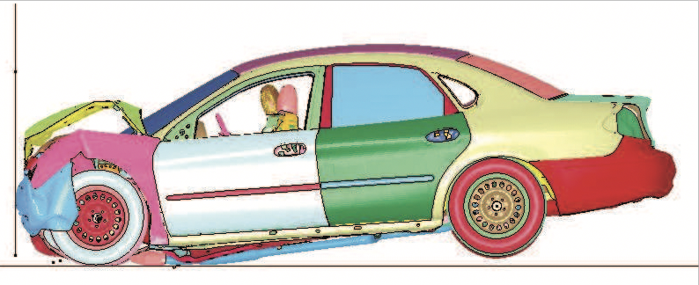Figure 4
(B. Munyazikwiye, et al., 2018)
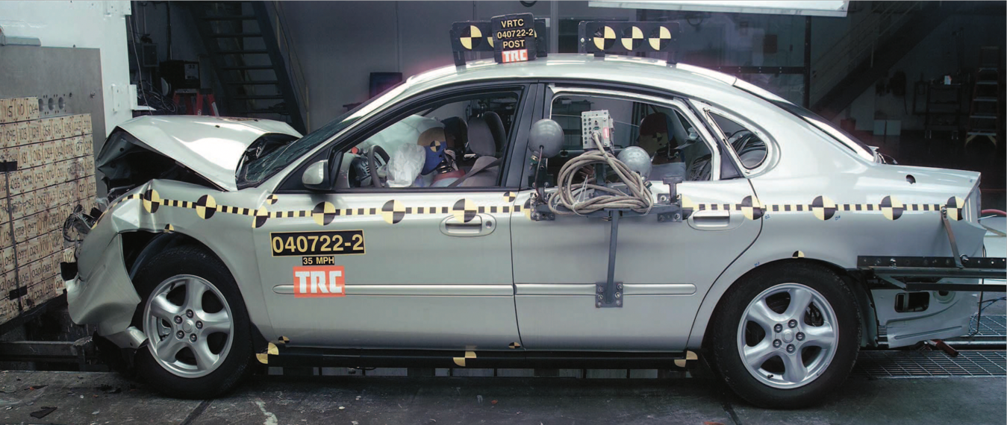
Figure 5 (NHTSA , 2004)

In the case study in question the parameters recorded by the physical test carried out by the NHTSA and a finite element analysis simulation that was carried out by the NHTSA (using LS-DYNA software) can be compared. The same parameters were also recorded for a lumped parameter model (LPM) . The LPM was calibrated to both the data gained from the physical test and the FEA simulation in order to evaluate its ability to accurately predict basic crashworthiness parameters. The LPM can be calculated in around 15-30 minutes compared to around 14 hours for the full FEA model in this particular case study (B. Munyazikwiye, et al., 2018). The results gained were as follows;
Table 1
Approaches | Parameters | Results of 56km/h impact
FSCT | Tm (s)  Cm (m)  ASI (-) | 0.0723  0.7551  2.5
FEA | Tm (s)  Cm (m)  ASI (-) | 0.0801  0.7180  2.0
LPM calibrated to FSCT | Tm (s)  Cm (m)  ASI (-) | 0.0738  0.7508  2.6
LPM calibrated to FEA | Tm (s)  Cm (m)  ASI (-) | 0.0793  0.7108  2.0
Key:
- Tm (time at maximum dynamic crush in seconds)
- Cm (maximum dynamic crush in metres)
- ASI (accident severity index)

In this particular study the results suggest that the initial FEA model carried out by the NHTSA did not estimate the same degree of accident severity as the physical test calculated. By completing the physical test then producing a LPM with the data gained, a more accurate simulation was produced. This data can be correlated with the known material properties of this particular vehicle in order to improve the accuracy of the initial FEA models in the future.

Should finite element analysis ever replace physical crash testing?

The continued advancement of computationally aided design has been a critical tool in allowing automotive design engineers to improve the safety of passenger vehicles. As the availability and capability of computers and FEA software increased rapidly through the beginning of the 21st century to the current day, the ability of mass production passenger vehicles to protect their occupants has improved significantly. The following test carried out by the ANCAP (Australasian New Car Assessment Program), highlights the advancement automotive design engineers have achieved in vehicle safety in the past twenty years or so. The following test involved crashing a 1998 Toyota Corolla against a 2015 Toyota Corolla in a head-on, partial overlap collision. Both vehicles were accelerated to 40mph before the moment of impact.
Figures 6 & 7 (Berry, 2017)
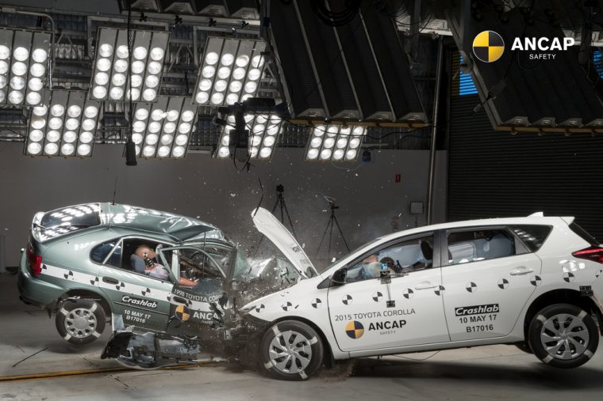

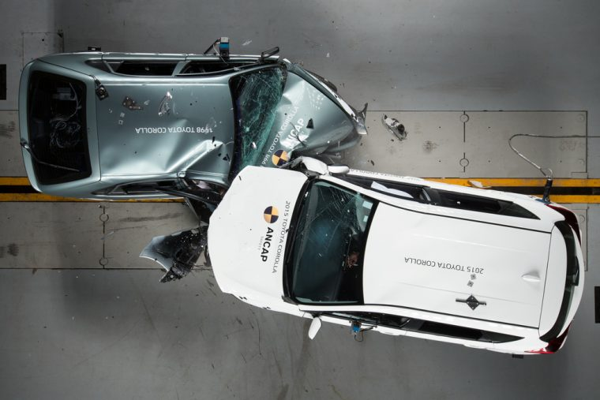

By comparing the images below the extent of the damage to the drivers occupant area in the older vehicle compared to the newer vehicle can clearly be observed;

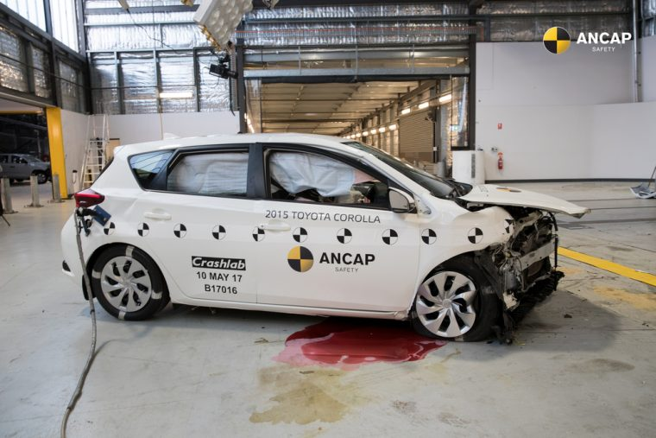
Figure 8: The 2015 Toyota Corolla after impact (Berry, 2017).

Figure 9: The 1998 Toyota Corolla after impact (Berry, 2017).
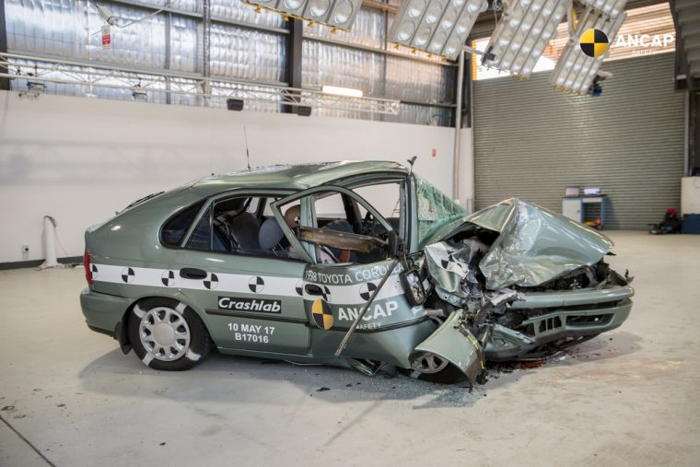

Upon completion of the test, ANCAP awarded the 2015 Toyota Corolla a score of 12.93 out of a possible 16, meaning that there was a high likelihood of all occupants surviving with minor injuries. The 1998 Toyota Corolla merited a score of 0.40 out of 16, meaning it would be highly unlikely for any passengers to survive the impact. The potentially life -saving advancements in vehicle occupant protection achieved in recent history has been achieved by engineers using physical testing and FEA simulations collaboratively to inform their design decisions.

Conclusion

As computing power and the wealth of experimental data available to engineers in the automotive industry continues to increase, the ability of Finite Element Analysis models to produce ever more detailed crash simulations continues to develop. Conducting a FEA model to simulate a car crash is a time consuming process, however as computing power increases the ability to complete a comparable simulation in detail to the past in a considerably reduced time-frame is possible. This presents an opportunity to automakers in being able to reduce development costs, or to invest the same amount of time in developing improved vehicle safety, but with far superior computational resources than was available in the past. It is difficult to predict how far technology and computational power will advance in the future, however the question of whether FEA could ever replace physical testing is one that needs to be taken seriously. However, a vehicle crash is a complex and dynamic event that is considerably difficult to evaluate computationally without any uncertainty. Death due to road traffic incidents is one of the leading killers in the developed world, and as such governing bodies take the safety of any mass produced passenger vehicle very seriously. Due to the nature of vehicle crash testing, it is highly unlikely that the testing of vehicle safety can ever be fully simulated computationally. However, the role of FEA in aiding engineers to improve vehicle safety should not be overlooked as such developments in technology has doubtlessly saved many lives.

Bibliography
Abbey, T., 2014. Structural FEA in the Automotive Industry. [Online]
Available at: https://www.digitalengineering247.com/article/structural-fea-in-the-automotive-industry/
Abdullah, S., Al-Asady, N., Ariffin, A. & Rahman, M., 2008 . A Review on Finite Element Analysis Approaches in Durability Assessment of Automotive Components. Journal Of Applied Sciences , pp. 2192-2201.
Altem Technologies , n.d. CAE Solutions | Engineering Analysis & Simulation. [Online]
Available at: https://www.altem.com/cae-solutions/
B. Munyazikwiye, B., Vysochinskiy, D., Khadyko, M. & G. Robbersmyr, K., 2018. Prediction of Vehicle Crashworthiness Parameters Using Piecewise Lumped Parameters and Finite Element Models. Designs, 2(43), pp. 3-4.
Belhe, R., 2014. FEA and Its Impact on the Design Process and Lifecycle of a Product. [Online]
Available at: https://www.hitechcae.com/blog/fea-and-its-impact-on-the-design-process-and-lifecycle-of-a-product/
[Accessed 10 March 2020].
Berry, Z., 2017. Crash Test Between 1998 Corolla and 2015 Corolla Reveals Just How Far Car Safety Has Come. [Online]
Available at: https://thenewswheel.com/crash-test-between-1998-corolla-and-2015-corolla-reveals-just-how-far-car-safety-has-come/
[Accessed 18 March 2020].
Cecchel, S., Ferrario, D., Mega, F. & Cornacchia, G., 2019. Correlation between Numerical and Experimental Structural Resistance of a Safety Relevant Aluminum Automotive Component. Metals , 9(949), pp. 1-2.
Abrahamson, M., 2004. Genetic Algorithm and Direct Search Toolbox For Use with MATLAB®. 1st Edition ed. Natick, Massachusetts: MathWorks .
Keenan, T., 1995. Engineering revolution: CAD/CAE advancements changing vehicle development.. [Online]
Available at: https://www.wardsauto.com/news-analysis/engineering-revolution-cadcae-advancements-changing-vehicle-development
NHTSA , 2004. NHTSA Vehicle Database. [Online]
Available at: https://www-nrd.nhtsa.dot.gov/database/VSR/SearchMedia.aspx?database=v&tstno=5143&mediatype=p&p_tstno=5143
[Accessed 17 March 2020].
NSAI Standards, 2010. Road restraint systems - Part 2: Performance classes, impact test acceptance criteria and test methods for safety barriers including vehicle parapets, Dublin: SAI Global.
S. Roth, D. C. J. B. J. I. a. S. G., 2011. Crash FE Simulation in the Design Process - Theory and Application, s.l.: IntechOpen .

