  Component One: Student Journal (learning log) 750 words +/- 10%  Contribution to Overall Module Assessment: 25% | Student No: | 2212249
 | Module Title: | Operating Hotel Facilities
 | Module Code: | BMIH4006
 | Lecturer: | Muhammad Cassamo
Component One- Learning Log
Required skills to work within the housekeeping team
The required skills to work within a housekeeping team are discussed below:
Customer Service: This is one of the most required skills of to work within a housekeeping team because their core job role is to achieve customer satisfaction (Granger, 2020). So, to work in a housekeeping team individual needs to possess good customer service providing skills to succeed in the role.
Time management: Time management is another required skill for housekeepers. Housekeepers need to perform a lot of cleaning of different things whether in a group or alone so they need proper time management skills to perform their tasks effectively and ensure cleaning on time.
Communication skills: Housekeepers also need good communication skills to effectively perform their tasks. They need to communicate with clients, staff, and managers to understand their roles and tasks effectively because, without good communication skills, housekeepers will not be able to satisfy their clients (Lengyel, Domaracki and Lyon, 2018).
Teamwork: This is another important skill for housekeepers. They need to often work in a team because a hotel needs a lot of cleaning that cannot be performed alone (Granger, 2020). SO, housekeepers need to have good teamwork skills to effectively divide their work and successfully complete their tasks.
Housekeeping hard skills: Housekeepers must have housekeeping hard skills to perform their roles properly. Housekeepers have to perform different types of tasks and cleaning so they need to know different housekeeping hard skills like sweeping, mopping, carpet cleaning, vacuuming, polishing and so on (Lengyel, Domaracki and Lyon, 2018).
Reflection on the skills and experiences to work within a housekeeping team
Using Gibb’s reflective cycle, a reflection on the skills and experience to work within a housekeeping team is presented below:
Description: I have worked in a housekeeping team for a five-star hotel for the development of my skills and experience so I can build a career in it. There were other people who also worked as a housekeeper (Black and Plowright, 2020). The job was significant for me as I was able to develop some necessary skills and gather experience which is required to succeed in the field.
Feelings: Before joining the job, I was feeling very nervous because I heard housekeeping is an odd job and the work environment is shallow. After joining the workplace, I found that my colleagues were very friendly and supportive also my manager was highly cooperative helping me to relax about my fear (Finlayson, 2020). After working for a month, I feel confident as I have handled many customers and clients. Now, after finishing my job I feel optimistic about building a career in this sector.
Evaluation: The whole experience was a positive aspect for me because it was my first job. Also, the thing that went well was that I was able to manage my work through effective time management and was able to contribute to the teamwork. Also, I was able to communicate effectively with the clients which improved my communication skills (Joshi, 2020). I was able to provide satisfactory customer service which was another positive aspect for me. However, I have lacking in some housekeeping skills and adaptability to new environments so it did not go well for me.
Analysis: I was determined to perform all my tasks which allowed me to manage my time properly so it went well. Also, I have worked in a group during high school which allowed me to effectively perform teamwork and contribute to it. The teamwork also helped me to improve my communication skills so I was able to provide satisfactory customer service and it also went well (Black and Plowright, 2020). However, I did not perform some of the housekeeping hard skills so I was lacking and it did not go well. Also, it was my first job so I felt shy for this reason I could not adapt to the new environment properly and it did not go well.
Conclusion: I have learned housekeeping plays a significant role in the hospitality industry and it requires a lot of skills to provide satisfactory customer service. If I had good housekeeping skills, I could have performed the job better also adaptability could have helped me to make it a better experience.
Action plan: If I had to perform the task again, I would improve my housekeeping soft skills and adaptability skills in a new environment (Granger, 2020). I will take training to improve my housekeeping hard skills I will take help from my manager to improve my adaptability skills so that I can make it a better experience next time.

Component Two: Housekeeping cleaning checklist
Contribution to Overall Module Assessment: 25%

Based on your completed checklist you will need to write 500 words in essay format discussing the following:
- How will you ensure that the rooms are cleaned to brand standards?
- What measures would you introduce to improve team effectiveness?
- Why would you consider your checklist to be the most effective?

References

Black, P.E. and Plowright, D. (2020). A multi‐dimensional model of reflective learning for professional development. Reflective Practice, 11(2), pp.245–258.
Bridger, E. (2018) Employee engagement: a practical introduction. 2nd ed. HR Fundamentals. London: CIPD and Kogan Page.
Cottrell, S. (2019) The Study Skills Handbook. 5th ed. London: Red Globe Press.
Finlayson, A. (2020). Developing a reflective practice model . Reflective Practice, 17(2), pp.87–99.
Granger, G.L. (2020). Training Programs Increase Skills, Foster Efficiency, Good Morale: Housekeeping Services. Hospital Topics, 45(7), pp.53–56.
Joshi, D.B. (2020). ‘Hungry Tigers Talk to the Wall’: An Action Research on Reflective Teaching Practice Cycle. Journal of NELTA, 12(1).
Leiter, M. P. and Bakker, A. B. (2010) Work Engagement: A Handbook of Essential Theory and Research. Hove [England]: Psychology Press.
Lengyel, L.M., Domaracki, J.W. and Lyon, S.R. (2018). General Case Simulation Instruction of Generalized Housekeeping Skills in Blind, Multihandicapped Adults. Journal of Visual Impairment & Blindness, 84(4), pp.166–170.
Mullins, L. and Dossor, P. (2013) Hospitality Management and Organisational Behaviour. 5th ed. Harlow: Pearson.
Quick, L. (2020) Managing Events. Real Challenges, Real Outcomes. London: SAGE Publications Ltd.
Raghubalan, G. and Raghubalan, S. (2016) Hotel Housekeeping - Operations And Management. 3rd ed.India: Oxford University Press.

Component Two: Housekeeping cleaning checklist
Contribution to Overall Module Assessment: 25%
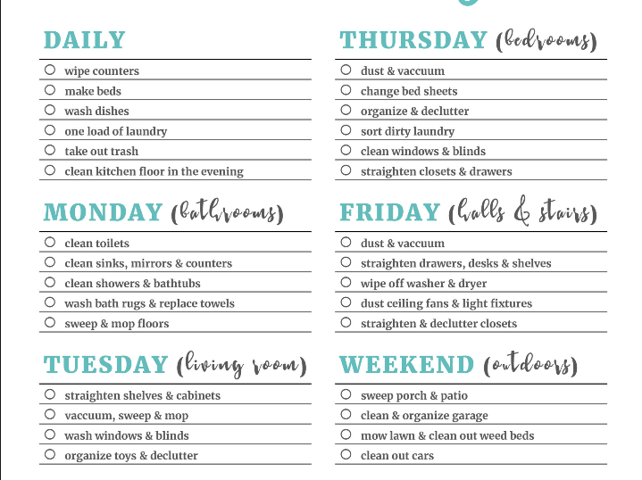

Based on your completed checklist you will need to write 500 words in essay format discussing the following:
The way of ensuring that the rooms are cleaned to brand standards
To maintain the cleanliness of the hotel rooms as per the brand standard, the hotel brands may adopt the Five “S” subsystem of hotel housekeeping. The abbreviation of the five “S” is Sort, Set In Order, Shine, Standardise, and Sustain (Higgs, 2020). In the beginning stage, the businesses need to sort the housekeeping mandatory things and eliminate the unnecessary things for making the work easier by decluttering the work area. Next, businesses need to set the time in order which refers putting everything in the appropriate place in terms of making them easily found and giving an appealing look Magnus and Bo (2023). Then they must maintain shininess ensuring maximum hygienist and cleaning the areas for making it more presentable and inevitable. Then they need to standardise the area maintaining consistency in the cleaning system and finally sustaining the overall cleanliness and standard for maintaining the band standard.
The measures need to be introduced to improve team effectiveness
To maintain the team's effectiveness and improve it, hospitality businesses need to Diversity the team, lead gratitude, remain authentic and vulnerable, prioritize the wellbeing, clarify each person’s role, prioritising as well as ruthless and ensure open communication (Moroz, Wilson and Murzin, 2021). They can direct the team by celebrating individual differences and the different team members can share unique ideas from different minds, share opinions and learn from each other which can foster innovation as well as creativity of the business (Sanon, 2022). They also can lead the gratitude by giving recognition to the unique ideas of the individual team members and praising them rather than taking credit for encouraging them and enhancing efficiency and loyalty. The prioritising well-being and clarifying each person role, individuals can remain on track while carrying out their role without any interruption and discomfort. These all can greatly introduce in terms of improving the team effectiveness.
Things which force to considered the checklist to be the most effective
There are various things in the checklist which influenced in term of considering the checklist to be the most effective (Vestal, 2021). For example, the short and simple presentation of the necessary housekeeping and cleaning duties and shorting them as per the weekly schedule. It also visualises the duties of each of the day and in a short and specific form which help to understand the role and responsibility of each day. The checklist is easily understandable and not many possibilities are included in it which will be easy to carry out (Bridger, 2018). The checklists also keep off days for some work and mentioned some work which need to carry out for a daily basis (Cottrell, 2019). Thus, a consistency in the housekeeping and cleaning service can be maintained a s great scale. The checklist also mentioned the specific rooms for cleaning a day like the hall room, bathrooms, bedrooms, front desk, stairs, outdoors, and living rooms for reducing the rigidity in the cleaning and making it easily manageable as well as maintainable. This all make the checklist most efeftcive.

References

Bridger, E. (2018). Employee engagement: a practical introduction. 2nd ed. HR Fundamentals. London: CIPD and Kogan Page.
Cottrell, S. (2019). The Study Skills Handbook. 5th ed. London: Red Globe Press.
Higgs, M. (2020). Building an effective team. Team Performance Management: An International Journal, 2(4), pp.33–39
Leiter, M. P. and Bakker, A. B. (2010). Work Engagement: A Handbook of Essential Theory and Research. Hove [England]: Psychology Press.
Magnus, G. and Bo, Å. (2023). A1M, an extravascular tissue cleaning and housekeeping protein: a possible drug candidate. Free Radical Biology and Medicine, 75, p.S31.
Moroz, O.V., Wilson, K.S. and Murzin, A.G. (2021). House cleaning, a part of good housekeeping. Molecular Microbiology, 59(1), pp.5–19.
Mullins, L. and Dossor, P. (2013). Hospitality Management and Organisational Behaviour. 5th ed. Harlow: Pearson.
Quick, L. (2020). Managing Events. Real Challenges, Real Outcomes. London: SAGE Publications Ltd.
Raghubalan, G. and Raghubalan, S. (2016). Hotel Housekeeping - Operations and Management. 3rd ed. India: Oxford University Press.
Sanon, M.-A. (2022). Hotel housekeeping work influences on hypertension management. American Journal of Industrial Medicine, 56(12), pp.1402–1413. Available at:
Vestal, A.J. (2021). Housekeeping Services: Pediatric Cleaning Technics Diverse as Unit itself. Hospital Topics, 45(12), pp.55–58.
Vestal, A.J. (2022). Housekeeping Services: Cleaning the OB-GYN Floor: Special Treatment for Special Area. Hospital Topics, 45(5), pp.57–59.

Programme name: Hospitality & Tourism Management
Institute of Management & Health
Module code: BMIH4006
Module title: Operating Hotel Facilities
LEVEL 4

Slide 1
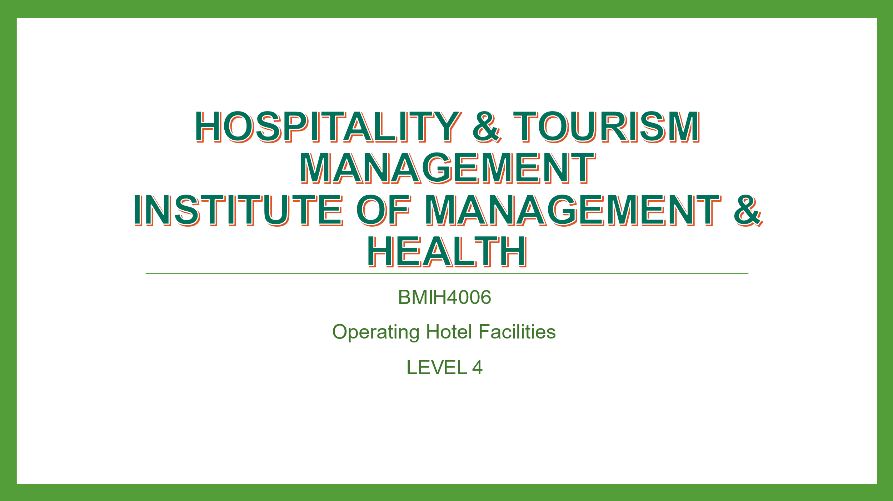
Slide 2
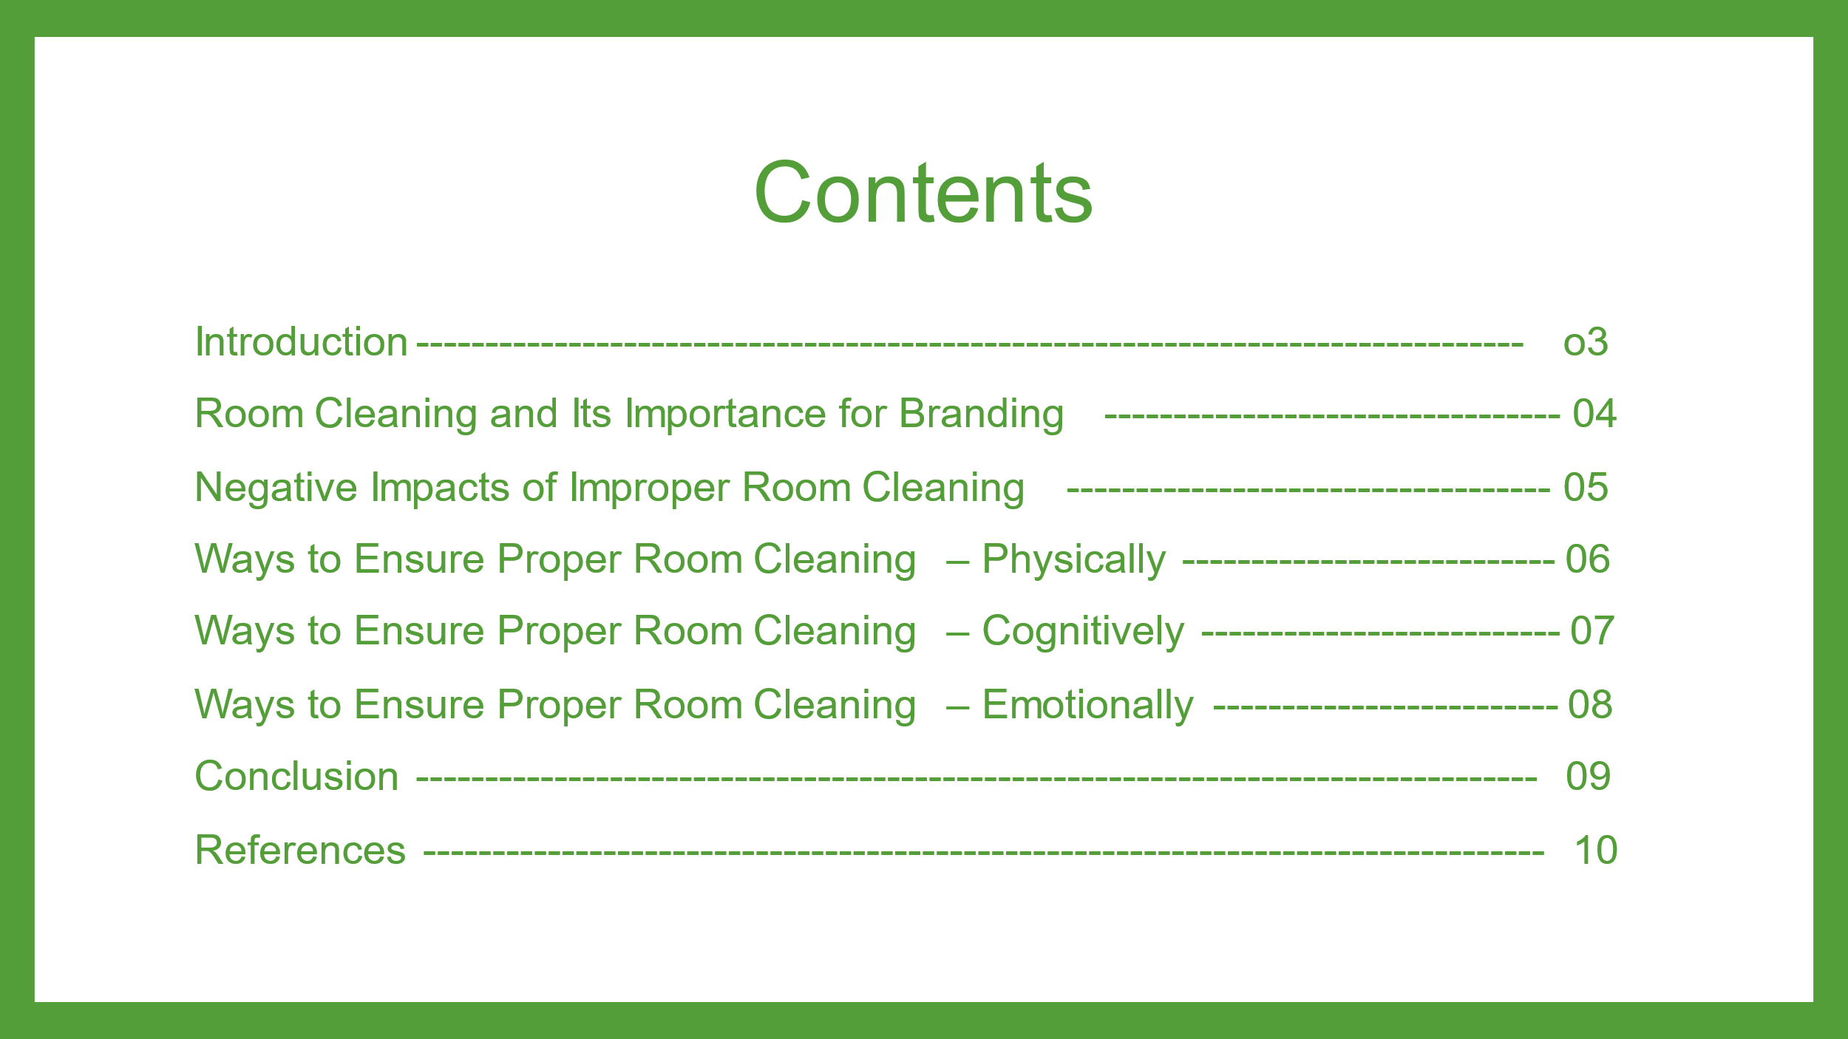
Slide 3
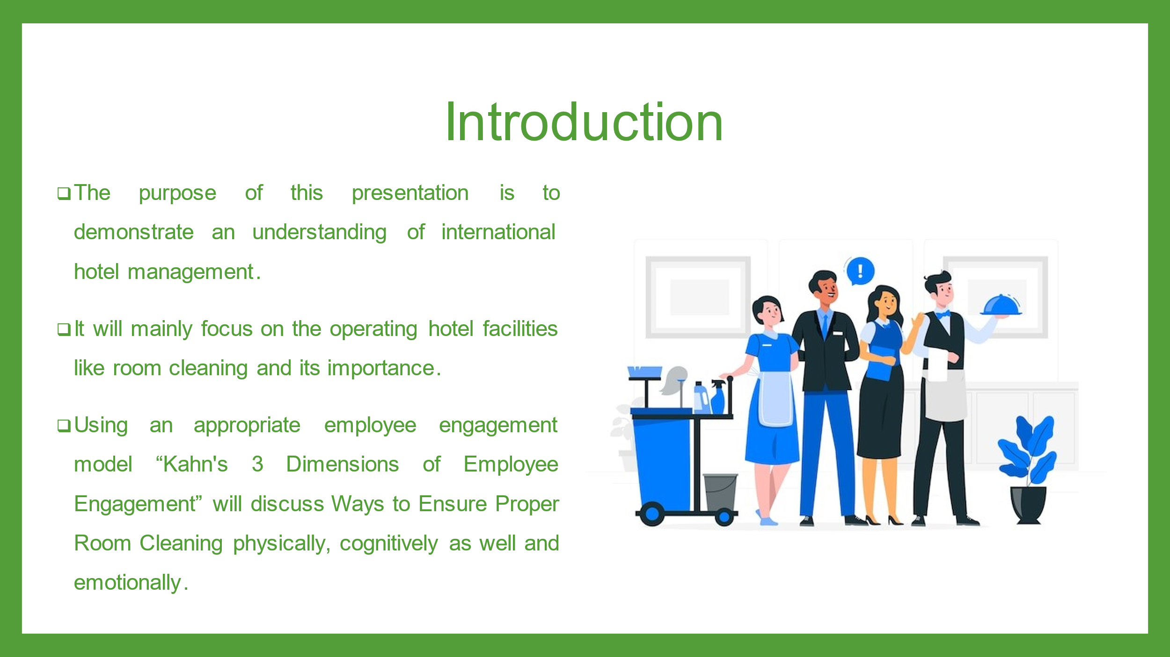
Slide 4
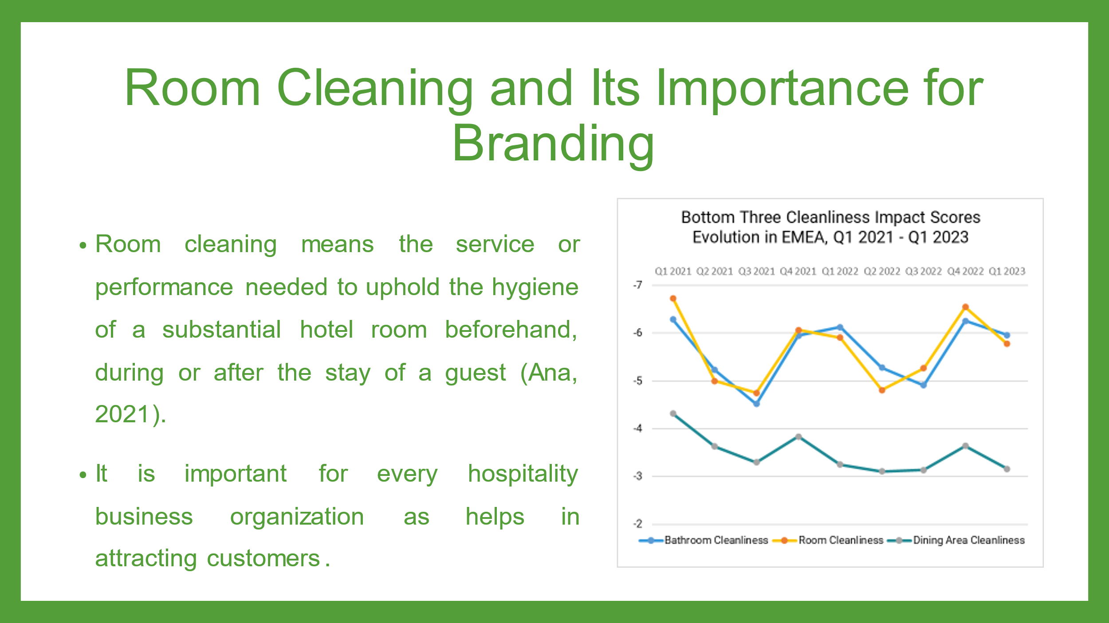
Room cleaning is important in our lives, especially in business. It is important for the branding of the organization. A guest stays in a hotel room for rest. If the room is dirty and not cleaned properly, it has a bad effect on the reputation of the company. As a result, the company will lose a potential repeat customer (Cvelbar, Grun and Dolnicar, 2020). In addition, they may advise others not to visit hotels due to lack of cleanliness. Therefore, the reputation of the organization will be tarnished (Hipe, 2020). On the other hand, if the company cleans the hotel regularly, it will have a good impact on the hotel and the guest will provide positive reviews and suggest others to stay at this hotel. Apart from this, it helps in attracting customers as well as turning the customer into a regular customer which increases the brand value of the company.
Slide 5
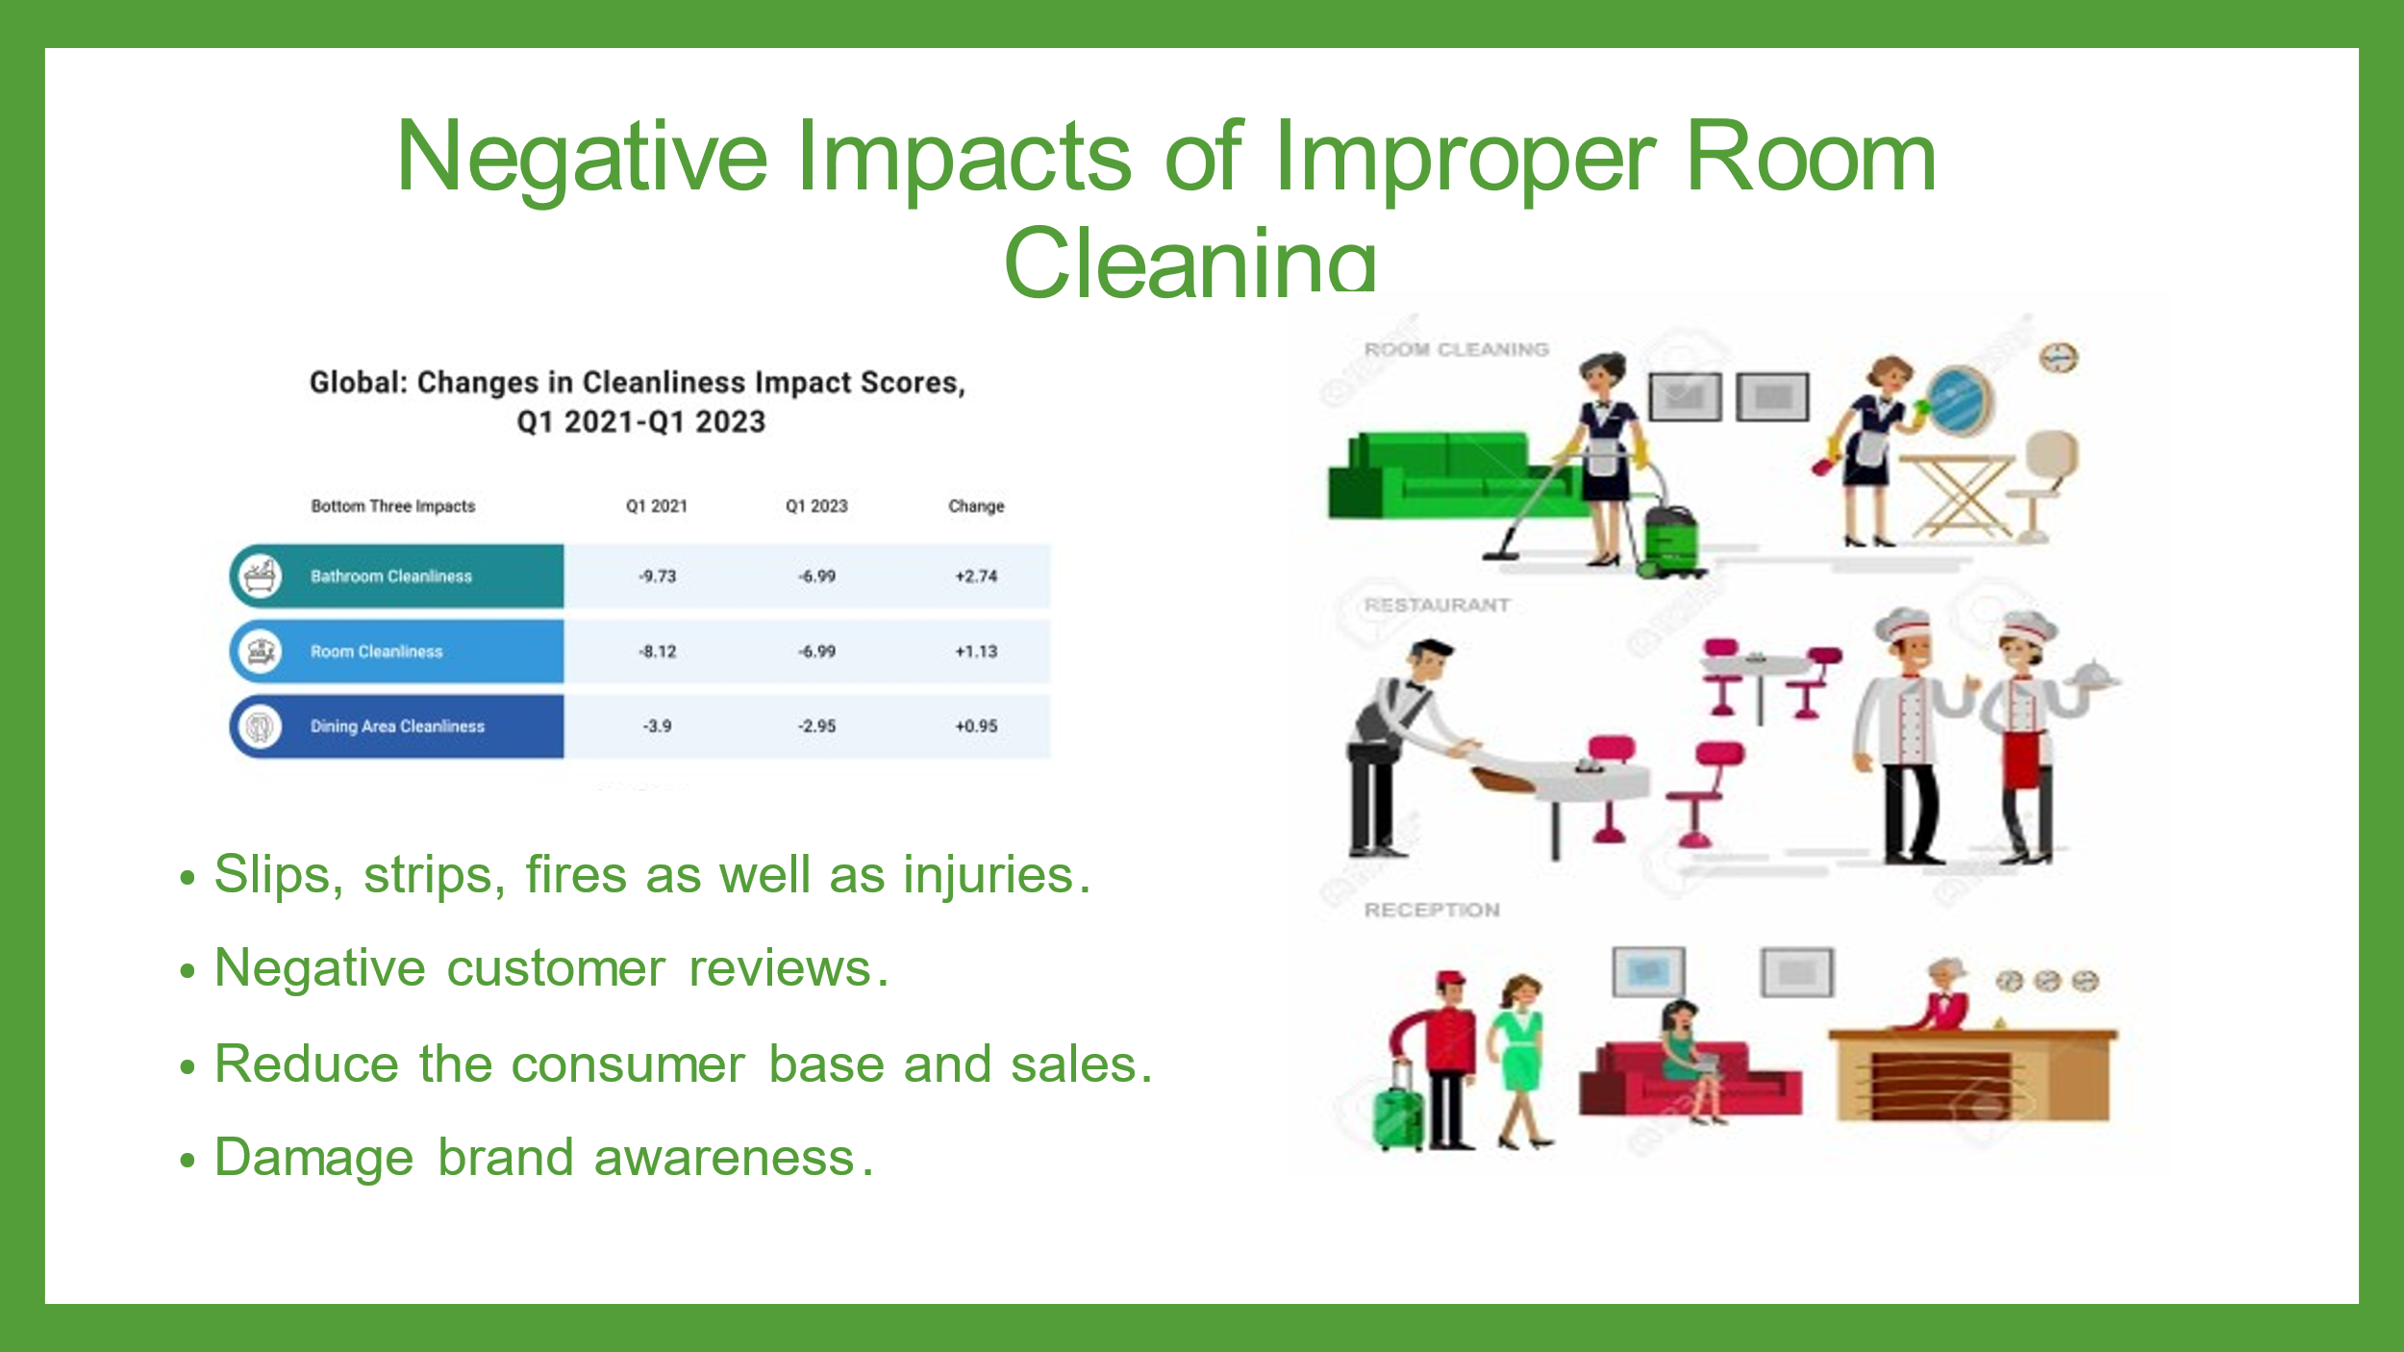
Slips, strips, fires as well as injuries: Improper room cleaning can cause the accidents like the slips, strips, fires as well as injuries. The improper cleaning of the water, dirt, dust, and oils can lead to accident and injury and can enhance the physical, phycological as well as emotional harms (Lewis and McCann, 2021).
Discomfort of the consumers: The improper room cleaning also causes discomfort to the guests. The poor cleaning of room, bathroom or clean areas make consumers uneasy and restrict their patients visit to the hotel.
Negative customer reviews: The poor room cleaning cause the outcome of poor and negative reviews form the customers. It can damage the brand awareness and the repetitive customers and can reduce the consumer base and potential clients (Ramanathan and Ramanathan, 2021).
Reduce the consumer base and sales: The post room cleaning also can reduce the potential, actual and repetitive customers because the cleanliness is the major condition for staying the need and demand of customers and influence them for repetitive visit.
Damage brand awareness: The poor room cleaning cause dissatisfaction of the customers. It can damage the brand awareness and the repetitive customers and can reduce the consumer base and potential clients.
Slide 6
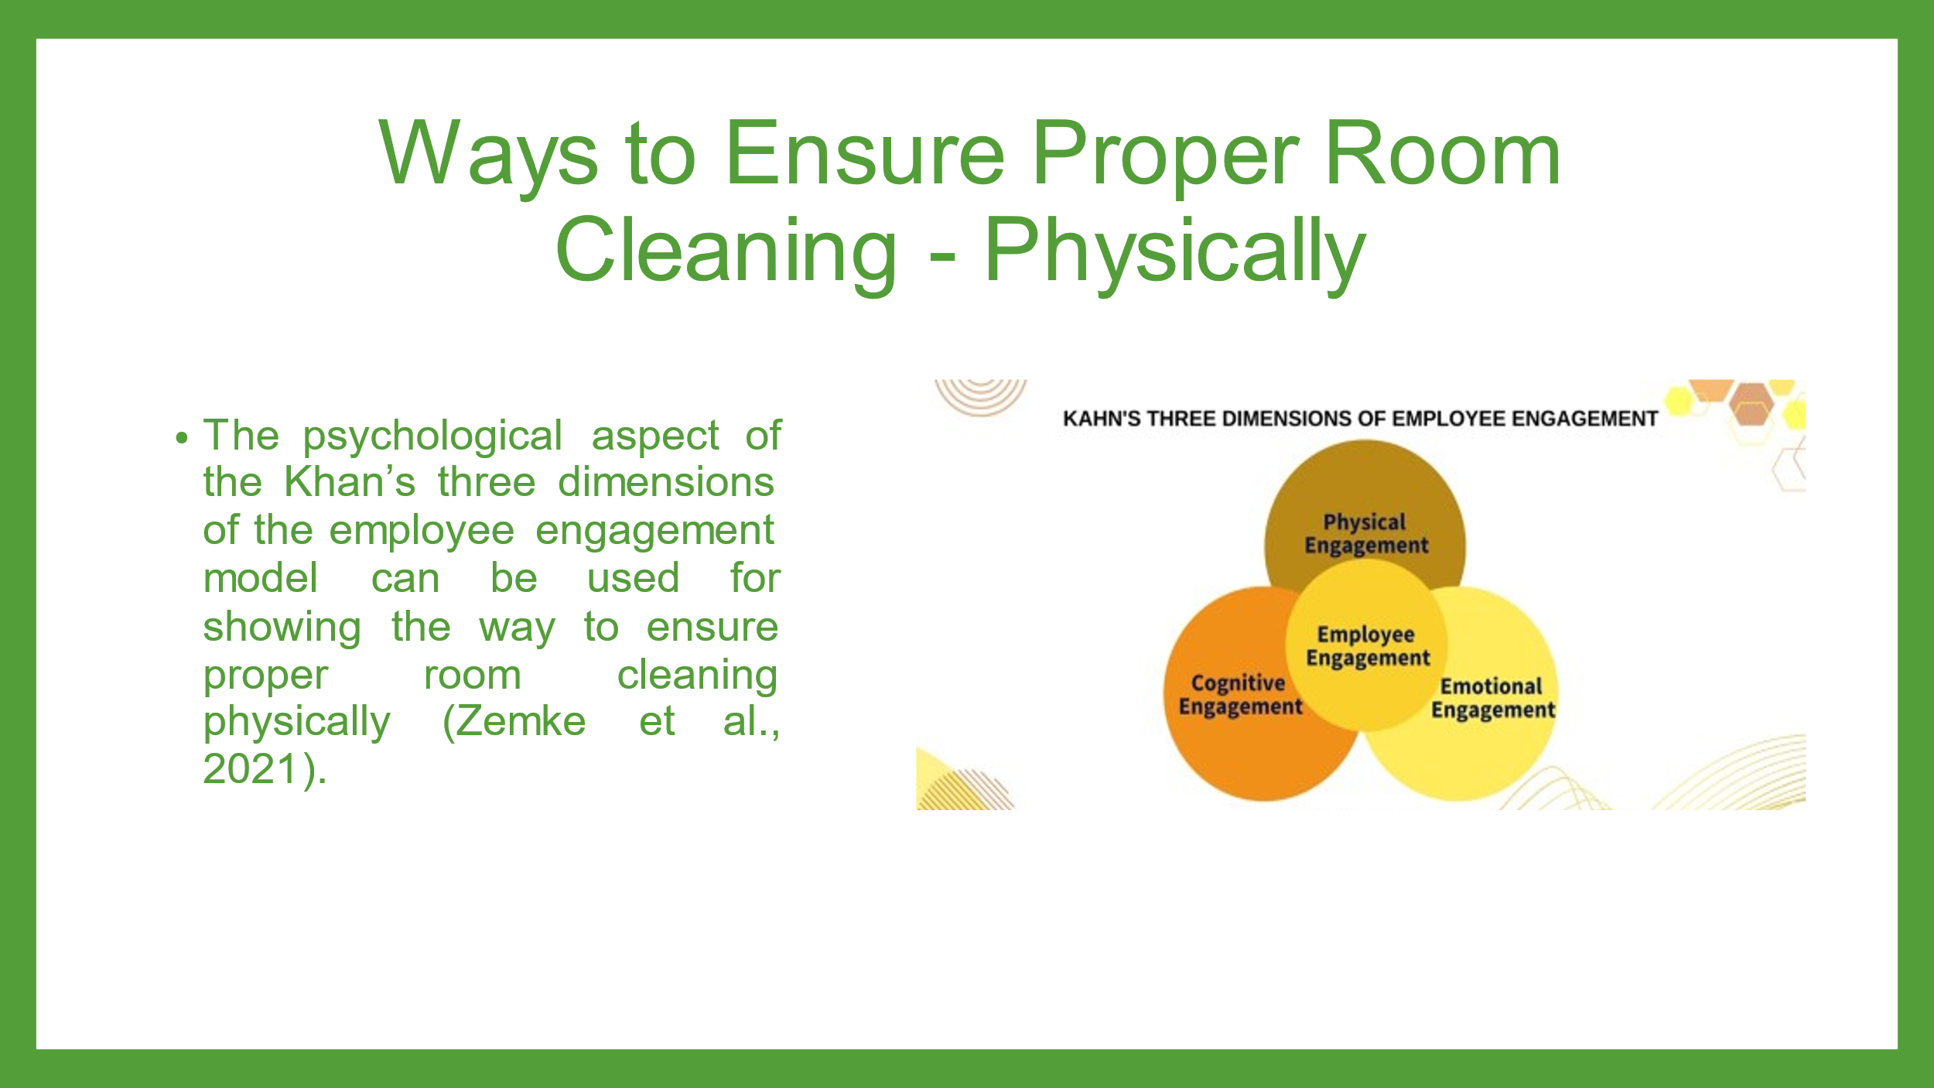
Proper room cleaning within the hospitality businesses can be ensured by engaging the employees physically (Raghubalan and Raghubalan, 2016). As per Khans’ employee engagement model, physical engagement refers to when the employees give adequate physical and mental effort to maintain the quality and standard of their job performance. It means the investment in their job and physical effort. The more physically engaged employee feels more motivated and enthusiastic and gives more hard work and dedication to doing a work well (Quick, 2020). For this employee need to be motivated by ensuring their physical well-being. Like adequate salary, flexible work hours for remaining fit and healthy, health and safety benefits and investment for making them feel supported physicality and engaging them in a proper room cleaning process.
Slide 7
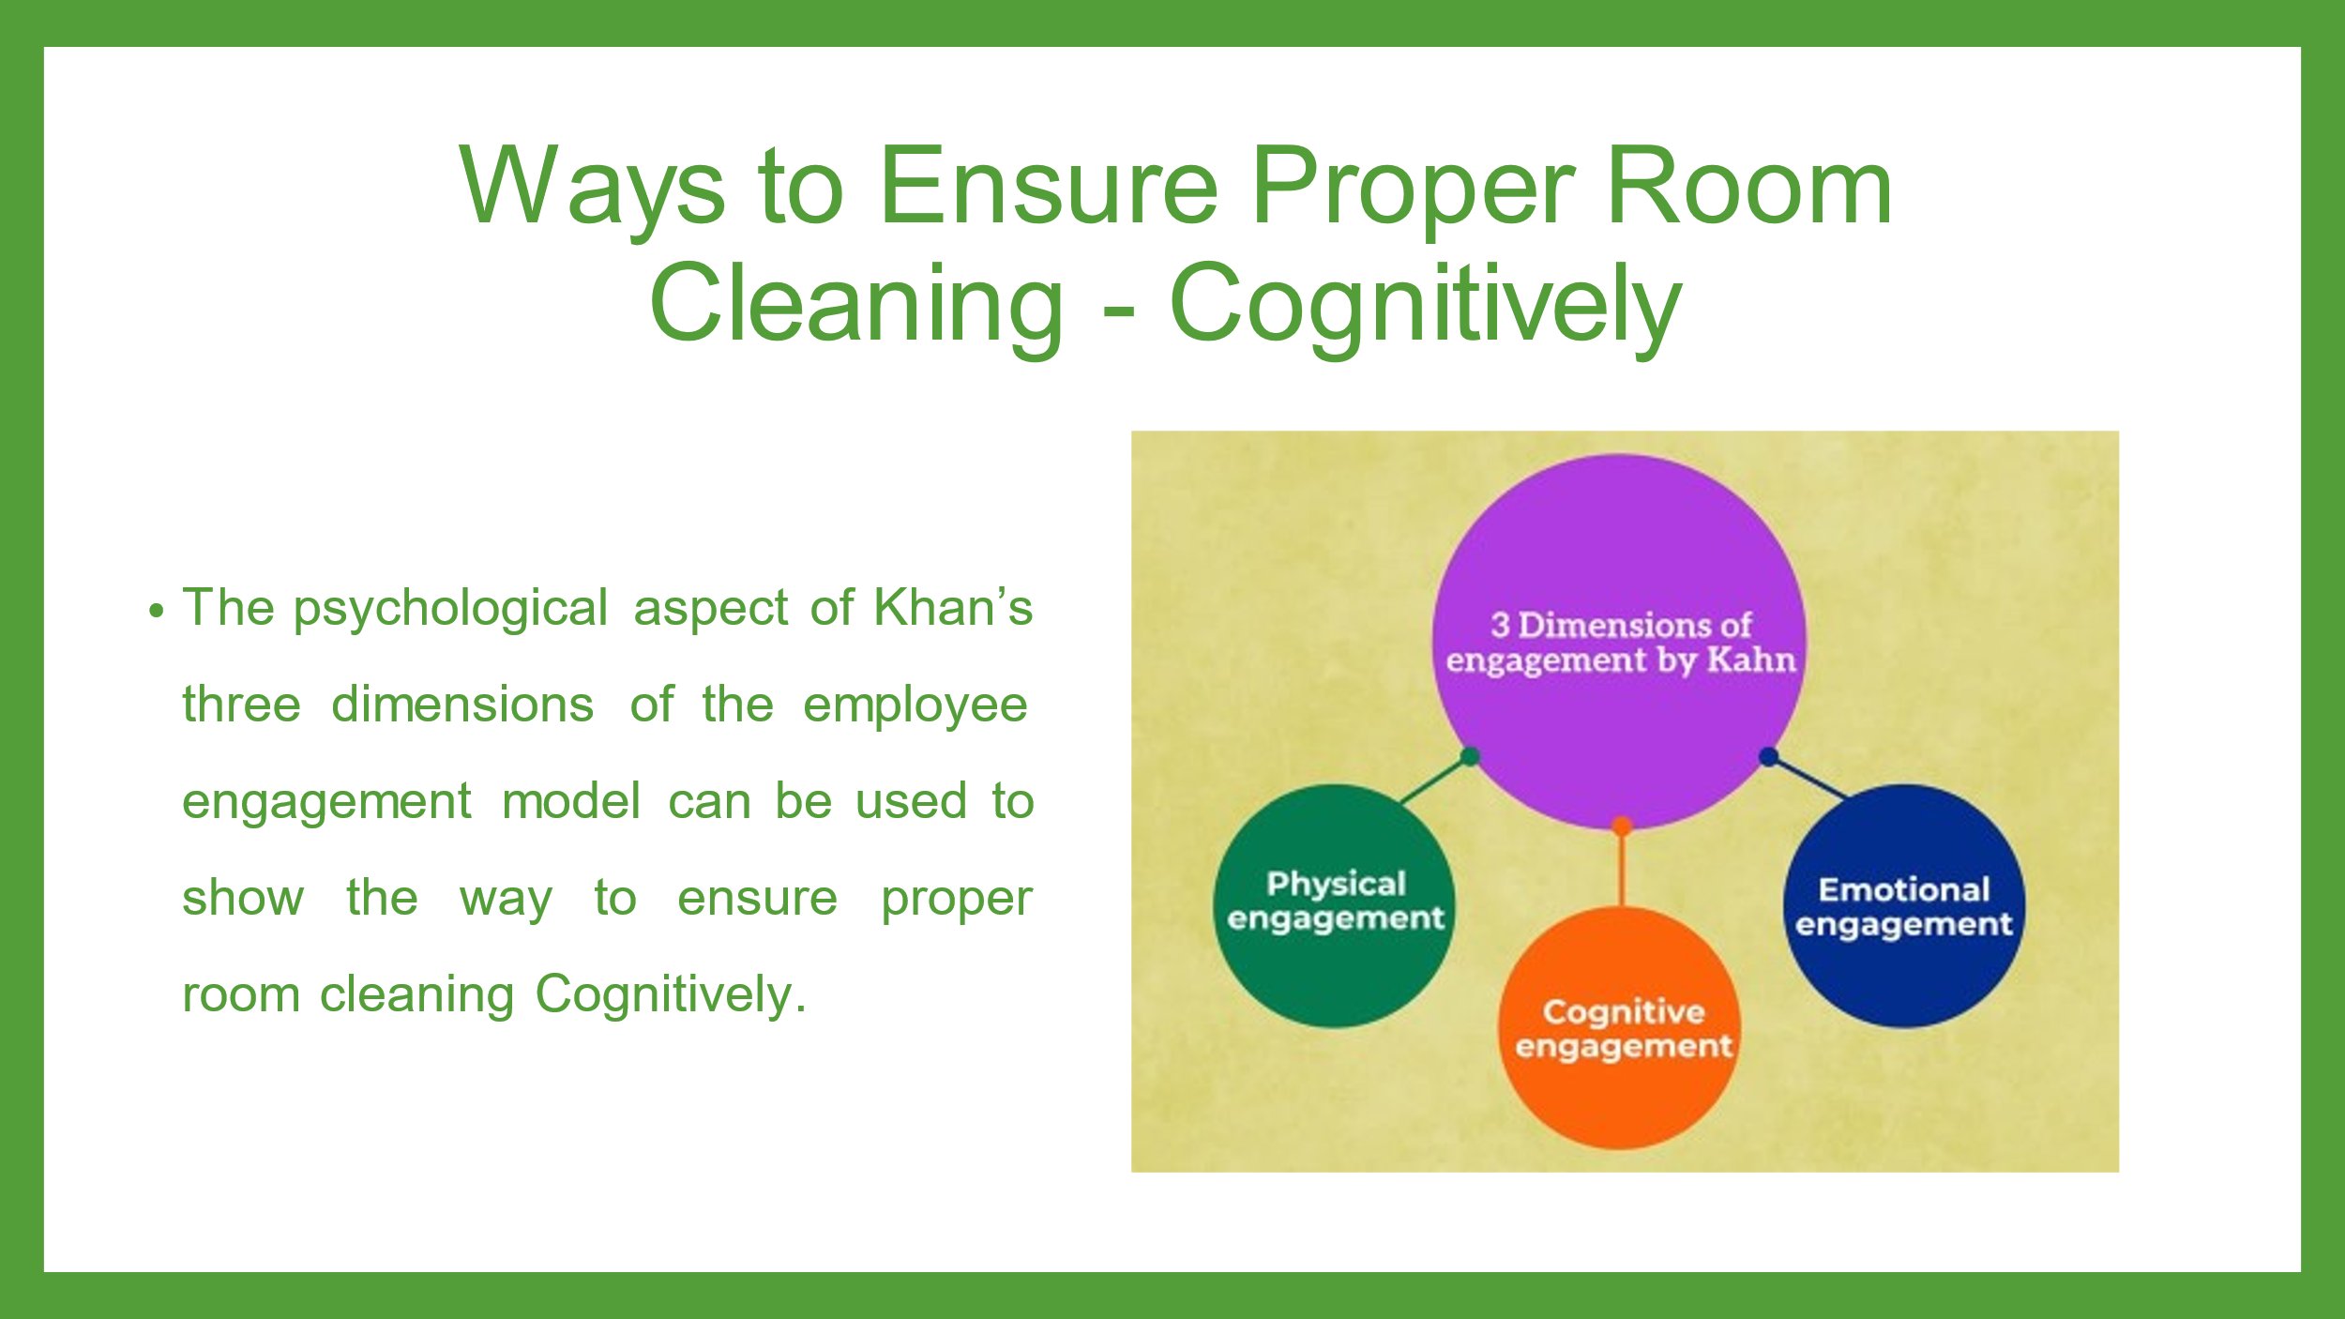
For ensuring a Proper room cleaning the emotional engagement of the employees is also needed. As per Khans’ employee engagement model, emotional engagement refers to the engagement of the employees with their work cognitively and with full focus without any interruption or distraction (Hipe, 2020). It refers to the thinking of employees about their jobs and organizations. It is caused by the in-depth understanding of the vision, mission, and goal of the business. The employees can be cognitively engaged by reminding term about the company’s vision, mission and goals which make them focused and dedicated to their job role (Bridge, 2018). Here businesses can cognitively engage employees by making checklists of housekeeping, giving education, and training and reminding them about their job roles and companies expectations for ensuring proper room cleaning.
Slide 8
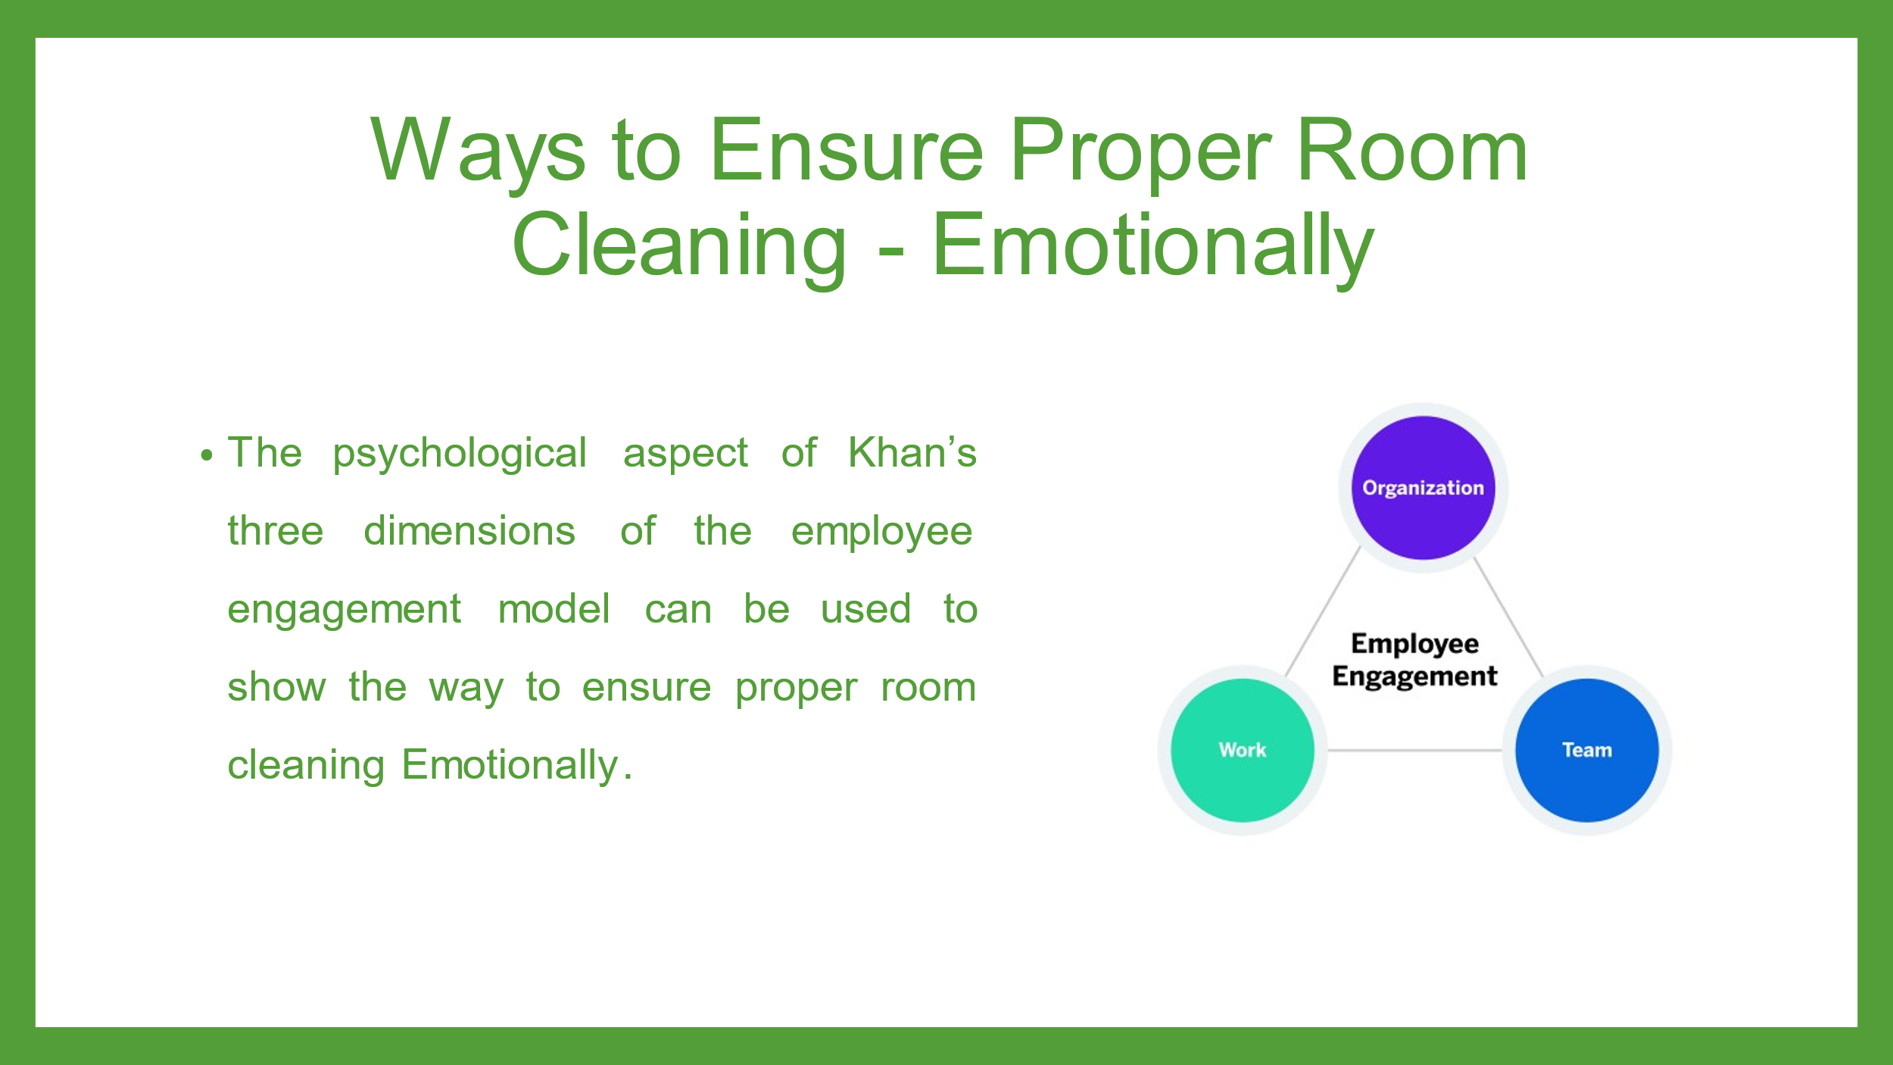
Proper room cleaning within the hospitality businesses can be ensured by engaging the employees emotionally. As per the Khans’ employee engagement model, emotional engagement refers to the engagement of the employees with their work, and job roles. As per Cottrell (2019), for make the employees feel committed to their job role and work, they need to feel that they are valued by the organization and that their contribution is meaningful to the business. It develops their cognitive awareness and they feel valued, motivated, and committed to their Job. Thus they give high performance, productivity and creativity and can contribute to effective room cleaning (Leiter and Bakkar, 2010).
Slide 9
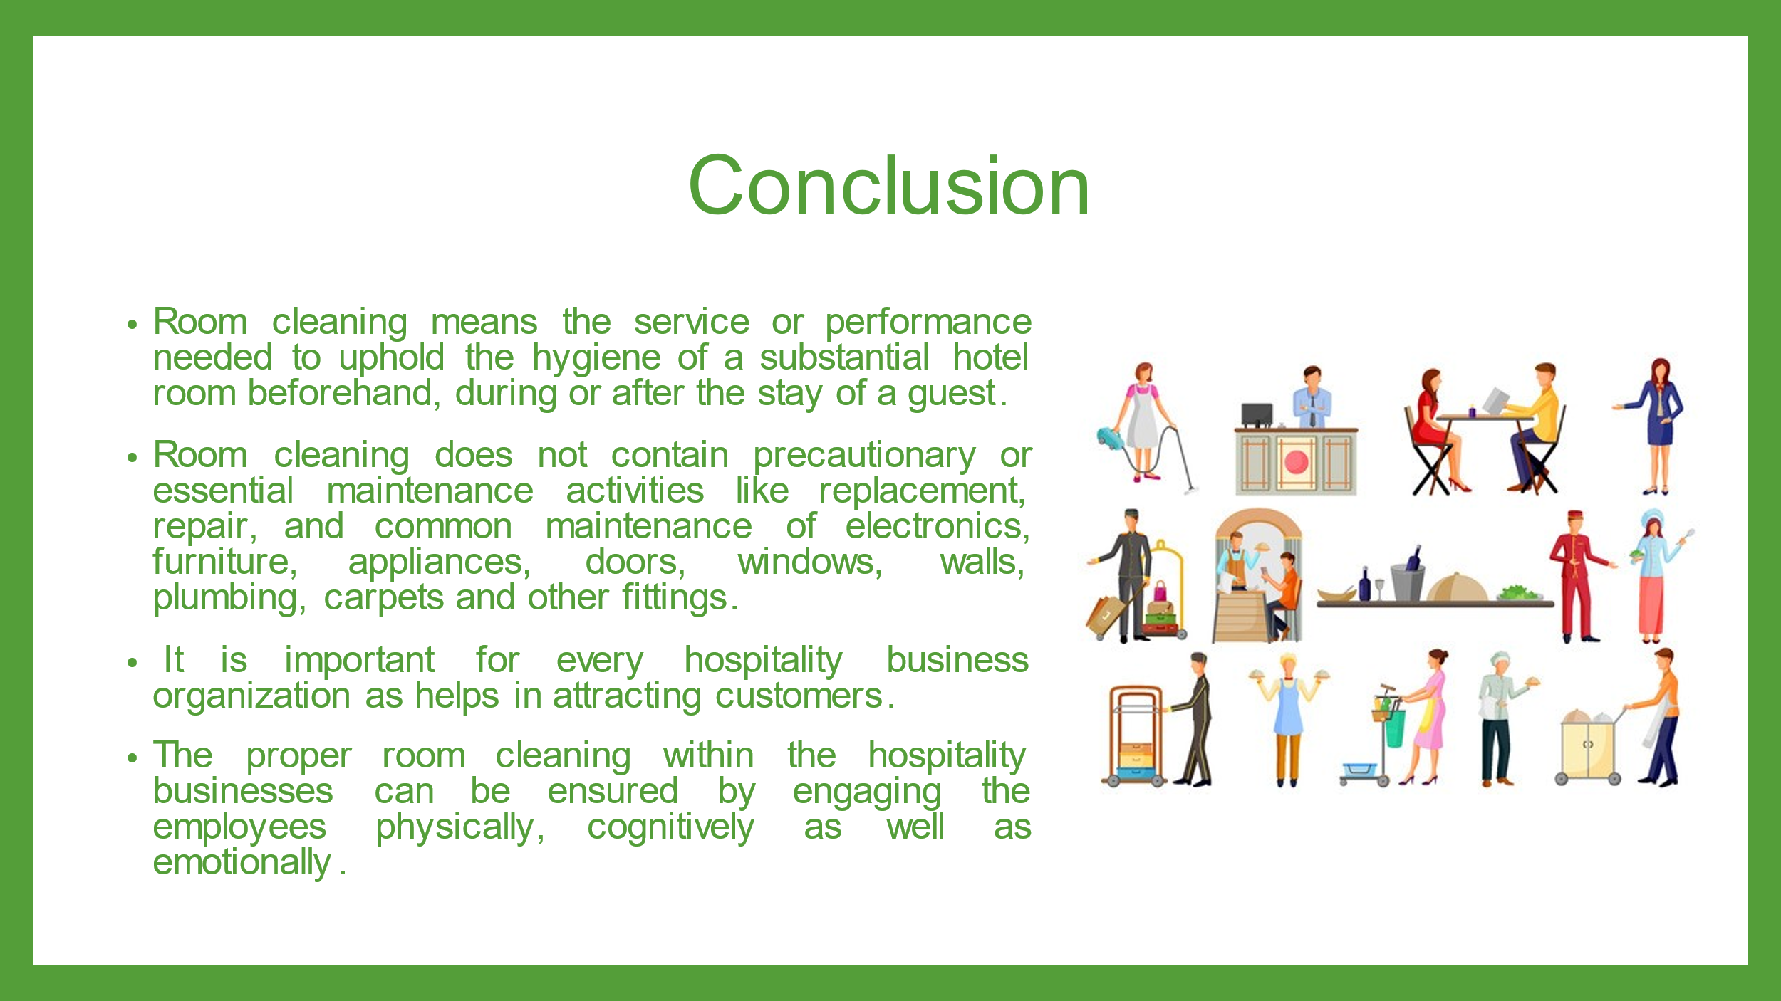
Slide 10
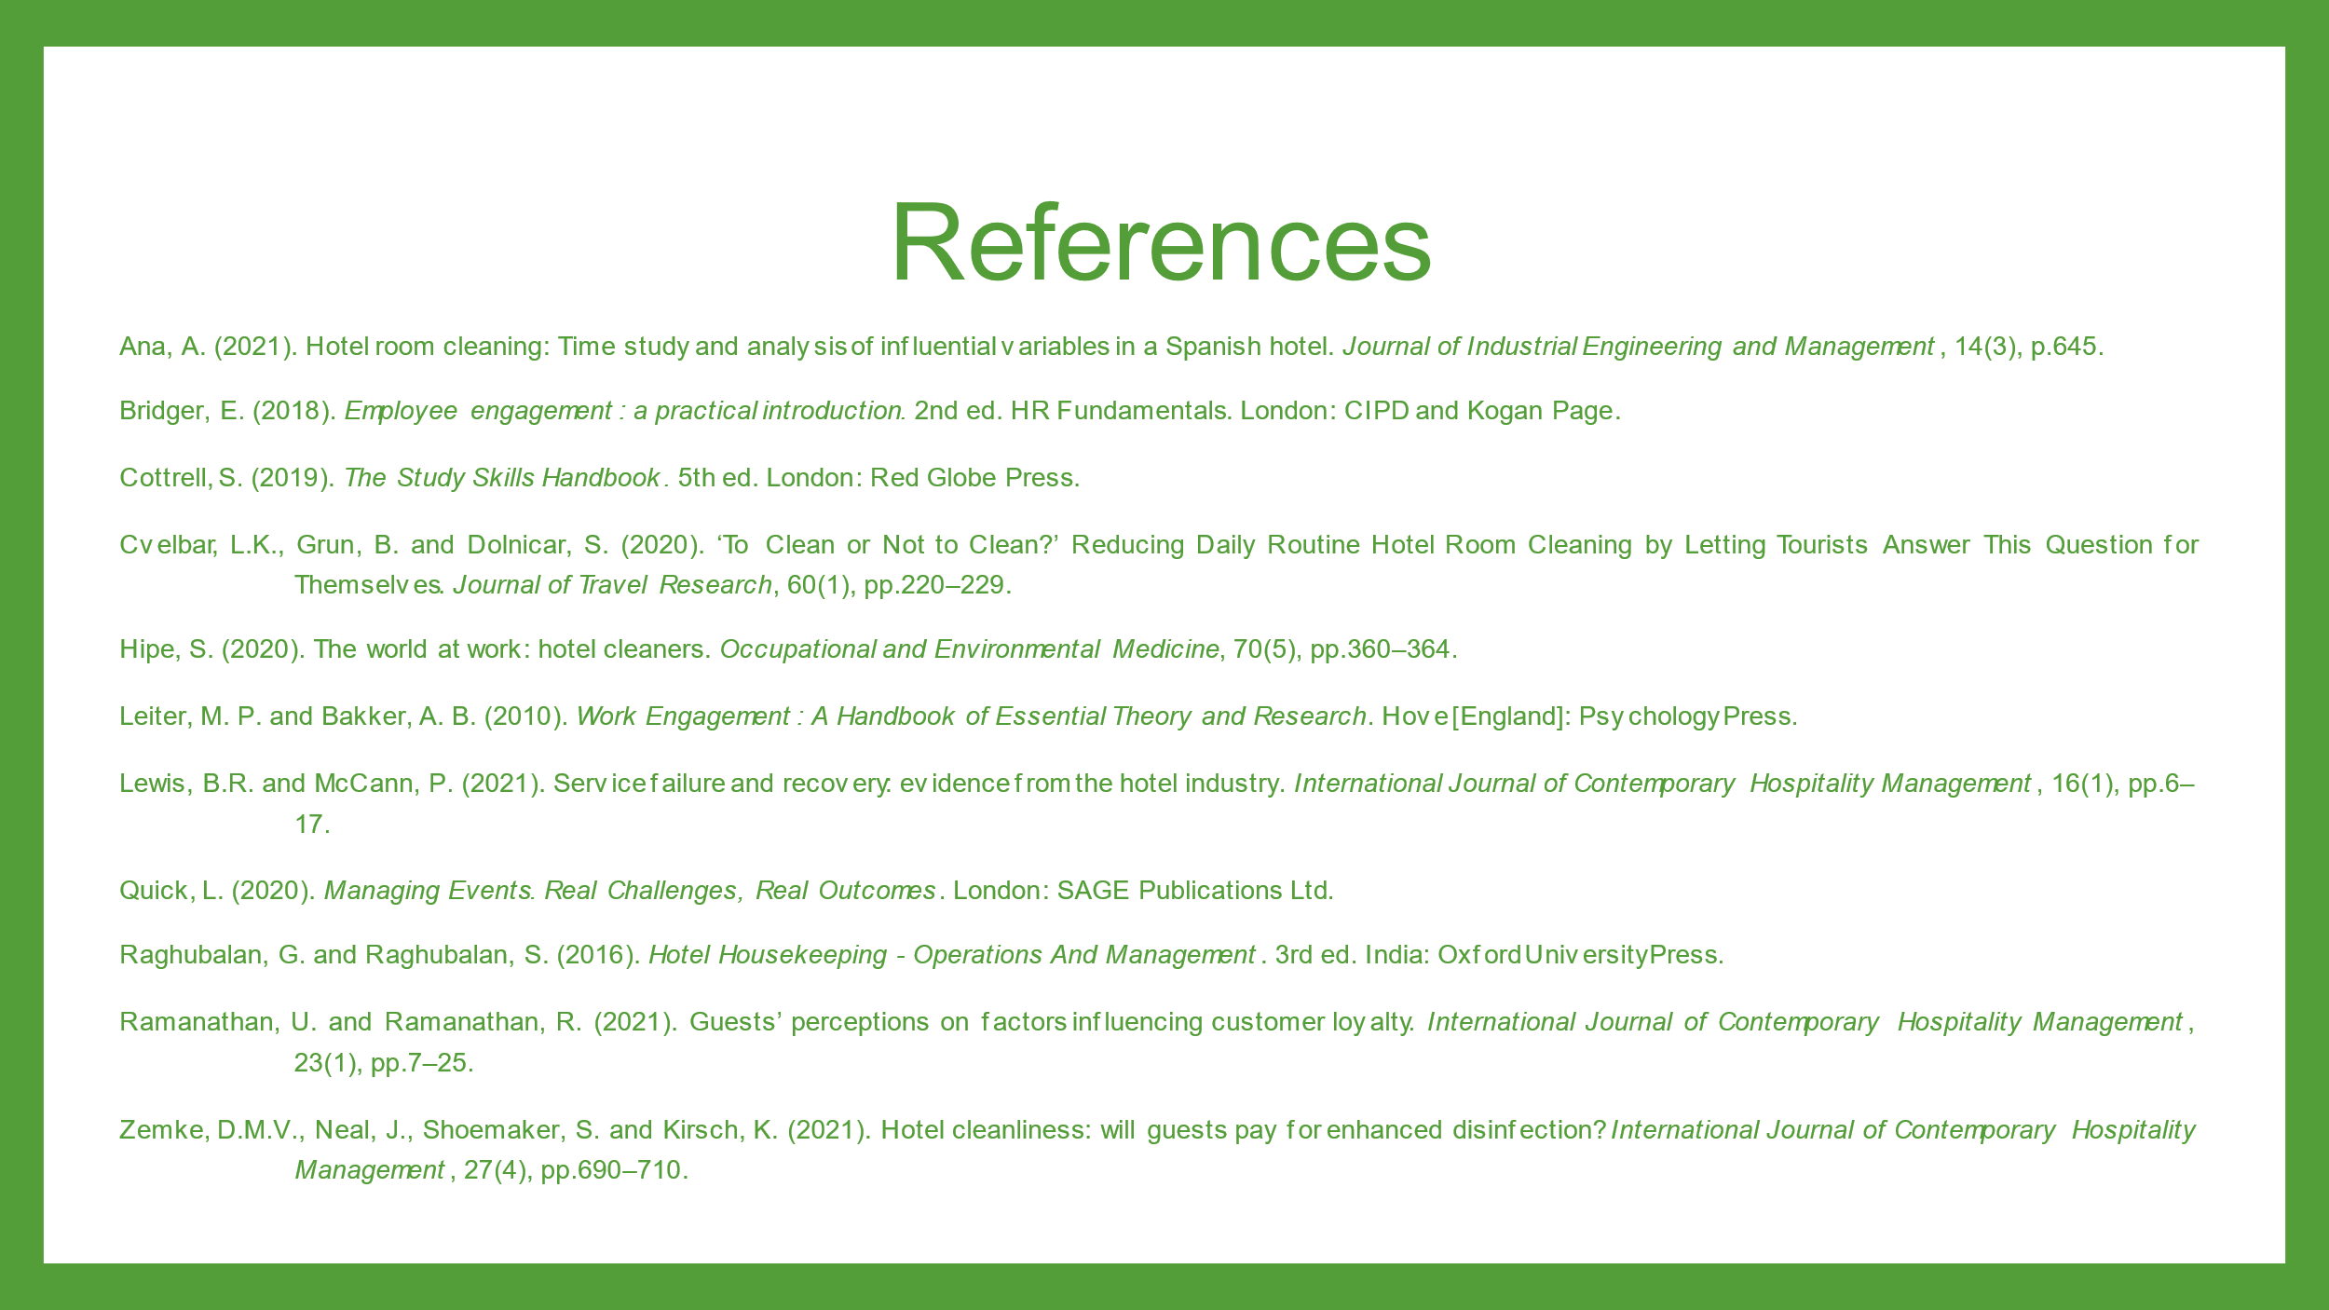
Ana, A. (2021). Hotel room cleaning: Time study and analysis of influential variables in a Spanish hotel. Journal of Industrial Engineering and Management, 14(3), p.645.
Bridger, E. (2018). Employee engagement: a practical introduction. 2nd ed. HR Fundamentals. London: CIPD and Kogan Page.
Cottrell, S. (2019). The Study Skills Handbook. 5th ed. London: Red Globe Press.
Cvelbar, L.K., Grun, B. and Dolnicar, S. (2020). ‘To Clean or Not to Clean?’ Reducing Daily Routine Hotel Room Cleaning by Letting Tourists Answer This Question for Themselves. Journal of Travel Research, 60(1), pp.220–229.
Hipe, S. (2020). The world at work: hotel cleaners. Occupational and Environmental Medicine, 70(5), pp.360–364.
Leiter, M. P. and Bakker, A. B. (2010). Work Engagement: A Handbook of Essential Theory and Research. Hove [England]: Psychology Press.
Lewis, B.R. and McCann, P. (2021). Service failure and recovery: evidence from the hotel industry. International Journal of Contemporary Hospitality Management, 16(1), pp.6–17.
Quick, L. (2020). Managing Events. Real Challenges, Real Outcomes. London: SAGE Publications Ltd.
Raghubalan, G. and Raghubalan, S. (2016). Hotel Housekeeping - Operations And Management. 3rd ed. India: Oxford University Press.
Ramanathan, U. and Ramanathan, R. (2021). Guests’ perceptions on factors influencing customer loyalty. International Journal of Contemporary Hospitality Management, 23(1), pp.7–25.
Zemke, D.M.V., Neal, J., Shoemaker, S. and Kirsch, K. (2021). Hotel cleanliness: will guests pay for enhanced disinfection? International Journal of Contemporary Hospitality Management, 27(4), pp.690–710.

