Practical Assessment Hotel Placement

Student Name: Cristian Paveliuc
Student Number: 2110402
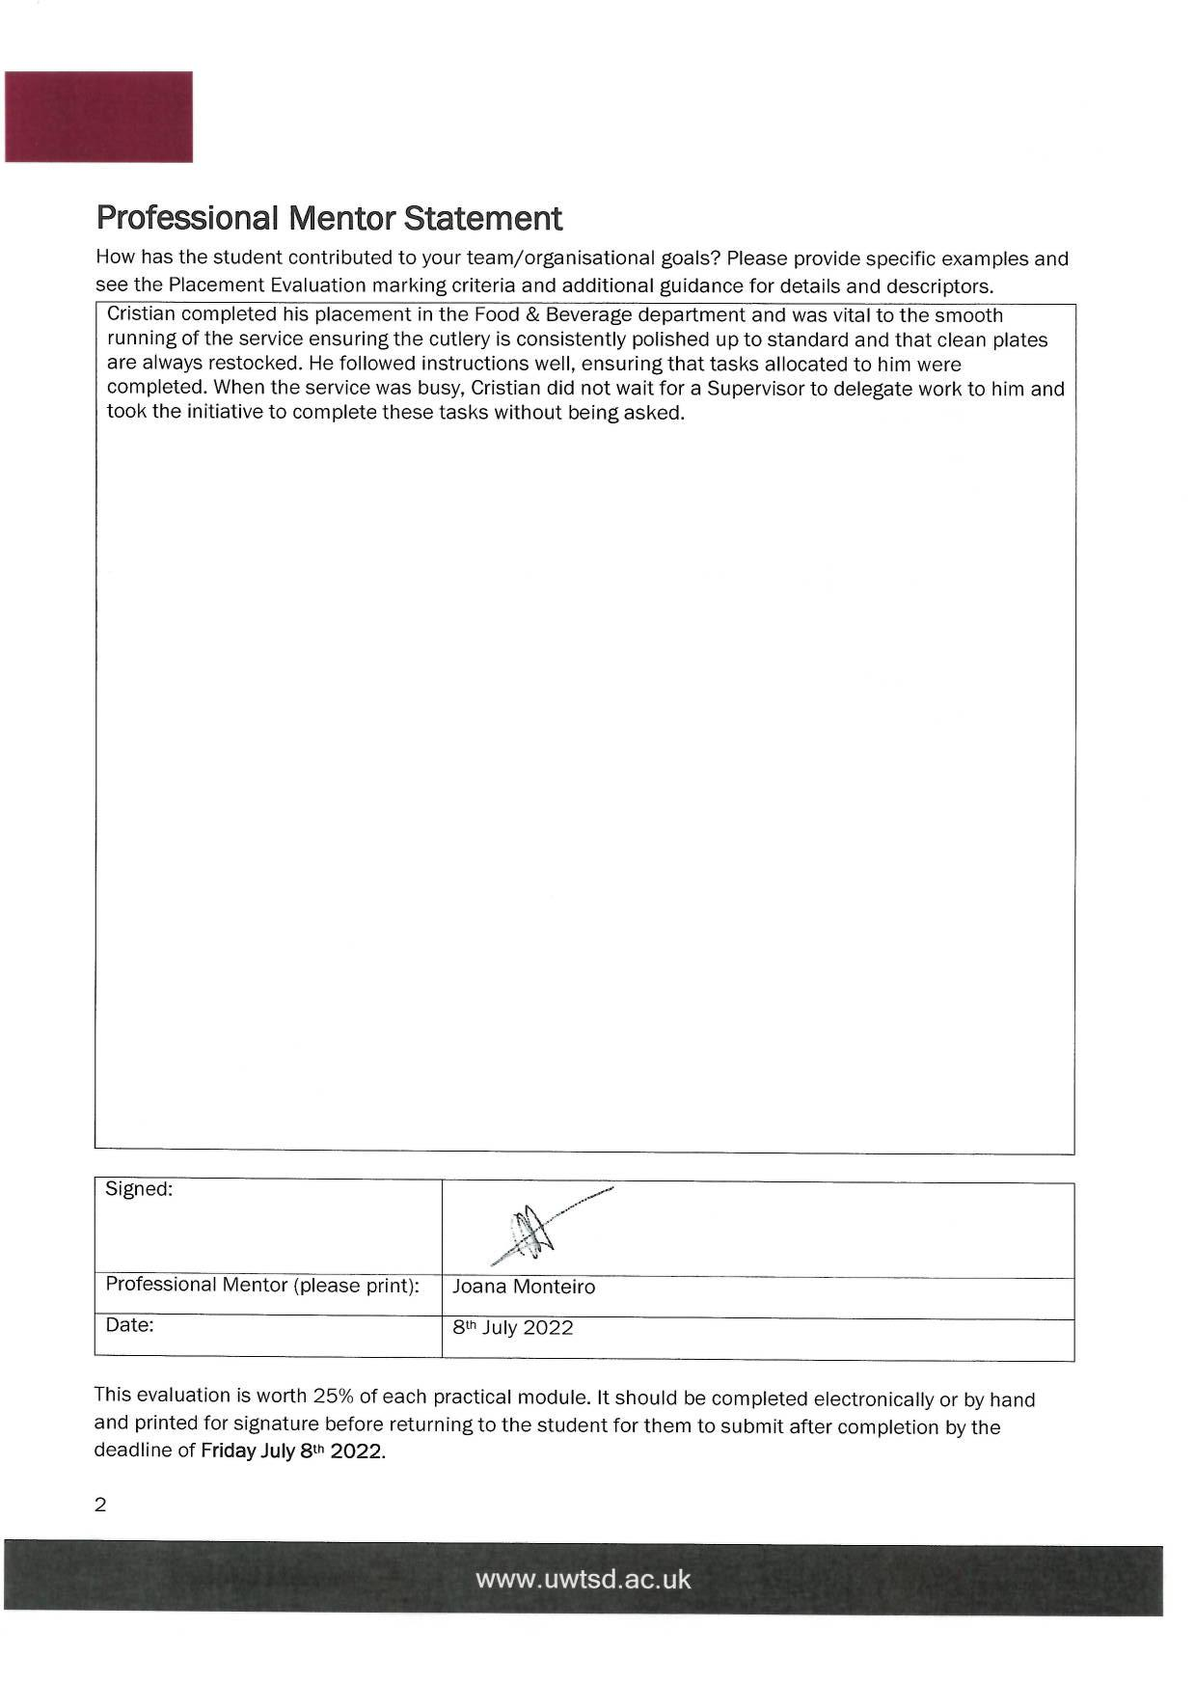
Module Code: BMIH4002
Module name: Food and Beverage Operations

