Programme: Master of Business Administration

Module: Marketing Management

Module code: LCMB7024

Name of the student: Shivang Narshibhai Kalsariya
Student ID:2532573
Program teacher : lailla

Table of Contents
1.0 Element 1: Sustainable Brand Extension Poster Presentation 3
2.0 Element 2: Develop a Segmentation, Targeting, Differentiation, and Positioning (STDP) 4
2.1 Key market segments relevant to the brand extension using geographic, demographic, psychographic, and behavioural variables 4
2.2 Detailed explanation of your chosen target audience 6
2.3 Way brand will differentiate itself from competitors in the market 6
2.4 Positioning of the brand extension 7
3.0 Element 3: Marketing Mix (4Ps or 7Ps) 8
3.1 Way each element of the marketing mix will be applied and how it aligns with and supports the overall brand extension strategy 8
4.0 Element 4: Reflection 12
4.1 Reflection on my experience developing the brand extension 12
4.2 Reflection on the experience preparing and delivering the poster presentation 12
4.3 Key skills, knowledge, and insights you have gained throughout this process 12
4.4 Way these have contributed to my personal and professional development 12
4.5 Way I could further enhance my approach and performance in similar projects in the future 13
References 14

1.0 Element 1: Sustainable Brand Extension Poster Presentation
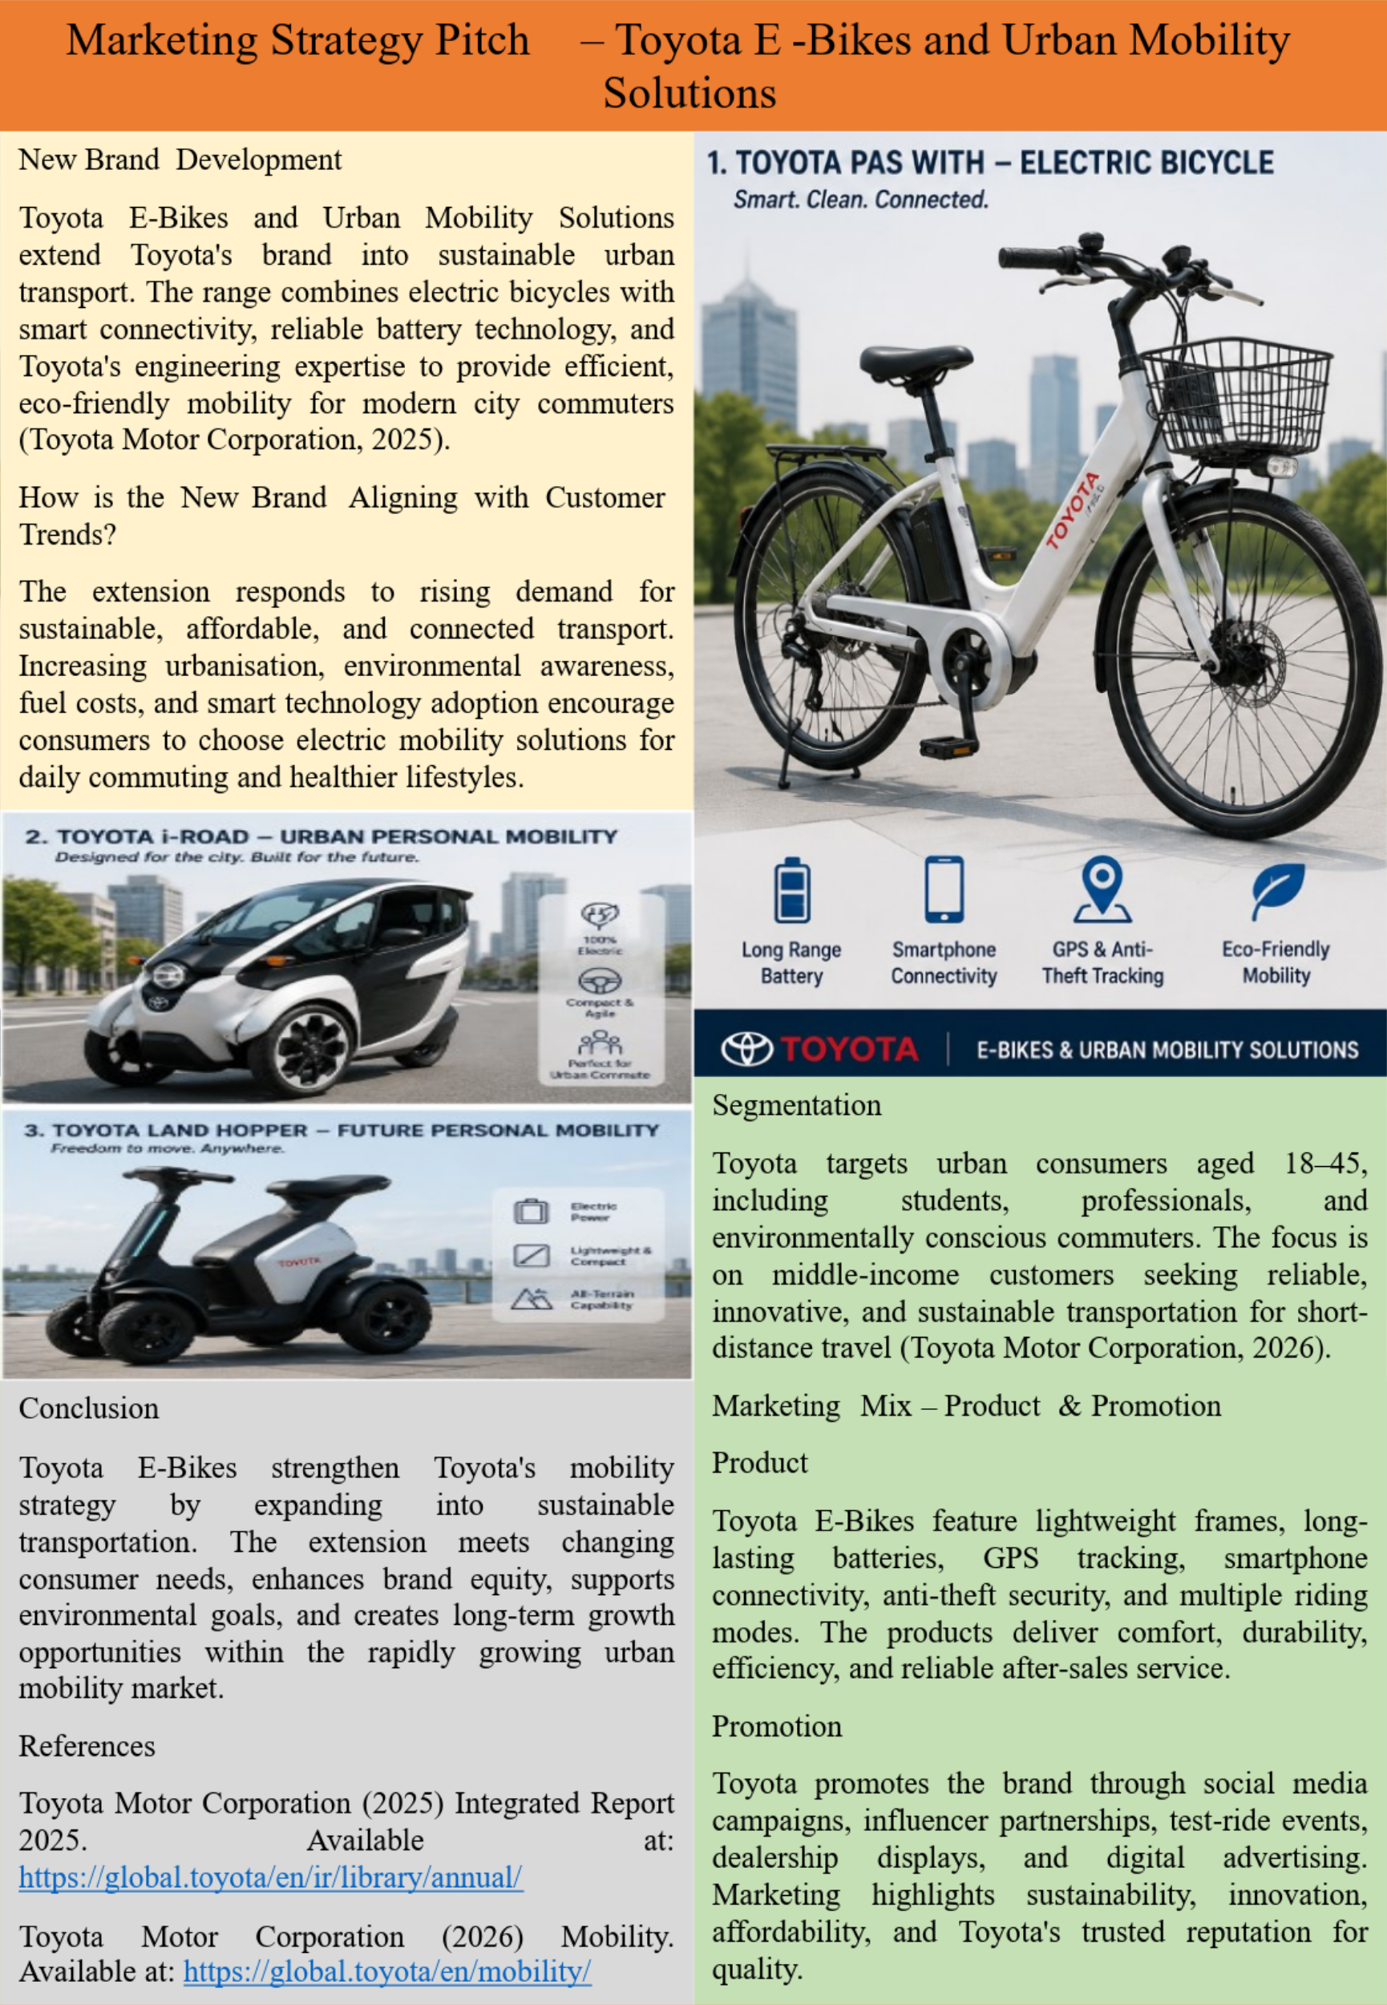

2.0 Element 2: Develop a Segmentation, Targeting, Differentiation, and Positioning (STDP)

2.1 Key market segments relevant to the brand extension using geographic, demographic, psychographic, and behavioural variables
Geographic Segmentation
The primary cities to target are Tier-1 and dense metropolitan areas where traffic and environmental issues and cycling infrastructure are becoming more prevalent. Asia-Pacific was the largest e-bike market in 2025, with 58.7% of the global share, led by markets in Japan, China and India, with Europe being the top adopter region as a result of its government support for low emission mobility (Toyota Motor Corporation, 2025a). Cities like Tokyo, London, Amsterdam, Bengaluru, and Singapore offer the greatest potential, as they are local markets that are easily accessible for a Toyota launch (IEA, 2025).
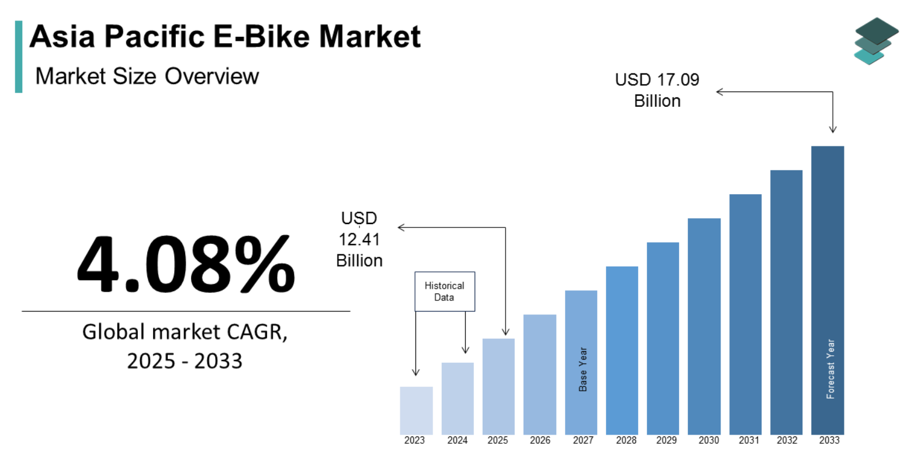
Fig 1: Asia Pacific E-Bike Market
Source: (Market Data Forecast, 2025)
Demographic Segmentation
Toyota E-Bikes are designed for customers of 18-45 years who are interested in university students, young professionals and city dwellers who want to experience transportation for middle class in a cost-effective and sustainable way. The global e-bike market is worth around USD 69.7 billion in 2025 and should reach USD 77.9 billion in 2026, as working-age people seek to cut expenses on their commute while keeping mobility at their fingertips (Toyota Motor Corporation, 2025b). This demographic is also highly digitally oriented, who can be open to the smart connectivity offered by Toyota.
Psychographic Segmentation
The brand extension is aimed at consumers with an eco-friendly, tech-savvy, health-conscious mindset who prioritize convenience and sustainability. The global e-bike market is expected to grow at a CAGR of 9.2% (2026-2033) driven by an increase in fuel prices, urban congestion, and climate awareness (PwC, 2025). Toyota's reputation for innovative, reliable and sustainable engineering is a significant advantage as consumers are drawn to brands that can meet their expectations in these areas (Toyota Motor Corporation, 2025c).
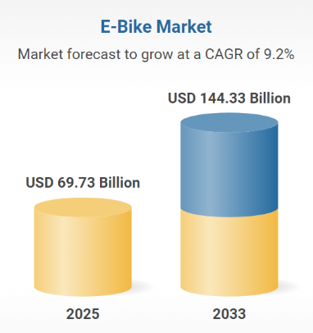
Fig 2: E-Bike Market
Source: (Research and Markets, 2026)
Behavioural Segmentation
Toyota E-Bikes should target people who commute regularly to and from work and individuals who need mobility for short-distance trips throughout the day. The personal-use market dominated the global e-bike market in 2025, and the uptake of e-bikes with GPS navigation, smartphone connectivity, and anti-theft systems is growing (Toyota Motor Corporation, 2026a). An increase in demand for comfortable daily urban mobility and connected mobility solutions will promote the re-use of a vehicle and reinforce customer loyalty for high-quality, high-featured e-bikes, including products from Toyota.

2.2 Detailed explanation of your chosen target audience
The Toyota E-Bikes are mainly targeting 18-45 age group urban consumers such as university students, young professionals, office commuters and middle to upper middle income environmental consumers. Such consumers are on average traveling 5 to 15 km a day and for short distances e-bikes make sense compared to car and public transport. This commuting distance is projected to be the fastest-growing application segment in India with the rise in electric mobility in the urban scenario (Toyota Motor Corporation, 2026b). Target consumers are customers who enjoy smart features like GPS tracking, smartphone compatibility and anti-theft features, and are digitally connected. They also look for convenience, cost-effectiveness, sustainability, and reputable brands when it comes to mobility services. Toyota's commitment to quality, reliability, and technological innovation means it is a trusted and popular brand for those who value reliable, environmentally friendly transportation that helps them enjoy better and more sustainable living (Deloitte, 2025).

2.3 Way brand will differentiate itself from competitors in the market
Toyota E-Bikes will stand out thanks to Toyota's worldwide established expertise in vehicle construction, smart mobility systems and outstanding after-sales service. Whereas Trek, Giant, Specialized, Rad Power Bikes and Yadea are all focused primarily on performance or cost, Toyota has the widespread dealer network, battery expertise, connected vehicle technology, and reputation for reliability. The top seven e-bike companies in the U.S. market share together for about 36%, suggesting the potential for additional premium players with differentiated value propositions (Grand View Research, 2025). Toyota can continue to leverage these features to establish greater competitive advantages, including seamless smartphone connectivity, predictive maintenance services, high quality lithium ion batteries, extended warranties, and integrated sustainability initiatives; areas where many specialists bicycle manufacturers have less customer confidence.

2.4 Positioning of the brand extension
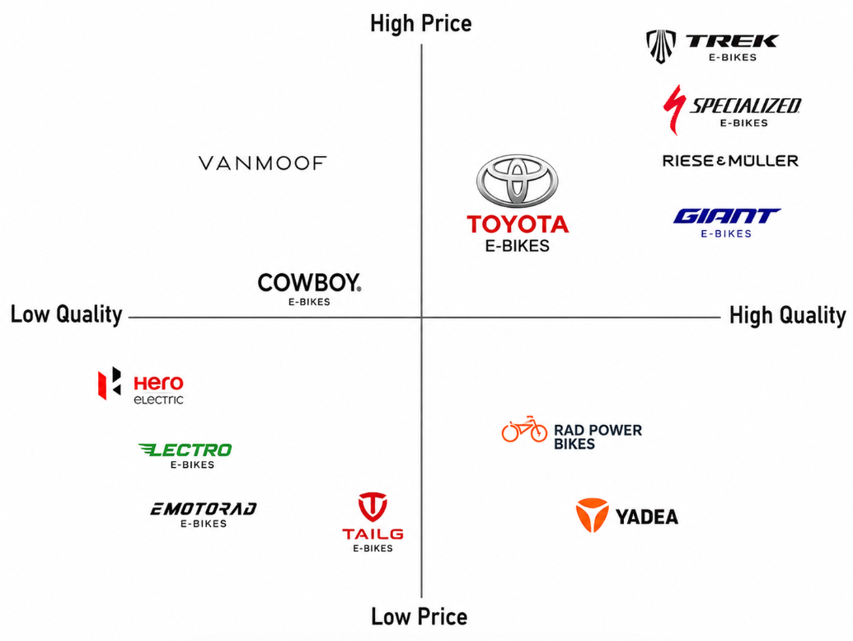
Fig 3: Positioning Map
Source: (Self-Created)
Positioning map indicated that Toyota E-Bikes are in the premium-price, high-quality segment among established brands like Trek, Specialized, Giant and Riese & Müller. Toyota is not a value brand like Hero Electric, Lectro, eMotorad, Tailg or Yadea, but it has a focus on the best engineering, advanced technology, reliability and after-sales service. There are brands such as VanMoof and Cowboy which provide high quality urban mobility at an expensive price, but their quality and network are not as popular. Toyota's strategic positioning allows it to target urban professionals and eco-conscious consumers who value innovative, long-lasting, and connected mobility options, while maintaining the trust of the automotive brand (Fortune Business Insights, 2025). By positioning itself strategically, Toyota can appeal to urban professionals and eco-conscious consumers who are looking for innovative, long-lasting, and connected mobility solutions, while also building a sustainable competitive edge through the trust of the automotive brand.

3.0 Element 3: Marketing Mix (4Ps or 7Ps)

3.1 Way each element of the marketing mix will be applied and how it aligns with and supports the overall brand extension strategy
Product
Toyota E-Bikes will be marketed as an all-in-one smart-urban mobility package based on the combined strength of Toyota's engineering prowess, sustainability, and cutting-edge digital technologies. Commuter, folding and hybrid e-bike models will be developed for urban consumers to be offered in the product portfolio, all of which will be lightweight, with aluminium frames, removable lithium-ion batteries, GPS navigation, smartphone connectivity, anti-theft tracking, regenerative braking, LED lights and multiple riding modes (IMARC Group, 2025). These elements help satisfy the rising demand for consumers to connect with their cars and enjoy more eco-friendly travel, as well as underpinning the reputation of Toyota's reliability and innovation. The dedicated mobile app will simplify the use of the app, allowing users to track battery levels, route planning, and maintenance planning and ride analytics in a seamless digital customer experience. The product strategy shows Toyota's intention to be more than just an automobile company, and instead is a comprehensive mobility company. Toyota keeps investing heavily in the next generation battery technologies to achieve 20% reduction in battery costs, charging time of 20 minutes or less (10–80% state of charge) and future battery innovations that will provide much higher efficiency and durability. The technologies enable Toyota to build off its expertise to deliver high quality products throughout its mobility offerings, including for premium electric bicycles. The product is also likely to be a good fit with the increasing demand of the consumers for technologically advanced e-bikes. When it comes to premium e-bikes, industry-accepted reviews highlight the significance of a built-in GPS system, detachable batteries, and compatibility with smartphones, lightweight frames, and safety features (Research and Markets, 2025). In recent years, consumers' expectations have been shifting in urban mobility, with premium commuter models now standardizing intelligent security and digital connectivity features.
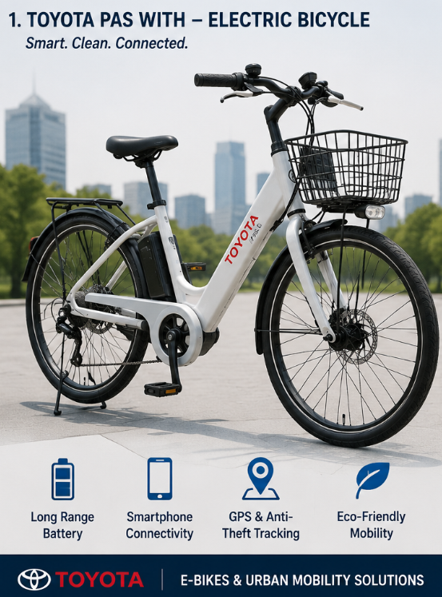
Fig 4: Toyota Bicycle
Source: (Self-Generated)
Price
Toyota E-Bikes will be priced in line with their value, embodying the brand's image of quality, reliability, and technological advancement, yet with a more budget-friendly price tag than their ultra-premium European counterparts. The retail price the company is proposing ranges from US$1,800 to 3,000 (£1,350 to 2,250) – a slightly high price compared to budget brands such as Hero Electric and Lectro, but still lower than high end brands like Riese & Müller and Specialized, which offer a flagship commuter bike that can easily go over US$5,000 (£3,750). This approach will convey high quality and yet be affordable to middle and upper-middle class urban consumers who are looking for value over time (Statista, 2025a). Toyota's economies of scale, high manufacturing efficiency, and well-established supply chain provide competitive pricing without affecting product quality or durability. The price is competitive with the growing trend of premium e-bikes. As the global electric bikes and scooters market is expected to grow from US$30.27 billion (2026) to US$42.74 billion (2030), at a 9.0% CAGR, it is clear that consumers are becoming more willing to spend premium price on high-quality, tech-powered urban mobility solutions, which has enabled Toyota's premium value-based pricing strategy (Fortune Business Insights, 2025). Consumers are willing to pay more for connected functions, better battery life, better safety and after-sales service. Toyota can enhance the value to customers by flexibility in the financing, monthly instalment plans, trade-in programmes, seasonal promotions, extended warranty packages (Statista, 2025b).
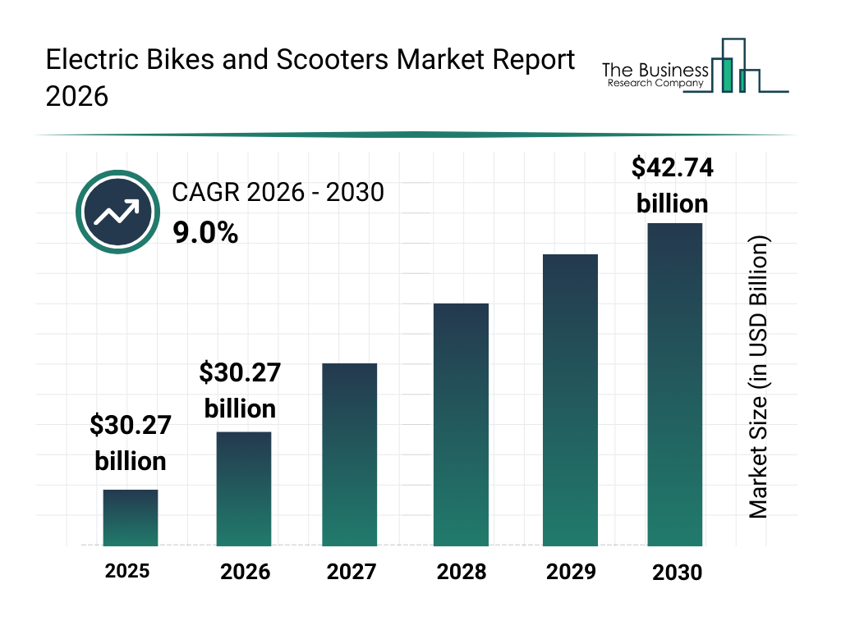
Fig 5: Electric Bikes and Scooters Market
Source: (The Business Research Company, 2026)
Place
Toyota E-Bikes will implement an omnichannel sales approach that leverages Toyota's global network of dealerships and its digital sales channels, as well as specialized bicycle retailers. Toyota products will be sold via Toyota dealerships, the official Toyota online store, through authorised mobility partners and through major e-commerce websites and Toyota will provide servicing from certified Toyota service centres (TechRadar, 2025). The integration of this approach helps to offer the customer purchasing possibilities, and ensures both the quality of the products and their after-sales support. Physical dealerships will also provide test-drive opportunities, product demos, financing options, and maintenance, to help ease the decision-making process of the purchase and build trust with the customer. The distribution strategy enables to change the consumer purchasing behaviour in the e-bike sector. In 2024, the offline distribution channel held over 73% of the global e-bike market share as consumers sought to view products, compare models and take test rides prior to making high-priced purchases.The offline distribution channel represented more than 73% share of the global e-bike market in 2024, as consumers have a preference to physically inspect the product, compare models, and take test rides before committing to high dollar purchases (Toyota GB PLC, 2025). But online sales are continuing to rise because of increased online adoption and the preference for home delivery and comparisons of products online. Many specialist e-bike manufacturers are mainly direct-to-consumer online brands, whereas Toyota has a proven base of dealerships worldwide, which gives it a huge advantage. The company has thousands of authorised Toyota dealers around the world, providing them with a broader geographical reach, trained service providers, availability of spare parts, and uniform customer support during the product's lifecycle.
Promotion
The integrated marketing communication (IMC) strategy will be followed by Toyota E-Bikes, which will utilize digital marketing, social media, influencer marketing, experiential marketing, and dealership promotions to establish robust brand awareness and customer engagement. Sustainability, smart mobility, reliability and Toyota's proven engineering know-how will be core messages in the promotion, which will be carried out across various social media channels, including Instagram, YouTube, TikTok and LinkedIn (Global Market Insights, 2025). Consumers will get hands-on experience of the product through test-ride events, urban cycling festivals, university roadshows, and fitness and environmental organisation partnerships to boost purchase confidence. Digital marketing is proving to be a powerful method of promotion with global spending on digital ads set to reach US$790 billion by 2026 and on influencer marketing reaching over US$33 billion in 2026. Toyota will also enhance the experience of customers by using personalised email campaigns, loyalty programs, refer-a-friend and user-generated content (McKinsey & Company, 2025). The promotion method helps to advance the brand extension by augmenting the engagement of customers, enhancing Toyota's brand reputation as a premium and innovative brand and increasing adoption of sustainable urban mobility solutions.

4.0 Element 4: Reflection

4.1 Reflection on my experience developing the brand extension
Developing the Toyota E-Bikes brand extension enhanced my understanding of strategic brand management and innovation within the automotive industry. I gained insights into the process of expanding into a new market successfully while adhering to the quality, reliability, and tech excellence values of an established global brand. Market research helped me analyse customer needs, understand the latest trends in sustainable urban travel, and analyse the competition in the e-bike sector.

4.2 Reflection on the experience preparing and delivering the poster presentation
The process of making the poster presentation helped me to become more skillful in the presentation of concepts in a marketing communication in a concise and visual way. The ability to research and identify the most pertinent information was a skill that was essential and required critical thinking and prioritisation to ensure that key components of the brand extension were presented logically and professionally. In the presentation I became more confident in explaining strategic decisions, answering queries and justifying suggestions based on literature and industry reports.

4.3 Key skills, knowledge, and insights you have gained throughout this process
This project enhanced a number of key academic and professional skills. Developed market research abilities by studying consumer trends, competitor positioning and industry developments from trusted secondary sources. Through strategic thinking, I have learned to evaluate and gain insights into how Toyota's current brand equity could enable them to make successful diversifications in the field of sustainable mobility. I also learned to improve my analytical skills in using marketing tools like segmentation, targeting, positioning and the marketing mix to real business scenarios. Additionally, the project enhanced my knowledge and understanding of sustainable marketing, digital marketing communications, customer behaviour and integrated branding strategies.

4.4 Way these have contributed to my personal and professional development
I think a lot of the knowledge and skills I developed during this assessment have helped me personally and professionally. The project gave me the confidence to work on my own to research information, analyse various sources and suggest clear and concise business solutions. For its professional aspect it enhanced skills that are very useful for marketing and business consultancy, such as strategic planning, problem-solving, critical analysis, communication and decision making. The task also gave a good understanding of the process of identifying customer needs and matching customer needs with marketing strategies and organisational goals. The skills I have acquired are transferrable to my future career, in which I will be able to participate in projects related to brand development, product innovation and strategic marketing projects in various sectors.

4.5 Way I could further enhance my approach and performance in similar projects in the future
In future projects I would improve my approach by conducting more detailed primary research to obtain further information from consumers, by using secondary research and consumer surveys or interviews to obtain further information about the consumers and lead to further understanding. I would also spend extra time on competitor benchmarking, financial feasibility analysis, customer testing, etc. to enhance the feasibility of strategic recommendations. The ability to use higher-level presentation software and interactive design tools to improve data visualisation skills would further enhance the effectiveness of communicating complex information.

References
Deloitte (2025) Global Automotive Consumer Study. Available at: https://www.deloitte.com/global/en/Industries/automotive.html
Fortune Business Insights (2025) Electric Bike Market Size, Share & Industry Analysis. Available at: https://www.fortunebusinessinsights.com/electric-bike-market-102222
Global Market Insights (2025) U.S. E-Bike Market Size, Share & Forecast Report. Available at: https://www.gminsights.com/industry-analysis/us-e-bike-market
Grand View Research (2025) E-Bikes Market Size, Share & Trends Analysis Report. Available at: https://www.grandviewresearch.com/industry-analysis/e-bikes-market-report
IMARC Group (2025) Electric Bike Market: Global Industry Trends, Share, Size, Growth, Opportunity and Forecast. Available at: https://www.imarcgroup.com/electric-bike-market
International Energy Agency (IEA) (2025) Global EV Outlook 2025. Available at: https://www.iea.org/reports/global-ev-outlook-2025
Market Data Forecast (2025) Asia Pacific E-Bike Market Size, Share & Trends, 2033. Available at: https://www.marketdataforecast.com/market-reports/asia-pacific-e-bike-market
McKinsey & Company (2025) Automotive and Assembly Insights. Available at: https://www.mckinsey.com/industries/automotive-and-assembly/our-insights
PwC (2025) Automotive Industry Insights. Available at: https://www.pwc.com/gx/en/industries/automotive.html
Research and Markets (2025) India E-Bike Market Size & Share Analysis. Available at: https://www.researchandmarkets.com/reports/5306266/india-e-bike-market-share-analysis-industry
Research and Markets (2026) E-Bike Market Size, Share & Trends Analysis Report by Drive, Battery, End Use, Region, and Growth Forecasts, 2026–2033. Available at: https://www.researchandmarkets.com/reports/5595843/e-bike-market-size-share-and-trends-analysis
Statista (2025a) Digital Advertising Market Worldwide. Available at: https://www.statista.com/outlook/dmo/digital-advertising/worldwide
Statista (2025b) Influencer Advertising Market Worldwide. Available at: https://www.statista.com/outlook/dmo/digital-advertising/influencer-advertising/worldwide
TechRadar (2025) Best Electric Bikes 2025. Available at: https://www.techradar.com/best/electric-bike
The Business Research Company (2026) Electric Bikes and Scooters Market Report 2026. Available at: https://www.thebusinessresearchcompany.com/report/electric-bikes-and-scooters-global-market-report
Toyota GB PLC (2025) Toyota Reinforces its Multi-Pathway Approach and Commitment to Customer-Focused Innovation. Available at: https://media.toyota.co.uk/toyota-reinforces-its-multi-pathway-approach-and-commitment-to-customer-focused-innovation/
Toyota Motor Corporation (2025a) Integrated Report 2025. Available at: https://global.toyota/en/ir/library/annual/
Toyota Motor Corporation (2025b) Battery Electric Vehicle Technologies. Available at: https://global.toyota/pages/global_toyota/ir/library/annual/2025_001_integrated_en.pdf
Toyota Motor Corporation (2025c) Sustainability Data Book 2025. Available at: https://global.toyota/en/sustainability/report/sdb/
Toyota Motor Corporation (2026a) Mobility. Available at: https://global.toyota/en/mobility/
Toyota Motor Corporation (2026b) Corporate Sustainability. Available at: https://global.toyota/en/sustainability/

