2021
Calina Ionita - 2007698
UNIVERSITY OF WALES TRINITY SAINT DAVID SWANSEA

Managing Enterprise in the 21st Century
BMSW4006
BUSINESS PLAN
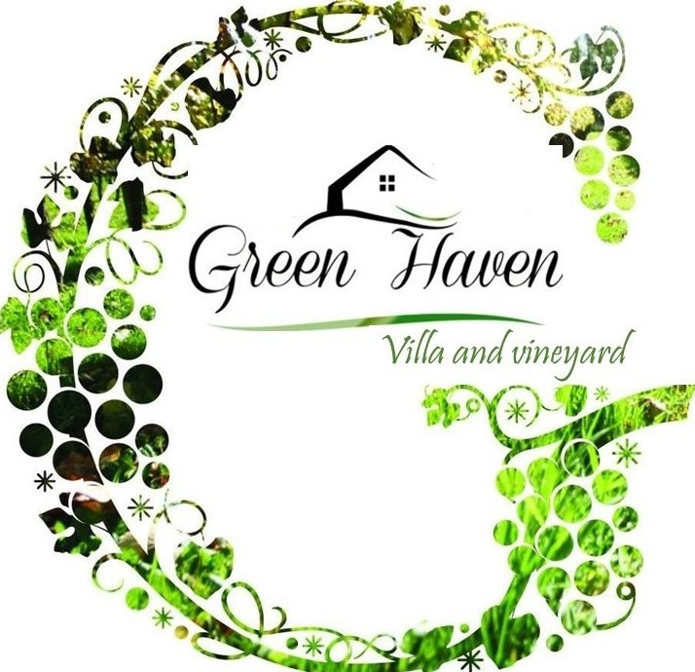
Contents
1. Introduction 2
2. Name of business and type of business ownership 2
3. Mission statement and objectives of business 2
4. Marketing strategies 2
5. Business description 6
6. Human resources 7
7. Financial resources 8
8. S.W.O.T. analysis of the business 9
9. 12 month cash flow forecast 10
10. Conclusions 12
11. References 13

Introduction
Tourism as an economic and social phenomenon registered a special dynamic in the 21st century, turning into an activity that engages from year to year a growing number of people. "Tourists are more experienced and therefore increasingly discerning in their choice of holidays, in terms of both destinations and activities" (Ashworth and Goodall, 2013).

Name of business and type of business ownership
The concept of the business was to create a vacation rental property using the resources already possessed. The idea was accessible due to fact that my family has inherited my grandparents old house, a beautiful stone building ideally located in a picturesque area in my hometown Iasi, Romania. The property has also a vineyard and amazing landscapes, which makes it unique as a location for travel and tourism.
The name of the business is the actual name of the property which describes the location at its best – Green Haven Villa.
As a new business the legal identity that has been chosen is sole trader because it requires minimal set up and administration and also benefits from fewer regulations and reduced filing requirements (Simpleformations.com, 2019).

Mission statement and objectives of business
As a brief summary of what the business mission is: " We are a family run business that prides in being able to secure beautiful, conveniently located, and cost worthy vacation rental property that is sure to satisfy the wants and needs of even the most discerning clients. We create the perfect haven, far away from the bustle of the city. Come and relax with your loved ones and enjoy nature in an idyllic paradise. Create your memories here!".
"Hospitality business has a main goal of customer service" (Travelling Teams, 2016).
The aim of our business is to offer quality vacation rental services at a cost worthy price.
Considering the aim of our business it is imperative to define the business objectives that the company will try to achieve.
First of all, as a new business, it is important for the company to increase awareness in the first 6 months. Also increase sales monthly by 20% by the end of first year. Other objective would be to create a marketing plan that targets every family, couples, with an average income, from Romania, in the first 2-3 years.

Marketing strategies
To accomplish the growth objectives that the business has defined above, Green Haven Villa will direct its marketing activities toward the following strategies:
- Target market strategy – target markets
Market segmentation is an undeniably significant piece of a solid marketing strategy and can have a significant effect for organizations in competitive market landscapes. It offers a chance to pinpoint precisely what informing will drive the clients to make a buy. The purpose behind market segmentation is to recognize various groups inside the intended target group so that the business can deliver more valuable and targeted information for them (Thomas, 2020).
As a marketing research tool, we have created a questionnaire with the purpose to gather primary data so we can identify specific trends regarding our target market (Annex 1).
The primary customer target market for Green Haven Villa can be described as follows:
Demographics:
- Families and couples aged between 25- over 55
- Household income: £30,000 and above
- Level of education: College or above
- Profession/role in a company: administrative, professional or workers
Psychographics:
- Enjoy holidays, travelling, exploring new and unique places
- Enjoy spending time with friends and family
- Busy lifestyles and need to use time efficiently when spending holidays
- Enjoy outdoor activities
- Look for quiet, secluded places
Geographics:
- Located in Iasi surroundings and nearby cities
Behavioural:
- Browsing habits: target market is more likely to search for accommodation offers online
- Purchasing habits: target market will buy from trustworthy booking websites
- Spending habits: target market will likely spend more for a quality service rental accommodation.
- Positioning strategy
To overcome the clutter and noise of today’s marketplace, there is a need to win a serious position by presenting a unique offering in a manner that genuinely makes a difference to clients (Chiaravalle and Barbara Findlay Schenck, 2007).
Green Haven Villa seeks to position its services as the first choice for its clients, through unique attributes and features that the property has to offer. It can be mentioned the unique location, with a vineyard, in a picturesque landscape. Another unique feature is the multiple outdoor areas for dining or barbecue. The spacious garden that represents the perfect set up for wedding ceremonies, parties, or special events. The heated private swimming pool with sunbeds and garden furniture. Another attribute that differentiates us from the competitors is that clients can book the entire villa for themselves.
- Product/Service strategy
To increase its leverage on the market and to meet its sales objectives the focus will be on the design and presentation on the personal website. Also, it is going to be taken into consideration the listings on the other booking websites that the property will be present. The features and amenities of the villa will be highlighted, and also the special deals that the property offers. The stunning photos of the villa and surroundings will contribute as a persuasive tool in the quest to encourage potential guests to view the listing. As a unique feature of the product strategy, as mentioned above, Green Haven Villa offers its guests the choice of booking the whole property for themselves, having the privacy of their own home.

- Pricing strategy
Price is another fundamental component of the vacation rental business marketing mix. About 60% of the potential income derives from the characteristic worth of the property, area, and amenities. The other 40% represents an effective pricing strategy (iGMS, 2020).
Researching the competitors in the area the findings show a rate starting from £80 per room/night for a similar type of accommodation. As a pricing strategy that the business will undertake is market penetration pricing (CO-Staff, 2019).
It involves pricing the service 25% under the estimated market value, then slowly increase the rates as the reviews start coming in. This strategy will be used to increase the property awareness and will last until getting the first 5 reviews. Another pricing strategy that will be applied is dynamic pricing, making sure they are competitive and also in line with the guest’s demand. There will be different tariffs for weekdays and weekends throughout the year. The average weekday tariffs will be between £60-£80 per room/night, weekends tariffs between £75-£100 per room/night. The guest can book the entire villa for a pricing starting from £700 per villa/weekend.
- Promotion strategy
Business promotional strategy is part of the 4 P’s of marketing mix. It represents a part of marketing communication, and its primary role is to reach the target market and to gain awareness and also to cultivate discussion with prospects and clients (Trillo, 2019). Promotion helps the business to draw the target’s attention, create interest in the service, generate demand and most important aspect to generate purchase.
Regarding our promotional strategy we are going to focus on 4 key promotion types that include: personal selling, direct marketing, advertising, and sales promotions.
Personal selling is going to be achieved through the company’s personal website (Annex 2) where customers can book online or ask additional information if required. The concept of the website was to build a visual space where visitors can get familiar with the villa and find out more information about the services we offer and how to book.
Direct marketing communication will be through the following marketing channels: personal website, email, direct emails, newspaper adverts, partners’ booking websites (Airbnb, Booking.com, Expedia.com, TripAdvisor).
Advertising is another tool to promote our business. We have created the traditional advertising prints like brochures (Annex 3) and leaflets (Annex 4). We will also use our personal social media platforms like Facebook and Instagram as a tool to make our potential customer aware of the presence of the brand, but also use this as a tool to get in touch with us and get updates of the current promotional offers. Another way to advertise our business is to participate at wedding and event fairs so we can directly promote our offers to potential customers. It represents the perfect opportunity to discuss and show case our offer. Local partnerships will be arranged with shops, restaurants, or other local businesses. Local restaurants will be able to cater for our events booked at the property. The other business-owners can recommend the property to their clients, and also, we can promote their services in return. Part of the advertising there is a logo (figure 1) that has been created specifically for this brand, with the purpose to create an image for the business. Customers will get familiar with the brand in this way, associating the image with the business itself. The design represents the theme of the brand - nature.

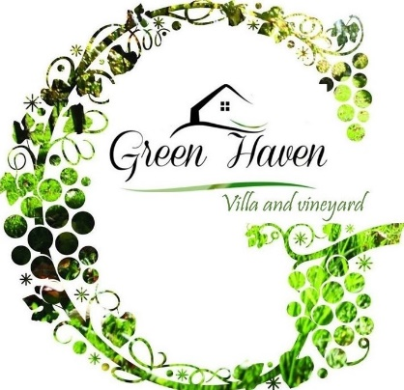

Figure 1 - Logo

Sales promotions refers to short-term marketing campaigns with the purpose to encourage purchase. Our start-up offers will include discounted prices for booking in advance or for multiple night stays. All these offers will be available on the printed materials, our website, social media platforms, partners’ booking websites.
- Place strategy
In order to reach its target market Green Haven Villa will focus its placing strategy on the internet, which represents the major distributing channel for our business. The online media plays a huge role, as travellers use it to compare different accommodation, rates, offers etc. The customers can find our offer and book using the online platforms such as: personal website, social media platforms, as direct channels or holiday rental websites, as indirect distributing channels.
Another aspect of distributing strategy includes the location itself as the place for consuming the service. Part of our distribution plan is represented by a channel manager. This is an innovative online tool that synchronises all our listings in one place. It is called Lodgify and it easily connects with the top online travel agents like Airbnb, Booking.com, Expedia, TripAdvisor, to keep calendars automatically synchronized across all channels and prevent double bookings. This online software has many benefits to include: saves time and effort, manages all reservations from one place, increases the brand visibility (Lodgify, n.d.).

Business description
As mentioned at the beginning of this report the concept of the business was to renovate and manage a vacation rental accommodation. This idea was accessible due to resources already possessed from my grandparent’s inheritance.
5.1 Physical description of service
The property itself has a one-of-a-kind architecture, a beautiful stone building ideally located in a picturesque area in Iasi, Romania. The property has also a vineyard and amazing landscapes, which makes it unique as a location for travel and tourism.
The property has 4 bedrooms and 4 bathrooms and can accommodate up to 10 guests. The ground floor includes: kitchen, dining room, living room, 2 bedrooms and 2 bathrooms. The upper floor has: 2 bedrooms and 2 bathrooms. The kitchen is fully equipped with: dishwasher, fridge, microwave, stove top, oven. There are 3 double bedrooms and 1 room with 2 single beds. All bathrooms have toilets, basins, and showers. Outdoor area includes: 3 dining spaces, swimming pool with sunbeds area, spacious private garden, barbecue, and private parking.
Regarding the description of the service itself we can describe our offer as follows:
- Vacation rental services – from only one night stay to packages with multiple night stays.
- Private events rental – the villa can be booked for organising wedding ceremonies, parties, anniversaries, weekend getaways etc.
- Wine tasting – package that includes 2 nights stay, vineyard tour and wine tasting experience.
- Book entire villa – the villa can accommodate up to 10 guests.
5.2 Process of the service
The operations plan is simple, as managing the property can be done from any location, even from home. Regarding the necessary equipment to manage the property there are mainly office requirements like: laptop, printer, landline phone with a fax, consumables etc.
The process of consuming the service is part of the marketing mix and can be described as in the figure below:
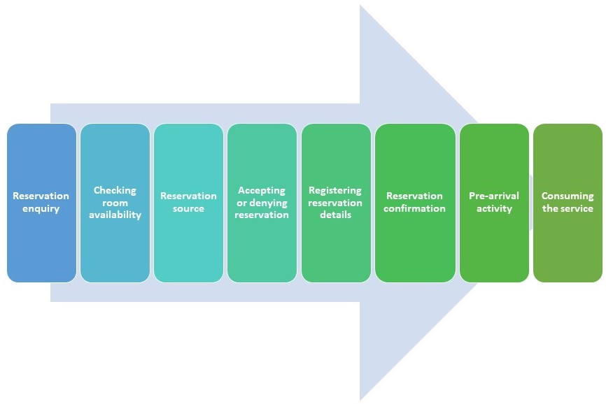
Figure 2 – Process of consuming the service

Human resources

As a small business, Green Haven Villa has a very simple organisational structure. Main departments can be observed in the organisational chart below:
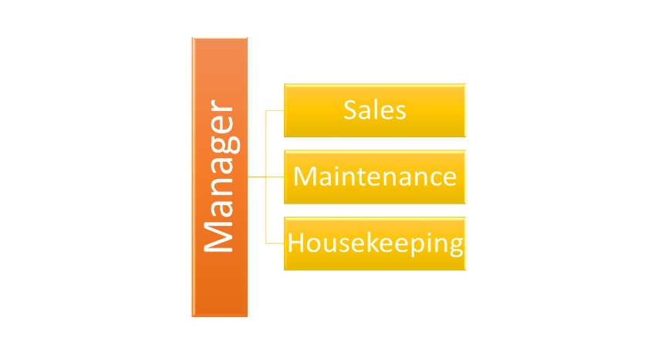
Figure 3 – Organisational chart

The key personnel include the following:
- Manager – this role will be fulfilled by the business owner, in this case, myself. Responsible for the creation, design, and packaging of the service. Responsible for the smooth running of all other departments.
- Sales – the department will be run by myself and my mother. We will monitor all bookings made through our channel manager website, reply to emails, regarding quotes and confirmations, requirements, and complaints. Greet guests, do the check in/check out procedures, manage payments, perform accountancy documentation.
- Maintenance – the department will be run by my partner and my father. They are both specialised in property renovation, maintenance.
- Housekeeping – externalised service – 1 person to be hired part-time, by friend’s referral.
The personnel are fully qualified with vast experience in tourism and also property maintenance. Being a family run business, the recruitment process will not be necessary. The figure below shows a proposal of the monthly salary grid for our personnel.
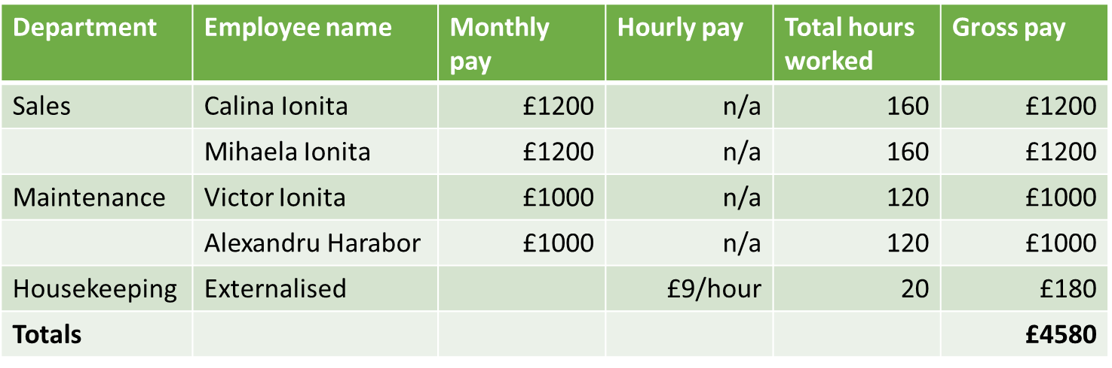
Figure 4 – Salary spreadsheet

Financial resources
Finding sources of finance when considering starting a business is crucial. There are many sources to help businesses start and obviously grow. Referring to our business idea the proposal was to invest our own funds from personal savings, having the benefit of being personally in control, and also being the only option available that I want to consider being a start-up business. The figure below shows the anticipated costs that will be needed to start the business.
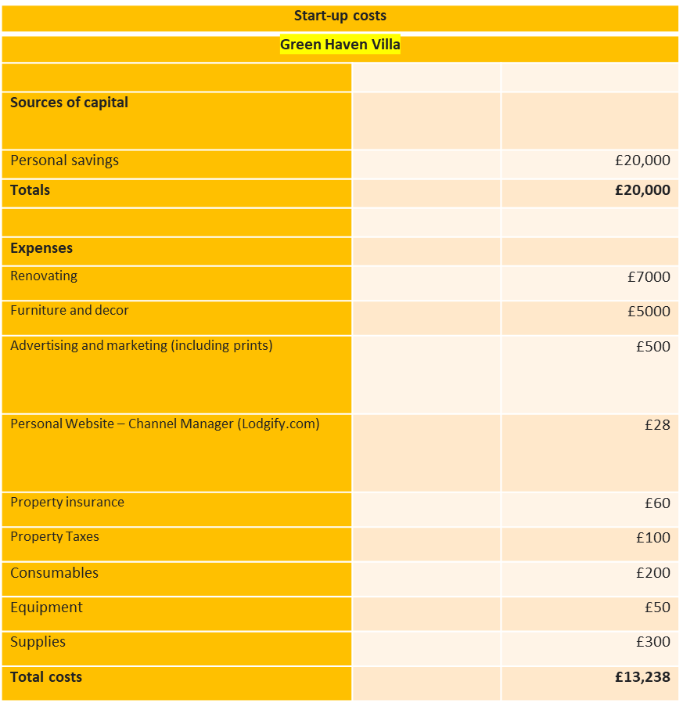
Figure 5 – Anticipated start-up costs

S.W.O.T. analysis of the business
This useful framework represents an important tool for the business to evaluate its strengths, weaknesses, opportunities, and threats. It helps build on what the business does well, it addresses the lacks, helps minimise the risks, and influence the decisions for running a successful business.
Strengths
- A creative and fully qualified team
- A cost-worthy service defined by unique features
- Conveniently located
- Flexible and adaptable to environmental changes
- Trustworthy online booking partners
- Variety of services
Weaknesses
- Limited financial resources for possible expansion, additional features
- Little flexibility regarding staff, due to the small business size.
Opportunities
- Growing customer interest for booking holidays
- The continuing development of online environment
- New business partnership opportunities
- Brand recognition
Threats
- Competitor’s potential
- Covid-19
- Different economic aspects that can influence the sector of tourism
- Changing travel patterns

12-month cash flow forecast
An important aspect of a business plan is represented by the cash flow forecast. It allows the business to predict its money needs in advance (Berry, 2019). The figures below show the cash flow forecast for a 12-month period for Green Haven Villa.
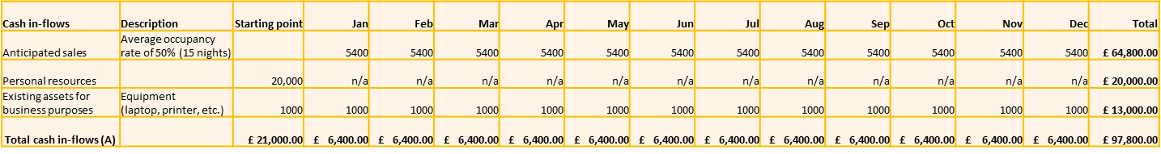
Figure 6 – Cash in-flow
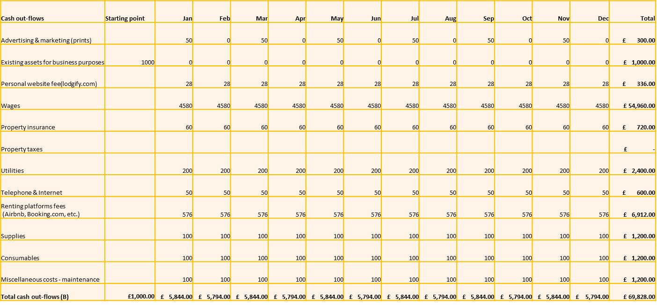
Figure 7 – Cash out-flow
Figure 8 – Cash balance

The figure 9 represents an average cost of the fees that online booking websites charge per booking. This estimate is included in the cash flow forecast, as it is part of our monthly expenses.
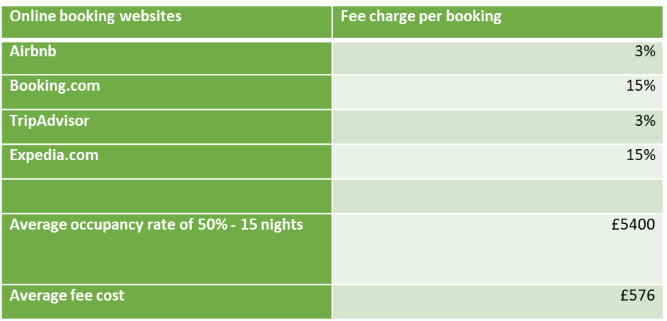
Figure 9 – Online platforms fees
Analysing the cash flow forecast we can estimate that for the first year of running the business the anticipated sales are calculated for an occupancy rate of 50% - 15 nights, with total sales of £64,800. The total expenses amount calculated for a year is £69,828. It can be observed from figure 8 that after the first year the business is profitable, having a net cash flow of £27,972.

Conclusions
The industry of tourism today is a highly competitive market. Nowadays tourists have to be enticed: "the destination’s place product must be marketed effectively" (Ashworth and Goodall, 2013).
In this marketing context there is a greater emphasis on marketing techniques such as positioning and branding. But also, the marketing research cannot be omitted since it represents an important part of the marketing plan when looking to put in practice a business idea.
A well-documented business plan, with clearly defined objectives, precise marketing strategies with a continuous thorough research of its target market represents the key to a successful business start-up and development.

References
- Altaf (n.d.). THE RESERVATION PROCESS IN HOTELS | HOTELIER LIFE. www.hotelierlife.com. Available at: https://www.hotelierlife.com/the-reservation-process-in-hotels/ (Accessed: 20th June 2021).
- Ashworth, G.J. and Goodall, B. (2013). Marketing tourism places. London; New York: Routledge.
- ASTRHO. (2020). Manage your vacation rental expenses with ASTRHO. Available at: https://astrho.org/blog/budget-and-expense-control-for-your-vacation-rental/ (Accessed: 24th June 2021).
- Berry, T. (2019). How to Forecast Cash Flow -.Bplans Blog. Available at: https://articles.bplans.com/how-to-forecast-cash-flow/ (Accessed: 21st June 2021).
- Chiaravalle, B. and Barbara Findlay Schenck (2007). Branding for dummies. Indianapolis, In: Wiley Pub., Inc. (p.77)
- CO— Staff (2019). How to Determine the Right Pricing Strategy For Your Business. https://www.uschamber.com/co. Available at: https://www.uschamber.com/co/run/finance/pricing-strategies-for-your-business (Accessed: 4th June 2021).
- iGMS. (2020). Vacation Rental Marketing: 4P Formula to Increase Revenue. Available at: https://www.igms.com/vacation-rental-marketing/ (Accessed: 4th June 2021).
- Lodgify. (n.d.). Best Vacation Rental Channel Manager Booking Software. Available at: https://www.lodgify.com/vacation-rental-channel-manager/ (Accessed: 20th June 2021).
- Simpleformations.com. (2019). Simple Formations. Available at: https://www.simpleformations.com/types-of-business.htm. (Accessed: 3rd June 2021).
- Solomon, M.R. (2013). Marketing: real people, real decisions. Harlow, England; New York: Pearson Education. (p577-589)
- Thomas, S.R. (2020). 4 Types of Market Segmentation With Real-World Examples. Yieldify. Available at: https://www.yieldify.com/blog/types-of-market-segmentation/. (Accessed: 3rd June 2021).
- Traveling Teams. (2016). Hospitality Main Goal Customer Service. Available at: https://travelingteams.com/hospitality-main-goal-customer-service/ (Accessed: 3rd June 2021).
- Trillo, C. (2019). Promotion Strategy: The Ultimate Guide for Your Business in 2020. Evinex Digital Marketing Agency. Available at: https://www.evinex.com/promotion-strategy/ (Accessed: 10th June 2021).
- Young House Love. (2019). The Costs Of Running A Vacation Rental (With Real Numbers). Available at: https://www.younghouselove.com/airbnb-vacation-rental-costs/ (Accessed: 24th June 2021).

Annex 1
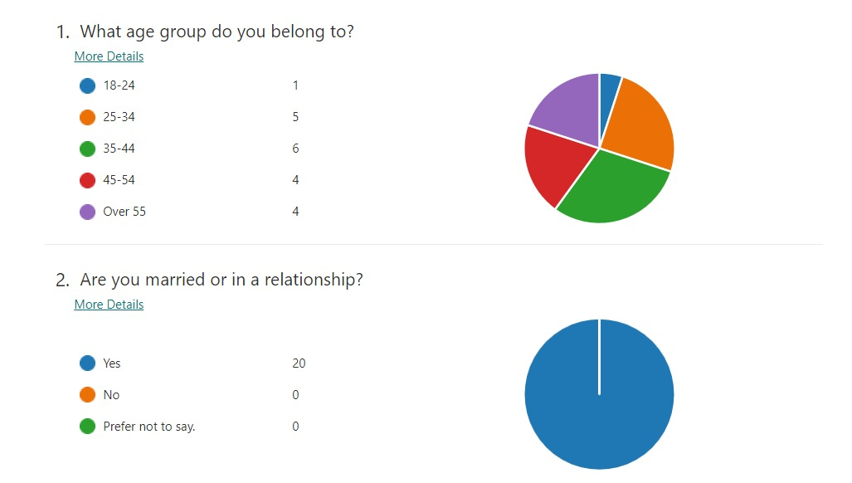
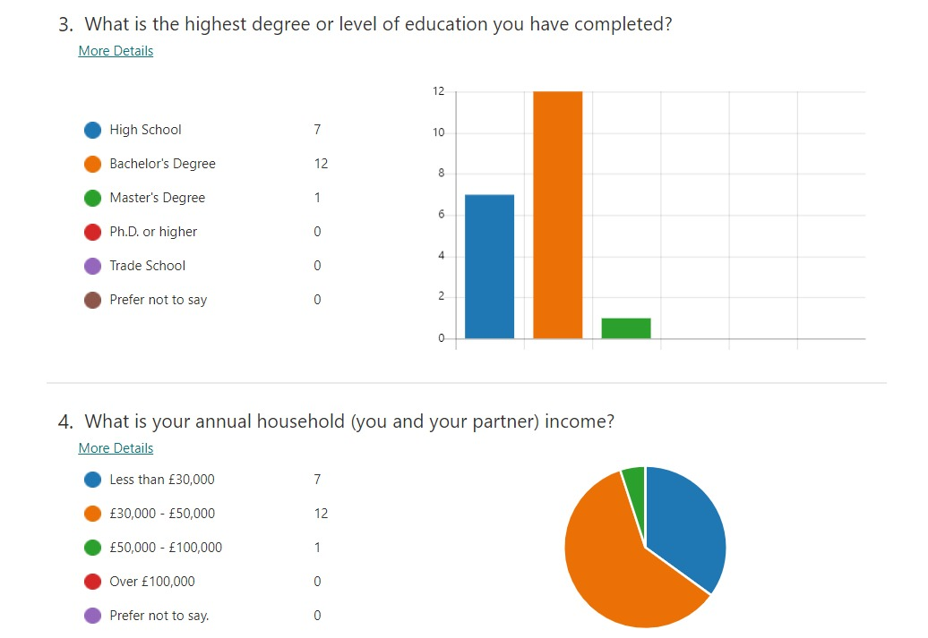
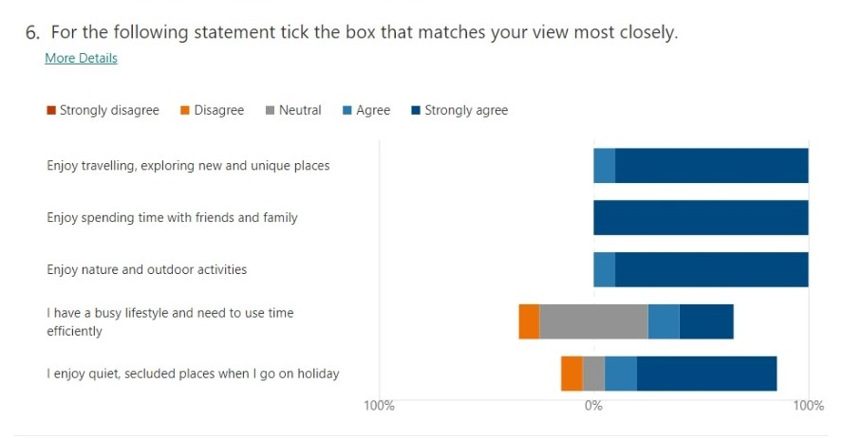
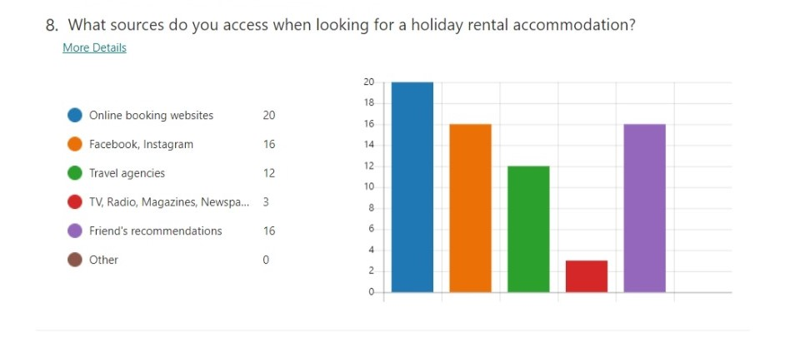

Annex 2
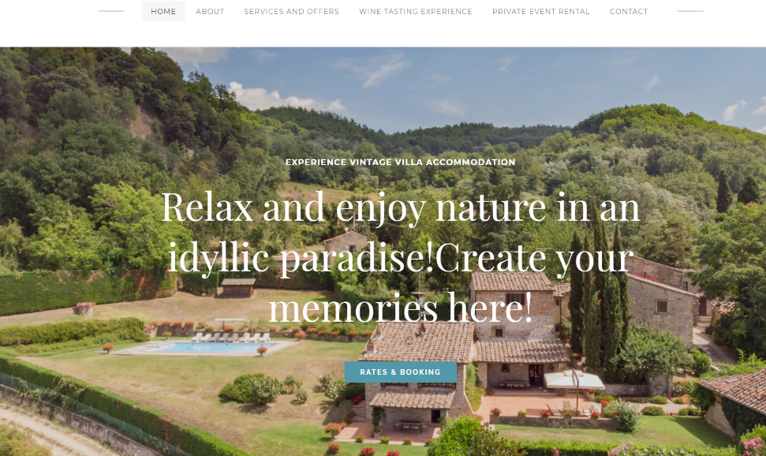

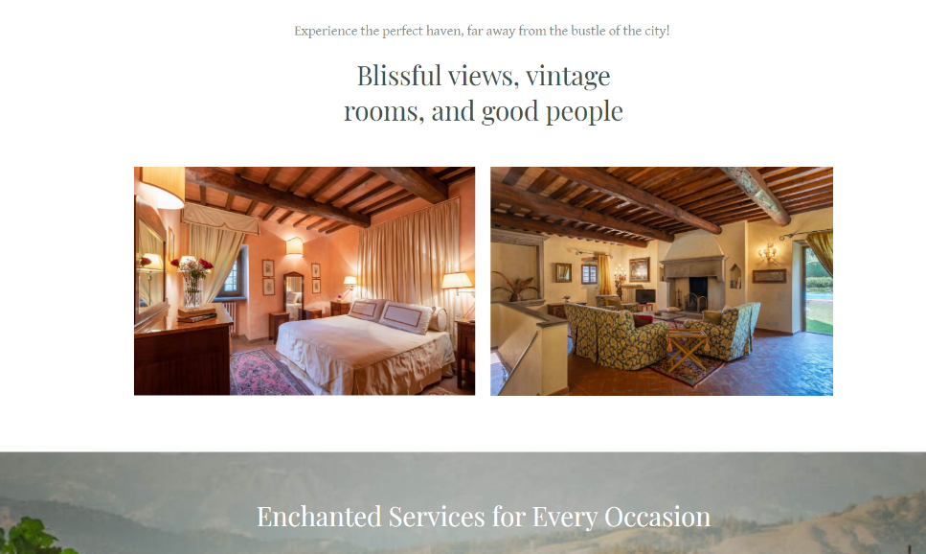

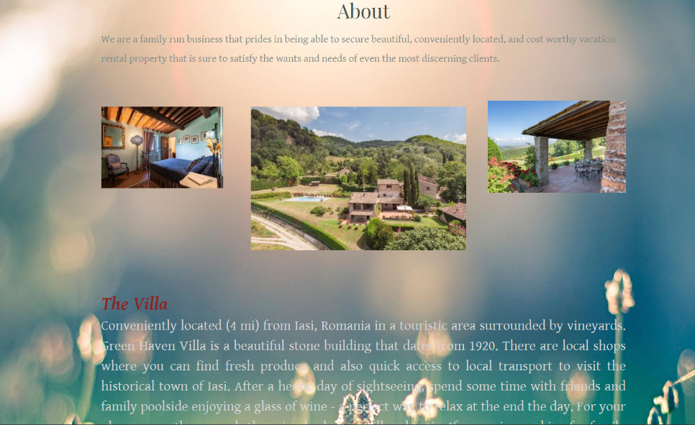
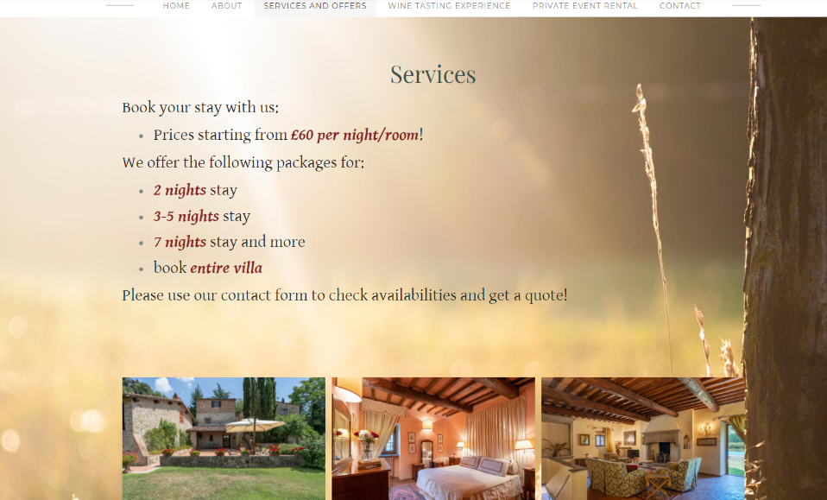
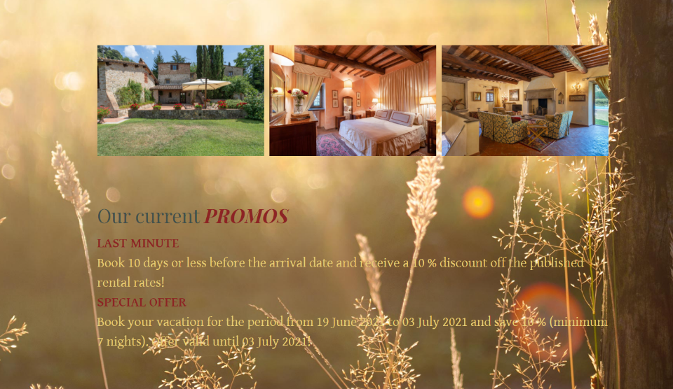
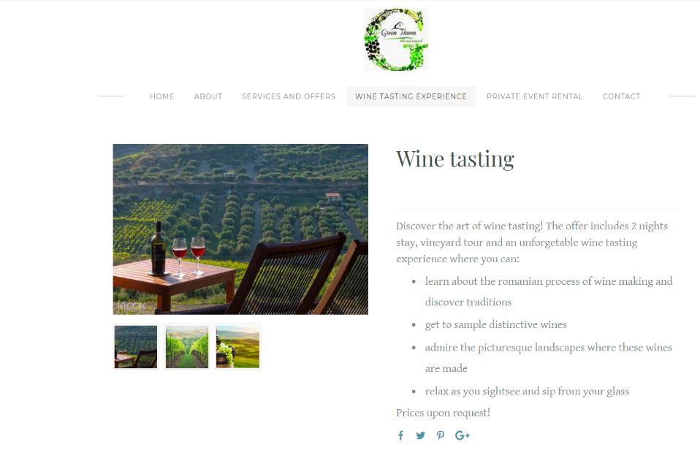
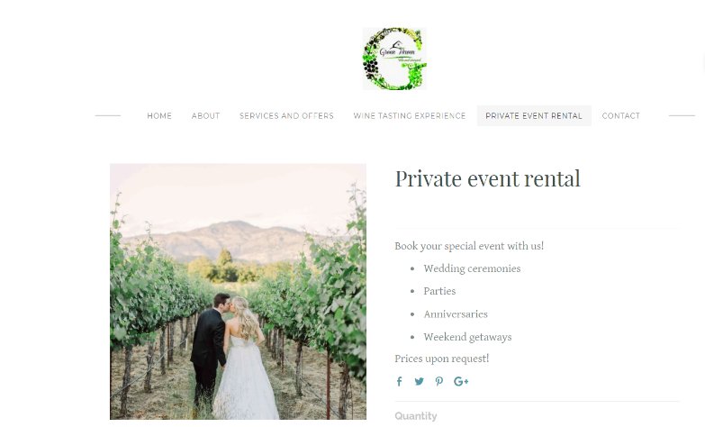
Annex 3
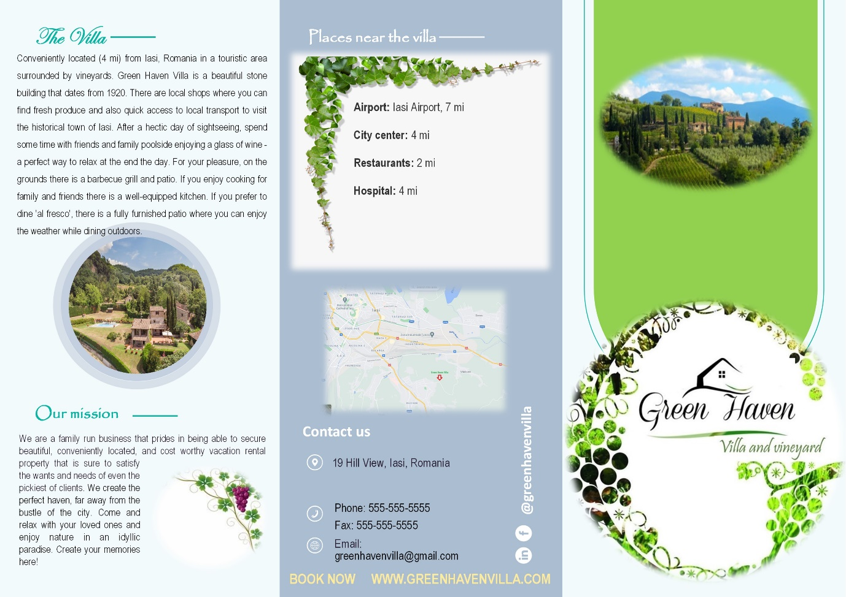

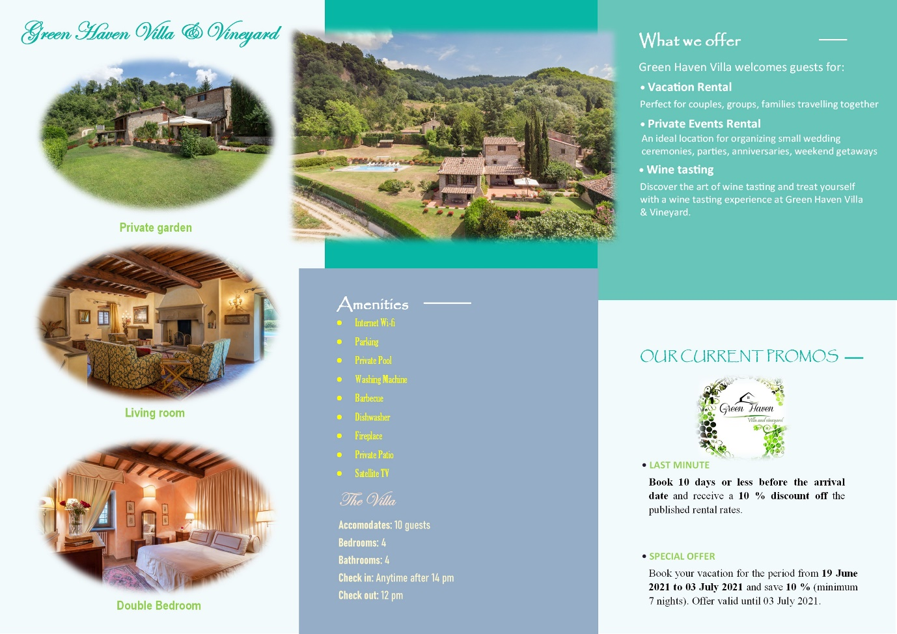

Annex 4


