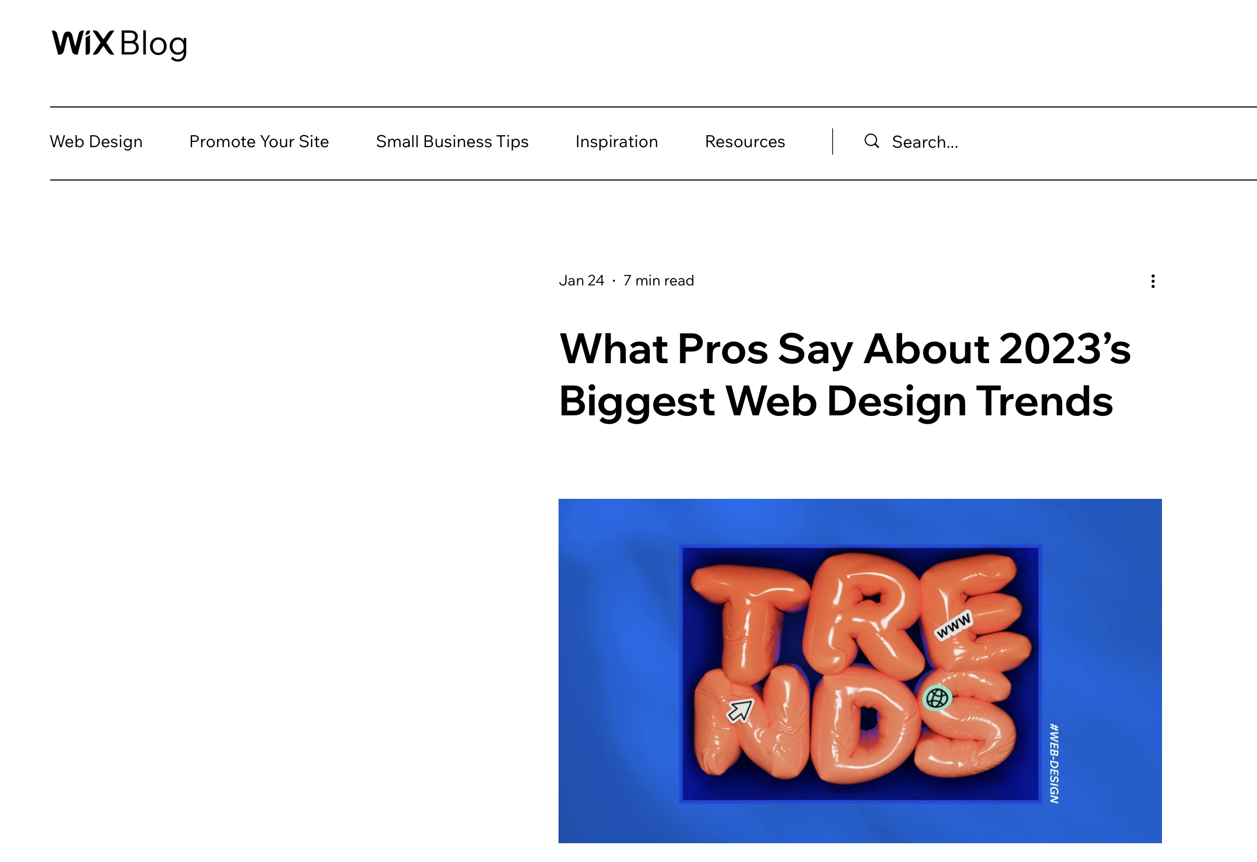
9th Feb 2023
ONLINE PORTFOLIO Top Tips


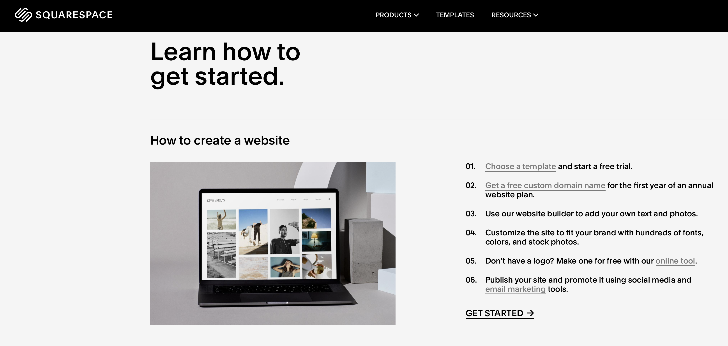
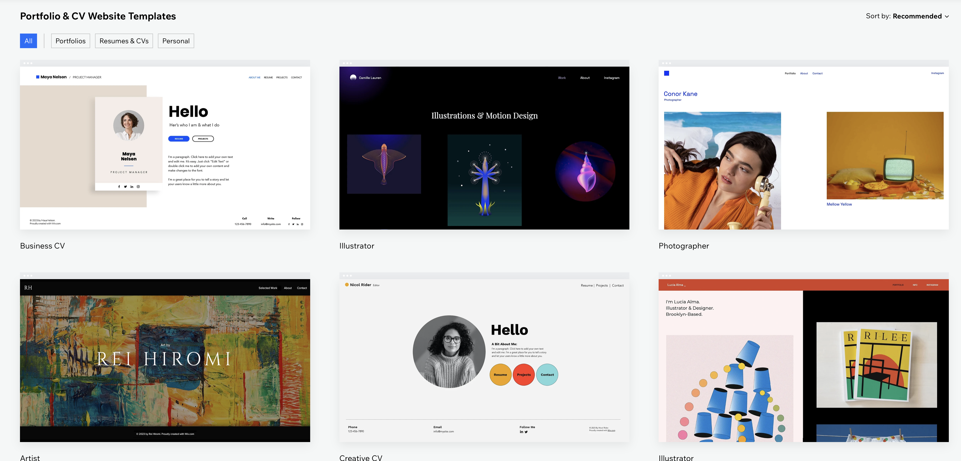






- WIX, Square Space, Adobe Portfolio are affordable and easy to use for publishing an online presence.
http://www.wix.com/
https://www.squarespace.com/
https://portfolio.adobe.com

- Your website should reflect you and your creative identity, aspirations, experience, skills.
It is a showcase of your work in a clean and simple setting. It is a professional public place to view your online portfolio.

- Your online presence is a shop window of yourself and your work. It’s a place where you can sell and promote yourself. It may well become the first-place people get to see your work and becomes a portfolio that you can point to or direct people to remotely.

- Images are key! These make or break your overlook of your website. Please choose wisely. Less is more, only put up your best work. Prepare your images well, you needn’t upload huge resolution images; you could add 1 or 2 decent ones and then downsize to 800px x 600px, at 72dpi .jpg is fine and gives you some protection from your images being stolen.

- ONLY upload images that are YOURS! Use STOCK or COPYRIGHT free images for visualisation purposes or for any posting as this is a PUBLIC domain – credit photographers where appropriate. Pexels.com or Unsplash.com are great resources at your fingertips!

- If you need to upload an image with a transparent background; you can save a file from Photoshop or Illustrator that has no background as .png file and this will appear translucent on any online presence.

- When using a template on WIX or SquareSpace or Adobe Portfolio try and stick to it as much as you can. These are designed well. It’s quite tempting to change a lot, try not to do this too much as it will have detrimental consequences to the whole look of the websites; you will find there might be glitches, or you can’t quite fix what you have undone.

- On-going updating is crucial to maintaining your online presence. Approx. 1 hour a week. Regular blog posts and updating with your best work will keep your website fresh and will encourage regular visits and create a good SEO ranking.

- Choose a font and stick to it. Don’t use crazy fonts that distract from your work. Sans-serif fonts are easier to read and can be less distracting.

- Many of these sites have dynamic reflowing to display your content on phones and tablets.
Wix will let you customise how this is displayed. This is worth bearing in mind as many people will only see your site on their phones or mobile devices.

- All these sites allow you to add a custom domain name. Usually when you sign up to a paid account – this can be useful for the future.

- Picking a good domain name is key. Something that is not too long, memorable, easy to spell and obvious. Ideally com or .co.uk domains are best; you DO NOT need to do this for this submission; but it is worth knowing for future development.

- To add video, you simply embed videos that you have uploaded to your Vimeo or YouTube accounts. If you rely heavily on video content, it may be worth upgrading to a pro account with Vimeo so you content will be at HD when embedded.

- Only add links to professional/career based social media sites you are regularly using. Nothing worse than linking to a dormant account or a generic WIX account with no user interactivity.

- LINKED IN & INSTAGRAM are accounts YOU need to sign up for – what is your name, YOUR BRAND? BRAND YOU! Use your name in the first instance.

https://www.wix.com/blog/2020/12/web-design-trends/

