Strategic Management
Starbucks – Premier Roaster and retailer of speciality coffee.
Amber Jade
2017
Contents
List of Figures 2
1. Executive Summary 2
2. Introduction 2
2.1 Background of Starbucks 2
2.2 Definitions of Major Concepts 3
2.2.1 Levels of Strategy 3
2.2.2 Competitive Advantage 3
2.2.3 Porter’s Generic Strategy 3
3. The Differentiation Strategy 4
3.1 Starbuck’s Differentiation Strategy 4
3.1.1 Corporate Social Responsibility 4
3.1.2 Product Differentiation 5
3.1.2.1 Organisational Differentiation 5
3.2 Advantages of the Differentiation Strategy 6
3.2.1 Attainment of competitive advantage 6
3.2.2 Premium Price Charge 6
3.3 Disadvantages of the Differentiation Strategy 6
3.3.1 Expensive 6
3.3.2 Imitation 6
4.0 Conclusion 6
5.0 Recommendations 7
References 7
Appendix 9

List of Figures
- Figure 1-1 Porters Generic strategy

Executive Summary
This report will examine the strategy that Starbucks have chosen to implement and how they have managed to achieve it successfully. The report will then critically evaluate the strategy and provide recommendations for the company to improve their overall performance. The information provided within this report was collated using a number of sources including books, websites and journals.
The report uncovered that Starbucks uses a differentiation strategy in order to achieve a competitive advantage within their market. The report touches on how Starbucks implements their chosen strategy and also uncovers the advantages and disadvantages associated with it.

Introduction

2.1 Background of Starbucks
Starbucks is a multinational corporation that specialises in sourcing and roasting the highest quality coffee in the world. On March 31, 1971, the first Starbucks store was established in the historic Pike Place Market within Seattle, USA. The company was originally founded by three business men that were inspired to sell high-quality coffee beans by an entrepreneur however, it wasn’t until 1981 that Howard Schultz (Starbucks CEO) first stepped foot into the Starbucks store in which he was captivated by the romance of the coffee experience. The company’s website states that after travelling to Italy in 1983, Schultz had a vision to bring the Italian coffeehouse tradition back to the USA. He left Starbucks for a short period to start his own coffeehouses and returned in 1987 to purchase Starbucks with the help of local investors (Starbucks, 2017). Since then the corporation has expanded rapidly and currently operates in 65 countries across North America, Asia Pacific, the Europe, Middle East and Africa (EMEA), and Latin America (MarketLine Company Profiles, 2015). This ultimately lead to the company becoming a dominant leader within the coffee industry. Appendix A (Statista, 2016) demonstrates the amount of revenue Starbucks has occurred from the years 2003 to 2016. In 2016 the company reported a revenue of 21,32 billion U.S dollars. The company’s mission is to “inspire and nurture the human spirit – one person, one cup and one neighbourhood at a time” (Starbucks, 2017). This demonstrates that the company is highly focused on their performance in relation to their overall customer service. This is proven as one of the company’s core values that they live is “creating a culture of warmth and belonging, where everyone is welcome” (Starbucks, 2017). Starbuck’s also states that they are “performance driven, through the lens of humanity” (Starbucks, 2017).

2.2 Definitions of Major Concepts
Strategy has been defined as “the direction and scope of an organisation over the long-term: which achieves advantage for the organisation through its configuration of resources within a challenging environment, to meet the needs of markets and fulfil stakeholder expectations” (Johnson, Scholes, & Whittington, 2010). An earlier definition of strategy that falls in line with Johnson et al. is provided by Kenneth Andrews, whom states that “strategy is the pattern of decisions in a company that determines and reveals its objectives, purposes or goals produces the principal policies and plans for achieving those goals, and defines the range of business the company is to pursue, the kind of economic and human organization it is or intends to be, and the nature of the economic and non-economic contribution it intends to make to its shareholders, employees, customers, and communities” (Andrews, 1980).

2.2.1 Levels of Strategy
Literature of strategy defines three levels (appendix B) which in the sources are named as corporate-level strategy, business-level strategy and functional-level strategy (Wheelen & Hunger, 2010). Corporate strategy has been described as creating value through shaping corporate activities in multi-business markets (Collis & Montgomery, 2005). In simpler form, corporate level strategy is focused on the decisions that a business makes that in turn affects the overall company. The second level that has been defined within appendix B is business-level strategy which ultimately focuses on the actions a business must take to provide value to customers and gain a competitive advantage by performing activities diversely in order to exploit their chosen market. (Collis & Montgomery, 2005) determined the notion that firms needed to adopt a unified approach to their activities and resource allocation decisions, therefore proving business-level strategies to be of upmost importance in relation to a business’ success. Lastly, functional-level strategy is the third level within appendix B and can be defined as strategies that are developed to support in order to support the business-level strategy (Davis, Aquilano, & Chase, 2003). This is essentially an organisational plan put in place for all functional areas such as human resources and marketing, in order to support the business-level strategy.

2.2.2 Competitive Advantage
Another major concept that ties in with business-level strategy is competitive advantage. As stated by (Ohmae, 1982), what distinguishes strategy from other types of business plans is one word and that is competitive advantage, as the sole aim of strategic planning is to enable the organisation to achieve efficiency and superiority over its competitors. Thus, the existence of strategy would be meaningless without the existence of a competitive environment.

2.2.3 Porter’s Generic Strategy
In 1980, a model was developed by Michael Porter which suggested that there are only three generic business strategies able to be undertaken by a company in order to achieve competitive advantage. As demonstrated in figure 1 below, it is clear to see that both the cost leadership and differentiation strategies seek competitive advantage in multiple sectors of the industry whereas focus concentrates more on cost advantage (cost focus) or differentiation (cost differentiation) in a niche segment (Porter, 2004). The obvious advantage of using Porter’s Generic Strategy framework is that each strategy is able to achieve competitive advantage for a company for example applying a cost leadership strategy would allow an organisation to receive a higher average profit from their products. Although the model is extremely effective it does have its limitation. A prime example of this would be if a company applied a cost leadership strategy it could be easily simulated by competitors.
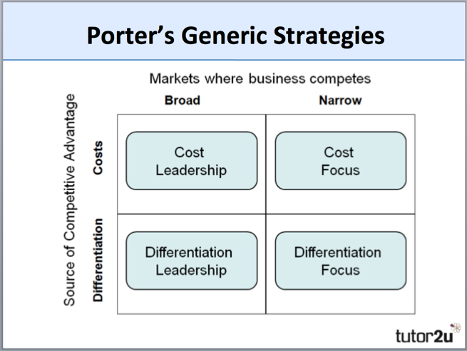
Figure 1-1: Porters Generic Strategy

The Differentiation Strategy
The differentiation strategy is attained when the company is able to offer a product/service that ultimately differentiates from all other products available within the industry, therefore distinguishing the organisation’s brand from all other competitors. There are a number of elements of differentiation, including pricing, product and organisation. In relation to pricing, a business that is applying the differentiation strategy can either choose to determine to offer a lower price in comparison to their competitors or can attempt to create superiority through higher prices. The differentiation strategy often allows a business to charge a premium price for their product due to the high quality in which it offers. A further area of differentiation is achieved via product offerings. By offering innovative products that appeal to their targeted consumers’ needs, a company such as Starbuck’s can achieve a competitive advantage over competitors. This is supported by (Hitt, Ireland, & Hoskisson, 2006) whom states that by using the differentiation strategy an organisation will produce non-standardised products which attract customers who will happily pay for a unique product despite the potentially higher costs. However, this is one of the more riskier forms of differentiation as research development, production and marketing costs can potentially be costly. Lastly, organisational differentiation can be used in order to gain competitive advantage. This essentially consists of a company using the advantages they already possess in order to differentiate themselves from their competitors. This could include location advantages, name recognition and customer loyalty.

Starbuck’s Differentiation Strategy
Starbuck’s have chosen to implement a broad differentiation strategy in order to help them gain a competitive advantage within their target market and to differentiate themselves from their main competitors, including Dunkin’ Donuts, Mc Donald’s and Costa Coffee. Starbuck’s currently use several methods within their differentiation strategy in order to attain a competitive advantage which consist of corporate social responsibility, product differentiation and ….

Corporate Social Responsibility
The first way in which Starbucks attains a competitive advantage via their differentiation strategy is by using an effective corporate social responsibility strategy within it. It is stated by (Carroll, 1983) that corporate social responsibility involves the conduct of a business so that it is economically profitable, law abiding, ethical and socially supportive. Nowadays, CSR plays an important role in a business’ strategy and its overall success, as in recent years more consumers are concerned with a company’s ethical behavior with it almost becoming an obligation and responsibility to a number of companies. Starbucks is currently known as an ethical company worldwide, due to the number of strategies they have in place in order to improve their corporate social responsibility. One strategy that they have in place is ethical sourcing, as their website states that “99% of our coffee is ethically sourced and accredited by Conservation International under our CAFE Practices programme. Our coffee is also accredited by Fairtrade in some of our large European markets. We know our supply chain inside out bringing you unique, sustainably produced coffee from across the world” (Starbucks, 2017) Starbucks’ CAFÉ (Coffee and Farmer Equity) policy essentially allows them to take accountability for the moral, environmental and quality aspects of sourcing, processing and selling coffee. Moreover, Starbucks is currently in possession of an extremely effective strategy that concerns the welfare of their employees. According to (Hale, 2013) Starbucks offers their partners the opportunity to purchase company stock through payroll deductions. Moreover, Starbucks offers all part-time employees that work at least twenty hours health insurance benefits, a benefit implemented by Schultz who watched his father struggle as an employee of companies that did not offer such benefits. By offering such benefits, Schultz expects to retain employees therefore reducing training and turn over expenses and to also generate revenue via customer satisfaction. By ensuring their coffee is ethically sourced and their employees are fairly treated, Starbucks are essentially setting their brand apart from competitors and ensuring that their customers know that they are aware of the impact they have on society.

Product Differentiation
The second strategy Starbucks uses in order to achieve a competitive advantage is product differentiation. It has been declared that product differentiation is a business strategy whereby firms attempt to gain a competitive advantage by increasing the perceived value of their products or services relative to the perceived value of firm’s products or services. This higher price can increase a firm’s revenue and therefore generate competitive advantage (Barney & Hesterly, 2006). Starbucks offers their consumers several differentiators including a premium product mix, beverages and outstanding customer service which ultimately led to the organisation becoming a premium value brand which is costly for competitors to replicate. According to (Thompson, 2017) prime example of Starbucks innovating its product mix would be after the firm had acquired The Coffee Connection, it started offering Frappuccino at Starbucks cafes. The company also introduced sodas in 2014. By developing new products, Starbucks is able to grow and increase overall revenue whilst achieving a competitive advantage.

Organisational Differentiation
Starbucks also uses an effective organisational differentiation strategy in order to gain a competitive advantage and increase their overall revenue. Organisational differentiation can range from location advantages to general brand recognition. It has been stated that the Starbucks company-operated retail stores are located in high traffic, high-visibility locations, such as down town and suburban retail centres, office buildings, university campuses and in select rural and off-highway locations (Wahlen, Jones, & Pagach, 2015). By deciding to place their stores in high visibility locations, Starbucks are able to increase footfall within their branches therefore leading to an increase in profits for the company. Moreover, Starbucks has refused offers to franchise its standalone stores. When companies franchise, outside operators pay to independently build, open and run chain restraint locations with a cut of the profits in return. Franchising allows chains to open more location, faster and with fewer costs for the company (Taylor, 2016). Starbucks CEO Howard Schultz stated that “franchisees are middlemen who would stand between us and our customer, if we had taken the decision to franchise Starbucks would have lost the common culture that made us strong. We teach baristas not only how to handle the coffee properly but also how to impart to customers our passion for our products” (Schultz & Yang, 1997). By deciding not to franchise their stores, this sets Starbucks apart from their competitors therefore gaining a competitive advantage.

Advantages of the Differentiation Strategy

Attainment of competitive advantage
It has been stated that the characteristics of the differentiation strategy can enable an organisation to gain substantial competitive advantage over their competitors (Meek, Meek, & Ensor, 2003). This is ultimately due to the fact that companies are recognised as being different which can attract potential customers.

Premium Price Charge
As touched on previously, the differentiation strategy allows a business to charge premium prices for their products/services. This is due to the fact that if a company can produce a product of a high quality then consumers will be more likely to purchase from the company again therefore encouraging brand loyalty. Brand Loyalty is the tendency for customers to be committed to a particular brand and to continually purchase the same brands products (Block & Roering, 1979).

Disadvantages of the Differentiation Strategy

Expensive
Although product differentiation can attract loyalty from customers, it often comes at a cost. This is due to the fact that product differentiation requires a number of resources in order to undertake effective market research, product development, launch, advertisement and monitoring. In order to cover these costs, companies often need to charge premium prices which can sometimes proceed to the consumer looking for a cheaper alternative.

Imitation
Another disadvantage of the differentiation strategy is the risk of imitation from competitors. This often occurs as competitors may seek the opportunity to use the development of a new product to their advantage by imitating the product in a bid to increase their revenue. A competitor is able to imitate a product in either two ways which are substitution or duplication. Imitation if done right can be potentially consequential for a business due to the fact that if a competitor gains the competitive advantage they could take customers therefore leading to a decrease in profit.

4.0 Conclusion
In conclusion, Starbucks have benefited greatly from implementing their differentiation strategy as they managed to successfully gain the competitive advantage. Due to the fact that they have attained the competitive advantage, Starbucks are able to charge a premium price for their products therefore increasing their overall revenue.
Starbucks have implemented the differentiation via:
- Ensuring CSR is being taken seriously by incorporating it into their values and sourcing the best ingredients in the most ethical manner for their products.
- Providing customers with several differentiators including a premium product mix, beverages and outstanding customer service.
- By deciding to place their stores in high visibility locations, Starbucks are able to increase footfall within their branches therefore leading to an increase in profits for the company.
Starbucks decision to implement the differentiation strategy has led to the attainment of a number of advantages for the company including the ability to charge a premium price for their products and gaining an overall competitive advantage. Nevertheless, there are limitations regarding the differentiation strategy for Starbucks. The first being that competitors could attempt to imitate their product in a bid to increase their profits. Another disadvantage in relation to Starbucks implementing the differentiation strategy is that it is often costly to create an innovative product or service.

5.0 Recommendations
- Continue to implement an effective CSR strategy and use their influence as an organisation to tackle ethical issues.
- Introduce further innovative products in order to appeal to new customers and gain the competitive advantage.
- Continue to focus on their customers instead of profit in relation to not franchising their stores.

References
Andrews, K. (1980). The Concept of Corporate Strategy. Dow-Jones Irwin.
Barney, J., & Hesterly, W. (2006). Strategic Management and Competitive Advantage. New Jersey: Pearson.
Block, C., & Roering, K. (1979). Essentials of consumer behaviour: concepts and applications. Dryden Press.
Carroll, A. (1983). Corporate social responsibility: Will industry respond to cut backs in social program funding? Retrieved from Vital speeches of the day: https://www.vsotd.com/issue/1983-19/corporate-social-responsibility
Collis, D., & Montgomery, C. (2005). Corporate Strategy - A Resource Based Approach. McGraw-Hill Press.
Davis, M., Aquilano, N., & Chase, R. (2003). Fundamentals Of Operations Management. McGraw-Hill Press.
Hale, A. (2013). Starbucks - pursues a broad differentiation strategy . Retrieved from Amanda Hale Online - Strategic Management: http://amandahaleonline.com/2013/10/12/starbucks-focused-differentiation-strateg/
Hitt, M., Ireland, R., & Hoskisson, R. (2006). Strategic Managment: Concepts and Cases. Boston: Cengage Learning.
Johnson, G., Scholes, K., & Whittington, R. (2010). Exploring Corporate Strategy. Harlow: FT Prentice Hall.
MarketLine Company Profiles. (2015). Starbucks Corporation. New York: Alacra Store. Retrieved Oct 24, 2017, from http://www.alacrastore.com/storecontent/MarketLine-Company-Profiles/Starbucks-Corporation-2123-33226
Meek, H., Meek, R., & Ensor, J. (2003). Strategic Marketing Management: Planning and Control. London: Butterworth Heinemann.
Ohmae, K. (1982). The Mind of Strategist: The Art of Japanese business. New York: Mc-Graw Hill Book Company.
Porter, M. (2004). Competitive Advantage. New York: Free Press.
Salimian, H., Khalili, S., Nazemi, J., & Alborzi, M. (2012). Alignment in the organization’s strategy window (concentration on business strategy and operations strategy) . African Journal of Business Management.
Schultz, H., & Yang, D. (1997). Pour Your Heart Into It: How Starbucks Built a Company One Cup at a Time. Hyperion Books.
Starbucks. (2017). Company Information. Retrieved from Starbucks : https://www.starbucks.com/about-us/company-information
Starbucks. (2017). Responsibility. Retrieved from Starbucks Website: https://www.starbucks.co.uk/responsibility
Statista. (2016). Revenue of Starbucks worldwide from 2003 to 2016 (in billion U.S. dollars). Retrieved from Statistics Website: https://www.statista.com/statistics/266466/net-revenue-of-the-starbucks-corporation-worldwide/
Taylor, K. (2016). Why Starbucks doesn't franchise. Retrieved from Business Insider UK: http://uk.businessinsider.com/why-starbucks-doesnt-franchise-2016-9
Thompson, A. (2017). Starbucks Coffee’s Generic and Intensive Growth Strategies. Retrieved from Panmore Institute : http://panmore.com/starbucks-coffee-generic-strategy-intensive-growth-strategies
Wahlen, J., Jones, J., & Pagach, D. (2015). Intermediate Accounting: Reporting and Analysis. Cengage Learning.
Wheelen, T., & Hunger, D. (2010). Strategic Management and Business Policy. Prentice Hall.

Appendix
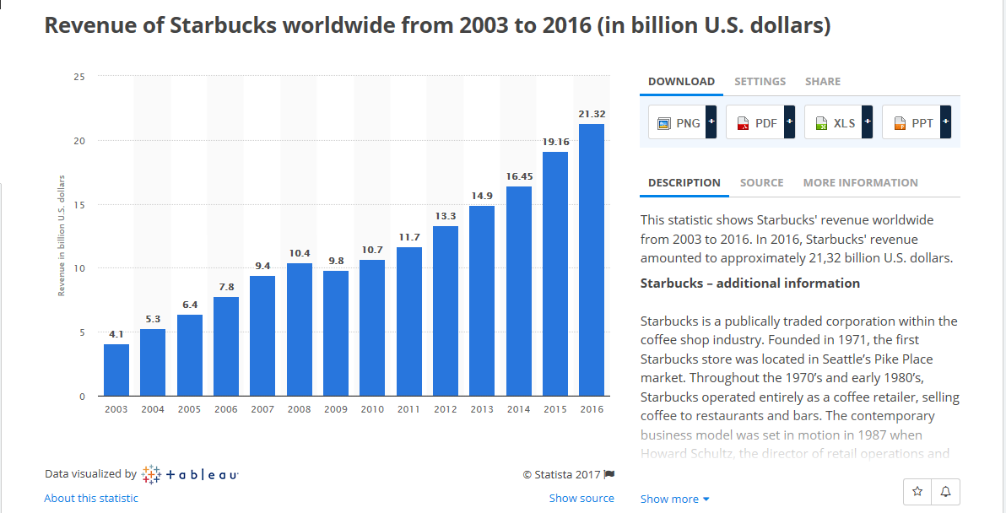

Appendix A - (Statista, 2016)
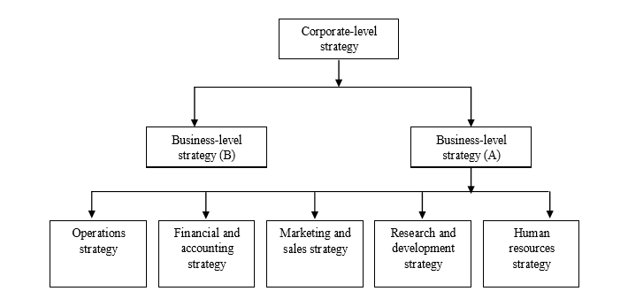
Appendix 2 – Levels of Strategy (Salimian, Khalili, Nazemi, & Alborzi, 2012)

