
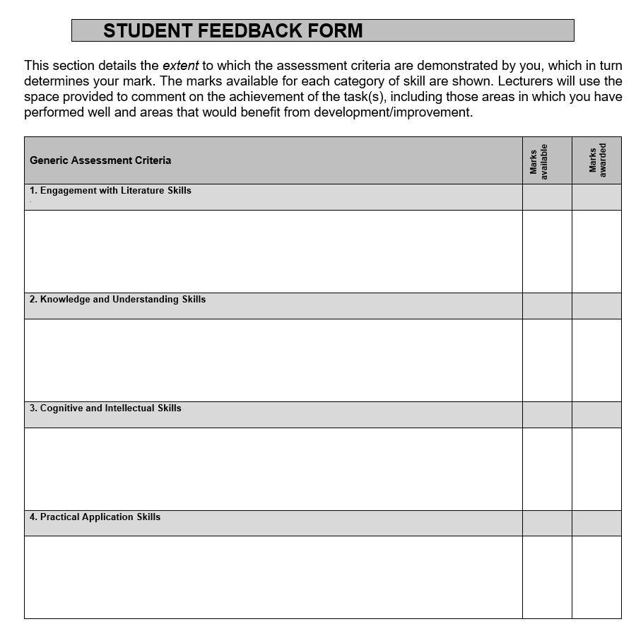
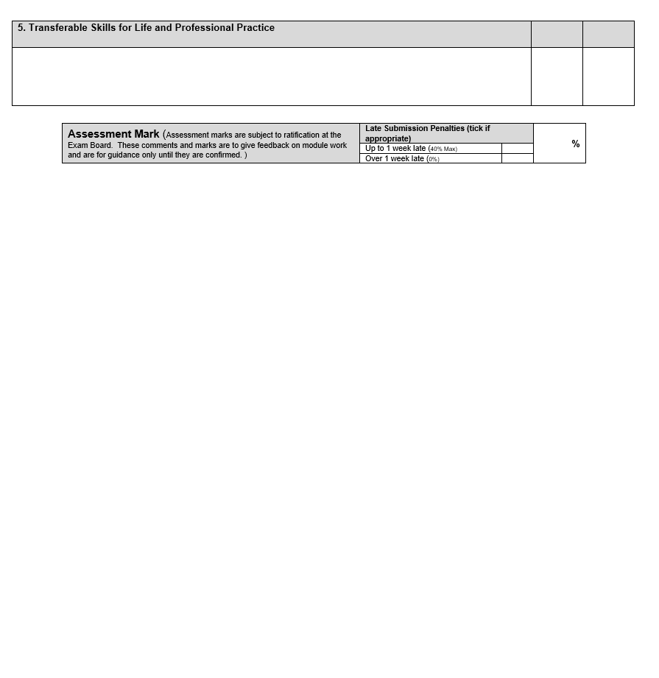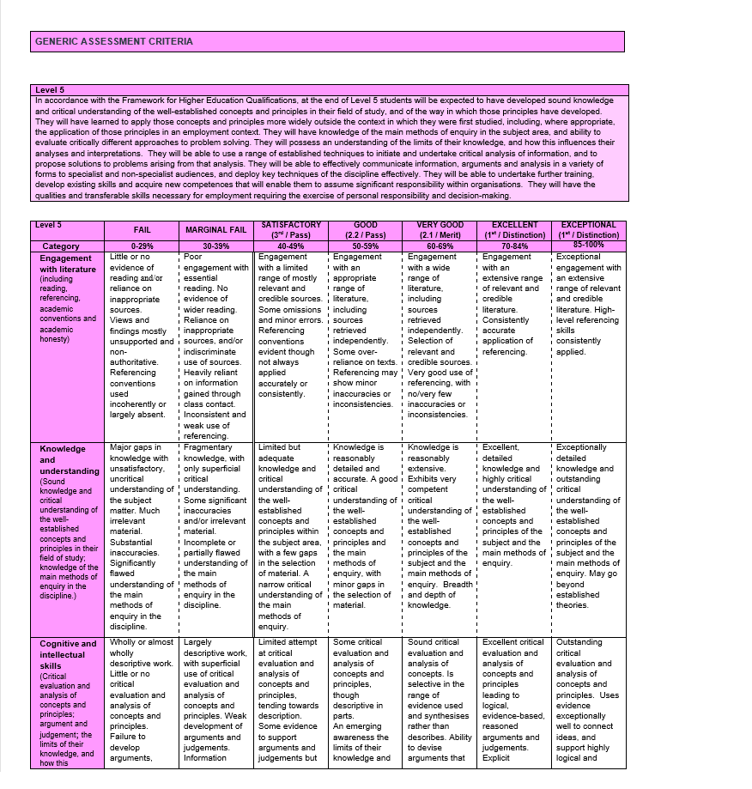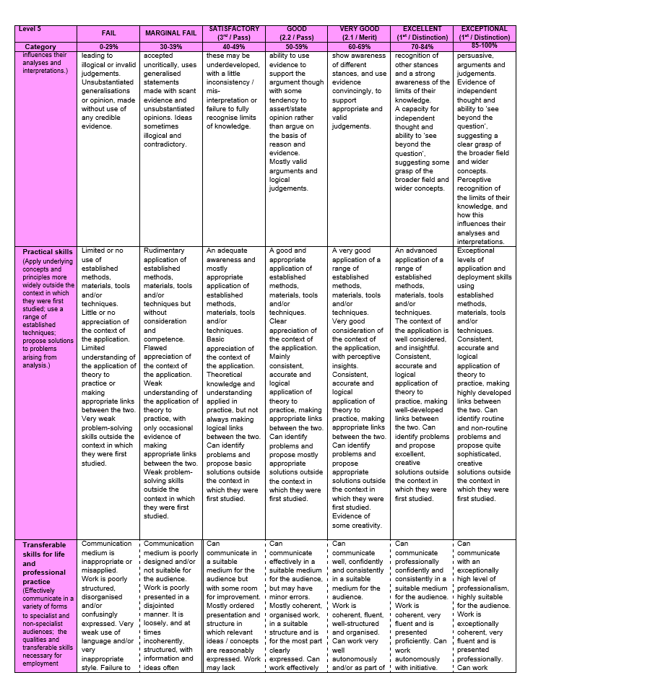

Discuss the importance and effectiveness of developing Assessment for Learning throughout the primary school, including critical analysis of personal implementation of ONE AfL strategy from Professional Teaching Experience.

Assessment for Learning (AfL) is completed formatively, it can occur several times in many different ways during a lesson. It should be viewed as a key component to good teaching pedagogy. When completed effectively, it can shape the lesson to the individual learner’s needs (Black and Wiliam, 1998). The main aim of assessment for learning is to increase engagement and raise academic attainment. AfL should not be confused with assessment of learning, which is summative and often used to hold schools accountable (Black et al. 2003).

There are ten principles of AfL as noted by the Assessment Reform Group (2002), these principles are comprehensive and give practitioners an understanding of the scope of AfL, ideas of how to implement and shows immediate and long-term benefits for pupils and the teacher. When educators plan for AfL, they should have an understanding of theories of learning. Without understanding how someone learns, we cannot hope to understand how we can help them learn. Black (2005), states we can view learning as the closing of a gap in knowledge and that the learner should conceptualise the gap in order to move on in their learning. This draws similarities with Vygotsky’s Zone of Proximal Development, a theory stating that if a step in learning is too large, then the learner would fail. Vygotsky’s social constructivist theories have many benefits in classrooms today as when social interactions are promoted, a more effective classroom environment is generated (Powell and Kalina, 2009). There is strong evidence that AFL is a vital tool in teaching as it allows teachers to assess students as the learning is occuring. It provides students with a confidence that they are being listened to (Rudduck and McIntyre, 2007). This builds stronger relationships between teacher and pupil. We need to always be mindful in the way we deal with feeding back to individuals, there always needs to be a sensitivity (ARG, 2002).

The OECD study states that, “Formative assessment has been shown to be highly effective in raising the level of student attainment, increasing equity of student outcomes, and improving students’ ability to learn” (OECD, 2005, p. 2). There are numerous other supporters of AfL including Gardner (2006) and Ofsted (2011) both supporting the evidence that through assessment we will understand what level the pupil is currently at and that test scores should rise through implementation of effective strategies. Furthermore, teachers themselves will gain important professional values through deploying AfL strategies. Finally and most importantly, pupils will take more pleasure in their learning, as they have more understanding of it (Black et al. 2003). To improve the effectiveness of AfL there are a myriad of things to consider. Making sure the learning is at a suitable level for the individual is an effective starting point. Hallam, Ireson and Davies (2002) note that through effective pupil grouping, the practitioner should already be aware of pupil’s abilities and use the information to group pupils specifically to each task or learning outcome desired. Hallam, Ireson and Davies (2002) and Powell and Kalina (2009) agree that competent pupil grouping engenders opportunities for cooperation through group work and interactions with all peers.

AfL is separated into four elements, these are peer and self-assessment, quality of questions, use quality feedback and sharing criteria with learners (Black and William 1998). These are all vital aspects to consider when planning the use of an AfL strategy and all come with their own benefits and negatives. As good practitioners it is vital to constantly reflect on all strategies, especially when first introducing them. What works for one student, class or school may not work for the other (Black et al. 2003).

There is support for the wide ranging benefits of AfL including reports from Estyn (2018) and ARG (2002) who both support the idea that by contributing their own ideas, and shaping their own learning that learners gained self-efficacy. Grigg (2015) knows that this is important because once self-efficacy is established, a learner is inclined to view difficult tasks as a challenge rather than alarming. Another aspect is that self-assessment and engaging learners to consider their own understanding develops thinking skills (Grigg, 2015). This is beneficial to the pupil and something the new curriculum for Wales looks to promote when it speaks of pupils thinking “creatively to reframe and solve problems.” The curriculum goes on to talk about how thinking skills are a valuable asset for children in an ever-changing world and another reason for teachers to provide AfL in all possible lessons (Donaldson, 2015, p. 31). Potential downfalls with AfL can occur when students are directly compared to each other, this could be viewed as rivalry as opposed to bettering oneself. This goes against the humanist theory, which looks to support individual’s emotions (Holt, 1990). In addition to this, when providing feedback some low attaining pupils feel de-motivated as they feel they are unable to achieve the desired level (Black et al., 2005).

To counteract negative aspects the teacher should strive to build a solid and trusting relationship with individuals and should promote strong pupil-to-pupil bonds so that there is a culture of respect in the classroom (Grigg, 2015). Educators should ensure that they are not completing AfL purely for superficial reasons. They must follow through with the feedback received from pupils and act upon this if necessary. (Dassa et al. 1993) quoted in Black et al. (2005).

It is important to consider planning for AfL throughout the primary school, as beneficial learning takes place with a spectrum of learners through all ages. We need to consider the whole person and how they develop throughout their school life, mentally, physically and emotionally (Claxton, 2009). It is a key professional skill, providing information about progress towards learning goals which ties into QTS standard S3.2 (WAG, 2009).

The strategy implemented was a certainty line, this is a way for pupils to express how well they understand a topic. Curriculum documents highlight that in foundation phase we need to foster in children an understanding of themselves, this understanding is shaped by a teacher’s feedback, leading to pupil’s ideas of their own self-worth (WAG, 2015). The strategy consists of two small whiteboards placed apart in the classroom. Words and pictures are added to these to engage the pupils. The idea was modified for a year two class by using a happy and sad face with the words ‘hapus’ and ‘trist’ written underneath. The faces were used as a continuum from the happy-face feedback pupils provide in books. The substitution of English to Welsh words was a simple way to include more Welsh language in the pupils learning.
This is a physical way to engage the pupils in providing feedback. The teacher should highlight an area between the two boards for the pupils to stand in if they understand some elements but not the whole topic. This strategy combines elements from Bloom’s taxonomy when individuals remember previous lessons and activate their prior knowledge, also when pupils demonstrate comprehension of their understanding by applying previous knowledge to a new topic (Darwazeh, 2017).

The strategy lies mainly in the constructivist theory of learning with the teacher using poor answers or a lack of knowledge to explore misconceptions (Grigg, 2015). Although this task can make children feel that they are put on the spot, there are elements of a humanist approach touching on esteem issues highlighted in Maslow’s Hierarchy of Needs (Maslow and Frager, 1987). The child is at centre of learning, the practitioner wants to understand what the pupil already knows, in order to further help them. The teacher can use poor answers to explore misconceptions, this enables children to be confident in trying to answer. A way to ensure there is trust in the teacher is for the teacher to take a personal approach and let the children know that it is ok to not be sure of something and relate it to yourself as a teacher. The strategy focuses on the quality feedback element of AfL, for effective feedback there should be a focus on pupil’s perception of a topic, instead of focussing on the delivery or observed behaviour. Feedback should lead on to moments that the teacher has prepared themselves for in order to support the learner and extend their knowledge (Gardner, 2013). Peer and self-assessment is another element of this strategy and there is also support as pupils can judge their own thoughts and this gives additional time for students to expand their knowledge about a topic (Sadler and Good, 2006).

From observations and discussions with fellow practitioners, it was noted that the class were very engaged in providing feedback through this method. There were some pupils who lacked knowledge in the topic and this was addressed instantly through questioning the whole class to provide a suitable peer-led answer. When individuals were questioned about why they were stood near the sad face they seemed genuinely pleased to engage in further discussion as they had a good relationship with the teacher and felt secure in this interaction. This will help the teacher understand where the gap in knowledge is and how this can be bridged during the lesson (Stobart, 1997). Upon reflection there are potential negative aspects, as individuals may be more interested in the act of moving, rather than considering their understanding of the topic. The strategy could have been vastly improved through differentiation when questioning the pupils. Combining previous assessment and the formative feedback an effective teacher should recognise the individual’s strengths in each subject and design the activities around their current level of knowledge (Sutton, 1998). A further improvement for consideration is to record the pupil’s responses for later use. This record could have been completed by the children when they leave a name tag near the happy or sad whiteboard. The teacher could also have recorded the class on an ipad to view at a later time. Although it should be stressed that the record keeping should not slow the pace of the lesson and should not stop the class teacher from providing formative feedback which is such an important element of AfL. The specific strategy used should be clearly explained to the pupils before asking for feedback. There are potential safety issues if children push each other or moving too fast and fall over so these guidelines should be laid out prior to implementation.

The strategy could be extended throughout the school into key stage two by replacing the words used with more complex vocabulary suitable for older children. Potentially the pupils could be asked to leave a small note or buzzword on the whiteboards to show their understanding. When discussing teacher assessment, the government is looking for “End-to-end process to ensure quality, consistency and reliability” (WAG, 2014). A continuum of a specific strategy through the whole school has its own positives and negatives. The pupils will already know the process and feel more secure in providing feedback although if a strategy is not engaging then the pupils will lose engagement with it. To keep any strategy relevant and engaging the practitioner should adapt it to the pupils. A strategy should be replaced if it is no longer viable.

From the critical engagement the research suggests that AfL promotes listening, verbal communication, critical thinking and decision making (Black et al. 2003). For any AfL strategy to be implemented effectively, the pupil’s first need to have a good relationship with the educator, they also need to be secure enough in themselves and have a mutual respect with their peers providing the feedback. Black et al. (2003) and Grigg (2015) support AfL when they talk about it being a useful tool to help raise attainment and increases teacher’s focus on learner’s development. With effective use leading to support for pupil tracking, marking and implementing targets (Ofsted, 2011). From the research it appears that all AfL strategies could be considered humanistic. Not only is it benefiting the pupil, but does so in a way that helps them feel more in touch with their own learning. More research would be required to develop a deeper knowledge of all the potential negatives associated with AfL.
From my critical engagement and research we can see that formative feedback helps pupils and teachers to explore wrong answers and misconceptions. These can then be removed from the learners thinking. There is a need to remove misconceptions, otherwise these may continue to be help by the individuals, and this is an invaluable element in the process of learning (WAG, 2010) Effective use of ICT could revolutionise AfL by helping teachers to personalise learning within the curriculum to individual through greater amounts of pupil-led teaching. Technology facilitated learners to be involved in their own target-setting and for teachers to provide more individualised feedback (Somekh et al. 2007). Through observation and assessment, children make sense of their own world, now practitioners need to assess and observe pupils understanding to make sense of the pupil’s world (Smidt, 2015).

Reference List

Assessment reform group. (2002) Research-based principles to guide classroom practice.
Available at: http://www.hkeaa.edu.hk/DocLibrary/SBA/HKDSE/Eng_DVD/doc/Afl_principles.pdf
(Accessed: 13 December 2018)

Black, P. and Wiliam, D. (1998). Inside the black box. 1st ed. NferNelson: London.

Black, P., Harrison, C., Lee, C., Marshall, B. and Wiliam, D. (2003). Assessment for Learning. Putting it into practice. 1st ed. Maidenhead: Open University Press.

Black, P. (2005). Testing: friend or foe?. London: RoutledgeFalmer.

Cambridge-community.org.uk. (2018). Getting started with Assessment for Learning. [online] Available at: https://cambridge-community.org.uk/professional-development/gswafl/index.html [Accessed 11 Dec. 2018].

Claxton, G. (2002) Building Learning Power, Bristol: TLO Ltd.

Darwazeh, A. (2017). A New Revision of the [Revised] Bloom's Taxonomy. Distance Learning, 14(3), 13-28.

ESTYN (2018) School offers a flexible approach to learning
Available at: https://www.estyn.gov.wales/effective-practice/school-offers-flexible-approach-learning
(Accessed: 12/12/2018)

Gardner, J. (2013). Assessment and learning. London: SAGE Publications Ltd.

Grigg, R. (2015). Becoming an outstanding primary school teacher. 2nd ed. Oxon: Routledge.

Hallam, S., Ireson, J. and Davies, J. (2013). Effective pupil grouping in the primary school. 1st ed. Abingdon, Oxon: Routledge.

Holt, J. (1990). How children fail (2nd ed.). London: Penguin.

Maslow, R., Frager, R., & Frager, Robert. (1987). Motivation and personality (3rd ed. / (revised by Robert Frager .. et al.). ed.). New York ; London: Harper & Row.

Oecd.org. (2018). FORMATIVE ASSESSMENT: IMPROVING LEARNING IN SECONDARY CLASSROOMS. [online] Available at: http://www.oecd.org/education/ceri/35661078.pdf [Accessed 11 Dec. 2018].

Ofsted. (2011). The impact of the ‘Assessing pupils’ progress’ initiative. Manchester. Ofsted.

Rudduck, J. and McIntyre, D. (2007). Improving learning through consulting pupils. London: Routledge.

Sadler, P. and Good, E. (2006). The Impact of Self- and Peer-Grading on Student Learning. Lawrence Erlbaum Associates, Inc. Cambridge. Harvard.

Smidt, S. (2015) Observing Young Children. 2nd Edition. London. Routledge.

Somekh, B. et al. (2007). Evaluation of the ICT Test Bed Project The Qualitative Report.
Available at: https://dera.ioe.ac.uk/1590/7/becta_2006_icttestbed_qualitative_report_Redacted.pdf
(Accessed: 09/12/2018)

Stobart, G. and Gipps, C. (1997). Assessment. London: Hodder & Stoughton.

Sutton, R. (1998). Assessment for learning. Salford: RS Publications.

Welsh Assembly Government. (2009) Becoming a Qualified Teacher Handbook of Guidance 017/2009 (2009), Cardiff: WAG.

Welsh Assembly Government (2015) Foundation Phase Framework
Available at: http://learning.gov.wales/docs/learningwales/publications/150803-fp-framework-en.pdf
(Accessed: 10/12/2018)

Welsh Assembly Government. (2010). How to develop thinking and assessment for learning in the classroom. Cardiff. Welsh Assembly Government.

