Professional Development
Student Name: Michael Ridgway
P Number: 1701446

Table of Contents
1. Part A 2
1.1 Introduction 2
1.2 Placement Benefits 2
1.3 Placement Rationale 2
1.4 Placement Opportunities 2
2. Part B 3
2.1 Qualifications Audit 3
2.2 Training Needs Analysis 3
2.5 Pre-Placement Review 3
3. Reference List 3
4. Appendix 0
4.1 Personal Career Action Plan 0
4.2 Curriculum Vitae 0
4.3 Cover Letter 0

1. Part A

A work placement is important for the development of students and young adults to understand the real world and gain experience in a working environment opening up opportunities and developing life skills. As the NCUB (National centre for universities and business) states that “It increases their knowledge of an industry or sector, allowing them to make better informed decisions about future career choices.” As an adult in everyday life its about making the correct choices to benefit yourself and others which works in the work place, any actions taken affect the business whether it be positive or negative. Another reason why work placement is important is because a lot of young people don’t know what career they wish to pursue and as the website all about careers explains “it’s a way of exploring different jobs without actually committing to anything. You can dip your toe in the water without taking the full plunge.”

As a Sports management student finding a placement that relates to the course whether it be sport or leisure is important to benefit me gaining my degree and also in later life with what career path I decide to take. The future career I would like once I finish my degree is to be a sports development officer, this role appeals to me as it focuses on working with younger people and getting more young people involved in sport keeping them fit and active as well as out of trouble. I considered a few different options such a Swansea city Football club, the Welsh rugby union as well as Dragons rugby in Newport.

The sports management degree as explained by the university of wales trinity St David website “will prepare students for future sports and recreation management careers. Early career skills and knowledge will be developed through studying skill acquisition, coaching and instructing processes whilst introducing key theories and issues affecting the sports and leisure industries.” With this in mind I looked towards a placement that would coincide with this and develop my learning further in the sports sector and help me when I come back from placement to carry on and complete my degree.

I chose to pursue a placement with Dragons rugby as it fits in with my career path of sports development officer. My degree requires me to complete a placement as the main aim of the course is “tracksuit to boardroom” going from coaching children with the degree to pursuing a career working with children as a development officer in the future.
Dragons rugby is one of the main four regions in Wales making them a big organisation to work for an completing a placement with them hopefully helps me gain a foot in the door towards my career path. A placement with the Dragons is also more suitable for me as its very local and having previously worked with them before is a bonus as I know the employers.

The other options I considered such as Swansea city football club, they are one of if not the biggest club in wales playing at a top level in the English football pyramid and opportunities to work for them are very slim and with the high chance of myself travelling from home the distance is quite substantial if I was to travel daily. My other consideration was the Welsh rugby union, I have previously worked with this organisation within the last year and although the opportunities are there as well as being able to work for the main rugby governing body in Wales offers great career opportunities, I managed to gain the contacts in the Dragons through the Welsh rugby union and after having a taster for both the Dragons rugby appeals far greater.

2. Part B

The second part of your portfolio should focus on identification of the knowledge, skills and attributes you possess that you can offer to the placement provider.

Consideration should be given to the following areas:

2.1 Qualifications Audit
Qualifications required for a sports development officer | Have I gained the qualification?
 | Yes | No
Sports degree |  | (pending)
BTEC sports science level 2
BTEC sport science level 3
GCSE PE
GCSE Maths
GCSE English
Any sports coaching qualifications | 1 – WRU rugby leaders

2.2 Training Needs Analysis

For myself to be considered for a role as a sports development officer I would need to gain more experience working with young people and gain some coaching qualifications so that I could be able to lead groups for sessions in various sports and not limit myself to one specific sport. I also have to become fully first aid trained to deal with any injury or incident that occurs and deal with it appropriately and professionally. Being a sports development officer requires working in a group as a team with other officers so I’d have to develop my team work skills from a student level to a professional work place level as well as being organised and ahead so that I can be productive and offer my services on the job to the best of my ability.

2.5 Pre-Placement Review

Whilst looking into placement options I took into consideration factors such as travel, career opportunities and cost. Taking all of those in consideration were vital as the placement has to benefit me in all aspects. Basing my search on this I looked towards professional sports organisations in Wales such as Swansea city football club, the Welsh rugby union and Dragons rugby. These all offer a potential career pathway and job role of a sports development officer which is my end goal after gaining my sports management degree. One of the problems I faced is getting into aa professional sports team is very difficult and they don’t offer many opportunities for a work placement. Trying to get hold of them via email came with great difficulty which is why my previous experiences ended up being very useful. I have previously worked with the Welsh rugby union for a placement and was given work with Dragons rugby through them which is why I decided to use my contacts to pursue a placement with the Dragons rugby. This works very well for me as it is not far from home which limits travel time and costs and it also offers the job role of a sports development officer. I got in contact with the head of community rugby of the Dragons explaining that I need to complete 8 weeks and 200 hours minimum of work placement for my university agree which was complied with on their end without much hassle, all I am required to do now is have the relevant paperwork filled out and agree on a start date.

3. Reference List

- Business, N. (n.d.). What are the benefits of a quality placement? [online] NCUB. Available at: http://www.ncub.co.uk/placements-report/the-benefits-of-a-high-quality-placement.html [Accessed 7 Jan. 2020].
- Allaboutcareers.com. (n.d.). Why is Work Experience Important? | AllAboutCareers. [online] Available at: https://www.allaboutcareers.com/careers-advice/work-experience/why-is-work-experience-important [Accessed 7 Jan. 2020].
- UWTSD, W. (2020). Sports Management (Tracksuit to Boardroom) (BA, HND, Foundation Degree) | University of Wales Trinity Saint David. [online] Uwtsd.ac.uk. Available at: https://www.uwtsd.ac.uk/ba-sports-management/ [Accessed 7 Jan. 2020].

4. Appendix

4.1 Personal Career Action Plan

Personal Development Plan

Name: Date:

Objectives  What do I want to be able to do  or do better? | Success criteria  How will I recognise success?  How will I review and measure my improvement? | Actions  What methods will I use to achieve my learning objectives? | Implementation  How will I practise and apply what I learn?
Gain various sports coaching qualifications | Being able to coach various sports successfully.  Running a session and seeing the overall success of the session and gaining feedback from participants | Using various sports organisations and  governing bodies to complete coaching qualifications | Running sports sessions and coaching people of all ages the skills, I have learnt.
Understanding more about my desired career job role of a sports development officer | Being able to understand what goes on in the daily life of a sports development officer and the challenges they must overcome and able to answer any questions about the job role. | I will use various sports organisations websites with job descriptions as well as employment agencies that can help me understand the role. | Using what I have learnt to go out of my way and carry out things that will help me develop into a sports development officer. Being proactive and searching for vacancies.
Being able to work better in a team  environment and understanding  team goals not just individual goals. | Working within a team and achieving  success through outstanding work  results. | Communicating well with colleagues  and team members to achieve the best results. Asking for advice and offering help instead of being an individual. | Taking on teamwork and challenges not just  doing individual tasks.
Being more organised and prepared when running coaching sessions and other activities | No noticeable disruptions or long  delays in sessions everything runs  smoothly and everyone is happy. | Planning in advance writing things out and getting advice from people with more experience. | Running sessions and activities based on what I have written down and planned either earlier on or in the days previously in the build up to the session

4.2 Curriculum Vitae

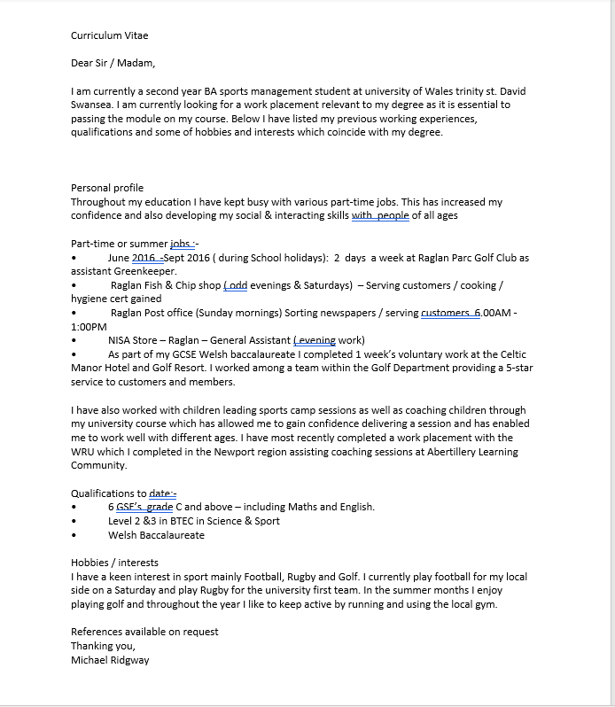

Above is my CV which I used to apply for placements it shows my sports related experience and interests as well as work outside of sport showing my experience in a working environment and the development of skills because of this.

4.3 Cover Letter

A professional Cover Letter that is aimed at your preferred placement.

Below is a cover letter for my chosen placement Dragons rugby sent to Head of community Rugby, Mr Mike Sage.



