

Computer and Network Architecture

WC April 22 - 29, 2013

Faculty of Applied Design and Engineering
School of Applied Computing
Mount Pleasant Campus
Swansea
SA1 6ED

- INTRODUCTION AND OBJECTIVES OF THE Exercises
In your lectures, you learnt about Network devices, Network topology, Communication models, IP Addresses, Internet and Active Directory. In this exercise you are required to use Virtual Box to install Windows 2008 server, create Active Directory and install Window 7. You will be connecting a client to a sever in the Active Directory.

Procedures using Virtual Box to instal Windows 2008 Sever and creating your Active Directory.

First open Virtual Box, the icon is on the desk top, following the below procedure to create your virtual machine.
Select new at the top left hand corner
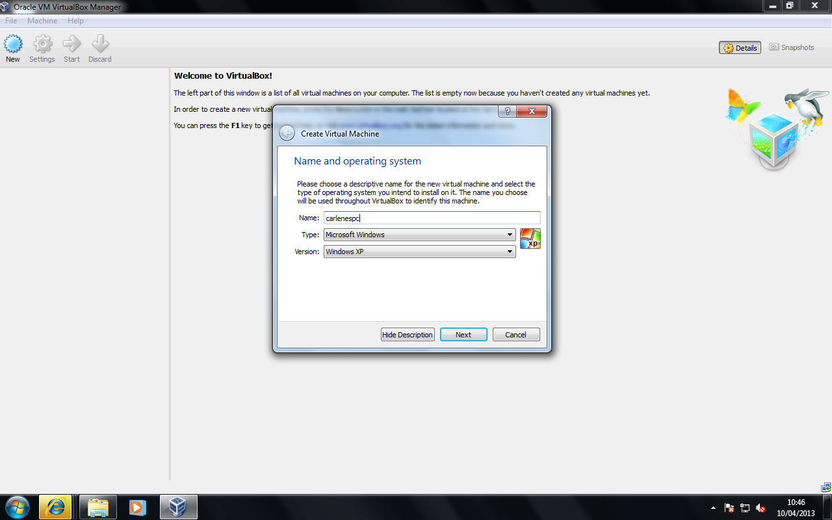

Choose a name and an operating system type/version.

Click Next

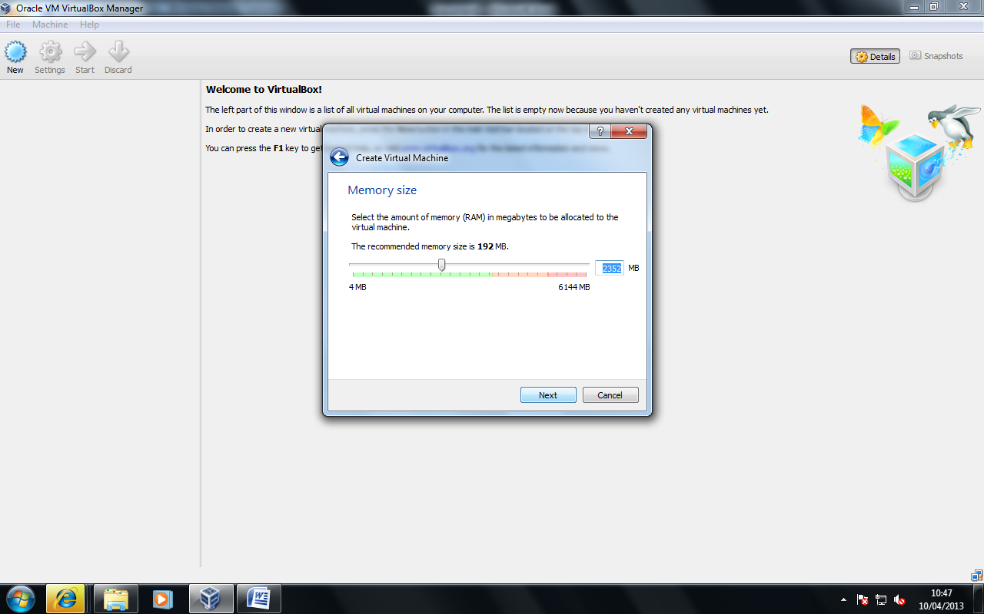
Assign sufficient memory (approx 2.5GB for Windows Server 2008)

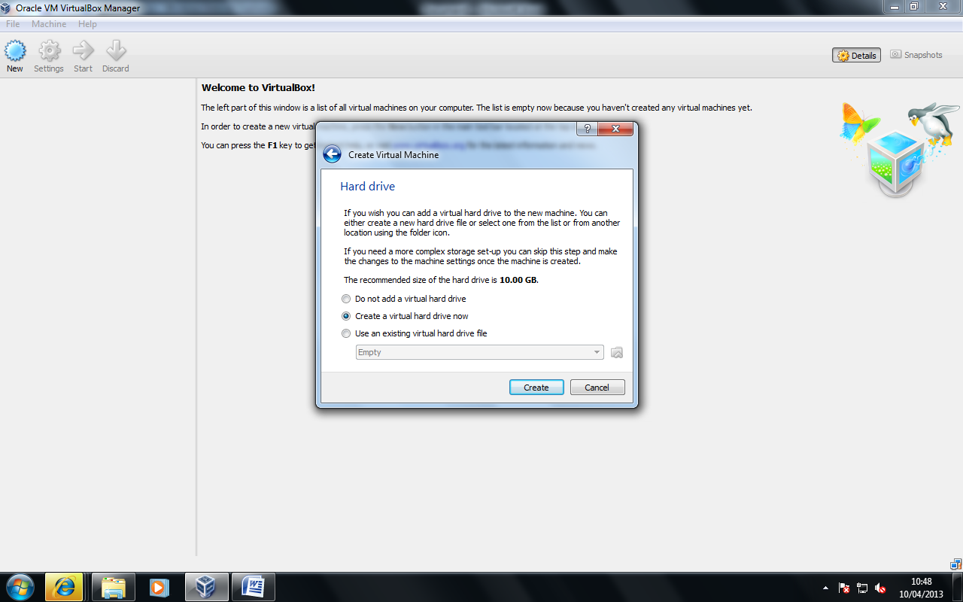
Assign a hard disk for the virtual machine (Create a virtual hard drive now).
Click Create
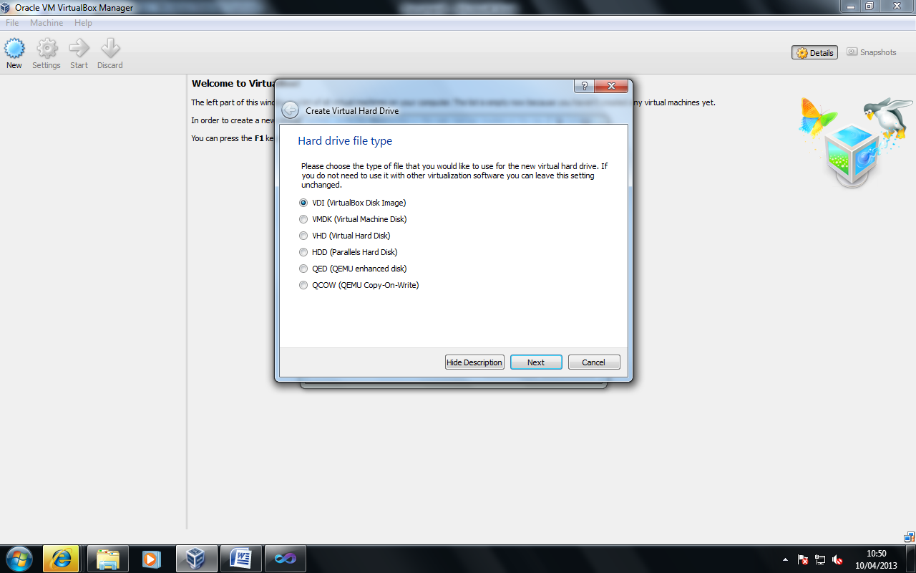
Choose default .VDI (this is used for easier porting between different physical systems).

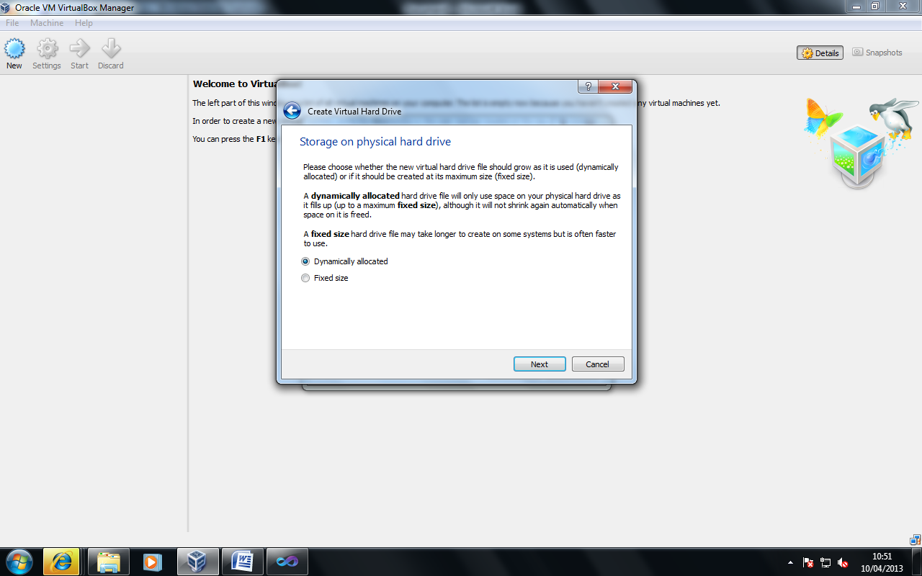
Here we create a dynamic disk, so that in result of the file system capacity reaching its threshold, it will dynamically adjust (as oppose to crash).

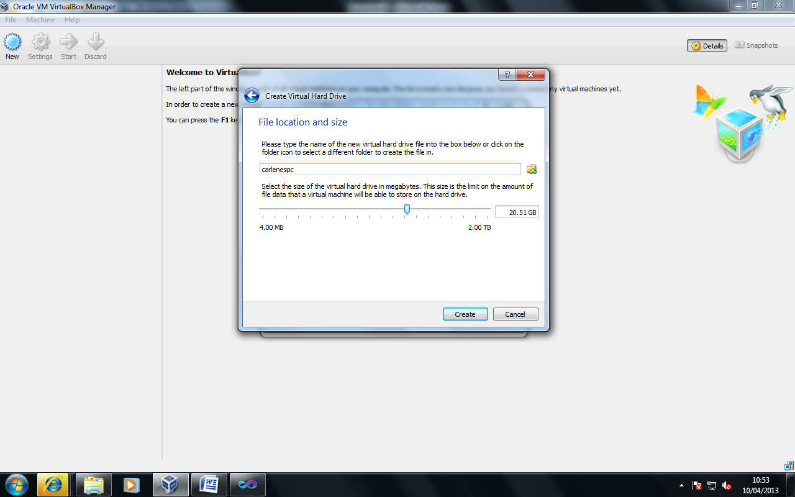
Assign disk capacity (you can do this by entering a value or adjusting the slider) 20GB is recommended for this OS version. Click Create
You now have your virtual PC created. We now need to install the Operating System, the best to envision what you have just done is this; You have effectively built a PC with its individual components (e.g. RAM, HDD, OS VERSION), now we need to power on the PC and install an Operating System.
Before we install an Operating System, we need to tell the system where we have the install media (e.g. Windows DVD) located. In physical systems we need to go into a program called the BIOS, however with Virtualbox, this is far more straightforward.

Click Settings:
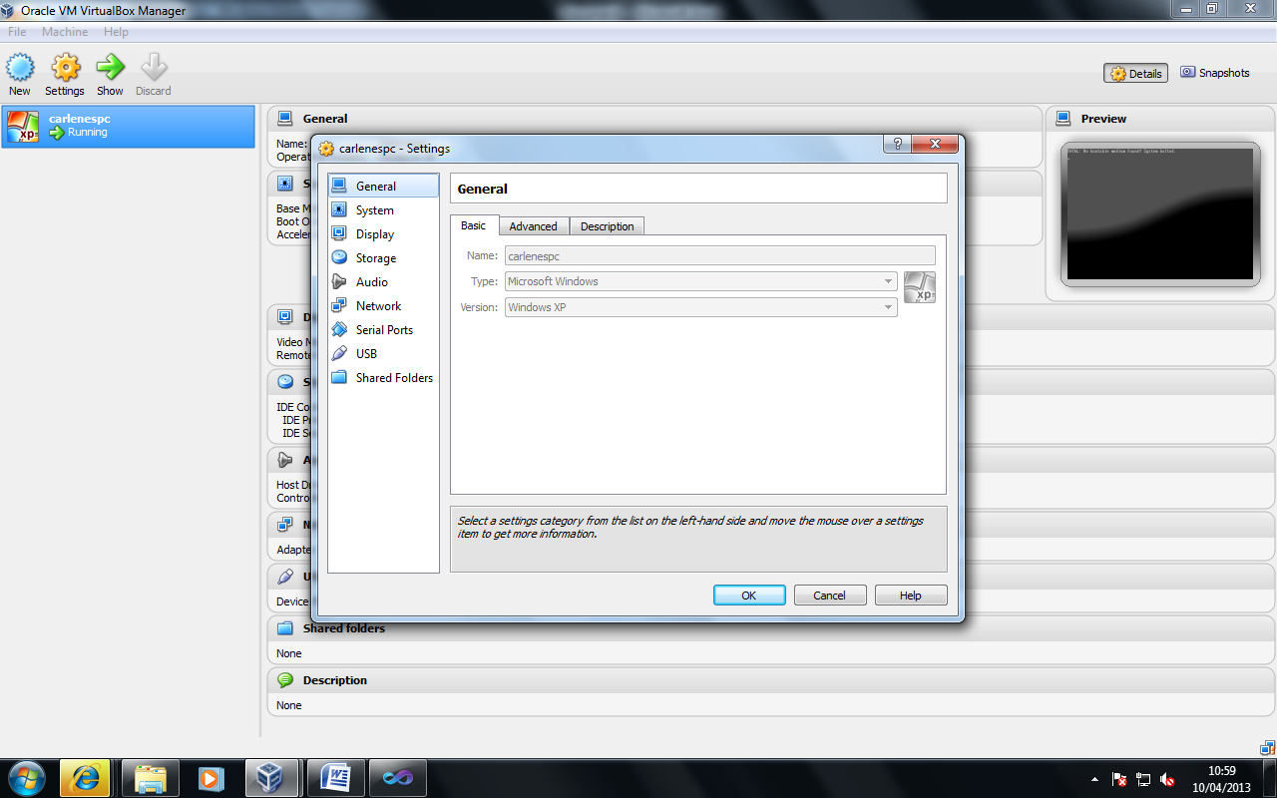

Now choose the System option from the left hand menu.

We need to make the cd drive the first bootable drive, you can do this with the arrows at the right of the options (e.g. CD Drive 1st, Hard Disk 2nd, Floppy Drive 3rd etc).
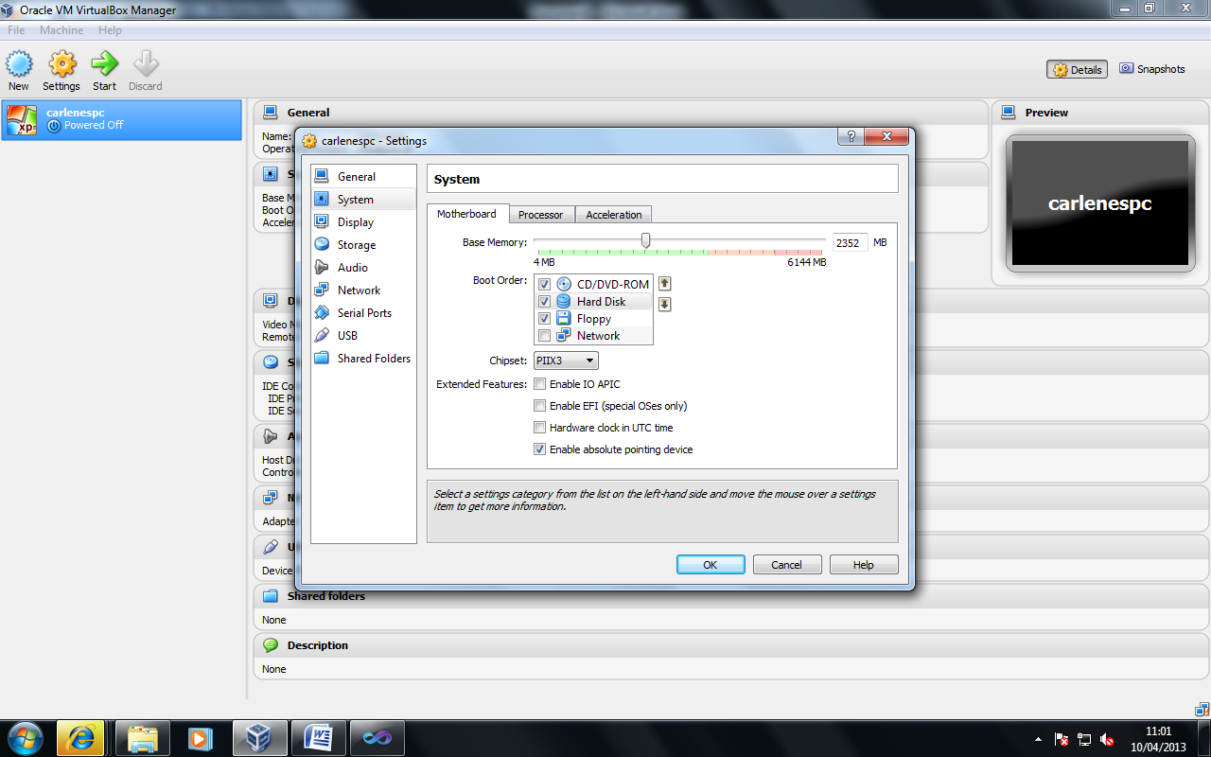
You can see our PC in the left hand console, to start click the green Start arrow on the top menu.
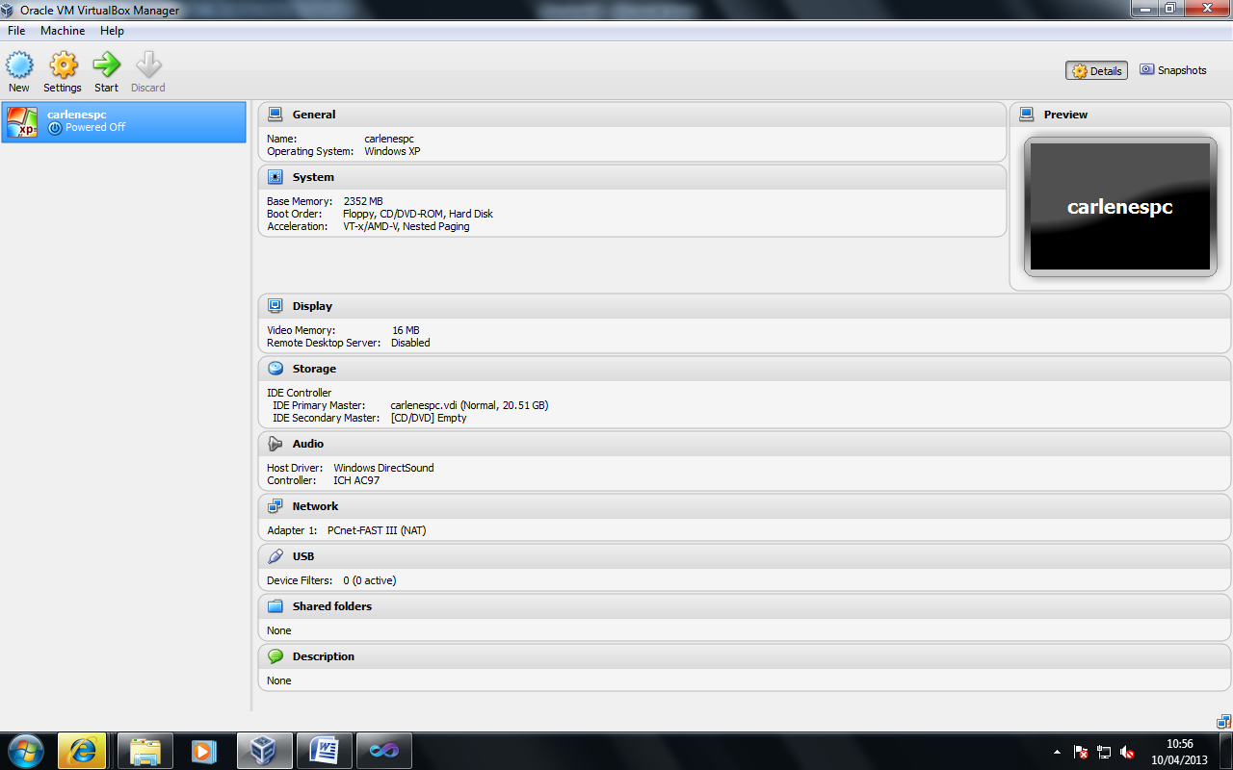

At this stage place the DVD provided into the drive.

You will see that the system moves immediately into Windows Setup.
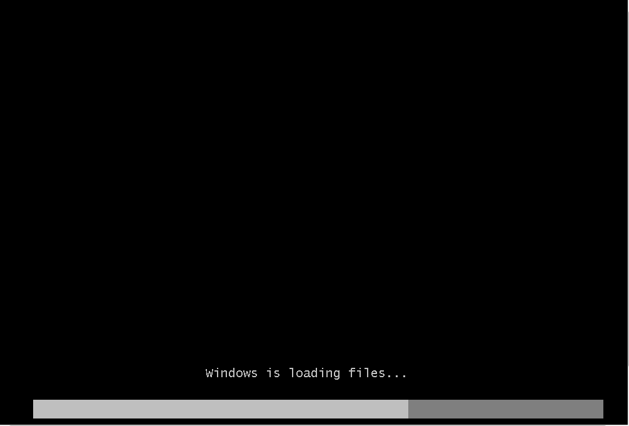

Select United Kingdom settings :
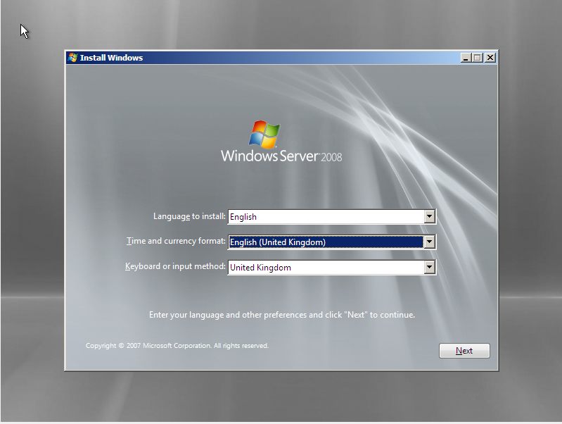
Choose Next
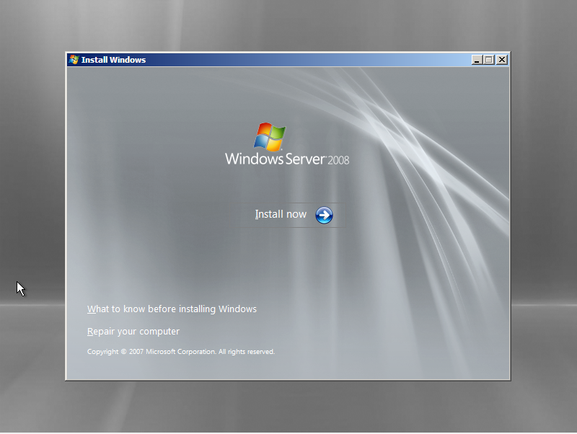
Choose Install Now
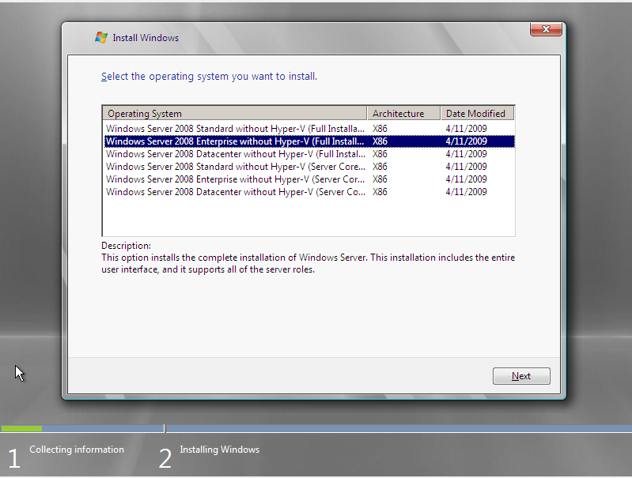
Select Enterprise Edition, choose Next:
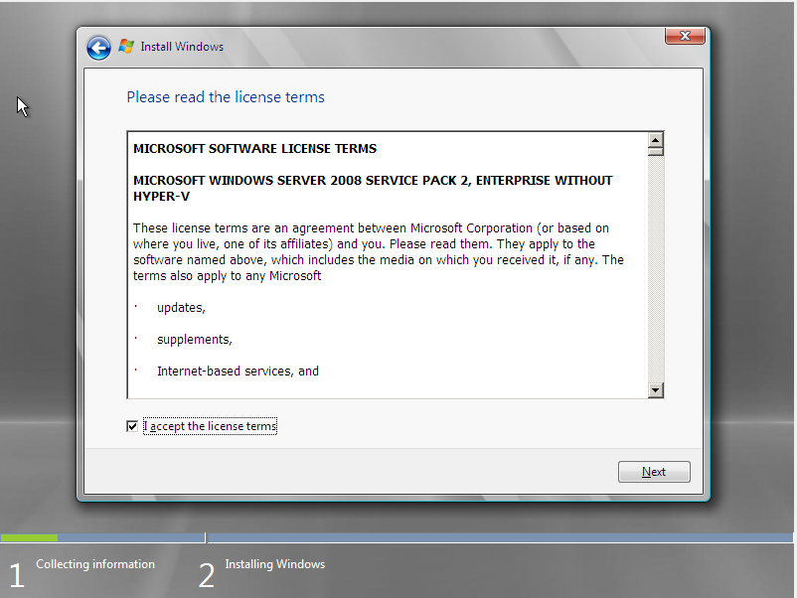
Accept license terms, click next:
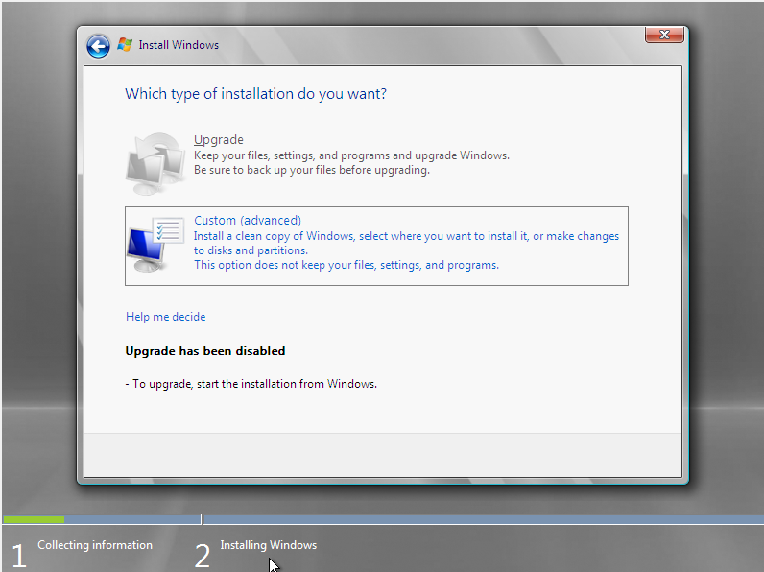
Choose custom (advanced):
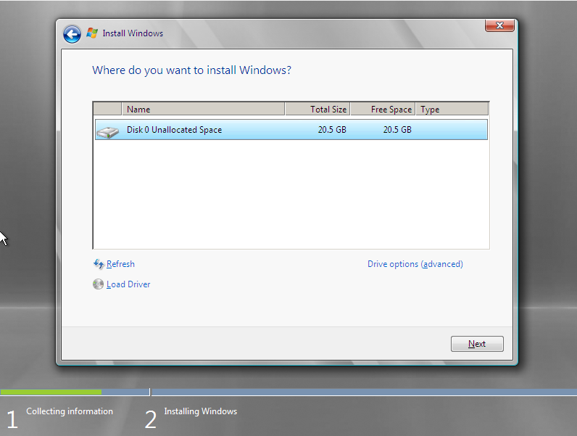
Here you can see the disk we created earlier (note the 20GB capacity shows us we are using the right disk), choose Next
Windows will now install (this should take around 30 minutes).
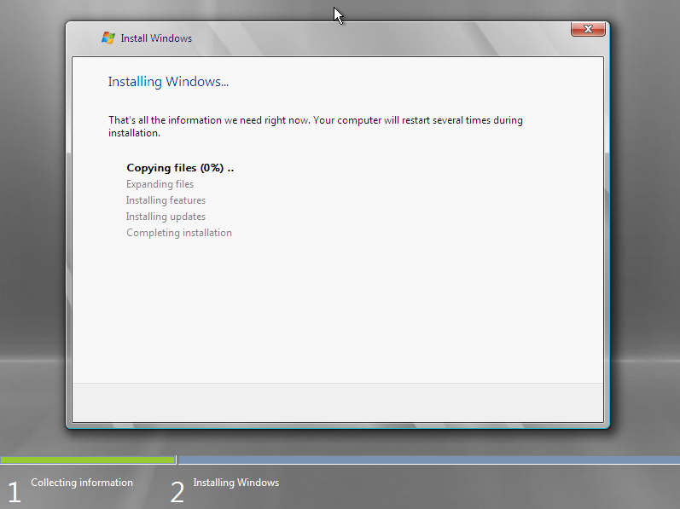

After the server installs successfully, you should now shut down the server to configure network settings.
One of the aims of this tutorial is to develop a simple client/server architecture. To do this we need to specify the correct network settings for each of our virtual pcs. To do this the PC should be in a shutdown state:
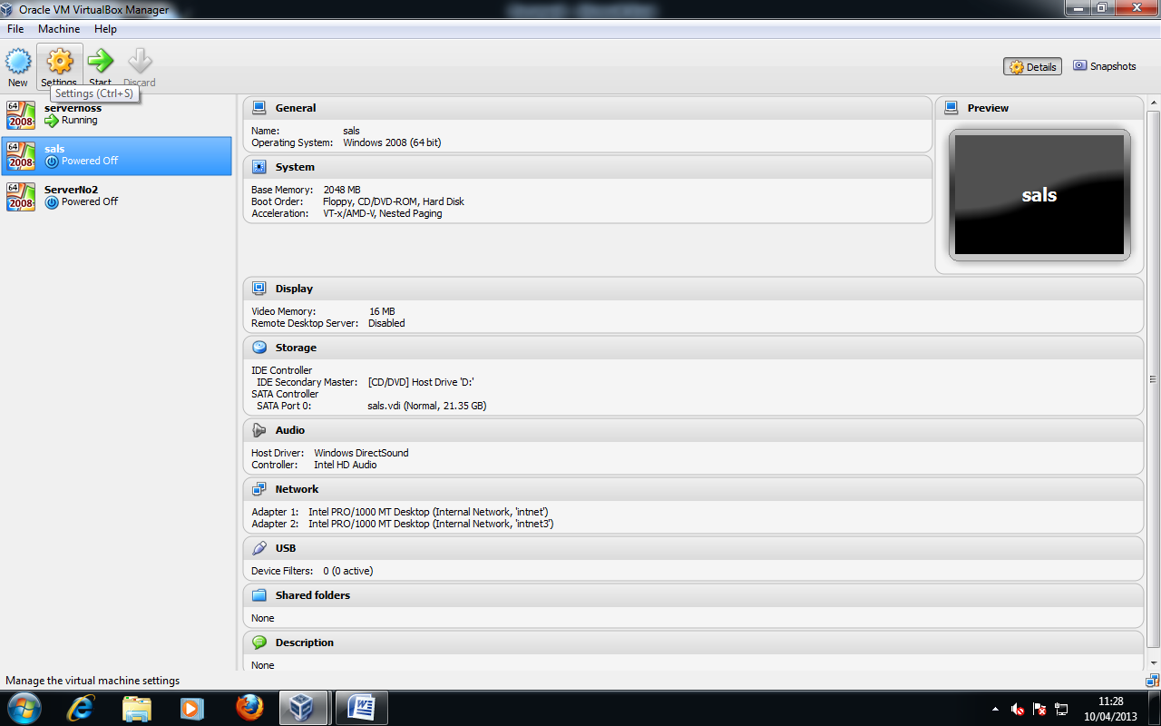

Whilst in the shutdown state, select Settings from the top menu and then Network from the left hand console:
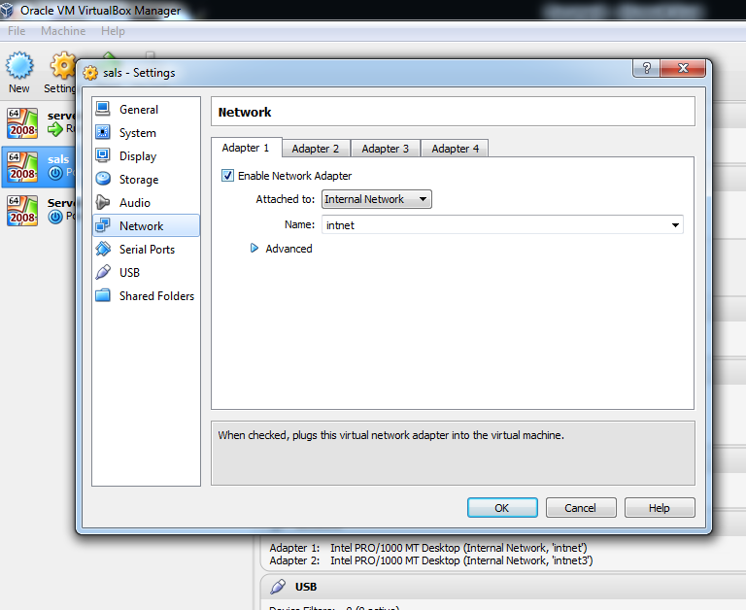
Choose Internal Network from the Attached to: drop down box.
Also note the Name assigned (intnet) this is the name of the logical networking Switch device. Network switches are needed to establish basic LAN connectivity for client/server architecture.
These settings will need to be mirrored on both your client and server.

Task:
Using the steps provided, create a client pc in virtual box. Ensure you use the Windows 7 DVD provided and pay particular attention to hardware settings used. When installed remember you need to correctly configure your network settings:

Installing the Active Directory:
Start your server:
Here we are going to install Microsoft's Network Directory Service product called Active Directory. We need to use a directory service in a network for critical functions such as authentication of users, managing software environments and policies and site to site security tasks. To install Active Directory: choose Start → run and type in the command dcpromo.
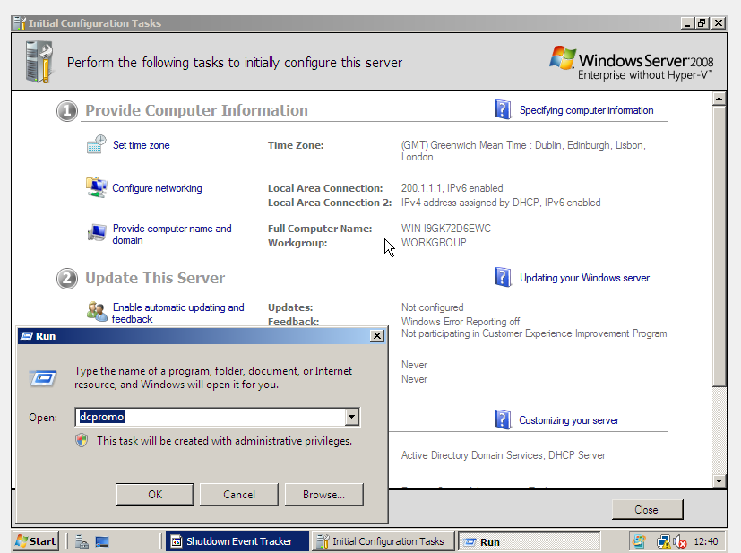

DCPROMO stands for Domain Controller promote. This is because an Active directory is established by promoting a standalone server to a domain controller. This in essence is all that is needed to establish the active directory. Choose Ok, the Active Directory wizard will begin:

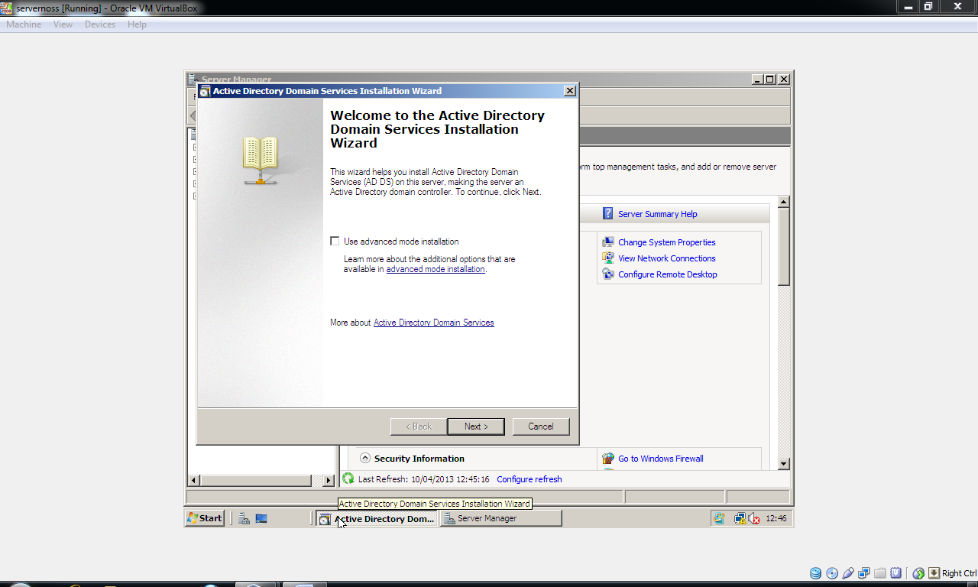
Choose Next:

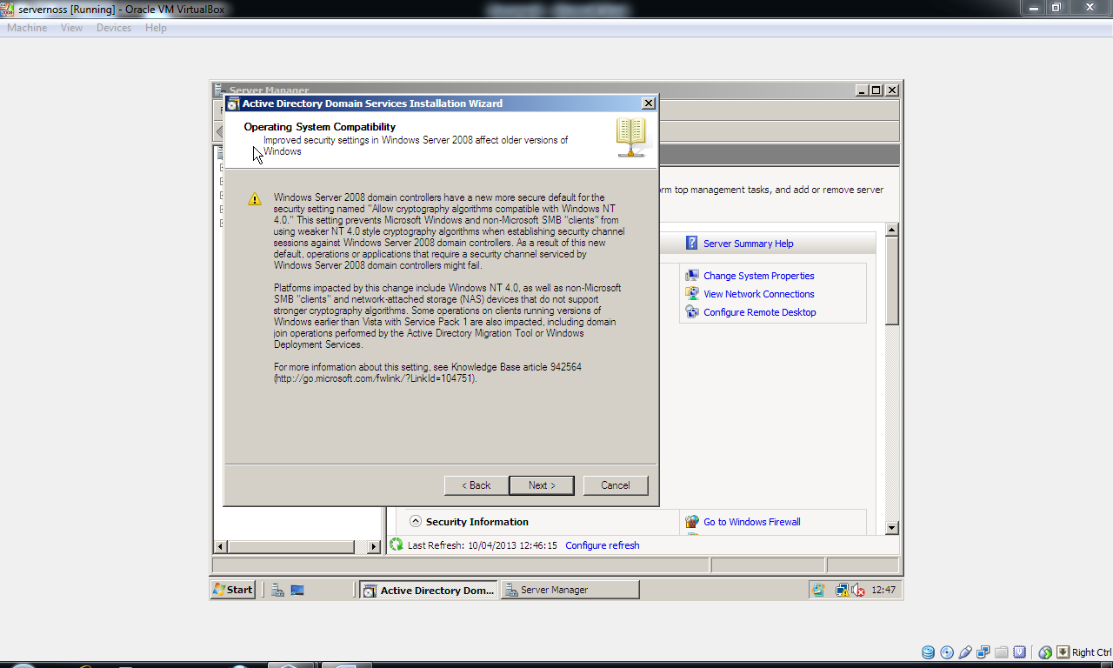
Choose next:
Here we are going to be creating a new Active Directory domain for a new forest (forest simply refers to a DNS namespace e.g. smu.ac.uk, or sid.smu.ac.uk).
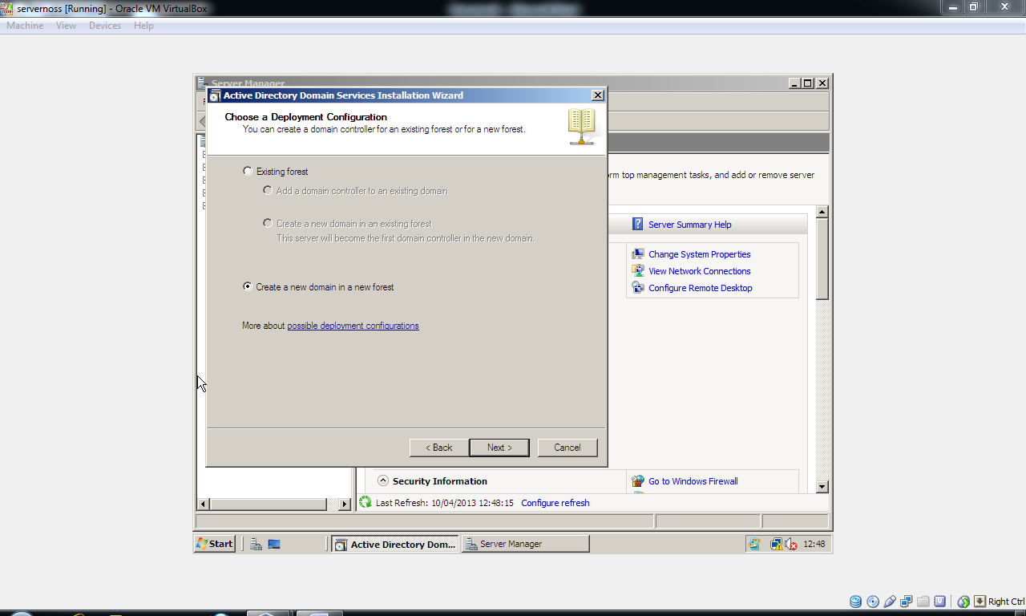
Select Create a new domain in a new forest: choose Next:

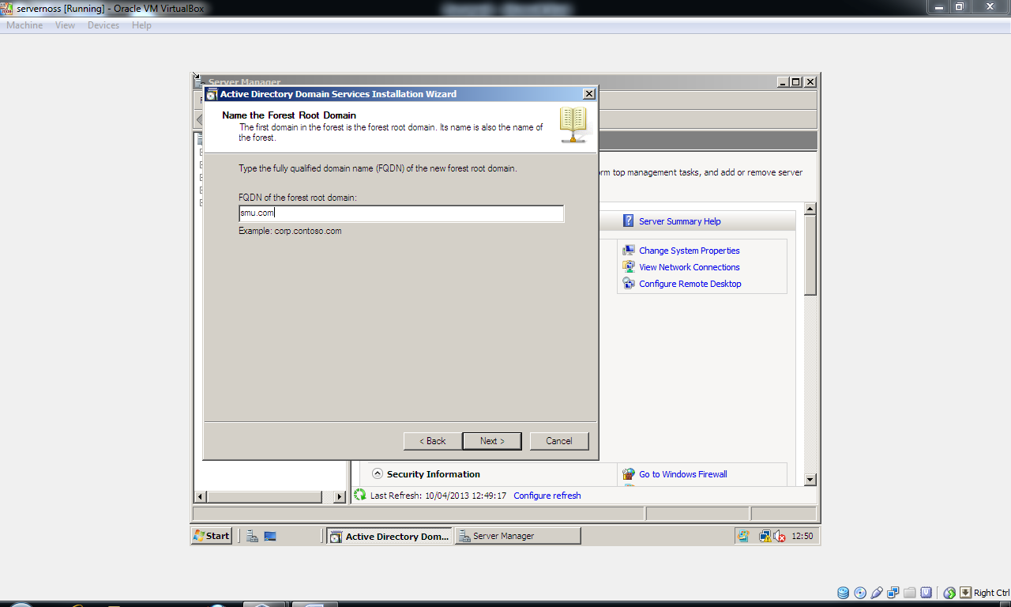
We need to give the domain a name, ours will be smu.com, choose Next:
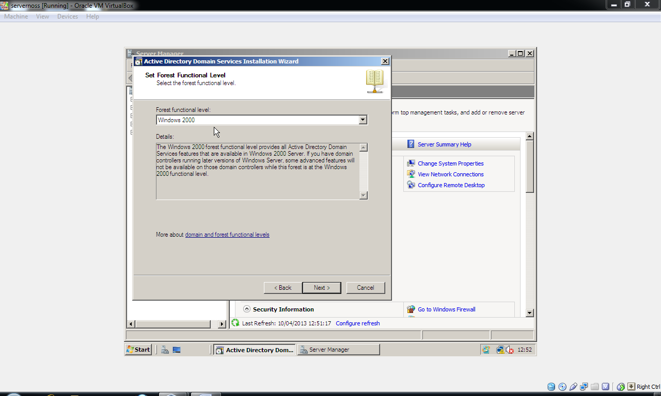
Select Windows 2000 as the Forest Function level, as we can still provide legacy support for older systems in our network if need be.

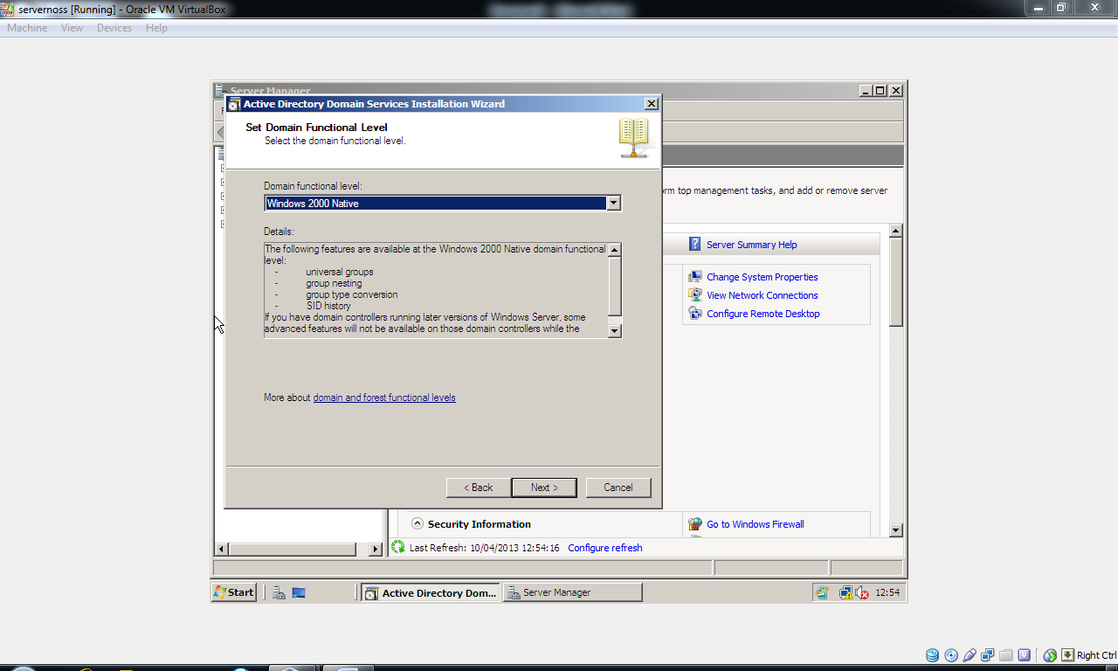
Accept defaults and choose Next.
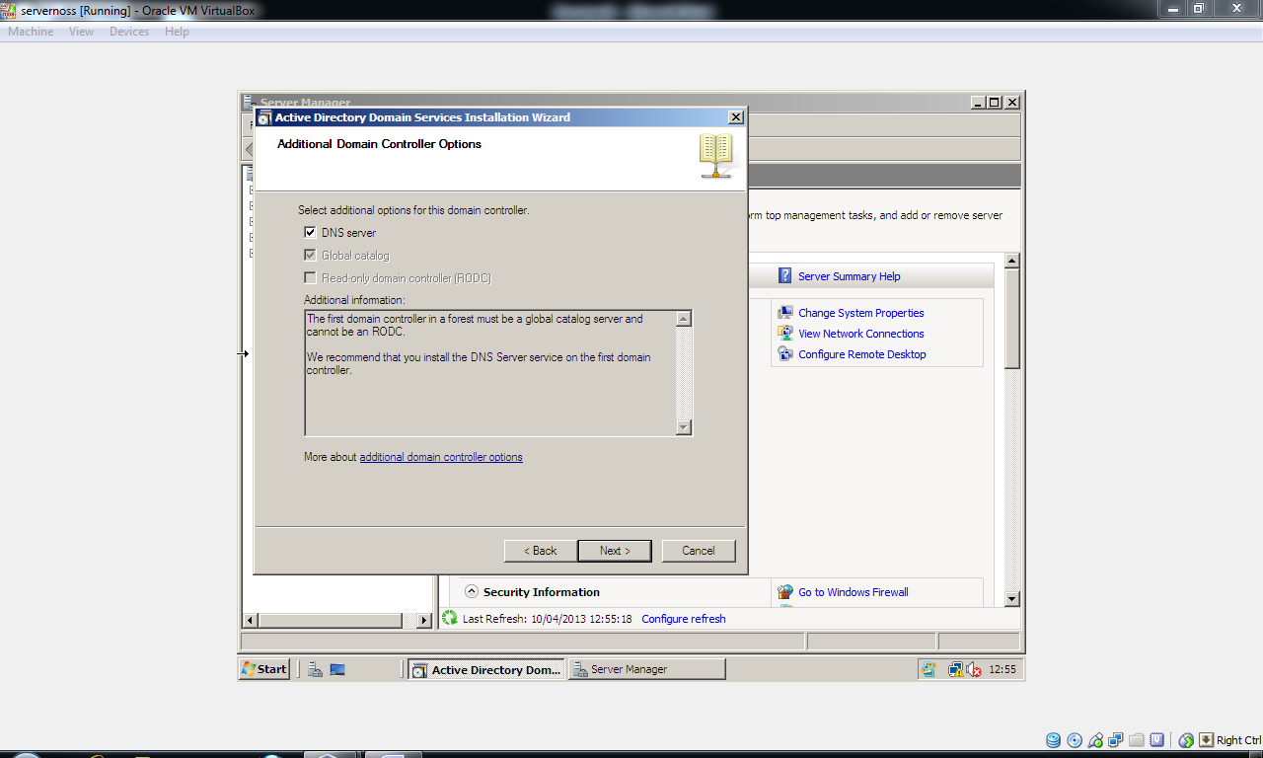
We need to ensure that DNS server is checked on, without a DNS service active directory is unable to resolve name queries for users (e.g. carlene@smu.com) when logging on and also requests to find other pcs via their name.

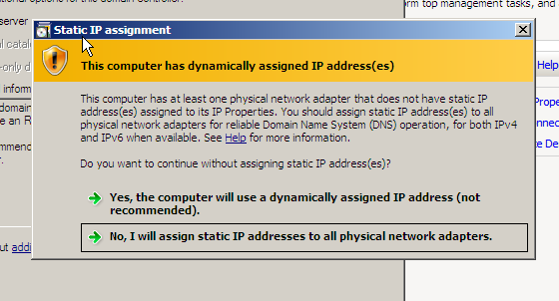
At this stage you will need to assign your Virtual pc an IP address, click on the option No I will assign static IP addresses to all physical network adapters:
We now need to go into control panel and assign static IP address: Choose Start → Control Panel
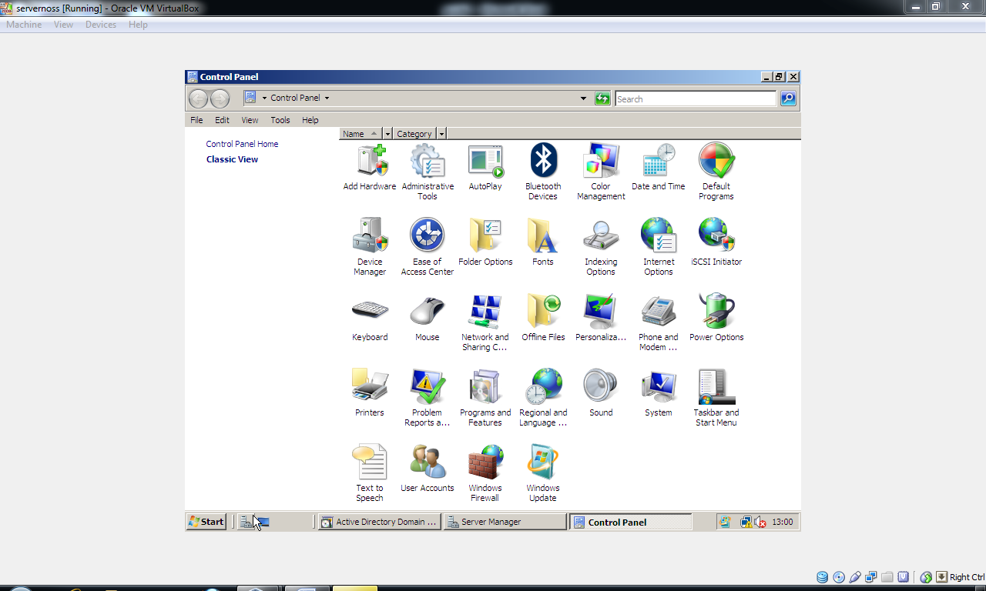
Choose the Network and Sharing Center icon:

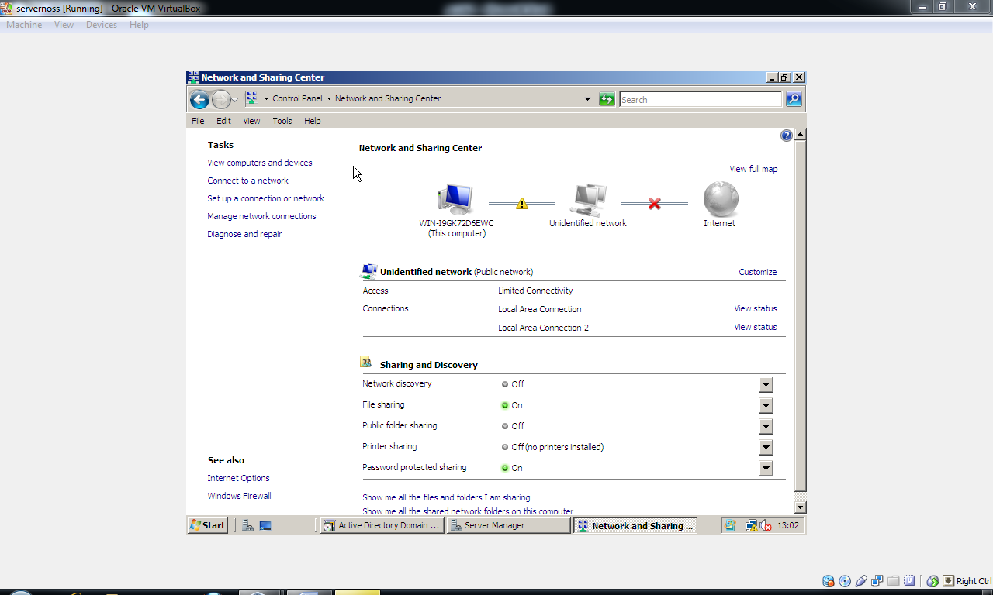
Choose Manage Network Connections from the left hand console:
Right click on your network adapter:
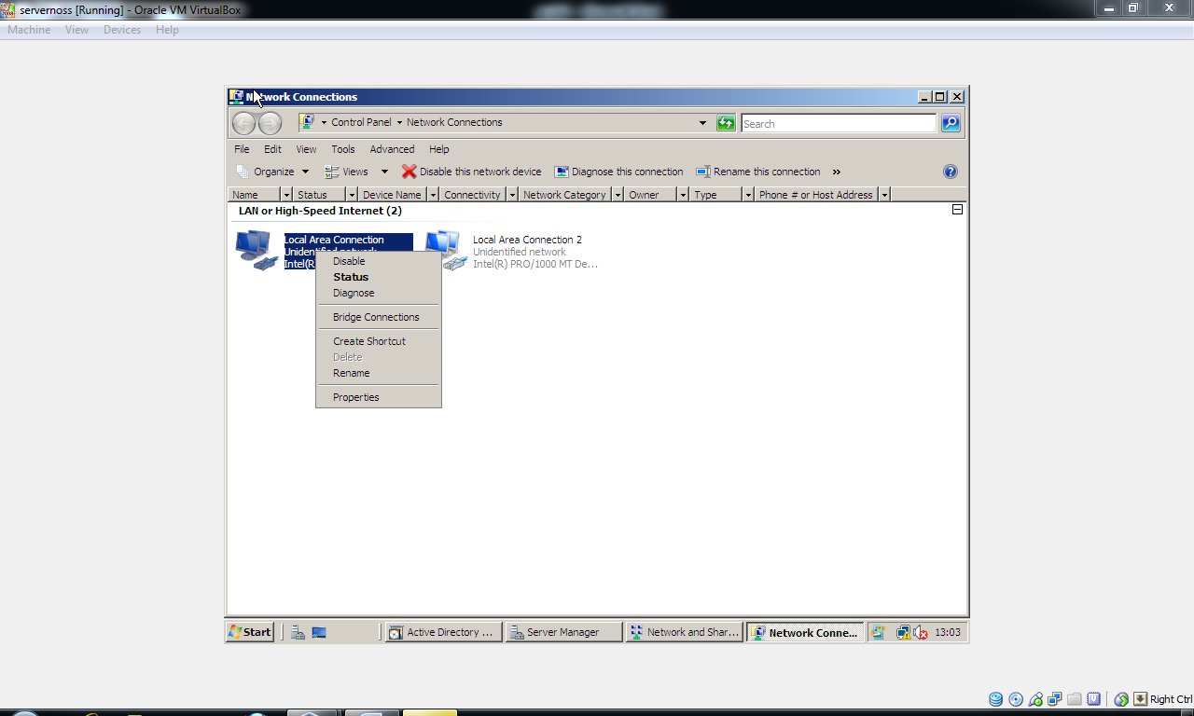
Choose Properties:

Select Internet Protocol version 4 choose Properties:
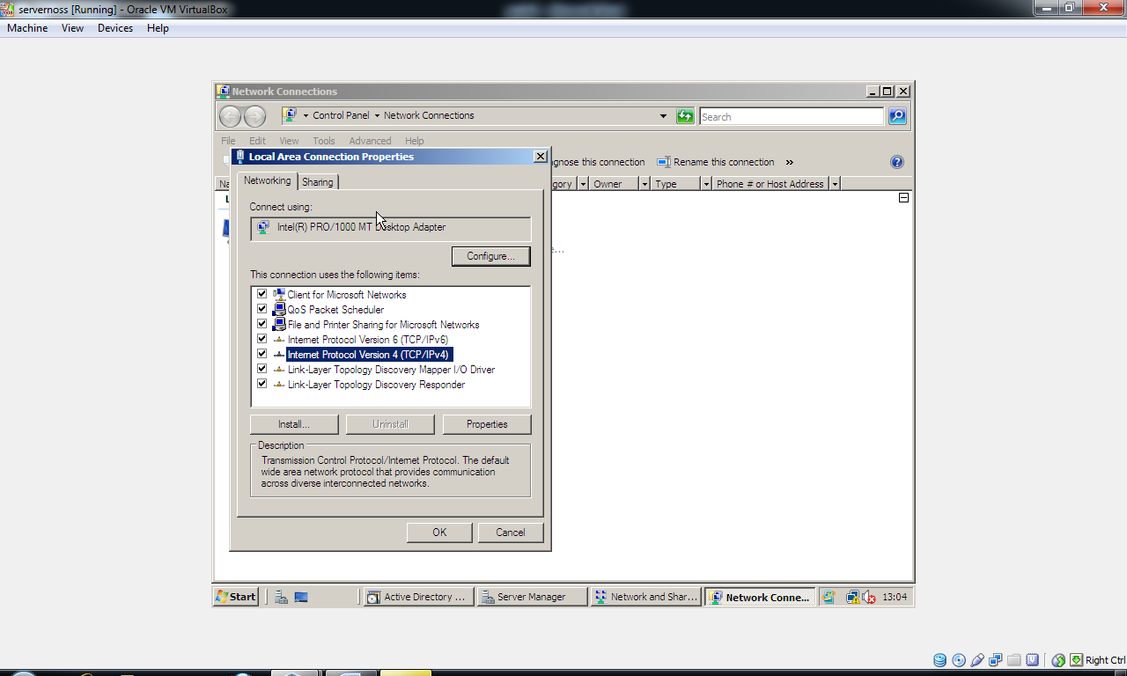
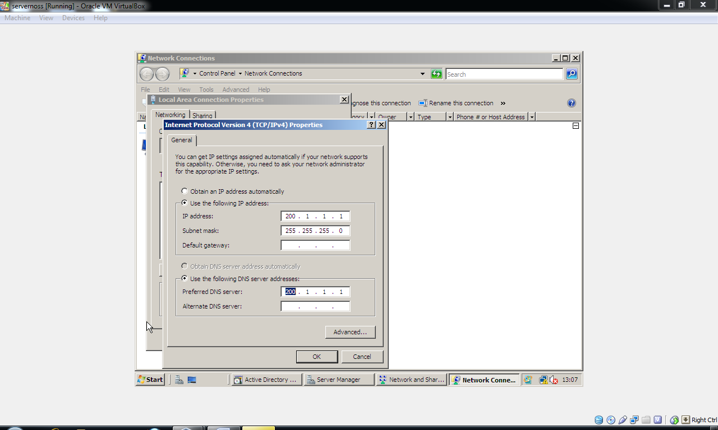
Choose Use the following IP address and enter the following:
IP address: 200.1.1.1
Subnet: 255.255.255.0
Gateway: 200.1.1.1
Also choose Use the following DNS server addresses:
Preferred DNS Server: 200.1.1.1
Click Ok and return to the Active Directory wizard and now click next.
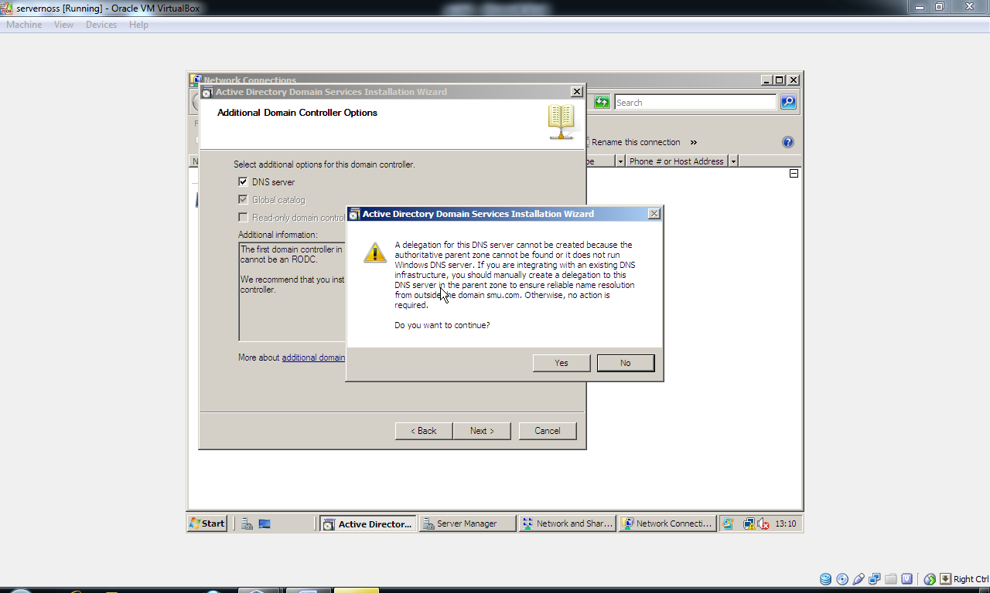
Choose Yes to DNS delegation.

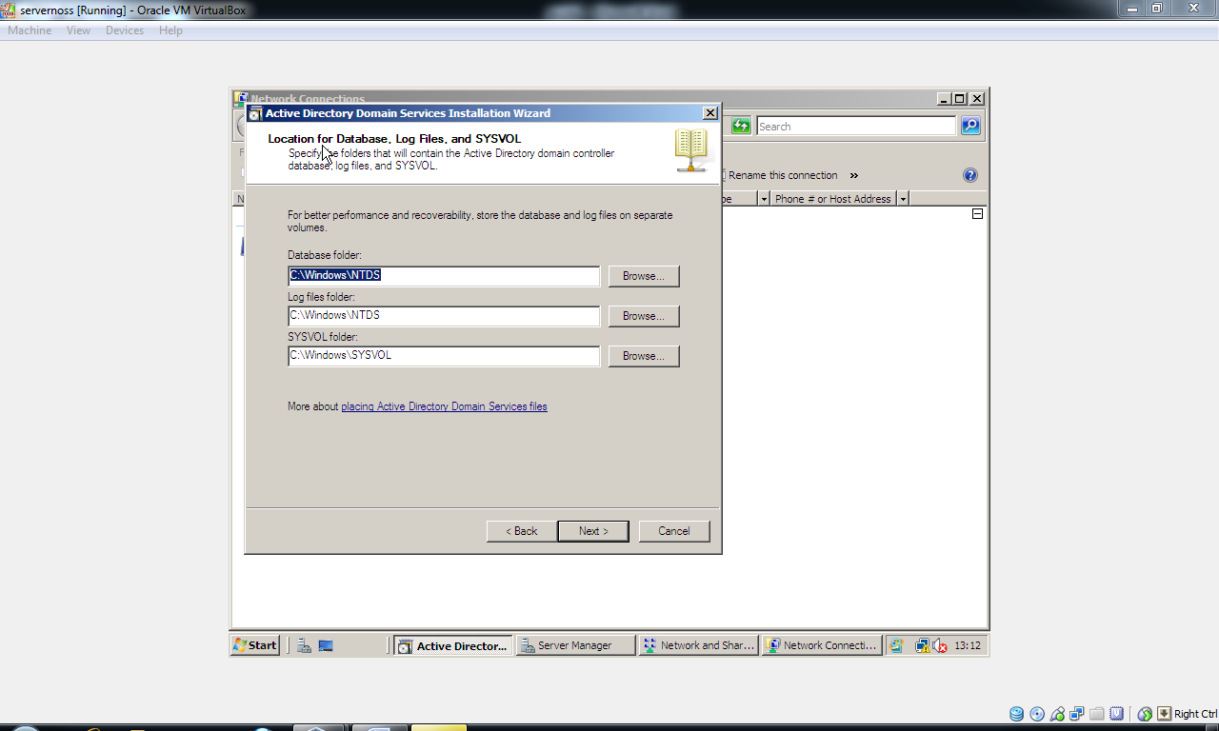
Choose Next (accept defaults).
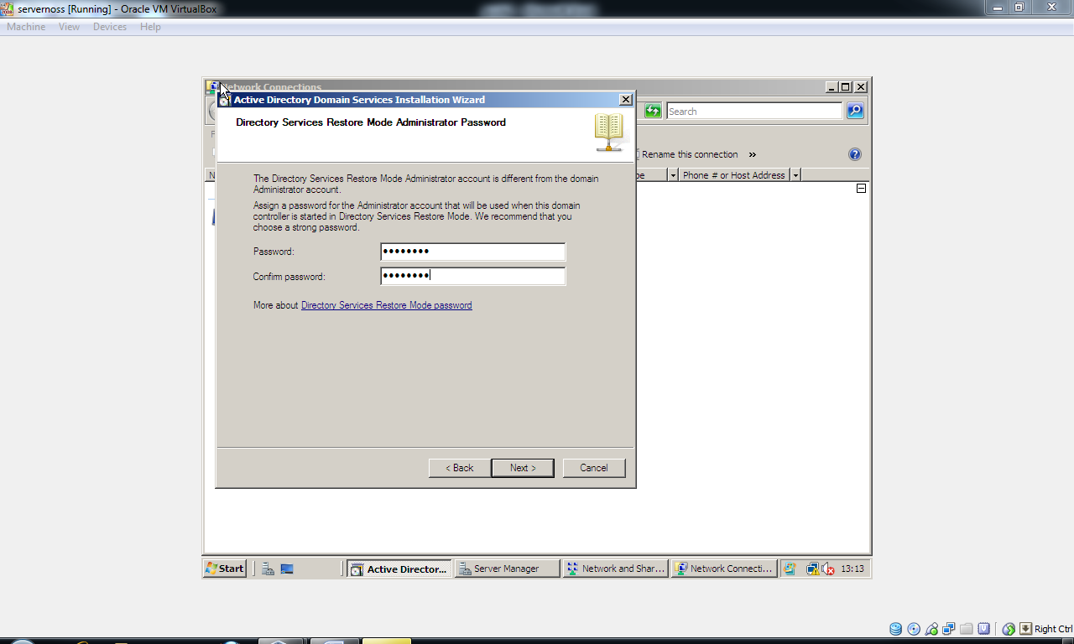
Here you will need to supply an administrative password for the admin account (the one you're presently using). You will need to supply a password that meets minimum complexity requirements specified by Microsoft security standards: One is provided for you below, simply enter it and confirm it and choose Next:
Password is: P@ssw0rD

Finally choose next to accept the summarised options, Active Directory will now install. You will need to restart your virtual PC when prompted:
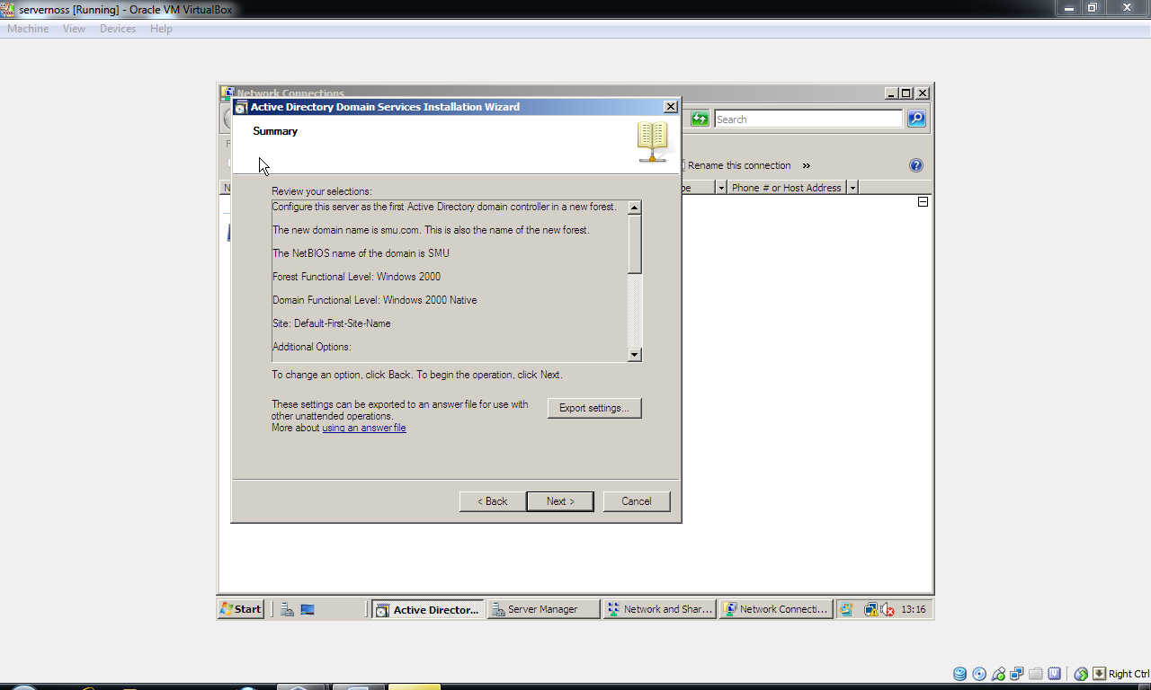
Creating User and Computer accounts in Active Directory:
Every network resource (users, computers etc) in Active Directory is treated as an Object. To access a network utilising user accounts and computer accounts we effectively need to ensure that these objects are creating in the Active Directory Global Catalog. Global catalog is a form of index that you can use to store and organise your active directory namespace resources (e.g. all the users that belong to smu.com).

To create user accounts (for login purposes):

Click Start → Administrative Tools → Active Directory Users and Computers:
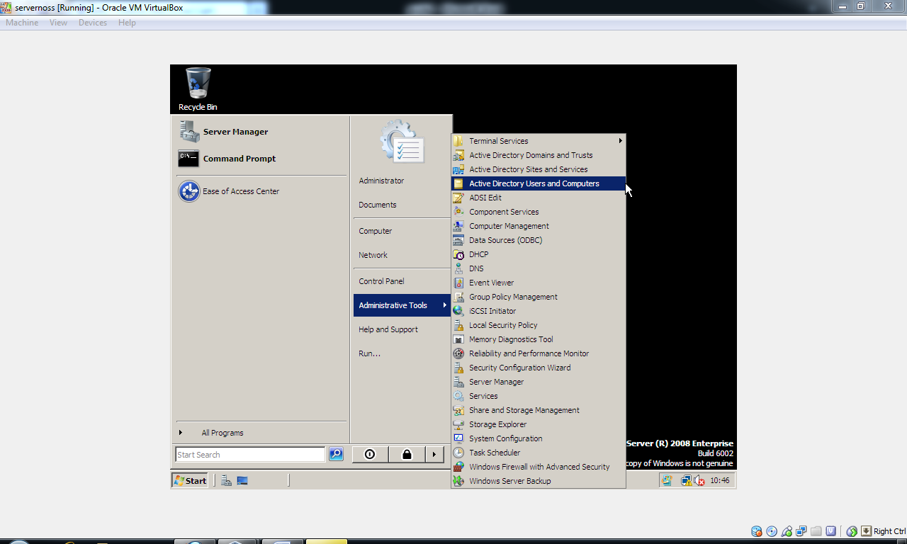

Expand the smu.com namespace (on the left hand console)
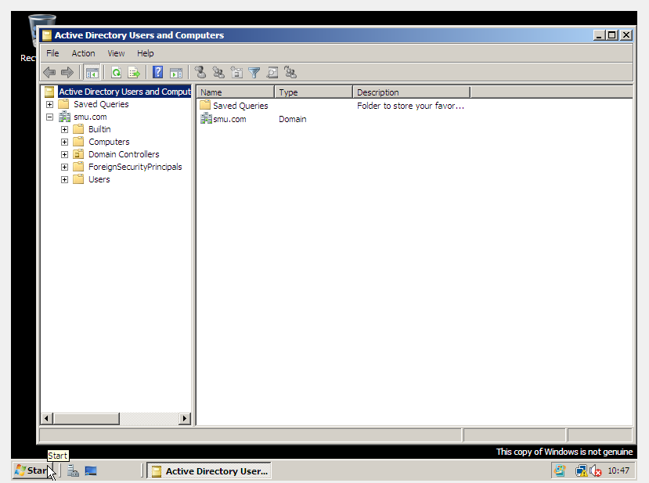

Right click the users folder and choose new user:
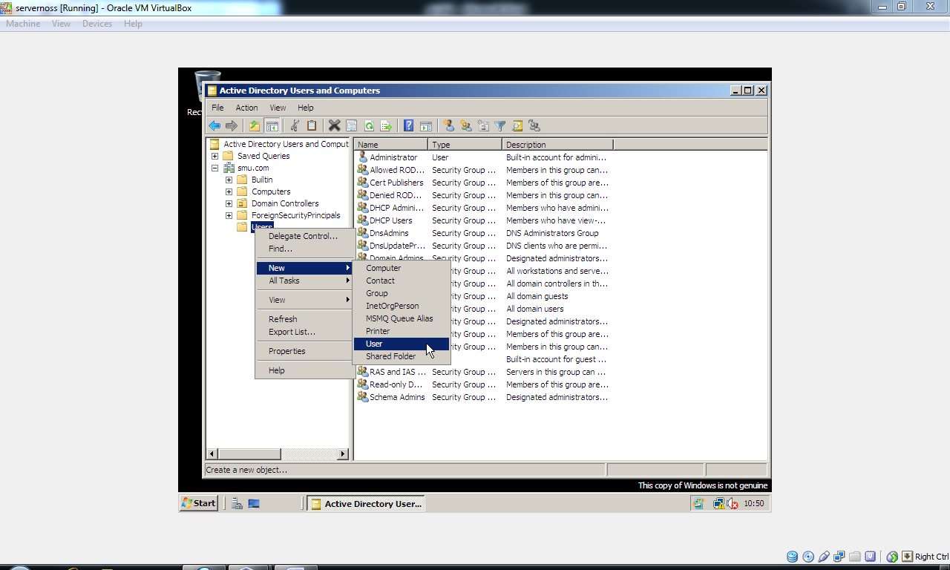
Now enter the details for a new user account, here is an example:
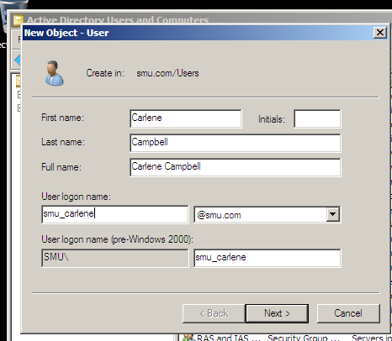
Choose Next:
Your password will need to meet minimum complexity requirements (use the password provided below), you should also check on Password never expires and Password never expires and also check off user needs to reset password on next Login
P@ssw0rD
Then click Next and then Finish, your account is created. We cannot actually access this server with the new account we have created as the Server is a Domain Controller and our account is merely a domain user account. To add this account to domain admins take the following steps:
Click on the users folder and then double click the Domain Admins group:
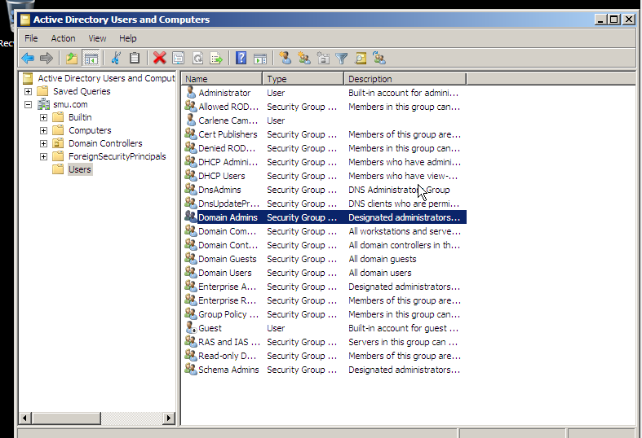
Click on the Members tab, and then click on the Add Button:
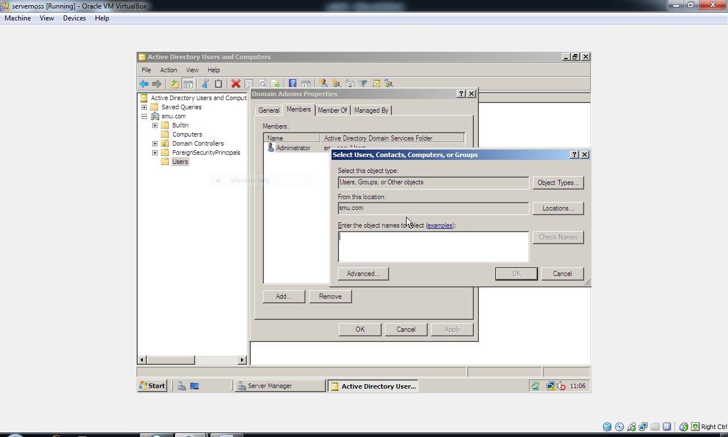
In the whitespace where it says Enter the object names to select type in the username of your account (e.g. smu_carlene). Now click on the Check Names button.
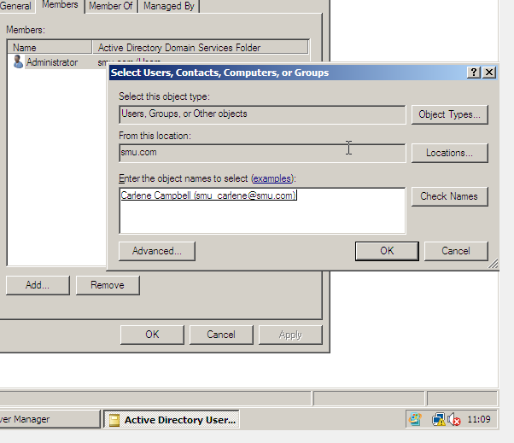
You should find that your account is returned (see above example)
Choose Ok. One word of caution, the accounts you place into the domain admin group will have administrative permissions over the entire network and all its contained resources. It is for this reason you should be very selective of who you give these permissions to, in enterprise networks this would be the admin/technical staff and not regular users.
Click Apply:
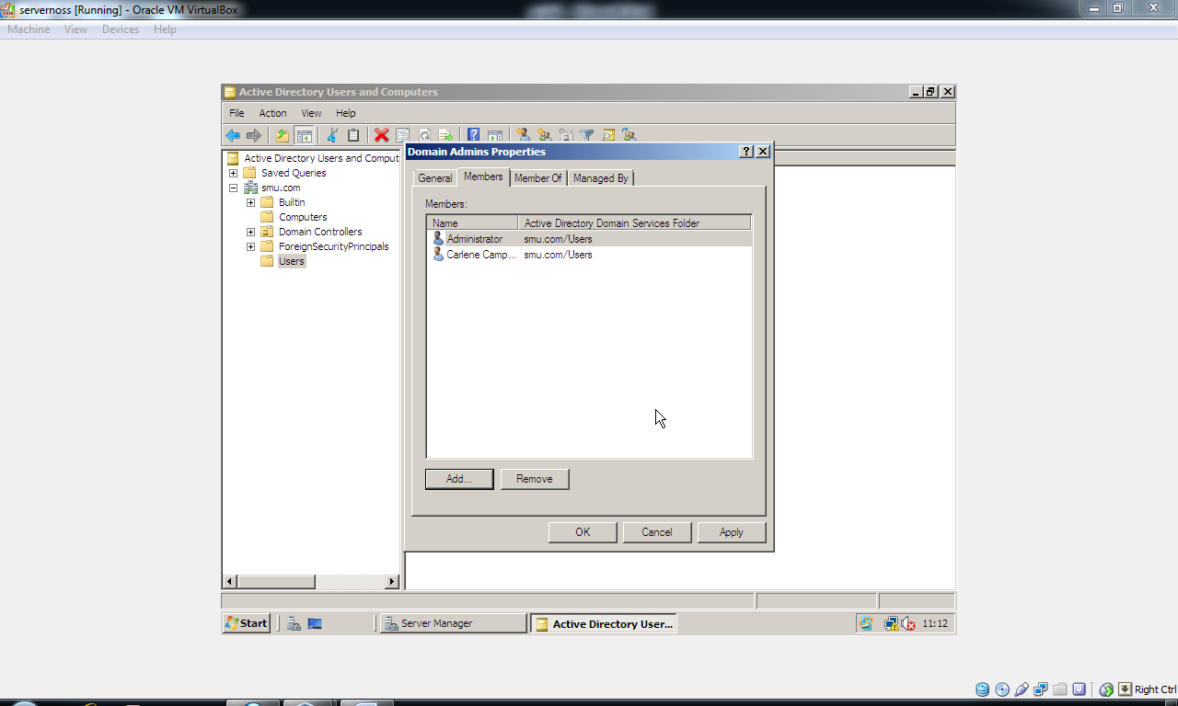

To test this account logoff from your server and login using your newly created user account:
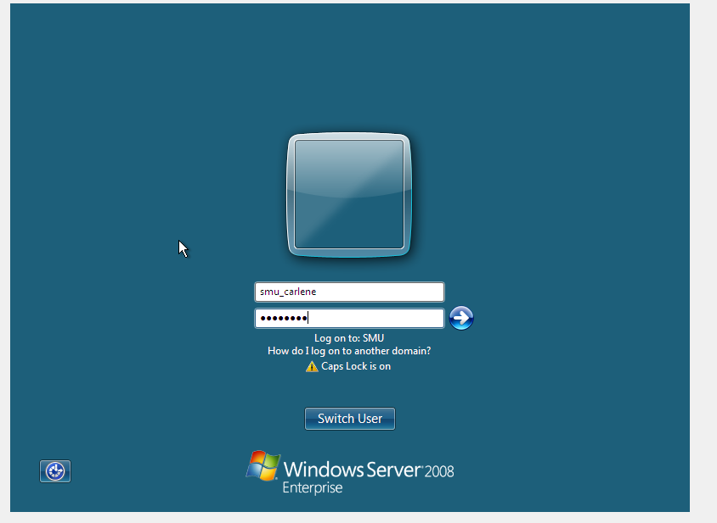
Create a Computer Account:
Start → Admin Tools → Active Directory Users and Computers, expand the smu.com namespace (as we did above when creating user accounts)
Right click on the Computer folder and choose New Computer:
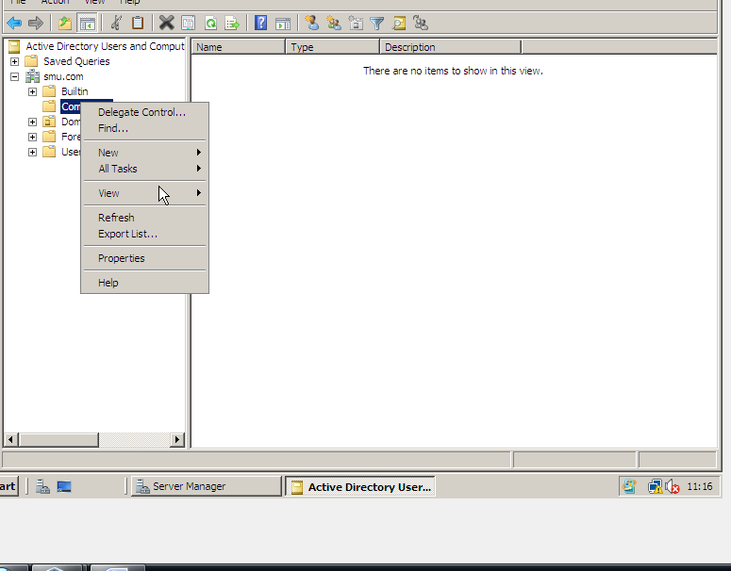

Give the computer account suitable naming information, bear in mind that this is a member server that will adjoin to the smu.com active directory network. The steps for creating client computers and joining these to the network are identical, as is the installation of modern client Network operating systems (e.g. the windows 7 and windows 2008 server installs are identical).
An example of creating a machine account is shown below:
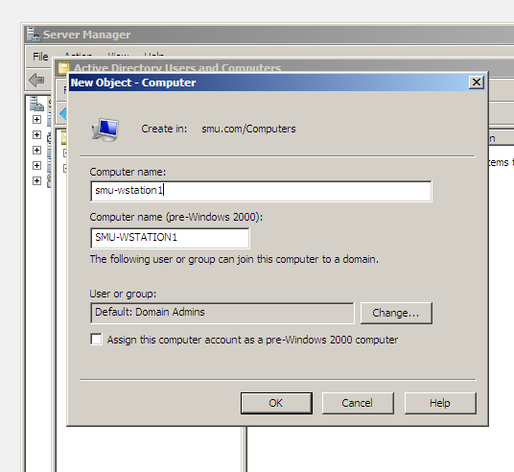
Choose Ok.

We now need to install another OS on a new Virtual PC. It is only when we have both two operational systems that are networked can we say we have established a LAN. First we need to create a new Virtual machine:
Provide details for your new workstation (an example is provided below):
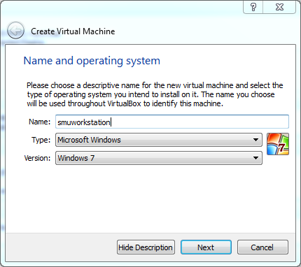
Quickly move through the next steps use the following details:
RAM: 2000MB
CREATE NEW DISK
DISK IS OF TYPE VDI
DYNAMIC TYPE DISK
HARD DISK CAPACITY: 20GB
As before we need to set the CD/DVD ROM as the first bootable device and hard disk should be set to second bootable device. Refer to the previous steps on how to use the System Option and to set boot device order.
You will need to place the provided Windows 2008 DVD in the drive at this stage, now Start your newly created Virtual PC.
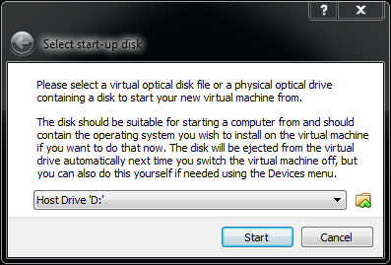
You may find that the PC will now either (A) begin to launch windows setup automatically or (B) the prompt shown above will appear, if the latter is true simply click Start.
Install the operational system using exactly the same steps as above:
You should ensure that the Network settings for Virtual PC are identical between the first system and the second.
When your new virtual pc finishes installing, we need to configure IP address and related network settings namely DNS.
To do this. Choose Start → Control panel → Network and Sharing Center (as you did with the first Server).

Choose Change Adapter Settings:
Right click on your network connection choose Properties
Double click IP Version 4 (TCP/IP version 4).
Use the following IP/ and DNS addresses:
IP address: 200.1.1.2
Subnet Mask: 255.255.255.0
Gateway: 200.1.1.1
Preferred DNS Server: 200.1.1.1
When this is done try the ping command to test network connectivity between the two servers. To do this:
Choose Start →type cmd in search programs and files textbox (shown below).
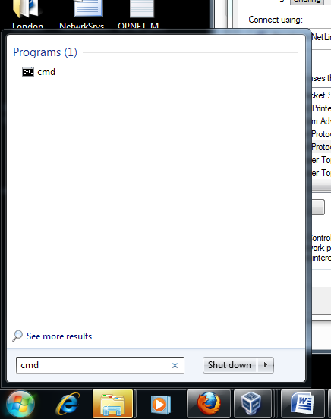
Click on the cmd program
Enter the following command:
ping 200.1.1.1
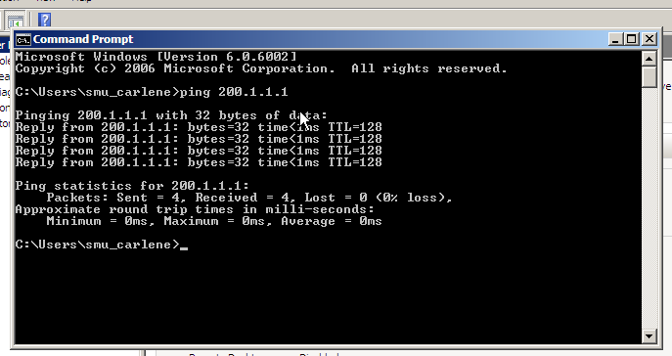
You should find that the other server responds with a reply, if not you may have an error due to one of two causes:
(a). Your networking settings are not configured identically (in Virtual Box main program)
(b). There is a firewall switched on, on one on both of the machines, to rectify this:
Choose Start → Control Panel → Windows Firewall
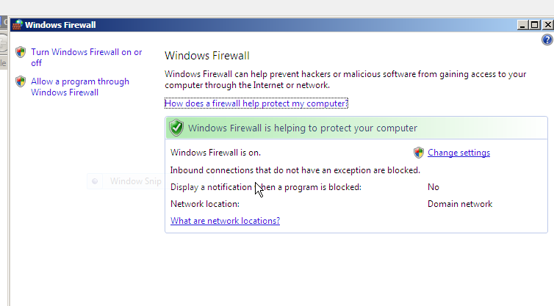
Usually we would specifically allow a program through the firewall (e.g. cmd) but here we will simply for convenience turn off the firewall - choose Turn Windows Firewall on or off and then choose Off
Go back to the cmd program and now verify that you can complete the ping command.
To join this server to the domain:
Right click Computer and choose Properties
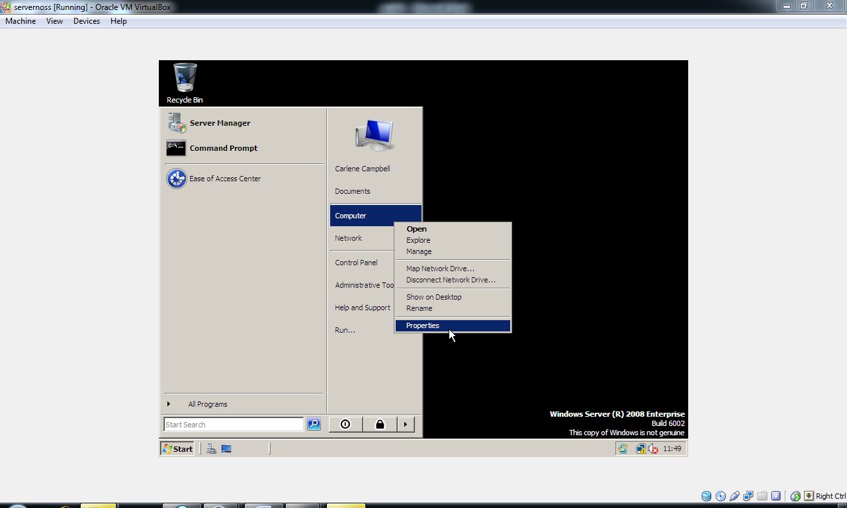

Click Advanced System Settings:
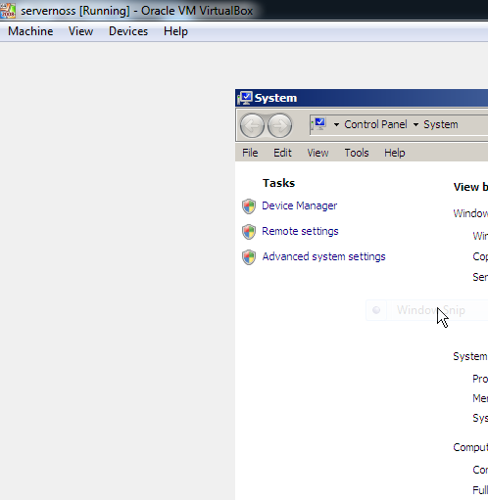
Click on the Computer Name tab then click Change.
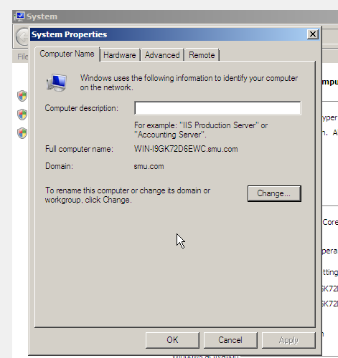
Here you should specify a name for the system, this should be Identical to the name you specified when you created the Computer object earlier on in active directory (e.g. in this example ours was smu-wstation1 (note this is not case sensitive).
Choose Ok and the computer will need to restart.
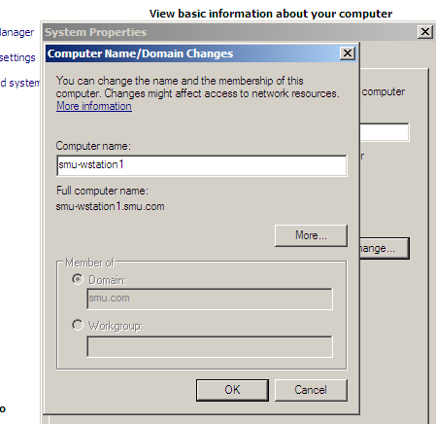
When the computer restarts we need to go back into Advanced System Settings to join the domain.
Right click Computer → properties → Advanced System Settings
Click on the Computer Name Tab, choose Change.
In the domain field type in the following:
smu.com
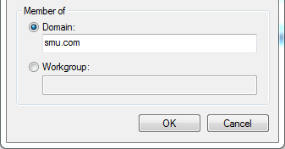
Choose Ok, you will now be asked to provide authentication for joining the domain, you should use the account you created earlier (Remember we gave the user account domain admin privileges earlier on) Ours for example is as follows:
username: smu.com\smu_carlene
password: P@ssw0rD
When prompted, restart this computer.
Upon reboot you will notice that a Prompt for CTRL + ALT +DEL appears. This means that the server is now a member of an Active Directory domain. We will need to use an account on this domain to access the computer, so try logging in using the account you have been using up until this stage.

