Module Name: Changemakers: Network Operating System
Module Code: ACCA5023

Student Name: Maricor Hernando Lindo
Student ID: 2440415
Group: 1

Lecturer’s Name: Md Sadeque Imam Shaikh
Date of Submission: August 14, 2026

Table of Contents
Screenshots 2
Routing 2
1.1Routing in Birmingham Network 2
1.2 Routing in London Network 3
2. Domain Server Birmingham 4
3. Encrypted Connection Between Birmingham and London 6
4. Users 7
5. Domain Client 8
6.1 Configure B-DC as DHCP Server 9
7. Test and Troubleshoot 10
8. Disk drive 10
9. IIS SERVER 11
10. Remote Desktop Services 12

Screenshots

Routing

1.1Routing in Birmingham Network
Figure 1.1 Routing and Remote Access Services
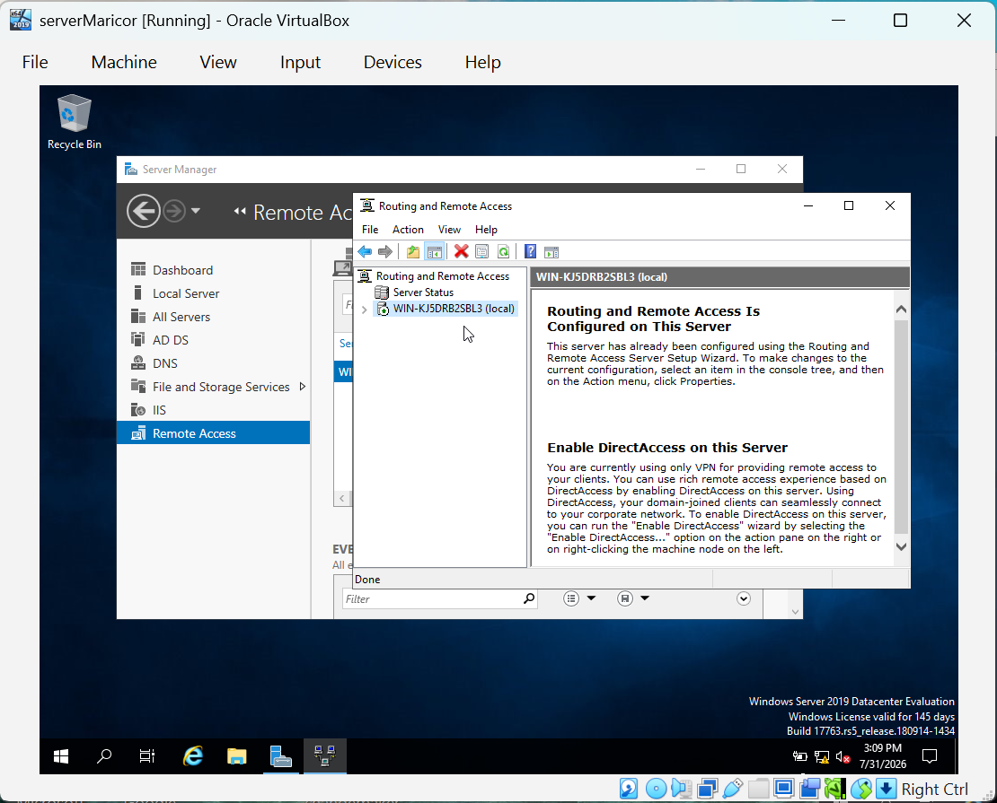

1.2 Routing in London Network
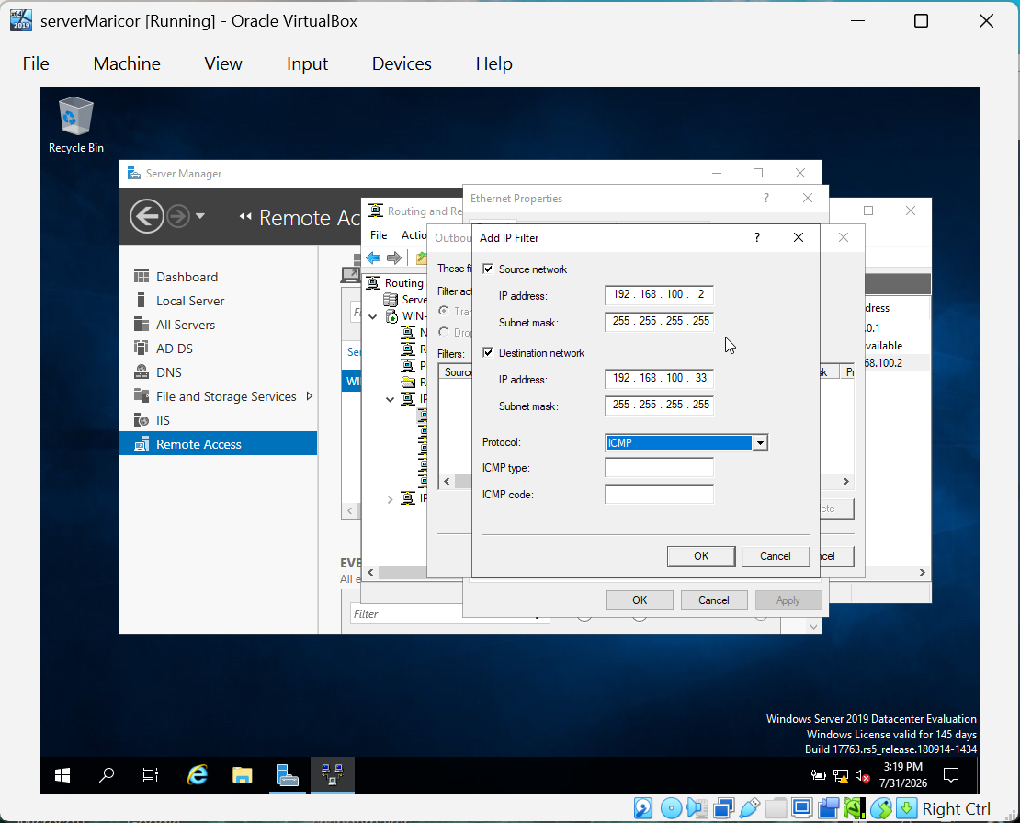

2. Domain Server Birmingham
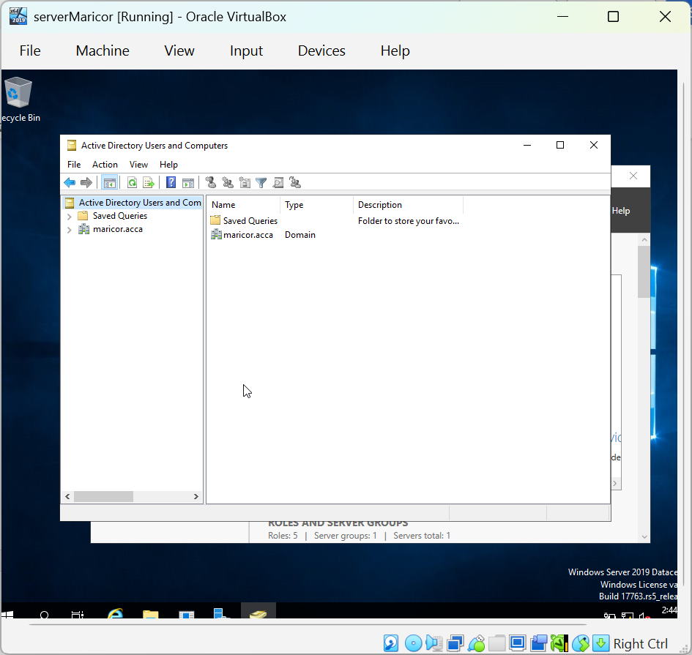
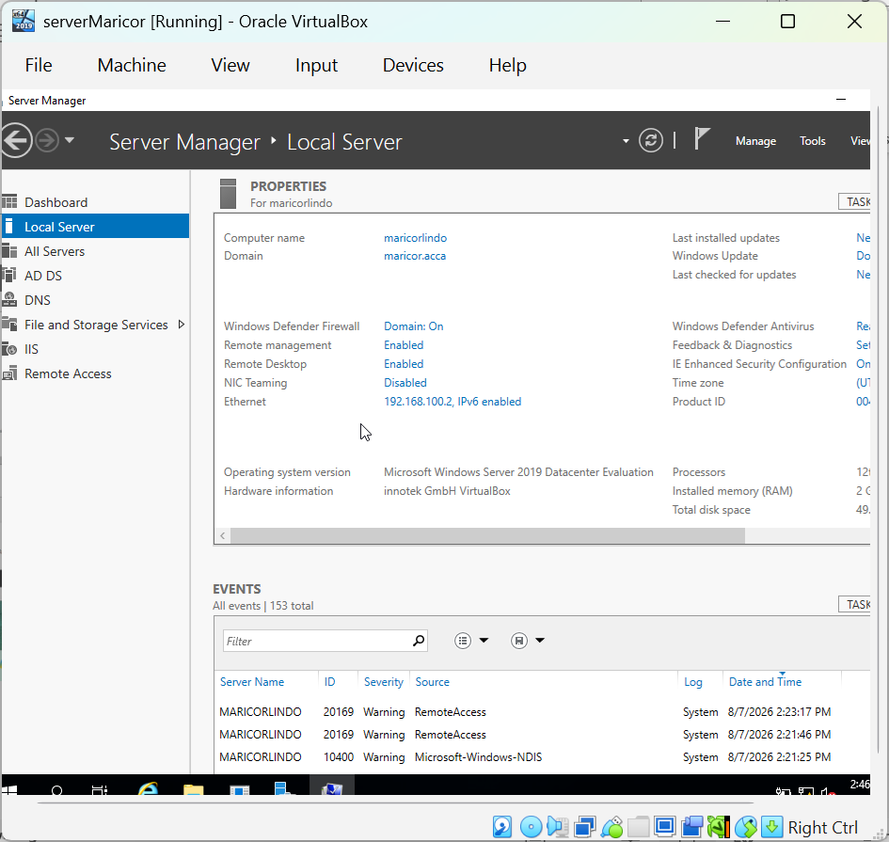

3. Encrypted Connection Between Birmingham and London
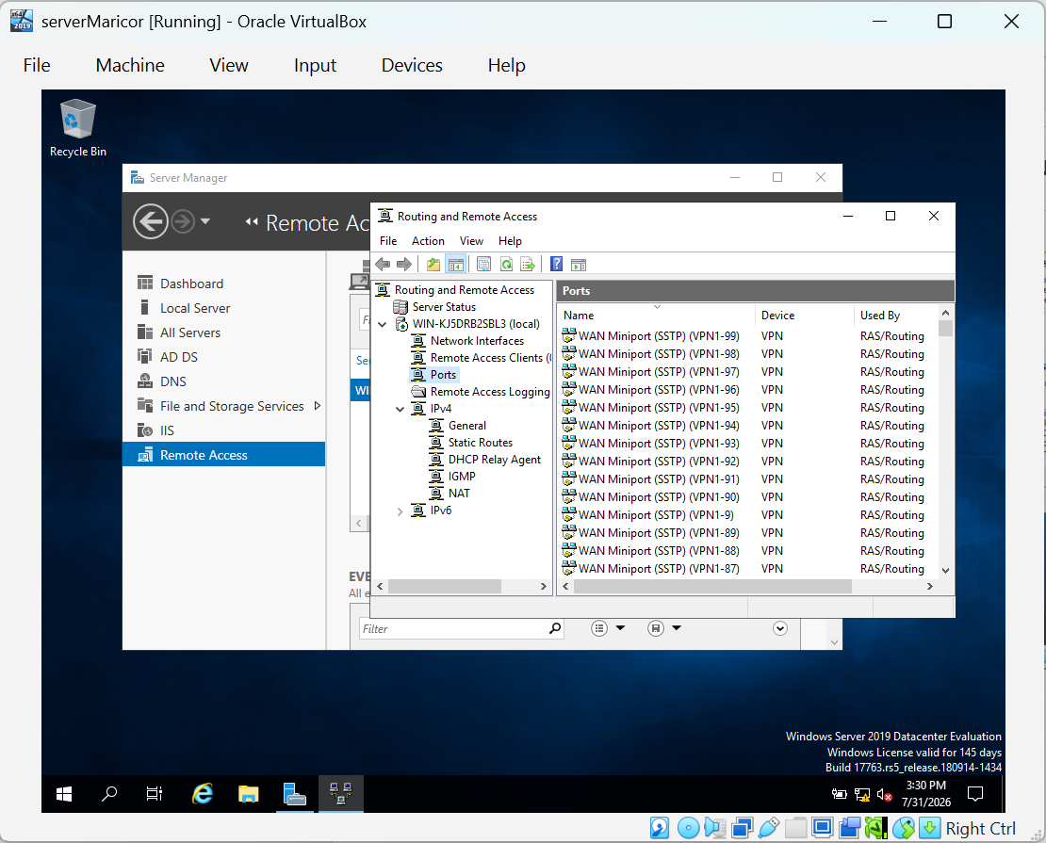

4. Users
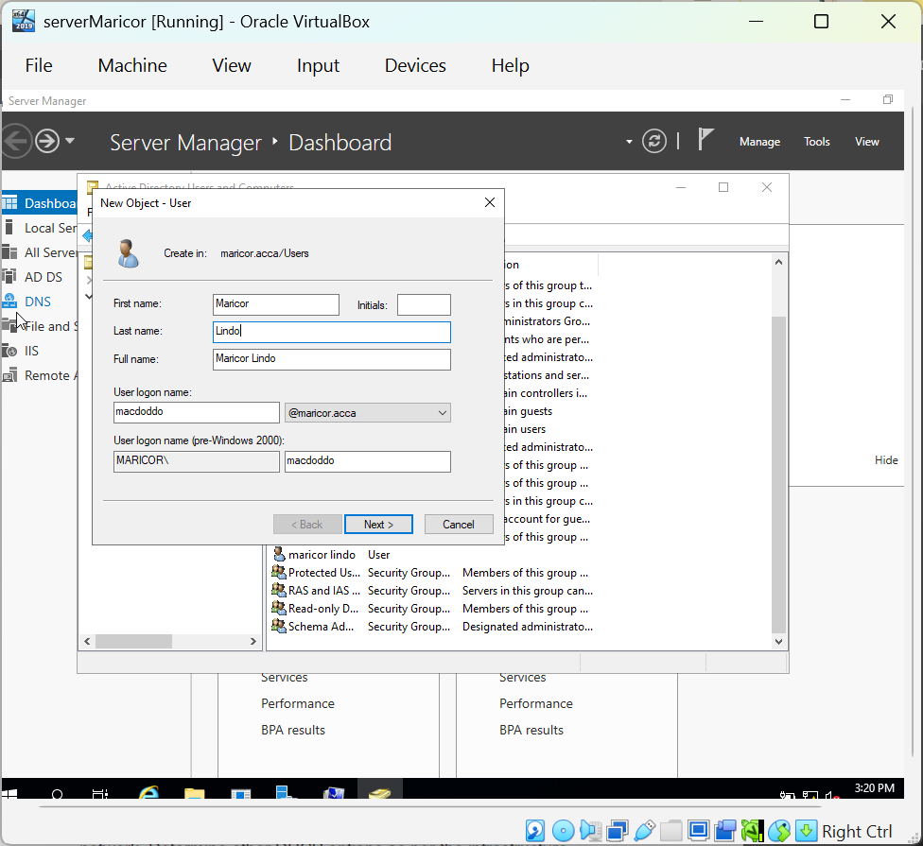

5. Domain Client
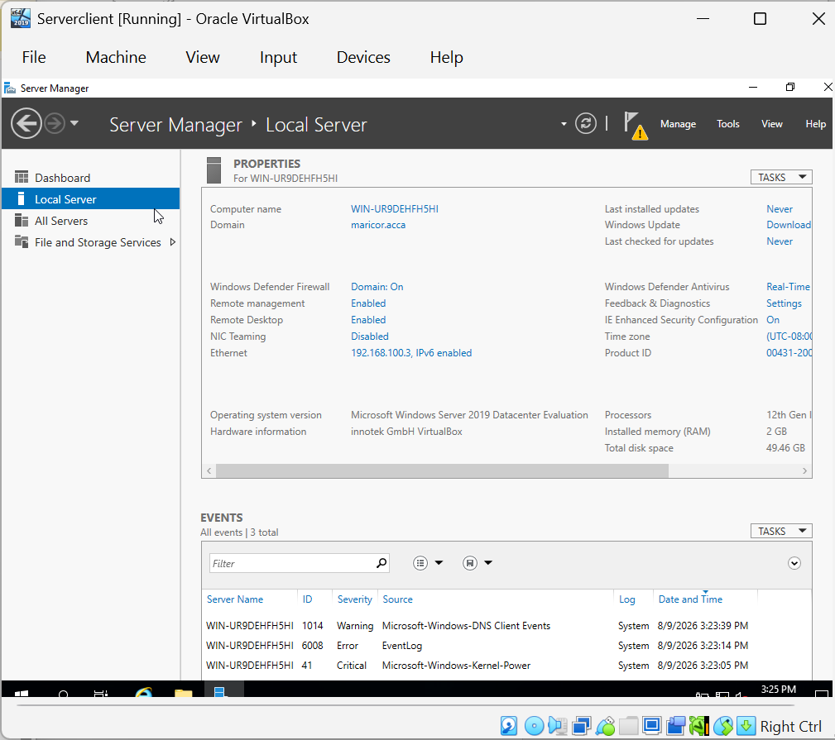

6.1 Configure B-DC as DHCP Server
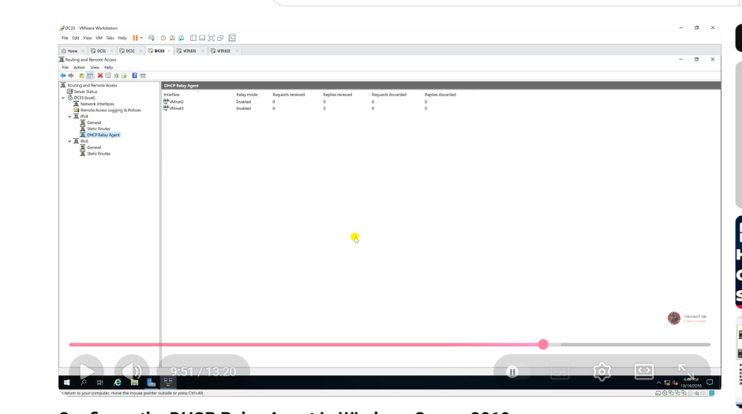

7. Test and Troubleshoot
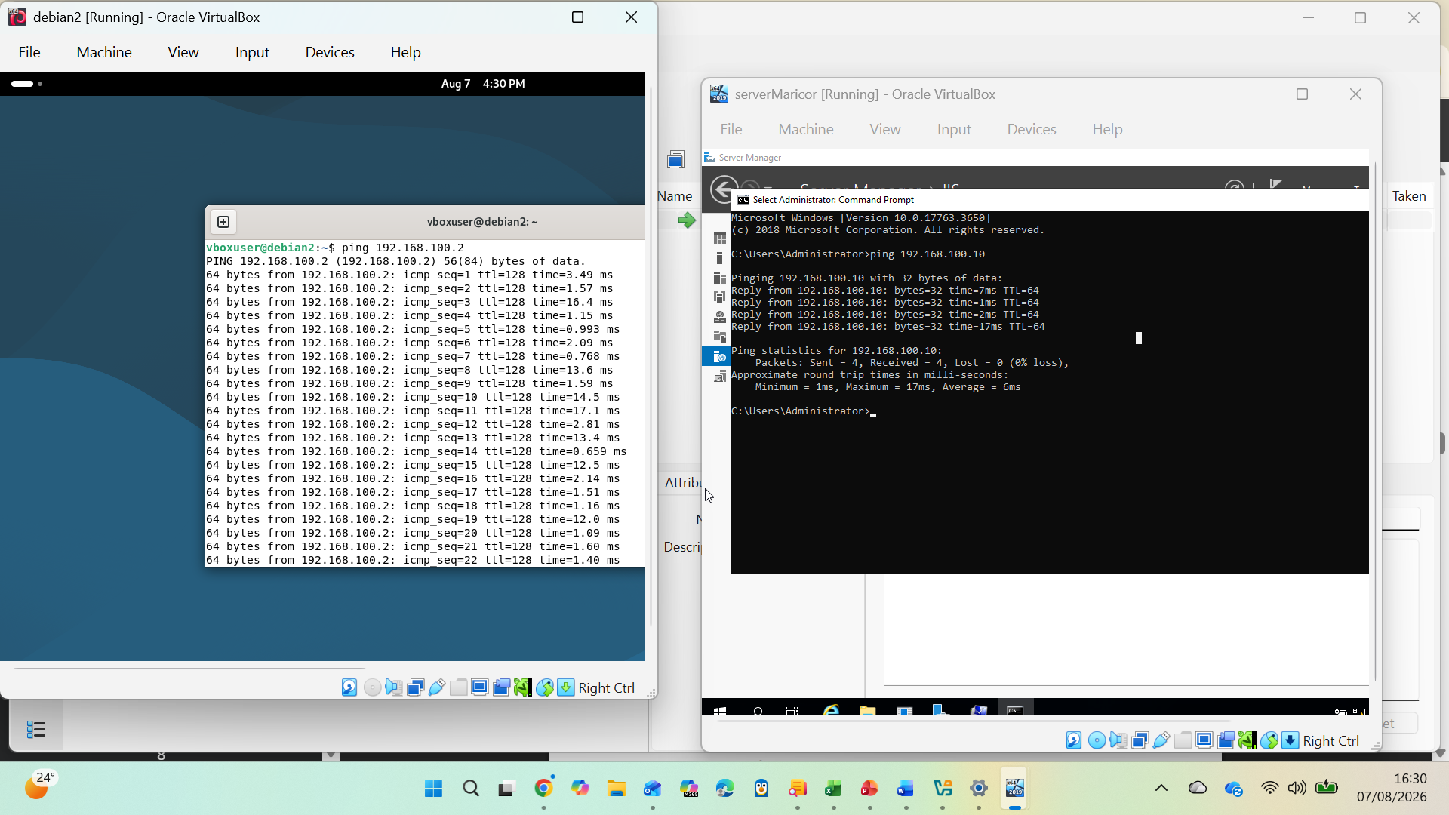

8. Disk drive
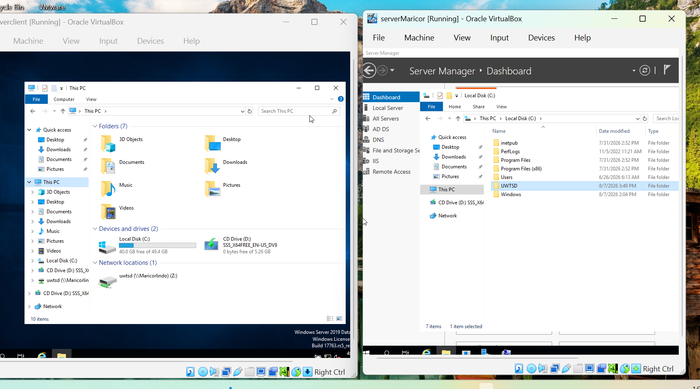

9. IIS SERVER
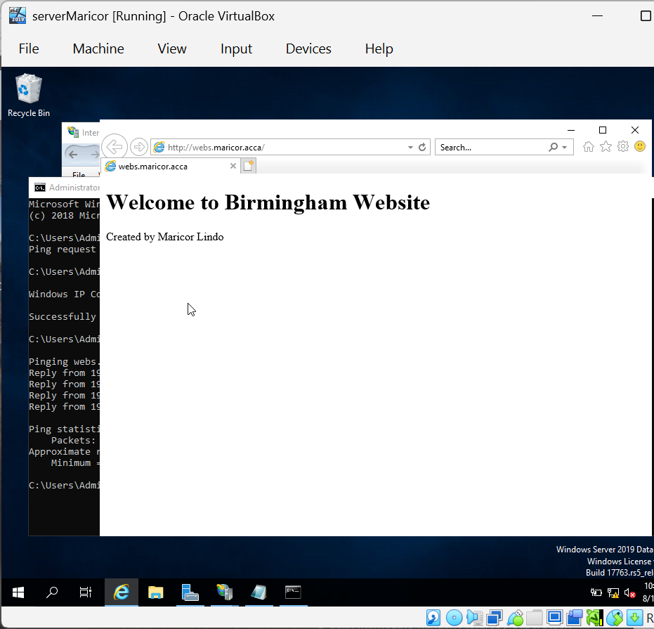

10. Remote Desktop Services


