STUDENT NAME | EVA BOATENG
STUDENT NUMBER | 1714255
MOODLE NUMBER | BMSW5006
MOODLE TITLE | KNOWLEDGE & INFORMATION MANAGEMENT FOR WORKPLACE
LECTURE NAME | TANJA NATHAN

Contents
Introduction 1
Company Background 2
Explaining the relationship between data, information and knowledge 2
Explaining the relationship between individual knowledge and organisational knowledge 4
Applying analysis and modelling techniques to identify knowledge assets 5
Evaluating the actual and potential knowledge assets 6
Explaining what is required to create, store, apply and integrate knowledge 7
Considering the importance of intellectual property rights 9
Explaining the contribution knowledge management have on HSBC 10
Evaluating the knowledge requirement for HSBC 11
Evaluating the current knowledge sharing framework of HSBC 13
Conclusion 14
Recommendation 14
References 15

Introduction
This report will discuss knowledge and information management skills in the workplace in the context of HSBC. HSBC is one of the largest financial service providers in the world with 3900 branches in more than 65 countries in the world. The company has a large operation and for managing the operation, the organization focus on knowledge management. The first section of the report will discuss the concept of knowledge management and the importance of this management. Then the importance of intellectual property rights and knowledge management process will be discussed for HSBC. Finally, the importance of knowledge management will be discussed and the current knowledge-sharing platform will be evaluated.

Company Background
HSBC is one of the best financial institutions in the world and the bank is the 7th largest bank in the world. The company offers investment and financial services including corporate, retail and investment banking along with mortgage loans, insurance and wealth management services. The company is conducting its operations in more than 65 countries through its 3900 branches in the countries. The financial services are provided to around 38 million customers in the world through the huge banking network of HSBC (Bergeron, 2018). The company has been conducting the business successfully and managing wealth. The revenue earned by HSBC in 2018 was £40.4 billion and the net income earned was around £11.25 billion. The worth of total assets that HSBC has is around £1.92 trillion. This huge company is managed by a strong management team. To make the decisions, the management use information, data, wisdom and knowledge, and the knowledge management to ensure that the managers are having the right knowledge for making effective decisions.

Explaining the relationship between data, information, and knowledge
The relationship among these data, information, knowledge, and wisdom is strong as presented below:
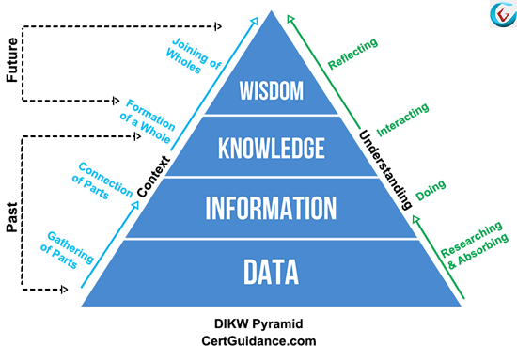
Figure: DIKW model
Source: (Lehaney, 2014)
The data is collected at the first step from primary and secondary sources. The data is collected by making research and absorbing it. Then the data is organized to make them meaningful. This is the connection step. After organizing the data, the information is analysed to gain knowledge from the information. Finally, the knowledge is applied in the company to make decisions and solve real-life problems and this the application step.
What is Data?
Data can be defined as the raw facts that do not create meaning and add value to the users. The data is needed to be processed to use. The data is collected from different primary and secondary sources (Wing, 2013). To make the data meaningful, the users organize, summarises and analyse the data. HSBC collects customer-related data from the branches around the world. The company collects data regarding the satisfaction of the customers, a several loyal customers, the services that are looking for, the annual sales in different branches and countries and other data. The data initially does not create any value for HSBC. But HSBC organizes and summarizes the data and make them useable.
For example, last year the company found that in China the revenue was around £5.3 billion and the net income was £1.09 billion. The number of customers served in the region was around 5.3 million and they provided 4.1 stars out of 5 on an average which was less than the rating of 2017. The management collects this data to improve the customers’ satisfaction in China.
What is Information?
To make the data meaningful and to create value from the data, the data is processed which means the data is organized, summarized and analysed. The processed data which can create value for the users is called information for those particular users. The information for one user may be data for another user as the definition of information depends on whether the data can create meaning and value for the users. The customers’ satisfaction reports prepared by local consultancy firms in China are information for them but they will be used in HSBC as data and they are further needed to be organized for making them valuable for the company.
HSBC collected customer service data in China and after organizing the data the managers found that the customers are less satisfied compared to that of the previous year although the number of customers increased by 3% comparing the number in 2017. This increased the net profits of HSBC by 3.11% comparing to 2017.

What is Knowledge?
Through learning and gaining experiences a person gains knowledge and skills. So knowledge is the information, skills, and concepts that are developed over time through experiences and learning (Tiwana, 2012). By using the knowledge, the managers make information. If the managers do not have knowledge about a particular issue they cannot make decisions. So, to make decisions, HSBC ensures that the managers have the knowledge which is required.
For example, after analysing the information about customer service in HSBC, the managers gained knowledge of the condition of customer’s satisfaction in the country. They found that the quality of customers’ services decreased slightly as the number of customers increased by around 3% in the last year. The increase in the number of customers made an increase in the net income of the company.
Wisdom
When the knowledge is applied in real life to solve real-life problems then the knowledge is called is wisdom (Schwartz and Te’eni, 2011). That means wisdom is the proper application of knowledge in real life. If the knowledge is applied properly in real life, then the knowledge is valueless for the users.
For example, after analysing the condition of customer service in China, the management decided to increase the number of relationship officers and the staff in the customer service department. The managers will also provide training to the existing staff to make them more productive. So, to improve customer satisfaction, the management applied the knowledge that they gained. This is called wisdom.

Explaining the relationship between individual knowledge and organisational knowledge
The individual who works the company has skills and experiences and this is called individual knowledge. The knowledge is developed by the individual through learning and taking experiences from different steps of life. When the individuals work in the organization and they work together and apply the knowledge to solve the problems of the organization is called organizational knowledge (Schwalbe, 2014). So, organizational knowledge is the combined form of the individual knowledge of the staff and managers working in that particular organization. Organizational knowledge can be optimized if staffs are allowed to work in different teams.
The relationship between these two types of knowledge can be different as the relationship depends on the communication channel and culture of the organization. As the cultures of the company varies and the communication channel, the relationship varies.
In HSBC, culture is an open culture. In the company, the staffs have the right to maintain an informal relationship in the workplace and they can share the knowledge regardless of the position in the company. In the company, there is a platform called “Share” and using the platform, staff, and managers can share their knowledge. This makes the relationship between the individual and organizational knowledge in HSBC very strong. The relationship depends on the formal and informal communication systems of HSBC:
- Formal communication
- Informal communication
Formal communication: The communication between the members of the company that occurs through the formal structure of HSBC is called formal communication. Formal communication can play a role in organizational knowledge management (Sarngadharan and Minimol, 2015)Sa. The managers allow the subordinates to share their ideas and knowledge with them as the democratic leadership style is followed in HSBC.
Informal communication: Informal communication plays the most important role for HSBC to make the organizational knowledge management process more effective. The name of the informal communication platform in HSBC is “Share”. This is an online platform where the employees of all levels can share their ideas and knowledge with others effectively. The organization also rewards the staff who make a better contribution.

Applying analysis and modelling techniques to identify knowledge assets
The knowledge assets are the most important assets for a company and if the company can apply the knowledge effectively, then they can make the optimum use of the other resources. To identify the knowledge assets, HSBC uses the following techniques:
Focus group: HSBC formed a focus group in different countries to identify the knowledge assets among the countries. The group is comprised of managers and other members of the company and they are responsible for identifying the people who have better knowledge and identifying the effective ideas from the staff (Schwalbe, 2014). The focus group also analyses the contribution of the members in the online knowledge-sharing platform of HSBC.
Structural change: By making the change in the type of activities performed by the staff, the managers can identify knowledge in the company. HSBC sometimes assigns the staff who perform capital intensive work to perform labour intensive works and vice versa to identify knowledge.
Information and communication technology: The use of communication technologies can play the most important role in the knowledge identification process of a company. HSBC makes the best use of technologies to identify the best assets. For example, the company has an online communication platform named “Share” and using the platform HSBC manages the sharing of ideas, knowledge, and experiences among the staff and managers. In the platform, the staff can easily share their problems and other staff assists them to solve the problems by sharing their knowledge. In addition, the staff can also share their innovative ideas in “Share” to improve the operations of the company. The focus group is responsible for identifying the best ideas from them and advise the management to implement the ideas in the company. The staff who make a better contribution are rewarded by the company. This motivates the staff to share their knowledge and ideas in the future. So, using this platform, HSBC identifies the most effective knowledge assets.
These are the common techniques that are used in HSBC to identify the knowledge assets. The company also uses other techniques in different countries. The application of these techniques depends on the work environment in different countries.

Evaluating the actual and potential knowledge assets
The knowledge assets are the most important assets of HSBC as having the best knowledge assets helps the company to gain the optimum use of other resources. The management uses several techniques to identify the knowledge assets. The actual and potential knowledge assets of HSBC are discussed below:
Actual knowledge assets:
Human knowledge assets: The skills, experiences, and knowledge of the employees in HSBC are called human knowledge assets (Collinson and Parcell, 2004). The company has strong management and work teams. They have knowledge on different issues such as leadership, marketing, finance, people management, production, and research. Using the knowledge, they contribute to HSBC.
Structural knowledge assets: The methods, techniques, and processes used by the staff to complete the tasks are called structural knowledge assets of HSBC. The leaders select the best approach to motivate the staff, the production managers use the most effective production technique and the managers use the best method to manage the activities.
Intellectual assets: The brand name is the best intellectual assets of HSBC. The brand has a high reputation in the world. The brand value of HSBC is £20.4 billion. To protect the intellectual assets, the company uses the trademark, patent, and other measures. To protect the software and the data of HSBC, the managers use patent.
Potential knowledge assets:
Market knowledge assets: Having strong knowledge about the market demand, the trends and the preferences of the customers will help the HSBC to improve the service quality and ensure high satisfaction (Dau, Mugnier and Stumme, 2015). The company can use market knowledge to gain better access to the market.
The innovation of the employees: The innovative ideas of the staff will allow the company to complete the tasks more efficiently and improve productivity. The creative staff can make a huge contribution to the company.
Administrative systems: The system used to manage the activities and staff can be improved to improve the effectiveness of the system and the profitability of HSBC.

Explaining what is required to create, store, apply and integrate knowledge
The knowledge management cycle is the process that is used to acquire, retain and transfer the knowledge within the organization is called organizational knowledge management cycle. The knowledge management cycle helps the organization to create, apply, store and integrate the knowledge.
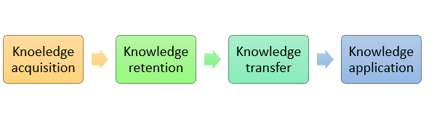
Figure: Knowledge management life cycle
Source: (Dupuy, 2014)
Knowledge creation: Knowledge creation is started with the knowledge acquisition process of the members of HSBC. The staff gain knowledge by learning new methods and techniques, taking experiences in different situations, developing different skills. HSBC provides off the job and on the job training to the staff to help them acquire knowledge. The company encourages staffs to gain new knowledge. For this, the highly skilled and talented employees are highly rewarded in the company.
For example, when the new graduate teams join HSBC they get through a one-year training program to gain knowledge regarding the company, the culture, the management process and the work environment in HSBC. The new staffs at the management level also get a one-month training program to adjust to the work environment of HSBC.
Knowledge store: The process of knowledge store and retention is a crucial step in the knowledge management cycle (Davenport and Prusak, 2000). The new graduate teams are bound to stay for a certain time in the company after completing the training in HSBC. The information that HSBC collects from the market is also stored using information technologies. The company also uses a strong system to ensure that the information is protected and the outside parties do not have access to the information.
For example, HSBC has a strong database management system and the organization has a team that is responsible for storing and protecting the information. To store the information the organization also uses other digitalized systems.
Knowledge integration: The knowledge integration system ensure that the information is properly summarized and organization so that the managers can use the information (Bergeron, 2018). To integrate the information, HSBC uses a relational database management system and the system allows the company to share the information with the related parties. The database management system collects information from all the branches around the world and allows the related parties to access the information. This system integrates the knowledge management system from 3900 branches of 65 countries where HSBC operates.
Also, to integrate the information, HSBC also uses the online platform named “Share” and the platform integrates all the ideas of the employees and presents the ideas to the focus group. The focus group selects the best and most effective ideas.
Knowledge application: The application of knowledge is the most crucial in knowledge management. If the knowledge cannot be applied, the knowledge cannot create value for the users. To use the knowledge, the management uses different approaches. The decisions are made using the knowledge and this increases the effectiveness of the decisions in HSBC.
For example, after gaining knowledge about the customer service quality in China, the top management decided to improve the skills of the staff working in the customer service management, increase the number of relationship managers and customer management staffs. This is how knowledge is applied in HSBC.

Considering the importance of intellectual property rights
To protect the intellectual properties and knowledge assets such as innovation, new products, software, information and brand name, different types of intellectual property rights are used. HSBC use patents to protect the innovation of the company. The company provides some innovative financial services such as wealth management, retail banking, and investment banking and to protect this innovation, the patent is used. HSBC uses a strong software and communication network to complete and integrate the activities around the world. To develop the software and communication network, HSBC spent billions of pounds and they are needed to be protected. The value of the brand of HSBC is £20.4 billion and to protect the brand name the company uses the trademark. For the following reasons, intellectual property rights are used in HSBC like other companies:
Encourage innovation: By using innovation, a company develops different new products, add new features to the products, develops new methods and processes and innovative techniques. If the innovations cannot be protected, then the company will not be motivated to innovate as to innovate a company spent huge money (Easterby-Smith and Lyles, 2003). So, intellectual property rights provide protection to innovations and encourage innovation.
Gaining competitive advantages: By applying innovative methods and processes, a company can reduce costs and improves the quality of the services. HSBC can also increase market share by offering innovative financial services. This provides competitive advantages to the company.
Benefits of the customers: Innovation and intellectual properties to improve the service quality and reduce the costs of the company (Jones, 2001). By providing high-quality services, HSBC can make customers more satisfied. The customers can also get services at lower prices.

Explaining the contribution knowledge management have on HSBC
Knowledge management is the process that is used to gain knowledge, store and retain the knowledge and application of the knowledge to solve the organizational problems and make decisions.
Access to information and knowledge: Providing access to information in real-time is one of the core aspects of knowledge management. The managers have access to the information and analysing the information they can gain knowledge about certain issues and make decisions on that issue. Knowledge management protects and retains the information properly and makes the information available to the users. HSBC can have access to any information through the knowledge management system.
Integration of knowledge: HSBC uses the relational database management system to ensure the integration of knowledge among different departments and the branches in 65 countries. The integration of knowledge helps the top management to understand the overall scenario of the organization (Ichijo and Nonaka, 2007). HSBC also ensures that the knowledge is properly shared among the parties so that they can make the optimum contribution.
Promotion of innovation: To make innovation, the R&D department needs information and knowledge about the market and the demands of the customers. The employees can also new products and ideas if they have access to the proper knowledge. The knowledge management process of HSBC promotes innovation among the members in this way.
Improving efficiency and productivity: The employees can solve the problems if they can get support from others. The knowledge management process of HSBC enables the staffs to share the knowledge and help other staffs. The staffs can assist the management to determine the techniques and methods which will improve productivity. This has been implemented in HSBC as knowledge management is strong in the company.

Evaluating the knowledge requirement for HSBC
To determine the requirement of knowledge, the knowledge gap is needed to be determined. The knowledge gap is the distance between what the organization needs to know and what the organization knows.
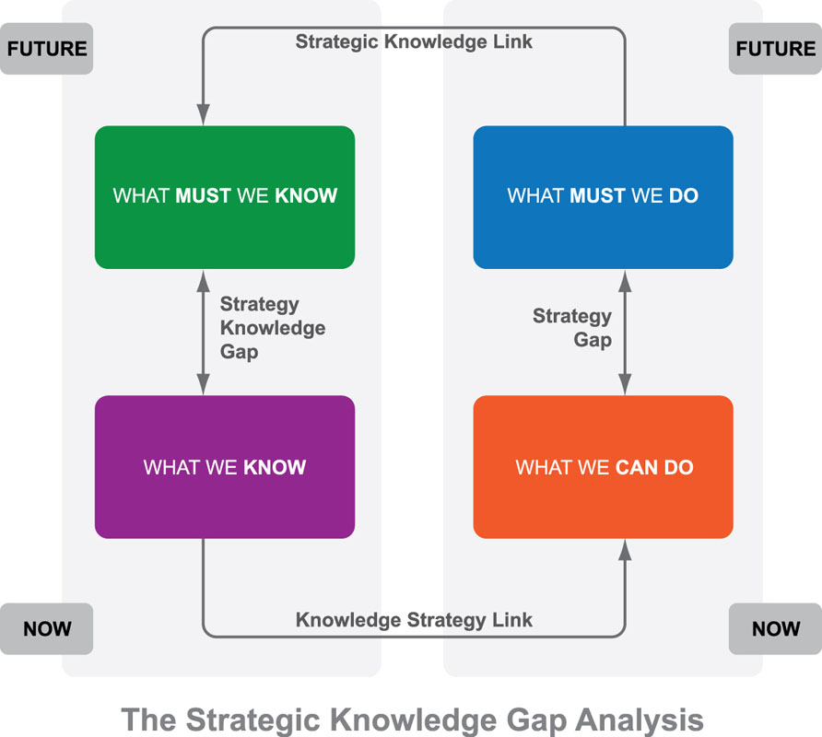

Figure: Knowledge gap analysis
Source: (Griseri, 2002)
What HSBC must know:
To have better access to qthe market and provide more effective services, HSBC must have knowledge of the following issues:
- The knowledge about the overall financial service industry in the world and the market trends in the industry will help HSBC to understand which products will help the company to retain and increase the market share.
- The risks in the financial service industry are also needed to be assessed properly so that the company can evaluate the potential threats and take steps in advance.
- The preferences of the customers and their requirements are also needed to be identified and analysed so that the company can improve customer management and satisfaction (Frappaolo, 2018).
- HSBC must have sound knowledge about the laws and regulations which are regulating the financial industry in the world. This will help the company to conform to the laws and make better decisions.
- The company must also have knowledge about the competition in the industry, the strategies that competitors are following and the prices they are charging.
What HSBC knows
- The company has sound knowledge about market demand, market trends and market condition. Thus the company can offer the services that best match the market requirement.
- HSBC also has good knowledge about the competitors and the strategies followed by the competitors to beat the market.
- HSBC has good knowledge about the preferences of the customers. The company makes a regular survey in the market to understand the demand of the customers and their preferences.
Knowledge gap:
- HSBC has lacked knowledge about the risks in the financial industry and thus the company faces different types of risks in different markets of the world.
- The company also needs to improve the knowledge regarding the laws and regulations in the financial industry. Previously the company charged with penalties by the regulatory authorities in different countries for violating the laws.

Evaluating the current knowledge sharing framework of HSBC
HSBC is currently using an online knowledge-sharing platform and the name of the platform is “Share”. In this platform, staffs can share their ideas and opinions with others. In addition, when a staff faces a problem, he or she can share the problem on the platform and other employees support the staff by sharing the knowledge with the staff. As a result, the problem can be solved.
The knowledge-sharing platform has been proved effective in the company as the staff can share the ideas with the company easily (Knowledge Management Systems, 2010). The company has a focus group which is responsible for analysing the ideas suggested by staffs and select the best ideas among them.
As a result, the company can implement innovative ideas at lower costs. In addition, when an employee shares an idea he is rewarded. The employees who make the highest contribution to the company are rewarded by providing financial and non-financial incentives by the company.
When an employee cannot solve an issue individually he or she can share the issue on the platform. The team can also share their problems with other staffs using the platform. May be another employee working in another country knows the solution to the problem. The staff can share his knowledge and support the individual or team to solve the problem. The staffs who make the highest contribution are also highly rewarded by HSBC.
So, the knowledge-sharing platform is very effective in solving the problems of the staffs and developing innovative ideas for HSBC. The platform has been proved to improve the productivity and co-operation among the staffs. So, the platform is effective for the company.

Conclusion
Knowledge management is one of the most important factors for a company as this process helps the managers to keep the staffs motivated to gain knowledge, share the knowledge, integrate the knowledge and apply the knowledge for the organization to achieve the goals. The knowledge-sharing platform and framework can play a most important role in improving productivity and co-operation among the staffs if the organization can design an effective knowledge-sharing platform. So, every organization should give a high concentration on knowledge management.

Recommendation
Although the current platform “Share” is very effective for developing new ideas and solving the problems of the company, there are still rooms for making improvements in the platform and this will help HSBC to go to a further level.
- The organization usually provides financial incentives to the staffs who make the highest contribution to the platform by sharing the knowledge to solve the problems of other staffs and teams (Wiig, 2013). In addition, the employees who provide the best ideas are also rewarded financially in most of the cases. The company can also introduce non-financial incentives to motivate the teams and individuals to make a contribution to the platform.
- The focus group finds it hard to get the best ideas from the platform as it is very difficult to search a needle from a large haystack. The company can increase the number of staffs working for the focus group and thus they can manage the ideas and select the best ideas for HSBC.
- The managers do not regularly monitor the activities of the members on the platform. As a result, the platform is not used optimally in the company. To improve the motivation of the team and members, the managers should actively participate in the platform and make a contribution as well. This will boost the motivation of the staff to share more ideas and knowledge on the platform.
- The formal communication channel can also make a high contribution to the knowledge management process of HSBC. The organization should also improve the formal communication platform among the manager and staff so that knowledge sharing can be improved and the individual knowledge can be optimally transferred to organizational knowledge.

References
Bergeron, B. (2018). Essentials of knowledge management. Hoboken, N.J.: J. Wiley.
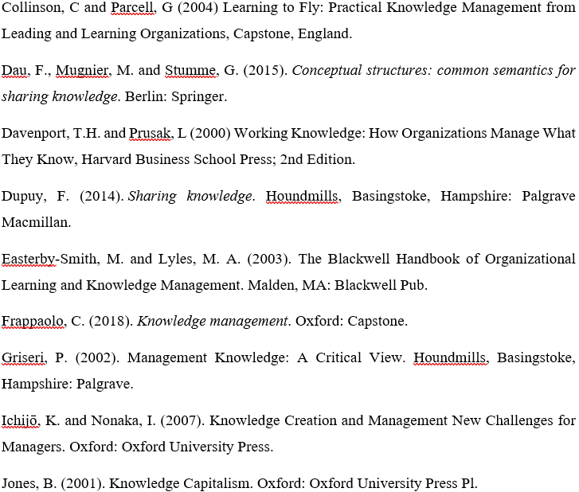
Knowledge Management Systems. (2010). Gardners Books.
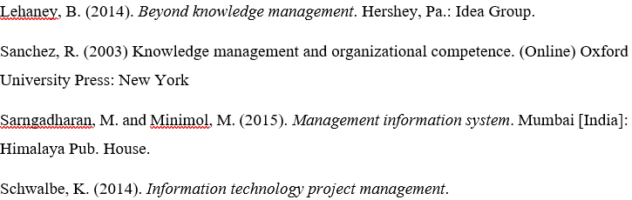
Schwartz, D. and Te'eni, D. (2011). Encyclopedia of knowledge management. Hershey, PA: Information Science Reference.


