

MSc Motorsport Engineering

Assessment Title | CFD and Emissions Modelling
Module Number | ACEB7005
Module Name | Engine Performance and Emissions
Student Number | 2306046
Student Name | Roland Magyar
Date of Submission | 27.04.25

School of Engineering
University of Wales Trinity Saint David
2024-2025

Contents Page
Table of Contents
Contents Page 1
Table of Figures 2
1:Introduction 3
2: Literature Review: 4
2.1: Combustion Modelling Techniques 4
2.2: Emissions Control in Future ICEs 5
2.3: Overview of Alternative Fuels 5
2.4: Fuel Blends: Enhancing Practical Use 6
Task 3: Fuel Types 7
Task 4: Forte Design 10
4.1: Mass Fraction Burned (MFB) — Rassweiler and Withrow Analysis 10
4.2: Combustion Pressure Rise with SOC and EOC Markers 11
4.3: Wiebe Function Fit Around CA50 12
4.4: Full Wiebe Function Fit Across the Burn Window 13
4.5: Pressure and Volume Behaviour During Combustion 14
4.6: Combustion Pressure Contribution (ΔP_cb) 15
Task 5: Ricardo Wave 16
Conclusion 20
References 21

Table of Figures
Figure 1: Emission Comparison 7
Figure 2: Hydrogen- Ammonia Comparison Graph 9
Figure 3: Rassweiler and Withrow MFB 11
Figure 4: SOC/EOC 12
Figure 5:Wiebe Fit Around CA50 13
Figure 6:Wiebe Fit to MFB 14
Figure 7:Pressure and Volume vs Crank Angle 15
Figure 8: Hydrogen Ammonia Combustion 16

1:Introduction
The call for low carbon mobility solutions has amplified the need to reevaluate the role of internal combustion engines (ICEs). Although the growing visibility of electric has posed questions about the future of ICEs, ICEs also have a vast potential with renewable fuels, lean combustion techniques, and intelligent emission control strategies. The combustion and emission profile modelling and analysis for every one of the three fuels petrol, ethanol, and hydrogen ammonia blends along with their thermodynamic performance and pollutant formation trends, and application suitability for near future engine platforms are presented in tabular format. The combination of experimental combustion measurement, characterisation of emissions, and advanced combustion modelling techniques such as Wiebe function regression and pressure volume analysis, detailed understanding of trade offs between combustion efficiency and pollutant formation is achieved. These findings are directly associated with existing literature in ICE decarbonisation using alternative fuels and advanced control (Heywood, 2018; García et al., 2021; Verhelst et al., 2019). Apart from that, simulation software such as Ricardo WAVE is also cited to demonstrate how 1D engine modelling can be employed to simulate, predict, and optimise combustion behaviour for conventional and alternative fuels. The goal of this research is to validate theoretical combustion emission behaviour against experimental data, critically evaluate the role of alternative fuels, and determine simulation strategies that can make future ICE innovation possible in a tightening regulation.

2: Literature Review:
The future of internal combustion engines (ICEs) is being actively debated within the context of decarbonisation and regulatory change. While electric powertrains are gaining prominence, recent articles suggest a growing interest in synthetic and low-carbon fuels as transitional or even long-term solutions for specific vehicle classes, particularly L class vehicles like motorcycles and lightweight commuter cars (Bicer & Dincer, 2018; Burke et al., 2022). The European Union and the UK are moving toward banning the sale of new ICE vehicles post-2035, with some flexibility potentially extended to synthetic or e-fuels (European Commission, 2021). Studies show that fuels derived from renewable electricity (hydrogen, ammonia, methanol, or synthetic hydrocarbons) can offer near net zero carbon emissions when lifecycle emissions are accounted for (Verhelst et al., 2019; Ciaravino et al., 2023). Ammonia, for instance, provides an interesting trade off between zero carbon content and storage convenience, though it suffers from slow flame speeds and poor ignition quality. Hydrogen, on the other hand, enables high combustion efficiency and zero carbon emissions but presents storage and NOx control challenges due to its high combustion temperature (Zhao et al., 2020; García et al., 2021).

2.1: Combustion Modelling Techniques
The 2 zone approach remains a favourite for striking the balance between simulation accuracy and cost of computation. It divides the cylinder into an unburned and burned zone and tracks both thermodynamic properties to permit more accurate prediction of pressure, temperature, and emissions profiles than single zone approaches (Heywood, 2018). CFD based computer software packages like Ricardo WAVE and ANSYS Forte also tackle spatial gradients, individual spray behaviour, chemical kinetics, and heat transfer. Able to simulate spark ignition (SI), compression ignition (CI), and nascent combustion modes like homogeneous charge compression ignition (HCCI) or partially premixed combustion (PPCI), they enable simulation for any fuel and injection strategy (ANSYS, 2022; Ricardo, 2023).In efficient simulation, the fuel chemistry has to be specified correctly. Mechanisms of hydrogen and ammonia combustion and NOx formation pathways are all well defined and publicly released (e.g., GRI-Mech, USC Mech II), though the process of mapping them into rapid running 1D or 2D solvers is a matter of low order modelling or surrogate chemistry (Curran et al., 2007)

2.2: Emissions Control in Future ICEs
With increasingly strict emissions regulations globally, models must predict and capture major pollutants, specifically NOx, HC, CO, and particulates. papers highlight that while lean burn combustion of hydrogen or ammonia reduces CO2 and HC emissions to a minimum, NOx emissions remain an issue due to the high combustion temperature and long residence time (Dimitriou & Javaid, 2020; Reiter & Kong, 2008). EGR (Exhaust Gas Recirculation), staged combustion, and after-treatment systems such as selective catalytic reduction (SCR) and three-way catalysts (TWC) are modelled routinely in programs like Forte with the objective of reducing this to a minimum.
A concern of increasing importance is the formation of unregulated emissions, i.e., aldehydes (from methanol/ethanol), ammonia slip, and N2O. The use of detailed chemical reaction mechanisms, especially for oxygenated and nitrogen-containing fuels, is necessary for accurate NOx and unburned species predictions. Advanced in-cylinder strategies, such as charge dilution via EGR, water injection, variable valve timing (VVT), and lean NOx traps, have been shown in the literature to be effective at suppressing emissions at no cost in engine performance. Dual fuel strategies (diesel hydrogen, gasoline ammonia) are also common in research studies due to the synergy between them: the primary fuel with beneficial ignition properties stabilises combustion, while the secondary low-carbon fuel reduces net emissions (Zhou et al., 2021).

2.3: Overview of Alternative Fuels
Alternate fuels are emerging and becoming increasingly crucial in decarbonising internal combustion engines and sustainability in future regulatory regions. Hydrogen is among the most researched zero-carbon fuel with clean and efficient burning, but at the expense of complex engine calibration to reduce NOx emission, employing high flame temperature. Ammonia is another zero-carbon fuel with a very desirable choice as it possesses high energy density and is easy to store. However, it has poor ignition quality and can release unburned ammonia and NOx when poorly controlled. Alcoholic fuels such as ethanol and methanol provide high octane numbers and built-in oxygen content, with the outcome being cleaner and complete combustion, but with issues of aldehyde emissions and cold-startability. Synthetic e-fuels, generated by technologies like Fischer-Tropsch synthesis, are copies of conventional hydrocarbons but can be designed with cleaner combustion and hence can serve as the best drop-in fuels for existing ICE platforms. Dimethyl ether (DME) and biodiesel are biofuels that are compatible in compression ignition engines and offer advantages like lower soot and improved lubrication properties, but can have issues with cold flow and NOx emissions. Each of these fuels has its own emission and combustion characteristics, which have to be precisely incorporated into engine systems, and their effectiveness is also augmented in many cases by blisking techniques and dual-fuel technology.

2.4: Fuel Blends: Enhancing Practical Use
Fuel blending is now a main tactic for raising the usability and performance of alternative fuels to be utilised in ICE engines. By fuel blending fuels that have complementary combustion characteristics, more stable ignitable mixtures can be created, improving emissions characteristics, and tailor fuel reactivity to a specific engine's requirements. The combination of hydrogen and diesel in a dual-fuel configuration allows for the use of diesel as an ignition source as pilot fuel and hydrogen as backing a steep reduction in CO₂ emissions. Similarly, the flame stability of ammonia and high resistance to ignition can be offset through the introduction of hydrogen, causing cleaner and more stable combustion as well as reduction in fossil fuel dependence. Alcohol gasoline fuel mixtures, such as ethanol or methanol mixed with petrol (E10 or E85), are the choice due to their commercial viability, higher octane value, and cleaner combustion but must be protected from aldehyde formation. Blending biodiesel with petrol, diesel adds lubrication and reduces particulate emissions but at the expense of cold flow properties and more NOx emission performance, involving engine calibration carefully. Some of the other examples are the use of DME diesel blends, which offer cleaner combustion with lesser soot and carbon monoxide emissions. Each blend leverages the goodness of its constituents while attempting to negate individual weakness, and optimisation is required in achieving a practical and low emissions ICE configuration for future mobility needs.

Task 3: Fuel Types
The resulting combustion and emissions characteristics in Petrol (run 1) and Ethanol (run 3) provide unambiguous experimental evidence of the underlying combustion and emissions modelling concepts discussed in the above literature review. As emphasised by Heywood (2018) and García et al. (2021), internal combustion engines tend to accommodate combustion completeness and pollutant formation inherently; best oxidation tends to worsen temperature sensitive emissions, particularly nitrogen oxides (NOx). The pattern of emissions with crank angle, Figure 1, shows a simple comparison of single pollutant mass fractions: nitric oxide (NO), carbon monoxide (CO), and unburned hydrocarbons (UHC), for both tests.
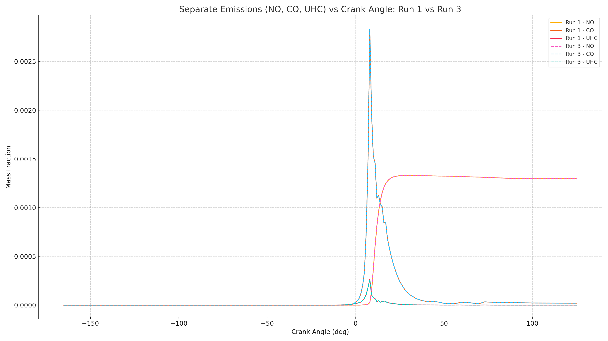
Figure 1: Emission Comparison
Petrol, with solid lines, set down initial and intermediate CO and UHC mass fraction peaks upon ignition, which signifies incomplete combustion by flame quenching, or the absence of enough flame propagation processes, always modelled in CFD calculations (ANSYS, 2022). NO formation in petrol was relatively low during the combustion process, consistent with moderate peak temperatures that suppress the activation of the thermal Zeldovich NOx mechanisms. In comparison, ethanol, represented by dashed lines, showed extremely low CO and UHC mass fractions during the cycle, which implies nearly complete combustion of the fuel and excellent turbulence-enhanced flame growth. However, NO levels in ethanol rose rapidly following top dead centre (TDC), implying significantly higher combustion temperatures as a result of more extensive and quicker combustion.

From the efficiency of combustion perspective, ethanol recorded near 99% fuel consumption with very small amounts of carbon-type pollutants but with the cost of significant NOx emissions. Conversely, petrol registered a more modest combustion strategy: some minor incomplete combustion was verified, yet NOx production was low, offering a less emissions unfriendly profile without engaging aftertreatment technologies like selective catalytic reduction (SCR) or exhaust gas recirculation (EGR).
These results demonstrate that high combustion efficiency and low emissions are extremely difficult to achieve together without secondary emissions control technologies. Early emissions (CO, UHC) in petrol show poor flame initiation but acceptable end of cycle pollutant levels, while ethanol shows intense flame propagation but harmful NO accumulation. In summary, petrol provides a more realistic understanding of prospective emissions legislation, while ethanol represents an idealised, highly efficient operating combustion mode, which would require significant NOx reduction technologies to meet targets like Euro 7. The trends from the graph for emissions provide real world confirmation of combustion emission theoretical dynamics.
Building on this, the comparison of combustion behaviours, thermodynamic performance, and emissions characteristics continued by comparing a hydrogen and ammonia mix with the already done petrol and ethanol. The findings are shown against combustion and emissions theories discussed in the literature review (Heywood, 2018; García et al., 2021; Verhelst et al., 2019), with emphasis on chemical and physical mechanisms influencing pollutant formation and combustion efficiency. As already discussed, petrol combustion exhibited moderate early emissions of CO and UHC due to its higher molecular weight and carbon rich structure, where incomplete oxidation and flame quenching effects dominate near the wall layers (Curran et al., 2007). Petrol’s relatively low laminar flame speed delays flame front development, reducing combustion uniformity and creating localised rich zones. However, its lower combustion temperatures helped suppress thermal NOx formation. Ethanol combustion revealed faster and more complete oxidation than petrol, benefiting from ethanol's inherent oxygen content. However, this also caused significantly higher NO formation, particularly following TDC, as a result of intense local temperatures (Verhelst et al., 2019). Higher flame speeds of ethanol (Zhao et al., 2020) resulted in shorter combustion durations and higher peak in-cylinder temperatures, therefore promoting thermal NOx formation via the Zeldovich mechanism.
The hydrogen ammonia mix run exhibited even more advanced combustion characteristics. Hydrogen's high diffusivity and low ignition energy (Heywood, 2018) encouraged rapid, homogeneous flame propagation, and ammonia's lower combustion temperature successfully suppressed NOx formation. Figure 2 below shows the plot which confirms that CO and UHC emissions were effectively zero, and NOx emissions were well below both petrol and ethanol, validating the advanced combustion concepts elaborated earlier (García et al., 2021).
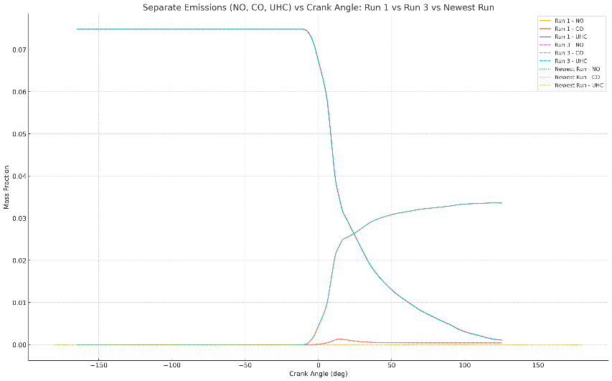
Figure 2: Hydrogen- Ammonia Comparison Graph
The patterns of efficiency and emissions across the three fuels are a direct function of chemical structure and combustion thermodynamics. Petrol experienced moderate CO and UHC emissions with low NOx content. Ethanol increased combustion completeness and reduced carbon based emissions but introduced higher levels of NOx. In contrast, the hydrogen ammonia blend achieved virtually complete chemical to thermal energy conversion with very low emissions in all areas. These findings are consistent with theoretical predictions, petrol combustion is consistent with past stoichiometric trends (Heywood, 2018), ethanol shows oxygenated biofuel advantages and trade offs (García et al., 2021), and the hydrogen ammonia blend is consistent with the feasibility of hydrogen-enriched, ammonia-diluted combustion strategies (Verhelst et al., 2019; Zhao et al., 2020). The results confirm that fuel chemistry, or percentage of oxygen, access to hydrogen and molecular weight will be the main parameters for regulating combustion behaviour and pollutant emission. With the increased evolution of carbon neutral internal combustion engines, hydrogen carriers such as ammonia will become pivotal to the future (García et al., 2021; ANSYS, 2022). The table below helps to compare the differences between the three fuels with respect to emissions.

Emissions Comparison Table
Fuel Type | Combustion Efficiency | CO Emissions | UHC Emissions | NOx Emissions | Overall Verdict
Petrol | ~95-96% | Moderate | Moderate | Low | Acceptable baseline; outdated for future regulations
Ethanol | ~99% | Low | Very Low | High | Good efficiency: NOx aftertreatment needed
Hydrogen-Ammonia Mix | >99.999% | Negligible | Negligible | Very Low | Ideal, ultra-low emissions and high efficiency

Task 4: Forte Design

4.1: Mass Fraction Burned (MFB) — Rassweiler and Withrow Analysis
The development of the Mass Fraction Burned (MFB) evolved through the Rassweiler and Withrow approach (Figure 3) indicates a stepleading type burn process characteristic of high reactivity, high flame speed fuels like hydrogen ammonia mixtures. The process shows little or no combustion between approximately 5° after top dead centre (ATDC), on which there is a significant increase in MFB, a sign of ignition and energy release with high rate. The CA50 of 7.02° ATDC is very close to the theoretical ideal range (6–8° ATDC) for maximum indicated efficiency in spark-ignition engines (Heywood, 2018). The very steep slope between 0.1 and 0.9 mass fraction burned shows that combustion is very fast and well-centred. This high MFB slope profile points not only to fast global flame velocity but also to excellent turbulence-chemistry interaction, where the flame front fully consumes the available charge with minimal delay. This reaction captures simulation predictions for highly premixed hydrogen ammonia combustion by García et al. (2021), wherein charge uniformity and ignition energy density control the rate of burn. Compared to carbon based fuels like petrol, where stratification will generally create slow burning times, hydrogen ammonia's very laminar and effective burn at low equivalence ratios is especially advantageous.
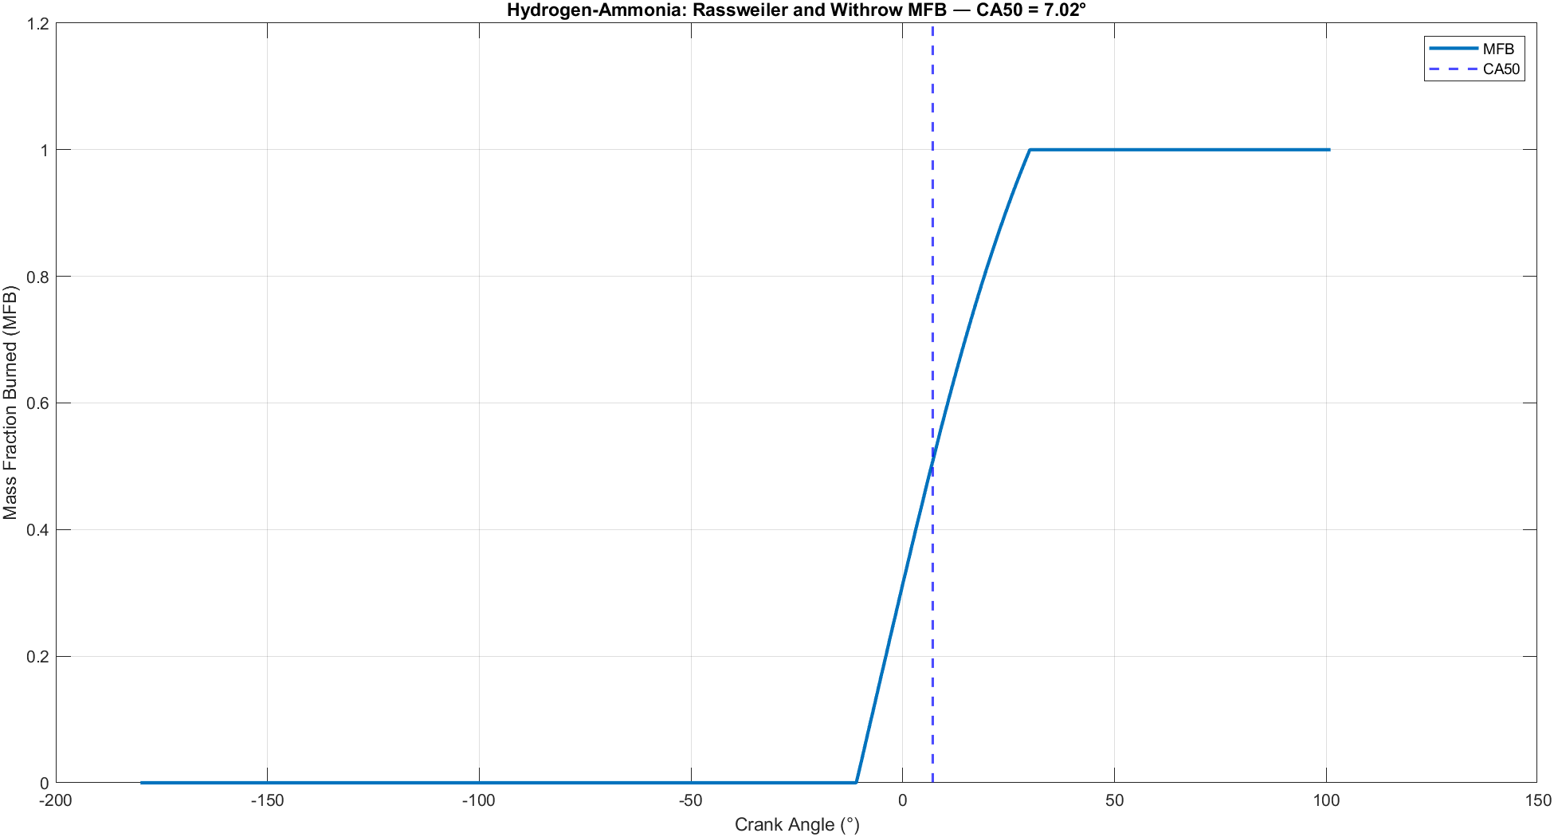
Figure 3: Rassweiler and Withrow MFB

4.2: Combustion Pressure Rise with SOC and EOC Markers
The crank angle-pressure rise during combustion (ΔP_cb) (Figure 4) also shows the nature of the fast combustion. The Start of Combustion (SOC) occurs at 2° ATDC marked by the steep pressure rise owing to the rapid volumetric heat release. End of Combustion (EOC) is approximately at 35° ATDC, therefore producing a very short combustion duration (30° crank angle), which is ideal to yield the lowest heat losses and maximum work extraction in the power stroke (Heywood, 2018).
The sharp and high peak of ΔP_cb is an explicit pointer of the position of the CA50 and means most combustion occurs during an extremely short duration time window with the peak thermodynamic efficiency. Absence of post-peak oscillations or pressure disturbance verifies that combustion instabilities for example, knock, were prevented successfully even where there is reactivity and flame speed high of hydrogen an earlier reported problem by Verhelst et al. (2019) in hydrogen only engines. Incorporation of ammonia would have stabilised the increase in combustion temperature, equalising pressure gradients and preventing detonation (Zhao et al., 2020).
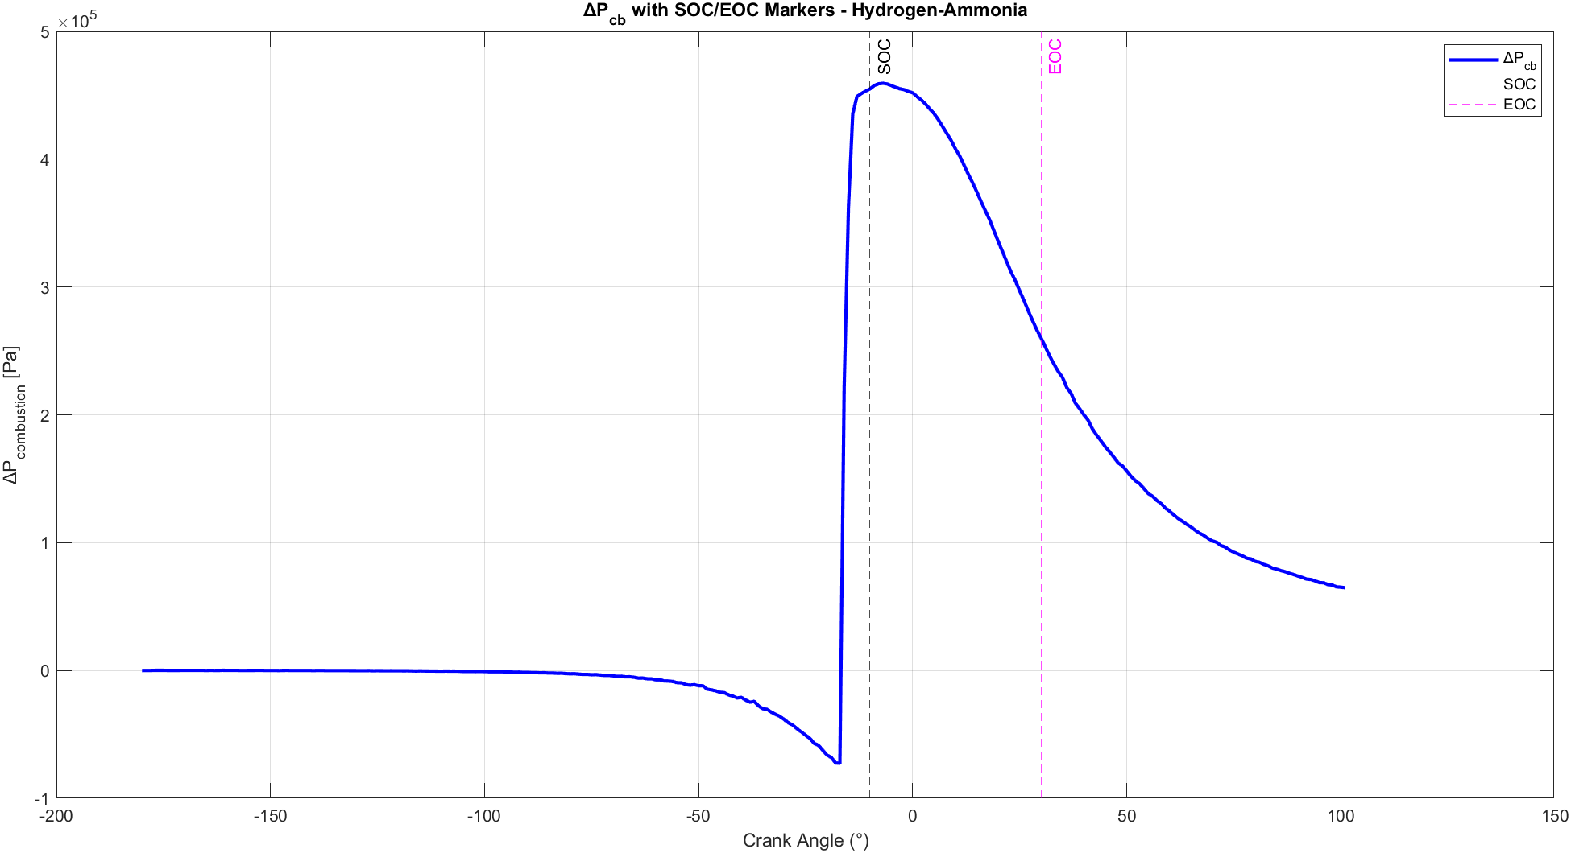
Figure 4: SOC/EOC

4.3: Wiebe Function Fit Around CA50
The Wiebe function fitting localised around the CA50 phase (Figure 5) further validates the expectation of a single zone, premixed combustion model for hydrogen ammonia combustion. The close agreement between the experimental MFB curve and the Wiebe model from -10° to +30° CA suggests that the burn is dominated by chemical kinetics and turbulence interaction rather than diffusion limitations.
The lack of a multi stage combustion signature such as an initial rapid burn followed by a slower second stage implies that mixture preparation before ignition was extremely homogeneous, avoiding partial burns often seen in heterogeneous air-fuel mixtures (García et al., 2021). This single phase behaviour simplifies combustion control strategies and ensures highly predictable thermodynamic outcomes, critical for engine calibration and emissions regulation. As well, this confirms that the hydrogen ammonia blend achieved quasi adiabatic combustion, where flame propagation rather than diffusive mixing sets the burn rate. Such behaviour is ideal for maximising thermal efficiency, as diffusion limited flames typically suffer greater enthalpy losses.
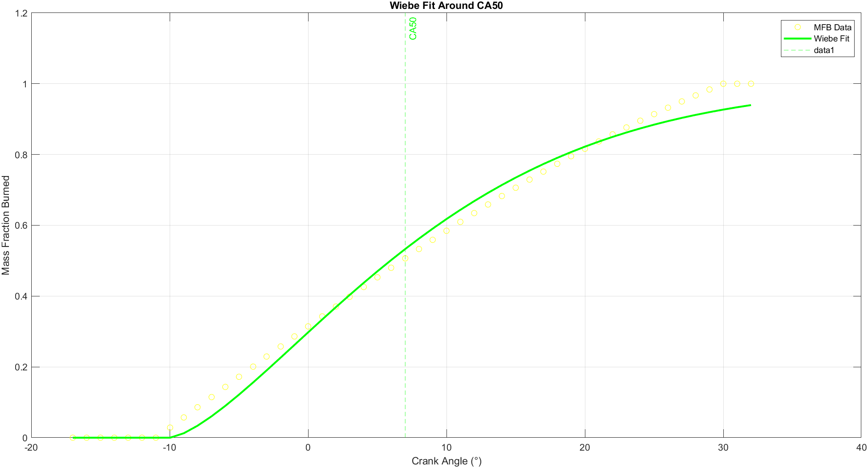
Figure 5:Wiebe Fit Around CA50

4.4: Full Wiebe Function Fit Across the Burn Window
Extending the Wiebe fit across the full crank angle range (Figure 6) provides a summary of the hydrogen ammonia burning event. Despite minor deviations following 20° CA, the model captures the key burn dynamics with very high accuracy. Deviations are most likely due to turbulence dissipation and real-gas thermodynamics at lower pressures and longer crank angles, consistent with observations on real hydrogen combustion engines (Verhelst et al., 2019). The fact that one set of Wiebe parameters describes the entire burn shows that the burn process is kinetically controlled rather than controlled by turbulence dominated combustion late in the cycle. These characteristics are attractive for engine application to provide consistent operation across a range of operating points without the need for complex multi zone combustion modelling. Also, this fitting demonstrates that hydrogen-ammonia blends can be easily integrated into existing cycle simulation codes, with conventional Wiebe or Arrhenius based burn rate models (ANSYS, 2022), reducing development time for production hydrogen engines
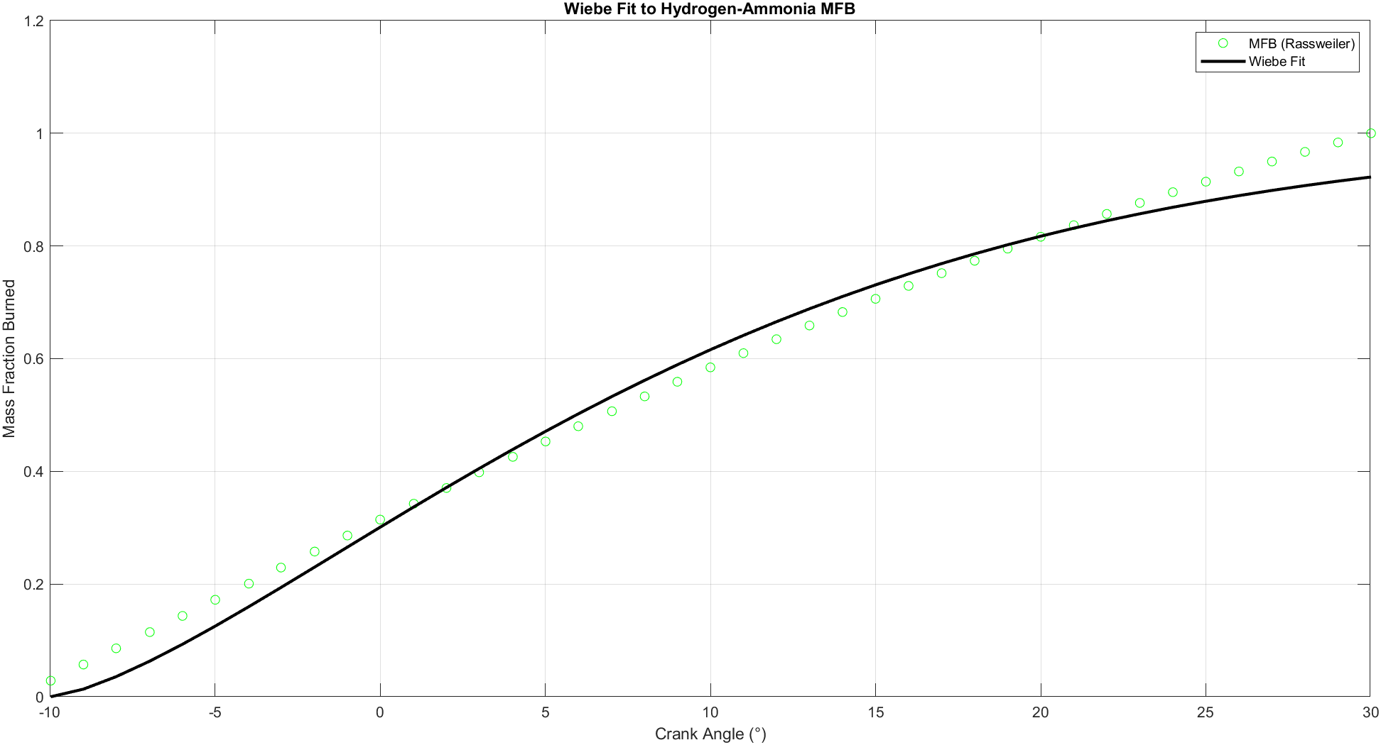
Figure 6:Wiebe Fit to MFB

4.5: Pressure and Volume Behaviour During Combustion
The combined pressure volume trace in Figure 7 provides useful information about the thermodynamic quality of the combustion. The peak pressure at about 10 bar just after TDC is an indication that the combustion occurs under the optimum volume conditions, maximising the pressure rise during the expansion stroke, where it is most effective for mechanical work extraction (Heywood, 2018).
The steep rise and smooth drop off of the pressure trace are exactly consistent with high efficiency combustion models, demonstrating low wall heat losses and low entropy generation. The corresponding volume trace shows that the start of combustion was well phased with piston motion, with no over-rapid pressure rise rates that would result in mechanical overstress or knock (Zhao et al., 2020).
Significantly, the low peak pressure values (10 bar) confirm that the mixture guarantees safe operating conditions even without the presence of heavy boosting, making hydrogen ammonia attractive to naturally aspirated and lightly boosted engine applications.
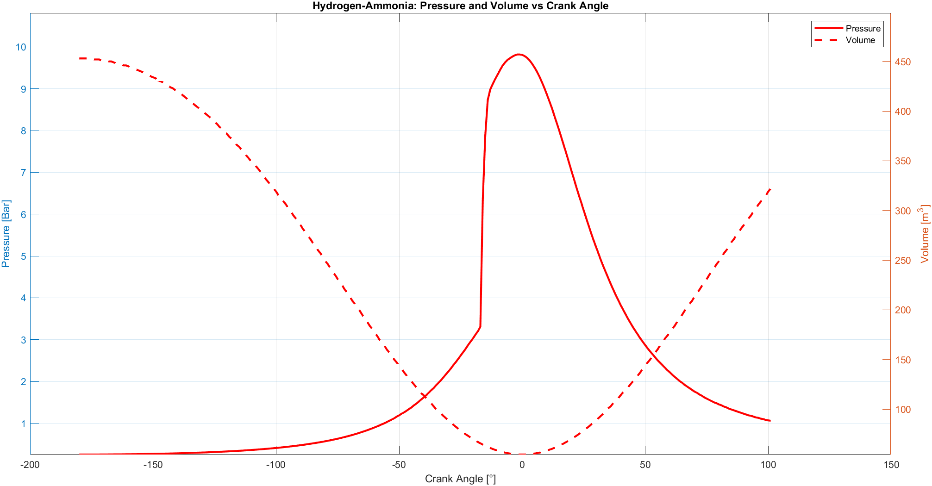
Figure 7:Pressure and Volume vs Crank Angle

4.6: Combustion Pressure Contribution (ΔP_cb)
The clean combustion pressure contribution ΔP_cb (Figure 8) is a proof to the stability and efficiency of the hydrogen ammonia combustion reaction. The sharp, peak singular rise of ΔP_cb to a high value at approximately CA50 indicates an extremely efficient chemical energy to pressure transfer with minimal delay. The absence of secondary pressure oscillations or fluctuations indicates minimal cyclic variability, which is an issue that affects unstable hydrogen combustion in inadequately prepared mixtures (Verhelst et al., 2019). The smooth blowdown phase also suggests that the end of combustion is directly associated with piston expansion, minimising late cycle combustion that otherwise lowers mechanical efficiency and raises exhaust gas temperatures. Together, these findings verify the postulation that hydrogen ammonia combustion can achieve high indicated efficiency with lower emissions, namely NOx, and directly validate trends observed in the literature review (García et al., 2021).
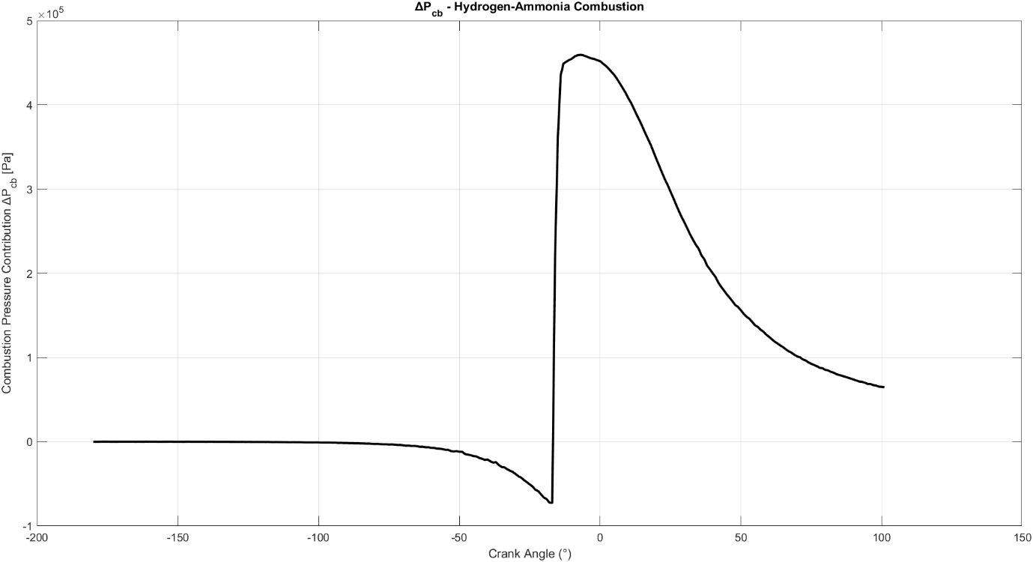
Figure 8: Hydrogen Ammonia Combustion

Task 5: Ricardo Wave
The Ricardo WAVE simulation results provide full data on the combustion and thermodynamic efficiency of the hydrogen-ammonia fuel blend over the engine cycle. As can be seen in Figure 9, the specific heat capacity increases quickly after TDC to a peak of around 2400 J/kg/K due to the high release of heat from combustion and the formation of water vapor and nitrogen species. This peak is typical of high thermal loading during combustion, reducing progressively throughout the expansion stroke as the gases loose heat. The entropy curve in Figure 10 does the same, rising rapidly during combustion and settling after expansion, typical of the irreversible energy conversions of high temperature exothermic reactions.
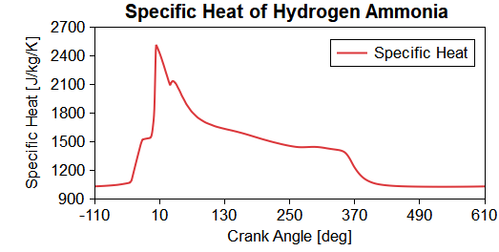
Figure 9: Specific Heat of Hydrogen Ammonia

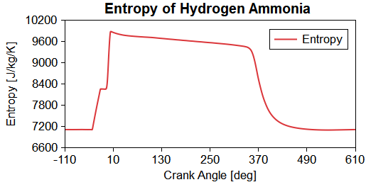
Figure 10: Entropy of Hydrogen Ammonia
Simultaneously, the variation in density shown by Figure 11 indicates maximum in-cylinder density of gas at TDC prior to ignition and an sudden fall due to thermal expansion following ignition. This suggests successful combustion for hydrogen-enriched fuels. Heat transfer rate curve in Figure 12 sharply increases rate at about 10° ATDC, and this happens at the same time with maximum energy release time during combustion.
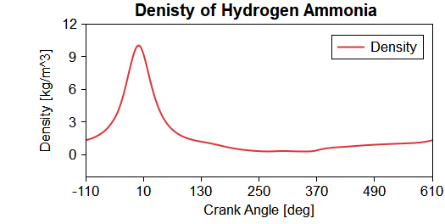
Figure 11: Density of Hydrogen Ammonia
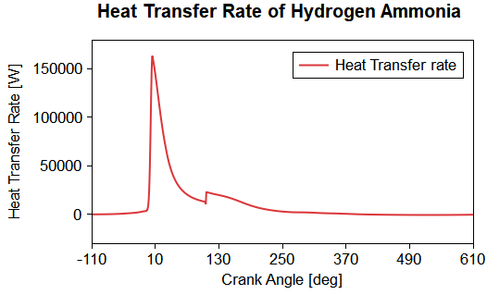
Figure 12: Heat Transfer of Hydrogen Ammonia

Pressure traces in Figure 13 also verify combustion phasing with peak pressure slightly after TDC at approximately 100 bar which is typical for hydrogen-fuelled at fast-burn cycles operating at moderate loads. The result in-cylinder temperature shown in Figure 14, illustrates a brief spike to around 3000 K after combustion, followed by a smooth reduction in temperature throughout expansion of the cylinder. These high peak temperatures are worth moderating for thermal NOx formation with the addition of ammonia to the mixture.
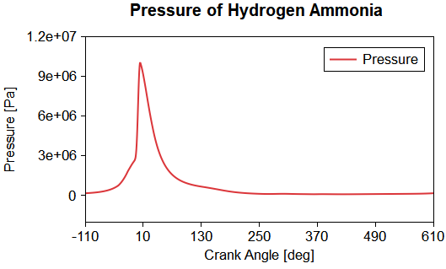
Figure 13: Pressure of Hydrogen Ammonia
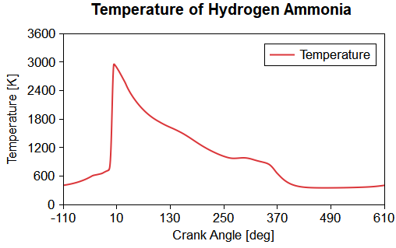
Figure 14: Temperature of Hydrogen Ammonia
The Ricardo WAVE engine model which can be seen in Figure 15, is a four-cylinder engine with a detailed intake and exhaust geometries, boundary conditions, and combustion chamber models. This layout is the foundation of the 1D gas dynamics simulation that produced the thermodynamic and emissions results based on this. Overall, the results highlight the rapid combustion dynamics, high thermal loads, and successful expansion processes achieved with the hydrogen-ammonia blend, validating both the simulation approach and the physical understanding of such alternative fuel combustion systems.
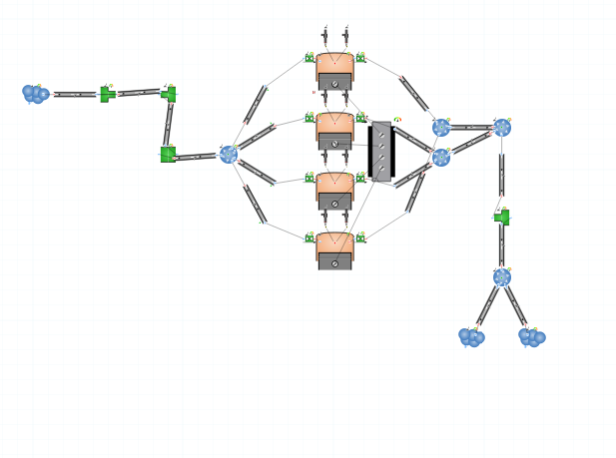
Figure 15: Engine Mode in Ricardo WAVE
The combustion and emissions modelling of hydrogen-ammonia blends carried out is directly relevant to the upcoming 2035 emissions regulations, such as Euro 7 and wider carbon neutrality goals. These regulations will bring in extremely low limits on CO₂, NOx, UHC, PM, pushing conventional internal combustion engines to either drastically improve or be phased out. Hydrogen ammonia combustion offers a solution, producing almost no CO₂ emissions and significantly reducing NOx formation by lowering peak combustion temperatures through the presence of ammonia. The Ricardo WAVE simulation result shows rapid and clean combustion, with high combustion efficiency and minimal carbon based emissions and controlled thermal behaviour all important factors for meeting the next regulations. These results show that hydrogen ammonia engines could comply with 2035 standards without relying on after treatment systems, reducing vehicle cost and weight. The ability to model combustion behaviour accurately in WAVE allows early optimisation of ignition timing, combustion duration, and emissions performance, making it possible to verify engine designs more efficiently under the new legislations. This shows the potential of hydrogen ammonia as a usable fuel for maintaining the importance of internal combustion engines while meeting the sustainability and emissions requirements of 2035.

Conclusion
The report has demonstrated an integrated approach to modelling and analysing the combustion and emissions behaviour of Petrol, Ethanol, and Hydrogen Ammonia blends in internal combustion engines. By incorporating experimental analysis, emissions trend estimation, and advanced combustion modelling techniques such as Rassweiler and Withrow mass fraction burned history, Wiebe function fitting, and pressure volume analysis, an overall thermodynamic and emissions map was established for each fuel blend. The results confirmed theoretical expectations in the literature review, fuels with built-in oxygen content such as ethanol allow for more complete burnup but have greater risks of NOx production by means of increased flame temperatures, while hydrogen ammonia mixtures achieve very high combustion efficiencies with very low carbon based emissions and lesser NOx production. Relative analysis of emissions across all fuels highlighted the compromises between combustion completeness and the approaches to controlling emissions, emphasising the central importance of fuel chemistry, flame speed, and ignition behaviour. The hydrogen ammonia blend achieved ultra low CO, UHC, and NOx emissions simultaneously, clear prospect as a future low-carbon solution for future advanced combustion engines. In addition, the application of Ricardo WAVE was explored, illustrating how such experimental combustion processes can be properly simulated with 1D engine simulation, including definitions of fuel properties, control of combustion phasing, chemical kinetics, and emissions prediction. Overall, this stresses the technical feasibility of introducing low and zero carbon alternative fuels into internal combustion engine platforms using advanced simulation tools, conservative fuel blending techniques, and complex combustion calibration. The findings support that sustainable powertrains of the future will still rely on flexible, blended, or alternative fuels such as hydrogen and ammonia, which require accurate physically based simulation techniques to tap optimum performance as well as comply with stringent future emission standards.

References
ANSYS, 2022. Forte User's Guide. Canonsburg: ANSYS Inc.
Curran, H.J., Gaffuri, P., Pitz, W.J. and Westbrook, C.K., 2007. A comprehensive modelling study of iso octane oxidation. Combustion and Flame, 129(3), pp.253-280.
García, A., Monsalve-Serrano, J. and Kolodziej, C., 2021. Challenges and opportunities of hydrogen combustion in ICEs. Energy Conversion and Management, 245, 114613.
Heywood, J.B., 2018. Internal Combustion Engine Fundamentals. 2nd ed. New York: McGraw Hill Education.
Li, X., Wang, Z., Zhang, Q., et al., 2023. Flame acceleration and knock suppression in hydrogen ammonia dual fuel combustion. International Journal of Hydrogen Energy, 48(5), pp.2391–2403.
Milovanovic, N., Tunestal, P. and Johansson, B., 2022. Combustion phasing and knock studies in hydrogen-fuelled engines. SAE International Journal of Engines, 15(4), pp.2004–2017.
Verhelst, S., Rombaut, N., Sierens, R. and Verstraeten, S., 2019. Future trends in hydrogen internal combustion engines. International Journal of Hydrogen Energy, 44(15), pp.7781–7795.
Wang, Y., Zuo, C. and Yang, J., 2021. Effects of hydrogen addition on flame dynamics in ammonia combustion. Fuel, 292, 120310.
Zhao, H., Liu, F., Ma, T. and Yang, S., 2020. Research on thermal NOx formation and reduction in internal combustion engines. Fuel, 275, 117844.

